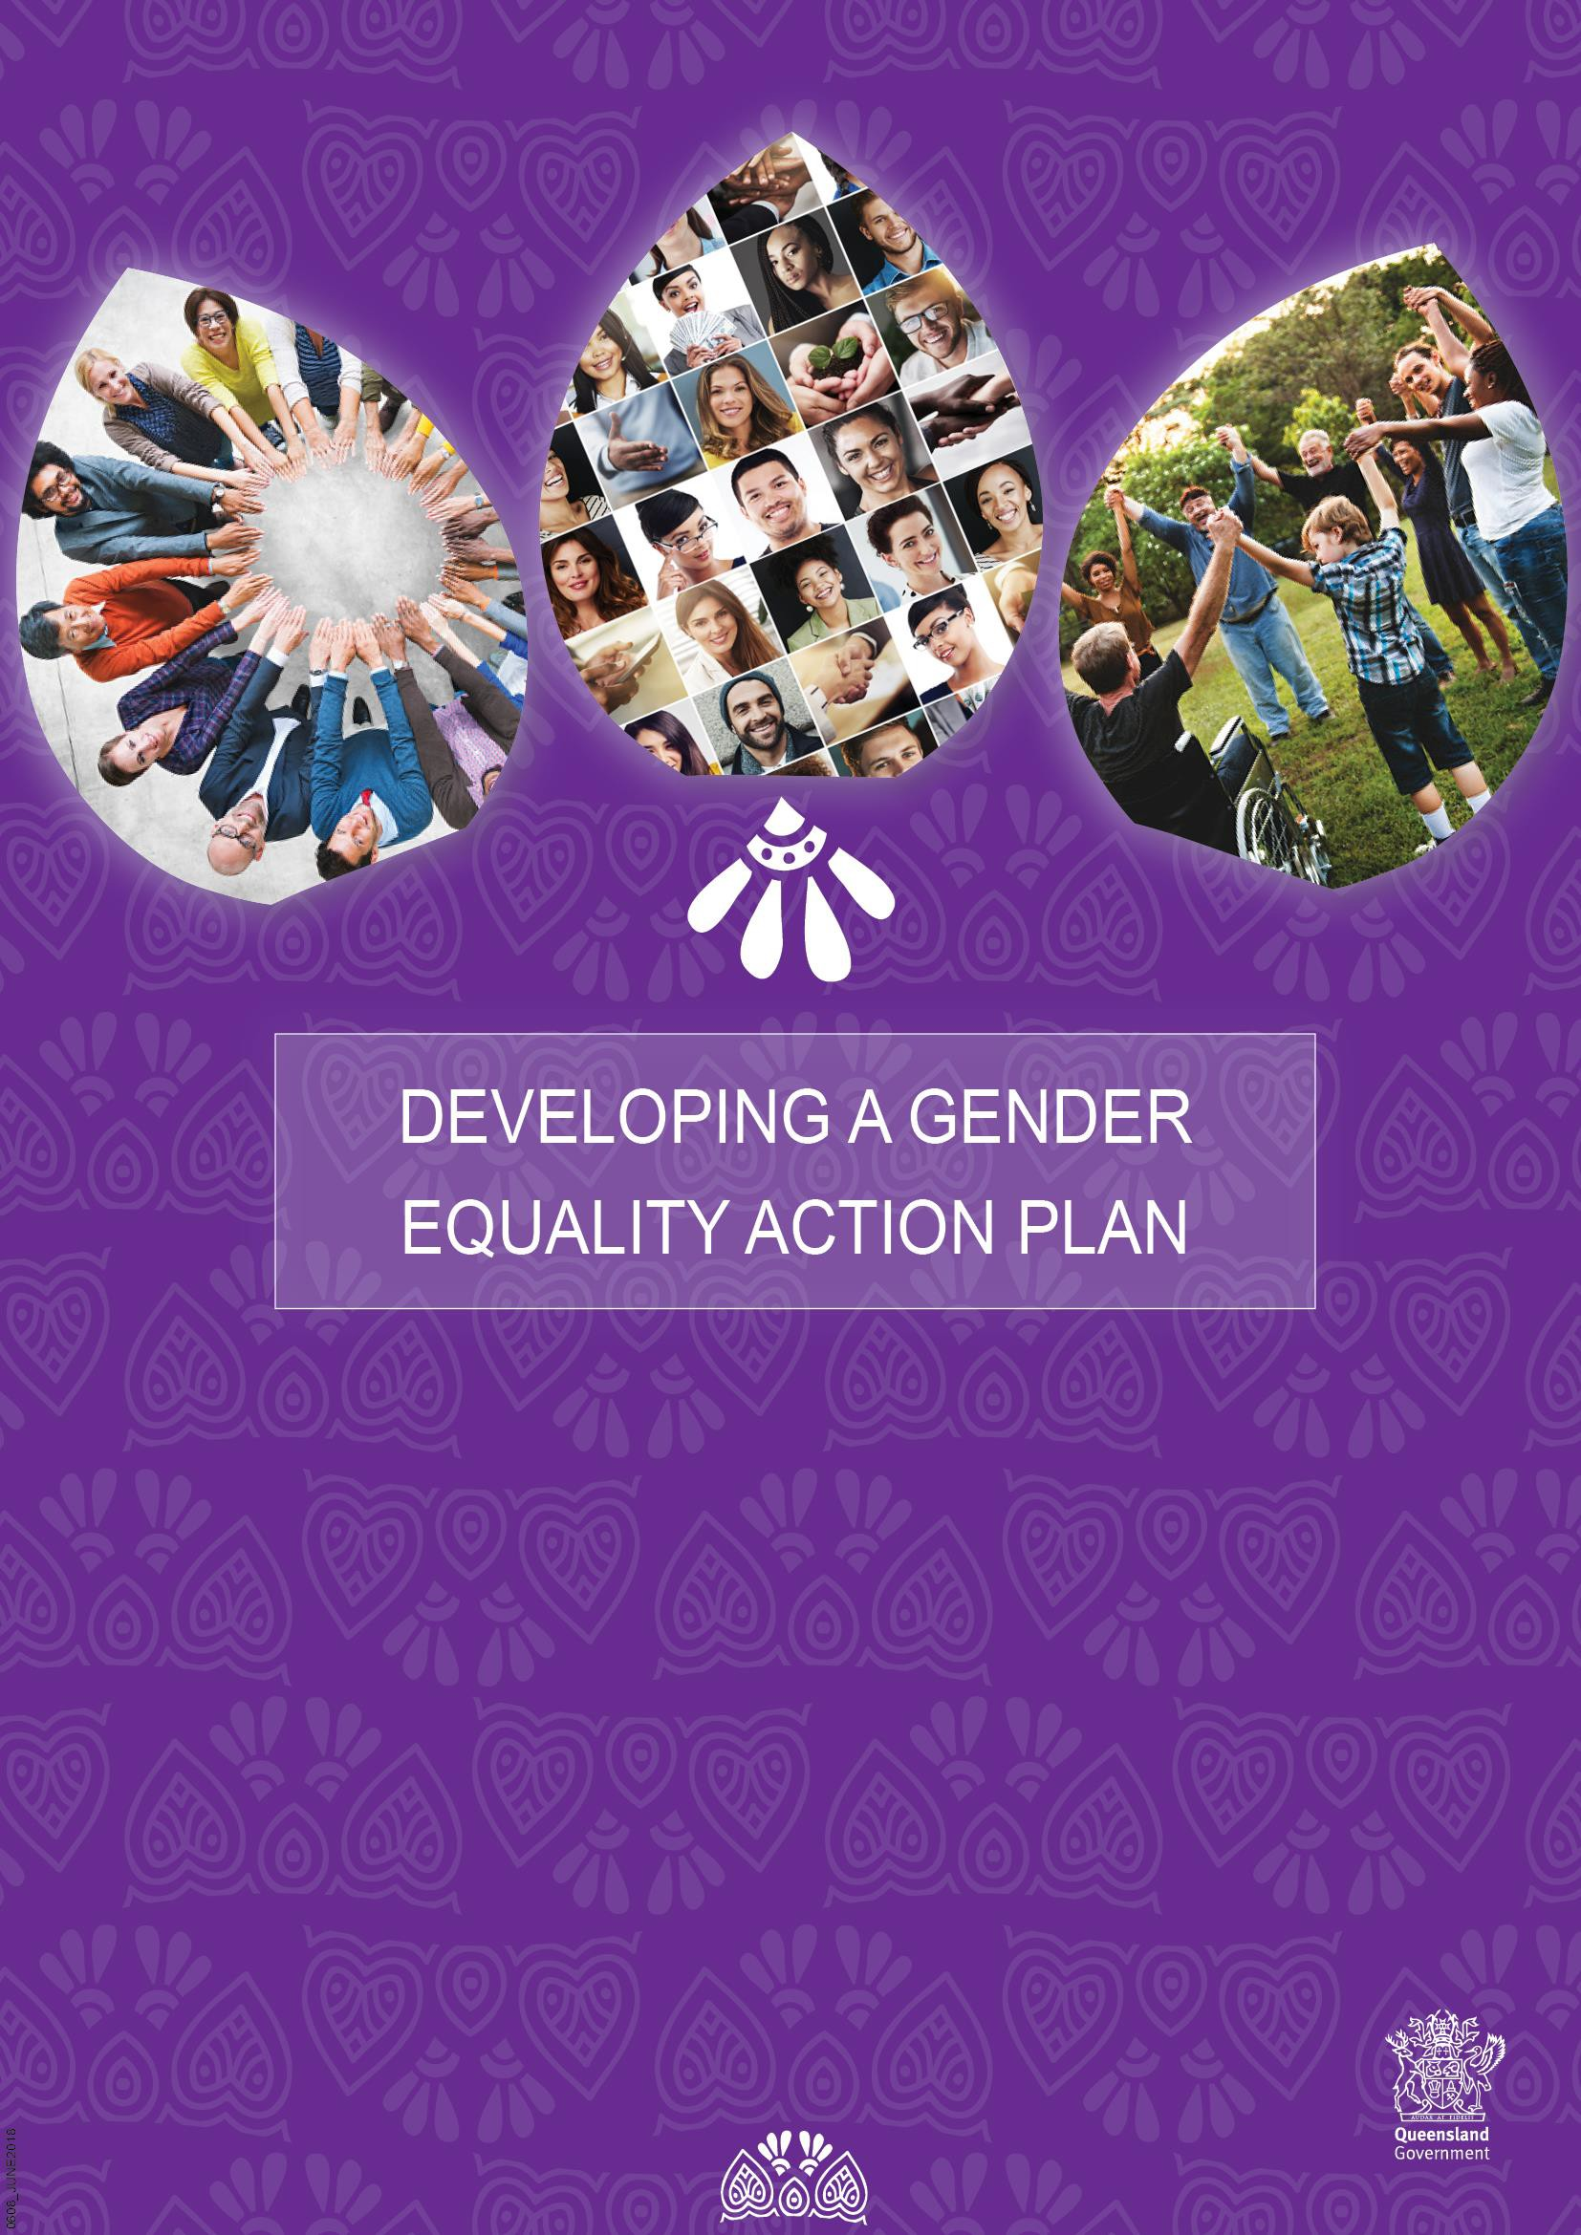

# Overview

Gender equality is a fundamental component of a civil society and equal opportunity in Australia. The Queensland Government is committed to gender equality in all aspects of society, and recognise that to achieve gender equality, wholesale cultural change is required. Without demonstrated commitment from leaders to plan, drive and deliver on gender equality, effective change will not succeed.

It is important for government, business, community services and the broader community to take action to achieve gender equality across all aspects of their business including workforce participation, development and delivery of policy, programs and services and how we communicate and engage both internally and externally.

To assist government, business and community organisations to plan, this Gender Equality Action Plan guide and template has been developed.

## Gender Equality Action Plan template

The Gender Equality Action Plan template has been developed to assist you in documenting and promoting your Gender Equality Action Plan (Appendix 1).

Page 1 is designed to be used as a promotional tool to demonstrate your commitment to and focus on gender equality all on one page. It is recommended you promote this on your website.

If you have any questions please contact the Office for Women by emailing [women@qld.gov.au](mailto:women@qld.gov.au)

## Why have a Gender Equality Action Plan?

The Queensland Government recognises that a gender equal society enables women to reach their full potential, so that both women and men can fully participate as equal partners in society.

The [*Queensland Women’s Strategy 2016-21*](https://www.google.com.au/url?sa=t&rct=j&q&esrc=s&source=web&cd=2&cad=rja&uact=8&ved=0ahUKEwjFr7rZl_zYAhUETrwKHZzzDOoQFgguMAE&url=https%3A%2F%2Fwww.communities.qld.gov.au%2Fresources%2Fcommunityservices%2Fwomen%2Fqueensland-womens-strategy.pdf&usg=AOvVaw3N9yNncX-pI5GLFGBWFu3I) outlines the Government’s vision for women and girls: that the Queensland community respects women, embraces gender equality and promotes and protects the rights, interests and wellbeing of all women and girls.

To demonstrate commitment, the Queensland Government has included Gender Equality Action Plans for Government departments and statutory authorities as a discretionary [*Specific Purpose Planning Requirements*](https://www.forgov.qld.gov.au/sites/default/files/specific-purpose-planning-requirements.pdf) under the [*Queensland Government Performance*](http://www.premiers.qld.gov.au/publications/categories/guides/perf-manage-framework.aspx)[*Management Framework*](http://www.premiers.qld.gov.au/publications/categories/guides/perf-manage-framework.aspx) Policy.

**Embedding your commitment across your organisation**

To achieve true commitment to gender equality and help you to plan for change, you are strongly encouraged to ensure gender analysis is a key component when developing policies, legislation, programs, services and resources. Tools and resources are available to assist including a [Gender Analysis Toolkit](https://www.communities.qld.gov.au/communityservices/women/about-office-women/gender-analysis) as well as access to [gender report](https://www.communities.qld.gov.au/resources/campaign/womens-strategy/report-card-all.pdf) [cards](https://www.communities.qld.gov.au/resources/campaign/womens-strategy/report-card-all.pdf) for Queensland to support your planning and progress for gender equality.

## What is gender equality1?

* Gender equality refers to the equal rights, responsibilities and opportunities of women and men and girls and boys. Equality does not mean that women and men will become the same but that women’s and men’s rights, responsibilities and opportunities will not depend on whether they are born male or female and that opportunities are available for people of all genders to realise their full human rights and potential.
* Gender equality implies that the interests, needs and priorities of people of different genders are taken into consideration, thereby recognising the diversity of different groups of people of all genders.

## What is a gender perspective?

A gender perspective examines the impact of gender on people’s opportunities, social roles and interactions. Including a ‘gender perspective’ requires an understanding that individuals have different experiences, needs and interests.

## What is the business case for gender equality?

A growing body of research shows that2:

* organisations that demonstrate gender equality outperform those that don’t,
* increasing the proportion of women in leadership roles is associated with better economic, social and financial performance, and
* gender equality in teams promotes an environment where innovation can flourish.

## What needs to be included in the Gender Equality Action Plan?

This guide to developing a Gender Equality Action Plan has been designed based on research across a range of jurisdictional plans and gender equality planning tools. It includes an example of three key focus areas identified as important in a Gender Equality Action Plan. These are:

1. **Workforce Participation:** Includes recruitment and employment practices.
2. **Policy, Programs and Services:** Includes all aspects of policy and program development, procurement practices and service delivery.
3. **Communication and Engagement:** Includes all aspects of how we communicate and engage both internally and externally of the department, business or organisation.

**Communicating your commitment**

It is recommended that you promote your Gender Equality Action Plan on your website to showcase your commitment to gender equality.

Communicating gender equality at a senior leadership level is very important and promoting results with internal and external benchmarking on a regular basis will demonstrate the commitment and progress being made.

# A guide for developing your Gender Equality Action Plan

## Step 1: Prepare to plan: Review current status

Assess your current status and analyse performance to identify strengths, weaknesses, barriers and gaps for gender equality.

* Undertake an analysis of how well you are performing on gender equality. A Gender Analysis Toolkit developed by the Queensland Government can assist you [here](https://www.communities.qld.gov.au/communityservices/women/about-office-women/gender-analysis/gender-analysis-toolkit-resource).
* Identify what you are already doing well and what other strategies or plans exist that have or require more action.

**ACTION:** Insert any links/references to relevant gender equality actions and activities identified in existing strategies and plans into your Gender Equality Action Plan.

## Step 2: Our Commitment: Define your story

Develop a statement that provides an overview of why you have a gender equality action plan, what you hope to achieve and how it relates to your core business and existing strategic plans.

* Define your robust and credible business case. (What are the benefits beyond just social or corporate responsibility for your organisation?)
* Determine what your commitment to gender equality is, why are you doing it and what difference it will make?

**ACTION:** Enter your ‘Our Commitment’ statement on ‘Page 1’ of the Gender Equality Action Plan template. An example of one is shown below.

## Our Commitment

E.g. We are committed to building and sustaining gender equality through our workforce, products, services and communication practices to better serve our customer base and demonstrate that gender is not a barrier to success.

**Step 3: Our Focus: Establish your key statements of commitment**

It is important to know, understand and have agreement on what the core focus for achieving gender equality in these three key areas of your business means to your organisation.

**ACTION:** Enter statements for ‘Our Focus’ for each focus area on ‘Page 1’ of the Gender Equality Action Plan template. An example is shown below.

## Our Focus

|  |  |  |
| --- | --- | --- |
| **Workforce**  **Participation** | **Policy, Programs**  **and Services** | **Communication**  **and Engagement** |
| E.g. People are able to access and enjoy workforce participation with the same rewards, resources, opportunities and outcomes regardless of gender | E.g. Consideration is given to the differences in the lives of women and men, their participation in social and economic life and the differential impacts on their lives from our policies,  programs and services | E.g. Communication and engagement is gender neutral and the organisation demonstrates a reputation for inclusive behaviour |

**Step 4: Our Priorities: Identify your actions in each focus area**

Each focus area will require some high level key actions that define what you will be committed to achieving over the next 3 year period. To identify what the priorities are for your workforce, policies, programs and services and how you communicate and engage in the future you should consider:

* what activities can change culture through leadership, flexibility and innovation?
* what research or plans already exist that can inform your actions?
* how might you benchmark your performance against other similar entities and/or competitors?

Steps may include:

* ensuring input from a gender diverse group of stakeholders
* identifying existing consultation mechanisms and leadership teams for input to the plan
* consulting with colleagues across your workforce
* consulting with external stakeholders such as your core clients
* considering establishing a working group to have input to your plan

**ACTION:** Enter your key actions for each focus area under ‘Our Priorities’ on ‘Page 1’ of the Gender Equality Action Plan template. An example is shown below.

## Our Priorities

|  |  |
| --- | --- |
| **Workforce Participation** | * Establish flexible work practices that support women’s participation in leadership roles * Review and address any gender pay gap for staff * Build the leadership pipeline of women for senior management roles |
| **Policy, Programs and Services** | * Undertake gender analysis to review policies, programs and services to ensure they support gender diversity and inclusion * Build organisational capability to address unconscious bias and gender inequality practices * Revise procurement policies to address gender equality issues |
| **Communication and Engagement** | * Build gender equality into our communication and engagement strategy to gender inclusive practices * Become recognised as an employer of choice for gender equality * Ensure consultation and promotional resources consider and demonstrate gender diversity |

**Step 5: Our Action Plan Activities:**

It is important to define the short-term ‘Year 1’, medium-term ‘Year 2’ and longer-term ‘Year 3’ activities you will undertake to achieve actions.

To achieve actions for gender equality across all focus areas you will need to identify:

* specific activities that need to be undertaken to achieve each action
* measures and targets to monitor performance and drive change
* the stakeholders responsible to deliver the activities
* who the champion or person responsible for accountability and reporting on activities and outcomes is.

Note: You may wish to set up a management team/advisory body that includes experts across each priority area who will take carriage of this plan.

Here are some examples of what you might discuss for each priority area.

* What are some potential stretch targets that can help drive change through goal setting and leverage commitment and accountability?
* How might you measure your performance, who will do this and how?
* Who is best placed to lead the activities to achieve each action and who else might need to be involved?
* Who will monitor progress and when will you report on your actions?
* Who will you need to consult and seek endorsement of your plan from*?*

ACTION: Enter your short (Yr1), medium (Yr2) and long term (Yr3) activities for each key action identified on ‘Page 1’ of the Gender Equality Action Plan template. An example is shown below.

**Workforce Participation (Example)**

(Where appropriate, include links to relevant actions that already exist in other plans)

|  |  |  |  |  |
| --- | --- | --- | --- | --- |
| **Year 1**  **(Insert) 2018 –**  **2019** | **Year 2**  **Insert) 2019 –**  **2020** | **Year 3**  **Insert) 2020**  **– 2021** | **Success Measures** (Performance against targets and/or how we  will know actions are successfully achieved) | **Responsible Department/ Area** |
| **#Key Action: Establish flexible work practices that support women’s participation in**  **leadership roles** | | | | |
| e.g. Audit number of staff on flexible work arrangements | e.g. Establish targets for flexible work arrangements for men and women | e.g. Undertake review of progress against  targets | e.g. Report on progress and promote and publish your results internally and  externally | XXXX |
| e.g. Identify best practice and establish and promote successful case studies | e.g. Have agency heads and executives agree to implement best practice arrangements identified from  case studies | e.g. Undertake review of flexible work practices and the benefits to the  business | e.g. Number of women in leadership roles has increased by XX% | XXXX |

# Monitoring Progress and Reporting

As a three year plan it will be important to monitor the progress of your actions and consider reporting on your progress and achievements regularly.

It is recommended you review your plan and progress annually, and if necessary, make adjustments to the detailed actions in your plan to represent any changes or additional actions you need to take.

Consider publicly reporting on your progress and demonstrate what has been achieved alongside your published action plan.

Significant research has been undertaken and organisations such as the Diversity Council of Australia and the Workplace Gender Equality Agency can confirm, showcasing your commitment, demonstrates there is a purposeful approach to diversity and inclusion enabling broader perspectives and insights to better serve your customers and to be recognised as an employer of choice and an enhanced organisational reputation.

At the end of the three years, review and develop a plan for the following three years, ensuring gender equality is sustained.

# Supporting Resources

## Workforce Participation:

Gender Strategy Toolkit – A direction for achieving gender equality in your organisations. Developed by the Workplace Gender Equality Agency (Access resource [here](https://www.wgea.gov.au/lead/building-gender-equality-strategy)).

Who is this toolkit for? Any individual who is a stakeholder in workplace gender equality and has the potential to influence an organisation’s approach to gender issues should find some or all of the frameworks and ideas useful. Such stakeholders are likely to include business leaders and managers, diversity champions and sponsors within organisations, and human resources or diversity practitioners.

[Diversity resources – ASX](https://www.asx.com.au/regulation/corporate-governance-council/resources.htm) offers a range of resources that listed companies may find helpful in implementing diversity.

Working for Queensland survey – collects data annually on the use of flexible work options and employee perceptions of whether gender is a barrier to success in their organisation - <https://www.forgov.qld.gov.au/working-queensland-survey>

Inclusion and diversity commitment, including gender targets for the Queensland public service at the SO and SES level - [https://www.forgov.qld.gov.au/inclusion-and-diversity-](https://www.forgov.qld.gov.au/inclusion-and-diversity-commitment) [commitment](https://www.forgov.qld.gov.au/inclusion-and-diversity-commitment)

## Policy, Programs and Services:

*Gender Analysis Toolkit* – a resource to assist in analysis of gender equality developed by the Queensland Government (Access resource [here](https://www.communities.qld.gov.au/communityservices/women/about-office-women/gender-analysis/gender-analysis-toolkit-resource))

This toolkit can help to apply gender analysis in daily activities with focus on:

* better interpreting policy, and outcomes of policy implementation and program and service delivery, in respect of gender awareness; and/or
* consideration of gender issues as an integral factor in each stage of the development, implementation and evaluation of all policies, programs and services.

## Communication and Engagement:

*Communicating gender diversity: A critical approach* - examines the variety of ways in which communication of and about gender enables and constrains people's intersectional identities.

Authors Victoria Pruin DeFrancisco and Catherine Helen Palczewski place an emphasis not on how gender influences communication, but on how communication constitutes gender.

Operating from a gender diversity perspective. Published by Sage 2007. (Access book [here](http://scholar.google.com.au/scholar_url?url=https%3A%2F%2Fbooks.google.com.au%2Fbooks%3Fhl%3Den%26lr%3D%26id%3DOp51AwAAQBAJ%26oi%3Dfnd%26pg%3DPR5%26dq%3Dcommunicating%2Bgender%2Bequality%26ots%3DCG2dqqh475%26sig%3DiY9jIK32W4LVuqojn7CGv0JD9yI&hl=en&sa=T&ct=res&cd=3&ei=y0ZxWuyFO4rWjgS0_aHYBQ&scisig=AAGBfm3mtwr72WY1AZ0P3R1GBF1H6Z189A&nossl=1&ws=1003x759))

*WordsAtWork - Building inclusion through the power of language* - developed by Diversity Council Australia as part of a campaign, explains how language is a powerful tool for building inclusion and exclusion at work and how inclusive language can improve workplace culture and drive productivity. (Access resource [here](https://www.dca.org.au/research/project/wordsatwork-building-inclusion-through-power-language))

## Setting gender targets:

*Setting gender targets* - a target-setting tool to assist employers set voluntary targets within their organisation developed by the Workplace Gender Equality Agency. (Access resource [here](https://www.wgea.gov.au/lead/setting-gender-targets))

1. [UN Women, Concepts and definitions, viewed 31 January 2018,](http://www.un.org/womenwatch/osagi/conceptsandefinitions.htm)

<<http://www.un.org/womenwatch/osagi/conceptsandefinitions.htm>>

1. 'The business case for gender equality', Workplace Gender Equality Agency (2016), [www.wgea.gov.au,](https://www.wgea.gov.au/sites/default/files/wgea-business-case-for-gender-equality.pdf) 'Supporting Working Parents: Pregnancy and Return to Work National Review – Report' (Section 1.3(a)), Australian Human Rights Commission (2014), [https://www.humanrights.gov.au/publications/supporting-working-parents-pregnancy-and-return-work-national- review-report/chapter-1,](https://www.humanrights.gov.au/publications/supporting-working-parents-pregnancy-and-return-work-national-review-report/chapter-1) accessed 10 May 2016 'What is the impact of gender diversity on technology business performance',

National Centre for Women and Information Technology

(2014), [https://www.ncwit.org/sites/default/files/resources/impactgenderdiversitytechbusinessperformance_print.pdf,](https://www.ncwit.org/sites/default/files/resources/impactgenderdiversitytechbusinessperformance_print.pdf) accessed 10 May 2016, 'Is there a payoff from top-team diversity?', McKinsey and Company (2012), [http://www.mckinsey.com/business-](http://www.mckinsey.com/business-functions/organization/our-insights/is-there-a-payoff-from-top-team-diversity) [functions/organization/our-insights/is-there-a-payoff-from-top-team-diversity,](http://www.mckinsey.com/business-functions/organization/our-insights/is-there-a-payoff-from-top-team-diversity) accessed 10 May 2016, 'ASX 500 – Women Leaders, Research Notes' (page 12), Reibey Institute (2011) [http://www.reibeyinstitute.org.au/wp-](http://www.reibeyinstitute.org.au/wp-content/uploads/2011/10/ASX500_Women-Leaders-2011.pdf) [content/uploads/2011/10/ASX500_Women-Leaders-2011.pdf,](http://www.reibeyinstitute.org.au/wp-content/uploads/2011/10/ASX500_Women-Leaders-2011.pdf) accessed 10 May 2016, ['The Business Case for Gender Equality’ –](https://www.wgea.gov.au/sites/default/files/wgea-business-case-for-gender-equality.pdf) [The Workplace Gender Equality Agency](https://www.wgea.gov.au/sites/default/files/wgea-business-case-for-gender-equality.pdf) viewed 18 September 2018