Publications portal user guide

Author | Queensland Online  Smart Service Queensland
Organisation | Department of Communities, Housing and Digital Economy
Version | 0.4
Version date | 27/04/2021
Security class | OFFICIAL

Contents
Entering a publication set into the Publications portal 3
Download Google Chrome 3
Do the training 3
Log on to the Publications portal 3
Step 1: Add a publication set 3
Step 2: Add data 5
Making changes 7
Changing or deleting publication sets 7
Adding, changing or deleting resources 9
Change (update) an existing resource 10
Delete a resource 10
Linking to the same resource from different publication sets 11
Writing guidelines for titles and descriptions 12
General rules 12
Publication set titles and descriptions 12
Titles 12
Descriptions 12
Resource names and descriptions 12
Markdown formatting 13
Links 13
Italics 13
Bolding 13
Publication suitability 14
General guidelines 14
Accessibility requirements 14
File size 14
Exceptions to accessibility requirements 14
Documents that might be suitable for the Publications portal 15
Documents that are unsuitable for the Publications portal 15

Entering a publication set into the Publications portal

Download Google Chrome
The Publications portal displays better with Google Chrome. We recommend downloading the latest version of the Google Chrome browser.

Do the training
Before you can access the Publications portal you will need to do some training in the ‘test site’ and get approval to use the ‘live site’.
To access the test site, send an email to online@qld.gov.au requesting a username and password.
Once you have you login details you can access the test site. The URL for the test site is https://training.publications.qld.gov.au/user/login.
Once you are logged in, follow the steps below starting with Step 1: Add a publication set (i.e. these are the same steps for the live site).
After you have completed training on the test site you will need to send a self-publishing account request form) to online@qld.gov.au and request a login to the live site.

Log on to the Publications portal
MAKE SURE THAT YOU ARE ON THE RIGHT SITE BEFORE MAKING ANY CHANGES.
The URL for the live site is https://www.publications.qld.gov.au/user/login.
Note: You may get a warning message when you try to access the portal. Click ‘Proceed anyway’ or ‘Continue to this site’ at this step.

Step 1: Add a publication set
Once you are logged in the first step is to enter details about your publication set. A publication set is the 'overall category' or 'main page' under which a single resource or a group of resources (i.e. PDFs or other document types) will be listed.
For example, Liquor licensing and compliance forms is a publication set. This page lists all the resources related to this set (i.e. Form 1, Form 3, Form 5 and any other PDFs that apply to liquor licensing applications).
- On the top menu, select Publication, then select Add Dataset.
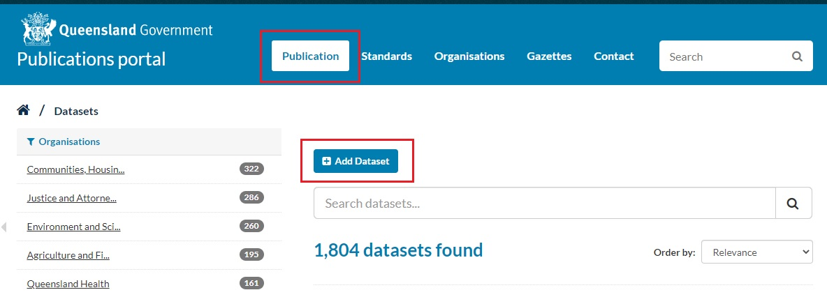
- A page will display that shows the 2 steps involved (screenshot below):

- Create dataset.
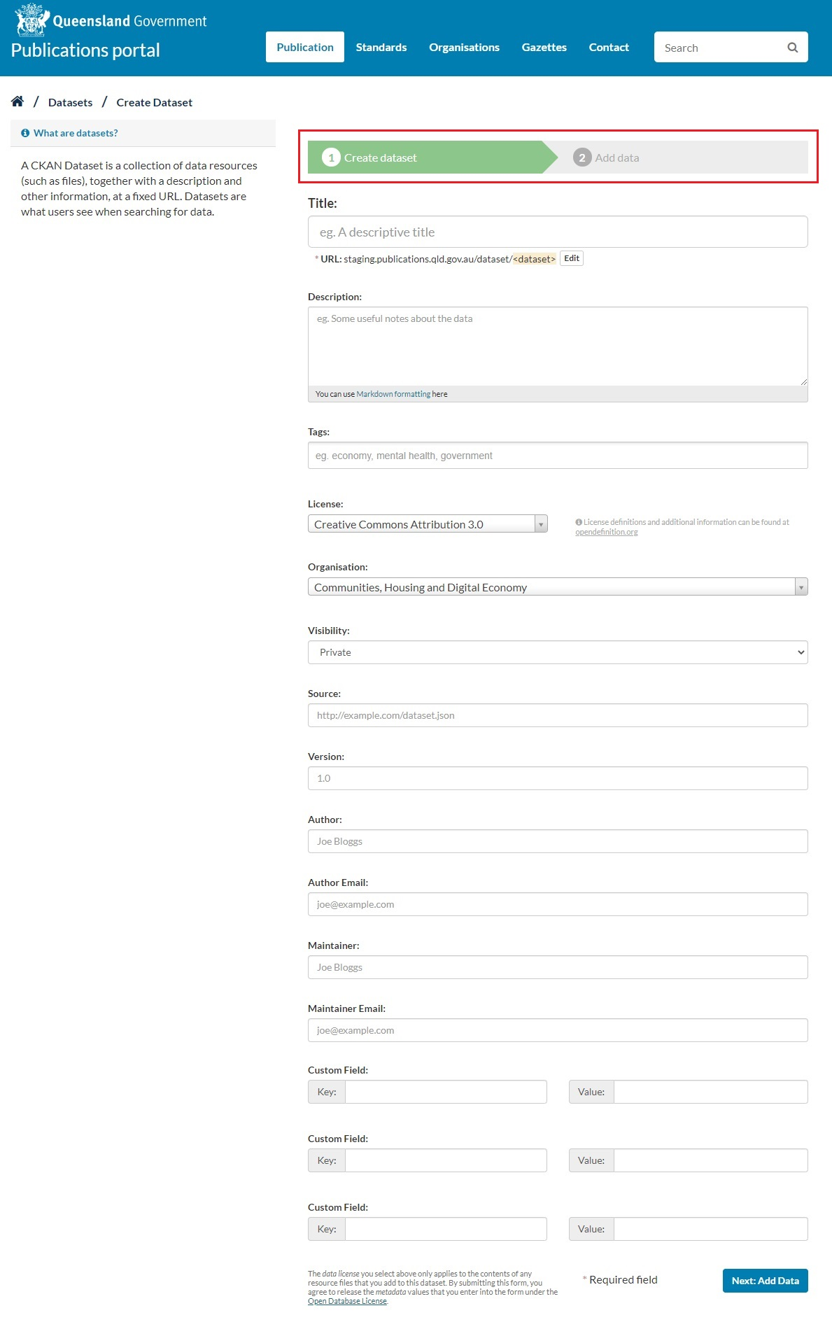
- Add data.
- Enter the Title of your publication set. (Read more about writing effective publication set titles and descriptions.)
Note: You can edit the URL that is created. Think about how you can optimise your URL using a minimum number of keywords. Also take care to ‘future-proof’ your URL by removing words such ‘draft’, ‘version’, ‘proposed’, ‘for comment’ etc. from the URL. Keep it generic. (This might save you coming back later and editing the URL when the resources become ‘approved’ or ‘final’).
- Enter a Description of your publication set. (Read more about writing effective publication set titles and descriptions.)
Note: You can use markdown formatting in your description to link to other websites for more information.
- Enter Tags. These are key phrases or words to improve searching (e.g. ‘Gaming forms’, ‘Gaming licence application’, ‘Gaming machine application’).
- Select a Licence from the drop-down menu. Most Queensland Government resources will be ‘Creative Commons Attribution’, but some resources may require a different licence type. For example, technical documents that we need to protect our intellectual property will be CC-NC. For descriptions of licence types visit the Creative Commons website.
- Select your Organisation from the drop-down menu (e.g. Justice and Attorney-General).
- Select your Visibility from the drop-down menu.
Note: By default, the dataset Visibility is set to ‘private. If you keep it as ‘private’, it will only
be visible to people from your organisation who are logged into the Publications portal. Change this to ‘public’ for other people to be able to view your dataset.
- Type in the Author Name. This can be a person’s name or the author email address. This is not displayed on the Publications portal.
- Type in your Author Email address. This must not be an individual email address as it is displayed on the Publications portal. Instead, use a shared team email address.
- Type in the Maintainer name. This should be the person responsible for managing the dataset and can be their name or email address. This is not published on the Publications portal.
- Type in the Maintainer email address. This should be the team responsible for managing the dataset. This address is also published on the Publications portal.
Note: Ignore the Key and Value fields.
- Click on Next: Add Data

Step 2: Add data
You can now start uploading any resources (PDFs, DOCs, etc.) that you want to list under your newly created publication set.
- There are 2 ways to add a resource.
    - You can ‘Link’ (e.g. a resource already uploaded on the Publications portal or another website)
    - You can ‘Upload’ (i.e. upload and save a PDF or other document into the Publications portal content management system).
- To upload a file, you will first need to save the resource (e.g. PDF) you wish to add on your desktop.
Note: Think carefully about what name you give to your file. Don’t just use the file name that generates automatically.
- Click Upload (screenshot below). Select the resource (e.g. PDF) you want to upload from your desktop.
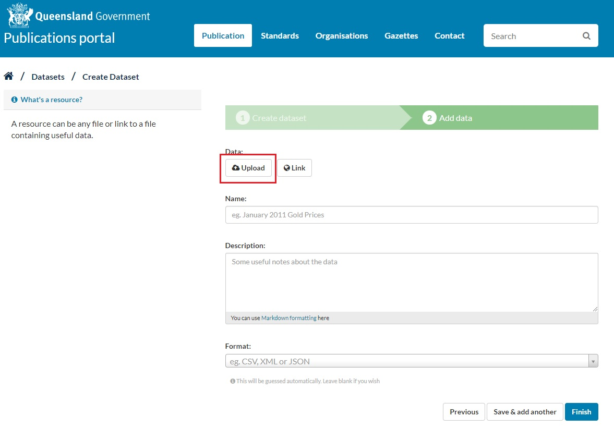
- The File field will show the path (URL) to the uploaded file.
- The Name field will show the filename of the uploaded file. It is a good idea to remove any terms associated with file extensions (e.g. ‘pdf’) from the name. (Read more about writing effective resource names and descriptions.)
- Write a Description of the resource. Explain what it is and how a customer would use it. (Read more about writing effective resource names and descriptions.)
Note: You can use markdown formatting in your description to link to other websites for more information.
- For the Format click in the dropdown menu and start typing the filetype e.g. PDF or DOC.
- The Filesize should automatically generate.
- Add a Next review date.
- Once you have finished click Save & add another if you want to add more files to the dataset or click Finish.

Making changes

Changing or deleting publication sets
- Make sure you are logged into the Publications portal.
- Find the publication set you want to change and click Manage (screenshot below). The edit view will open.
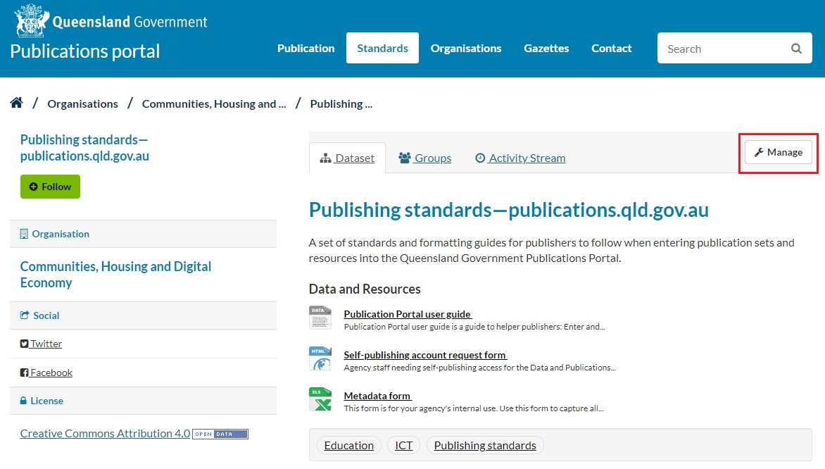
- To change the publication set details, update any form fields as required (screenshot below).

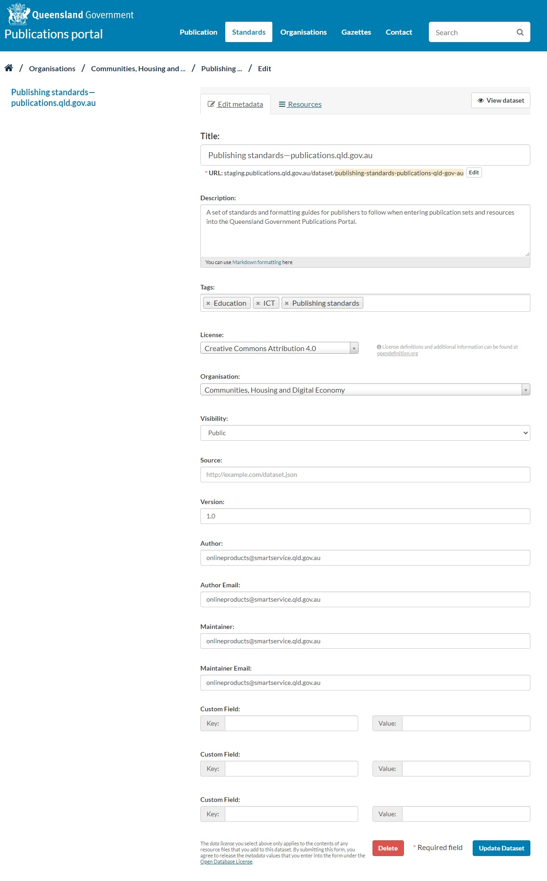
- To add a tag, click into the Tags field and start typing then press Enter. To remove a tag, click the X next to the tag text.
- Save the dataset when you are done by clicking Update Dataset at the bottom of the page.
- Check straight away that the live data matches the information in the metadata form, and you can view the resources.
- To delete a publication set, click Delete in the publication set edit view.
Note: Depending on your role, you may not have permission to delete a publication set. In this case, ask your administrator to delete it.

Adding, changing or deleting resources
- Make sure you are logged into the Publications portal.
- Find the publication set where you want to add a new resource.
- Click on Manage see the screenshot on page 8 of this guide.
- Click on the Resources tab (see below).

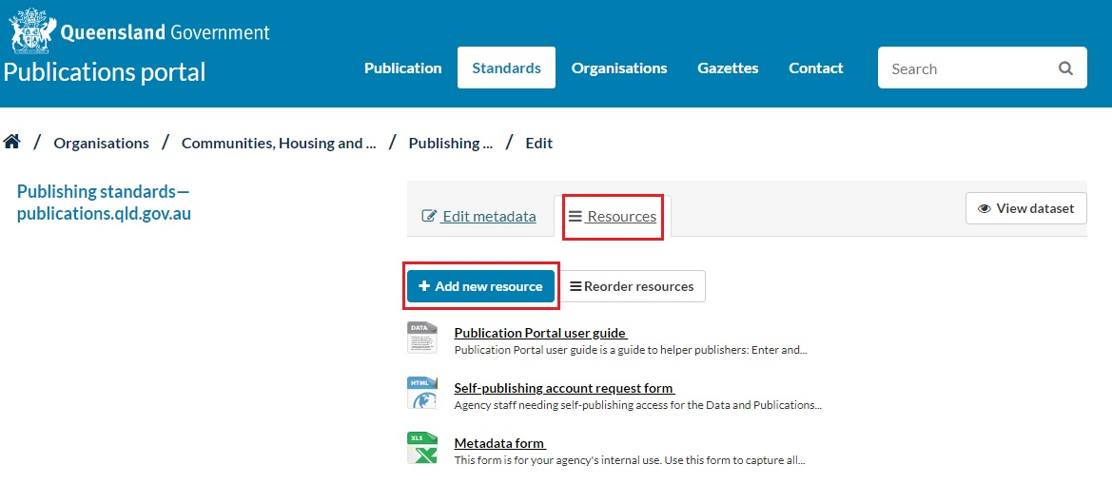
- Save the file you wish to add to your desktop. Be sure to name your file properly. (Read more about writing effective resource names and descriptions.)
- Click Upload (select the file you want to upload from your desktop) or Link (to link to an existing resource already uploaded elsewhere on the portal).
- The Resource field will show the path (URL) to the uploaded file.
- The Name field will show the filename of the uploaded file. It is a good idea to remove any terms associated with file extensions (e.g. PDF) from the name. (Read more about writing effective resource names and descriptions.)
- Write a Description. (Read more about writing effective resource names and descriptions.)
Note: You can use markdown formatting in your description to link to other websites for more information.
- For the Format click in the dropdown menu and start typing the filetype e.g. PDF or DOC.
- The Filesize should automatically generate.
- Click Add to add this new resource to your publication set.

Change (update) an existing resource
- Make sure you are logged into the Publications portal.
- Find the publication set where you want to add a new resource and select Manage.
- Click on the Resources tab.
- Click on the title of the resource you wish to change or delete.
- Click Remove next to the current file. Select the file you want to upload from your desktop (e.g. the PDF that will replace the existing PDF) or enter the link you want to replace the existing link with.
- Click Update Resource.
Note: The old resource will be replaced by the new resource. It is important to note that the URL of the resource’s landing should remain the same. Only the URL of the resource itself will change.

Delete a resource
- Make sure you are logged into the Publications portal.
- Find the publication set where you want to add a new resource and click on Manage.
- Click on the title of the resource you wish to change or delete.
- Click Delete.
- Click Confirm.
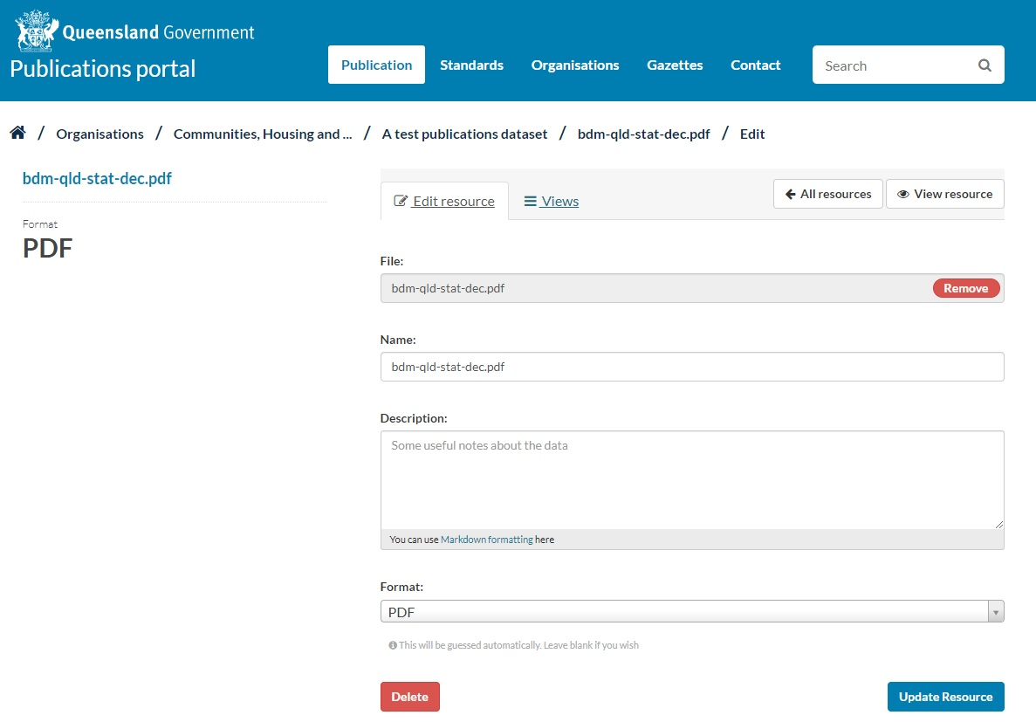

Linking to the same resource from different publication sets
A resource may be common to multiple publication sets. For example, the OLGR credit card payment form is common to the following publication sets:
- Liquor licensing and compliance forms
- Wine licensing and compliance forms
- Gaming licensing and compliance forms
To avoid uploading the same resource in 3 different places:
- First, upload your resource to one publication set (follow the process described above in Add data).
- Then link to that resource from as many other publication sets as you like. To link to this resource in any subsequent publication sets you create, follow the process described above in Add data but at step 1, click Link instead of Upload and select the URL of the resource where it has been uploaded in your original publication set.
Note: Be sure to use the same Name and Description for all instances of the resource.
PDFs and other resources will be a lot easier to maintain. Just be aware that if you need to update this resource in the future you will need to update it from the publication set where you originally uploaded it (process for updating is described above in Change (update) an existing resource).

Writing guidelines for titles and descriptions
You will need to enter a title and description for each publication set, as well as a name and description for each resource belonging to that set. Getting this right is important, as the quality of the titles and descriptions will directly affect:
- the findability of publications through the search engine
- people’s understanding of what a publication set covers
- people’s perception and trust of publications.qld.gov.au
- people’s ability to scan a list of resources for the correct one.

General rules
- Use words that people will type into the search box, not government jargon (e.g. ‘home’ not ‘residence’).
- Make sure your titles are in sentence case.
- Follow the style recommendations in the Web writing and style guide.

Publication set titles and descriptions

Titles
- Limited to 100 characters (including spaces).
- Must be unique—publication set titles generate URLs, and all URLs must be unique.
- Must not be the same as the description. Keep them succinct—move any unnecessary detail such as ‘Queensland’ into the description.
- Follow the format of ‘what’ followed by ‘when’. For example:
Projected population by age—from 2011 to 2056

Descriptions
- Must not be the same as the title.
- Should offer more detail than the title.
- Should be around 25 words.

Resource names and descriptions
Resource names and descriptions follow the same rules as publication set titles and descriptions, except when there are multiple resources (more than 5) in the same set. In this case, place the most unique part of the title at the start, so the list is easy to scan.
- Brisbane—Hours of reality TV watched by location
- Gold Coast—Hours of reality TV watched by location
- Wide Bay–Burnett—Hours of reality TV watched by location
- Mackay—Hours of reality TV watched by location
- Toowoomba and Darling Downs—Hours of reality TV watched by location
- Kilcoy—Hours of reality TV watched by location

- Hours of reality TV watched by location—Brisbane
- Hours of reality TV watched by location—Gold Coast
- Hours of reality TV watched by location—Wide Bay–Burnett
- Hours of reality TV watched by location—Mackay
- Hours of reality TV watched by location—Toowoomba and Darling Downs
- Hours of reality TV watched by location—Kilcoy

Markdown formatting
You use markdown formatting to include links to other web pages in descriptions and to emphasise words. This can be useful if you need to refer people to a web page to explain more than can be covered in a description.

Links
Put your link text inside square brackets. Put the URL inside regular brackets, following your link text. For example: Read the [Queensland road rules] (http://real-url-would-go-here.qld.gov.au) for more information.
=
Read the Queensland road rules for more information.

Italics
Place single asterisks on either side of the text to be italicised. For example:
*Felis catus* sat on the mat.
=
Felis catus sat on the mat.

Bolding
Place double asterisks on either side of the text to be bolded. For example:
You **must** register first.
=
You must register first.

Note: The more emphasis you use, the less effect it has. See the Web writing and style guide for more information.

Publication suitability

General guidelines
It is appropriate to upload a document to the Publications portal only where:
- the content need can’t be met with HTML only (keeping in mind that HTML can be split over several web pages)
- a demonstrated need exists to download the document as a complete package.

Accessibility requirements
- Existing documents should have an accessible alternative (contact details to request an accessible version at a minimum)
- New documents must be published with an accessible alternative.
  - Accessible alternatives
    - HTML (preferred)
    - RTF
- Module 6—Non-HTML documents (CUE Standard 3.0)
- Information Standard 26—Websites policy (Policy requirement 1— Queensland Government websites must maximise accessibility, usability and consistent presentation)
- Disability Discrimination Act 1992 (Cwlth) (Part 2, Division 1, Section 24)
Note: CUE Module 6 and IS26 are written in accordance with this Act.

File size
- All informational documents bigger than 1MB must be available in sections smaller than 1MB
  - Excluded—posters, high-resolution maps and other visual/non-informational material.

Exceptions to accessibility requirements
The following document types may be published without an accessible format—at the agency’s own risk—but must include contact details (e.g. email, phone) so a customer can ask for the information in an alternative format:
- ‘right to information’ documents—documents included in an agency disclosure log under section 78 of the Right to Information Act 2009.
- image-based documents such as maps, where there is no appropriate other format for displaying the resource.

Documents that might be suitable for the Publications portal
- Some image-based content (e.g. high-resolution maps).
- Agency and whole-of-government strategic plans/policies.
- White papers.
- Annual reports.
  - Data (e.g. financial) must also be available through data portal separately.
- Science journals and lengthy reports.
- Content that a customer may want to print or keep. For example
  - Checklists (accessible equivalents should also be offered)
  - Information booklets/kits. For example
    - Your keys to driving in Queensland
    - Young people in care info kit
    - Emergency REDiPlan for seniors
    - School transport code of conduct.
- Procedure manuals for non-government service providers.
- External consultant reports that are relevant to a customer need.
- Documents available in other languages.
- Posters and brochures needed by non-government service providers to print and distribute to customers.
  - Excluded—material needed only by other government staff (e.g. campaign merchandise for regional teams).
  - Brochures/fact sheets etc. should not be the only source of information (same information should be available as HTML).

Documents that are unsuitable for the Publications portal
- Documents that duplicate existing HTML content (without a demonstrated need for that content to be downloadable as a ‘package’).
- Documents for government staff to download and print out as part of their work (e.g. counter staff downloading and printing out brochures for the public—this content should be on the intranet or on a network hard drive).
- Content where the need can be met with HTML only.

