## Writing a grant application

**Practical advice for completing your grant application**

Applying for grants may feel overwhelming, especially for those new to the process or with varying levels of experience in grant writing. We recognise that disparities in access to education and resources can impact the ability to develop and practice the necessary skills for crafting compelling grant applications. Additionally, some applicants may face challenges if English is an additional language.

In this section, we provide guidance on writing a grant application with a focus on clarity. You will learn how to build a strong case for your proposal, ensuring your language is precise and persuasive, while effectively preparing your legal documents and communicating your budget requests. We also offer tips for completing essential forms accurately, including financial information, and the importance of letters of support.

We encourage all applicants to seek support and resources tailored to their needs to enhance their applications. By effectively evidencing [community consultation](https://www.publications.qld.gov.au/dataset/1fff06e2-0b11-4dfa-afaa-f23d55fc8f8a/resource/9ee7d8d3-00b0-4d90-a673-7ca5ebbbcca6/download/01.-program-design-101.pdf), [risk assessment and management](https://www.publications.qld.gov.au/dataset/1fff06e2-0b11-4dfa-afaa-f23d55fc8f8a/resource/6dd4b834-f7a6-4ede-afa0-dfa6bbfd9650/download/04.-program-design-risk-assessment-and-risk-management.pdf), [cultural safety](https://www.publications.qld.gov.au/dataset/1fff06e2-0b11-4dfa-afaa-f23d55fc8f8a/resource/a25d7748-136f-4f63-865b-9f3a4dbd5cad/download/06.-program-design-cultural-safety.pdf), and [accessibility](https://www.publications.qld.gov.au/dataset/1fff06e2-0b11-4dfa-afaa-f23d55fc8f8a/resource/dae50661-7bda-4ed3-9ea5-b2d01ba0872b/download/07.-program-design-accessibility.pdf) in your application, you strengthen your application and demonstrate your program's alignment with the grant's criteria.

**A reminder that to uphold fairness and impartiality for all applicants, the department cannot provide feedback or advice on individual proposals, discuss their suitability, or assist with the content of your application.**

## Building a strong case

Building a strong case is a foundational aspect of any grant application. It involves clearly and convincingly demonstrating how your proposed project aligns with the grant's goals and priorities, and how it will address a specific need in the community. Here are some key elements to focus on when building a strong case:

By following these steps and presenting a well-reasoned case for your project, you can strengthen your grant application and make a compelling argument for why your project should receive funding.

## How to write clearly and convincingly

When writing your grant application, prioritise clarity and conciseness so assessors can quickly understand your proposal and its goals. Keep in mind that your reader may not know the details as you do, so use straightforward language to make your proposal easy to grasp.

Plain English relies on clear language and avoiding jargon, complex terms, and confusing sentences. This helps your grant application by making it simpler for reviewers to understand your proposal and ideas efficiently. It shows respect for their time and helps convey your message clearly.

For example, instead of saying, "The organisation will facilitate a comprehensive training program for the youth population to acquire essential life competencies," you could say, "We will provide training for young people to help them gain important life skills." This is direct and easy to understand.

### Clarity is key

### Make it understandable

### Headline information first, details afterwards

**Engage your reader with main points for context.** When information is presented in a clear and concise manner, starting with a headline or main point, it allows our brains to quickly process and understand the key message. Once we have a grasp of the main idea, we are then more receptive to absorbing additional details and knowing what context to apply those details to.

Start with a concise summary of your program, explaining what it is, why it matters, and how you plan to achieve your goals.

**Follow the brain's natural order:** Presenting information in the order that the brain processes it helps readers absorb information more efficiently.

**Helpful tips**

**Putting it all together**

Combining the way the brain best responds to information and the helpful hints above, consider the difference in language and most importantly, *clarity* in these two examples of a brief program description.

Imagine you are on the grants assessment panel assessing applications for youth crime prevention responses and compare the language choices in the below examples.

**Example 1**

*The 'Youth Impact Project - inspirational presentation for positive community impact' aims to create a supportive environment where young people can thrive and reach their full potential by promoting positive behaviours and attitudes among youth. Through ongoing evaluation and collaboration, the program endeavours to address various societal challenges faced by high school students in Queensland. By partnering with local stakeholders and utilising evidence-based methodologies, the project seeks to instil values of responsibility, integrity, and empathy in the next generation. With a focus on education and empowerment, the program aims to make a meaningful and lasting impact on the lives of Queensland's youth, paving the way for a brighter future for all.*

Would you be able to communicate what the proposal is? How is it delivered? What community issue is it trying to specifically address?

The example shows that there is heart and intent in the application, but for the reader it is vague and lacks specificity, and you are left with questions about any actual details.

**Example 2**

*The Youth Impact Project delivers targeted workshops to Year 7 students across the Central Queensland Region, specifically addressing issues related to consent and image-based abuse. With rising rates of sexual violence among young people, these workshops aim to educate students on healthy relationship dynamics, boundaries, and respectful behaviour, providing them with foundational knowledge for their high school experience and futures. Through engaging presentations, group discussions, and interactive activities, we empower students to make informed decisions and advocate for themselves and others. Workshops are conducted directly within participating high schools, ensuring accessibility for all Year 7 students.*

*To measure our impact, we track participation rates and conduct pre- and post-workshop surveys to gauge changes in knowledge and attitudes. We also collect feedback from students, teachers, and parents and analyse long-term outcomes, such as reduced incidents of consent and image-based abuse, to continuously refine our approach and better meet the needs of the participants and community.*

In this second example, the language is clear, concise, and specific, allowing the reader to grasp the core of the proposal quickly. It follows the brain’s natural order of processing information, avoids vague platitudes, identifies the need, and highlights an alignment with the grant’s priorities.

**In conclusion**

When you are very close to the subject, it is sometimes difficult to remember that others do not have the in-depth knowledge that you have about your program.

Make sure that you look at your application with fresh eyes and review what you have written through the lens of someone who has never heard of your program before, working towards giving them a succinct and clear understanding.

There are AI tools available that may also be able to give suggestions about clarifying your language. You will still need to thoroughly review the outputs to ensure it is accurate, appropriate, and relevant for the grant criteria, and still written in your own voice and tone.

Remember to lead with a clear headline, outline your proposal's essential elements, and guide your reader through the application logically and effectively. Ensure your language is tailored to each question and maintain a professional tone throughout your application.

# Getting the budget right

An accurate budget is crucial in grant applications as it outlines how you plan to use the funds.

A well-prepared budget:

* demonstrates your grasp of the project's financial requirements and your ability to manage resources efficiently
* reduces questions from the assessment panel by showing your thorough understanding of the project's financial needs and how the grant funds will be used
* enhances your application's credibility by showcasing transparency and accountability
* builds trust with the funding body, reflecting your careful planning and clear implementation strategy
* shows your organisation's readiness to responsibly manage the grant funds, a key factor in grant decision-making.

Remember, your proposed budget is more than just numbers; it reflects your project's vision and your organisation's capacity to implement it effectively. By taking the time to understand the budgeting process and providing clear and detailed information, you will improve the quality of your grant application and demonstrate your readiness to undertake your crime prevention project.

For support on understanding the correct *content* of your budget, please make sure you clearly read the Program Information and Grant Guidelines and FAQs to understand the parameters of the funding and what can and cannot be included.

**Funding tips**

* Check that your requested funding is within the grant's funding limits.
* Ensure your costs align with the grant's eligible expenses as outlined in the guidelines.
* Include all costs, considering administrative overheads.
* If submitting a catalogue of services from a supplier, specify the items you are purchasing.
* Ensure your organisation has the financial capacity to cover costs before funding is disbursed.
  + Keep in mind that funding success is not guaranteed, and you are responsible for covering associated program costs.
* Review your budget for accuracy.
  + List the total value of any in-kind support and other funding sources.
  + Ensure total income (including in-kind support) equals total expenditure.
* Be prepared to provide evidence of approved items spent using grant money as part of the acquittal process.

**Importance of accurate and balanced budget information**

In your funding application, you need to clearly demonstrate the true cost of running your proposal.

Assessment panels need to gain a clear understanding of:

* what money are you receiving to cover the full costs (income/revenue)
* what money you plan to spend to make the proposal work (expenditure)

The total amount of money you receive (income) should equal the total amount you plan to spend (expenditure). This means that all sources of funding, including grants, donations, and in-kind support, should match your project's total costs. Balancing your budget this way shows you have a clear plan for how you will use the funds effectively.

The Department of Youth Justice and Victim Support grants application form includes two separate tables for you to fill out to detail your income and expenditure. Items need to be listed as separate line items, with details and in whole numbers. All figures should exclude GST.

1. **Income/revenue section (aka, money in):** This table requires you to list all sources of income or revenue for your proposal, excluding the grant funding request. Include any other grant funding, your own in-kind support, and contributions from other sources such as donations, volunteer hours, or partnerships. For example:

|  |  |
| --- | --- |
| **Income/revenue sources** | **$** |
| *Relevant item on each line and with detail. Do not list your funding request amount as that is automatically calculated below.* | *Amount for that specific line item* |
| Local council community funding | $5,000 |
| Program fundraising | $2,000 |
| Volunteer hours (in-kind): 20 x $46.75 | $935 |
| Hall hire donation (in-kind): 20 weeks x 3 hours | $6,000 |
| Counselling services (in-kind) from XYZ Services: 10-week program | $5,000 |

The SmartyGrants system will automatically calculate the total of your listed income/revenue sources, add it to your amount requested for funding, and calculate those combined costs.

|  |  |  |
| --- | --- | --- |
| **Total of other sources of income/revenue** | **Funding amount requested *(in your grant application)*** | **Total income/revenue** |
| $18,935 | $14,765 | $33,700 |

1. **Expenditure section:** This table requires you to list all costs associated with your proposal, including where your previously listed in-kind items will be allocated.

Include all necessary expenses related to your project, for example:

* salary and wages
* resources
* hire fees
* program resources
* training
* equipment
* consumables
* travel costs
* other relevant costs

Your expenditure items need to have:

* + Clear and detailed information regarding the items you’re requesting.
    - Wording like “Program costs” or “Other costs” would need to have specific descriptors added (see below examples)
  + Separate line items for the items and resources you require
  + A clear distinction of where your items listed in the Income table will be spent.

For example:

Lists clear breakdown of what the expenditure actually is

Matches amounts listed in income table, and how that money will be used

|  |  |
| --- | --- |
| **Expenditure (excl. GST)** | **$** |
| *Details of all expenditure items for your project, with breakdown in each line of details (e.g. Program consumable: water bottles, towels, hygiene products, manuals and evaluation materials)* | *Amount for that specific line item* |
| Program facilitator wages – 2 staff x 40 hours | $5,000 |
| Bus hire x 5 sessions - $2,000 | $2,000 |
| (In-kind) Volunteer hours: 20 x $46.75 | $935 |
| (In-kind) Hall hire donation: 20 weeks x 3 hours | $6,000 |
| (In-kind) Counselling services from XYZ Services: 10-week program | $5,000 |
| Program consumables (water bottles, towels, hygiene products) x 4 groups | $8,000 |
| Food x 40 sessions | $2,400 |
| Program equipment (PPE for 10 students - hard hats, high vis clothing, eye protection) | $3,000 |
| Staff training (5 x Cultural Competency training) | $960 |
| Staff certification (4 x Blue Cards) | $405 |

Your total costs must match your total income, ensuring your budget balances to $0.

Lists clear breakdown of how the requested funding will be spent

|  |  |  |
| --- | --- | --- |
| **Total proposal income** | **Total expenditure amount** | **Income minus expenditure** |
| $33,700 | $33,700 | $0 |

# Important supporting documentation

Providing strong supporting documentation can bolster your grant application and provide the assessment panel with additional evidence of your project's merit. This documentation serves as proof of your preparedness, commitment, and understanding of the project's various aspects.

Key supporting documents required for Department of Youth Justice and Victim Support grants include evidence of:

* [**Community consultation**](https://www.publications.qld.gov.au/dataset/1fff06e2-0b11-4dfa-afaa-f23d55fc8f8a/resource/9ee7d8d3-00b0-4d90-a673-7ca5ebbbcca6/download/01.-program-design-101.pdf)**:** Demonstrate that you have engaged with and understood the needs and perspectives of the community you plan to serve. This can include surveys, meeting notes, or feedback from community members.
* **Letters of support:** Letters from stakeholders, partners, or other relevant parties can lend credibility to your application and highlight the support your project has within the community.
* [**Risk assessment and management**](https://www.publications.qld.gov.au/dataset/1fff06e2-0b11-4dfa-afaa-f23d55fc8f8a/resource/6dd4b834-f7a6-4ede-afa0-dfa6bbfd9650/download/04.-program-design-risk-assessment-and-risk-management.pdf)**:** Show that you have identified potential risks and developed plans to mitigate them. This can include a risk management plan that outlines how you intend to address challenges.
* [**Cultural safety**](https://www.publications.qld.gov.au/dataset/1fff06e2-0b11-4dfa-afaa-f23d55fc8f8a/resource/a25d7748-136f-4f63-865b-9f3a4dbd5cad/download/06.-program-design-cultural-safety.pdf)**:** Provide evidence of how you plan to ensure cultural safety within your project, particularly if working with Indigenous or culturally diverse communities. This may include cultural awareness training or partnership with local cultural advisors.
* **Legal registration documents:** Include any necessary documentation to verify your organisation's legal standing, such as certificates of registration or incorporation.

## Evidencing community consultation

Demonstrating evidence of community consultation in grant applications is crucial as it validates the program's responsiveness to community needs and ensures transparency in decision-making processes. Providing documentation of genuine community engagement strengthens the credibility of the proposed initiative and enhances the likelihood of securing funding by showcasing meaningful partnerships and a commitment to community-driven solutions.

Evidence of community consultation can take various forms, including:

## Letters of support

A letter of support (LOS) is a document written by an individual or organisation to express their endorsement, encouragement, or backing for a specific project, proposal, or grant application. Asking your relevant networks and partners for a LOS is a crucial step of your grant application, and Youth Justice grants require service delivery partners to provide a LOS to confirm their co-delivery of the project.

Below is a quick summary of the type of detail to ask your networks to provide when writing a LOS:

* **Content and formatting:** Ensure the letter contains accurate and official information to add authenticity, credibility and relevance to the endorsement

**Letterhead**

**Date relevant to the funding**

- Introduction

- Statement of Support / specific endorsement

- Reasons for support / background and connection

- Testimony

- Closing

- Contact information

Signature

Name, role, organisation

**Logo**

* + If applicable, provide the LOS on their organisation’s/business’ letterhead, which includes their logo and relevant details
  + Date of the letter (it’s important to show that this LOS is current and specific to the specific stream of funding you are applying for)
  + Signature
  + Name and role of the person writing the LOS
* **Introduction:** Begin by introducing themselves or their organisation and their relationship to the project or proposal for which they are providing support.
  + Ensure that they name the specific project/program that is in your application
* **Statement of support:** Clearly state their support for the project or proposal. Emphasise the importance of the endeavour and its potential impact and use specific examples or evidence to support the claims.
* **Reasons for support:** Provide specific reasons why they are endorsing the project. This could include highlighting the project's alignment with their organisation's mission or goals, partnering for its delivery, its potential benefits to the community or target audience, or the qualifications and capabilities of the individuals involved.
* **Personal or organisational capacity:** Briefly mention their organisation's relevant experience, expertise, or resources that could contribute to the success of the project.
* **Contact information**: Include their contact information so that the recipient can follow up with any questions or further discussion.
* **Closing:** End the letter with a polite closing statement expressing their willingness to provide further assistance if needed.
* **Signature:** Sign the letter to authenticate their endorsement.

Remember to tailor the content of the Letter of Support to the specific context and requirements of the project or grant application. Additionally, ensure that the letter is well-written, concise, and professionally formatted.

Make sure to request your letters of support before the grant application deadline. Letters can sometimes take others a while to put together, and documents cannot be added to your application once the funding has closed.

## Evidencing risk assessment and management

When applying for grants, it's essential to provide evidence of your risk assessment and management process to demonstrate your organisation's preparedness and accountability.

**Risk assessment examples**

**Risk management examples**

These are not comprehensive lists, and you must make sure that the actions you take are appropriate to your organisation, program, participants, and community.

By effectively demonstrating your organisation's risk assessment process and providing evidence of risk management strategies, you can instil confidence in grant funders and stakeholders, ultimately enhancing the success and impact of your program.

## Evidencing cultural safety

Grant assessment panels are looking for explicit evidence of intentional cultural safety practice. Grant applicants can provide evidence of cultural safety in several ways.

By building, demonstrating, and evidencing cultural safety throughout the program design and delivery process, you not only meet grant application requirements but also demonstrate a genuine commitment to inclusivity, equity, and respect for diversity.

This comprehensive approach fosters a sense of belonging, empowerment, and trust among participants, leading to more impactful and sustainable outcomes within your community.

## Legal registration documents

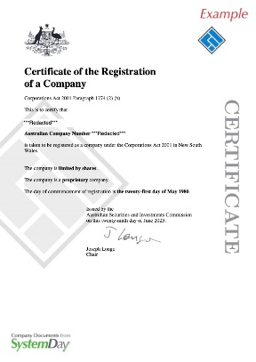

**EXAMPLE**

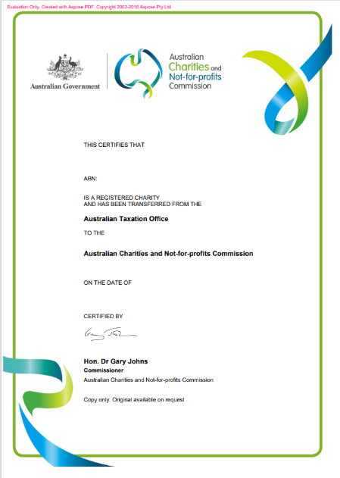

**EXAMPLE**

In the grant applications process, the submission of legal registration documentation is incredibly important. These documents serve as evidence of an organisation's legal status, confirming its legitimacy, compliance with regulatory requirements, and eligibility to receive funding. It is imperative that such documentation is current and relevant, reflecting the organisation's ongoing commitment to transparency and accountability.

Submitting up-to-date legal registration documentation ensures eligibility for funding and demonstrates an organisation's capacity to meet grant requirements.

Failure to provide valid documentation may result in delays, or your application being deemed ineligible to be considered for funding.

Common legal registration documents in Australia include:

## Financial documents

**Electronic Funds Transfer (EFT) and RCTI agreement forms**

The Department of Youth Justice and Victim Support grant application form requires applicants to complete accurate financial information via Electronic Funds Transfer (EFT) and RCTI agreement forms.

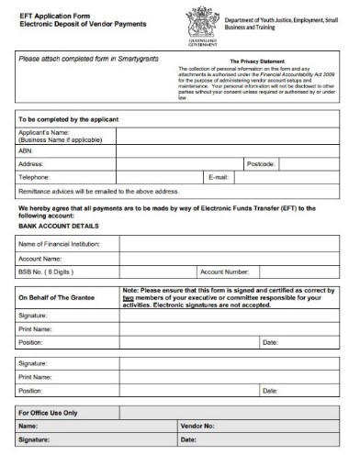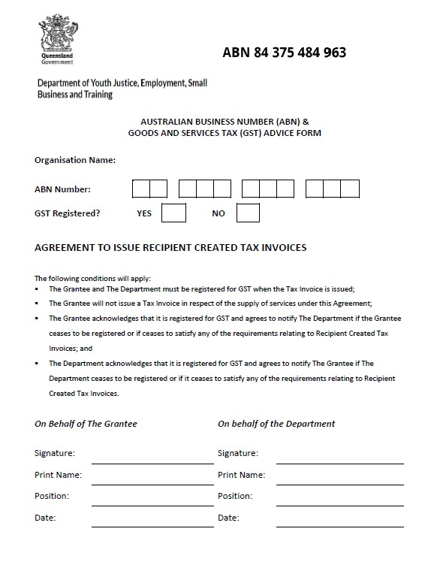

We ask for them as part of the application process so this information can be verified and actioned as soon as the grants outcome is determined. Accurate information is important to include in your application.

Please review the sections in red below, as they outline areas where errors are frequently encountered.

**Electronic Funds Transfer (EFT) Form**

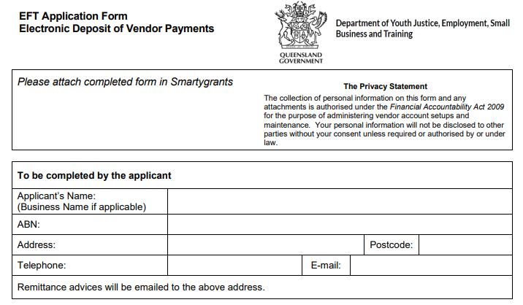

**- Applicant Name must be the same as Applicant Name you entered in your application. Name must align with the ABN you provided.**

**- ABN listed here must be the same as the ABN listed in your application.**

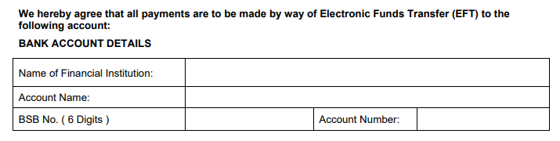

**- Bank account name must align with the Applicant Name.**

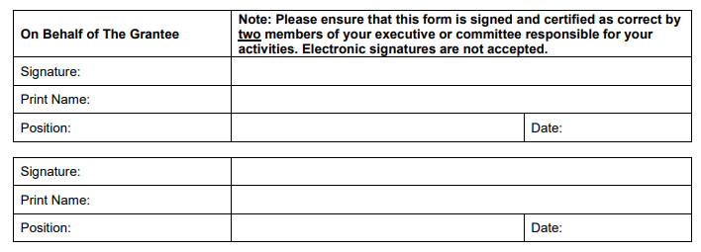

**- Document must be signed and certified by two members of your executive position or committee responsible for the activities (the Applicant).**

**- Please note that electronic signatures are not acceptable in this instance.**

**RCTI agreement form**

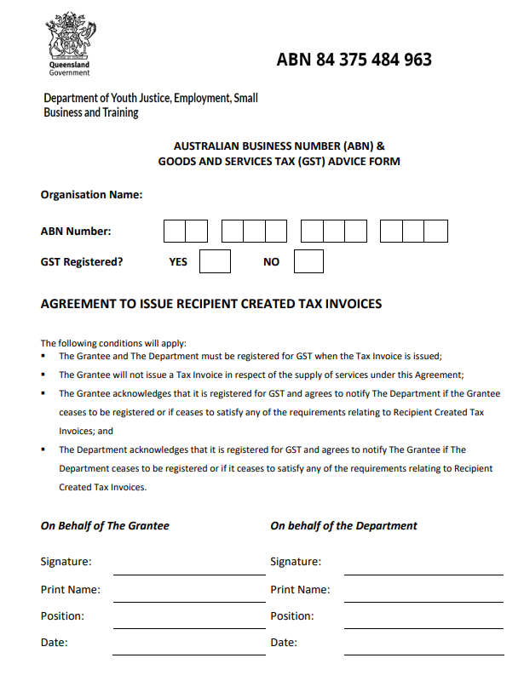

**- Name must match Applicant Name in SmartyGrants application**

**- ABN must match ABN supplied in application**

**- One box must be ticked**

**- Leave this section blank – to be completed by the Department**

**- Must be completed by the Applicant**