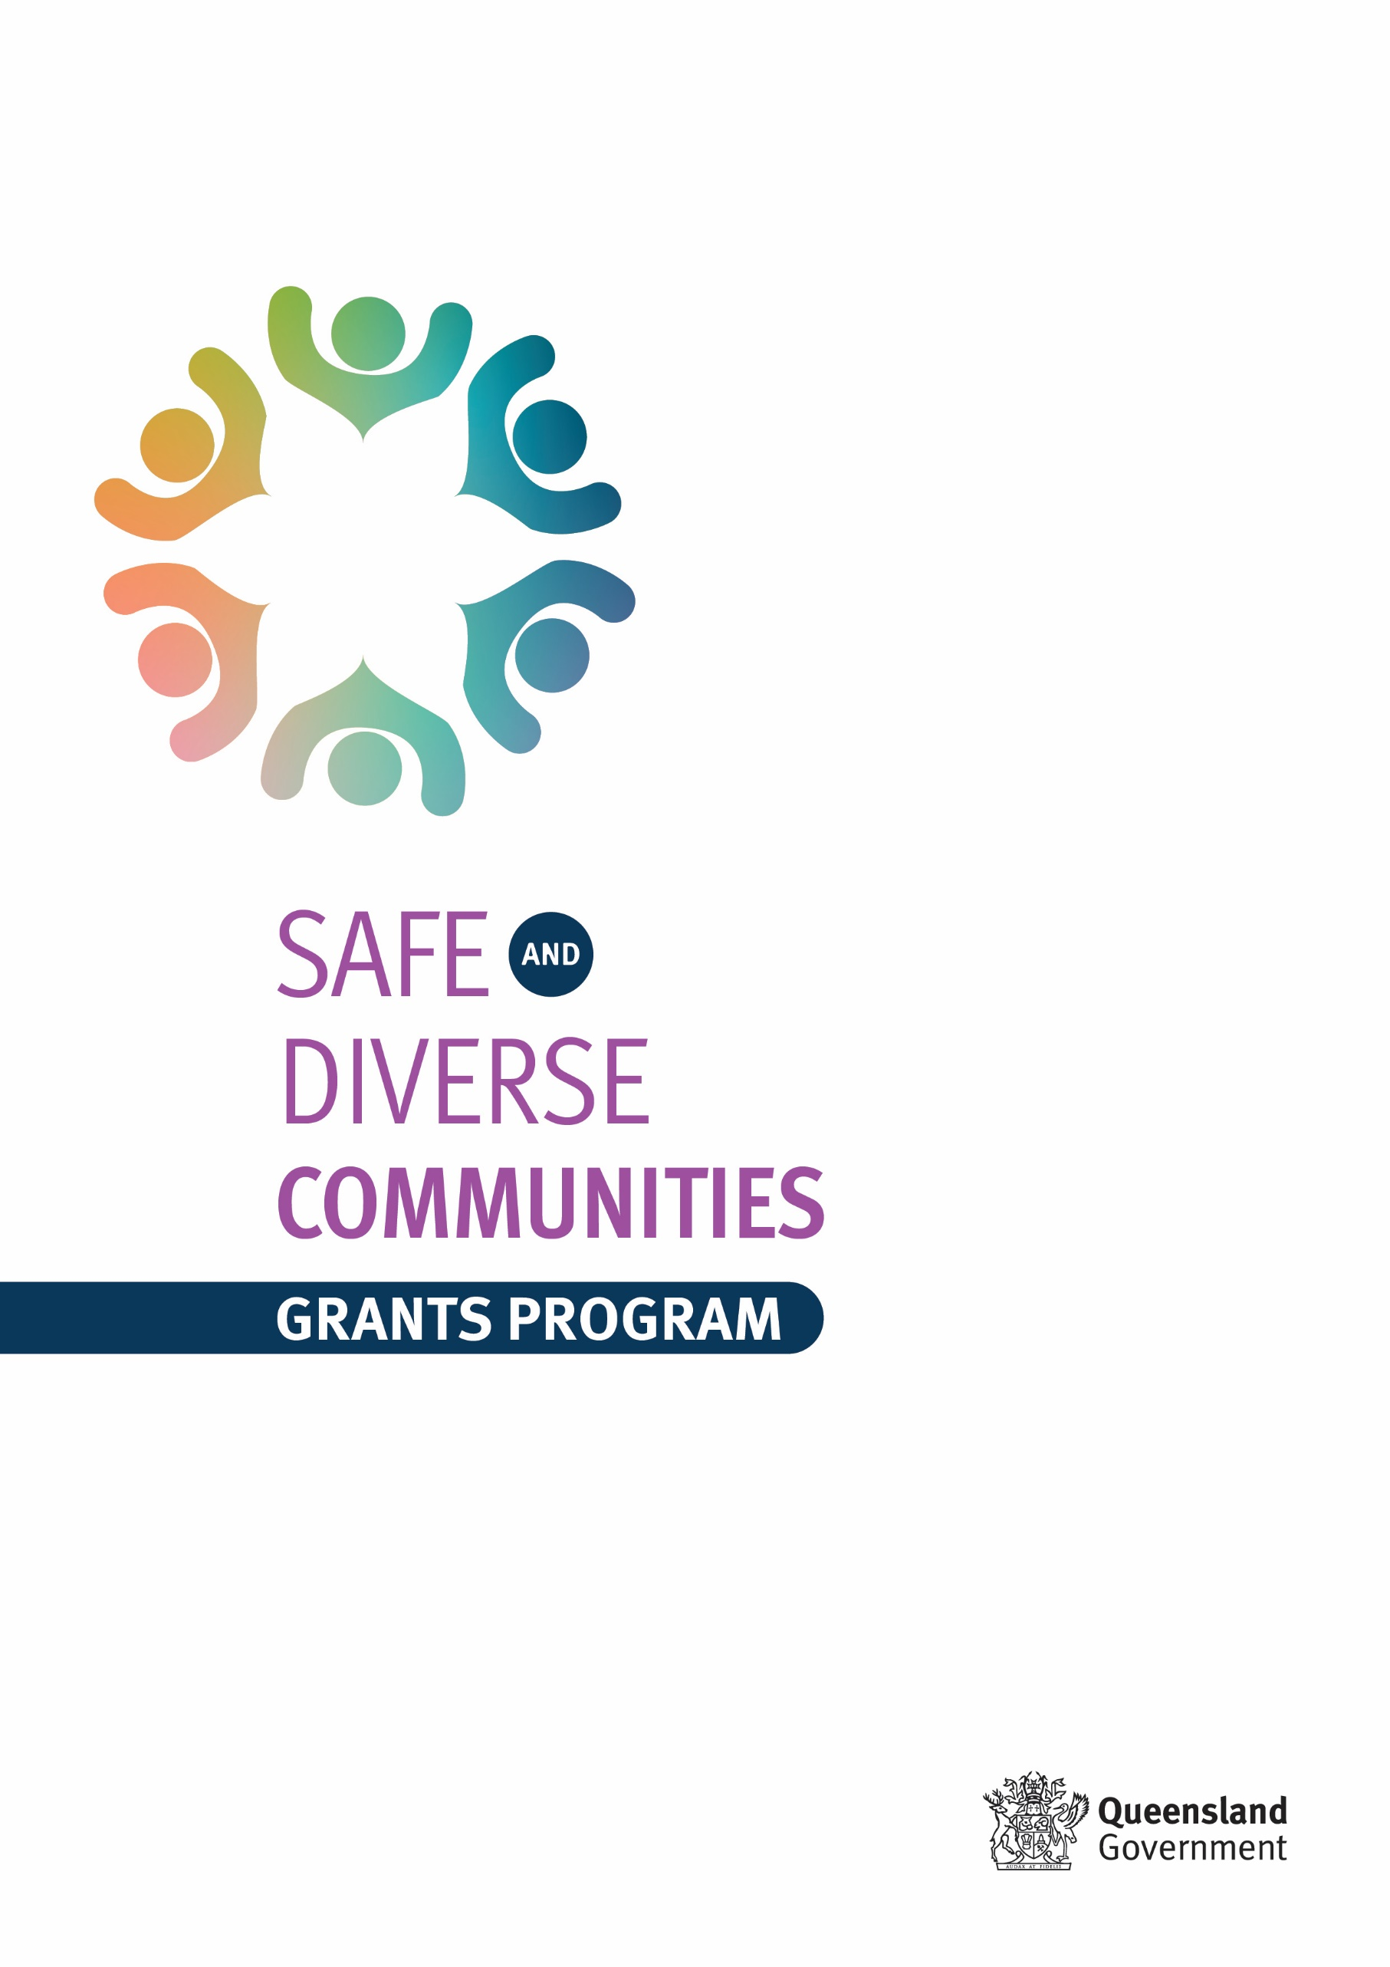**Frequently asked questions**

**Who can apply?**

Check the [Grant Information and Application Guidelines (PDF)](https://www.publications.qld.gov.au/dataset/safe-diverse-communities-grants/resource/95294833-53cc-4d7b-b806-dd4f093687e4) (or [DOCX](https://www.publications.qld.gov.au/dataset/safe-diverse-communities-grants/resource/d2c17e45-7b15-425d-9f41-0009dcd1e2d9)) to see if you are eligible for a grant.

**How do I apply?**

Applications are to be submitted through [SmartyGrants](https://justiceqld.smartygrants.com.au/SDC2023).

**What if I can’t access SmartyGrants to submit an application?**

Applications can only be submitted through [SmartyGrants](https://justiceqld.smartygrants.com.au/SDC2023).

For more information about applying online, you can read the [SmartyGrants – Help Guide for Applicants](https://applicanthelp.smartygrants.com.au/help-guide-for-applicants). If you need assistance with your SmartyGrants account, you can contact SmartyGrants Technical Support on (03) 9320 6888 or [service@smartygrants.com.au](mailto:service@smartygrants.com.au). Support desk hours are 9am to 5pm AEST, Monday to Friday.

**When do applications close?**

5:00pm on Friday, 15 March 2024.

**Can I submit a late application?**

No. Late applications will not be accepted.

SmartyGrants will automatically close at 5:00pm on the closing date and will not allow applications past this time. Please ensure you allow adequate time to submit your application. Applications and supporting documentation will not be accepted after this time to ensure fairness to all applicants.

**How much funding can I apply for?**

Eligible applicants can apply for grants of up to $25,000 and up to $150,000 (excluding GST).

**What if I have applied previously and been unsuccessful?**

Where eligibility criteria are met, we encourage previous applicants to reapply. The outcomes of previous rounds – whether an application was successful or unsuccessful – do not impact on the outcomes of current or future rounds.

**Do I need an ABN (Australian Business Number)?**

Yes, you are required to have an ABN. The ABN identifies your business to the government and shows evidence that you are a Queensland based organisation.

**What if my organisation is not a not-for-profit legal entity OR local government entity?**

If your organisation is **not** a not-for-profit legal entity OR local government entity (e.g. non-incorporated bodies, entities that operate under a parent ABN), you may wish to consider an **auspicing** arrangement. An auspicing arrangement is when a larger organisation partners with a smaller organisation to fund a grant activity or event, and accepts legal and financial responsibility for the grant.

The larger organisation is known as the **Auspicor** **/auspice organisation**. Your community group or organisation is known as the **Auspicee** or grant recipient. An auspice agreement provides an outline of the services and support the auspice organisation will contribute to the activity.

The **Auspicing** section of the grant application outlines what information is required where an auspice arrangement is taking place.

The applicant, or the organisation auspicing the grants application, must have the capacity to administer the grant in accordance with the grants reporting requirements.

**Can someone from the Safe and Diverse Communities Grants Team help me with my application?**

The Safe and Diverse Communities Grants Team can only provide general information and advice on completing your application. To maintain the fairness and integrity of the application process, applicants cannot be offered individual support or help with their applications.

**My organisation operates a number of outlets across the state. Is each outlet allowed to submit an application?**

Yes. A separate application can be submitted for each proposed project, however successful organisations will only be awarded one grant.

**What if I have numerous projects needing funding?**

Applications can be submitted for more than one project by the one organisation. A separate application will need to be prepared for each project. Any successful organisation will only be awarded one grant.

**Can grant funding be put towards staffing wages?**

Projects where more than 20 per cent of funds are allocated to administrative costs will not be funded, as outlined in the ‘What projects will not be funded’ section of the [Grant Information and Application Guidelines](https://www.publications.qld.gov.au/dataset/safe-diverse-communities-grants/resource/95294833-53cc-4d7b-b806-dd4f093687e4).

‘Administrative costs’ are defined in the grant guidelines as costs relating to the administration of your business/organisation. Some examples of administration costs would be someone employed to answer the phones, completing business as usual requests such as reporting or data collection. Within your grant application you are only allowed to allocate 20 per cent of your budget towards administrative costs.

**What if my project spans Northern NSW and Southern Queensland?**

The purpose of the grant is to help Queenslanders. If the benefit extends beyond Queensland, the applicant is encouraged to explain to what extent this will happen so panel members can assess whether this is an acceptable use of funds. Any projects that do not benefit Queenslanders as the primary beneficiaries will not be considered.

**Our organisation is looking at submitting a joint application with another organisation. Is this okay?**

Yes. A group of eligible organisations may submit a joint application for grants. Each submitted application, regardless of it being submitted by a group, partnership or single entity, is eligible for one grant. Where successful, the primary grant applicant would then be provided the funds for disbursement.

**What if our organisation does not have insurance?**

Organisations that do not have appropriate insurance are not eligible for a grant. As part of the terms and conditions of the grants, an organisation wishing to apply for grants must have the following current insurance policies in place:

* public liability for a sum of not less than $10 million per claim with an insurer authorised by the Australian Prudential Regulation Authority to operate in Australia.

**I am developing an activity that has some elements of domestic and family violence prevention but primarily focuses on other unrelated objectives. Can I apply?**

No. Where projects have a focus other than the objectives outlined in the guidelines, applications for grants from other available Queensland Government programs should be considered. The aim of this program is to fund activities that align with the Safe and Diverse Communities Grants objectives.

**I am developing a project that is aimed towards Aboriginal and/or Torres Strait Islander communities. Can I apply?**

No, applications for grants from other available Queensland Government programs should be considered in this case.

The Safe and Diverse Communities Grants program targets culturally and linguistically diverse communities including people from migrant or refugee backgrounds, as well as people who are born in Queensland who self-identify as ‘being from multicultural backgrounds’. This applies to groups and individuals who differ according to religion, language and ethnicity and whose ancestry is *other than* Aboriginal and/or Torres Strait Islander, Anglo Saxon or Anglo Celtic.

**Does this program support women and men impacted by domestic and family violence, or just women?**

The Safe and Diverse Communities Grants Program supports projects to better respond to domestic and family violence broadly within Queensland’s multicultural communities. Previous successful Grant recipients have included community organisations supporting both women and men affected by domestic and family violence. This includes initiatives aimed at supports for victim-survivors, as well as persons using violence.

**How do I complete the budget?**

A budget table has been provided as part of the application process. Use this to itemise the costs associated with your activity. This includes in-kind support. All budget amounts should be GST exclusive.

[How to write an effective grant proposal (PDF)](https://www.publications.qld.gov.au/dataset/safe-diverse-communities-grants/resource/438687ef-668a-4d11-a764-bcef410992f2) (or [DOCX](https://www.publications.qld.gov.au/dataset/safe-diverse-communities-grants/resource/22ed8ad9-59ff-4e79-bf22-6ca616dd4b61)) has more information about costs / budget.

**What is in-kind support?**

In-kind support is a contribution of a good or a service other than money. Examples include voluntary labour (volunteer time) and donated goods (bus/venue hire, recording equipment). Please provide an estimate of the financial value of the in-kind contribution.

**The word count for some sections on the online application are too short. Can I submit a longer answer?**

Unfortunately, no. Due to the expected high volume of applications we have limited certain free text fields.

**If the department was to contact us and request a copy of our most recent Audited Financial Statement, would it be required to be completed by a qualified auditor** **or would any Certified Practising Accountant or Chartered Accountant accreditation suffice?**

If requested, your most recent Audited Financial Statement would need to be certified by a qualified independent auditor.

**Will I receive acknowledgement of my application?**

Receipt of all applications will be acknowledged via email, so please ensure you provide a correct email address on your application form. If you do not receive an email acknowledgment within five (5) business days, it may mean that your application was not submitted. Please contact the Safe and Diverse Communities Grants Team via email at [SafeandDiverseGrantPrg@justice.qld.gov.au](mailto:SafeandDiverseGrantPrg@justice.qld.gov.au).

**How will my application be assessed?**

Eligible applications will be assessed as part of a process against how well the application aligns with the Safe and Diverse Communities Grants program objectives and the selection criteria.

**What are the selection criteria?**

The selection criteria are included in the Grant Information and Application Guidelines. There are five standard selection criteria for all applications, and one additional criterion for applications seeking the larger grant amount.

[How to write an effective grant proposal (PDF)](https://www.publications.qld.gov.au/dataset/safe-diverse-communities-grants/resource/438687ef-668a-4d11-a764-bcef410992f2) (or [DOCX](https://www.publications.qld.gov.au/dataset/safe-diverse-communities-grants/resource/22ed8ad9-59ff-4e79-bf22-6ca616dd4b61)) also outlines the selection criteria, and offers some additional guidance on addressing each one.

**When will I find out the outcome of my application?**

Grant applicants will be notified of the outcome of their application by 3 May 2024.

**What am I required to do if I am successful?**

You will be required to:

* enter into a funding agreement with the Queensland Government through the Department of Justice and Attorney-General
* deliver the event/activity/initiative/project as per your grant application and supporting documentation(s)
* acknowledge the Queensland Government’s support as stipulated in the funding agreement
* deliver on milestones as detailed in the funding agreement
* incorporate and display any logos, signage and merchandise provided by the Queensland Government
* liaise with the Safe and Diverse Communities Grants Team regarding the event/activity/initiative/project and any modifications that may be necessary
* provide a final report and images following the finalisation of the grant period
* participate in any review or evaluation of the grant program that may take place.

[What is expected of an organisation if they are successful in this grant program (PDF)](https://www.publications.qld.gov.au/dataset/safe-diverse-communities-grants/resource/da4ea203-758f-4926-a917-d74c398dda06) (or [DOCX](https://www.publications.qld.gov.au/dataset/safe-diverse-communities-grants/resource/18ed4eae-d227-401f-bf76-c16964708cb0)) has more information for what is expected of successful applicants.

**When does the money need to be spent by?**

Funds should be spent within 8 months of receiving the grant monies.

**Who do I contact for assistance?**

For more information, and/or translation services, please phone 1800 177 577. Or you could email the Safe and Diverse Communities Grants Team at [SafeandDiverseGrantPrg@justice.qld.gov.au](mailto:SafeandDiverseGrantPrg@justice.qld.gov.au).