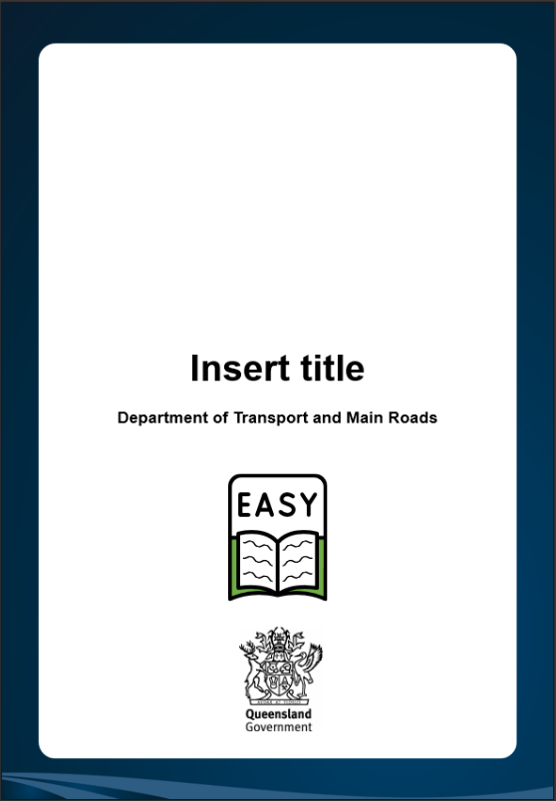tra



**Department of Transport and Main Roads**

**Internal Review of Complaints**

**About this book**

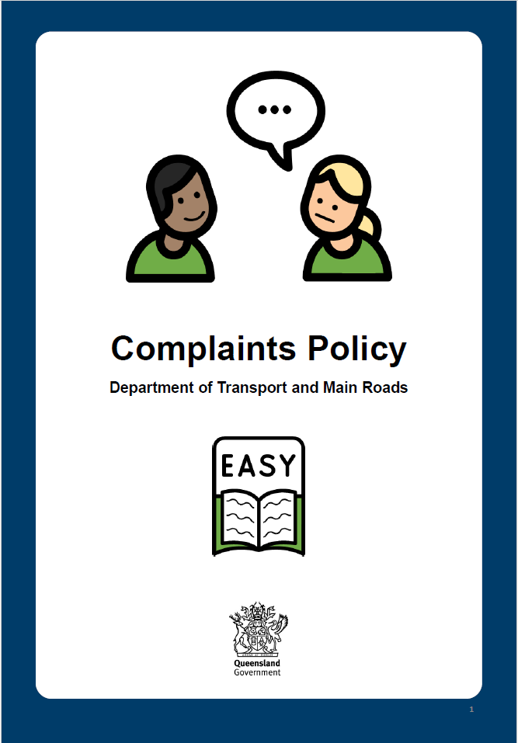





This book is the second book about the Transport and Main Roads complaints process.

The first book about the complaints process is the Easy Read Complaints Policy.

**A complaint means you are not happy about something and tell us.**

If you want to make a complaint, you can find help in the first book. You can find it on our

website under **contact-us/compliments-and-complaints**.

**What is an internal review?**







After receiving our response to your complaint, you might not feel that we have been fair.

If you are unhappy with the decision made in response to your complaint, you can request an Internal Review of this decision.

**An internal review asks someone else at TMR, of the same level or higher, to look at the result of your complaint.**

They will not investigate your complaint again.

They will check what happened with your complaint to see if the result was fair and the rules were followed.

**What should I do?**





You need to contact us within 20 days of us responding to your complaint. You can write or call the person who looked after your complaint.

When you contact us, tell us:

* Why you want to request an Internal Review
* Anything new about your complaint
* How the result has affected you
* What you would like done

**What will happen?**





We will contact you so that you know we are looking at your request.

We will internally review the response to your complaint.

We will contact you within 20 days to tell you the result of your Internal Review.

We will contact you if your Internal Review is going to take longer than 20 days.

**What if you are still unhappy?**







We only review a complaint once internally. If you are still unhappy with the result, there are two more groups you can contact.

These groups do external reviews.

**An external review means someone from outside TMR will check your complaint to see if it was handled correctly.**

The Queensland Ombudsman

* Telephone: **(07) 3005 7000** (during business hours)
* Web: **ombudsman.qld.gov.au**

The Queensland Human Rights Commission

* Telephone: **1300 130 670**
* Web: **qhrc.qld.gov.au**