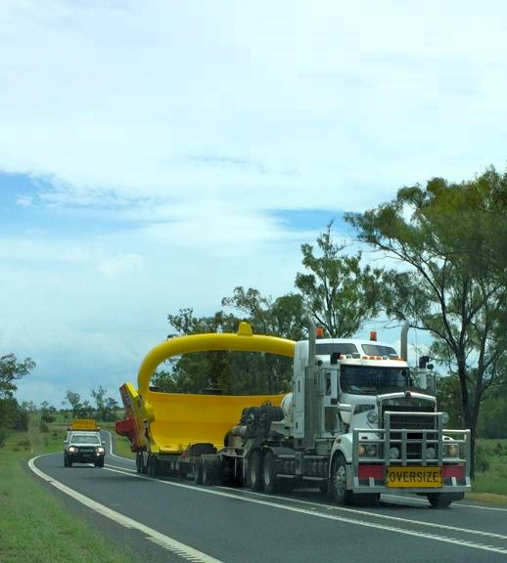



**Queensland Access Conditions Guide**

Version 6.0 | December 2023

Contents

Part 1 Introduction 3

1. Purpose 3

2. Policy statement 3

3. Date of commencement 3

4. Scope 3

Part 2 General conditions 4

5. Queensland maximum speed limits 4

6. General conditions of Schedule 8 Heavy Vehicle (Mass, Dimension and Loading) National Regulation 4

7. Permits 5

8. Chain of Responsibility 5

9. Queensland convoy operations 5

10. Road conditions/closures 5

10.1. Queensland Globe 5

10.2. Conditions of Operation Database 5

10.3. Bridge and culvert conditions 6

10.4. Temporary road conditions 6

11. Location, day, and time conditions 6

11.1. Restricted motorways, tunnels, and roads 6

11.2. City of Brisbane and other cities/towns peak hour time conditions 7

11.3. Queensland – southeast corner conditions 7

11.4. Burdekin River Bridge (Bruce Highway) conditions 8

11.5. Christmas conditions 8

11.6. Easter conditions 8

11.7. Cooper Basin Christmas and Easter holidays condition 9

12. Daytime travel pilot and escort conditions 9

12.1. Daytime travel general conditions 9

12.2. Period or specified route permits 11

13. Night travel conditions 11

13.1. Approved night travel 11

13.2. Night travel conditions for an oversize vehicle more than 3.1m in width or 25m in length 12

13.3. Permit conditions for night travel 12

14. Pilot and escort operational conditions 12

15. Contact details for Queensland Police Service 12

16. Rear-end steering requirement for vehicles longer than 30 metres other than a B-double or road train 13

Part 3 Schedules 14

Schedule 1 — Class 1 Special Purpose Vehicles 14

Schedule 1 exemptions to general conditions in Part 2 14

1. Location, day, and time conditions for SPVs 14

2. Exemption to Christmas and Easter holiday conditions 15

3. Tunnel access dimension, conditions, and conditions 15

Schedule 2 — Class 1 Special Purpose Combinations 16

Schedule 2 exemptions to general conditions in Part 2 16

1. Location, day, and time conditions for SPV combinations 16

Schedule 3 — Class 1 Load Carrying Vehicles 17

Schedule 3 exemptions to general conditions in Part 2 17

1. A prime mover towing a low loader or an extendable semitrailer up to 26m. 17

2. Peak hour conditions 17

3. Location, day, and time conditions for oversize vehicles 18

4. Between the Port of Brisbane or Mackay Ports and a Bond Store/Holding Yard Christmas and Easter holiday exemption 18

5. Transporting an eligible cotton harvester or associated equipment (Easter holiday) 19

6. Extended night travel times and pilot conditions 20

Schedule 4 – Class 3 oversize vehicles 21

Schedule 4 exemptions to general conditions in Part 2 21

1. Location, day, and time conditions for oversize vehicles 21

Schedule 5 — Oversize conditionally registered vehicles 22

Schedule 5 exemptions to General conditions in Part 2 22

1. Travel Conditions 22

Appendix A — Bond Stores/Holding Yards and Bulk Terminal Wharfs 23

Appendix B — Cooper Basin Region Map 25

Appendix C — Cotton Harvest Zones Map 26

Appendix D — Port of Brisbane roads 27

Definitions 28

Version Control Table 30

# Part 1 Introduction

## Purpose

The purpose of the Queensland Access Conditions Guide (the Guide) is to provide specific access conditions for the movement of oversize heavy vehicles (over 4.5 tonnes) operating under a notice or permit in Queensland. For example, access conditions relating to a time-of-day, route, network, and location.

## Policy statement

This Guide is an approved guide for the purposes of sections 118, 119 and 122 of the [Heavy Vehicle National Law](https://www.legislation.qld.gov.au/view/whole/html/inforce/current/act-2012-hvnlq) (HVNL) and failure to comply with these conditions are enforceable under the HVNL.

## Date of commencement

Version 6.0 of this Guide commences on **11 December 2023**. It revokes and replaces Version 5.1.

## Scope

This Guide applies to oversize heavy vehicles (other than agricultural vehicles or combinations) operating on public roads in Queensland. The Guide contains three parts and consists of:

* Part 1 Introduction
* Part 2 General conditions apply to oversize vehicles unless permitted otherwise by a notice, permit, or a schedule in Part 3 of this Guide. In the event of a contradiction between a general condition (Part 2), or a schedule in Part 3 of this Guide, the schedule conditions (Part 3) will apply.
* Part 3 - Schedules 1-5 apply exemptions to general conditions in Part 2 to vehicles under the following notices and permits:
  + Schedule 1 – Special Purpose Vehicles (SPVs) under the [National Class 1 Special Purpose Vehicle (up to 40t total mass) Mass and Dimension Notice](https://www.nhvr.gov.au/C2021G00652) or a crane up to 3.5m in width operating under permit issued by the NHVR.
  + Schedule 2 – Special purpose combinations under the Queensland [Class 1 Special Purpose Combination Mass and Dimension Exemption Notice](https://www.legislation.gov.au/Details/C2019G00066).
  + Schedule 3 – Load carrying vehicles under the [Multi-State Class 1 Load Carrying Vehicle Dimension Exemption Notice](https://www.legislation.gov.au/Details/C2022G00120)
  + Schedule 4 – Class 3 oversize vehicles (large indivisible items) under the [Queensland Class 3 B-Double and Road Train (Carriage of Large Indivisible Items) Dimension Exemption Notice](https://www.nhvr.gov.au/C2022G01054) and the [Queensland Class 3 Truck and Dog Trailer (exceeding 19m up to 31.5m in length) Mass and Dimension Exemption Notice](https://www.nhvr.gov.au/C2022G01151)
  + Schedule 5 — Oversize conditionally registered vehicles travelling to or from un-programmed operations.

This Guide does not exempt an operator from obtaining any permit, or other authority, or complying with the provisions of any other law if required.

All vehicles must have current registration or be operating under an authorisation issued under the [Transport Operations (Road Use Management — Vehicle Registration) Regulation 2021](https://www.legislation.qld.gov.au/view/html/inforce/current/sl-2021-0113) or a correspondence registration law of another jurisdiction.

# Part 2 General conditions

## Queensland maximum speed limits

The maximum speed limit applying to an oversize vehicle in Queensland is shown in Table 1.

Table Maximum speed limits for oversize vehicles in Queensland

|  |  |
| --- | --- |
| **Oversize vehicle description** | **Maximum speed limit** |
| Articulated steering crane. | 80km/h |
| A vehicle required to travel with a pilot or escort. | 80km/h |
| A vehicle not required to travel with a pilot or escort. | 90km/h |

Operators must comply with the lesser applicable speed limit of either the posted speed limit, manufacturer ratings or the specified speed in this Table 1.

## General conditions of Schedule 8 Heavy Vehicle (Mass, Dimension and Loading) National Regulation

An oversize vehicle must comply with all the conditions of schedule 8 of the Heavy Vehicle (Mass, Dimension and Loading) National Regulation (MDL Regulation). Refer to the National Heavy Vehicle Regulator (NHVR) for more information on [Schedule 8 - Conditions applying to class 1 heavy vehicles](https://www.nhvr.gov.au/schedule-8).

General conditions under schedule 8 include:

* smallest practical dimension
* warning headlights, delineators, signs, and flags
* headlights
* night travel
* no travelling if low visibility
* minimum following distance
* allowing overtaking
* assessing routes
* third party approvals
* communication equipment
* towing a low loader dolly with an unladen low loader.

## Permits

The NHVR manages road access applications (permits) for heavy vehicle journeys. Permits can include operating conditions and pilot and escort conditions. A copy of the permit must be carried in the vehicle, and produced when requested by an authorised officer, police officer, pilot, or escort. For more information on permits, see the [NHVR Road Access webpage](https://www.nhvr.gov.au/road-access/mass-dimension-and-loading/loading).

## Chain of Responsibility

The Chain of Responsibility (CoR) ensures everyone who works with heavy vehicles – from the business that employs a driver or owns a vehicle, to the business that sends or receives goods, is accountable for safety of the heavy vehicle, its driver, and its load throughout the journey. To learn more about your CoR obligations refer to the [NHVR Chain of Responsibility webpage](https://tmrqld.sharepoint.com/teams/HVPolicySection/Shared%20Documents/Road%20Manager%20Policy/Publication%20Folder/1.%20Access%20Conditions%20Guide_ApprovedandHistoricDocuments/Access%20Conditions%20Guideline%20versions/Version%206.0%20working%20draft/NHVR%20Chain%20of%20Responsibility%20webpage).

## Queensland convoy operations

Oversize vehicles are not permitted to operate in convoy formation. An oversize vehicle must drive 200m behind another oversize vehicle unless on a multi-lane road or a road in a built-up area.

In special circumstances convoy travel may be approved via a NHVR permit application, subject to risk evaluation and available resources.

## Road conditions/closures

### Queensland Globe

The Queensland Globe is an online interactive mapping tool for Queensland. It provides drivers and operators the ability to view which roads are state-controlled, and which roads are defined as Critical or Major. To learn more about Queensland Globe refer to <https://qldglobe.information.qld.gov.au>.

### Conditions of Operation Database

The TMR [Conditions of Operation Database](https://www.tmr.qld.gov.au/business-industry/Heavy-vehicles/Queensland-excess-mass-and-dimension-conditions#_Conditions_of_Operation) lists the changes and updates to road conditions in Queensland. You are required to check the Conditions of Operation Database before commencing your journey for additional conditions.

A driver can present either hard copy or electronic form to an authorised officer for routes/roads being used. Electronic documents must be presented on a device with a visual display that enables an authorised officer to read and understand all elements of the document, without the authorised officer having to enter the vehicle. Both the operator and driver are responsible for checking the Conditions of Operation Database before any trip.

### Bridge and culvert conditions

The TMR [Bridge and culvert restrictions webpage](https://www.tmr.qld.gov.au/business-industry/heavy-vehicles/bridge-and-culvert-restrictions) can help you quickly identify bridge and culvert restrictions. These resources are updated regularly, and it is your responsibility to ensure you are up to date with the current list of bridge and culvert restrictions that apply to your vehicle type. The vehicle must not travel on a restricted structure identified in the network category for the vehicle type in Table 2. [Subscribe to receive bridge and culvert restriction changes](https://www.vision6.com.au/em/forms/subscribe.php?db=502232&s=219270&a=84280&k=r3LaziAsySOi3Yss406dBQH51lxHUZ4xLdRI2WO0sEc).

Table 2 Bridge and culvert conditions

|  |  |  |
| --- | --- | --- |
| Vehicle description | Mass limit | Network conditions map |
| Two-axle prescribed SPV, or Two-axle articulated steering crane | With a mass more than 10(t) on one or more axles | [Two-axle prescribed SPV and two-axle articulated steering crane map](https://www.tmr.qld.gov.au/business-industry/Heavy-vehicles/Bridge-and-culvert-restrictions#2axle) |
| Three-axle articulated steering crane | N/A | [Three-axle articulated steering crane map](https://www.tmr.qld.gov.au/business-industry/Heavy-vehicles/Bridge-and-culvert-restrictions#3axle) |
| Category 1 Special Purpose Vehicle | N/A | [Category 1 (IAP) special purpose vehicles](https://www.tmr.qld.gov.au/business-industry/heavy-vehicles/bridge-and-culvert-restrictions#class1) |
| Category 2 Special Purpose Vehicle | N/A | [Category 2 (IAP) special purpose vehicles](https://www.tmr.qld.gov.au/business-industry/heavy-vehicles/bridge-and-culvert-restrictions#class2) |

### Temporary road conditions

Oversize movements can be affected by temporary road closures or mass conditions. The driver and operator of an oversize vehicle must be aware of, and comply with, any temporary road closure or conditions for the proposed time of travel. Temporary conditions are available on the [QLD Traffic website](https://qldtraffic.qld.gov.au/), or by downloading the QLD Traffic app or by contacting 13 19 40. The [QLD Traffic website](https://qldtraffic.qld.gov.au/) will list the road conditions until the road condition is removed by the road manager.

## Location, day, and time conditions

### Restricted motorways, tunnels, and roads

An oversize vehicle is not permitted on the following roads:

* Pacific Motorway (South-east Freeway & Riverside Expressway) north of the Gateway Arterial Road intersection, or
* Western Arterial Road from Mount Coot-tha Road and Milton Road roundabout, Toowong to Stafford Road, Everton Park. Including: (Frederick Street, Rouen Road, Boundary Road, Kaye Street, MacGregor Terrace, Jubilee Terrace, Elimatta Drive, Stewart Road, Wardell Street, South Pine Road), or
* Airport Link Tunnel, or
* Legacy Way Tunnel, or
* Clem7 (North-South bypass) Tunnel

### City of Brisbane and other cities/towns peak hour time conditions

An oversize vehicle described in Table 3 must **not be driven** in a location on a day and time in Table 3.

Table Peak hour time conditions

|  |  |  |  |
| --- | --- | --- | --- |
| Description of oversize vehicle | Location | Day | Time |
| Any oversize vehicle | * Brisbane City Council, * Gold Coast City Council, or * The CBD of any other city | On a business day | Between the hours of:   * 7am and 9am, and * 4pm and 6pm. |
| more than   * 3.5m in width, or * 25m in length. | Brisbane Central Traffic Area | On a business day | Between the hours of:   * 7am and 6pm. |
| more than   * 4.5m in width, or * 30m in length. | Brisbane City Council | On a business day | Between the hours of:   * 9am and 4pm. |

Note: Location meanings are defined in the definitions of this Guide.

### Queensland – southeast corner conditions

An oversize vehicle identified in Table 4 **must not be driven** within the southeast corner on a day and time specified in Table 4.

Table Queensland southeast day and time of conditions

|  |  |  |
| --- | --- | --- |
| Description of oversize vehicle | Day | Time |
| more than   * 3.1m in width, or * 25m in length. | Saturdays, Sundays, and statewide public holidays, including a day on a statewide long weekend. | Between the hours of:   * 7am and sunset of the day. |
| more than   * 3.1m in width, or * 25m in length. | The day prior to a statewide long weekend. | Between the hours of:   * 12pm (midday) and sunset. |

Note: Christmas holiday conditions (section 11.5) and Easter holiday conditions (section 11.6) supersede Table 4 conditions.

### Burdekin River Bridge (Bruce Highway) conditions

#### Burdekin River Bridge (Bruce Highway), day, and time conditions

The Burdekin River Bridge (Bruce Highway) must not be crossed by any oversize vehicle during the day and time shown in Table 5.

Table Burdekin River Bridge (Bruce Highway), day, and time conditions

|  |  |
| --- | --- |
| Day | Time |
| Monday to Friday | Between the hours of:   * 7:30am to 9:00 am, and * 3:00 pm to 4:30pm |

Note: An oversize vehicle can travel on the Burdekin River Bridge (Bruce Highway) outside the day and times listed in Table 5, provided they comply with access conditions in the Queensland excess mass and dimension [Conditions of Operation Database](https://www.tmr.qld.gov.au/business-industry/heavy-vehicles/queensland-excess-mass-and-dimension-conditions#_Conditions_of_Operation).

### Christmas conditions

An oversize vehicle **must not be driven** on a road during the Christmas holiday described in Table 6.

Table Christmas conditions

|  |  |
| --- | --- |
| Type of oversize vehicles | Day and time |
| An oversize vehicle that requires more than one pilot or escort vehicle. | From 12:01am 19 December  To 11:59pm 2 January the following year** |
| Any oversize vehicles. | From 12:01am 24 December*  To 11:59pm 2 January the following year** |

*When Christmas day falls on a Sunday or a Monday, the Christmas holiday will commence on the Friday before Christmas day from 12:00pm.

**When New Year's Day (1 January) falls on a Friday, the Christmas holiday is extended to 11:59pm the 3 January that year.

### Easter conditions

An oversize **must not be driven** on a road during the Easter holiday described in Table 7.

Table Easter conditions

|  |  |
| --- | --- |
| Type of oversize vehicles | Day and time |
| Any oversize vehicle | From 12:01am the Thursday before Easter Sunday.  To 11:59pm the Tuesday after Easter Sunday. |

### Cooper Basin Christmas and Easter holidays condition

An oversize vehicle can be driven in a location described in Table 8 during the Christmas and Easter holidays when complying with the conditions in Table 8.

Table Cooper Basin Christmas and Easter holiday travel conditions

|  |  |  |
| --- | --- | --- |
| Location | Day | Conditions |
| Cooper Basin (within the QLD border) as mapped in Appendix B. | Any day or time | Travel must be directly involved with, or in support of, Liquefied Natural Gas or mining activities. |

## Daytime travel pilot and escort conditions

### Daytime travel general conditions

Pilot and escort conditions are determined by the length and width of an oversize vehicle and the road (or area) of travel.

The following tables provide the minimum pilot and escort conditions on a critical road or area (Table 9), major roads (Table 10) and roads not identified as major or critical roads (Table 11).

Table Daylight pilot conditions for critical roads and areas

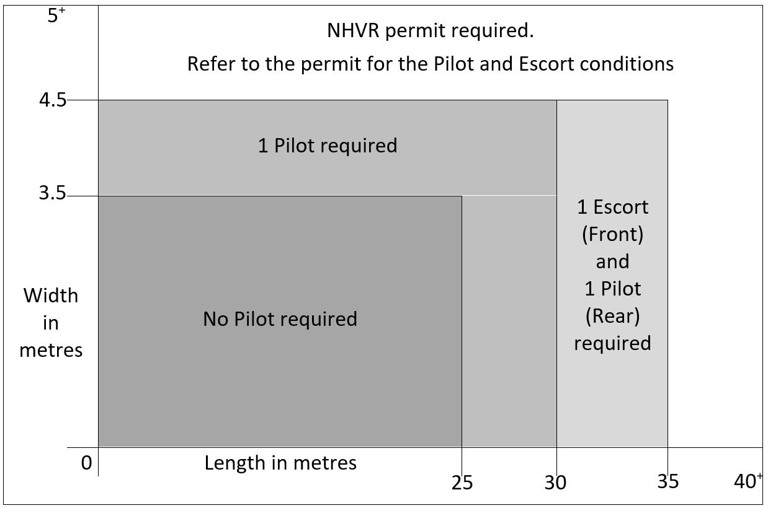

Table Daytime pilot conditions for major roads

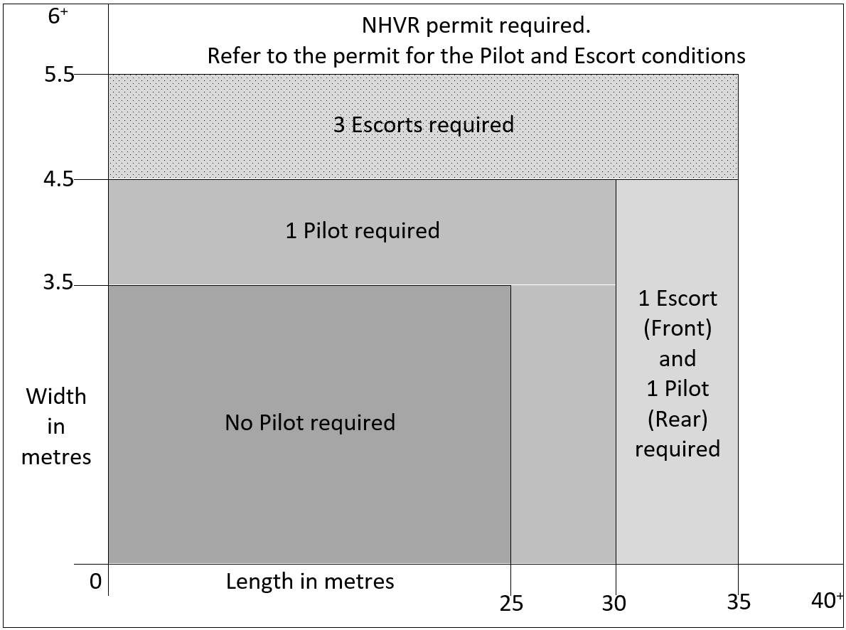

Table Daytime piloting conditions for roads not identified in a critical area or on a critical or major road

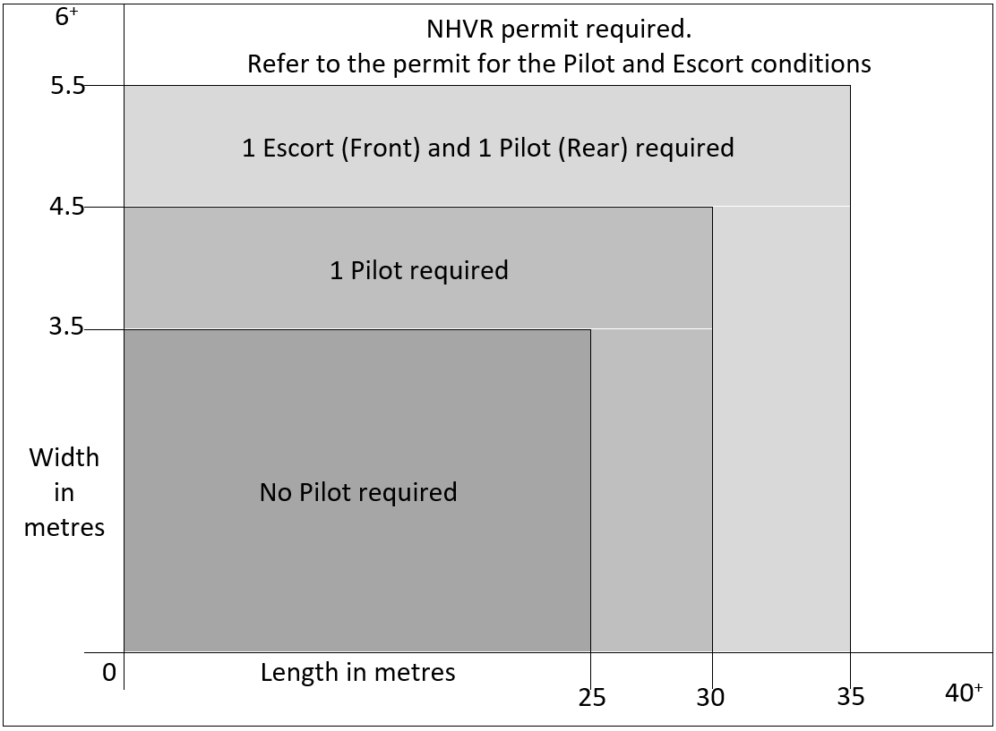

### Period or specified route permits

Table 12 specifies the dimensions when a vehicle requires a permit. An operator must obtain, carry, and comply with a current NHVR permit before travel. For more information on applying for a permit visit the [NHVR Road Access webpage](https://www.nhvr.gov.au/road-access/mass-dimension-and-loading/loading).

Table Dimension for oversize vehicle requiring a permit

|  |  |  |
| --- | --- | --- |
| Description of oversize vehicle | Road or area | Conditions |
| An oversize vehicle more than:   * 4.5m in width, or * 35m in length, or * 5.0m in height. | Critical areas, and critical roads. | Subject to permit conditions |
| An oversize vehicle more than:   * 5.5m in width, or * 35m in length, or * 5.0m in height. | Any road or area other than in a critical area or on a critical road. | Subject to permit conditions |

Note: To view critical areas, critical roads and major roads refer to the Critical Road Network layer of Queensland Globe.

## Night travel conditions

### Approved night travel

Table 13 provides the maximum vehicle dimensions approved for night travel at any location, unless conditioned otherwise by a notice, permit or schedule of this Guide.

Table Night travel for oversize vehicles

|  |  |
| --- | --- |
| Description of oversize vehicle | Maximum dimension for night travel |
| An oversize vehicle that is a   * B-double, or * road train or * a truck and dog combination exceeding 19m up to 31.5m in length. | is not permitted to travel at night. |
| Rigid truck or truck and dog combination | * 3.1m in width, and * 12.5m in length. |
| Rigid truck and trailer combination | * 3.1m in width, and * 19m in length. |
| A prime mover towing a semitrailer | * 3.1m in width or * 25m in length. |

Note: Conditions in this Table 13 are general conditions and an oversize vehicle may be conditioned otherwise by a notice, permit or schedule of this Guide.

### Night travel conditions for an oversize vehicle more than 3.1m in width or 25m in length

An oversize vehicle more than 3.1m in width or 25m in length can travel at a time in and location in Table 14 when complying with the conditions.

Table night travel considerations for oversize vehicles more than 3.1m in width or 25m in length

|  |  |  |  |
| --- | --- | --- | --- |
| Location | Time | Eligible Vehicle | Conditions |
| Any location in Queensland. | Permitted to travel up to 7pm. | Any oversize vehicle. | * The journey commences in daytime, and * The journey commences in daytime, and * The journey being undertaken can be completed by 7pm, and * The driver, the lead pilot or escort driver considers it would be safe, having regard to road and traffic conditions, and would not unreasonably inconvenience the public. |
| In the boundary of Brisbane City Council Area or within the boundary of a town or city listed under the critical areas. | Permitted to begin travel from 12:01am. | * An oversize crane up to 3.5m in width, or * Any other oversize vehicle | * The driver, lead pilot or escort vehicle driver considers it necessary to complete a journey being undertaken on that day and the vehicle leaves the city boundary by 7am. * An oversize vehicle (other than a crane) must be escorted by:   + At least two pilot or escort vehicles: one driving in front, and one driving behind, or   + If the oversize vehicle requires more than two pilots or escorts during daytime travel, the travel must comply with daytime pilot and escort conditions. |

### Permit conditions for night travel

An oversize vehicle not complying with Table 13 or Table 14 is not eligible to travel at night unless a notice or permit states otherwise. The permit will specify the required number of pilots and/or escorts and/or police and any additional specific operating conditions.

## Pilot and escort operational conditions

All pilot/escort vehicles and operations must comply with the conditions of the [Safe Movement Guideline, Pilot and Escort Operations in Queensland](https://www.publications.qld.gov.au/ckan-publications-attachments-prod/resources/8af8f3a7-f503-407f-9535-007f1df3d3c3/safe-movement-guideline-pilot-and-escort-vehicles_version-4.1.pdf?ETag=a3fae11720bc0389281a83f6206c64af) and schedule 8, Division 5 of the MDL Regulation.

## Contact details for Queensland Police Service

For enquires relating to [Police escorts](https://www.police.qld.gov.au/units/police-wide-load-escorts), contact QPS by email [HVROPO@police.qld.gov.au](mailto:HVROPO@police.qld.gov.au) or phone 1300 077 020.

## Rear-end steering requirement for vehicles longer than 30 metres other than a B-double or road train

An oversize vehicle other than a B-double or road train that is longer than 30m must be fitted with rear-end steering.

# Part 3 Schedules

## Schedule 1 — Class 1 Special Purpose Vehicles

This schedule provides specific conditions in relation to:

1. SPVs operating under the National [Class 1 Special Purpose Vehicle (up to 40t total mass) Mass and Dimension Exemption Notice](https://www.nhvr.gov.au/C2021G00652), or
2. SPVs complying with the mass and dimensions limits in (1) and operating under a permit issued by the NHVR.
3. SPVs up to 3.5m in width operating under a permit issued by the NHVR.

## Schedule 1 exemptions to general conditions in Part 2

### Location, day, and time conditions for SPVs

A SPV described in Table 15 can be driven in a location on the specified day and time when complying with the conditions in Table 15.

Table Location, day, and time conditions for SPVs

|  |  |  |  |
| --- | --- | --- | --- |
| Description of SPV | Location | Day | Time and conditions |
| Any SPV | A PoB road in Appendix D — Port of Brisbane roads Table 25. | Any day. | Any time (including Christmas and Easter Holidays). |
| A SPV less than 3.5m in width. | * Brisbane City Council, * Gold Coast City Council, or * the CBD of any other city. | On business day. | Between the hours of:   * 7am and 9am, and * 4pm and 6pm, and * the vehicle is travelling to or from a job site. |
| A SPV more than 3.1m up to 3.5m in width. | Southeast corner, except roads within the Brisbane Central Business Traffic Area and Brisbane Urban Corridor. | Saturdays, Sundays, and statewide public holidays. | Between the hours of:   * sunrise and 10am. |
| A SPV more than 3.1m up to 3.5m in width. | Toowoomba to Rocklea via Warrego Hwy, Ipswich Mwy or Toowoomba Connection Road (including a radius of 500m from Ipswich Road Rocklea). | Saturday or a public holiday | Between the hours of:   * 10am and sunset. |
| A SPV more than 3.1m up to 3.5m in width. | Toowoomba to Rocklea via Warrego Hwy, Ipswich Mwy or Toowoomba Connection Road (including a radius of 500m from Ipswich Road Rocklea). | Sundays. | Between the hours of:   * 10am and 4pm. |

Note: Conditions in Table 15 do not apply if conditioned otherwise by a notice, permit or Guide.

Heavy vehicle conditions apply to the Toowoomba bypass, refer to the TMR website for more information on the [Toowoomba Bypass](https://www.tmr.qld.gov.au/business-industry/Heavy-vehicles/Heavy-vehicle-route-maps-and-restrictions/Toowoomba-Bypass).

### Exemption to Christmas and Easter holiday conditions

Christmas and Easter holiday conditions do not apply to:

1. SPVs operating under a permit (up to 3.5m in width) that references the Queensland Access Conditions Guide, or
2. an eligible SPV of the [National Class 1 Special Purpose Vehicle (up to 40t total mass) Mass and Dimension Exemption Notice](https://www.nhvr.gov.au/C2021G00652) (under Notice or Permit).

All other SPVs, must comply with the general condition in section 11.5 Christmas holiday conditions and section 11.6 Easter holiday conditions.

### Tunnel access dimension, conditions, and conditions

An SPV can travel in Queensland tunnels if it complies with conditions in Table 16.

Table SPV tunnel conditions

|  |  |
| --- | --- |
| Maximum dimension | Conditions |
| * 2.9m in width * 14.5m in length * 5.5m forward projection | 1. An SPV with a forward projection exceeding 3.5 metres, must be fitted with a tether that meets all the following conditions:   * Be yellow and red in colour; and   Be manufactured to a standard outlined in the current version of AS 4497-1997; and * Be fitted from either of the travelling lugs of the boom to a lug at the front of the crane carrier as per the Crane Industry Council of Australia (CICA) Tether Fitting Instructions Information Sheet (which is available on the CICA website); and * Must not obscure the visibility of the mobile crane’s number plate.   2. No SPV access on the South-East Freeway   * Exiting the Clem7 tunnel (Southbound) must use the Ipswich Road exit only. |

## Schedule 2 — Class 1 Special Purpose Combinations

This schedule provides specific conditions in relation to:

1. SPV combinations operating under the [Queensland Class 1 Special Purpose Combination Mass & Dimension Exemption Notice](https://www.legislation.gov.au/Details/C2019G00066), or
2. SPV combinations complying with the mass and dimensions limits in (1) and operating under a permit issued by the NHVR.

## Schedule 2 exemptions to general conditions in Part 2

### Location, day, and time conditions for SPV combinations

A SPV combination described in Table 17 can be driven in a location on the specified day and time when complying with the conditions of Table 17.

Table Location, day, and time conditions for SPV combinations

|  |  |  |  |
| --- | --- | --- | --- |
| Description of SPV | Location | Day | Time |
| Any SPV combination | A PoB road in Appendix D — Port of Brisbane roads Table 25. | Any day. | Any time (including Christmas and Easter Holidays). |
| A SPV combination more than 3.1m but less than 3.5m in width. | Southeast corner, except roads within the Brisbane Central Traffic Area and Brisbane Urban Corridor. | Saturdays, Sundays, and statewide public holidays. | Between the hours of:   * Sunrise and 10am. |
| A SPV combination more than 3.1m but less than 3.5m in width. | Toowoomba to Rocklea via Warrego Hwy, Ipswich Mwy or Toowoomba Connection Road (including a radius of 500m from Ipswich Road Rocklea). | Saturday or a public holiday. | Between the hours of:   * 10am and sunset. |
| A SPV combination more than 3.1m but less than 3.5m in width. | Toowoomba to Rocklea via Warrego Hwy, Ipswich Mwy or Toowoomba Connection Road (including a radius of 500m from Ipswich Road Rocklea). | Sundays. | Between the hours of:   * 10am and 4pm. |

Note: Conditions in Table 17 do not apply if conditioned otherwise by a notice or a permit.

Heavy vehicle conditions apply to the Toowoomba bypass, refer to the TMR website for more information on the [Toowoomba Bypass](https://www.tmr.qld.gov.au/business-industry/Heavy-vehicles/Heavy-vehicle-route-maps-and-restrictions/Toowoomba-Bypass).

## Schedule 3 — Class 1 Load Carrying Vehicles

This schedule provides specific conditions in relation to oversize vehicles:

1. operating under the [Multi-State Class 1 Load Carrying Vehicle Dimension Exemption Notice](https://www.legislation.gov.au/Details/C2020G00352), or
2. complying with the mass and dimensions limits in (1) and operating under a permit by the NHVR.

## Schedule 3 exemptions to general conditions in Part 2

### A prime mover towing a low loader or an extendable semitrailer up to 26m.

Under Schedule 3, a prime mover towing a low loader or an extendable semitrailer (with/without a low loader dolly), up to 26m in length, is permitted to operate on the B-double or road train networks as though the eligible vehicle were 25m in length.

### Peak hour conditions

An oversize vehicle can operate during peak hour times when complying with the conditions in Table 18.

Table Peak hour conditions for oversize vehicles

|  |  |  |
| --- | --- | --- |
| Description of oversize vehicle | Location | Day |
| Any vehicle | A PoB road in Appendix D — Port of Brisbane roads in Table 25. | Any day |
| An oversize vehicle up to 4.5m in width and 25m in length. | Additional roads in the PoB in Appendix D — Port of Brisbane roads in Table 26. | On a business day. |
| An oversize vehicle up to 2.5m in width and 25m long | When operating on the approved B-double network. | On a business day |
| An oversize vehicle up to 3.2m in width and 25m long | When operating on the approved road train network. | On a business day |

Note: Table 18 provides exemption to the general peak hour conditions in General Peak Hour conditions in Table 3.

### Location, day, and time conditions for oversize vehicles

An eligible oversize vehicle can be driven in a location and a day shown in Table 19, when complying with the conditions of travel.

Table Location, day, and time conditions for oversize vehicles

|  |  |  |  |
| --- | --- | --- | --- |
| Location | Dimension | Day | Time |
| Southeast corner, except roads within the Brisbane Central Business Traffic Area and Brisbane Urban Corridor | * more than 3.1m but less than 4.5m in width, or * more than 25m but less than 30m in length. | Saturdays, Sundays, statewide public holidays and on each day of a long weekend. | Between the hours of:   * sunrise and 10am (including each day of the long weekend). |
| Toowoomba to Rocklea via Warrego Hwy, Ipswich Mwy or Toowoomba Connection Road (including a radius of 500m from Ipswich Road Rocklea) | more than 3.1m but less than 3.5m in width. | Saturday or a public holiday. | Between the hours of:   * 10am and sunset. |
| Toowoomba to Rocklea via Warrego Hwy, Ipswich Mwy or Toowoomba Connection Road (including a radius of 500m from Ipswich Road Rocklea) | more than 3.5m but less than 4.5m in width. | Saturday or a public holiday. | Between the hours of:   * 12pm (midday) to sunset on a Saturday. |
| Toowoomba to Rocklea via Warrego Hwy, Ipswich Mwy or Toowoomba Connection Road (including a radius of 500m from Ipswich Road Rocklea) | more than 3.1m but less than 4.5m in width. | Sundays. | Between the hours of:   * 10am and 4pm. |

Note: Christmas holiday conditions (section 11.5) and Easter holiday conditions (section 11.6) supersede Table 19 conditions.

Heavy vehicle conditions apply to the Toowoomba bypass, refer to the TMR website for more information on the [Toowoomba Bypass](https://www.tmr.qld.gov.au/business-industry/Heavy-vehicles/Heavy-vehicle-route-maps-and-restrictions/Toowoomba-Bypass).

### Between the Port of Brisbane or Mackay Ports and a Bond Store/Holding Yard Christmas and Easter holiday exemption

The following conditions applies to an oversize vehicle that does not exceed 4.5m in width or 30.0m in length.

The oversize vehicle can be driven for the approved purpose during a holiday period shown in Table 20.

Table Port of Brisbane and Mackay Ports holiday travel time exemptions

|  |  |  |  |  |
| --- | --- | --- | --- | --- |
| Approved purpose of travel | Approved roads | Christmas | Easter | weekends, statewide public holidays, or each day of a long weekend |
| Import, export, or loading/unloading bulk carriers. | Roads listed in Note: The exemption provided in this schedule is subject to the oversize conditionally registered vehicle complying with the operating conditions and areas of operation of the conditional registration.  Appendix A — Bond Stores/Holding Yards and Bulk Terminal Wharfs (Table 24) | Between the 27 December to 30 December during the hours between sunrise and 10.00am. | * The Thursday before Easter, and Easter Saturday and Easter Sunday during the hours of sunrise and 10.00am, and * The Tuesday immediately after Easter during the hours of:   1. Sunrise to 7am   2. 9am to 4pm   3. 6pm to sunset | During the hours of:   * Sunrise and 10.00am. |
| To move gangways, to allow Navy personnel to board or disembark a vessel. | Any road | Any road | Any road | Any road |

Note: No movement in Table 20 is permitted on statewide public holidays that fall between the 27th to 30th of December, or on Good Friday or Easter Monday.

### Transporting an eligible cotton harvester or associated equipment (Easter holiday)

An oversize vehicle up to 5.55m in width carrying agricultural equipment in association with cotton harvesting is permitted to travel during daylight hours of Easter holiday when complying with the conditions of Table 21.

Table Load carrying Easter cotton harvester exemptions

|  |  |  |
| --- | --- | --- |
| Area of travel | Day | Conditions |
| Zone A, identified in Figure 2 Appendix C — Cotton Harvest Zones Map. | * The Thursday before Easter, and * Easter Saturday and * Easter Sunday, and * The Tuesday immediately after Easter Monday | * No travel is permitted on Good Friday or Easter Monday * No access on the Warrego Hwy between Miles and Roma. * Travel includes an extra pilot to the required number of pilots in Section 12.1 of this Guide. |
| Zone B, identified in Figure 2 Appendix C — Cotton Harvest Zones Map | * Easter Saturday and * Easter Sunday | * No travel is permitted on the Thursday before Easter, Good Friday, Easter Monday, or Tuesday immediately after Easter Monday * No access on the Warrego Hwy between Oakey to Dalby. * Travel includes an extra pilot to the required number of pilots in Section 12.1 of this Guide. |

Note: Travel is permitted for eligible cotton harvesters on days where access is required to local cotton fields/farms in the Emerald and Theodore Irrigation Areas and the Biloela surrounds on a road not identified in a critical area or on a critical or major road outside the boundary of Zone B.

### Extended night travel times and pilot conditions

An eligible oversize vehicle can operate at night without a pilot or escort if the travel complies with Table 22.

Table Extended night travel for load carrying vehicles

|  |  |  |  |
| --- | --- | --- | --- |
| Description of vehicle | Width | Length | Network |
| A prime mover towing a low loader with/without a low loader dolly or an extendable trailer. | up to 3.1m | up to 26m | QLD 25/26m B-double or road train network. |

Note: Travel outside the dimension or networks in Table 22 are as per the pilot/escort vehicle conditions in Section 12 of this Guide.

## Schedule 4 – Class 3 oversize vehicles

This schedule provides specific conditions in relation to Class 3 B-double, road trains and rigid truck and dog combinations carrying a large indivisible item and operating under:

1. The [Queensland Class 3 B-Double and Road Train (Carriage of Indivisible Items) Dimension Exemption Notice](https://urldefense.com/v3/__https:/www.legislation.gov.au/Details/C2022G01054__;!!OMLVqIk!1HJqryaJJlY7oURfUhEv_-GdrD36_O7vscfZVaNOeFHBjn232h-nh6ETIr5OhQUfWm6A9dmca5YHho_YAfpZVO_cTIIoCwf_6S_OPAg$), or
2. The [Queensland Class 3 Truck and Dog Trailer (exceeding 19m up to 31.5m in length) Mass and Dimension Exemption Notice](https://www.legislation.gov.au/Details/C2022G01151), or
3. A combination that complies with the mass and dimensions limits of (1) or (2) and operating under a permit by the NHVR.

## Schedule 4 exemptions to general conditions in Part 2

### Location, day, and time conditions for oversize vehicles

An oversize vehicle transporting a large indivisible item can be driven in a location listed in Table 23, if it complies with dimension, day, and time conditions of the table.

Table Location, day, and time conditions for class 3 oversize vehicles

|  |  |  |
| --- | --- | --- |
| Location | Day | Time |
| On an approved road train network in the southeast corner area of Warwick and Toowoomba including access to the Gatton Heavy Vehicle Decoupling Facility. | Saturday or a public holiday. | Between the hours of:   * 10am and sunset. |
| On an approved road train network in the southeast corner area of Warwick and Toowoomba including access to the Gatton Heavy Vehicle Decoupling Facility. | Sundays. | Between the hours of:   * 10am and 4pm. |

Heavy vehicle conditions apply to the Toowoomba bypass, refer to the TMR website for more information on the [Toowoomba Bypass](https://www.tmr.qld.gov.au/business-industry/Heavy-vehicles/Heavy-vehicle-route-maps-and-restrictions/Toowoomba-Bypass).

## Schedule 5 — Oversize conditionally registered vehicles

This schedule provides specific conditions in relation to an oversize conditionally registered vehicle with unrestricted access under the [Safe Movement Guideline for Conditionally Registering a Vehicle in Queensland](https://www.publications.qld.gov.au/dataset/vehicle-standards-safe-movement-guidelines/resource/722c95c8-c9c5-4771-bdaf-8f1a8489f6e6).

This schedule does not exempt an operator from obtaining any permit, or other authority, or complying with the provisions of any other law if required.

## Schedule 5 exemptions to General conditions in Part 2

### Travel Conditions

An oversize conditionally registered vehicle can travel at any time (including Christmas and Easter Holidays) if it is travelling to or from operations that involve urgent repairs to public utilities, responding to damage caused by natural disasters, and any other emergencies. Example - a backhoe attending the repair of a burst water main, or a grader used for cutting fire breaks to control a bushfire.

Note: The exemption provided in this schedule is subject to the oversize conditionally registered vehicle complying with the operating conditions and areas of operation of the conditional registration.

## Appendix A — Bond Stores/Holding Yards and Bulk Terminal Wharfs

Table Roads approved for travel to and from a bond store, holding yard or bulk terminal wharf

|  |  |  |
| --- | --- | --- |
| Approved roads | Conditions | Map of approved roads |
| Brisbane:   * Port Drive (Port of Brisbane - Lytton) * Port of Brisbane Motorway (Lytton - Murarrie) * Lindum Road (Hemmant) * Lytton Road (Lytton - Murarrie) * Kingsford Smith Drive (Pinkenba - Eagle Farm) * Sugarmill Road (Pinkenba) * Gateway Motorway (Eagle Farm - Drewvale) * Logan Motorway (Drewvale - Gailes) * Beaudesert Road (Parkinson - Archerfield) * Ipswich Motorway (Gailes - Rocklea) * Eagle Farm Road (Pinkenba) * Main Myrtletown Road (Pinkenba - Brisbane Airport) * Priors Road (Brisbane Airport) | No movement:   * west of the Port of Brisbane Motorway along the Gateway Motorway, * west of Southern Cross Way along the Kingsford Smith Drive, * west of the intersection of Logan Motorway and Ipswich Motorway, * north of Kingsford Smith Drive along the Gateway Motorway, * north of Riawena Road and Granard Road, along the Ipswich Motorway or Beaudesert Road. * past 6 Priors Road Brisbane Airport | Brisbane area map  Please be advised this map is for indicative purposes only. For defined routes please refer to the list of *approved Brisbane roads.* |
| Mackay:   * Bruce Highway (Alligator Creek - Paget) * Bruce Highway (Mount Pleasant - Farleigh) * Hay Point Road (Alligator Creek - Hay Point) * Harbour Road (Mackay Harbour - North Mackay) * Sams Road (North Mackay - Mount Pleasant) * Joint Levee Road (North Mackay) * Mackay Ring Road (Te Kowai - Glenella) * Peak Downs Highway (Hay Point - Te Kowai) | No movement on the Bruce Highway:   * north of the intersection of Bruce Highway and Peak Downs Highway * south of the intersection of Bruce Highway and Sams Road * north of Farleigh * south of Paget * south of the Bruce Highway and Hay Point Road. | Please be advised this map is for indicative purposes only. For defined routes please refer to the list of *approved Mackay roads.* |

## Appendix B — Cooper Basin Region Map

Figure Cooper Basin Region

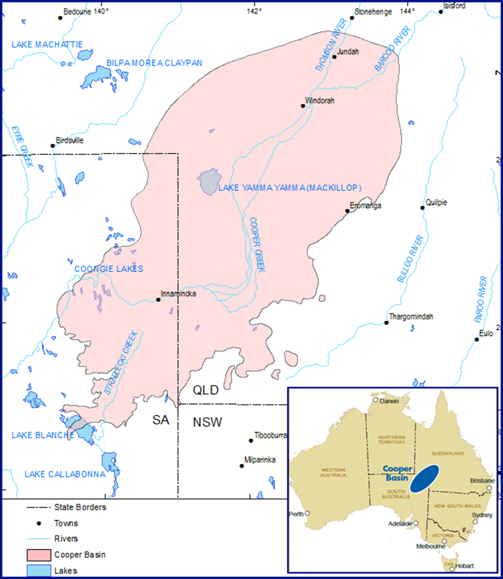

## Appendix C — Cotton Harvest Zones Map

Figure Image of Cotton Harvester Zone A and Zone B

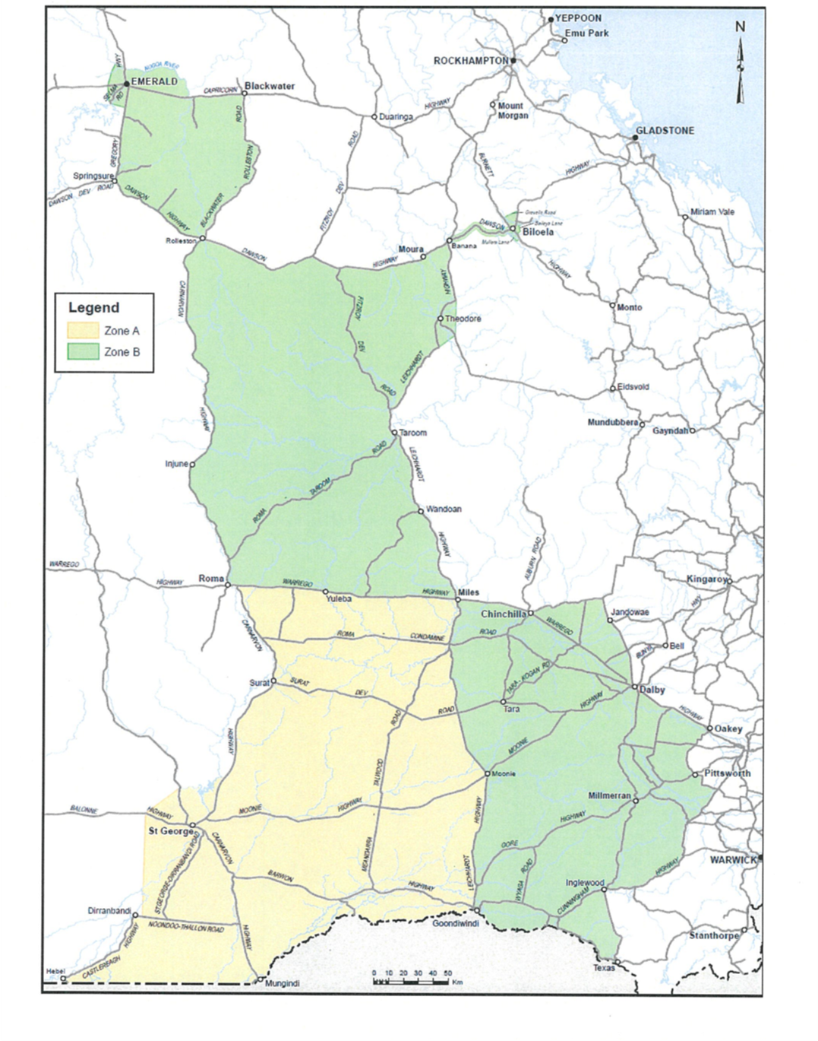

## Appendix D — Port of Brisbane roads

Table PoB roads

|  |  |
| --- | --- |
| Approved Port of Brisbane precinct roads | Map of Roads |
| * Howard Smith Drive * Osprey Drive * Kite Street * Port Drive including and north of the roundabout at Port Gate * Captain Bishop Bridge * all roads within Fisherman Island, including Port Drive, Bishop Drive, Bingera Drive, Whimbrel Street and Lucinda Drive. | Image of Port of Brisbane roadsPlease be advised this map is for indicative purposes only. For defined routes please refer to the list of *Approved Port of Brisbane precinct roads*. |

Table Additional PoB roads for oversize vehicles up to 4.5m in width and 25m in length

|  |  |
| --- | --- |
| Approved Port of Brisbane precinct roads | Map of Roads |
| * Gosport Street * Anton Street * Wyuna Circuit * Akuna Circuit * Luke Street * Benjamin Place * Radar Street * Trade Street * Freight Street * Pritchard Street (from Port Drive to PoB Motorway) * Export Street * Lytton Road (from Gosport Street to Port Drive) * PoB Motorway (from Port Drive to Lindum Drive) * Lindum Drive (from PoB Motorway exit to  Gosport Street) | Image of additional PoB roads for holiday travel.  Please be advised this map is for indicative purposes only. For defined routes please refer to the list of *Approved Port of Brisbane precinct roads.* |

## Definitions

Unless otherwise stated, words and expressions used in this guide have the same meanings as those defined in the HVNL or its Regulations, Transport Operations (Road Use Management) Act 1995 and other legislation.

Table Definitions of the Access Conditions Guide

|  |  |  |
| --- | --- | --- |
| Term | Explanation | Source |
| ADR | means the ADR titled ‘Vehicle Standard (Australian Design Rule—Definitions and Vehicle Categories) 2005’. | HVNL |
| Built-up area | means an area in which there are buildings on land immediately adjacent to a declared road, or there is street lighting at intervals of 100m or less for a distance of at least 500m, or if the road is less than 500m for the entire length. | Built-up area |
| Brisbane Central Traffic Area | means the area declared by Brisbane City Council and depicted on the Brisbane City Council website. | Chapter 14 - Parking and Control of Traffic Local Law |
| Brisbane City Council | means the local government area identified as Brisbane City in the Queensland Globe. | [Queensland Globe](https://qldglobe.information.qld.gov.au/) |
| Brisbane Urban Corridor | means the urban arterial road corridor as depicted on the TMR [Through truck restrictions—Brisbane Urban Corridor](https://www.tmr.qld.gov.au/business-industry/Heavy-vehicles/Compliance-and-enforcement/Through-Truck-Restrictions-Brisbane-Urban-Corridor) webpage. | [Transport Operations (Road Use Management—Road Rules) Regulation 2009](https://www.legislation.qld.gov.au/view/pdf/2017-08-25/sl-2009-0194) |
| Business day | means a day that is not—   1. a Saturday or Sunday; or 2. a public holiday, special holiday, or bank holiday in the place in which any relevant act is to be or may be done. | Access Conditions Guide |
| Category 1 SPV | means an SPVs not complying with 3L+15+/- G that have been assessed and approved by TMR’s Bridge Construction, Maintenance and Asset Management (BCMAM) unit for operation under 48t SPV restrictions. | Access Conditions Guide |
| Category 2 SPV | means an SPVs not complying with 3L+15+/- G that have been assessed by TMR’s BCMAM unit and determined to not be suitable for operation under 48t SPV restrictions. | Access Conditions Guide |
| CBD | means Central Business District and the network of roads located within the regulated parking zone of any city. | Access Conditions Guide |
| Christmas holiday | means the Christmas holiday defined in section 11.5 (Christmas holiday) of this guide. | Access Conditions Guide |
| City | includes any place within the city limits, but not limited to the Central Business Districts of Brisbane, Bundaberg, Caboolture, Cairns, Caloundra, Charters Towers, Gladstone, Gold Coast City, Gympie, Ipswich, Logan City, Mackay, Maryborough/Hervey Bay, Mount Isa, Redcliffe, Redland City, Rockhampton, Toowoomba, and Townsville. | Access Conditions Guide |
| Conditions of Operation Database | means the Transport and Main Roads database containing specific access conditions for vehicles and combinations on the Queensland road network and is available on the [TMR website](https://www.tmr.qld.gov.au/business-industry/Heavy-vehicles/Queensland-excess-mass-and-dimension-conditions). | [Queensland excess mass and dimension conditions](https://www.tmr.qld.gov.au/business-industry/heavy-vehicles/queensland-excess-mass-and-dimension-conditions) webpage |
| Convoy | *means* a group of oversize vehicles or combinations traveling together. | Access Conditions Guide |
| Cooper Basin | *means as mapped in* *Appendix B.* | Access Conditions Guide |
| Critical road | is a road identified on the Critical Road Network layer on [Queensland Globe](https://qldglobe.information.qld.gov.au/). | [Queensland Globe](https://qldglobe.information.qld.gov.au/) |
| Critical area | is an area identified on the Critical Area layer on [Queensland Globe](https://qldglobe.information.qld.gov.au/). Critical area also includes roads in the built-up areas in the towns or city limits of Atherton, Ayr, Barcaldine, Biloela, Blackwater, Bowen, Bundaberg, Cairns, Charleville, Charters Towers, Cloncurry, Dalby, Emerald, Gladstone, Goondiwindi, Gordonvale, Ingham, Innisfail, Kingaroy, Longreach, Mackay, Mareeba, Maryborough, Hervey Bay, Mount Isa, Port Douglas, Proserpine, Sarina, Rockhampton, Roma, Toowoomba, Townsville, and Warwick. | Access Conditions Guide  [Queensland Globe](https://qldglobe.information.qld.gov.au/) |
| Daytime | means the period beginning at sunrise and ending at sunset. | [*HVNL*](https://www.legislation.qld.gov.au/view/pdf/inforce/current/act-2012-hvnlq) |
| Easter holiday | means the Easter holiday defined in section 11.6 (Easter holiday) of this guide. | Access Conditions Guide |
| Escort vehicle | means a vehicle that displays warning signs and lights as required under schedule 8, Part 1, Division 5, section 27 of the [*Heavy Vehicle (Mass, Dimension and Loading) National Regulation*](https://www.legislation.qld.gov.au/view/whole/html/inforce/current/sl-2013-0077) *(MDL Regulation)*. | [*MDL Regulation*](https://www.legislation.qld.gov.au/view/pdf/inforce/current/sl-2013-0077) |
| Escort vehicle driver | means a person appointed by the Chief Executive of Department of Transport and Main Roads, to carry out escort duties under Part 2, Accredited persons, [*Transport Operations (Road Use Management—Accreditation and Other Provisions) Regulation 2015*](https://www.legislation.qld.gov.au/view/html/inforce/current/sl-2015-0087), or a Police Officer. A police officer is not bound by escort vehicle driver conditions. | [*Transport Operations (Road Use Management—Accreditation and Other Provisions) Regulation 2015.*](https://www.legislation.qld.gov.au/view/pdf/inforce/2017-09-01/sl-2015-0087) |
| Excess Mass  and Dimension Conditions | means the [Queensland excess mass and dimension conditions](https://www.tmr.qld.gov.au/business-industry/Heavy-vehicles/Queensland-excess-mass-and-dimension-conditions), and the route conditions listed in the Conditions of Operation Database. | [Queensland excess mass and dimension conditions](https://www.tmr.qld.gov.au/business-industry/heavy-vehicles/queensland-excess-mass-and-dimension-conditions) webpage |
| Forward projection | has the same meaning as National Class 1 Special Purpose Vehicle (up to 40t total mass) Mass and Dimension Exemption Notice 2021 (No.1). | [*National Class 1 Special Purpose Vehicle (up to 40t total mass) Mass and Dimension Exemption Notice*](https://www.legislation.gov.au/Details/C2021G00652) |
| Gold Coast City Council | means the local government area identified as Gold Coast City in the Queensland Globe. | [Queensland Globe](https://qldglobe.information.qld.gov.au/) |
| Heavy vehicle | means a vehicle with a GVM or ATM of more than 4.5 tonnes. | [*HVNL*](https://www.legislation.qld.gov.au/view/pdf/inforce/current/act-2012-hvnlq) |
| Long weekend | means a weekend including one or more public holidays falling on a Friday or Monday.  *Note: a long weekend does not apply to the Christmas and Easter holidays – see subsections* *11.5 (Christmas holiday)* *and* *11.6 (Easter holiday)* *for Christmas and Easter holiday conditions.* | Access Conditions Guide |
| Low loader | has the same means as the Queensland schedule of the Multi-State Class 1 Load Carrying Vehicle Dimension Exemption Notice 2022 (No.1) | [Multi-State Class 1 Load Carrying Vehicle Dimension Exemption Notice](https://www.legislation.gov.au/Details/C2023G00100) |
| Major road | is a road identified on the Critical Road Network layer on [Queensland Globe](https://qldglobe.information.qld.gov.au/). | [Queensland Globe](https://qldglobe.information.qld.gov.au/) |
| MDL Regulation | means the Heavy Vehicle (Mass, Dimension and Loading) National Regulation. | [*MDL Regulation*](https://www.legislation.qld.gov.au/view/pdf/inforce/current/sl-2013-0077) |
| New Year's Day | means the 1st of January and included in the Christmas holiday defined in section 11.5 (Christmas holiday) of this guide. | Access Conditions Guide |
| NHVR | means the [National Heavy Vehicle Regulator](https://www.nhvr.gov.au/). | [*HVNL*](https://www.legislation.qld.gov.au/view/pdf/inforce/current/act-2012-hvnlq) |
| Night | means the period between sunset on a day and sunrise on the next day. | [*HVNL*](https://www.legislation.qld.gov.au/view/pdf/inforce/current/act-2012-hvnlq) |
| Pilot vehicle driver | means a person who holds accreditation to drive a pilot vehicle under Part 2 of the [*Transport Operations (Road Use Management — Accreditation and Other Provisions) Regulation*](https://www.legislation.qld.gov.au/view/html/inforce/current/sl-2015-0087) *2015*. | [*Transport Operations (Road Use Management — Accreditation and Other Provisions) Regulation*](https://www.legislation.qld.gov.au/view/html/inforce/current/sl-2015-0087) *2015*. |
| Pilot and Escort Guide | means the [Guideline - Pilot and Escort Operations in Queensland](https://www.publications.qld.gov.au/dataset/pilot-and-escort-operations-in-queensland) that provides conditions for pilot/escort vehicles and drivers. | [Guideline - Pilot and Escort Operations in Queensland](https://www.publications.qld.gov.au/dataset/pilot-and-escort-operations-in-queensland) |
| Pilot or escort operation | includes any operation where a pilot, escort or police vehicle escorts an oversize vehicle in accordance with a notice, guideline, permit, or other lawful authorisation. | [Safe Movement Guideline - Pilot and Escort Operations in Queensland](https://www.publications.qld.gov.au/dataset/pilot-and-escort-operations-in-queensland) |
| Pilot vehicle | means a vehicle equipped with warning signs and lights as required under schedule 8, Part 1, Division 5, section 26 of the [*MDL Regulation*](https://www.legislation.qld.gov.au/view/whole/html/inforce/current/sl-2013-0077). | [*MDL Regulation*](https://www.legislation.qld.gov.au/view/pdf/inforce/current/sl-2013-0077) |
| PoB | means the Port of Brisbane. | [Queensland Globe](https://qldglobe.information.qld.gov.au/) |
| Operate and Operator | A person operates the vehicle or combination, and is an operator of the vehicle or combination, or a person who is responsible for controlling or directing the use of:   1. for a vehicle (including a vehicle in a combination)—the vehicle; or 2. for a combination—the towing vehicle in the combination. | [*HVNL*](https://www.legislation.qld.gov.au/view/pdf/inforce/current/act-2012-hvnlq) |
| Queensland Globe | means the [Queensland mapping website](https://qldglobe.information.qld.gov.au/). | [Queensland Globe](https://qldglobe.information.qld.gov.au/) |
| QPS | means the [Queensland Police Service](https://www.police.qld.gov.au/). | [Queensland Police Service](https://www.police.qld.gov.au/) |
| Oversize vehicle | means a heavy vehicle or combination that does not comply with prescribed dimension and described in following sections of the HVNL:   * [Section 116](https://www.legislation.qld.gov.au/view/html/inforce/current/act-2012-hvnlq#sec.116) (1)(a) and (c), as it relates to class 1 vehicles, or * [Section 116](https://www.legislation.qld.gov.au/view/html/inforce/current/act-2012-hvnlq#sec.116) (3) as it relates to class 3 vehicles | Section 116 of the [*HVNL*](https://www.legislation.qld.gov.au/view/pdf/inforce/current/act-2012-hvnlq)  *HVNL Definitions* |
| Overmass  vehicle | means a heavy vehicle or combination that does not comply with prescribed mass limits and described in the following section of the HVNL:   * [Section 116](https://www.legislation.qld.gov.au/view/html/inforce/current/act-2012-hvnlq#sec.116) (1)(a) and (c), as it relates to class 1 vehicles, or * [Section 116](https://www.legislation.qld.gov.au/view/html/inforce/current/act-2012-hvnlq#sec.116) (3) as it relates to class 3 vehicles | Section 116 of the [*HVNL*](https://www.legislation.qld.gov.au/view/pdf/inforce/current/act-2012-hvnlq)  *HVNL Definitions* |
| Reduced  visibility | means where visibility is less than 250m in the daytime or the headlights of a vehicle approaching within 250m could not be seen at night. | Schedule 8 section 8 of the [*MDL Regulation*.](https://www.legislation.qld.gov.au/view/pdf/inforce/current/sl-2013-0077) |
| Safe parking  Area | for an oversize vehicle, means an area at which vehicles of that kind may be parked lawfully and safely. | Schedule 8 section 8 of the [*MDL Regulation*.](https://www.legislation.qld.gov.au/view/pdf/inforce/current/sl-2013-0077) |
| Southeast  corner | means the area bounded by Coolangatta in the south, Gympie in the north, Toowoomba, and Warwick in the west. | Access Conditions Guide |
| Special Purpose Vehicle (SPV) | has the same meaning as defined in [section 116](https://www.legislation.qld.gov.au/view/html/inforce/current/act-2012-hvnlq#sec.116) of the HVNL. | Section 116 of the [*HVNL*](https://www.legislation.qld.gov.au/view/pdf/inforce/current/act-2012-hvnlq) |
| Special purpose combination | has the same means as the Queensland Class 1 Special Purpose Combination Mass & Dimension Notice. | [Queensland Class 1 Special Purpose Combination Mass & Dimension Notice](https://www.nhvr.gov.au/files/c2019g00066-qld-class-1-special-purpose-combination-mass-dimension-exemption-notice-2019-no1.pdf) |
| Special purpose trailer | has the same means as the Queensland Class 1 Special Purpose Combination Mass & Dimension Notice. | [Queensland Class 1 Special Purpose Combination Mass & Dimension Notice](https://www.nhvr.gov.au/files/c2019g00066-qld-class-1-special-purpose-combination-mass-dimension-exemption-notice-2019-no1.pdf) |
| Sunset | as defined by Australian Government Bureau of Meteorology for your location. | Access Conditions Guide |
| Sunrise | as defined by Australian Government Bureau of Meteorology for your location. | Access Conditions Guide |
| TMR | means the Department of Transport and Main Roads. | [Department of Transport and Main Roads](https://www.tmr.qld.gov.au/about-us) |
| Urban area | has the same meaning as the Heavy Vehicle (Mass, Dimension and Loading) National Regulation. | [*MDL Regulation*](https://www.legislation.qld.gov.au/view/pdf/inforce/current/sl-2013-0077) |

## Version Control Table

Table Version control table

|  |  |  |
| --- | --- | --- |
| Version | Sections amended | Date published |
| 1.0 | Original document | 18 February 2019 |
| 2.0 | Added: Appendix B and Appendix C | 25 February 2019 |
| 3.0 | Added: Sections 1 – Purpose, 2 – Speed, 10.1, 10.2, 11.3, 11.4, 12.1  Amended: Sections 5, 5.2, 9, 9.2,11,12, 13.2, 13.3, Graph A, Appendix B, Appendix C | 29 April 2019 |
| 4.0 | Added: Context to cover, Appendix D  Amended: Definitions, Sections 2, 6, 6.2, 8.2, 9.1 | 8 July 2019 |
| 4.1 | Amended:   * Reference from pdf maps to Qld Globe * Definitions, Section 6.2 * Added specific conditions for: * SPV (from extended 2020 Class 1 National SPV Notice) * Version Control Table | 5 May 2021 |
| 5.0 | Added schedules for:   * SPVs (*Note: also moved SPV tunnel conditions to Schedule 1*) * Class 1 Load Carrying Vehicles and Combinations * Special Purpose Combinations * Agricultural Vehicles and Combinations (*Note: Heavy agricultural vehicles and combinations should continue to use the provisions of the national Notice and operator's guide until such provisions are formally transitioned into this Schedule and removed from the national Notice*). * Port of Brisbane * Conditionally registered vehicles. | 1 July 2021 |
| 5.1 | Minor amendments to:   * Include Light Agricultural Guideline access conditions * Amend pilot vehicle driver to 'accredited level 1 pilot vehicle driver' * Add pilot vehicle driver conditions (previously 'agricultural pilot')   Format adjustments to make more readable. | 1 October 2021 |
| 6.0 | The following amendments were made:   1. **Conversion of content:**   Content (where possible) has been transferred into tables, and  Information has been placed in plain English to assist with readability.   1. **Correction of:**  * Christmas and Easter Holiday exemptions in the schedules, and * Pilot and permit conditions relating to the length of combination, and * Conditionally registered vehicles to oversize conditionally registered vehicles.  1. **Removal of:**  * Year dates of Notices, avoiding outdated referencing, and * Port of Brisbane Schedule, conditions merged into relevant notice schedules, and * Houghton Hwy Bridge and Ted Smout Bridge conditions from restricted motorways, tunnels, and roads, and * Heavy agricultural schedule, condition transferred to the National Class 1 Agricultural Vehicle and Combination Mass and Dimension Exemption Notice and the QLD Safe Movement Guideline for light agricultural vehicles, and * Bridge and culvert report for Class 1 oversize and overmass load carrying vehicles.  1. **Added:**  * Burdekin River Bridge condition, and * Class 3 Southeast corner conditions to Gatton decoupling facility, and * Peak hour time exemption to additional PoB roads, and * a reference map for Appendix A and B aligning with the NSW format of the New South Wales Class 1 Load Carrying Vehicle Operator’s Guide, and * new approved roads added to Table 24 for Bond stores in the Brisbane Airport. * A column in Table 27 identifies the definition source. | 11 December 2023 |