What ICMS data activities do I need to complete or update prior to Unify Go-Live?

**Purpose of guide**

There will be some tasks that need to be completed within ICMS in the lead up to Unify go-live to support accurate data migration from one system to the next. This guide is for supervisors and managers to support data quality preparation for the transition to Unify.

**Activities prior to go-live are to be completed the Wednesday prior to ICMS being switched to read only for Youth Justice.**

|  |  |
| --- | --- |
| **Type of activities** | **Actions to undertake** |
| **Case management** | * Ensure case allocation is current in ICMS * Close completed orders * Complete outstanding RIC requests – if not done prior to go-live, they will need to be re-set up in Unify * Update YP schedule in ICMS (if used):   + Finalise all warning meetings and applications associated with open orders   + Finalise PSRs   + Finalise variation documentation associated with open orders   + Finalise suspension documentation associated with open orders   + Finalise ISO/CRO/CBP proposals   **Note** – open forms will be migrated to the assigned person on that document, however, may go back to draft stage. Some ICMS fields do not match to Unify fields – if a form in ICMS was migrated, review the form in Unify before finalising the form to ensure information is in the accurate sections |
| **Court** | * Finalise incomplete court remarks * Complete outstanding RIC requests * Complete outstanding AoA forms * Complete outstanding WDD forms * Complete outstanding movement forms * Update YP location to current location * Complete pre-court custody, attendance, and court case notes tab in ICMS where these are only partially completed |

**Post go-live tasks**

From go-live, iDOCS will be read only for client information – it will continue be used as a corporate system for business-related purposes. As a result, there will be documents currently in iDOCS that will need to be uploaded to Unify:

* Completed initial interviews
* SRO documents
* Service Response Plans
* Oath of Service
* MAC-P referrals
* Recent casework summary (for court)
* Release memos

It is not anticipated this will all occur immediately at go-live and may be a graduated process as caseworkers are completing their day-to-day tasks i.e. when completing a case review, the caseworker can upload their last service response plan, or when completing a new court summary, the caseworker can upload their previous summary.

The process to upload these documents will be a simple ‘drag and drop’ from iDOCS to the Documents tab in the Person Profile screen in Unify.

Step 1: Navigate to the person profile screen.

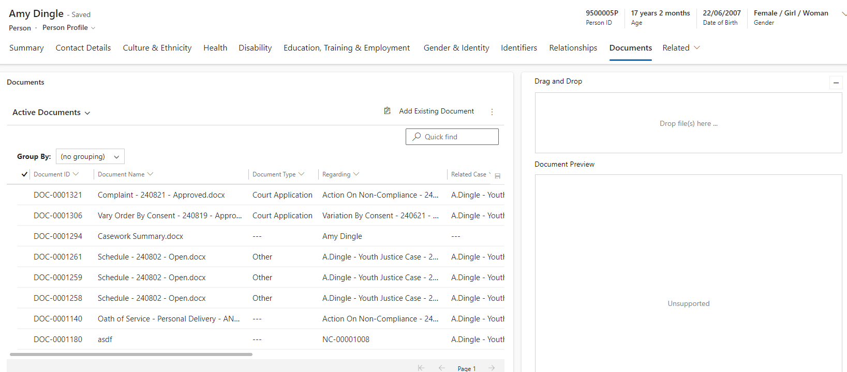

Step 3: Drag and drop document into this box.

Step 2: Select documents tab.

Document types that can be selected from the drop-down list include:

|  |  |
| --- | --- |
| Affidavit | For child safety only* |
| Application | For child safety only* |
| Assessment | May include:   * Psychological assessments * Psychiatric assessments * GYFS assessments * Brief screeners   YLS/CMI assessments will be completed within Unify and previous assessments migrated from ICMS. |
| Care arrangement support | For child safety only |
| Carer entity | For child safety only |
| Child Protection Order | For child safety only |
| Childrens Court | For child safety only* |
| Complaint and Summons | For child safety only* |
| Consent | * All signed consent forms from young people * Any signed consent forms from the young person’s parent or carer |
| Court appearance/outcome | For child safety only* |
| Court application | For child safety only* |
| Criminal and Domestic Violence History | May include:   * A young person’s DFV history or offending history * Documents provided by QPS * Information sharing requests * DFV screeners and tools * Referrals to HRT * Any safety plans that have been developed   Note – all documents must comply with the department’s DFV procedure and recordkeeping requirements outlined in that procedure.  The document title must be clear that the document may contain sensitive information and caution is to be exercised in accordance with the DFV procedure. |
| Culture and ethnicity | Any documentation the young person provides in relation to their culture or ethnicity |
| Decision | For child safety only |
| Delegated Authority approval process | For child safety only |
| Disability | Any assessments or reports relating to a young person’s disability and NDIS information |
| Disclosure | May include:   * Consents from the young person and their family to disclose personal confidential information * MACP information sharing * Requests from other agencies for information e.g. QPS, ODPP, Queensland Education and the department’s response * Subpoenas * Offline approvals to share information   Note – DFV information disclosure must be saved under the DFV document type. |
| Draft affidavit | For child safety only* |
| Education and training | Any education and training certificates or reports. May include certificates a young person attains while in custody |
| Emergent order | For child safety only |
| Employment | Any employment-related information a young person may provide, including proof of employment records |
| Exhibit | For child safety only* |
| Family Law Court | For child safety only |
| Feedback | * Surveys we may ask a young person to complete in relation to programs and services provided by youth justice * Feedback forms |
| Financial | Copies of   * Financial approvals * Receipts for youth justice funded programs, services, or activities |
| Health | Copies of:   * Any physical health assessments a young person may provide * Assessments commissioned for the purpose of administering the young person’s statutory order * Medical certificates * Correspondence from health professionals relating to any work restrictions |
| Identification | Copies of:   * Birth certificates * Learner’s permits * Medicare cards * Passports   NOTE – the young person does not need to provide this documentation for youth justice purposes but may provide a copy for our records and safe keeping. |
| Intercountry Court | A copy of:   * Court order/s * QP9 equivalent * Transfer summary * Formal request for transfer * All relevant correspondence * If the YP is transferring **to** Queensland, copies of current service response plan equivalent * Any previous contravention documentation |
| Interstate court | A copy of:   * Court order/s * QP9 equivalent * Transfer summary * Formal request for transfer * All relevant correspondence * If the YP is transferring **to** Queensland, copies of current service response plan equivalent * Any previous contravention documentation |
| IPS and ICA | For child safety only |
| Legal advice | The outcome of any crown law advice sought in relation to a young person. |
| Missing child checklist | May include:   * Missing young person checklist * Information from QPS in relation to the missing child * Information from child safety in relation to the missing child * Correspondence between QPS/child safety * Information sharing specific to a young person who is missing * Copies of any offline critical incident forms * Offline approvals |
| Plan | May include:   * Service response plans * 72-hour plans * Safety plans (does not include DFV safety plans, these should be captured under the DFV type) * Any other plans developed in consultation with stakeholders |
| QCAT | For child safety only |
| Recording and transcript | Includes:   * Formal requests for transcripts/recordings * Copies of transcripts/recordings |
| Referral – Child Safety | For child safety only |
| Referral – Youth Justice | This may include:   * Referral forms sent to external agencies for a young person’s involvement in programs * Offline internal referral forms |
| Regulation of Care | For child safety only |
| Request for information | This may include formal requests from:   * Child safety for child safety-related information * Service providers as they relate to a young person’s statutory order |
| Residency and Visa | Any documentation relating to a young person’s residency or visa, that may include their passport, noting the young person does not need this documentation for youth justice purposes but may provide a copy for our records and safe keeping. |
| Reviewable decision | For child safety only |
| SCAN confidentiality acknowledgement | For child safety only |
| SCAN core member commitment | For child safety only |
| Sensitive information checklist | For child safety only |
| Standards of care | For child safety only |
| Transfer | May include:   * Transfer summaries between service centres * RD approvals if completed offline * Transfer to prison information   Note – interstate and intercountry transfers should be saved under those document types and **not** under ‘transfer’ |
| Transition to adulthood | For child safety only |
| Travel | Copies of any youth justice funded travel documentation provided to young people. This may include:   * Copies of tickets * Itineraries |
| Youth Justice court | This will include all youth justice court-related information:   * Applications * Court summaries completed offline * QP9’s/Bench charge sheets * Briefs * VJRs * Orders (including PSR requests) * Notices to appear * Statement of Facts * Bail undertakings * Bail merit assessments * Letters of non-compliance for CBP * Formal requests for information from QPS/ODPP   It is critical that the title of these documents accurately reflects what they are. |
| Other | Any information that does not fit into one of the above categories.  When using this document type, the title of the document must accurately reflect what the document is. |

*Note - while these ‘types’ also relate to youth justice, all youth justice court information is to be saved under the *Youth Justice Court* document type. This is to assist with filtering e.g. if Youth Justice and Child Safety affidavits are all saved under ‘Affidavits’ type, when filtering, an extensive list of all affidavits will be displayed, however if they’re saved under Youth Justice Court, this will restrict the search options to Youth Justice.