# Youth Justice Sentence Orders

## Unsupervised Sentences

After you go to court, a judge may give you a sentence.

**Reprimand**

A reprimand is a warning.

 The judge gives you a reprimand if:

* You say you are guilty of

an offence

* Court finds you guilty

You will get a sentence if:

you say you are guilty of an offence. This means, you said you did it.



court finds you guilty of an offence.

Every person’s case is different.

All courts follow a set of rules when they sentence people.

**Good behaviour order**

The judge may give you a good behaviour order.

You must not break the law for up to 1 year.

If you break the law, the court may give you a different punishment.

They want to keep the community safe

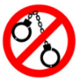

They want you and your family to understand what is happening in court.

You can ask them questions.

**Fine**

A fine is when the court tells you to pay them money.

The judge will tell you when you need to pay the money by.

The judge will think about



the person’s age

how grown up they are. This is called maturity.

cultural background

## Supervised Sentences

**Probation**

A probation order

is a court order from the judge after you went to court for your offence

It means a youth justice officer (or YJ officer) will supervise you during this order.

You must not break the law. You need to follow the rules.



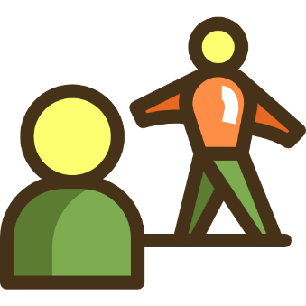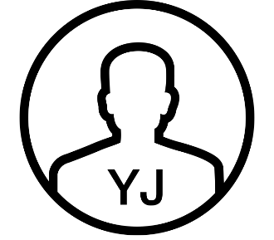



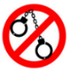

**Graffiti removal order**

Unpaid work to remove graffiti

**12+ years old and older**

Are guilty of doing graffiti. You said you did graffiti, or the court said you did graffiti.

You can fix the damage you did.

The court and YJ officer will tell you how many hours you need to do.

The YJ officer will organise this work.











**Community service order**

Unpaid work.

The court tells you how many hours you need to do.

Helps your community

The YJ officer will organise this work.

The work supervisor will count how many hours you did. They will tell your YJ officer.

 You can fix the damage

you did.



The court and YJ officer

will tell you how many

hours you need to do.

**Intensive supervision order**

It is for young people who have been on other orders and may next go to detention.

For **10, 11 or 12** years old at the time the court decides your sentence.

You can still live with your family

YJ officers will help you do a program.

This program may help you with

* not offending
* your health
* school and family
* good things you want to do with your life.













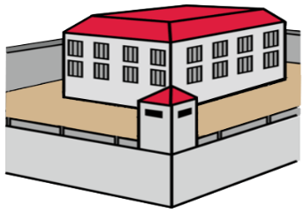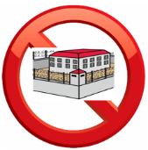

**Conditional release order**

A judge gives you this if:

you say you are guilty

the judge finds you guilty

you have been sentenced to go to youth detention.

But the judge wants you to do this order **first** so you do **not** go to detention.

If you cannot finish this order, you may go to detention.

You can still live with your family.

**You must do a program for**

**up to 6 months.**

A YJ officer will supervise you.

1. Before you get this order, the judge must tell a YJ officer to write a report about you.
2. You meet with the YJ officer.

They will talk to you more about what you can do in your program

1. You go back to court.

The judge will give you a conditional release order.

.

//





The program may have activities about

school or TAFE

getting a job

good things you want to in your life

how you can stop offending

in a positive way.

If you break the rules,

you may go back to court.

The court will decide if you go to detention or not.



**Restorative Justice Order**

You go to a meeting with the victim and other people affected by the offence.

You talk about how you can fix the harm.

You can bring a support person.

It means a YJ convenor will facilitate you during this order.

If you do not attend the conference, you will go back to court.

The judge may give you a different sentence.

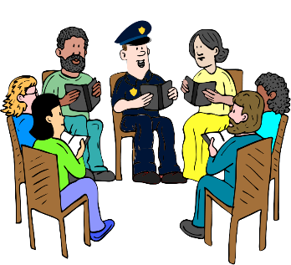





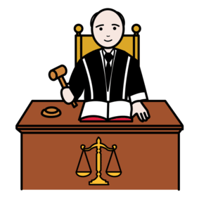

**Detention order**

A judge may send you to detention if:

* you say you are guilty an offence
* court finds you guilty

You may be in detention for

**up to 1 year**.

A **higher court** may send you to detention **for more than 1 year**.

This depends on the offence.

You may spend **half to most of your order in detention** (50-70%). Then you will do the rest in community.

**What if I turn 18 in detention?**

You may go to an adult prison if:

You turn 18 **AND** You have **6+ months in custody** **left** in

You are **18 or older** when the judge says you go to detention.

The court officer will talk to you.





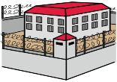



## Other Sentences

**Restitution and compensation**

A court may tell you to pay money.

This will help fix the broken property or the victim’s injury.

The judge asks you when you can finish paying the money.







**Licence disqualification**

A court can stop you getting a drivers licence for some time.



**Drug assessment and education**

A judge gives you this if:

you say you are guilty of an offence with drugs

court finds you guilty of an offence with drugs

The judge will tell you to talk to someone about drug use.

If you do not attend, you may go back to court. The judge may give you a different sentence.







 different sentence.

**Who do I talk to in YJ?**

**Ask for the Intake Officer.**

You must report **1 day** after court.

**Where _____________________________________________________**

**Phone (07) _________________________________________________**

**Email ______________________________________________________**

**Time _______________________________________________________**

[**www.cyjma.qld.gov.au**](http://www.cyjma.qld.gov.au)

 **Time _______________________________________________________**

[](https://emojipedia.org/mobile-phone/)

[**www.cyjma.qld.gov.au**](http://www.cyjma.qld.gov.au)





The material presented in this publication is distributed by the Queensland Government for information only and is subject to change without notice. The Queensland Government disclaims all responsibility and liability (including liability in negligence) for all expenses, losses, damages and costs incurred as a result of the information being inaccurate or incomplete in any way and for any reason. ©State of Queensland (Youth Justice) 2024

Youth Justice Sentence Orders (Easy English), ver. 1.0, April 2041