15-year Vision and Action Plans for the Bruce Highway

Overseen by the Bruce Highway Trust Advisory Council

**Copyright information**

© State of Queensland (Department of Transport and Main Roads) 2024

The Queensland Government is committed to providing accessible services to Queenslanders of all cultural and linguistic backgrounds. If you have difficulty understanding this publication and need a translator, please call the Translating and Interpreting Service (TIS National) on 13 14 50 and ask them to telephone the Queensland Department of Transport and Main Roads on 13 74 68.

**Disclaimer**

While every care has been taken in preparing this publication, the State of Queensland accepts no responsibility for decisions or actions taken as a result of any data, information, statement or advice, expressed or implied, contained within. To the best of our knowledge, the content was correct at the time of publishing.

Artwork: ‘Travelling’ by Gilimbaa.

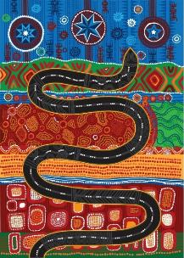

The Department of Transport and Main Roads (TMR) respectfully acknowledges the Traditional Owners and Custodians of the land and waterways. We pay respect to their Elders past, present and emerging. TMR recognises those whose ongoing effort to protect and promote Aboriginal and Torres Strait Islander cultures will leave a lasting legacy for future First Nations people.

Cover image: Caloundra Road to Sunshine Motorway, upgraded highway and new western service road looking north at the Mooloolah River (September 2021).

Contents

15-year Vision and Action Plans for the Bruce Highway 0

Foreword 2

Snapshot of the Bruce Highway 6

The Bruce Highway 7

The journey so far 9

Opportunities 11

Challenges 15

Customer insights 16

Bruce Highway Vision 19

Delivering the 15-year Vision and Action Plans 28

Next steps 35

# Foreword

## Mr Peter Garske

On behalf of members of the Bruce Highway Trust Advisory Council (BHTAC), I am pleased to recommend the *15-year Vision and Action Plans for the Bruce Highway*, commencing from 2024–25 to 2038–39 for government consideration.

I acknowledge the Queensland Government’s commitment to future-proofing the Bruce Highway by establishing the BHTAC, bringing together representatives from the state’s peak transport and industry bodies, the Local Government Association of Queensland, the Department of Infrastructure, Transport, Regional Development, Communications and the Arts, the Department of Transport and Main Roads (TMR) and six regional representatives.

The BHTAC members were tasked with overseeing the development of this 15-year Vision and three five-year rolling action plans for the Bruce Highway (Brisbane to Cairns), as well as the companion document the *Safer Bruce 2030 Action Plan*. Our purpose was to align investment decision-making to the three key BHTAC objectives: **to unlock economic growth, build flood resilience and improve safety**.

Working alongside the Deputy Chair, Barbara Madden and our fellow 14 members, we ensured the voices of hundreds of thousands of road users who drive the Bruce Highway were heard. Whether it is a truck driver taking a break to manage their fatigue at a heavy vehicle rest stop, a business getting product to market on time, a tourist having a safer drive, or a regional resident arriving to work sooner, we have listened and considered the many ways customers use the Bruce Highway now, and their needs into the future.

Working with key stakeholders and hearing from customers, the BHTAC has sought expert advice from the BHTAC-Technical Working Group within TMR to shape this well-considered and long-term *15-year vision and Action Plans for the Bruce Highway*. It was an ambitious task to deliver, but by balancing members’ perspectives, using technical expertise and analysis and carefully considering the needs of the many types of customers that traverse the Bruce Highway every year, the result is a strong and ambitious Vision that will guide future investment in this nationally significant highway.

It is important to recognise that substantial infrastructure upgrades are often accompanied by traffic delays along the Bruce Highway due to roadworks. The BHTAC encourages Queenslanders to always show patience and drive safely along the highway, particularly during these short-term periods and to remember the long-term benefits these upgrades will bring to local communities, businesses and visitors. Road safety is everybody’s responsibility.

Thank you to my fellow BHTAC members for their commitment to helping shape the Bruce Highway to 2038–39 and beyond to benefit all Queenslanders. Together, we worked hard to oversee the development of this document and the *Safer Bruce 2030 Action Plan*. I look forward to monitoring how this Vision and Action Plans will support Queensland’s diverse economy, creating jobs and improving road safety.

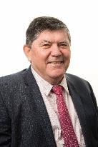

**Mr Peter Garske,**  
Chair, Bruce Highway Trust Advisory Council.

## The Honourable Steven Miles MP and The Honourable Bart Mellish MP

Queensland Government is pleased to release the *15-year Vision and Action Plans for the Bruce Highway*, the development of which was overseen and recommended by the Bruce Highway Trust Advisory Council (BHTAC) for government consideration.

Queensland is renowned for its drive tourism experiences and the Bruce Highway, as Queensland’s longest road spanning 1673 kilometres from Brisbane to Cairns, is a stand-out. For decades, as people have journeyed along the eastern seaboard, they have told stories about the varying landscapes they experienced and the communities (large and small) the Bruce Highway supports. Each and every day, this critical artery of Queensland’s economy links people and places, moving freight, tourists and commuters north and south, while also connecting the significant resource and agriculture sectors to 11 coastal ports.

As part of its remit, the BHTAC invited road users and key industry stakeholders to have their say on the priorities for the Bruce Highway through a customer survey and targeted focus groups.

We commend the BHTAC for working diligently to ensure the voices of regional Queenslanders, local businesses, transport operators, tourists and those whose livelihoods depend on the Bruce Highway were heard and have been considered in development of the Action Plans.

The Australian and Queensland governments have jointly invested heavily in the Bruce Highway in recent years through progressive delivery of the Bruce Highway Upgrade Program (BHUP) 2013–14 to 2027–28.

While the current jointly funded BHUP has gone a long way to improving the Bruce Highway for all road users, there is more work to be done. This Vision and related rolling five-year Action Plans outline unfunded high priority upgrades to guide future investment in this nationally-significant corridor.

Having a future-focused *15-year Vision and Action Plans for the Bruce Highway*, which outlines where essential upgrades are planned to be delivered will ensure this vital north-south road corridor can support the evolving needs of this great state by connecting communities, creating jobs and growing our regions.

We acknowledge and thank BHTAC Chair, Peter Garske, Deputy Chair, Barbara Madden and all BHTAC members for their oversight of, and contribution to, development of this *15-year Vision and Action Plans for the Bruce Highway* and the *Safer Bruce 2030 Action Plan*.

Going forward, as part of future budget processes, the Queensland Government will work closely with the Australian Government to finalise both delivery of the current BHUP and to confirm funding for the priority projects and statewide programs outlined in the Action Plans.

By working together, we can unlock economic growth, build flood resilience and improve safety on the Bruce Highway—now and into the future.



**The Honourable Steven Miles MP**,  
Premier



**The Honourable Bart Mellish MP**,  
Minister for Transport and Main Roads and Minister for Digital Services

**Bruce Highway Trust Advisory Council Membership**

* Chair, Peter Garske
* Deputy Chair, Barbara Madden

**Ex officio members**

* Chief Executive Officer, Local Government Association of Queensland (LGAQ)
* Group Chief Executive Officer, Royal Automobile Club of Queensland (RACQ)
* Chief Executive Officer, Queensland Farmers’ Federation (QFF)
* Chief Executive Officer, Queensland Trucking Association (QTA)
* Chief Executive Officer, Queensland Tourism Industry Council (QTIC)
* Branch Secretary, Transport Workers Union Queensland (TWU)
* Director-General, Department of Transport and Main Roads (TMR)
* First Assistant Secretary. Department of Infrastructure, Transport, Regional Development, Communications and the Arts (DITRDCA)

**Regional members**

* Anita Mumford
* Brian Hughes
* Elise Pearson
* Julie Boyd
* Robert Dorgelo
* Tania Dennis

# Snapshot of the Bruce Highway

The Bruce Highway is Queensland’s longest road, stretching 1673 kilometres from Brisbane in the south of the state, to Cairns in the north. The Bruce Highway joins coastal population centres, directly and through connecting roads to Brisbane, Moreton Bay, the Sunshine Coast, Gympie, Maryborough, Bundaberg, Gladstone, Rockhampton, Mackay, Townsville and Cairns.

**Key functions of the Bruce Highway include:**

* providing connectivity to 11 coastal trading ports, and between key economic areas of the state, such as the Atherton Tablelands, Bowen Basin, and the South and North Burnett regions
* providing an inter and intra-regional connection for medium and long-haul freight and passenger movements, including the National Land Transport Network freight routes to and from Queensland’s capital city Brisbane and beyond
* providing access to Queensland’s natural attractions, including the Great Barrier Reef, beaches, resorts and tropical rainforests and supporting the ‘drive tourism’ economy
* providing connectivity for regional centres in and around Cairns, Townsville, Mackay and Rockhampton to essential businesses, health and educational services
* connecting the Wide Bay and Sunshine Coast regions to Brisbane in the south.

*Fast facts*

* **1673 kilometers long**   
  Queensland’s longest road connecting people and freight between Brisbane and Cairns and a vital part of the National Land Transport Network
* **Services 62 percent of Queensland's population**   
  Including 18 local government areas and equating to 3.21 million people, and expected to reach 4.13 million people by 2041
* **Carries around 20 million tonnes of freight every year**   
  Supporting major industries, including agriculture, resources, construction, manufacturing and services with connections to 11 coastal trading ports
* **Drives tourism**   
  Is a major route providing access to Queensland’s natural attractions, including the Great Barrier Reef, beaches and tropical rainforests

# The Bruce Highway

More than half of Queensland’s population lives and works along Queensland’s coastline, with the Bruce Highway providing the primary north-south road connection.

* 144 kilometres Brisbane–Gympie
* Dual carriageway
* Motorway standard
* High traffic volumes
* Urban traffic patterns
* 465 kilometres Gympie–Rockhampton
* Dual carriageway in sections
* Wide centre lines
* Heavy vehicles >20 per cent
* 334 kilometres Rockhampton–Mackay
* Single carriageway
* Dual carriageway – provincial cities
* 377 kilometres Mackay–Townsville
* Single carriageways
* Dual carriageway – provincial cities
* Wide centre lines
* 353 kilometres Townsville–Cairns
* Single carriageway
* Dual carriageway – provincial cities
* Wide centre lines

Figure 1: The various sections of the Bruce Highway.

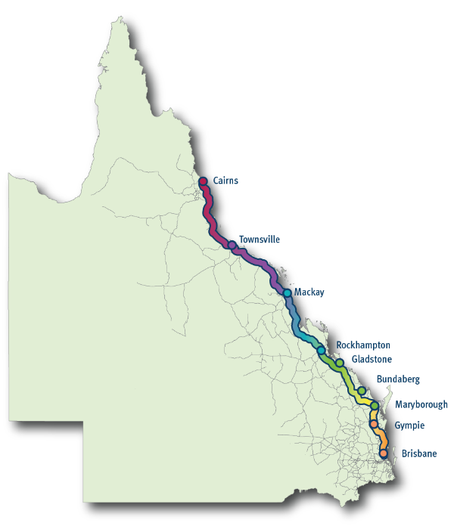

# The journey so far

In 2013, the largest road infrastructure program Queensland has ever seen commenced to improve safety, capacity and flood resilience along the length and breadth of the Bruce Highway between Brisbane and Cairns.

Starting on 1 July 2013, the Bruce Highway Upgrade Program (BHUP) was initially developed as an $8.5 billion 10-year commitment, jointly-funded by the Australian and Queensland governments. In May 2018, the Australian Government committed an additional $3.3 billion (based on 80:20 funding arrangements) to its existing $6.7 billion commitment.

The Queensland Government also committed to providing an additional $200 million each year (based on 80:20 funding arrangements) for upgrades on the Bruce Highway on top of the already provided $1.8 billion.

As part of the Queensland Government’s ongoing commitment to the Bruce Highway, the Queensland Government’s 2017 *Future-Proofing the Bruce* policy established the Bruce Highway Trust Advisory Council (BHTAC) to oversee the development of this *15-year Vision and Action Plans for the Bruce Highway*, based on an annual remit of $1 billion per annum on an 80:20 funding arrangement with the Australian Government. The Vision and the Action Plans are to deliver on three key objectives: **to unlock economic growth, build flood resilience** and **improve safety.**

In 2020, with the release of *A Real Bruce Plan*, the Queensland Government tasked the BHTAC to also oversee the development of a companion *Safer Bruce 2030 Action Plan*, with an ambitious target of reducing the rate of fatalities along the Bruce Highway by 60 per cent by 2030.

The BHTAC brings together leaders of Queensland’s peak transport and industry bodies, together with regional representatives of road users, road safety and regional development experts from along the Bruce Highway, north of Gympie, to provide a state-wide perspective on Bruce Highway upgrade needs.

The BHTAC is supported by a Technical Working Group established within the Department of Transport and Main Roads (TMR) comprising technical and subject-matter experts.

## The existing Bruce Highway Upgrade Program (2013–14 to 2027–28), being delivered in partnership with the Australian Government:

Major Bruce Highway upgrades between Brisbane and Cairns delivered as at 31 December 2023 include:

* Six-laning between Caloundra Road and the Sunshine Motorway and between Caboolture Bribie Island Road and Steve Irwin Way
* Cooroy to Curra, Sections A, B and C
* Yeppen Flood Plain Upgrade (south of Rockhampton)
* Rockhampton Northern Access Upgrade
* Mackay Ring Road Stage 1
* Sandy Gully Bridge Upgrade, near Bowen
* Haughton River Floodplain Upgrade, midway between Ayr and Townsville
* Townsville Ring Road – Stages 4 and 5
* Cattle and Francis Creek Upgrade, south of Ingham
* Cairns Southern Access Corridor – Stages 1, 2, 3 and 4

Targeted road safety improvements delivered as at 31 December 2023:

* 239 kilometres of new Wide Centre Line Treatment (WCLT)*
* 98 new overtaking lanes
* 195 protected right-hand turns and 32 signalised intersections
* 120 new bridges
* 35 new and 30 upgraded rest areas
* 479 kilometres of roadside safety barriers
* 72 township entry treatments

* In addition, 667 kilometres of WCLT and 430 kilometres of Audio Tactile Line Marking (ATLM) have been delivered on the Bruce Highway under other programs.

Planning and delivery of other key major projects and targeted road safety improvements progressing as at 31 December 2023:

* Smart Motorways (Stage 2) – Pine River to Caloundra
* Six-laning between Caboolture – Bribie Island Road and Steve Irwin Way
* Cooroy to Curra, Section D: Woondum to Curra Tiaro Bypass
* Rockhampton Ring Road
* Gateway Motorway to Dohles Rocks Road
* Dohles Rocks Road to Anzac Avenue upgrade
* Anzac Avenue to Uhlmann Road upgrade
* Cairns Southern Access Corridor – Stages 5 (Foster Road upgrade intersection)
* Tiaro Bypass

# Opportunities

Traversing 18 local government areas servicing 3.21 million people (2021), or 62 per cent of Queensland’s population, the Bruce Highway connects people with each other, work, education, healthcare and tourism destinations. The highway is Queensland’s major north-south intra-state road in the Brisbane–Cairns Corridor and is a critical link in the National Land Transport Network and National Key Freight Route. Directly and through connecting freight routes, the Bruce Highway is a major contributor to the Queensland and Australian economies, linking agriculture, resources, construction, tourism, manufacturing and services industries to ports and business centres.

## Future growth projections

The population within the highway corridor is forecast to grow over the next two decades, reaching 4.13 million people by 2041 (Queensland Government Statistician’s Office (QGSO) 2023). As the population along the corridor continues to grow, so too will demand for goods and services.

## Emerging industries

The vitality of tomorrow’s communities and businesses—particularly in regional Queensland—needs to be supported by an integrated transport system that can respond to changes in the economy, communities and environment. With regional growth in established markets expected to continue over the coming years and new industries emerging, such as renewable energy and hydrogen, more opportunities are emerging to drive performance of the transport network and better realise regional economic outcomes.

More people and businesses are embracing new vehicle technologies, such as electric and autonomous vehicles and adapting their travel behaviours, including working from home. Opportunities for integrated journey planning information and new services, such as renewable hydrogen refuelling for heavy vehicles and logistics and fast-charging sites for low or zero emission vehicles along the Bruce Highway present new ways of meeting the travel needs of Queenslanders now and into the future.

## The Inland Freight Route

Viewing the Bruce Highway as part of the wider transport network provides opportunities to encourage moving heavy vehicles from the Bruce Highway to other north-south routes, such as the Inland Freight Route (from Mungindi on the New South Wales border to Charters Towers in north Queensland), refer to Figure 2. This route provides an alternative to the Bruce Highway, particularly during wet weather events, to ensure regional towns and communities continue receiving essential goods and services.

Figure 2: The Inland Freight Route (from Mungindi on the New South Wales border to Charters Towers in north Queensland).

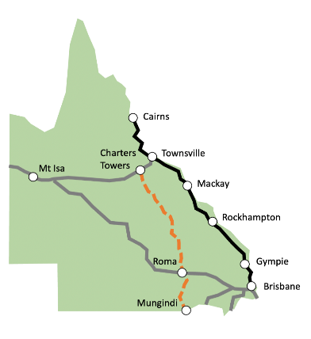

## Enhanced driving experiences

There are opportunities to further enhance the driving experience for those travelling the Bruce Highway. For example, heavy vehicle drivers and other road users while managing their fatigue at rest areas, could enjoy targeted tourism experiences. This could include connecting people and place through information and stories about the local regional history or natural attractions, as well as educating on the benefits of taking frequent rest stops while driving.

Additionally, tapping into technology advancements to allow for better journey planning along the Bruce Highway would further enhance the driving experience. Early warning systems that advise of flooded roads or traffic incidents would give road users the opportunity to find alternative routes to improve safety and save time.

## The Brisbane 2032 Olympic and Paralympic Games

Upgrades to the Bruce Highway in south-east Queensland are required to meet population growth and forecast traffic demand in the region. The Brisbane 2032 Olympic and Paralympic Games provides a unique opportunity to accelerate the delivery of key infrastructure across south-east Queensland.

## Economic Drivers

Adapted from the *State Infrastructure Plan* 2016

Figure 3: Update this header

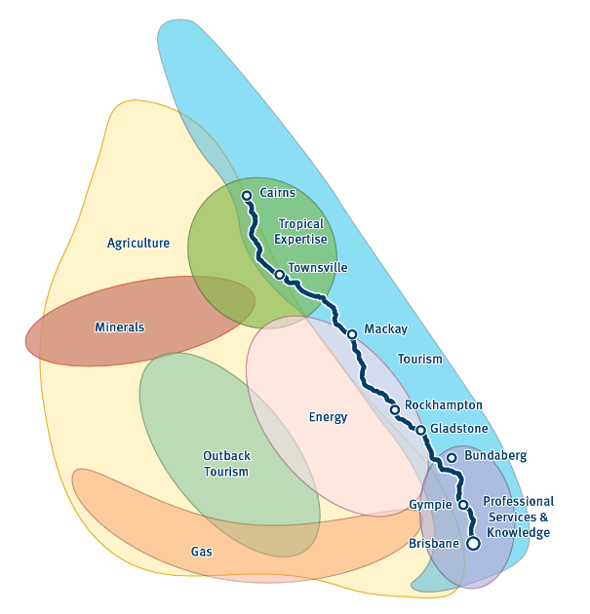

# Challenges

Given its extensive length, the Bruce Highway faces a diverse range of challenges, including congestion, flood resilience and safety. Identified investments proposed in the 15-year Vision and the three, five-year rolling Action Plans build on previous upgrades to the Bruce Highway to help address these challenges and aim to achieve better outcomes to connect communities and support the economy.

## Traffic volumes

The Bruce Highway carries a significant volume of traffic, ranging from about 2600 vehicles per day (annual average daily traffic (AADT)) around St Lawrence, north of Rockhampton, to around 165,000 near the Pine River, north of Brisbane. Heavy vehicle volumes travelling sections of the Bruce Highway range between 600 vehicles per day and 23,000 vehicles per day. Congestion, particularly in the south-east and on the approaches to regional centres impacts the economic productivity of the highway. This affects the entire network and the wider economy through increased freight costs and travel times for road users.

## Safety

The Bruce Highway faces safety challenges with these high traffic volumes contributing to serious and fatal accidents along the corridor, particularly in the more populated areas, as well as the less populated rural single carriage sections of the highway where people generally travel long distances at high speeds. Every serious injury and fatality on the road network has a ripple effect that impacts individuals, families and communities. A lack of rest areas and overtaking lanes at relevant locations along the Bruce Highway, combined with a varied traffic mix of heavy vehicles, commercial vehicles, private vehicles and recreational vehicles, such as campervans also present safety challenges along the highway.

## Asset limitations

Maintaining the pavement condition and the hundreds of bridges and structures along the Bruce Highway is a challenge, particularly given the age, condition, strength and widths of the existing infrastructure and the increasing user demands and disruptive weather impacts across the state.

## Climate impacts

Crossing a number of major floodplains and climatic zones, during extreme wet weather events, flooding can close the Bruce Highway at multiple locations. These temporary closures impact travel time reliability and disrupt the transport of goods and services across the state, causing increased costs for supply chains and population centres reliant on the highway. Entirely flood-proofing the Bruce Highway within the next 15 years would be cost-prohibitive and needs to be carefully balanced with safety, improving flood resilience and capacity improvements.

Understanding regional climate risks and integrating resilience and sustainability across the transport system will be critical so that, when extreme wet weather events do occur, communities can continue to access essential goods and services and the network can reopen faster. Other north-south routes, such as the Inland Freight Route provide an alternative to the Bruce Highway during extreme wet weather events.

## Environmental sustainability

Queensland is the most biologically diverse state in Australia and experiencing continued loss of biodiversity, consistent with the current national and worldwide declines in biodiversity and ecosystem services.

Biodiversity supports people’s health, well-being, culture, lifestyle and the economy and contributes to tourism, primary production and creative industries. Biodiverse natural environments enhance people’s physical, social and mental well-being, as it provides important cultural, spiritual and aesthetic value.

As an integral part of its business activities, Transport and Main Roads is committed to managing its environmental interactions and incorporating sustainable and innovative solutions to minimise its environmental footprint.

# Customer insights

An extensive program of customer research was conducted to understand users’ perspectives and priorities for the Bruce Highway and how these are changing over time. BHTAC members supported the researchers to ensure the participants reflected the diversity of customers who rely on the highway for both private and business needs. Research activities included analysing customer enquiries and submissions and conducting in-depth interviews and focus groups. The final research phase included an online survey of private citizens, business operators and commercial drivers. In total, 3945 respondents **completed** the online survey.

As part of this research, customers were asked to identify:

* their experiences on the highway, both positive and negative, by location and what highway characteristics were important to them
* how they prioritised the three BHTAC objectives: to unlock economic growth, build flood resilience and improve safety on the Bruce Highway, and how well the Bruce Highway is currently meeting these objectives.

Customers who participated in the research shared a number of positive experiences along the Bruce Highway, identifying the dual carriageway from Brisbane to Gympie and other sections along the highway with effective traffic flow and good rest areas as examples of how the highway performed well. On the flip side, customers identified sections of the highway where they were experiencing poor traffic flow, challenges in overtaking slower vehicles and issues with the road surface.

**Unlocking economic growth, building flood resilience** and **improving safety** were all important objectives to customers and inter-related. How a customer prioritised the objectives, depended upon factors, such as when and why people used the highway, frequency of travel and where respondents were located or the sections they travelled. This highlighted the value of asking customers about these factors in detail, which informed investment priorities by highway section. Overall, customers prioritised unlocking **economic growth** and **improving safety** similarly as most important, followed by **building flood resilience**.

Customers identified four characteristics that impacted their experience of the highway: consistency of travel experience, the capacity of the highway, maintaining reliable connectivity and the highway’s ability to safely handle different vehicle types.

Customers said they appreciated the opportunity to have their say on the Bruce Highway, highlighting the importance of community input.

## Consistency of travel experience

**Consistency** refers to a consistent experience when either driving or travelling as a passenger along the highway, including consistent travel times, the ability to safely manage fatigue at regular intervals, consistent signage, road treatments and road quality. Consistency aligned with all three of the BHTAC objectives, **unlocking economic growth, building flood resilience** and **improving safety**. Consistency was the top priority for all customer groups. Customers said the benefits of consistency included predictable travel times, traffic flow, safer behaviour by road-users (knowing what to expect when on the road) and reliable network connectivity.

## Capacity of the highway

**Capacity** refers to how much traffic the highway can handle safely, while maintaining good traffic flow. Good capacity contributed to the **unlocking economic growth** and **improving safety** objectives. Road treatments customers identified that increase and improve capacity included dual carriageway, town bypasses, regular overtaking lanes, access to alternative routes, roadwork management and road surface upgrades.

## Reliable connectivity

**Connectivity** refers to the Bruce Highway’s ability to efficiently connect customers with where they need to go and the products and services they need to access. Connectivity contributed to the **unlocking economic growth** and **building flood resilience** objectives. Interestingly, 36 per cent of private citizens selected connecting with friends and family as the most important reason for using the highway. The road treatments customers identified included timely access to information on alternate routes and flood mitigation measures.

## Ability to safely handle different vehicle types

The **ability to safely handle different vehicle types** refers to the highway’s effectiveness at safely accommodating different types of vehicles, from cars to heavy and long vehicles, light trucks and caravans. When the highway handles different vehicle types well, it contributed to **unlocking economic growth** and **improving safety**. Road treatments identified by customers included rest stops to cater for different road users, longer overtaking lanes, smoother road surface and road design standards to handle heavier vehicles.

## How this research supported the development of the 15-year Vision and Action Plans

The information and advice provided by BHTAC members, combined with critical information from the customer research work and technical analysis on deficiencies, were key inputs in prioritising potential future investments on the Bruce Highway. Through the BHTAC, the voices of customers have shaped this 15-year Vision and Action Plans for the Bruce Highway.

This document responds to the customer research findings targeting the highest priority improvements along the length of the Bruce Highway. These upgrades will improve the ability of the highway to safely handle different vehicle types and provide the consistency, capacity and connectivity sought by those who rely on the Bruce Highway to get them to their destination efficiently, safely and on time.

# Bruce Highway Vision

The vision for the Bruce Highway is to unlock economic growth, build flood resilience and improve safety to benefit current and future generations.

## Unlock economic growth

An efficient and safe road network bolsters our ability to grow Queensland’s economy and support businesses in all regions along the coast. Targeted investment in key parts of the corridor can open up new opportunities for trade, investment and jobs.

The Bruce Highway will have the **capacity** to support future population growth, **consistency** to ensure reliable freight movements with more **predictable** and **efficient** travel times, and **connectivity** to enable road users and freight to get to where they need to go and when they need to get there.

## Build flood resilience

Through targeted upgrades, sections of the Bruce Highway will be more **resilient** to extreme weather events, improving **connectivity** and providing communities and regions more **consistent** access to essential services. Road users will appreciate improved advance warning of likely flooding to enable them to make alternative travel arrangements.

## Improve safety

To reduce fatalities and serious injuries, priority upgrades in this *15-year Vision and Action Plans* for *the Bruce Highway* and the companion *Safer Bruce* *2030* Action Plan will enable the Bruce Highway to better accommodate the **mix of different vehicle types**. Drivers will be provided with a **safer and more consistent driving experience** along the length of the highway, including better separation of vehicles on single carriageways, safer places to pull over and rest, more opportunities to safely overtake other vehicles and advanced hazard warning signs. In 2020, the Queensland Government committed to reduce the rate of fatalities on the Bruce Highway by 60 per cent over 10 years to 2030, through the development of the *Safer Bruce 2030* Action Plan.

## The vision for the Bruce Highway is to unlock economic growth, build flood resilience and improve safety to benefit current and future generations.

### To achieve this vision, the three, five-year rolling Action Plans include the following priorities:

* improving traffic flow on the Bruce Highway on the Brisbane to Sunshine Coast link with additional capacity between Brisbane and Caboolture and six-laning from Steve Irwin Way to Johnson Road at Beerburrum
* duplicating priority sections of the Bruce Highway, including north of Gympie from Curra to Tiaro, at Bajool south of Rockhampton, south of Mackay and north of Townsville
* completing WCLT with ATLM on all remaining single carriageway sections of the highway by 2030–31 to provide a more safe and consistent journey experience from Brisbane to Cairns
* upgrading narrow bridges (less than 8.4 metres wide) to complement the application of WCLT treatment for safer and more reliable movement of freight and all road users
* additional overtaking lanes (new and upgraded) along the Bruce Highway
* additional rest areas (new and upgrades to existing facilities) at priority sites between Brisbane and Cairns as part of a whole-of-corridor fatigue management strategy
* a major program of pavement rehabilitation and strengthening on priority locations between Brisbane and Cairns to improve ride quality and asset condition
* priority intersection upgrades to improve safety and travel consistency
* applying and updating technology, including Intelligent Transport Systems (ITS), to provide customers with better advance warning and predictive information to inform their travel choices
* enhancing flood resilience along the highway.

### Three, five-year rolling action plans

The three, five-year rolling action plans are represented in each regional map, corresponding with a table that includes a description of the project, an indicative timeframe for delivery (known as a tranche and depicted with small triangular shapes) and the project’s benefits. The first tranche covers the period 2024–25 to 2028–29, the second tranche covers 2029–30 to 2033–34 and the third tranche covers 2034–35 to 2038–39—noting as the current BHUP 2013–14 to 2027–28 winds down, the first tranche of the Action Plans will be ramping up. The benefits align with the three objectives to **unlock economic growth**, **build flood resilience** and **improve safety**.

The priorities recommended by the BHTAC in the 15-year Vision and Action Plans for the Bruce Highway are subject to further planning and business case development, including rigorous assessment and consideration of financial, economic and environmental factors to confirm project scope, cost and delivery timeframes.

Project and state-wide program priorities outlined in the Vision and Action Plans will inform Bruce Highway investment decisions as part of future Federal and State Budgets, with funding outcomes published in the annual Queensland Transport and Roads Investment Program. This transparency of future works will give the community and industry increased certainty regarding Bruce Highway upgrade delivery timeframes.

TMR’s decentralised operations have provided a strong local presence in Queensland communities for many years. Across Queensland, TMR has six regional offices with employees located throughout these regions to facilitate the safe and efficient delivery of transport infrastructure and operations of the Queensland transport system.

The Bruce Highway traverses four TMR regions, namely North Coast Region, Southern Queensland Region (through the Wide Bay Burnett District), Central Region (through the Fitzroy District and Mackay/Whitsunday District) and North Queensland Region (through the Northern District and Far North District).

## State-wide package priorities

There are a number of state-wide packages that include priorities across all four regions that contribute towards achieving the 15-year Vision. Specific priority locations and scope will be informed through further planning.

Over the next 15 years, between Brisbane and Cairns, the BHTAC recommends the delivery of the following key state-wide priority packages to **unlock economic growth, build flood resilience** and **improve safety**, including:

* undertaking a major program of **pavement rehabilitation and strengthening** on priority locations between Brisbane and Cairns to improve ride quality and asset resilience to extreme weather events
* additional **rest areas** (new and upgrades to existing facilities) at priority sites between Brisbane and Cairns as part of a whole-of-corridor **fatigue management strategy**
* maintaining an **Intelligent Transport System** (ITS) between Brisbane and Cairns to provide customers with better advance warning and predictive information to inform their travel choices
* major **culvert rehabilitation** works to enhance asset resilience
* investigating a flood warning system. Combining TMR data with rainfall and landscape models will help assess flood risk at particular Bruce Highway locations and provide customers with improved and timely flood warning advice when planning their trip.
* **route and link planning** to better inform detailed priority project development.

### Statewide proposed investments

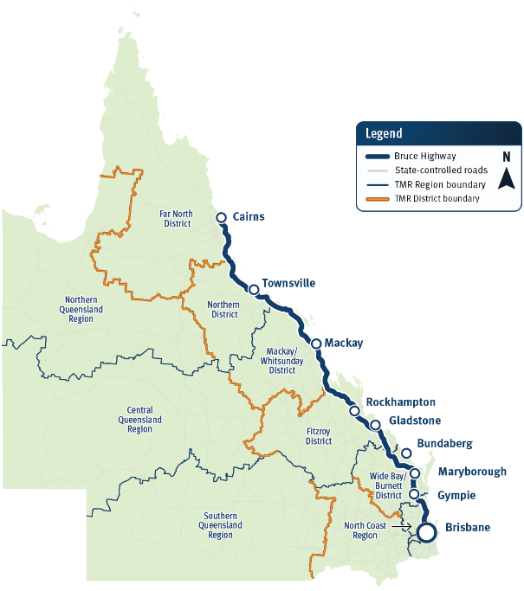

Map 1: Queensland indicating TMR’s regional and district boundaries, with the Bruce Highway highlighted.

| Bruce Highway Proposed Investment | Indicative Benefit Alignment | Proposed Delivery Tranche |
| --- | --- | --- |
| Brisbane - Cairns: Route and link planning |  | * 2024–25 to 2028–29 |
| Brisbane - Cairns: Pavement strengthening | * Unlock economic growth * Improve safety * Build flood resilience | * 2029–30 to 2033–34 * 2034–35 to 2038–39 |
| Brisbane - Cairns: Fatigue management and rest areas | * Improve safety | * 2024–25 to 2028–29 * 2029–30 to 2033–34 |
| Brisbane - Cairns: Intelligent Transport Systems rehabilitation | * Unlock economic growth * Improve safety | * 2024–25 to 2028–29 * 2029–30 to 2033–34 * 2034–35 to 2038–39 |
| Brisbane - Cairns: Major culvert rehabilitation works | * Improve safety * Build flood resilience | * 2024–25 to 2028–29 * 2029–30 to 2033–34 * 2034–35 to 2038–39 |
| Brisbane - Cairns: Bruce Highway flood warning system | * Unlock economic growth * Improve safety * Build flood resilience | * 2024–25 to 2028–29 |

## North Coast Region

TMR’s North Coast Region is one of Queensland’s fastest-growing regions and a major tourism destination, featuring the Sunshine Coast and its hinterland and beautiful beaches, including Caloundra, Mooloolaba, Coolum and Noosa Heads. Residents here enjoy proximity to Brisbane and an outdoor lifestyle, with many working in the tourism, leisure, construction and retail sectors. As travellers head north along the Bruce Highway from Brisbane, they are treated to the craggy peaks of the spectacular Glass House Mountains. These mountains are one of the Q150 Icons.

The Bruce Highway in the North Coast Region between Brisbane and Gympie is generally a motorway-standard road (between four and eight lanes) and carries the highest traffic volumes of around 165,000 vehicles per day.

## North Coast priorities

BHTAC members and customers indicated the key issues on this section of the highway included traffic flow and congestion with these issues often linked to delays due to roadworks. The customer research also showed that although congestion was a concern, the dual carriageway was viewed as a positive attribute.

Over the next 15 years, between Brisbane and Gympie, the BHTAC recommends the delivery of the following key priorities to **unlock economic growth, build flood resilience** and **improve safety**, including:

* improving traffic flow on the Bruce Highway with **additional capacity between Brisbane and Caboolture**
* six-laning upgrade between **Steve Irwin Way to Johnston Road at Beerburrum**
* upgrading and maintaining **ITS** on the Brisbane to Gympie link to provide customers with better advance warning and predictive information to inform their travel choices.

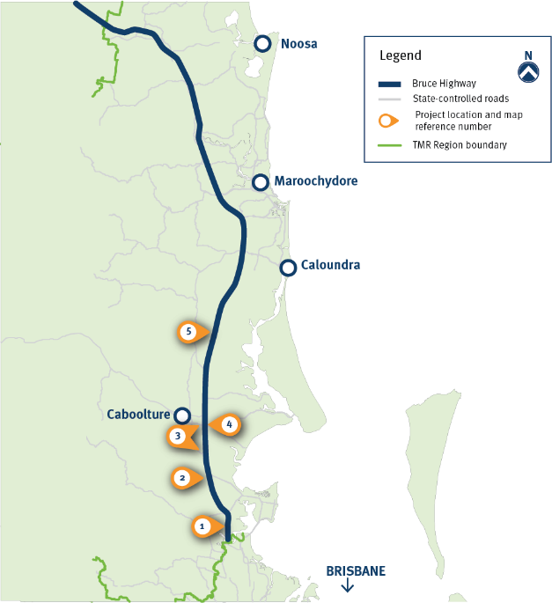

Map 2: North Coast Region

| Bruce Highway Proposed Investment | Indicative Benefit Alignment | Proposed Delivery Tranche |
| --- | --- | --- |
| 1. Brisbane - Gympie: Dohles Rocks Road to Anzac Avenue upgrade | * Unlock economic growth * Improve safety | * 2024–25 to 2028–29 |
| 1. Brisbane - Gympie: Anzac Avenue to Uhlmann Road upgrade | * Unlock economic growth * Improve safety | * 2024–25 to 2028–29 * 2029–30 to 2033–34 |
| 1. Brisbane - Gympie: Buchanan Road and Uhlmann Road interchange upgrades | * Unlock economic growth * Improve safety | * 2024–25 to 2028–29 |
| 1. Brisbane - Gympie: Uhlmann Road to Caboolture-Bribie Island Road upgrade | * Unlock economic growth * Improve safety | * 2024–25 to 2028–29 * 2029–30 to 2033–34 * 2034–35 to 2038–39 |
| 1. Brisbane - Gympie: Steve Irwin Way to Johnston Road upgrade | * Unlock economic growth * Improve safety | * 2029–30 to 2033–34 * 2034–35 to 2038–39 |

## Southern Queensland Region – Wide Bay/Burnett District

TMR’s Wide Bay/Burnett District within Southern Queensland Region has a number of drawcards for visitors and residents alike, including whale watching in Hervey Bay, four-wheel driving at the World Heritage K’gari (Fraser Island), turtle nesting and hatching at Mon Repos Beach, north of Bargara and the magnificent Mary River which undulates through the region. The region includes the farming and sugar towns of Maryborough, Childers, Gin Gin and Bundaberg.

The Bruce Highway within the Southern Queensland Region is generally of rural highway standard, including overtaking lanes. The Cooroy to Curra Section D project is scheduled for completion by late-2024, weather permitting. This project will provide a motorway standard highway between Brisbane and Curra, north of Gympie. The Tiaro Bypass project, currently in planning and funded for delivery, will also improve safety, flood immunity and traffic flow in and around Tiaro.

## Southern Queensland – Wide Bay/ Burnett District priorities

BHTAC members and customers said the key issues on this section of the highway included delays through townships, overtaking lane frequency and length, rest area provision, road quality and road design, including shoulder width.

Over the next 15-years, the BHTAC recommends the delivery of the following key priorities in the Southern Queensland Region to **unlock** **economic growth, build flood resilience** and **improve safety**, including:

* continuing **duplication of the highway north between Curra and Tiaro**, increasing the capacity of the highway from two to four lanes
* delivering a major package of interim **safety and renewal works between Tiaro and Maryborough**
* **completing WCLT on two-lane rural highway sections**
* **upgrading narrow bridges** (less than 8.4 metres wide), including Duingal Creek, Walily Creek and Tararan Creek bridges to complement the application of WCLT
* delivering **safety and minor capacity upgrades** of priority rural highway sections in the Southern Queensland Region.

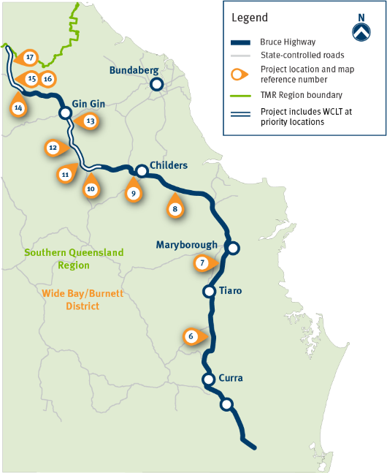

Map 3: Southern Queensland Region – Wide Bay/Burnett District

| Bruce Highway Proposed Investment | Indicative Benefit Alignment | Proposed Delivery Tranche |
| --- | --- | --- |
| 1. Gympie - Maryborough: Curra to Tiaro upgrade | * Unlock economic growth * Improve safety * Build flood resilience | * 2029–30 to 2033–34 * 2034–35 to 2038–39 |
| 1. Gympie - Maryborough: Tiaro to Maryborough interim safety and critical maintenance/rehabilitation works | * Unlock economic growth * Improve safety * Build flood resilience | * 2029–30 to 2033–34 |
| 1. Maryborough - Gin Gin: Torbanlea to Childers safety and minor capacity upgrade | * Unlock economic growth * Improve safety * Build flood resilience | * 2029–30 to 2033–34 |
| 1. Maryborough - Gin Gin: Childers to Apple Tree Creek safety upgrade | * Improve safety * Build flood resilience | * 2029–30 to 2033–34 |
| 1. Maryborough - Gin Gin: Sandy Creek to Duingal Creek safety upgrades (incl. WCLT) | * Unlock economic growth * Improve safety * Build flood resilience | * 2024–25 to 2028–29 |
| 1. Maryborough - Gin Gin: Duingal Creek to Booyal School bridge replacement and safety upgrade (incl. WCLT) | * Improve safety * Build flood resilience | * 2024–25 to 2028–29 * 2029–30 to 2033–34 |
| 1. Maryborough - Gin Gin: Booyal School to Wallaville flood resilience and safety upgrade (incl. WCLT) | * Improve safety | * 2024–25 to 2028–29 |
| 1. Maryborough - Gin Gin: Gin Gin southern approach safety upgrades (incl. WCLT) | * Improve safety * Build flood resilience | * 2024–25 to 2028–29 |
| 1. Gin Gin - Benaraby: Tararan Creek bridge replacement (incl. WCLT) | * Improve safety * Build flood resilience | * 2029–30 to 2033–34 |
| 1. Gin Gin - Benaraby: Kalpowar Road to north of Walily Creek safety upgrade (incl. WCLT) | * Improve safety * Build flood resilience | * 2024–25 to 2028–29 * 2029–30 to 2033–34 |
| 1. Gin Gin - Benaraby: North of Walily Creek to Telegraph Creek safety upgrade (incl. WCLT) | * Improve safety * Build flood resilience | * 2024–25 to 2028–29 * 2029–30 to 2033–34 |
| 1. Gin Gin - Benaraby: Barton Road to Kolan River safety upgrade (incl. WCLT) | * Unlock economic growth * Improve safety * Build flood resilience | * 2024–25 to 2028–29 * 2029–30 to 2033–34 |

## Central Queensland Region – Fitzroy District and Mackay/Whitsunday District

Those who either visit Central Queensland or call it home are treated to a number of natural wonders, including the World Heritage Great Barrier Reef, the Whitsunday Islands, numerous beautiful beaches and national parks featuring limestone caves.

The region has the port city of Gladstone, servicing the coal, aluminium and power industries, Rockhampton on the Fitzroy River, renowned for its beef cattle and the coastal and port centres of Mackay and Bowen which support the coal, sugar and tourism sectors.

The Bruce Highway within Central Queensland Region is generally of rural highway standard, including overtaking lanes, with either additional lanes or bypasses in urban areas. The delivery of the Mackay Ring Road – Stage 1 (completed in late 2020) has improved freight efficiency, safety and community amenity by reducing traffic, including heavy vehicle movements through the urban areas in these provincial cities.

## Central Queensland Region – Fitzroy District and Mackay/Whitsunday District priorities

BHTAC members and customers said the key issues on this section of the highway included congestion in urban areas, driver fatigue, overtaking lane frequency and length, rest area provision, road quality and road design (including shoulder width), narrow bridges and flood resilience.

Over the next 15 years, the BHTAC recommends the delivery of the following key priorities in Central Queensland to **unlock** **economic growth, build flood resilience** and **improve safety**, including:

* completing the **Bajool duplication**
* progressing **duplication south of Mackay in stages to Hay Point Road**
* **completing WCLT on two-lane rural highway sections**
* **upgrading narrow bridges** (less than 8.4 metres wide), including Sarina Rail Bridge and Slater Creek Bridge to complement the application of WCLT treatment for safer and more reliable movement of freight and all road users
* delivering **overtaking lane packages on priority sections** in the Central Queensland Region
* **intersection upgrades** to improve safety at key sites in Central Queensland Region.

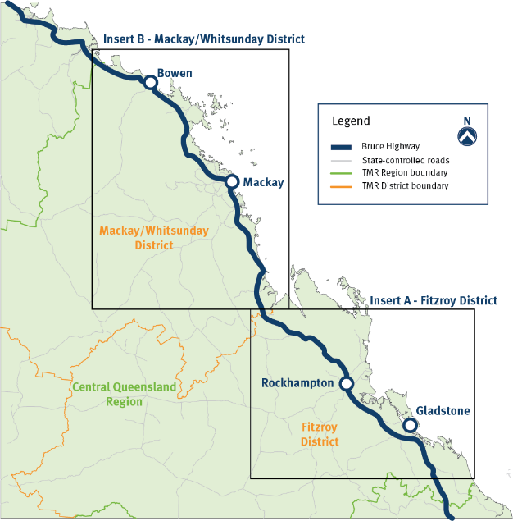

Map 4: Central Queensland Region – Fitzroy and Mackay/Whitsunday Districts

### Central Queensland Region - Fitzroy District (Insert A)

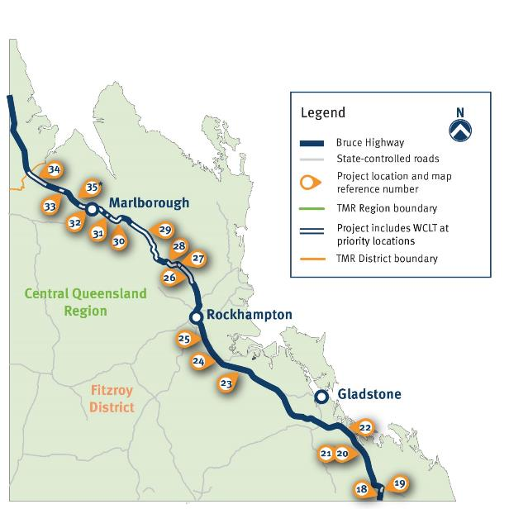

Map 5: Central Queensland Region - Fitzroy District (Insert A)

| Bruce Highway Proposed Investment | Indicative Benefit Alignment | Proposed Delivery Tranche |
| --- | --- | --- |
| 1. Gin Gin - Benaraby: Palm Creek to Colosseum Creek upgrade (incl. WCLT) | * Improve safety | * 2029–30 to 2033–34 |
| 1. Gin Gin - Benaraby: House Creek to Miriam Vale safety upgrade (incl. WCLT) | * Improve safety | * 2029–30 to 2033–34 |
| 1. Gin Gin - Benaraby: Miriam Vale to Tannum Sands Road (Stage 2) overtaking lanes | * Unlock economic growth * Improve safety | * 2029–30 to 2033–34 |
| 1. Gin Gin - Benaraby: Miriam Vale to Tannum Sands Road (Stage 1) overtaking lanes | * Unlock economic growth * Improve safety | * 2029–30 to 2033–34 |
| 1. Gin Gin - Benaraby: Iveragh to Tannum Sands intersection upgrade package | * Improve safety * Build flood resilience | * 2029–30 to 2033–34 |
| 1. Benaraby - Rockhampton: Gladstone-Mount Larcom Road to Bajool-Port Alma Road overtaking lanes | * Unlock economic growth * Improve safety | * 2029–30 to 2033–34 |
| 1. Benaraby - Rockhampton: Bajool duplication | * Improve safety | * 2024–25 to 2028–29 |
| 1. Benaraby - Rockhampton: Bajool to Gavial-Gracemere Road overtaking lanes | * Unlock economic growth * Improve safety | * 2029–30 to 2033–34 |
| 1. Rockhampton - St Lawrence: Etna Creek Road to Rossmoya Road safety upgrade (incl. WCLT) | * Unlock economic growth * Improve safety | * 2024–25 to 2028–29 |
| 1. Rockhampton - St Lawrence: Rossmoya Road to Plentiful Creek safety upgrade (incl. WCLT) | * Improve safety | * 2024–25 to 2028–29 |
| 1. Rockhampton - St Lawrence: north of Alligator Creek safety upgrade (incl. WCLT) | * Improve safety | * 2024–25 to 2028–29 |
| 1. Rockhampton - St Lawrence: Atkinson’s Road to Raspberry Road safety upgrade (incl. WCLT) | * Improve safety | * 2024–25 to 2028–29 * 2029–30 to 2033–34 |
| 1. Rockhampton - St Lawrence: Eden Gary Road to Princhester Road safety upgrade (incl. WCLT) | * Improve safety | * 2024–25 to 2028–29 * 2029–30 to 2033–34 |
| 1. Rockhampton - St Lawrence: Princhester Road to Marlborough floodways safety upgrade (incl. WCLT) | * Improve safety | * 2024–25 to 2028–29 |
| 1. Rockhampton - St Lawrence: north of Kooltandra-Ogmore Road North safety upgrade (incl. WCLT) | * Improve safety | * 2024–25 to 2028–29 * 2029–30 to 2033–34 |
| 1. Rockhampton - St Lawrence: south of Mount Bison Road safety upgrade (incl. WCLT) | * Improve safety | * 2029–30 to 2033–34 |
| 1. Rockhampton - St Lawrence: Mount Bison to Tooloombah Creek safety upgrade (incl. WCLT) | * Improve safety | * 2024–25 to 2028–29 * 2029–30 to 2033–34 |
| 1. Rockhampton - St Lawrence: Priority intersection upgrades | * Improve safety | * 2034–35 to 2038–39 |

### Central Queensland Region - Mackay/Whitsunday District (Insert B)

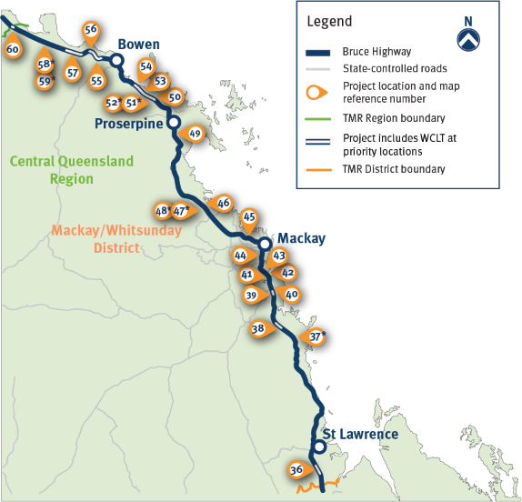

Map 6: Central Queensland Region – Mackay/Whitsunday District (Insert B)

| Bruce Highway Proposed Investment | Indicative Benefit Alignment | Proposed Delivery Tranche |
| --- | --- | --- |
| 1. Rockhampton - St Lawrence: Prospect Creek to Waverley Creek safety upgrade (incl. WCLT) | * Improve safety | * 2029–30 to 2033–34 |
| 1. St Lawrence - Mackay: WCLT, widening and pavement rehabilitation upgrades | * Improve safety | * 2024–25 to 2028–29 |
| 1. St Lawrence - Mackay: Smarts Road to Andrew Street overtaking lanes and pavement rehabilitation | * Improve safety * Build flood resilience | * 2034–35 to 2038–39 |
| 1. St Lawrence - Mackay: Sarina rail bridge upgrade and widening (incl. WCLT) | * Improve safety | * 2024–25 to 2028–29 |
| 1. St Lawrence - Mackay: Sarina to Hay Point overtaking lane | * Unlock economic growth * Improve safety | * 2034–35 to 2038–39 |
| 1. 41 St Lawrence - Mackay: Alligator Creek bridge replacement | * Unlock economic growth * Improve safety | * 2024–25 to 2028–29 |
| 1. St Lawrence - Mackay: Hay Point Road to Munbura Road duplication | * Unlock economic growth * Improve safety | * 2034–35 to 2038–39 |
| 1. St Lawrence - Mackay: Munbura Road to Crouchs Road duplication | * Unlock economic growth * Improve safety | * 2034–35 to 2038–39 |
| 1. St Lawrence - Mackay: Crouchs Road to Temples Lane duplication | * Unlock economic growth * Improve safety | * 2034–35 to 2038–39 |
| 1. Mackay - Proserpine: Conningsby State School North overtaking lanes | * Unlock economic growth * Improve safety | * 2034–35 to 2038–39 |
| 1. Mackay - Proserpine: St Helens overflow to north of Mackenzies Rd overtaking lanes, pavement rehabilitation | * Unlock economic growth * Improve safety | * 2034–35 to 2038–39 |
| 1. Mackay - Proserpine: Priority WCLT, widening and pavement rehabilitation upgrades | * Improve safety | * 2024–25 to 2028–29 |
| 1. Mackay - Proserpine: Priority intersection upgrades | * Improve safety | * 2034–35 to 2038–39 |
| 1. Mackay - Proserpine: O’Connell River and Proserpine overtaking lanes | * Unlock economic growth * Improve safety | * 2034–35 to 2038–39 |
| 1. Proserpine - Bowen: Dingo Creek to north of Eden Lassie Road (Stage 1) safety upgrades (incl. WCLT) | * Improve safety | * 2029–30 to 2033–34 |
| 1. Proserpine - Bowen: Priority WCLT, widening and pavement rehabilitation upgrades | * Improve safety | * 2029–30 to 2033–34 |
| 1. Proserpine - Bowen: Priority intersection upgrades | * Improve safety | * 2034–35 to 2038–39 |
| 1. Proserpine - Bowen: Dingo Creek to north of Eden Lassie Road (Stage 2) safety upgrades (incl. WCLT) | * Improve safety | * 2024–25 to 2028–29 |
| 1. Proserpine - Bowen: Emu Creek north bridge widening and overtaking lanes | * Unlock economic growth * Improve safety | * 2034–35 to 2038–39 |
| 1. Bowen - Ayr: Euri Creek to Abbot Point bridge widening and safety upgrades (incl. WCLT) | * Improve safety | * 2029–30 to 2033–34 |
| 1. Bowen - Ayr: Abbot Point North bridge widening and safety upgrades (incl. WCLT) | * Improve safety | * 2024–25 to 2028–29 |
| 1. Bowen - Ayr: Splitter Creek to Plain Creek widening and safety upgrades (incl. WCLT) | * Improve safety | * 2024–25 to 2028–29 |
| 1. Bowen - Ayr: Priority WCLT widening and pavement rehabilitation upgrades | * Improve safety | * 2024–25 to 2028–29 |
| 1. Bowen - Ayr: Priority intersection upgrades | * Improve safety | * 2034–35 to 2038–39 |
| 1. Bowen - Ayr: Slater Creek bridge replacement (incl. WCLT) | * Improve safety | * 2029–30 to 2033–34 |

## North Queensland Region – Northern District and Far North District

The beautiful Great Barrier Reef is one of the many unique experiences the North Queensland Region offers, with thousands of visitors every year flocking to this part of Australia to swim, snorkel and dive. The port and defence city of Townsville is famous for The Strand, Castle Hill and access to the spectacular Magnetic Island. The northern tropical city of Cairns is the gateway to the reef, northern beaches, ancient World Heritage rainforests and Cape York Peninsula. Other iconic locations in the North Queensland Region include the coastal and port town of Bowen, the Burdekin sugarcane region, Ingham and Innisfail and the beachside areas of Cardwell and Mission Beach.

The Bruce Highway in the North Queensland Region is generally of rural highway standard, including overtaking lanes, with duplication on approaches and within key urban centres. In recent years, the Townsville Ring Road has progressively been constructed in stages to remove through-traffic from the Townsville urban area to improve safety, amenity and traffic flow. Duplication of the Townsville Ring Road was completed in 2023. Further north, major capacity upgrades have been progressively delivered, including the duplication of the highway between Edmonton to Gordonvale, south of Cairns, with construction completed in 2023.

## North Queensland Region – Northern District and Far North District priorities

BHTAC members and customers said the key issues on this section of the highway included overtaking lane frequency and length, rest area provision, road quality and design (including width and alignment), narrow bridges and flood resilience.

Over the next 15 years, the BHTAC recommends the delivery of the following key priorities in North Queensland to **unlock** **economic growth, build flood resilience** and **improve safety**, including:

* delivering **additional major capacity in Townsville and on southern and northern approaches**, including:
  + service road upgrades south of Townsville, including improved connections to the Townsville State Development Area to support regional economic development opportunities
  + upgrading University Road between Douglas and Annandale
  + duplicating the highway north of Townsville between Pope Road and Purono Parkway
* **completing WCLT on two-lane rural highway sections**, from south of Ayr up to Gordonvale, near Cairns
* **upgrading 15 narrow bridges** (less than 8.4 metres wide) in the North Queensland Region to complement the application of WCLT treatment for safer and more reliable movement of freight and all road users
* continued **rehabilitation and maintenance of the Burdekin River bridge**
* delivering **overtaking lane packages** on priority sections in North Queensland Region
* improving the **resilience of the highway to extreme weather events** between Liverpool Creek and Cowley, south of Innisfail and at Eubenangee, north of Innisfail.

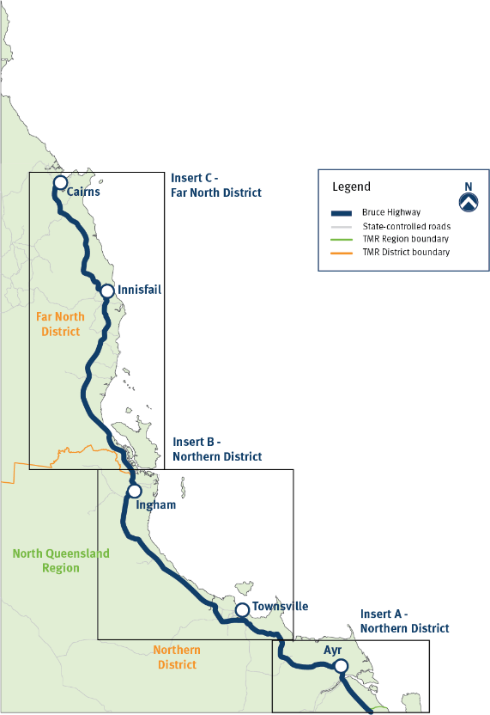

Map 7: North Queensland Region – Northern and Far North Districts

### North Queensland Region - Northern District (Insert A)

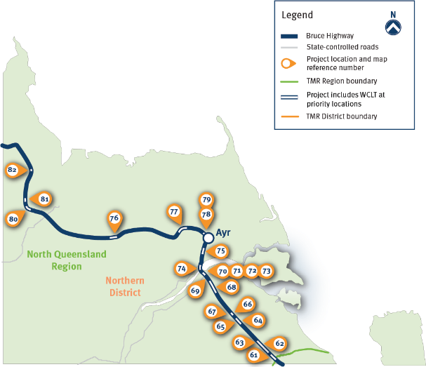

Map 8: North Queensland Region – Northern District (Insert A)

| Bruce Highway Proposed Investment | Indicative Benefit Alignment | Proposed Delivery Tranche |
| --- | --- | --- |
| 1. Bowen - Ayr: Wangaratta Creek to south of Yellow Gin Creek safety upgrade (incl. WCLT) | * Improve safety | * 2024–25 to 2028–29 |
| 1. Bowen - Ayr: north of Beachmont Road to north of Saltwater Creek safety upgrade (incl. WCLT) | * Improve safety | * 2024–25 to 2028–29 |
| 1. Bowen - Ayr: Saltwater Creek to Wallace Road overtaking lanes | * Unlock economic growth * Improve safety | * 2034–35 to 2038–39 |
| 1. Bowen - Ayr: Old Bowen Road intersection upgrade | * Improve safety | * 2034–35 to 2038–39 |
| 1. Bowen - Ayr: (Package 1) south of Home Hill safety upgrade (incl. WCLT) | * Improve safety | * 2024–25 to 2028–29 |
| 1. Bowen - Ayr: (Package 2) south of Home Hill safety upgrade (incl. WCLT) | * Improve safety | * 2024–25 to 2028–29 |
| 1. Bowen - Ayr: Homestead Road and Charlies Hill Road intersection upgrade | * Improve safety | * 2034–35 to 2038–39 |
| 1. Bowen - Ayr: north of Koolkuna Road to First Street (Home Hill) safety upgrade (incl. WCLT) | * Improve safety | * 2024–25 to 2028–29 |
| 1. Bowen - Ayr: Bojak Road intersection upgrade | * Improve safety | * 2034–35 to 2038–39 |
| 1. Bowen - Ayr: South of Burdekin River safety upgrade (incl. WCLT) | * Unlock economic growth * Improve safety | * 2029–30 to 2033–34 |
| 1. Bowen - Ayr: Burdekin River Bridge corrosion protection | * Unlock economic growth * Improve safety | * 2024–25 to 2028–29 * 2029–30 to 2033–34 * 2034–35 to 2038–39 |
| 1. Bowen - Ayr: (Package 1) Burdekin River Bridge maintenance rehabilitation | * Unlock economic growth * Improve safety | * 2024–25 to 2028–29 |
| 1. Bowen - Ayr: (Package 2) Burdekin River Bridge maintenance rehabilitation | * Unlock economic growth * Improve safety | * 2034–35 to 2038–39 |
| 1. Bowen - Ayr: North of Burdekin River safety upgrade (incl. WCLT) | * Unlock economic growth * Improve safety | * 2024–25 to 2028–29 |
| 1. Bowen - Ayr: south of Ayr safety package (incl. WCLT) | * Unlock economic growth * Improve safety | * 2029–30 to 2033–34 |
| 1. Ayr - Townsville: West Barratta Creek Bridge replacement (incl. WCLT) | * Improve safety * Build flood resilience | * 2029–30 to 2033–34 |
| 1. Ayr - Townsville: Brandon to Five Ways Road safety upgrade (incl. WCLT) | * Improve safety | * 2024–25 to 2028–29 |
| 1. Ayr - Townsville: Ayr to Brandon overtaking lanes | * Unlock economic growth * Improve safety | * 2029–30 to 2033–34 |
| 1. Ayr - Townsville: Ayr to Brandon safety upgrade (incl. WCLT) | * Unlock economic growth * Improve safety | * 2024–25 to 2028–29 |
| 1. Ayr - Townsville: Palm Creek Bridge replacement (incl. WCLT) | * Improve safety | * 2024–25 to 2028–29 |
| 1. Ayr - Townsville: St. Margaret Creek Bridge replacement (incl. WCLT) | * Improve safety | * 2024–25 to 2028–29 |
| 1. Ayr - Townsville: Emmett Creek Bridge replacement (incl. WCLT) | * Improve safety | * 2029–30 to 2033–34 |

### North Queensland Region - Northern District (Insert B)

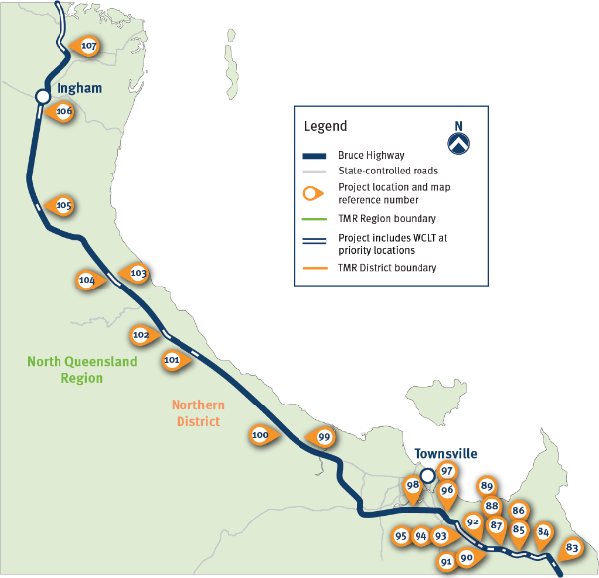

| Bruce Highway Proposed Investment | Indicative Benefit Alignment | Proposed Delivery Tranche |
| --- | --- | --- |
| 1. Ayr - Townsville: Mackenzie Creek Bridge replacement | * Improve safety | * 2029–30 to 2033–34 |
| 1. Ayr - Townsville: Cape Cleveland Road (AIMS turn-off) safety upgrade (incl. WCLT) | * Improve safety | * 2024–25 to 2028–29 |
| 1. Ayr - Townsville: Cape Cleveland Road (AIMS turn-off) to Killymoon Creek safety upgrade (incl. WCLT) | * Improve safety | * 2024–25 to 2028–29 |
| 1. Ayr - Townsville: Killymoon Creek Bridge replacement (incl. WCLT) | * Improve safety * Build flood resilience | * 2024–25 to 2028–29 |
| 1. Ayr - Townsville: south of Marron Road to Alligator Creek safety upgrade (incl. WCLT) | * Improve safety | * 2029–30 to 2033–34 |
| 1. Ayr - Townsville: Killymoon Creek to Tindall Court safety upgrade (incl. WCLT) | * Improve safety | * 2029–30 to 2033–34 |
| 1. Ayr - Townsville: Alligator Creek Bridge replacement (incl. WCLT) | * Improve safety * Build flood resilience | * 2024–25 to 2028–29 |
| 1. Ayr - Townsville: Allendale Drive intersection upgrade | * Unlock economic growth * Improve safety | * 2029–30 to 2033–34 |
| 1. Ayr - Townsville: Allendale Drive safety upgrade (incl. WCLT) | * Unlock economic growth * Improve safety | * 2024–25 to 2028–29 |
| 1. Ayr - Townsville: Muntalunga Drive intersection upgrade | * Unlock economic growth * Improve safety | * 2029–30 to 2033–34 |
| 1. Ayr - Townsville: Townsville Southern Access Corridor (Allendale Dr to Zinc Rd safety upgrade (incl. WCLT) | * Unlock economic growth * Improve safety | * 2029–30 to 2033–34 * 2034–35 to 2038–39 |
| 1. Ayr - Townsville: south of Julago Street to south of Zinc Road safety upgrade (incl. WCLT) | * Unlock economic growth * Improve safety | * 2024–25 to 2028–29 |
| 1. Ayr - Townsville: Stuart railway overpass bridge replacement (incl. WCLT) | * Unlock economic growth * Improve safety | * 2024–25 to 2028–29 |
| 1. Ayr - Townsville: Townsville State Development Area upgrade (northern service roads) | * Unlock economic growth * Improve safety | * 2034–35 to 2038–39 |
| 1. Ayr - Townsville: Townsville State Development Area upgrade (southern service roads) | * Unlock economic growth * Improve safety | * 2029–30 to 2033–34 |
| 1. Townsville - Ingham: Stage 1 University Road link upgrade (Douglas to Annandale) | * Unlock economic growth * Improve safety | * 2034–35 to 2038–39 |
| 1. Townsville - Ingham: Pope Road to Purono Parkway duplication | * Improve safety | * 2024–25 to 2028–29 |
| 1. Townsville - Ingham: Saunders Beach and Bluewater overtaking lanes | * Unlock economic growth * Improve safety | * 2029–30 to 2033–34 |
| 1. Townsville - Ingham: Station Creek Bridge replacement (incl. WCLT) | * Improve safety | * 2029–30 to 2033–34 |
| 1. Townsville - Ingham: Crystal Creek to Stony Creek safety upgrade (incl. WCLT) | * Improve safety | * 2029–30 to 2033–34 |
| 1. Townsville - Ingham: Mount Spec Road and Waterfall Creek overtaking lanes | * Unlock economic growth * Improve safety | * 2034–35 to 2038–39 |
| 1. Townsville - Ingham: south of Studs Road to Spring Gully safety upgrade (incl. WCLT) | * Improve safety | * 2024–25 to 2028–29 |
| 1. Townsville - Ingham: Larkins Road to Grassos Road safety upgrade (incl. WCLT) | * Improve safety | * 2029–30 to 2033–34 |
| 1. Townsville - Ingham: Ingham (south of Challands St) safety upgrade (incl. WCLT) | * Improve safety | * 2029–30 to 2033–34 |
| 1. Ingham - Innisfail: Seymour Creek and Arnot Creek widening (incl. WCLT) | * Improve safety | * 2029–30 to 2033–34 |

### Far North Queensland Region - Northern District (Insert C)

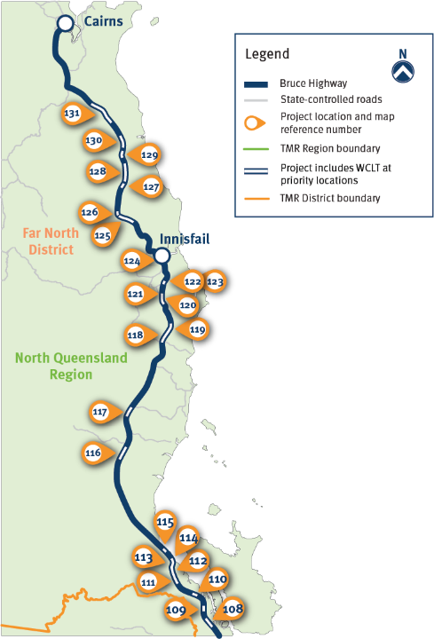

Map 9: Far North Queensland Region – Northern District (Insert C)

| Bruce Highway Proposed Investment | Indicative Benefit Alignment | Proposed Delivery Tranche |
| --- | --- | --- |
| 1. Ingham - Innisfail: south of Rungoo safety upgrade (incl. WCLT) | * Unlock economic growth * Improve safety | * 2024–25 to 2028–29 |
| 1. Ingham - Innisfail: Porters Creek Bridge duplication (incl. WCLT) | * Improve safety * Build flood resilience | * 2024–25 to 2028–29 |
| 1. Ingham - Innisfail: Damper Creek Bridge upgrade (incl. WCLT) | * Improve safety | * 2024–25 to 2028–29 |
| 1. Ingham - Innisfail: Clarkson Creek Bridge upgrade (incl. WCLT) | * Improve safety * Build flood resilience | * 2024–25 to 2028–29 |
| 1. Ingham - Innisfail: Broken Pole Creek Bridge replacement (incl. WCLT) | * Improve safety * Build flood resilience | * 2024–25 to 2028–29 |
| 1. Ingham - Innisfail: south of Damper Creek Safety upgrade (incl. WCLT) | * Improve safety | * 2024–25 to 2028–29 |
| 1. Ingham - Innisfail: 5 Mile Creek Bridge replacement (incl. WCLT) | * Improve safety * Build flood resilience | * 2024–25 to 2028–29 |
| 1. Ingham - Innisfail: Keith Williams Drive to Dalrymple Street safety upgrade (incl. WCLT) | * Improve safety | * 2029–30 to 2033–34 |
| 1. Ingham - Innisfail: south of Euramo safety upgrade (incl. WCLT) | * Improve safety | * 2029–30 to 2033–34 |
| 1. Ingham - Innisfail: Tully safety upgrade (incl. WCLT) | * Improve safety | * 2024–25 to 2028–29 |
| 1. Ingham - Innisfail: south of Liverpool Creek safety upgrade (incl. WCLT) | * Improve safety | * 2024–25 to 2028–29 * 2029–30 to 2033–34 |
| 1. Ingham - Innisfail: Liverpool Creek to Cowley Realignment flood resilience works (incl. WCLT) | * Improve safety * Build flood resilience | * 2024–25 to 2028–29 * 2029–30 to 2033–34 |
| 1. Ingham - Innisfail: Boobah Creek and Little Moresby River Bridge upgrade (incl. WCLT) | * Improve safety * Build flood resilience | * 2024–25 to 2028–29 |
| 1. Ingham - Innisfail: south of Sandy Pocket to Moresby River safety upgrade (incl. WCLT) | * Improve safety | * 2024–25 to 2028–29 * 2029–30 to 2033–34 |
| 1. Ingham - Innisfail: Mourilyan safety upgrade | * Improve safety | * 2029–30 to 2033–34 |
| 1. Ingham - Innisfail: Mourilyan Harbour Road intersection upgrade | * Improve safety | * 2034–35 to 2038–39 |
| 1. Ingham - Innisfail: Stitt Street and Ida Street intersection upgrade | * Unlock economic growth * Improve safety | * 2034–35 to 2038–39 |
| 1. Innisfail - Cairns: Eubenangee safety and flood resilience upgrade (incl. WCLT) | * Improve safety * Build flood resilience | * 2024–25 to 2028–29 |
| 1. Innisfail - Cairns: Russell River safety upgrade (incl. WCLT) | * Improve safety | * 2029–30 to 2033–34 |
| 1. Innisfail - Cairns: Babinda Creek safety upgrade (incl. WCLT) | * Improve safety | * 2029–30 to 2033–34 |
| 1. Innisfail - Cairns: Babinda safety upgrade (incl. WCLT) | * Improve safety | * 2029–30 to 2033–34 |
| 1. Innisfail - Cairns: Bellenden Ker safety upgrade (incl. WCLT) | * Improve safety | * 2029–30 to 2033–34 |
| 1. Innisfail - Cairns: north of Bellenden Ker safety upgrade (incl. WCLT) | * Improve safety | * 2024–25 to 2028–29 |
| 1. Innisfail - Cairns: north of Fishery Falls safety upgrade (incl. WCLT) | * Improve safety | * 2024–25 to 2028–29 * 2029–30 to 2033–34 |

# Delivering the 15-year Vision and Action Plans

## Partnering with government

This *15-year Vision and Action Plans for the Bruce Highway,* aimed at **unlocking economic growth,** **building flood resilience** and **improving safety**, seeks to build on the record investment by the Australian and Queensland governments partnership investment by the Australian and Queensland Governments in the Bruce Highway Upgrade Program (2013–14 to 2027–28).

Continued collaboration between the Queensland Government and Australian Government will be critical to deliver on this Bruce Highway 15-year Vision, with the three five-year rolling Action Plans informing decision-making about future investment priorities for the highway.

The Queensland Government will also continue to collaborate with relevant local councils along the corridor during planning, construction and delivery of Bruce Highway works.

## Delivering jobs and value for money

Supporting jobs, keeping Queensland moving and growing the regions is critical in the delivery of future Bruce Highway investments informed by *15-year Vision and Action Plans for the Bruce Highway*. It is estimated that delivery of this pipeline of investment priorities in the Bruce Highway would support thousands of jobs during the program, particularly in regional areas.

During the life of the *15-year Vision and Action Plans for the Bruce Highway*, it is important that TMR continues to monitor the financial and procurement performance of all Bruce Highway delivery projects. This will ensure TMR continues to achieve value for money and support Queensland businesses by focusing on local economic and employment opportunities.

## Partnering with industry

Partnering with industry and having a clear plan that outlines major works and supports local jobs and suppliers is critical to unlocking economic growth. Investment in the Bruce Highway has the capacity to unlock economic growth across many sectors and in the regions and further support jobs and industries through the efficient transport of goods and services.

As per the commitment in *A Real Bruce Plan 2020*, priority will be given to local suppliers and local workers under the *Buy Queensland Policy*. Every tenderer on Bruce Highway projects worth more than $100 million will be required to submit a skills and apprentices plan and to demonstrate how locals will be given the chance to work on the project. The Indigenous (Aboriginal and Torres Strait Islander) Procurement Guide will also ensure best practice is achieved in engaging Indigenous businesses in the delivery of Bruce Highway upgrades.

## Partnering with the community

A significant and large-scale future ongoing infrastructure investment program for the Bruce Highway requires collaboration between industry, communities, road users and TMR to minimise disruption and maximise safety during roadworks. The customer research showed that, while customers understood the ‘short-term pain for long-term gain’ regarding delays around roadworks, technology such as Variable Message Signs and predictive estimated timeframes were important to assist with journey planning. This is particularly critical for the heavy vehicle sector to help manage drivers’ schedules and fatigue.

In delivering the critical investment priorities identified, as is the usual practice, it is important TMR continues to undertake effective community engagement to ensure the scheduling of roadworks and network disruptions are minimised and traveller communication is timely and accurate.

## Cultural Heritage and Native Title

The Queensland Government and BHTAC pays respects to the many First Nations communities whose Country the Bruce Highway now traverses and acknowledges their long and continuing connection to Country.

The Queensland Government is committed to recognising the significance of different cultures and the importance of managing Aboriginal and Torres Strait Islander People’s heritage, whether it be archaeological, intangible, historical, shared or natural heritage in Queensland. This includes respectfully acknowledging and protecting:

* places and built structures
* landscapes and ecological communities
* documentary records and works of art and non-material culture, such as religious beliefs and folklore
* ideas, memories, skills and practices.

Queensland Government departments and agencies are committed to complying with both the *Native Title Act 1993* (Cth) and the *Human Rights Act 2019* (Qld) by affording Aboriginal and Torres Strait Islander People procedural fairness for future act dealings in accordance with the Queensland Government Native Title Work Procedures.

### Case Study

#### Bruce Highway Edmonton to Gordonvale

The Bruce Highway Cairns Southern Access Corridor (Stage 3), Edmonton to Gordonvale (E2G) project is located within the traditional lands of the Gimuy Walubara Yidindji People and Dulabed Malanbarra and Yidinji People respectively, with some areas on ‘shared country’.

In 2018, a Cultural Heritage Risk Assessment was undertaken, followed by a series of consultation meetings and field assessments with both Aboriginal Parties in 2018–2019. The entire landscape was found to be culturally named via Dreamtime Storylines and was of high significance to Traditional Owners.

A Cultural Heritage Management Agreement (CHMA) was agreed in 2019 between TMR and the Traditional Owners to manage heritage values and places within the project area. During construction activity, Cultural Heritage Monitors observed activities at selected locations, particularly at the various creeks where cultural values had been identified.

In collaboration with the local Traditional Owner groups, TMR and E2G project team identified previously unknown and protected indigenous burials, artifacts, and heritage sites, and fostered an appreciation for cultural heritage and legacy outcomes through cultural inductions, artwork, signage and naming infrastructure.

## Project planning and design

TMR undertakes transport planning at the network, corridor/area, route and link levels to identify infrastructure priorities which then undergo a rigorous project assessment.

The BHTAC has provided advice during the development of this 1*5-year Vision and Action Plans for the Bruce Highway* on future priorities designed to **unlock economic growth,** **build flood resilience** and **improve safety**.

TMR projects valued at more than $100 million are to continue to be developed in accordance with the Queensland Government’s Project Assessment Framework and, for projects valued at less than $100 million, the TMR OnQ Project Management Framework is to apply.

All Queensland road projects are designed in accordance with   
an agreed set of standards to provide a more consistent and safer experience for all road users. TMR builds a thorough understanding of the location and its specific environment, then applies technical expertise to develop the most appropriate and affordable solution to deliver the maximum benefit to customers.

## Supporting active transport in Queensland

Supporting active transport in Queensland involves helping to make walking and riding a bike in Queensland safer, enjoyable and a more attractive transport choice. The Queensland Government has a vision for ‘more cycling, more often’ and is committed to delivering well-planned, connected and fit-for-purpose active transport infrastructure.

Under the *Cycling Infrastructure Policy*, TMR progressively plans, designs, constructs, maintains and operates the state-controlled transport network taking account of the needs of bicycle riders.

Recognising the various functions of the Bruce Highway and surrounding land uses, some sections are identified as principal cycle routes, particularly where the Bruce Highway connects small townships. It is important that projects on the principal cycle routes continue to include cycling facilities within the project’s scope.

The Bruce Highway – Caloundra Road to Sunshine Motorway project, situated on the South East Queensland Principal Cycle Network, provided more than nine kilometres of new active transport infrastructure, including a dedicated bridge for pedestrians and bike riders at Sippy Downs.

## Road safety

Improving safety along the length of the Bruce Highway is one of the BHTAC’s three key objectives. Saving lives and reducing serious injuries on the Bruce Highway will be achieved through a number of road safety programs, including investing in the road infrastructure priorities as outlined in this document. Technology advancements in vehicles and influencing safer driver behaviour also play a part in improving road safety.

As part of the Queensland Government’s commitment to future-proofing the Bruce Highway, the BHTAC was tasked to also oversee the development of the companion *Safer Bruce 2030* Action Plan. This plan sets out a number of actions to reduce the rate of fatalities along the Bruce Highway by 60 per cent by 2030.

The *National Road Safety Strategy 2021–2030* and the *Queensland Road Safety Strategy 2022–2031* and supporting action plans guided the development of the *Safer Bruce 2030* Action Plan. This document details how the internationally-recognised Safe System model guides road safety decision-making in Queensland.

## Worksite safety

A safe and healthy environment for employees, contractors and customers by eliminating hazards that could result in injury and mitigating risk is critical in the delivery of future investments informed by the *15-year Vision and Action Plans for the Bruce Highway*.

During delivery of the identified priorities, it is important TMR continues to maintain the highest of safety standards for both those working on major upgrades and improvements and for motorists travelling the highway during roadworks.

Road users must also help to ensure they, other road users and roadworkers arrive home to their families safely by driving to the conditions, obeying slower speed limits and adhering to traffic controller directions.

## Queensland Electric Super Highway.

Figure 4: Map of the Queensland Electric Super Highway – Version: November 2023

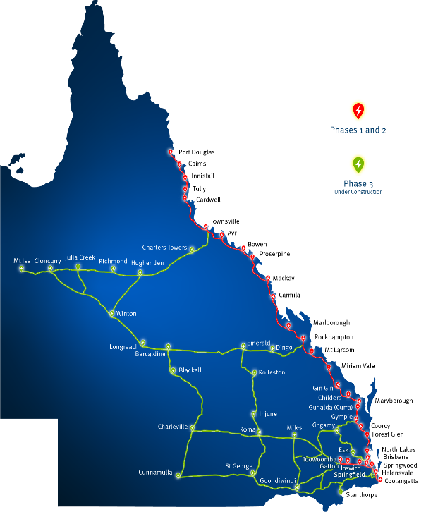

Always plan your trip accordingly. Please take into account circumstances such as road, weather and vehicle operating capabilities which will impact your vehicles driving range.

## Protecting the environment

Protecting the environment for future generations, including action on climate change, is one of the Queensland Government’s priority objectives and strongly supported by BHTAC members. Under the *Queensland Climate Action Plan 2030*, the Queensland Government has set targets for a 30 per cent emissions reduction below 2005 levels by 2030 and net zero emissions by 2050.

To both mitigate greenhouse gas emissions and address climate change risk, TMR’s *Zero Emission Vehicle Strategy and Action Plan*, sets a vision for a cleaner, greener, integrated transport and energy network that encourages zero emission transport solutions.

The strategy focuses on reducing emissions from vehicles that use transport infrastructure and providing zero emission charging locations, including 31 fast-charging sites on the Queensland Electric Super Highway (QESH), many of which are situated on the Bruce Highway, as illustrated in Figure 3.

The identified priority projects and packages that form part of the *15-year Vision and Action Plans for the Bruce Highway* will support efficient, reliable and productive transport of people and goods and sustainable, resilient and liveable communities.

## Stainable practices

Released in late 2021, the *Environmental Sustainable Policy* is the overarching policy guiding TMR’s environmental management and sustainability outcomes. It includes objectives to ‘avoid, minimise, mitigate and offset’ the environmental impacts associated with TMR activities and to move beyond compliance to encouraging innovative, sustainable solutions for protecting the environment.

TMR *Climate Change Risk Assessments for Infrastructure Projects* provides guidance to incorporate climate change risk assessments into infrastructure projects (currently mandated for projects valued at $100 million and above), so that future transport infrastructure can be more resilient to the projected impacts of climate change.

TMR continues to strive towards a circular economy through initiatives such as the *Waste 2 Resource Strategy*, with a vision to become a zero waste organisation and preferencing the use of recycled materials on transport infrastructure projects, under specified conditions. TMR has also developed an industry-first waste and recycling calculator to assist both construction and maintenance projects to better plan, manage and reduce waste disposed to landfill.

### Case Study

#### Koala fencing

The Caloundra Road to Sunshine Motorway Project installed approximately five kilometres of permanent koala fencing along the road upgrade, with fauna escape poles generally located every 100 metres along the fence alignment. During the construction timeframe (over four years), temporary koala fencing was installed and maintained along the project alignment to mitigate any risk of either koala ingress or impact from the project works.

TMR is committed to fauna protection along its road corridors by designing, constructing and maintaining roads that better accommodate the needs of fauna. Infrastructure, including fauna crossings and koala fencing, as well as appropriate signage, are designed to reduce the impacts transport infrastructure has on fauna.

It is important TMR’s strong environmental commitment continues to guide planning and delivery of identified priority projects and packages that form part of the *15-year Vision and Action Plans for the Bruce Highway* and reduce the impact of transport infrastructure on the environment and communities by:

* improving the resilience of transport infrastructure to climate risk
* building sustainable roads protecting the natural environment, including fauna and flora.

# Next steps

* Unlock economic growth
* Build flood resilience
* Improve safety

Overseen by the BHTAC, this *15-year Vision and Action Plans* for the Bruce Highway was developed by TMR, in consultation with key stakeholders and customers.

It is important the Queensland Government works closely with the Australian Government to agree funding arrangements to enable the planning and delivery of priority projects identified in the Action Plans.

Each year, TMR releases the Queensland Transport and Roads Investment Program (QTRIP) which outlines current and planned investment in road and transport infrastructure for delivery over the following four-year period. The projects outlined in this *15-year Vision and Action Plans for the Bruce Highway* will inform future investment decisions, with funding to be confirmed in annual QTRIP publications. This transparency of future works will give the community and industry increased certainty about Bruce Highway upgrades and timeframes.

As part of this *15-year Vision and Action Plans for the Bruce Highway*, the BHTAC recommends periodic reviews of the Action Plans by TMR at every five-year tranche. This will ensure the objectives, costs, scope, assumptions and growth predictions remain relevant.