Department of Child Safety, Youth and Women

**Sexual Violence Prevention**

**Consultation summary**



This Consultation Summary contains the individual and collective views of participants in the consultation process to support the development of a Queensland sexual violence prevention framework. These views do not necessarily represent the decisions or policy of the Queensland Government. We acknowledge the voices and experiences of the victims and survivors, their supporters, service representatives and interested members of the public, and thank them for contributing their time and effort throughout the consultation process

**Contents**

Overview 1

Who we consulted 1

How we consulted 1

Our consultation at a glance 2

Key consultation findings 3

What we heard 3

Three priority areas 3

Intersectionality and meeting the needs of diverse groups 3

What Queenslanders said 5

Key findings: Prevention 6

Key findings: Support and healing 7

Key findings: Accountability and justice 8

# Overview

Sexual violence is an issue that can affect all Queenslanders. For many people, it is a deeply personal issue that has a significant impact on lives, families and communities.

In July 2018, the Queensland Government committed to developing a sexual violence prevention framework that would set out our vision and priorities for future action to prevent and respond to all forms of sexual violence.

To help develop a framework, we developed a background paper and a consultation toolkit, and undertook a range of consultation activities so we could hear from Queenslanders about their experiences, thoughts and ideas. The four areas the background paper and our consultation activities focused on were: education, awareness and cultural change; supporting victims and survivors, and holding perpetrators to account; meeting the needs of all Queenslanders; and, strengthening and integrating the service system.

From late 2018 to June 2019, we consulted with the community and stakeholders to help inform the development of a framework. The feedback we received throughout the consultation process has directly informed the principles and priorities set out in *Prevent. Support. Believe. Queensland’s Framework to address Sexual Violence* (the Framework), as well as the supporting actions Government has committed to.

## Who we consulted

To help us develop the Framework, we wanted to hear from anyone with an interest in the issue of preventing and responding to sexual violence. It was particularly important for us to hear the voices of people with lived experience of sexual violence. Many victims and survivors we spoke to said that being able to use their personal experiences to contribute to the Framework would help them with their ongoing recovery.

We also spoke to community members, academics, community services workers (those working in specialist sexual assault services and a wide range of other services who support people who have experienced sexual violence), young people, police, paramedics, lawyers, justice advocates and many others.

## How we consulted

We undertook a wide range of consultation activities to make sure that anyone, regardless of their location or background, could contribute to the consultation process. These activities included community forums, online surveys, specific sessions for victims and survivors of sexual violence, focus groups with representatives of specific population groups, consultation with government advisory groups and agencies.

We also established a Sexual Violence Prevention Roundtable, made up of sector and community representatives, academic experts, and senior government representatives. The Roundtable provided feedback on our approach to consultation, expert advice and insight on issues relating to sexual violence, and ideas for potential solutions.

Quote – Sexual violence is like all other types of violence, in that it is about power and control (Survey respondent)

# Our consultation at a glance

Across all public consultation activities, there were over 700 engagements from March to June 2019

* 296 people participated in community forums held in:
  + Brisbane (84 people)
  + Gold Coast (41 people)
  + Sunshine Coast (22 people)
  + Toowoomba (36 people)
  + Bundaberg (14 people)
  + Rockhampton (30 people)
  + Townsville (47 people)
  + Mount Isa (22 people)
* 278 survey responses via Get Involved
* 61 survey responses received through Youth e-Hub
* 17 written submissions received from stakeholders, individuals and organisations
* 39 victims and survivors shared their ideas and experiences through specific session in Brisbane (including male survivors), Toowoomba, Mount Isa, Rockhampton and the Sunshine Coast
* 4 focus groups with services and stakeholders working with LGBTIQ+ people, older women, women from diverse cultural backgrounds, and Aboriginal and Torres Strait Islander women
* Targeted consultation with Aboriginal and Torres Strait Islander leaders and advisory bodies
* Consultation with the Queensland Youth Engagement Panel and the Queensland Indigenous Youth leadership Program participants
* Input from the Truth, Healing and Reconciliation Taskforce.

# Key consultation findings

## What we heard

We have re-shaped the priority areas originally proposed in our background paper to reflect what Queenslanders told us throughout the consultation process. Across all consultation activities, we heard a clear message that we should be focusing on:

## Three priority areas

1. Prevention: including increasing community awareness of sexual violence, promoting belief of victims and survivors, dispelling myths, and providing comprehensive education on sex, healthy relationships and sexual violence for children and young people.
2. Support and healing: including ensuring all Queenslanders can access specialist support when and where they need it (including early intervention), strengthening responses to groups with specific needs, and providing coordinated support across all parts of the service system.
3. Accountability and justice: including improving support and choice for victims and survivors as they navigate the justice system, reducing barriers to reporting sexual violence, holding perpetrators of violence to account, increasing access to behaviour change programs for perpetrators, and the need for legislative reform relating to consent in sexual assault matters, including the 'mistake of fact' excuse.

## Intersectionality and meeting the needs of diverse groups

In the background paper used during consultation, we had included a priority area called ‘meeting the needs of all Queenslanders.’ This priority area highlighted that certain groups of people are more likely to experience sexual violence, and looked at what kinds of responses could be developed that would respond to the needs of specific groups, considering things like: geographical issues; cultural and language background, including Indigenous status; poverty and social disadvantage; and, intergenerational trauma and disadvantage.

Through the consultation process, we clearly heard that consideration of these specific needs and how they intersect (known as ‘intersectionality’) was important across all priority areas. As a result, intersectional approaches are no longer a separate priority area, but are built into all aspects of the Framework and its supporting actions.

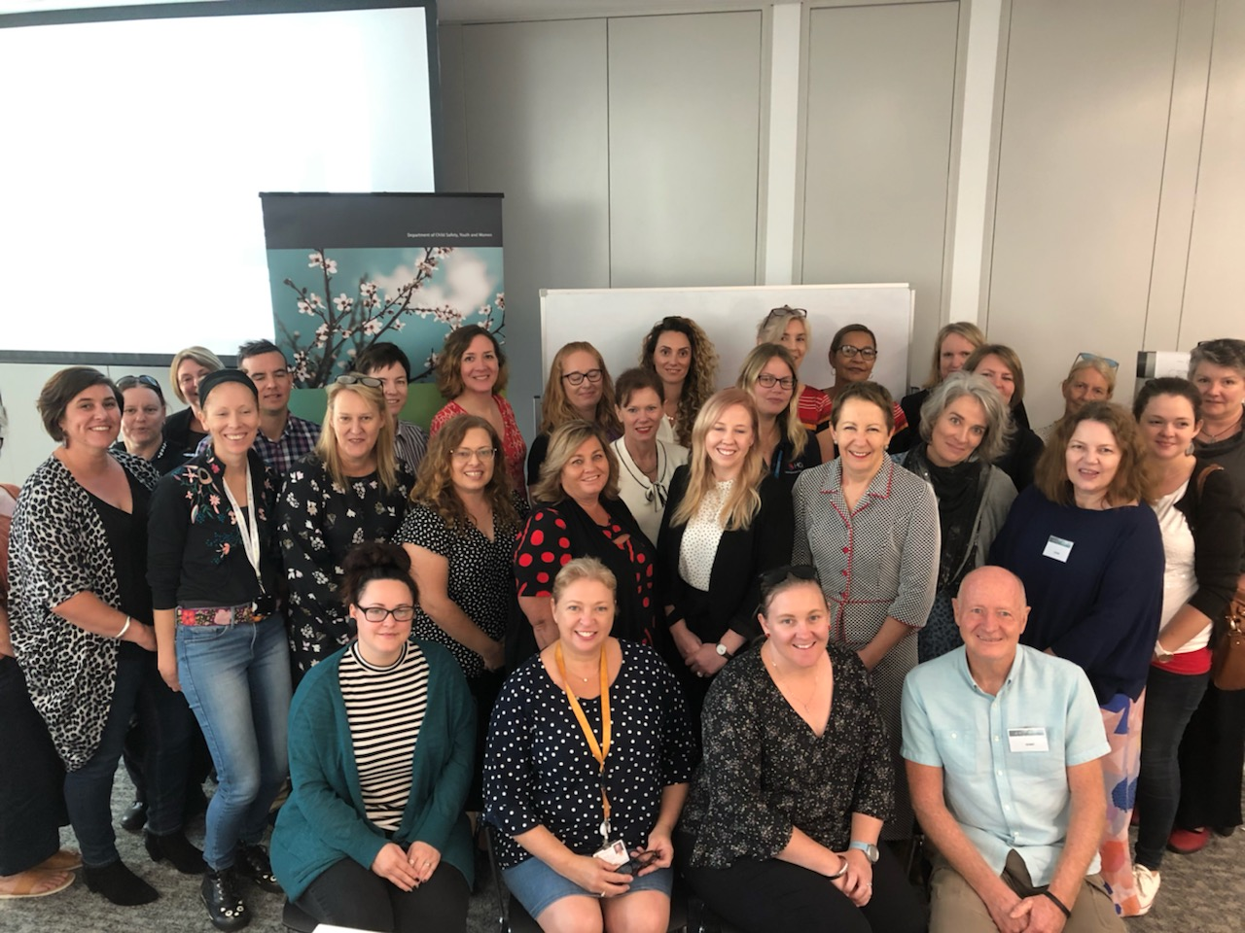

*Toowoomba consultation forum*

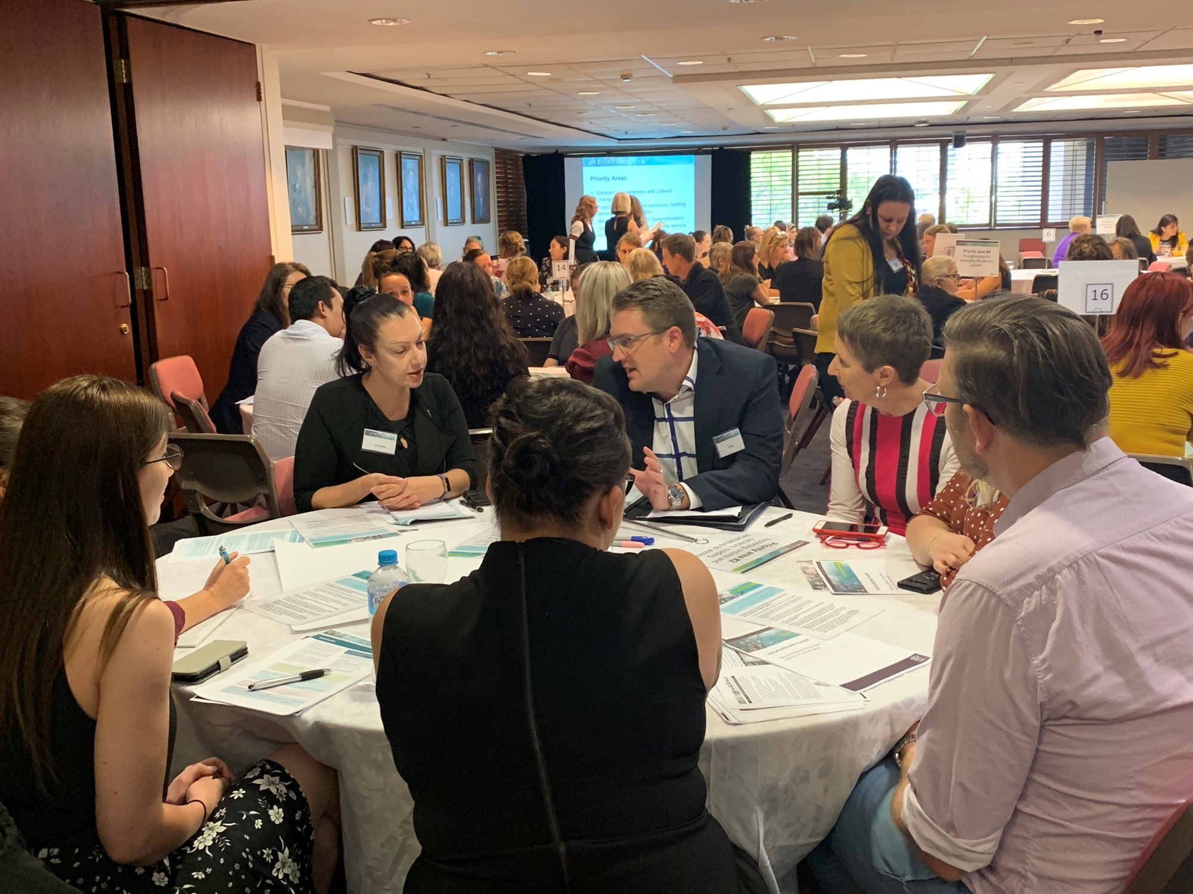

*Brisbane consultation forum*

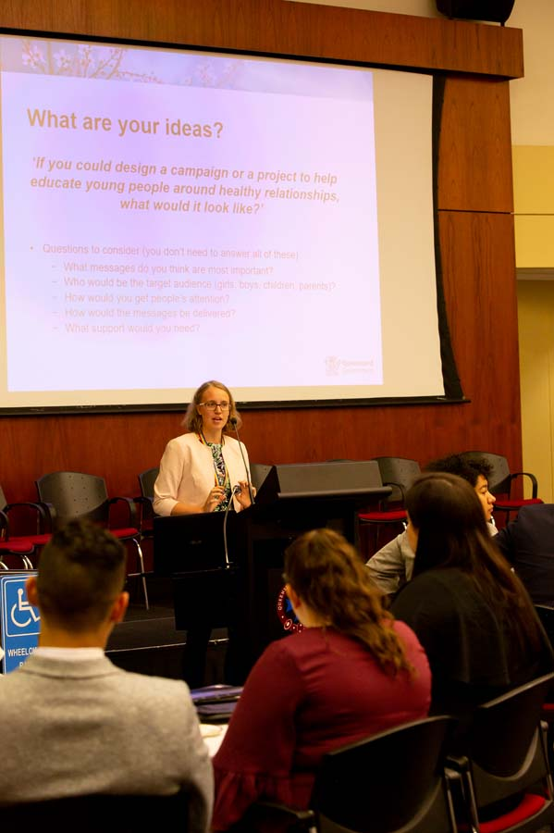 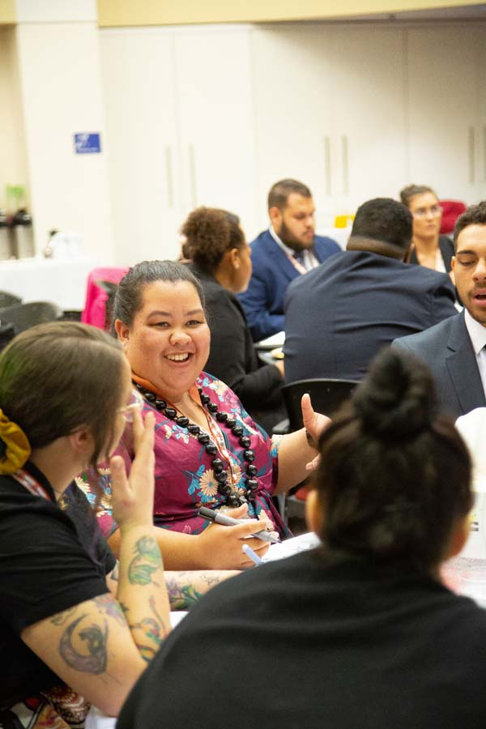

*Queensland Indigenous Youth Leadership program consultation*

# What Queenslanders said

*“As a supporter of someone who experienced sexual violence I wish I had more education and knowledge about the support that is out there, so I knew how to help, or guide others towards help.”* (Young person)

*“We need consent culture, where all sex that is had is sex that is wanted. We need massive education about consent, sexual violence and the law.”* (Young person)

*“We need younger sex education classes with talk about consent and assault. As someone who had it happen to them when I was young, I didn’t understand what it was and thought that it was love.”* (Young person)

*“Reforms need to be made in our failing judicial system so that courts can more easily convict a perpetrator, i.e. get rid of "mistake of fact" clause as an excuse, build a wider community awareness campaign about what constitutes enthusiastic consent.”* (Survey respondent*)*

*“We all need to be active bystanders and call out behaviour that may marginalise or stigmatise a victim.”* (Survey respondent)

*“The only way to address systemic issues is with systemic change.”* (Survey respondent)

*“The police officer I reported to was amazing. I had great support from my detectives and prosecutor throughout the entire process.”* (Young person)

*“More belief towards victims will, in the end, allow sexual violence to be talked about more, which should hopefully allow people to understand consent better”* (Young person)

*“I wish I knew the steps I needed to take to get myself safe and report what happened.”* (Young person)

*“We’ve almost normalised sexual violence. Until we start caring about what happens to women, it will keep happening.”* (Survey respondent)

# Key findings: Prevention

Prevention – falling under the broad umbrella of ‘primary prevention’ activities – was identified during consultation as critical to a sexual violence prevention framework. This is consistent with what we know from research and the work undertaken by expert bodies such as Our Watch and ANROWS (Australia’s National Research Organisation for Women’s Safety). Both our consultation and the research emphasises the importance of broad-scale, population level prevention activities that aim to prevent violence before it occurs.

Many people involved in the consultation felt that the broader Queensland community didn’t know enough about the prevalence of sexual violence in the community, and the significant impact it can have on victims and survivors. We also heard that victim-blaming attitudes persist, and that this contributes to the secrecy, shame and stigma people who have experienced sexual violence often feel.

The following themes emerged across all consultation activities:

* Individual and community responses need to start from a place of believing and supporting victims and survivors of sexual violence when they speak up about their experiences.
* Community-wide, multi-faceted prevention activities are needed to make sure that cultural change occurs across all communities, promoting respect for diversity, zero tolerance to sexual violence, equality, and positive role models. We also need to focus on challenging attitudes which support, condone or trivialise violence, especially violence against women.
* School- and preschool-based relationships education programs should be compulsory, consistent, and evidence-informed, starting when children are young and continuing through primary and high school. Many young people we spoke to felt they had not been given any or enough information about respectful and healthy relationships, consent, power and control, their rights in relationships, and what does and doesn’t constitute sexual violence.
* Improved and inclusive sex and sexuality education is also needed, connected to broader relationships education programs. These programs need to be inclusive of all genders and sexual orientations, and incorporate a focus on breaking down attitudes that focus only on opposite-sex relationships.
* Broader community education campaigns are also needed. This includes campaigns and education tailored for specific cohorts, such as older people, culturally and linguistically diverse communities, and LGBTIQ+ communities.
* Sex and relationships education campaigns and programs for Aboriginal and Torres Strait Islander communities should be co-designed with communities, use local language where appropriate, and focus on culture and community strengths. Consultation with Aboriginal and Torres Strait Islander people highlighted that shame and taboos associated with sex and sexual violence play a big role in communities, and that campaigns and programs should be communicated in a way that helps overcome those taboos and uses local channels, not just through the internet and schools.
* Increased awareness and knowledge among generalist services – such as doctors and other health professionals, housing and homelessness services, and youth and community services – is important in making sure victims are believed and supported when they come forward. Generalist services should be supported to better identify signs of sexual violence and refer victims and survivors to specialist support options.

# Key findings: Support and healing

The service systems that support victims and survivors of sexual violence are broad. They include both specialist services – which provide counselling and practical support to adults and children who have experienced sexual violence – and generalist services, which are likely to receive reports or disclosures of sexual assault in the first instance.

Generalist services may include first responders such as paramedics, teachers, medical professionals, and community services like housing and homelessness services or neighbourhood centres. Police, courts staff, judges and other people working in the justice system are also likely to work with people who have experienced sexual violence, and are discussed in more detail in Priority Area 3.

While we heard from Queenslanders that specialist services were generally well regarded by victims, survivors and their supporters, there was a strong view that these services were not sufficiently resourced and that more specialist services were needed, particularly in regional areas.

When it comes to generalist services, we heard that responses to victims and survivors were highly variable. Some participants commented that it was “luck of the draw” whether generalist services were supportive, understanding and trauma-informed, or held a lack of awareness, or even negative attitudes towards victims.

The following themes emerged across the consultation activities:

* The need for a more integrated service system in which non-government services and government agencies all work together to support victims and survivors and their families, as well as perpetrators where appropriate.
* The need for more specialist sexual assault services to provide greater coverage across the state, particularly in rural and regional areas.
* Additional funding for existing specialist sexual assault services to reduce waiting times and provide a faster response to more victims and survivors, and undertake more outreach work.
* Specialist support for child victims of sexual abuse and their parents/carers (not subject to child protection orders) was identified as a significant gap in many areas of the state, particularly for children under the age of 12.
* The accessibility of specialist services to support people with diverse needs, such as Aboriginal and Torres Strait Islander people, people from culturally and linguistically diverse backgrounds, men, LGBTIQ+ people and older people, was raised as an area for improvement.
* In particular, we heard calls for the establishment of specialist services for men and LGBTIQ+ people, and improved training for interpreters supporting people from culturally and linguistically diverse backgrounds.
* The importance of trauma-informed practice was raised repeatedly – emphasising that it should be a central part of any services provided to victims and survivors, including by generalist services.
* Professional training in sexual violence and trauma-informed practice should be provided for service providers such as police, first responders, teachers, medical professionals and judges. There should also be a focus on cultural change to make sure that the needs of victims and survivors are at the centre of all responses.
* Many participants also felt that services for adult perpetrators and children and young people displaying problematic or harmful sexual behaviours, including early intervention and rehabilitation services, were lacking in Queensland.

# Key findings: Accountability and justice

Two distinct themes that emerged during consultation related to accountability for perpetrators of sexual violence, and the impact of navigating the justice system on the healing of victims and survivors.

We know from research that up to 87 per cent of sexual assaults that occur are not reported to police, and that only a small proportion of reported cases are prosecuted in court and achieve a conviction. Throughout the consultation process, it was clear that for many people who had experienced sexual violence, the process of seeking justice was lengthy and traumatic, with many victims and survivors feeling that they did not receive sufficient support to navigate and cope with the many different elements of the system, such as multiple types of court hearings and frequent delays.

There was a strong community perception that perpetrators of sexual violence are rarely held to account for their behaviours, and that there was a lack of rehabilitation and support options to help perpetrators stop re-offending. Many victims and survivors highlighted that knowing the perpetrator had been held to account was important for their own healing, and the significant negative impact on their wellbeing and recovery when they did not feel justice has been achieved.

Consultation participants noted that victims and survivors needed to be shown respect, and their voices heard, as part of ongoing efforts to improve responses to sexual violence in the justice system and beyond.

The following themes emerged across the consultation activities:

* Victims and survivors of sexual violence need more support through the justice system including when first reporting incidents of sexual violence to the police, and navigating lengthy court processes.
* The court process was seen as onerous and often traumatic for anyone pursuing a complaint of sexual violence. Specific concerns were raised regarding:
  + the length of the process from complaint to hearing, the length of time between hearings and the number of adjournments, each of which cause additional stress and anxiety for complainants and families
  + the experience of giving evidence and cross examination and lack of support while giving evidence, which was seen as unnecessarily confronting and often placing the victim in a position of defending their own credibility and behaviour
  + poor communication by police, prosecutors and liaison staff regarding expectations around process and timeframes can mean that victims and families are not sufficiently informed about case developments, hearing dates and other important information. This further exacerbates the stress experienced by victims.
* A range of concerns about the legislative framework under which sexual violence operates were raised, including around Queensland’s definition of consent, the use of the ‘mistake of fact’ excuse, issues relating to the burden of proof in cases, penalties and sentencing for perpetrators, and the alignment between state (criminal code) and federal (family law) legislation.
* As noted under Priority area 2, training in the facts about sexual violence and trauma-informed practice was specifically raised in relation to police, judges, prosecutors and other justice staff, as well as broader generalist services.
* Evidence-informed, effective behaviour change programs for perpetrators of sexual violence were frequently identified as a gap in the existing service system and as critical to breaking the cycle of violence and preventing re-offending.