**Cultural Heritage Online Portal User Satisfaction Review**

Department Of Treaty, Aboriginal and Torres Strait Islander Partnerships, Communities and the arts

**Research Insights Report**

**May 2024**

Table of Contents

Table of Contents 1

Research Background & Objectives 2

BACKGROUND 2

RESEARCH OBJECTIVES 2

Methodology & Interpretation 3

METHODOLOGY 3

REPORT INTERPRETATION 3

ADDITIONAL CONTENT 3

Portal Usage & Satisfaction 4

FREQUENCY OF USE 4

OVERALL SATISFACTION 5

POSITIVE ASPECTS OF THE PORTAL 6

PORTAL ACCESSIBILITY 7

PORTAL EASE OF USE 8

DESIRABLE OUTCOME 9

Query Resolution 10

CONTACT WITH TATSIPCA 10

RESOLUTION TIMELINESS 11

STAFF PERFORMANCE 12

Respondent Profile 13

DEMOGRAPHICS 13

FIRMOGRAPHICS 14

# Research Background & Objectives

## BACKGROUND

The Department of Treaty, Aboriginal and Torres Strait Islander Partnerships, Communities and the Arts (TATSIPCA) provide information from the Aboriginal and Torres Strait Islander Cultural Heritage Database and Register to land users seeking to comply with their cultural heritage duty of care. The Cultural Heritage Online Portal enables all land users, who have registered for special access, to undertake cultural heritage search requests. These search requests provide land users with information about Aboriginal or Torres Strait Islander areas and objects of traditional, customary, and archaeological significance to assist land users in meeting their duty of care under the Aboriginal Cultural Heritage Act 2003 and Torres Strait Islander Cultural Heritage Act 2003.

Enhance Research was commissioned by TATSIPCA to undertake an online survey. This report shows the findings of the quantitative research from 2017 to 2024.

## RESEARCH OBJECTIVES

The key objective of the survey was to evaluate the Cultural Heritage Online Portal and measure users’ experience and satisfaction.

# Methodology & Interpretation

## METHODOLOGY

Online survey invitations were sent between March 28 and April 19, 2024 to a list of 500 portal users provided by TATSIPCA.

A total of 124 surveys were completed with a response rate of 25%.

|  |  |
| --- | --- |
| **ORGANISATION OF USER** | **n =** |
| Queensland Government | 46 |
| Other Organisations | 78 |
| TOTAL | 124 |

## REPORT INTERPRETATION

Please note the following when reading this report:

* Where question response percentages do not sum to 100%, this is due either to rounding or a question allowing multiple responses
* Caution is needed in interpreting data with small base sizes of around n=30 or less
* The base note included on each page throughout this report represents the number of respondents who answered the particular question.

Statistical significance testing has been used to examine changes over time. Statistical significance between years will be displayed on line charts with the use of arrows.

⯅ are significantly greater than ⯆

Due to the small sample size, the probability of differences between waves being statistically significant is reduced. This means that figures appearing to have a large difference between them may not be statically different from each other.

## ADDITIONAL CONTENT

Users' aspects of the online portal that work well and why, and their suggestions for improvements to the online portal are available in a separate excel document that contains users' open responses.

# Portal Usage & Satisfaction

## FREQUENCY OF USE

Overall, one in four users (28%) access the portal at least several times a week. Around two in five (38%) use it several times a month. One in three users (34%) access the portal several times a year or less.

**Portal Usage in Past 12 Months**

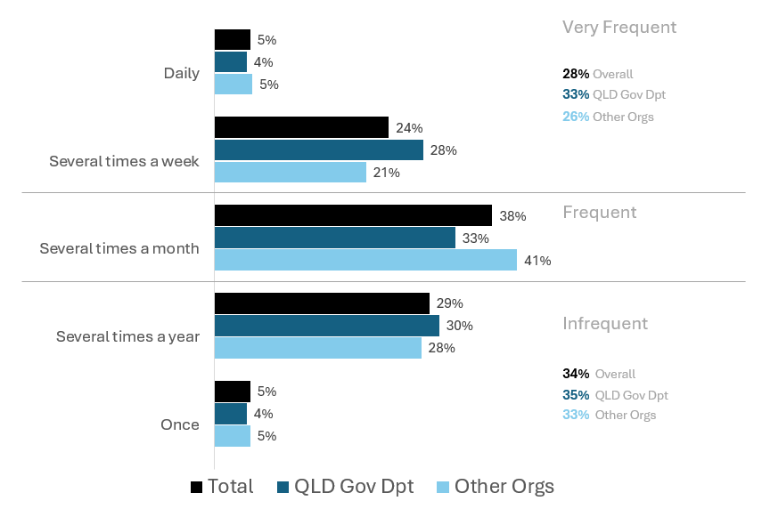

Base: All respondents (2024 n=124, QLD Gov Dpt n=46, Other Orgs n=78, Very Frequent n=35, Frequent n=47, Infrequent n=42)

S1. How many times in the past 12 months have you accessed the Cultural Heritage Online Portal?

## OVERALL SATISFACTION

Overall satisfaction with the online portal has stabilised, after a gradual decline in previous waves. Satisfaction among is highest among QLD Government users (87%) compared with users from other organisations (71%).

Overall satisfaction remains high, with three in four (77%) users happy with the online portal.

**Overall Satisfaction with the Cultural Heritage Online Portal**

⯅ are significantly greater than ⯆

% satisfied (4) or very satisfied (5)

Base: All respondents (2024 n=124, QLD Gov Dpt n=46, Other Orgs n=78, Very Frequent n=35, Frequent n=47, Infrequent n=42)

Q3. Overall, how satisfied are you with the Cultural Heritage Online Portal?

## POSITIVE ASPECTS OF THE PORTAL

Positive aspects for portal users include the ease of use and navigation, the results produced, the search function, and the timeliness of results and reports.

Base: Base: (2024 n=124)

Q7. What aspects of the Cultural Heritage Online Portal worked well for you and why?

## PORTAL ACCESSIBILITY

Accessibility of the portal remains high, with over four in five users (85%) finding it easy to access. Currently all (100%) very frequent users are satisfied or very satisfied with accessing the Portal and satisfaction also may be rising among infrequent users in 2024.

**Ease of Accessing the Cultural Heritage Online Portal**

⯅ are significantly greater than ⯆

% satisfied (4) or very satisfied (5)

Base: All respondents (2024 n=124, QLD Gov Dpt n=46, Other Orgs n=78, Very Frequent n=35, Frequent n=47, Infrequent n=42)

Q1a. To what extent do you agree that it was easy to access the Cultural Heritage Online Portal?

## PORTAL EASE OF USE

Overall, the ease of using the online portal has stabilised somewhat. This stabilisation may result from the apparent perceived improvements in ease of use by infrequent and non-Governmental orgs.

Satisfaction remains high among government department users, with more than four in five (85%) finding the portal easy to use.

**Ease of Using the Cultural Heritage Online Portal**

⯅ are significantly greater than ⯆

% satisfied (4) or very satisfied (5)

Base: All respondents (2024 n=124, QLD Gov Dpt n=46, Other Orgs n=78, Very Frequent n=35, Frequent n=47, Infrequent n=42)

Q1b. To what extent do you agree that it was easy to use the Cultural Heritage Online Portal?

## DESIRABLE OUTCOME

Satisfaction with getting what they need from the online portal has remained fairly stable with last years levels. Satisfaction with getting this information remains significantly lower than 2022 overall and among infrequent users.

Objectively, overall satisfaction is high with nearly nine in ten (86%) happy with content they got from the portal.

**Frequency Of Gaining the Information or Outcome Needed From The Portal**

% often (4) or always (5)

⯅ are significantly greater than ⯆

Base: All respondents (2024 n=124, QLD Gov Dpt n=46, Other Orgs n=78, Very Frequent n=35, Frequent n=47, Infrequent n=42)

Q2. How often did you get the information or outcome that you needed from the Cultural Heritage Online Portal?

# Query Resolution

## CONTACT WITH TATSIPCA

In the past 12 months, around four in ten users (41%) sought assistance to use the online portal and one in five (22%) requested additional information following a search.

Users from other organisations were significantly more likely to seek assistance (51%) with the portal when compared with government department users (26%). Infrequent users were more likely to seek assistance (49%) with the portal than Very Frequent (25%).

**Sought Assistance To Use The Online Portal**

**Requested Additional Information Following A Search**

⯅ are significantly greater than ⯆

Base: All respondents (2024 n=124, QLD Gov Dpt n=46, Other Orgs n=78, Very Frequent n=35, Frequent n=47, Infrequent n=42)

Q4a. In the past 12 months, did you contact the Department to seek assistance to use the Cultural Heritage Online Portal

Q4b. In the past 12 months, did you contact the Department to request additional information following a search request?

## RESOLUTION TIMELINESS

In 2024, the length of time it takes an enquiry to be resolved has risen. Whilst most enquiries (70%) continue to be settled within 2 business days, the proportions of enquiries taking 3-5 business days (19% in 2024, up from 11% in 2023) or more than five business days (11% in 2024, up from 0% in 2023) have increased.

**Length of Time To Resolve Enquiry**

Base: Respondents who contacted with the Department (2024 n=62)

Q5. Thinking about your most recent contact with the Department, how long did it take for your enquiry to be resolved?

## STAFF PERFORMANCE

Most users who contacted the Department in the past 12 months are satisfied with the knowledge and competency of staff (91%), the attentiveness (90%), and being kept informed (88%).

**Staff Performance on Most Recent Contact**

% satisfied (4) or very satisfied (5)

Base: Respondents who had contact with the department (2024 n=62)

Q6. Thinking of your most recent contact with the Department, how much do you agree with the following…?

# Respondent Profile

## DEMOGRAPHICS

GENDER

AGE

Base: All respondents (2024 n=124)

## FIRMOGRAPHICS

ORGANISATION TYPE

ROLE WITHIN ORGANISATION

Base: All respondents (2024 n=124)