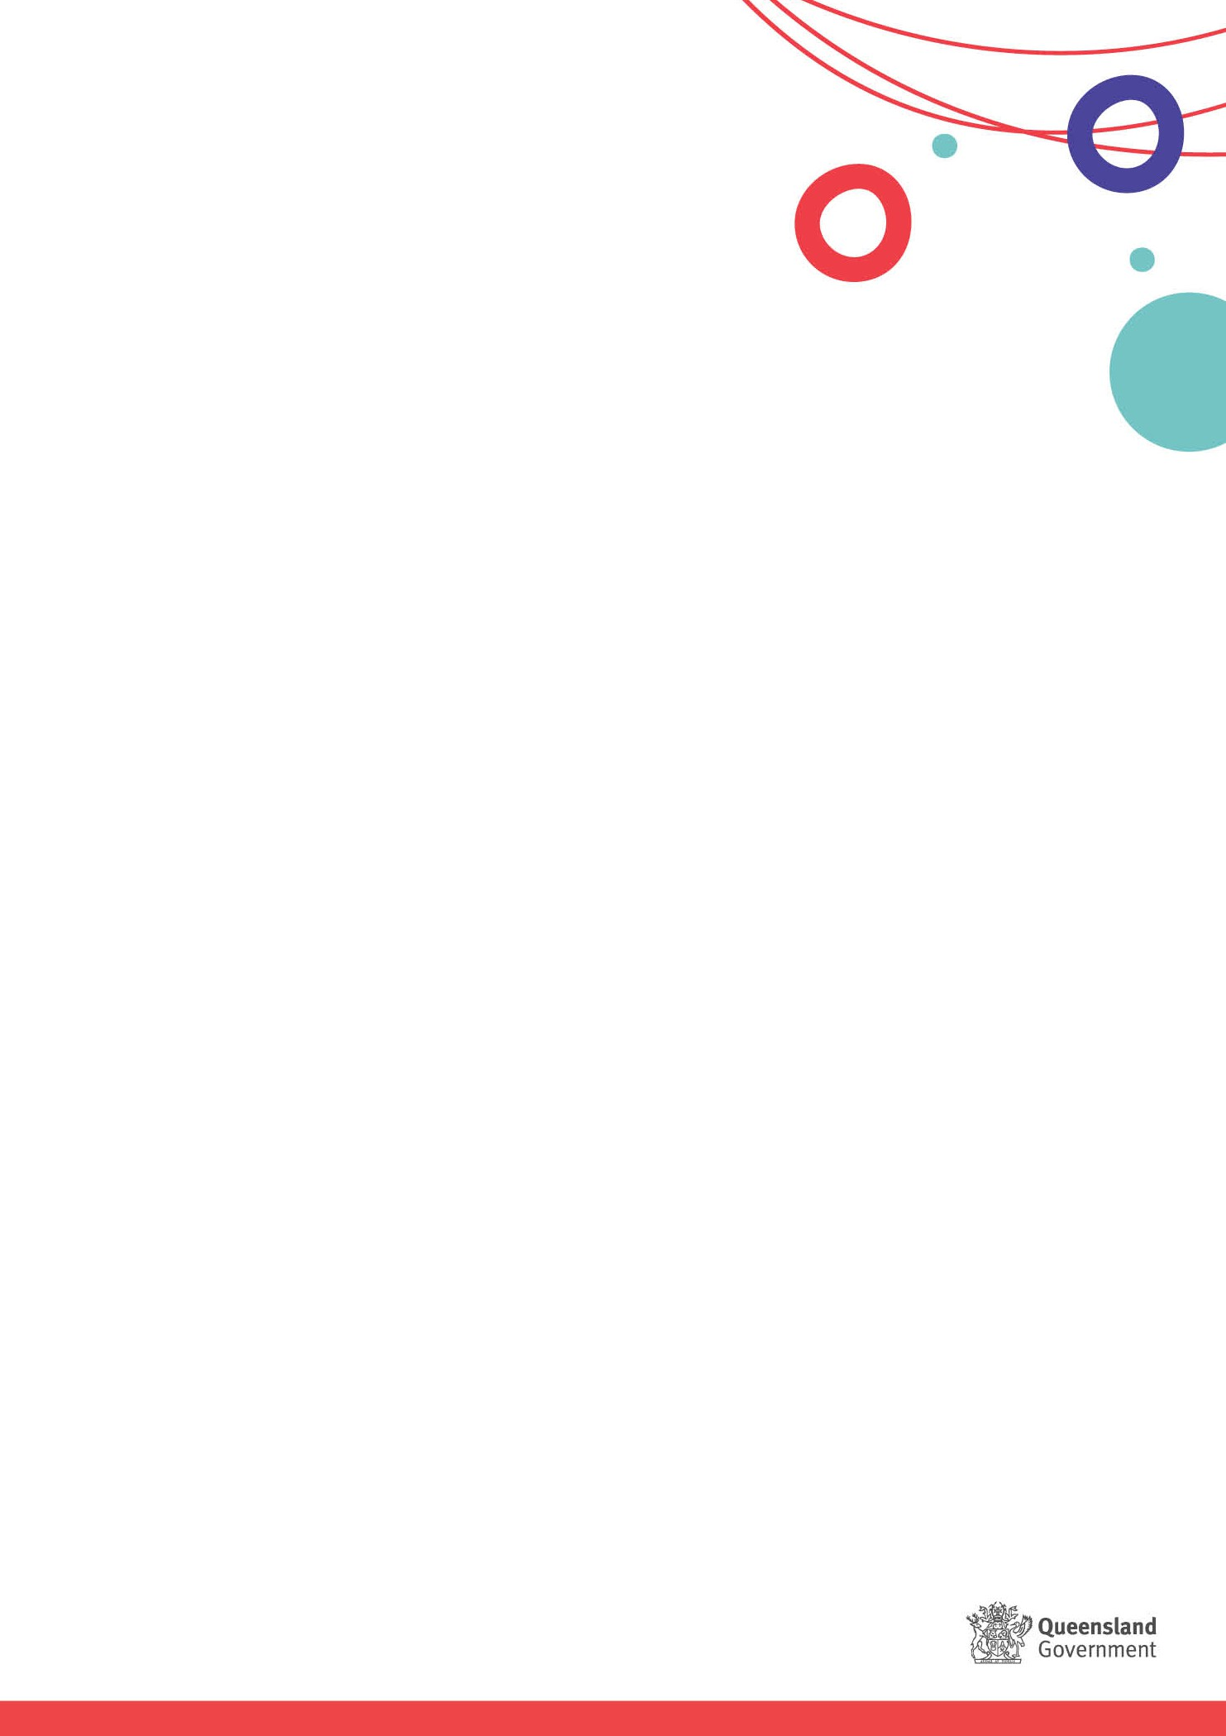

YLS/CMI™2.0: Substance Abuse

This brief aims to provide information to all Youth Justice staff about what works for young people when addressing assessed need in the Substance Abuse domain of the Youth Level of Service/Case Management Inventory (YLS/CMI™) 2.0.

# High need in Substance Abuse: What does this mean?

Young people with high needs in the Substance Abuse domain of the YLS/CMI™ will often:

* Minimise the harmful effects of substance use.
* Not recognise their substance use as a problem.
* Form connections with others who are substance dependent.
* Find it difficult to pursue or maintain education and employment.
* Avoid positive relationships.
* Engage in offending behaviour to fund their substance abuse

# Does drug/alcohol consumption mean high need in Substance Abuse?

## Not necessarily.

The need is only a reoffending risk when the young person’s use of alcohol or other drugs directly contributes to offending behaviour and/or interferes with day-to-day prosocial behaviour. For example, where a young person is damaging property when intoxicated or stealing property to fund the purchase of substances.

# How to address Substance Abuse

The focus is supporting the **reduction and desistance** of the young person’s substance use which will vary from person to person. Youth Justice staff should:

* Engage in discussions with young people about their substance use and provide referrals to appropriate support agencies.
* Encourage and support young people to regularly engage in **structured activities** (refer to [Risk & Need: Leisure Recreation](https://cyjmaintranet.root.internal/service-delivery/youth-justice/youth-justice-practice/service-response-guides-srgs) and [YJ Programs: What works and Programs vs activities](https://cyjmaintranet.root.internal/service-delivery/youth-justice/youth-justice-practice/service-response-guides-srgs)).
* **Update plans regularly** upon circumstances changing.

# What might success in this domain look like?

Success includes situations when a young person:

* Shifts their thinking around substance use and acknowledges their use as a problem.
* Understands their triggers and urges.
* Identifies strategies to reduce triggers and urges.
* Is connected and receives specialist support.
* Can reduce their substance use.
* Is not dependent on substances (i.e. use is recreational). **What if the young person doesn’t want to change? Help develop readiness through** **motivational interviewing.**

For young people who haven’t identified current use as a problem or can’t see a reason to change their substance use (i.e. pre-contemplative), Youth Justice staff may need to focus on **actively increasing readiness** before referring to external specialist services. There is a range of training available for all youth justice staff on the topic of Motivational Interviewing in Activation and Building phases on th[e YJ iLearn Portal.](https://cyjma.cls.janisoncloud.com/pages/yj-abc-portal_home) Motivational Interviewing is a skill that requires practice and refinement over time. Following attendance at training, it would be beneficial to allow opportunity to practice and gain feedback from your supervisor to further embed and develop skill in this area.

# What if the young person engages well in reporting, but doesn’t want to attend a specialist service?

## This is a great first step, but don’t stop there – keep using reporting sessions to promote the benefits of engaging with specialist services.

While some general responses or drug education may result in positive progress in the Substance Abuse domain, **the most effective programs combine** **intervention techniques,**whether these occur in custody or the community. Young people engaging in substance use are likely to experience emotional regulation difficulties and may be more willing to address their substance use if they have engaged in [Emotional Regulation and Impulse Control](https://cyjmaintranet.root.internal/resources/dcsywintranet/service-delivery/youth-justice/practice/eric-factsheet.pdf) (ERIC) to improve this issue.

It is important the young person is **referred early to talk to a specialist service or doctor** about reducing or quitting substance use. This is particularly important in relation to some dependencies which require medical treatment to support withdrawal (i.e. alcohol, heroin).

**Intergenerational substance use** can be addressed through clear conversations with the family about the impact on the young person, with Child Safety collaboration if required. Casework with Aboriginal and Torres Strait Islander young people should focus on partnering with culturally appropriate services and significant members of their family and community. [Family Led Decision Making (FLDM)](https://cyjmaintranet.root.internal/service-delivery/youth-justice/cultural-resources-youth-justice/family-led-decision-making) processes may also provide wraparound support for the young person.

# What specialist services can be used?

It is important to understand what services and supports are available in your local area such as:

* General Practitioners and Aboriginal Medical Centres.
* Regional or YDC psychologists.
* [Navigate Your Health.](https://noffs.org.au/)
* [Ted Noffs Foundation](https://cyjmaintranet.root.internal/service-delivery/child-safety/child-protection/navigate-your-health)
* [Lives Lived Well.](https://www.liveslivedwell.org.au/)
* [Alcohol, Tobacco and Other Drugs services](https://www.health.qld.gov.au/public-health/topics/atod/services/support-services)
* [Teen Challenge.](https://www.teenchallengeqld.org.au/)

# What core programs address high need in Substance Use?

Core internal programs that address this need and/or has a focus on one or more of the corresponding short term outcome statements include:

* Integrated Case Management (ICM)
* Changing Habits and Reaching Targets (CHART)*
* Emotional Regulation and Impulse Control (ERIC)*
* Girls… Moving On (GMO)

* Please note these programs do not address Substance Abuse specifically: CHART includes a discretionary module on ‘Drugs and Alcohol’ and both programs have content that could support substance use related service responses. ERIC was designed to build readiness with comorbidity (mental health and substance use in youth) and helps young people to identify the triggers for their substance use and better manage their responses. GMO also includes a module on Alcohol and Drug use.