Eighth Annual Compliance Report Bruce Highway Upgrade Project [Caloundra Road to Sunshine Motorway]
  - EPBC 2015/7464
December 2023 – December 2024


Document Control

Departmental approvals
Date | Name | Position | Action
13/01/2025 | Shannon Nestor | Environmental Officer | Initial draft
30/1/2025 | Tim Doherty | Senior Environmental Officer | Review
05/03/2025 | Justin Valks | Deputy Regional Director (North Coast) | Approve

Risk level
☒ High risk (but not GACC)
Prepared by | Shannon Nestor
Title | Environmental Officer
District & Region | North Coast
Branch & Division | PDO
Project/program | Bruce Highway Upgrade Program - Caloundra Road to Sunshine Motorway
Project number | 280/10A/1
Project location | Glenview
Status | Revision 1
DMS ref. no. | 450/01693

Accessibility Statement
We are committed to making our information accessible to all individuals, including those with disabilities. This commitment is in line with our dedication to inclusive community values and equal access to published information.
Please note there may be content within appendices to this report that are not fully accessible to individuals using assistive technology. This may be due to the technical nature of these documents, which can contain complex tables, graphics, and legal language that are not compatible with certain accessibility tools.
If you require them in an alternative format, please email northcoast@tmr.qld.gov.au or telephone 13 74 68.
Please provide your name, contact information, and a detailed description of the issue you encounter or the format you require.

Proponent and Approval Action
EPBC Act Reference | 2015/7464
Project Name: | Bruce Highway Upgrade – Caloundra Road to Sunshine Motorway
Proponent: | Department of Transport and Main Roads
ABN: | 390 407 690 291
Proposed Action: | To upgrade a seven-kilometre section of the Bruce Highway between Caloundra Road at Meridan Plains and the Sunshine Motorway at Sippy Downs, Queensland. The upgrade will allow for the construction of a six-lane highway, the upgrade of two interchanges and the addition of a two-way service road.
Location of Action: | Between Caloundra Road at Meridan Plains and the Sunshine Motorway at Sippy Downs, Queensland
Reporting Period: | December 2023 – December 2024
Date Prepared: | January 2025

Declaration of Accuracy
In making this declaration, I am aware that sections 490 and 491 of the Environment Protection and Biodiversity Conservation Act 1999 (Cth) (EPBC Act) make it an offence in certain circumstances to knowingly provide false or misleading information or documents. The offence is punishable on conviction by imprisonment or a fine, or both. I declare that all the information and documentation supporting this compliance report is true and correct in every particular. I am authorised to bind the approval holder to this declaration and that I have no knowledge of that authorisation being revoked at the time of making this declaration.

Signed Justin Valks
Full name Justin Valks
Position Deputy Regional Director (North Coast)
Organisation Department of Transport and Main Roads (ABN 39 407 690 291)
Date 05/03/2025

Table of Contents
1. Introduction 1
1.1 Project Background 1
1.2 Purpose of this Report 1
1.3 Matters of National Environmental Significance 2
2. Description of Activity 3
2.1 Project Location 3
2.2 Description of the Project 3
2.3 Project Status 6
2.4 Approval History 6
3. Summary of Compliance 7
4. OEMP Conditions Compliance 12
4.1 EPBC Condition 1 12
4.2 Condition 2 12
4.2.1 Condition 2(a) 12
4.2.2 Condition 2(b) 12
4.2.3 Condition 2(c) 16
4.3 Condition 3 19
4.3.1 Condition 3(a) 19
4.3.2 Condition 3(b) 19
4.3.3 Monitoring Fauna Infrastructure 19
4.3.4 Condition 3(c) 21
4.4 Condition 5 22
5. Conclusion 23
6. References 24
7. Appendices 25

- Introduction
  - Project Background
The Queensland Department of Transport and Main Roads (TMR) has constructed a seven-kilometre upgrade of the Bruce Highway between Caloundra Road and Sunshine Motorway (hereafter referred to as “the Project”). The Project consisted of an upgrade to both the Sunshine Motorway and Caloundra Road interchanges, a six-lane upgrade of the Bruce Highway between the two interchanges, as well as a fully connected service road on the western side of the highway. TMR (as Administrator) awarded the Project to a Joint Venture of Fulton Hogan and Seymour Whyte (hereafter referred to as “the Contractor”) as a design and construct contract. All main construction-related works were completed by August 2022.
The Project was referred to the Federal Department of Climate Change, Energy, the Environment and Water (DCCEEW) (formerly referred to as Department of Agriculture, Water and Environment (DoAWE)) on the 15 April 2015 for determination of whether the Project is likely to have a significant impact on Matters of National Environmental Significance (MNES). Projects likely to cause a significant impact on MNES require approval under the Environmental Protection and Biodiversity Conservation Act 1999 (EPBC Act).
The Project was deemed a controlled action on 18 May 2015 and was approved, subject to conditions, on 2 September 2016 (EPBC 2015/7464).
  - Purpose of this Report
Condition 6 of approval EPBC 2015/7464 requires the approval holder (TMR) to prepare and publish an annual compliance report for each 12-month period following Action commencement date.
This report is the eighth annual compliance report for the Project.
This report has been prepared in accordance with DCCEEW annual compliance report guidelines.
  - Matters of National Environmental Significance
Under the EPBC Act, a project must be referred to DCCEEW for actions that are likely to have a significant impact on MNES protected by Part 3 of the EPBC Act. These are known as “controlling provisions”. This project triggered one controlling provision: “potential impacts to listed threatened species and communities (Section 18 and Section 18A)”. The proposed action is likely to have a significant impact on the following matters protected by the EPBC Act.
- Lowland Rainforest of Subtropical Australia – critically endangered:
- the proposed actions will reduce the extent of the critically endangered Lowland Rainforest of Subtropical Australia (LRSA) Threatened Ecological Community.
- Koala (Phascolarctos cinerus) – vulnerable (at the time of approval):
  - the proposed action will reduce the extent of critical habitat for the Koala.

- Description of Activity
  - Project Location
The upgrade to the Bruce Highway involved major construction activities between the area extending south of Caloundra Road at Meridan Plains and north towards the Sunshine Motorway at Sippy Downs, Queensland. The Project also included areas on the Mooloolah River floodplain and areas north of Aussie World along Frizzo Connection Road.
The project was located within the Sunshine Coast Council (SCC) Local Government Area, approximately 15-kilometres west of Caloundra and 10-kilometres southwest of Mooloolaba. The project area encroached on a section of the former Beerwah State Forest, west of the Bruce Highway at Glenview.
Sections of the project area have been historically cleared along the Bruce Highway for residential and commercial purposes. The project area also included areas of remnant vegetation, within the former Beerwah State Forest, Palmview Regional Park and along the Mooloolah River.
  - Description of the Project
The Project consisted of an upgrade to a seven-kilometre section of the Bruce Highway between Caloundra Road and the Sunshine Motorway from four to six lanes, including major upgrades to the interchanges at Caloundra Road and the Sunshine Motorway. The major construction activities associated with the upgrade were completed in July 2021 and all main construction works finalised by August 2022. The completed Project works included the following key features:
- upgrade of the historical Bruce Highway alignment from four to six lanes and to provide immunity for a 1 in 100-year flood event
- a “diverging diamond” interchange at the intersection of the Bruce Highway and Caloundra Road to better facilitate right-turn movements that are critical to the effective functioning of the interchange
- the western service road (Frizzo Connection Road) linking the Caloundra Road interchange with the Aussie World precinct and extending through to the Sunshine Motorway interchange
- a grade-separated interchange at the intersection of the Bruce Highway, the Sunshine Motorway and the new western service road to provide improved efficiency for all movements, reduce queuing and delays, and increase road safety by eliminating high speed at grade intersections
- a southbound off-ramp at Pignata Road providing access to the Aussie World precinct and the local road network
- replacement and upgrades of existing drainage structures (bridges and culverts) on the Bruce Highway to maintain the existing surface water hydrological and hydraulic characteristics of the area
- fauna passage structures, including an underpass, fauna fencing, a rope ladder and fauna escape structures for animals trapped on the Bruce Highway.
Figure 1 provides the Project’s final design layout as an overview of the completed project.

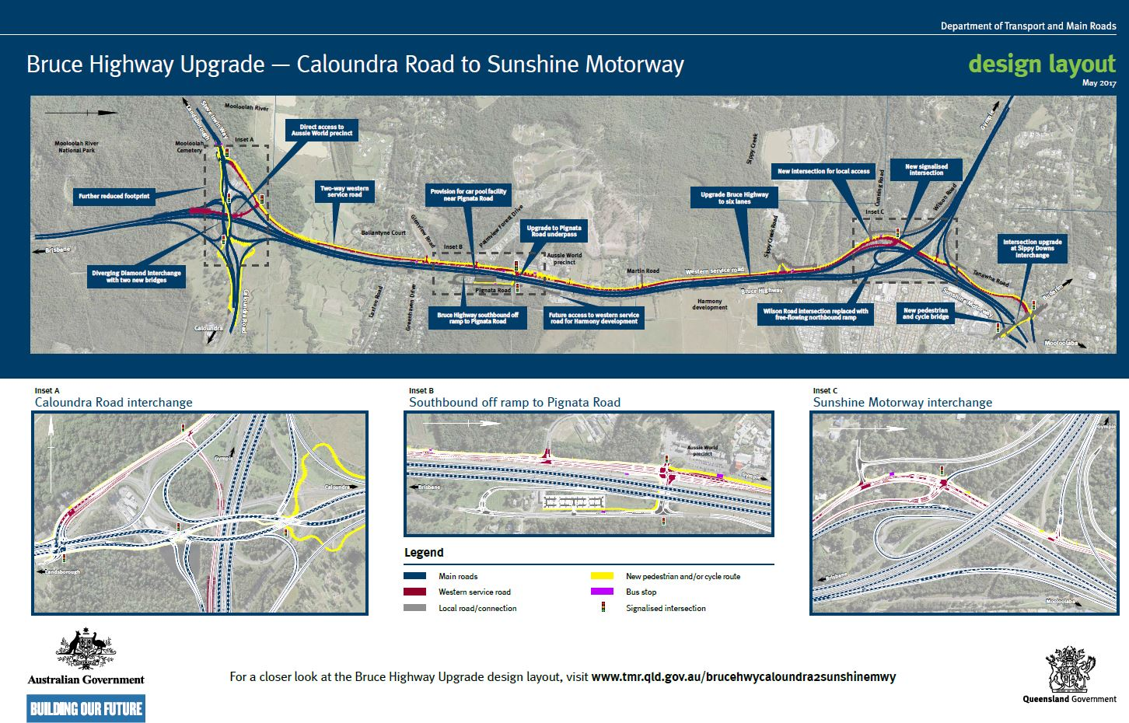
Figure 1. Bruce Highway Upgrade—Caloundra Road to Sunshine Motorway, Final design layout

  - Project Status
The Project achieved practical completion in July 2021, with the project completing all Conditions related to construction activities during the 2021 – 2022 reporting period.
The Project has met the objectives and measures of the Fauna Infrastructure Monitoring Program during the 2024 – 2025 reporting period and is now completed. This eighth annual report summaries the outcomes of the two-year fauna infrastructure monitoring, refer section 4.3.3.
One of the Project’s offset sites has completed the objectives and measures of the offset management plan during the 2021 – 2022 reporting period and is now completed.
The remaining environmental offset sites are continuing with rehabilitation and maintenance activities as required under the approved Environmental Management Plans. The results from each specific BioCondition survey undertaken at the offset sites reported continued improvement.
The respective offset sites have been purchased with voluntary declarations in place, and one property legally secured under a Conservation Agreement from the Commonwealth with Department of Natural Resources, Mines and Energy (NRME), TMR and Sunshine Coast Council (SCC) as parties to the agreement.
  - Approval History
EPBC approval and approval documentation dates, compliance reporting dates and status of the annual compliance reports are provided in Table 1 and Table 2.
Table 1. Relevant Dates for EPBC Act Approval
Approval Document | Date of Decision | Expiry Date
EPBC 2015/7464 | 2 September 2016 | 31 December 2026

Table 2. Chronology of Annual Compliance Reports
Reporting Dates | Report No. | Status
December 2016 – December 2017 | 01 | Completed
December 2017 – December 2018 | 02 | Completed
December 2018 – December 2019 | 03 | Completed
December 2019 – December 2020 | 04 | Completed
December 2020 – December 2021 | 05 | Completed
December 2021 – December 2022 | 06 | Completed
December 2022 – December 2023 | 07 | Completed
December 2023 – December 2024 | 08 | Completed (this report)
- Summary of Compliance
Table 3 details the Project’s compliance status for each approval condition over the 12-month reporting period: December 2023 to December 2024.
Where required, reference has been made to relevant Appendices for further evidence of compliance.
The Project was found to be fully compliant with the requirements of the EPBC Approval 2015/7464.

Table 3. Compliance with conditions of EPBC Approval 2015/7464
No. | Condition | Timeframe | Status | Evidence of Compliance
1 | For protection of the EPBC Act listed Koala (Phascolarctos cinereus) and Lowland rainforest of subtropical Australia Threatened Ecological Community, the approval holder must implement the “Overarching Environmental Management Plan” while undertaking the proposed action. | Progressive – for the period of construction | Compliant and Closed | The works have been completed and now closed.  Refer to previous compliance reports. Closed reporting period 2021-2022.
2 | For the protection of the EPBC Act listed critically endangered Lowland Rainforest of Subtropical Australia (LRSA) the approval holder must:  - Not disturb more than 3.92ha of the LRSA Threatened Ecological Community (TEC) within and adjacent to the project site;  - Enter into a Conservation Agreement over the offset of 16.64ha at the location shown (Attachment B of the Conditions Approval) and ensure that by the tenth anniversary of commencement of the action, the offset meets the following condition thresholds:  - Canopy cover: at least 70% of canopy vegetation is native;  - Species richness: contains 30 native woody species from the LRSA TEC listing advice; and  - Total vegetation: At least 70% of total vegetation cover is native.  - Legally secure and implement the offset of 4.65ha at the location shown (Attachment C of the Conditions Approval) by the first 12-month anniversary of the commencement of the action. | - For the construction period.  - By the tenth anniversary of commencement action  (b)(i)  (b)(ii)  (b)(iii)  (c) By the first 12-month anniversary of commencement | - Compliant and Closed  - Compliant  (b)(i) Compliant  (b)(ii) Compliant  (b)(iii) Compliant  (c) Compliant | (a) Refer to previous compliance reports. Closed reporting period 2021-2022.  (b) Lot 37 C3147, Lot 1 SP300404, and Lot 2 RP27760 have been legally secured. The implementation of offset actions relevant to Section (b) are currently works in progress. Local Government (Sunshine Coast Council) has been engaged to undertake management of the site to meet the condition thresholds.  (b)(i) Data was collected from transects during the fourth quarter of 2024 for this Year 8 Report. Refer to Section 4.3 for detailed information.  (b)(ii) BioCondition Assessment undertaken,  Eco 9 Pty. Ltd. 2011. “Lower Mooloolah River Environmental Reserve, Claymore Road, Sippy Downs”. This report has identified 61 native woody species from the Lowland Rainforest of Subtropical Australia threatened ecological community listing advice.  (b)(iii) Data was collected from transects during the fourth quarter of 2024 for this Year 8 Report. Refer to Section 4.3 for detailed information. Refer to Appendix D for map of Lower Mooloolah River Environmental Reserve.  (c) Lot 2 SP268457 has been legally secured by TMR. The implementation of offset actions relevant to Section (c) are currently works in progress. The management actions relevant to these conditions are being undertaken by the engaged TMR contractor.  Refer to Appendix E for map of Mooloolah Valley property.  Refer to Section 4.2 for additional information pertaining to Condition 2.
3 | For the protection of the EPBC Act listed vulnerable Koala (Phascolarctos cinereus) the approval holder must:  (a) Not disturb more than 35.3ha of Koala habitat within the Project site;  (b) Implement the five Koala movement structures (Koala friendly underpasses) within the Project site, namely:  i. One new structure to facilitate Koala movement across Steve Irwin Way;  ii. One new structure to facilitate Koala movement across the Bruce Highway south of the Mooloolah River;  iii. One new structure to facilitate Koala movement across the Bruce Highway north of Sippy Creek;  iv. Improve the existing structure at Sippy Creek to facilitate Koala movement across the Bruce Highway; and  v. Improve the existing structure at Mooloolah River to facilitate Koala movement across the Bruce Highway.  (c) Legally secure and implement the offset of 50ha at the location shown by the first 12-month anniversary of the commencement of the action. | (a) For the construction period.  (b) Design and Implementation phase  (c) By the first 12-month anniversary of commencement. | (a) Compliant and Closed  (b) (i) – (v) Compliant and Closed  (c) Compliant and Closed | (a) The action is compliant to the condition and now closed. Refer to previous compliance reports. Closed in reporting period 2021-2022.  (b) (i-v) The action is compliant to the condition and now closed. Refer to previous compliance reports. Closed in reporting period 2021-2022.  (c) The action is compliant to the condition and now closed. Refer to previous compliance reports. Closed in reporting period 2021-2022.  Refer to Appendix F or map of Glenview property.  Refer to Section 4.3 for additional information pertaining to Condition 3.
4 | Within 10 days of the commencement of the action, the approval holder must advise the Department in writing of the actual date of commencement of the action. | Within 10 days of commencement of construction | Compliant and Closed | The action is compliant to the condition and now closed.  A letter was submitted to the Department on 23 December 2016 to formally notify of the commencement of works.  Refer to Appendix G for this notice.
5 | The approval holder must maintain accurate records substantiating all activities associated with or relevant to the conditions of approval and make them available upon request to the Department.  Such records may be subject to audit by the Department or an independent auditor in accordance with Section 458 of the EPBC Act or used to verify compliance with the conditions of approval. Summaries of audits will be posted on the Department’s website. The results of audits must also be published on the approval holder’s website within two weeks of the Department’s approval of the final audit. | Progressive | Ongoing | All records associated with this condition are maintained and updated on a regular basis.
6 | Within three months of every 12-month anniversary of the commencement of the action, the approval holder must publish a report on their website addressing compliance with each of the conditions of this approval over the previous 12 months. Documentary evidence providing proof of the date of publication and non-compliance with any of the conditions of this approval must be provided to the Department at the same time as the compliance report is published. | For the Period of construction.  The compliance report must be published within three months of every 12-month anniversary. | Compliant  Eighth compliance report complete (this report).  Seventh compliance report completed.  Sixth compliance report completed.  Fifth compliance report completed.  Fourth compliance report completed.  Third compliance report completed.  Second compliance report  completed.  Minor Non-Compliance  The first compliance report was published on TMR's project website October 2018, which was not within the reporting period. DoAWE was notified of this non-compliance. | This report provides the eighth compliance report. This report will be published on the TMR website concurrently with submission to the Department, satisfying this condition of approval.  The relevant documentary evidence will be provided to DCCEEW at the time of publication.
7 | Upon direction of the Minister, the person taking the action must ensure that an independent audit of compliance with the conditions of approval is conducted and a report submitted to the Minister. The independent auditor must be approved by the Minister prior to the commencement of the audit. Audit criteria must be agreed to by the Minister and the audit report must address the criteria to the satisfaction of the Minister. | Following direction from the Minister | To date, there has been no direction from the Minister to complete an independent audit. | Not Applicable
8 | Condition 6 ceases to apply once the approval holder has demonstrated to the satisfaction of the Minister that all conditions have been achieved. | Not currently applicable | Not currently applicable | Not currently applicable

- OEMP Conditions Compliance
  - EPBC Condition 1
For the protection of the EPBC Act listed vulnerable Koala (Phascolarctos cinereus) and Lowland rainforest of subtropical Australia Threatened Ecological Community, the approval holder must implement the Overarching Environmental Management Plan while undertaking the proposed action.
As detailed within the fifth annual compliance report this condition was completed within the 2020 – 2021 reporting period. Condition 1 is considered compliant and closed.
  - Condition 2
    - Condition 2(a)
Not disturb more than 3.92ha of the Lowland Rainforest of Subtropical Australia Threatened Ecological Community within and adjacent to the project site.
As detailed within the fifth annual compliance report this condition was completed within the 2020 – 2021 reporting period. Condition 2a is considered compliant and closed.
    - Condition 2(b)
Legally secure and implement the offset of 16.64ha at the location shown and ensure that by the tenth anniversary of commencement of action, the offset meets the following condition thresholds.
  - Canopy cover – at least 70% of canopy vegetation is native;
  - Species richness – contains 30 native woody species from the LRSA TEC listing advice;
  - Total vegetation – at least 70% of total vegetation cover is native.
An Offset Management Plan (OMP) has been developed by TMR to demonstrate the objectives of the EPBC Act Environmental Offsets Policy in compensating for impacts on the Lowland Rainforest of Subtropical Australia (LRSA) Threatened Ecological Community (TEC). The impacts on this TEC will result from works associated with the Project.
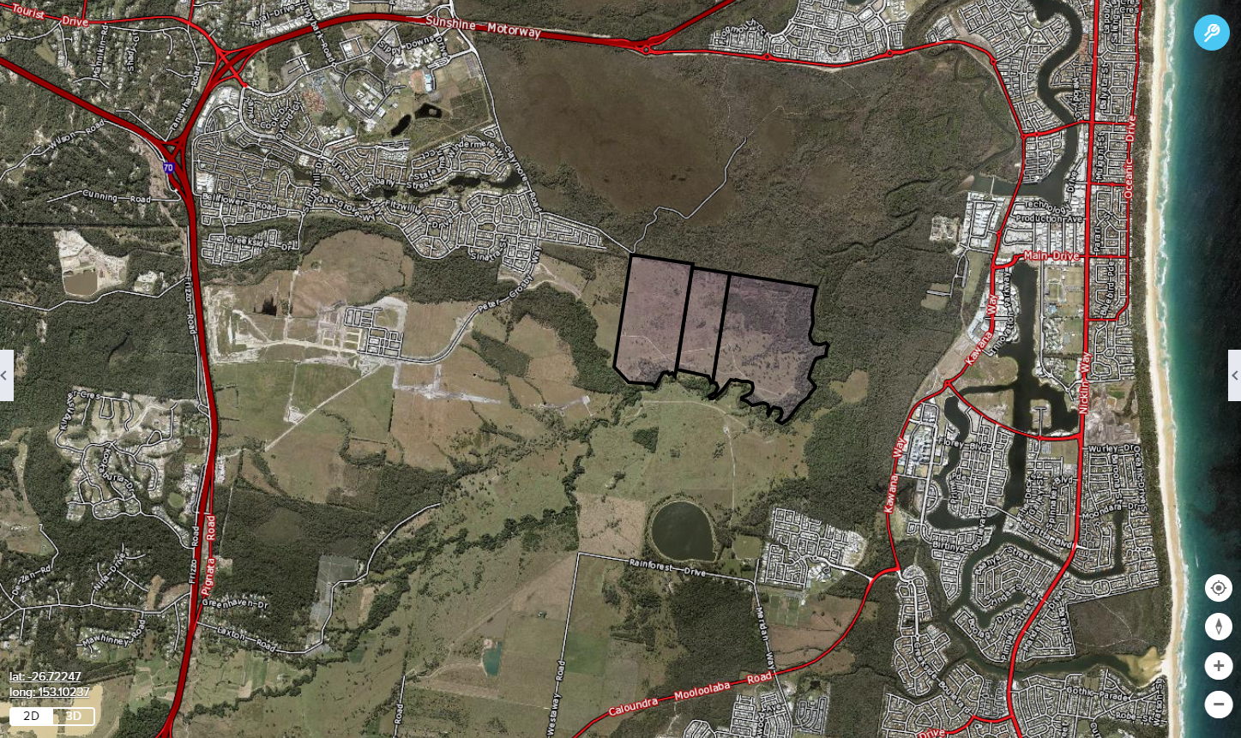
Lower Mooloolah River Environmental Reserve
Figure 2. Lower Mooloolah River Environmental Reserve Offset Locality Map
The scope of the OMP is to align specific environmental revegetation, regeneration, rehabilitation and protection measures for vegetation that occurs in a portion of the Lower Mooloolah River Environmental Reserve (LMRER) at Laxton Road, Palmview. These activities will deliver TMR’s offset obligations under the EPBC Act, yielding an overall conservation outcome for the LRSA TEC.
An agreement between SCC and TMR to deliver and manage the Mooloolah River Rainforest Offset Project was signed on 1 June 2017. The SCC/TMR environmental offset delivery agreement will comply with and meet the EPBC conditions of approval and is part of the agreement.
A summary of works undertaken for this reporting period is provided below:
- Ongoing control of weed and exotic grass across entire 16.64-hectare offset area around naturally regenerating species as a key component to assisted natural regeneration. Ongoing maintenance of weeds along the edge of the remnant area (Lantana, Broadleaved pepper tree, Mile-a-minute, Singapore daisy in particular). Greater than 98% of weeds on the rainforest edges have been controlled. The ongoing maintenance will ensure close to 100% weed control along the remnant edge.
Weed density in the remnant rainforest has been reported as almost negligible. Weed density in the reconstruction zones has reported to have been reduced from approximately 80% down to less than 5%.
Weed control activities and reinforcement plantings have resulted in 100% of canopy vegetation being native, significantly more than 30 different native woody LSRA TEC species (54 species in total) and significantly greater than 75% total vegetation cover being native in these zones.
In total, 1798 replacement tubestock have been installed for the project to date, with 80 replacements within this reporting period to ensure original planting numbers are maintained. Losses were attributed to short lived pioneer species reaching the end of their life spans, initially planted within the establishment phase of the revegetation program. Replacement plantings during the reporting period were secondary and climax phase species adapted to the changed conditions in the reserve.
The bio-condition monitoring was undertaken at the six established transects locations across the offset area. Transects 1 and 2 were established within high quality LRSA remnant and will provide a direct comparison across all attributes monitored with Transects 3 to 6, that were established within the reconstruction zones and transitional zone. Both Transect 1 and 2 are only 25m long compared to the 100-metre Transects for BioCondition Assessment, this in turn has provided results with slightly lower species diversity.

T1 and T2 vegetation are a very good representation of RE 12.3.1 and is in excellent condition. The canopy cover is 100% native.

Transects T3, T4 and T5 are located within a reconstruction zone of the offset area and as such are representative of the areas where exotic pasture grasses previously dominated. Natural recruitment is responsible for 16.8%, 20.6% and 14% within T3, T4 and T5, respectively, of the native stem count for the transects, with the balance attributed to successful native tube stock installation during Stage 1 and Stage 2 reconstruction plantings. The vegetation assemblage at these transects continues on a positive trajectory towards a representation of LRSA. The vegetation cover at transects T3, T4 and T5 was reported as 100% native canopy with 5% non-native ground cover recorded.
T6 is located within a transitional zone of the offset area where elements of RE 12.3.5 and RE 12.3.1 occur. Eucalypt, Allocasuarina and Melaleuca emergents exist as well as lower and mid-storey rainforest species and native shade-tolerant grasses. Reinforcement planting occurred throughout this zone as part of Stage 1 and Stage 2 plantings. As expected, natural recruitment is significantly higher in this zone than in the reconstruction zones. Natural recruitment is responsible for 30% (24/80) of the native stem count for this transect with the balance directly attributed to successful native tube stock installation during the Stage 1 and Stage 2 reinforcement plantings. The vegetation assemblage at T6 is on a positive trajectory towards a representation of LRSA. The vegetation cover was reported as being 100% native canopy with 2% non-native ground cover recorded.
The SCC Pest Management Team has collected pest animal data and responded accordingly throughout the reporting period.
The following upcoming activities are scheduled to occur over the following twelve months:
- ongoing monitoring and weed control throughout the rainforest remnant;
- ongoing monitoring and data collection;
- ongoing general maintenance works as required by the OMP and the SCC technical specification; and
- removal of tree guards as necessary.
The final BioCondition report will be completed in November 2026.
Refer to Appendix D for the Lower Mooloolah River Environmental Reserve Offset Site.
    - Condition 2(c)
Legally secure and implement the offset of 4.65ha at the location shown by the first 12-month anniversary of the commencement of the action.
TMR has purchased Lot 2 RP268457 (28 Mooloolah Road, Mooloolah Valley, Sunshine Coast) in Freehold in 2016 and a Voluntary Declaration is in place.
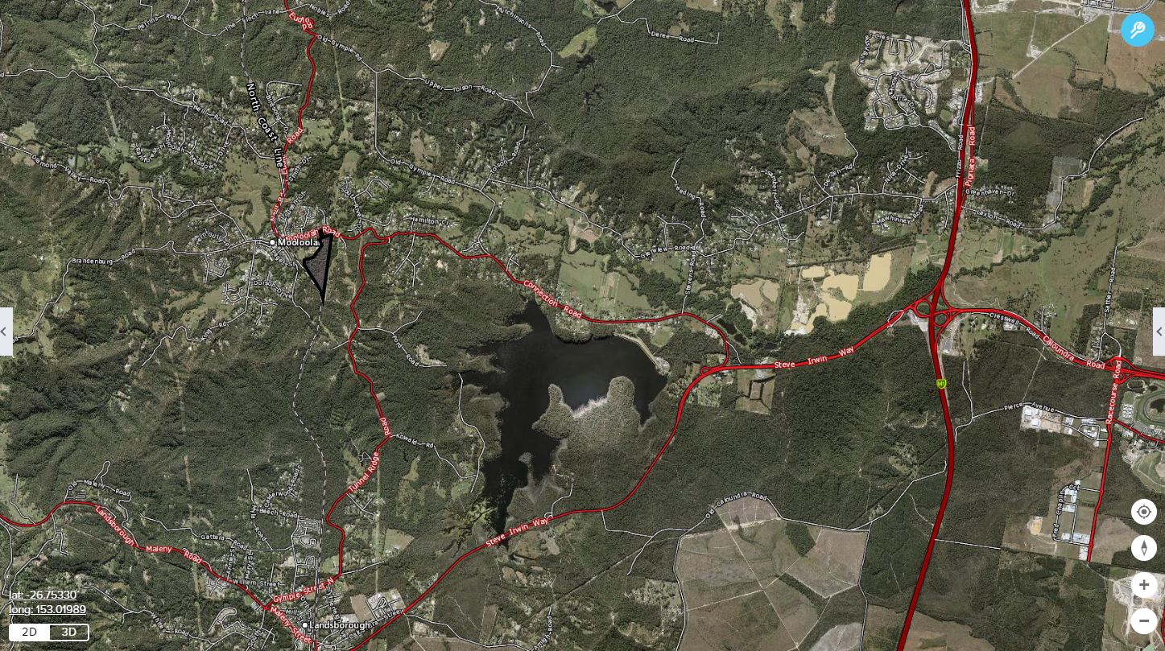
Mooloolah Valley
Figure 3. Mooloolah Valley Offset Locality Map
An Offset Management Plan (OMP) has been prepared and aims to protect and maintain in perpetuity 5.02-hectare of Lowland Rainforest of Subtropical Australia and manage to remnant status approximately 4.5-hectare of high value regrowth as a land-based offset for clearing works associated with the Project works.
The OMP details key risks and management actions and provides support for a Voluntary Declaration under the Vegetation Management Act 1999, and the requirements of the approval under the EPBC Act for the Project.
The primary management objective for the site is to conserve and improve the value of the area for the Lowland Rainforest of Subtropical Australia (LRSA). The overall management outcome will be to maintain current vegetation structure, composition and diversity, and improve the value of the area through management of high value regrowth. This will increase the total area of LRSA, and buffer core LRSA against weed invasion and fire.
TMR has engaged a separate Contractor to deliver the works required under the OMP and to meet the EPBC conditions of approval as part of the agreement. The purpose of the OMP and works is to protect and maintain in perpetuity 5.02ha of LRSA and manage to remnant status.
A summary of works undertaken for this reporting period is provided below:
- Weed control activities continued throughout the reporting period. The primary focus was to control reshooting and germinating weeds, particularly madeira vine (Anredera cordifolia), blue morning glory (Ipomoea indica) and Singapore daisy (Sphagneticola trilobata).
- Other species treated throughout the reporting period included blue billygoat weed (Ageratum houstonianum), broad leafed paspalum (Paspalum mandiocanum), inch plant (Callisia repens), trad (Tradescantia fluminensis), broad-leaved pepper tree (Schinus terebinthifolius).
- Follow up weed control continued along the northern boundary of 1d, through 2a, 2c and 3c controlling larger woody weeds and vines such as Easter cassia (Senna pendula var. glabrata), broad leaf pepper tree (Schinus terebinthifolius), lantana (Lantana camara).
The following upcoming activities are scheduled to occur over the next 12 months:
- Ongoing maintenance and weed control of site, particularly in ‘hotspot’ areas along the creek and open boundaries;
- BioCondition survey to be completed in accordance with biennial schedule; and
- Open areas in Zone 3c to be planted to assist with canopy cover, vegetation structure and complexity.
Refer to Appendix E for location.

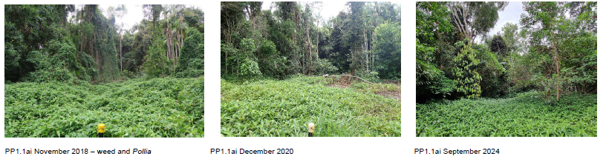
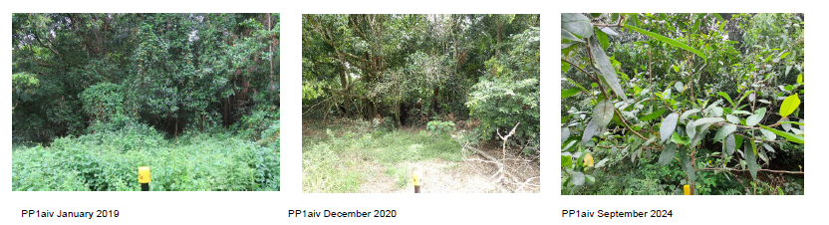
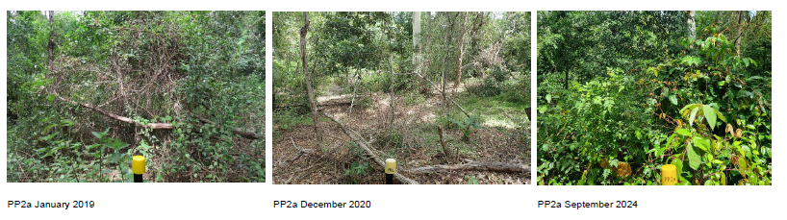
Figure 4. Photo monitoring at Bio-Condition plots
  - Condition 3
    - Condition 3(a)
Not disturb more than 35.3ha of Koala habitat within the project site.
As detailed within the fifth annual compliance report this condition was completed within the 2020 – 2021 reporting period. Condition 3a is considered compliant and closed.
    - Condition 3(b)
Implement five koala movement structures (Koala friendly underpasses) within the project area.
As detailed within the sixth annual compliance report this condition was completed within the 2021 – 2022 reporting period. Condition 3b is considered compliant and closed.
Photos of the installed fauna structures are shown in Appendix H.
    - Monitoring Fauna Infrastructure
As part of the Project’s requirements to mitigate its impacts on the Koala, five Koala movement structures (fauna underpasses) were required to be incorporated into design. In addition to these, the project installed a new fauna rope ladder along Steve Irwin Way, and 45 Koala escape poles located along 13-kilometres of Koala exclusion fencing. These were successfully installed in July 2021 and a separate contractor has been engaged to monitor for fauna movement.
A total of 88 passive infrared cameras traps were installed in April 2022 across the fauna infrastructure to monitor their use by fauna. As detailed in the 2023 Annual Report, three separate theft events occurred where deployed cameras were stolen during the 2023 monitoring period resulting in a reduced data set. To mitigate the risk of further theft over the high-risk period during the school holidays (November 2023 – January 2024), cameras were re-installed in late January 2024 at impacted underpasses. To increase available data, cameras remained operational until the end of May 2024.
At the completion of this monitoring program, assessment of Koala utilisation and movement within the fauna structures was undertaken. As noted within the Seventh annual compliance report (2022 – 2023 reporting period) one Koala sighting was recorded within the adjacent bushland east of the northern underpass. Whilst no other Koala identifications were made during the monitoring program, the structures were deemed to be compliant. This is due to the structures being of a suitable type and size range of crossing structures that Koala’s have been observed using at other locations. It was noted that whilst Koala’s had not utilised any of the underpasses it appeared more to be a factor of low abundance or low activity of Koala’s in the immediate areas surrounding the underpasses rather than any deficiencies of the structure design or construction.
A summary of the monitoring results over the course of the two-year monitoring program is detailed below;
- A total of 558 fauna crossings were recorded over the monitoring program, being confirmed or probable crossings. Where confirmed crossings provided evidence of species entering and exiting the crossing and probably crossings provided evidence of species either clearly entering or clearly exiting the infrastructure, but was only captured on one camera.
- During the seventh monitoring review (15 November 2023 to 5 March 2024), there were 144 crossing events, including 76 confirmed crossings, 68 probable crossings.
- During the eighth monitoring review (6 March to 31 May 2024), there were 76 crossing events, including 12 confirmed crossings, 64 probable crossings.
Fauna species recorded on the monitoring cameras:
- Arboreal fauna other than Koalas recorded on and around the fauna infrastructure included Common Brushtail Possum (Trichosurus vulpecula), Ringtail Possum (Pseudocheirus peregrinus), Short-eared Brushtail Possum (Trichosurus caninus), and Squirrel Glider (Petaurus norfolcensis). These results are consistent with the results of the 2023 monitoring periods.
- Terrestrial fauna species recorded on and around the fauna mitigation structures, that are likely to use the fauna mitigation structures based on their ecology, included Yellow-footed Antechinus (Antechinus flavipes), Brush Turkey (Alectura lathami), Eastern Grey Kangaroo (Macropus giganteus), Eastern Water Dragon (Intellagama lesueuri), Long-nosed Bandicoot (Perameles nasuta), Northern Brown Bandicoot (Isoodon macrourus), Short-beached Echidna (Tachyglossus aculeatus), and Swamp Wallaby (Wallabia bicolor). These results are consistent with the results of the 2023 monitoring periods.
- Other individual macropods were recorded but could not be identified, as these individuals were often captured moving past the camera at speed and at night resulting in a lack of detail for any distinguishing features.
- One Koala was recorded on a camera adjacent to the Northern underpass during the fifth (May to August) monitoring period in 2023.
The monitoring works per the requirement of the Overarching Environmental Management Plan for the project has been completed and have been considered to have met the intent of the objectives and measures as detailed.
Images taken throughout this monitoring period can be found in Appendix I.
    - Condition 3(c)
Legally secure and implement the offset of 50ha by the first 12-month anniversary of the commencement of action.
TMR purchased Lot 2 RP51879 (Missing Link Road, Glenview) in Freehold in 2016 from a private landowner, a Voluntary Declaration is now in place.
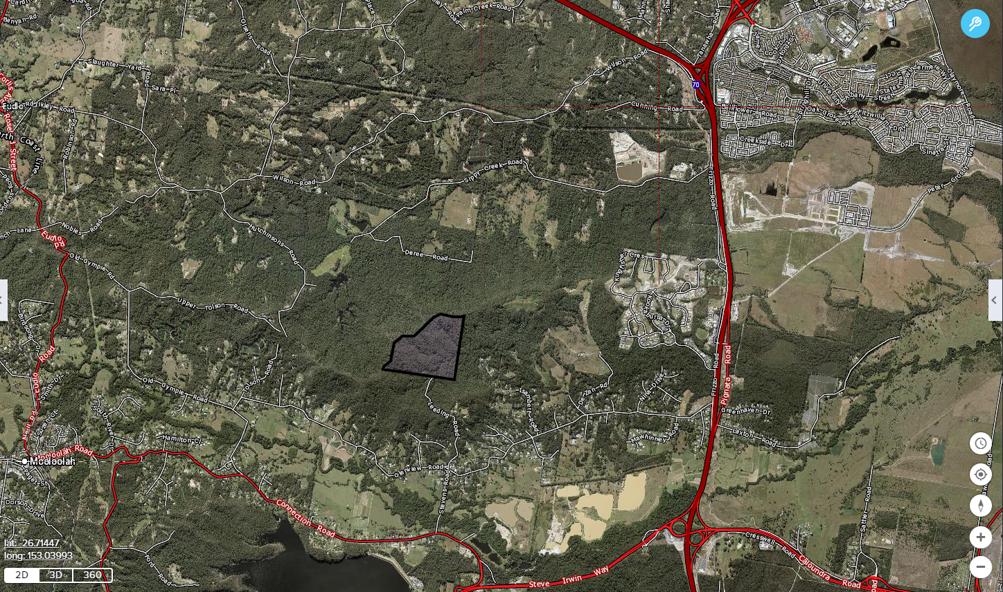
Missing Link Road
Figure 5. Koala Habitat Offset Locality Map
An Offset Management Plan (OMP) has been prepared for the property to protect and maintain in perpetuity 50.07ha of Koala habitat as a land-based offset for clearing works associated with the Project. The OMP details key risks management actions, provides support for a Voluntary Declaration under the Vegetation Management Act 1999 and outlines the requirements for management of Koala habitat offsets.
As detailed within the sixth annual compliance report this condition was completed within the 2021 – 2022 reporting period by meeting the intent of the objectives and measures within the OMP. Condition 3c is considered compliant and closed.
Refer to Appendix F offset site locality map.
  - Condition 5
Condition 5 of the EPBC Act Approval states:
The approval holder must maintain accurate records substantiating all activities associated with or relevant to the conditions of approval and make them available upon request to the Department.
TMR acknowledges this condition. All records pertaining to activities associated with or relevant to the EPBC Act conditions of approval are maintained and updated on a regular basis.
- Conclusion
The CR2SM Project reached final Practical Completion in the 2021 - 2022 reporting period. The proposed Action “to upgrade a 7km section of the Bruce Highway between Caloundra Road to Sunshine Motorway, Queensland” is considered to be completed. The works have now entered into a maintenance period.
Condition 1 of the approval was closed in the 2021-2022 reporting period.
The Glenview environmental offset site delivered compliance in the 2021-2022 reporting period.
This reporting period covers the progress status of the environmental offset site management and compliance to the associated approval conditions.
The Lower Mooloolah River and Mooloolah Valley environmental offset site continue to show positive improvements and compliance to the approval conditions.
The monitoring of the fauna infrastructure has been completed in the monitoring period and has shown fauna movement of the structures.
As of the end of the 2024-2025 reporting period, approval conditions 1, 2a, 3a,3b,3c and 4 are compliant and closed. Approval conditions 2b(i-iiI) and 2c remain compliant, and approval conditions 5 and 6 are still in progress.

- References
Department of Transport and Main Roads (2016), Offset Management Plan – Lowland Rainforest of Subtropical Australia: Lower Mooloolah River Environmental Reserve.
Ecosure Pty Ltd (2023), Mooloolah Valley Offset Year 6 Annual Report: December 2024, report prepared for the Department of Transport and Main Roads.
Sunshine Coast Council (2024), Annual Report – Year 8 (2023-2024) Lowland Rainforest of Subtropical Australia Threatened Ecological Community offset; Lower Mooloolah River Environmental Reserve, report prepared for the Department of Transport and Main Roads.
WSP (2024), 2024 Annual Fauna Monitoring Report, report prepared for the Department of Transport and Main Roads.
- Appendices

Appendix A –EPBC Approval Decision Notice

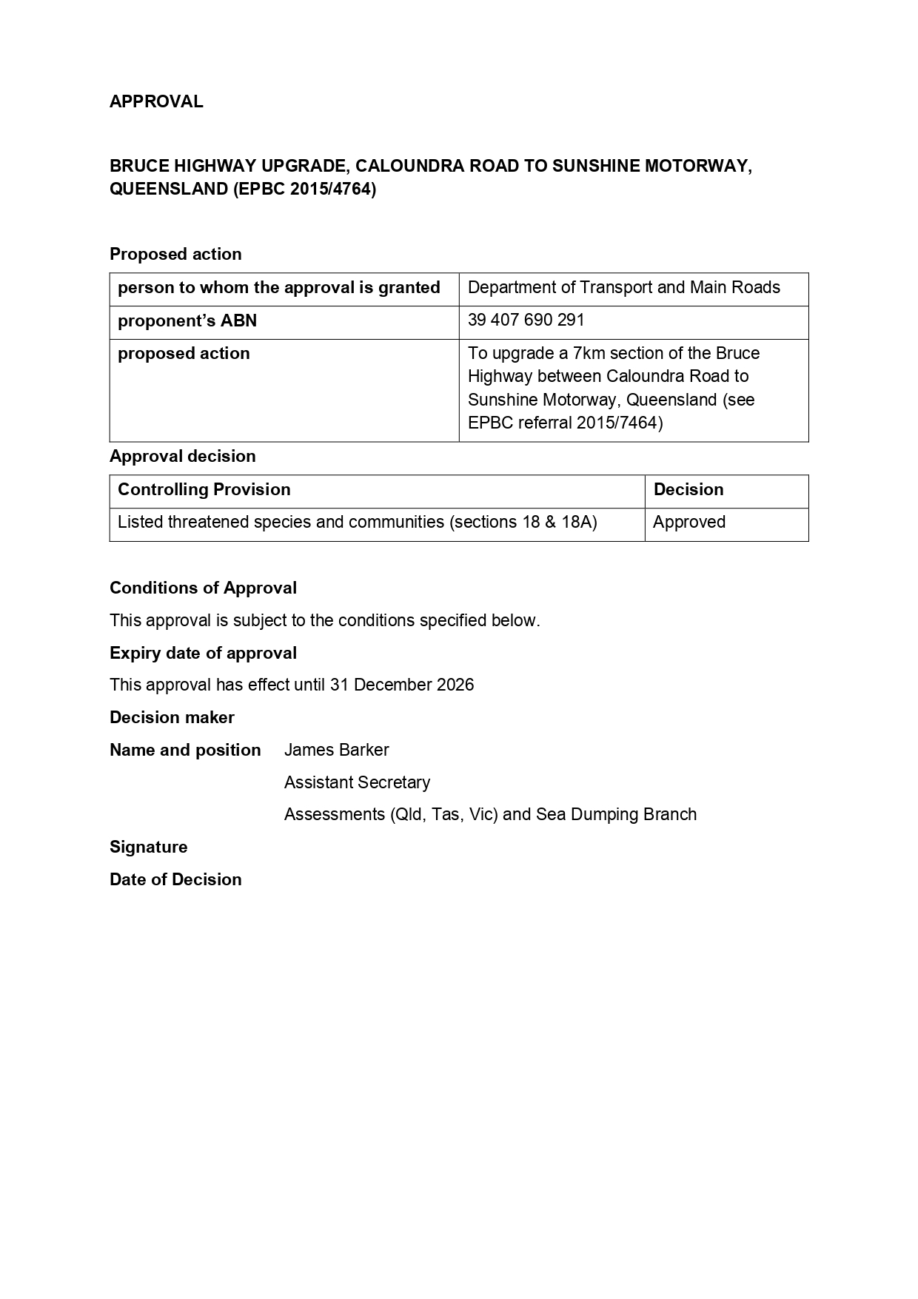
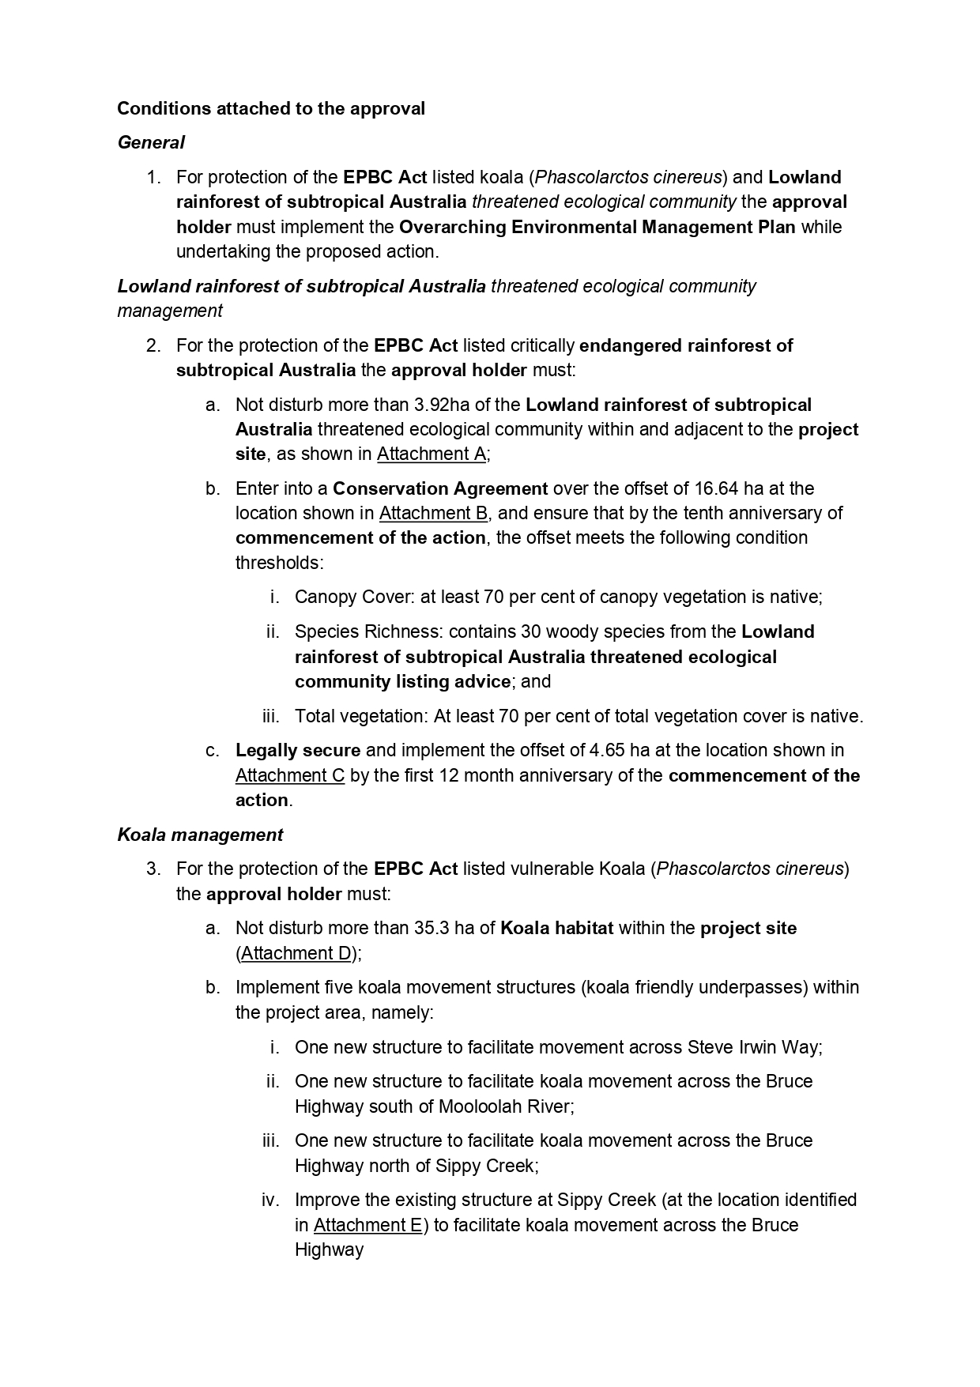
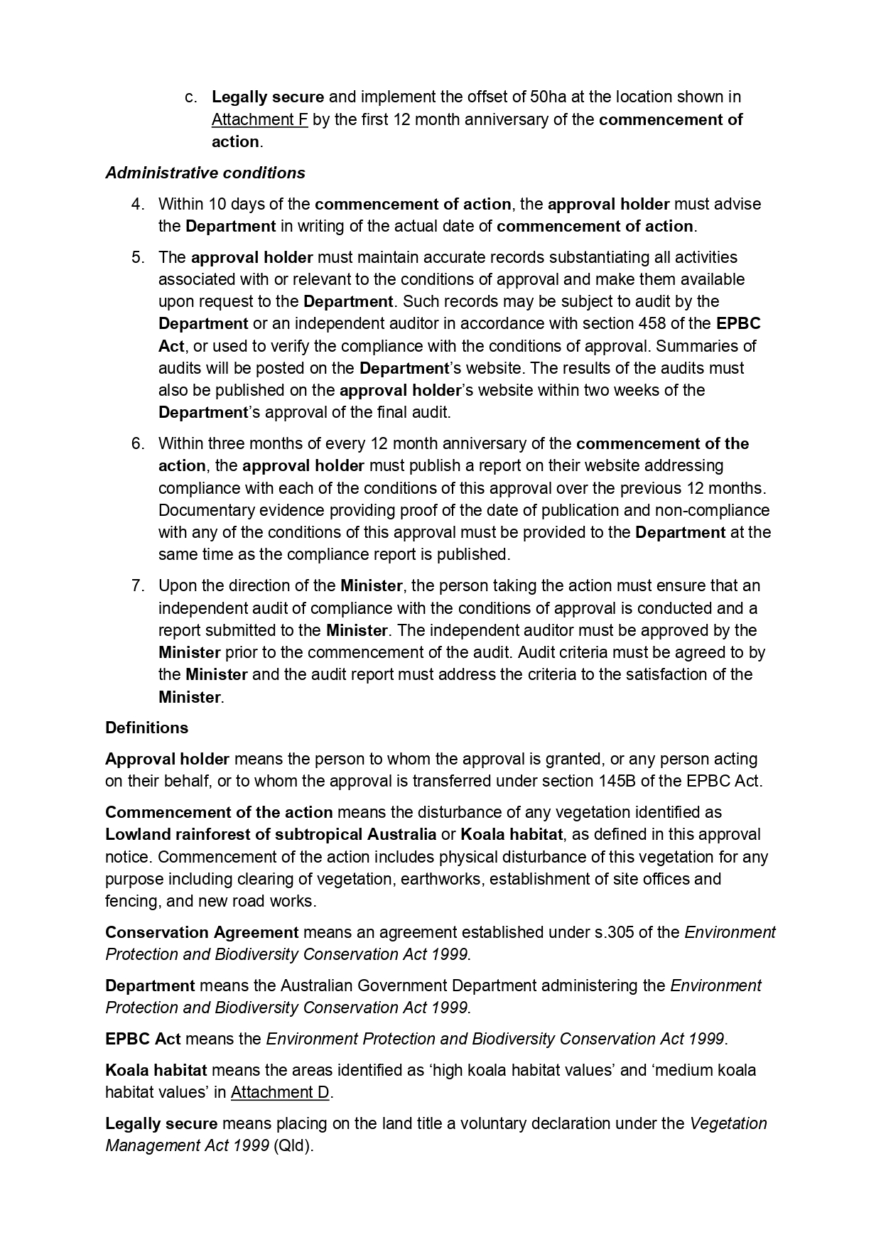
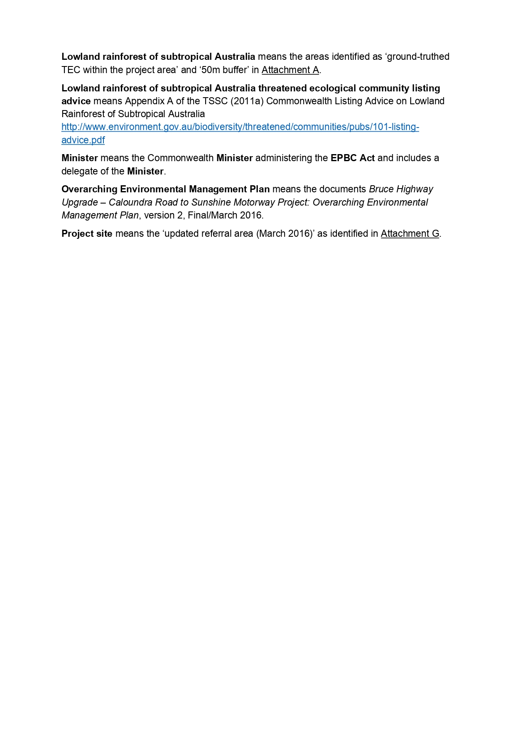
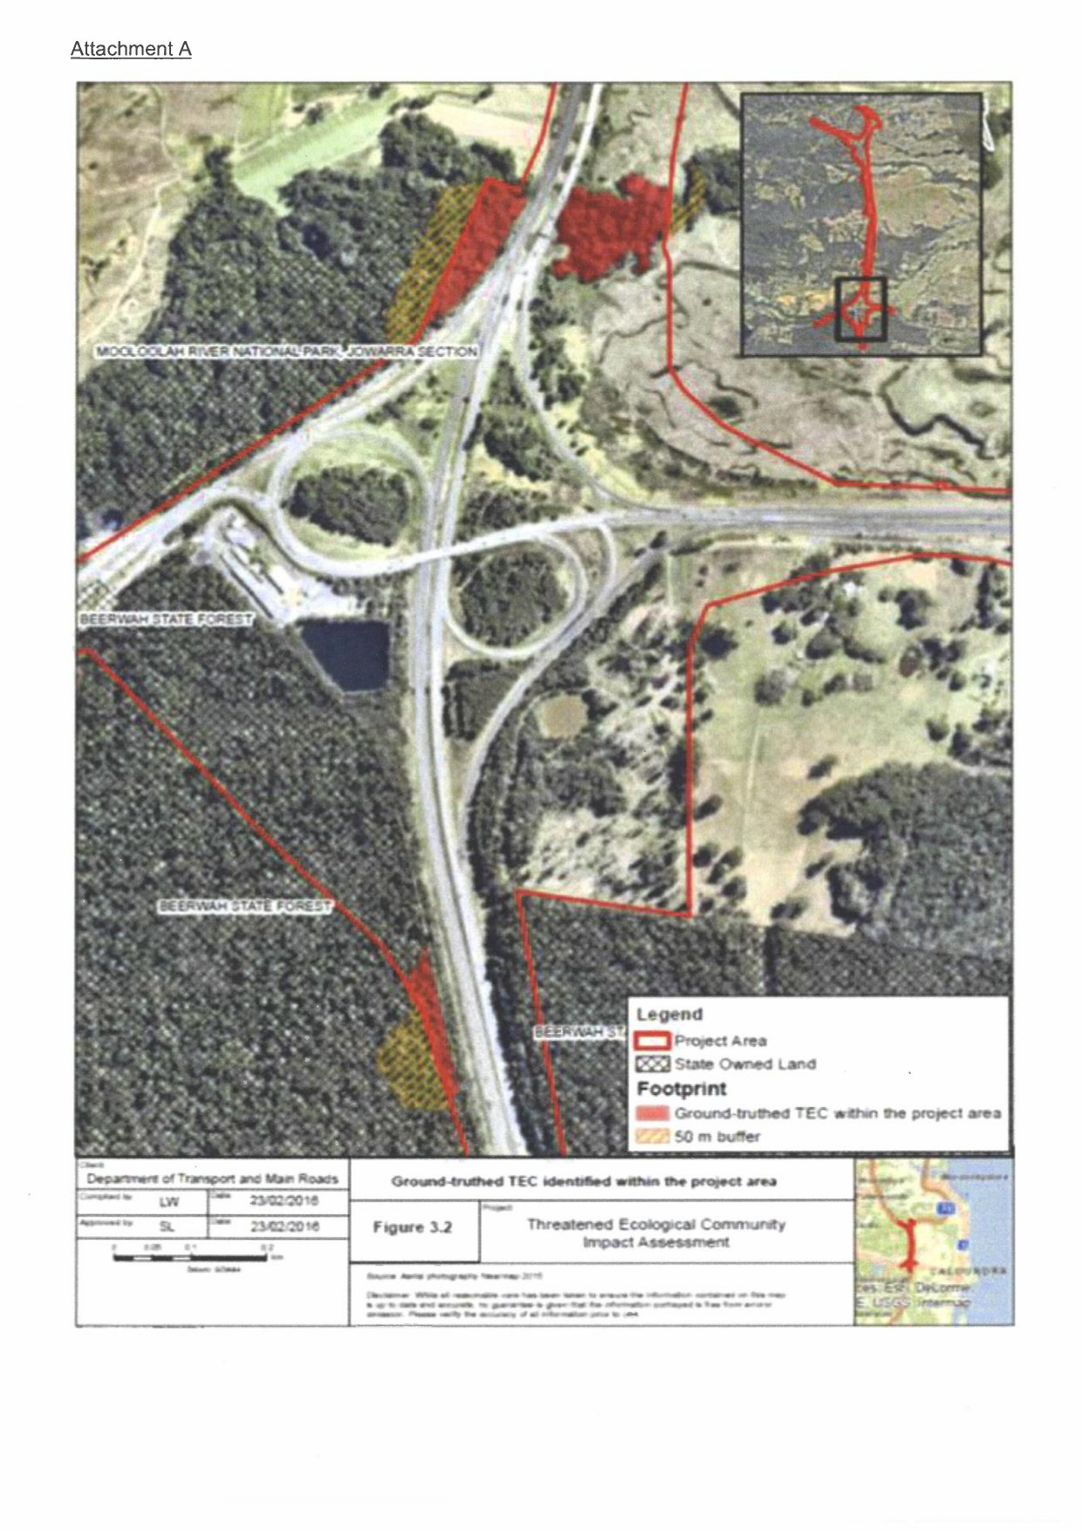
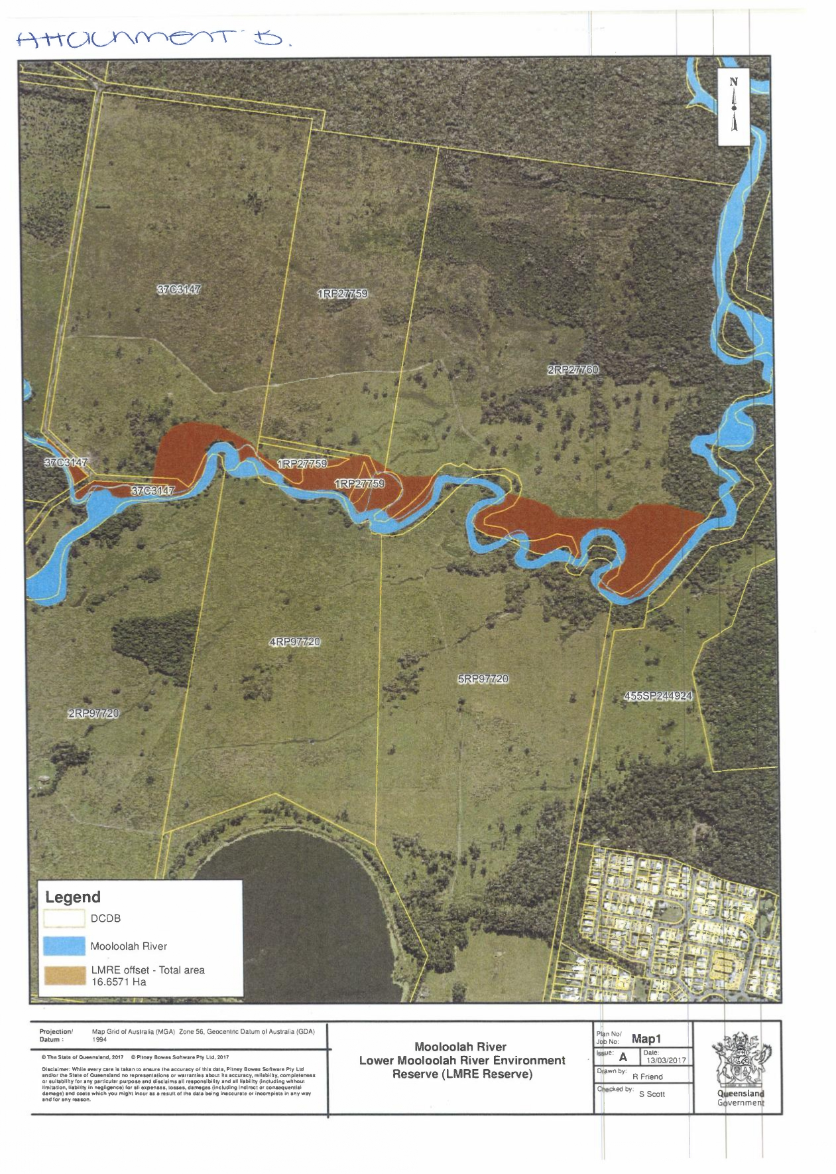
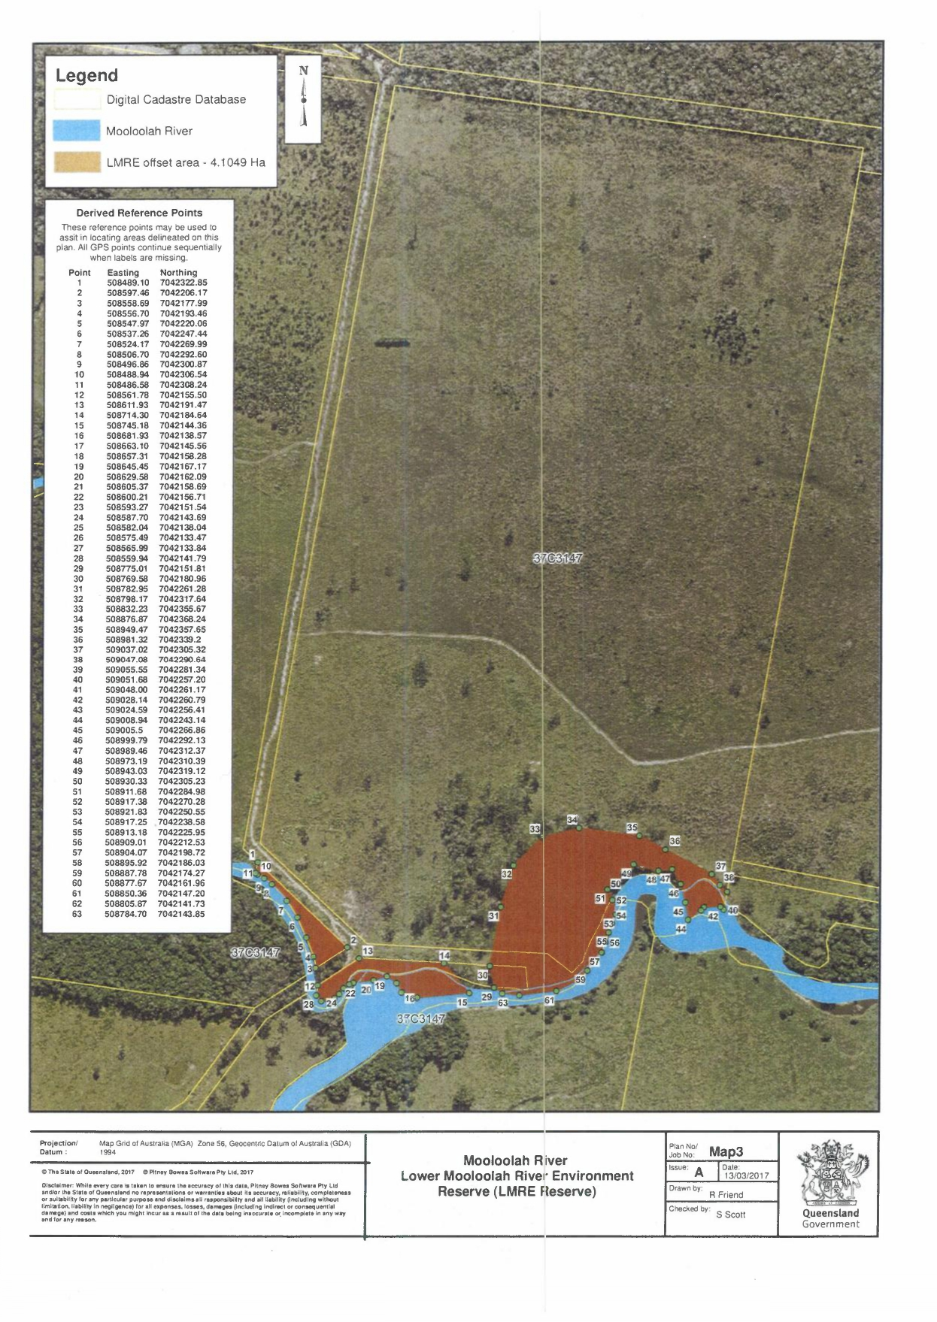
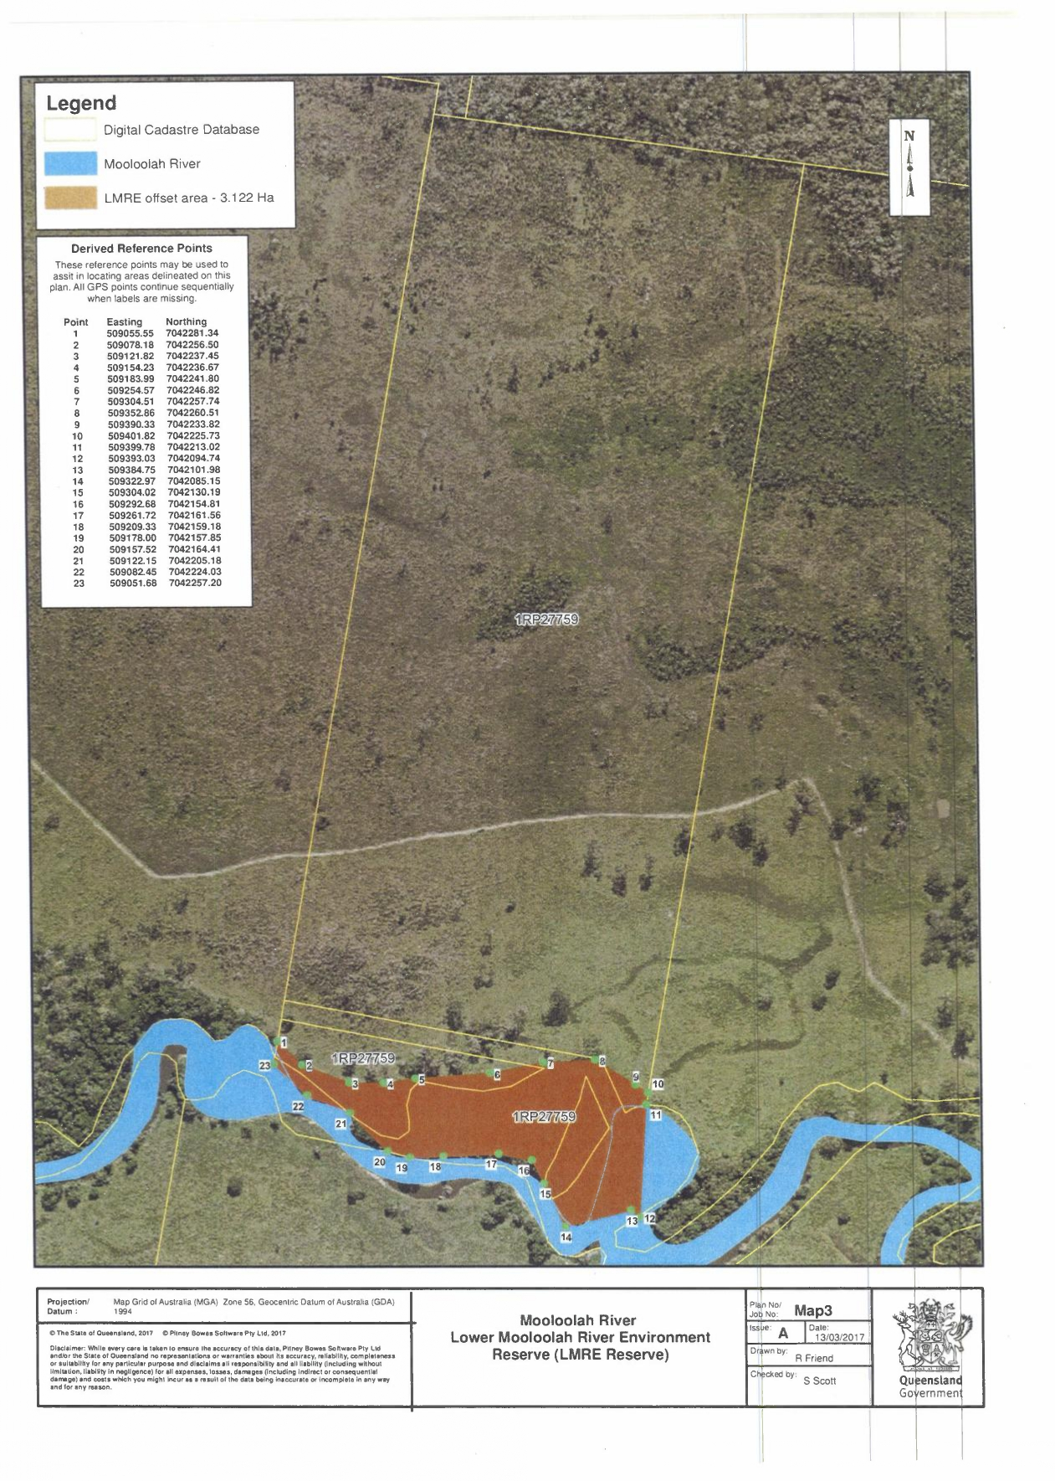
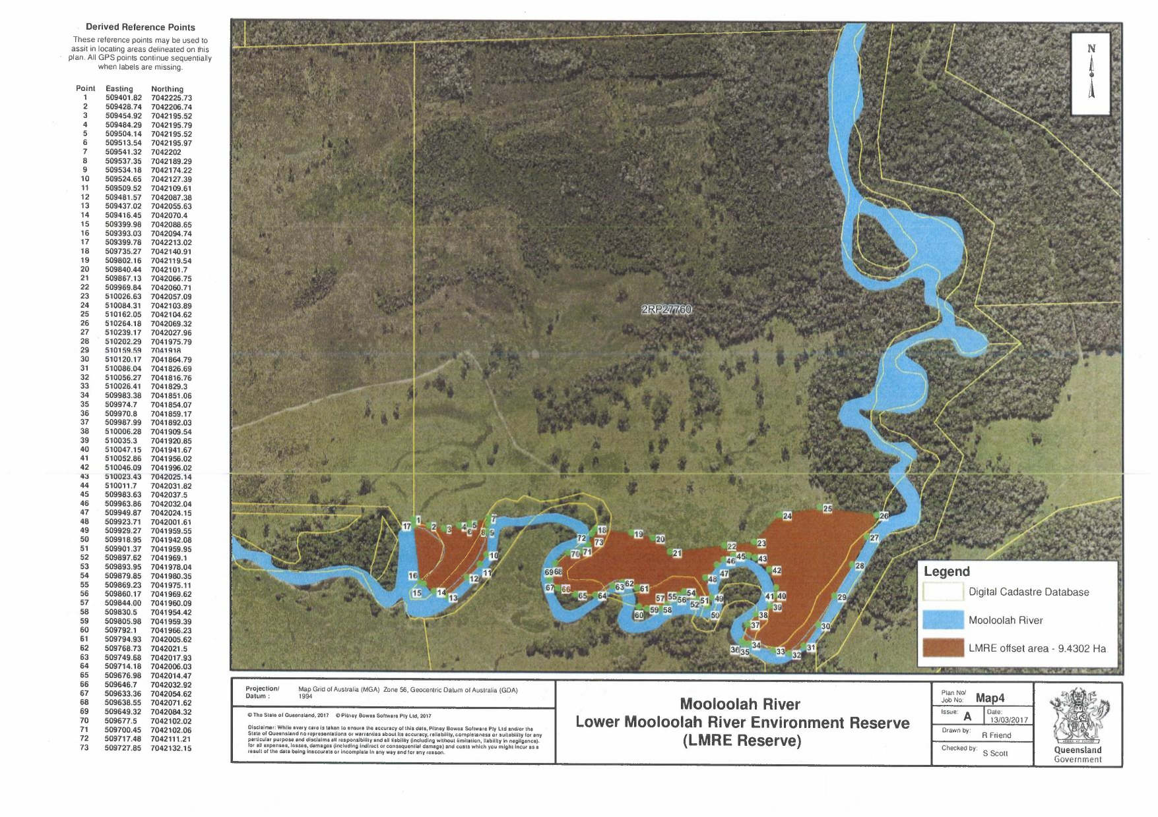
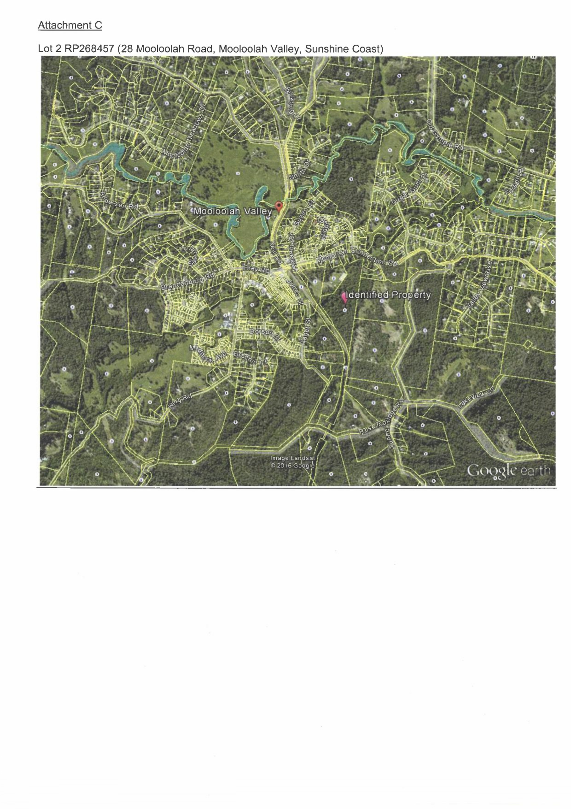
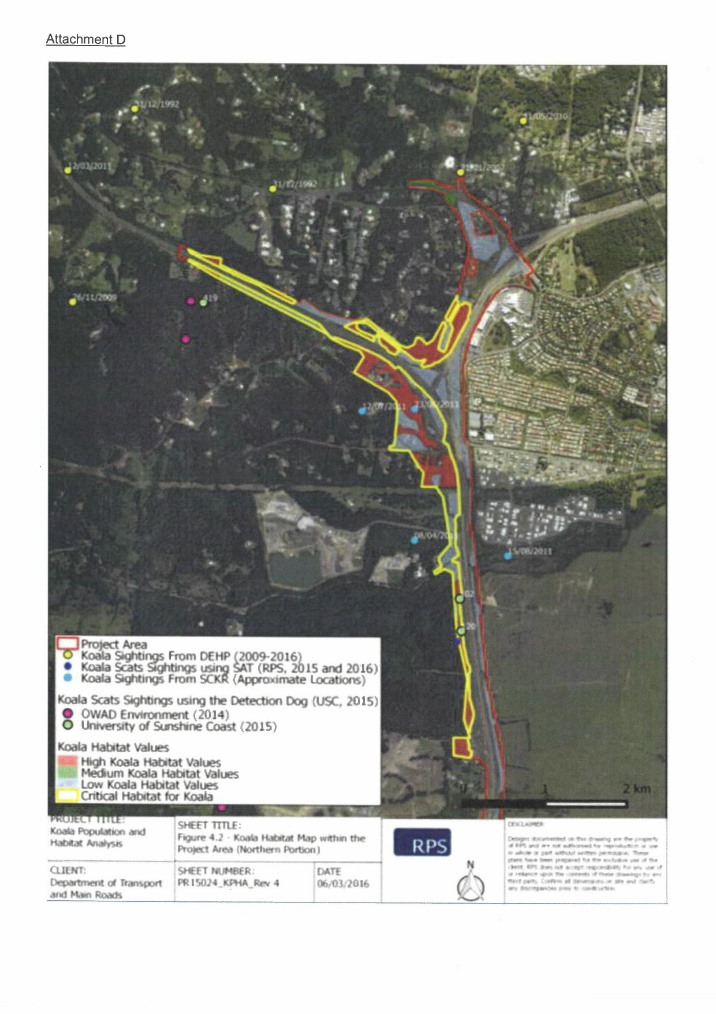
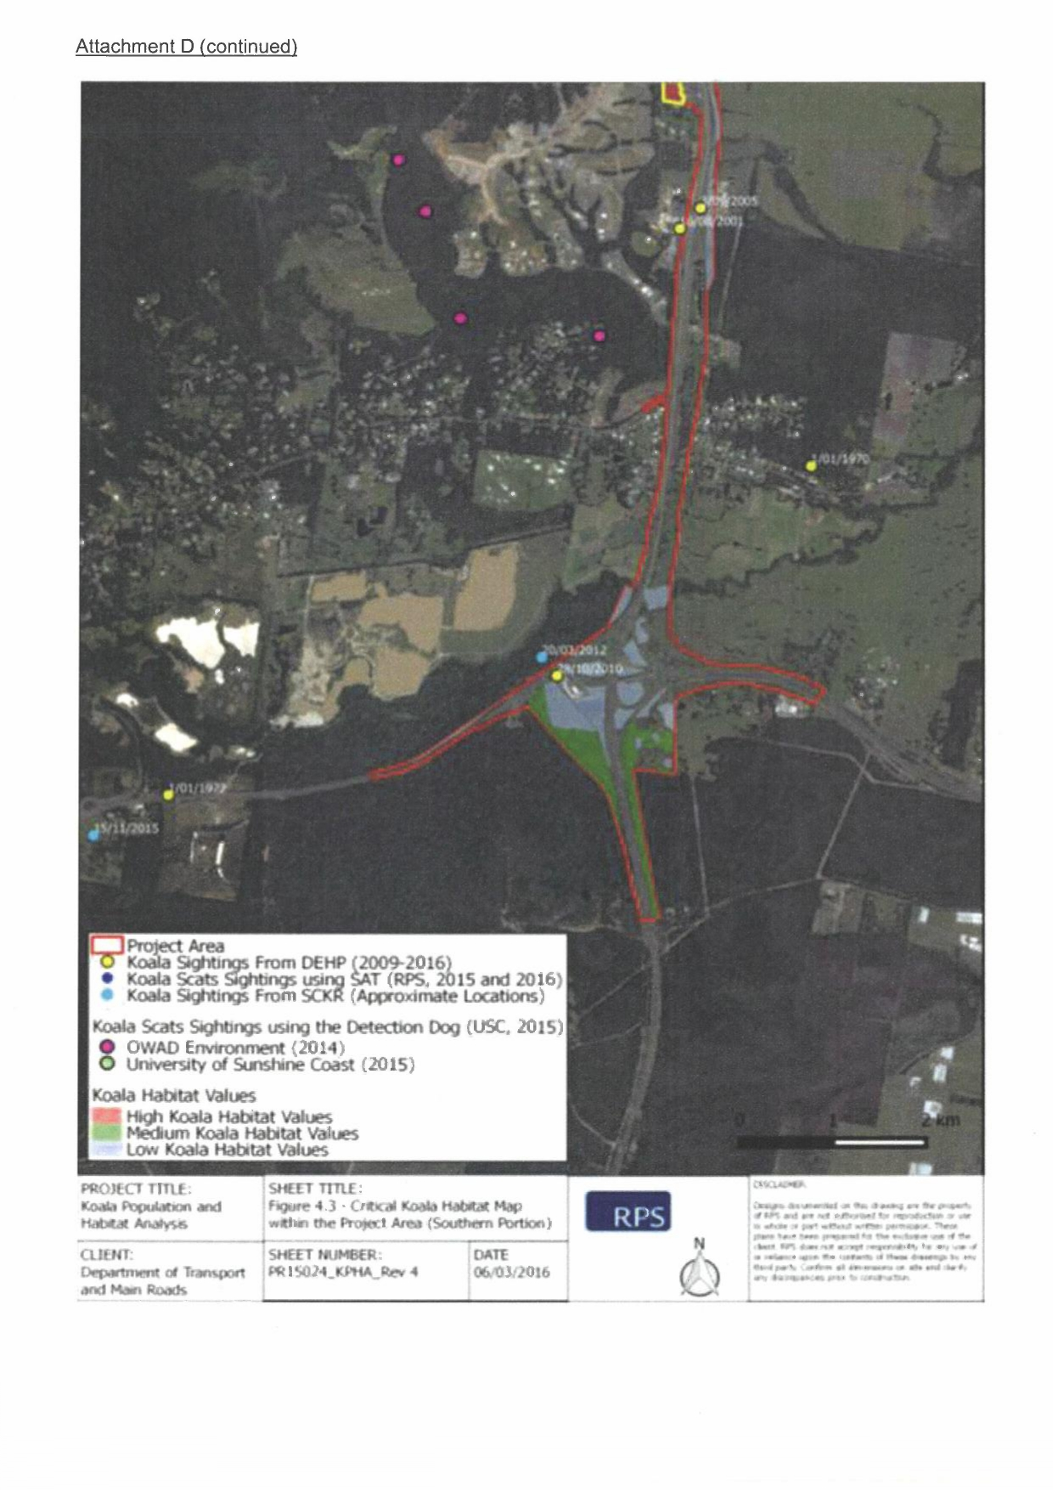
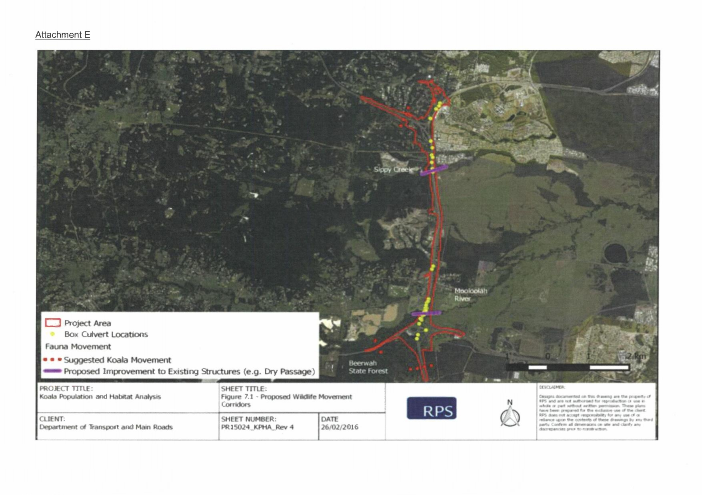
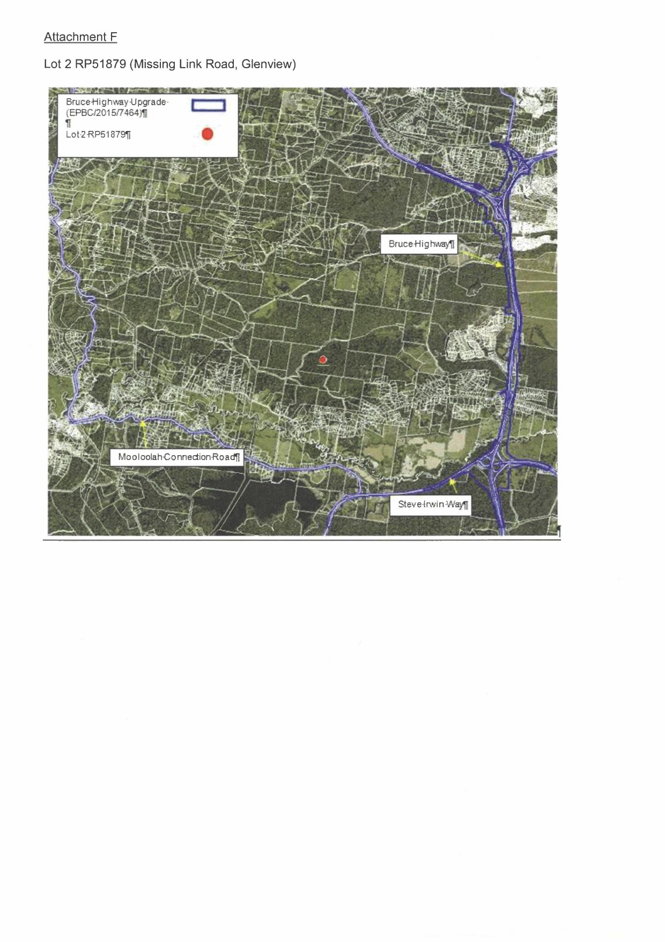
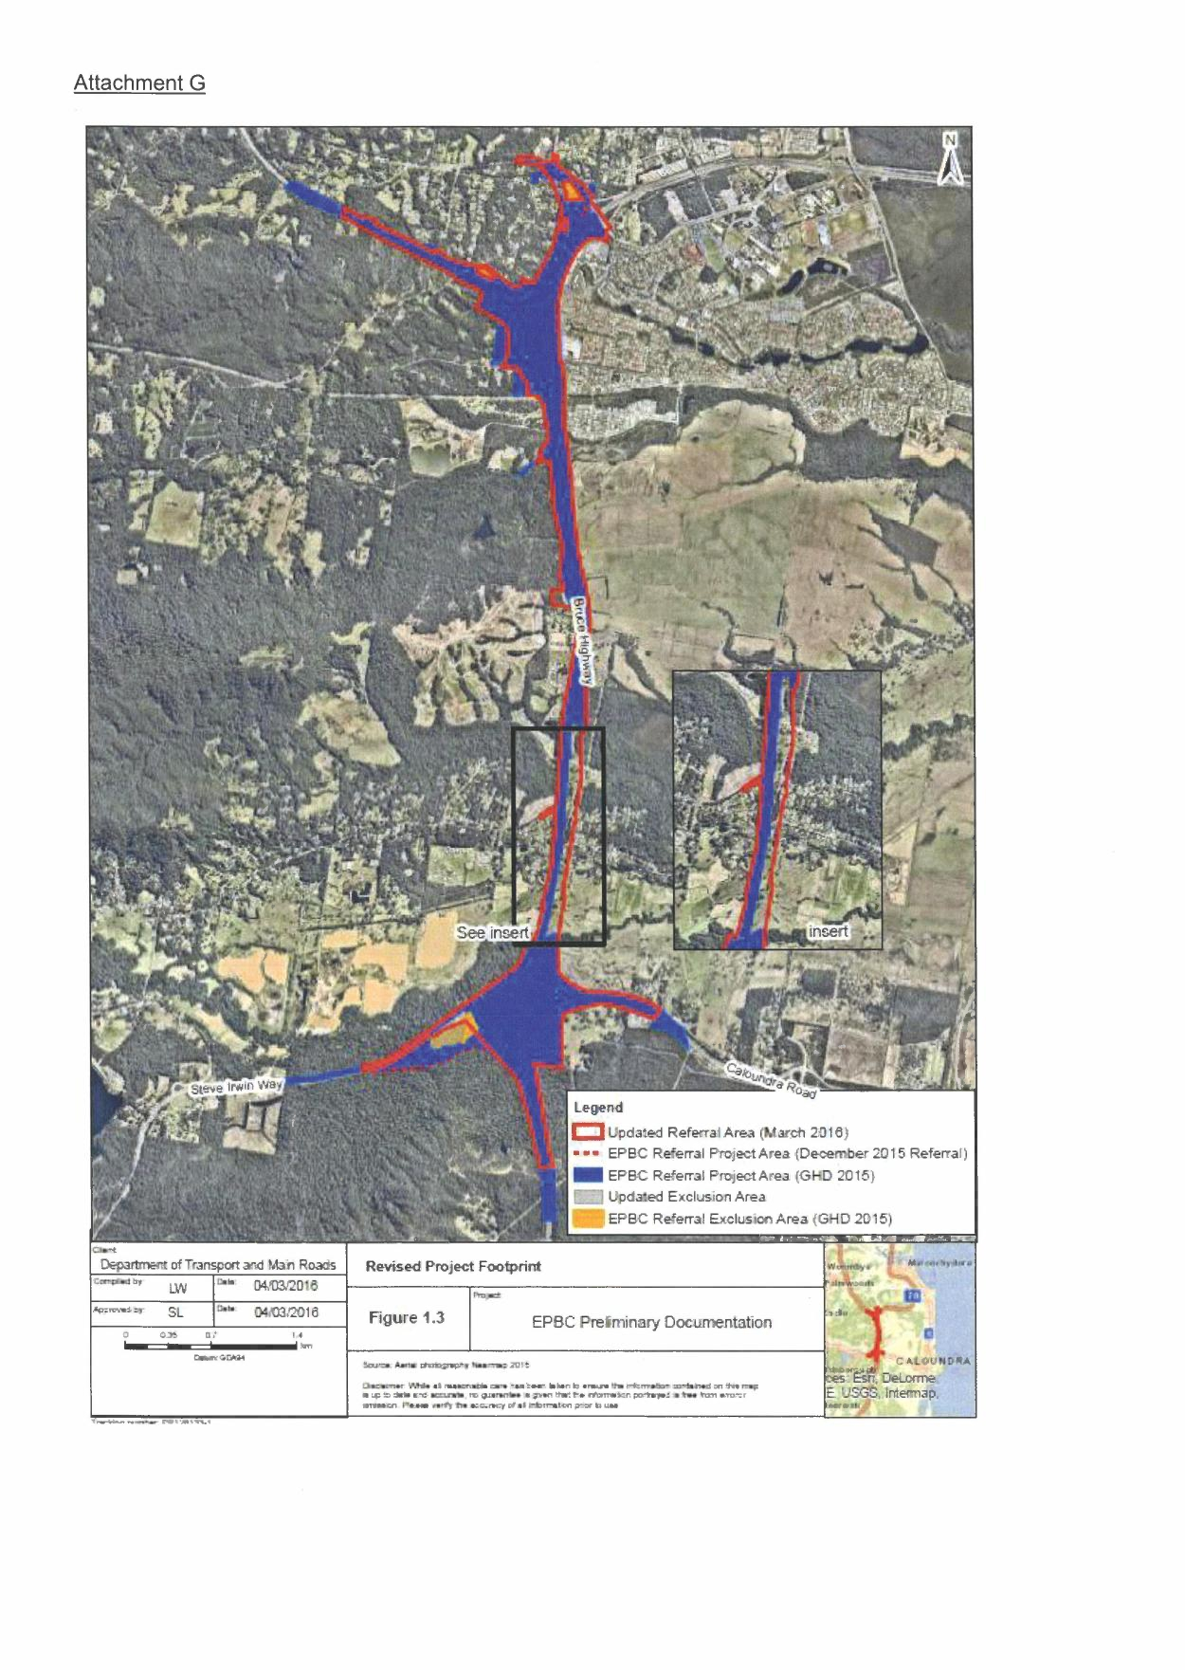

Appendix B – CR2SM Project Site Threatened Ecological Community
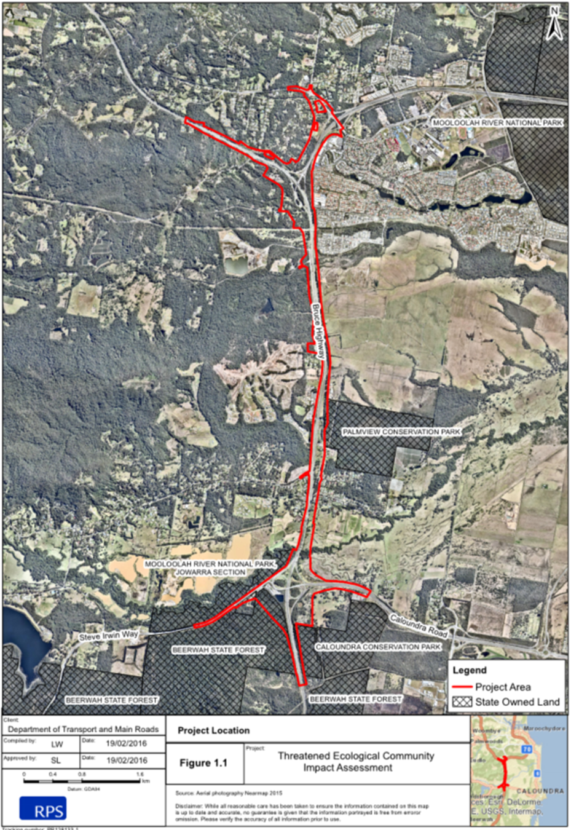

Appendix C – As-Built Clearing Diagrams

Medium and high value Koala habitat cleared to date - north

Medium and high value Koala habitat cleared to date - south

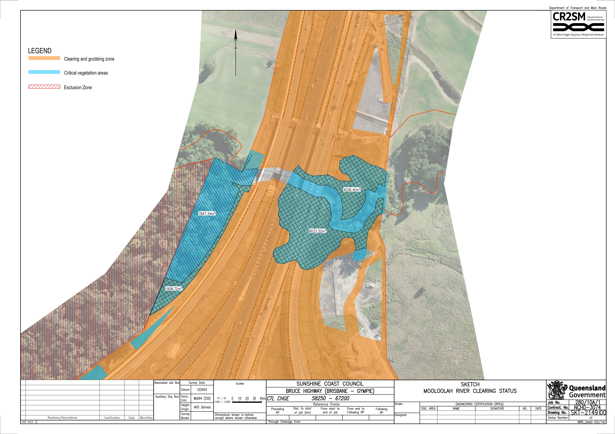

Total TEC cleared

Appendix D – Lower Mooloolah River Environmental Reserve Offset Site (16.64ha)

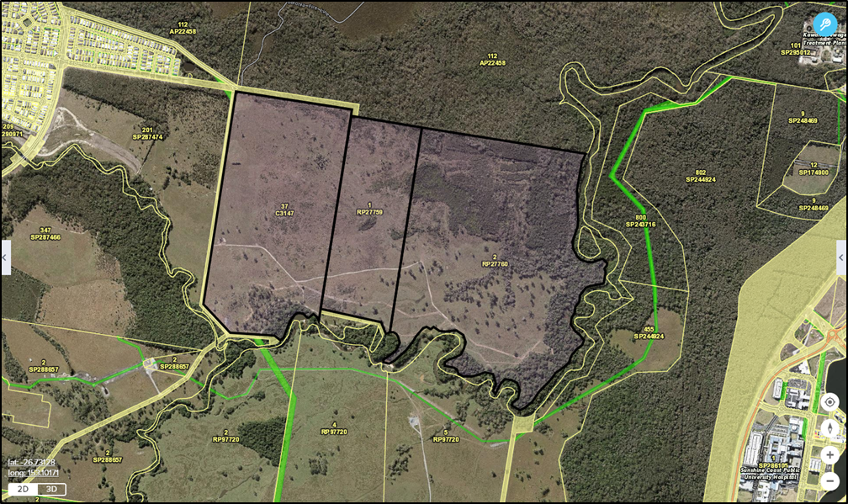
Lower Mooloolah River Environmental Reserve Offset Site.
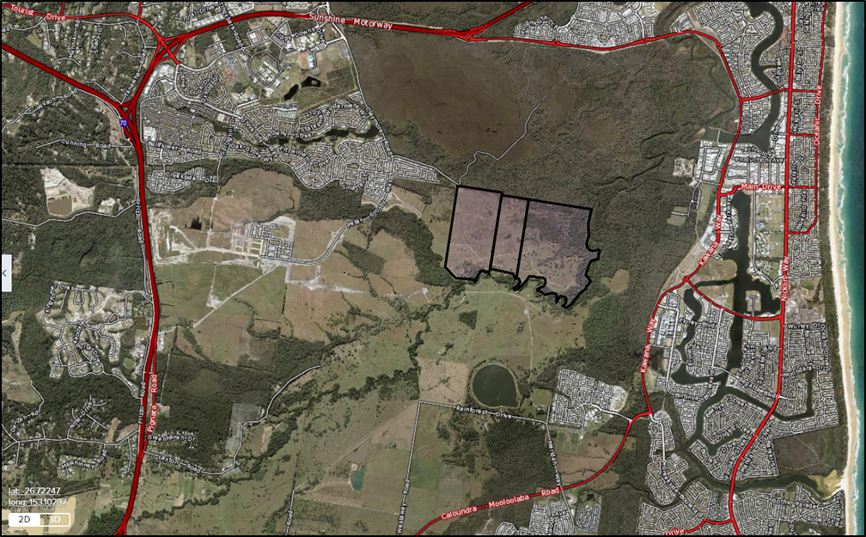
Offset Site
Lower Mooloolah River Environmental Reserve Offset Site general locale.

Appendix E – 28 Mooloolah Road, Mooloolah Valley Offset Site (4.65ha)

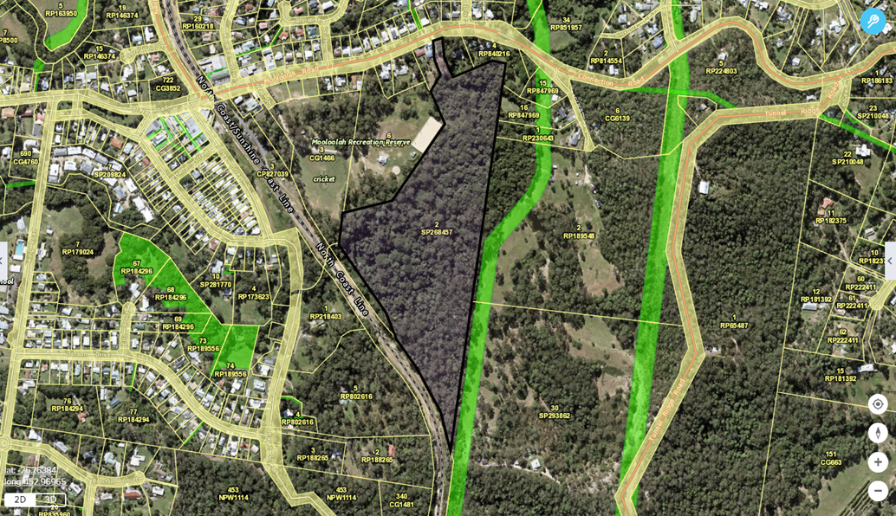
28 Mooloolah Road, Mooloolah Valley Offset Site.
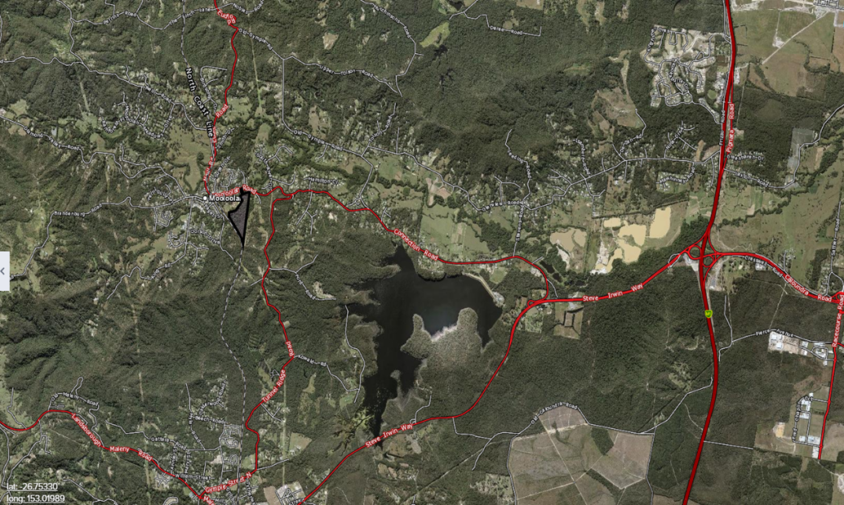
Offset Site
28 Mooloolah Road, Mooloolah Valley Offset Site general locale.

Appendix F – Missing Link Road, Glenview Offset Site (50ha)

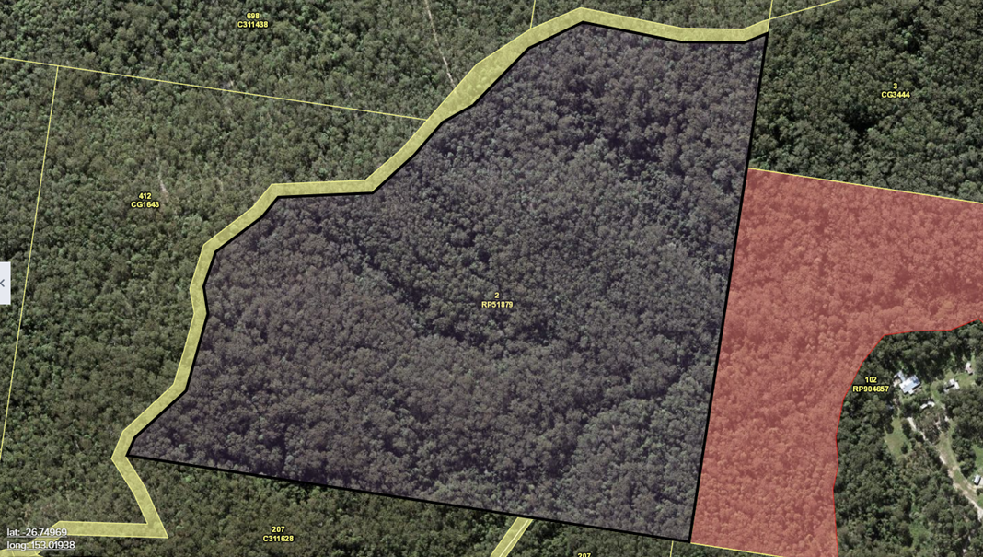
Missing Link Road, Glenview Offset Site.
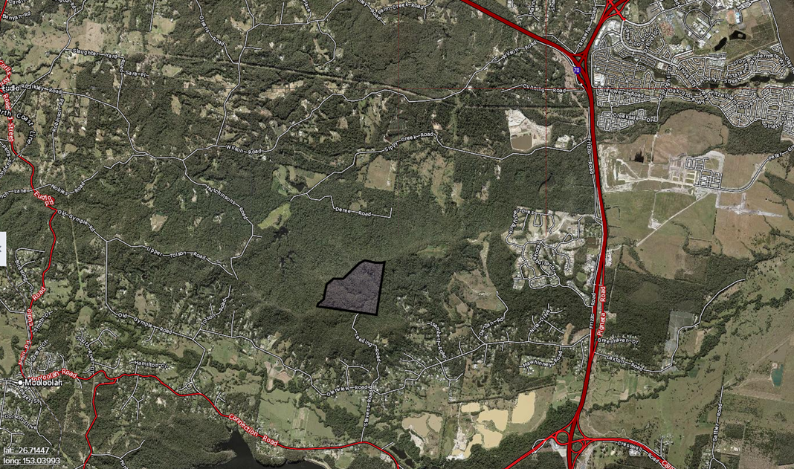
Offset Site
Missing Link Road, Glenview Offset Site general locale.

Appendix G – Notification of Commencement of the Action

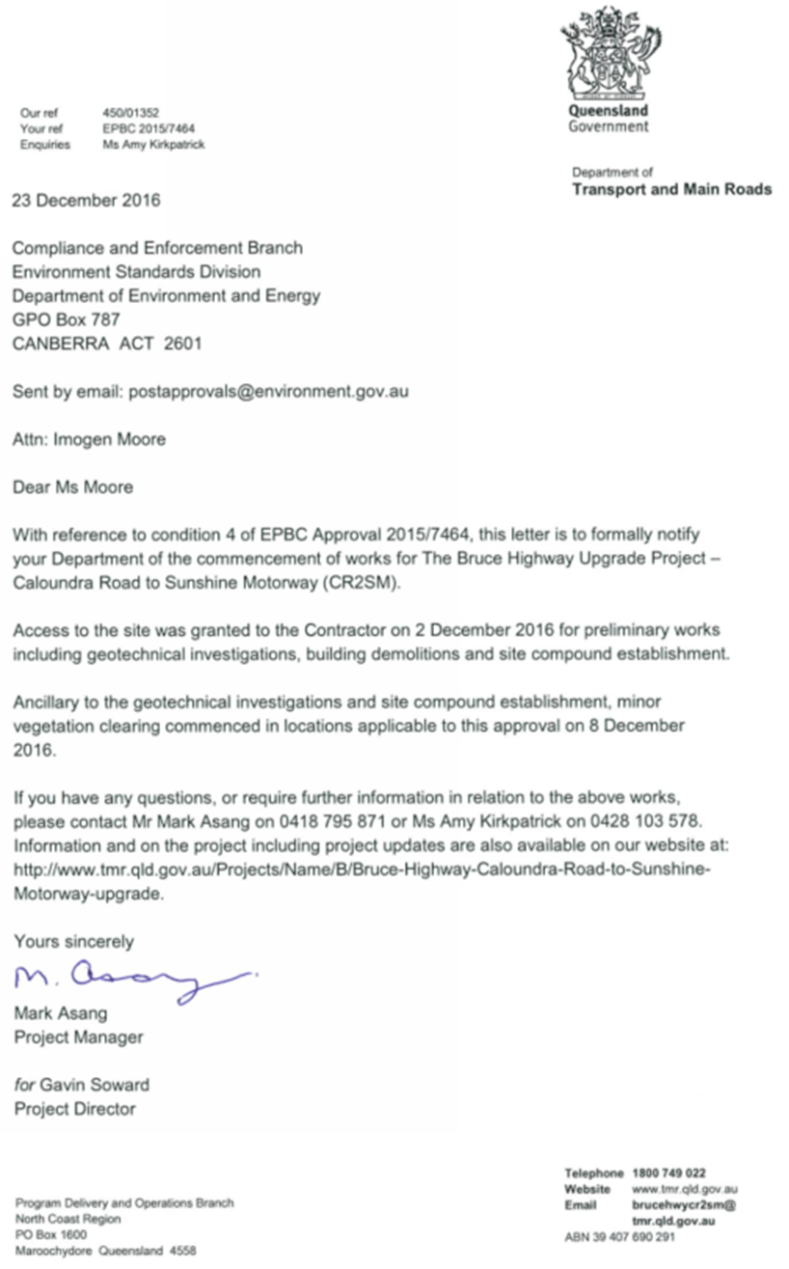

Appendix H – Fauna furniture locations

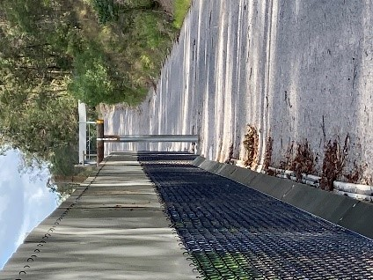
Photo Plate 1. Permanent fauna fence with frog exclusion fencing and Koala escape pole adjacent to Bruce Highway

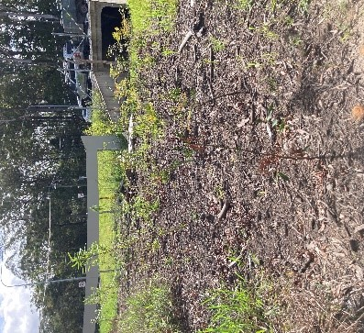
Photo Plate 2. Completed Steve Irwin Way fauna passage

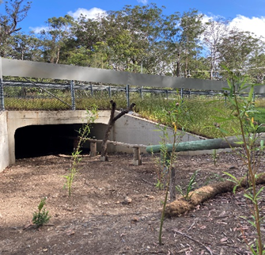
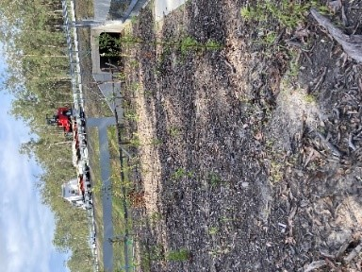

Photo Plate 3 and 4. Completed southern fauna passage

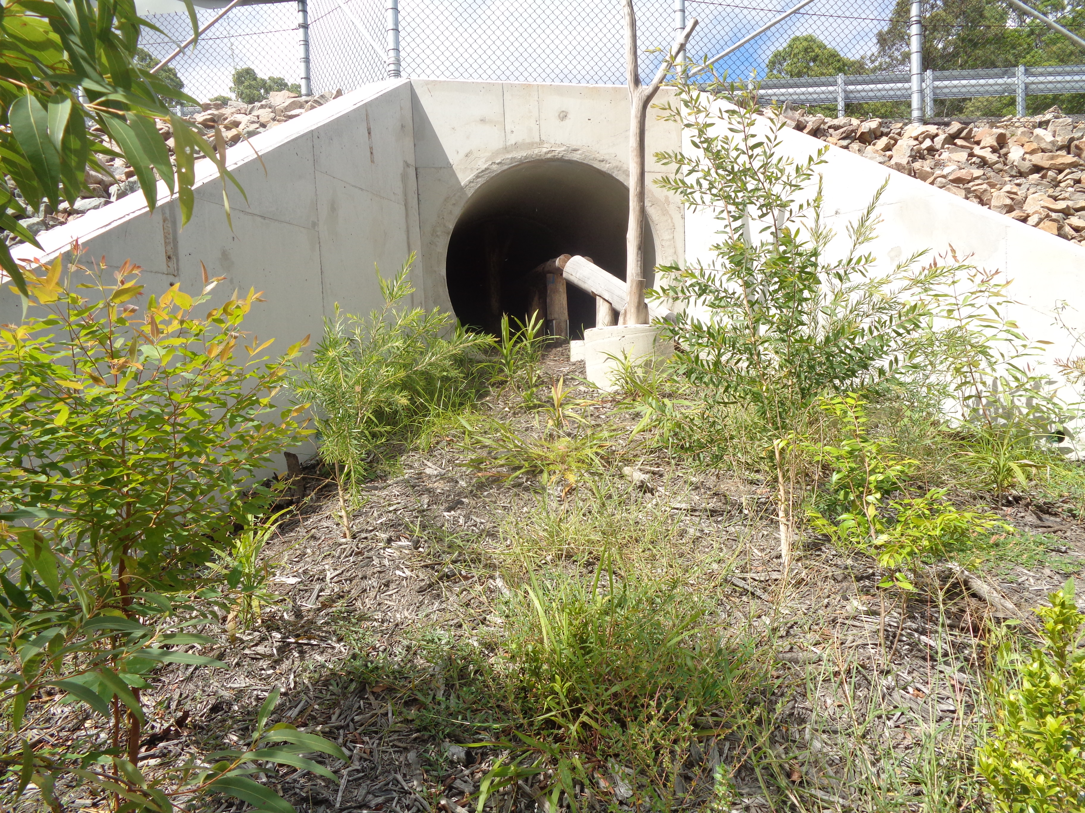
Photo Plate 5. Completed northern fauna passage
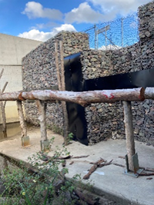
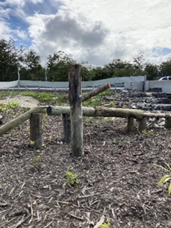
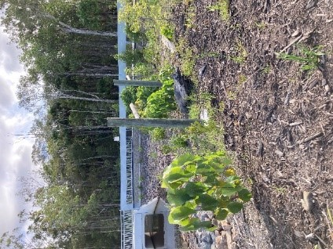

Photo Plate 6, 7 and 8. Fauna structures installed at Sippy Creek
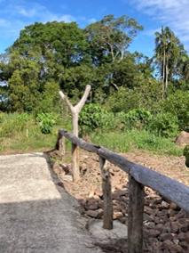
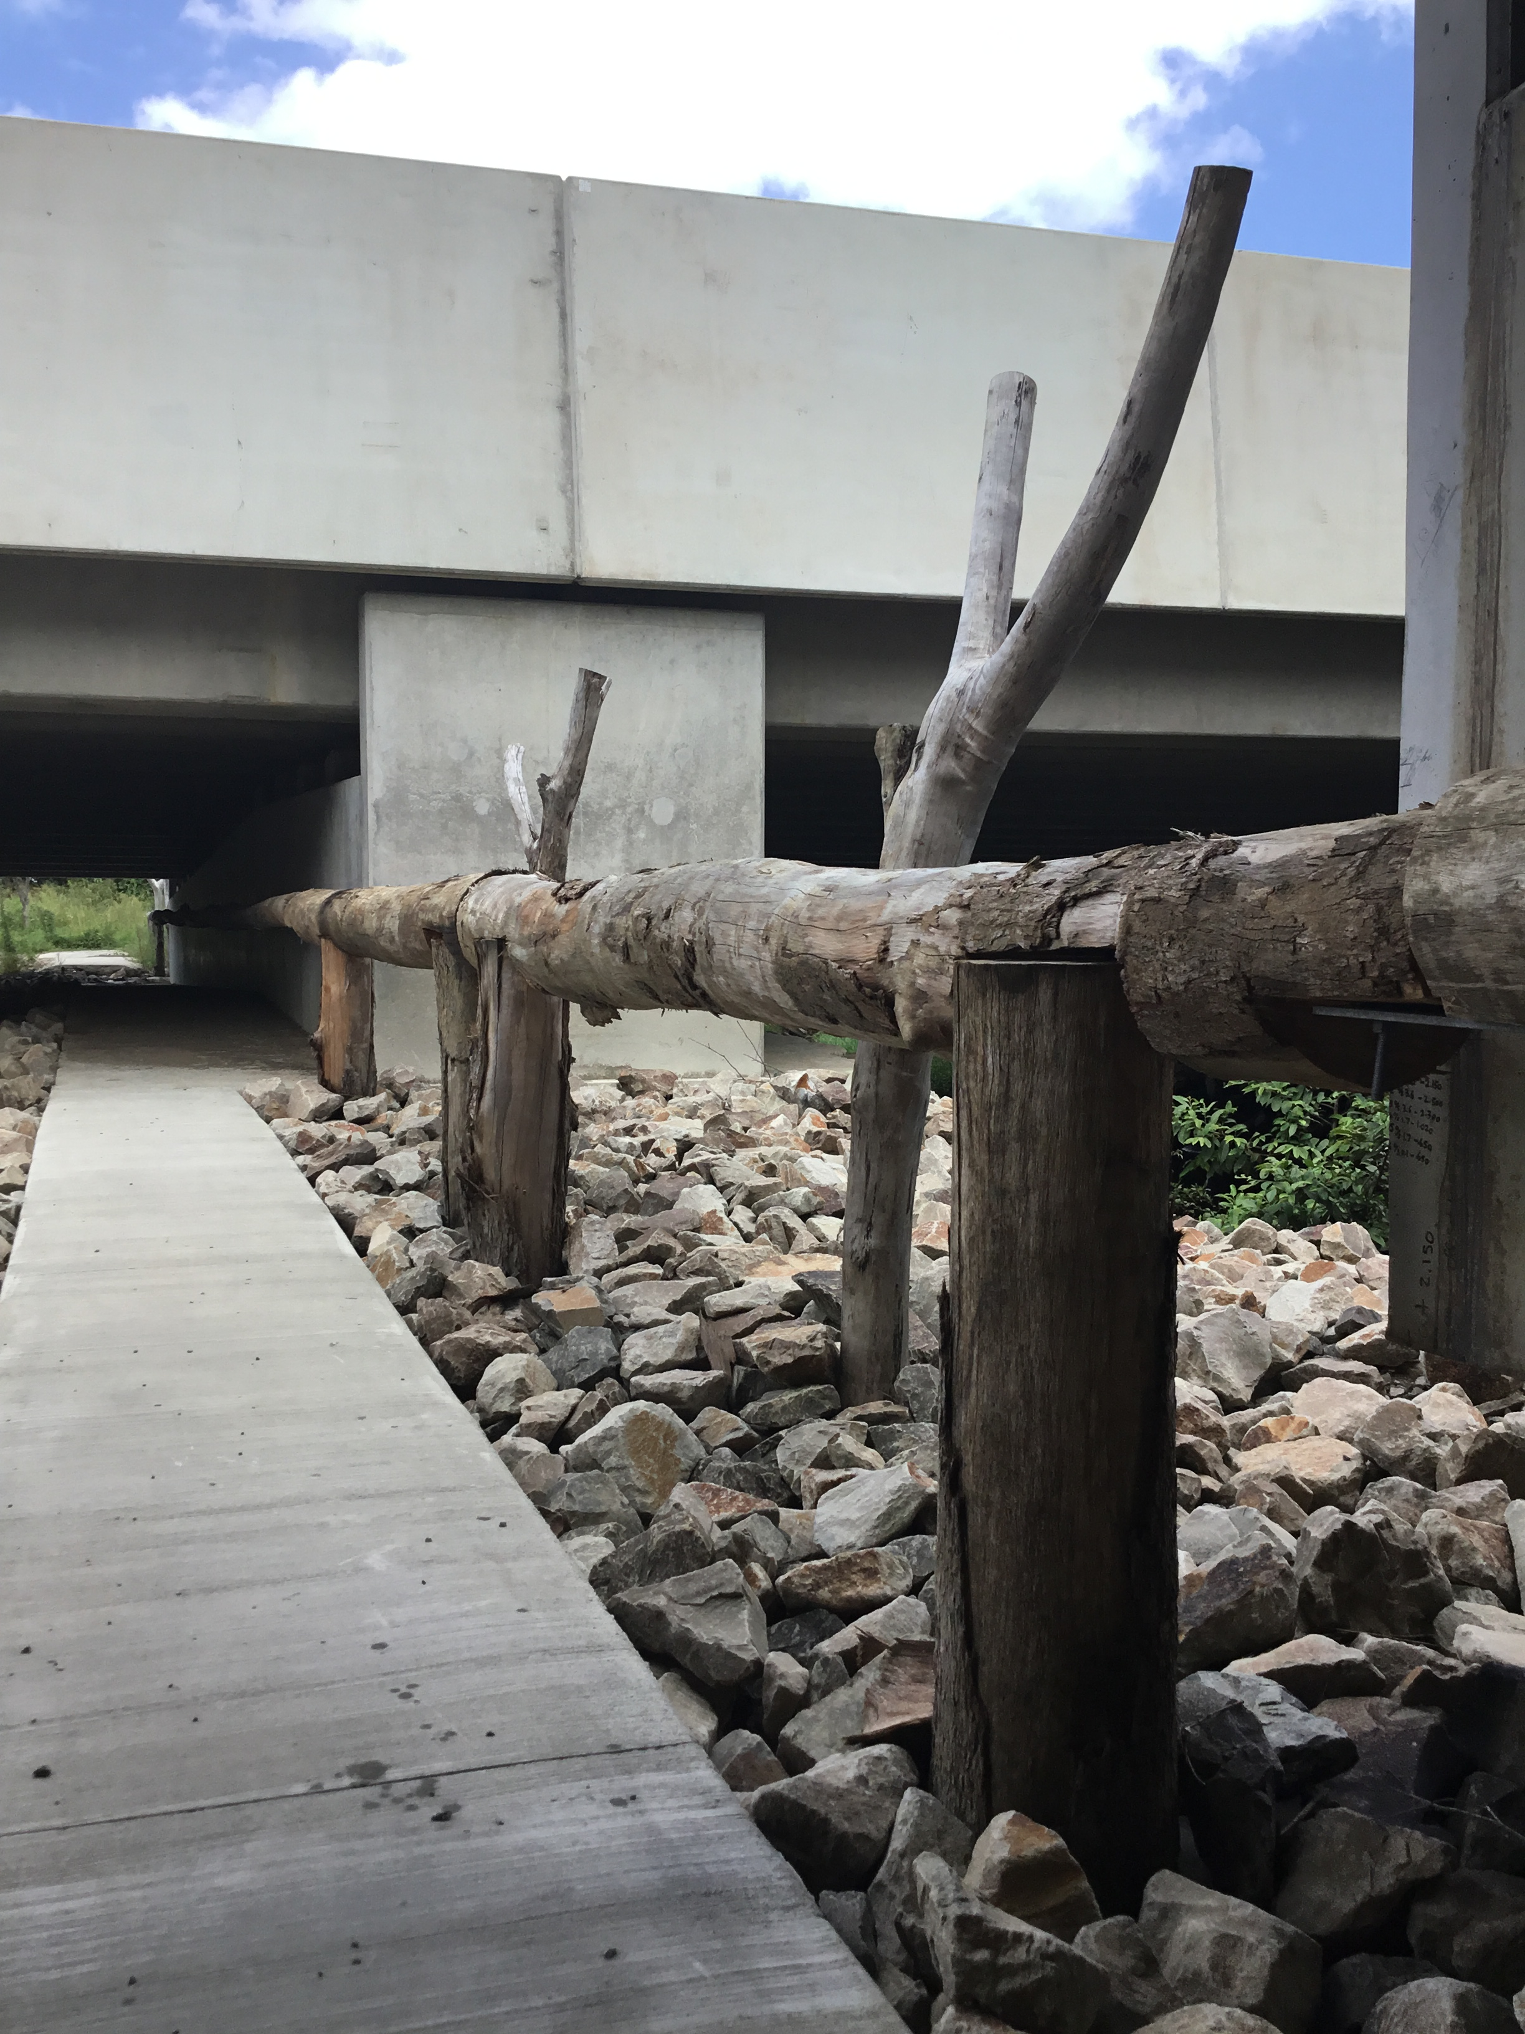

Photo Plate 9 and 10. Fauna structures installed at Mooloolah River
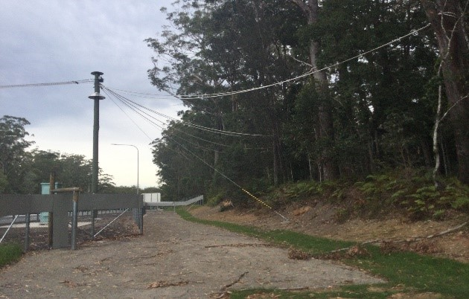

Photo Plate 11. Rope bridge across Steve Irwin Way

Appendix I – Fauna Infrastructure Monitoring Photos

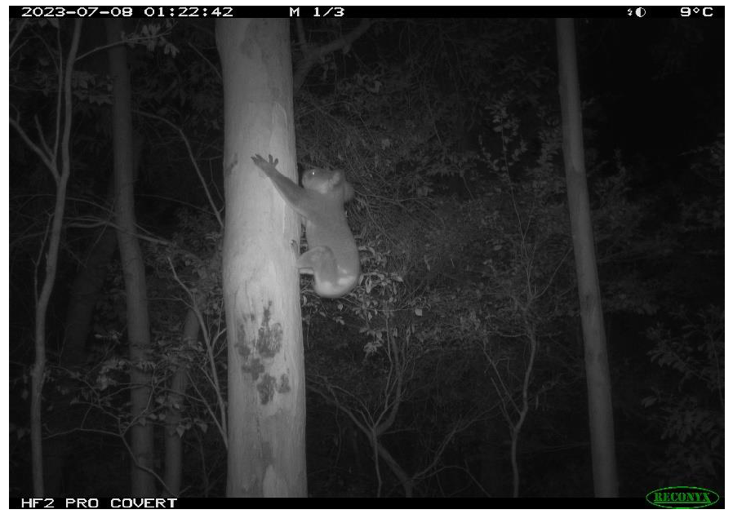
Photo Plate 1: Koala recorded during the August 2023 monitoring period at the northern underpass bushland.
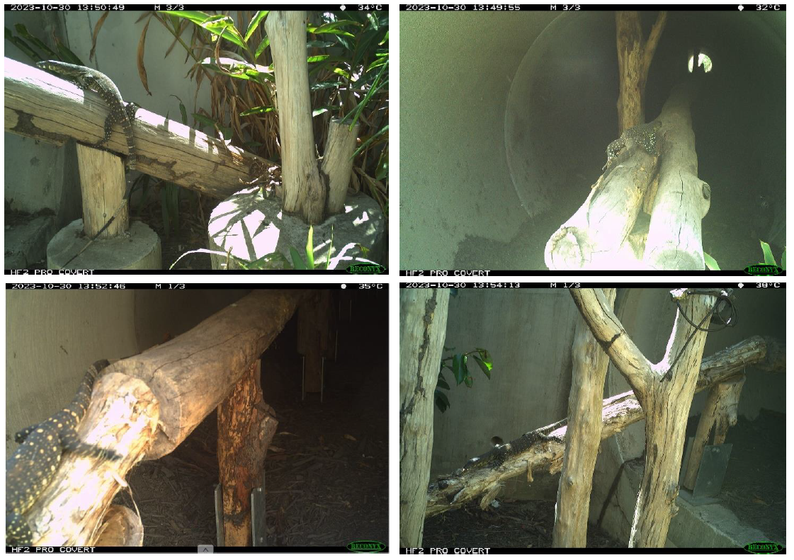
Photo Plate 2: Sequence showing a Lace Monitor crossing through the northern underpass using the log rail (from east to west), captured on all four cameras, confirming a complete crossing event.
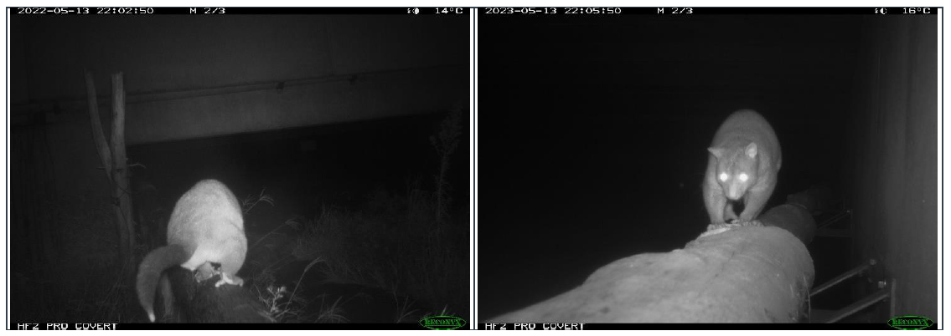
Photo Plate 3: Short-eared Brushtail Possum shown entering the Mooloolah River Underpass east (left) and exiting on the western side (right) confirming a complete crossing event via the log rails.
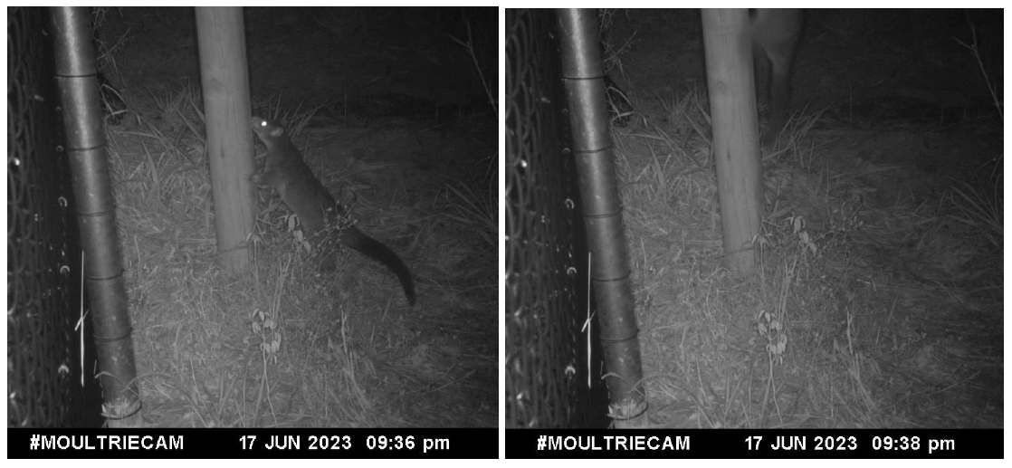
Photo Plate 4: Series showing a Short-eared Brushtail Possum climbing an escape pole at Frizzo Connection Road.

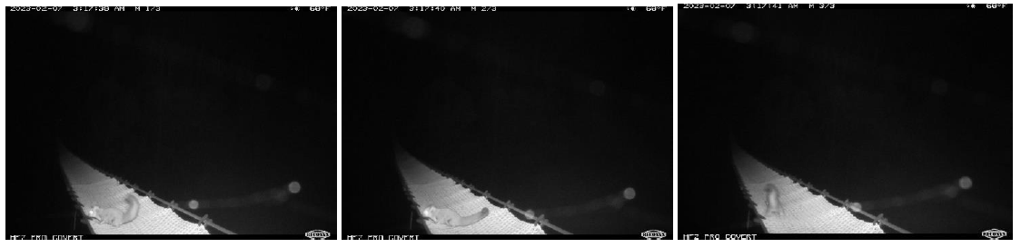
Photo Plate 5: Probable Sugar Glider crossing event captured on the original eight-metre rope ladder (northern camera).
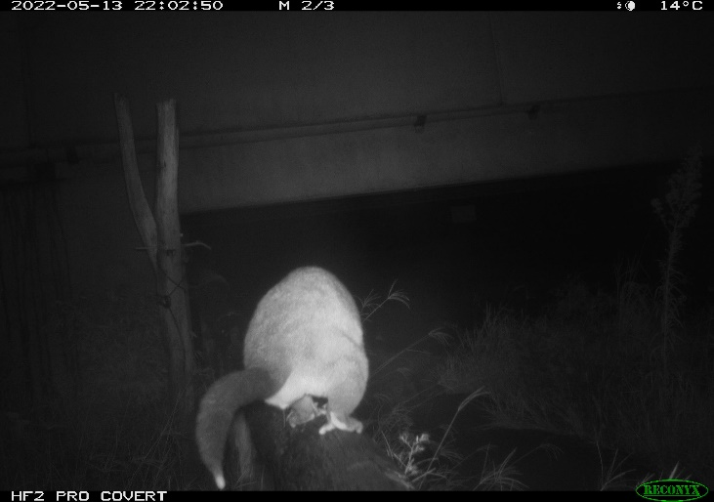 | 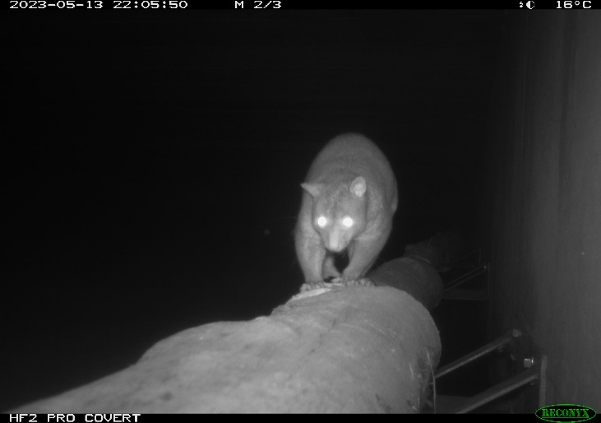
Photo Plate 6. Short-eared Brushtail Possum shown entering the Mooloolah River Underpass east (left), and exiting on the western side (right) confirming a complete crossing event via the log rails
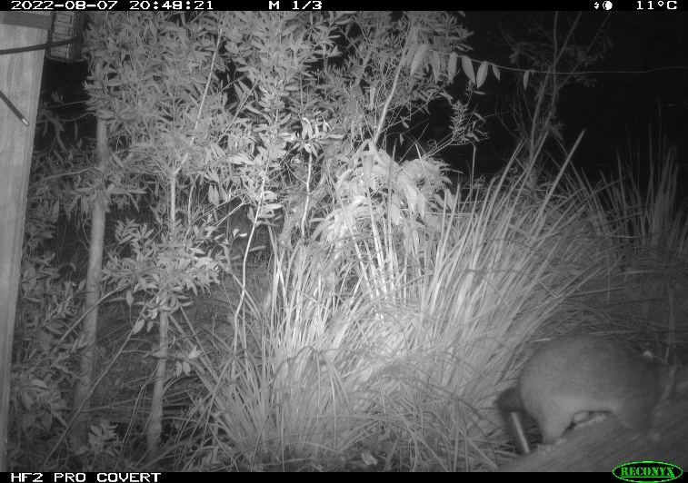 | 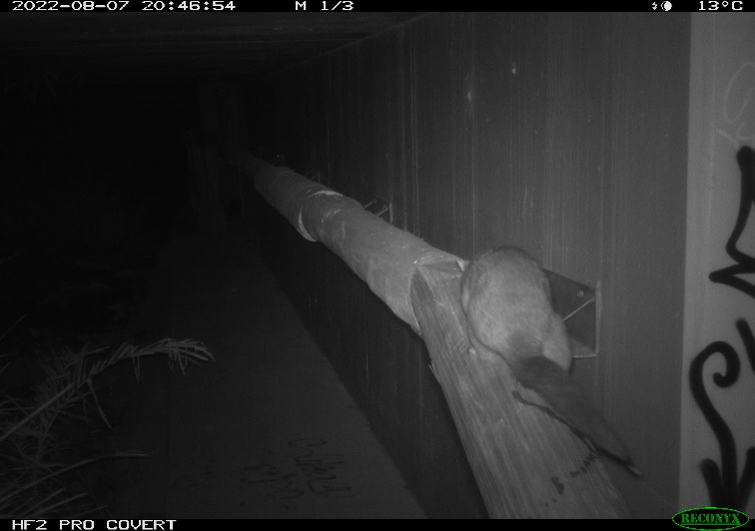
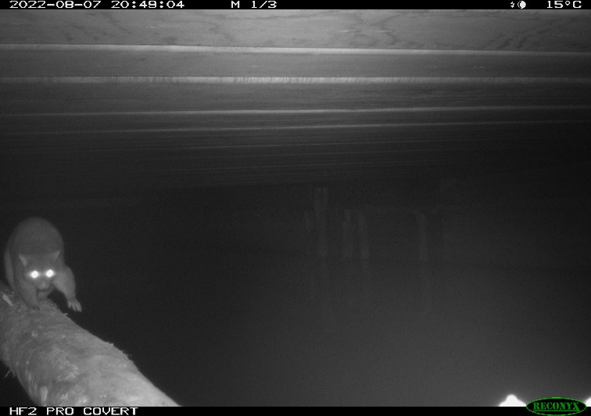 | 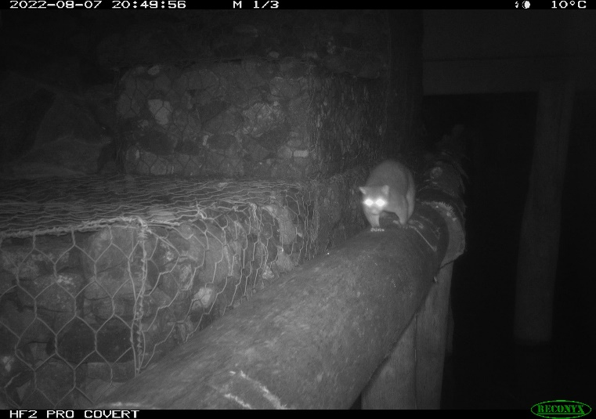
Photo Plate 7. Complete crossing by a Short-eared Brushtail Possum captured on all four underpass cameras at Sippy Creek
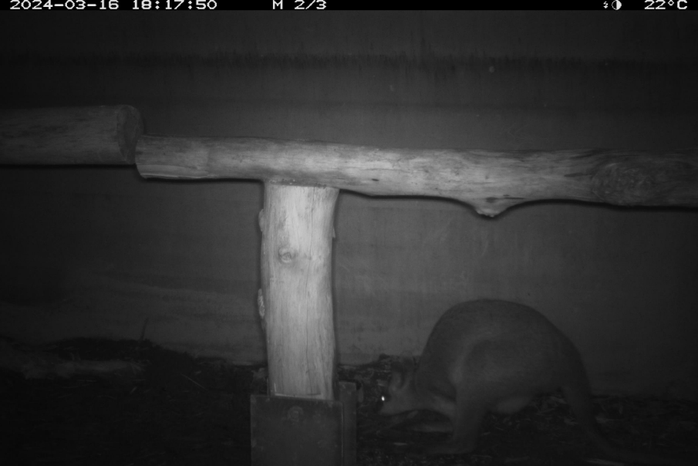 | 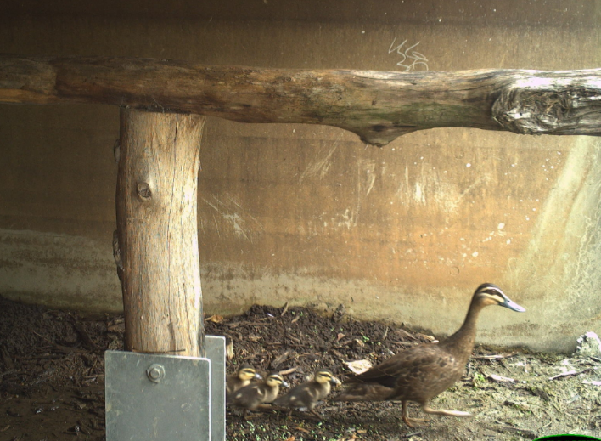
Photo Plate 8. Probable crossings of Swamp Wallaby and Pacific Black Duck at the Southern underpass

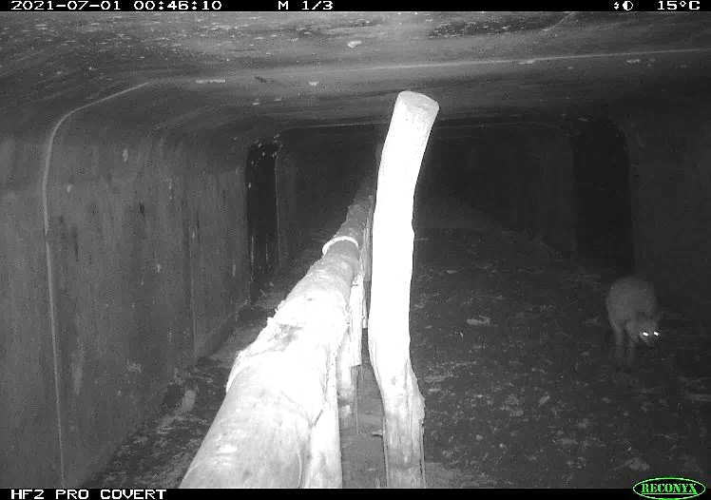 | 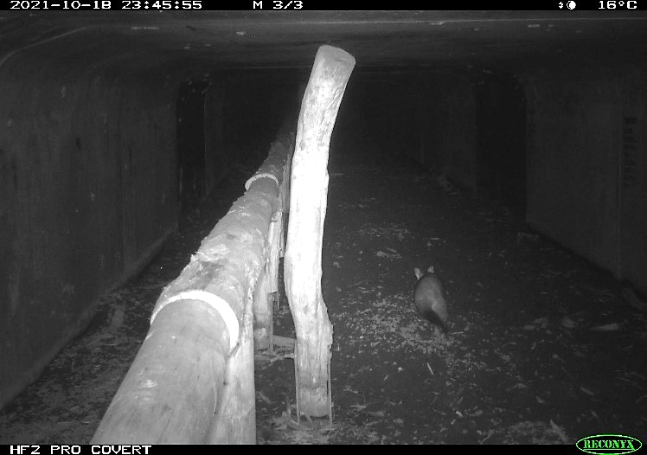
Photo Plate 9. Crossing events showing a Wallaby exiting, and a Common Brushtail Possum entering the Steve Irwin Way underpass (southern camera #671) (brightness adjusted +40%)

This page is intentionally blank.

