|  |
| --- |
| Queensland Recreational Boating Facilities Demand Forecasting Study 2022  Moreton Bay LGA Assessment |
|  |
|  |

|  |  |  |
| --- | --- | --- |
| Customer |  | Maritime Safety Queensland |
| Project |  | A12068 |
| Deliverable |  | 006 |
| Version |  | 01 |
|  |  | 21 April 2023 |

Document Control

Document Identification

|  |  |
| --- | --- |
| Title | Queensland Recreational Boating Facilities Demand Forecasting Study 2022 |
| Project No | A12068 |
| Deliverable No | 006 |
| Version No | 01 |
| Version Date | 21 April 2023 |
| Customer | Maritime Safety Queensland, a branch of the Department of Transport and Main Roads |
| Customer Contact | boatinginfrastructure@msq.qld.gov.au |
| Classification | {None} |

|  |  |
| --- | --- |
| Author | Daniel Wishaw, Nicholas Heiner, Geoff Long, Jeremy Visser, Azam Dolatshah |
| Reviewed By | Katrina O’Malley-Jones |
| Project Manager | Daniel Wishaw |

Amendment Record

The Amendment Record below records the history and issue status of this document.

| Version | Version Date | Distribution | Record |
| --- | --- | --- | --- |
| 00 | 15 February 2023 | Maritime Safety Queensland  Moreton Bay Regional Council | Draft |
| 01 | 21 April 2023 | Maritime Safety Queensland | Final |

Executive Summary

This report, part of the Queensland Recreational Boating Facilities Demand Forecasting Study 2022 (‘the Study’), provides a summary of current and forecast demand on recreational boating facilities in Moreton Bay LGA and the capacity of existing facilities to meet this demand. Where capacity is insufficient to meet current or forecast demand, recommendations have been made to improve existing facilities or for the construction of new facilities. This report is intended to support facility deliverers, owners, and managers over the next 20 years in their decision-making on development priorities for recreational boating facilities within Moreton Bay LGA.

Key issues and attributes of recreational boating

The key attributes of recreational boating facilities identified in this Study for Moreton Bay LGA are summarised in Table 1, while consultation with stakeholders undertaken as part of the Study identified the following key issues:

* Significant boat launching demand exists across all southeast Queensland LGAs and is creating a regional capacity shortfall.
* Strong anticipated population growth over the 20-year planning time frame of the Study indicates a significant future shortfall in boat launching capacity, particularly around the Caboolture growth corridor.
* Conflicts with other foreshore development and various environmental protection zones make the construction of new boat launching facilities difficult.

1. Key recreational boating attributes for Moreton Bay LGA

| Key attribute | Value |
| --- | --- |
| Deep-draught landing facilities |  |
| Existing demand (number) | 3.8 |
| Existing capacity (number) | 3 |
| Existing shortfall (number) | 0.8 |
| Boat launching facilities |  |
| Number of existing facilities | 23 |
| Current demand for boat launching lanes (effective lanes) | 38.9 |
| Number of existing ‘effective’ boat launching lanes | 36.2 |
| Current shortfall of ‘effective’ boat launching lanes (number) | 2.7 |
| Demand satisfaction for ‘effective’ boat launching lanes | 93% |
| State-wide demand satisfaction for ‘effective’ boat launching lanes | 82% |

Demand summary

The assessment of recreational boating demand is centred on a statistical demand model that considers vessel registration data, population statistics, assumptions around local usage and the movement of vessels into and out of the LGA. Key parameters from this assessment for Moreton Bay LGA are:

* The population is 483,743 as at the 2021 census and is projected to be 690,602 by 2041.
* As of July 2022, there is a total of 25,793 vessels with a home registration within the LGA, with 96% being ‘trailable’ – and therefore requiring boat launching facilities – and 4% being non-trailable.
* Moreton Bay LGA is deemed to be Metropolitan with an assumed vessel activation rate of 7% on a ‘good boating day’.
* Vessels are primarily used within the LGA, with moderate (8%) use of Brisbane facilities and minor use of facilities in the Sunshine Coast (5%), Somerset (3%), Gold Coast, Fraser Coast and Gympie (all 2%) LGAs.
* Vessels from Brisbane, Sunshine Coast, Ipswich, Logan and other western LGAs use facilities within Moreton Bay LGA.
* The existing demand for boat launching facilities is 38.9 ‘effective’ boat ramp lanes and projected to be 51 ‘effective’ lanes by 2041. As presented in Table 1, current capacity is 36.2 ‘effective’ lanes.
* The existing demand for deep-draught vessel landings is four currently and projected to be five by 2041. As presented in Table 1, current capacity is three deep-draught landings.

Boat launching

Boat launching facilities comprise boat ramps, any queuing facilities (floating walkways, pontoons, beaches and fixed sloping walkways) and the provision of car-trailer unit (CTU) parking. The capacity of a boat launching facility is measured in ‘effective’ lanes for both waterside and landside facilities, with the total capacity of a facility being the minimum of the waterside or landside capacity. Waterside capacity is calculated from the number of boat ramp lanes multiplied by environmental reduction factors (for tide, current or waves) and queuing facility improvement factors to derive the number of ‘effective’ lanes. The landside capacity is calculated from the number of available CTU parking spaces.

Moreton Bay LGA has 23 boat launching facilities, comprising 51 boat ramp lanes with a total effective boat launching capacity of 36.2 ‘effective’ lanes. Seven of these facilities are constrained by waterside capacity with the remainder constrained by landside capacity.

The capacity, forecast demand and shortfall of boat ramp effective lanes in Moreton Bay LGA is shown in Figure 1.

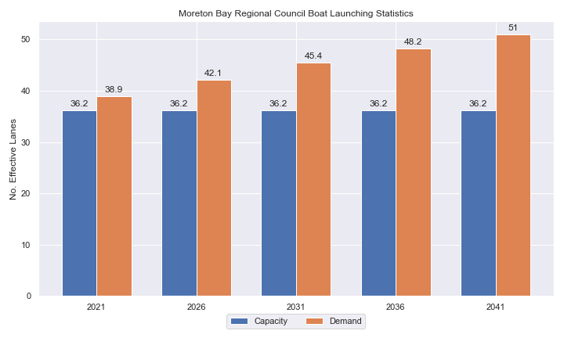

1. Existing capacity, forecast demand and shortfall of ‘effective’ boat ramp lanes for Moreton Bay LGA

Deep-draught vessel landings

Vessel landing facilities are provided across the state in the form of pontoons and jetties, to provide locations for larger vessels, or their tenders, to access landside destinations or facilities. Pontoons and jetties may also be provided for other purposes such as supporting boat launching or other recreation and may not be suitable for deep-draught vessels. The trend across Queensland indicates that jetties are rarely used as landings, with pontoons preferred by recreational users. As such, the Study has limited the capacity of deep-draught vessel landings to those that are accessible and commonly used by deep-draught vessels, as identified in consultation with stakeholders.

Moreton Bay LGA has three public deep-draught vessel landings comprising important facilities in Scarborough Boat Harbour, Bribie Island (Bongaree) and at Redcliffe Pier, which are supported by private facilities at Spinnaker Sound Harbour, Newport Marina, Scarborough Boat Harbour and Pacific Harbour Marina, as well as private pontoons in various canal estates. The shortfall assessment in Table 2 indicates that public landing capacity for deep-draught vessels is currently insufficient to support demand in Moreton Bay LGA.

1. Deep-draught vessel landing shortfall summary

| Criteria | 2021 | 2026 | 2031 | 2036 | 2041 |
| --- | --- | --- | --- | --- | --- |
| Deep-draught vessel demand | 3.8 | 4.1 | 4.4 | 4.6 | 4.9 |
| Deep-draught vessel capacity | 3 | 3 | 3 | 3 | 3 |
| Shortfall | 0.8 | 1.14 | 1.4 | 1.6 | 1.9 |

Priority recommendations

Recommendations for new facilities or upgrades to existing facilities are outlined in Table 3. The range of recommendations seeks to reduce the overall capacity shortfall within Moreton Bay LGA over the 20-year planning life of this project, as well as address specific concerns, including:

* considering opportunities through the Scarborough Boat Harbour master planning process and the planning and design of other recommended sites, to provide a new or improved facility that improves access, increases capacity and provides more deep-draught landings
* catering to the recreational boating needs of the growth corridor in and around Caboolture
* providing solutions to conflicting uses at Clontarf’s Pelican Park facility.

Recommendations

1. Summary of recommended boating infrastructure upgrades for Moreton Bay LGA

| Priority | Criteria | Recommendations |
| --- | --- | --- |
| 1 | * Required to meet existing demand. * Sites that can provide maximum benefit for existing demand pressures at an LGA scale or satisfy specific safety pressures. | * Uhlmann Road: Two options to increase CTU parking to provide for 75 CTU spaces. * Dohles Rocks: Acquire land to install 78 additional CTU spaces. |
| 2 | * Required to meet demand within the next five to ten years. * Sites that are likely to have low to medium approval complexity. * Sites that can provide satisfaction of specific demand or safety pressures within the LGA. | * Scarborough Boat Harbour: Consider opportunities through the Scarborough Boat Harbour master planning process and the planning and design of other recommended sites, to provide a new or improved facility that improves access, increases capacity and provides more deep-draught landings. * Clontarf, Pelican Park: Option 1 to provide minor increase for existing facility, Option 2 to redevelop site to separate the facility from the rest of the park via reclamation, or Option 3 to relocate existing infrastructure to expand and separate the facility without reclamation. |
| 3 | * Required to meet demand within the next ten to fifteen years. * Sites that service planned future growth within the LGA. | * Nil |
| 4 | * Required to meet demand within the next fifteen to twenty years. * Sites that service planned future growth within the LGA. | * North Harbour Marina: Construct a 4-lane boat ramp with two centralised floating walkways and carpark with 140 CTU spaces for public use, as part of the proposed North Harbour Marina development |

Contents

Definitions 10

1 Introduction 13

2 Moreton Bay LGA Overview 14

2.1 Key influences on recreational boating 14

2.2 Existing recreational boating infrastructure 14

2.3 Existing usage and issues 17

3 Capacity Assessment 18

3.1 Boat ramps 18

3.2 Access to sheltered near all-tide and all-tide facilities 24

3.3 Deep-draught vessel landings 27

4 Beach Ramps 28

4.1 Margate, Eveline Street 28

4.2 Scarborough, Flinders Parade 29

5 Demand Assessment 31

5.1 Activation rate 31

5.2 Digital user survey 32

5.3 Active fleet size 37

5.4 Boat ramp lane demand 37

5.5 Non-statistical demand 37

5.6 Deep-draught vessel demand 38

6 Shortfall Assessment 40

6.1 Shortfall assessment – boat ramps 40

6.2 Shortfall assessment – deep-draught landings 41

7 Stakeholder Feedback 43

7.2 Stakeholder feedback 43

8 Development Recommendations 46

8.1 Previous recommendations 46

8.2 Priority recommendations 47

8.3 Priority 1 recommendations 50

8.4 Priority 2 recommendations 56

8.5 Priority 3 recommendations 67

8.6 Priority 4 recommendations 69

9 References 72

Annex A Demand Study A-1

Annex B Boat launching facility capacity B-1

Annex C Travel time statistics C-1

Annex D Facility Use D-1

Tables

Table 2.1 Recreational boating facilities by facility owner in Moreton Bay LGA 14

Table 3.1 Queuing facility efficiency modifiers 21

Table 3.2 Deep-draught landing facilities within Moreton Bay LGA 27

Table 5.1 LGA of origin for active fleet in Moreton Bay LGA 32

Table 5.2 Popularity of boat launching facilities. 33

Table 5.3 Active fleet vessel size 37

Table 5.4 Boat ramp lane demand 37

Table 5.5 Deep-draught vessel landing demand 39

Table 6.1 Shortfall of boat launching facilities 40

Table 6.2 Shortfall assessment for open water, all-tide or near all-tide facilities for Moreton Bay LGA 41

Table 6.3 Shortfall of deep-draught vessel landings 42

Table 7.1 Stakeholder identified opportunities 43

Table 8.1 Assessment of unimplemented 2017 recommendations 46

Table 8.2 Summary of recommendations for Moreton Bay LGA 48

Table 8.3 Burpengary East, Uhlmann Road - (Priority 1) 50

Table 8.4 Griffin, Dohles Rocks - (Priority 1) 54

Table 8.5 Scarborough Boat Harbour - (Priority 2) 56

Table 8.6 Pelican Park, Clontarf – Option 1 - (Priority 2) 58

Table 8.7 Pelican Park, Clontarf – Option 2 - (Priority 2) 61

Table 8.8 Pelican Park, Clontarf – Option 3 - (Priority 2) 64

Table 8.9 Marine Parade, Bellara, Bribie Island - (Priority 3) 67

Table 8.10 Lower Caboolture River - (Priority 4) 69

Table B.1. Capacity of existing boat launching facilities B-1

Table C.1. Travel time from population centres to nearest sheltered all-tide or near all-tide open water accessible facilities C-1

Table D.1. Boat launching facility usage statistics D-1

Figures

Figure 2.1 Moreton Bay LGA – Boat launching facilities 15

Figure 2.2 Moreton Bay LGA - Deep-draught landing facilities 16

Figure 3.1 (a) Summary of open water access from boat launching facilities (left) and (b) Summary of tidal restrictions at tidal boat launching facilities (right) 23

Figure 3.2 Summary of limiting capacity constraint 24

Figure 3.3 Distribution of travel time from Moreton Bay LGA’s eligible population centres to sheltered near all-tide facilities 25

Figure 3.4 Bundaberg LGA – Travel time to nearest all-tide or near all-tide facility 26

Figure 4.1 Margate, Eveline Street beach ramp 28

Figure 4.2 Scarborough, Flinders Parade beach ramp 29

Figure 4.3 Scarborough, Flinders Parade beach ramp cracking example 30

Figure 5.1 Moreton Bay LGA – Vessel pathing 36

Figure 6.1 Shortfall assessment with recommended upgrades adopted 40

Figure 8.1 Priority 1 Recommendation – Uhlmann Road, Burpengary East (Option 1) 52

Figure 8.2 Priority 1 Recommendation – Uhlmann Road, Burpengary East (Option 2) 53

Figure 8.3 Priority 1 Recommendation – Griffin, Dohles Rocks Road 55

Figure 8.4 Priority 2 Recommendation – Clontarf, Pelican Park, Thomas Street (Option 1) 60

Figure 8.5 Priority 2 Recommendation – Clontarf, Pelican Park, Thomas Street (Option 2) 63

Figure 8.6 Priority 3 Recommendation – Clontarf, Pelican Park, Thomas Street (Option 3) 66

Figure 8.7 Priority 3 Recommendation – Marine Parade, Bellara 68

Figure 8.8 Priority 4 Recommendation – Caboolture River 71

Definitions

| Term | Definition |
| --- | --- |
| All‑tide (for boat ramps) | Access from a boat ramp to the open sea with an approach depth of 0.5m below LAT or deeper and a depth at boat ramp toe of 0.5m below LAT or deeper. |
| All-tide (for landings) | Access from a gangway‑access pontoon or jetty to the open sea with an approach depth of 1.5m below LAT or deeper and a depth on at least one face of the pontoon of 1.5m below LAT or deeper. |
| BIP | Boating Infrastructure Program – a sub‑program within MSQ's Maritime Assets and Infrastructure Program |
| Boat ramp | A foreshore concrete ramp with a slope designed for vehicular launching and retrieving of recreational boats. |
| Breakwater | A structure constructed over the seabed and/or the foreshore, usually rising to a height above high tide, designed to provide protection to landward areas by limiting penetration of wave action or currents. |
| CTU | Car-trailer unit space – a parking space for a typical car with a boat trailer attached. |
| Demand | Demand is the requirement of the boat‑owning population for facilities to launch/retrieve trailer boats and/or to berth suitable boats at a given year to service their average (non‑peak period) needs. In most locations demand is based on vessel registrations and is expressed in terms of boat ramp lanes or in number of 12m berths at landings. |
| Effective capacity | For a boat ramp, effective capacity (effective lanes) means the number of boat ramp lanes after adjusting for anticipated unavailability due to unacceptable wave action (>0.2m wave height) or water depth, usage constraints such as the lack of adequate parking, and improvements to efficiency or launch/retrieval throughput such as floating walkways or pontoons. |
| FHA | Fish Habitat Area, declared under the Fisheries Act, 1994 |
| FIFO | Fly‑in fly‑out, where skilled workers travel from their city or central location home communities to a remote site to perform their duties often in blocks of time that provide regular, non-weekend, days off. |
| Fixed sloping walkway | A fixed sloping structure installed at the side of a boat ramp to assist launching/retrieval of trailer boats, and dry embarkation/disembarkation from trailer boats. It is sloped to allow use at varying tide heights – sometimes with sections of different slope. |
| Floating walkway | Multiple connected/hinged flotation modules configured to assist launching/retrieval of trailer boats, and dry embarkation/disembarkation from trailer boats at most if not all stages of the tide. Floating walkways are connected to a concrete shore abutment allowing pedestrian and assisted wheelchair access. |
| Gangway access pontoon | A platform/module that always floats, where a boat can be secured alongside on one or more faces. Pontoons are usually separated from a boat ramp and have a hinged articulated gangway for access to the shore via an abutment. |
| GBR | Great Barrier Reef |
| GCWA | Gold Coast Waterways Authority |
| Landing | A landing is a jetty or gangway‑access pontoon that facilitates berthing of vessels and transfer of passengers and stores. They are most often associated with non-trailable vessels |
| Landside | Refers to areas above high-water mark, often used to denote the location of and type of infrastructure. |
| LAT | Lowest Astronomical Tide, used as Chart Datum on navigational charts. |
| LGA | Local Government Area |
| Managing authority | Councils, port authorities, water storage managers as listed in schedule 1 of the Transport Infrastructure (Public Marine Facilities) Regulation 2011 |
| MCU | Material change of use under the planning scheme |
| MNES | Matter of national environmental significance under the Environment Protection and Biodiversity Conservation Act 1999 |
| MSQ | Maritime Safety Queensland |
| NC Act | Nature Conservation Act 1992 |
| Near all‑tide | Access from a boat ramp to the open sea with a minimum approach depth of 0.5m below LAT and minimum depth at the boat ramp of 0.5m below LAT for 80 percent or more of the tidal range (time measured over a year). |
| Parking - Formalised | A sealed, line-marked parking area for car-trailer units, providing adequately sized parking spaces, roadways and turning circles. |
| Parking – Semi-formalised | An all-weather non-sealed parking area, with markers to delineate adequately sized car-trailer unit parking bays and turning circles. Markers can be concrete blocks, pavement markers (e.g. retro-reflective raised markers) or other permanent instalment to show parking bays. |
| Parking – Informal overflow | A naturally surfaced area available for use as overflow parking on the design boating day, signed as such. To have mixed-use purpose (e.g., parkland) when not being utilised as overflow parking. |
| Part‑tide | Boat ramps that do not meet near all-tide or near all-tide requirements. |
| PV | Passenger vehicle (i.e., car – as opposed to car-trailer unit). |
| Port Authority | An organisation that is responsible for the management of one or more ports on the Queensland coast. |
| Population Centre | Official named urban settlements (populated places) that have been sourced from the Queensland Place Names Database. |
| Registration activation rate | The percentage of registered vessels liable to be in use on any given good weather weekend day |
| Shortfall | The number of effective boat ramp lanes or landings required to meet demand for a given timeframe. Negative shortfall signifies an oversupply for the time period nominated. |
| SPL | Strategic Port Land |
| Study | The Recreational Boating Facility Demand Forecasting Study 2022, including this document. |
| TMR | Department of Transport and Main Roads |
| Water Storage Authority | Includes Seqwater, Sunwater |
| Waterside | Refers to areas below high-water mark, often used to denote the location of and type of infrastructure, including dredged channels and breakwaters. |
| WHA | World Heritage Area |
| # | Number |

# Introduction

BMT has been appointed to undertake the Recreational Boating Facilities Demand Forecasting Study 2022 (‘the Study’) by Maritime Safety Queensland (MSQ), a branch of the Queensland Department of Transport and Main Roads (TMR), on behalf of all public recreational boating facility managers and owners across Queensland. The Study supersedes the 2017 study of the same name and is intended to report on recreational boating facility demand, capacity, and shortfall over a 20-year period at a Local Government Area (LGA) scale across Queensland.

The Study has been developed using information from the 2021 Australian Census (ABS, 2021), recreational boat vessel registrations, consultation with facility owners, managers, and stakeholders, the 2022 Queensland Government Get-Involved recreational boating facilities survey (MSQ, 2022), and previous versions of this study (2011, 2017). The Study is intended for use by deliverers, owners, managers, and key stakeholders of public recreational boating facilities across Queensland, namely state government agencies including MSQ and the Gold Coast Waterways Authority (GCWA), local governments, port authorities and water authorities. The Study is non-regulatory in nature and is intended to be used as part of a broader suite of information to identify priority investment in recreational boating infrastructure at a local and state level.

The Study establishes demand primarily on statistics derived from registration and population data. Please refer to Section 4.5 for discussion of non-statistical demand. The Study evaluates existing and forecast demand over a 20-year period and makes recommendations on how this demand might be met over that period. Recommendations may include improvements to both landside and waterside capacity depending on the facility.

Recommendations are assigned a priority ranking, from 1 to 4, indicating if they are required immediately or in the next 5, 10 or 15 years respectively. To end 2022, 14% of recommendations from the 2017 study have been completed, comprising 11% of land-side recommendations and 18% of waterside recommendations and reflecting 22% of priority 1 the 2017 recommendations. A much greater percentage of the earlier 2011 study recommendations have now been implemented. Given the low uptake on existing/outstanding recommendations, this Study will review previous recommendations and carry forward, modify, or remove as appropriate. The Study has also been tasked with reviewing specific wave exposed beach launching facilities across the state to determine their contribution to meeting boating facilities demand and make recommendations about their future.

The Study is comprised of a report for every LGA in Queensland and a state-wide summary report. Each LGA report summarises demand pressures from vessel registration data, population statistics, assumptions around local usage and the movement of vessels into and out of the LGA, and existing capacity and recommends opportunities to satisfy shortfall. The state-wide report will support the LGA reports and provide context at a state level for demand pressures, current capacity, equity of access to facilities and Statewide priority for major boating facilities.

The Study is intended to report on publicly accessible recreational boating facilities for registered vessels. This includes boat ramps, floating walkways, pontoons, fixed sloping walkways and supporting car-trailer unit parking at each facility. The Study does not include recommendations for facilities that are used primarily for commercial purposes, private facilities, non-motorised recreation such as launching canoes and stand-up paddle boards, and fishing platforms.

# Moreton Bay LGA Overview

## Key influences on recreational boating

Within Moreton Bay LGA, the principal attributes and influences that affect demand on recreational boating infrastructure include:

* its designation as a Metropolitan area, with a large local recreational boating fleet
* strong projected population growth
* high tourism inputs, particularly from other large southeast Queensland LGAs
* significant constraints (spatial, environmental etc.) on the development of foreshore land across the region.

## Existing recreational boating infrastructure

The recreational boating facilities within Moreton Bay LGA are summarised in Table 2.1. These facilities are owned or managed by multiple organisations and include facilities that provide access to open water, and estuaries. MSQ’s long term vision is to provide unrestricted access to open water from facilities along the Queensland coast such that all significant population centres are within one hour’s driving range where practical. For clarity, the Study has defined this vision to be the provision of sheltered all-tide, or near all-tide, boat launching facilities within one hour driving range of official population centres (DoR, 2022) lying within 30km of the coastline between the NSW border and Cooktown.

Recreational boating facilities by facility owner in Moreton Bay LGA

| Owner | Open-water boat ramps | | Other boat ramps | | Landings | |
| --- | --- | --- | --- | --- | --- | --- |
| Facilities | Lanes | Facilities | Lanes | Pontoons | Jetties |
| Moreton Bay Regional Council | 1 | 1 | 1 | 2 | 1 | 3 |
| TMR | 14 | 33 | 6 | 11 | 1 | 1 |

Each of the boat launching facilities within the LGA are shown in Figure 2.1 and deep-draught vessel landings in Figure 2.2.

Access to land from deep-draught vessels is catered for by the provision of landings such as jetties and pontoons that are intended for short term usage, mainly to drop off and embark passengers and supplies. Within Moreton Bay LGA these vessels are catered for at the following locations:

* Redcliffe Pier, providing access into the Redcliffe CBD
* Scarborough Boat Harbour, Thurecht Parade, providing access to the marine precinct
* Bongaree, First Avenue, providing access to Bribie Island.

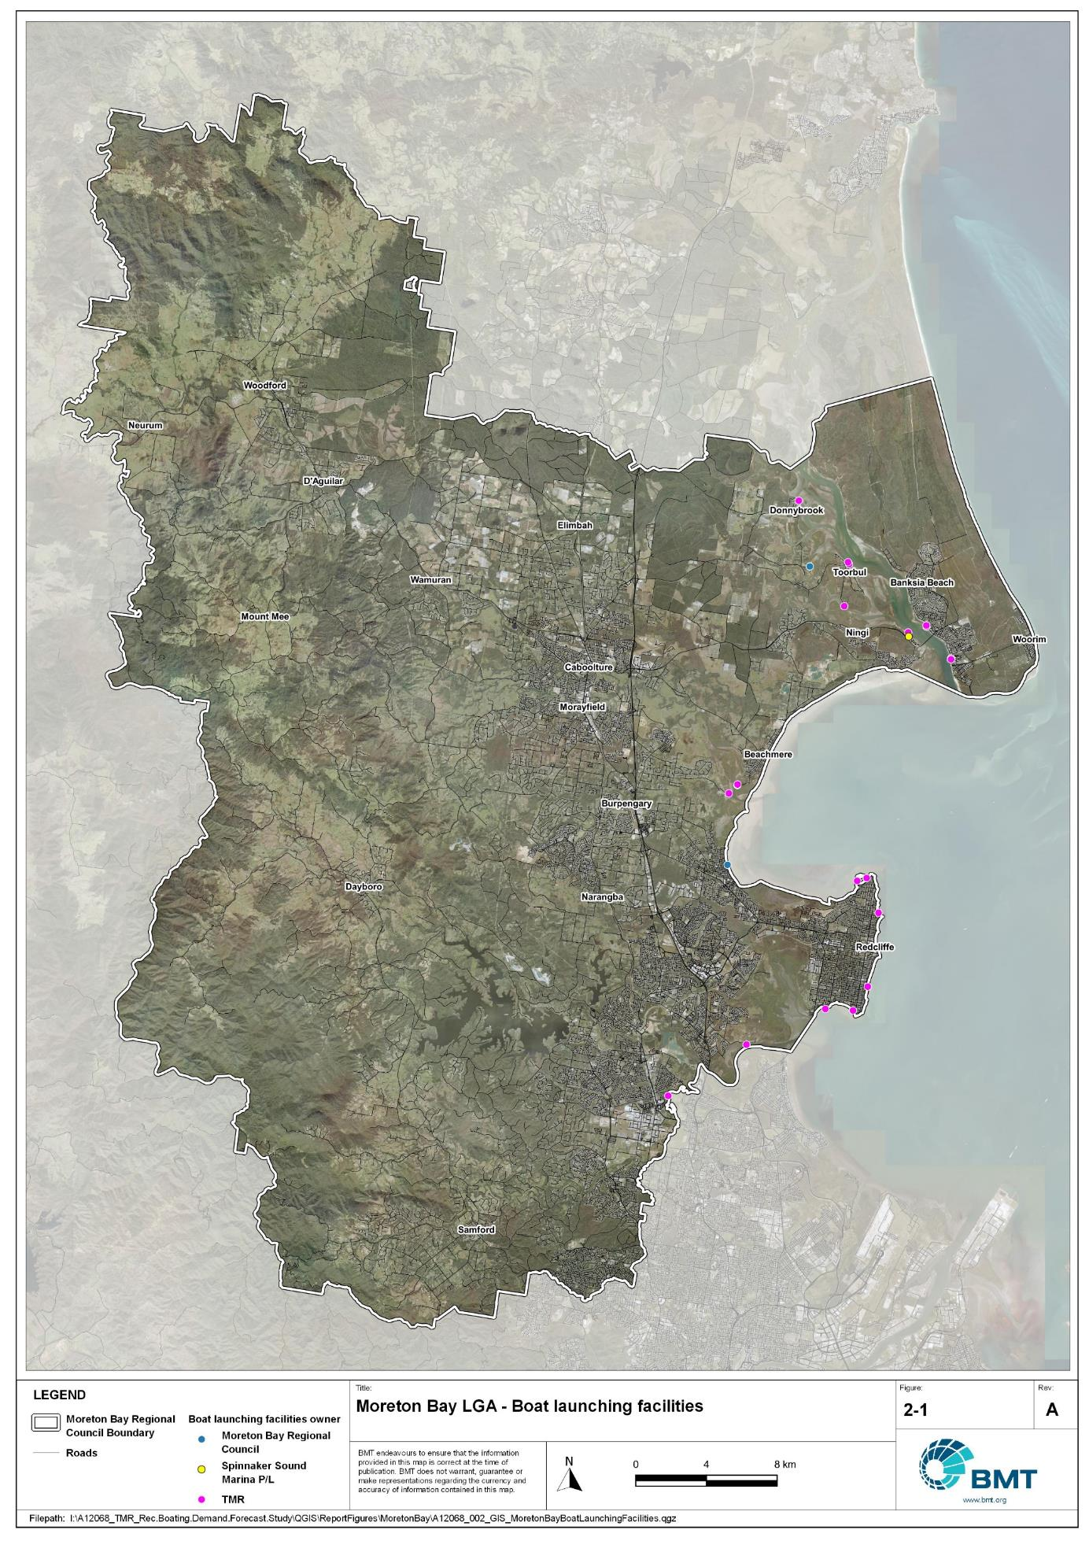

Moreton Bay LGA – Boat launching facilities

"I:\A12068_TMR_Rec.Boating.Demand.Forecast.Study\QGIS\ReportFigures\MoretonBay\A12068_002_GIS_MoretonBayBoatLaunchingFacilities.jpg"

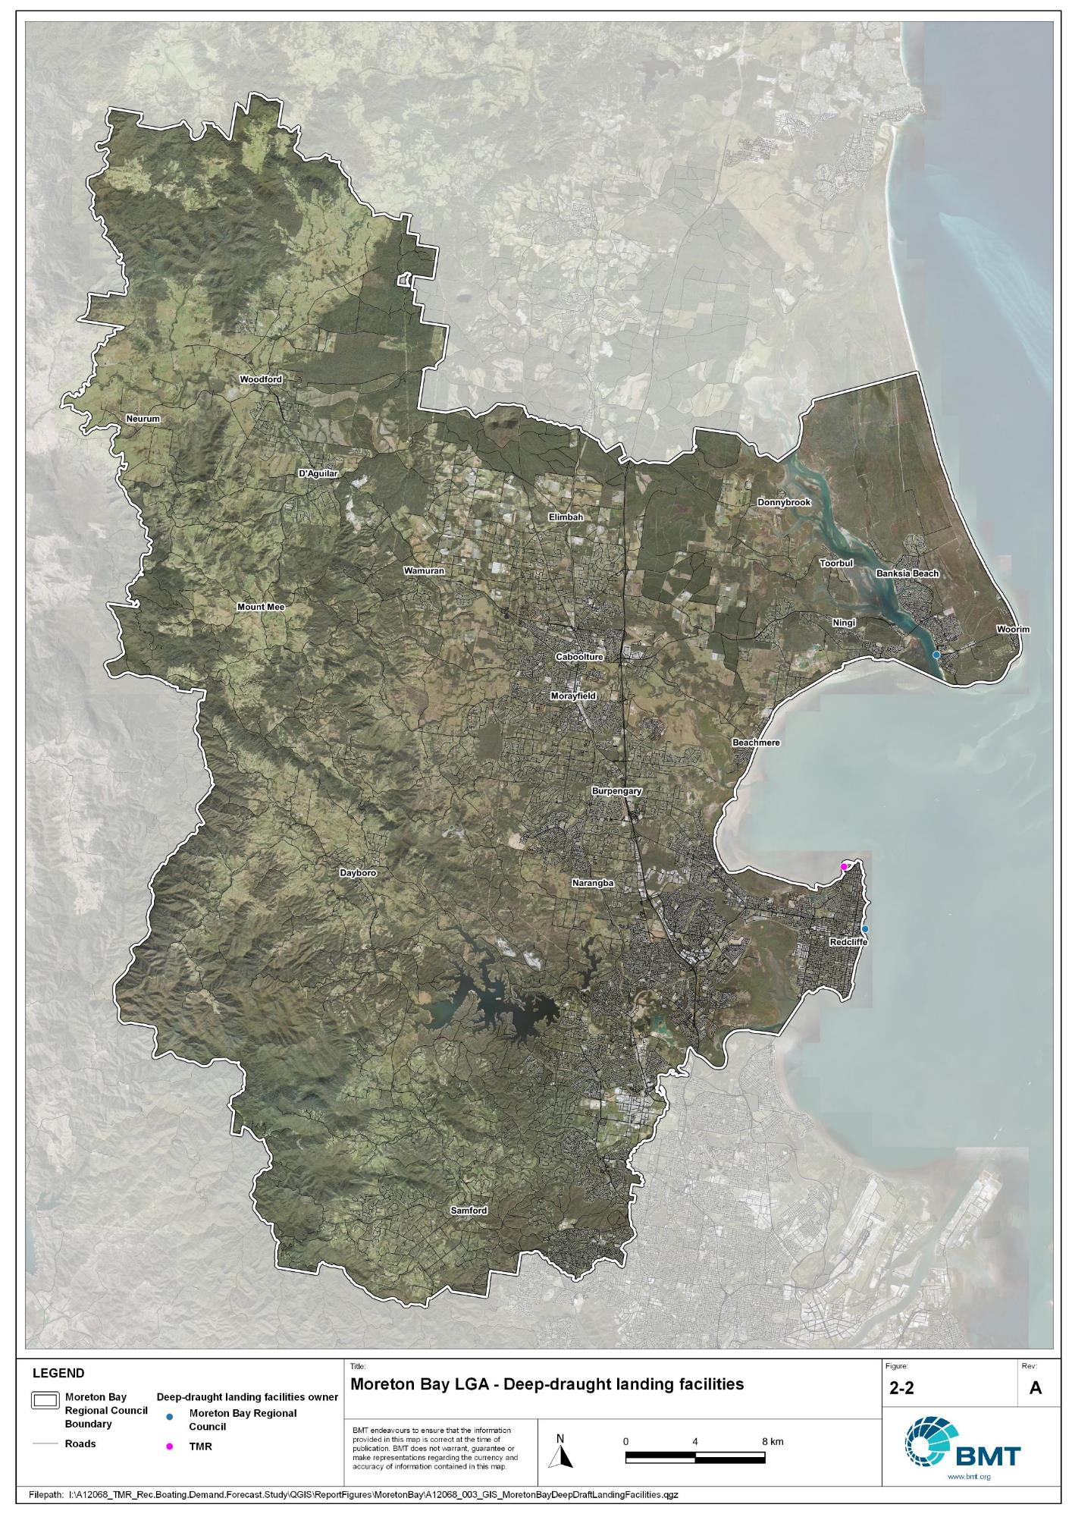

Moreton Bay LGA - Deep-draught landing facilities

"I:\A12068_TMR_Rec.Boating.Demand.Forecast.Study\QGIS\ReportFigures\MoretonBay\A12068_003_GIS_MoretonBayDeepDraftLandingFacilities.jpg"

## Existing usage and issues

Consultation with Moreton Bay Regional Council, Maritime Safety Queensland, recreational groups and feedback from the recreational boating facilities survey hosted by TMR indicate the following major themes and issues within Moreton Bay LGA.

* + 1. Strong projected growth for the region

Moreton Bay LGA, along with the Sunshine Coast on the northern border, is one of the LGAs projected to grow very strongly over the next 20 years. This strong population growth has the consequence of also growing demand for boat launching and landing facilities within the region. Despite this strong projected increase in demand, there is no corresponding increase in availability of foreshore land for boat launching facilities. In contrast, competition for land of this type is only growing due to other types of development and conservation needs. As such, more capacity is required in a shrinking availability of space.

* + 1. Competing priorities for space close to population centres

Foreshore land near major population centres is subject to increasing pressure for use for reasons other than recreational boating. Even within established recreational boating facilities, competing uses of the facilities (for example, the kite festival or triathlons etc.) can reduce the usability of these facilities during parts of the year. For most facilities, the only possibility for expansion is through reclamation of the seabed or adjacent wetlands, which can be very administratively and technically difficult, and expensive to achieve.

# Capacity Assessment

## Boat ramps

* + 1. Introduction

Boat ramps are facilities that are used for launching and retrieving trailable vessels, typically up to 8m in length (with some exceptions), to and from the water. Boat ramps consist of one or more lanes and their use is often supported by landside and waterside infrastructure to improve efficiency. In some instances, the usability of a facility can be adversely affected by environmental constraints such as low water levels, currents, or wave exposure, reducing the overall availability of the facility. Together, consideration of the number of boat ramp lanes, the supporting infrastructure, and environmental constraints results in the facility having a capacity described in terms of ‘effective lanes’ that may or may not be equal to the number of actual boat ramp lanes.

To maximise usage of each facility, the landside and waterside capacity should be balanced. Each facility will have a calculated ‘effective’ capacity for both the landside and waterside elements, with the limiting element dictating the facility's overall effective capacity. Recommendations for works or infrastructure promote balancing these two capacity elements by either improving the limiting element for increased facility effectiveness or by increasing the overall 'effective capacity' through changes to both elements.

* + 1. Boat ramp capacity

The overall capacity of each boat launching facility is limited by the effective capacity of either the waterside or landside elements. The waterside capacity is informed by the number of boat ramp lanes and the number and type of queuing facilities, such as pontoons, floating walkways, queuing beaches and fixed sloping walkways. It may also be limited by the available water depth in the adjacent waterbody and exposure to environmental or other physical factors.

Landside capacity is governed by the availability of nearby spaces for parking of car-trailer units (CTU), the provision of rigging and de-rigging facilities, and provision of single car parking spaces (single cars may otherwise be obliged to park in CTU spaces).

While it is expected that facilities will have their own characteristics influencing efficient use, this Study applies an approach that is consistent across the entire state and consistent with previous editions of the Study. Accordingly, the effective waterside capacity of a boat launching facility is determined as being:

* the ability to support 40 vessels being launched and retrieved per day per lane (see section 3.1.3)
* influenced by exposure to wave, tide, and current conditions (see section 3.1.4)
* supported by queuing facilities that assist in the efficient use of the boat ramp (see section 3.1.4).

Calculation of landside capacity is in line with the TMR guideline (TMR, 2020), which requires less provision of CTU parking per lane than the Australian standard (AS3962 Table 7.1), and advises:

* 10 CTUs for a single lane boat ramp accessed by an unsealed road, or 15 CTUs accessed by a sealed road
* 45 CTUs for a two-lane boat ramp
* 70 CTUs for a three-lane boat ramp
* 90 CTUs for a four-lane boat ramp.

A notable difference from the 2017 study is the recognition and inclusion of areas close to existing boating facilities that are unsealed and/or not line marked where parking of cars with trailers occurs and is not discouraged. These areas of informal parking have been identified on aerial imagery and through discussions with managing authorities. Each informal area has been assumed to be available for CTU parking only 50% of the time to account for conflicts with other uses (for example, markets), inefficient parking practices, or poor ground conditions. The rate of parking has been calculated as:

* for linear areas where nose-to-tail parking is expected – 1 CTU per 13m
* for linear areas with enough space to allow side-by-side parking – 1 CTU per 3m, provided there is a minimum distance of 15m from the road or manoeuvring area
* for large areas – 1 CTU per 100m2.
  + 1. Boat ramp capacity basis

The number of vessels per day each boat ramp lane can support is based on the Australian Standard for the Design of Marinas (AS3962-2001) and previous versions of this report (GHD, 2011 and 2017).

Research on boat ramp lane efficiency described in the previous report (GHD, 2017) identified that 40 vessels per lane per day was a reasonable compromise between 50 vessels per lane per day (representing congested conditions) and 30 vessels per lane per day (representing unhampered conditions). For context, the 40 vessels per lane per day rate represents a vessel launch or retrieval every 9 minutes per lane within an average normally used period of 12 hours per day.

During this Study, BMT has sought to validate the assumptions presented above, and those relating to capacity modification, by undertaking a literature review, conducting site visits that included observations of launching and retrieving manoeuvres, and reviewing video recordings of boats launching and retrieving at popular boating facilities. The literature review included a boat ramp efficiency investigation undertaken by BMT on the Mornington Peninsula, Victoria (BMT, 2015) and a review of standards from other Australian states and countries that undertake similar studies. The onsite and video analysis provided the opportunity to observe recreational boat operators using facilities included in the Study but did not include observation of total throughput during high demand periods. This assessment was undertaken during site visits across Queensland, and a full day of video recording at Manly Boat Harbour (north ramp) in Brisbane.

The New South Wales and Victoria governments are currently in a planning phase for boating infrastructure and there are presently no publicly accessible documents identifying how those jurisdictions calculate boat ramp lane capacity. The Western Australia government has commissioned studies of the Perth region and the southwest region (Western Australia Department of Transport, 2019 and 2021) that indicate a base rate of 50 vessels per lane per day, with no modifiers applied. Internationally, studies from Florida in the USA (Bell, 2022 and Swett et. al, 2012) assumed that total vessel launch plus retrieval time is between 20 to 40 minutes (18 to 36 vessels per day), although no evidence is provided to support this assumption.

The Mornington Peninsula report (BMT, 2015) collected boat launch and retrieval data for 6 boat ramp facilities on the Mornington Peninsula across 9 days, including the peak Australia Day holiday. Total throughput was assessed for each facility on days where there was constant pressure for launching and retrieving boats with results between 30 and 70 vessels per lane per day for the various facilities. When adjusted for queuing modifications, a baseline rate of between 20 and 50 vessels per lane per day was identified. Of the facilities, the higher rates were achieved where sufficient parking was provided and both waterside and landside queuing facilities existed.

Observations of recreational boat users launching and retrieving their vessels undertaken through the site visits and the analysis of video footage showed that:

* Most observed launches were of ‘multi-person’ boats, which made launching and retrieving boats more efficient.
* Almost all users were able to launch and/or retrieve their boat within the 9-minute target time, when adjusted for queuing facility efficiency.
* There was a preference to launch adjacent to a floating walkway, where one was available. At facilities where a queuing facility is not immediately adjacent to the lane it is expected that average launch times may slightly increase during busy periods.

While the observations that were made generally aligned with expectations, a more in-depth review of capacity assumptions was outside of the scope of the Study. For future studies there would be value in undertaking a more thorough, data-driven investigation of the assumptions about boat ramp lane capacity, both at its base level and modified by queuing facilities. Overall, the preliminary investigations undertaken as part of the Study suggest that the base rate of 40 vessels per lane per day adopted in previous studies is appropriate.

* + 1. Boat ramp efficiency modifications

The waterside capacity of boat ramp lanes can be reduced by environmental factors that include:

* Water levels: Mainly relating to tidal areas this factor considers the reduction in the amount of time the boat ramp is available to launch and retrieve vessels over the full tidal cycle, thus reducing the overall capacity of the facility. For all-tide access, the boat ramp and connecting channel to the open sea are available during all tidal conditions and therefore available 100% of the time. For near all-tide access the boat ramp and the connecting channel to the open sea are assumed to be available, on average, for 80% of the tidal cycle. For part-tide access the boat ramp and its access channel are available less than 80% of the time. A modification factor of 0.8 is applied for near all-tide facilities and 0.5 for part-tide facilities.
* Wave and current conditions: In areas where vessel launching and retrieval may be intermittently impacted by waves (most commonly on beach ramps, but not exclusively) or strong currents (such as in rivers), a modification factor of 0.5 is applied.

Conversely, effective boat ramp capacity can be improved through the use of well-designed queuing facilities. Queuing facilities aim to improve amenity and efficient use of the boat ramp by accelerating one or more of the following phases of boat launching, with the opposite steps required for retrieval:

1. manoeuvring for launching, including for CTU entering the queuing area for the boat ramp and reversing into position for launch
2. launching and securing the launched vessel
3. moving the launch vehicle from the boat ramp to the parking area
4. removing the vessel from the waterside queuing facility.

A range of waterside queuing facilities is in use in Queensland boating infrastructure, which modify different phases of the total launching process. These include:

* Floating walkways and fixed sloping walkways: Positioned to about a boat ramp lane, these structures aim to:
  + improve amenity – such as to assist embarking/disembarking passengers, provide a refuge from in-water contact with crocodiles and so on.
  + make securing the vessel and removing the vehicle from the boat ramp more rapid, while freeing the boat ramp for subsequent users.
* Pontoons: Also used by deep-draught vessels, these structures improve the ability to secure the vessel and clear the boat ramp, but there is usually some time lost returning to recover the launch vehicle compared with the above options as they are generally positioned slightly further away from the ramp.
* Queuing beaches: These also provide a place to secure the vessel close to the boat ramp, although they are generally not as fast to use as pontoons.

As observed throughout the Study site visits, each of these queuing facility types can support a limited number of boat ramp lanes depending on the available space on the queuing facility. The 2017 edition of this Study applied a blanket uplift for all boat ramp lanes where a queuing facility was provided. However, the number of lanes each type of queuing facility can realistically support varies. Accordingly, this Study has provided limitations to the number of boat ramp lanes that can benefit from each queuing facility, based on the number of “working faces” (or area for a queuing beach) provided, where the “working face” is a face that allows temporary securing of vessels during launching or retrieval. The adopted improvement factors and supported lanes are summarised in Table 3.1.

Queuing facility efficiency modifiers

| Queuing facility | Modification factor | Supported lanes |
| --- | --- | --- |
| Floating walkway (lanes adjacent to walkway) | 1.7 | 1 Lane/face |
| Floating walkway (lanes not adjacent to walkway) | 1.3 | 1 Lane/face |
| Fixed sloping walkway | 1.7 | 1 Lane/face |
| Pontoon | 1.2 | 2 Lanes/face |
| Queuing beach | 1.1 | Site-based |

In other states in Australia, reversing queuing bays are more commonly used than in Queensland. These are CTU waiting bays at the head of the boat ramp that are aligned with each boat ramp lane to allow the user to reverse directly down the boat ramp once it is clear. CTU waiting bays reduce the time of the first phase of boat launching by allowing waiting CTU’s to be ready to reverse as soon as the lane becomes clear. The BMT (2015) study on the Mornington Peninsula included facilities with and without these bays. Boat ramps that included reversing queuing bays achieved 50% greater throughput. Facilities that have implemented this approach in Queensland include North Street Southport, Urangan Boat Harbour, Townsville Recreational Boating Park, and the (under construction late 2022) boat ramp at Yorkeys Knob.

* + 1. Accessibility from boat launching facilities

Recreational boat users will typically select the boat launching facility most appropriate or convenient to the activity they are seeking to undertake, the anticipated weather/wave conditions, and their destination. Each of facility within an LGA will provide a varying degree of access to different destinations and for different activities. During the Study, consultation with stakeholders highlighted the following general types of destinations and activities:

* open water/offshore: typically accessed for visiting offshore islands or remote beaches, snorkelling or diving locations, deep sea fishing and general recreation
* creeks and estuaries: typically accessed for fishing, crabbing, wildlife observation, skiing and general recreation
* freshwater: typically accessed for skiing, fishing, wildlife observation and general recreation.

These destinations are typically serviced by different types of recreational vessels. Inshore locations including creeks, estuaries and other freshwater locations are typically patronised by vessels less than 4.5m, except for ski boats, which can be much larger than this. Offshore locations typically require larger boats for access as these vessels are more capable of managing a wide range of wave conditions and can carry sufficient fuel to access distant destinations. Smaller vessels may be able to access close destinations on good weather days, and larger vessels may choose to access inshore destinations, particularly on poor weather days.

Consequently, the following aspects are used to classify how well a facility provides open water access:

* Open-water access: There are no restrictions between the facility and open water.
* Depth-limited access: There are depth restrictions between the facility and open water that limit navigable access to part of the tidal range. This differs from tidal constraints at the actual facility, which might be usable at all tides, but offshore access is limited by a downstream bar or delta.
* Distance-limited access: The distance from the facility to the open water is unrealistic for typical boat users. This distance is assumed to be about 4.5km between the facility and open water to rate as 'distance limited', with travel times increased further where portions of the access channel are regulated by speed limits.
* Infrastructure-limited access: There are man-made obstacles between the facility and open water, such as above-ground pipeline crossings, low bridges or weirs that impede navigable access to open water.
* Beach ramps: These provide open-water access but are typically constrained by environmental conditions such as wave exposure and tide levels. The capacity of these facilities has been individually assessed based on consultation and other data sources and is described in more detail in section 4.
* Freshwater: There is no access to open water.

Certain facilities, particularly those in freshwater, may be constrained by periods of drought, or debris deposition after rainfall events that limit access to destinations, and therefore whether a facility will provide useful boat launching capacity. While it is noted that drought and rainfall may affect the overall capacity of boat launching within an LGA, and given that the timing of such events is not readily predictable, their impact on capacity has not been evaluated.

* + 1. Existing boat launching capacity

Within Moreton Bay LGA there are 23 boat launching facilities with a total effective capacity of 36.7 lanes. The effective capacity of boat launching facilities within Moreton Bay LGA is shown in Annex B, with a summary of the access to open water and tidal constraints shown in Figure 3.1 and the overall capacity constraint shown in Figure 3.2. Pertinent features of these facilities include:

* there are 51 total lanes, with an effective capacity of 36.7 effective lanes. This effective capacity is due to both waterside constraints at a minority of facilities and insufficient parking being allocated for each lane at a majority of facilities.
* boat users in Moreton Bay LGA primarily access the open waters into Moreton Bay, with a minority of facilities also providing access to the local rivers
* the majority of the facilities provide all-tide access.

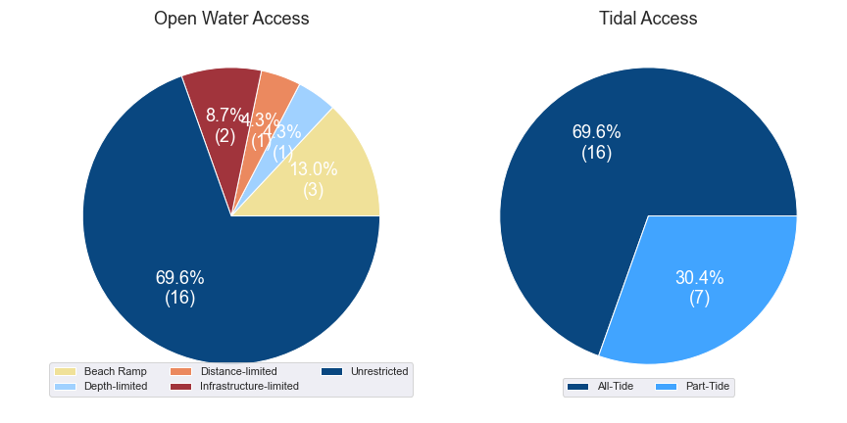

(a) Summary of open water access from boat launching facilities (left) and (b) Summary of tidal restrictions at tidal boat launching facilities (right)

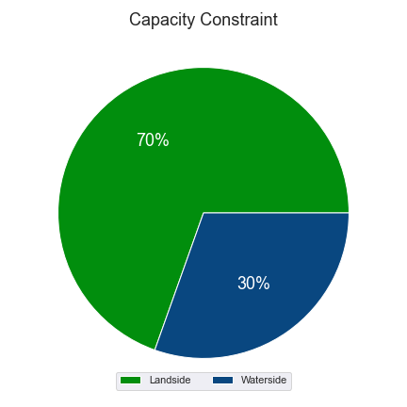

Summary of limiting capacity constraint

## Access to sheltered near all-tide and all-tide facilities

MSQ has a longer-term vision to provide access to all-tide or near all-tide open water access boat launching facilities along the Queensland coast, such that all significant population centres are within one hour’s driving range as far as practical (TMR, 2020). For this purpose, the Study has defined towns as being within the coastal strip if within 30km of the Queensland coastline. The vision (TMR,2020) is applied to the coastal strip between the NSW border and Cooktown. Consultation throughout the Study has highlighted that this vision is important with users/stakeholders and organisations that own and manage these facilities. As such, the Study has developed a statistical approach to quantify this vision to allow it to be measured and tracked over time. To do this, the Study has calculated the travel time from all Population Centres (DoR, 2022) within the coastal zone to the nearest available sheltered, all-tide or near all-tide facility, regardless of which LGA it is in. This has been accomplished using mapped road networks and assigning speed limits to each type of road, with the following speed limits applied:

* for restricted roads, 40km/hr
* for local roads, 60km/hr
* for connector roads, 70km/hr
* for distributor roads, 80km/hr
* for highways, 100km/hr.

For Moreton Bay LGA the median travel time from eligible Population Centres to the nearest sheltered all-tide or near all-tide facility is 13 minutes. The distribution of travel times is shown in Figure 3.3 with detailed travel times in Annex C. Figure 3.4 provides a visual representation of the travel time from each of the sheltered near all-tide facilities that serve the LGA. Of interest for Moreton Bay LGA are:

* 100% of the eligible population centres are within the desired 1-hour travel time.
* With the exception of Neurum in the Moreton Bay LGA hinterland, all eligible population centres are within 30 minutes of a sheltered near all-tide or all-tide facility.

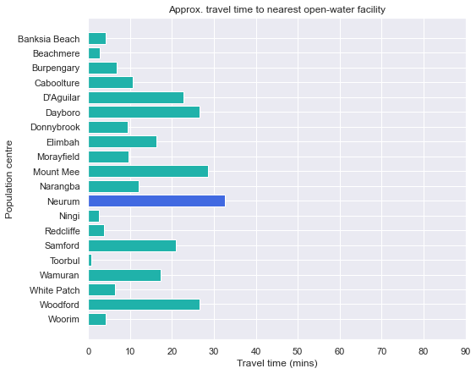

Distribution of travel time from Moreton Bay LGA’s eligible population centres to sheltered near all-tide facilities

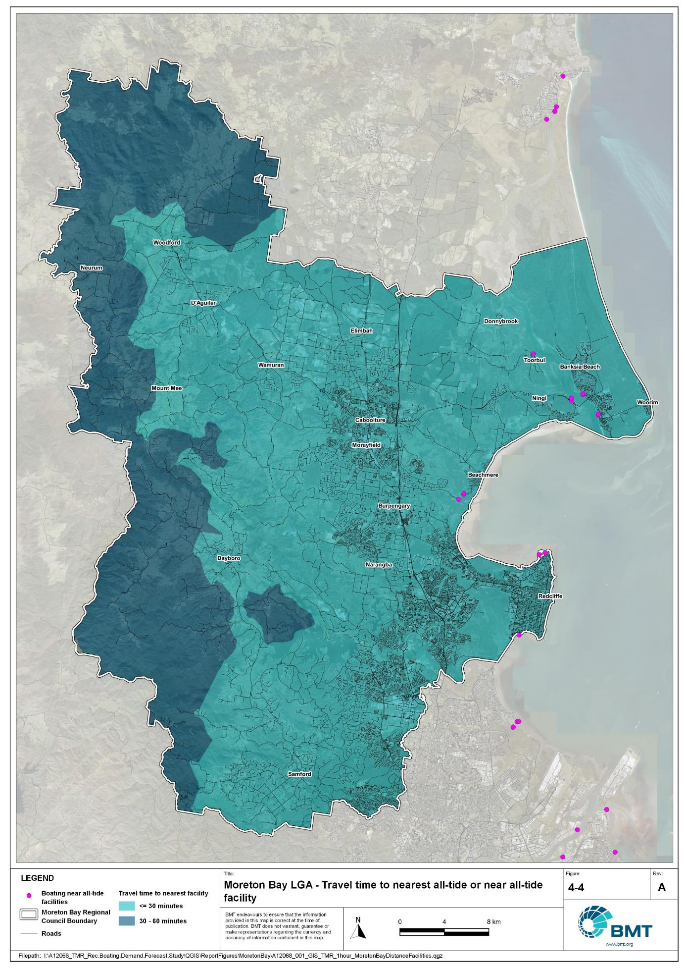

Bundaberg LGA – Travel time to nearest all-tide or near all-tide facility

"I:\A12068_TMR_Rec.Boating.Demand.Forecast.Study\QGIS\ReportFigures\MoretonBay\A12068_001_GIS_TMR_1hour_MoretonBayDistanceFacilities.jpg"

## Deep-draught vessel landings

Deep-draught vessel landings are intended to provide short-term landing capacity for vessels that are too large to use public boat launching and retrieval facilities. These facilities are provided for the benefit of both local vessels and to service the fleet of vessels that travel along the Queensland coast. Deep-draught vessel landings may be designed to accept one or more large vessels at a time and/or provide capacity for tenders from larger vessels that may be anchored or moored nearby, for the purpose of loading and offloading passengers and supplies, and making short local visits to onshore destinations.

For the Study, deep-draught vessel landings need to be primarily accessible by recreational boats for short, temporary stays. In some cases, commercial vessels may utilise these facilities subject to the relevant permissions, however, this may reduce the capacity of the facility to cater for recreational vessels. Deep-draught vessel landings should be located such that the facility provides reasonable access to landside passenger pick up and drop off, provisioning, recreational destinations, or population centres. Within Moreton Bay LGA there are three deep-draught vessel landings that provide access to the following facilities or destinations:

* Redcliffe Pier provides access to restaurants, shops for provisioning, parking areas for passenger drop off/pick-up and public transport.
* Scarborough Boat Harbour, Thurecht Parade pontoon provides access to parking area for passenger drop off/pick-up.
* Bongaree, First Avenue pontoons- provide access to local restaurants, parking areas for passenger drop off/pick-up and public transport.

As well as the above, Moreton Bay LGA has additional deep-draught vessel landings provided by private facilities, including those in Newport Marina, Scarborough Boat Harbour and Spinnaker Sound Marina. There are also several canal estates featuring extensive private landings.

In summary, Table 3.2 shows the total capacity of deep-draught landing facilities within Moreton Bay LGA.

Deep-draught landing facilities within Moreton Bay LGA

| Facility type | Total capacity |
| --- | --- |
| Public sheltered mainland landings | 3 |
| Private sheltered landings | 3 |
| **Total** | **6** |

# Beach Ramps

As part of the Study, an investigation into the suitability of wave-exposed beach launching ramps was undertaken. These facilities were visited as part of the Study and discussed with managing authorities during consultation, to assess their capability to meet existing demand and their future potential/need. In many cases, the current fleet size and intended use has outgrown the suitability of these ramps, but in some locations, they remain the only facility to service key communities along parts of the Queensland coast. These assessments seek to assist MSQ to determine its future strategy about retention, demolition, maintenance, upgrade, or potential conversion to non-registered boating use (for instance, personal watercraft, vehicular beach access) and consider where communities benefiting from these facilities have suitable alternatives.

## Margate, Eveline Street

The Margate beach ramp provides access from Redcliffe directly into Moreton Bay on the south end of the east-facing side of the Redcliffe peninsula. The facility is a concrete piled beach ramp with parking for four CTUs and is shown in Figure 4.1. During the inspection of the facility, it was noted that:

* The decking was in reasonable condition, with the substructure difficult to inspect due to the sand level.
* The ramp was very exposed to wave conditions, with a fetch greater than 30km from 28 degrees (north-northeast) to 140 degrees (south-southeast), with the only wave protection in this window from Mud Island, which reduced the fetch to 15km.
* While four CTU spaces were provided, there was limited space for manoeuvring of vehicles.
* There appeared to be a rocky outcrop at the bottom of the ramp that may reduce its usability at low tide.

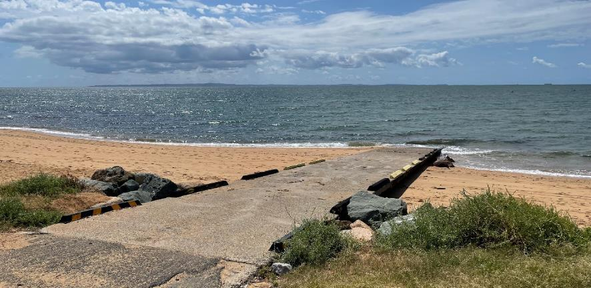

Margate, Eveline Street beach ramp

The human movement statistics (see section 5.2) indicate that this facility receives very low usage, mostly by residents of Moreton Bay LGA, and with users remaining very close to shore generally. The human movement data also shows that amongst this very low usage is large a proportion of users that are not entering the water, indicating that the ramp is being used to access the beach. The Pelican Park facility is only 3km to the south-west.

Given the level of exposure to waves, tidal constraints, and landside constraints, it is likely that the facility is only available for boat launching approximately 25% of the time and therefore provides little in the way of satisfying statistical demand for Moreton Bay LGA. The human movement data suggests that approximately 0.1% of the total Moreton Bay LGA boating facility users are using this facility, and this is expected to be higher than actual usage due to people also using the ramp for beach access. It is the recommendation of the Study that the Margate facility is retired or downgraded to a beach access ramp for pedestrians, and users of non-motorised craft.

## Scarborough, Flinders Parade

The Scarborough beach ramp provides access from Redcliffe directly into Moreton Bay on the north end of the east-facing side of the Redcliffe peninsula. The facility is a concrete piled beach ramp (Figure 4.1) that is not supported by any formal CTU parking, although there is a rigging bay. During the inspection of the facility, it was noted that:

* The decking was in average condition, with parts of the substructure having significant cracking (Figure 4.3).
* The ramp was very exposed to wave conditions, with similar exposure to that noted for Margate.
* There was very little space available for manoeuvring and parking of cars with trailers at the top of the ramp without entering the road space.
* There appeared to be a rocky outcrop at the bottom of the ramp that may reduce its usability at low tide.
* There was a pronounced difference in beach width on either side of the ramp, with the northern side retaining sand while there was very little on the southern side, indicating that the ramp, despite being elevated, was impacting sand supply along the beach.

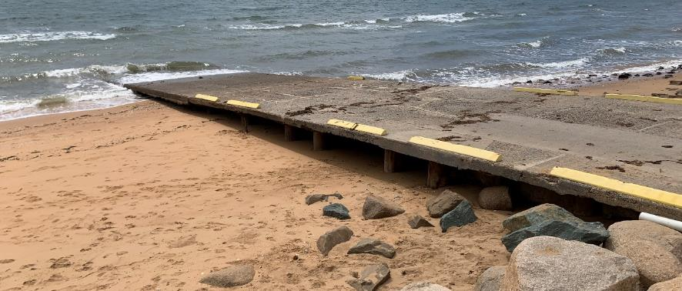

Scarborough, Flinders Parade beach ramp

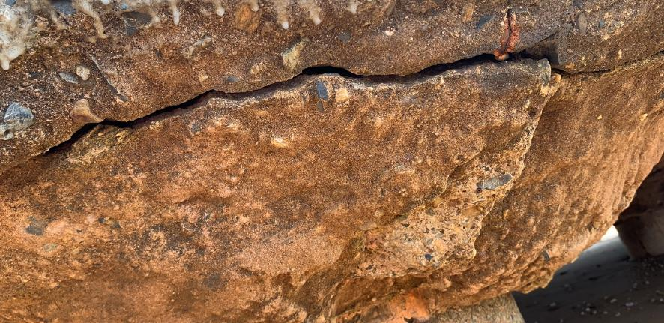

Scarborough, Flinders Parade beach ramp cracking example

The human movement statistics (see section 5.2) indicate that this facility receives very low usage, mostly by residents of Moreton Bay LGA, and with users remaining very close to shore generally. The human movement data also shows that amongst this very low usage is a large proportion of users that are not entering the water, indicating that the ramp is being used to access the beach. The Scarborough Boat Harbour facilities are only 2km to the north-west.

Given the level of exposure to waves, tidal constraints, and landside constraints, it is likely that the facility is only available for boat launching approximately 25% of the time and therefore provides little in the way of satisfying statistical demand for Moreton Bay LGA. The human movement data suggests that approximately 0.2% of the total Moreton Bay LGA boating facility users are using this facility, and this is expected to be higher than actual usage due to people also using the ramp for beach access. Given the very low usage by recreational boat users, the condition of the ramp and the impacts to coastal processes it is the recommendation of the Study that the Scarborough, Flinders Parade facility be decommissioned and removed.

# Demand Assessment

The Study has developed a model to calculate statistical demand for boat launching facilities and deep-draught vessel landings at an LGA scale. Vessels that are less than 8m in length are considered trailable and drive demand for boat launching facilities such as boat ramps, while those over 8m are assumed to remain on water and drive demand for deep-draught landings.

Statistical demand is recognised at three different levels for public marine facilities within the TMR guidelines (TMR, 2020), which are:

* off-peak demand – typical weekday usage
* average demand – demand on ‘good boating days’, taken to be demand for a facility on weekends (and, for certain regional locations, other busy periods)
* peak demand – demand for a facility at peak holiday periods or for special events.

The demand model created for this Study is intended to provide information on demand pressures on ‘good boating days’ for all facilities as per the intentions of the guidelines. The model achieves this through a ‘registration activation rate’ that estimates the proportion of registered vessels in an LGA that is assumed to be active on a ‘good boating day’, as well as the exchange of vessels between LGAs, and general tourism pressures.

## Activation rate

The fleet size for each LGA is determined statistically from vessel registration numbers and the application of a vessel activation rate, while for future time horizons vessel registration and population growth estimates are also utilised. The methodology for determining the registration activation rate has been adopted from the previous study (GHD, 2017), with activation rates taken to be between 8% and 14% for a typical weekend. The variability of the activation rate is intended to capture the regional differences in vessel types, and is driven by the availability of access to open water, accessibility of other recreational opportunities, and likelihood of users’ available time for recreation, considering factors including:

* remoteness classification for the LGA
* incidence of blue-collar employment
* average age of residents
* whether the LGA is coastal.

Further information about the derivation of this rate can be found in Annex A. For Moreton Bay LGA the activation rate is assumed to be 7%, with the key factors influencing the rate including:

* its classification as a Metropolitan Area
* it being located adjacent to the open coast.

## Digital user survey

To gain an understanding of usage trends at existing formal recreational boating facilities across Queensland, the Study has considered the results of a digital user survey using human movement data, sourced through a third party. The data was acquired from a location data store with more than 13 trillion mobile location observations globally from 2019 to present, which were sourced from 250,000 different mobile phone applications that users ‘opted-in’ to use the location services under the application’s terms and conditions. All data received was deidentified and compliant with relevant data privacy regulations.

The analysis uses mobile devices (such as telephones) location data as a proxy for boat user traffic, however, this relationship has several limitations including, but not limited to:

* Mobile device users detected in the area of interest may not be boat users (for example, pedestrians not using vessels may walk through the detection area).
* The relationship between mobile device users and vessels may not be 1:1 (that is, there may be multiple mobile devices providing data for each vessel).
* Users of vessels may not have a mobile device, may not be using a mobile device or may not have provided permission to use their location data.

With these, and potentially other, limitations in mind, the Study compared this data against vessel launching counts provided by various facility managers and found that approximately 15-30% of vessels are captured using this digital survey method. This percentage can change from facility to facility and from day to day. Consequently, the Study has not relied on raw counts of users from this data, but instead considered the relative trends within the data, with the assumption that no groups (for example, users from a particular LGA or using a particular facility) within the data would be more or less likely to be captured by the technique.

The Study has used this data to identify the relative volume of users, the ‘home’ local government area of users and the popularity of destinations that users travel to once vessels have been launched.

* + 1. Inter-LGA demand

The human movement data has been interrogated to determine the LGA of origin for users of Moreton Bay LGA’s public boating facilities to ascertain the proportion of users from each LGA that are using specific facilities. Statistics from all public boating facilities within the LGA are then grouped together to determine the total proportion of resident or visiting users across the LGA. Table 5.1shows the active fleet proportion from the top 10 LGAs contributing to demand on facilities within Moreton Bay LGA. All other sources have been grouped together.

LGA of origin for active fleet in Moreton Bay LGA

| LGA of origin | Active fleet proportion |
| --- | --- |
| Moreton Bay | 73.7% |
| Brisbane | 12.9% |
| Sunshine Coast | 2.4% |
| Logan | 1.7% |
| Ipswich | 1.4% |
| Gold Coast | 1.2% |
| Redland | 1.2% |
| Toowoomba | 0.7% |
| Somerset | 0.3% |
| Fraser Coast | 0.2% |
| Other LGAs | 4.4% |

* + 1. Intra-LGA demand distribution

Recreational boating users will tend to use facilities that best suit their needs, the destinations they want to access, the capability of their vessel and the weather conditions. Consequently, distribution within an LGA is unlikely to be evenly spread across all facilities, with some facilities attracting users disproportionately due to amenity, access, or destinations. The attractiveness of large well-designed facilities is likely to draw visiting boat users in preference to smaller or less desirable facilities across the LGA. The human movement statistics have been assessed to qualitatively estimate the proportion of users using each facility, both in total and with respect to both resident and visiting boat users (Table 5.2).

Popularity of boat launching facilities.

| Facility | Overall fleet | Resident fleet | Visiting fleet |
| --- | --- | --- | --- |
| Scarborough Boat Harbour, Thurecht Parade | 19.6% | 22.0% | 12.9% |
| Clontarf, Pelican Park, Thomas Street | 16.2% | 12.5% | 26.5% |
| Scarborough Boat Harbour, Bird O'Passage Parade | 13.1% | 13.8% | 10.8% |
| Bongaree, Fifth Avenue | 11.2% | 11.1% | 11.6% |
| Bellara, Marine Parade | 10.5% | 9.2% | 14.3% |
| Burpengary, Uhlmann Road | 5.3% | 6.3% | 2.2% |
| Griffin, Dohles Rocks Road | 4.8% | 5.3% | 3.6% |
| Spinnaker Sound, Sandstone Point,  Kal Ma Kuta Drive | 4.8% | 4.7% | 5.1% |
| Toorbul, First Avenue | 3.7% | 3.6% | 3.9% |
| Beachmere, Saint Smith Road | 3.0% | 3.3% | 2.3% |
| Sandstone Point, Kal Ma Kuta Drive | 2.3% | 2.2% | 2.5% |
| Deception Bay, Bayview Terrace | 1.8% | 2.1% | 0.9% |
| Donnybrook, Grant Lane | 1.2% | 1.2% | 1.2% |
| Strathpine, Learmonth Street | 0.8% | 0.9% | 0.5% |
| Toorbul, Moffat Esplanade | 0.7% | 0.7% | 0.9% |
| Meldale, Way Street | 0.7% | 0.8% | 0.4% |
| Scarborough, Flinders Parade | 0.2% | 0.2% | 0.2% |
| Margate, Eveline Street | 0.1% | 0.1% | 0.1% |

The results indicate that the combined Scarborough Boat Harbour facilities cater for approximately one third of the total demand in the LGA, with the resident fleet preferring to use these facilities more than the visiting fleet. The visiting fleet prefers using the Pelican Park facility, which is easily accessible from Brisbane LGA, which also contributes the largest number of vessels to the visiting fleet. The facilities on Bribie Island are very popular, with a minority of the fleet distributed amongst the remainder of the facilities.

The distribution of capacity within the LGA needs to consider these trends to avoid consistent capacity shortfalls at some facilities or indicating demand for unnecessary extra capacity at other facilities. Results from the above statistics and feedback obtained through the TMR online survey indicate that within Moreton Bay LGA the following factors tend to influence the preferred facilities for recreational boat users:

* access to sheltered, all-tide launching facilities
* dry entry/exit capabilities of launching facilities provided through floating walkways, pontoons and to a lesser extent fixed sloping walkways
* ability to access Moreton Bay.
  + 1. Destinations

For facilities that provide sheltered, near all-tide or all-tide open water access, additional analysis of the human movement statistics has been undertaken to identify destinations for users of these facilities. Location data from users utilising the facilities was extracted for a period of two hours after they used the facility and trimmed for water-side destinations. For Moreton Bay LGA this additional analysis was applied to the following facilities, with destinations mapped in Figure 5.1:

* Beachmere, Saint Smith Road
* Bellara, Marine Parade
* Bongaree, Fifth Avenue
* Burpengary, Uhlmann Road
* Clontarf, Pelican Park, Thomas Street
* Scarborough Boat Harbour, Thurecht Parade
* Spinnaker Sound.

From this additional analysis, the following notable observations were made:

* Users from almost all facilities entered Moreton Bay and travelled across to Moreton Island, with the Tangalooma Wrecks a popular destination.
* Of the locations assessed, users wanting to access Pine River or southern Moreton Bay almost exclusively used the Pelican Park facility.
* Pumicestone Passage was a popular destination, as far north as Caloundra, for vessels launching from Spinnaker Sound, Bellara and Bongaree.
* Users of the Uhlman Road facility accessed the Caboolture River as well as destinations in and beyond Moreton Bay.

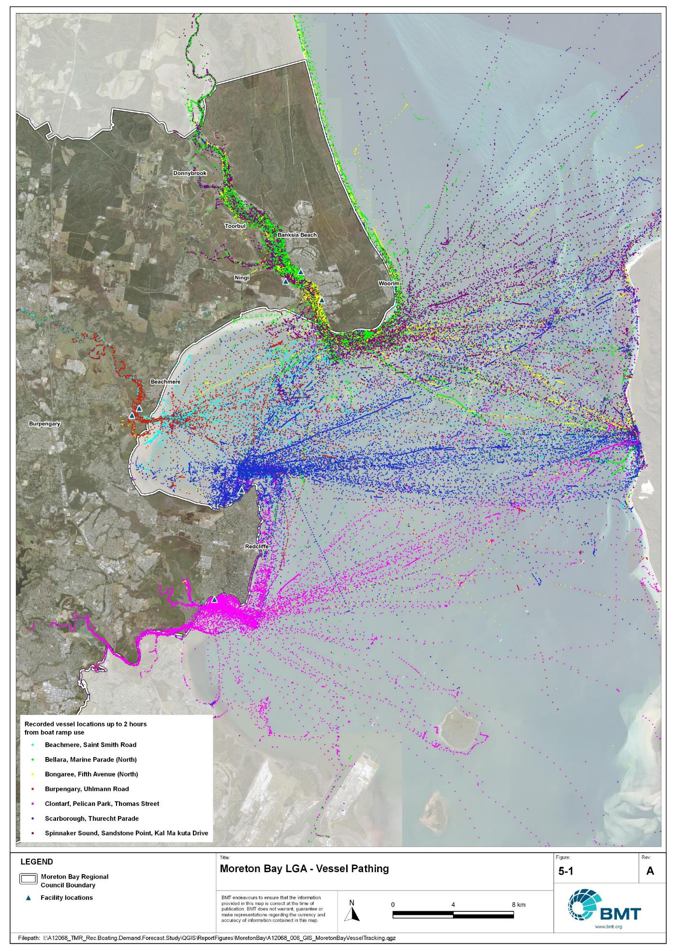

Moreton Bay LGA – Vessel pathing

"I:\A12068_TMR_Rec.Boating.Demand.Forecast.Study\QGIS\ReportFigures\MoretonBay\A12068_006_GIS_MoretonBayVesselTracking.jpg"

## Active fleet size

The total ‘active’ fleet on a good boating day is derived from the activation rate of the total fleet of registered vessels within the LGA and the net inflow of visiting vessels. The total number of visiting vessels from each LGA is determined from the number of vessels in the resident active fleet and the relative proportion of resident to visiting vessels outlined in Table 5.1.The fleet size is expected to change over time due to changes in population and vessel acquisition trends, with the size and proportion of the fleet across the Study period described in Table 5.3.

Active fleet vessel size

| Vessel length | 2021 | 2026 | 2031 | 2036 | 2041 |
| --- | --- | --- | --- | --- | --- |
| 0 to 4.5m | 1093 | 1183 | 1276 | 1356 | 1433 |
| 4.5m to 8m | 462 | 500 | 540 | 574 | 606 |
| >8m | 75 | 81 | 87 | 92 | 97 |
| Total | 1630 | 1764 | 1903 | 2022 | 2136 |

## Boat ramp lane demand

The fleet size derived in Table 5.3 represents the statistical demand for the LGA, with vessels under 8m assumed to contribute to boat ramp demand, measured in boat ramp lanes. As outlined in section 3.1.2 the adopted capacity of each effective lane is 40 vessels per day, with each vessel assumed to both launch and retrieve, for a total of 80 vessel movements per day. The total boat ramp lane demand across the Study period is shown in Table 5.4.

Boat ramp lane demand

|  | 2021 | 2026 | 2031 | 2036 | 2041 |
| --- | --- | --- | --- | --- | --- |
| Boat ramp lane demand | 38.9 | 42.1 | 45.4 | 48.2 | 51 |

For Moreton Bay LGA the important elements that contribute to the boat ramp lane demand include:

* a large sized local fleet, with a high proportion of trailable vessels
* large fleets in neighbouring LGAs, which contribute a significant number of vessels to Moreton Bay LGA
* strong projected population growth, particularly close to the Caboolture River, which does not currently provide significant recreational boat launching capacity
* attractive destinations for visitors from elsewhere in south-east Queensland.

## Non-statistical demand

As well as the statistical demand outlined in the section above, facilities may face demand pressures that are related to their functional use, which reduces the capability of the facility to service the recreational boat fleet in the desired manner. Issues with specific facilities have been identified within the consultation process of the Study with appointed managers and other stakeholders. While care has been taken to identify these non-statistical demand issues throughout the Study, it is beyond the scope of the Study to individually review the functionality, safety, and amenity of each facility across Queensland. Non-statistical demand pressures may warrant upgrades to facilities even where statistical demand is satisfied by existing capacity. These pressures have been classified into the following categories:

* Amenity: Amenity describes the functional usability of the facility including the desire to provide dry entry and exit facilities, facilities that provide easy access and/or access for persons with restricted mobility.
* Safety: Safety demand may include protection from currents and waves or contact with marine creatures such as sharks, jellyfish, and crocodiles.
* In-water congestion: Where existing queuing facilities are not able to efficiently meet the needs of the facility. Such deficiency may warrant additional queuing facility capacity to optimise boat launching and retrieval.

The Study's recommendations may alleviate these non-statistical demand pressures with consideration for capability of all facilities within the LGA. The presence of a non-statistical demand pressure at a facility may not warrant upgrades where other suitable facilities are reasonably available.

## Deep-draught vessel demand

* + 1. Cruising vessels

Vessels cruising along the east coast of Queensland have a requirement for a network of deep-draught vessel landings that are appropriately spaced to be within a day’s sailing on good weather days. These facilities are required to support the reprovisioning of vessels as they travel along the coast and provide access to desirable land-based destinations. Private marina facilities may be used by cruising vessels where there is an expectation for a prolonged stay that requires protected mooring or berthing. Within Moreton Bay LGA suitable facilities for deep-draught vessels include the public pontoon on the Redcliffe Jetty in Redcliffe, Scarborough Boat Harbour and Bribie Island.

The collection of councils fronting Moreton Bay (Moreton Bay, Brisbane and Redland) along with the Gold Coast contribute approximately half of all deep-draught vessel registrations in Queensland, with this area typically the origin for Queensland coastal cruising. Within the east coast network but outside Moreton Bay LGA, the nearest public deep-draught vessel facility to the north is at Mooloolaba, approximately 35 nautical miles north of Scarborough Boat Harbour. Vessels travelling to Mooloolaba have three pontoons as well as private facilities that may be used for landing or mooring.

* + 1. Landing demand

Statistical demand for deep-draught vessel landings has been assessed based on the size of the non-trailable fleet within Moreton Bay LGA. Landing demand is more difficult to assess than boat ramp lane demand as the requirements and duration of the landing influence the demand pressure but are highly variable between users. Nevertheless, the Study has assumed that 5% of the non-trailable fleet will be seeking a landing at any given time. The consultation undertaken during the Study indicates that this assumption may overestimate the number of landings, but that the landings are often utilised for other boating and recreation activities when not in use by deep-draught vessels. In particular, landings that are located near boat launching facilities may be used as queuing facilities and therefore support the efficient launching of smaller recreational vessels. Given this, the 5% assumption has been adopted noting that it may overestimate capacity, but not to an extent that it would be onerous to facility providers. Within Moreton Bay LGA the demand for deep-draught vessel landings is outlined in Table 5.5.

Deep-draught vessel landing demand

| Requirement | 2021 | 2026 | 2031 | 2036 | 2041 |
| --- | --- | --- | --- | --- | --- |
| No. of Landings | 3.8 | 4 | 4.4 | 4.6 | 4.9 |

# Shortfall Assessment

## Shortfall assessment – boat ramps

The shortfall of boat ramp lanes within Moreton Bay LGA is shown in Table 6.1 and Figure 6.1 at an LGA scale. This is presented both with and without the inclusion of additional capacity provided by the recommended upgrades.

Shortfall of boat launching facilities

| Assessment | Metric | 2021 | 2026 | 2031 | 2036 | 2041 |
| --- | --- | --- | --- | --- | --- | --- |
| Demand | Demand | 38.9 | 42.1 | 45.4 | 48.2 | 51 |
| Existing | Capacity | 36.2 | 36.2 | 36.2 | 36.2 | 36.2 |
| **Shortfall** | 2.7 | 5.9 | 9.2 | 12 | 14.8 |
| Improved  (Minimum upgrades) | Capacity | 36.2 | 41.7 | 43.9 | 44.9 | 50.9 |
| **Shortfall** | 2.7 | 0.4 | 1.5 | 3.3 | 0.1 |
| Improved  (Maximum upgrades) | Capacity | 36.2 | 41.7 | 51.5 | 52.5 | 58.5 |
| **Shortfall** | 2.7 | 0.4 | -6.1 | -4.3 | -7.5 |

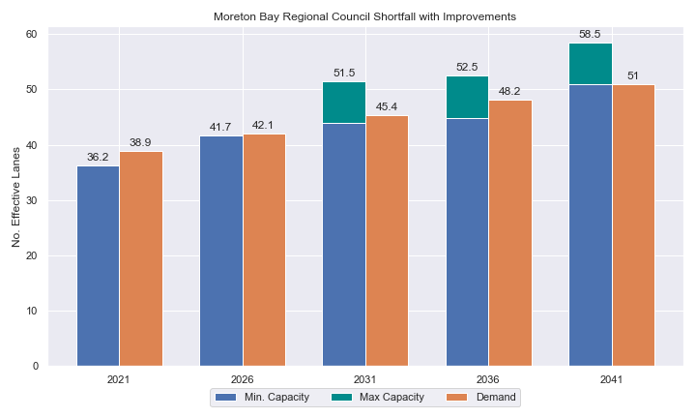

Shortfall assessment with recommended upgrades adopted

* + 1. Open-water access shortfall in boat ramp lanes

Statistical capacity has been calculated across Moreton Bay LGA in its entirety, however, some facilities are evidently more popular than others due to their ability to access open-water destinations, and/or their usability. In general, larger vessels are more suited to access open-water destinations while smaller vessels are more likely to remain in sheltered environments. This was identified in the 2017 study and confirmed during discussions with stakeholders. The human movement data indicates that visiting boats from other LGAs are drawn to facilities that provide access to open-water destinations. To ensure that the capacity of effective boat ramp lanes in the LGA is appropriately distributed to cater for these usage trends, it is worth assessing facilities providing this desirable access as a subset of the total capacity for the LGA. A ‘scenario’ approach to assessing this capacity has been developed, with Scenario 1 derived from empirical estimates of vessel distribution and Scenario 2 derived from the human movement statistics, and the result averaged between the two scenarios. This provides the opportunity to rationalise the figure that drives the demand and acknowledge when one scenario is not representative of the population or consistent with stakeholder feedback. The scenarios that were assessed are:

Scenario 1: 80% of larger vessels and 20% of smaller vessels from the local fleet and 80% of the visiting fleet are using the facilities with unrestricted open water access.

Scenario 2: Distributing the fleet between facilities as per the human movement statistics.

The results of this approach suggest that the shortfall from these specific facilities is in proportion to the overall shortfall for Moreton Bay LGA.

Shortfall assessment for open water, all-tide or near all-tide facilities for Moreton Bay LGA

| Assessment | Metric | 2021 | 2026 | 2031 | 2036 | 2041 |
| --- | --- | --- | --- | --- | --- | --- |
| Overall | Capacity | 30.6 | 30.6 | 30.6 | 30.6 | 30.6 |
| Scenario 1 | Demand | 31.1 | 33.7 | 36.3 | 38.6 | 40.8 |
| Shortfall | 0.6 | 3.2 | 5.7 | 8.1 | 10.2 |
| Scenario 2 | Demand | 34.4 | 37.2 | 40.2 | 42.7 | 45.1 |
| Shortfall | 3.8 | 6.7 | 9.7 | 12.2 | 14.6 |
| **Average** | Demand | 32.8 | 35.5 | 38.3 | 40.7 | 43.0 |
| **Shortfall** | **2.2** | **4.9** | **7.7** | **10.1** | **12.4** |

Comparing the LGA-scale shortfall with the subset of facilities providing protected all-tide or near all-tide access to open water indicate that the growth in demand is heavily focused on facilities that provide this access.

## Shortfall assessment – deep-draught landings

The shortfall of public deep-draught landings for Moreton Bay LGA is provided in Table 6.3. The existing capacity is statistically inadequate to meet demand, however, at present the capacity provided by private facilities at Scarborough Boat Harbour, Newport Marina and Spinnaker Sound Marina mitigate this shortfall. It is projected that additional deep-draught vessel landings will be required in the intermediate timeframes of this Study.

Shortfall of deep-draught vessel landings

| Assessment | Metric | 2021 | 2026 | 2031 | 2036 | 2041 |
| --- | --- | --- | --- | --- | --- | --- |
| Deep-draught vessel landings | Demand | 3.8 | 4 | 4.4 | 4.6 | 4.9 |
| Capacity | 3 | 3 | 3 | 3 | 3 |
| **Shortfall** | 0.8 | 1 | 1.4 | 1.6 | 1.9 |

# Stakeholder Feedback



For Moreton Bay LGA, the Study team met with Moreton Bay Regional Council and Maritime Safety Queensland to discuss recreational boating facilities within the region. This consultation process identified a range of potential opportunities to alleviate demand pressures. The Study has considered the practical implementation of each of these opportunities with respect to the required infrastructure, difficulty of implementation, and magnitude of benefit, as summarised in Table 7.1.

Stakeholder identified opportunities

| Location | Stakeholder opportunity | Review comments |
| --- | --- | --- |
| Burpengary East, Uhlmann Road | Expansion here to provide capacity for demand from Caboolture. | Agreed subject to environmental constraints. |
| Griffin, Dohles Rocks | Acquire land for expansion of parking facilities. and construct parking facilities | Agreed. |
| Scarborough Boat Harbour | Replace east facility with new facility on the existing spoil handling ponds. | Agreed. This would need to be considered as part of the Scarborough Boat Harbour master planning process. |
| Bellara, Marine Parade | Reconfigure carparking to make more efficient. | Additional parking could be provided to the south, but conflicts with other uses. |
| Burpengary East, North Harbour, | Proposed residential development on the Caboolture River, no current plans for public recreational boat facility. | Recommend that a public recreational boat facility be encouraged to relieve pressure on the Uhlmann Road boat ramp which will be generated from the broader development. |
| Woody Point | Potential large expansion for Olympics. | Future expansion of recreation facilities would be better suited at Pelican Park. |
| Margate, Eveline Street | Downgrade to beach access only. | Agreed |
| Scarborough, Flinders Parade | Downgrade to beach access only. | Agreed |

## Stakeholder feedback

Broad stakeholder feedback has been conducted within the Study by undertaking virtual or face-to-face meetings with recreational boating groups and marine rescue organisations, as well as through the Recreational Boating Facility Survey (MSQ, 2022) undertaken by Maritime Safety Queensland, which included survey responses of nearly 3,000 users and open submissions. For Moreton Bay LGA a total of 175 submissions was received, with 65% of respondents using trailable power boats and 97% of respondents using recreational boating facilities at least once a month. For Moreton Bay LGA the following statistics or themes were extracted from the survey and associated comments:

* 92% of respondents typically travel less than 1hr to their preferred boat ramp (which may not be their closest facility).
* 57% of respondents indicated that floating walkways are their preferred type of queuing facility.
* 93% of respondents indicated that they would be unwilling to walk further than 200m from designated CTU parking to a boat ramp.
* The most common requests for new boat ramps were at:
  + Bribe Island (Solander Esplanade, Sunderland Drive, Banksia Beach, Sylvan Beach, and so on.)
  + Scarborough
  + Caboolture River
  + Deception Bay.
* The following themes were identified with respect to existing facilities
  + more (formalised and secure) parking areas for normal and slightly bigger trailers - applying strict rules for non-towing cars to prevent occupying spaces – and using more cameras, lighting, and patrols
  + more pontoons and mooring at the ramps (for example, down the middle of Queen Beach at Redcliffe Coastguard)
  + tidy toilets, shower, change rooms, bins, recreational (like Bald Hills, Lawnton, and Dohles Rocks) and wash down facilities (like those in northern Queensland)
  + separate/dedicated ramps (or adjacent sand beach) and parking areas for jet skis and non-motorised craft to get off the boat ramps
  + fish cleaning benches, disposal areas and running water at fish filleting areas.
* Where the closest available boat launching facility was not preferred, respondents indicated that the following key aspects influenced their choice:
  + closer to preferred fishing and crabbing spots
  + access to larger and better ramps to avoid congestion (including multi-lane ramps, pontoons, floating walkways, trailer parking areas)
  + ability to launch/retrieve at low tide
  + access to open ocean and islands
  + strong wind and current protection of the ramp
  + friendliness for families and people with disabilities.
* Respondents were given an opportunity to provide additional feedback, with the following themes identified:
  + need for larger ramps for launching/retrieving car plus boats weighing about 8 tonnes and above
  + making boat ramps friendly for people with disabilities to help them go out fishing by themselves, which significantly improves their mental health
  + regular maintenance and cleaning of the facilities.
  + Government should incentivise private companies to build dry-stack boat storage facilities to take the load off public boat ramps and reduce road traffic and parking pressure.

# Development Recommendations

## Previous recommendations

The 2017 GHD assessment recommended opportunities for increasing capacity of recreational boating facilities across the state. However, the implementation of these recommendations has been low, with only 10% of the total state-wide recommendations delivered in part or full in the 5 years since the delivery of the report. Of the priority 1 recommendations (for immediate delivery) and priority 2 recommendations (for implementation within 5 years) only 18% and 6% respectively have been delivered. State-wide only 5% of landside recommendations were delivered, while 16% of waterside recommendations were delivered.

Within Moreton Bay LGA 29% of waterside recommendations and none of the landside recommendations have been implemented since the delivery of the 2017 GHD study. The low rate of implementation of these recommendations is likely the result of budgetary constraints applied due to the COVID-19 pandemic. As such, many of the recommendations proposed in the 2017 GHD study remain viable. This current Study has reviewed the unimplemented 2017 recommendations (Table 8.1) for Moreton Bay LGA in conjunction with stakeholders during the consultation process to identify previous recommendations that are:

* Still viable: The recommendation in its original form remains suitable for solving demand pressures
* Still viable with modifications: The recommendation could remain viable with modifications identified throughout the consultation process
* No longer viable: The recommendations are no longer suitable to be carried through as recommendations in this Study.

Recommendations from the 2017 study that are considered viable or viable with modifications are carried forward into the recommendations of this Study with a suitable update to their priority status if required.

Assessment of unimplemented 2017 recommendations

| Location | 2017 Recommendation | 2022 Review | Review comment |
| --- | --- | --- | --- |
| Priority 1 |  |  |  |
| Bellara, Marine Parade | Expand parking to 150 CTUs | No longer viable | Space required to undertake this is currently used for other purposes. |
| Priority 2 | | | |
| Griffin, Dohles Rocks Road | Purchase land to expand parking to 90 CTU spaces. | Viable with modifications | Some modification of the 2017-recommended parking layout could require less land acquisition. |
| Priority 3 | | | |
| Clontarf, Pelican Park, Thomas Street | Formalise CTU to achieve a further 32 CTU spaces | Viable with modifications | This remains viable as one option, but further expansion can also be undertaken - preferably to accommodate annual KiteFest and keep boat ramp open. |
| Beachmere, Saint Smith Road | Construct a 2-lane ramp with a floating walkway. Formalise parking area to achieve 45 CTU spaces. | Viable with modifications | Capacity on the north side of the Caboolture River could be carried forward as a low priority, as there are plentiful other opportunities that provide better access. |
| Beachmere, Beachmere Road | Construct new facility with 45 CTU spaces. | Viable with modifications | Capacity on the north side of the Caboolture River could be carried forward as a low priority, as there are plentiful other opportunities that provide better access. |
| Priority 4 | | | |
| Burpengary East, Uhlmann Road | Reclaim land to the south, extend parking into reclaimed area to achieve 70 CTU spaces | Still viable | Recommend making a higher priority, providing 2 options for car park layout. |
| Burpengary East, North Harbour (Caboolture Marina) | Construct a 4-lane facility with a floating walkway. Construct 90 CTU spaces | Viable with modifications | Additional capacity may be required to cater for future demand at this site. |
| Toorbul, Freeman Road | Expand parking area to achieve 45 CTU spaces, using land adjacent to the Esplanade. | No longer viable | Not enough local pressure to support this. Better opportunities to provide capacity regionally elsewhere. |

## Priority recommendations

The selection and ranking of development priorities provides for progressive implementation of solutions to meet capacity shortfalls and/or resolve existing safety and usage issues at existing facilities over time. Recommendations have been split into four categories for implementation within the 20-year planning period of this Study, with the following projected timelines:

* Priority 1: For immediate planning and design.
* Priority 2: Planning and design intended to provide capacity within 5-10 years.
* Priority 3: Planning and design intended to provide capacity within 10-15 years.
* Priority 4: Planning and design intended to provide capacity within 15-20 years.

The recommendations have been structured to include consideration of the reasonable timelines for implementation. This may include consideration for budgetary processes, planning, environmental approvals, consultation periods, and construction. The priority selection of recommendations has been conducted in accordance with TMR’s Marine Infrastructure and Facilities Plan (TMR, 2020) guidelines, namely:

1. *priority to be given to the provision of sheltered all-tide or near all-tide launching facilities giving access to the open sea on an all-tide or near all-tide basis.*
2. *part-tide facilities (for launching or access) may be provided where there is demand and dredged access is not feasible. For instance, beach access or open beach ramps may be provided where there is sufficient demand and no suitable nearby sheltered waterway*
3. *the most economically viable options will take precedence, including the expansion of existing facilities, and the changing of existing foreshore land uses. In many cases, limiting or avoiding dredging and/or breakwater costs will be a crucial factor*
4. *a goal of providing access to sheltered all-tide or near all-tide boat launching facilities within one hour’s drive for significant communities*

Consequently, higher order recommendations need to address, where possible, the provision of facilities that provide maximum benefit in the widest range of conditions and will be limited to those solutions that are already significantly advanced or ‘shovel ready’ or that require limited further design, planning and approvals. Lower order recommendations will consist of solutions where there is reduced adherence to the TMR guidelines and/or there are constraints that may result in long lead times to resolve. A summary of the recommendations is provided in Table 8.2 with full detail of each recommendation in the tables that follow.

Summary of recommendations for Moreton Bay LGA

| Priority | Description | Landside or Waterside | Increased capacity  (effective lanes) |
| --- | --- | --- | --- |
| 1 | Burpengary East, Uhlmann Road: Reclaim land north-west of existing parking facility to expand to 70 CTU. If not possible due to environmental constraints, provide 70 CTU capacity along Uhlmann Road. | Landside | 2.25 lanes |
| 1 | Griffin, Dohles Rocks: Acquire land and install 78 additional CTU spaces. | Landside | 3.25 lanes |
| 2 | Scarborough Boat Harbour: Consider opportunities through the Scarborough Boat Harbour master planning process and the planning and design of other recommended sites, to provide a new or improved facility that improves access, increases capacity and provides more deep-draught landings. | Both | Recommend net increase of:  6.5 lanes  2 deep-draught landings |
| 2 | Clontarf, Pelican Park, : Option 1 to provide minor increase for existing facility, Option 2 to redevelop the site and reclaim land to provide a new facility, or Option 3 to redevelop the adjacent parkland to provide a new standalone carpark separate from the rest of the park, via relocation of existing infrastructure. | Both | 2.25 lanes (option 1)  3.25 lanes (option 2 and 3) |
| 4 | Burpengary East, North Harbour Marina: Construct a 4-lane boat ramp with two centralised (working faces both sides) floating walkways and carpark with 140 CTU spaces for public use, as part of the North Harbour Marina development. Either long floating walkways or a separate gangway-access pontoon for temporarily leaving boat unattended. | Both | 6 lanes |

## Priority 1 recommendations

Burpengary East, Uhlmann Road - (Priority 1)

|  |  |  |  |  |
| --- | --- | --- | --- | --- |
| General description | | | | |
| Location | South bank of Caboolture River, on Uhlmann Road, Burpengary East | | | |
| Existing Facility? | Yes | | | |
| Coordinates | -27.14947000, 153.03136000 | | | |
| Existing tidal status | All-tide | | | |
| Existing wave exposure | Exposed | | | |
| Existing current exposure | Exposed | | | |
| Proposed works | Increase parking to 75 CTU spaces, with options for development at the existing parking site (Option 1) or to reclaim and construct additional CTU spaces to the west along Uhlmann Road (Option 2) (if development within Ramsar Wetland is not feasible).  If the options provided are deemed unachievable, it would be suggested to negotiate with the landowner of the commercial property to the west regarding the potential for acquisition of freehold land for CTU parking. | | | |
| Increased effective capacity | 2.25 Lanes | | | |
| Capacity improvement position | Waterside | Landside | | Both |
| Rationale | This existing facility services a major growth corridor and provides all-tide access to Moreton Bay. Pressure on this facility is expected to continue to increase with population growth. | | | |
| Anticipated Costs (+/- 50%) | Waterside infrastructure | | - | |
| Landside infrastructure | | $330,000 (option 1)  $480,000 (option 2) | |
| Planning, environmental and approvals constraints | | | | |
| Assessment | Requirement | Comments | | |
| Fish Habitat Zone | X | N/A | | |
| Native Title  (Gubbi Gubbi People) | ü | Parking area works could trigger Native Title negotiations. | | |
| MCU requirement | X | N/A | | |
| Clearing remnant vegetation | ü | Both proposed carpark upgrades (Options 1 and 2) are within the areas of RVM category B – remnant vegetation. A permit may be required before clearing remnant vegetation in these areas. | | |
| GBRWHA | X | N/A | | |
| Marine Park | ü | The eastern section of the proposed Option 1 upgrade is within the Moreton Bay Marine Park (General Use Zone) which may require a permit. | | |
| Tidal works assessment | X | N/A | | |
| Other as required | ü | Ramsar Wetlands – the eastern section of Option 1 would occur within the Moreton Bay Ramsar Wetlands which may trigger a Controlled Activity Approval.  Marine Plants – The development of both carparks (Options 1 and 2) may involve clearing of marine plants and therefore, a Development Permit for marine plants disturbance may be required.  Quarry Material Allocation – if the reclamation is undertaken using dredged material, it will require a Quarry Material Allocation. | | |
| Sea Level Rise | ü | The proposed carpark upgrades (Options 1 and 2) works are within the boundaries of the erosion prone area at risk of sea level rise. | | |
| Storm Tide Hazard | ü | The proposed carpark upgrades (Options 1 and 2) are within the boundaries of a high hazard storm tide area. | | |
| Anticipated Complexity | Low (Option 2) | Medium (Option 1) | | High |

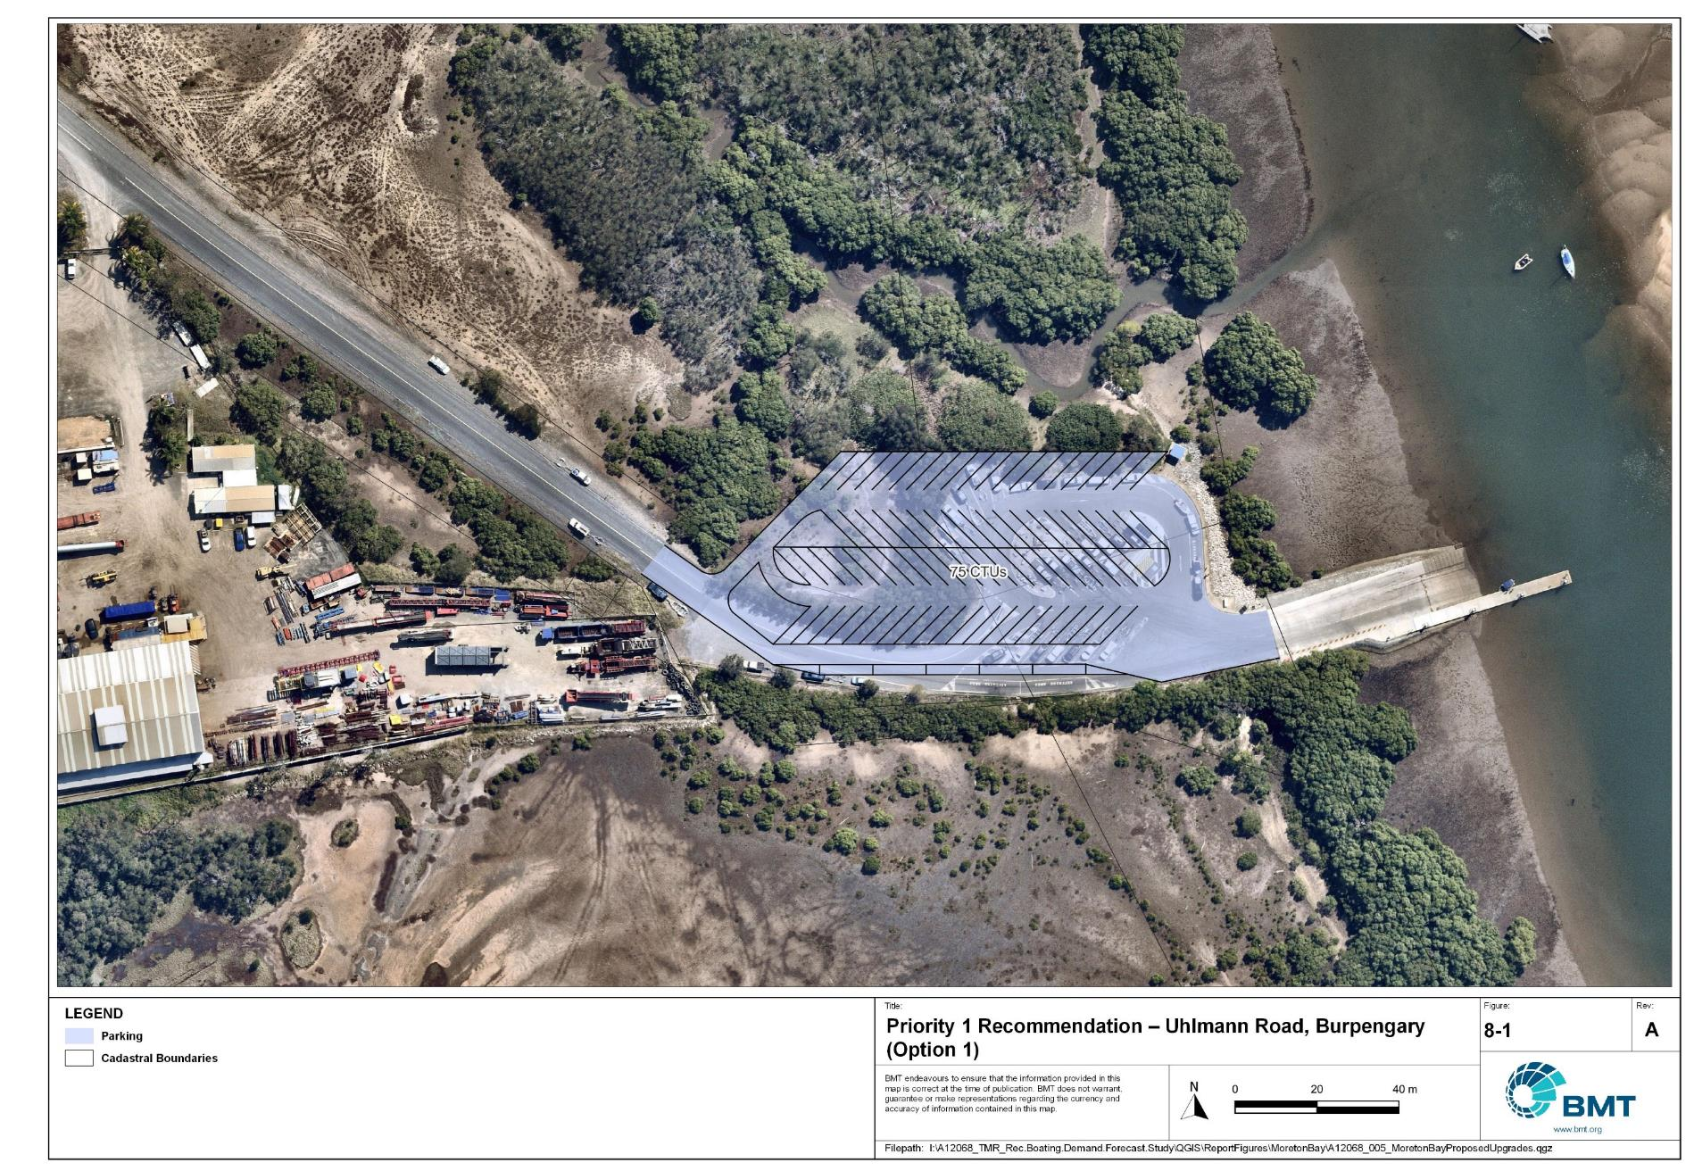

Priority 1 Recommendation – Uhlmann Road, Burpengary East (Option 1)

"I:\A12068_TMR_Rec.Boating.Demand.Forecast.Study\Recomendations by Council\JPG\MoretonBay\A12068_005_MoretonBayProposedUpgrades_8-1.jpg"

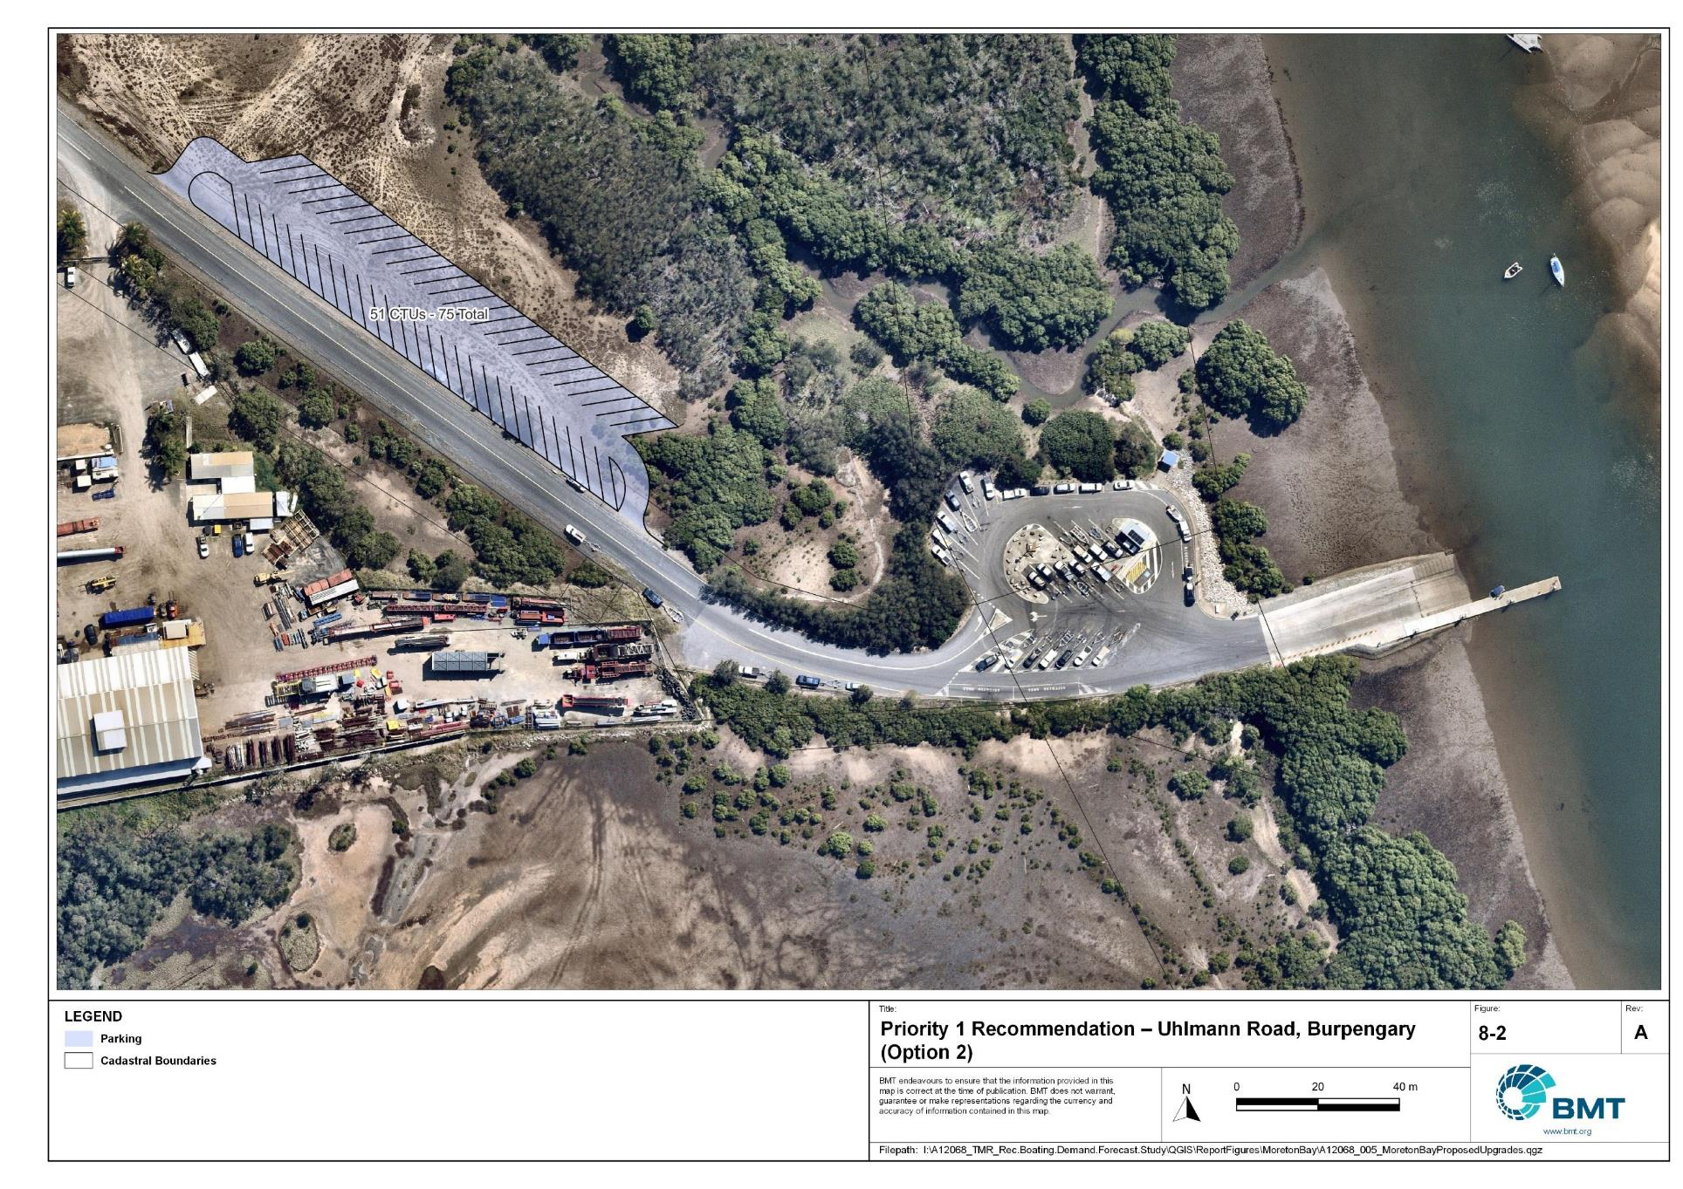

Priority 1 Recommendation – Uhlmann Road, Burpengary East (Option 2)

"I:\A12068_TMR_Rec.Boating.Demand.Forecast.Study\Recomendations by Council\JPG\MoretonBay\A12068_005_MoretonBayProposedUpgrades_8-2.jpg"

Griffin, Dohles Rocks - (Priority 1)

|  |  |  |  |  |
| --- | --- | --- | --- | --- |
| General description | | | | |
| Location | Dohles Rocks, Griffin, north bank of Pine River, off Dohles Rocks Road | | | |
| Existing Facility? | Yes | | | |
| Coordinates | -27.27760900, 153.04140700 | | | |
| Existing tidal status | All-tide | | | |
| Existing wave exposure | Yes | | | |
| Existing current exposure | No | | | |
| Proposed works | Acquire land to install 80 additional CTU spaces, which can be constructed in two stages. | | | |
| Increased effective capacity | 3.25 effective lanes | | | |
| Capacity improvement position | Waterside | Landside | | Both |
| Rationale | Improve landside capacity to match waterside facilities. Allow greater access to the Pine River(s) and Moreton Bay, noting that this is the closest facility to The Mill Priority Development Area. | | | |
| Anticipated Costs (+/- 50%) | Waterside infrastructure | | - | |
| Landside infrastructure | | $180,000 (Stage 1) + land acquisition  $110,000 (Stage 2) + land acquisition | |
| Planning, environmental and approvals constraints | | | | |
| Assessment | Requirement | Comments | | |
| Fish Habitat Zone | X | N/A | | |
| Native Title | X | N/A | | |
| MCU requirement | ü | The development of a new carpark may trigger a Development Permit for a Material Change of Use | | |
| Clearing remnant vegetation | X | N/A | | |
| GBRWHA | X | N/A | | |
| Marine Park | X | N/A | | |
| Tidal works assessment | X | N/A | | |
| Other as required | ü | Construction of the carpark may be operational works and therefore, require a Development Permit. | | |
| Sea Level Rise | ü | The proposed works are within the boundaries of the erosion prone area at risk of sea level rise. | | |
| Storm Tide Hazard | ü | The proposed works are within the boundaries of a medium to high storm tide hazard area. | | |
| Anticipated Complexity | Low | Medium | | High |

Priority 1 Recommendation – Griffin, Dohles Rocks Road

I:\A12068_TMR_Rec.Boating.Demand.Forecast.Study\Recomendations by Council\JPG\MoretonBay\A12068_005_MoretonBayProposedUpgrades_8-3.jpg

## Priority 2 recommendations

Scarborough Boat Harbour - (Priority 2)

|  |  |  |  |  |
| --- | --- | --- | --- | --- |
| General description | | | | |
| Location | Northern side of Scarborough Boat Harbour | | | |
| Existing Facility? | No | | | |
| Coordinates | -27.19270481, 153.10457364 | | | |
| Existing tidal status | N/A | | | |
| Existing wave exposure | N/A | | | |
| Existing current exposure | N/A | | | |
| Proposed works | Consider opportunities through the Scarborough Boat Harbour master planning process and the planning and design of other recommended sites, to provide a new or improved facility that improves access, increases capacity and provides more deep-draught landings. | | | |
| Increased effective capacity | 6.5 effective lanes | | | |
| Capacity improvement position | Waterside | Landside | | Both |
| Rationale | The area set aside for dredge spoil from the harbour has never been used for that purpose since harbour construction. Development of this area presents an opportunity to increase the availability of all-tide deep water launching facilities and take pressure off other facilities, without major impacts on adjacent land uses. | | | |
| Anticipated Costs (+/- 50%) | Waterside infrastructure | | TBD | |
| Landside infrastructure | | TBD | |
| Planning, environmental and approvals constraints | | | | |
| Assessment | Requirement | Comments | | |
| Fish Habitat Zone | X | N/A | | |
| Native Title | X | N/A | | |
| MCU requirement | ü | A new or improved facility may trigger a Development Permit for a Material Change of Use. | | |
| Clearing remnant vegetation | X | N/A | | |
| GBRWHA | X | N/A | | |
| Marine Park | ü | Any marine-based works would be within the Moreton Bay Marine Park, therefore a permit may be required to undertake works within the marine park. | | |
| Tidal works assessment | ü | Any marine based works are tidal works and therefore will likely require a development permit. | | |
| Other as required | ü | Marine plants - A new or improved facility may require clearing of marine plants and therefore require a development permit for marine plant disturbance. Potential acid sulphate soils. | | |
| Sea Level Rise | X | N/A | | |
| Storm Tide Hazard | ü | Any new or improved facility would likely be within the boundaries of a medium storm tide hazard area. | | |
| Anticipated Complexity | Low | Medium | | High |

Pelican Park, Clontarf – Option 1 - (Priority 2)

|  |  |  |  |  |
| --- | --- | --- | --- | --- |
| General description | | | | |
| Location | Pelican Park, Thomas Street, Clontarf | | | |
| Existing Facility? | Yes | | | |
| Coordinates | -27.25951279, 153.08657334 | | | |
| Existing tidal status | All-tide | | | |
| Existing wave exposure | None | | | |
| Existing current exposure | None | | | |
| Proposed works | Reopen and formalise overflow parking area, allowing construction of 46 CTU spaces to 109 total with minimal reconfiguration. Parking can be semi-formalised with geo-grid or concrete marker blocks to maintain mixed-use values. Relocate 15 car-only parking spaces. | | | |
| Increased effective capacity | 2.25 effective lanes | | | |
| Capacity improvement position | Waterside | Landside | | Both |
| Rationale | The existing facility is constrained by insufficient parking. This popular area is shared with other recreational activities throughout the year, and this solution allows for the existing area to accommodate a significant increase to parking capacity which could also benefit those other activities. | | | |
| Anticipated Costs (+/- 50%) | Waterside infrastructure | | - | |
| Landside infrastructure | | $95,000 | |
| Planning, environmental and approvals constraints | | | | |
| Assessment | Requirement | Comments | | |
| Fish Habitat Zone | X | N/A | | |
| Native Title | X | N/A | | |
| MCU requirement | X | N/A | | |
| Clearing remnant vegetation | X | N/A | | |
| GBRWHA | X | N/A | | |
| Marine Park | X | N/A | | |
| Tidal works assessment | X | N/A | | |
| Other as required | ü | Marine Plants – upgrade to existing carpark may require removal of marine plants and therefore, may require a Development Permit for marine plant disturbance.  Quarry Material Allocation – if the reclamation is undertaken using dredged material, it will require a Quarry Material Allocation. | | |
| Sea Level Rise | ü | The southern extent of the proposed carpark upgrade is within the erosion prone area at risk of sea level rise. | | |
| Storm Tide Hazard | ü | The proposed upgrade to the existing carpark is within the boundaries of a medium storm tide hazard area. | | |
| Anticipated Complexity | Low | Medium | | High |

Priority 2 Recommendation – Clontarf, Pelican Park, Thomas Street (Option 1)

"I:\A12068_TMR_Rec.Boating.Demand.Forecast.Study\Recomendations by Council\JPG\MoretonBay\A12068_005_MoretonBayProposedUpgrades_8-4.jpg"

Pelican Park, Clontarf – Option 2 - (Priority 2)

|  |  |  |  |  |
| --- | --- | --- | --- | --- |
| General description | | | | |
| Location | Pelican Park, Thomas Street, Clontarf | | | |
| Existing Facility? | Yes | | | |
| Coordinates | -27.25951279, 153.08657334 | | | |
| Existing tidal status | All-tide | | | |
| Existing wave exposure | None | | | |
| Existing current exposure | None | | | |
| Proposed works | Reclaim land to the west to construct 160+ CTU spaces. Demolish existing ramp and construct new boat ramp (2-lane with central floating walkway) in the northern revetment area. Investigate the need for a secondary breakwater to the west to form a mini-harbour. | | | |
| Increased effective capacity | 3.25 effective lanes | | | |
| Capacity improvement position | Waterside | Landside | | Both |
| Rationale | Pelican Park is a popular spot for various leisure activities, including festivals and triathlons. The conflict between recreational boat users and pedestrians and park-goers has at times caused problems. Reclaiming this land allows for the separation of pedestrian areas with the recreational boating facility and allows the existing parking area to be resumed as parkland, while increasing the effective capacity of the facility significantly. | | | |
| Anticipated Costs (+/- 50%) | Waterside infrastructure | | $1,300,000 | |
| Landside infrastructure | | $7,616,000 | |
| Planning, environmental and approvals constraints | | | | |
| Assessment | Requirement | Comments | | |
| Fish Habitat Zone | X | N/A | | |
| Native Title | X | N/A | | |
| MCU requirement | ü | A Development Permit for Material Change of Use will likely be required for reclamation works. | | |
| Clearing remnant vegetation | X | N/A | | |
| GBRWHA | X | N/A | | |
| Marine Park | ü | Reclamation and new boat ramp works are within the Conservation Park Zone in the Moreton Bay Marine Park. Reclamation works are considered major works in the Moreton Bay Marine Park and will require a Marine Park Permit and potential Environmental Offset | | |
| Tidal works assessment | ü | Reclamation and boat ramp works will likely be tidal works and require a Development Permit | | |
| Other as required | ü | Marine Plants – the reclamation works may impact on marine plants and therefore may require a Development Permit for marine plant disturbance  Quarry Material Allocation – if the reclamation is undertaken using dredged material, it will require a Quarry Material Allocation | | |
| Sea Level Rise | ü | The proposed works are within the boundaries of the erosion prone area | | |
| Storm Tide Hazard | ü | The proposed works are within the boundaries of a medium and high hazard area | | |
| Anticipated Complexity | Low | Medium | | High |
| Maritime engineering review | | | | |
| Assessment | Site considerations | Comments | | |
| Engineering Matters | Wave Forces | Wave conditions at the site will need a detailed assessment to ensure the recommended configuration and sizing is suitable for the conditions. | | |
| Geotechnical | Low strength or unsuitable materials are likely to be found at this site and a more detailed geotechnical assessment of this recommendation is suggested. | | |
| Sediment Transport | This recommendation requires further investigation to ensure undesirable siltation or disruption to sediment transport does not occur. | | |
| Anticipated Complexity | Low | Medium | | High |

Priority 2 Recommendation – Clontarf, Pelican Park, Thomas Street (Option 2)

"I:\A12068_TMR_Rec.Boating.Demand.Forecast.Study\Recomendations by Council\JPG\MoretonBay\A12068_005_MoretonBayProposedUpgrades_8-5.jpg"

Pelican Park, Clontarf – Option 3 - (Priority 2)

|  |  |  |  |  |
| --- | --- | --- | --- | --- |
| General description | | | | |
| Location | Pelican Park, Thomas Street, Clontarf | | | |
| Existing Facility? | Yes | | | |
| Coordinates | -27.25951279, 153.08657334 | | | |
| Existing tidal status | All-tide | | | |
| Existing wave exposure | None | | | |
| Existing current exposure | None | | | |
| Proposed works | Relocate the public infrastructure (playground, BBQs, picnic tables) to the open parkland north of the existing carpark. Construct a new, standalone parking area for at least 67 CTU parking spaces. | | | |
| Increased effective capacity | 3.25 effective lanes | | | |
| Capacity improvement position | Waterside | Landside | | Both |
| Rationale | Pelican Park is a popular spot for various leisure activities, including festival and triathlons. The conflict between recreational boat users and pedestrians and park-goers has at times caused problems. This option allows for the waterside capacity to be matched on the landside without requiring reclamation of land. It also provides the opportunity for the facility to operate at an acceptable capacity (approximately half landside capacity) during periods of conflicting use. | | | |
| Anticipated Costs (+/- 50%) | Waterside infrastructure | | - | |
| Landside infrastructure | | $511,000 | |
| Planning, environmental and approvals constraints | | | | |
| Assessment | Requirement | Comments | | |
| Fish Habitat Zone | X | N/A | | |
| Native Title | X | N/A | | |
| MCU requirement | X | N/A | | |
| Clearing remnant vegetation | X | N/A | | |
| GBRWHA | X | N/A | | |
| Marine Park | X | N/A | | |
| Tidal works assessment | X | N/A | | |
| Other as required | ü | State Controlled Road – The proposed works is adjacent to a State Controlled Road and therefore may require a Development Permit. | | |
| Sea Level Rise | ü | The northern and southern extents of the proposed carpark are within the boundaries of an erosion prone area. | | |
| Storm Tide Hazard | ü | The proposed carpark is within the boundaries of medium to high storm tide hazard area. | | |
| Anticipated Complexity | Low | Medium | | High |

Priority 3 Recommendation – Clontarf, Pelican Park, Thomas Street (Option 3)

I:\A12068_TMR_Rec.Boating.Demand.Forecast.Study\Recomendations by Council\JPG\MoretonBay\A12068_005_MoretonBayProposedUpgrades_8-6.jpg\

## Priority 3 recommendations

Marine Parade, Bellara, Bribie Island - (Priority 3)

|  |  |  |  |  |
| --- | --- | --- | --- | --- |
| General description | | | | |
| Location | Marine Parade, Bellara, near Bibimulya Street. | | | |
| Existing Facility? | Yes | | | |
| Coordinates | -27.06431525, 153.14411780 | | | |
| Existing tidal status | All-tide | | | |
| Existing wave exposure | None | | | |
| Existing current exposure | Exposed. | | | |
| Proposed works | Expand parking area to allow 25 additional CTU parking spaces. | | | |
| Increased effective capacity | 1 effective lane | | | |
| Capacity improvement position | Waterside | Landside | | Both |
| Rationale | This popular facility is currently constrained by a lack of formal CTU parking. There is sufficient room within the adjacent parkland for CTU parking expansion. Note: These plans align with concepts made available by MBRC. | | | |
| Anticipated Costs (+/- 50%) | Waterside infrastructure | | - | |
| Landside infrastructure | | $170,000 | |
| Planning, environmental and approvals constraints | | | | |
| Assessment | Requirement | Comments | | |
| Fish Habitat Zone | X | N/A | | |
| Native Title | X | N/A | | |
| MCU requirement | X | N/A | | |
| Clearing remnant vegetation | X | N/A | | |
| GBRWHA | X | N/A | | |
| Marine Park | X | N/A | | |
| Tidal works assessment | X | N/A | | |
| Other as required | ü | Carpark work may require a Development Permit for operational work. | | |
| Sea Level Rise | ü | Proposed work is within the boundaries of an erosion prone area subject to sea level rise. | | |
| Storm Tide Hazard | ü | Proposed work is within the boundaries of a medium to high storm tide hazard area. | | |
| Anticipated Complexity | Low | Medium | | High |

Priority 3 Recommendation – Marine Parade, Bellara

"I:\A12068_TMR_Rec.Boating.Demand.Forecast.Study\Recomendations by Council\JPG\MoretonBay\A12068_005_MoretonBayProposedUpgrades_8-7.jpg"

## Priority 4 recommendations

Lower Caboolture River - (Priority 4)

|  |  |  |  |  |
| --- | --- | --- | --- | --- |
| General description | | | | |
| Location | Lower Caboolture River (Beachmere or vicinity of ‘North Harbour’ development, Burpengary East). | | | |
| Existing Facility? | No | | | |
| Coordinates | -27.11992812, 153.00877929  -27.10769956, 153.01651177 | | | |
| Existing tidal status | N/A | | | |
| Existing wave exposure | N/A | | | |
| Existing current exposure | N/A | | | |
| Proposed works | Provide 6 effective lanes of capacity along the Caboolture River. A large public facility should be considered as part of the North Harbour Marina development, if it progresses. In the case that this proposed development is not completed, other options along the Caboolture River should be considered to provide this amount of capacity. | | | |
| Increased effective capacity | 6 effective lanes | | | |
| Capacity improvement position | Waterside | Landside | | Both |
| Rationale | This area is a development corridor within Moreton Bay LGA. Significant increased demand is forecast here, necessitating the additional launching/retrieving capacity along the Caboolture River. This will provide opportunities to access destinations in the river as well as offshore.  The proposed North Harbour Marina and associated residential development will contribute significantly to generating additional recreational boating demand in the region. If this private facility is developed, it should include a facility to service the general public. | | | |
| Anticipated Costs (+/- 50%) | Waterside infrastructure | | TBC | |
| Landside infrastructure | | TBC | |
| Planning, environmental and approvals constraints | | | | |
| Assessment | Requirement | Comments | | |
| Fish Habitat Zone | X | N/A | | |
| Native Title | X | N/A | | |
| MCU requirement | X | N/A | | |
| Clearing remnant vegetation | X | N/A | | |
| GBRWHA | X | N/A | | |
| Marine Park | X | N/A | | |
| Tidal works assessment | ü | The works proposed works will likely be tidal works and therefore require a Development Permit. | | |
| Other as required | ü | Though no specific requirements, it is likely additional negotiation with marina developers will be required for installation of a new boat ramp, floating walkways and carparks. | | |
| Sea Level Rise | ü | The proposed works are within the boundaries of the erosion prone area subject to sea level rise. | | |
| Storm Tide Hazard | ü | The proposed works are within the boundaries of a high storm tide hazard area. | | |
| Anticipated Complexity | Low | Medium | | High |

Priority 4 Recommendation – Caboolture River

"I:\A12068_TMR_Rec.Boating.Demand.Forecast.Study\Recomendations by Council\JPG\MoretonBay\A12068_005_MoretonBayProposedUpgrades_8-8.jpg"

# References

Australian Bureau of Statistics (ABS), 2021, *2021 Census,* <https://www.abs.gov.au/census>

Bell, Frederick W. 2022, *Estimation of the present and projected demand and supply of boat ramps for Florida's coastal regions and counties*, Florida State University, Department of Economics.

BMT, 2015, *MPSC Managed Boating Facilities Demand and Capacity Study: Boat Ramp Modelling*

Department of Transport and Main Roads (TMR), 2020, Marine facilities and infrastructure plan.

GHD, 2011, *Recreational Boating Facilities Demand Forecasting Study*

GHD, 2017, *Queensland Recreational Boating Facilities Demand Forecasting Study 2017.*

Maritime Safety Queensland (MSQ), 2022, *Recreational Boating Facilities,* <https://www.getinvolved.qld.gov.au/gi/consultation/8850/view.html>

Queensland Government Department of Resources (DoR), 2022, *Cities and towns [OGC WMS Service]*, Accessed 5/10/2022, available online at spatial.information.qld.gov.au/arcgis/home/item.html?id=103c7c9ccca449fab79d27cde06868ab

Rose, T., R. Powell & J. Yu (2009). Identification of the Present and Future Recreational Boating Infrastructure in Redland City – A 10 Year Infrastructure Plan- Griffith University

SKM (1998) Public Boat Ramps Central Queensland Strategic Plan - Volume One - Demand Forecasting - Noosa to Yeppoon. Sinclair Knight Merz, March 1998.

Swett, R., Fik, T., Ruppert, T., Davidson, G., Guevara, C. & Betty Staugler, 2012, *Planning for the future of recreational boating access to charlotte county waterways: 2010 – 2050*, Florida Sea Grant, University of Florida.

Western Australia Department of Transport, 2019, *Perth Recreational Boating Facilities Study Review 2019*, https://www.transport.wa.gov.au/mediaFiles/marine/MAC_P_Perth_RBFS_study_review_2019.pdf

Western Australia Department of Transport, 2021, *South West Region Recreational Boating Facilities Study July 2021,* https://www.transport.wa.gov.au/mediaFiles/marine/MAC_P_SouthWest_RBFS_Study_2021.pdf

###### Demand Study

"G:\Admin\A12068.g.mpb.TMRBoatingDemand\06_Reports\09_Demand Study\2022_2119 (016) Final Demand Report (March 2023).pdf"

###### Boat launching facility capacity

Capacity of existing boat launching facilities

| Facility ID | Facility name | | No. lanes | Tidal access at ramp | Tidal access to open water | Queuing facility | Formal CTUs | Informal CTUs | Waterside capacity | Landside capacity | Effective capacity | Constraint |
| --- | --- | --- | --- | --- | --- | --- | --- | --- | --- | --- | --- | --- |
| **Open Water Access** | | | | | | | | | | | | | |
| CB11 | Deception Bay, Bayview Terrace | | 1 | Part-Tide | Part-Tide | None | 0 |  | 0.25 | 0 | 0 | Landside |
| CB21 | Beachmere, Saint Smith Road | | 2 | All-Tide | All-Tide | Beach | 20 | 5 | 2.2 | 1.5 | 1.5 | Landside |
| CB22 | Beachmere, Saint Smith Road | | 2 | All-Tide | All-Tide | Floating Walkway | 20 | 5 | 3 | 1.5 | 1.5 | Landside |
| CB23 | Burpengary, Uhlmann Road | | 3 | All-Tide | All-Tide | Floating Walkway | 21 | 13 | 5 | 1.75 | 1.75 | Landside |
| CB32 | Bongaree, Fifth Avenue (North) | | 1 | All-Tide | All-Tide | Beach | 15 |  | 1.1 | 1 | 1 | Landside |
| CB33 | Bongaree, Fifth Avenue (South) | | 2 | All-Tide | All-Tide | Beach | 15 |  | 2.2 | 1 | 1 | Landside |
| CB40 | Bellara, Marine Parade (South) | | 4 | All-Tide | All-Tide | Floating Walkway | 106 |  | 6 | 5 | 5 | Landside |
| CB41 | Bellara, Marine Parade (North) | | 1 | All-Tide | All-Tide | Pontoon | 30 |  | 1.2 | 1.5 | 1.2 | Waterside |
| CB48 | Spinnaker Sound, Sandstone Point, Kal Ma kuta Drive | | 4 | All-Tide | All-Tide | Beach | 67 |  | 4.4 | 3 | 3 | Landside |
| CB52 | Sandstone Point, Kal Ma kuta Drive | | 2 | All-Tide | All-Tide | Beach | 43 |  | 1.1 | 2 | 1.1 | Waterside |
| CB61 | Toorbul, Moffat Esplanade | | 1 | Part-Tide | Part-Tide | None | 0 | 8 | 0.5 | 0.75 | 0.5 | Waterside |
| CB66 | Toorbul, First Avenue | | 1 | Part-Tide | Part-Tide | Beach | 18 |  | 0.55 | 1.25 | 0.55 | Waterside |
| CB67 | Toorbul, Freeman Road | | 2 | All-Tide | All-Tide | Floating Walkway | 18 |  | 3 | 1.25 | 1.25 | Landside |
| RF12 | Clontarf, Pelican Park, Thomas Street | | 4 | All-Tide | All-Tide | Floating Walkway | 63 |  | 6 | 2.75 | 2.75 | Landside |
| RF71 | Scarborough, Bird O'Passage Parade | | 4 | All-Tide | All-Tide | Floating Walkway | 90 |  | 6 | 4 | 4 | Landside |
| RF81 | Scarborough, Thurecht Parade | | 4 | All-Tide | All-Tide | Floating Walkway | 120 |  | 6 | 5.5 | 5.5 | Landside |
| **Subtotal** |  | | **38** |  |  |  | **646** | **31.6** | **47.7** | **33.8** | **31.6** |  |
| **Distance-limited** | | | | | | | | | | | | | |
| CB71 | Donnybrook, Grant Lane | | 2 | Near all-Tide | Part-Tide | None | 15 |  | 1 | 1 | 1 | Waterside |
| **Subtotal** |  | | **2** |  |  |  | **15** | **0** | **1** | **1** | **1** |  |
|  | | **Depth-limited** | | | | | | | | | | | |
| CB64 | Meldale, Way Street | | 2 | Part-tide | Part-Tide | None | 0 | 10 | 2 | 0.75 | 0.75 | Landside |
| **Subtotal** |  | | **2** |  |  |  | **0** | **10** | **2** | **0.75** | **0.75** |  |
|  | | **Infrastructure-limited** | | | | | | | | | | | |
| PR12 | Griffin, Dohles Rocks Road | | 3 | All-Tide | All-Tide | Floating Walkway | 16 |  | 5 | 1.25 | 1.25 | Landside |
| PR16 | Strathpine, Learmonth Street | | 1 | All-Tide | Near All-Tide | None | 5 |  | 1 | 0.5 | 0.5 | Landside |
| **Subtotal** |  | | **4** |  |  |  | **21** | **0** | **6** | **1.75** | **1.75** |  |
| **Beach ramps** | | | | | | | | | | | | |
| RF51 | Margate, Eveline Street | | 1 | Part-Tide | Part-Tide | Beach | 4 |  | 0.28 | 0.5 | 0.275 | Waterside |
| RF41 | Scarborough, Flinders Parade | | 1 | Part-Tide | Part-Tide | Beach | 0 |  | 0.28 | 0 | 0 | Landside |
| RF21 | Woody Point, Hornibrook Esplanade | | 3 | Part-Tide | Part-Tide | Beach | 13 |  | 0.83 | 1 | 0.825 | Waterside |
| **Subtotal** |  | | **5** |  |  |  | **17** | **0** | **1.38** | **1.5** | **1.1** |  |
|  | | **Total effective capacity** | | | | | | | | | **36.2** |  | |

###### Travel time statistics

Travel time from population centres to nearest sheltered all-tide or near all-tide open water accessible facilities

| Population Centre | Travel time (mins) |
| --- | --- |
| Beachmere | 3 |
| D'Aguilar | 23 |
| Donnybrook | 10 |
| Dayboro | 27 |
| Caboolture | 11 |
| Elimbah | 16 |
| Mount Mee | 29 |
| Samford | 21 |
| Burpengary | 7 |
| White Patch | 6 |
| Narangba | 12 |
| Woodford | 27 |
| Morayfield | 10 |
| Wamuran | 17 |
| Woorim | 4 |
| Toorbul | 1 |
| Ningi | 3 |
| Banksia Beach | 4 |
| Neurum | 33 |
| Redcliffe | 4 |

###### Facility Use

Boat launching facility usage statistics

| Facility ID | Facility name | Total reports | Moreton Bay | Brisbane | Sunshine Coast | Logan | Ipswich | Gold Coast | Redland | Toowoomba | Somerset | Fraser Coast | Other LGAs |
| --- | --- | --- | --- | --- | --- | --- | --- | --- | --- | --- | --- | --- | --- |
| Total |  | 99941 | 73674 | 12886 | 2344 | 1720 | 1390 | 1210 | 1155 | 648 | 311 | 194 | 4409 |
| Total % |  | 100% | 73.7% | 12.9% | 2.3% | 1.7% | 1.4% | 1.2% | 1.2% | 0.6% | 0.3% | 0.2% | 4.4% |
| RF81 | Scarborough Boat Harbour, Thurecht Parade | 19607 | 82.7% | 10.4% | 0.9% | 0.7% | 0.7% | 0.8% | 0.6% | 0.3% | 0.1% | 0.1% | 2.8% |
| RF12 | Clontarf, Pelican Park, Thomas Street | 16146 | 56.9% | 27.6% | 1.5% | 3.3% | 2.1% | 1.3% | 1.6% | 0.4% | 0.3% | 0.1% | 4.8% |
| RF71 | Scarborough Boat Harbour, Bird O'Passage Parade | 13046 | 78.2% | 11.1% | 1.1% | 2.0% | 1.1% | 0.9% | 0.9% | 0.4% | 0.1% | 0.2% | 3.9% |
| CB32 | Bongaree, Fifth Avenue (North) | 11220 | 72.9% | 9.3% | 3.2% | 2.1% | 1.9% | 1.9% | 1.3% | 1.5% | 0.3% | 0.2% | 5.5% |
| CB40 | Bellara, Marine Parade (South) | 10528 | 64.4% | 14.6% | 3.3% | 2.3% | 2.7% | 2.2% | 1.7% | 1.0% | 0.5% | 0.2% | 7.1% |
| CB23 | Burpengary, Uhlmann Road | 5251 | 88.9% | 3.9% | 1.6% | 0.7% | 0.4% | 0.6% | 0.3% | 0.3% | 0.3% | 0.2% | 2.8% |
| PR12 | Griffin, Dohles Rocks Road | 4829 | 80.5% | 14.4% | 0.5% | 0.8% | 0.8% | 0.3% | 0.2% | 0.1% | 0.0% | 0.3% | 2.0% |
| CB48 | Spinnaker Sound, Sandstone Point, Kal Ma Kuta Drive | 4801 | 72.0% | 8.4% | 5.4% | 0.8% | 1.2% | 1.5% | 4.4% | 0.8% | 0.6% | 0.2% | 4.7% |
| CB66 | Toorbul, First Avenue | 3671 | 72.1% | 8.0% | 7.7% | 1.2% | 0.5% | 0.6% | 0.6% | 1.1% | 0.8% | 0.1% | 7.4% |
| CB21 | Beachmere, Saint Smith Road | 3019 | 80.2% | 4.5% | 4.1% | 1.0% | 1.7% | 0.7% | 0.7% | 0.5% | 1.1% | 0.9% | 4.8% |
| CB52 | Sandstone Point, Kal Ma Kuta Drive | 2322 | 71.4% | 9.8% | 4.0% | 2.4% | 1.1% | 2.0% | 1.6% | 1.0% | 0.9% | 0.1% | 5.7% |
| CB11 | Deception Bay, Bayview Terrace | 1813 | 86.7% | 5.3% | 0.9% | 1.2% | 0.7% | 1.0% | 0.4% | 0.9% | 0.2% | 0.1% | 2.7% |
| CB71 | Donnybrook, Grant Lane | 1185 | 72.3% | 8.0% | 5.9% | 1.7% | 4.5% | 0.5% | 0.6% | 0.4% | 0.3% | 1.2% | 4.6% |
| PR16 | Strathpine, Learmonth Street | 762 | 82.7% | 11.7% | 0.8% | 0.1% | 0.9% | 0.8% | 0.5% | 0.3% | 0.0% | 0.0% | 2.2% |
| CB61 | Toorbul, Moffat Esplanade | 728 | 67.0% | 7.3% | 12.2% | 0.3% | 0.1% | 1.8% | 0.8% | 4.7% | 0.7% | 0.0% | 5.1% |
| CB64 | Meldale, Way Street | 671 | 83.9% | 4.5% | 5.4% | 0.0% | 1.3% | 0.7% | 0.3% | 0.1% | 0.3% | 0.3% | 3.1% |
| RF41 | Scarborough, Flinders Parade | 225 | 75.6% | 12.9% | 0.9% | 3.6% | 0.9% | 3.6% | 0.0% | 0.0% | 0.0% | 0.4% | 2.2% |
| RF51 | Margate, Eveline Street | 117 | 81.2% | 13.7% | 0.9% | 0.0% | nan% | 0.0% | 0.0% | 0.0% | 0.0% | 0.9% | 3.4% |

|  |  |  |
| --- | --- | --- |
|  |  | BMT is a leading design, engineering, science and management consultancy with a reputation for engineering excellence. We are driven by a belief that things can always be better, safer, faster and more efficient. BMT is an independent organisation held in trust for its employees. |

|  |  |  |  |  |  |  |  |  |
| --- | --- | --- | --- | --- | --- | --- | --- | --- |
|  |  |  |  |  |  |  | Contact us  enquiries@bmtglobal.com  www.bmt.org  Follow us  www.bmt.org/linkedin LinkedIn logo.  www.bmt.org/youtube YouTube logo.  www.bmt.org/twitter Twitter logo.  www.bmt.org/facebook Facebook logo. |  |
|  | Level 5  348 Edward Street  Brisbane  QLD 4000  Australia  +61 7 3831 6744 |  | Registered in Australia  Registered no. 010 830 421  Registered office  Level 5, 348 Edward Street,  Brisbane QLD 4000 Australia |  |  |  |  |
|  | For your local BMT office visit www.bmt.org | | |  |  |  |  |  |