|  |
| --- |
| Queensland Recreational Boating Facilities Demand Forecasting Study 2022  Sunshine Coast LGA Assessment |
|  |
|  |

|  |  |  |
| --- | --- | --- |
| Customer |  | Maritime Safety Queensland |
| Project |  | A12068 |
| Deliverable |  | 035 |
| Version |  | 01 |
|  |  | 21 April 2023 |

Document Control

Document Identification

|  |  |
| --- | --- |
| Title | Queensland Recreational Boating Facilities Demand Forecasting Study 2022 |
| Project No | A12068 |
| Deliverable No | 035 |
| Version No | 01 |
| Version Date | 21 April 2023 |
| Customer | Maritime Safety Queensland, a branch of the Department of Transport and Main Roads |
| Customer Contact | boatinginfrastructure@msq.qld.gov.au |
| Classification | {None} |

|  |  |
| --- | --- |
| Author | Daniel Wishaw, Nicholas Heiner, Geoff Long, Jeremy Visser, Azam Dolatshah |
| Reviewed By | Katrina O’Malley-Jones |
| Project Manager | Daniel Wishaw |

Amendment Record

The Amendment Record below records the history and issue status of this document.

| Version | Version Date | Distribution | Record |
| --- | --- | --- | --- |
| 00 | 16 March 2023 | Maritime Safety Queensland  Sunshine Coast Regional Council | Report |
| 01 | 21 April 2023 | Maritime Safety Queensland | Final |

Executive Summary

This report, part of the Queensland Recreational Boating Facilities Demand Forecasting Study 2022 (‘the Study’), provides a summary of current and forecast demand on recreational boating facilities in the Sunshine Coast LGA and the capacity of existing facilities to meet this demand. Where capacity is insufficient to meet current or forecast demand, recommendations have been made to improve existing facilities or for the construction of new facilities. This report is intended to support facility deliverers, owners, and managers over the next 20 years in their decision-making on development priorities for recreational boating facilities within the Sunshine Coast LGA.

This abbreviated summary report has been produced for consultation purposes only and is intended for use by stakeholders to provide comments on the preliminary findings and recommendations for upgrades and/or new facilities. This consultation will be used to inform the full report.

Key issues and attributes of recreational boating

The key attributes of recreational boating facilities identified in this Study for the Sunshine Coast LGA are summarised in Table 1, while consultation with stakeholders undertaken as part of the Study identified the following key issues:

* very strong growth in trailable (<8m) vessel registrations over the past 5 years (+23%) making it difficult to provide sufficient capacity to keep pace with growing demand
* change to boat traffic movements and accessibility to open water in northern Pumicestone Passage due to the breakthrough of the northern end of Bribie Island
* lack of parking and overcrowding of boat launching facilities that provide good access to open water, particularly at Mooloolaba boat harbour, Adaluma Street (La Balsa Park), and the Caloundra Power Boat Club (Churchill Street) ramp

1. Key recreational boating attributes for Sunshine Coast LGA

| Key attribute | Value |
| --- | --- |
| Deep-draught landing facilities |  |
| Existing capacity (number) | 5 |
| Existing demand (number) | 3.7 |
| Existing shortfall (number) | -1.3 |
| Boat launching facilities |  |
| Number of existing facilities | 23 |
| Current demand for boat launching lanes (effective lanes) | 45.6 |
| Number of existing ‘effective’ boat launching lanes | 25.5 |
| Current shortfall of ‘effective’ boat launching lanes (number) | 20.1 |
| Demand satisfaction for ‘effective’ boat launching lanes | 56% |
| State-wide demand satisfaction for ‘effective’ boat launching lanes | 81% |

Demand summary

The assessment of recreational boating demand is centred on a statistical demand model that considers vessel registration data, population statistics, assumptions around local usage and the movement of vessels into and out of the LGA. Key parameters from this assessment for the Sunshine Coast LGA are:

* The population is 351,424 as at the 2021 census and is projected to be 518,004 by 2041.
* As of July 2022, there is a total of 22,256 vessels with a home registration within the LGA, with 96% being ‘trailable’ – and therefore requiring boat launching facilities – and 4% being non-trailable.

The Sunshine Coast LGA has several waterfront communities with vessels moored on private pontoons. A survey of Noosa Sound and Noosa Waters indicates there are approximately 1,451 private pontoons with 400 vessels less than 8m in length moored at them. These vessels are assumed not to need launching facilities and will reduce the demand for boat launching demand.

* The Sunshine Coast LGA is deemed to be a Metropolitan Region with an assumed vessel activation rate of 6% on a ‘good boating day’.
* Vessels are primarily used within the LGA, with some leakage to Noosa, Gympie, Moreton Bay and Fraser Coast LGAs.
* Vessels from Brisbane, Moreton Bay, Noosa, Toowoomba and other western LGAs flow into the LGA and contribute to local demand.
* The existing demand for boat launching facilities is 45.6 ‘effective’ boat lanes and projected 59.2 ‘effective’ lanes by 2041.
* The existing demand for deep-draught vessel landings is 3.8 currently and projected to be 5.0 by 2041.

Boat launching

Boat launching facilities comprise boat ramps, any queuing facilities (floating walkways, pontoons, beaches and fixed sloping walkways) and the provision of car-trailer unit (CTU) parking. The capacity of a boat launching facility is measured in ‘effective’ lanes for both waterside and landside facilities, with the total capacity of a facility being the minimum of the waterside or landside capacity. Waterside capacity is calculated from the number of boat ramp lanes multiplied by environmental reduction factors (for tide, current or waves) and queuing facility improvement factors to derive the number of ‘effective’ lanes. The landside capacity is calculated from the number of available CTU parking spaces.

The Sunshine Coast LGA has 23 boat launching facilities, comprising 40 boat ramp lanes with a total effective boat launching capacity of 25.5 ‘effective’ lanes. Seven of these facilities are constrained by waterside capacity with the remainder constrained by landside capacity.

The capacity, forecast demand, and shortfall of boat ramp effective lanes in the Sunshine Coast LGA are shown in Figure 1, with the capacity of upgrades or new facilities that are expected to be delivered in the next five years included.

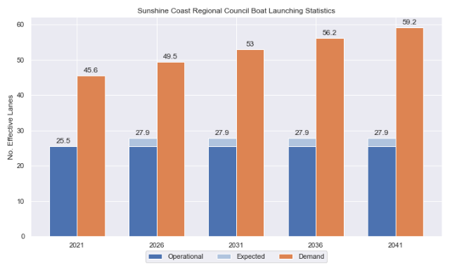

1. Existing capacity, forecast demand and shortfall of ‘effective’ boat ramp lanes for the Sunshine Coast LGA

Deep-draught vessel landings

Vessel landing facilities are provided across the state in the form of pontoons and jetties, to provide locations for larger vessels, or their tenders, to access landside destinations or facilities. Pontoons and jetties may also be provided for other purposes such as supporting boat launching or other recreation and may not be suitable for deep-draught vessels. The trend across Queensland indicates that jetties are rarely used as landings, with pontoons preferred by recreational users. As such, the Study has limited the capacity of deep-draught vessel landings to those that are accessible and commonly used by deep-draught vessels, as identified in consultation with stakeholders.

The Sunshine Coast region has four public deep-draught vessel landings comprising important facilities in the Mooloolah River (Penny Lane, Parkyn Parade and Adaluma Avenue) and Pumicestone Passage (Tripcony Lane). A new public pontoon at The Basin has also been recently constructed in Pelican Waters near the new marina facility. These public facilities are supported by private marina facilities at Mooloolaba Marina and a new facility in Pelican Waters. The shortfall assessment in Table 2 indicates that public landing capacity for deep-draught vessels is currently sufficient to support demand in the Sunshine Coast region.

1. Deep-draught vessel landing shortfall summary

| Criteria | 2021 | 2026 | 2031 | 2036 | 2041 |
| --- | --- | --- | --- | --- | --- |
| Deep-draught vessel demand | 3.7 | 4.1 | 4.4 | 4.7 | 4.9 |
| Deep-draught vessel capacity | 5 | 5 | 5 | 5 | 5 |
| Shortfall | -1.3 | -0.9 | -0.6 | -0.3 | -0.1 |

Priority recommendations

Recommendations for new facilities or upgrades to existing facilities are outlined in Table 3. The range of recommendations seeks to reduce the overall capacity shortfall within the Sunshine Coast LGA over the 20-year planning life of this project, as well as address specific concerns, including:

* providing immediate additional capacity in northern Pumicestone Passage to suit the change in open water access provided by the existing facilities
* providing additional capacity in the Mooloolah River to cater for the intense demand on existing facilities
* Catering for the major growth areas around Bli Bli and Caloundra south.

Recommendations

1. Summary of recommended boating infrastructure upgrades for the Sunshine Coast LGA

| Priority | Criteria | Recommendations |
| --- | --- | --- |
| 1 | * Required to meet existing demand. * Sites that can provide maximum benefit for existing demand pressures at an LGA scale or satisfy specific safety pressures. | * Churchill Street, Golden Beach: Formalise 14 CTU spaces in the existing carpark. Expand CTU parking capacity further through one of 2 options, adding a further 45-50 CTUs. |
| 2 | * Required to meet demand within the next five to ten years. * Sites that are likely to have low to medium approval complexity. * Sites that can provide satisfaction of specific demand or safety pressures within the LGA. | * Parkyn Parade, Mooloolaba: Realign existing carpark layout to achieve 21 new CTU spaces. Add 2nd level parking to achieve 225 CTU space total. * Fishermans Road, Maroochydore: Duplicate waterside facilities and provide an additional 45 CTU spaces. * Short Street, Caloundra: Widen boat ramp to accommodate a floating walkway. Construct 50 CTU spaces. * Bells Creek Road, Bells Creek: Create new 2-lane facility with 65 CTU spaces. |
| 3 | * Required to meet demand within the next ten to fifteen years. * Sites that service planned future growth within the LGA. | * Muller Park, Bli Bli: Reconstruct the boat ramp in an area with full tide access and include a floating walkway and add either 55 (Option 1) or 85 (Option 2) CTU spaces. * West Coolum Road, Coolum: Duplicate boat ramp lane and install fixed sloping walkway. Formalise 35 CTUs. |
| 4 | * Required to meet demand within the next fifteen to twenty years. * Sites that service planned future growth within the LGA. | * Maroochy River: Determine feasibility of a double lane ramp with central floating walkway and 65 CTU parking spaces at four potential boat ramp locations. * Nojoor Road, Twin Waters: Expand facility to include 4 boat ramp lanes and a total of 100 CTUs |

Contents

Definitions 11

1 Introduction 14

2 Sunshine Coast Overview 15

2.1 Key influences on recreational boating 15

2.2 Existing recreational boating infrastructure 15

2.3 Existing usage and issues 18

3 Capacity Assessment 19

3.1 Boat ramps 19

3.2 Access to sheltered near all-tide and all-tide facilities 26

3.3 Deep-draught vessel landings 29

4 Demand Assessment 30

4.1 Activation rate 30

4.2 Digital user survey 31

4.3 Active fleet size 38

4.4 Boat ramp lane demand 38

4.5 Non-statistical demand 39

4.6 Deep-draught vessel demand 39

5 Shortfall Assessment 41

5.1 Shortfall assessment – boat ramps 41

5.2 Shortfall assessment – deep-draught landings 42

6 Stakeholder Feedback 44

6.1 Managing authority feedback 44

6.2 Stakeholder feedback 45

7 Development Recommendations 47

7.1 Previous recommendations 47

7.2 Priority recommendations 48

7.3 Priority 1 recommendations 51

7.4 Priority 2 recommendations 58

7.5 Priority 3 recommendations 70

7.6 Priority 4 recommendations 77

8 References 82

Annex A Demand Study A-1

Annex B Boat launching facility capacity B-1

Annex C Travel time statistics C-1

Annex D Facility Use D-1

Tables

Table 2.1 Recreational boating facilities by facility owner in the Sunshine Coast LGA 15

Table 3.1 Queuing facility efficiency modifiers 22

Table 3.2 Expected capacity to be provided in the near-term 26

Table 3.3 Deep-draught landing facilities within Sunshine Coast LGA 29

Table 4.1 LGA of origin for active fleet in the Sunshine Coast LGA 31

Table 4.2 Popularity of boat launching facilities. 32

Table 4.3 Active fleet vessel size 38

Table 4.4 Boat ramp lane demand 38

Table 4.5 Deep-draught vessel landing demand 40

Table 5.1 Shortfall of boat launching facilities 41

Table 5.2 Shortfall assessment for open water, all-tide or near all-tide facilities for Sunshine Coast LGA 42

Table 5.3 Shortfall of deep-draught vessel landings 43

Table 6.1 Stakeholder identified opportunities 44

Table 7.1 Assessment of unimplemented 2017 recommendations 47

Table 7.2 Summary of recommendations for Sunshine Coast LGA 49

Table 7.3 Golden Beach, Churchill St (Priority 1) – Stage 1 51

Table 7.4 Golden Beach, Churchill St (Priority 1) – Stage 2A 53

Table 7.5 Golden Beach, Churchill St (Priority 1) – Stage 2B 56

Table 7.6 Parkyn Parade, Mooloolaba (Priority 2) 58

Table 7.7 Fishermans Road, Maroochydore (Priority 2) 62

Table 7.8 Short Street, Caloundra (Priority 2) 64

Table 7.9 Bells Creek (Priority 2) 67

Table 7.10 Muller Park, Bli Bli (Priority 3) 70

Table 7.11 West Coolum Road, Coolum (Priority 3) 74

Table 7.12 Maroochy River (Priority 4) 77

Table 7.13 Nojoor Road, Twin Waters (Priority 4) 80

Table B.1. Capacity of existing boat launching facilities B-1

Table C.1. Travel time from population centres to nearest sheltered all-tide or near all-tide open water accessible facilities C-1

Table D.1. Boat launching facility usage statistics D-1

Figures

Figure 2.1 Public boat launching facilities within the Sunshine Coast LGA 16

Figure 2.2 Public deep-draught vessel facilities within the Sunshine Coast LGA 17

Figure 3.1 (a) Summary of open water access from boat launching facilities (left) and (b) Summary of tidal restrictions at tidal boat launching facilities (right) 24

Figure 3.2 Summary of limiting capacity constraint 25

Figure 3.3 Distribution of travel time from the Sunshine Coast LGA’s eligible population centres to sheltered near all-tide facilities 27

Figure 3.4 Sunshine Coast LGA – Travel time to nearest all-tide or near all-tide facility 28

Figure 4.1 Sunshine Coast LGA (Mooloolah River) – Vessel pathing 35

Figure 4.2 Sunshine Coast LGA (Maroochy River) – Vessel pathing 36

Figure 4.3 Sunshine Coast LGA (Pumicestone Passage) – Vessel pathing 37

Figure 5.1 Shortfall assessment with recommended upgrades adopted 41

Figure 7.1 Priority 1 Recommendation – Churchill Street, Golden Beach – Option 1 52

Figure 7.2 Priority 1 Recommendation – Churchill Street, Golden Beach (Stage 2A) 55

Figure 7.3 Priority 1 Recommendation – Churchill Street, Golden Beach – Option 2B 57

Figure 7.4 Priority 2 Recommendation – Parkyn Parade, Mooloolaba 60

Figure 7.5 Priority 2 Recommendation – Parkyn Parade, Mooloolaba – Level 2 61

Figure 7.6 Priority 2 Recommendation – Fishermans Road 63

Figure 7.7 Priority 2 Recommendation – Short Street, Caloundra 66

Figure 7.8 Priority 2 Recommendation – Bells Creek 69

Figure 7.9 Priority 3 Recommendation – Muller Park (Option 1) 72

Figure 7.10 Priority 2 Recommendation – Muller Park (Option 2) 73

Figure 7.11 Priority 2 Recommendation – West Coolum Road, Coolum 76

Figure 7.12 Priority 4 Recommendation – Maroochy River 79

Figure 7.13 Priority 4 Recommendation – Nojoor Road, Twin Waters 81

Definitions

| Term | Definition |
| --- | --- |
| All‑tide (for boat ramps) | Access from a boat ramp to the open sea with an approach depth of 0.5m below LAT or deeper and a depth at boat ramp toe of 0.5m below LAT or deeper. |
| All-tide (for landings) | Access from a gangway‑access pontoon or jetty to the open sea with an approach depth of 1.5m below LAT or deeper and a depth on at least one face of the pontoon of 1.5m below LAT or deeper. |
| BIP | Boating Infrastructure Program – a sub‑program within MSQ's Maritime Assets and Infrastructure Program |
| Boat ramp | A foreshore concrete ramp with a slope designed for vehicular launching and retrieving of recreational boats. |
| Breakwater | A structure constructed over the seabed and/or the foreshore, usually rising to a height above high tide, designed to provide protection to landward areas by limiting penetration of wave action or currents. |
| CTU | Car-trailer unit space – a parking space for a typical car with a boat trailer attached. |
| Demand | Demand is the requirement of the boat‑owning population for facilities to launch/retrieve trailer boats and/or to berth suitable boats at a given year to service their average (non‑peak period) needs. In most locations demand is based on vessel registrations and is expressed in terms of boat ramp lanes or in number of 12m berths at landings. |
| Effective capacity | For a boat ramp, effective capacity (effective lanes) means the number of boat ramp lanes after adjusting for anticipated unavailability due to unacceptable wave action (>0.2m wave height) or water depth, usage constraints such as the lack of adequate parking, and improvements to efficiency or launch/retrieval throughput such as floating walkways or pontoons. |
| FHA | Fish Habitat Area, declared under the Fisheries Act, 1994 |
| FIFO | Fly‑in fly‑out, where skilled workers travel from their city or central location home communities to a remote site to perform their duties often in blocks of time that provide regular, non-weekend, days off. |
| Fixed sloping walkway | A fixed sloping structure installed at the side of a boat ramp to assist launching/retrieval of trailer boats, and dry embarkation/disembarkation from trailer boats. It is sloped to allow use at varying tide heights – sometimes with sections of different slope. |
| Floating walkway | Multiple connected/hinged flotation modules configured to assist launching/retrieval of trailer boats, and dry embarkation/disembarkation from trailer boats at most if not all stages of the tide. Floating walkways are connected to a concrete shore abutment allowing pedestrian and assisted wheelchair access. |
| Gangway access pontoon | A platform/module that always floats, where a boat can be secured alongside on one or more faces. Pontoons are usually separated from a boat ramp and have a hinged articulated gangway for access to the shore via an abutment. |
| GBR | Great Barrier Reef |
| GCWA | Gold Coast Waterways Authority |
| Landing | A landing is a jetty or gangway‑access pontoon that facilitates berthing of vessels and transfer of passengers and stores. They are most often associated with non-trailable vessels |
| Landside | Refers to areas above high-water mark, often used to denote the location of and type of infrastructure. |
| LAT | Lowest Astronomical Tide, used as Chart Datum on navigational charts. |
| LGA | Local Government Area |
| Managing authority | Councils, port authorities, water storage managers as listed in schedule 1 of the Transport Infrastructure (Public Marine Facilities) Regulation 2011 |
| MCU | Material change of use under the planning scheme |
| MNES | Matter of national environmental significance under the Environment Protection and Biodiversity Conservation Act 1999 |
| MSQ | Maritime Safety Queensland |
| NC Act | Nature Conservation Act 1992 |
| Near all‑tide | Access from a boat ramp to the open sea with a minimum approach depth of 0.5m below LAT and minimum depth at the boat ramp of 0.5m below LAT for 80 percent or more of the tidal range (time measured over a year). |
| Parking - Formalised | A sealed, line-marked parking area for car-trailer units, providing adequately sized parking spaces, roadways and turning circles. |
| Parking – Semi-formalised | An all-weather non-sealed parking area, with markers to delineate adequately sized car-trailer unit parking bays and turning circles. Markers can be concrete blocks, pavement markers (e.g. retro-reflective raised markers) or other permanent instalment to show parking bays. |
| Parking – Informal overflow | A naturally surfaced area available for use as overflow parking on the design boating day, signed as such. To have mixed-use purpose (e.g., parkland) when not being utilised as overflow parking. |
| Part‑tide | Boat ramps that do not meet near all-tide or near all-tide requirements. |
| PV | Passenger vehicle (i.e., car – as opposed to car-trailer unit). |
| Port Authority | An organisation that is responsible for the management of one or more ports on the Queensland coast. |
| Population Centre | Official named urban settlements (populated places) that have been sourced from the Queensland Place Names Database. |
| Registration activation rate | The percentage of registered vessels liable to be in use on any given good weather weekend day |
| Shortfall | The number of effective boat ramp lanes or landings required to meet demand for a given timeframe. Negative shortfall signifies an oversupply for the time period nominated. |
| SPL | Strategic Port Land |
| Study | The Recreational Boating Facility Demand Forecasting Study 2022, including this document. |
| TMR | Department of Transport and Main Roads |
| Water Storage Authority | Includes Seqwater, Sunwater |
| Waterside | Refers to areas below high-water mark, often used to denote the location of and type of infrastructure, including dredged channels and breakwaters. |
| WHA | World Heritage Area |
| # | Number |

# Introduction

BMT has been appointed to undertake the Recreational Boating Facilities Demand Forecasting Study 2022 (‘the Study’) by Maritime Safety Queensland (MSQ), a branch of the Queensland Department of Transport and Main Roads (TMR), on behalf of all public recreational boating facility managers and owners across Queensland. The Study supersedes the 2017 study of the same name and is intended to report on recreational boating facility demand, capacity, and shortfall over a 20-year period at a Local Government Area (LGA) scale across Queensland.

The Study has been developed using information from the 2021 Australian Census (ABS, 2021), recreational boat vessel registrations, consultation with facility owners, managers, and stakeholders, the 2022 Queensland Government Get-Involved recreational boating facilities survey (MSQ, 2022), and previous versions of this Study (2011, 2017). The Study is intended for use by deliverers, owners, managers, and key stakeholders of public recreational boating facilities across Queensland, namely state government agencies including MSQ and the Gold Coast Waterways Authority (GCWA), local governments, port authorities and water authorities. The Study is non-regulatory in nature and is intended to be used as part of a broader suite of information to identify priority investment in recreational boating infrastructure at a local and state level.

The Study establishes demand primarily on statistics derived from registration and population data. Please refer to Section 4.5 for discussion of non-statistical demand. The Study evaluates existing and forecast demand over a 20-year period and makes recommendations on how this demand might be met over that period. Recommendations may include improvements to both landside and waterside capacity depending on the facility.

Recommendations are assigned a priority ranking, from 1 to 4, indicating if they are required immediately or in the next 5, 10 or 15 years respectively. To end 2022, 14% of recommendations from the 2017 study have been completed, comprising 11% of land-side recommendations and 18% of waterside recommendations and reflecting 22% of priority 1 the 2017 recommendations. A much greater percentage of the earlier 2011 study recommendations have now been implemented. Given the low uptake on existing/outstanding recommendations, this Study will review previous recommendations and carry forward, modify, or remove as appropriate. The Study has also been tasked with reviewing specific wave exposed beach launching facilities across the state to determine their contribution to meeting boating facilities demand and make recommendations about their future.

The Study is comprised of a report for every LGA in Queensland and a state-wide summary report. Each LGA report summarises demand pressures from vessel registration data, population statistics, assumptions around local usage and the movement of vessels into and out of the LGA, and existing capacity and recommends opportunities to satisfy shortfall. The state-wide report will support the LGA reports and provide context at a state level for demand pressures, current capacity, equity of access to facilities and statewide priority for major boating facilities.

The Study is intended to report on publicly accessible recreational boating facilities for registered vessels. This includes boat ramps, floating walkways, pontoons, fixed sloping walkways and supporting car-trailer unit parking at each facility. The Study does not include recommendations for facilities that are used primarily for commercial purposes, private facilities, non-motorised recreation such as launching canoes and stand-up paddle boards, and fishing platforms.

# Sunshine Coast Overview

## Key influences on recreational boating

Within the Sunshine Coast LGA the principal attributes and influences that affect demand on recreational boating infrastructure include:

* its designation as a Metropolitan Area, with a large local recreational boating fleet
* very strong projected population growth
* strong inflows from neighbouring LGAs
* several canal estates that include private pontoons with waterside residential properties

## Existing recreational boating infrastructure

The recreational boating facilities within the Sunshine Coast LGA are summarised in Table 2.1. These facilities are owned or managed by multiple organisations and include facilities that provide access to open water, estuaries, and fresh water. MSQ’s long term vision is to provide unrestricted access to open water from facilities along the Queensland coast such that all significant population centres are within one hour’s driving range where practical. For clarity, the Study has defined this vision to be the provision of sheltered all-tide, or near all-tide, boat launching facilities within one hour driving range of official population centres (DoR, 2022) lying within 30km of the coastline between the NSW border and Cooktown.

Recreational boating facilities by facility owner in the Sunshine Coast LGA

| Owner | Open-water boat ramps | | Other boat ramps | | Landings | |
| --- | --- | --- | --- | --- | --- | --- |
| Facilities | Lanes | Facilities | Lanes | Pontoons | Jetties |
| Sunshine Coast Regional Council | 1 | 1 | 4 | 5 | 6 | 1 |
| TMR | 11 | 26 | 5 | 6 | 2 |  |
| Seqwater |  |  | 2 | 2 |  |  |

Each of the boat launching facilities within the LGA are shown in Figure 2.1 and deep-draught vessel landings in Figure 2.2.

Access to land from deep-draught vessels is catered for by the provision of landings such as jetties and pontoons that are intended for short term usage, mainly to drop off and embark passengers and supplies. Within the Sunshine Coast LGA these vessels are catered for at the following locations:

* Penny Lane and Parkyn Parade in Mooloolaba
* Adaluma Avenue in Buddina
* Tripcony Lane in Caloundra
* The Basin in Pelican Waters.

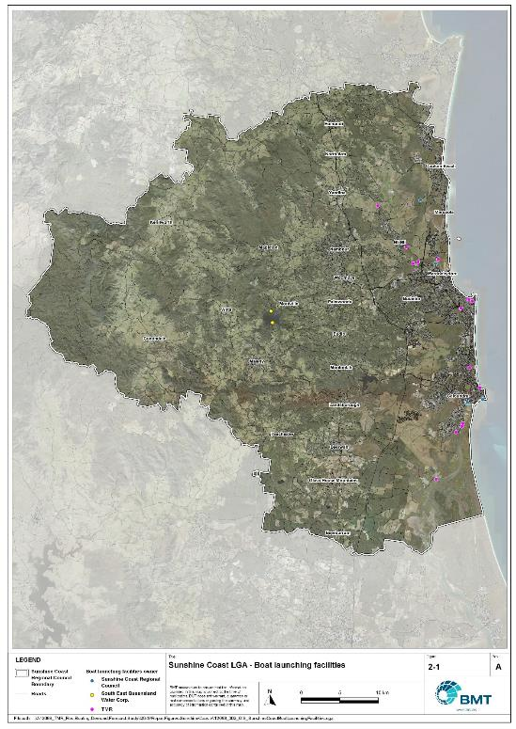

Public boat launching facilities within the Sunshine Coast LGA

"I:\A12068_TMR_Rec.Boating.Demand.Forecast.Study\QGIS\ReportFigures\SunshineCoast\A12068_002_GIS_SunshineCoastBoatLaunchingFacilities.jpg"

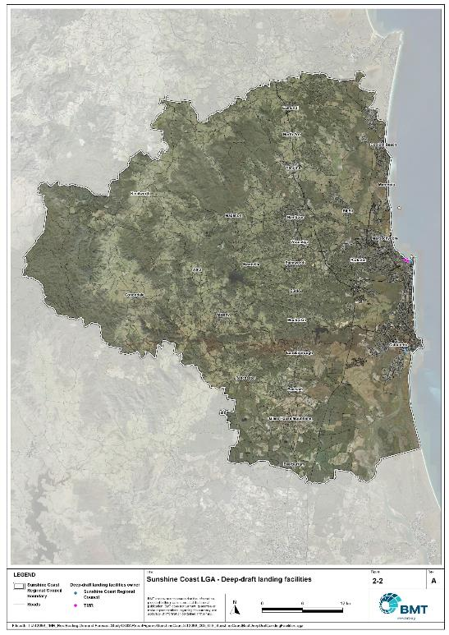

Public deep-draught vessel facilities within the Sunshine Coast LGA

"I:\A12068_TMR_Rec.Boating.Demand.Forecast.Study\QGIS\ReportFigures\SunshineCoast\A12068_003_GIS_SunshineCoastBoatDeepDraftLandingFacilities.jpg"

## Existing usage and issues

Consultation with the Sunshine Coast Regional Council, Seqwater, Maritime Safety Queensland, recreational groups and feedback from the recreational boating facilities survey hosted by TMR indicate the following major trends and issues within the Sunshine Coast LGA.

* + 1. Very high population growth

The Sunshine Coast has several growth corridors that will continue to grow the local population by nearly 50% over the next 20 years, with the largest of these being the Caloundra South development. This strong growth will correspond with an increasing local boating fleet size, that will want access to local boat launching facilities.

* + 1. Offshore access navigation

Boat users seeking access to open water launching from facilities in the Maroochy and Mooloolah Rivers as well as Pumicestone Passage have to traverse coastal bars that are subject to change. The northern entrance to Pumicestone Passage has recently changed configuration dramatically with the tidal breakthrough of Bribie Island, while siltation of the Mooloolah River is an ongoing concern for both the Sunshine Coast Council and MSQ, which manages the entrance. The Maroochy River mouth has been partially stabilised on the southern bank but is otherwise untrained and dynamic. All three of these coastal entrances change regularly and can impede safe navigation for recreational boats.

# Capacity Assessment

## Boat ramps

* + 1. Introduction

Boat ramps are facilities that are used for launching and retrieving trailable vessels, typically up to 8m in length (with some exceptions), to and from the water. Boat ramps consist of one or more lanes and their use is often supported by landside and waterside infrastructure to improve efficiency. In some instances, the usability of a facility can be adversely affected by environmental constraints such as low water levels, currents, or wave exposure, reducing the overall availability of the facility. Together, consideration of the number of boat ramp lanes, the supporting infrastructure, and environmental constraints results in the facility having a capacity described in terms of ‘effective lanes’ that may or may not be equal to the number of actual boat ramp lanes.

To maximise usage of each facility, the landside and waterside capacity should be balanced. Each facility will have a calculated ‘effective’ capacity for both the landside and waterside elements, with the limiting element dictating the facility's overall effective capacity. Recommendations for works or infrastructure promote balancing these two capacity elements by either improving the limiting element for increased facility effectiveness or by increasing the overall 'effective capacity' through changes to both elements.

* + 1. Boat ramp capacity

The overall capacity of each boat launching facility is limited by the effective capacity of either the waterside or landside elements. The waterside capacity is informed by the number of boat ramp lanes and the number and type of queuing facilities, such as pontoons, floating walkways, queuing beaches and fixed sloping walkways. It may also be limited by the available water depth in the adjacent waterbody and exposure to environmental or other physical factors.

Landside capacity is governed by the availability of nearby spaces for parking of car-trailer units (CTU), the provision of rigging and de-rigging facilities, and provision of single car parking spaces (single cars may otherwise be obliged to park in CTU spaces).

While it is expected that facilities will have their own characteristics influencing efficient use, this Study applies an approach that is consistent across the entire state and consistent with previous editions of the Study. Accordingly, the effective waterside capacity of a boat launching facility is determined as being:

* the ability to support 40 vessels being launched and retrieved per day per lane (see section 3.1.3)
* influenced by exposure to wave, tide, and current conditions (see section3.1.4
* supported by queuing facilities that assist in the efficient use of the boat ramp (see section 3.1.4).

Calculation of landside capacity is in line with the TMR guideline (TMR, 2020), which requires less provision of CTU parking per lane than the Australian standard (AS3962 Table 7.1), and advises:

* 10 CTUs for a single lane boat ramp accessed by an unsealed road, or 15 CTUs accessed by a sealed road
* 45 CTUs for a two-lane boat ramp
* 70 CTUs for a three-lane boat ramp
* 90 CTUs for a four-lane boat ramp.

A notable difference from the 2017 study is the recognition and inclusion of areas close to existing boating facilities that are unsealed and/or not line marked where parking of cars with trailers occurs and is not discouraged. These areas of informal parking have been identified on aerial imagery and through discussions with managing authorities. Each informal area has been assumed to be available for CTU parking only 50% of the time to account for conflicts with other uses (for example, markets), inefficient parking practices, or poor ground conditions. The rate of parking has been calculated as:

* for linear areas where nose-to-tail parking is expected – 1 CTU per 13m
* for linear areas with enough space to allow side-by-side parking – 1 CTU per 3m, provided there is a minimum distance of 15m from the road or manoeuvring area
* for large areas – 1 CTU per 100m2.
  + 1. Boat ramp capacity basis

The number of vessels per day each boat ramp lane can support is based on the Australian Standard for the Design of Marinas (AS3962-2001) and previous versions of this report (GHD, 2011 and 2017).

Research on boat ramp lane efficiency described in the previous report (GHD, 2017) identified that 40 vessels per lane per day was a reasonable compromise between 50 vessels per lane per day (representing congested conditions) and 30 vessels per lane per day (representing unhampered conditions). For context, the 40 vessels per lane per day rate represents a vessel launch or retrieval every 9 minutes per lane within an average normally used period of 12 hours per day.

During this Study, BMT has sought to validate the assumptions presented above, and those relating to capacity modification, by undertaking a literature review, conducting site visits that included observations of launching and retrieving manoeuvres, and reviewing video recordings of boats launching and retrieving at popular boating facilities. The literature review included a boat ramp efficiency investigation undertaken by BMT on the Mornington Peninsula, Victoria (BMT, 2015) and a review of standards from other Australian states and countries that undertake similar studies. The onsite and video analysis provided the opportunity to observe recreational boat operators using facilities included in the study but did not include observation of total throughput during high demand periods. This assessment was undertaken during site visits across Queensland, and a full day of video recording at Manly Boat Harbour (north ramp) in Brisbane.

The New South Wales and Victoria governments are currently in a planning phase for boating infrastructure and there are presently no publicly accessible documents identifying how those jurisdictions calculate boat ramp lane capacity. The Western Australia government has commissioned studies of the Perth region and the southwest region (Western Australia Department of Transport, 2019 and 2021) that indicate a base rate of 50 vessels per lane per day, with no modifiers applied. Internationally, studies from Florida in the USA (Bell, 2022 and Swett et. al, 2012) assumed that total vessel launch plus retrieval time is between 20 to 40 minutes (18 to 36 vessels per day), although no evidence is provided to support this assumption.

The Mornington Peninsula report (BMT, 2015) collected boat launch and retrieval data for 6 boat ramp facilities on the Mornington Peninsula across 9 days, including the peak Australia Day holiday. Total throughput was assessed for each facility on days where there was constant pressure for launching and retrieving boats with results between 30 and 70 vessels per lane per day for the various facilities. When adjusted for queuing modifications, a baseline rate of between 20 and 50 vessels per lane per day was identified. Of the facilities, the higher rates were achieved where sufficient parking was provided and both waterside and landside queuing facilities existed.

Observations of recreational boat users launching and retrieving their vessels undertaken through the site visits and the analysis of video footage showed that:

* Most observed launches were of ‘multi-person’ boats, which made launching and retrieving boats more efficient.
* Almost all users were able to launch and/or retrieve their boat within the 9-minute target time, when adjusted for queuing facility efficiency.
* There was a preference to launch adjacent to a floating walkway, where one was available. At facilities where a queuing facility is not immediately adjacent to the lane it is expected that average launch times may slightly increase during busy periods.

While the observations that were made generally aligned with expectations, a more in-depth review of capacity assumptions was outside of the scope of the Study. For future studies there would be value in undertaking a more thorough, data-driven investigation of the assumptions about boat ramp lane capacity, both at its base level and modified by queuing facilities. Overall, the preliminary investigations undertaken as part of the Study suggest that the base rate of 40 vessels per lane per day adopted in previous studies is appropriate.

* + 1. Boat ramp efficiency modifications

The waterside capacity of boat ramp lanes can be reduced by environmental factors that include:

* Water levels: Mainly relating to tidal areas this factor considers the reduction in the amount of time the boat ramp is available to launch and retrieve vessels over the full tidal cycle, thus reducing the overall capacity of the facility. For all-tide access, the boat ramp and connecting channel to the open sea are available during all tidal conditions and therefore available 100% of the time. For near all-tide access the boat ramp and the connecting channel to the open sea are assumed to be available, on average, for 80% of the tidal cycle. For part-tide access the boat ramp and its access channel are available less than 80% of the time. A modification factor of 0.8 is applied for near all-tide facilities and 0.5 for part-tide facilities.
* Wave and current conditions: In areas where vessel launching and retrieval may be intermittently impacted by waves (most commonly on beach ramps, but not exclusively) or strong currents (such as in rivers), a modification factor of 0.5 is applied.

Conversely, effective boat ramp capacity can be improved through the use of well-designed queuing facilities. Queuing facilities aim to improve amenity and efficient use of the boat ramp by accelerating one or more of the following phases of boat launching, with the opposite steps required for retrieval:

1. manoeuvring for launching, including for CTU entering the queuing area for the boat ramp and reversing into position for launch
2. launching and securing the launched vessel
3. moving the launch vehicle from the boat ramp to the parking area
4. removing the vessel from the waterside queuing facility.

A range of waterside queuing facilities are in use in Queensland boating infrastructure, which modify different phases of the total launching process. These include:

* Floating walkways and fixed sloping walkways: Positioned to about a boat ramp lane, these structures aim to:
  + improve amenity – such as to assist embarking/disembarking passengers, provide a refuge from in-water contact with crocodiles and so on.
  + make securing the vessel and removing the vehicle from the boat ramp more rapid, while freeing the boat ramp for subsequent users.
* Pontoons: Also used by deep-draught vessels, these structures improve the ability to secure the vessel and clear the boat ramp, but there is usually some time lost returning to recover the launch vehicle compared with the above options as they are generally positioned slightly further away from the ramp.
* Queuing beaches: These also provide a place to secure the vessel close to the boat ramp, although they are generally not as fast to use as pontoons.

As observed throughout the Study site visits, each of these queuing facility types can support a limited number of boat ramp lanes depending on the available space on the queuing facility. The 2017 edition of this Study applied a blanket uplift for all boat ramp lanes where a queuing facility was provided. However, the number of lanes each type of queuing facility can realistically support varies. Accordingly, this Study has provided limitations to the number of boat ramp lanes that can benefit from each queuing facility, based on the number of “working faces” (or area for a queuing beach) provided, where the “working face” is a face that allows temporary securing of vessels during launching or retrieval. The adopted improvement factors and supported lanes are summarised in Table 3.1.

Queuing facility efficiency modifiers

| Queuing facility | Modification factor | Supported lanes |
| --- | --- | --- |
| Floating walkway (lanes adjacent to walkway) | 1.7 | 1 Lane/face |
| Floating walkway (lanes not adjacent to walkway) | 1.3 | 1 Lane/face |
| Fixed sloping walkway | 1.7 | 1 Lane/face |
| Pontoon | 1.2 | 2 Lanes/face |
| Queuing beach | 1.1 | Site-based |

In other states in Australia, reversing queuing bays are more commonly used than in Queensland. These are CTU waiting bays at the head of the boat ramp that are aligned with each boat ramp lane to allow the user to reverse directly down the boat ramp once it is clear. CTU waiting bays reduce the time of the first phase of boat launching by allowing waiting CTU’s to be ready to reverse as soon as the lane becomes clear. The BMT (2015) study on the Mornington Peninsula included facilities with and without these bays. Boat ramps that included reversing queuing bays achieved 50% greater throughput. Facilities that have implemented this approach in Queensland include North Street Southport, Urangan Boat Harbour, Townsville Recreational Boating Park, and the (under construction late 2022) boat ramp at Yorkeys Knob.

* + 1. Accessibility from boat launching facilities

Recreational boat users will typically select the boat launching facility most appropriate or convenient to the activity they are seeking to undertake, the anticipated weather/wave conditions, and their destination. Each of facility within an LGA will provide a varying degree of access to different destinations and for different activities. During the Study, consultation with stakeholders highlighted the following general types of destinations and activities:

* open water/offshore: typically accessed for visiting offshore islands or remote beaches, snorkelling or diving locations, deep sea fishing and general recreation
* creeks and estuaries: typically accessed for fishing, crabbing, wildlife observation, skiing and general recreation
* freshwater: typically accessed for skiing, fishing, wildlife observation and general recreation.

These destinations are typically serviced by different types of recreational vessels. Inshore locations including creeks, estuaries and other freshwater locations are typically patronised by vessels less than 4.5m, except for ski boats, which can be much larger than this. Offshore locations typically require larger boats for access as these vessels are more capable of managing a wide range of wave conditions and can carry sufficient fuel to access distant destinations. Smaller vessels may be able to access close destinations on good weather days, and larger vessels may choose to access inshore destinations, particularly on poor weather days.

Consequently, the following aspects are used to classify how well a facility provides open water access:

* Open-water access: There are no restrictions between the facility and open water.
* Depth-limited access: There are depth restrictions between the facility and open water that limit navigable access to part of the tidal range. This differs from tidal constraints at the actual facility, which might be usable at all tides, but offshore access is limited by a downstream bar or delta.
* Distance-limited access: The distance from the facility to the open water is unrealistic for typical boat users. This distance is assumed to be about 4.5km between the facility and open water to rate as 'distance limited', with travel times increased further where portions of the access channel are regulated by speed limits.
* Infrastructure-limited access: There are man-made obstacles between the facility and open water, such as above-ground pipeline crossings, low bridges or weirs that impede navigable access to open water.
* Beach ramps: These provide open-water access but are typically constrained by environmental conditions such as wave exposure and tide levels. The capacity of these facilities has been individually assessed based on consultation and other data sources and is described in more detail in section 4.
* Freshwater: There is no access to open water.

Certain facilities, particularly those in freshwater, may be constrained by periods of drought, or debris deposition after rainfall events that limit access to destinations, and therefore whether a facility will provide useful boat launching capacity. While it is noted that drought and rainfall may affect the overall capacity of boat launching within an LGA, and given that the timing of such events is not readily predictable, their impact on capacity has not been evaluated.

* + 1. Existing boat launching capacity

Within the Sunshine Coast LGA there are 23 boat launching facilities with a total effective capacity of 25.5 lanes. The effective capacity of boat launching facilities within the Sunshine Coast LGA is shown in Annex B, with a summary of the access to open water and tidal constraints shown in Figure 3.1 and the overall capacity constraint shown in Figure 3.2. Pertinent features of these facilities include:

* There are 40 total lanes, with an effective capacity of 25.5 effective lanes. This effective capacity is primarily reduced due to insufficient parking being allocated for each lane.
* Boat users in the Sunshine Coast LGA have a range of options for boating, with facilities available for accessing freshwater destinations, estuaries and offshore destinations.
* The majority of the facilities provide all-tide access or near all-tide access.

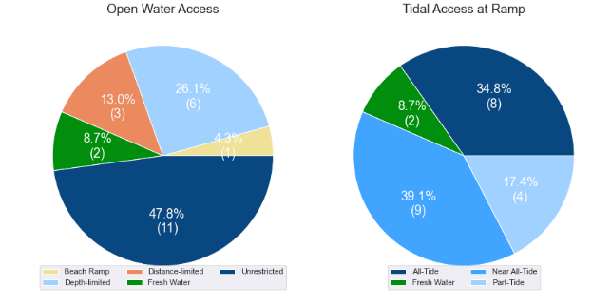

(a) Summary of open water access from boat launching facilities (left) and (b) Summary of tidal restrictions at tidal boat launching facilities (right)

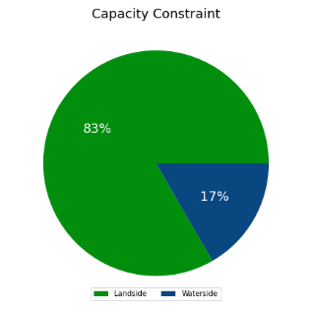

Summary of limiting capacity constraint

* + 1. Facilities expected to be completed within the Study Period

Facilities that are expected to be constructed and providing capacity within the Study period are accounted for in this section. These are projects that have secured funding, have begun construction or have a current works contract. For all intents and purposes, these upgrades are intended to be providing capacity within the next 5 years or sooner. As such, this section acknowledges the increase in capacity that these facility upgrades will supply.

### Outrigger Island, Minyama

The existing facility at Outrigger Park, Minyama, provides access to the Mooloolah River and offshore, and an upgrade to the capacity will assist in taking pressure off facilities downstream. It is currently a 1 lane facility with 10 designated CTU parks. This will be expanded to a 2-lane ramp with a central floating walkway and 36 CTU parking spaces.

### Adaluma Avenue, Buddina

This facility provides direct access into the Mooloolah River close to the mouth and is very popular for offshore ventures, particularly with boaters who reside south of the Mooloolah River. The current parking arrangement is a wide open hardstand area with no line-marking, where CTUs park wherever they can find a spot along the perimeter of the area. This creates inefficiencies which impact parking capacity, and as such has been planned for a landside upgrade. These upgrades include line-marking to designate a total of 39 CTU parking spaces (32 standard size, 7 large bays), as well as rigging/derigging areas, passenger vehicle parks and landscaping.

### June Street, Pelican Waters

Intended works at June Street, Pelican Waters include the formalisation of the existing parking area, which at present is not line-marked. Line-marking will provide order and maximise efficiency of that parking area. Proposed works include the installation of signs designating CTU-only parking spaces along June Street and 15 further CTU parking spaces on Booker Parade, increasing the total number of CTU parking spaces here from 25 (informal) to 45 (formal).

Expected capacity to be provided in the near-term

| Facility | Existing effective lanes | Expected total effective lanes | Capacity increase |
| --- | --- | --- | --- |
| Outrigger Island, Minyama | 0.88 | 1.75 | 0.87 |
| La Balsa Park, Adaluma Avenue, Buddina | 1.5 | 2.5 | 1.0 |
| June Street, Pelican Waters | 1.5 | 2.0 | 0.5 |
| **Total (effective lanes)** | **3.88** | **6.25** | **2.37** |

## Access to sheltered near all-tide and all-tide facilities

MSQ has a longer-term vision to provide access to all-tide or near all-tide open water access boat launching facilities along the Queensland coast, such that all significant population centres are within one hour’s driving range as far as practical (TMR, 2020). For this purpose, the Study has defined towns as being within the coastal strip if within 30km of the Queensland coastline. The vision (TMR, 2020) is applied to the coastal strip between the NSW border and Cooktown. Consultation throughout the Study has highlighted that this vision is important with users/stakeholders and organisations that own and manage these facilities. As such, the Study has developed a statistical approach to quantify this vision to allow it to be measured and tracked over time. To do this, the Study has calculated the travel time from all Population Centres (DoR, 2022) within the coastal zone to the nearest available sheltered, all-tide or near all-tide facility, regardless of which LGA it is in. This has been accomplished using mapped road networks and assigning speed limits to each type of road, with the following speed limits applied:

* for restricted roads, 40km/hr
* for local roads, 60km/hr
* for connector roads, 70km/hr
* for distributor roads, 80km/hr
* for highways, 100km/hr.

For the Sunshine Coast LGA the median travel time from eligible Population Centres to the nearest sheltered all-tide or near all-tide facility is 16 minutes. The distribution of travel times is shown in Figure 3.3 with detailed travel times in Annex C. Figure 3.4 provides a visual representation of the travel time from each of the sheltered near all-tide facilities that serve the LGA. Of interest for the Sunshine Coast LGA are:

* All of the eligible population centres are within the desired 1-hour travel time.
* the majority of eligible population centres are within 30 minutes of a sheltered near all-tide or all-tide facility.

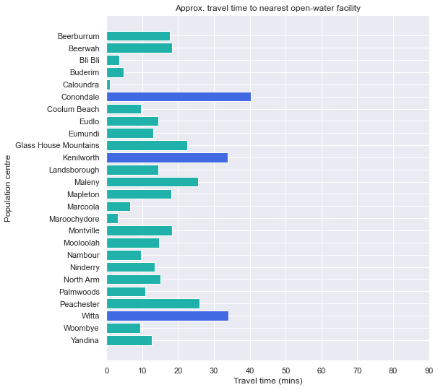

Distribution of travel time from the Sunshine Coast LGA’s eligible population centres to sheltered near all-tide facilities

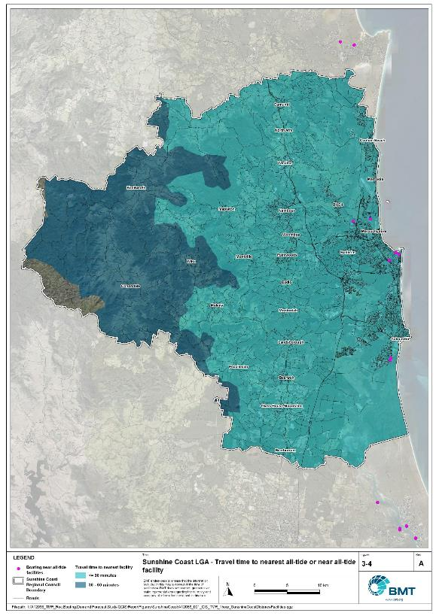

Sunshine Coast LGA – Travel time to nearest all-tide or near all-tide facility

"I:\A12068_TMR_Rec.Boating.Demand.Forecast.Study\QGIS\ReportFigures\SunshineCoast\A12068_001_GIS_TMR_1hour_SunshineCoastDistanceFacilities.jpg

## Deep-draught vessel landings

Deep-draught vessel landings are intended to provide short-term landing capacity for vessels that are too large to use public boat launching and retrieval facilities. These facilities are provided for the benefit of both local vessels and to service the fleet of vessels that travel along the Queensland coast. Deep-draught vessel landings may be designed to accept one or more large vessels at a time and/or provide capacity for tenders from larger vessels that may be anchored or moored nearby, for the purpose of loading and offloading passengers and supplies, and making short local visits to onshore destinations.

For the Study, deep-draught vessel landings need to be primarily accessible by recreational boats for short, temporary stays. In some cases, commercial vessels may utilise these facilities subject to the relevant permissions, however, this may reduce the capacity of the facility to cater for recreational vessels. Deep-draught vessel landings should be located such that the facility provides reasonable access to landside passenger pick up and drop off, provisioning, recreational destinations, or population centres. Within the Sunshine Coast LGA there are five deep-draught vessel landings that provide access to the following facilities or destinations:

* Penny Lane pontoon in Mooloolaba adjacent to ‘The Wharf Mooloolaba’ has a selection of nearby specialty shops, restaurants and public transport facilities.
* Parkyn Parade, Mooloolaba and Adaluma Avenue, Buddina pontoon provides limited opportunity for provisioning, and is suitable for passenger pickup and drop-off.
* Tripcony Lane, Caloundra provides access into downtown Caloundra, however, access to this facility is currently restricted due to highly mobile sand shoals associated with the recent breakthrough of Bribie Island.
* The Basin in Pelican Waters is situated in a developing area that will include shops and restaurants.

As well as the above, the Sunshine Coast LGA has additional deep-draught vessel landings provided by private marina facilities at Mooloolaba and Pelican Waters.

In summary, Table 3.3 shows the total capacity of deep-draught landing facilities within the Sunshine Coast.

Deep-draught landing facilities within Sunshine Coast LGA

| Facility type | Total capacity |
| --- | --- |
| Public sheltered mainland landings | 5 |
| Private sheltered landings | 2 |
| **Total** | **7** |

# Demand Assessment

The Study has developed a model to calculate statistical demand for boat launching facilities and deep-draught vessel landings at an LGA scale. Vessels that are less than 8m in length are considered trailable and drive demand for boat launching facilities such as boat ramps, while those over 8m are assumed to remain on water and drive demand for deep-draught landings.

Statistical demand is recognised at three different levels for public marine facilities within the TMR guidelines (TMR, 2020), which are:

* off-peak demand – typical weekday usage
* average demand – demand on ‘good boating days’, taken to be demand for a facility on weekends (and, for certain regional locations, other busy periods)
* peak demand – demand for a facility at peak holiday periods or for special events.

The demand model created for this Study is intended to provide information on demand pressures on ‘good boating days’ for all facilities as per the intentions of the guidelines. The model achieves this through a ‘registration activation rate’ that estimates the proportion of registered vessels in an LGA that is assumed to be active on a ‘good boating day’, as well as the exchange of vessels between LGAs, and general tourism pressures.

## Activation rate

The fleet size for each LGA is determined statistically from vessel registration numbers and the application of a vessel activation rate, while for future time horizons vessel registration and population growth estimates are also utilised. The methodology for determining the registration activation rate has been adopted from the previous study (GHD, 2017), with activation rates taken to be between 8% and 14% for a typical weekend. The variability of the activation rate is intended to capture the regional differences in vessel types, and is driven by the availability of access to open water, accessibility of other recreational opportunities, and likelihood of users’ available time for recreation, considering factors including:

* remoteness classification for the LGA
* incidence of blue-collar employment
* average age of residents
* whether the LGA is coastal.

Further information about the derivation of this rate can be found in Annex A. For the Sunshine Coast LGA the activation rate is assumed to be 6%, with the key factors influencing the rate including:

* its classification as a Metropolitan Area
* the incidence of blue-collar employment being in line with the state average
* the average age being higher than the state average
* it being located adjacent to the open coast.

## Digital user survey

To gain an understanding of usage trends at existing formal recreational boating facilities across Queensland, the Study has considered the results of a digital user survey using human movement data, sourced through a third party. The data was acquired from a location data store with more than 13 trillion mobile location observations globally from 2019 to present, which were sourced from 250,000 different mobile phone applications that users ‘opted-in’ to use the location services under the application’s terms and conditions. All data received was deidentified and compliant with relevant data privacy regulations.

The analysis uses mobile devices (such as telephones) location data as a proxy for boat user traffic, however, this relationship has several limitations including, but not limited to:

* Mobile device users detected in the area of interest may not be boat users (for example., pedestrians not using vessels may walk through the detection area).
* The relationship between mobile device users and vessels may not be 1:1 (that is, there may be multiple mobile devices providing data for each vessel).
* Users of vessels may not have a mobile device, may not be using a mobile device or may not have provided permission to use their location data.

With these, and potentially other, limitations in mind, the Study compared this data against vessel launching counts provided by various facility managers and found that approximately 15-30% of vessels are captured using this digital survey method. This percentage can change from facility to facility and from day to day. Consequently, the Study has not relied on raw counts of users from this data, but instead considered the relative trends within the data, with the assumption that no groups (for example, users from a particular LGA or using a particular facility) within the data would be more or less likely to be captured by the technique.

The Study has used this data to identify the relative volume of users, the ‘home’ local government area of users and the popularity of destinations that users travel to once vessels have been launched.

* + 1. Inter-LGA demand

The human movement data has been interrogated to determine the LGA of origin for users of the Sunshine Coast LGA’s public boating facilities to ascertain the proportion of users from each LGA that are using specific facilities. Statistics from all public boating facilities within the LGA are then grouped together to determine the total proportion of resident or visiting users across the LGA. Table 4.1shows the active fleet proportion from the top 10 LGAs contributing to demand on facilities within the Sunshine Coast LGA. All other sources have been grouped together.

LGA of origin for active fleet in the Sunshine Coast LGA

| LGA of origin | Active fleet proportion |
| --- | --- |
| Sunshine Coast | 73.8% |
| Brisbane | 7.1% |
| Moreton Bay | 5.0% |
| Gold Coast | 1.5% |
| Toowoomba | 1.3% |
| Logan | 1.2% |
| Noosa | 1.2% |
| Ipswich | 0.9% |
| Redland | 0.9% |
| Gympie | 0.6% |
| Other LGAs | 6.4% |

* + 1. Intra-LGA demand distribution

Recreational boating users will tend to use facilities that best suit their needs, the destinations they want to access, the capability of their vessel and the weather conditions. Consequently, distribution within an LGA is unlikely to be evenly spread across all facilities, with some facilities attracting users disproportionately due to amenity, access, or destinations. The attractiveness of large well-designed facilities is likely to draw visiting boat users in preference to smaller or less desirable facilities across the LGA. The human movement statistics have been assessed to qualitatively estimate the proportion of users using each facility, both in total and with respect to both resident and visiting boat users (Table 4.2).

Popularity of boat launching facilities.

| Facility | Overall fleet | Resident fleet | Visiting fleet |
| --- | --- | --- | --- |
| Mooloolaba, Parkyn Parade | 18.2% | 17.1% | 21.2% |
| Buddina, Adaluma Avenue | 12.3% | 13.7% | 8.5% |
| Maroochydore, Bradman Avenue | 11.3% | 12.5% | 7.8% |
| Golden Beach, Churchill Street | 6.7% | 6.2% | 8.2% |
| Maroochydore, Fishermans Road | 6.6% | 7.3% | 4.6% |
| Twin Waters, Nojoor Road | 6.3% | 6.6% | 5.5% |
| Maroochydore, Picnic Point | 5.7% | 5.1% | 7.5% |
| Pelican Waters, Raleigh Street | 4.5% | 4.6% | 4.2% |
| Minyama, Outrigger Island | 4.3% | 5.0% | 2.5% |
| Golden Beach, Short Street | 4.2% | 4.0% | 4.9% |
| Pelican Waters, June Street | 3.7% | 3.5% | 4.2% |
| Caloundra, Tripcony Lane | 3.5% | 2.4% | 6.5% |
| Bli Bli, Muller Park Road | 3.1% | 3.4% | 1.9% |
| Kings Beach, Margaret Street | 2.6% | 2.6% | 2.4% |
| Currimundi, Lara Street | 1.8% | 1.8% | 1.8% |
| Lake Baroon | 1.7% | 1.0% | 3.9% |
| Coochin Creek, Roys Road | 0.7% | 0.6% | 0.9% |
| Coolum, West Coolum Road | 0.5% | 0.6% | 0.5% |

The results indicate that the resident fleet has a preference for facilities that provide access to open water from the Mooloolah River, with the Parkyn Parade facility (Mooloolaba state boat harbour) somewhat preferred over the Adaluma Avenue facility, probably because of its better facilities and parking capacity. The visiting fleet has a strong preference for the Parkyn Parade facility, given it is the best facility in the region with the best access to open water destinations, as well as proximity to food and retail outlets. Beyond the Mooloolah River, the fleet is well distributed between the remainder of the facilities, with the Churchill Street facility the most popular for accessing Pumicestone Passage.

The distribution of capacity within the LGA needs to consider these trends to avoid consistent capacity shortfalls at some facilities or indicating demand for unnecessary extra capacity at other facilities. Results from the above statistics and feedback obtained through the TMR online survey indicate that within the Sunshine Coast LGA the following factors tend to influence which facilities are preferred by recreational boat users:

* access to sheltered, all-tide launching facilities
* dry entry/exit capabilities of launching facilities provided through floating walkways and pontoons
* ability to access offshore destinations.
  + 1. Destinations

For facilities that provide sheltered, near all-tide or all-tide open water access, additional analysis of the human movement statistics has been undertaken to identify destinations for users of these facilities. Location data from users utilising the facilities was extracted for a period of two hours after they used the facility, and trimmed for waterside destinations. For the Sunshine Coast LGA this additional analysis was applied to the following facilities, with destinations mapped in Figure 4.1, Figure 4.2 and Figure 4.3:

* Adaluma Avenue, Buddina
* Outrigger Island, Minyama
* Parkyn Parade, Mooloolaba
* Fishermans Road, Maroochydore
* Muller Park, Bli Bli
* Nojoor Road, Twin Waters
* Churchill Street, Golden Beach
* Short Street, Golden Beach
* June Street, Pelican Waters

From this additional analysis, the following notable observations were made:

* Users accessing offshore destinations gave heavy preference to the facilities in the Mooloolah River.
* Most users in the Maroochy River remained in the river, with a minority of users going offshore to destinations such as Mudjimba Island.
* Most users in the Pumicestone Passage remained in the estuary, with a minority of users going offshore as far as Moreton Island.

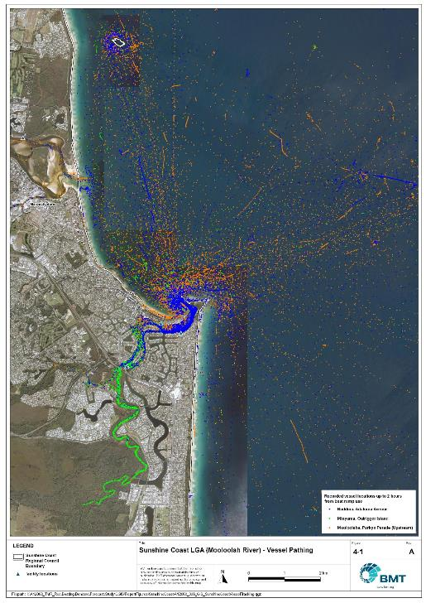

Sunshine Coast LGA (Mooloolah River) – Vessel pathing

"I:\A12068_TMR_Rec.Boating.Demand.Forecast.Study\QGIS\ReportFigures\SunshineCoast\A12068_006_GIS_SunshineCoastVesselTracking_Mooloolabah.jpg"

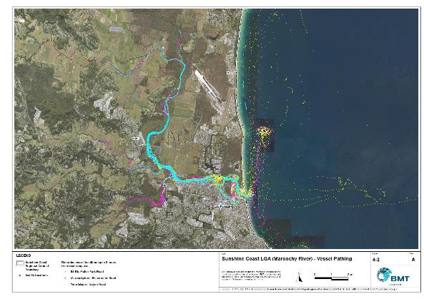

Sunshine Coast LGA (Maroochy River) – Vessel pathing

"I:\A12068_TMR_Rec.Boating.Demand.Forecast.Study\QGIS\ReportFigures\SunshineCoast\A12068_006_GIS_SunshineCoastVesselTracking_Maroochydore.jpg"

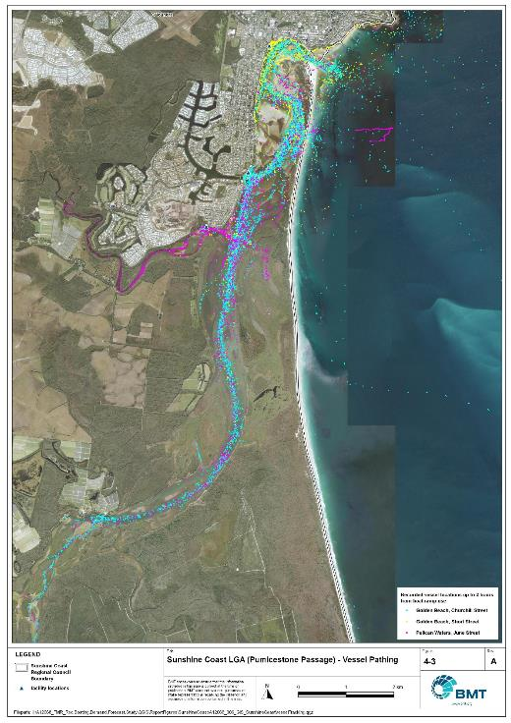

Sunshine Coast LGA (Pumicestone Passage) – Vessel pathing

"I:\A12068_TMR_Rec.Boating.Demand.Forecast.Study\QGIS\ReportFigures\SunshineCoast\A12068_006_GIS_SunshineCoastVesselTracking_Caloundra.jpg""

## Active fleet size

The total ‘active’ fleet on a good boating day is derived from the activation rate of the total fleet of registered vessels within the LGA and the net inflow of visiting vessels. The total number of visiting vessels from each LGA is determined from the number of vessels in the resident active fleet and the relative proportion of resident to visiting vessels outlined in Table 4.1.The fleet size is expected to change over time due to changes in population and vessel acquisition trends, with the size and proportion of the fleet across the study period described in Table 4.3.

Active fleet vessel size

| Vessel length | 2021 | 2026 | 2031 | 2036 | 2041 |
| --- | --- | --- | --- | --- | --- |
| 0 to 4.5m | 1315 | 1425 | 1526 | 1620 | 1707 |
| 4.5m to 8m | 511 | 554 | 592 | 629 | 662 |
| >8m | 75 | 81 | 88 | 93 | 98 |
| Total | 1901 | 2060 | 2206 | 2342 | 2468 |

## Boat ramp lane demand

The fleet size derived in Table 4.3 represents the statistical demand for the LGA, with vessels under 8m assumed to contribute to boat ramp demand, measured in boat ramp lanes. As outlined in section 3.1.2 the adopted capacity of each effective lane is 40 vessels per day, with each vessel assumed to both launch and retrieve, for a total of 80 vessel movements per day. The total boat ramp lane demand across the study period is shown in Table 4.4.

The total boat ramp demand is reduced by those vessels assumed to be ‘active’ on the target day that are stored on private pontoons. This is expected to reduce the boat ramp lane demand by 0.6 lanes across all periods.

Boat ramp lane demand

|  | 2021 | 2026 | 2031 | 2036 | 2041 |
| --- | --- | --- | --- | --- | --- |
| Boat ramp lane demand | 45.6 | 49.5 | 53 | 56.2 | 59.2 |

For the Sunshine Coast LGA the important elements that contribute to boat ramp lane demand include:

* a large local fleet, with a high proportion of trailable vessels
* large sized fleets in the LGAs to the south, in particular Brisbane and Moreton Bay LGAs
* poor demand satisfaction in Noosa LGA directly to the north, which results in Noosa-LGA-registered vessels using Sunshine Coast LGA facilities
* attractive boating destinations, including for visitors from across Queensland.

## Non-statistical demand

As well as the statistical demand outlined in the section above, facilities may face demand pressures that are related to their functional use, which reduces the capability of the facility to service the recreational boat fleet in the desired manner. Issues with specific facilities have been identified within the consultation process of the Study with appointed managers and other stakeholders. While care has been taken to identify these non-statistical demand issues throughout the Study, it is beyond the scope of the Study to individually review the functionality, safety, and amenity of each facility across Queensland. Non-statistical demand pressures may warrant upgrades to facilities even where statistical demand is satisfied by existing capacity. These pressures have been classified into the following categories:

* Amenity: Amenity describes the functional usability of the facility including the desire to provide dry entry and exit facilities, facilities that provide easy access and/or access for persons with restricted mobility.
* Safety: Safety demand may include protection from currents and waves or contact with marine creatures such as sharks, jellyfish, and crocodiles.
* In-water congestion: Where existing queuing facilities are not able to efficiently meet the needs of the facility. Such deficiency may warrant additional queuing facility capacity to optimise boat launching and retrieval.

The Study's recommendations may alleviate these non-statistical demand pressures with consideration for capability of all facilities within the LGA. The presence of a non-statistical demand pressure at a facility may not warrant upgrades where other suitable facilities are reasonably available.

## Deep-draught vessel demand

* + 1. Cruising vessels

Vessels cruising along the east coast of Queensland have a requirement for a network of deep-draught vessel landings that are appropriately spaced to be within a day’s sailing on good weather days. These facilities are required to support the reprovisioning of vessels as they travel along the coast and provide access to desirable land-based destinations. Private marina facilities may be used by cruising vessels where there is an expectation for a prolonged stay that requires protected mooring or berthing. Within the Sunshine Coast LGA suitable facilities for deep-draught vessels includes the public pontoons at Adaluma Avenue, Tripcony Lane (acknowledging that deep-water access is restricted at the time of writing), Parkyn Parade, Penny Lane and a new facility at The Basin in Pelican Waters. The landings at Penny Lane, Tripcony Lane and The Basin all provide excellent access to shops for reprovisioning, have access to landside amenities and recreational destinations and have plentiful adjacent passenger vehicle parking. The Parkyn Parade facility provides access to the Coastguard, water police and other marine specific clubs and services, while there is also ample landside parking for passenger vehicles. Adaluma Avenue, while capable of servicing larger vessels is generally used to support the adjacent boat ramp but can be used for passenger pick-up and drop-off.

Within the east coast network but outside of the LGA, the nearest deep-draught vessel facility to the north is at Norman Point in Tin Can Bay (Gympie LGA), approximately 65 nautical miles north of Mooloolaba. To the south there are numerous facilities within Moreton Bay.

* + 1. Landing demand

Statistical demand for deep-draught vessel landings has been assessed based on the size of the non-trailable fleet within the Sunshine Coast LGA. Landing demand is more difficult to assess than boat ramp lane demand as the requirements and duration of the landing influence the demand pressure but are highly variable between users. Nevertheless, the Study has assumed that 5% of the non-trailable fleet will be seeking a landing at any given time. The consultation undertaken during the Study indicates that this assumption may overestimate the number of landings, but that the landings are often utilised for other boating and recreation activities when not in use by deep-draught vessels. In particular, landings that are located near boat launching facilities may be used as queuing facilities and therefore support the efficient launching of smaller recreational vessels. Given this, the 5% assumption has been adopted noting that it may overestimate capacity, but not to an extent that it would be onerous to facility providers. Within the Sunshine Coast LGA the demand for deep-draught vessel landings is outlined in Table 4.5.

Deep-draught vessel landing demand

| Requirement | 2021 | 2026 | 2031 | 2036 | 2041 |
| --- | --- | --- | --- | --- | --- |
| No. of Landings | 3.7 | 4.1 | 4.4 | 4.7 | 4.9 |

# Shortfall Assessment

## Shortfall assessment – boat ramps

The shortfall of boat ramp lanes within the Sunshine Coast LGA is shown in Table 5.1 and Figure 6.1 at an LGA scale. This is presented both with and without the inclusion of additional capacity provided by the recommended upgrades.

Shortfall of boat launching facilities

| Assessment | Metric | 2021 | 2026 | 2031 | 2036 | 2041 |
| --- | --- | --- | --- | --- | --- | --- |
| Demand | Demand | 45.6 | 49.5 | 53 | 56.2 | 59.2 |
| Existing | Capacity | 25.5 | 27.9 | 27.9 | 27.9 | 27.9 |
| **Shortfall** | 20.1 | 21.6 | 25.1 | 28.3 | 31.3 |
| Improved  (Minimum upgrades) | Capacity | 25.5 | 28.1 | 35.8 | 38.4 | 44 |
| **Shortfall** | 20.1 | 21.4 | 17.2 | 17.8 | 15.2 |
| Improved  (Maximum upgrades) | Capacity | 25.5 | 30.3 | 42 | 46.2 | 51.8 |
| **Shortfall** | 20.1 | 19.2 | 11 | 10 | 7.4 |

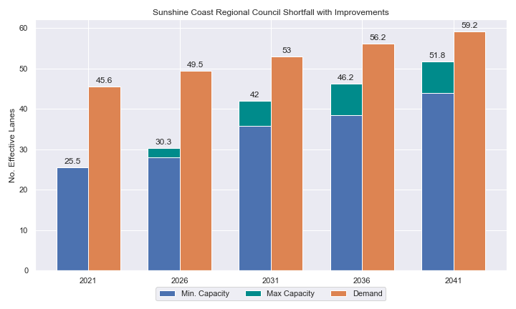

Shortfall assessment with recommended upgrades adopted

* + 1. Open-water access shortfall in boat ramp lanes

Statistical capacity has been calculated across the Sunshine Coast LGA in its entirety, however, some facilities are evidently more popular than others due to their ability to access open-water destinations, and/or their usability. In general, larger vessels are more suited to access open-water destinations while smaller vessels are more likely to remain in sheltered environments. This was identified in the 2017 study and confirmed during discussions with stakeholders. The human movement data indicates that visiting boats from other LGAs are drawn to facilities that provide access to open-water destinations. To ensure that the capacity of effective boat ramp lanes in the LGA is appropriately distributed to cater for these usage trends, it is worth assessing facilities providing this desirable access as a subset of the total capacity for the LGA. A ‘scenario’ approach to assessing this capacity has been developed, with Scenario 1 derived from empirical estimates of vessel distribution and Scenario 2 derived from the human movement statistics, and the final result averaged between the two scenarios. This provides the opportunity to rationalise the figure that drives the demand and acknowledge when one scenario is not representative of the population or consistent with stakeholder feedback. The scenarios that were assessed are:

Scenario 1: 80% of larger vessels and 20% of smaller vessels from the local fleet and 80% of the visiting fleet are using the facilities with unrestricted open water access.

Scenario 2: Distributing the fleet between facilities as per the human movement statistics.

The results of this approach suggest that the shortfall from these specific facilities is in proportion to the overall shortfall for the Sunshine Coast LGA.

Shortfall assessment for open water, all-tide or near all-tide facilities for Sunshine Coast LGA

| Assessment | Metric | 2021 | 2026 | 2031 | 2036 | 2041 |
| --- | --- | --- | --- | --- | --- | --- |
| Overall | Capacity | 16.6 | 19.0 | 19.0 | 19.0 | 19.0 |
| Scenario 1 | Demand | 32.8 | 35.5 | 38.0 | 40.4 | 42.5 |
| Shortfall | 16.2 | 16.5 | 19.0 | 21.4 | 23.5 |
| Scenario 2 | Demand | 25.4 | 27.5 | 29.4 | 31.2 | 32.9 |
| Shortfall | 8.8 | 8.5 | 10.4 | 12.2 | 13.9 |
| **Average** | Demand | 29.1 | 31.5 | 33.7 | 35.8 | 37.7 |
| **Shortfall** | **12.5** | **12.5** | **14.7** | **16.8** | **18.7** |

Comparing the LGA-scale shortfall with the subset of facilities providing protected all-tide or near all-tide access to open water indicates that the demand is well distributed within the LGA based on the human movement data and more focused at this subset of facilities based on the empirical assumptions. On average the shortfall is well distributed amongst facilities, with significant shortfall present and projected for the all-tide or near all-tide open-water accessible facilities.

## Shortfall assessment – deep-draught landings

The shortfall of public deep-draught landings for the Sunshine Coast LGA is provided in Table 5.3. The existing capacity is statistically adequate to meet demand, particularly with the inclusion of the new facility at The Basin and supporting private facilities in Pelican Waters and Mooloolaba.

Shortfall of deep-draught vessel landings

| Assessment | Metric | 2021 | 2026 | 2031 | 2036 | 2041 |
| --- | --- | --- | --- | --- | --- | --- |
| Deep-draught vessel landings | Demand | 3.7 | 4.1 | 4.4 | 4.7 | 4.9 |
| Capacity | 5 | 5 | 5 | 5 | 5 |
| **Shortfall** | -1.3 | -0.9 | -0.6 | -0.3 | -0.1 |

# Stakeholder Feedback



The Study has undertaken extensive consultation throughout its execution to achieve a comprehensive understanding of issues relating to the use of recreational boating facilities across the state. This consultation was conducted with managing authorities that own and/or and manage recreational boating facilities, as well as with facility stakeholders including recreational groups, volunteer marine rescue and coastguard organisations, and the general public. Stakeholder engagement was supplemented with site visits to facilities where key issues had been identified.

## Managing authority feedback

For the Sunshine Coast LGA, the Study team met with Sunshine Coast Regional Council, Seqwater, Coastguard and Maritime Safety Queensland to discuss recreational boating facilities within the region. This consultation process identified a range of potential opportunities to alleviate demand pressures. The Study has considered the practical implementation of each of these opportunities with respect to the required infrastructure, difficulty of implementation and magnitude of benefit, as summarised in Table 6.1.

Stakeholder identified opportunities

| Location | Stakeholder opportunity | Review comments |
| --- | --- | --- |
| Stoney Wharf. Bli Bli | Existing recommendation from the 2017 report is oversized, suggest revising. | Agreed. Suggest focusing on one larger facility in the Bli Bli area, rather than lots of smaller facilities. |
| Lake Dunethin, Maroochy River | Would be a good spot for an upgrade, not highly used at the moment. | This site doesn’t have suitable space for expansion of parking, however another site nearby would be useful to service expansion in Bli Bli region. |
| Muller Park, Bli Bli | Redevelop in the future. | Agree. This site is ideal for expansion of capacity. |
| Fishermans Road, Maroochydore | Parking could be improved. | Agreed. |
| Adaluma Avenue, Buddina | Need to improve this facility with parking and floating walkway. | Agreed. |
| Seaview Terrace, Moffat Beach | Decommission | Agreed. |
| June Street, Pelican Waters | Improve parking and dredge to make all-tide accessible. | Agreed, subject to environmental constraints. |
| Bells Creek, | New facility needed to cater for expansion from Caloundra South | Agreed, subject to environmental constraints. |

## Stakeholder feedback

Broader stakeholder feedback has been conducted within the Study by undertaking virtual or face-to-face meetings with recreational boating groups and marine rescue organisations, as well as through the Recreational Boating Facility Survey (MSQ, 2022) undertaken by Maritime Safety Queensland, which included survey responses of nearly 3,000 users and open submissions. For the Sunshine Coast LGA a total of 135 submissions were received, with 79% of respondents using trailable power boats and 95% of respondents using recreational boating facilities at least once a month. For the Sunshine Coast LGA the following statistics or themes were extracted from the survey and associated comments:

* 94% of respondents typically travel less than 1hr to their preferred boat ramp (which may not be their closest facility).
* 60% of respondents indicated that floating walkways are their preferred type of queuing facility.
* 95% of respondents indicated that they would be unwilling to walk further than 200m from designated CTU parking to a boat ramp.
* The most common requests for new boat ramps were at:
  + Maroochy River (Ashton Wharf, Mount Coolum, Coolum Creek)
  + Maroochy River at Bli Bli (Godfrey Avenue, Muller Park and Stoney Wharf Road)
  + Mooloolah River (La Balsa Park)
  + Bells Creek.
* The following themes were identified with respect to existing facilities:
  + provision of more CTU parking areas (Caloundra, Mooloolaba, Golden Beach)
  + upgrading existing boat ramps with pontoons, jetties and mooring piles (for example, Fishermans Road, Bradman Avenue, La Balsa Park, Coolum Creek, Muller Park, Mackenzie Bridge, Buddina) and by dredging (Bells Creek) and expanding (Buddina)
  + provision of fish cleaning and filleting tables and wash-down water tap (Bli Bli).
* Where the closest available boat launching facility was not preferred, respondents indicated that the following key aspects influenced their choice:
  + parking availability
  + proximity to fishing spots
  + better boat ramps (larger and safer, preferably with pontoons or floating walkways).
* Respondents were given an opportunity to provide additional feedback, with the following themes identified:
  + Overcrowding of the boat ramps and nearby car park areas during peak periods was identified as a major concern amongst the local community, especially with the growing population.
  + Congestion at the Parkyn Parade (Mooloolaba) facility was a major issue with some respondents identifying that it is at “crisis point” during peak periods.
  + More cleaning of ramps is desirable.
  + Overall capacity is too low for the Sunshine Coast region (including Noosa LGA facilities as well).

# Development Recommendations

## Previous recommendations

The 2017 GHD assessment recommended opportunities for increasing capacity of recreational boating facilities across the state. However, the implementation of these recommendations has been low, with only 10% of the total state-wide recommendations delivered in part or full in the 5 years since the delivery of the report. Of the Priority 1 recommendations (for immediate delivery) and Priority 2 recommendations (for implementation within 5 years) only 18% and 6% respectively have been delivered. State-wide only 5% of landside recommendations were delivered, while 16% of waterside recommendations were delivered.

Within the Sunshine Coast LGA none of the recommendations have been implemented since the delivery of the 2017 GHD study, however, design of the Outrigger facility has been substantially completed, while concepts for other facilities have been progressed. The low rate of implementation of these recommendations is likely the result of budgetary constraints applied due to the COVID-19 pandemic. As such, many of the recommendations proposed in the 2017 GHD study remain viable. This current Study has reviewed the unimplemented 2017 recommendations (Table 7.1) for the Sunshine Coast LGA in conjunction with stakeholders during the consultation process to identify previous recommendations that are:

* Still viable: The recommendation in its original form remains suitable for solving demand pressures.
* Still viable with modifications: The recommendation could remain viable with modifications identified throughout the consultation process.
* No longer viable: The recommendations are no longer suitable to be carried through as recommendations in this study.

Recommendations from the 2017 study that are considered viable or viable with modifications are carried forward into the recommendations of this Study with a suitable update to their priority status if required.

Assessment of unimplemented 2017 recommendations

| Location | 2017 Recommendation | 2022 Review | Review comment |
| --- | --- | --- | --- |
| Priority 2 |  |  |  |
| Buddina, Adaluma Avenue | Formalise parking to maximise practicable CTU capacity. | Still Viable | Agreed. Upgraded priority. |
| June Street Golden Beach | Convert ramp to 2-lanes with a central floating walkway. Formalise the parking to achieve 45 CTU spaces. | Viable with modifications | Additional parking could be implemented with this recommendation. Upgraded priority. |
| Kawana Way, Mountain Creek | New 2-lane ramp with a floating walkway. New 45 space CTU park. | No longer viable | Site not suitable. |
| Priority 3 | | | |
| Stoney Wharf Road, Bli Bli | Formalise the facility to a 4-lane ramp with a floating walkway. Expand the parking to achieve an all-weather surfaced area large enough to support 90 CTU Spaces. | No longer viable | Better utilisation of funds by upgrading facility at Muller Park. |
| Coolum, West Coolum Road | Create an all-weather surface area for 10-15 CTUs | Viable with modifications | An upgrade recommendation is suitable at this facility, with increased capacity on the 2017 recommendation. |
| Priority 4 | | | |
| Coochin Creek, Roys Road | Reclaim land to expand facility to a 4-lane ramp with a floating walkway. Reclaim land for 90 CTU spaces | No longer viable | Better utilisation of funds by upgrading more popular facilities. |
| Quota Hideaway Park, Cootamundra Drive | Construction of a new 2-lane ramp with a floating walkway. Construction of 45 new CTU spaces. | No longer viable | Better utilisation of funds by upgrading more popular facilities. |

## Priority recommendations

The selection and ranking of development priorities provides for progressive implementation of solutions to meet capacity shortfalls and/or resolve existing safety and usage issues at existing facilities over time. Recommendations have been split into four categories for implementation within the 20-year planning period of this study, with the following projected timelines:

* Priority 1: For immediate planning and design.
* Priority 2: Planning and design intended to provide capacity within 5-10 years.
* Priority 3: Planning and design intended to provide capacity within 10-15 years.
* Priority 4: Planning and design intended to provide capacity within 15-20 years.

The recommendations have been structured to include consideration of the reasonable timelines for implementation. This may include consideration for budgetary processes, planning, environmental approvals, consultation periods, and construction. The priority selection of recommendations has been conducted in accordance with TMR’s Marine Infrastructure and Facilities Plan (TMR, 2020) guidelines, namely:

1. *priority to be given to the provision of sheltered all-tide or near all-tide launching facilities giving access to the open sea on an all-tide or near all-tide basis.*
2. *part-tide facilities (for launching or access) may be provided where there is demand and dredged access is not feasible. For instance, beach access or open beach ramps may be provided where there is sufficient demand and no suitable nearby sheltered waterway*
3. *the most economically viable options will take precedence, including the expansion of existing facilities, and the changing of existing foreshore land uses. In many cases, limiting or avoiding dredging and/or breakwater costs will be a crucial factor*
4. *a goal of providing access to sheltered all-tide or near all-tide boat launching facilities within one hour’s drive for significant communities*

Consequently, higher order recommendations need to address, where possible, the provision of facilities that provide maximum benefit in the widest range of conditions. Lower order recommendations will consist of solutions where there is reduced adherence to the TMR guidelines and/or there are constraints that may result in long lead times to resolve. A summary of the recommendations is provided in Table 7.2 with full detail of each recommendation in the tables that follow.

Summary of recommendations for Sunshine Coast LGA

| Priority | Description | Landside or waterside | Increased capacity  (effective lanes) |
| --- | --- | --- | --- |
| 1 | Churchill Street, Golden Beach (Stage 1): Convert passenger vehicle parking into 14 new CTU spaces for immediate additional capacity. | Landside | 0.25 lanes |
| 1 | Churchill Street, Golden Beach (Stage 2A): Reclaim land adjacent to the boat ramp for an additional 45 CTU parking spaces. | Landside | 2.0 lanes |
| 1 | Churchill Street, Golden Beach (Stage 2B): Add another 50 CTU as parks overflow at the reserve on Lamerough Pde. | Landside | 2.2 lanes |
| 2 | Mooloolaba, Parkyn Parade: Reconfigure existing parking layout to increase CTU spaces from 134 to 155 and allow for future multi-storey parking. Provide additional 2nd level (elevated) parking for a total of 225 CTU spaces. | Both | 1 lane  4 lanes |
| 2 | Fishermans Road, Maroochydore: Install 45 new CTU spaces. | Landside | 2.0 lanes |
| 2 | Short Street, Caloundra: Widen boat ramp to accommodate floating walkway. Construct 50 CTU spaces. | Both | 2.0 lanes |
| 2 | Bells Creek Road, Bells Creek: Provide new 2 lane boat ramp with floating walkway and 65 new CTU spaces. | Both | 2.7 lanes |
| 3 | Muller Park, Bli Bli: Reconstruct the boat ramp in an area with full tide access and include a floating walkway and add either 55 (Option 1) or 85 (Option 2) CTU spaces. | Both | Option 1: 1.4 lanes  Option 2: 2.9 lanes |
| 3 | West Coolum Road, Coolum: Duplicate boat ramp lane and install fixed sloping walkway. Formalise 35 CTUs. | Both | 1.25 lanes |
| 4 | Determine feasibility of a double lane ramp with central floating walkway and 65 CTU parking spaces at four potential boat ramp locations along the Upper Maroochy River. | Both | 3.0 lanes |
| 4 | Nojoor Road, Twin Waters: Expand facility to include 4 boat ramp lanes and a total of 100 CTUs. | Both | 2.6 lanes |

## Priority 1 recommendations

Golden Beach, Churchill St (Priority 1) – Stage 1

|  |  |  |  |  |
| --- | --- | --- | --- | --- |
| General description | | | | |
| Location | Churchill St, Golden Beach | | | |
| Existing Facility? | Yes | | | |
| Coordinates | -26.830365746786995, 153.1201915601357 | | | |
| Existing tidal status | All-tide | | | |
| Existing wave exposure | None | | | |
| Existing current exposure | None | | | |
| Proposed works | Stage 1 works consist of converting existing passenger vehicle parks to CTU spaces for additional 14 CTU spaces. | | | |
| Increased effective capacity | 0.25 effective lanes | | | |
| Capacity improvement position | Waterside | Landside | | Both |
| Rationale | This existing facility is the closest to the primary northern opening of Pumicestone Passage. It has excellent waterside capacity but extremely limited landside parking space. Additional CTU space will align the landside capacity with the waterside capacity. New CTU parking spaces can be hybrid to allow parking of passenger vehicles at some times of the day/week. | | | |
| Anticipated Costs (+/- 50%) | Waterside infrastructure | | - | |
| Landside infrastructure | | $50,000 | |
| Planning, environmental and approvals constraints | | | | |
| Assessment | Requirement | Comments | | |
| Fish Habitat Zone | X | N/A | | |
| Native Title | X | N/A | | |
| MCU requirement | X | N/A | | |
| Clearing remnant vegetation | X | N/A | | |
| GBRWHA | X | N/A | | |
| Marine Park | X | N/A | | |
| Tidal works assessment | X | N/A | | |
| Other as required | X | N/A | | |
| Sea Level Rise | X | N/A | | |
| Storm Tide Hazard | ü | The proposed works are within the boundaries of a medium storm tide hazard area. | | |
| Anticipated Complexity | Low | Medium | | High |

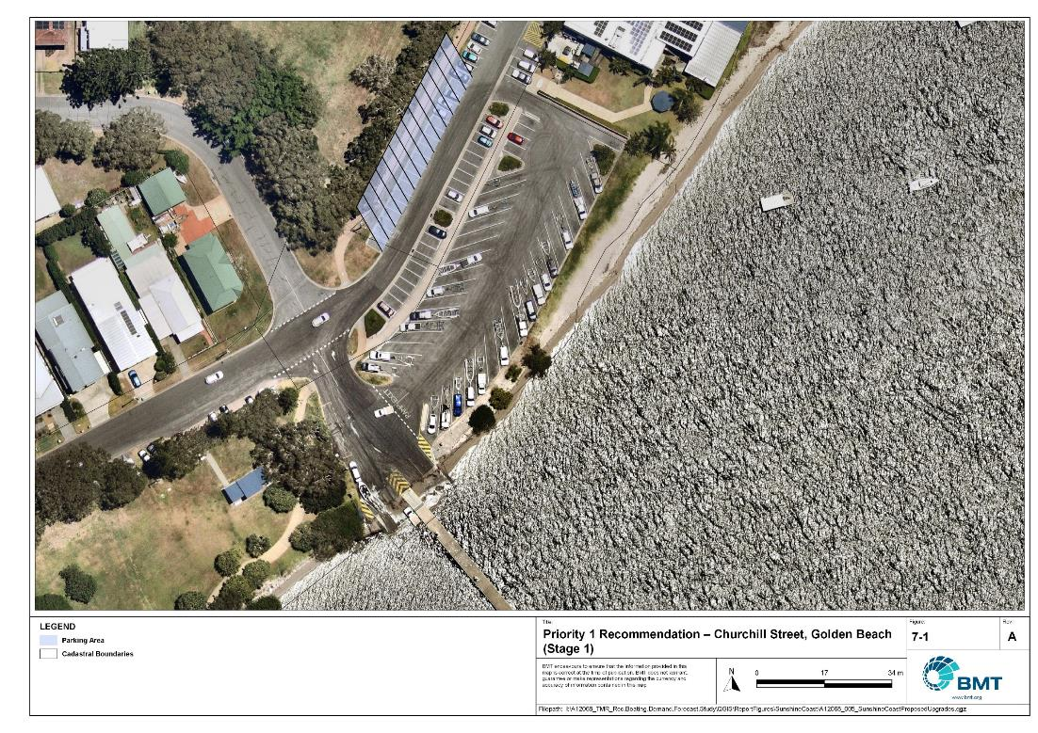

Priority 1 Recommendation – Churchill Street, Golden Beach – Option 1

I:\A12068_TMR_Rec.Boating.Demand.Forecast.Study\Recomendations by Council\JPG\Sunshine Coast\A12068_005_SunshineCoastProposedUpgrades_7-1.jpg

Golden Beach, Churchill St (Priority 1) – Stage 2A

|  |  |  |  |  |
| --- | --- | --- | --- | --- |
| General description | | | | |
| Location | Churchill St, Golden Beach | | | |
| Existing Facility? | Yes | | | |
| Coordinates | -26.830365746786995, 153.1201915601357 | | | |
| Existing tidal status | All-tide | | | |
| Existing wave exposure | None | | | |
| Existing current exposure | None | | | |
| Proposed works | Reclaim land to provide 45 additional CTU parking spaces. | | | |
| Increased effective capacity | 2.0 effective lanes | | | |
| Capacity improvement position | Waterside | Landside | | Both |
| Rationale | This existing facility is the closest to the primary northern opening of Pumicestone Passage. It has excellent waterside capacity but extremely limited landside parking space. Additional land around the site is limited, so reclaiming land to provide additional parking is a potential solution for consideration. Additional CTU space will align the landside capacity with the waterside capacity. New CTU parking spaces can be hybrid to allow parking of passenger vehicles. | | | |
| Anticipated Costs (+/- 50%) | Waterside infrastructure | | - | |
| Landside infrastructure | | $900,000 | |
| Planning, environmental and approvals constraints | | | | |
| Assessment | Requirement | Comments | | |
| Fish Habitat Zone | X | N/A | | |
| Native Title | X | N/A | | |
| MCU requirement | ü | Reclamation works may trigger a Development for a Material Change of Use. | | |
| Clearing remnant vegetation | X | N/A | | |
| GBRWHA | X | N/A | | |
| Marine Park | ü | Reclamation area is located within Habitat Protection Zone of Moreton Bay Marine Park and will require a Marine Park Permit and may also trigger the need for re-gazettal of marine park boundaries.  Works can be undertaken within the Habitat Protection Zone to the extent they protect and manage sensitive habitats (for example. seagrass meadows, coral reef). | | |
| Tidal works assessment | ü | Reclamation will likely be tidal works and require a Development Permit. | | |
| Other as required | ü | Marine Plants – the reclamation works bey impact on seagrass and therefore may require a Development Permit for marine plant disturbance.  Quarry Material Allocation – if the reclamation is undertaken using dredged material, it will require a Quarry Material Allocation.  Ramsar Wetlands – the reclamation works will be within the Moreton Bay Ramsar wetland. This may trigger a Controlled Activity Approval if there is likely to be a significant impact. | | |
| Sea Level Rise | ü | The proposed works are within the boundaries of an erosion prone area. | | |
| Storm Tide Hazard | ü | The proposed works are within the boundaries of a high and medium storm tide hazard area. | | |
| Anticipated Complexity | Low | Medium | | High |
| Maritime engineering review | | | | |
| Assessment | Site considerations | Comments | | |
| Engineering Matters | Water Levels | This site is subject to inundation from tidal waters during storm conditions and more detailed consideration will be required to ensure the recommended option is suitable. | | |
| Sediment Transport | This recommendation requires further investigation to ensure undesirable siltation or disruption to sediment transport does not occur. | | |
| Anticipated Complexity | Low | Medium | | High |

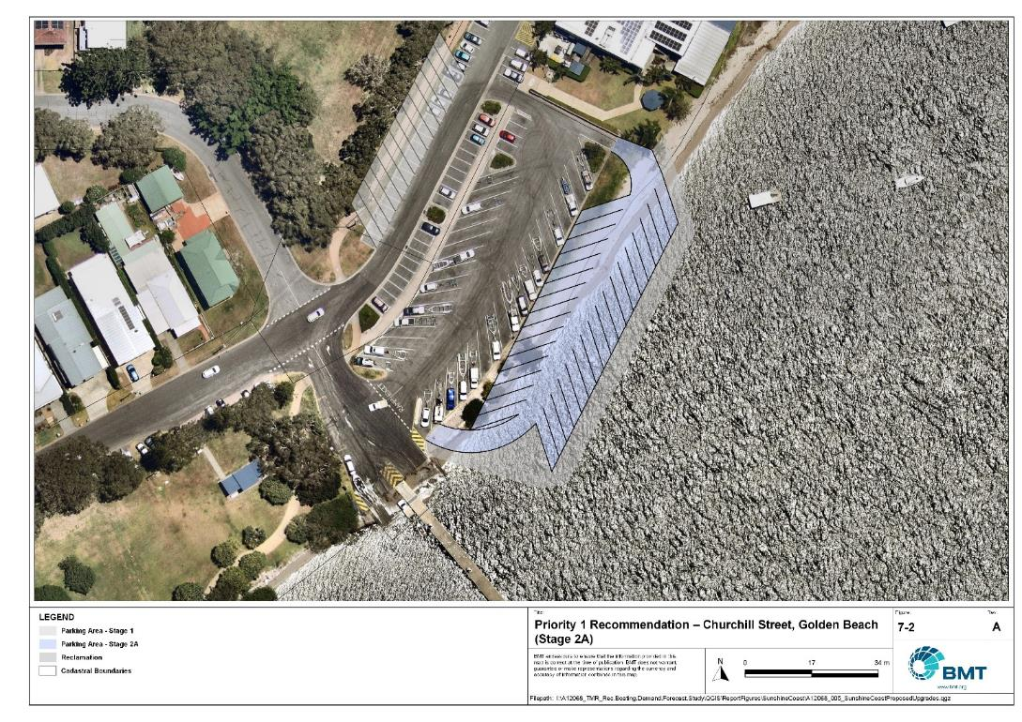

Priority 1 Recommendation – Churchill Street, Golden Beach (Stage 2A)

I:\A12068_TMR_Rec.Boating.Demand.Forecast.Study\Recomendations by Council\JPG\Sunshine Coast\A12068_005_SunshineCoastProposedUpgrades_7-2.jpg

Golden Beach, Churchill St (Priority 1) – Stage 2B

|  |  |  |  |  |
| --- | --- | --- | --- | --- |
| General description | | | | |
| Location | Churchill St, Golden Beach | | | |
| Existing Facility? | Yes | | | |
| Coordinates | -26.830365746786995, 153.1201915601357 | | | |
| Existing tidal status | All-tide | | | |
| Existing wave exposure | None | | | |
| Existing current exposure | None | | | |
| Proposed works | Construct new overflow parking area on land parcel on Lamerough Pde to the west, providing 50 new CTU parking spaces. | | | |
| Increased effective capacity | 2.2 effective lanes. | | | |
| Capacity improvement position | Waterside | Landside | | Both |
| Rationale | This existing facility is the closest to the primary northern opening of Pumicestone Passage. It has excellent waterside capacity but extremely limited landside parking space. Additional land around the site is limited, so this option considers a block of land that is connected via a footpath under the Lamerough Canal Bridge to the facility (approximately 250-300m walk). Parking can be staged to provide increasing capacity. This is an alternative to the reclamation works in Stage 2 of Option 1, should that option prove too costly or environmentally unviable. | | | |
| Anticipated Costs (+/- 50%) | Waterside infrastructure | | - | |
| Landside infrastructure | | $250,000 | |
| Planning, environmental and approvals constraints | | | | |
| Assessment | Requirement | Comments | | |
| Fish Habitat Zone | X | N/A | | |
| Native Title  (Gubbi Gubbi People) | ü | New tenure may be required and therefore interaction with Native Title. | | |
| MCU requirement | ü | Construction of an additional carpark may require a Development Permit for a Material Change of Use. | | |
| Clearing remnant vegetation | X | N/A | | |
| GBRWHA | X | N/A | | |
| Marine Park | X | N/A | | |
| Tidal works assessment | X | N/A | | |
| Other as required | X | N/A | | |
| Sea Level Rise | X | N/A | | |
| Storm Tide Hazard | ü | The proposed carpark works are within the boundaries of a medium storm tide hazard area. | | |
| Anticipated Complexity | Low | Medium | | High |

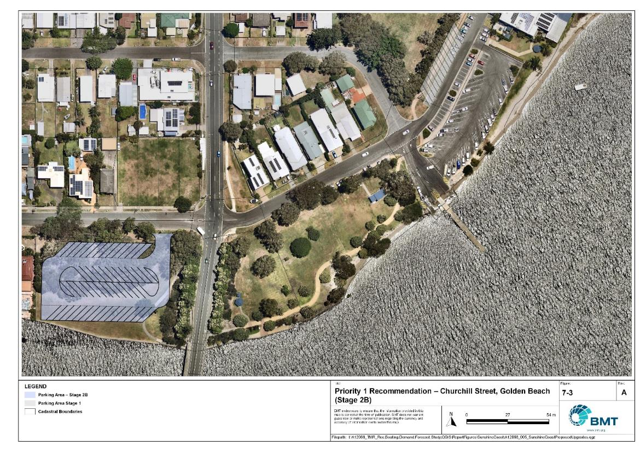

Priority 1 Recommendation – Churchill Street, Golden Beach – Option 2B

I:\A12068_TMR_Rec.Boating.Demand.Forecast.Study\Recomendations by Council\JPG\Sunshine Coast\A12068_005_SunshineCoastProposedUpgrades_7-3.jpg

## Priority 2 recommendations

Parkyn Parade, Mooloolaba (Priority 2)

|  |  |  |  |  |
| --- | --- | --- | --- | --- |
| General description | | | | |
| Location | Mooloolaba State Boat Harbour, Parkyn Parade, Mooloolaba | | | |
| Existing Facility? | Yes | | | |
| Coordinates | --26.685429, 153.127317 | | | |
| Existing tidal status | All-tide | | | |
| Existing wave exposure | None | | | |
| Existing current exposure | None | | | |
| Proposed works | Reconfigure parking to achieve 155 CTU spaces with a second storey (elevated) parking structure that can accommodate a further 80 CTU spaces. | | | |
| Increased effective capacity | 1 lane (ground level)  4 lanes (2nd storey) | | | |
| Capacity improvement position | Waterside | Landside | | Both |
| Rationale | The existing facility is the most popular facility regionally, with high use from local and visiting boat users visiting offshore destinations. The existing space can be more efficiently laid out, with a multi-storey parking option the only realistic way of improving capacity at this facility given the limited availability of additional land for parking.  *Please note this public marine facility is located within a State Boat Harbour, any upgrades should seek to align with future planning processes for the harbour.* | | | |
| Anticipated Costs (+/- 50%) | Waterside infrastructure | | - | |
| Landside infrastructure | | $320,000 (Level 1)  $5,000,000 (Level 2) | |
| Planning, environmental and approvals constraints | | | | |
| Assessment | Requirement | Comments | | |
| Fish Habitat Zone | X | N/A | | |
| Native Title | X | N/A | | |
| MCU requirement | X | N/A | | |
| Clearing remnant vegetation | X | N/A | | |
| GBRWHA | X | N/A | | |
| Marine Park | X | N/A | | |
| Tidal works assessment | X | N/A | | |
| Other as required | X | N/A | | |
| Sea Level Rise | ü | The proposed works are partially within the boundaries of the erosion prone area with the exception of the majority of the parking lot. | | |
| Storm Tide Hazard | ü | The proposed works are within the boundaries of a high and medium storm tide hazard area with the exception of the northern portion of the parking lot. | | |
| Anticipated Complexity | Low | Medium | | High |

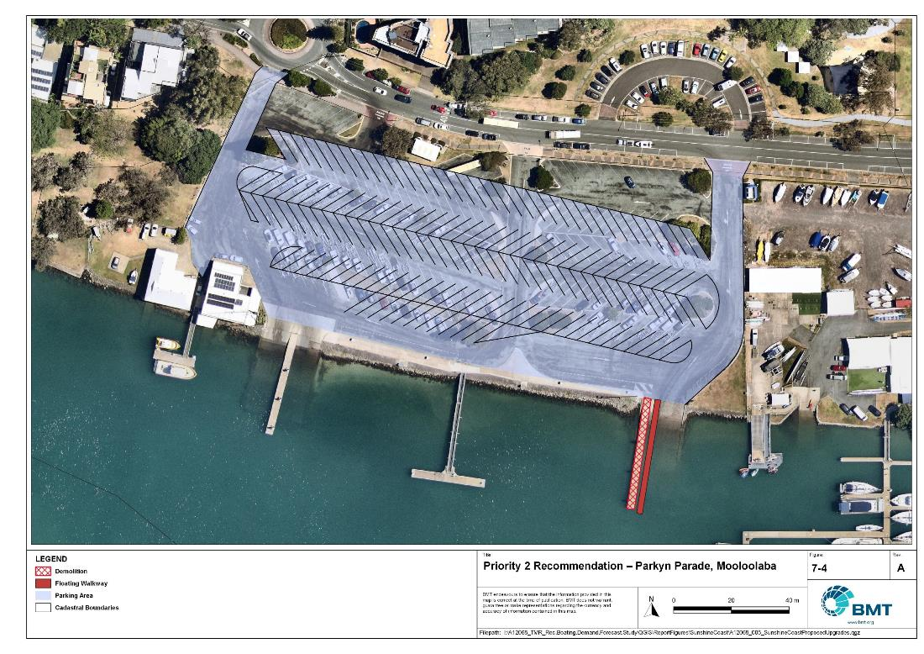

Priority 2 Recommendation – Parkyn Parade, Mooloolaba

I:\A12068_TMR_Rec.Boating.Demand.Forecast.Study\Recomendations by Council\JPG\Sunshine Coast\A12068_005_SunshineCoastProposedUpgrades_7-4.jpg

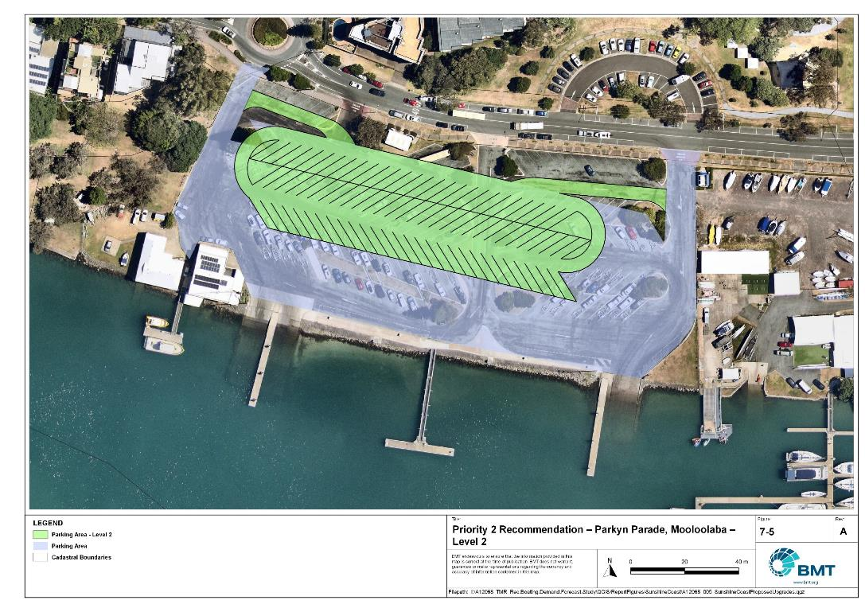

Priority 2 Recommendation – Parkyn Parade, Mooloolaba – Level 2

I:\A12068_TMR_Rec.Boating.Demand.Forecast.Study\Recomendations by Council\JPG\Sunshine Coast\A12068_005_SunshineCoastProposedUpgrades_7-5.jpg

Fishermans Road, Maroochydore (Priority 2)

|  |  |  |  |  |
| --- | --- | --- | --- | --- |
| General description | | | | |
| Location | Fishermans Road, Maroochydore | | | |
| Existing Facility? | Yes | | | |
| Coordinates | -26.643823398683423, 153.0554265638794 | | | |
| Existing tidal status | Near All-tide | | | |
| Existing wave exposure | None | | | |
| Existing current exposure | None | | | |
| Proposed works | Add 45 CTU parking spaces by semi-formalising the existing grass parking area to the east, providing hybrid parks for both CTUs and passenger vehicles. Construct an extra 2 boat ramp lanes and another central floating walkway. | | | |
| Increased effective capacity | 2.0 effective lanes | | | |
| Capacity improvement position | Waterside | Landside | | Both |
| Rationale | This is a popular facility that provides access to the lower Maroochy River with space for expansion. The grassed area is presently being used as parking space for the Fishermans Road Markets. The hybrid parking option will allow this to continue to occur when the markets are on and increase the landside capacity, while the waterside facilities will improve throughput. | | | |
| Anticipated Costs (+/- 50%) | Waterside infrastructure | | $720,000 | |
| Landside infrastructure | | $350,000 | |
| Planning, environmental and approvals constraints | | | | |
| Assessment | Requirement | Comments | | |
| Fish Habitat Zone | ü | Marine-based works is within the Maroochy Fish Habitat Area (FHA008) – Management B Boundary. A Development Permit and Resource Allocation Authority will be required for works within a declared FHA. | | |
| Native Title | X | N/A | | |
| MCU requirement | X | N/A | | |
| Clearing remnant vegetation | X | N/A | | |
| GBRWHA | X | N/A | | |
| Marine Park | X | N/A | | |
| Tidal works assessment | ü | The proposed works will likely be tidal works and therefore require a Development Permit. | | |
| Other as required | X | N/A | | |
| Sea Level Rise | ü | Marine-based infrastructure and the western carpark upgrade is within the boundaries of the erosion prone area subject to sea level rise. | | |
| Storm Tide Hazard | ü | Marine-based infrastructure is within the boundaries of a high storm tide hazard area while the carpark upgrade is within a medium storm tide hazard area. | | |
| Anticipated Complexity | Low | Medium | | High |

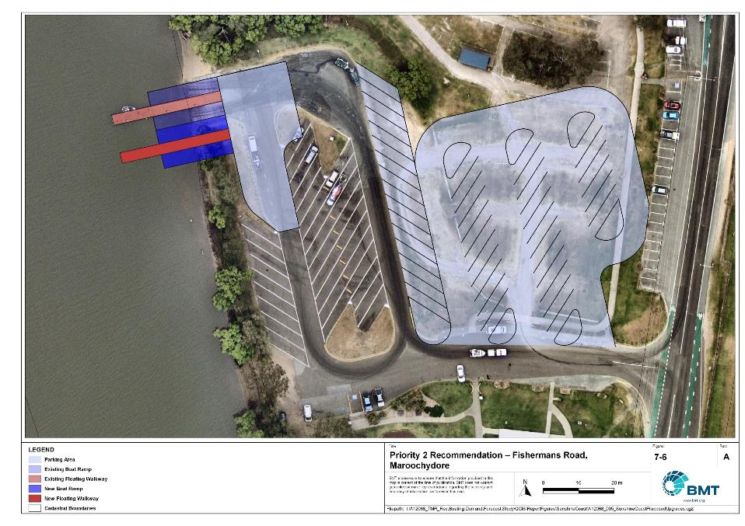

Priority 2 Recommendation – Fishermans Road

I:\A12068_TMR_Rec.Boating.Demand.Forecast.Study\Recomendations by Council\JPG\Sunshine Coast\A12068_005_SunshineCoastProposedUpgrades_7-6.jpg

Short Street, Caloundra (Priority 2)

|  |  |  |  |  |
| --- | --- | --- | --- | --- |
| General description | | | | |
| Location | Short Street, Caloundra | | | |
| Existing Facility? | Yes | | | |
| Coordinates | -26.80705664685497, 153.12430925601282 | | | |
| Existing tidal status | Near all-tide | | | |
| Existing wave exposure | None | | | |
| Existing current exposure | None | | | |
| Proposed works | Widen boat ramp to allow for floating walkway. Construct 50 CTU spaces. | | | |
| Increased effective capacity | 2.0 effective lanes | | | |
| Capacity improvement position | Waterside | Landside | | Both |
| Rationale | This facility is very popular and is often at capacity. While this facility may be currently being used less following the Bribie Island tidal breakthrough and subsequent changes to navigable channels within Pumicestone Passage, it is anticipated that this may resolve itself sufficiently for this recommendation to remain valid at future planning horizons. An upgrade to this facility also supports management of demand on other facilities within the Caloundra and Pelican Waters area.  Monitoring of the navigability of northern Pumicestone Passage is required for the continued use of this facility. | | | |
| Anticipated Costs (+/- 50%) | Waterside infrastructure | | $443,000 | |
| Landside infrastructure | | $350,000 | |
| Planning, environmental and approvals constraints | | | | |
| Assessment | Requirement | Comments | | |
| Fish Habitat Zone | X | N/A | | |
| Native Title | X | N/A | | |
| MCU requirement | X | N/A | | |
| Clearing remnant vegetation | X | N/A | | |
| GBRWHA | X | N/A | | |
| Marine Park | ü | Proposed works are within the Moreton Bay Marine Park within a Habitat Protection Zone and therefore will require a Marine Park Permit.  Works can be undertaken within the Habitat Protection Zone to the extent they protect and manage sensitive habitats (for example. seagrass meadows, coral reef). | | |
| Tidal works assessment | ü | Construction of a floating walkway will likely be tidal works and therefore require a Development Permit | | |
| Other as required | X | N/A | | |
| Sea Level Rise | ü | The northern extent of the carpark and boat ramp are within the boundaries of the erosion prone area subject to sea level rise. | | |
| Storm Tide Hazard | ü | The northern extent of the carpark is within the boundaries of a medium storm tide hazard area while the waterside infrastructure is within the boundaries of a high storm tide hazard area. | | |
| Anticipated Complexity | Low | Medium | | High |
| Maritime engineering review | | | | |
| Assessment | Site considerations | Comments | | |
| Engineering Matters | Sediment Transport | This recommendation requires close monitoring of the local sand shoals to ensure the site still provides useful access to the waterways | | |
| Anticipated Complexity | Low | Medium | | High |

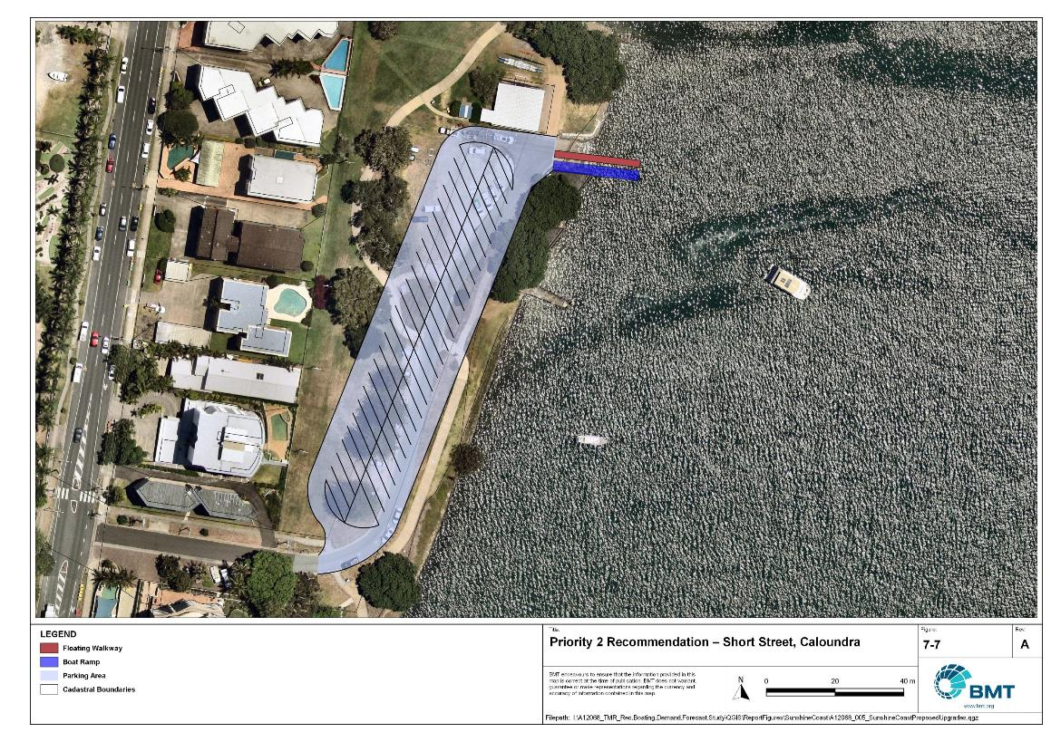

Priority 2 Recommendation – Short Street, Caloundra

I:\A12068_TMR_Rec.Boating.Demand.Forecast.Study\Recomendations by Council\JPG\Sunshine Coast\A12068_005_SunshineCoastProposedUpgrades_7-7.jpg

Bells Creek (Priority 2)

|  |  |  |  |
| --- | --- | --- | --- |
| General description | | | |
| Location | Bells Creek Road, Bells Creek | | |
| Existing Facility? | No | | |
| Coordinates | -26.853391528211684, 153.09290472357867 | | |
| Existing tidal status | N/A – Near all-tide once complete | | |
| Existing wave exposure | None | | |
| Existing current exposure | TBC | | |
| Proposed works | New 2 lane boat ramp with floating walkway and 65 CTU spaces. | | |
| Increased effective capacity | 2.7 Lanes | | |
| Capacity improvement position | Waterside | Landside | Both |
| Rationale | An additional facility at Bells Creek will service the rapidly expanding Caloundra south region with direct access to Pumicestone Passage. At present, residents in this area have a reasonably long drive through Caloundra or Mooloolaba to launch their vessels at facilities that are already under significant demand pressure. The new facility would provide nearby access for residents in this area and reduce pressure on other facilities. | | |
| Anticipated Costs (+/- 50%) | Waterside infrastructure | | $420,000 |
| Landside infrastructure | | $265,000 |
| Planning, environmental and approvals constraints | | | |
| Assessment | Requirement | Comments | |
| Fish Habitat Zone | X | N/A | |
| Native Title  (Gubbi Gubbi People) | ü | New tenure required for new boat ramp, floating walkway and parking lot works so interaction with Native Title may be required | |
| MCU requirement | ü | Boat ramp, floating walkway and parking lot works may trigger a Development Permit for a Material Change of Use | |
| Clearing remnant vegetation | ü | Works are within area containing RVM category B – remnant vegetation. A Development Permit will likely be required for clearing of remnant vegetation. | |
| GBRWHA | X | N/A | |
| Marine Park | X | N/A | |
| Tidal works assessment | ü | Boat ramp and floating walkway works will likely be tidal works and require a Development Permit. | |
| Other as required | ü | Marine Plants – Boat ramp, floating walkway and parking lot works may require clearing of marine plants (that is, mangroves) and therefore may require a Development Permit for marine plant disturbance. | |
| Sea Level Rise | ü | The proposed works are partially within the boundaries of the erosion prone area except for the parking lot. | |
| Storm Tide Hazard | ü | The proposed works are partially within the boundaries of a high and medium storm tide hazard area except for the parking lot. | |
| Anticipated complexity | Low | Medium | High |

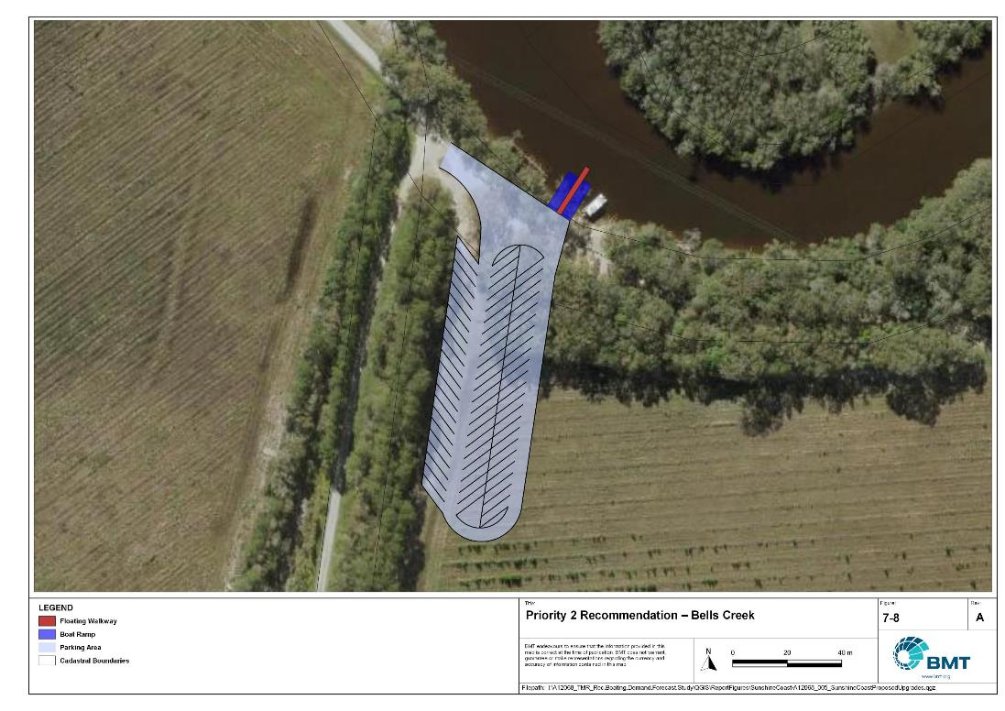

Priority 2 Recommendation – Bells Creek

I:\A12068_TMR_Rec.Boating.Demand.Forecast.Study\Recomendations by Council\JPG\Sunshine Coast\A12068_005_SunshineCoastProposedUpgrades_7-8.jpg

## Priority 3 recommendations

Muller Park, Bli Bli (Priority 3)

|  |  |  |  |  |
| --- | --- | --- | --- | --- |
| General description | | | | |
| Location | Muller Park, Bli Bli | | | |
| Existing Facility? | Yes | | | |
| Coordinates | -26.623838724268854, 153.04611539649957 | | | |
| Existing tidal status | Part-tide | | | |
| Existing wave exposure | None | | | |
| Existing current exposure | None | | | |
| Proposed works | Reconstruct the boat ramp in an area with full tide access and include a floating walkway. Decommission the existing ramp. Expand parking via one of the following parking layouts: Option 1: 55 formal CTUs.  Option 2: 85 formal CTUs. | | | |
| Increased effective capacity | Option 1: 1.4 effective lanes  Option 2: 2.9 effective lanes | | | |
| Capacity improvement position | Waterside | Landside | | Both |
| Rationale | The existing, popular facility services the large northern growth corridor, with this site preferred to others that are further upstream and within fish habitat areas. Relocation of the ramp improves tidal accessibility while removing conflicts with environmental and native title concerns at the existing ramp site. Two parking options have been provided to either minimise the extent of hardstand or maximise capacity. | | | |
| Anticipated Costs (+/- 50%) | Waterside infrastructure | | $785,000 | |
| Landside infrastructure | | $340,000 (either option) | |
| Planning, environmental and approvals constraints | | | | |
| Assessment | Requirement | Comments | | |
| Fish Habitat Zone | ü | Ramp realignment and floating walkway located within the Maroochy Fish Habitat Area (FHA-008) -Management Area B. A Development Permit and Resource Allocation Authority may be required for works within a declared FHA. | | |
| Native Title | X | N/A | | |
| MCU requirement | X | N/A | | |
| Clearing remnant vegetation | X | N/A | | |
| GBRWHA | X | N/A | | |
| Marine Park | X | N/A | | |
| Tidal works assessment | ü | Ramp realignment and floating walkway will likely be tidal works and require a Development Permit | | |
| Other as required | ü | Marine Plants – the ramp and walkway works may impact on marine plants and therefore may require a Development Permit for marine plant disturbance | | |
| Sea Level Rise | ü | The proposed works are within the boundaries of the erosion prone area with the exception of some south-eastern CTU spaces. | | |
| Storm Tide Hazard | ü | The proposed works are within the boundaries of a high and medium storm tide hazard area. | | |
| Anticipated Complexity | Low | Medium | | High |
| Maritime engineering review | | | | |
| Assessment | Site considerations | Comments | | |
| Engineering Matters | Currents | Further assessment of currents at the location of the new boat ramp is suggested. | | |
| Anticipated Complexity | Low | Medium | | High |

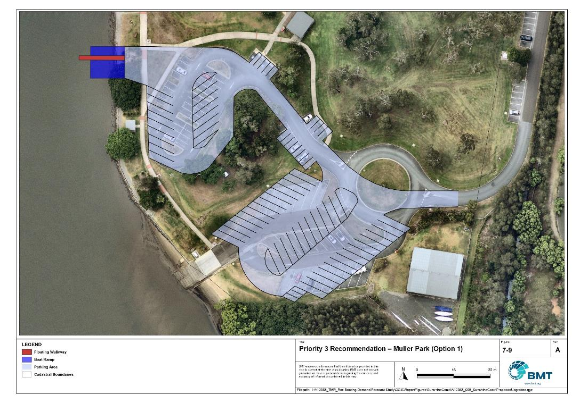

Priority 3 Recommendation – Muller Park (Option 1)

I:\A12068_TMR_Rec.Boating.Demand.Forecast.Study\Recomendations by Council\JPG\Sunshine Coast\A12068_005_SunshineCoastProposedUpgrades_7-9.jpg

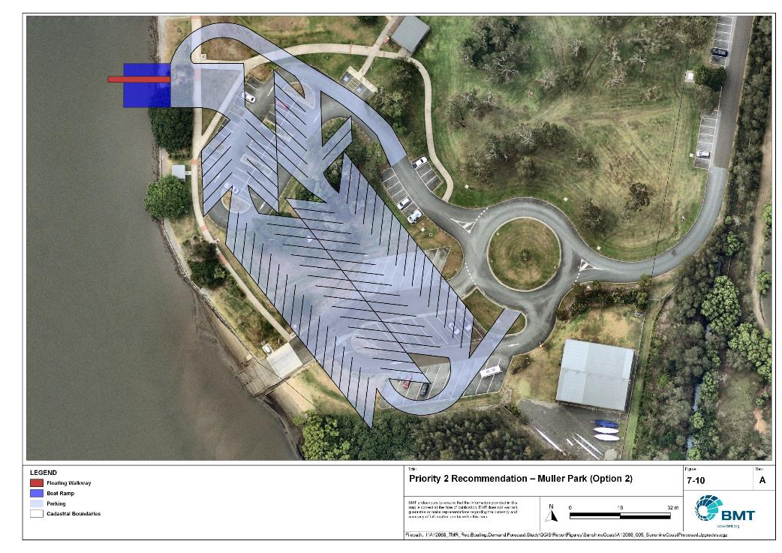

Priority 2 Recommendation – Muller Park (Option 2)

I:\A12068_TMR_Rec.Boating.Demand.Forecast.Study\Recomendations by Council\JPG\Sunshine Coast\A12068_005_SunshineCoastProposedUpgrades_7-10.jpg

West Coolum Road, Coolum (Priority 3)

|  |  |  |  |  |  |
| --- | --- | --- | --- | --- | --- |
| General description | | | | | |
| Location | | West Coolum Road, Coolum | | | |
| Existing Facility? | | Yes | | | |
| Coordinates | | -26.569195813412925, 153.06476970378733 | | | |
| Existing tidal status | | All-tide | | | |
| Existing wave exposure | | None | | | |
| Existing current exposure | | None (flood exposure) | | | |
| Proposed works | | Duplicate boat ramp lane and install fixed sloping walkway. Formalise 35 CTUs. | | | |
| Increased effective capacity | | 1.25 Lanes | | | |
| Capacity improvement position | | Waterside | Landside | | Both |
| Rationale | | This facility provides excellent access for the northern coastal suburbs of the Sunshine Coast LGA into the upper Maroochy River. At present it has no formalised parking and limited overall capacity. Expansion of this site would alleviate pressure on facilities closer to the river mouth, such as Nojoor Road. As the site is subject to flooding a fixed sloping walkway has been proposed, although this should be further assessed during detailed design. | | | |
| Anticipated Costs (+/- 50%) | | Waterside infrastructure | | $364,000 | |
| Landside infrastructure | | $300,000 | |
| Planning, environmental and approvals constraints | | | | | |
| Assessment | | Requirement | Comments | | |
| Fish Habitat Zone | | ü | Proposed marine-based works are located within the Maroochy Fish Habitat Area (FHA-008) – Management B Area. A Development Permit and Resource Allocation Authority may be required for works within a declared FHA. | | |
| Native Title  (Gubbi Gubbi People) | | ü | New tenure required for proposed works and therefore, interaction with Native Title. | | |
| MCU requirement | | ü | Installation of new boat ramp, walkway and parking lot work may trigger a Development Permit for a Material Change of Use. | | |
| Clearing remnant vegetation | | ü | Proposed works are within an area containing RVM category B – remnant vegetation. A Development Permit may be required for the clearing of remnant vegetation. | | |
| GBRWHA | | X | N/A | | |
| Marine Park | | X | N/A | | |
| Tidal works assessment | | ü | The proposed works is likely tidal works and therefore will require Development Permit. | | |
| Other as required | | ü | Marine Plants – The proposed works are likely to disturb marine plants (i.e. mangroves). A Development Permit may be required for the disturbance or removal or marine plants. | | |
| Sea Level Rise | | ü | The marine-based infrastructure and eastward section of the carpark are within the boundaries of the erosion prone area subject to sea level rise. | | |
| Storm Tide Hazard | | ü | The marine-based infrastructure and eastward section of the carpark is within the boundaries of a medium to high storm tide hazard area. | | |
| Anticipated Complexity | | Low | Medium | | High |
| Maritime engineering review | | | | | |
| Assessment | Site considerations | | Comments | | |
| Engineering Matters | Geotechnical | | Low strength or unsuitable materials are likely to be found at this site and a more detailed geotechnical assessment of this recommendation is suggested. | | |
| Current Forces | | Site may be subject to moderate to high flood currents and further assessment of the impact on this recommendation is required. | | |
| Water Levels | | This site is subject to inundation from flood waters during storm conditions and more detailed consideration will be required to ensure the recommended option is suitable. | | |
| Anticipated Complexity | Low | | Medium | | High |

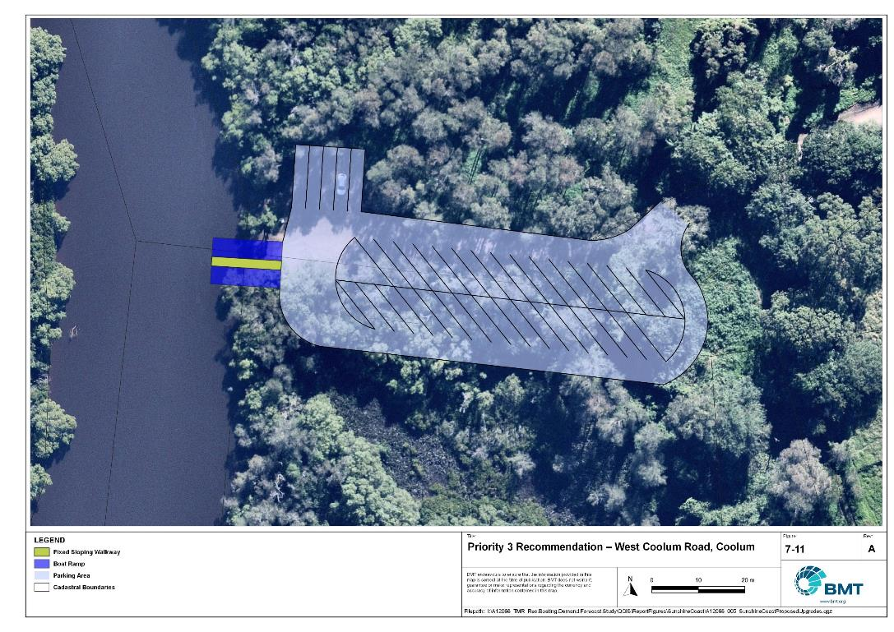

Priority 2 Recommendation – West Coolum Road, Coolum

I:\A12068_TMR_Rec.Boating.Demand.Forecast.Study\Recomendations by Council\JPG\Sunshine Coast\A12068_005_SunshineCoastProposedUpgrades_7-11.jpg

## Priority 4 recommendations

Maroochy River (Priority 4)

|  |  |  |  |  |
| --- | --- | --- | --- | --- |
| General description | | | | |
| Location | Multiple potential locations along the Maroochy River, upstream of Bli Bli | | | |
| Existing Facility? | No | | | |
| Coordinates | Ashton’s Wharf: -26.57030885, 153.00369473  River Store Road: -26.58291135, 153.02622744  River Road: -26.57029199, 153.05354058  Stoney Wharf Road: -26.59657432, 153.05648430 | | | |
| Existing tidal status | N/A | | | |
| Existing wave exposure | N/A | | | |
| Existing current exposure | N/A | | | |
| Proposed works | Investigate feasibility of these sites to determine most appropriate location to construct a 2-lane boat ramp with a floating walkway and 65 CTU parking spaces. | | | |
| Increased effective capacity | 3.0 effective lanes | | | |
| Capacity improvement position | Waterside | Landside | | Both |
| Rationale | Capacity in the upper Maroochy River should be increased to cater for demand from population growth in the Yandina and Bli Bli areas. | | | |
| Anticipated Costs (+/- 50%) | Waterside infrastructure | | TBC | |
| Landside infrastructure | | TBC | |
| Planning, environmental and approvals constraints | | | | |
| Assessment | Requirement | Comments | | |
| Fish Habitat Zone | ü | River Road location is within the Maroochy Fish Habitat Area (FHA-008) – Management B area.  Stoney Wharf Road location is within the Maroochy FHA (FHA-008) – Management A Area.  A Development Permit and Resource Allocation Authority will be required for works within a declared FHA.  Works for public boating infrastructure are permissible in FHA Management A but only where a range of policy requirements are met, including clear demand and the absence of any viable alternatives. | | |
| Native Title  (Gubbi Gubbi People) | ü | A new carpark facility at any location may require new tenure and therefore, interaction with Native Title. | | |
| MCU requirement | ü | Construction of a new carpark facility at any location may trigger a Development Permit for a Material Change of Use. | | |
| Clearing remnant vegetation | ü | Stoney Wharf Road location is within a declared RVM category B – remnant vegetation area. A permit may be required for the clearing of remnant vegetation. | | |
| GBRWHA | X | N/A | | |
| Marine Park | X | N/A | | |
| Tidal works assessment | ü | Construction of a new boat ramp facility at any location will likely be tidal works and require a Development Permit. | | |
| Other as required | ü | Marine Plants – There are marine plants (that is. mangroves) at the Stoney Wharf Road location. A Development Permit may be required for the clearing of marine plants. | | |
| Sea Level Rise | ü | All locations are within the boundaries of the erosion prone area subject to sea level rise | | |
| Storm Tide Hazard | ü | Proposed works at any location are within a medium to high storm tide hazard area. | | |
| Anticipated Complexity | Low | Medium | | High |

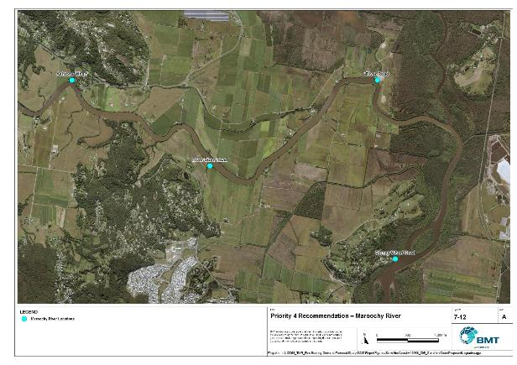

Priority 4 Recommendation – Maroochy River

I:\A12068_TMR_Rec.Boating.Demand.Forecast.Study\Recomendations by Council\JPG\Sunshine Coast\A12068_005_SunshineCoastProposedUpgrades_7-12.jpg

Nojoor Road, Twin Waters (Priority 4)

|  |  |  |  |  |
| --- | --- | --- | --- | --- |
| General description | | | | |
| Location | Nojoor Road, Twin Waters | | | |
| Existing Facility? | Yes | | | |
| Coordinates | -26.638639813867005, 153.0878975097292 | | | |
| Existing tidal status | Near all-tide | | | |
| Existing wave exposure | Nil | | | |
| Existing current exposure | Nil | | | |
| Proposed works | Expand facility to include a total of 4 boat ramp lanes and a total of 100 CTUs.  Prepare sand management plan. | | | |
| Increased effective capacity | 2.6 Lanes | | | |
| Capacity improvement position | Waterside | Landside | | Both |
| Rationale | The existing facility at Nojoor Road is popular and provides high quality access to the lower Maroochy River. With good access from the Sunshine Motorway and from the coastal suburbs north of the river, expansion of this facility provides an optimal location to increase capacity.  This site is prone to shoaling, and to ensure safe launching at all tides, a sand management plan should be implemented. | | | |
| Anticipated Costs (+/- 50%) | Waterside infrastructure | | TBC | |
| Landside infrastructure | | TBC | |
| Planning, environmental and approvals constraints | | | | |
| Assessment | Requirement | Comments | | |
| Fish Habitat Zone | ü | Proposed marine-based works are located within the Maroochy Fish Habitat Area (FHA-008) – Management B Area. A Development Permit and Resource Allocation Authority may be required for works within a declared FHA. | | |
| Native Title | X | N/A | | |
| MCU requirement | X | N/A | | |
| Clearing remnant vegetation | X | Proposed works are within an area containing RVM category B – remnant vegetation. A Development Permit may be required for the clearing of remnant vegetation. | | |
| GBRWHA | X | N/A | | |
| Marine Park | X | N/A | | |
| Tidal works assessment | ü | The proposed works will likely be tidal works and therefore require a Development Permit. | | |
| Other as required | ü | Koala Habitat - Proposed works located within Southeast Queensland (SEQ) koala habitat. A Development Permit may be required for works in SEQ Koala habitat. | | |
| Sea Level Rise | ü | The proposed works are within the boundaries of the erosion prone area subject to sea level rise. | | |
| Storm Tide Hazard | ü | The proposed works are within the boundaries of a medium to high storm tide hazard area. | | |
| Anticipated Complexity | Low | Medium | | High |

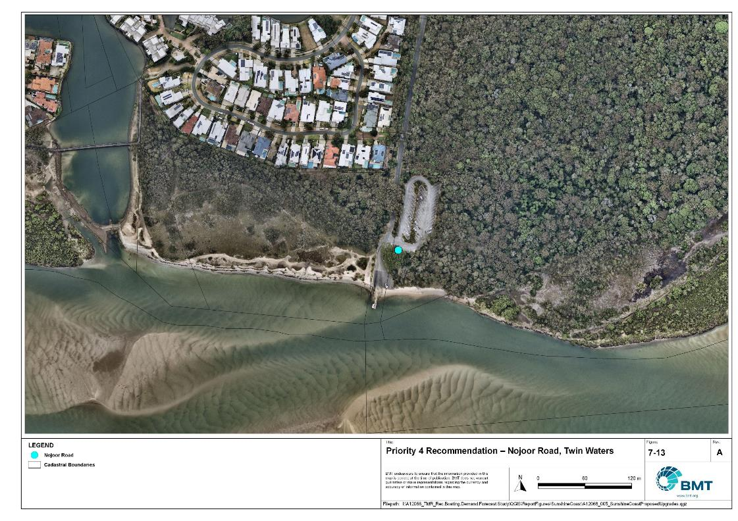

Priority 4 Recommendation – Nojoor Road, Twin Waters

I:\A12068_TMR_Rec.Boating.Demand.Forecast.Study\Recomendations by Council\JPG\Sunshine Coast\A12068_005_SunshineCoastProposedUpgrades_7-13.jpg

# References

Australian Bureau of Statistics (ABS), 2021, *2021 Census,* <https://www.abs.gov.au/census>

Bell, Frederick W. 2022, *Estimation of the present and projected demand and supply of boat ramps for Florida's coastal regions and counties*, Florida State University, Department of Economics.

BMT, 2015, *MPSC Managed Boating Facilities Demand and Capacity Study: Boat Ramp Modelling*

Department of Transport and Main Roads (TMR), 2020, Marine facilities and infrastructure plan.

GHD, 2011, *Recreational Boating Facilities Demand Forecasting Study*

GHD, 2017, *Queensland Recreational Boating Facilities Demand Forecasting Study 2017.*

Maritime Safety Queensland (MSQ), 2022, *Recreational Boating Facilities,* <https://www.getinvolved.qld.gov.au/gi/consultation/8850/view.html>

Queensland Government Department of Resources (DoR), 2022, *Cities and towns [OGC WMS Service]*, Accessed 5/10/2022, available online at spatial.information.qld.gov.au/arcgis/home/item.html?id=103c7c9ccca449fab79d27cde06868ab

Rose, T., R. Powell & J. Yu (2009). Identification of the Present and Future Recreational Boating Infrastructure in Redland City – A 10 Year Infrastructure Plan- Griffith University

SKM (1998) Public Boat Ramps Central Queensland Strategic Plan - Volume One - Demand Forecasting - Noosa to Yeppoon. Sinclair Knight Merz, March 1998.

Swett, R., Fik, T., Ruppert, T., Davidson, G., Guevara, C. & Betty Staugler, 2012, *Planning for the future of recreational boating access to charlotte county waterways: 2010 – 2050*, Florida Sea Grant, University of Florida.

Western Australia Department of Transport, 2019, *Perth Recreational Boating Facilities Study Review 2019*, https://www.transport.wa.gov.au/mediaFiles/marine/MAC_P_Perth_RBFS_study_review_2019.pdf

Western Australia Department of Transport, 2021, *South West Region Recreational Boating Facilities Study July 2021,* https://www.transport.wa.gov.au/mediaFiles/marine/MAC_P_SouthWest_RBFS_Study_2021.pdf

###### Demand Study

"G:\Admin\A12068.g.mpb.TMRBoatingDemand\06_Reports\09_Demand Study\2022_2119 (016) Final Demand Report (March 2023).pdf"

###### Boat launching facility capacity

Capacity of existing boat launching facilities

| Facility ID | Facility Name | | No. Lanes | Tidal Access  (at ramp) |  | Queuing Facility | Formal CTUs | Informal CTUs | Waterside Capacity | Landside Capacity | Effective Capacity | Constraint |
| --- | --- | --- | --- | --- | --- | --- | --- | --- | --- | --- | --- | --- |
| **Open Water Access** | | | | | | | | | | | | | |
| LB21 | Pelican Waters, Raleigh Street | | 1 | Near All-Tide | Near All-Tide | Pontoon | 2 | 3 | 0.96 | 0.5 | 0.5 | Landside |
| LB22 | Pelican Waters, Raleigh Street | | 1 | Near All-Tide | Near All-Tide | Pontoon | 2 | 2 | 0.96 | 0.5 | 0.5 | Landside |
| LB31 | Golden Beach, Churchill Street | | 4 | Near All-Tide | Near All-Tide | Floating Walkway | 31 | 0 | 4.16 | 1.75 | 1.75 | Landside |
| LB51 | Kings Beach, Margaret Street | | 1 | Part-Tide | Part-Tide | None | 4 | 0 | 0.25 | 0.5 | 0.25 | Waterside |
| LB75 | Minyama, Outrigger Island | | 1 | Near All-Tide | Near All-Tide | Beach | 10 | 5 | 0.88 | 1 | 0.88 | Waterside |
| LB82 | Buddina, Adaluma Avenue | | 3 | All-Tide | All-Tide | Pontoon | 0 | 27 | 3.5 | 1.5 | 1.5 | Landside |
| MA11 | Maroochydore, Bradman Avenue | | 2 | All-Tide | All-Tide | Floating Walkway | 17 | 0 | 3 | 1.25 | 1.25 | Landside |
| MA14 | Maroochydore, Fishermans Road | | 2 | All-Tide | All-Tide | Floating Walkway | 32 | 17 | 3.4 | 2.25 | 2.25 | Landside |
| MA15 | Twin Waters, Nojoor Road | | 2 | Near All-Tide | Near All-Tide | Floating Walkway | 45 | 0 | 2.72 | 2 | 2 | Landside |
| MA81 | Mooloolaba, Parkyn Parade (Upstream) | | 4 | All-Tide | All-Tide | Floating Walkway | 70 | 0 | 6 | 3 | 3 | Landside |
| MA83 | Mooloolaba, Parkyn Parade (Downstream) | | 3 | All-Tide | All-Tide | Floating Walkway | 70 | 0 | 4.2 | 3 | 3 | Landside |
| **Subtotal** |  | | **24** |  |  |  | **283** | **54** | **30.0** | **17.3** | **16.9** |  |
| **Distance-limited** | | | | | | | | | | | | | |
| LB55 | Coochin Creek, Roys Road | | 1 | All-Tide | Near All-Tide | Beach | 15 | 0 | 1.1 | 1 | 1 | Landside |
| MA31 | Dunethin Lake, Lake Dunethin Road | | 1 | All-Tide | N/A | None | 0 | 7 | 1 | 0.5 | 0.5 | Landside |
| MA75 | Coolum, West Coolum Road | | 1 | All-Tide | All-Tide | None | 0 | 4 | 1 | 0.5 | 0.5 | Landside |
| **Subtotal** |  | | **3** |  |  |  | **15** | **11** | **3.1** | **2** | **2** |  |
| **Depth-limited** | | | | | | | | | | | | | |
| LB11 | Pelican Waters, June Street | | 3 | Near All-Tide | Near All-Tide | Beach | 25 | 0 | 2.64 | 1.5 | 1.5 | Landside |
| LB12 | Golden Beach, Short Street | | 2 | Near All-Tide | Near All-Tide | Beach | 0 | 10 | 1.76 | 0.75 | 0.75 | Landside |
| LB41 | Caloundra, Tripcony Lane | | 1 | Near All-Tide | Near All-Tide | Pontoon | 8 | 0 | 0.96 | 0.75 | 0.75 | Landside |
| LB71 | Currimundi, Lara Street | | 1 | Part-Tide | Part-Tide | Beach | 4 | 7 | 0.55 | 0.75 | 0.55 | Waterside |
| MA17 | Maroochydore, Picnic Point | | 1 | Near All-Tide | Near All-Tide | Beach | 9 | 0 | 0.88 | 0.75 | 0.75 | Landside |
| MA21 | Bli Bli, Muller Park Road | | 2 | Part-Tide | Part-Tide | Beach | 25 | 0 | 1.1 | 1.5 | 1.1 | Waterside |
| **Subtotal** |  | | **10** |  |  |  | **71** | **17** | **7.9** | **6.0** | **5.4** |  |
|  | | **Fresh Water** | | | | | | | | | | |
| NM01 | Lake Baroon (North) | | 1 | Fresh Water | Fresh Water | None | 0 | 5 | 1 | 0.5 | 0.5 | Landside |
| NM02 | Lake Baroon (South) | | 1 | Fresh Water | Fresh Water | Beach | 10 | 0 | 1.1 | 0.75 | 0.75 | Landside |
| **Sub Total** |  | | **2** |  |  |  | **10** | **5** | **2.1** | **1.25** | **1.25** |  |
|  | | **Total Effective Capacity** | | | | | | | | | **25.5** |  | |

###### Travel time statistics

Travel time from population centres to nearest sheltered all-tide or near all-tide open water accessible facilities

| Population Centre | Travel Time (mins) |
| --- | --- |
| Beerburrum | 17.6 |
| Beerwah | 18.3 |
| Bli Bli | 3.5 |
| Buderim | 4.7 |
| Caloundra | 1.0 |
| Conondale | 40.3 |
| Coolum Beach | 9.5 |
| Eudlo | 14.6 |
| Eumundi | 13.2 |
| Glass House Mountains | 22.4 |
| Kenilworth | 33.7 |
| Landsborough | 14.6 |
| Maleny | 25.5 |
| Mapleton | 18.0 |
| Marcoola | 6.5 |
| Maroochydore | 3.1 |
| Montville | 18.3 |
| Mooloolah | 14.8 |
| Nambour | 9.7 |
| Ninderry | 13.4 |
| North Arm | 15.1 |
| Palmwoods | 10.9 |
| Peachester | 26.0 |
| Witta | 34.0 |
| Woombye | 9.3 |
| Yandina | 12.7 |

###### Facility Use

Boat launching facility usage statistics

| FacilityId | Facility Name | Total Reports | Sunshine Coast | Brisbane | Moreton Bay | Gold Coast | Toowoomba | Logan | Noosa | Ipswich | Redland | Gympie | Other LGAs |
| --- | --- | --- | --- | --- | --- | --- | --- | --- | --- | --- | --- | --- | --- |
| Total |  | 97428 | 71892 | 6912 | 4895 | 1437 | 1266 | 1216 | 1194 | 904 | 862 | 603 | 6247 |
| Total % |  | 100% | 73.8% | 7.1% | 5.0% | 1.5% | 1.3% | 1.2% | 1.2% | 0.9% | 0.9% | 0.6% | 6.4% |
| MA81 | Mooloolaba, Parkyn Parade | 17720 | 69.5% | 7.8% | 5.9% | 2.0% | 1.3% | 1.2% | 1.6% | 0.8% | 0.8% | 0.6% | 8.6% |
| LB82 | Buddina, Adaluma Avenue | 12001 | 82.0% | 3.6% | 2.3% | 1.0% | 2.0% | 0.3% | 0.5% | 0.5% | 0.4% | 0.2% | 7.2% |
| MA11 | Maroochydore, Bradman Avenue | 10984 | 81.9% | 4.2% | 3.0% | 1.2% | 0.8% | 0.7% | 1.4% | 0.9% | 0.4% | 0.7% | 4.7% |
| LB31 | Golden Beach, Churchill Street | 6526 | 67.9% | 10.0% | 6.1% | 1.6% | 1.9% | 2.5% | 0.7% | 1.8% | 1.1% | 0.4% | 6.0% |
| MA14 | Maroochydore, Fishermans Road | 6443 | 81.6% | 5.2% | 2.8% | 0.9% | 0.8% | 0.8% | 1.5% | 0.5% | 0.4% | 0.8% | 4.5% |
| MA15 | Twin Waters, Nojoor Road | 6110 | 77.1% | 7.0% | 4.1% | 1.3% | 1.0% | 0.7% | 3.2% | 0.7% | 0.5% | 0.8% | 3.6% |
| MA17 | Maroochydore, Picnic Point | 5551 | 65.7% | 9.1% | 7.8% | 2.1% | 1.8% | 1.7% | 1.1% | 0.9% | 1.8% | 1.2% | 6.7% |
| LB21 | Pelican Waters, Raleigh Street | 4395 | 75.7% | 7.3% | 4.9% | 1.3% | 1.0% | 0.8% | 0.4% | 1.3% | 0.9% | 0.2% | 6.3% |
| LB75 | Minyama, Outrigger Island | 4199 | 84.8% | 4.2% | 3.0% | 1.4% | 0.4% | 0.3% | 0.5% | 0.4% | 0.3% | 0.5% | 4.1% |
| LB12 | Golden Beach, Short Street | 4137 | 69.5% | 9.8% | 6.5% | 1.2% | 1.6% | 2.2% | 0.8% | 1.3% | 1.3% | 0.4% | 5.4% |
| LB11 | Pelican Waters, June Street | 3609 | 70.5% | 7.6% | 6.3% | 0.8% | 1.1% | 4.2% | 0.3% | 1.6% | 1.1% | 0.4% | 6.3% |
| LB41 | Caloundra, Tripcony Lane | 3407 | 51.6% | 12.0% | 8.8% | 3.1% | 3.5% | 2.2% | 0.6% | 2.5% | 2.3% | 1.2% | 12.2% |
| MA21 | Bli Bli, Muller Park Road | 2973 | 83.4% | 4.4% | 2.5% | 1.2% | 0.8% | 0.5% | 2.3% | 0.4% | 0.2% | 0.8% | 3.7% |
| LB51 | Kings Beach, Margaret Street | 2496 | 75.5% | 9.1% | 4.1% | 1.4% | 0.7% | 1.0% | 0.3% | 1.0% | 1.1% | 0.4% | 5.6% |
| LB71 | Currimundi, Lara Street | 1787 | 73.8% | 9.6% | 6.7% | 0.7% | 0.7% | 1.0% | 0.7% | 0.9% | 1.8% | 0.6% | 3.5% |
| NM02 | Lake Baroon (South) | 1703 | 42.2% | 18.1% | 14.9% | 3.3% | 0.6% | 2.9% | 1.2% | 2.0% | 2.8% | 1.6% | 10.4% |
| MA31 | Dunethin Lake, Lake Dunethin Road | 1100 | 87.5% | 2.7% | 2.0% | 0.1% | 0.3% | 1.3% | 1.0% | 0.0% | 0.4% | 1.4% | 3.5% |
| NM01 | Lake Baroon (North) | 1080 | 36.6% | 16.8% | 13.7% | 3.2% | 1.8% | 3.8% | 2.7% | 1.9% | 3.4% | 1.4% | 14.7% |
| LB55 | Coochin Creek, Roys Road | 679 | 67.3% | 6.8% | 14.9% | 0.4% | 0.1% | 0.9% | 2.4% | 0.6% | 1.2% | 0.3% | 5.2% |
| MA75 | Coolum, West Coolum Road | 528 | 77.3% | 3.0% | 6.8% | 1.1% | 0.6% | 0.4% | 5.5% | 0.0% | 0.2% | 0.0% | 5.1% |

|  |  |  |
| --- | --- | --- |
|  |  | BMT is a leading design, engineering, science and management consultancy with a reputation for engineering excellence. We are driven by a belief that things can always be better, safer, faster and more efficient. BMT is an independent organisation held in trust for its employees. |

|  |  |  |  |  |  |  |  |  |
| --- | --- | --- | --- | --- | --- | --- | --- | --- |
|  |  |  |  |  |  |  | Contact us  enquiries@bmtglobal.com  www.bmt.org  Follow us  www.bmt.org/linkedin LinkedIn logo  www.bmt.org/youtube YouTube logo.  www.bmt.org/twitter Twitter logo.  www.bmt.org/facebook Facebook logo. |  |
|  | Level 5  348 Edward Street  Brisbane  QLD 4000  Australia  +61 7 3831 6744 |  | Registered in Australia  Registered no. 010 830 421  Registered office  Level 5, 348 Edward Street,  Brisbane QLD 4000 Australia |  |  |  |  |
|  | For your local BMT office visit www.bmt.org | | |  |  |  |  |  |