|  |
| --- |
| Queensland Recreational Boating Facilities Demand Forecasting Study 2022  Cairns LGA Assessment |
|  |
|  |

|  |  |  |
| --- | --- | --- |
| Customer |  | Maritime Safety Queensland |
| Project |  | A12068 |
| Deliverable |  | 018 |
| Version |  | 01 |
|  |  | 21 April 2023 |

Document Control

Document Identification

|  |  |
| --- | --- |
| Title | Queensland Recreational Boating Facilities Demand Forecasting Study 2022 |
| Project No | A12068 |
| Deliverable No | 018 |
| Version No | 01 |
| Version Date | 21 April 2023 |
| Customer | Maritime Safety Queensland, a branch of the Department of Transport and Main Roads |
| Customer Contact | boatinginfrastructure@msq.qld.gov.au |
| Classification | {None} |

|  |  |
| --- | --- |
| Author | Daniel Wishaw, Nicholas Heiner, Geoff Long, Azam Dolatshah, Sophie Barrett, Mackenzie Stacey |
| Reviewed By | Katrina O’Malley-Jones, Jeremy Visser |
| Project Manager | Daniel Wishaw |

Amendment Record

The Amendment Record below records the history and issue status of this document.

| Version | Version Date | Distribution | Record |
| --- | --- | --- | --- |
| 00 | 09 February 2023 | Maritime Safety Queensland  Cairns Regional Council | Draft |
| 01 | 21 April 2023 | Maritime Safety Queensland | Final |

Executive Summary

This report, part of the Queensland Recreational Boating Facilities Demand Forecasting Study 2022 (‘the Study’), provides a summary of current and forecast demand on recreational boating facilities in Cairns LGA and the capacity of existing facilities to meet this demand. Where capacity is insufficient to meet current or forecast demand, recommendations have been made to improve existing facilities or for the construction of new facilities. This report is intended to support facility deliverers, owners, and managers over the next 20 years in their decision-making on development priorities for recreational boating facilities within Cairns LGA.

Key issues and attributes of recreational boating

The key attributes of recreational boating facilities identified in this Study for Cairns LGA are summarised in Table 1, while consultation with stakeholders undertaken as part of the Study identified the following key issues:

* Expansion of other activities in the Port of Cairns conflicts with existing and proposed recreational boating facilities within Trinity Inlet.
* The population of the LGA and of Cairns City itself is well dispersed, necessitating facilities to service southern, central and northern Cairns.
* Safety of boat users with respect to crocodiles at many ramps is an identified hazard.
* A lack of public deep-draught vessel landings within the LGA.

1. Key recreational boating attributes for Cairns LGA

| Key attribute | Value |
| --- | --- |
| Deep-draught landing facilities |  |
| Existing capacity (number) | 1 |
| Existing demand (number) | 3.7 |
| Existing shortfall (number) | 2.7 |
| Boat launching facilities |  |
| Number of existing facilities | 13 |
| Number of existing ‘effective’ boat launching lanes | 22 |
| Current demand for boat launching lanes (effective lanes) | 28.8 |
| Current shortfall of ‘effective’ boat launching lanes (number) | 6.8 |
| Demand satisfaction for ‘effective’ boat launching lanes | 76% |
| State-wide demand satisfaction for ‘effective’ boat launching lanes | 87% |

Demand summary

The assessment of recreational boating demand is centred on a statistical demand model that considers vessel registration data, population statistics, assumptions around local usage and the movement of vessels into and out of the LGA. Key parameters from this assessment for Cairns LGA are:

* The population is 172,216 as at the 2021 census and is projected to be 206,548 by 2041.
* As of July 2022, there is a total of 11,553 vessels with a home registration within the LGA, with 95% being ‘trailable’ – and therefore requiring boat launching facilities – and 5% being non-trailable.
* Cairns is deemed to be a Regional Centre with an assumed vessel activation rate of 10% on a ‘good boating day’.
* Vessels are primarily used within the LGA, with some leakage to Cassowary Coast, Douglas, Hinchinbrook and Townsville LGAs.
* Vessels from Tablelands, Cassowary Coast, Townsville and other western LGAs flow into the LGA and contribute to local demand.
* The existing demand for boat launching facilities is 28.8 ‘effective’ boat ramp lanes and projected 34.2 ‘effective’ lanes by 2041.
* The existing demand for deep-draught vessel landings is 3.7 currently and 4.4 by 2041.

Boat launching

Boat launching facilities comprise boat ramps, any queuing facilities (floating walkways, pontoons, beaches and fixed sloping walkways) and the provision of ca-trailer unit (CTU) parking. The capacity of a boat launching facility is measured in ‘effective’ lanes for both waterside and landside facilities, with the total capacity of a facility being the minimum of the waterside or landside capacity. Waterside capacity is calculated from the number of boat ramp lanes multiplied by environmental reduction factors (for tide, current or waves) and queuing facility improvement factors to derive the number of ‘effective’ lanes. The landside capacity is calculated from the number of available CTU parking spaces.

Cairns LGA has 13 boat launching facilities, comprising 31 boat ramp lanes with a total effective boat launching capacity of 22 ‘effective’ lanes. One of these facilities is constrained by waterside capacity with the remainder constrained by landside capacity.

The capacity, forecast demand, and shortfall of boat ramp effective lanes in Cairns LGA is shown in Figure 1.

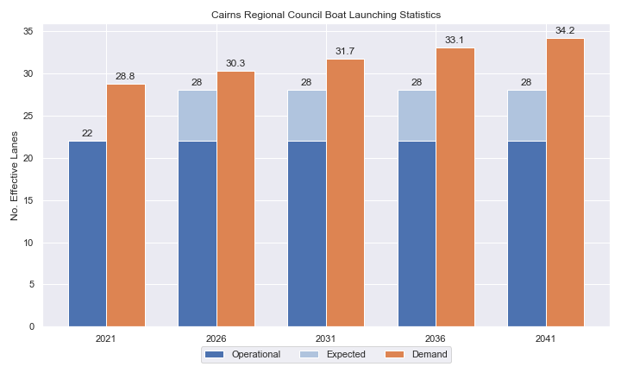

1. Existing capacity, forecast demand and shortfall of ‘effective’ boat ramp lanes for Cairns LGA

Deep-draught vessel landings

Vessel landing facilities are provided across the state in the form of pontoons and jetties, to provide locations for larger vessels, or their tenders, to access landside destinations or facilities. Pontoons and jetties may also be provided for other purposes such as supporting boat launching or other recreation and may not be suitable for deep-draught vessels. The trend across Queensland indicates that jetties are rarely used as landings, with pontoons preferred by recreational users. As such, the Study has limited the capacity of deep-draught vessel landings to those that are accessible and commonly used by deep-draught vessels, as identified in consultation with stakeholders.

Cairns LGA has one mainland public deep-draught vessel landing at Tingira Street, that is used by vessels anchored in Trinity Inlet, but it is not ideally located to access landside destinations. Public jetties are available on Fitzroy and Green Islands; however, they haven’t been included as deep-draught landings as they are only used to access the resorts on these islands. The one mainland public facility is supported by private facilities at Yorkeys Knob and Cairns Marlin Marina, the latter of which can arrange free short-term berthing. The shortfall assessment in Table 2 indicates that public landing capacity for deep-draught vessels is currently insufficient to support demand in Cairns LGA as well as coastal passaging vessels.

1. Deep-draught vessel landing shortfall summary

| Criteria | 2021 | 2026 | 2031 | 2036 | 2041 |
| --- | --- | --- | --- | --- | --- |
| Deep-draught vessel demand | 3.7 | 3.9 | 4.1 | 4.3 | 4.4 |
| Deep-draught vessel capacity | 1 | 1 | 1 | 1 | 1 |
| Shortfall | 2.7 | 2.9 | 3.1 | 3.3 | 3.4 |

Priority recommendations

Recommendations for new facilities or upgrades to existing facilities are outlined in Table 3. The range of recommendations seeks to reduce the overall capacity shortfall within Cairns LGA over the 20-year planning life of this project, as well as address specific concerns, including:

* providing a suitable alternative to the Fearnley Street and Tingira Street facilities, should either be lost to port expansion
* providing a deep-draught vessel landing that has good access to desirable landside destinations in Cairns LGA
* providing suggestions to modify the flow of the Trinity Park (Bluewater) boat launching facility to improve traffic issues
* distributing capacity around the communities within Cairns LGA.

Recommendations

1. Summary of recommended boating infrastructure upgrades for Cairns LGA

| Priority | Criteria | Recommendations |
| --- | --- | --- |
| 1 | * Required to meet existing demand. * Sites that can provide maximum benefit for existing demand pressures at an LGA scale or satisfy specific safety pressures. | * Deeral: Formalise additional 30 CTU spaces and add an additional queuing facility * Tingira south: Provide replacement capacity for Tingira and Fearnley Street. Construct 2x4-lane ramps with 2 floating walkways per ramp and 240 CTUs. * Marlin Parade: Install deep-draught pontoon with 2 berthing sites. |
| 2 | * Required to meet demand within the next five to ten years. * Sites that are likely to have low to medium approval complexity. * Sites that can provide satisfaction of specific demand or safety pressures within the LGA. | * Nil |
| 3 | * Required to meet demand within the next ten to fifteen years. * Sites that service planned future growth within the LGA. | * Trinity Park (Bluewater Estate): Modify parking layout to achieve an additional 12 CTU spaces. Modify road alignment to reduce congestion. Install pontoon. |
| 4 | * Required to meet demand within the next fifteen to twenty years. * Sites that service planned future growth within the LGA. | * Nil |

Contents

Definitions 10

1 Introduction 13

2 Cairns LGA Overview 14

2.1 Key influences on recreational boating 14

2.2 Existing recreational boating infrastructure 14

2.3 Existing usage and issues 17

3 Capacity Assessment 18

3.1 Boat ramps 18

3.2 Access to sheltered near all-tide and all-tide facilities 24

3.3 Deep-draught vessel landings 27

4 Demand Assessment 28

4.1 Activation rate 28

4.2 Digital user survey 29

4.3 Active fleet size 33

4.4 Boat ramp lane demand 33

4.5 Non-statistical demand 33

4.6 Deep-draught vessel demand 34

5 Shortfall Assessment 35

5.1 Shortfall assessment – boat ramps 35

5.2 Shortfall assessment – deep-draught landings 36

6 Stakeholder Feedback 37

6.1 Managing authority feedback 37

6.2 Stakeholder feedback 37

7 Development Recommendations 39

7.1 Previous recommendations 39

7.2 Priority recommendations 40

7.3 Priority 1 recommendations 42

7.4 Priority 4 Recommendations 54

8 References 55

Annex A Demand Study A-1

Annex B Boat launching facility capacity B-1

Annex C Travel time statistics C-1

Annex D Facility Use D-1

Tables

Table 2.1 Recreational boating facilities by facility owner in Cairns LGA 14

Table 3.1 Queuing facility efficiency modifiers 21

Table 3.2 Mainland deep-draught landing facilities within Cairns LGA 27

Table 4.1 LGA of origin for active fleet in Cairns LGA 29

Table 4.2 Popularity of boat launching facilities 30

Table 4.3 Active fleet vessel size 33

Table 4.4 Boat ramp lane demand 33

Table 4.5 Deep-draught vessel landing demand 34

Table 5.1 Shortfall of boat launching facilities 35

Table 5.2 Shortfall assessment for open water, all-tide or near all-tide facilities for Cairns LGA 36

Table 5.3 Shortfall of deep-draught vessel landings 36

Table 6.1 Stakeholder identified opportunities 37

Table 7.1 Assessment of unimplemented 2017 recommendations 39

Table 7.2 Summary of recommendations for Cairns LGA 41

Table 7.3 Deeral - (Priority 1) 42

Table 7.4 Tingira Street south- (Priority 1) 45

Table 7.5 Marlin Parade pontoon - (Priority 1) 48

Table 7.6 Trinity Park - (Priority 3) 51

Table B.1. Capacity of existing boat launching facilities B-1

Table C.1. Travel time from population centres to nearest sheltered all-tide or near all-tide open water accessible facilities C-1

Table D.1. Boat launching facility usage statistics D-1

Figures

Figure 2.1 Cairns LGA - Boat launching facilities 15

Figure 2.2 Cairns LGA - Deep-draught landing facilities 16

Figure 3.1 (a) Summary of open water access from boat launching facilities (left) and (b) Summary of tidal restrictions at tidal boat launching facilities (right) 23

Figure 3.2 Summary of limiting capacity constraint 24

Figure 3.3 Distribution of travel time from Cairns LGA’s eligible population centres to sheltered near all-tide facilities 25

Figure 3.4 Cairns LGA – Travel time to nearest all-tide or near all-tide facility 26

Figure 4.1 Cairns LGA – vessel pathing 32

Figure 5.1 Shortfall assessment with recommended upgrades adopted. 35

Figure 7.1 Priority 1 Recommendation – Deeral, Ross Road 44

Figure 7.2 Priority 1 Recommendation – Tingira Street south 47

Figure 7.3 Priority 1 Recommendation – Marlin Parade Pontoon 50

Figure 7.4 Priority 3 Recommendation – Harbour Drive, Trinity Park 53

Definitions

| Term | Definition |
| --- | --- |
| All‑tide (for boat ramps) | Access from a boat ramp to the open sea with an approach depth of 0.5m below LAT or deeper and a depth at boat ramp toe of 0.5m below LAT or deeper. |
| All-tide (for landings) | Access from a gangway‑access pontoon or jetty to the open sea with an approach depth of 1.5m below LAT or deeper and a depth on at least one face of the pontoon of 1.5m below LAT or deeper. |
| BIP | Boating Infrastructure Program – a sub‑program within MSQ's Maritime Assets and Infrastructure Program |
| Boat ramp | A foreshore concrete ramp with a slope designed for vehicular launching and retrieving of recreational boats. |
| Breakwater | A structure constructed over the seabed and/or the foreshore, usually rising to a height above high tide, designed to provide protection to landward areas by limiting penetration of wave action or currents. |
| CTU | Car-trailer unit space – a parking space for a typical car with a boat trailer attached. |
| Demand | Demand is the requirement of the boat‑owning population for facilities to launch/retrieve trailer boats and/or to berth suitable boats at a given year to service their average (non‑peak period) needs. In most locations demand is based on vessel registrations and is expressed in terms of boat ramp lanes or in number of 12m berths at landings. |
| Effective capacity | For a boat ramp, effective capacity (effective lanes) means the number of boat ramp lanes after adjusting for anticipated unavailability due to unacceptable wave action (>0.2m wave height) or water depth, usage constraints such as the lack of adequate parking, and improvements to efficiency or launch/retrieval throughput such as floating walkways or pontoons. |
| FHA | Fish Habitat Area, declared under the Fisheries Act, 1994 |
| FIFO | Fly‑in fly‑out, where skilled workers travel from their city or central location home communities to a remote site to perform their duties often in blocks of time that provide regular, non-weekend, days off. |
| Fixed sloping walkway | A fixed sloping structure installed at the side of a boat ramp to assist launching/retrieval of trailer boats, and dry embarkation/disembarkation from trailer boats. It is sloped to allow use at varying tide heights – sometimes with sections of different slope. |
| Floating walkway | Multiple connected/hinged flotation modules configured to assist launching/retrieval of trailer boats, and dry embarkation/disembarkation from trailer boats at most if not all stages of the tide. Floating walkways are connected to a concrete shore abutment allowing pedestrian and assisted wheelchair access. |
| Gangway access pontoon | A platform/module that always floats, where a boat can be secured alongside on one or more faces. Pontoons are usually separated from a boat ramp and have a hinged articulated gangway for access to the shore via an abutment. |
| GBR | Great Barrier Reef |
| GCWA | Gold Coast Waterways Authority |
| Landing | A landing is a jetty or gangway‑access pontoon that facilitates berthing of vessels and transfer of passengers and stores. They are most often associated with non-trailable vessels |
| Landside | Refers to areas above high-water mark, often used to denote the location of and type of infrastructure. |
| LAT | Lowest Astronomical Tide, used as Chart Datum on navigational charts. |
| LGA | Local Government Area |
| Managing authority | Councils, port authorities, water storage managers as listed in schedule 1 of the Transport Infrastructure (Public Marine Facilities) Regulation 2011 |
| MCU | Material change of use under the planning scheme |
| MNES | Matter of national environmental significance under the Environment Protection and Biodiversity Conservation Act 1999 |
| MSQ | Maritime Safety Queensland |
| NC Act | Nature Conservation Act 1992 |
| Near all‑tide | Access from a boat ramp to the open sea with a minimum approach depth of 0.5m below LAT and minimum depth at the boat ramp of 0.5m below LAT for 80 percent or more of the tidal range (time measured over a year). |
| Parking - Formalised | A sealed, line-marked parking area for car-trailer units, providing adequately sized parking spaces, roadways and turning circles. |
| Parking – Semi-formalised | An all-weather non-sealed parking area, with markers to delineate adequately sized car-trailer unit parking bays and turning circles. Markers can be concrete blocks, pavement markers (e.g., retro-reflective raised markers) or other permanent instalment to show parking bays. |
| Parking – Informal overflow | A naturally surfaced area available for use as overflow parking on the design boating day, signed as such. To have mixed-use purpose (e.g., parkland) when not being utilised as overflow parking. |
| Part‑tide | Boat ramps that do not meet near all-tide or near all-tide requirements. |
| PV | Passenger vehicle (i.e., car – as opposed to car-trailer unit). |
| Port Authority | An organisation that is responsible for the management of one or more ports on the Queensland coast. |
| Population Centre | Official named urban settlements (populated places) that have been sourced from the Queensland Place Names Database. |
| Registration activation rate | The percentage of registered vessels liable to be in use on any given good weather weekend day |
| Shortfall | The number of effective boat ramp lanes or landings required to meet demand for a given timeframe. Negative shortfall signifies an oversupply for the time period nominated. |
| SPL | Strategic Port Land |
| Study | The Recreational Boating Facility Demand Forecasting Study 2022, including this document. |
| TMR | Department of Transport and Main Roads |
| Water Storage Authority | Includes Seqwater, Sunwater |
| Waterside | Refers to areas below high-water mark, often used to denote the location of and type of infrastructure, including dredged channels and breakwaters. |
| WHA | World Heritage Area |
| # | Number |

# Introduction

BMT has been appointed to undertake the Recreational Boating Facilities Demand Forecasting Study 2022 (‘the Study’) by Maritime Safety Queensland (MSQ), a branch of the Queensland Department of Transport and Main Roads (TMR), on behalf of all public recreational boating facility managers and owners across Queensland. The Study supersedes the 2017 study of the same name and is intended to report on recreational boating facility demand, capacity, and shortfall over a 20-year period at a Local Government Area (LGA) scale across Queensland.

The Study has been developed using information from the 2021 Australian Census (ABS, 2021), recreational boat vessel registrations, consultation with facility owners, managers, and stakeholders, the 2022 Queensland Government Get-Involved recreational boating facilities survey (MSQ, 2022), and previous versions of this Study (2011, 2017). The Study is intended for use by deliverers, owners, managers, and key stakeholders of public recreational boating facilities across Queensland, namely state government agencies including MSQ and the Gold Coast Waterways Authority (GCWA), local governments, port authorities and water authorities. The Study is non-regulatory in nature and is intended to be used as part of a broader suite of information to identify priority investment in recreational boating infrastructure at a local and state level.

The Study establishes demand primarily on statistics derived from registration and population data. Please refer to Section 4.5 for discussion of non-statistical demand. The Study evaluates existing and forecast demand over a 20-year period and makes recommendations on how this demand might be met over that period. Recommendations may include improvements to both landside and waterside capacity depending on the facility.

Recommendations are assigned a priority ranking, from 1 to 4, indicating if they are required immediately or in the next 5, 10 or 15 years respectively. To end 2022, 14% of recommendations from the 2017 study have been completed, comprising 11% of land-side recommendations and 18% of waterside recommendations and reflecting 22% of priority 1 the 2017 recommendations. A much greater percentage of the earlier 2011 study recommendations have now been implemented. Given the low uptake on existing/outstanding recommendations, this Study will review previous recommendations and carry forward, modify, or remove as appropriate. The Study has also been tasked with reviewing specific wave exposed beach launching facilities across the state to determine their contribution to meeting boating facilities demand and make recommendations about their future.

The Study is comprised of a report for every LGA in Queensland and a state-wide summary report. Each LGA report summarises demand pressures from vessel registration data, population statistics, assumptions around local usage and the movement of vessels into and out of the LGA, and existing capacity and recommends opportunities to satisfy shortfall. The state-wide report will support the LGA reports and provide context at a state level for demand pressures, current capacity, equity of access to facilities and state-wide priority for major boating facilities.

The Study is intended to report on publicly accessible recreational boating facilities for registered vessels. This includes boat ramps, floating walkways, pontoons, fixed sloping walkways and supporting car-trailer unit parking at each facility. The Study does not include recommendations for facilities that are used primarily for commercial purposes, private facilities, non-motorised recreation such as launching canoes and stand-up paddle boards, and fishing platforms.

# Cairns LGA Overview

## Key influences on recreational boating

Within Cairns LGA, the principal attributes and influences that affect demand on recreational boating infrastructure include:

* its designation as a Regional Centre, with a large local recreational boating fleet
* strong projected population growth
* attractive destinations accessed from facilities in neighbouring LGAs that are used by Cairns LGA vessels.

## Existing recreational boating infrastructure

The recreational boating facilities within Cairns LGA are summarised in Table 2.1. These facilities are owned or managed by multiple organisations and include facilities that provide access to open water and estuaries. MSQ’s long term vision is to provide unrestricted access to open water from facilities along the Queensland coast such that all significant population centres are within one hour’s driving range where practical. For clarity, the Study has defined this vision to be the provision of sheltered all-tide, or near all-tide, boat launching facilities within one hour driving range of official population centres (DoR, 2022) lying within 30km of the coastline between the NSW border and Cooktown.

Recreational boating facilities by facility owner in Cairns LGA

| Owner | Open-water boat ramps | | Other boat ramps | | Landings | |
| --- | --- | --- | --- | --- | --- | --- |
| Facilities | Lanes | Facilities | Lanes | Pontoons | Jetties |
| TMR | 4 | 13 | 9 | 18 | 1 | 3 |
| Cairns Regional Council |  |  |  |  |  | 1 |

Each of the boat launching facilities within the LGA are shown in Figure 2.1 and deep-draught vessel landings in Figure 2.2.

Access to land from deep-draught vessels is catered for by the provision of landings such as jetties and pontoons that are intended for short term usage, mainly to drop off and embark passengers and supplies. Within Cairns LGA the only mainland deep-draught landing is the pontoon at the Tingira street boat launching facility. Free temporary mooring can also be arranged at Cairns Marlin Marina.

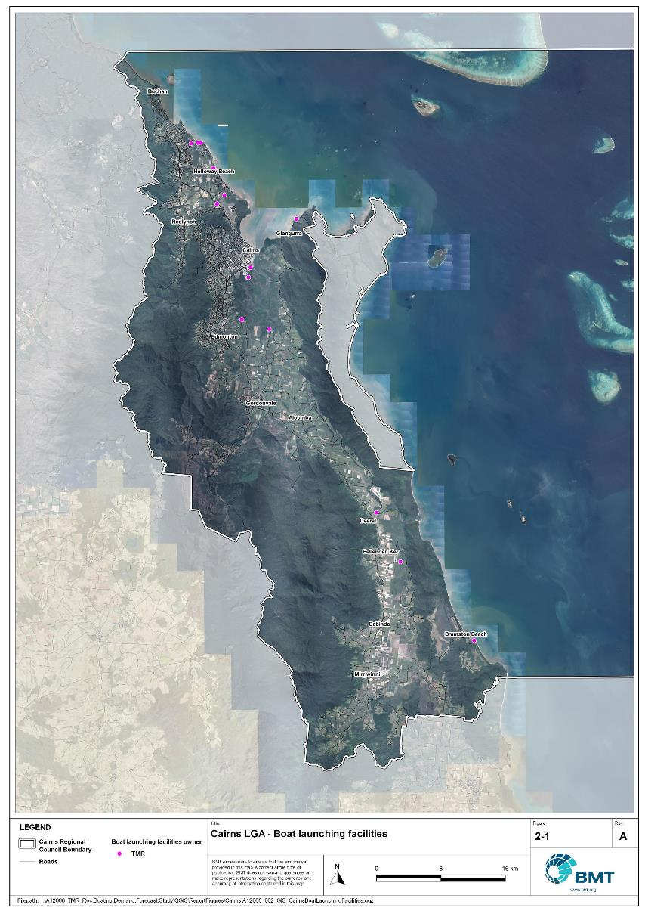

Cairns LGA - Boat launching facilities

"I:\A12068_TMR_Rec.Boating.Demand.Forecast.Study\QGIS\ReportFigures\Cairns\A12068_002_GIS_CairnsBoatLaunchingFacilities.jpg"

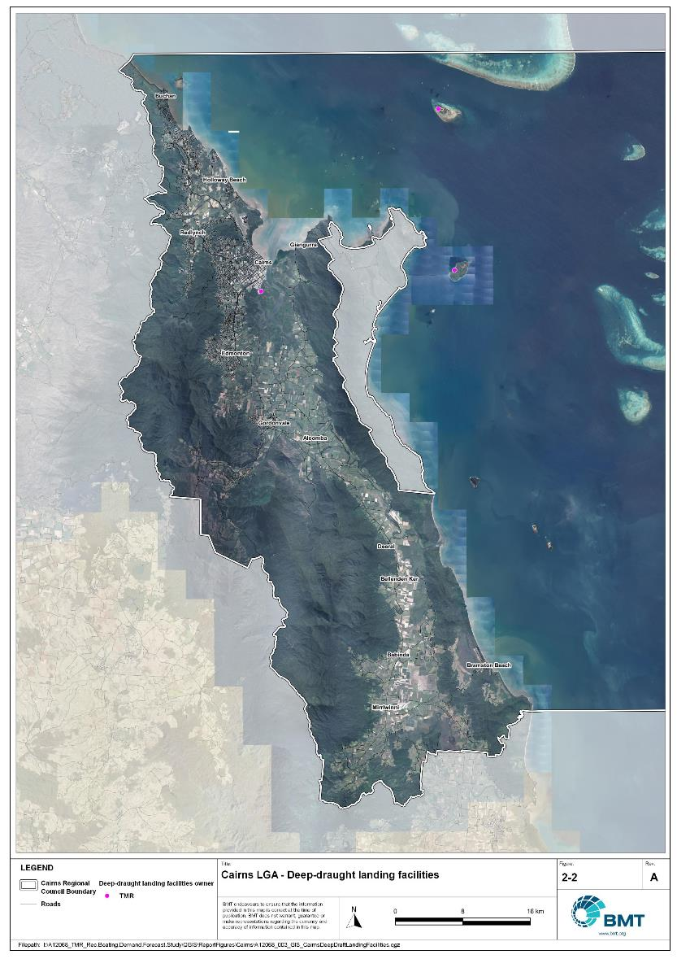

Cairns LGA - Deep-draught landing facilities

"I:\A12068_TMR_Rec.Boating.Demand.Forecast.Study\QGIS\ReportFigures\Cairns\A12068_003_GIS_CairnsDeepDraftLandingFacilities.jpg"

## Existing usage and issues

Consultation with Cairns Regional Council, Sunwater, Ports North, Maritime Safety Queensland, recreational groups and feedback from the recreational boating facilities survey hosted by TMR indicate the following major themes and issues within Cairns LGA.

* + 1. Lack of deep-draught landings

Within Cairns LGA, there is only one public, mainland deep-draught landing at Tingira Street, which is not optimally located to access to shops for reprovisioning, fuel, public transport or other landside destinations. New opportunities for deep-draught landings to access Cairns CBD are limited to Trinity Inlet. While Cairns Marlin Marina at the mouth of Trinity Inlet does offer free temporary berthing by prior arrangement, this is unlikely to be well known or widely utilised by the boating public, resulting in poor accessibility to the CBD by visiting deep-draught vessels.

* + 1. Conflicts with port activity

The Port of Cairns manages all of the land on the northern bank of Trinity Inlet, separating the Inlet from Cairns CBD. This area has two very popular public boat launching facilities at Tingira Street and Fearnley Street. Pressure for future expansion of port activities seeks to reallocate the land that these facilities are on to other activities, requiring replacement of this critical capacity. In addition, planned Port expansion limits opportunities for deep-draught landings close to the mouth of Trinity Inlet and with good proximity to the Cairns CBD. With very few other opportunities for recreational facilities close to the CBD, the conflict between port expansion and recreational boating facilities is likely to continue to be a key issue requiring careful attention.

* + 1. High demand for open water accessible facilities

Destinations for recreational boating in Cairns LGA are almost exclusively offshore, given the close proximity of the Great Barrier Reef. Consequently, the demand for boat launching in the region is heavily focused on facilities that can provide unrestricted access to open water. The new facility at Yorkeys Knob will provide significant relief for this demand in the short-term, however, it is expected that future increases in demand will be focused on these types of facilities.

# Capacity Assessment

## Boat ramps

* + 1. Introduction

Boat ramps are facilities that are used for launching and retrieving trailable vessels, typically up to 8m in length (with some exceptions), to and from the water. Boat ramps consist of one or more lanes and their use is often supported by landside and waterside infrastructure to improve efficiency. In some instances, the usability of a facility can be adversely affected by environmental constraints such as low water levels, currents, or wave exposure, reducing the overall availability of the facility. Together, consideration of the number of boat ramp lanes, the supporting infrastructure, and environmental constraints results in the facility having a capacity described in terms of ‘effective lanes’ that may or may not be equal to the number of actual boat ramp lanes.

To maximise usage of each facility, the landside and waterside capacity should be balanced. Each facility will have a calculated ‘effective’ capacity for both the landside and waterside elements, with the limiting element dictating the facility's overall effective capacity. Recommendations for works or infrastructure promote balancing these two capacity elements by either improving the limiting element for increased facility effectiveness or by increasing the overall 'effective capacity' through changes to both elements.

* + 1. Boat ramp capacity

The overall capacity of each boat launching facility is limited by the effective capacity of either the waterside or landside elements. The waterside capacity is informed by the number of boat ramp lanes and the number and type of queuing facilities, such as pontoons, floating walkways, queuing beaches and fixed sloping walkways. It may also be limited by the available water depth in the adjacent waterbody and exposure to environmental or other physical factors.

Landside capacity is governed by the availability of nearby spaces for parking of car-trailer units (CTU), the provision of rigging and de-rigging facilities, and provision of single car parking spaces (single cars may otherwise be obliged to park in CTU spaces).

While it is expected that facilities will have their own characteristics influencing efficient use, this Study applies an approach that is consistent across the entire state and consistent with previous editions of the Study. Accordingly, the effective waterside capacity of a boat launching facility is determined as being:

* the ability to support 40 vessels being launched and retrieved per day per lane (see section 3.1.3)
* influenced by exposure to wave, tide, and current conditions (see section 3.1.4)
* supported by queuing facilities that assist in the efficient use of the boat ramp (see section 3.1.4).

Calculation of landside capacity is in line with the TMR guideline (TMR, 2020), which requires less provision of CTU parking per lane than the Australian standard (AS3962 Table 7.1), and advises:

* 10 CTUs for a single lane boat ramp accessed by an unsealed road, or 15 CTUs accessed by a sealed road
* 45 CTUs for a two-lane boat ramp
* 70 CTUs for a three-lane boat ramp
* 90 CTUs for a four-lane boat ramp.

A notable difference from the 2017 study is the recognition and inclusion of areas close to existing boating facilities that are unsealed and/or not line marked where parking of cars with trailers occurs and is not discouraged. These areas of informal parking have been identified on aerial imagery and through discussions with managing authorities. Each informal area has been assumed to be available for CTU parking only 50% of the time to account for conflicts with other uses (for example, markets), inefficient parking practices, or poor ground conditions. The rate of parking has been calculated as:

* for linear areas where nose-to-tail parking is expected – 1 CTU per 13m
* for linear areas with enough space to allow side-by-side parking – 1 CTU per 3m, provided there is a minimum distance of 15m from the road or manoeuvring area
* for large areas – 1 CTU per 100m2.
  + 1. Boat ramp capacity basis

The number of vessels per day each boat ramp lane can support is based on the Australian Standard for the Design of Marinas (AS3962-2001) and previous versions of this report (GHD, 2011 and 2017).

Research on boat ramp lane efficiency described in the previous report (GHD, 2017) identified that 40 vessels per lane per day was a reasonable compromise between 50 vessels per lane per day (representing congested conditions) and 30 vessels per lane per day (representing unhampered conditions). For context, the 40 vessels per lane per day rate represents a vessel launch or retrieval every 9 minutes per lane within an average normally used period of 12 hours per day.

During this Study, BMT has sought to validate the assumptions presented above, and those relating to capacity modification, by undertaking a literature review, conducting site visits that included observations of launching and retrieving manoeuvres, and reviewing video recordings of boats launching and retrieving at popular boating facilities. The literature review included a boat ramp efficiency investigation undertaken by BMT on the Mornington Peninsula, Victoria (BMT, 2015) and a review of standards from other Australian states and countries that undertake similar studies. The onsite and video analysis provided the opportunity to observe recreational boat operators using facilities included in the Study but did not include observation of total throughput during high demand periods. This assessment was undertaken during site visits across Queensland, and a full day of video recording at Manly Boat Harbour (north ramp) in Brisbane.

The New South Wales and Victoria governments are currently in a planning phase for boating infrastructure and there are presently no publicly accessible documents identifying how those jurisdictions calculate boat ramp lane capacity. The Western Australia government has commissioned studies of the Perth region and the southwest region (Western Australia Department of Transport, 2019 and 2021) that indicate a base rate of 50 vessels per lane per day, with no modifiers applied. Internationally, studies from Florida in the USA (Bell, 2022 and Swett et. al, 2012) assumed that total vessel launch plus retrieval time is between 20 to 40 minutes (18 to 36 vessels per day), although no evidence is provided to support this assumption.

The Mornington Peninsula report (BMT, 2015) collected boat launch and retrieval data for 6 boat ramp facilities on the Mornington Peninsula across 9 days, including the peak Australia Day holiday. Total throughput was assessed for each facility on days where there was constant pressure for launching and retrieving boats with results between 30 and 70 vessels per lane per day for the various facilities. When adjusted for queuing modifications, a baseline rate of between 20 and 50 vessels per lane per day was identified. Of the facilities, the higher rates were achieved where sufficient parking was provided and both waterside and landside queuing facilities existed.

Observations of recreational boat users launching and retrieving their vessels undertaken through the site visits and the analysis of video footage showed that:

* Most observed launches were of ‘multi-person’ boats, which made launching and retrieving boats more efficient.
* Almost all users were able to launch and/or retrieve their boat within the 9-minute target time, when adjusted for queuing facility efficiency.
* There was a preference to launch adjacent to a floating walkway, where one was available. At facilities where a queuing facility is not immediately adjacent to the lane it is expected that average launch times may slightly increase during busy periods.

While the observations that were made generally aligned with expectations, a more in-depth review of capacity assumptions was outside of the scope of the Study. For future studies there would be value in undertaking a more thorough, data-driven investigation of the assumptions about boat ramp lane capacity, both at its base level and modified by queuing facilities. Overall, the preliminary investigations undertaken as part of the Study suggest that the base rate of 40 vessels per lane per day adopted in previous studies is appropriate.

* + 1. Boat ramp efficiency modifications

The waterside capacity of boat ramp lanes can be reduced by environmental factors that include:

* Water levels: Mainly relating to tidal areas this factor considers the reduction in the amount of time the boat ramp is available to launch and retrieve vessels over the full tidal cycle, thus reducing the overall capacity of the facility. For all-tide access, the boat ramp and connecting channel to the open sea are available during all tidal conditions and therefore available 100% of the time. For near all-tide access the boat ramp and the connecting channel to the open sea are assumed to be available, on average, for 80% of the tidal cycle. For part-tide access the boat ramp and its access channel are available less than 80% of the time. A modification factor of 0.8 is applied for near all-tide facilities and 0.5 for part-tide facilities.
* Wave and current conditions: In areas where vessel launching and retrieval may be intermittently impacted by waves (most commonly on beach ramps, but not exclusively) or strong currents (such as in rivers), a modification factor of 0.5 is applied.

Conversely, effective boat ramp capacity can be improved through the use of well-designed queuing facilities. Queuing facilities aim to improve amenity and efficient use of the boat ramp by accelerating one or more of the following phases of boat launching, with the opposite steps required for retrieval:

1. manoeuvring for launching, including for CTU entering the queuing area for the boat ramp and reversing into position for launch
2. launching and securing the launched vessel
3. moving the launch vehicle from the boat ramp to the parking area
4. removing the vessel from the waterside queuing facility.

A range of waterside queuing facilities are in use in Queensland boating infrastructure, which modify different phases of the total launching process. These include:

* Floating walkways and fixed sloping walkways: Positioned to about a boat ramp lane, these structures aim to:
  + improve amenity – such as to assist embarking/disembarking passengers, provide a refuge from in-water contact with crocodiles and so on
  + make securing the vessel and removing the vehicle from the boat ramp more rapid, while freeing the boat ramp for subsequent users.
* Pontoons: Also used by deep-draught vessels, these structures improve the ability to secure the vessel and clear the boat ramp, but there is usually some time lost returning to recover the launch vehicle compared with the above options as they are generally positioned slightly further away from the ramp.
* Queuing beaches: These also provide a place to secure the vessel close to the boat ramp, although they are generally not as fast to use as pontoons.

As observed throughout the Study site visits, each of these queuing facility types can support a limited number of boat ramp lanes depending on the available space on the queuing facility. The 2017 edition of this Study applied a blanket uplift for all boat ramp lanes where a queuing facility was provided. However, the number of lanes each type of queuing facility can realistically support varies. Accordingly, this Study has provided limitations to the number of boat ramp lanes that can benefit from each queuing facility, based on the number of “working faces” (or area for a queuing beach) provided, where the “working face” is a face that allows temporary securing of vessels during launching or retrieval. The adopted improvement factors and supported lanes are summarised in Table 3.1.

Queuing facility efficiency modifiers

| Queuing facility | Modification factor | Supported lanes |
| --- | --- | --- |
| Floating walkway (lanes adjacent to walkway) | 1.7 | 1 Lane/face |
| Floating walkway (lanes not adjacent to walkway) | 1.3 | 1 Lane/face |
| Fixed sloping walkway | 1.7 | 1 Lane/face |
| Pontoon | 1.2 | 2 Lanes/face |
| Queuing beach | 1.1 | Site-based |

In other states in Australia, reversing queuing bays are more commonly used than in Queensland. These are CTU waiting bays at the head of the boat ramp that are aligned with each boat ramp lane to allow the user to reverse directly down the boat ramp once it is clear. CTU waiting bays reduce the time of the first phase of boat launching by allowing waiting CTU’s to be ready to reverse as soon as the lane becomes clear. The BMT (2015) study on the Mornington Peninsula included facilities with and without these bays. Boat ramps that included reversing queuing bays achieved 50% greater throughput. Facilities that have implemented this approach in Queensland include North Street Southport, Urangan Boat Harbour, Townsville Recreational Boating Park, and the (under construction late 2022) boat ramp at Yorkeys Knob.

* + 1. Accessibility from boat launching facilities

Recreational boat users will typically select the boat launching facility most appropriate or convenient to the activity they are seeking to undertake, the anticipated weather/wave conditions, and their destination. Each of facility within an LGA will provide a varying degree of access to different destinations and for different activities. During the Study, consultation with stakeholders highlighted the following general types of destinations and activities:

* open water/offshore: typically accessed for visiting offshore islands or remote beaches, snorkelling or diving locations, deep sea fishing and general recreation
* creeks and estuaries: typically accessed for fishing, crabbing, wildlife observation, skiing and general recreation
* freshwater: typically accessed for skiing, fishing, wildlife observation and general recreation.

These destinations are typically serviced by different types of recreational vessels. Inshore locations including creeks, estuaries and other freshwater locations are typically patronised by vessels less than 4.5m, except for ski boats, which can be much larger than this. Offshore locations typically require larger boats for access as these vessels are more capable of managing a wide range of wave conditions and can carry sufficient fuel to access distant destinations. Smaller vessels may be able to access close destinations on good weather days, and larger vessels may choose to access inshore destinations, particularly on poor weather days.

Consequently, the following aspects are used to classify how well a facility provides open water access:

* Open-water access: There are no restrictions between the facility and open water.
* Depth-limited access: There are depth restrictions between the facility and open water that limit navigable access to part of the tidal range. This differs from tidal constraints at the actual facility, which might be usable at all tides, but offshore access is limited by a downstream bar or delta.
* Distance-limited access: The distance from the facility to the open water is unrealistic for typical boat users. This distance is assumed to be about 4.5km between the facility and open water to rate as 'distance limited', with travel times increased further where portions of the access channel are regulated by speed limits.
* Infrastructure-limited access: There are man-made obstacles between the facility and open water, such as above-ground pipeline crossings, low bridges or weirs that impede navigable access to open water.
* Beach ramps: These provide open-water access but are typically constrained by environmental conditions such as wave exposure and tide levels. The capacity of these facilities has been individually assessed based on consultation and other data sources and is described in more detail in section 4.
* Freshwater: There is no access to open water.

Certain facilities, particularly those in freshwater, may be constrained by periods of drought, or debris deposition after rainfall events that limit access to destinations, and therefore whether a facility will provide useful boat launching capacity. While it is noted that drought and rainfall may affect the overall capacity of boat launching within an LGA, and given that the timing of such events is not readily predictable, their impact on capacity has not been evaluated.

* + 1. Existing boat launching capacity

Within Cairns LGA there are 13 boat launching facilities with a total effective capacity of 28.8 lanes. The effective capacity of boat launching facilities within Cairns LGA is shown in Annex B, with a summary of the access to open water and tidal constraints shown in Figure 3.1 and the overall capacity constraint shown in Figure 3.2. Pertinent features of these facilities include:

* There are 31 total lanes, with an effective capacity of 28.8 effective lanes. This effective capacity is primarily reduced due to insufficient parking being allocated for each lane.
* Boat users in Cairns LGA have a strong preference for access to offshore destinations, but a minority of facilities provide unrestricted access to open water.
* The majority of facilities provide all-tide or near all-tide access.

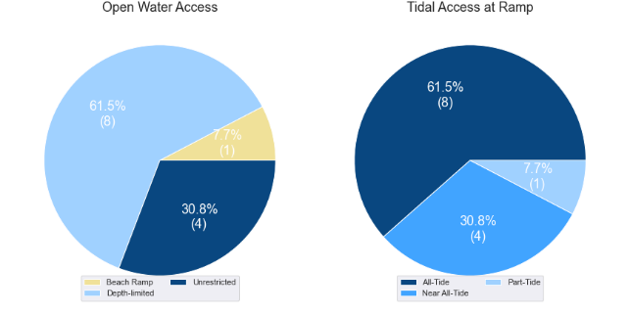

(a) Summary of open water access from boat launching facilities (left) and (b) Summary of tidal restrictions at tidal boat launching facilities (right)

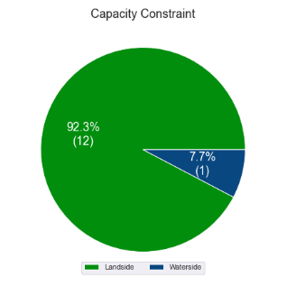

Summary of limiting capacity constraint

* + 1. Facilities expected to be completed within the Study period

Facilities that are expected to be constructed and actively providing capacity within the Study period are accounted for in this section. These are projects that have secured funding, have begun construction or have a current works contract. For all intents and purposes, these are intended to be providing capacity within the next 5 years or sooner. As such, this section acknowledges the increase in capacity that these facilities will supply.

### *Yorkeys Knob*

Under construction in 2022, the new facility at Yorkeys Knob is expected to be providing capacity for the Cairns LGA over the Study period. Key features of the new development include six boat ramp lanes, three floating walkways, a dredged basin and access channel for all-tide accessibility, queuing beaches and 135 CTU parking spaces. This facility will provide an additional 6 effective lanes of capacity once operational.

## Access to sheltered near all-tide and all-tide facilities

MSQ has a longer-term vision to provide access to all-tide or near all-tide open water access boat launching facilities along the Queensland coast, such that all significant population centres are within one hour’s driving range as far as practical (TMR, 2020). For this purpose, the Study has defined towns as being within the coastal strip if within 30km of the Queensland coastline. The vision (TMR,2020) is applied to the coastal strip between the NSW border and Cooktown. Consultation throughout the Study has highlighted that this vision is important with users/stakeholders and organisations that own and manage these facilities. As such, the Study has developed a statistical approach to quantify this vision to allow it to be measured and tracked over time. To do this, the Study has calculated the travel time from all Population Centres (DoR, 2022) within the coastal zone to the nearest available sheltered, all-tide or near all-tide facility, regardless of which LGA it is in. This has been accomplished using mapped road networks and assigning speed limits to each type of road, with the following speed limits applied:

* for restricted roads, 40km/hr
* for local roads, 60km/hr
* for connector roads, 70km/hr
* for distributor roads, 80km/hr
* for highways, 100km/hr.

For Cairns LGA the median travel time from eligible Population Centres to the nearest sheltered all-tide or near all-tide facility is 17 minutes. The distribution of travel times is shown in Figure 3.3 with detailed travel times in Annex C. Figure 3.4 provides a visual representation of the travel time from each of the sheltered near all-tide facilities that serve the LGA. Of interest for Cairns LGA are:

* 100% of the eligible population centres are within the desired 1-hour travel time.
* The majority of eligible population centres are within 30 minutes of a sheltered near all-tide or all-tide facility.
* Facilities in Coconuts and Innisfail in Cassowary Coast LGA provide the closest access for sheltered near all-tide access for vessels in the southern part of the LGA (south of Fishery Falls).

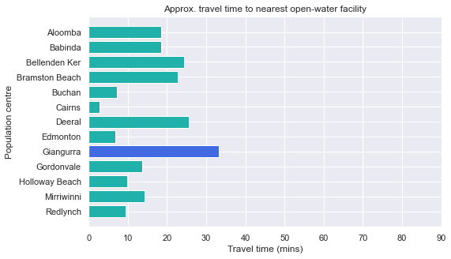

Distribution of travel time from Cairns LGA’s eligible population centres to sheltered near all-tide facilities

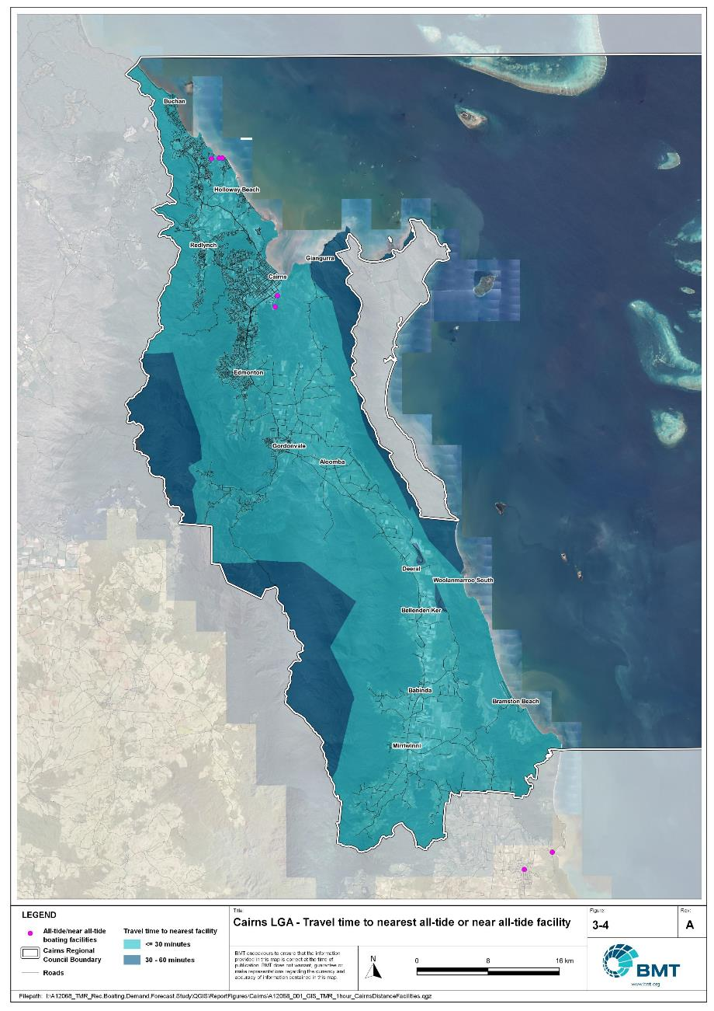

Cairns LGA – Travel time to nearest all-tide or near all-tide facility

"I:\A12068_TMR_Rec.Boating.Demand.Forecast.Study\QGIS\ReportFigures\Cairns\A12068_001_GIS_TMR_1hour_CairnsDistanceFacilities.jpg"

## Deep-draught vessel landings

Deep-draught vessel landings are intended to provide short-term landing capacity for vessels that are too large to use public boat launching and retrieval facilities. These facilities are provided for the benefit of both local vessels and to service the fleet of vessels that travel along the Queensland coast. Deep-draught vessel landings may be designed to accept one or more large vessels at a time and/or provide capacity for tenders from larger vessels that may be anchored or moored nearby, for the purpose of loading and offloading passengers and supplies, and making short local visits to onshore destinations.

For the Study, deep-draught vessel landings need to be primarily accessible by recreational boats for short, temporary stays. In some cases, commercial vessels may utilise these facilities subject to the relevant permissions, however, this may reduce the capacity of the facility to cater for recreational vessels. Deep-draught vessel landings should be located such that the facility provides reasonable access to landside passenger pick up and drop off, provisioning, recreational destinations, or population centres. Within Cairns LGA there is only one mainland deep-draught vessel landing at Tingira Street, which has access to passenger vehicle parking but no other amenities, public transport or landside destinations. There are also two public jetties located on Green Island and Fitzroy Island that provide access to the resorts on these islands but provide little else for deep-draught vessels landing at these sites.

As well as the above, Cairns LGA has additional deep-draught vessel landings provided by private facilities at the Cairns Marlin Marina, which can provide free temporary mooring if arranged prior to arrival. This facility also provides access to fuel and pump out facilities.

In summary, Table 3.2 shows the total capacity of deep-draught landing facilities within Cairns LGA.

Mainland deep-draught landing facilities within Cairns LGA

| Facility type | Total capacity |
| --- | --- |
| Public sheltered mainland landings | 1 |
| Private sheltered landings | 1 |
| **Total** | **2** |

# Demand Assessment

The Study has developed a model to calculate statistical demand for boat launching facilities and deep-draught vessel landings at an LGA scale. Vessels that are less than 8m in length are considered trailable and drive demand for boat launching facilities such as boat ramps, while those over 8m are assumed to remain on water and drive demand for deep-draught landings.

Statistical demand is recognised at three different levels for public marine facilities within the TMR guidelines (TMR, 2020), which are:

* off-peak demand – typical weekday usage
* average demand – demand on ‘good boating days’, taken to be demand for a facility on weekends (and, for certain regional locations, other busy periods)
* peak demand – demand for a facility at peak holiday periods or for special events.

The demand model created for this Study is intended to provide information on demand pressures on ‘good boating days’ for all facilities as per the intentions of the guidelines. The model achieves this through a ‘registration activation rate’ that estimates the proportion of registered vessels in an LGA that is assumed to be active on a ‘good boating day’, as well as the exchange of vessels between LGAs, and general tourism pressures.

## Activation rate

The fleet size for each LGA is determined statistically from vessel registration numbers and the application of a vessel activation rate, while for future time horizons vessel registration and population growth estimates are also utilised. The methodology for determining the registration activation rate has been adopted from the previous study (GHD, 2017), with activation rates taken to be between 8% and 14% for a typical weekend. The variability of the activation rate is intended to capture the regional differences in vessel types, and is driven by the availability of access to open water, accessibility of other recreational opportunities, and likelihood of users’ available time for recreation, considering factors including:

* remoteness classification for the LGA
* incidence of blue-collar employment
* average age of residents
* whether the LGA is coastal.

Further information about the derivation of this rate can be found in Annex A. For Cairns LGA the activation rate is assumed to be 10%, with the key factors influencing the rate including:

* its classification as a Regional Centre
* the incidence of blue-collar employment being lower than the state average
* the average age being lower than the state average
* it being located adjacent to the open coast.

## Digital user survey

To gain an understanding of usage trends at existing formal recreational boating facilities across Queensland, the Study has considered the results of a digital user survey using human movement data, sourced through a third party. The data was acquired from a location data store with more than 13 trillion mobile location observations globally from 2019 to present, which were sourced from 250,000 different mobile phone applications that users ‘opted-in’ to use the location services under the application’s terms and conditions. All data received was deidentified and compliant with relevant data privacy regulations.

The analysis uses mobile devices (such as telephones) location data as a proxy for boat user traffic, however, this relationship has several limitations including, but not limited to:

* Mobile device users detected in the area of interest may not be boat users (for example, pedestrians not using vessels may walk through the detection area).
* The relationship between mobile device users and vessels may not be 1:1 (that is, there may be multiple mobile devices providing data for each vessel).
* Users of vessels may not have a mobile device, may not be using a mobile device or may not have provided permission to use their location data.

With these, and potentially other, limitations in mind, the Study compared this data against vessel launching counts provided by various facility managers and found that approximately 15-30% of vessels are captured using this digital survey method. This percentage can change from facility to facility and from day to day. Consequently, the Study has not relied on raw counts of users from this data, but instead considered the relative trends within the data, with the assumption that no groups (for example, users from a particular LGA or using a particular facility) within the data would be more or less likely to be captured by the technique.

The Study has used this data to identify the relative volume of users, the ‘home’ local government area of users and the popularity of destinations that users travel to once vessels have been launched. Presentation of the full dataset can be found in Annex D.

* + 1. Inter-LGA demand

The human movement data has been interrogated to determine the LGA of origin for users of Cairns LGA’s public boating facilities to ascertain the proportion of users from each LGA that are using specific facilities. Statistics from all public boating facilities within the LGA are then grouped together to determine the total proportion of resident or visiting users across the LGA. Table 4.1 shows the active fleet proportion from the top 10 LGAs contributing to demand on facilities within Cairns LGA. All other sources have been grouped together.

LGA of origin for active fleet in Cairns LGA

| LGA of origin | Active fleet proportion |
| --- | --- |
| Cairns | 82.1% |
| Mareeba | 2.2% |
| Tablelands | 1.5% |
| Townsville | 1.3% |
| Brisbane | 1.3% |
| Cassowary Coast | 1.1% |
| Gold Coast | 0.8% |
| Sunshine Coast | 0.6% |
| Mackay | 0.5% |
| Logan | 0.5% |
| Other LGAs | 8.0% |

* + 1. Intra-LGA demand distribution

Recreational boating users will tend to use facilities that best suit their needs, the destinations they want to access, the capability of their vessel and the weather conditions. Consequently, distribution within an LGA is unlikely to be evenly spread across all facilities, with some facilities attracting users disproportionately due to amenity, access, or destinations. The attractiveness of large well-designed facilities is likely to draw visiting boat users in preference to smaller or less desirable facilities across the LGA. The human movement statistics have been assessed to qualitatively estimate the proportion of users using each facility, both in total and with respect to both resident and visiting boat users (Table 4.2).

Popularity of boat launching facilities

| Facility | Overall fleet | Resident fleet | Visiting fleet |
| --- | --- | --- | --- |
| Portsmith, Tingira Street | 22.4% | 23.1% | 18.9% |
| Portsmith, Fearnley Street | 15.9% | 16.0% | 15.1% |
| Stratford, Greenbank West Road | 9.2% | 9.1% | 9.5% |
| Packers Camp, Mackey Creek | 8.1% | 8.7% | 5.5% |
| Edmonton, Fisherman Road | 7.2% | 8.0% | 3.8% |
| Trinity Park, Schooner Road | 6.4% | 6.8% | 4.9% |
| Deeral, Ross Road | 6.1% | 6.1% | 6.1% |
| Yorkeys Knob, Buckley Street | 5.9% | 5.0% | 10.0% |
| Bellenden Ker, Russell River Road | 4.7% | 4.7% | 4.4% |
| Bramston Beach, Evans Road | 4.3% | 3.3% | 8.7% |
| Machans Beach, Barron River Esplanade | 3.8% | 3.6% | 4.9% |
| East Trinity, Second Beach, Pine Creek Yarrabah Road | 3.2% | 2.8% | 4.6% |
| Holloways Beach, Thomatis (Richters) Creek, Acacia Street | 2.9% | 2.8% | 3.5% |

The results indicate that the active fleet in Cairns LGA is overwhelmingly from the LGA, with very little contribution from neighbouring LGAs. The Yorkeys Knob facility is the most preferred, although this might be overestimated due to pedestrian traffic around the facility. Tingira Street and Fearnley Street are important facilities that are strongly preferred by local boat users.

The distribution of capacity within the LGA needs to consider these trends to avoid consistent capacity shortfalls at some facilities or indicating demand for unnecessary extra capacity at other facilities. Results from the above statistics and feedback obtained through the TMR online survey indicate that within Cairns LGA the following factors tend to influence the preferred facilities for recreational boat users:

* access to sheltered, all-tide launching facilities
* dry entry/exit capabilities of launching facilities provided through floating walkways, pontoons and to a lesser extent fixed sloping walkways
* ability to access offshore destinations.
  + 1. Destinations

For facilities that provide sheltered, near all-tide or all-tide open water access, additional analysis of the human movement statistics has been undertaken to identify destinations for users of these facilities. Location data from users utilising the facilities was extracted for a period of two hours after they used the facility and trimmed for water-side destinations. For Cairns LGA this additional analysis was applied to the following facilities, with destinations mapped in Figure 4.1:

* Fearnley Street
* Tingira Street
* Deeral
* Trinity Park
* Yorkeys Knob.

From this additional analysis, the following notable observations were made:

* Users accessed offshore destinations from all of these facilities, with a variety of offshore reefs and islands popular.
* The Deeral facility was used to access the Frankland Island group, that was too distant to access from other facilities.
* Users of the Tingira Street facility travelled as far north as Port Douglas.

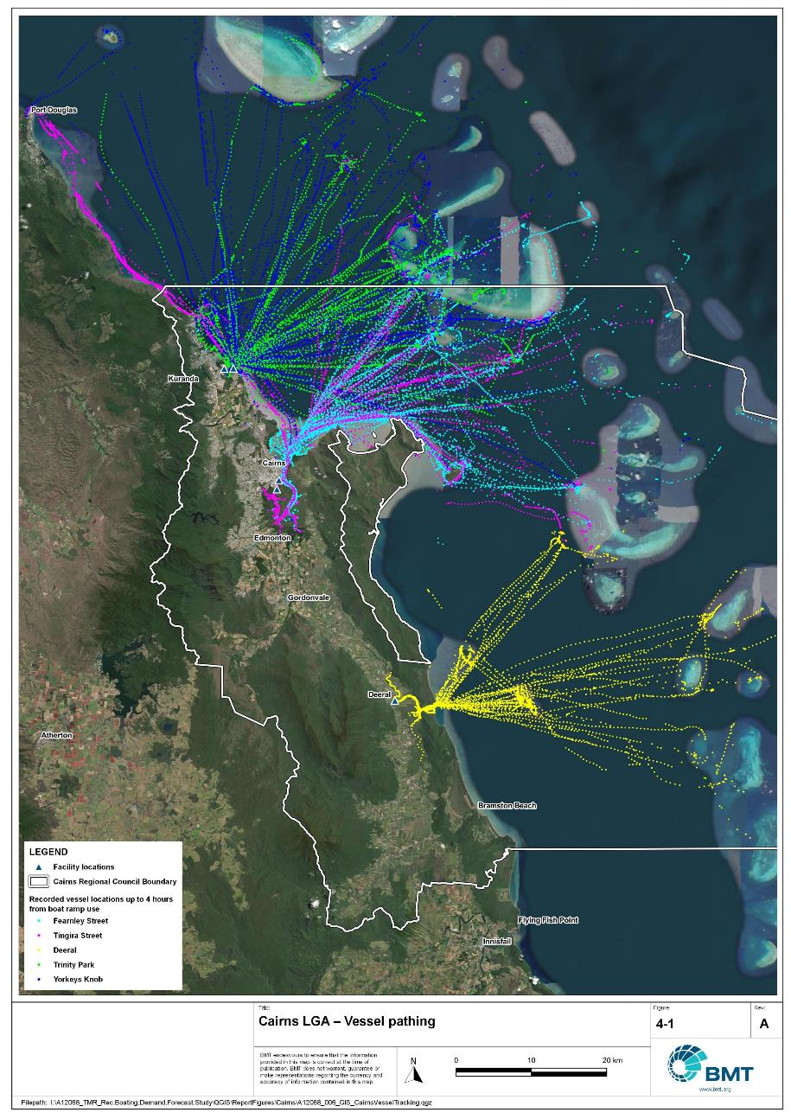

Cairns LGA – vessel pathing

"I:\A12068_TMR_Rec.Boating.Demand.Forecast.Study\QGIS\ReportFigures\Cairns\A12068_006_GIS_CairnsVesselTracking.jpg"

## Active fleet size

The total ‘active’ fleet on a good boating day is derived from the activation rate of the total fleet of registered vessels within the LGA and the net inflow of visiting vessels. The total number of visiting vessels from each LGA is determined from the number of vessels in the resident active fleet and the relative proportion of resident to visiting vessels outlined in Table 4.1.The fleet size is expected to change over time due to changes in population and vessel acquisition trends, with the size and proportion of the fleet across the Study period described in Table 4.3.

Active fleet vessel size

| Vessel length | 2021 | 2026 | 2031 | 2036 | 2041 |
| --- | --- | --- | --- | --- | --- |
| 0 to 4.5m | 713 | 750 | 786 | 819 | 848 |
| 4.5m to 8m | 438 | 461 | 483 | 503 | 522 |
| >8m | 74 | 78 | 82 | 85 | 88 |
| Total | 1226 | 1289 | 1351 | 1407 | 1458 |

## Boat ramp lane demand

The fleet size derived in Table 4.3 represents the statistical demand for the LGA, with vessels under 8m assumed to contribute to boat ramp demand, measured in boat ramp lanes. As outlined in section 3.1.2 the adopted capacity of each effective lane is 40 vessels per day, with each vessel assumed to both launch and retrieve, for a total of 80 vessel movements per day. The total boat ramp lane demand across the Study period is shown in Table 4.4.

Boat ramp lane demand

|  | 2021 | 2026 | 2031 | 2036 | 2041 |
| --- | --- | --- | --- | --- | --- |
| Boat ramp lane demand | 28.8 | 30.3 | 31.7 | 33.1 | 34.2 |

For Cairns LGA the important elements that contribute to the boat ramp lane demand include:

* a large sized local fleet, with a high proportion of trailable vessels.
* attractive destinations accessed by facilities in neighbouring LGAs that are used by Cairns LGA vessels.
* attractive destinations for visitors from southeast Queensland.

## Non-statistical demand

As well as the statistical demand outlined in the section above, facilities may face demand pressures that are related to their functional use, which reduces the capability of the facility to service the recreational boat fleet in the desired manner. Issues with specific facilities have been identified within the consultation process of the Study with appointed managers and other stakeholders. While care has been taken to identify these non-statistical demand issues throughout the Study, it is beyond the scope of the Study to individually review the functionality, safety, and amenity of each facility across Queensland. Non-statistical demand pressures may warrant upgrades to facilities even where statistical demand is satisfied by existing capacity. These pressures have been classified into the following categories:

* Amenity: Amenity describes the functional usability of the facility including the desire to provide dry entry and exit facilities, facilities that provide easy access and/or access for persons with restricted mobility.
* Safety: Safety demand may include protection from currents and waves or contact with marine creatures such as sharks, jellyfish, and crocodiles.
* In-water congestion: Where existing queuing facilities are not able to efficiently meet the needs of the facility. Such deficiency may warrant additional queuing facility capacity to optimise boat launching and retrieval.

The Study's recommendations may alleviate these non-statistical demand pressures with consideration for capability of all facilities within the LGA. The presence of a non-statistical demand pressure at a facility may not warrant upgrades where other suitable facilities are reasonably available.

## Deep-draught vessel demand

* + 1. Cruising vessels

Vessels cruising along the east coast of Queensland have a requirement for a network of deep-draught vessel landings that are appropriately spaced to be within a day’s sailing on good weather days. These facilities are required to support the reprovisioning of vessels as they travel along the coast and provide access to desirable land-based destinations. Private marina facilities may be used by cruising vessels where there is an expectation for a prolonged stay that requires protected mooring or berthing. Within Cairns LGA suitable facilities for deep-draught vessels are available at Tingira Street.

Within the east coast network but outside of the LGA, the nearest deep-draught vessel facility to the north is at Port Douglas, approximately 35 nautical miles north of Cairns, and to the south at Clump Point in Cassowary Coast LGA, approximately 75 nautical miles south. Vessels from Clump Point can stop at the facilities in Innisfail, although navigable access to these facilities can be limited by the depth of the river mouth entrance.

The public pontoon at Tingira Street has limited access to supplies and provisions, with access to passenger vehicle parking available nearby. For vessels seeking to stay in the region, protected mooring or berthing is seasonally available at private facilities at Cairns Marlin Marina.

* + 1. Landing demand

Statistical demand for deep-draught vessel landings has been assessed based on the size of the non-trailable fleet within Cairns LGA. Landing demand is more difficult to assess than boat ramp lane demand as the requirements and duration of the landing influence the demand pressure but are highly variable between users. Nevertheless, the Study has assumed that 5% of the non-trailable fleet will be seeking a landing at any given time. The consultation undertaken during the Study indicates that this assumption may overestimate the number of landings, but that the landings are often utilised for other boating and recreation activities when not in use by deep-draught vessels. In particular, landings that are located near boat launching facilities may be used as queuing facilities and therefore support the efficient launching of smaller recreational vessels. Given this, the 5% assumption has been adopted noting that it may overestimate capacity, but not to an extent that it would be onerous to facility providers. Within Cairns LGA the demand for deep-draught vessel landings is outlined in Table 4.5.

Deep-draught vessel landing demand

| Requirement | 2021 | 2026 | 2031 | 2036 | 2041 |
| --- | --- | --- | --- | --- | --- |
| No. of Landings | 3.7 | 3.9 | 4.1 | 4.2 | 4.4 |

# Shortfall Assessment

## Shortfall assessment – boat ramps

The shortfall of boat ramp lanes within Cairns LGA is shown in Table 5.1 and Figure 6.1 at an LGA scale. This is presented both with and without the inclusion of additional capacity provided by the recommended upgrades.

Shortfall of boat launching facilities

| Assessment | Metric | 2021 | 2026 | 2031 | 2036 | 2041 |
| --- | --- | --- | --- | --- | --- | --- |
| Demand | Demand | 28.8 | 30.3 | 31.7 | 33.1 | 34.2 |
| Existing | Capacity | 22 | 28 | 28 | 28 | 28 |
| **Shortfall** | 6.8 | 2.3 | 3.7 | 5.1 | 6.2 |
| Improved | Capacity | 22 | 35.2 | 35.2 | 36.2 | 36.2 |
| **Shortfall** | 6.8 | -4.9 | -3.5 | -3.1 | -2 |

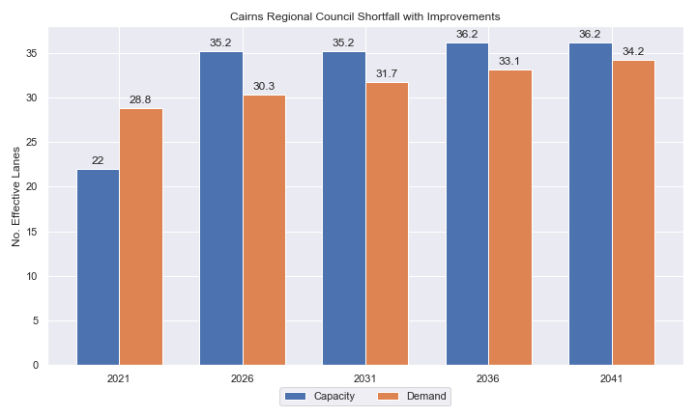

Shortfall assessment with recommended upgrades adopted.

* + 1. Open-water access shortfall in boat ramp lanes

Statistical capacity has been calculated across Cairns LGA in its entirety, however, some facilities are evidently more popular than others due to their ability to access open-water destinations, and/or their usability. In general, larger vessels are more suited to access open-water destinations while smaller vessels are more likely to remain in sheltered environments. This was identified in the 2017 study and confirmed during discussions with stakeholders. The human movement data indicates that visiting boats from other LGAs are drawn to facilities that provide access to open-water destinations. To ensure that the capacity of effective boat ramp lanes in the LGA is appropriately distributed to cater for these usage trends, it is worth assessing facilities providing this desirable access as a subset of the total capacity for the LGA. A ‘scenario’ approach to assessing this capacity (Table 5.2) has been developed, with Scenario 1 derived from empirical estimates of vessel distribution and Scenario 2 derived from the human movement statistics, and the final result averaged between the two scenarios. This provides the opportunity to rationalise the figure that drives the demand and acknowledge when one scenario is not representative of the population or consistent with stakeholder feedback. The scenarios that were assessed are:

Scenario 1: 80% of larger vessels and 20% of smaller vessels from the local fleet and 80% of the visiting fleet are using the facilities with unrestricted open water access.

Scenario 2: Distributing the fleet between facilities as per the human movement statistics.

Shortfall assessment for open water, all-tide or near all-tide facilities for Cairns LGA

| Assessment | Metric | 2021 | 2026 | 2031 | 2036 | 2041 |
| --- | --- | --- | --- | --- | --- | --- |
| Overall | Capacity | 10.5 | 16.5 | 16.5 | 16.5 | 16.5 |
| Scenario 1 | Demand | 15.3 | 16 | 16.8 | 17.5 | 18.1 |
| Shortfall | 4.8 | -0.5 | 0.3 | 1 | 1.6 |
| Scenario 2 | Demand | 19.9 | 21 | 22 | 22.9 | 23.7 |
| Shortfall | 9.4 | 4.5 | 5.5 | 6.4 | 7.2 |
| **Average** | Demand | 17.6 | 18.5 | 19.4 | 20.2 | 20.9 |
| **Shortfall** | **7.1** | **2.0** | **2.9** | **3.7** | **4.4** |

Comparing the LGA-scale shortfall with the subset of facilities providing protected all-tide or near all-tide access to open water indicate that the demand is focused on this subset of facilities, with the new Yorkeys Knob facility currently under construction providing significant relief in the short-term.

## Shortfall assessment – deep-draught landings

The shortfall of public deep-draught landings for Cairns LGA is provided in Table 5.3. The existing capacity is statistically inadequate to meet demand, with the only deep-draught facility in Cairns LGA providing little in the way of access to amenities and supplies. Additional deep-draught vessel capacity is urgently needed within Cairns LGA.

Shortfall of deep-draught vessel landings

| Assessment | Metric | 2021 | 2026 | 2031 | 2036 | 2041 |
| --- | --- | --- | --- | --- | --- | --- |
| Deep-draught vessel landings | Demand | 3.7 | 3.9 | 4.1 | 4.2 | 4.4 |
| Capacity | 1 | 1 | 1 | 1 | 1 |
| **Shortfall** | 2.7 | 2.9 | 3.1 | 3.2 | 3.4 |

# Stakeholder Feedback



The Study has undertaken extensive consultation throughout its execution to achieve a comprehensive understanding of issues relating to the use of recreational boating facilities across the state. This consultation was conducted with managing authorities that own and/or and manage recreational boating facilities, as well as with facility stakeholders including recreational groups, volunteer marine rescue and coastguard organisations, and the general public. Stakeholder engagement was supplemented with site visits to facilities where key issues had been identified.

## Managing authority feedback

For Cairns LGA, the Study team met with Cairns Regional Council, Ports North, and Maritime Safety Queensland to discuss recreational boating facilities within the region. This consultation process identified a range of potential opportunities to alleviate demand pressures. The Study has considered the practical implementation of each of these opportunities with respect to the required infrastructure, difficulty of implementation, and magnitude of benefit, as summarised in Table 6.1.

Stakeholder identified opportunities

| Location | Stakeholder opportunity | Review comments |
| --- | --- | --- |
| Fearnley Street | Provide additional parking facilities to the north of the site. | This site may be decommissioned to accommodate future port expansion. Review when port planning is confirmed but need to offset any capacity loss through new facility or facility expansion. |
| Deeral | Provide additional queuing facility for safety from crocodiles noting flood heights and velocities. | Agreed. |
| Tingira Street south | Possible site if Fearnley Street site is decommissioned. | Agreed. |
| Swallows Landing | Possible site if Fearnley Street site is decommissioned. | Commute time to open water is problematic from this site. |

## Stakeholder feedback

Broader stakeholder feedback has been conducted within the Study by undertaking virtual or face-to-face meetings with recreational boating groups and marine rescue organisations, as well as through the Recreational Boating Facility Survey (MSQ, 2022) undertaken by Maritime Safety Queensland, which included survey responses of nearly 3,000 users and open submissions. For Cairns LGA a total of 216 submissions was received, with 72% of respondents using trailable power boats and 99% of respondents using recreational boating facilities at least once a month. For Cairns LGA the following statistics or themes were extracted from the survey and associated comments:

* 96% of respondents typically travel less than 1hr to their preferred boat ramp (which may not be their closest facility).
* 70% of respondents indicated that floating walkways are their preferred type of queuing facility.
* 94% of respondents indicated that they would be unwilling to walk further than 200m from designated CTU parking to a boat ramp.
* The most common requests for new boat ramps were at:
  + any point along Trinity Beach / Park, Clifton Beach, Palm Cove beach, Ellis Beach
  + anywhere around Portsmith – Tingira Street, Dutton Street
  + Saltwater Creek (Cairns north)
  + Lake Tinaroo (Malcolm Road) – Tablelands LGA.
* The following trends were identified with respect to existing facilities:
  + a desire for upgrading boat ramps with pontoons (Deeral, Bloomfield River, Machans Beach, Edmonton), extending ramps (Edmonton) or widening ramps (Tingira Street)
  + providing more secure parking spaces (Fearnley Street, Deeral, Machans Beach, Tingira Street, Trinity Park, Edmonton)
  + providing wash down areas, fish filleting tables and fish waste bins, toilets (Machans Beach, Clifton Beach, Palm Cove), lighting (Edmonton), regular cleaning (of the ramp at low tide levels).
* Where the closest available boat launching facility was not preferred, the following themes amongst respondents were identified:
  + all-tide access
  + better parking (adequate and secure)
  + pontoon access
  + ocean / reef access, fishing ground.
* Respondents were provided an opportunity to provide additional feedback, with the following themes identified:
  + a desire for pontoon installation at existing boat ramps
  + concerns around a lack of adequate and secure parking
  + concerns around safety against crocodile attack.

# Development Recommendations

## Previous recommendations

The 2017 GHD assessment recommended opportunities for increasing capacity of recreational boating facilities across the state. However, the implementation of these recommendations has been low, with only 10% of the total state-wide recommendations delivered in part or full in the 5 years since the delivery of the report. Of the Priority 1 recommendations (for immediate delivery) and Priority 2 recommendations (for implementation within 5 years) only 18% and 6% respectively have been delivered. state-wide only 5% of landside recommendations were delivered, while 16% of waterside recommendations were delivered.

Within Cairns LGA none of the recommendations have been implemented since the delivery of the 2017 GHD study, however the new Yorkeys Knob facility is nearing completion. The low rate of implementation of these recommendations is likely the result of budgetary constraints applied due to the COVID-19 pandemic, although for Cairns LGA, all focus has been on progressing implementation of the new Yorkeys Knob facility. As such, some of the recommendations proposed in the 2017 GHD study remain viable. This current Study has reviewed the unimplemented 2017 recommendations (Table 7.1) for Cairns LGA in conjunction with stakeholders during the consultation process to identify previous recommendations that are:

* Still viable: The recommendation in its original form remains suitable for solving demand pressures.
* Still viable with modifications: The recommendation could remain viable with modifications identified throughout the consultation process.
* No longer viable: The recommendations are no longer suitable to be carried through as recommendations in this Study.

Recommendations from the 2017 study that are considered viable or viable with modifications may be carried forward into the recommendations of this Study with a suitable update to their priority status if required.

Assessment of unimplemented 2017 recommendations

| Location | 2017 Recommendation | 2022 Review | Review comment |
| --- | --- | --- | --- |
| Priority 1 | | | |
| Portsmith, Fearnley Street | Widening of Fearnley Street road reserve to accommodate an additional 20 CTU parking spaces along the eastern frontage. | No longer viable | Upgrades at this site not recommended due to potential decommission. |
| Portsmith, Tingira Street | Expand existing parking area by 25 CTUs. | No longer viable | Land not available. |
| Priority 2 | | | |
| Portsmith, Tingira Street | Construction of a new 4 lane boat ramp plus floating walkway on the southern side of the existing pontoon - or alternatively, construction of a new 4-lane facility and construction of a parking area to accommodate 90 CTU. | No longer viable | Land not available. |
| Deeral, Ross Road | Expansion of the ramp to include an additional lane and a floating walkway.  Formalisation of 80 CTU spaces. | Viable with modifications | Level of parking not required due to sufficient overflow facilities. |
| Cairns, Abbott Street | Installation of a pontoon for access by deep-draught vessels or their tenders. | No longer viable | Conflicts with other port uses. |
| Priority 4 | | | |
| East Trinity, Pine Creek Road | New 4-lane ramp, floating walkway. | Still viable | Not required to meet demand |
| Bellenden Ker, Russell River Road | Formalisation and expansion of parking to achieve 45 CTU spaces. | Still viable | Not required to meet demand |
| Machans Beach, Barron River Esplanade | Pontoon or floating walkway.  Formalisation of 15 CTU Spaces. | Still viable | Not required to meet demand |
| Holloways Beach, Thomatis (Richters) Creek, Acacia Street | Pontoon or floating walkway. | Still viable | Not required to meet demand |

## Priority recommendations

The selection and ranking of development priorities provides for progressive implementation of solutions to meet capacity shortfalls and/or resolve existing safety and usage issues at existing facilities over time. Recommendations have been split into four categories for implementation within the 20-year planning period of this Study, with the following projected timelines:

* Priority 1: For immediate planning and design.
* Priority 2: Planning and design intended to provide capacity within 5-10 years.
* Priority 3: Planning and design intended to provide capacity within 10-15 years.
* Priority 4: Planning and design intended to provide capacity within 15-20 years.

The recommendations have been structured to include consideration of the reasonable timelines for implementation. This may include consideration for budgetary processes, planning, environmental approvals, consultation periods and construction. Furthermore, the priority selection of recommendations has been conducted in accordance with TMR’s Marine Infrastructure and Facilities Plan (TMR, 2020) guidelines, namely:

1. *priority to be given to the provision of sheltered all-tide or near all-tide launching facilities giving access to the open sea on an all-tide or near all-tide basis.*
2. *part-tide facilities (for launching or access) may be provided where there is demand and dredged access is not feasible. For instance, beach access or open beach ramps may be provided where there is sufficient demand and no suitable nearby sheltered waterway*
3. *the most economically viable options will take precedence, including the expansion of existing facilities, and the changing of existing foreshore land uses. In many cases, limiting or avoiding dredging and/or breakwater costs will be a crucial factor*
4. *a goal of providing access to sheltered all-tide or near all-tide boat launching facilities within one hour’s drive for significant communities*

Consequently, higher order recommendations need to address, where possible, the provision of facilities that provide maximum benefit in the widest range of conditions and will be limited to those solutions that are already significantly advanced or ‘shovel ready’ or that require limited further design, planning and approvals. Lower order recommendations will consist of solutions where there is reduced adherence to the TMR guidelines and/or there are constraints that may result in long lead times to resolve. A summary of the recommendations is provided in Table 7.2 with full detail of each recommendation in the tables that follow.

Summary of recommendations for Cairns LGA

| Priority | Description | Landside or Waterside | Increased capacity  (effective lanes) |
| --- | --- | --- | --- |
| 1 | Deeral: Formalise additional 30 CTU spaces and add an additional queuing facility (fixed sloping walkway) to the downstream side of the ramp. | Both | 2 lanes |
| 1 | Tingira south: Provide replacement capacity for future decommissioning of Tingira and Fearnley Street facilities. Construct 2x4-lane ramps with 2 floating walkways per ramp and 240 CTUs. | Both | 5.25 lanes |
| 1 | Marlin Parade (Cairns City): Install deep-draught pontoon with 2 berthing sites. | Waterside | 2 deep-draught landings |
| 3 | Trinity Park: Modify parking layout to achieve an additional 12 CTU spaces. Modify road alignment to reduce congestion. Install pontoon. | Both | 1 lane  Safety Improvements |

## Priority 1 recommendations

Deeral - (Priority 1)

|  |  |  |  |  |
| --- | --- | --- | --- | --- |
| General description | | | | |
| Location | Ross Road, Deeral | | | |
| Existing Facility? | Yes | | | |
| Coordinates | -17.21710346271666, 145.92062864387879 | | | |
| Existing tidal status | All-tide | | | |
| Existing wave exposure | Nil | | | |
| Existing current exposure | Yes | | | |
| Proposed works | Formalise parking for 30 CTUs to the west of the site. Install fixed sloping walkway on the downstream side. | | | |
| Increased effective capacity |  | | | |
| Capacity improvement position | Waterside | Landside | | Both |
| Rationale | This facility provides excellent access to the Frankland Islands and is popular for fishing in the Mulgrave River. The facility is also used to access properties at Russell Heads (Woolanmaroo south). The existing facility currently has a limited amount of CTU parking available, with informal overflow at several locations around the ramp, which is degrading the surface. Formalising some of the overflow area to provide an additional 30 CTU spaces will provide suitable balance between formal and overflow capacity at the site.  Installing a fixed sloping walkway close to the downstream bank will allow more opportunity to access a queuing facility and dry entry/exit opportunities, which will improve safety and launch/retrieval operations. | | | |
| Anticipated Costs (+/- 50%) | Waterside infrastructure | | $570,000 | |
| Landside infrastructure | | $140,000 | |
| Planning, environmental and approvals constraints | | | | |
| Assessment | Requirement | Comments | | |
| Fish Habitat Zone | X | N/A | | |
| Native Title | ü | New tenure required for carpark works therefore, interaction with Native Title required. | | |
| MCU requirement | ü | Parking lot works within nature conservation area will likely trigger a Development Permit for a Material Change of Use. | | |
| Clearing remnant vegetation | ü | The works are within areas containing RVM category B – remnant vegetation and RVM category R – reef-regrowth watercourse vegetation. A Development Permit may be required for the clearing of remnant vegetation. | | |
| GBRWHA | ü | Works are within the GBRWHA which may require a Controlled Activity Approval if there is likely to be a significant impact. | | |
| Marine Park | X | N/A | | |
| Tidal works assessment | ü | A new fixed sloping walkway is likely tidal works and therefore, will require a Development Permit. | | |
| Other as required | ü | Marine plants – Works may impact marine plants and therefore, require a Development Permit for marine plant disturbance | | |
| Sea Level Rise | ü | Proposed works are within the boundaries of the erosion prone area subject to sea level rise. | | |
| Storm Tide Hazard | ü | Proposed works are within the boundaries of a high storm tide hazard area. | | |
| Anticipated Complexity | Low | Medium | | High |
| Maritime engineering review | | | | |
| Assessment | Site considerations | Comments | | |
| Engineering Matters | Current Forces | Site may be subject to moderate to high currents and further assessment of the impact on this recommendation is required. | | |
| Water Levels | This site is subject to inundation from flood waters and more detailed consideration will be required to ensure the recommended option is suitable. | | |
| Anticipated Complexity | Low | Medium | | High |

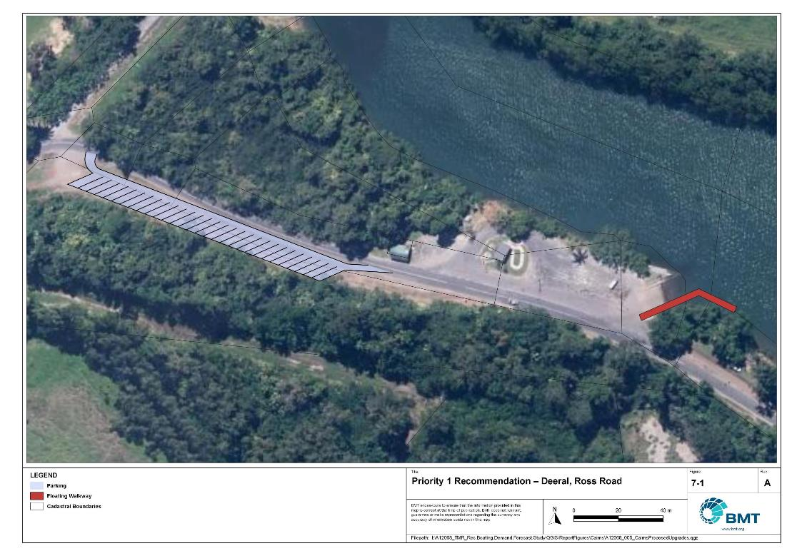

Priority 1 Recommendation – Deeral, Ross Road

"I:\A12068_TMR_Rec.Boating.Demand.Forecast.Study\Recomendations by Council\JPG\Cairns\A12068_005_CairnsProposedUpgrades_7-1.jpg"

Tingira Street south- (Priority 1)

|  |  |  |  |  |
| --- | --- | --- | --- | --- |
| General description | | | | |
| Location | Southern end of Tingira Street, Cairns | | | |
| Existing Facility? | No | | | |
| Coordinates | -16.956404639043317, 145.7705261088599 | | | |
| Existing tidal status | N/A | | | |
| Existing wave exposure | Nil | | | |
| Existing current exposure | Nil | | | |
| Proposed works | Install 2x4-lane boat ramps with 2 floating walkways on each ramp. Install 240 CTUs to replace or supplement existing capacity at Fearnley Street and Tingira Street facilities. | | | |
| Increased effective capacity | 5.25 lanes | | | |
| Capacity improvement position | Waterside | Landside | | Both |
| Rationale | The existing facilities at Fearnley Street and Tingira Street are both at capacity and conflict with plans from other stakeholders to expand port activities. As such, a replacement for these facilities will be required to be operational before those facilities can be decommissioned. Supplementation of the existing capacity is desirable regardless. This recommendation consolidates the existing capacity and provides additional capacity for future growth at the only viable location in Trinity Inlet that adequately services all of the Cairns LGA. | | | |
| Anticipated Costs (+/- 50%) | Waterside infrastructure | | $3,500,000 | |
| Landside infrastructure | | $10,750,000 | |
| Planning, environmental and approvals constraints | | | | |
| Assessment | Requirement | Comments | | |
| Fish Habitat Zone | ü | Works are within the Trinity Inlet Fish Habitat Area (FHA-003) - Management Area B. A Development Permit and Resource Allocation Authority will be required for works within a declared FHA. | | |
| Native Title | ü | New tenure required for works and therefore, interaction with Native Title. | | |
| MCU requirement | ü | Works will trigger a Development Permit for a Material Change of Use. | | |
| Clearing remnant vegetation | ü | Works are within area containing RVM category B – remnant vegetation. A Development Permit will likely be required for clearing of remnant vegetation. | | |
| GBRWHA | ü | Some aspects of the works may occur within the GBRWHA and therefore, may trigger a Controlled Activity Approval if there is likely to be a significant impact. | | |
| Marine Park | ü | Works are within the Great Barrier Reef Coast Marine Park (Trinity Inlet) in an Estuarine Conservation Zone which will likely require a Marine Park Permit.  Works can be undertaken within a Conservation Zone to the extent they have limited impact. | | |
| Tidal works assessment | ü | Construction of new boat ramps and floating walkways will likely be tidal works and require a Development Permit. | | |
| Other as required | ü | Marine Plants – will likely disturb marine plants (that is. mangroves) and therefore will require a Development Permit for marine plant disturbance. | | |
| Sea Level Rise | ü | The proposed works are within the boundaries of the erosion prone area subject to sea level rise. | | |
| Storm Tide Hazard | ü | The proposed works are within the boundaries of a high storm tide hazard area. | | |
| Anticipated Complexity | Low | Medium | | High |
| Maritime engineering review | | | | |
| Assessment | Site considerations | Comments | | |
| Engineering Matters | Geotechnical | Low strength or unsuitable materials are likely to be found at this site and a more detailed geotechnical assessment of this recommendation is suggested. Consultation with stakeholders suggests that local dredge material will be unsuitable for reclamation and fill will need to be imported. | | |
| Anticipated Complexity | Low | Medium | | High |

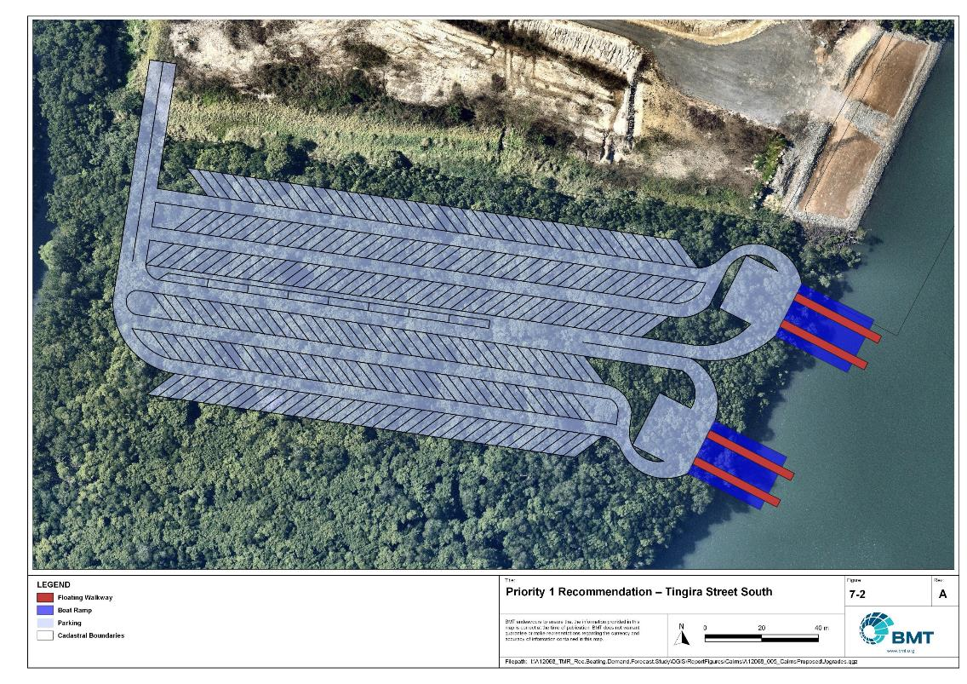

Priority 1 Recommendation – Tingira Street south

"I:\A12068_TMR_Rec.Boating.Demand.Forecast.Study\Recomendations by Council\JPG\Cairns\A12068_005_CairnsProposedUpgrades_7-2.jpg"

Marlin Parade pontoon - (Priority 1)

|  |  |  |  |  |
| --- | --- | --- | --- | --- |
| General description | | | | |
| Location | Marlin Parade, Cairns | | | |
| Existing Facility? | No | | | |
| Coordinates | -16.922646429693316, 145.78088508049186 | | | |
| Existing tidal status | N/A | | | |
| Existing wave exposure | N/A | | | |
| Existing current exposure | N/A | | | |
| Proposed works | Install pontoon suitable for short term berthing of 2x deep-draught or other vessels and capacity for tender tie up. | | | |
| Increased effective capacity | 2 landings | | | |
| Capacity improvement position | Waterside | Landside | | Both |
| Rationale | Cairns LGA currently has only one mainland deep-draught pontoon at Tingira Street. It does not provide ready access to any mainland destinations of note, facilities for reprovisioning or public transport. The pontoon at Tingira Street is not recommended to be relocated to the Tingira St south option for this reason. As such, Marlin Parade is the only site within Cairns LGA that is suitable for a public-access deep-draught landing. The Study is aware that this location will conflict with expansion of the commercial mooring facilities by the port in future but would recommend that this level of capacity be provided within any future expansion. | | | |
| Anticipated Costs (+/- 50%) | Waterside infrastructure | | $100,000 | |
| Landside infrastructure | |  | |
| Planning, environmental and approvals constraints | | | | |
| Assessment | Requirement | Comments | | |
| Fish Habitat Zone | X | N/A | | |
| Native Title | X | N/A | | |
| MCU requirement | X | N/A | | |
| Clearing remnant vegetation | ü | Part of the pontoon is situated within an area containing RVM category R – reef-regrowth watercourse vegetation. A Development Permit may be required for clearing remnant vegetation. | | |
| GBRWHA | ü | The works are within the GBRWHA which may trigger a Controlled Activity Approval if there is likely to be a significant impact. | | |
| Marine Park | X | N/A | | |
| Tidal works assessment | ü | Construction of a new pontoon will likely be tidal works and require a Development Permit. | | |
| Other as required | X | N/A | | |
| Sea Level Rise | ü | The proposed works are within the boundaries of the erosion prone area subject to sea level rise. | | |
| Storm Tide Hazard | ü | The proposed works are within the boundaries of a high storm tide hazard area. | | |
| Anticipated Complexity | Low | Medium | | High |

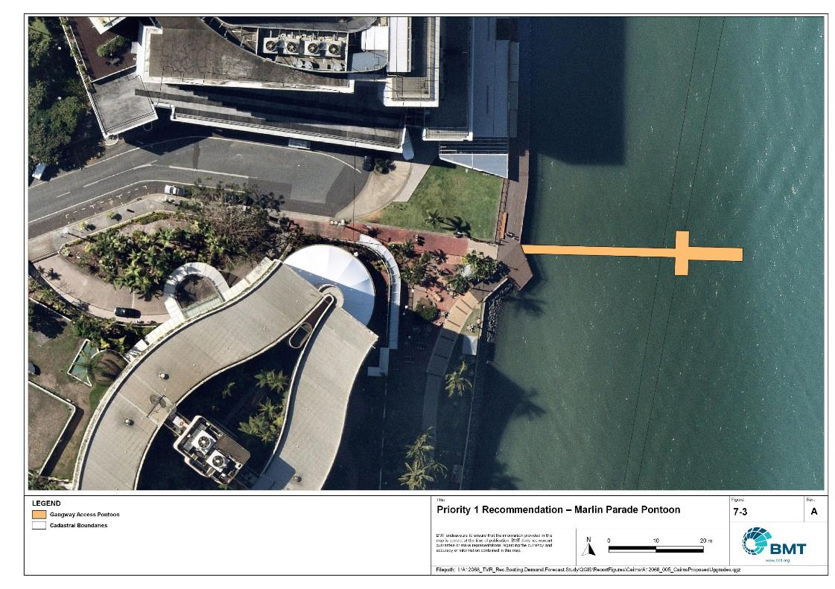

Priority 1 Recommendation – Marlin Parade Pontoon

"I:\A12068_TMR_Rec.Boating.Demand.Forecast.Study\Recomendations by Council\JPG\Cairns\A12068_005_CairnsProposedUpgrades_7-3.jpg"

Trinity Park - (Priority 3)

|  |  |  |  |  |
| --- | --- | --- | --- | --- |
| General description | | | | |
| Location | Harbour Drive, Trinity Park (known as the Bluewater boat ramp) | | | |
| Existing Facility? | Yes | | | |
| Coordinates | -16.801921622410386, 145.7068106463332 | | | |
| Existing tidal status | All-tide | | | |
| Existing wave exposure | Nil | | | |
| Existing current exposure | Nil | | | |
| Proposed works | Install additional 12 CTU spaces. Create queuing lane for access to the boat ramp. Install gangway-access pontoon. | | | |
| Increased effective capacity |  | | | |
| Capacity improvement position | Waterside | Landside | | Both |
| Rationale | The existing facility in Bluewater Marina is a very popular launching location for recreational boat users in north Cairns and is highly likely to remain so after completion of the new Yorkeys Knob boat launching facility. However, traffic problems have been identified by multiple stakeholders. The proposed works would create a slip lane where cars waiting to use the facility can queue off the road and keep access open for other road users. The gangway-access pontoon provides a location for queuing vessels to drop off/pick-up drivers that are parking the car and therefore free up the boat ramp and its floating walkway more rapidly. Additional parking optimises the existing land parcels and provides additional capacity. | | | |
| Anticipated Costs (+/- 50%) | Waterside infrastructure | | $100,000 | |
| Landside infrastructure | | $130,000 | |
| Planning, environmental and approvals constraints | | | | |
| Assessment | Requirement | Comments | | |
| Fish Habitat Zone | X | N/A | | |
| Native Title | X | N/A | | |
| MCU requirement | X | N/A | | |
| Clearing remnant vegetation | ü | The works is within an area containing RVM Category R – reef-regrowth watercourse vegetation. A Development Permit may be required for clearing of remnant vegetation. | | |
| GBRWHA | X | N/A | | |
| Marine Park | X | N/A | | |
| Tidal works assessment | ü | Marine-based works will likely be tidal works and require a Development Permit | | |
| Other as required | ü | Marine Plants – works may interfere with marine plants and therefore require a Development Permit for marine plant disturbance. | | |
| Sea Level Rise | ü | The pontoon is the only component of the works within the erosion prone area subject to sea level rise. | | |
| Storm Tide Hazard | ü | The pontoon and queuing lane are within the boundaries of a high storm tide hazard area, although the carpark upgrade is within the boundaries of a medium storm tide hazard area. | | |
| Anticipated Complexity | Low | Medium | | High |

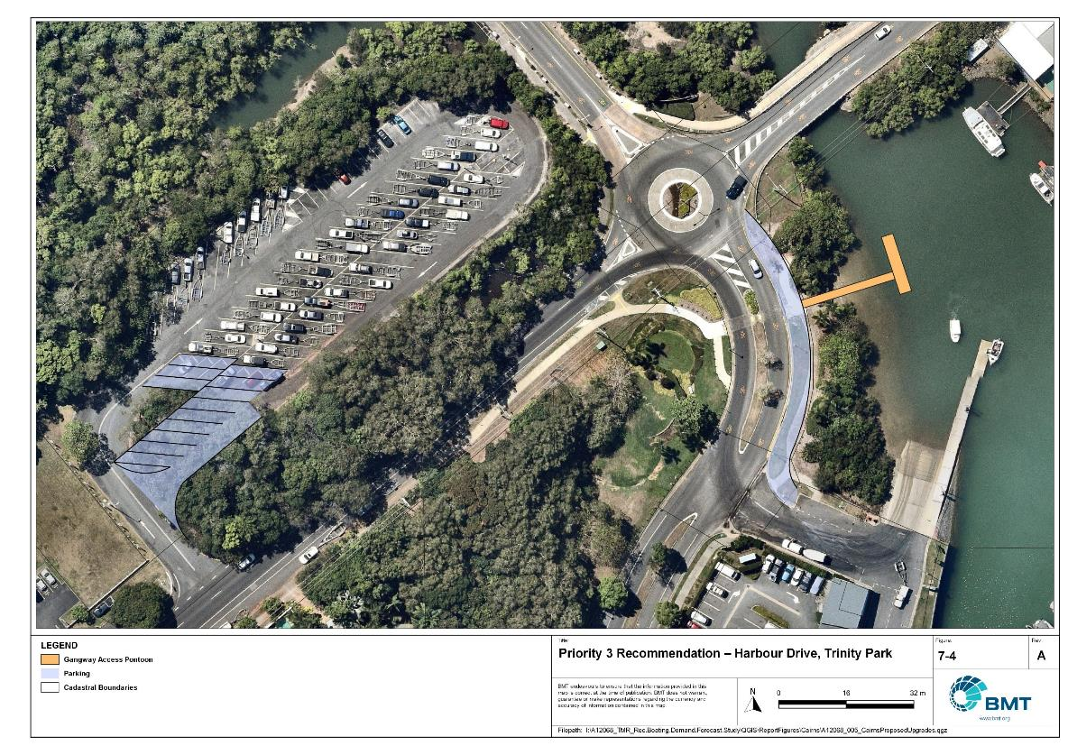

Priority 3 Recommendation – Harbour Drive, Trinity Park

"I:\A12068_TMR_Rec.Boating.Demand.Forecast.Study\Recomendations by Council\JPG\Cairns\A12068_005_CairnsProposedUpgrades_7-4.jpg"

## Priority 4 Recommendations

Nil.

# References

Australian Bureau of Statistics (ABS), 2021, *2021 Census,* <https://www.abs.gov.au/census>

Bell, Frederick W. 2022, *Estimation of the present and projected demand and supply of boat ramps for Florida's coastal regions and counties*, Florida State University, Department of Economics.

BMT, 2015, *MPSC Managed Boating Facilities Demand and Capacity Study: Boat Ramp Modelling*

Department of Transport and Main Roads (TMR), 2020, Marine facilities and infrastructure plan.

GHD, 2011, *Recreational Boating Facilities Demand Forecasting Study*

GHD, 2017, *Queensland Recreational Boating Facilities Demand Forecasting Study 2017.*

Maritime Safety Queensland (MSQ), 2022, *Recreational Boating Facilities,* <https://www.getinvolved.qld.gov.au/gi/consultation/8850/view.html>

Queensland Government Department of Resources (DoR), 2022, *Cities and towns [OGC WMS Service]*, Accessed 5/10/2022, available online at spatial.information.qld.gov.au/arcgis/home/item.html?id=103c7c9ccca449fab79d27cde06868ab

Rose, T., R. Powell & J. Yu (2009). Identification of the Present and Future Recreational Boating Infrastructure in Redland City – A 10 Year Infrastructure Plan- Griffith University

SKM (1998) Public Boat Ramps Central Queensland Strategic Plan - Volume One - Demand Forecasting - Noosa to Yeppoon. Sinclair Knight Merz, March 1998.

Swett, R., Fik, T., Ruppert, T., Davidson, G., Guevara, C. & Betty Staugler, 2012, *Planning for the future of recreational boating access to charlotte county waterways: 2010 – 2050*, Florida Sea Grant, University of Florida.

Western Australia Department of Transport, 2019, *Perth Recreational Boating Facilities Study Review 2019*, https://www.transport.wa.gov.au/mediaFiles/marine/MAC_P_Perth_RBFS_study_review_2019.pdf

Western Australia Department of Transport, 2021, *South West Region Recreational Boating Facilities Study July 2021,* https://www.transport.wa.gov.au/mediaFiles/marine/MAC_P_SouthWest_RBFS_Study_2021.pdf

###### Demand Study

"G:\Admin\A12068.g.mpb.TMRBoatingDemand\06_Reports\09_Demand Study\2022_2119 (016) Final Demand Report (March 2023).pdf"

###### Boat launching facility capacity

Capacity of existing boat launching facilities

| Facility ID | Facility Name | No. lanes | Tidal access  (at ramp) | Tidal access  (to open water) | Queuing facility | Formal CTUs | Informal CTUs | Waterside capacity | Landside capacity | Effective capacity | Constraint |
| --- | --- | --- | --- | --- | --- | --- | --- | --- | --- | --- | --- |
| **Open water access** | | | | | | | | | | | | |
| CN21 | Portsmith, Fearnley Street | 4 | All-Tide | All-Tide | Floating Walkway | 43 | 25 | 6 | 3 | 3 | Landside |
| CN22 | Portsmith, Tingira Street | 5 | All-Tide | All-Tide | Floating Walkway | 84 |  | 7.4 | 3.75 | 3.75 | Landside |
| MG80 | Cairns, Trinity Park, Schooner Road | 2 | All-Tide | All-Tide | Floating Walkway | 48 |  | 3.4 | 2.25 | 2.25 | Landside |
| MG91 | Yorkeys Knob, Buckley Street | 2 | All-Tide | All-Tide | Floating Walkway | 25 |  | 3 | 1.5 | 1.5 | Landside |
| **Subtotal** |  | **13** |  |  |  | **200** | **25** | **19.8** | **10.5** | **10.5** |  |
| **Depth-limited** | | | | | | | | | | | | |
| MG12 | Bramston Beach | 1 | Near All-Tide | Near All-Tide | None | 0 | 8 | 1.36 | 0.75 | 0.75 | Landside |
| MG21 | Deeral, Ross Road | 3 | All-Tide | Near All-Tide | Fixed Walkway | 11 | 40 | 3.7 | 2.25 | 2.25 | Landside |
| MG31 | Bellenden Ker, Russell River Road | 2 | Near All-Tide | Near All-Tide | Fixed Walkway | 20 |  | 2.16 | 1.25 | 1.25 | Landside |
| MG41 | Packers Camp, Mackey Creek | 4 | All-Tide | Near All-Tide | Floating Walkway | 26 | 15 | 6 | 2 | 2 | Landside |
| MG51 | Cairns, Stratford, Greenbank West Road | 3 | All-Tide | Near All-Tide | Floating Walkway | 33 |  | 4.2 | 1.75 | 1.75 | Landside |
| MG52 | Machans Beach, Barron River Esplanade | 1 | All-Tide | Near All-Tide | None | 6 |  | 1 | 0.5 | 0.5 | Landside |
| MG63 | Edmonton, Fisherman Road | 2 | Near All-Tide | Part-Tide | Floating Walkway | 40 |  | 2.72 | 2 | 2 | Landside |
| MG81 | Thomatis (Richters) Creek, Holloways Beach, Acacia Street | 1 | Near All-Tide | Part-Tide | None | 5 |  | 0.8 | 0.5 | 0.5 | Landside |
| **Subtotal** |  | **17** |  |  |  | **141** | **63** | **21.94** | **11** | **11** |  |
| **Beach Ramps** | | | | | | | | | | | |
| MG42 | Second Beach, Pine Creek Yarrabah Road, Yarrabah | 1 | Part-Tide | Part-Tide | None | 4 |  | 0.5 | 0.5 | 0.5 | Waterside |
| **Subtotal** |  | **1** |  |  |  | **4** | **0** | **0.5** | **0.5** | **0.5** |  |
| **Total Effective Capacity** | | | | | | | | | | **22** |  | |

###### Travel time statistics

Travel time from population centres to nearest sheltered all-tide or near all-tide open water accessible facilities

| Population Centre | Travel time (mins) |
| --- | --- |
| Aloomba | 18 |
| Babinda | 18 |
| Bellenden Ker | 24 |
| Bramston Beach | 23 |
| Buchan | 7 |
| Cairns | 2 |
| Deeral | 25 |
| Edmonton | 7 |
| Giangurra | 33 |
| Gordonvale | 14 |
| Holloways Beach | 10 |
| Mirriwinni | 14 |
| Redlynch | 10 |

###### Facility Use

Boat launching facility usage statistics

| Facility ID | Facility name | Total reports | Cairns | Mareeba | Tablelands | Townsville | Brisbane | Cassowary Coast | Gold Coast | Sunshine Coast | Mackay | Logan | Other LGAs |
| --- | --- | --- | --- | --- | --- | --- | --- | --- | --- | --- | --- | --- | --- |
| Total |  | 15583 | 12800 | 349 | 238 | 209 | 204 | 172 | 123 | 86 | 83 | 77 | 1242 |
| Total % |  | 100% | 82.10% | 2.2% | 1.5% | 1.3% | 1.3% | 1.1% | 0.8% | 0.6% | 0.5% | 0.5% | 8.0% |
| CN22 | Portsmith, Tingira Street | 3485 | 84.90% | 2.2% | 1.6% | 1.1% | 0.7% | 0.3% | 1.1% | 0.3% | 0.5% | 0.4% | 6.8% |
| CN21 | Portsmith, Fearnley Street | 2474 | 83.00% | 1.6% | 1.0% | 1.9% | 1.9% | 0.4% | 0.7% | 0.2% | 0.4% | 0.5% | 8.4% |
| MG51 | Stratford, Greenbank West Road | 1427 | 81.50% | 2.8% | 0.6% | 0.6% | 1.1% | 0.5% | 0.9% | 1.8% | 0.6% | 0.4% | 9.3% |
| MG41 | Packers Camp, Mackey Creek | 1265 | 87.90% | 0.4% | 3.3% | 0.2% | 1.0% | 0.6% | 0.0% | 1.0% | 0.5% | 0.3% | 4.7% |
| MG63 | Edmonton, Fisherman Road | 1128 | 90.60% | 0.6% | 2.4% | 0.8% | 0.7% | 0.4% | 0.2% | 0.1% | 0.1% | 0.2% | 4.0% |
| MG80 | Trinity Park, Schooner Road | 1002 | 86.50% | 4.0% | 0.2% | 0.4% | 1.2% | 0.1% | 1.0% | 0.5% | 0.8% | 0.6% | 4.7% |
| MG21 | Deeral, Ross Road | 956 | 82.10% | 4.5% | 1.9% | 0.7% | 2.1% | 2.0% | 1.5% | 0.2% | 0.3% | 0.0% | 4.7% |
| MG91 | Yorkeys Knob, Buckley Street | 920 | 69.90% | 7.8% | 1.3% | 2.2% | 2.3% | 0.1% | 1.7% | 1.3% | 0.4% | 0.2% | 12.7% |
| MG31 | Bellenden Ker, Russell River Road | 727 | 83.10% | 0.8% | 1.4% | 0.7% | 1.2% | 1.7% | 0.1% | 0.4% | 1.5% | 0.3% | 8.8% |
| MG12 | Bramston Beach, Evans Road | 665 | 63.50% | 1.1% | 2.3% | 4.2% | 1.1% | 12.5% | 1.1% | 1.1% | 1.1% | 1.2% | 11.1% |
| MG52 | Machans Beach, Barron River Esplanade | 593 | 76.90% | 0.5% | 1.5% | 3.0% | 0.8% | 0.8% | 0.3% | 0.0% | 0.8% | 0.5% | 14.7% |
| MG42 | East Trinity, Second Beach, Pine Creek Yarrabah Road | 491 | 73.70% | 0.4% | 1.2% | 1.8% | 1.6% | 1.2% | 0.8% | 0.0% | 0.0% | 2.6% | 16.5% |
| MG81 | Holloways Beach, Thomatis (Richters) Creek, Acacia Street | 450 | 78.40% | 1.6% | 1.8% | 2.4% | 3.1% | 0.9% | 0.0% | 0.4% | 0.2% | 1.3% | 9.8% |

|  |  |  |
| --- | --- | --- |
|  |  | BMT is a leading design, engineering, science and management consultancy with a reputation for engineering excellence. We are driven by a belief that things can always be better, safer, faster and more efficient. BMT is an independent organisation held in trust for its employees. |

|  |  |  |  |  |  |  |  |  |
| --- | --- | --- | --- | --- | --- | --- | --- | --- |
|  |  |  |  |  |  |  | Contact us  enquiries@bmtglobal.com  www.bmt.org  Follow us  www.bmt.org/linkedin LinkedIn logo.  www.bmt.org/youtube YouTube logo.  www.bmt.org/twitter Twitter logo.  www.bmt.org/facebook Facebook logo. |  |
|  | Level 5  348 Edward Street  Brisbane  QLD 4000  Australia  +61 7 3831 6744 |  | Registered in Australia  Registered no. 010 830 421  Registered office  Level 5, 348 Edward Street,  Brisbane QLD 4000 Australia |  |  |  |  |
|  | For your local BMT office visit www.bmt.org | | |  |  |  |  |  |