|  |
| --- |
| Queensland Recreational Boating Facilities Demand Forecasting Study 2022  Noosa Shire Assessment |
|  |
|  |

|  |  |  |
| --- | --- | --- |
| Customer |  | Maritime Safety Queensland |
| Project |  | A12068 |
| Deliverable |  | 005 |
| Version |  | 01 |
|  |  | 21 April 2022 |

Document Control

Document Identification

|  |  |
| --- | --- |
| Title | Queensland Recreational Boating Facilities Demand Forecasting Study 2022 |
| Project No | A12068 |
| Deliverable No | 005 |
| Version No | 01 |
| Version Date | 21 April 2022 |
| Customer | Maritime Safety Queensland, a branch of the Department of Transport and Main Roads |
| Customer Contact | boatinginfrastructure@msq.qld.gov.au |
| Classification | {None} |

|  |  |
| --- | --- |
| Author | Daniel Wishaw, Nicholas Heiner, Geoff Long, Jeremy Visser, Azam Dolatshah |
| Reviewed By | Katrina O’Malley-Jones |
| Project Manager | Daniel Wishaw |

Amendment Record

The Amendment Record below records the history and issue status of this document.

| Version | Version Date | Distribution | Record |
| --- | --- | --- | --- |
| 00 | 13 March 2023 | Maritime Safety Queensland Noosa Shire Council | Report |
| 01 | 21 April 2023 | Maritime Safety Queensland | Final |

Executive Summary

This report, part of the Queensland Recreational Boating Facilities Demand Forecasting Study 2022 (‘the Study’), provides a summary of current and forecast demand on recreational boating facilities in Noosa Shire and the capacity of existing facilities to meet this demand. Where capacity is insufficient to meet current or forecast demand, recommendations have been made to improve existing facilities or for the construction of new facilities. This report is intended to support facility deliverers, owners, and managers over the next 20 years in their decision-making on development priorities for recreational boating facilities within the Noosa Shire.

Key issues and attributes of recreational boating

The key attributes of recreational boating facilities identified in this Study for Noosa Shire are summarised in Table 1, while consultation with stakeholders undertaken as part of the Study identified the following key issues:

* very low overall satisfaction of recreational boating demand for boat launching facilities
* the highest per-capita registration of small (less than 4.5m in length) vessels in south-east Queensland, and the second highest per-capita registration of trailable (less than 8m in length) vessels in south-east Queensland (behind Redland City Council LGA)
* very high conflict with competing uses for available land along the Noosa River foreshore
* strong disagreement between various stakeholders on the appropriateness of competing uses of the Noosa River and the surrounding foreshore land.

1. Key recreational boating attributes for Noosa Shire

| Key attribute | Value |
| --- | --- |
| Deep draught landing facilities |  |
| Existing demand (number) | 1.2 |
| Existing capacity (number) | 0 |
| Existing shortfall (number) | 1.2 |
| Boat launching facilities |  |
| Number of existing facilities | 9 |
| Current demand for boat launching lanes (effective lanes) | 9.8 |
| Number of existing ‘effective’ boat launching lanes | 5.75 |
| Current shortfall of ‘effective’ boat launching lanes (number) | 4.05 |
| Demand satisfaction for ‘effective’ boat launching lanes | 59% |
| State average demand satisfaction for ‘effective’ boat launching lanes | 82% |

Demand summary

The assessment of recreational boating demand is centred on a statistical demand model that considers vessel registration data, population statistics, assumptions around local usage and the movement of vessels into and out of the LGA. Non-statistical demand is addressed in section 4.5. Key parameters from this assessment for Noosa Shire are:

* The population is 56,308 as at the 2021 census and is projected to be 64,999 by 2041.
* As of July 2022, there is a total of 5,146 vessels with a home registration within the LGA, with 95% being ‘trailable’ – and therefore requiring boat launching facilities – and 5% being non-trailable.
* Noosa has several waterfront communities with vessels moored on private pontoons. A survey of Noosa Sound and Noosa Waters indicates there are approximately 600 private pontoons with 200 vessels less than 8m in length moored at them. The total trailable fleet size has been reduced by 200 vessels to reflect that these boats will not be contributing to demand pressure for boat launching facilities. There is an equivalent reduced demand for this reason for future public pontoon facilities.
* Noosa Shire is deemed to be a Metropolitan Area with an assumed vessel activation rate of 8% on a ‘good boating day’.
* Vessels are primarily used within the LGA, with some leakage to Sunshine Coast, Gympie and Fraser Coast LGAs.
* Vessels from the Sunshine Coast, Brisbane, Moreton Bay, Gold Coast and Toowoomba are expected to flow into the LGA and contribute to local demand.
* The existing demand for boat launching facilities is 9.8 ‘effective’ boat lanes and projected 11.3 ‘effective’ lanes by 2041. As presented in Table 1, the current capacity is 5.8 ‘effective’ boat lanes.
* The existing demand for deep-draught vessel landings is 1.2 currently and 1.3 by 2041. As presented in Table 1, there are currently no deep-draught vessel landings.

Boat launching

Boat launching facilities comprise boat ramps, any queuing facilities (floating walkways, pontoons, beaches, and fixed sloping walkways) and the provision of car-trailer unit (CTU) parking. The capacity of a boat launching facility is measured in ‘effective lanes’ for both waterside and landside facilities, with the total capacity of a facility being the minimum of the waterside or landside capacity. Waterside capacity is calculated from the number of boat ramp lanes multiplied by environmental reduction factors (for tide, current or waves) and queuing facility improvement factors to derive the number of ‘effective’ lanes. The landside capacity is calculated from the number of available CTU parking spaces.

Noosa Shire has nine boat launching facilities, comprising twelve boat ramp lanes with a total effective boat launching capacity of 5.8 ‘effective’ lanes. All these facilities are constrained by landside capacity.

The capacity, forecast demand and shortfall of boat ramp effective lanes in Noosa Shire is shown in Figure 1.

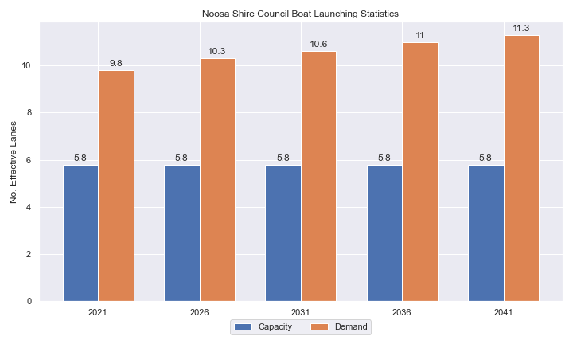

1. Existing capacity, forecast demand and shortfall of ‘effective’ boat ramp lanes for Noosa Shire

Deep-draught vessel landings

Vessel landing facilities are provided across the state in the form of pontoons and jetties, to provide locations for larger vessels, or their tenders, to access landside destinations or facilities. Pontoons and jetties may also be provided for other purposes such as supporting boat launching or other recreation and may not be suitable for deep-draught vessels. The trend across Queensland indicates that jetties are rarely used as landings, with pontoons preferred by recreational users. As such, the Study has limited the capacity of deep-draught vessel landings to those that are accessible and commonly used by deep-draught vessels, as identified in consultation with stakeholders.

Noosa Shire has no usable public deep-draught vessel landings, with public jetties along the Noosaville foreshore unsuitable for this purpose. The shortfall assessment for deep-draught vessel landings is shown in Table 2 and indicates that additional facilities are required for Noosa.

1. Deep-draught vessel landing shortfall summary

| Criteria | 2021 | 2026 | 2031 | 2036 | 2041 |
| --- | --- | --- | --- | --- | --- |
| Deep-draught vessel demand | 1.2 | 1.2 | 1.3 | 1.3 | 1.3 |
| Deep-draught vessel capacity | 0 | 0 | 0 | 0 | 0 |
| Shortfall | 1.2 | 1.2 | 1.3 | 1.3 | 1.3 |

Priority recommendations

Recommendations for new facilities or upgrades to existing facilities are outlined in Table 3. The range of recommendations seeks to reduce the overall capacity shortfall within Noosa Shire over the 20-year planning life of this project, as well as address specific concerns, including:

* providing suitable landing facilities for larger vessels within the Noosa River
* providing queuing facilities at boat ramps to better cater for people with restricted mobility.

Recommendations

1. Summary of recommended boating infrastructure upgrades for Noosa Shire

| Priority | Criteria | Recommendations |
| --- | --- | --- |
| 1 | * Required to meet existing demand. * Sites that can provide maximum benefit for existing demand pressures at an LGA scale or satisfy specific safety pressures. | * Thomas Street, Noosaville: Improve car parking and reposition floating walkway. * Tewantin, Lake Street: Improve car parking and install new floating walkway. Remove existing jetty in due course. * Hilton Esplanade, Tewantin: Reclaim land to construct a new 2-lane, 45 CTU facility. * Noosa Woods: Replace existing jetty with pontoon. |
| 2 | * Required to meet demand within the next five to ten years. * Sites that are likely to have low to medium approval complexity. * Sites that can provide satisfaction of specific demand or safety pressures within the LGA. | * Moorindil Street (north end), Tewantin: Formalise a single-lane boat ramp supported by 15 CTU parking spaces. |
| 3 | * Required to meet demand within the next ten to fifteen years. * Sites that service planned future growth within the LGA. | * Chaplin Park, Noosaville: Construct new 2-lane facility with a floating walkway and 51 CTU spaces. * Gympie Terrace: Replace existing jetty with pontoon. |
| 4 | * Required to meet demand within the next fifteen to twenty years. * Sites that service planned future growth within the LGA. | * Nil |

Contents

Definitions 10

1 Introduction 13

2 Noosa Shire Overview 14

2.1 Key influences on recreational boating 14

2.2 Existing recreational boating infrastructure 14

2.3 Existing usage and issues 16

3 Capacity Assessment 17

3.1 Boat ramps 17

3.2 Access to sheltered near all-tide and all-tide facilities 23

3.3 Deep-draught vessel landings 24

4 Demand Assessment 26

4.1 Activation rate 26

4.2 Digital user survey 27

4.3 Active fleet size 31

4.4 Boat ramp lane demand 31

4.5 Non-statistical demand 31

4.6 Deep-draught vessel demand 32

5 Shortfall Assessment 33

5.1 Shortfall assessment – boat ramps 33

5.2 Shortfall assessment – deep-draught landings 34

6 Stakeholder Feedback 36

6.1 Managing authority feedback 36

6.2 Stakeholder feedback 37

7 Development Recommendations 39

7.1 Previous recommendations 39

7.2 Priority recommendations 40

7.3 Priority 1 recommendations 42

7.4 Priority 2 recommendations 53

7.5 Priority 3 recommendations 56

8 References 62

Annex A Demand Study A-1

Annex B Boat launching facility capacity B-1

Annex C Travel time statistics C-1

Annex D Facility Use D-1

Tables

Table 2.1 Recreational boating facilities by facility owner in Noosa Shire 14

Table 3.1 Queuing facility efficiency modifiers 20

Table 4.1 LGA of origin for active fleet in Noosa Shire 28

Table 4.2 Popularity of boat launching facilities. 28

Table 4.3 Active fleet vessel size 31

Table 4.4 Boat ramp lane demand 31

Table 4.5 Deep-draught vessel landing demand. 32

Table 5.1 Shortfall of boat launching facilities 33

Table 5.2 Shortfall assessment for open water, all-tide or near all-tide facilities for Noosa LGA 34

Table 5.3 Shortfall of deep-draught vessel landings 35

Table 6.1 Stakeholder identified opportunities 36

Table 7.1 Assessment of unimplemented 2017 recommendations 39

Table 7.2 Summary of recommendations for Noosa Shire 41

Table 7.3 Thomas Street/Albert Street (Priority 1) 42

Table 7.4 Tewantin, Lake Street (Priority 1) 45

Table 7.5 Hilton Esplanade (Priority 1) 48

Table 7.6 Noosa Woods pontoon - (Priority 1) 51

Table 7.8 Chaplin Park (Priority 3) 56

Table 7.9 Gympie Terrace pontoon - (Priority 3) 59

Table B.1. Capacity of existing boat launching facilities B-1

Table C.1. Travel time from population centres to nearest sheltered all-tide or near all-tide open water accessible facilities C-1

Table D.1. Boat launching facility usage statistics D-1

Figures

Figure 2.1 Public boat launching facilities within Noosa Shire 15

Figure 3.1 (a) Summary of open water access from boat launching facilities (left) and (b) Summary of tidal restrictions at tidal boat launching facilities (right) 22

Figure 3.2 Summary of limiting capacity constraint 23

Figure 3.3 Distribution of travel time from Noosa’s eligible population centres to open-water accessible, sheltered, near all-tide or all-tide facilities 24

Figure 3.4 Noosa Shire – Travel time to nearest all-tide or near all-tide facility 25

Figure 4.1 Noosa Shire – Vessel pathing 30

Figure 5.1 Shortfall assessment with recommended upgrades adopted 33

Figure 7.1 Priority 1 Recommendation – Thomas Street 44

Figure 7.2 Priority 1 Recommendation – Tewantin 47

Figure 7.3 Priority 1 Recommendation – Hilton Esplanade 50

Figure 7.4 Priority 1 Recommendation – Noosa Woods Landing 52

Figure 7.5 Priority 2 Recommendation – Moorindil Street, Tewantin 55

Figure 7.6 Priority 3 Recommendation – Chaplin Park 58

Figure 7.7 Priority 1 Recommendation – Gympie Terrace Landing 61

Definitions

| Term | Definition |
| --- | --- |
| All‑tide (for boat ramps) | Access from a boat ramp to the open sea with an approach depth of 0.5m below LAT or deeper and a depth at boat ramp toe of 0.5m below LAT or deeper. |
| All-tide (for landings) | Access from a gangway‑access pontoon or jetty to the open sea with an approach depth of 1.5m below LAT or deeper and a depth on at least one face of the pontoon of 1.5m below LAT or deeper. |
| BIP | Boating Infrastructure Program – a sub‑program within MSQ's Maritime Assets and Infrastructure Program |
| Boat ramp | A foreshore concrete ramp with a slope designed for vehicular launching and retrieving of recreational boats. |
| Breakwater | A structure constructed over the seabed and/or the foreshore, usually rising to a height above high tide, designed to provide protection to landward areas by limiting penetration of wave action or currents. |
| CTU | Car-trailer unit space – a parking space for a typical car with a boat trailer attached. |
| Demand | Demand is the requirement of the boat‑owning population for facilities to launch/retrieve trailer boats and/or to berth suitable boats at a given year to service their average (non‑peak period) needs. In most locations demand is based on vessel registrations and is expressed in terms of boat ramp lanes or in number of 12m berths at landings. |
| Effective capacity | For a boat ramp, effective capacity (effective lanes) means the number of boat ramp lanes after adjusting for anticipated unavailability due to unacceptable wave action (>0.2m wave height) or water depth, usage constraints such as the lack of adequate parking, and improvements to efficiency or launch/retrieval throughput such as floating walkways or pontoons. |
| FHA | Fish Habitat Area, declared under the Fisheries Act, 1994 |
| FIFO | Fly‑in fly‑out, where skilled workers travel from their city or central location home communities to a remote site to perform their duties often in blocks of time that provide regular, non-weekend, days off. |
| Fixed sloping walkway | A fixed sloping structure installed at the side of a boat ramp to assist launching/retrieval of trailer boats, and dry embarkation/disembarkation from trailer boats. It is sloped to allow use at varying tide heights – sometimes with sections of different slope. |
| Floating walkway | Multiple connected/hinged flotation modules configured to assist launching/retrieval of trailer boats, and dry embarkation/disembarkation from trailer boats at most if not all stages of the tide. Floating walkways are connected to a concrete shore abutment allowing pedestrian and assisted wheelchair access. |
| Gangway access pontoon | A platform/module that always floats, where a boat can be secured alongside on one or more faces. Pontoons are usually separated from a boat ramp and have a hinged articulated gangway for access to the shore via an abutment. |
| GBR | Great Barrier Reef |
| GCWA | Gold Coast Waterways Authority |
| Landing | A landing is a jetty or gangway‑access pontoon that facilitates berthing of vessels and transfer of passengers and stores. They are most often associated with non-trailable vessels |
| Landside | Refers to areas above high-water mark, often used to denote the location of and type of infrastructure. |
| LAT | Lowest Astronomical Tide, used as Chart Datum on navigational charts. |
| LGA | Local Government Area |
| Managing authority | Councils, port authorities, water storage managers as listed in schedule 1 of the Transport Infrastructure (Public Marine Facilities) Regulation 2011 |
| MCU | Material change of use under the planning scheme |
| MNES | Matter of national environmental significance under the Environment Protection and Biodiversity Conservation Act 1999 |
| MSQ | Maritime Safety Queensland |
| NC Act | Nature Conservation Act 1992 |
| Near all‑tide | Access from a boat ramp to the open sea with a minimum approach depth of 0.5m below LAT and minimum depth at the boat ramp of 0.5m below LAT for 80 percent or more of the tidal range (time measured over a year). |
| Parking - Formalised | A sealed, line-marked parking area for car-trailer units, providing adequately sized parking spaces, roadways and turning circles. |
| Parking – Semi-formalised | An all-weather non-sealed parking area, with markers to delineate adequately sized car-trailer unit parking bays and turning circles. Markers can be concrete blocks, pavement markers (e.g., retro-reflective raised markers) or other permanent instalment to show parking bays. |
| Parking – Informal overflow | A naturally surfaced area available for use as overflow parking on the design boating day, signed as such. To have mixed-use purpose (e.g., parkland) when not being utilised as overflow parking. |
| Part‑tide | Boat ramps that do not meet near all-tide or near all-tide requirements. |
| PV | Passenger vehicle (i.e., car – as opposed to car-trailer unit). |
| Port Authority | An organisation that is responsible for the management of one or more ports on the Queensland coast. |
| Population Centre | Official named urban settlements (populated places) that have been sourced from the Queensland Place Names Database. |
| Registration activation rate | The percentage of registered vessels liable to be in use on any given good weather weekend day |
| Shortfall | The number of effective boat ramp lanes or landings required to meet demand for a given timeframe. Negative shortfall signifies an oversupply for the time period nominated. |
| SPL | Strategic Port Land |
| Study | The Recreational Boating Facility Demand Forecasting Study 2022, including this document. |
| TMR | Department of Transport and Main Roads |
| Water Storage Authority | Includes SEQ Water, SunWater |
| Waterside | Refers to areas below high-water mark, often used to denote the location of and type of infrastructure, including dredged channels and breakwaters. |
| WHA | World Heritage Area |
| # | Number |

# 1 Introduction

BMT has been appointed to undertake the Recreational Boating Facilities Demand Forecasting Study 2022 (‘the Study’) by Maritime Safety Queensland (MSQ), a branch of the Queensland Department of Transport and Main Roads (TMR), on behalf of all public recreational boating facility managers and owners across Queensland. The Study supersedes the 2017 study of the same name and is intended to report on recreational boating facility demand, capacity, and shortfall over a 20-year period at a Local Government Area (LGA) scale across Queensland.

The Study has been developed using information from the 2021 Australian Census (ABS, 2021), recreational boat vessel registrations, consultation with facility owners, managers, and stakeholders, the 2022 Queensland Government Get-Involved recreational boating facilities survey (MSQ, 2022), and previous versions of this study (2011, 2017). The Study is intended for use by deliverers, owners, managers, and key stakeholders of public recreational boating facilities across Queensland, namely state government agencies including MSQ and the Gold Coast Waterways Authority (GCWA), local governments, port authorities and water authorities. The Study is non-regulatory in nature and is intended to be used as part of a broader suite of information to identify priority investment in recreational boating infrastructure at a local and state level.

The Study establishes demand primarily on statistics derived from registration and population data. However, non-statistical forms of demand may also be reflected in Study recommendations. Please refer to Section 4.5for discussion of non-statistical demand. The Study evaluates existing and forecast demand over a 20-year period and makes recommendations on how this demand might be met over that period. Recommendations may include improvements to both landside and waterside capacity depending on the facility.

Recommendations are assigned a priority ranking, from 1 to 4, indicating if they are required immediately or in the next 5, 10 or 15 years respectively. To end 2022, 14% of recommendations from the 2017 study have been completed, comprising 11% of landside recommendations and 18% of waterside recommendations and reflecting 22% of priority 1 2017 recommendations. A much greater percentage of the earlier 2011 study recommendations have now been implemented. Given the low uptake on existing/outstanding recommendations, this Study reviews previous recommendations and carries forward, modifies, or removes as appropriate. The Study has also been tasked with reviewing specific wave exposed beach launching facilities across the state to determine their contribution to meeting boating facilities demand and make recommendations about their future.

The Study includes a report for every LGA in Queensland and a state-wide summary report. Each LGA report summarises demand pressures from vessel registration data, population statistics, assumptions around local usage and the movement of vessels into and out of the LGA, and existing capacity and recommends opportunities to satisfy shortfall. The state-wide report supports the LGA reports and provides context at a state level for demand pressures, current capacity, equity of access to facilities and state-wide priority for major boating facilities.

The Study is intended to report on publicly accessible recreational boating facilities for registered vessels. This includes boat ramps, floating walkways, pontoons, fixed sloping walkways and supporting car-trailer unit parking at each facility. The Study does not include recommendations for facilities that are used primarily for commercial purposes, private facilities, non-motorised recreation such as launching canoes and stand-up paddle boards, and fishing platforms.

# 2 Noosa Shire Overview

## Key influences on recreational boating

Within Noosa Shire, the principal attributes and influences that affect demand on recreational boating infrastructure include:

* its designation as a Metropolitan Area, with a large local recreational boating fleet
* strong projected population growth
* high tourism inputs from other southeast Queensland LGAs.

## Existing recreational boating infrastructure

The recreational boating facilities within Noosa Shire are summarised in Table 2.1. These facilities are owned or managed by multiple organisations and include facilities that provide access to open water, estuaries, and fresh water. MSQ’s long term vision is to provide unrestricted access to open water from facilities along the Queensland coast such that all significant population centres are within one hour’s driving range where practical. For clarity, the Study has defined this vision to be the provision of sheltered all-tide, or near all-tide, boat launching facilities within one hour driving range of official population centres (DoR, 2022) lying within 30km of the coastline between the NSW border and Cooktown.

Recreational boating facilities by facility owner in Noosa Shire

| Owner | Open-water boat ramps | | Other boat ramps | | Landings | |
| --- | --- | --- | --- | --- | --- | --- |
| Facilities | Lanes | Facilities | Lanes | Pontoons | Jetties |
| Noosa Shire Council | 1 | 1 | 2 | 2 | 1 | 13 |
| TMR | 3 | 6 | 2 | 2 |  | 1 |
| Seqwater |  |  | 1 | 1 | 1 |  |

Each of the boat launching facilities within the LGA are shown in Figure 2.1.

Access to land from deep-draught vessels is catered for by the provision of landings such as jetties and pontoons that are intended for short term usage, mainly to drop off and embark passengers and supplies. Within Noosa Shire there are no suitable landings for larger vessels.

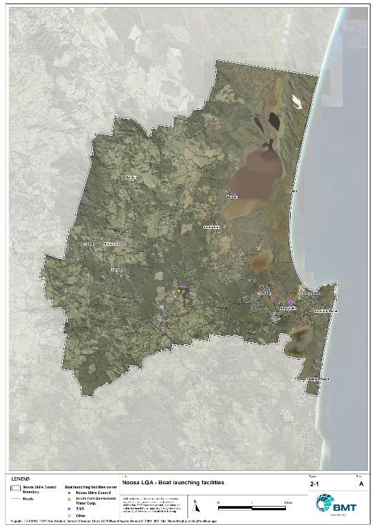

\\bmt-bne-fs01\drafting\A12068_TMR_Rec.Boating.Demand.Forecast.Study\QGIS\ReportFigures\Noosa\A12068_002_GIS_NoosaBoatLaunchingFacilities.jpg

Public boat launching facilities within Noosa Shire

## Existing usage and issues

Consultation with Noosa Shire Council, Seqwater, recreational groups and feedback from the recreational boating facilities survey hosted by TMR indicate the following major themes and issues within Noosa Shire.

* + 1. Insufficient capacity

Feedback from recreational groups and through the TMR recreational boating survey, indicated that the capacity of the existing infrastructure in Noosa Shire is inadequate and outdated. Generally, complaints focused on the lack of parking, or the excessive distances required to walk from informal parking locations (side streets etc), should they be available. The long walking distances and limited parking availability regularly results in boats being left on the ramp or floating walkway for long periods, leading to excessive congestion at the boat ramps themselves.

* + 1. Outdated facilities

Users highlighted that in the absence of floating walkways and/or pontoons the facilities are outdated and have fallen behind the standard built across the state. This type of infrastructure assists people with mobility constraints to access vessels, which was specifically mentioned as a problem at Noosa. A review of recreational facilities around Noosa indicates no significant increases to boat ramp capacity in the last 30 years.

* + 1. Strong competition for land availability

The Noosa River foreshore is the only viable place for recreational boating facilities, due to the river being designated as ‘Fish Habitat A’ for most of the river length and other potential sites being too far from desirable destinations. However, the foreshore region from Munna Point to Tewantin is heavily used for other land uses or desirable for future usage for a number of activities.

# 3 Capacity Assessment

## Boat ramps

* + 1. Introduction

Boat ramps are facilities that are used for launching and retrieving trailable vessels, typically up to 8m in length (with some exceptions), to and from the water. Boat ramps consist of one or more lanes and their use is often supported by landside and waterside infrastructure to improve efficiency. In some instances, the usability of a facility can be adversely affected by environmental constraints such as low water levels, currents, or wave exposure, reducing the overall availability of the facility. Together, consideration of the number of boat ramp lanes, the supporting infrastructure, and environmental constraints results in the facility having a capacity described in terms of ‘effective lanes’ that may or may not be equal to the number of actual boat ramp lanes.

To maximise usage of each facility, the landside and waterside capacity should be balanced. Each facility will have a calculated ‘effective’ capacity for both the landside and waterside elements, with the limiting element dictating the facility's overall effective capacity. Recommendations for works or infrastructure promote balancing these two capacity elements by either improving the limiting element for increased facility effectiveness or by increasing the overall 'effective capacity' through changes to both elements.

* + 1. Boat ramp capacity

The waterside capacity is informed by the number of boat ramp lanes and the number and type of queuing facilities, such as pontoons, floating walkways, queuing beaches and fixed sloping walkways. It may also be limited by the available water depth in the adjacent waterbody and exposure to environmental or other physical factors.

Landside capacity is governed by the availability of nearby spaces for parking of car-trailer units (CTU), the provision of rigging and de-rigging facilities, and provision of single car parking spaces (single cars may otherwise be obliged to park in CTU spaces).

While it is expected that facilities will have their own characteristics influencing efficient use, this Study applies an approach that is consistent across the entire state and consistent with previous editions of the Study. Accordingly, the effective waterside capacity of a boat launching facility is determined as being:

* the ability to support 40 vessels being launched and retrieved per day per lane (see section 3.1.3)
* influenced by exposure to wave, tide, and current conditions (see section 3.1.4)
* supported by queuing facilities that assist in the efficient use of the boat ramp (see section 3.1.4).

Calculation of landside capacity is in line with the TMR guideline (TMR, 2020), which requires less provision of CTU parking per lane than the Australian standard (AS3962 Table 7.1), and advises:

* 10 CTUs for a single lane boat ramp accessed by an unsealed road, or 15 CTUs accessed by a sealed road
* 45 CTUs for a two-lane boat ramp
* 70 CTUs for a three-lane boat ramp
* 90 CTUs for a four-lane boat ramp.

A notable difference from the 2017 study is the recognition and inclusion of areas close to existing boating facilities that are unsealed and/or not line marked where parking of cars with trailers occurs and is not discouraged. These areas of informal parking have been identified on aerial imagery and through discussions with managing authorities. Each informal area has been assumed to be available for CTU parking only 50% of the time to account for conflicts with other uses (for example, markets), inefficient parking practices, or poor ground conditions. The rate of parking has been calculated as:

* for linear areas where nose-to-tail parking is expected – 1 CTU per 13m
* for linear areas with enough space to allow side-by-side parking – 1 CTU per 3m, provided there is a minimum distance of 15m from the road or manoeuvring area
* for large areas – 1 CTU per 100m2
  + 1. Boat ramp capacity basis

The number of vessels per day each boat ramp lane can support is based on the Australian Standard for the Design of Marinas (AS3962-2001) and previous versions of this report (GHD, 2011 and 2017).

Research on boat ramp lane efficiency described in the previous report (GHD, 2017) identified that 40 vessels per lane per day was a reasonable compromise between 50 vessels per lane per day (representing congested conditions) and 30 vessels per lane per day (representing unhampered conditions). For context, the 40 vessels per lane per day rate represents a vessel launch or retrieval every 9 minutes per lane within an average normally used period of 12 hours per day.

During this Study, BMT has sought to validate the assumptions presented above, and those relating to capacity modification, by undertaking a literature review, conducting site visits that included observations of launching and retrieving manoeuvres, and reviewing video recordings of boats launching and retrieving at popular boating facilities. The literature review included a boat ramp efficiency investigation undertaken by BMT on the Mornington Peninsula, Victoria (BMT, 2015) and a review of standards from other Australian states and countries that undertake similar studies. The onsite and video analysis provided the opportunity to observe recreational boat operators using facilities included in the study but did not include observation of total throughput during high demand periods. This assessment was undertaken during site visits across Queensland, and a full day of video recording at Manly Boat Harbour (north ramp) in Brisbane.

The New South Wales and Victoria governments are currently in a planning phase for boating infrastructure and there are presently no publicly accessible documents identifying how those jurisdictions calculate boat ramp lane capacity. The Western Australia government has commissioned studies of the Perth region and the southwest region (Western Australia Department of Transport, 2019 and 2021) that indicate a base rate of 50 vessels per lane per day, with no modifiers applied. Internationally, studies from Florida in the USA (Bell, 2022 and Swett et. al, 2012) assumed that total vessel launch plus retrieval time is between 20 to 40 minutes (18 to 36 vessels per day), although no evidence is provided to support this assumption.

The Mornington Peninsula report (BMT, 2015) collected boat launch and retrieval data for 6 boat ramp facilities on the Mornington Peninsula across 9 days, including the peak Australia Day holiday. Total throughput was assessed for each facility on days where there was constant pressure for launching and retrieving boats with results between 30 and 70 vessels per lane per day for the various facilities. When adjusted for queuing modifications, a baseline rate of between 20 and 50 vessels per lane per day was identified. Of the facilities, the higher rates were achieved where sufficient parking was provided and both waterside and landside queuing facilities existed.

Observations of recreational boat users launching and retrieving their vessels undertaken through the site visits and the analysis of video footage showed that:

* Most observed launches were of ‘multi-person’ boats, which made launching and retrieving boats more efficient.
* Almost all users were able to launch and/or retrieve their boat within the 9-minute target time, when adjusted for queuing facility efficiency.
* There was a preference to launch adjacent to a floating walkway, where one was available. At facilities where a queuing facility is not immediately adjacent to the lane it is expected that average launch times may slightly increase during busy periods.

While the observations that were made generally aligned with expectations, a more in-depth review of capacity assumptions was outside of the scope of the Study. For future studies there would be value in undertaking a more thorough, data-driven investigation of the assumptions about boat ramp lane capacity, both at its base level and modified by queuing facilities. Overall, the preliminary investigations undertaken as part of the Study suggest that the base rate of 40 vessels per lane per day adopted in previous studies is appropriate.

* + 1. Boat ramp efficiency modifications

The waterside capacity of boat ramp lanes can be reduced by environmental factors that include:

* Water levels: Mainly relating to tidal areas this factor considers the reduction in the amount of time the boat ramp is available to launch and retrieve vessels over the full tidal cycle, thus reducing the overall capacity of the facility. For all-tide access, the boat ramp and connecting channel to the open sea are available during all tidal conditions and therefore available 100% of the time. For near all-tide access the boat ramp and the connecting channel to the open sea are assumed to be available, on average, for 80% of the tidal cycle. For part-tide access the boat ramp and its access channel are available less than 80% of the time. A modification factor of 0.8 is applied for near all-tide facilities and 0.5 for part-tide facilities.
* Wave and current conditions: In areas where vessel launching and retrieval may be intermittently impacted by waves (most commonly on beach ramps, but not exclusively) or strong currents (such as in rivers), a modification factor of 0.5 is applied.

Conversely, effective boat ramp capacity can be improved through the use of well-designed queuing facilities. Queuing facilities aim to improve amenity and efficient use of the boat ramp by accelerating one or more of the following phases of boat launching, with the opposite steps required for retrieval:

1. manoeuvring for launching, including for CTU entering the queuing area for the boat ramp and reversing into position for launch
2. launching and securing the launched vessel
3. moving the launch vehicle from the boat ramp to the parking area
4. removing the vessel from the waterside queuing facility.

A range of waterside queuing facilities are in use in Queensland boating infrastructure, which modify different phases of the total launching process. These include:

* Floating walkways and fixed sloping walkways: Positioned to about a boat ramp lane, these structures aim to:
  + improve amenity – such as to assist embarking/disembarking passengers, provide a refuge from in-water contact with crocodiles and so on
  + make securing the vessel and removing the vehicle from the boat ramp more rapid, while freeing the boat ramp for subsequent users.
* Pontoons: Also used by deep-draught vessels, these structures improve the ability to secure the vessel and clear the boat ramp, but there is usually some time lost returning to recover the launch vehicle compared with the above options as they are generally positioned slightly further away from the ramp.
* Queuing beaches: These also provide a place to secure the vessel close to the boat ramp, although they are generally not as fast to use as pontoons.

As observed throughout the Study site visits, each of these queuing facility types can support a limited number of boat ramp lanes depending on the available space on the queuing facility. The 2017 edition of this Study applied a blanket uplift for all boat ramp lanes where a queuing facility was provided. However, the number of lanes each type of queuing facility can realistically support varies. Accordingly, this Study has provided limitations to the number of boat ramp lanes that can benefit from each queuing facility, based on the number of “working faces” (or area for a queuing beach) provided, where the “working face” is a face that allows temporary securing of vessels during launching or retrieval. The adopted improvement factors and supported lanes are summarised in Table 3.1.

Queuing facility efficiency modifiers

| Queuing facility | Modification factor | Supported lanes |
| --- | --- | --- |
| Floating walkway (lanes adjacent to walkway) | 1.7 | 1 Lane/face |
| Floating walkway (lanes not adjacent to walkway) | 1.3 | 1 Lane/face |
| Fixed sloping walkway | 1.7 | 1 Lane/face |
| Pontoon | 1.2 | 2 Lanes/face |
| Queuing beach | 1.1 | Site-based |

In other states in Australia, reversing queuing bays are more commonly used than in Queensland. These are CTU waiting bays at the head of the boat ramp that are aligned with each boat ramp lane to allow the user to reverse directly down the boat ramp once it is clear. CTU waiting bays reduce the time of the first phase of boat launching by allowing waiting CTU’s to be ready to reverse as soon as the lane becomes clear. The BMT (2015) study on the Mornington Peninsula included facilities with and without these bays. Boat ramps that included reversing queuing bays achieved 50% greater throughput. Facilities that have implemented this approach in Queensland include North Street Southport, Urangan Boat Harbour, Townsville Recreational Boating Park, and the (under construction late 2022) boat ramp at Yorkeys Knob.

* + 1. Accessibility from boat launching facilities

Recreational boat users will typically select the boat launching facility most appropriate or convenient to the activity they are seeking to undertake, the anticipated weather/wave conditions, and their destination. Each of facility within an LGA will provide a varying degree of access to different destinations and for different activities. During the Study, consultation with stakeholders highlighted the following general types of destinations and activities:

* open water/offshore: typically accessed for visiting offshore islands or remote beaches, snorkelling or diving locations, deep sea fishing and general recreation
* creeks and estuaries: typically accessed for fishing, crabbing, wildlife observation, skiing and general recreation
* freshwater: typically accessed for skiing, fishing, wildlife observation and general recreation.

These destinations are typically serviced by different types of recreational vessels. Inshore locations including creeks, estuaries and other freshwater locations are typically patronised by vessels less than 4.5m, except for ski boats, which can be much larger than this. Offshore locations typically require larger boats for access as these vessels are more capable of managing a wide range of wave conditions and can carry sufficient fuel to access distant destinations. Smaller vessels may be able to access close destinations on good weather days, and larger vessels may choose to access inshore destinations, particularly on poor weather days.

Consequently, the following aspects are used to classify how well a facility provides open water access:

* Open-water access: There are no restrictions between the facility and open water.
* Depth-limited access: There are depth restrictions between the facility and open water that limit navigable access to part of the tidal range. This differs from tidal constraints at the actual facility, which might be usable at all tides, but offshore access is limited by a downstream bar or delta.
* Distance-limited access: The distance from the facility to the open water is unrealistic for typical boat users. This distance is assumed to be about 4.5km between the facility and open water to rate as 'distance limited', with travel times increased further where portions of the access channel are regulated by speed limits.
* Infrastructure-limited access: There are man-made obstacles between the facility and open water, such as above-ground pipeline crossings, low bridges or weirs that impede navigable access to open water.
* Beach ramps: These provide open-water access but are typically constrained by environmental conditions such as wave exposure and tide levels. The capacity of these facilities has been individually assessed based on consultation and other data sources and is described in more detail in section 0.
* Freshwater: There is no access to open water.

Certain facilities, particularly those in freshwater, may be constrained by periods of drought, or debris deposition after rainfall events that limit access to destinations, and therefore whether a facility will provide useful boat launching capacity. While it is noted that drought and rainfall may affect the overall capacity of boat launching within an LGA, and given that the timing of such events is not readily predictable, their impact on capacity has not been evaluated.

* + 1. Existing boat launching capacity

Within Noosa Shire there are nine boat launching facilities. The effective capacity of boat launching facilities within Noosa Shire is shown in Annex B, with a summary of the access to open water and tidal constraints shown in Figure 3.1 and the overall capacity constraint shown in Figure 3.2. Pertinent features of these facilities include:

* There are twelve total lanes, with an effective capacity of 5.75 effective lanes. The constraints on capacity are entirely due to the provision of insufficient parking at each facility.
* Boat users in Noosa Shire have a range of options for boating, with facilities available for accessing freshwater destinations in Lake MacDonald, the upper brackish lakes at Boreen Point and offshore destinations (via the Noosa River bar).
* The majority of facilities are tidally constrained during part of the tidal range.

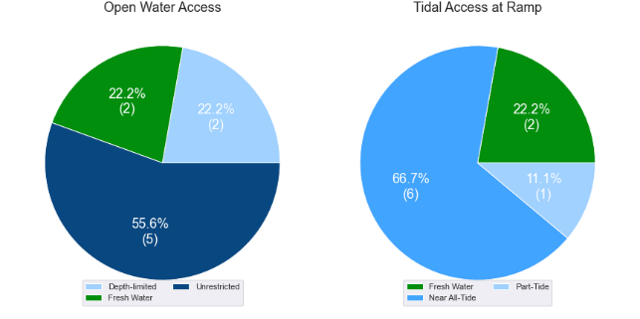

(a) Summary of open water access from boat launching facilities (left) and (b) Summary of tidal restrictions at tidal boat launching facilities (right)

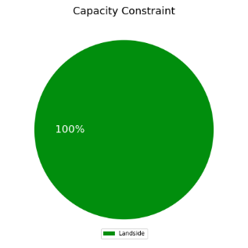

Summary of limiting capacity constraint

## Access to sheltered near all-tide and all-tide facilities

MSQ has a longer-term vision to provide access to all-tide or near all-tide open water access boat launching facilities along the Queensland coast, such that all significant population centres are within one hour’s driving range as far as practical (TMR, 2020). For this purpose, the Study has defined towns as being within the coastal strip if within 30km of the Queensland coastline. The vision (TMR, 2020) is applied to the coastal strip between the NSW border and Cooktown. Consultation throughout the Study has highlighted that this vision is important with users/stakeholders and organisations that own and manage these facilities. As such, the Study has developed a statistical approach to quantify this vision to allow it to be measured and tracked over time. To do this, the Study has calculated the travel time from all Population Centres (DoR, 2022) within the coastal zone to the nearest available sheltered, all tide or near all-tide facility, regardless of which LGA it is in. This has been accomplished using mapped road networks and assigning speed limits to each type of road, with the following speed limits applied:

* for restricted roads, 40km/hr
* for local roads, 60km/hr
* for connector roads, 70km/hr
* for distributor roads, 80km/hr
* for highways, 100km/hr.

For Noosa Shire the median travel time from eligible Population Centres to the nearest sheltered all-tide or near all-tide facility is 12 minutes. Noosa North Shore and Teewah are not included in this calculation as they are not connected continuously to the boat launching facilities by road. The distribution of travel times is shown in Figure 3.3 with detailed travel times in Annex C. Figure 3.4 provides a visual representation of the travel time from each of the sheltered near all-tide facilities that serve the LGA. Of interest for Noosa Shire are:

* 100% of the eligible population centres are within the desired 1-hour travel time.
* All eligible population centres are within 30 minutes of a sheltered near all-tide or all-tide facility.

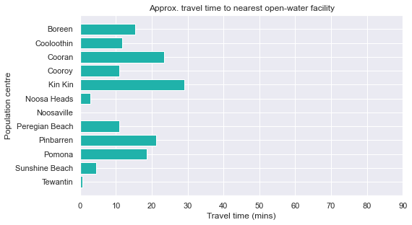

Distribution of travel time from Noosa’s eligible population centres to open-water accessible, sheltered, near all-tide or all-tide facilities

## Deep-draught vessel landings

Deep-draught vessel landings are intended to provide short-term landing capacity for vessels that are too large to use public boat launching and retrieval facilities. These facilities are provided for the benefit of both local vessels and to service the fleet of vessels that travel along the Queensland coast. Deep-draught vessel landings may be designed to accept one or more large vessels at a time and/or provide capacity for tenders from larger vessels that may be anchored or moored nearby, for the purpose of loading and offloading passengers and supplies, and making short local visits to onshore destinations.

For the Study, deep-draught vessel landings need to be primarily accessible by recreational boats for short, temporary stays. In some cases, commercial vessels may utilise these facilities subject to the relevant permissions, however, this may reduce the capacity of the facility to cater for recreational vessels. Deep-draught vessel landings should be located such that the facility provides reasonable access to landside passenger pick up and drop off, provisioning, recreational destinations, or population centres. Within Noosa Shire there are no suitable deep-draught vessel landings. Not within the scope of this Study, there may be a need to provide one or more public landings in the Noosa River for berthing of livaboard vessels to pump out sewage.

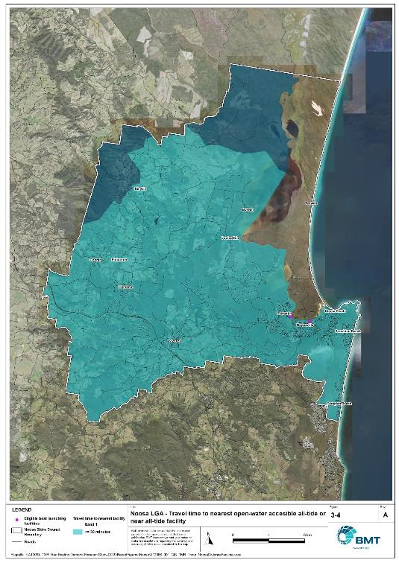

Noosa Shire – Travel time to nearest all-tide or near all-tide facility

[\\bmt-bne-fs01\draughting\A12068_TMR_Rec.Boating.Demand.Forecast.Study\QGIS\ReportFigures\Noosa\A12068_001_GIS_TMR_1hour_NoosaDistanceFacilities.jpg](\\\\bmt-bne-fs01\\drafting\\A12068_TMR_Rec.Boating.Demand.Forecast.Study\\QGIS\\ReportFigures\\Noosa\\A12068_001_GIS_TMR_1hour_NoosaDistanceFacilities.jpg)

# 4 Demand Assessment

The Study has developed a model to calculate statistical demand for boat launching facilities and deep-draught vessel landings at an LGA scale. Vessels that are less than 8m in length are considered trailable and drive demand for boat launching facilities such as boat ramps, while those over 8m are assumed to remain on water and drive demand for deep-draught landings.

Statistical demand is recognised at three different levels for public marine facilities within the TMR guidelines (TMR, 2020), which are:

* off-peak demand – typical weekday usage
* average demand – demand on ‘good boating days’, taken to be demand for a facility on weekends (and, for certain regional locations, other busy periods)
* peak demand – demand for a facility at peak holiday periods or for special events.

The demand model created for this Study is intended to provide information on demand pressures on ‘good boating days’ for all facilities as per the intentions of the guidelines. The model achieves this through a ‘registration activation rate’ that estimates the proportion of registered vessels in an LGA that is assumed to be active on a ‘good boating day’, as well as the exchange of vessels between LGAs, and general tourism pressures.

## Activation rate

The fleet size for each LGA is determined statistically from vessel registration numbers and the application of a vessel activation rate, while for future time horizons vessel registration and population growth estimates are also utilised. The methodology for determining the registration activation rate has been adopted from the previous study (GHD, 2017), with activation rates taken to be between 8% and 14% for a typical weekend. The variability of the activation rate is intended to capture the regional differences in vessel types, and is driven by the availability of access to open water, accessibility of other recreational opportunities, and likelihood of users’ available time for recreation, considering factors including:

* remoteness classification for the LGA
* incidence of blue-collar employment
* average age of residents
* whether the LGA is coastal.

Further information about the derivation of this rate can be found in Annex A. For Noosa Shire the activation rate is assumed to be 8%, with the key factors influencing the rate including:

* its classification as a Metropolitan Area
* the average age being higher than the state average
* it being located adjacent to the open coast.

## Digital user survey

To gain an understanding of usage trends at existing formal recreational boating facilities across Queensland, the Study has considered the results of a digital user survey using human movement data, sourced through a third party. The data was acquired from a location data store with more than 13 trillion mobile location observations globally from 2019 to present, which were sourced from 250,000 different mobile phone applications that users ‘opted-in’ to use the location services under the application’s terms and conditions. All data received was deidentified and compliant with relevant data privacy regulations.

The analysis uses mobile devices (such as telephones) location data as a proxy for boat user traffic, however, this relationship has several limitations including, but not limited to:

* Mobile device users detected in the area of interest may not be boat users (e.g., pedestrians not using vessels may walk through the detection area).
* The relationship between mobile device users and vessels may not be 1:1 (i.e., there may be multiple mobile devices providing data for each vessel).
* Users of vessels may not have a mobile device, may not be using a mobile device or may not have provided permission to use their location data.

With these, and potentially other, limitations in mind, the Study compared this data against vessel launching counts provided by various facility managers and found that approximately 15-30% of vessels are captured using this digital survey method. This percentage can change from facility to facility and from day to day. Consequently, the Study has not relied on raw counts of users from this data, but instead considered the relative trends within the data, with the assumption that no groups (for example, users from a particular LGA or using a particular facility) within the data would be more or less likely to be captured by the technique.

The Study has used this data to identify the relative volume of users, the ‘home’ local government area of users and the popularity of destinations that users travel to once vessels have been launched.

* + 1. Inter-LGA demand

The human movement data has been interrogated to determine the LGA of origin for users of Noosa Shire’s public boating facilities to ascertain the proportion of users from each LGA that are using specific facilities. Statistics from all public boating facilities within the LGA are then grouped together to determine the total proportion of resident or visiting users across the LGA. Table 4.1 shows the active fleet proportion from the top 10 LGAs contributing to demand on facilities within Noosa Shire. All other sources have been grouped together.

LGA of origin for active fleet in Noosa Shire

| LGA of origin | Active fleet proportion |
| --- | --- |
| Noosa | 43.6% |
| Sunshine Coast | 18.6% |
| Brisbane | 15.8% |
| Moreton Bay | 4.4% |
| Gold Coast | 2.2% |
| Gympie | 1.9% |
| Toowoomba | 1.0% |
| Redland | 1.0% |
| Logan | 1.0% |
| Ipswich | 0.8% |
| Other LGAs | 9.8% |

* + 1. Intra-LGA demand distribution

Recreational boating users will tend to use facilities that best suit their needs, the destinations they want to access, the capability of their vessel and the weather conditions. Consequently, distribution within an LGA is unlikely to be evenly spread across all facilities, with some facilities attracting users disproportionately due to amenity, access, or destinations. The attractiveness of large well-designed facilities is likely to draw visiting boat users in preference to smaller or less desirable facilities across the LGA. The human movement statistics have been assessed to qualitatively estimate the proportion of users using each facility, both in total and with respect to both resident and visiting boat users (Table 4.2). This analysis has excluded the Munna Point and Waterside Court facilities and combined the Thomas Street and Albert Street facilities into one facility.

Popularity of boat launching facilities.

| Facility | Overall fleet | Resident fleet | Visiting fleet |
| --- | --- | --- | --- |
| Noosaville, Albert Street | 65.1% | 62.1% | 67.3% |
| Tewantin, Lake Street | 22.7% | 25.2% | 20.7% |
| Boreen Point, Orchard Avenue | 4.9% | 4.4% | 5.2% |
| Lake MacDonald | 3.8% | 3.9% | 3.7% |
| Lake MacDonald (western) | 2.3% | 2.8% | 1.9% |
| Cooroibah, Bundoora Street | 1.4% | 1.7% | 1.1% |

The results indicate that both local and resident fleets are concentrated at the facilities that provide access to the Noosa River and provide access to offshore destinations from the Noosa River.

* + 1. Destinations

For facilities that provide sheltered, near all-tide or all-tide open water access, additional analysis of the human movement statistics has been undertaken to identify destinations for users of these facilities. Location data from users utilising the facilities was extracted for a period of two hours after they used the facility, and trimmed for waterside destinations. For Noosa Shire this additional analysis was applied to the following facilities, with destinations mapped in Figure 4.1:

* Noosaville, Albert Street
* Tewantin, Lake Street.

From this additional analysis, the following notable observations were made:

* Users accessing offshore destinations gave heavy preference to the Noosaville facility.
* Users of the Tewantin facility tended to stay in the river, with a lower proportion of vessels exiting through the river mouth to reach offshore destinations.

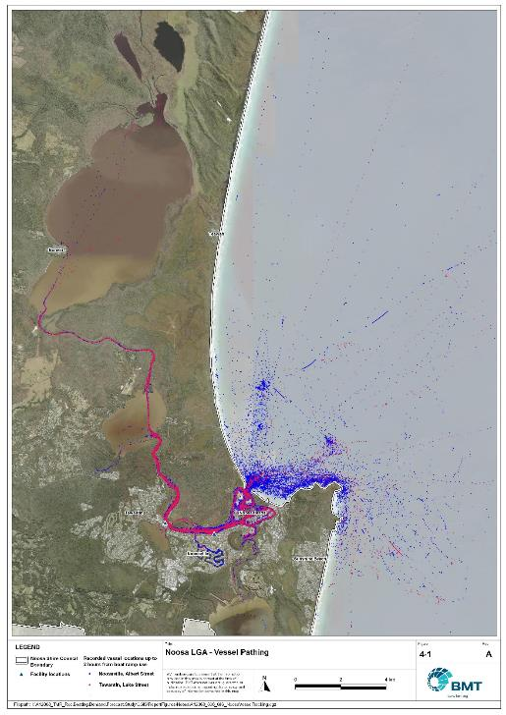

Noosa Shire – Vessel pathing

"I:\A12068_TMR_Rec.Boating.Demand.Forecast.Study\QGIS\ReportFigures\Noosa\A12068_006_GIS_NoosaVesselTracking.jpg"

## Active fleet size

The total ‘active’ fleet on a good boating day is derived from the activation rate of the total fleet of registered vessels within the LGA and the net inflow of visiting vessels. The total number of visiting vessels from each LGA is determined from the number of vessels in the resident active fleet and the relative proportion of resident to visiting vessels outlined in Table 4.1.The fleet size is expected to change over time due to changes in population and vessel acquisition trends, with the size and proportion of the fleet across the study period described in Table 4.3.

Active fleet vessel size

| Vessel length | 2021 | 2026 | 2031 | 2036 | 2041 |
| --- | --- | --- | --- | --- | --- |
| 0 to 4.5m | 241 | 354 | 368 | 380 | 390 |
| 4.5m to 8m | 160 | 168 | 174 | 179 | 184 |
| >8m | 29 | 31 | 32 | 33 | 34 |
| Total | 430 | 553 | 574 | 592 | 608 |

## Boat ramp lane demand

The fleet size derived in Table 4.3 represents the statistical demand for the LGA, with vessels under 8m assumed to contribute to boat ramp demand, measured in boat ramp lanes. As outlined in section 3.1.2 the adopted capacity of each effective lane is 40 vessels per day, with each vessel assumed to both launch and retrieve, for a total of 80 vessel movements per day. The total boat ramp lane demand across the study period is shown in Table 4.4.

Boat ramp lane demand

|  | 2021 | 2026 | 2031 | 2036 | 2041 |
| --- | --- | --- | --- | --- | --- |
| Boat ramp lane demand | 9.8 | 10.3 | 10.6 | 11.0 | 11.3 |

For Noosa Shire the important elements that contribute to the boat ramp lane demand include:

* a moderate sized local fleet, with a high proportion of trailable vessels
* two canal estates that include private pontoon landings for on-water storage of vessels
* attractive destinations for visitors from south-east Queensland.

## Non-statistical demand

As well as the statistical demand outlined in the section above, facilities may face demand pressures that are related to their functional use, which reduces the capability of the facility to service the recreational boat fleet in the desired manner. Issues with specific facilities have been identified within the consultation process of the Study with appointed managers and other stakeholders. While care has been taken to identify these non-statistical demand issues throughout the Study, it is beyond the scope of the Study to individually review the functionality, safety, and amenity of each facility across Queensland. Non-statistical demand pressures may warrant upgrades to facilities even where statistical demand is satisfied by existing capacity. These pressures have been classified into the following categories:

* Amenity: Amenity describes the functional usability of the facility including the desire to provide dry entry and exit facilities, facilities that provide easy access and/or access for persons with restricted mobility.
* Safety: Safety demand may include protection from currents and waves or contact with marine creatures such as sharks, jellyfish, and crocodiles.
* In-water congestion: Where existing queuing facilities are not able to efficiently meet the needs of the facility. Such deficiency may warrant additional queuing facility capacity to optimise boat launching and retrieval.

The Study's recommendations may alleviate these non-statistical demand pressures with consideration for capability of all facilities within the LGA. The presence of a non-statistical demand pressure at a facility may not warrant upgrades where other suitable facilities are reasonably available.

## Deep-draught vessel demand

* + 1. Cruising Vessels

Vessels cruising along the east coast of Queensland have a requirement for a network of deep-draught vessel landings that are appropriately spaced to be within a day’s sailing on good weather days. These facilities are required to support the reprovisioning of vessels as they travel along the coast and provide access to desirable land-based destinations. Private marina facilities may be used by cruising vessels where there is an expectation for a prolonged stay that requires protected mooring or berthing. Within Noosa Shire there are no suitable public landings for deep-draught vessels.

Within the east coast network but outside of the LGA, the nearest deep-draught vessel landing to the north is at Norman Point in Tin Can Bay, and to the south at Penny Lane and Parkyn Parade in Mooloolaba. The trip between Mooloolaba and Tin Can Bay is approximately 65 nautical miles, which is at the outer limit of what is typically achievable in a day’s sailing. As such, while acknowledging the difficulty vessels can face crossing the Noosa River bar, providing a deep-draught vessel landing in the Noosa River would be desirable to support the east coast network as well as serving local demand.

* + 1. Landing demand

Statistical demand for deep-draught vessel landings has been assessed based on the size of the non-trailable fleet within Noosa Shire. Landing demand is more difficult to assess than boat ramp lane demand as the requirements and duration of the landing influence the demand pressure but are highly variable between users. Nevertheless, the Study has assumed that 5% of the non-trailable fleet will be seeking a landing at any given time. The consultation undertaken during the Study indicates that this assumption may overestimate the number of landings, but that the landings are often utilised for other boating and recreation activities when not in use by deep-draught vessels. In particular, landings that are located near boat launching facilities may be used as queuing facilities and therefore support the efficient launching of smaller recreational vessels. Given this, the 5% assumption has been adopted noting that it may overestimate capacity, but not to an extent that it would be onerous to facility providers. Within Noosa Shire the demand for deep-draught vessel landings is outlined in Table 4.5

Deep-draught vessel landing demand.

| Requirement | 2021 | 2026 | 2031 | 2036 | 2041 |
| --- | --- | --- | --- | --- | --- |
| No. of Landings | 1.2 | 1.2 | 1.3 | 1.3 | 1.3 |

# 5 Shortfall Assessment

## Shortfall assessment – boat ramps

The shortfall of boat ramp lanes within Noosa Shire is shown in Table 5.1 and Figure 5.1 at an LGA scale. This is presented both with and without the inclusion of additional capacity provided by the recommended upgrades.

Shortfall of boat launching facilities

| Assessment | Metric | 2021 | 2026 | 2031 | 2036 | 2041 |
| --- | --- | --- | --- | --- | --- | --- |
| Demand | Demand | 9.8 | 10.3 | 10.6 | 11 | 11.3 |
| Existing | Capacity | 5.8 | 5.8 | 5.8 | 5.8 | 5.8 |
| **Shortfall** | 4 | 4.5 | 4.8 | 5.2 | 5.5 |
| Improved  (Minimum upgrades) | Capacity | 5.8 | 9.8 | 10.8 | 12 | 12 |
| **Shortfall** | 4 | 0.5 | -0.2 | -1 | -0.7 |
| Improved  (Maximum upgrades) | Capacity | 5.8 | 9.8 | 10.8 | 12.3 | 12.3 |
| **Shortfall** | 4 | 0.5 | -0.2 | -1.3 | -1 |

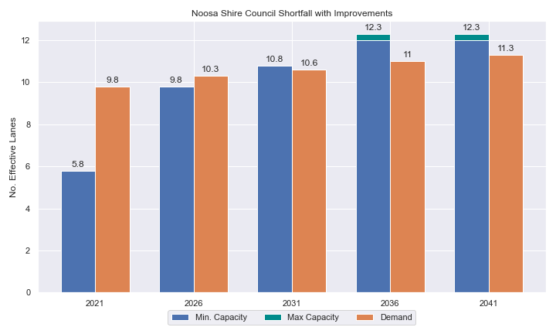

Shortfall assessment with recommended upgrades adopted

* + 1. Open-water access shortfall in boat ramp lanes

Statistical capacity has been calculated across the Noosa LGA in its entirety, however, some facilities are evidently more popular than others due to their ability to access open-water destinations, and/or their usability. In general, larger vessels are more suited to access open-water destinations while smaller vessels are more likely to remain in sheltered environments. This was identified in the 2017 study and confirmed during discussions with stakeholders. The human movement data indicates that visiting boats from other LGAs are drawn to facilities that provide access to open-water destinations. To ensure that the capacity of effective boat ramp lanes in the LGA is appropriately distributed to cater for these usage trends, it is worth assessing facilities providing this desirable access as a subset of the total capacity for the LGA. A ‘scenario’ approach to assessing this capacity has been developed, with Scenario 1 derived from empirical estimates of vessel distribution and Scenario 2 derived from the human movement statistics, and the final result averaged between the two scenarios. This provides the opportunity to rationalise the figure that drives the demand and acknowledge when one scenario is not representative of the population or consistent with stakeholder feedback. The scenarios that were assessed are:

Scenario 1: 80% of larger vessels and 20% of smaller vessels from the local fleet and 80% of the visiting fleet are using the facilities with unrestricted open water access.

Scenario 2: Distributing the fleet between facilities as per the human movement statistics.

The results of this approach suggest that the shortfall from these specific facilities is in proportion to the overall shortfall for the Noosa LGA.

Shortfall assessment for open water, all-tide or near all-tide facilities for Noosa LGA

| Assessment | Metric | 2021 | 2026 | 2031 | 2036 | 2041 |
| --- | --- | --- | --- | --- | --- | --- |
| Overall | Capacity | 3.9 | 3.9 | 3.9 | 3.9 | 3.9 |
| Scenario 1 | Demand | 5.1 | 5.4 | 5.6 | 5.8 | 6.0 |
| Shortfall | 1.2 | 1.5 | 1.7 | 1.9 | 2.1 |
| Scenario 2 | Demand | 7.8 | 8.2 | 8.5 | 8.7 | 9.0 |
| Shortfall | 3.9 | 4.3 | 4.6 | 4.8 | 5.1 |
| **Average** | Demand | 6.4 | 6.8 | 7.1 | 7.3 | 7.5 |
| **Shortfall** | 2.5 | 2.9 | 3.3 | 3.6 | 3.6 |

Comparing the LGA-scale shortfall with the subset of facilities providing protected all-tide or near all-tide access to open water indicates that the demand is well distributed within the Noosa LGA.

## Shortfall assessment – deep-draught landings

The shortfall of public deep-draught landings for Noosa Shire is provided in Table 5.3. The existing capacity is not adequate to current meet demand, with recommendations for new facilities based on the desirability of access to the Gympie Terrace and Hasting Street areas.

Shortfall of deep-draught vessel landings

| Assessment | Metric | 2021 | 2026 | 2031 | 2036 | 2041 |
| --- | --- | --- | --- | --- | --- | --- |
| Deep-draught vessel landings | Demand | 1.2 | 1.2 | 1.3 | 1.3 | 1.3 |
| Capacity | 0 | 0 | 0 | 0 | 0 |
| **Shortfall** | 1.2 | 1.2 | 1.3 | 1.3 | 1.3 |

# 6 Stakeholder Feedback



The Study has undertaken extensive consultation throughout its execution to achieve a comprehensive understanding of issues relating to the use of recreational boating facilities across the state. This consultation was conducted with managing authorities that own and/or manage recreational boating facilities, as well as with facility stakeholders including recreational groups, volunteer marine rescue and coastguard organisations, and the general public. Stakeholder engagement was supplemented with site visits to facilities where key issues had been identified.

## Managing authority feedback

For the Noosa region, the Study team met with Noosa Shire Council, Seqwater, and Maritime Safety Queensland to discuss recreational boating facilities within the region. This consultation process identified a range of potential opportunities to alleviate demand pressures. The Study has considered the practical implementation of each of these opportunities with respect to the required infrastructure, difficulty of implementation and magnitude of benefit, as summarised in Table 6.1.

Stakeholder identified opportunities

| Location | Stakeholder opportunity | Review comments |
| --- | --- | --- |
| Hilton Esplanade | Currently a low-lying informal area that is used for recreational and commercial launching. Opportunity to formalise. | Agreed. |
| Chaplin Park | Previous recommendation rejected by NSC at this site indicating future recommendations or project proposals would not be supported. | Understood. However, it remains one of the few places within Noosa where new facilities are possible due to land shortage and extent of fish habitat zone. |
| Albert Street/ Thomas Street | Conflicts with foreshore master plan, suggest decreasing size of the facility. | Not supported unless suitable replacement can be found. |
| Gympie Terrace jetty | Not used at present, suggest replacing with pontoon. | Agreed. Would provide landing point for access into Gympie Terrace. Potential to provide a pump-out facility. |
| Noosa Woods jetty | Only used for fishing, could be a potential combined recreational/ferry point in future. | Agreed. Would provide landing point for access into Hastings Street. |

## Stakeholder feedback

Broader stakeholder feedback has been conducted within the Study by undertaking virtual or face-to-face meetings with recreational boating groups (Noosa Boating and Fishing Alliance) and marine rescue organisations, as well as through the Recreational Boating Facility Survey (MSQ, 2022) undertaken by Maritime Safety Queensland, which included survey responses of nearly 3,000 users and open submissions. For Noosa, a total of 230 submissions was received, with 80% of respondents using trailable power boats and 99% of respondents using recreational boating facilities at least once a month. For Noosa Shire, the following statistics or themes were extracted from the survey and associated comments:

* 100% of respondents typically travel less than 1hr to their preferred boat ramp (which may not be their closest facility).
* 52% of respondents indicated that floating walkways are their preferred type of queuing facility.
* 80% of respondents indicated they would be unwilling to walk further than 200m from designated CTU parking to a boat ramp.
* The most common requests for new boat ramps were at:
  + Chaplin Park
  + Doonella Bridge/Hilton Esplanade
  + Moorindil Street next to the ferry.
* The following themes were identified with respect to existing facilities:
  + more facilities needed overall, including more parking - parking overflow onto surrounding streets being mentioned frequently in the responses as being “dangerous”, “hazardous” and “horrendous”
  + more pontoons or queuing facilities needed to launch boats efficiently
  + better ramps with fewer hazards (drop offs, submerged rocks, slippery surfaces)
  + removal of moored vessels off the river to make it easier to navigate
  + provision of access for people with reduced mobility.
* Where the closest available boat launching facility was not preferred, respondents indicated that the following key aspects influenced their choice:
  + unavailability of parking at their local ramp
  + easier access to the river due to lack of drop off and submerged rocks
  + safety and security issues associated with having to park so far away from launching site (for example, launched boat and parked “up to 1km away”, meanwhile other people moving boat from ramp without permission)
  + safety concerns associated with vessels crossing the Noosa River bar.
* Respondents were provided an opportunity to provide additional feedback, with the following themes identified:
  + an overwhelming number of respondents indicated that the quantity and quality of recreational boat launching facilities in Noosa was inadequate.
  + removal of moored vessels and houseboats on the river was viewed as a high priority as it was a main contributor to congestion.
  + better enforcement of car-trailer parking spaces, as they are often encroached upon by passenger vehicles.
  + reconsideration the zoning for personal water-craft (such as jet skis) as the current zoning limits their launching opportunities to the most congested ramp on the river.

# 7 Development Recommendations



## Previous recommendations

The 2017 GHD assessment recommended opportunities for increasing capacity of recreational boating facilities across the state. However, the implementation of these recommendations has been low, with only 10% of the total state-wide recommendations delivered in part or full in the 5 years since the delivery of the report. Of the priority 1 recommendations (for immediate delivery) and priority 2 recommendations (for implementation within 5 years) only 18% and 6% respectively have been delivered. State-wide only 5% of land-side recommendations were delivered, while 16% of water-side recommendations were delivered.

Within Noosa Shire, none of the recommendations have been implemented since the delivery of the 2017 GHD study. The low rate of planning or implementation of these works is likely due to Noosa Shire Council’s ongoing planning for the Noosa River and the foreshore as well as due to state-wide budgetary constraints due to the Covid-19 pandemic. As such, many of the recommendations proposed in the 2017 GHD study remain viable. This current Study has reviewed the unimplemented 2017 recommendations (Table 7.1) for Noosa Shire in conjunction with stakeholders during the consultation process to identify previous recommendations that are:

* Still viable: The recommendation in its original form remains suitable for solving demand pressures.
* Still viable with modifications: The recommendation could remain viable with modifications identified throughout the consultation process.
* No longer viable: The recommendations are no longer suitable.

Recommendations from the 2017 study that are considered viable or viable with modifications may be carried forward into the recommendations of this Study with a suitable update to their priority status if required.

Assessment of unimplemented 2017 recommendations

| Location | 2017 Recommendation | 2022 Review | Review comment |
| --- | --- | --- | --- |
| Priority 1 | | | |
| Chaplin Park, Mill Street, Noosaville | Construct a 2-lane ramp with a floating walkway. Construct 45 CTU spaces. | Viable | The solution remains one of the few viable opportunities for much needed boat launching capacity on the Noosa River. While not supported by Noosa Shire Council officers, it was well supported from other stakeholders during consultation. |
| Priority 3 | | | |
| Moorindil Street, Tewantin | Construct a 1 lane ramp with 15 CTU spaces. | Viable | Formalisation of this ramp is a viable option to increase the capacity in the area, despite perceived traffic conflicts with the ferry and the boat ramp being in a fish habitat A zone. |

## Priority recommendations

The selection and ranking of development priorities provides for progressive implementation of solutions to meet capacity shortfalls and/or resolve existing safety and usage issues at existing facilities over time. Recommendations have been split into four categories for implementation within the 20-year planning period of this study, with the following projected timelines:

* Priority 1: For immediate planning and design.
* Priority 2: Planning and design intended to provide capacity within 5-10 years.
* Priority 3: Planning and design intended to provide capacity within 10-15 years.
* Priority 4: Planning and design intended to provide capacity within 15-20 years.

The recommendations have been structured to include consideration of the reasonable timelines for implementation. This may include consideration for budgetary processes, planning, environmental approvals, consultation periods and construction. The priority selection of recommendations has been conducted in accordance with TMR’s Marine Infrastructure and Facilities Plan (TMR, 2020) guidelines, namely:

1. *priority to be given to the provision of sheltered all-tide or near all-tide launching facilities giving access to the open sea on an all-tide or near all-tide basis.*
2. *part-tide facilities (for launching or access) may be provided where there is demand and dredged access is not feasible. For instance, beach access or open beach ramps may be provided where there is sufficient demand and no suitable nearby sheltered waterway*
3. *the most economically viable options will take precedence, including the expansion of existing facilities, and the changing of existing foreshore land uses. In many cases, limiting or avoiding dredging and/or breakwater costs will be a crucial factor*
4. *a goal of providing access to sheltered all-tide or near all-tide boat launching facilities within one hour’s drive for significant communities*

Consequently, higher order recommendations need to address, where possible, the provision of facilities that provide maximum benefit in the widest range of conditions. Lower order recommendations will consist of solutions where there is reduced adherence to the TMR guidelines and/or there are constraints that may result in long lead times to resolve. A summary of the recommendations is provided in Table 7.2 with full detail of each recommendation in the tables that follow.

Summary of recommendations for Noosa Shire

| Priority | Description | Landside or waterside | Increased capacity  (effective lanes) |
| --- | --- | --- | --- |
| 1 | Albert and Thomas Streets, Noosaville: Realign carparking facility to increase available capacity to 46 CTU spaces and provide priority on-street parking for a further 5 CTU spaces. Move floating walkway to the centre of the downstream boat ramp and extend further into the waterway | Both | 1.25 lanes |
| 1 | Tewantin: Convert existing car-only parking to hybrid CTU parking to accommodate an additional 17 CTUs. Install floating walkway on downstream side of ramp. | Both | 0.75 lanes |
| 1 | Hilton Esplanade, Tewantin: Reclaim land and raise levels above the existing SLR hazard level for construction of 45 CTU spaces and 2 lane boat ramp with floating walkway. | Both | 2 lanes |
| 1 | Noosa Woods: Replace existing jetty structure with pontoon. | Waterside | 1 Landing |
| 2 | Moorindil Street, Tewantin: Formalise the existing launching point with one boat ramp lane and 15 CTU parking spaces. | Both | 1.0 lane |
| 3 | Chaplin Park, Noosaville: Construct new facility with 2 lanes and a floating walkway with provision for 30 CTU spaces. | Both | 1.25 lanes |
| 3 | Gympie Terrace, Noosaville: Replace existing jetty structure with pontoon. | Waterside | 1 Landing |

## Priority 1 recommendations

Thomas Street/Albert Street (Priority 1)

|  |  |  |  |  |
| --- | --- | --- | --- | --- |
| General description | | | | |
| Location | Gympie Terrace, Noosaville, between Thomas and Albert Streets | | | |
| Existing Facility? | Yes | | | |
| Coordinates | -26.397621005523845, 153.0629545177497 | | | |
| Existing tidal status | Near all-tide | | | |
| Existing wave exposure | No | | | |
| Existing current exposure | No | | | |
| Proposed works | Reconfigure parking to allow for 51 CTU spaces, relocate the floating walkway to the centre of the boat ramp on the Albert St ramp and extend by 1 module. | | | |
| Increased effective capacity | 1.25 Lanes | | | |
| Capacity improvement position | Waterside | Landside | | Both |
| Rationale | This facility contains two separate boat ramps. The Thomas and Albert Street facility is very popular for recreational boat users, with capacity severely restricted by the lack of CTU parking due to inefficient use of the space. A reconfiguration of the existing parking area would allow an increase in parking spaces from 22 CTUs to 51 CTUs and lessen the existing parking overflow to neighbouring streets. By relocating the floating walkway to the centre of the Albert Street ramp, users launching at either ramp can make easy use of the walkway for queueing. Extending the floating walkway further into the river will allow greater throughput. | | | |
| Anticipated Costs (+/- 50%) | Waterside infrastructure | | $112,000 | |
| Landside infrastructure | | $100,000 | |
| Planning, environmental and approvals constraints | | | | |
| Assessment | Requirement | Comments | | |
| Fish Habitat Zone | X | N/A | | |
| Native Title | X | N/A | | |
| MCU requirement | X | N/A | | |
| Clearing remnant vegetation | X | N/A | | |
| GBRWHA | X | N/A | | |
| Marine Park | X | N/A | | |
| Tidal works assessment | ü | Relocation of floating walkway will likely be tidal works and require a Development Permit | | |
| Other as required | ü | Marine Plants – the relocation works may impact marine plants and therefore may require a Development Permit for marine plant disturbance | | |
| Sea Level Rise | ü | The proposed relocation of the floating walkway is within the boundaries of the erosion prone area and the reconfiguration of the carpark is partially within. | | |
| Storm Tide Hazard | ü | The proposed relocation of the floating walkway is within the boundaries of a high hazard area and the reconfiguration on the carpark is within the boundaries of a medium hazard area. | | |
| Anticipated Complexity | Low | Medium | | High |

Priority 1 Recommendation – Thomas Street

"I:\A12068_TMR_Rec.Boating.Demand.Forecast.Study\Recomendations by Council\JPG\Noosa\A12068_005_NoosaProposedUpgrades_7-1.jpg"

Tewantin, Lake Street (Priority 1)

|  |  |  |  |  |
| --- | --- | --- | --- | --- |
| General description | | | | |
| Location | Lake Street, Tewantin | | | |
| Existing Facility? | Yes | | | |
| Coordinates | -26.393071424461695, 153.04149159252782 | | | |
| Existing tidal status | Near all-tide | | | |
| Existing wave exposure | None | | | |
| Existing current exposure | None | | | |
| Proposed works | Convert existing car-only parking to hybrid CTU parking to accommodate an additional 17 CTUs. Install downstream floating walkway with return to accommodate cross-river commuter boats and remove jetty when it reaches the end of its life. | | | |
| Increased effective capacity | 0.75 Lanes | | | |
| Capacity improvement position | Waterside | Landside | | Both |
| Rationale | The existing facility has a small number of ‘hybrid’ CTU spaces that can be used for both car-only and CTU parking when required, however, the overall provision of parking is lacking. By expanding the use of these hybrid parking spaces, the availability of parking for boat users is more than doubled without loss of green space in the area. The hybrid CTU would allow for time-based parking restrictions that prioritise CTU parking before a certain time (for example 9am), with free use thereafter. A combination of hybrid and CTU-only parking is the most appropriate way to cater for parking at this site where other parking demands exist.  The provision of a floating walkway at the site will make the boat ramp more usable. By placing it on the downstream side, no alteration to the manoeuvring area needs to be undertaken and a return can be incorporated that caters for cross-river commuters. | | | |
| Anticipated Costs (+/- 50%) | Waterside infrastructure | | $314,000 | |
| Landside infrastructure | | $80,000 | |
| Planning, environmental and approvals constraints | | | | |
| Assessment | Requirement | Comments | | |
| Fish Habitat Zone | X | N/A | | |
| Native Title | X | N/A | | |
| MCU requirement | X | N/A | | |
| Clearing remnant vegetation | X | N/A | | |
| GBRWHA | X | N/A | | |
| Marine Park | X | N/A | | |
| Tidal works assessment | ü | Replacement of jetty with floating walkway will likely be tidal works and require a Development Permit | | |
| Other as required | ü | Marine Plants – the replacement works may impact marine plants and therefore may require a Development Permit for marine plant disturbance | | |
| Sea Level Rise | ü | The proposed replacement of the jetty for floating walkway works is within the boundaries of the erosion prone area and the reconfiguration on the carpark is partially within. | | |
| Storm Tide Hazard | ü | The proposed replacement of the jetty for floating walkway works is within the boundaries of a high hazard area and the reconfiguration of the carpark is within the boundaries of a medium hazard area. | | |
| Anticipated Complexity | Low | Medium | | High |

Priority 1 Recommendation – Tewantin

"I:\A12068_TMR_Rec.Boating.Demand.Forecast.Study\Recomendations by Council\JPG\Noosa\A12068_005_NoosaProposedUpgrades_7-2.jpg"

Hilton Esplanade (Priority 1)

|  |  |  |  |  |
| --- | --- | --- | --- | --- |
| General description | | | | |
| Location | Hilton Esplanade, Noosaville | | | |
| Existing Facility? | Informal | | | |
| Coordinates | -26.39560270853397, 153.04262368356677 | | | |
| Existing tidal status | N/A - near all-tide once implemented | | | |
| Existing wave exposure | None | | | |
| Existing current exposure | None | | | |
| Proposed works | Reclaim land and raise above the existing SLR hazard level for construction of 45 CTU spaces and 2-lane boat ramp with a centralised floating walkway. | | | |
| Increased effective capacity | 2 Lanes | | | |
| Capacity improvement position | Waterside | Landside | | Both |
| Rationale | The existing site is currently being heavily used as an informal launching area for both recreational and commercial vessels but is inundated periodically on higher tides. By elevating the land and formalising the area there is an opportunity to both increase the capacity for recreational boats and provide protection from water ingress to the surrounding streets during flooding and high tides. A facility here would make use of one of the rare parcels of land directly fronting the Noosa River. | | | |
| Anticipated Costs (+/- 50%) | Waterside infrastructure | | $378,000 | |
| Landside infrastructure | | $845,000 | |
| Planning, environmental and approvals constraints | | | | |
| Assessment | Requirement | Comments | | |
| Fish Habitat Zone | X | N/A | | |
| Native Title | ü | New tenure required for works so interaction with Native Title | | |
| MCU requirement | ü | Reclamation works will likely trigger a Development Permit for a Material Change of Use | | |
| Clearing remnant vegetation | X | N/A | | |
| GBRWHA | X | N/A | | |
| Marine Park | X | N/A | | |
| Tidal works assessment | ü | Reclamation will likely be tidal works and require a Development Permit | | |
| Other as required | ü | Marine Plants – the reclamation works may impact marine plants and therefore may require a Development Permit for marine plant disturbance  Quarry Material Allocation – if the reclamation is undertaken using dredged material, it will require a Quarry Material Allocation. | | |
| Sea Level Rise | ü | The proposed works are within the boundaries of the erosion prone area. | | |
| Storm Tide Hazard | ü | The proposed works are within the boundaries of a high hazard area. | | |
| Anticipated Complexity | Low | Medium | | High |

Priority 1 Recommendation – Hilton Esplanade

"I:\A12068_TMR_Rec.Boating.Demand.Forecast.Study\Recomendations by Council\JPG\Noosa\A12068_005_NoosaProposedUpgrades_7-3.jpg"

Noosa Woods pontoon - (Priority 1)

|  |  |  |  |  |
| --- | --- | --- | --- | --- |
| General Description | | | | |
| Location | Noosa Woods, Noosa Heads | | | |
| Existing Facility? | No | | | |
| Coordinates | -26.38745083552284, 153.0857169099778 | | | |
| Existing tidal status | N/A - near all-tide once implemented | | | |
| Existing wave exposure | N/A | | | |
| Existing current exposure | N/A | | | |
| Proposed works | Replace existing jetty structure with pontoon. | | | |
| Increased effective capacity | 1 landing | | | |
| Capacity improvement position | Waterside | Landside | | Both |
| Rationale | Site provides excellent access to main tourist area of Hasting Street including access to shops for reprovisioning, restaurants and other specialty shops, and other recreational opportunities. There is public parking available near this facility and linkages with public transport. | | | |
| Anticipated Costs (+/- 50%) | Waterside infrastructure | | $157,000 | |
| Landside infrastructure | | TBC | |
| Planning, environmental and approvals constraints | | | | |
| Assessment | Requirement | Comments | | |
| Fish Habitat Zone | X | N/A | | |
| Native Title | X | N/A | | |
| MCU requirement | X | N/A | | |
| Clearing remnant vegetation | X | N/A | | |
| GBRWHA | X | N/A | | |
| Marine Park | X | N/A | | |
| Tidal works assessment | ü | Replacement of jetty with pontoon works will likely be tidal works and will require a Development Permit | | |
| Other as required | ü | Marine Plants – Replacement of jetty works may impact marine plants and therefore may require a Development Permit for marine plant disturbance | | |
| Sea Level Rise | ü | The proposed works are within the boundaries of the erosion prone area. | | |
| Storm Tide Hazard | ü | The proposed works are within the boundaries of a high hazard area. | | |
| Anticipated Complexity | Low | Medium | | High |

Priority 1 Recommendation – Noosa Woods Landing

"I:\A12068_TMR_Rec.Boating.Demand.Forecast.Study\Recomendations by Council\JPG\Noosa\A12068_005_NoosaProposedUpgrades_7-4.jpg"

## Priority 2 recommendations

Moorindil Street, Tewantin

|  |  |  |  |  |
| --- | --- | --- | --- | --- |
| General Description | | | | |
| Location | At the end of Moorindil Street, Tewantin. Downstream of Noosa North Shore ferry. | | | |
| Existing Facility? | No – Informal launching only. | | | |
| Coordinates | -26.37389568, 153.03853034 | | | |
| Existing tidal status | N/A – Informal creek bank – near all-tide once implemented | | | |
| Existing wave exposure | None. | | | |
| Existing current exposure | None. | | | |
| Proposed works | Formalise a single-lane boat ramp with 15 CTU parking spaces.  Vehicle traffic flow should be considered, particularly in relation to managing conflicts with long queues for the North Shore ferry. Potential widening of Moorindil Street may be required to accommodate this and allow thoroughfare. Safety considerations (clear signage) should be included to ensure no conflict with the adjacent ferry operations. | | | |
| Increased effective capacity | 1.0 effective lane | | | |
| Capacity improvement position | Waterside | Landside | | Both |
| Rationale | This informal launching/retrieving site already sees some use from the general public. Formalising will increase capacity, safety and amenity, and reduce pressures on other facilities in the river. This location is further upriver than other existing facilities, opening up different areas of the waterway for use, reducing on-water congestion. | | | |
| Anticipated Costs (+/- 50%) | Waterside infrastructure | | $196,000 | |
| Landside infrastructure | | $143,000 | |
| Planning, environmental and approvals constraints | | | | |
| Assessment | Requirement | Comments | | |
| Fish Habitat Zone | ü | New boat ramp works are located in Noosa River FHA (FHA-051) (Management A area). A Development Permit and Resource Allocation Authority will be required for boat ramp works within a declared FHA. The proposed parking lot works is not within the FHA.  Note: Any changes to the proposed parking lot works may change the boundaries of associated works to be included within FHA-051. Associated infrastructure such as parking lots do not have a physical requirement to be within a declared FHA and will likely not be supported. | | |
| Native Title | x | N/A | | |
| MCU requirement | x | N/A | | |
| Clearing remnant vegetation | x | N/A | | |
| GBRWHA | x | N/A | | |
| Marine Park | x | N/A | | |
| Tidal works assessment | ü | New boat ramp works will likely be tidal works and require a Development Permit. | | |
| Other as required | x | N/A | | |
| Sea Level Rise | ü | The proposed works are within the boundaries of the erosion prone area. | | |
| Storm Tide Hazard | ü | The proposed works are within the boundaries of a high hazard area. | | |
| Anticipated Complexity | Low | Medium | | High |

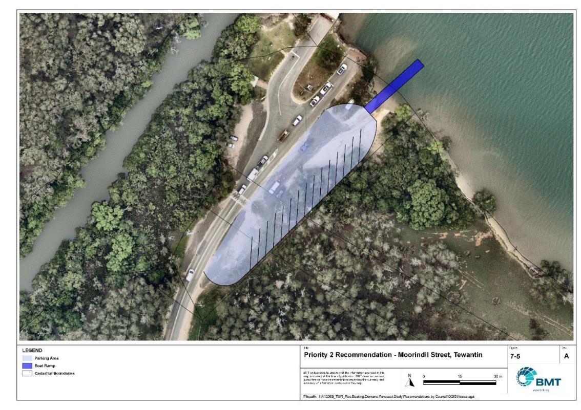

Priority 2 Recommendation – Moorindil Street, Tewantin

"I:\A12068_TMR_Rec.Boating.Demand.Forecast.Study\Recomendations by Council\JPG\Noosa\A12068_005_NoosaProposedUpgrades_7-5.jpg"

## Priority 3 recommendations

Chaplin Park (Priority 3)

|  |  |  |  |  |
| --- | --- | --- | --- | --- |
| General description | | | | |
| Location | Chaplin Park, Noosaville | | | |
| Existing Facility? | No | | | |
| Coordinates | -26.397474219687393, 153.05376741390933 | | | |
| Existing tidal status | N/A - near all-tide once implemented | | | |
| Existing wave exposure | N/A | | | |
| Existing current exposure | N/A | | | |
| Proposed works | Install 2-lane boat ramp with floating walkway and 30 CTUs. Parking area can be constructed to include 20 CTU parking spaces in Stage 1 and a further 10 in Stage 2. | | | |
| Increased effective capacity | Stage 1: 1.25 effective lanes  Stage 2: 1.5 effective lanes (total) | | | |
| Capacity improvement position | Waterside | Landside | | Both |
| Rationale | This site is one of the few undeveloped sites in Noosa Shire that could support a new facility. Currently it is used informally by a rowing club, and bank erosion from pedestrian traffic is evident. This recommendation has been reviewed following feedback from the 2017 study to reduce the overall footprint and maximise the availability of foreshore parkland for other land uses while providing enough capacity to reduce pressure on other facilities on the Noosa River.  Feedback received during the consultation process indicates that this site is not supported by Noosa Shire Council officers and may have outstanding Native Title considerations but is strongly supported by survey respondents. As such, this recommendation should be considered as an alternative solution should one or more of the above proposed solutions become untenable. | | | |
| Anticipated Costs (+/- 50%) | Waterside infrastructure | | $515,000 | |
| Landside infrastructure | | $200,000 (Stage 1)  $237,000 (Stage 2 – total) | |
| Planning, environmental and approvals constraints | | | | |
| Assessment | Requirement | Comments | | |
| Fish Habitat Zone | X | N/A | | |
| Native Title | ü | Previous investigations from Noosa Council indicate that there may still be native title considerations with this site. | | |
| MCU requirement | ü | A new boat ramp and carpark will likely require a Development Permit for a Material Change of Use | | |
| Clearing remnant vegetation | X | N/A | | |
| GBRWHA | X | N/A | | |
| Marine Park | X | N/A | | |
| Tidal works assessment | ü | New facility will be tidal works and will require a Development Permit | | |
| Other as required | ü | Marine Plants – Boat ramp and floating walkway works may impact marine plants and therefore may require a Development Permit for marine plant disturbance | | |
| Sea Level Rise | ü | The proposed works are within the boundaries of the erosion prone area. | | |
| Storm Tide Hazard | ü | The proposed works are within the boundaries of a high hazard area. | | |
| Anticipated Complexity | Low | Medium | | High |

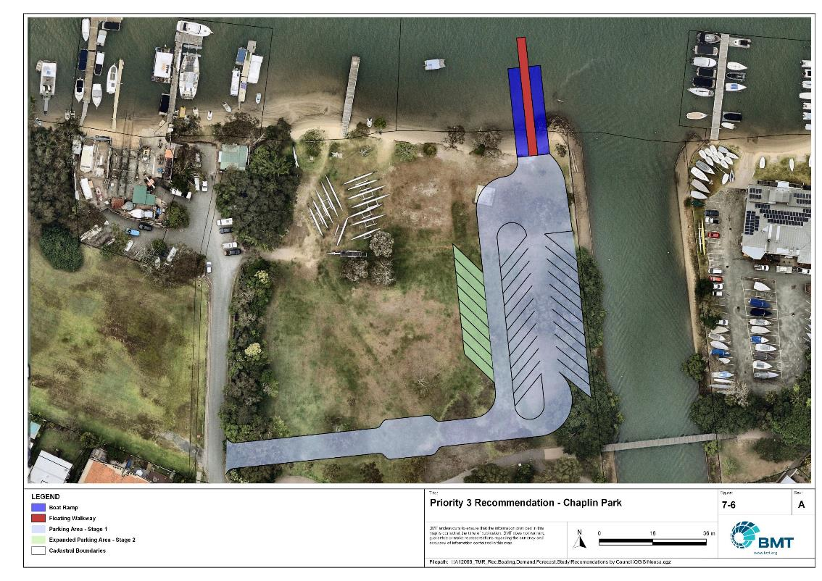

Priority 3 Recommendation – Chaplin Park

"I:\A12068_TMR_Rec.Boating.Demand.Forecast.Study\Recomendations by Council\JPG\Noosa\A12068_005_NoosaProposedUpgrades_7-6.jpg"

Gympie Terrace pontoon - (Priority 3)

|  |  |  |  |  |
| --- | --- | --- | --- | --- |
| General description | | | | |
| Location | Gympie Terrace, Noosaville | | | |
| Existing Facility? | Yes | | | |
| Coordinates | -26.396862044941596, 153.06462486652507 | | | |
| Existing tidal status | N/A - near all-tide once implemented | | | |
| Existing wave exposure | N/A | | | |
| Existing current exposure | N/A | | | |
| Proposed works | Replace existing jetty structure with pontoon. Suggest including sewage pump-out facility at this location to service the deep-draught vessels and shallow-draught houseboats using the Noosa River. The suggested configuration for the pontoon can readily be expanded to cater for more vessels if that is deemed necessary adequate pump-out capacity. | | | |
| Increased effective capacity | 1 landing | | | |
| Capacity improvement position | Waterside | Landside | | Both |
| Rationale | Location provides access into the Gympie Terrace/Noosaville precinct, which includes shops for resupplying as well as restaurants and other recreational facilities. There are sufficient parking options nearby for passenger vehicles should they be required and landside amenity blocks that should allow easy extension of sewerage lines to service the pontoon. | | | |
| Anticipated Costs (+/- 50%) | Waterside infrastructure | | $158,000 | |
| Landside infrastructure | | - | |
| Planning, environmental and approvals constraints | | | | |
| Assessment | Requirement | Comments | | |
| Fish Habitat Zone | X | N/A | | |
| Native Title | X | N/A | | |
| MCU requirement | X | N/A | | |
| Clearing remnant vegetation | X | N/A | | |
| GBRWHA | X | N/A | | |
| Marine Park | X | N/A | | |
| Tidal works assessment | ü | Replacement of jetty with pontoon will likely be tidal works and will require a Development Permit | | |
| Other as required | ü | Marine Plants – Replacement of jetty works may impact marine plants and therefore may require a Development Permit for marine plant disturbance | | |
| Sea Level Rise | ü | The proposed works are within the boundaries of the erosion prone area. | | |
| Storm Tide Hazard | ü | The proposed works are within the boundaries of a high hazard area. | | |
| Anticipated Complexity | Low | Medium | | High |

Priority 1 Recommendation – Gympie Terrace Landing

"I:\A12068_TMR_Rec.Boating.Demand.Forecast.Study\Recomendations by Council\JPG\Noosa\A12068_005_NoosaProposedUpgrades_7-7.jpg"

# 8 References

Australian Bureau of Statistics (ABS), 2021, *2021 Census,* <https://www.abs.gov.au/census>

Bell, Frederick W. 2022, *Estimation of the present and projected demand and supply of boat ramps for Florida's coastal regions and counties*, Florida State University, Department of Economics.

BMT, 2015, *MPSC Managed Boating Facilities Demand and Capacity Study: Boat Ramp Modelling*

Department of Transport and Main Roads (TMR), 2020, Marine facilities and infrastructure plan.

GHD, 2011, *Recreational Boating Facilities Demand Forecasting Study*

GHD, 2017, *Queensland Recreational Boating Facilities Demand Forecasting Study 2017.*

Maritime Safety Queensland (MSQ), 2022, *Recreational Boating Facilities,* <https://www.getinvolved.qld.gov.au/gi/consultation/8850/view.html>

Queensland Government Department of Resources (DoR), 2022, *Cities and towns [OGC WMS Service]*, Accessed 5/10/2022, available online at spatial.information.qld.gov.au/arcgis/home/item.html?id=103c7c9ccca449fab79d27cde06868ab

Rose, T., R. Powell & J. Yu (2009). Identification of the Present and Future Recreational Boating Infrastructure in Redland City – A 10 Year Infrastructure Plan- Griffith University

SKM (1998) Public Boat Ramps Central Queensland Strategic Plan - Volume One - Demand Forecasting - Noosa to Yeppoon. Sinclair Knight Merz, March 1998.

Swett, R., Fik, T., Ruppert, T., Davidson, G., Guevara, C. & Betty Staugler, 2012, *Planning for the future of recreational boating access to charlotte county waterways: 2010 – 2050*, Florida Sea Grant, University of Florida.

Western Australia Department of Transport, 2019, *Perth Recreational Boating Facilities Study Review 2019*, https://www.transport.wa.gov.au/mediaFiles/marine/MAC_P_Perth_RBFS_study_review_2019.pdf

Western Australia Department of Transport, 2021, *South West Region Recreational Boating Facilities Study July 2021,* https://www.transport.wa.gov.au/mediaFiles/marine/MAC_P_SouthWest_RBFS_Study_2021.pdf

###### Demand Study

"G:\Admin\A12068.g.mpb.TMRBoatingDemand\06_Reports\09_Demand Study\2022_2119 (016) Final Demand Report (March 2023).pdf"

###### Boat launching facility capacity

Capacity of existing boat launching facilities

| Facility ID | Facility name | | No. lanes | Tidal Access at Ramp | Tidal Access to Open Water | Queuing facility | Formal CTUs | Informal CTUs | Waterside capacity | Landside capacity | Effective capacity | Constraint |
| --- | --- | --- | --- | --- | --- | --- | --- | --- | --- | --- | --- | --- |
|  | | **Open Water Access** | | | | | | | | | | | |
| NS11 | Noosaville, Albert Street | | 2 | Near All-Tide | Near All-Tide | Floating Walkway | 11 |  | 2.4 | 0.75 | 0.75 | Land Side |
| NS12 | Noosaville, Thomas Street | | 2 | Near All-Tide | Near All-Tide | Pontoon | 11 |  | 1.92 | 0.75 | 0.75 | Land Side |
| NS32 | Tewantin, Lake Street | | 2 | Near All-Tide | Near All-Tide | Pontoon | 20 |  | 1.92 | 1.25 | 1.25 | Land Side |
| ADD1 | Munna Point Caravan Park | | 1 | Part-Tide | Part-Tide | Beach |  |  | 0.55 |  |  | Land Side |
| **Subtotal** |  | | **7** |  |  |  | **42** |  | **6.79** | **2.75** | **2.75** |  |
|  | | **Distance-limited Open Water Access** | | | | | | | | | | | |
| NS71 | Boreen Point, Orchard Avenue | | 1 | Near All-Tide | Near All-Tide | None |  | 9 | 0.8 | 0.758 | 0.75 | Land Side |
| NS75 | Cooroibah, Bundoora Street | | 1 | Near All-Tide | Near All-Tide | None |  | 10 | 0.8 | 0.75 | 0.75 | Land Side |
| **Subtotal** |  | | **2** |  |  |  |  | **19** | **1.6** | **1.5** | **1.5** |  |
|  | | **Infrastructure-limited Open Water Access** | | | | | | | | | | | |
| NS17 | Noosaville, Waterside Court | | 1 | Near All-Tide | N/A | None |  |  | 0.8 |  |  | Land Side |
| **Subtotal** |  | | **1** |  |  |  |  |  | **0.8** |  |  |  |
|  | | **Fresh Water** | | | | | | | | | | | |
| NS41 | Lake MacDonald | | 1 | Fresh Water | Fresh Water | Pontoon | 10 | 5 | 1.2 | 1 | 1 | Land Side |
| NS45 | Lake MacDonald (western) | | 1 | Fresh Water | Fresh Water | None |  | 5 | 1 | 0.5 | 0.5 | Land Side |
| **Subtotal** |  | | **2** |  |  |  | **10** | **10** | **2.2** | **1.5** | **1.5** |  |
|  | | **Total Effective Capacity** | | | | | | | | | 5.75 |  | |

###### Travel time statistics

Travel time from population centres to nearest sheltered all-tide or near all-tide open water accessible facilities

| Population centre | Travel time (mins) |
| --- | --- |
| Boreen Point | 15.3 |
| Cooran | 23.3 |
| Cooroy | 11.0 |
| Cooloothin | 11.7 |
| Noosa Heads | 2.8 |
| Kin Kin | 29.0 |
| Pomona | 18.5 |
| Tewantin | 0.7 |
| Peregian Beach | 11.0 |
| Sunshine Beach | 4.5 |
| Pinbarren | 21.3 |
| Noosaville | 0.1 |

###### Facility Use

Boat launching facility usage statistics

| FacilityId | Facility name | Total reports | Noosa | Sunshine Coast | Brisbane | Moreton Bay | Gold Coast | Gympie | Toowoomba | Redland | Logan | Ipswich | Other LGAs |
| --- | --- | --- | --- | --- | --- | --- | --- | --- | --- | --- | --- | --- | --- |
| Total |  | 10484 | 4568 | 1947 | 1654 | 461 | 229 | 201 | 103 | 103 | 102 | 85 | 1031 |
| Total % |  | 100% | 43.6% | 18.6% | 15.8% | 4.4% | 2.2% | 1.9% | 1.0% | 1.0% | 1.0% | 0.8% | 9.8% |
| NS11 | Noosaville, Albert Street | 6820 | 41.6% | 18.1% | 18.3% | 4.4% | 2.6% | 1.2% | 0.8% | 0.9% | 0.9% | 0.6% | 10.6% |
| NS32 | Tewantin, Lake Street | 2377 | 48.4% | 19.9% | 10.4% | 4.0% | 1.2% | 3.1% | 0.9% | 1.1% | 1.0% | 1.4% | 8.6% |
| NS71 | Boreen Point, Orchard Avenue | 509 | 39.1% | 13.6% | 19.8% | 6.1% | 1.8% | 2.8% | 2.4% | 1.8% | 1.6% | 0.8% | 10.4% |
| NS41 | Lake MacDonald | 394 | 45.2% | 25.6% | 8.9% | 3.6% | 2.5% | 4.3% | 3.0% | 1.0% | 0.8% | 0.3% | 4.8% |
| NS45 | Lake MacDonald (western) | 242 | 52.9% | 19.0% | 5.4% | 5.0% | 0% | 5.0% | 0.4% | 1.7% | 1.7% | 0.8% | 8.3% |
| NS75 | Cooroibah, Bundoora Street | 142 | 53.5% | 15.5% | 7.0% | 5.6% | 2.1% | 2.8% | 0% | 1.4% | 0.7% | 0.7% | 10.6% |

|  |  |  |
| --- | --- | --- |
|  |  | BMT is a leading design, engineering, science and management consultancy with a reputation for engineering excellence. We are driven by a belief that things can always be better, safer, faster and more efficient. BMT is an independent organisation held in trust for its employees. |

|  |  |  |  |  |  |  |  |  |
| --- | --- | --- | --- | --- | --- | --- | --- | --- |
|  |  |  |  |  |  |  | Contact us  enquiries@bmtglobal.com  www.bmt.org  Follow us  www.bmt.org/linkedin LinkedIn logo.  www.bmt.org/youtube YouTube logo.  www.bmt.org/twitter Twitter logo.  www.bmt.org/facebook Facebook logo. |  |
|  | Level 5  348 Edward Street  Brisbane  QLD 4000  Australia  +61 7 3831 6744 |  | Registered in Australia  Registered no. 010 830 421  Registered office  Level 5, 348 Edward Street,  Brisbane QLD 4000 Australia |  |  |  |  |
|  | For your local BMT office visit www.bmt.org | | |  |  |  |  |  |