|  |
| --- |
| Queensland Recreational Boating Facilities Demand Forecasting Study 2022  Rockhampton and Livingstone LGAs - Combined Regional Assessment |
|  |
|  |

|  |  |  |
| --- | --- | --- |
| Customer |  | Maritime Safety Queensland |
| Project |  | A12068 |
| Deliverable |  | 001 |
| Version |  | 01 |
|  |  | 21 April 2023 |

Document Control

Document Identification

|  |  |
| --- | --- |
| Title | Queensland Recreational Boating Facilities Demand Forecasting Study 2022 |
| Project No | A12068 |
| Deliverable No | 001 |
| Version No | 01 |
| Version Date | 21 April 2023 |
| Customer | Maritime Safety Queensland, a branch of the Department of Transport and Main Roads |
| Customer Contact | boatinginfrastructure@msq.qld.gov.au |
| Classification | {None} |

|  |  |
| --- | --- |
| Author | Daniel Wishaw, Nicholas Heiner, Geoff Long, Azam Dolatshah, Sophie Barrett, Mackenzie Stacey |
| Reviewed By | Katrina O’Malley-Jones, Jeremy Visser |
| Project Manager | Daniel Wishaw |

Amendment Record

The Amendment Record below records the history and issue status of this document.

| Version | Version Date | Distribution | Record |
| --- | --- | --- | --- |
| 00 | 13 April 2023 | Maritime Safety Queensland | Draft |
| 01 | 21 April 2023 | Maritime Safety Queensland | Final |

Executive Summary

This report, part of the Queensland Recreational Boating Facilities Demand Forecasting Study 2022 (‘the Study’), provides a summary of current and forecast demand on recreational boating facilities in the region encompassing Rockhampton and Livingstone LGA’s, and the capacity of existing facilities to meet this demand. Where capacity is insufficient to meet current or forecast demand, recommendations have been made to improve existing facilities or for the construction of new facilities.

This report is a stand-alone report for the combined two local government areas and aligns with MSQ’s strategy of improving boating facilities within the Rockhampton-Livingstone region as a whole. Individual reports for Livingstone and Rockhampton LGAs have also been provided with a focus specifically on those LGAs as discrete areas. This report is intended to support facility deliverers, owners, and managers over the next 20 years in their decision-making on development priorities for recreational boating facilities servicing the communities in the two LGAs.

Key issues and attributes of recreational boating

The key attributes of recreational boating facilities identified in this Study for the Rockhampton-Livingstone region are summarised in Table 1, while consultation with stakeholders undertaken as part of the Study identified the following key issues:

* high exchange of facility use, particularly of Rockhampton LGA residents using Livingstone LGA facilities
* significant demand pressures from across the combined local government areas on Rosslyn Bay Boat Harbour, as part of a strong desire for open-water access from a sheltered, all-tide accessible launching point.
* strong currents affecting riverine boat launching facilities, making launching difficult
* the need for public deep-draught vessel berthing pontoons with sewage pump-out facilities at Rosslyn Bay Boat Harbour and close to the Rockhampton central business district (CBD).

1. Key recreational boating attributes for the Rockhampton-Livingstone region

| Key attribute | Value |
| --- | --- |
| Deep-draught landing facilities |  |
| Existing demand (number) | 3.4 |
| Existing capacity (number) | 1 |
| Existing shortfall (number) | 2.4 |
| Boat launching facilities |  |
| Number of existing facilities | 21 |
| Current demand for boat launching lanes (effective lanes) | 39.1 |
| Number of existing ‘effective’ boat launching lanes | 33.3 |
| Shortfall of ‘effective’ boat launching lanes (number) | 5.8 |
| Demand satisfaction for ‘effective’ boat launching lanes | 85% |
| State-wide demand satisfaction for ‘effective’ boat launching lanes | 87% |

Demand summary

The assessment of recreational boating demand is centred on a statistical demand model that considers vessel registration data, population statistics, assumptions around local usage and the movement of vessels into and out of the two combined LGAs. Non-statistical demand is addressed in section 4.5. Key parameters from this assessment for the Rockhampton-Livingstone region are:

* The combined population is 118,644 as at the 2021 census and is projected to be 135,023 by 2041.
* As of July 2022, there is a total of 13,089 vessels with a home registration within the combined LGAs, with 96% being ‘trailable’ – and therefore requiring boat launching facilities – and 4% being non-trailable.
* Rockhampton is deemed to be a Regional Centre, while Livingstone is deemed to be a Remote region with assumed vessel activation rates of 10% and 14% respectively on a ‘good boating day’. This equates to a combined vessel activation rate of 12.5%.
* The existing demand for boat launching facilities is 39.1 ‘effective’ boat ramp lanes and is projected to be 44.2 ‘effective’ lanes by 2041. As presented in Table 1, the current capacity is 33.3 ‘effective’ lanes.
* The existing demand for deep-draught vessel landings is 3.4 currently and projected to be 3.9 by 2041. As presented in Table 1, the current capacity is one.

Boat launching

Boat launching facilities comprise boat ramps, any queuing facilities (floating walkways, pontoons, beaches and fixed sloping walkways) and the provision of car-trailer unit (CTU) parking. The capacity of a boat launching facility is measured in ‘effective lanes’ for both waterside and landside facilities, with the total capacity of a facility being the minimum of the waterside and landside capacity. Waterside capacity is calculated from the number of boat ramp lanes multiplied by environmental reduction factors (for tide, current or waves) and queuing facility improvement factors to derive the number of ‘effective’ lanes. The landside capacity is calculated from the number of available CTU parking spaces.

The Rockhampton-Livingstone region has 21 boat launching facilities, comprising 44 boat ramp lanes with a total effective boat launching capacity of 33.3 ‘effective’ lanes. 11 of these facilities are constrained by waterside capacity with the remainder constrained by landside capacity.

The capacity, forecast demand, and shortfall of boat ramp effective lanes in the Rockhampton-Livingstone region is shown in Figure 1, with the capacity of upgrades or new facilities that are expected to be delivered in the next five years included.

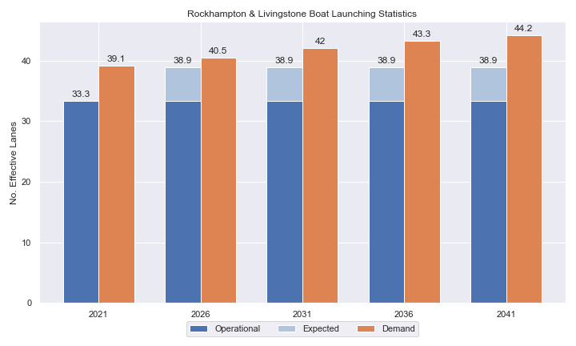

1. Existing capacity, forecast demand and shortfall of ‘effective’ boat ramp lanes for the Rockhampton-Livingstone region.

Deep-draught vessel landings

Vessel landing facilities are provided across the state in the form of pontoons and jetties, to provide locations for larger vessels, or their tenders, to access landside destinations or facilities. Pontoons and jetties may also be provided for other purposes such as supporting boat launching or other recreation and may not be suitable for deep-draught vessels. The trend across Queensland indicates that jetties are rarely used as landings, with pontoons preferred by recreational users. As such, the Study has limited the capacity of deep-draught vessel landings to those that are accessible and commonly used by recreational deep-draught vessels, as identified in consultation with stakeholders.

The Rockhampton-Livingstone region has a single public deep-draught vessel landing at Rosslyn Bay Boat Harbour, which is supported by private facilities also within the harbour. The shortfall assessment in Table 2 indicates that public landing capacity for deep-draught vessels is currently insufficient to support demand in the region and the coastal passaging route along the Queensland coastline. Opportunities for additional deep-draught landings should be identified.

1. Deep-draught vessel landing shortfall summary

| Criteria | 2021 | 2026 | 2031 | 2036 | 2041 |
| --- | --- | --- | --- | --- | --- |
| Deep-draught vessel demand | 3.4 | 3.5 | 3.6 | 3.7 | 3.9 |
| Deep-draught vessel capacity | 1 | 1 | 1 | 1 | 1 |
| Shortfall | 2.4 | 2.5 | 2.6 | 2.7 | 2.9 |

Priority recommendations

Recommendations for new facilities or upgrades to existing facilities are outlined in Table 3. The range of recommendations seeks to reduce the overall capacity shortfall within the region over the 20-year planning life of this Study, as well as address specific concerns, including:

* providing an expansion of capacity for facilities that provide sheltered unrestricted all-tide or near all-tide open water access
* providing publicly accessible deep-draught pontoons in Rosslyn Bay Boat Harbour and Rockhampton CBD
* maximising the capacity of and resolving conflicts at existing facilities.

Recommendations

1. Summary of recommended boating infrastructure upgrades for the Rockhampton-Livingstone region

| Priority | Criteria | Recommendations |
| --- | --- | --- |
| 1 | * Required to meet existing demand. * Sites that can provide maximum benefit for existing demand pressures at an LGA scale or satisfy specific safety pressures. | * Rosslyn Bay Boat Harbour: Build new facility within a breakwater extension north of the harbour, with four ramp lanes, two floating walkways and 120 CTUs. * Rosslyn Bay Boat Harbour: Provide deep-draught pontoon landing within the harbour. * Rockhampton Boathouse, Quay Street: Construct a gangway-access pontoon as a deep-draught vessel landing. |
| 2 | * Required to meet demand within the next five to ten years. * Sites that are likely to have low to medium approval complexity. * Sites that can provide satisfaction of specific demand or safety pressures within the LGA. | * Rosslyn Bay Boat Harbour: Improve parking capacity. * Stanage Bay: Improve parking capacity. * Nerimbera: Construct gangway-access pontoon. |
| 3 | * Required to meet demand within the next ten to fifteen years. * Sites that service planned future growth within the LGA. | * Callaghan Park: Construct additional carpark with 54 CTU spaces. * Quay Street: Reconfigure parking and relocate floating walkway to the northern lane. * Corbetts Landing: Improve parking capacity and install queuing structure. |
| 4 | * Required to meet demand within the next fifteen to twenty years. * Sites that service planned future growth within the LGA. | * Nil |

Contents

Definitions 10

1 Introduction 13

2 Rockhampton-Livingstone Region Overview 14

2.1 Key influences on recreational boating 14

2.2 Existing recreational boating infrastructure 14

2.3 Existing usage and issues 15

3 Capacity Assessment 19

3.1 Introduction 19

3.2 Boat ramp capacity 19

3.3 Boat ramp capacity basis 20

3.4 Boat ramp efficiency modifications 21

3.5 Accessibility from boat launching facilities 23

3.6 Existing boat launching capacity 24

3.7 Expected improvements to boat launching capacity 25

3.8 Access to sheltered near all-tide and all-tide facilities 27

3.9 Deep-draught vessel landings 30

4 Demand Assessment 31

4.1 Activation rate 31

4.2 Digital user survey 32

4.3 Active fleet size 37

4.4 Boat ramp lane demand 37

4.5 Non-statistical demand 37

4.6 Deep-draught vessel demand 38

5 Shortfall Assessment 40

5.1 Shortfall assessment – boat ramps 40

5.2 Shortfall assessment – deep-draught landings 41

6 Stakeholder Feedback 43

7 Development Recommendations 46

7.1 Previous recommendations 46

7.2 Priority recommendations 48

7.3 Priority 1 recommendations 50

7.4 Priority 2 recommendations 59

7.5 Priority 3 recommendations 67

7.6 Priority 4 Recommendations 75

8 References 76

Annex A Demand Study A-1

Annex B Boat launching facility capacity B-1

Annex C Travel time statistics C-1

Annex D Facility Use D-1

Tables

Table 2.1 Recreational boating facilities by facility owner in the Rockhampton-Livingstone region 14

Table 3.3 Deep-draught landing facilities within the Rockhampton-Livingstone region 30

Table 4.1 LGA of origin for active fleet in the Rockhampton-Livingstone region 32

Table 4.2 Popularity of boat launching facilities. 33

Table 4.3 Active fleet vessel size 37

Table 4.4 Boat ramp lane demand 37

Table 4.5 Deep-draught vessel landing demand 39

Table 5.1 Shortfall of boat launching facilities 40

Table 5.2 Shortfall assessment for open water, all-tide or near all-tide facilities for Rockhampton-Livingstone region 41

Table 5.3 Shortfall of deep-draught vessel landings 42

Table 7.1 Assessment of unimplemented 2017 recommendations 46

Table 7.2 Summary of recommendations for Rockhampton and Livingstone LGAs 49

Table 7.3 Rosslyn Bay Boat Harbour expansion - (Priority 1) 50

Table 7.4 Rosslyn Bay Boat Harbour deep-draught landing- (Priority 1) 54

Table 7.5 Rockhampton Boathouse, Quay Street (Priority 1) 57

Table 7.6 Rosslyn Bay Boat Harbour- (Priority 2) 59

Table 7.7 Stanage Bay, Banksia Road (Priority 2) 62

Table 7.8 Nerimbera, St Christophers Chapel Road - (Priority 2) 64

Table 7.9 Corbetts Landing (Priority 3) 67

Table 7.10 Robert Clark Drive, Callaghan Park (Priority 3) 70

Table 7.11 Quay Street (Priority 3) 72

Table B.1. Capacity of existing boat launching facilities B-1

Table C.1. Travel time from population centres to nearest sheltered all-tide or near all-tide open water accessible facilities C-1

Table D.1. Boat launching facility usage statistics D-1

Figures

Figure 2.1 Livingstone and Rockhampton region – boat launching facilities 17

Figure 2.2 Livingstone and Rockhampton region – deep-draught landings 18

Figure 3.1 (a) Summary of open water access from boat launching facilities (left) and (b) Summary of tidal restrictions at tidal boat launching facilities (right) 24

Figure 3.2 Summary of limiting capacity constraint 25

Figure 3.3 Concept plan for expected works at Rosslyn Bay Boat Harbour 26

Figure 3.4 Distribution of travel time from the Rockhampton-Livingstone region’s eligible population centres to sheltered near all-tide facilities 28

Figure 3.5 Livingstone and Rockhampton region – Travel time to nearest all-tide or near all-tide facility 29

Figure 4.1 Stanage Bay – vessel pathing 35

Figure 4.2 Livingstone and Rockhampton region – vessel pathing 36

Figure 5.1 Shortfall assessment with recommended upgrades adopted for Rockhampton-Livingstone region 40

Figure 7.1 Priority 1 Recommendation – Rosslyn Bay Boat Harbour expansion (western breakwater) 52

Figure 7.2 Priority 1 Recommendation – Rosslyn Bay Boat Harbour expansion (eastern breakwater) 53

Figure 7.3 Priority 1 Recommendation – Rosslyn Bay deep-draught vessel landing 56

Figure 7.4 Priority 1 Recommendation – Rockhampton Boathouse 58

Figure 7.5 Priority 2 Recommendation – Rosslyn Bay 61

Figure 7.6 Priority 2 Recommendation – Stanage Bay 63

Figure 7.7 Priority 2 Recommendation – Nerimbera 66

Figure 7.8 Priority 3 Recommendation – Corbett’s Landing 69

Figure 7.9 Priority 3 Recommendation – Callaghan Park 71

Figure 7.10 Priority 3 Recommendation – Quay Street 74

Definitions

| Term | Definition |
| --- | --- |
| All‑tide (for boat ramps) | Access from a boat ramp to the open sea with an approach depth of 0.5m below LAT or deeper and a depth at boat ramp toe of 0.5m below LAT or deeper. |
| All-tide (for landings) | Access from a gangway‑access pontoon or jetty to the open sea with an approach depth of 1.5m below LAT or deeper and a depth on at least one face of the pontoon of 1.5m below LAT or deeper. |
| BIP | Boating Infrastructure Program – a sub‑program within MSQ's Maritime Assets and Infrastructure Program |
| Boat ramp | A foreshore concrete ramp with a slope designed for vehicular launching and retrieving of recreational boats. |
| Breakwater | A structure constructed over the seabed and/or the foreshore, usually rising to a height above high tide, designed to provide protection to landward areas by limiting penetration of wave action or currents. |
| CTU | Car-trailer unit space – a parking space for a typical car with a boat trailer attached. |
| Demand | Demand is the requirement of the boat‑owning population for facilities to launch/retrieve trailer boats and/or to berth suitable boats at a given year to service their average (non‑peak period) needs. In most locations demand is based on vessel registrations and is expressed in terms of boat ramp lanes or in number of 12m berths at landings. |
| Effective capacity | For a boat ramp, effective capacity (effective lanes) means the number of boat ramp lanes after adjusting for anticipated unavailability due to unacceptable wave action (>0.2m wave height) or water depth, usage constraints such as the lack of adequate parking, and improvements to efficiency or launch/retrieval throughput such as floating walkways or pontoons. |
| FHA | Fish Habitat Area, declared under the Fisheries Act, 1994 |
| FIFO | Fly‑in fly‑out, where skilled workers travel from their city or central location home communities to a remote site to perform their duties often in blocks of time that provide regular, non-weekend, days off. |
| Fixed sloping walkway | A fixed sloping structure installed at the side of a boat ramp to assist launching/retrieval of trailer boats, and dry embarkation/disembarkation from trailer boats. It is sloped to allow use at varying tide heights – sometimes with sections of different slope. |
| Floating walkway | Multiple connected/hinged flotation modules configured to assist launching/retrieval of trailer boats, and dry embarkation/disembarkation from trailer boats at most if not all stages of the tide. Floating walkways are connected to a concrete shore abutment allowing pedestrian and assisted wheelchair access. |
| Gangway access pontoon | A platform/module that always floats, where a boat can be secured alongside on one or more faces. Pontoons are usually separated from a boat ramp and have a hinged articulated gangway for access to the shore via an abutment. |
| GBR | Great Barrier Reef |
| GCWA | Gold Coast Waterways Authority |
| Landing | A landing is a jetty or gangway‑access pontoon that facilitates berthing of vessels and transfer of passengers and stores. They are most often associated with non-trailable vessels |
| Landside | Refers to areas above high-water mark, often used to denote the location of and type of infrastructure. |
| LAT | Lowest Astronomical Tide, used as Chart Datum on navigational charts. |
| LGA | Local Government Area |
| Managing authority | Councils, port authorities, water storage managers as listed in schedule 1 of the Transport Infrastructure (Public Marine Facilities) Regulation 2011 |
| MCU | Material change of use under the planning scheme |
| MNES | Matter of national environmental significance under the Environment Protection and Biodiversity Conservation Act 1999 |
| MSQ | Maritime Safety Queensland |
| NC Act | Nature Conservation Act 1992 |
| Near all‑tide | Access from a boat ramp to the open sea with a minimum approach depth of 0.5m below LAT and minimum depth at the boat ramp of 0.5m below LAT for 80 percent or more of the tidal range (time measured over a year). |
| Parking - Formalised | A sealed, line-marked parking area for car-trailer units, providing adequately sized parking spaces, roadways and turning circles. |
| Parking – Semi-formalised | An all-weather non-sealed parking area, with markers to delineate adequately sized car-trailer unit parking bays and turning circles. Markers can be concrete blocks, pavement markers (e.g., retro-reflective raised markers) or other permanent instalment to show parking bays. |
| Parking – Informal overflow | A naturally surfaced area available for use as overflow parking on the design boating day, signed as such. To have mixed-use purpose (e.g., parkland) when not being utilised as overflow parking. |
| Part‑tide | Boat ramps that do not meet near all-tide or near all-tide requirements. |
| PV | Passenger vehicle (i.e., car – as opposed to car-trailer unit). |
| Port Authority | An organisation that is responsible for the management of one or more ports on the Queensland coast. |
| Population Centre | Official named urban settlements (populated places) that have been sourced from the Queensland Place Names Database. |
| Registration activation rate | The percentage of registered vessels liable to be in use on any given good weather weekend day |
| Shortfall | The number of effective boat ramp lanes or landings required to meet demand for a given timeframe. Negative shortfall signifies an oversupply for the time period nominated. |
| SPL | Strategic Port Land |
| Study | The Recreational Boating Facility Demand Forecasting Study 2022, including this document. |
| TMR | Department of Transport and Main Roads |
| Water Storage Authority | Includes Seqwater, Sunwater |
| Waterside | Refers to areas below high-water mark, often used to denote the location of and type of infrastructure, including dredged channels and breakwaters. |
| WHA | World Heritage Area |
| # | Number |

# Introduction

BMT has been appointed to undertake the Recreational Boating Facilities Demand Forecasting Study 2022 (‘the Study’) by Maritime Safety Queensland (MSQ), a branch of the Queensland Department of Transport and Main Roads (TMR), on behalf of all public recreational boating facility managers and owners across Queensland. The Study supersedes the 2017 study of the same name and is intended to report on recreational boating facility demand, capacity, and shortfall over a 20-year period at a Local Government Area (LGA) scale across Queensland.

The Study has been developed using information from the 2021 Australian Census (ABS, 2021), recreational boat vessel registrations, consultation with facility owners, managers, and stakeholders, the 2022 Queensland Government Get-Involved recreational boating facilities survey (MSQ, 2022), and previous versions of this Study (2011, 2017). The Study is intended for use by deliverers, owners, managers, and key stakeholders of public recreational boating facilities across Queensland, namely state government agencies including MSQ and the Gold Coast Waterways Authority (GCWA), local governments, port authorities and water authorities. The Study is non-regulatory in nature and is intended to be used as part of a broader suite of information to identify priority investment in recreational boating infrastructure at a local and state level.

The Study establishes demand primarily on statistics derived from registration and population data. Please refer to Section 4.5 for discussion of non-statistical demand. The Study evaluates existing and forecast demand over a 20-year period and makes recommendations on how this demand might be met over that period. Recommendations may include improvements to both landside and waterside capacity depending on the facility.

Recommendations are assigned a priority ranking, from 1 to 4, indicating if they are required immediately or in the next 5, 10 or 15 years respectively. To end 2022, 14% of recommendations from the 2017 study have been completed, comprising 11% of landside recommendations and 18% of waterside recommendations and reflecting 22% of priority 1 the 2017 recommendations. A much greater percentage of the earlier 2011 study recommendations have now been implemented. Given the low uptake on existing/outstanding recommendations, this Study will review previous recommendations and carry forward, modify, or remove as appropriate. The Study has also been tasked with reviewing specific wave exposed beach launching facilities across the state to determine their contribution to meeting boating facilities demand and make recommendations about their future.

The Study is comprised of a report for every LGA in Queensland, a regional assessment for the combined Rockhampton and Livingstone LGAs (this report), and a state-wide summary report. Each LGA report summarises demand pressures from vessel registration data, population statistics, assumptions around local usage and the movement of vessels into and out of the combined LGAs, and existing capacity and recommends opportunities to satisfy shortfall. The regional report provides this overview for the consolidated Rockhampton-Livingstone region, reflecting the high degree of facility sharing specific to these LGAs. The state-wide report will support the LGA reports and provide context at a state level for demand pressures, current capacity, equity of access to facilities and state-wide priority for major boating facilities.

The Study is intended to report on publicly accessible recreational boating facilities for registered vessels. This includes boat ramps, floating walkways, pontoons, fixed sloping walkways and supporting car-trailer unit parking at each facility. The Study does not include recommendations for facilities that are used primarily for commercial purposes, private facilities, non-motorised recreation such as launching canoes and stand-up paddle boards, and fishing platforms.

# Rockhampton-Livingstone Region Overview

## Key influences on recreational boating

Within the Rockhampton-Livingstone region, the principal attributes and influences that affect demand on recreational boating infrastructure include:

* Livingstone’s designation as a Remote Region and Rockhampton’s designation as a Regional Centre, with a large combined recreational boating fleet
* moderate projected population growth
* high tourism inputs including larger vessels cruising along the Queensland coast
* limited opportunities for unrestricted, all-tide or near all-tide open water access.

The region has significant interconnectivity between recreational boating facilities and recreational boating fleets in both LGAs. There are facilities that are on the border between the LGAs that are managed by Livingstone LGA but primarily used by residents of Rockhampton LGA. Rosslyn Bay Boat Harbour is the region’s major unrestricted open-water accessible all-tide or near all-tide facility, with many Rockhampton residents using this facility in Livingstone LGA as their preferred facility. Because of this intertwining, consideration across this two-LGA region is needed to identify region-wide solutions to resolve demand distribution and capacity issues.

MSQ has a carefully planned strategy for improving boating facilities in the region. This strategy seeks to maximise the potential capacity at Rosslyn Bay Boat Harbour (including minor improvements such as carpark upgrades along with major new infrastructure such as harbour expansion) and reduce the demand on Rosslyn Bay Boat Harbour by improving or constructing new facilities as alternative open-water access points and encouraging boating in estuarine waters. New facilities within the lower Fitzroy River are expected to provide capacity during this Study period, with the goal of attracting boat users away from Rosslyn Bay Boat Harbour to access the waters in the lower Fitzroy, the surrounding creek system, the Narrows, or open-water destinations that are closer to these new sites.

## Existing recreational boating infrastructure

The recreational boating facilities within the Rockhampton-Livingstone region are summarised in Table 2.1. These facilities are owned or managed by multiple organisations and include facilities that provide access to open water, estuaries, and fresh water. MSQ’s long term vision is to provide unrestricted access to open water from facilities along the Queensland coast such that all significant Population Centres are within one hour’s driving range where practical. For clarity, the Study has defined this vision to be the provision of sheltered all-tide, or near all-tide, boat launching facilities within one hour driving range of official Population Centres (DoR, 2022) lying within 30km of the coastline between the NSW border and Cooktown.

Recreational boating facilities by facility owner in the Rockhampton-Livingstone region

| Owner | Open-water boat ramps | | Other boat ramps | | Landings | |
| --- | --- | --- | --- | --- | --- | --- |
| Facilities | Lanes | Facilities | Lanes | Pontoons | Jetties |
| TMR | 3 | 10 | 16 | 32 |  | 5 |
| Rockhampton Regional Council |  |  | 2 | 2 |  |  |

Boat launching facilities within the region are shown in Figure 2.1 and deep-draught vessel landings in Figure 2.2.

Access to land from deep-draught vessels is catered for by the provision of landings such as jetties and pontoons that are intended for short term usage, mainly to drop off and embark passengers and supplies. Within the region these vessels are catered for at the following locations:

* at the Rosslyn Bay Boat Harbour public jetty
* the jetty near Derby Street in Rockhampton is occasionally used by deep-draught vessels, however feedback indicates that jetties are difficult to use and as such gangway-access pontoons are almost exclusively preferred.

## Existing usage and issues

Consultation with Rockhampton Regional Council, Livingstone Shire Council, Gladstone Port Corporation, Maritime Safety Queensland, and recreational groups, and feedback from the recreational boating facilities survey hosted by TMR, indicates the following major themes and issues within the region.

* + 1. Lack of unrestricted all-tide or near all-tide capacity

The facility at Rosslyn Bay Boat Harbour provides the majority of open-water access capacity for recreational boat users from both Livingstone and Rockhampton LGAs, as well as for visiting boat users from outside this region. Outside Rosslyn Bay Boat Harbour, there are no facilities that provide unrestricted all-tide or near all-tide access that are within a reasonable distance to the popular offshore destinations around the Keppel Islands. Other facilities used to access offshore destinations have significant restrictions due to depth restrictions at lower tides, distance restrictions to the destinations, or both. The facility at Coorooman Creek is an example, where knowledgeable boat users plan their open-water excursions based on a check of the predicted tides.

* + 1. Insufficient deep-draught landing facilities

There is demand within Rockhampton LGA for a deep-draught vessel landing near the city. Vessels moored or anchored in the river close to the CBD use tenders to access the shore at various facilities with floating infrastructure. As there is no fit-for-purpose public facility for these vessels, Rockhampton LGA is missing an opportunity to further attract boating/fishing tourism, which has been proven (advice from RRC) to stimulate the local economy.

In Rosslyn Bay Boat Harbour there is one public jetty that can be used by coastal passaging vessels. However, this facility is providing insufficient capacity and amenity for these vessels and an upgrade of this facility to a gangway-access pontoon is needed.

* + 1. Conflicts at facilities

There are conflicting usages at some facilities – particularly during frequent markets and the annual motor festival ‘RockyNats’. These conflicts cause the capacity at facilities to be severely reduced during the period around the festival and markets, and options to resolve these conflicts are desired and needed.

* + 1. Recreational Fishing Strategy

The Recreational Fishing Strategy implemented by Rockhampton Regional Council seeks to improve the quality of fishing opportunities within the broader region. The strategy has included the federal declaration of a net-free fishing zone in the lower Fitzroy River and Keppel Bay and is a key approach to achieving increased tourism in the region by becoming the “Home of the Barramundi and Threadfin”. The strategy has resulted in increased demand on recreational boating facilities due to perceptions (proven by statistics) that the quality of fishing has increased.

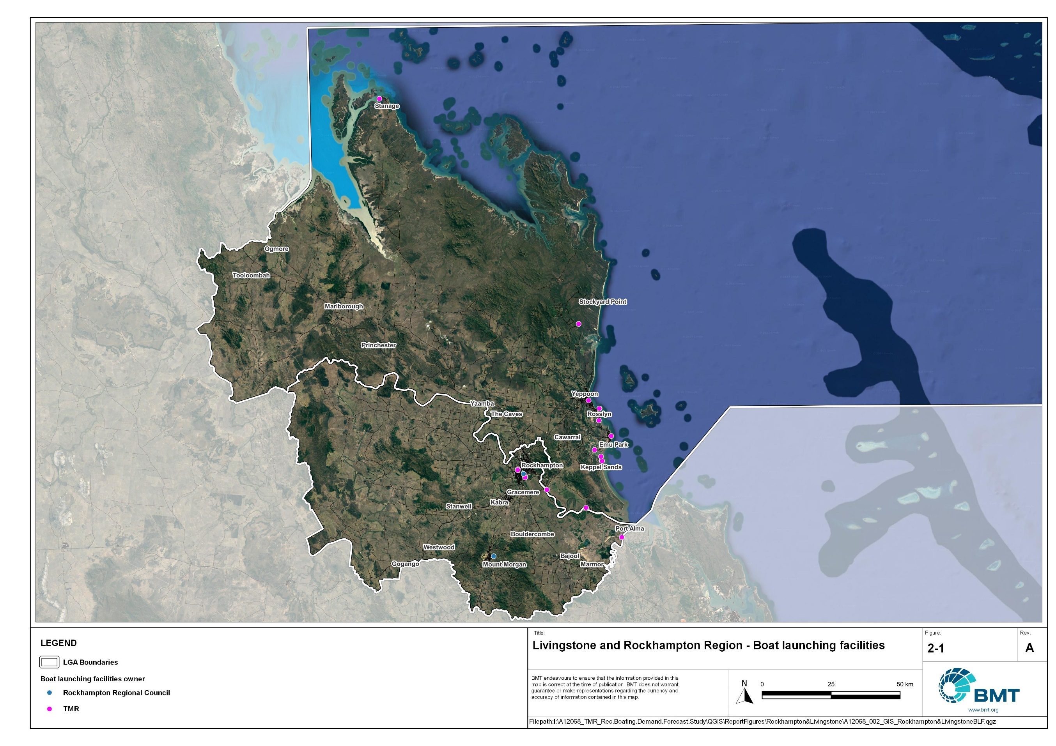

Livingstone and Rockhampton region – boat launching facilities

I:\A12068_TMR_Rec.Boating.Demand.Forecast.Study\QGIS\ReportFigures\Rockhampton&Livingstone\A12068_001_GIS_TMR_BLF_LivingstoneANDRocky.jpg

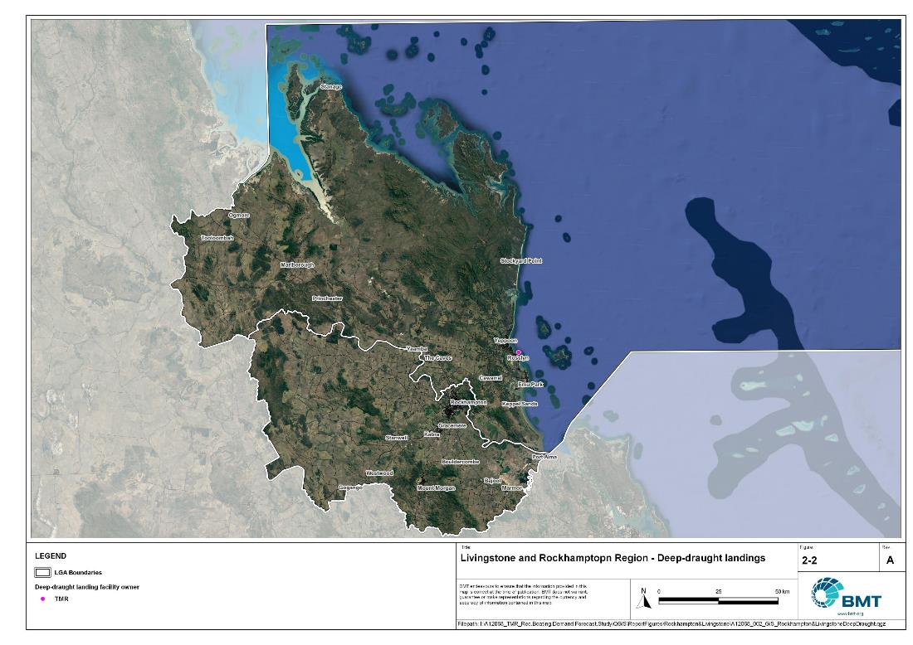

Livingstone and Rockhampton region – deep-draught landings

I:\A12068_TMR_Rec.Boating.Demand.Forecast.Study\QGIS\ReportFigures\Rockhampton&Livingstone\A12068_001_GIS_TMR_DDL_LivingstoneANDRocky.jpg

# Capacity Assessment

## Introduction

Boat ramps are facilities used for launching and retrieving trailable vessels, typically up to 8m in length (with some exceptions), to and from the water. Boat ramps consist of one or more lanes and their use is often supported by landside and waterside infrastructure to improve efficiency. In some instances, the usability of a facility can be adversely affected by environmental constraints such as low water levels, currents, or wave exposure, reducing the overall availability of the facility. Together, consideration of the number of boat ramp lanes, the supporting infrastructure, and environmental constraints results in the facility having a capacity described in terms of ‘effective lanes’ that may or may not be equal to the number of actual boat ramp lanes.

To maximise usage of each facility, the landside and waterside capacity should be balanced. Each facility will have a calculated ‘effective’ capacity for both the landside and waterside elements, with the limiting element dictating the facility's overall effective capacity. Recommendations for works or infrastructure promote balancing these two capacity elements by either improving the limiting element for increased facility effectiveness or by increasing the overall 'effective capacity' through changes to both elements.

## Boat ramp capacity

The overall capacity of each boat launching facility is limited by the effective capacity of either the waterside or landside elements. The waterside capacity is informed by the number of boat ramp lanes and the number and type of queuing facilities, such as pontoons, floating walkways, queuing beaches and fixed sloping walkways. It may also be limited by the available water depth in the adjacent waterbody and exposure to environmental or other physical factors.

Landside capacity is governed by the availability of nearby spaces for parking of car-trailer units (CTU), the provision of rigging and de-rigging facilities, and provision of single car parking spaces (single cars may otherwise be obliged to park in CTU spaces).

While it is expected that facilities will have their own characteristics influencing efficient use, this Study applies an approach that is consistent across the entire state and consistent with previous editions of the Study. Accordingly, the effective waterside capacity of a boat launching facility is determined as being:

* the ability to support 40 vessels being launched and retrieved per day per lane (see section 3.3)
* influenced by exposure to wave, tide, and current conditions (see section 3.4)
* supported by queuing facilities that assist in the efficient use of the boat ramp (see section 3.4).

Calculation of landside capacity is in line with the TMR guideline (TMR, 2020), which requires less provision of CTU parking per lane than the Australian standard (AS3962 Table 7.1), and advises:

* 10 CTUs for a single lane boat ramp accessed by an unsealed road, or 15 CTUs accessed by a sealed road
* 45 CTUs for a two-lane boat ramp
* 70 CTUs for a three-lane boat ramp
* 90 CTUs for a four-lane boat ramp.

A notable difference from the 2017 study is the recognition and inclusion of areas close to existing boating facilities that are unsealed and/or not line marked where parking of cars with trailers occurs and is not discouraged. These areas of informal parking have been identified on aerial imagery and through discussions with managing authorities. Each informal area has been assumed to be available for CTU parking only 50% of the time to account for conflicts with other uses (for example, markets), inefficient parking practices, or poor ground conditions. The rate of parking has been calculated as:

* for linear areas where nose-to-tail parking is expected – 1 CTU per 13m
* for linear areas with enough space to allow side-by-side parking – 1 CTU per 3m, provided there is a minimum distance of 15m from the road or manoeuvring area
* for large areas – 1 CTU per 100m2.

## Boat ramp capacity basis

The number of vessels per day each boat ramp lane can support is based on the Australian Standard for the Design of Marinas (AS3962-2001) and previous versions of this report (GHD, 2011 and 2017).

Research on boat ramp lane efficiency described in the previous report (GHD, 2017) identified that 40 vessels per lane per day was a reasonable compromise between 50 vessels per lane per day (representing congested conditions) and 30 vessels per lane per day (representing unhampered conditions). For context, the 40 vessels per lane per day rate represents a vessel launch or retrieval every 9 minutes per lane within an average normally used period of 12 hours per day.

During this Study, BMT has sought to validate the assumptions presented above, and those relating to capacity modification, by undertaking a literature review, conducting site visits that included observations of launching and retrieving manoeuvres, and reviewing video recordings of boats launching and retrieving at popular boating facilities. The literature review included a boat ramp efficiency investigation undertaken by BMT on the Mornington Peninsula, Victoria (BMT, 2015) and a review of standards from other Australian states and countries that undertake similar studies. The onsite and video analysis provided the opportunity to observe recreational boat operators using facilities included in the Study but did not include observation of total throughput during high demand periods. This assessment was undertaken during site visits across Queensland, and a full day of video recording at Manly Boat Harbour (north ramp) in Brisbane.

The New South Wales and Victoria governments are currently in a planning phase for boating infrastructure and there are presently no publicly accessible documents identifying how those jurisdictions calculate boat ramp lane capacity. The Western Australia government has commissioned studies of the Perth region and the southwest region (Western Australia Department of Transport, 2019 and 2021) that indicate a base rate of 50 vessels per lane per day, with no modifiers applied. Internationally, studies from Florida in the USA (Bell, 2022 and Swett et. al, 2012) assumed that total vessel launch plus retrieval time is between 20 to 40 minutes (18 to 36 vessels per day), although no evidence is provided to support this assumption.

The Mornington Peninsula report (BMT, 2015) collected boat launch and retrieval data for 6 boat ramp facilities on the Mornington Peninsula across 9 days, including the peak Australia Day holiday. Total throughput was assessed for each facility on days where there was constant pressure for launching and retrieving boats with results between 30 and 70 vessels per lane per day for the various facilities. When adjusted for queuing modifications, a baseline rate of between 20 and 50 vessels per lane per day was identified. Of the facilities, the higher rates were achieved where sufficient parking was provided and both waterside and landside queuing facilities existed.

Observations of recreational boat users launching and retrieving their vessels undertaken through the site visits and the analysis of video footage showed that:

* Most observed launches were of ‘multi-person’ boats, which made launching and retrieving boats more efficient.
* Almost all users were able to launch and/or retrieve their boat within the 9-minute target time, when adjusted for queuing facility efficiency.
* There was a preference to launch adjacent to a floating walkway, where one was available. At facilities where a queuing facility is not immediately adjacent to the lane it is expected that average launch times may slightly increase during busy periods.

While the observations that were made generally aligned with expectations, a more in-depth review of capacity assumptions was outside of the scope of the Study. For future studies there would be value in undertaking a more thorough, data-driven investigation of the assumptions about boat ramp lane capacity, both at its base level and modified by queuing facilities. Overall, the preliminary investigations undertaken as part of the Study suggest that the base rate of 40 vessels per lane per day adopted in previous studies is appropriate.

## Boat ramp efficiency modifications

The waterside capacity of boat ramp lanes can be reduced by environmental factors that include:

* Water levels: Mainly relating to tidal areas this factor considers the reduction in the amount of time the boat ramp is available to launch and retrieve vessels over the full tidal cycle, thus reducing the overall capacity of the facility. For all-tide access, the boat ramp and connecting channel to the open sea are available during all tidal conditions and therefore available 100% of the time. For near all-tide access the boat ramp and the connecting channel to the open sea are assumed to be available, on average, for 80% of the tidal cycle. For part-tide access the boat ramp and its access channel are available less than 80% of the time. A modification factor of 0.8 is applied for near all-tide facilities and 0.5 for part-tide facilities.
* Wave and current conditions: In areas where vessel launching and retrieval may be intermittently impacted by waves (most commonly on beach ramps, but not exclusively) or strong currents (such as in rivers), a modification factor of 0.5 is applied.

Conversely, effective boat ramp capacity can be improved through the use of well-designed queuing facilities. Queuing facilities aim to improve amenity and efficient use of the boat ramp by accelerating one or more of the following phases of boat launching, with the opposite steps required for retrieval:

1. manoeuvring for launching, including for CTU entering the queuing area for the boat ramp and reversing into position for launch
2. launching and securing the launched vessel
3. moving the launch vehicle from the boat ramp to the parking area
4. removing the vessel from the waterside queuing facility.

A range of waterside queuing facilities are in use in Queensland boating infrastructure, which modify different phases of the total launching process. These include:

* Floating walkways and fixed sloping walkways: Positioned to abut a boat ramp lane, these structures aim to:
  + improve amenity – such as to assist embarking/disembarking passengers, provide a refuge from in-water contact with crocodiles and so on.
  + make securing the vessel and removing the vehicle from the boat ramp more rapid, while freeing the boat ramp for subsequent users.
* Pontoons: Also used by deep-draught vessels, these structures improve the ability to secure the vessel and clear the boat ramp, but there is usually some time lost returning to recover the launch vehicle compared with the above options as they are generally positioned slightly further away from the ramp.
* Queuing beaches: These also provide a place to secure the vessel close to the boat ramp, although they are generally not as fast to use as pontoons.

As observed throughout the Study site visits, each of these queuing facility types can support a limited number of boat ramp lanes depending on the available space on the queuing facility. The 2017 edition of this Study applied a blanket uplift for all boat ramp lanes where a queuing facility was provided. However, the number of lanes each type of queuing facility can realistically support varies. Accordingly, this Study has provided limitations to the number of boat ramp lanes that can benefit from each queuing facility, based on the number of “working faces” (or area for a queuing beach) provided, where the “working face” is a face that allows temporary securing of vessels during launching or retrieval. The adopted improvement factors and supported lanes are summarised in Table 3.1.

Queuing facility efficiency modifiers

| Queuing facility | Modification factor | Supported lanes |
| --- | --- | --- |
| Floating walkway (lanes adjacent to walkway) | 1.7 | 1 Lane/face |
| Floating walkway (lanes not adjacent to walkway) | 1.3 | 1 Lane/face |
| Fixed sloping walkway | 1.7 | 1 Lane/face |
| Pontoon | 1.2 | 2 Lanes/face |
| Queuing beach | 1.1 | Site-based |

In other states in Australia, reversing queuing bays are more commonly used than in Queensland. These are CTU waiting bays at the head of the boat ramp that are aligned with each boat ramp lane to allow the user to reverse directly down the boat ramp once it is clear. CTU waiting bays reduce the time of the first phase of boat launching by allowing waiting CTU’s to be ready to reverse as soon as the lane becomes clear. The BMT (2015) study on the Mornington Peninsula included facilities with and without these bays. Boat ramps that included reversing queuing bays achieved 50% greater throughput. Facilities that have implemented this approach in Queensland include North Street Southport, Urangan Boat Harbour, Townsville Recreational Boating Park, and the (under construction late 2022) boat ramp at Yorkeys Knob.

## Accessibility from boat launching facilities

Recreational boat users will typically select the boat launching facility most appropriate or convenient to the activity they are seeking to undertake, the anticipated weather/wave conditions, and their destination. Each of facility within an LGA will provide a varying degree of access to different destinations and for different activities. During the Study, consultation with stakeholders highlighted the following general types of destinations and activities:

* open water/offshore: typically accessed for visiting offshore islands or remote beaches, snorkelling or diving locations, deep sea fishing and general recreation
* creeks and estuaries: typically accessed for fishing, crabbing, wildlife observation, skiing and general recreation
* freshwater: typically accessed for skiing, fishing, wildlife observation and general recreation.

These destinations are typically serviced by different types of recreational vessels. Inshore locations including creeks, estuaries and other freshwater locations are typically patronised by vessels less than 4.5m, except for ski boats, which can be much larger than this. Offshore locations typically require larger boats for access as these vessels are more capable of managing a wide range of wave conditions and can carry sufficient fuel to access distant destinations. Smaller vessels may be able to access close destinations on good weather days, and larger vessels may choose to access inshore destinations, particularly on poor weather days.

Consequently, the following aspects are used to classify how well a facility provides open water access:

* Open-water access: There are no restrictions between the facility and open water.
* Depth-limited access: There are depth restrictions between the facility and open water that limit navigable access to part of the tidal range. This differs from tidal constraints at the actual facility, which might be usable at all tides, but offshore access is limited by a downstream bar or delta.
* Distance-limited access: The distance from the facility to the open water is unrealistic for typical boat users. This distance is assumed to be about 4.5km between the facility and open water to rate as 'distance limited', with travel times increased further where portions of the access channel are regulated by speed limits.
* Infrastructure-limited access: There are man-made obstacles between the facility and open water, such as above-ground pipeline crossings, low bridges or weirs that impede navigable access to open water.
* Beach ramps: These provide open-water access but are typically constrained by environmental conditions such as wave exposure and tide levels. The capacity of these facilities has been individually assessed based on consultation and other data sources and is described in more detail in section 4.
* Freshwater: There is no access to open water.

Certain facilities, particularly those in freshwater, may be constrained by periods of drought, or debris deposition after rainfall events that limit access to destinations, and therefore whether a facility will provide useful boat launching capacity. While it is noted that drought and rainfall may affect the overall capacity of boat launching within an LGA, and given that the timing of such events is not readily predictable, their impact on capacity has not been evaluated.

## Existing boat launching capacity

Within the Rockhampton-Livingstone region there are 21 boat launching facilities with a total effective capacity of 33.3 lanes. The effective capacity of boat launching facilities within the region is shown in Annex B, with a summary of the access to open water and tidal constraints shown in Figure 3.1 and the overall capacity constraint shown in Figure 3.2. Pertinent features of these facilities include:

* There are 21 total lanes, with an effective capacity of 33.3 effective lanes. This effective capacity is primarily reduced due to insufficient parking being allocated for each lane.
* Boat users across the region have a range of options for boating, with facilities available for accessing freshwater destinations, water skiing areas and offshore destinations.
* A minority of the facilities provide all-tide access.
* The majority of open water access capacity in the region is provided by Rosslyn Bay Boat Harbour in Livingstone LGA.
* Freshwater facilities servicing the region are all located in Rockhampton LGA.

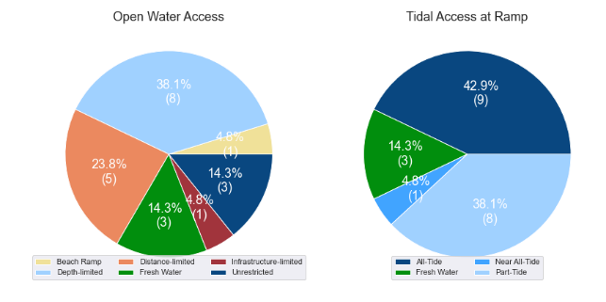

(a) Summary of open water access from boat launching facilities (left) and (b) Summary of tidal restrictions at tidal boat launching facilities (right)

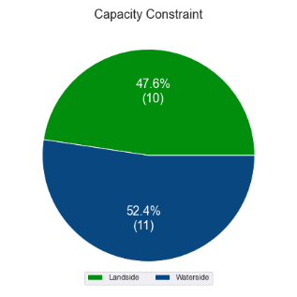

Summary of limiting capacity constraint

## Expected improvements to boat launching capacity

Facilities that are expected to be constructed and actively providing capacity within the Study period are accounted for in this section. These are projects that have secured funding, have begun construction or have a current works contract. For all intents and purposes, these are intended to be providing capacity within the next 5 years or sooner. As such, this section acknowledges the increase in capacity that these facilities will supply.

### *Casuarina Creek, Port Alma*

This is a 2-lane facility, with a central floating walkway and 53 CTU parking spaces, located off the Bajool-Port Alma road. The facility will provide improved access into Casuarina Creek and the associated waterways for boating and fishing, and also provide capacity for offshore ventures. Along with Inkerman Creek boat ramp, this facility is intended to replace and expand the capacity provided by the Port Alma facility on Raglan Creek, which will be withdrawn from public use on completion of the Casuarina Creek facility.

### *Inkerman Creek, Port Alma*

This is a 2-lane facility with 26 CTU parking spaces that was completed in May 2023, also off the Bajool-Port Alma road. This facility provides access into the Inkerman Creek system as well as to open water. Like the Casuarina Creek facility, the Inkerman Creek facility will contribute to the replacement of the capacity currently provided by the Raglan Creek, Port Alma boat ramp.

### Rosslyn Bay Boat Harbour

Upgrades to the recreational boating facilities at Rosslyn Bay are expected in late 2023, with works contracts in place (at May 2023) for two stages of upgrade to the in-water facilities. This involves:

* extension of the floating walkway adjacent to the western ramp
* widening the western ramp by one lane
* relocating the floating walkway on the eastern facility to a central lane, making this a 4-lane facility with a centralised floating walkway
* establishing a beaching area to the west of the western ramp
* constructing new gangway-access pontoons between the ramps, with a dredged basin for all-tide trailer-boat access.

As the landside capacity of the two facilities presently have a higher ‘effective lane’ capacity than the waterside (that is, the facilities are waterside constrained), these in-water upgrades will have direct impacts on the overall capacity of the facilities. This will provide better capacity for vessels to queue (temporarily tie up) while users are parking or retrieving their vehicles, allowing the ramps to remain available for other vessels.

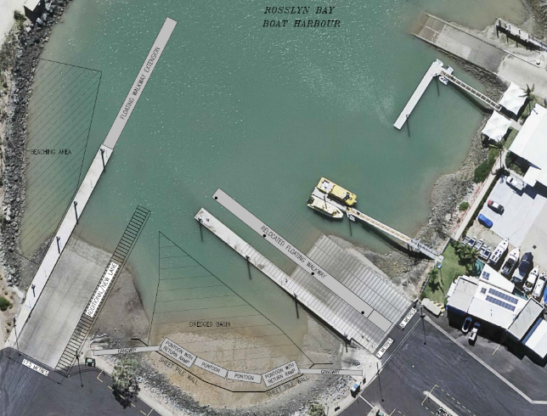

Concept plan for expected works at Rosslyn Bay Boat Harbour

Expected new facilities

| Criteria | Waterside effective lanes | Landside effective lanes | Total effective lanes |
| --- | --- | --- | --- |
| Casuarina Creek, Port Alma | 3.4 | 2.5 | 2.5 |
| Inkerman Creek, Port Alma | 3.4 | 1.5 | 1.5 |
| Rosslyn Bay Boat Harbour, Breakwater Drive (western) | 5.0 | 6.6 | 1.6 |
| Rosslyn Bay Boat Harbour, Anchor Drive (eastern) | 5.0 | 6.0 | 1.0 |

Once the Inkerman Creek and Casuarina Creek facilities are constructed and open to use by the public, the existing Port Alma facility on Raglan Creek will be closed to public use. This is expected to occur in late 2023 and will result in the loss of 1.0 effective lane of capacity provided by that facility. Therefore, the net increase in capacity following the construction of facilities at Casuarina Creek and Inkerman Creek, to replace the Port Alma facility, will be 3.0 effective lanes, with the upgrades at Rosslyn Bay Boat Harbour adding a further 2.6 effective lanes.

## Access to sheltered near all-tide and all-tide facilities

MSQ has a longer-term vision to provide access to all-tide or near all-tide open water access boat launching facilities along the Queensland coast, such that all significant population centres are within one hour’s driving range as far as practical (TMR, 2020). For this purpose, the Study has defined towns as being within the coastal strip if within 30km of the Queensland coastline. The vision (TMR,2020) is applied to the coastal strip between the NSW border and Cooktown. Consultation throughout the Study has highlighted that this vision is important with users/stakeholders and organisations that own and manage these facilities. As such, the Study has developed a statistical approach to quantify this vision to allow it to be measured and tracked over time. To do this, the Study has calculated the travel time from all Population Centres (DoR, 2022) within the coastal zone to the nearest available sheltered, all-tide or near all-tide facility, regardless of which LGA it is in. This has been accomplished using mapped road networks and assigning speed limits to each type of road, with the following speed limits applied:

* for restricted roads, 40km/hr
* for local roads, 60km/hr
* for connector roads, 70km/hr
* for distributor roads, 80km/hr
* for highways, 100km/hr.

For the Rockhampton-Livingstone region, the median travel time from eligible Population Centres to the nearest sheltered all-tide or near all-tide facility is 27 minutes. The distribution of travel times is shown in Figure 3.4 with detailed travel times in Annex C. Figure 3.5 provides a visual representation of the travel time from each of the sheltered near all-tide facilities that serve the region. Of interest for the region are:

* The majority of eligible Population Centres are within the desired 1-hour travel time.
* Rosslyn Bay Boat Harbour and Port Alma are the only facilities within the combined LGA area that provide desired all-tide sheltered capacity. Sheltered near all-tide open-water access capacity is provided at Coorooman Creek, Thompson Point, and Nerimbera, however access from these facilities is restricted by depth and/or distance limitations. (Note: While the Stanage Bay facility is used regularly for open-water access, this is on a part-tide basis.)
* The only population centre outside the desired 60-minutes travel time is Marlborough, which is at the very limit of the ‘30km from the coast’ criteria, with no facilities around the closest area of coastline.

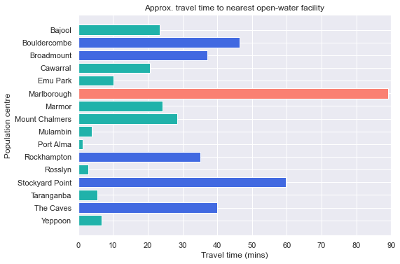

Distribution of travel time from the Rockhampton-Livingstone region’s eligible population centres to sheltered near all-tide facilities

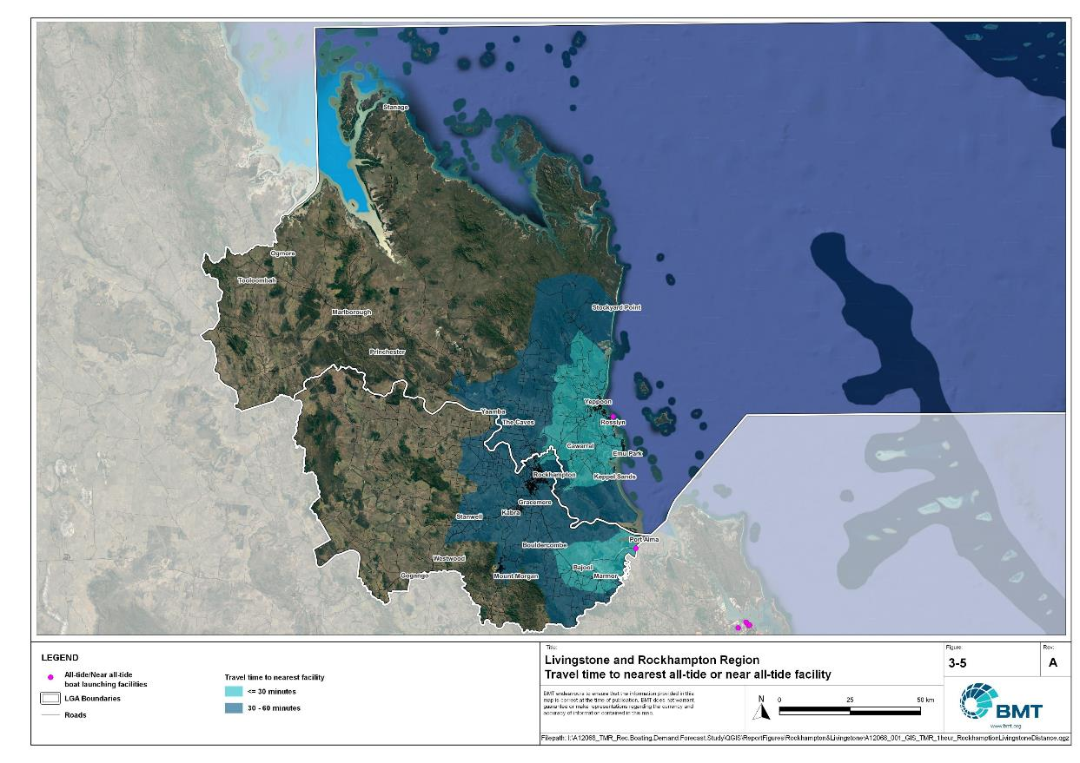

Livingstone and Rockhampton region – Travel time to nearest all-tide or near all-tide facility

I:\A12068_TMR_Rec.Boating.Demand.Forecast.Study\QGIS\ReportFigures\Rockhampton&Livingstone\A12068_001_GIS_TMR_1hour_Livingstone&Rockhampton_DistanceFacilities.jpg

## Deep-draught vessel landings

Deep-draught vessel landings are intended to provide short-term landing capacity for vessels that are too large to use public boat launching and retrieval facilities. These facilities are provided for the benefit of both local vessels and to service the fleet of vessels that travel along the Queensland coast. Deep-draught vessel landings may be designed to accept one or more large vessels at a time and/or provide capacity for tenders from larger vessels that may be anchored or moored nearby, for the purpose of loading and offloading passengers and supplies, and making short local visits to onshore destinations.

For the Study, deep-draught vessel landings need to be primarily accessible by recreational boats for short, temporary stays. In some cases, commercial vessels may utilise these facilities subject to the relevant permissions, however, this may reduce the capacity of the facility to cater for recreational vessels. Deep-draught vessel landings should be located such that the facility provides reasonable access to landside passenger pick up and drop off, provisioning, recreational destinations, or population centres.

Within Rockhampton LGA there are no fit-for-purpose deep-draught vessel landings that provide access to mainland destinations. The jetty near Derby Street in Rockhampton is in poor condition and is not preferred for use by deep-draught vessels, only seeing occasional use. Therefore, this jetty is not counted as a deep-draught landing as it is not fit-for-purpose at present. The capacity that was, in the past, provided by this jetty should be replaced.

Within Livingstone LGA there is one deep-draught vessel landing at Rosslyn Bay Boat Harbour that provides access to a car park with pickup/drop-off opportunities for passengers or supplies, and public transport connections to nearby towns (that is, Emu Park or Yeppoon) for reprovisioning. Additionally, Livingstone LGA has deep-draught vessel landings provided by the privately owned Keppel Bay Marina – which is located in Rosslyn Bay Boat Harbour. The marina has a minimum one-night paid berthing, which should be arranged prior to arrival. There is typical good availability at the Keppel Bay Marina for berthing, though it can be limited during the cruising season.

In summary, Table 3.3 shows the total capacity of deep-draught landing facilities within the Rockhampton-Livingstone region.

Deep-draught landing facilities within the Rockhampton-Livingstone region

| Facility type | Total capacity |
| --- | --- |
| Public sheltered mainland landings | 1 (1 berth) |
| Private sheltered landings | 1 (multiple berths) |

# Demand Assessment

The Study has developed a model to calculate statistical demand for boat launching facilities and deep-draught vessel landings at an LGA scale. Vessels that are less than 8m in length are considered trailable and drive demand for boat launching facilities such as boat ramps, while those over 8m are assumed to remain on water and drive demand for deep-draught landings.

Statistical demand is recognised at three different levels for public marine facilities within the TMR guidelines (TMR, 2020), which are:

* off-peak demand – typical weekday usage
* average demand – demand on ‘good boating days’, taken to be demand for a facility on weekends (and, for certain regional locations, other busy periods)
* peak demand – demand for a facility at peak holiday periods or for special events.

The demand model created for this Study is intended to provide information on demand pressures on ‘good boating days’ for all facilities as per the intentions of the guidelines. The model achieves this through a ‘registration activation rate’ that estimates the proportion of registered vessels in an LGA that is assumed to be active on a ‘good boating day’, as well as the exchange of vessels between LGAs, and general tourism pressures.

## Activation rate

The fleet size for each LGA is determined statistically from vessel registration numbers and the application of a vessel activation rate, while for future time horizons vessel registration and population growth estimates are also utilised. The methodology for determining the registration activation rate has been adopted from the previous study (GHD, 2017), with activation rates taken to be between 8% and 14% for a typical weekend. The variability of the activation rate is intended to capture the regional differences in vessel types, and is driven by the availability of access to open water, accessibility of other recreational opportunities, and likelihood of users’ available time for recreation, considering factors including:

* remoteness classification for the combined LGAs
* incidence of blue-collar employment
* average age of residents
* whether the combined LGAs is coastal.

Further information about the derivation of this rate can be found in Annex A. For Rockhampton and Livingstone LGAs, the activation rate is assumed to be 12% and 14% respectively, with the key factors influencing the rate including:

* its classification as either a Regional Centre or Remote Region
* the incidence of blue-collar employment being higher than the state average
* the average age being higher than the state average
* its adjacency to the open coast.

## Digital user survey

To gain an understanding of usage trends at existing formal recreational boating facilities across Queensland, the Study has considered the results of a digital user survey using human movement data, sourced through a third party. The data was acquired from a location data store with more than 13 trillion mobile location observations globally from 2019 to present, which were sourced from 250,000 different mobile phone applications that users ‘opted-in’ to use the location services under the application’s terms and conditions. All data received was deidentified and compliant with relevant data privacy regulations.

The analysis uses mobile devices (such as telephones) location data as a proxy for boat user traffic, however, this relationship has several limitations including, but not limited to:

* Mobile device users detected in the area of interest may not be boat users (for example, pedestrians not using vessels may walk through the detection area).
* The relationship between mobile device users and vessels may not be 1:1 (that is, there may be multiple mobile devices providing data for each vessel).
* Users of vessels may not have a mobile device, may not be using a mobile device or may not have provided permission to use their location data.

With these, and potentially other, limitations in mind, the Study compared this data against vessel launching counts provided by various facility managers and found that approximately 15-30% of vessels are captured using this digital survey method. This percentage can change from facility to facility and from day to day. Consequently, the Study has not relied on raw counts of users from this data, but instead considered the relative trends within the data, with the assumption that no groups (for example, users from a particular LGA or using a particular facility) within the data would be more or less likely to be captured by the technique.

The Study has used this data to identify the relative volume of users, the ‘home’ local government area of users and the popularity of destinations that users travel to once vessels have been launched. Presentation of the full dataset can be found in Annex D.

* + 1. Inter-LGA demand

The human movement data has been interrogated to determine the combined LGAs of origin for users of the Rockhampton-Livingstone region’s public boating facilities to ascertain the proportion of users from each LGA that are using specific facilities. Statistics from all public boating facilities within the combined LGAs are then grouped together to determine the total proportion of resident or visiting users across the combined LGAs. Table 4.1 shows the active fleet proportion from the top 10 LGAs contributing to demand on facilities within the region. All other sources have been grouped together.

LGA of origin for active fleet in the Rockhampton-Livingstone region

| LGA of origin | Active fleet proportion |
| --- | --- |
| Rockhampton | 44% |
| Livingstone | 31% |
| Brisbane | 3% |
| Central Highlands | 3% |
| Gold Coast | 2% |
| Moreton Bay | 2% |
| Sunshine Coast | 2% |
| Gladstone | 2% |
| Mackay | 1% |
| Other LGAs | 12% |

* + 1. Intra-LGA demand distribution

Recreational boating users will tend to use facilities that best suit their needs, the destinations they want to access, the capability of their vessel and the weather conditions. Consequently, distribution within the region is unlikely to be evenly spread across all facilities, with some facilities attracting users disproportionately due to amenity, access, or destinations. The attractiveness of large well-designed facilities is likely to draw visiting boat users in preference to smaller or less desirable facilities across the region. The human movement statistics have been assessed to qualitatively estimate the proportion of users using each facility, both in total and with respect to both resident and visiting boat users (Table 4.2).

Popularity of boat launching facilities.

| Facility | Overall fleet | Resident fleet | Visiting fleet |
| --- | --- | --- | --- |
| Rosslyn Bay, Anchor Drive | 36% | 33% | 44% |
| Robert Clark Drive, Callaghan Park | 13% | 13% | 13% |
| Rockhampton Ski Gardens - Ramsden Street | 9% | 11% | 5% |
| Rockhampton, Quay Street | 8% | 9% | 5% |
| Coorooman Creek | 7% | 7% | 7% |
| Rockhampton, Reaney Street | 6% | 7% | 3% |
| Mulambin, Yeppoon - Emu Park Road | 3% | 3% | 3% |
| Stanage Bay, Banksia Road | 3% | 1% | 7% |
| Mount Morgan, William Street | 3% | 3% | 3% |
| Rockhampton, Larcombe Street | 3% | 4% | 2% |
| Nerimbera, St Christopher's Chapel Road | 2% | 2% | 1% |
| Corbetts Landing | 1% | 1% | 1% |
| Thompson Point | 1% | 1% | 1% |
| Keppel Sands, Limpus Avenue | 1% | 1% | 1% |
| Fisherman Beach, Hill Street, Emu Park | 1% | 1% | 1% |
| Keppel Sands, Taylor Street, South (Musa) Head | 1% | 1% | 1% |
| Port Alma, Bajool-Port Alma road | 1% | 1% | 3% |
| Keppel Sands, Limpus Avenue | 0% | 0% | 0% |

The results indicate that both the resident and visiting fleet is heavily focused on the Rosslyn Bay Boat Harbour facility, with more than one-third of vessels launching from this facility. Elsewhere in the area, Stanage Bay is relatively more popular among visitors than the local fleet, while high numbers at Callaghan Park may be due to the ‘RockyNats’ event and local markets that are hosted at this facility.

The distribution of capacity within the region needs to consider these trends to avoid consistent capacity shortfalls at some facilities or indicating demand for unnecessary extra capacity at other facilities. Results from the above statistics and feedback obtained through the TMR online survey indicate that within the Rockhampton-Livingstone region the following factors tend to influence the preferred facilities for recreational boat users:

* access to sheltered, all-tide launching facilities
* dry entry/exit capabilities of launching facilities provided through floating walkways, pontoons and to a lesser extent fixed sloping walkways
* ability to access offshore destinations.
  + 1. Destinations

For facilities that provide sheltered, near all-tide or all-tide open water access, additional analysis of the human movement statistics has been undertaken to identify destinations for users of these facilities. Location data from users utilising the facilities was extracted for a period of two hours after they used the facility and trimmed for water-side destinations. For the Rockhampton-Livingstone region this additional analysis was applied to the following facilities, with destinations mapped in Figure 4.1:

* Port Alma
* Stanage Bay
* Coorooman Creek
* Emu Park
* Nerimbera
* Rosslyn Bay Boat Harbour
* Thompson Point.

From this additional analysis, the following notable observations were made:

* Users of Stanage Bay remained in the local waterway or travelled to the Duke Islands.
* Open water trips, particularly those to the Keppel Islands, were dominated by users departing from Rosslyn Bay Boat Harbour, with some minor visitation from Emu Park users.
* The facilities at Rosslyn Bay Boat Harbour are preferred for launching vessels for significantly longer open water voyages.
* Users of Nerimbera, Thompson Point, Port Alma and Coorooman Creek facilities had a strong preference to stay in the local estuaries.

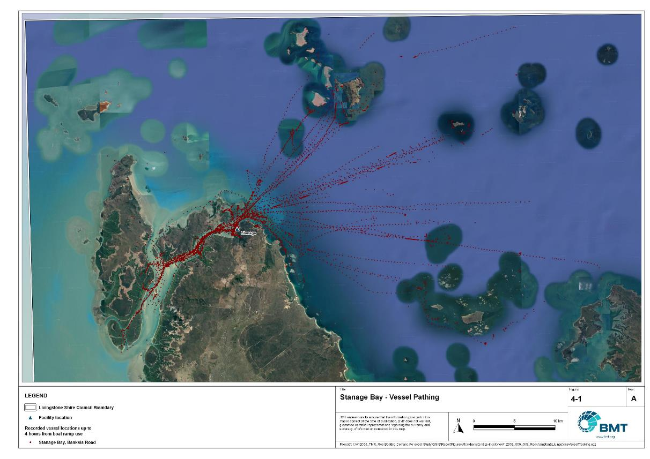

\\bmt-bne-fs01\drafting\A12068_TMR_Rec.Boating.Demand.Forecast.Study\QGIS\ReportFigures\Bundaberg\A12068_006_GIS_BundabergVesselTracking.jpg

Stanage Bay – vessel pathing

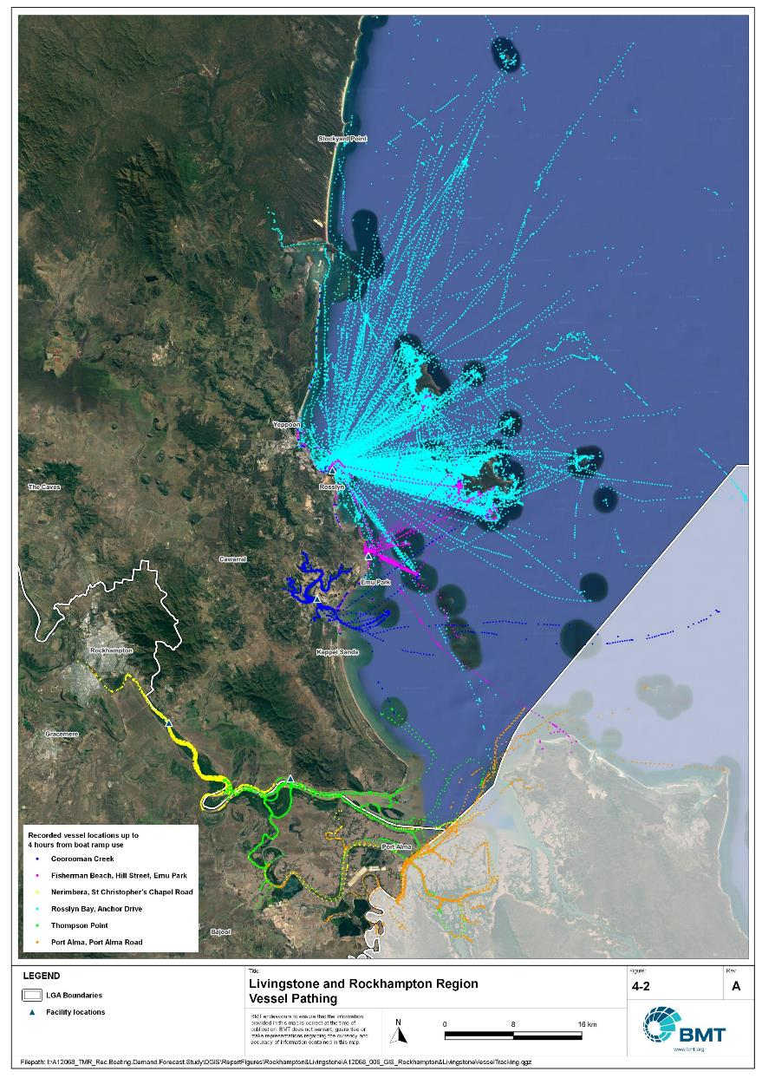

Livingstone and Rockhampton region – vessel pathing

I:\A12068_TMR_Rec.Boating.Demand.Forecast.Study\QGIS\ReportFigures\Rockhampton&Livingstone\A12068_006_GIS_Livingstone&RockhamptonVesselTracking_South.jpg

## Active fleet size

The total ‘active’ fleet on a good boating day is derived from the activation rate of the total fleet of registered vessels within the region and the net inflow of visiting vessels. The total number of visiting vessels from each LGA is determined from the number of vessels in the resident active fleet and the relative proportion of resident to visiting vessels outlined in Table 4.1.The fleet size is expected to change over time due to changes in population and vessel acquisition trends, with the size and proportion of the fleet across the Study period described in Table 4.3.

Active fleet vessel size

| Vessel length | 2021 | 2026 | 2031 | 2036 | 2041 |
| --- | --- | --- | --- | --- | --- |
| 0 to 4.5m | 1,040 | 1,076 | 1,114 | 1,148 | 1,172 |
| 4.5m to 8m | 526 | 545 | 565 | 583 | 596 |
| >8m | 68 | 71 | 73 | 76 | 78 |
| Total | 1,634 | 1,692 | 1,753 | 1,807 | 1,846 |

## Boat ramp lane demand

The fleet size derived in Table 4.3 represents the statistical demand for the combined LGAs, with vessels under 8m assumed to contribute to boat ramp demand, measured in boat ramp lanes. As outlined in section 3.2 the adopted capacity of each effective lane is 40 vessels per day, with each vessel assumed to both launch and retrieve, for a total of 80 vessel movements per day. The total boat ramp lane demand across the Study period is shown in Table 4.4.

Boat ramp lane demand

|  | 2021 | 2026 | 2031 | 2036 | 2041 |
| --- | --- | --- | --- | --- | --- |
| Boat ramp lane demand | 39.1 | 40.5 | 42.0 | 43.3 | 44.2 |

For the Rockhampton-Livingstone region the important elements that contribute to the boat ramp lane demand include:

* a large sized combined fleet, with a high proportion of trailable vessels
* attractive destinations for visitors from south-east Queensland
* limited opportunities for unrestricted, all-tide or near all-tide open water access
* opportunities for fishing, supported by Rockhampton Regional Council’s Recreational Fishing Strategy, which seeks to expand recreational fishing (and fishing tourism, thereby increasing demand for boating facilities) in the broader region.

## Non-statistical demand

As well as the statistical demand outlined in the section above, facilities may face demand pressures that are related to their functional use, which reduces the capability of the facility to service the recreational boat fleet in the desired manner. Issues with specific facilities have been identified within the consultation process of the Study with appointed managers and other stakeholders. While care has been taken to identify these non-statistical demand issues throughout the Study, it is beyond the scope of the Study to individually review the functionality, safety, and amenity of each facility across Queensland. Non-statistical demand pressures may warrant upgrades to facilities even where statistical demand is satisfied by existing capacity. These pressures have been classified into the following categories:

* Amenity: Amenity describes the functional usability of the facility including the desire to provide dry entry and exit facilities, facilities that provide easy access and/or access for persons with restricted mobility.
* Safety: Safety demand may include protection from currents and waves or contact with marine creatures such as sharks, jellyfish, and crocodiles.
* In-water congestion: Where existing queuing facilities are not able to efficiently meet the needs of the facility. Such deficiency may warrant additional queuing facility capacity to optimise boat launching and retrieval.

The Study's recommendations may alleviate these non-statistical demand pressures with consideration for capability of all facilities within the region. The presence of a non-statistical demand pressure at a facility may not warrant upgrades where other suitable facilities are reasonably available.

## Deep-draught vessel demand

* + 1. Cruising vessels

Vessels cruising along the east coast of Queensland have a requirement for a network of deep-draught vessel landings that are appropriately spaced to be within a day’s sailing on good weather days. These facilities are required to support the reprovisioning of vessels as they travel along the coast and provide access to desirable land-based destinations. Private marina facilities may be used by cruising vessels where there is an expectation for a prolonged stay that requires protected mooring or berthing. Within the Rockhampton-Livingstone region suitable facilities for deep-draught vessels include the public jetty in Rosslyn Bay Boat Harbour.

Within the east coast network, but outside of the region, the nearest public deep-draught vessel landing facility to the north is at Abell Point Marina, in Airlie Beach (Whitsunday LGA), a distance of approximately 235 nautical miles. Between, there are private landings available in Mackay Harbour and suitable facilities for tenders of deep-draught vessels to use, as well as a public pontoon at River Street, in Mackay, that is expected to be constructed and functioning as a deep-draught vessel landing during the Study’s 5-year outlook period. To the south, the nearest facility is in Gladstone in Auckland Creek, approximately 57 nautical miles distance.

The public jetty in Rosslyn Bay Boat Harbour provides access to mainland destinations including public transport options to Yeppoon or Emu Park for reprovisioning, however no fuel or sewage pump-out facilities are available for public use. For vessels seeking to stay in the region longer-term, protected berthing is seasonally available at private facilities in the Keppel Bay Marina (within Rosslyn Bay Boat Harbour).

At present, deep-draught vessels anchoring or mooring in the Fitzroy River near the Rockhampton CBD use tenders to access the shore. The relatively large number of vessels anchored or moored should be supported by a fit-for-purpose deep-draught landing facility. Locating this near Rockhampton CBD would allow for easy access to supermarkets and shops for reprovisioning by tender, for pickup and drop-off of passengers, and for access (via tender) to public transport.

* + 1. Landing demand

Statistical demand for deep-draught vessel landings has been assessed based on the size of the non-trailable fleet within the Rockhampton-Livingstone region. Landing demand is more difficult to assess than boat ramp lane demand as the requirements and duration of the landing influence the demand pressure but are highly variable between users. Nevertheless, the Study has assumed that 5% of the non-trailable fleet will be seeking a landing at any given time. The consultation undertaken during the Study indicates that this assumption may overestimate the number of landings, but that the landings are often utilised for other boating and recreation activities when not in use by deep-draught vessels. In particular, landings that are located near boat launching facilities may be used as queuing facilities and therefore support the efficient launching of smaller recreational vessels. Given this, the 5% assumption has been adopted noting that it may overestimate capacity, but not to an extent that it would be onerous to facility providers. Within the region the demand for deep-draught vessel landings is outlined in Table 4.5

Deep-draught vessel landing demand

| Requirement | 2021 | 2026 | 2031 | 2036 | 2041 |
| --- | --- | --- | --- | --- | --- |
| No. of Landings | 3.4 | 3.6 | 3.7 | 3.8 | 3.9 |

# Shortfall Assessment

## Shortfall assessment – boat ramps

The shortfall of boat ramp lanes within the Rockhampton-Livingstone region is shown in Table 5.1 and Figure 5.1at an LGA scale. This is presented both with and without the inclusion of additional capacity provided by the recommended upgrades.

Shortfall of boat launching facilities

| Assessment | Metric | 2021 | 2026 | 2031 | 2036 | 2041 |
| --- | --- | --- | --- | --- | --- | --- |
| Demand | Demand | 39.1 | 40.5 | 42 | 43.3 | 44.2 |
| Existing | Capacity | 33.3 | 38.9 | 38.9 | 38.9 | 38.9 |
| **Shortfall** | 5.8 | 1.6 | 3.1 | 4.4 | 5.3 |
| Improved | Capacity | 33.3 | 44.9 | 46.4 | 49.6 | 49.6 |
| **Shortfall** | 5.8 | -4.4 | -4.4 | -6.3 | -5.4 |

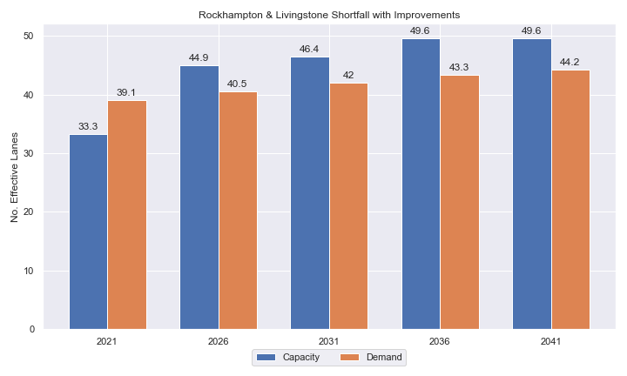

Shortfall assessment with recommended upgrades adopted for Rockhampton-Livingstone region

* + 1. Open-water access shortfall in boat ramp lanes

Statistical capacity has been calculated across the Rockhampton-Livingstone region in its entirety, however, some facilities are evidently more popular than others due to their ability to access open-water destinations, and/or their usability. In general, larger vessels are more suited to access open-water destinations while smaller vessels are more likely to remain in sheltered environments. This was identified in the 2017 study and confirmed during discussions with stakeholders. The human movement data indicates that visiting boats from other LGAs are drawn to facilities that provide access to open-water destinations. To ensure that the capacity of effective boat ramp lanes in the combined LGAs is appropriately distributed to cater for these usage trends, it is worth assessing facilities providing this desirable access as a subset of the total capacity for the combined LGAs. A ‘scenario’ approach to assessing this capacity (Table 5.2) has been developed, with Scenario 1 derived from empirical estimates of vessel distribution and Scenario 2 derived from the human movement statistics, and the result averaged between the two scenarios. This provides the opportunity to rationalise the figure that drives the demand and acknowledge when one scenario is not representative of the population or consistent with stakeholder feedback. The scenarios that were assessed are:

Scenario 1: 80% of larger vessels and 20% of smaller vessels from the local fleet and 80% of the visiting fleet are using the facilities with unrestricted open water access.

Scenario 2: Distributing the fleet between facilities as per the human movement statistics.

Shortfall assessment for open water, all-tide or near all-tide facilities for Rockhampton-Livingstone region

| Assessment | Metric | 2021 | 2026 | 2031 | 2036 | 2041 |
| --- | --- | --- | --- | --- | --- | --- |
| Overall | Capacity | 11 | 16.6 | 16.6 | 16.6 | 16.6 |
| Scenario 1 | Demand | 24.3 | 25.2 | 26 | 26.9 | 27.4 |
| Shortfall | 13.3 | 8.6 | 9.4 | 10.3 | 10.8 |
| Scenario 2 | Demand | 14.9 | 15.5 | 16.1 | 16.7 | 17.1 |
| Shortfall | 3.9 | -1.1 | -0.5 | 0.1 | 0.5 |
| **Average** | Demand | 19.6 | 20.35 | 21.05 | 21.8 | 22.25 |
| **Shortfall** | **8.6** | **3.75** | **4.45** | **5.2** | **5.65** |

Comparing the regional-scale shortfall with the subset of facilities providing protected all-tide or near all-tide access to open water indicate that the demand is focused on this subset of facilities, with a net shortfall of open-water facilities, despite the future satisfaction of overall demand on a regional-scale.

## Shortfall assessment – deep-draught landings

The shortfall of public deep-draught landings for the Rockhampton-Livingstone region is provided in Table 5.3. The existing capacity is statistically not meeting demand for public temporary berthing of deep-draught vessels along the coastline or within the Fitzroy River. Considering the lack of suitable existing public facilities to the north, the capacity for deep-draught landing in the central Queensland region is below the assessed demand and should be increased to better service the local deep-draught fleet and cruising vessels.

Shortfall of deep-draught vessel landings

| Assessment | Metric | 2021 | 2026 | 2031 | 2036 | 2041 |
| --- | --- | --- | --- | --- | --- | --- |
| Deep-draught vessel landings | Demand | 3.4 | 3.5 | 3.6 | 3.7 | 3.9 |
| Capacity | 1 | 1 | 1 | 1 | 1 |
| **Shortfall** | 2.4 | 2.5 | 2.6 | 2.7 | 2.9 |

# Stakeholder Feedback



The Study has undertaken extensive consultation throughout its execution to achieve a comprehensive understanding of issues relating to the use of recreational boating facilities across the state. This consultation was conducted with managing authorities that own and/or and manage recreational boating facilities, as well as with facility stakeholders including recreational groups, volunteer marine rescue and coastguard organisations, and the general public. Stakeholder engagement was supplemented with site visits to facilities where key issues had been identified.

* 1. **Managing authority feedback**

Within the Rockhampton-Livingstone region, the Study team met with Livingstone Shire Council, Rockhampton Regional Council, Gladstone Ports Corporation and Maritime Safety Queensland to discuss recreational boating facilities within the region. This consultation process identified a range of potential opportunities to alleviate demand pressures. The Study has considered the practical implementation of each of these opportunities with respect to the required infrastructure, difficulty of implementation, and magnitude of benefit, as summarised in Table 6.1.

Stakeholder identified opportunities

| Location | Stakeholder opportunity | Review comments |
| --- | --- | --- |
| Corbetts Landing | Provision of floating walkway would improve safety at this stie. | Agreed. |
| Rosslyn Bay Boat Harbour | Expansion beyond the existing breakwaters to cater for demand. | Agreed, noting that this is a state boat harbour. |
| Yeppoon, Fig Tree Creek. | Downgrade to access ramp for use by unpowered recreational craft. | Tidal and siltation issues severely limit the capacity of this ramp. Agree that it is not contributing to LGA capacity and would be difficult to improve. |
| Stanage Bay | Improve parking area. | Agreed. |
| Rockhampton Boathouse | Provide gangway-access pontoon with direct access to Rockhampton CBD and sewage pump-out facility. | Agreed. Excellent location for this facility. |
| Nerimbera | Provide a pontoon or floating walkway at this location | This facility is in Livingstone LGA but is heavily used by Rockhampton LGA vessels. Agreed with suggestion. |
| Parkhurst and Pink Lily | Exploration of new freshwater boating facilities. | The consideration of new freshwater facilities at these areas is viable and is not fundamentally opposed by the Study. However, current demand statistics presented in this Study indicate that demand will be satisfied by the expected facilities in the Fitzroy River delta and the two existing freshwater facilities upstream of the Fitzroy River Barrage, which are closer to major population centres. |

* 1. **Stakeholder feedback**

Broader stakeholder feedback has been conducted within the Study by undertaking virtual or face-to-face meetings with recreational boating groups and marine rescue organisations, as well as through the Recreational Boating Facility Survey (MSQ, 2022) undertaken by Maritime Safety Queensland, which included survey responses of nearly 3,000 users and open submissions. For the Rockhampton-Livingstone region a total of 125 submissions was received, with 82% of respondents using trailable power boats and 99% of respondents using recreational boating facilities at least once a month. For the region the following statistics or themes were extracted from the survey and associated comments:

* 98% of respondents typically travel less than 1hr to their preferred boat ramp (which may not be their closest facility).
* 78% of respondents indicated that floating walkways are their preferred type of queuing facility.
* 82% of respondents indicated that they would be unwilling to walk further than 200m from designated CTU parking to a boat ramp.
* The most common requests for new boat ramps were at:
  + Fisherman’s Beach (Emu Park)
  + Rosslyn Bay
  + Ritamada Beach (Ritamada Road)
  + Ross Creek, Yeppoon
  + the broader Yeppoon area
  + Keppel Bay.
* The following themes were identified with respect to existing facilities:
  + There were many reports of existing boat ramps being overcrowded. A high demand was also reported for building extra boat ramps further away from existing ramps or adding more lanes to existing ramps.
  + There was high demand for adding pontoons to existing boat ramps (for example, Nerimbera).
  + Upgrading the existing ramps to all-tide boat status (for example, Emu Park) was frequently reported.
  + There were many reports of trailer parking areas being insufficient.
  + More facilities such as toilets, bins, security lighting, and wash down taps were requested.
  + Filleting tables (like NSW, as an example) were requested.
* Where the closest available boat launching facility was not preferred, respondents indicated that the following key aspects influenced their choice:
  + access to safe all-tide ramps
  + access to better fishing and crabbing grounds
  + access to secure and large parking areas for CTUs
  + access to ramps suitable for launching/retrieving large boats.
* Respondents were given an opportunity to provide additional feedback, with the following themes identified:
  + provision of a separate launching ramp for jet skis
  + having a ramp marshal for smooth launching and retrieval of boats during peak periods
  + need for regular cleaning and maintenance of the facilities, as a major safety and health concern
  + policing of single cars taking up CTU parks
  + need for more pile berths for larger boats (for example, in Rosslyn Bay Boat Harbour).

# Development Recommendations

## Previous recommendations

The 2017 GHD assessment recommended opportunities for increasing capacity of recreational boating facilities across the State. However, the implementation of these recommendations has been poor, with only 10% of the total recommendations delivered in part or full in the 5 years since the delivery of the report. Of the priority 1 recommendations (for immediate delivery) and priority 2 recommendations (for implementation within 5 years) only 18% and 6% respectively have been delivered. State-wide only 5% of landside recommendations were delivered, while 16% of waterside recommendations were delivered.

Since the 2017 study works have commenced at Casuarina Creek and been completed (May 2023) at Inkerman Creek – both being recommendations from the 2017 GHD study. Upgrades to parking at Rosslyn Bay Boat Harbour have been implemented, as well as the waterside components of recommended upgrades at Thompson Point, Corbetts Landing and Stanage Bay. The low rate of implementation of the remaining recommendations is likely the result of budgetary constraints applied due to the COVID-19 pandemic. As such, many of the recommendations proposed in the 2017 GHD study remain viable. This current Study has reviewed the unimplemented 2017 recommendations (Table 7.1) for the region in conjunction with stakeholders during the consultation process to identify previous recommendations that are:

* Still viable: The recommendation in its original form remains suitable for solving demand pressures.
* Still viable with modifications: The recommendation could remain viable with modifications identified throughout the consultation process.
* No longer viable: The recommendations are no longer suitable to be carried through as recommendations in this Study.

Recommendations from the 2017 study that are considered viable or viable with modifications may be carried forward into the recommendations of this Study with a suitable update to their priority status if required.

Assessment of unimplemented 2017 recommendations

| Location | Description | Assessment | Review Comment |
| --- | --- | --- | --- |
| Priority 1 | | | |
| Thompson Point | Formalise 45 CTU spaces | Still viable | Formalisation of the parking at this location is still advised to support the recently upgraded facility. However, given the long, unsealed road servicing this facility, a semi-formalised option is probably the most appropriate. |
| Stanage Bay | Formalise 45 CTU spaces | Viable with modifications | Parking layout modified to cater for a staged approach to construction in future. |
| Rosslyn Bay | Expansion on the western side of the western breakwater. | Viable with modifications | Expansion outside the breakwater is a viable option, with additional configurations and capacity increases considered. |
| Thompson Point | Formalise 45 CTU spaces | Still viable | Formalisation of the parking at this location is still advised to support the recently upgraded facility. However, given the long, unsealed road servicing this facility, a semi-formalised option is probably the most appropriate. |
| Priority 3 | | | |
| Corbetts Landing | Formalise 45 CTU spaces | Viable with modifications | Reduced footprint due to vegetation sensitivity. |
| Priority 4 | | | |
| Quay St, Rockhampton | Pontoon for access by deep-draught vessels. | Still viable | Agreed, upgraded priority. |

As well as the recommendation made in the individual reports for the LGAs, the 2017 Study also produced a combined Rockhampton and Livingstone LGAs report that focused on the issue of insufficient unrestricted open water accessible, all-tide or near all-tide (open water) capacity. The 2017 report identified and investigated the following sites for further investigations:

* Fig Tree Creek
* Rosslyn Bay Boat Harbour
* North Kemp Beach
* South Kemp Beach
* Causeway Lake
* Ritamada
* Fishermans Beach (Emu Park)
* Ladys Beach (Emu Park)
* Shelly Beach
* Coorooman Creek
* Limpus Avenue (Pumpkin Creek)
* Thompson Point
* Port Alma

From these sites, the 2017 report made recommendations for Rosslyn Bay, Thompson Point, Port Alma (by way of new facilities at Inkerman Creek and Casuarina Creek) and Causeway Lake. All other sites were considered unfeasible for new major boating facilities by the 2017 study. The proposed facility at Causeway Lake has been reviewed and is not feasible without significant private/public interest at this site and is not recommended to be carried forward as part of this Study. The remaining recommendations have been progressed in part, or full, in line with the 2017 study, except for the expansion of the Rosslyn Bay Boat Harbour. Given that all other options have now been exhausted, the expansion of the Rosslyn Bay Boat Harbour remains the best and only reasonable solution to increase capacity for open water facilities in the region. Other facilities that are expected to provide capacity for the region will hopefully draw demand away from Rosslyn Bay Boat Harbour when they come online, however, Rosslyn Bay Boat Harbour is likely to remain extremely popular due to its proximity to the Keppel Island group and sheltered all-tide launching facilities. As such, maximising the capacity of this facility is recommended by this Study, with two configurations provided for consideration.

## Priority recommendations

The selection and ranking of development priorities provides for progressive implementation of solutions to meet capacity shortfalls and/or resolve existing safety and usage issues at existing facilities over time. Recommendations have been split into four categories for implementation within the 20-year planning period of this Study, with the following projected timelines:

* Priority 1: For immediate planning and design.
* Priority 2: Planning and design intended to provide capacity within 5-10 years.
* Priority 3: Planning and design intended to provide capacity within 10-15 years.
* Priority 4: Planning and design intended to provide capacity within 15-20 years.

The recommendations have been structured to include consideration of the reasonable timelines for implementation. This may include consideration for budgetary processes, planning, environmental approvals, consultation periods and construction. Furthermore, the priority selection of recommendations has been conducted in accordance with TMR’s Marine Infrastructure and Facilities Plan (TMR, 2020) guidelines, namely:

1. *priority to be given to the provision of sheltered all-tide or near all-tide launching facilities giving access to the open sea on an all-tide or near all-tide basis.*
2. *part-tide facilities (for launching or access) may be provided where there is demand and dredged access is not feasible. For instance, beach access or open beach ramps may be provided where there is sufficient demand and no suitable nearby sheltered waterway*
3. *the most economically viable options will take precedence, including the expansion of existing facilities, and the changing of existing foreshore land uses. In many cases, limiting or avoiding dredging and/or breakwater costs will be a crucial factor*
4. *a goal of providing access to sheltered all-tide or near all-tide boat launching facilities within one hour’s drive for significant communities*

Consequently, higher order recommendations need to address, where possible, the provision of facilities that provide maximum benefit in the widest range of conditions. Lower order recommendations will consist of solutions where there is reduced adherence to the TMR guidelines and/or there are constraints that may result in long lead times to resolve. A summary of the recommendations is provided in Table 7.2 with full detail of each recommendation in the tables that follow.

Summary of recommendations for Rockhampton and Livingstone LGAs

| Priority | Description | Landside or waterside | Increased capacity  (effective lanes) |
| --- | --- | --- | --- |
| 1 | Rosslyn Bay Boat Harbour: Expand the facility with a new boat launching facility with four boat ramp lanes and two floating walkways, both with two launch/retrieve working faces. This will require construction of new breakwaters, and land reclamation for 120 CTU parks. Two options provided. | Both | 6 lanes |
| 1 | Rosslyn Bay Boat Harbour: Replace existing jetty with public pontoon. | Waterside | 1 deep-draught landing |
| 1 | Rockhampton Boathouse, Quay Street: Construct a gangway-access pontoon for a deep-draught vessel landing. Pontoon should have sewage pump-out facilities and be DDA compliant. | Waterside | 1 landing |
| 2 | Rosslyn Bay Boat Harbour: Add 104 car parks in the road reserve to the south of the harbour. | Both | 0 lanes  Parking congestion improved |
| 2 | Stanage Bay: Formalise parking with concrete blocks to achieve 30 CTU parks. Further expansion of the parking into the clearing to the south can be achieved in two subsequent stages if required. | Landside | 0.5 lanes |
| 2 | Nerimbera: Add gangway-access pontoon to the south (downstream side) of the ramp. | Waterside | 1.0 lane |
| 3 | Corbetts Landing: Formalise parking area with concrete blocks or markers to achieve 14 CTU spaces. Later stages can formalise 17 further CTU spaces if demand requires. Add queuing structure to downstream ramp lane. | Landside | 0.75 Lanes |
| 3 | Callaghan Park: Construct additional carpark with 54 CTU spaces. | Landside | 2.5 lanes |
| 3 | Quay Street: Reconfigure parking and move floating walkway to the northern lane | Both | 0.25 lanes  Amenity Improvement |

## Priority 1 recommendations

Rosslyn Bay Boat Harbour expansion - (Priority 1)

|  |  |  |  |  |
| --- | --- | --- | --- | --- |
| General description | | | | |
| Location | Rosslyn Bay Boat Harbour | | | |
| Existing Facility? | Yes | | | |
| Coordinates | -23.16504539, 150.78864668 | | | |
| Existing tidal status | All-tide | | | |
| Existing wave exposure | None | | | |
| Existing current exposure | None | | | |
| Proposed works | Expand the capacity at the harbour with a new boat launching facility with four boat ramp lanes and two floating walkways, each with two launch/retrieve working faces. This will require construction of new breakwaters, and land reclamation for 120 CTU parks. Options for location include outside the eastern and western breakwaters of the current harbour. Extensive construction works would be required. To provide for queuing during vehicle retrieval, either one or both the two floating walkways will need to be extra-long, or a separate gangway-access pontoon will be needed. | | | |
| Increased effective capacity | 6 effective lanes | | | |
| Capacity improvement position | Waterside | Landside | | Both |
| Rationale | The Rosslyn Bay Boat Harbour facility is under major pressure as the only open-water all-tide accessible protected launching facility in a region where recreational boating is already very popular and growing steadily. Future master planning of the harbour should consider the presented options for extension. However, it is suggested that these options be developed as a Priority 1 recommendation given the considerable shortfall of all-tide or near all-tide open water access in this region and the need for extensive planning, approvals, and funding considerations. | | | |
| Anticipated Costs (+/- 50%) | Waterside infrastructure | | $50,000,000 - $60,000,000 | |
| Landside infrastructure | | $8,000,000 – $12,000,000 | |
| Planning, environmental and approvals constraints | | | | |
| Assessment | Requirement | Comments | | |
| Fish Habitat Zone | X | N/A | | |
| Native Title | X | N/A | | |
| MCU requirement | ü | Reclamation and new breakwater works may constitute a Concurrence ERA (as part of an ERA 16(1)) and will require a Development Permit for a Material Change of Use. | | |
| Clearing remnant vegetation | ü | The eastern breakwater is within an area of RVM Category B – remnant vegetation. A permit may be required before clearing remnant vegetation in these areas | | |
| GBRWHA | ü | The proposed works are within the GBRWHA which may trigger a Controlled Activity Approval if there is likely to be a significant impact. | | |
| Marine Park | X | N/A | | |
| Tidal works assessment | ü | Construction of new marine-based infrastructure will likely be tidal works and require a Development Permit. | | |
| Other as required | X | N/A | | |
| Sea Level Rise | ü | The proposed works are within the boundaries of the erosion prone area subject to sea level rise. | | |
| Storm Tide Hazard | ü | The proposed works are within the boundaries of a high storm tide hazard area. | | |
| Anticipated Complexity | Low | Medium | | High |
| Maritime engineering review | | | | |
| Assessment | Site considerations | Comments | | |
| Engineering Matters | Current Forces | Site may be subject to moderate currents and further assessment of the impact on this recommendation is required. | | |
| Wave Forces | Wave conditions at the site will need a detailed assessment to ensure the recommended configuration and sizing is suitable for the conditions. | | |
| Deep Water | This recommendation will require construction in deep water that may impact the suitability or constructability of this recommendation. | | |
| Sediment Transport | This recommendation requires further investigation to ensure undesirable siltation or disruption to sediment transport does not occur. | | |
| Adjacent Structures & Constraints | Detailed consideration of this recommendation on the existing structure and road network will be required. | | |
| Anticipated Complexity | Low | Medium | | High |

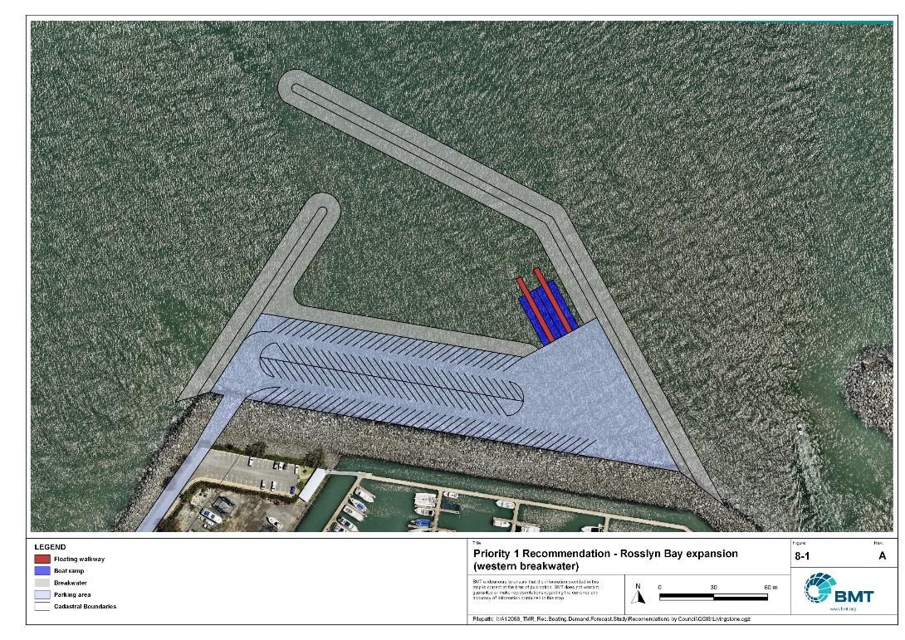

Priority 1 Recommendation – Rosslyn Bay Boat Harbour expansion (western breakwater)

"I:\A12068_TMR_Rec.Boating.Demand.Forecast.Study\Recomendations by Council\JPG\Livingstone\A12068_005_LivingstoneProposedUpgrades_8-1.jpg"

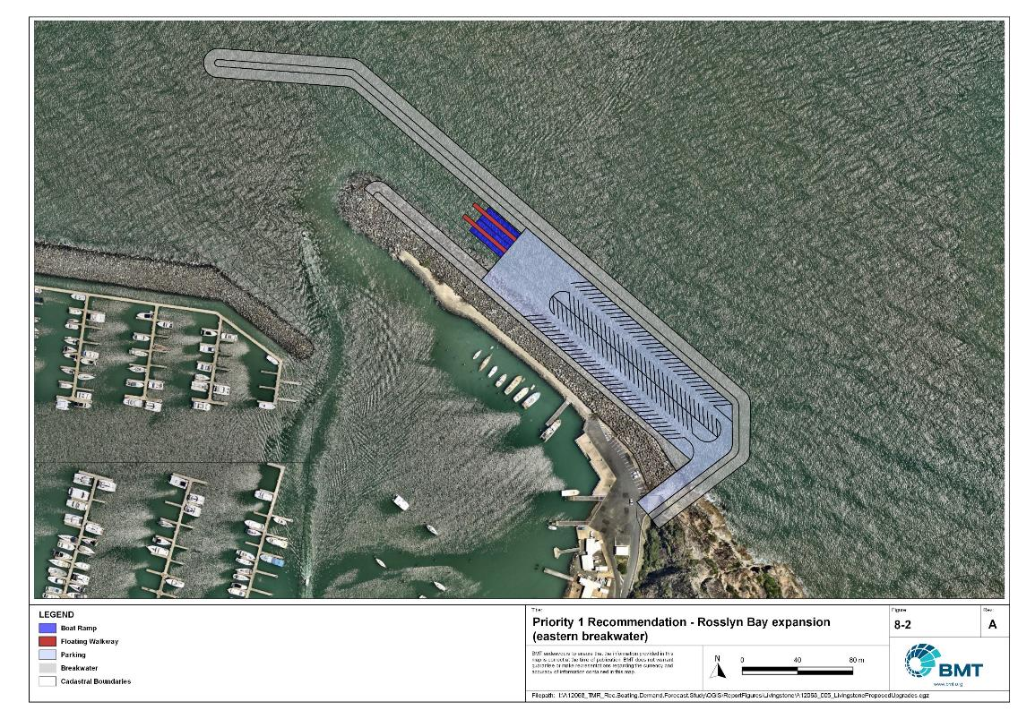

Priority 1 Recommendation – Rosslyn Bay Boat Harbour expansion (eastern breakwater)

"I:\A12068_TMR_Rec.Boating.Demand.Forecast.Study\Recomendations by Council\JPG\Livingstone\A12068_005_LivingstoneProposedUpgrades_8-2.jpg"

Rosslyn Bay Boat Harbour deep-draught landing- (Priority 1)

|  |  |  |  |  |
| --- | --- | --- | --- | --- |
| General description | | | | |
| Location | Vin E Jones Memorial Drive, Rosslyn Bay Boat Harbour | | | |
| Existing Facility? | No | | | |
| Coordinates | -23.160824268182562, 150.79025610413223 | | | |
| Existing tidal status | N/A | | | |
| Existing wave exposure | None | | | |
| Existing current exposure | None | | | |
| Proposed works | Replace commercial jetty with a pontoon that can provide deep-draught landing capability. | | | |
| Increased effective capacity | 1 deep-draught landing (berth) | | | |
| Capacity improvement position | Waterside | Landside | | Both |
| Rationale | There is currently an unmet demand for public deep-draught landings within the Rockhampton-Livingstone region. The commercial jetties in the north-east corner of Rosslyn Bay Boat Harbour could be modified so one of these facilities can provide a deep-draught gangway–access pontoon for recreational vessels, while still being able to be used for commercial vessels if required and approved. This does not completely solve the potential conflict between recreational and commercial vessels, which can pose a safety risk, though the improved capacity of this landing will reduce conflicts.  At present this site is the best available location for a public recreational deep-draught gangway-access pontoon. However, the Study understands that master planning of Rosslyn Bay harbour is planned and may result in modification to the layout of the harbour and therefore relocation of the most suitable location of a new public pontoon. The Study notes that pontoons are relatively easily relocated – and that this could occur if future master planning requires. | | | |
| Anticipated Costs (+/- 50%) | Waterside infrastructure | | $250,000 | |
| Landside infrastructure | | N/A | |
| Planning, environmental and approvals constraints | | | | |
| Assessment | Requirement | Comments | | |
| Fish Habitat Zone | X | N/A | | |
| Native Title | X | N/A | | |
| MCU requirement | X | N/A | | |
| Clearing remnant vegetation | X | N/A | | |
| GBRWHA | ü | The proposed works are within the GBRWHA which may trigger a Controlled Activity Approval if there is likely to be a significant impact. | | |
| Marine Park | X | N/A | | |
| Tidal works assessment | ü | Construction of new marine-based infrastructure will likely be tidal works and require a Development Permit. | | |
| Other as required | X | N/A | | |
| Sea Level Rise | ü | The proposed works is within the boundaries of the erosion prone area subject to sea level rise. | | |
| Storm Tide Hazard | ü | The proposed works is within the boundaries of a high storm tide hazard area. | | |
| Anticipated Complexity | Low | Medium | | High |

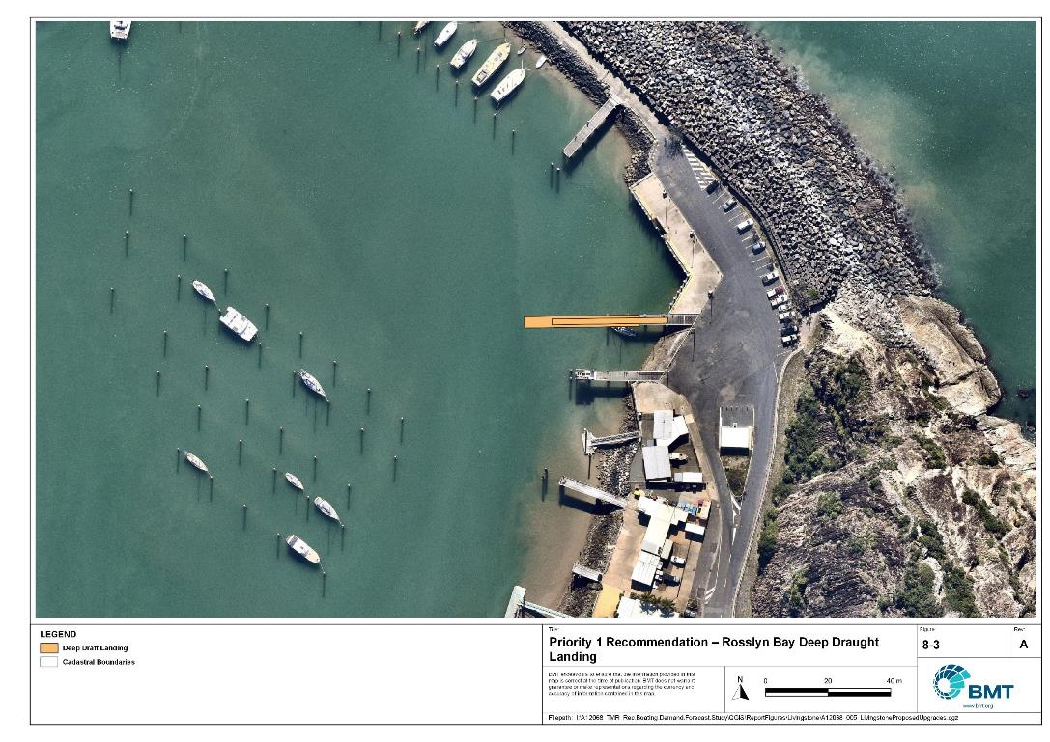

Priority 1 Recommendation – Rosslyn Bay deep-draught vessel landing

"I:\A12068_TMR_Rec.Boating.Demand.Forecast.Study\Recomendations by Council\JPG\Livingstone\A12068_005_LivingstoneProposedUpgrades_8-3.jpg"

Rockhampton Boathouse, Quay Street (Priority 1)

|  |  |  |  |  |
| --- | --- | --- | --- | --- |
| General description | | | | |
| Location | On Quay Street, Rockhampton, beneath the existing Boathouse on the Fitzroy River. | | | |
| Existing Facility? | No | | | |
| Coordinates | -23.37728141, 150.51476877 | | | |
| Existing tidal status | N/A | | | |
| Existing wave exposure | N/A | | | |
| Existing current exposure | N/A | | | |
| Proposed works | Construct a gangway-access pontoon for a deep-draught vessel landing. | | | |
| Increased effective capacity | N/A | | | |
| Capacity improvement position | Waterside | Landside | | Both |
| Rationale | An all-tide accessible landing for deep-draught vessels is needed in central Rockhampton to reinstate capacity historically provided by the Derby Street Jetty. This location is suitable due to its proximity to Rockhampton CBD, and the existing structure and amenities there, which also can support a sewage pump-out facility. This facility will improve access, particularly for visiting vessels. | | | |
| Anticipated Costs (+/- 50%) | Waterside infrastructure | | $110,000 | |
| Landside infrastructure | | N/A | |
| Planning, environmental and approvals constraints | | | | |
| Assessment | Requirement | Comment | | |
| Fish Habitat Zone | X | N/A | | |
| Native Title | X | N/A | | |
| MCU requirement | X | N/A | | |
| Clearing remnant vegetation | X | N/A | | |
| GBRWHA | ü | Construction of a pontoon within the GBRWHA may require a Controlled Activity Approval. | | |
| Marine Park | X | N/A | | |
| Tidal works assessment | ü | Construction of a new pontoon will likely be tidal works and require a Development Permit | | |
| Other as required | X | N/A | | |
| Sea Level Rise | ü | The marine-based works are within the boundaries of the erosion prone area. | | |
| Storm Time Hazard | ü | The works are within the boundaries of a high hazard area. | | |
| Anticipated Complexity | Low | Medium | | High |

Priority 1 Recommendation – Rockhampton Boathouse

I:\A12068_TMR_Rec.Boating.Demand.Forecast.Study\Recomendations by Council\JPG\Rockhampton\A12068_005_RockhamptonProposedUpgrades_7-1.jpg

## Priority 2 recommendations

Rosslyn Bay Boat Harbour- (Priority 2)

|  |  |  |  |  |
| --- | --- | --- | --- | --- |
| General description | | | | |
| Location | Breakwater Drive, Rosslyn Bay Boat Harbour | | | |
| Existing Facility? | Yes | | | |
| Coordinates | -23.16504539, 150.78864668 | | | |
| Existing tidal status | All-tide | | | |
| Existing wave exposure | None | | | |
| Existing current exposure | None | | | |
| Proposed works | Add 90 car parks in the road reserve to the south of the harbour adjacent Breakwater Drive. | | | |
| Increased effective capacity | 0 effective lanes | | | |
| Capacity improvement position | Waterside | Landside | | Both |
| Rationale | There is significant pressure on the Rosslyn Bay Boat Harbour facility as the most popular all-tide all-weather open-water access facility in the region, with recreational boat users travelling from various LGAs to use the facility. The number of CTU spaces existing at this facility are regularly filled, putting the facility over capacity. There is enough space in the road reserve adjacent Breakwater Drive to fit additional CTU parking.  Whilst not providing an increase to effective lanes, the expected in-water upgrades discussed in section 3.7 will improve queuing capacity, which isn’t statistically accounted for in the waterside capacity. To fully realise the benefits of this upgrade, further expansion of parking capacity is required. Extensive anecdotal evidence indicates that there is demand for increased parking capacity here.  If not implemented prior, this expansion could be considered as part of upcoming master planning of the boat harbour. | | | |
| Anticipated Costs (+/- 50%) | Waterside infrastructure | | N/A | |
| Landside infrastructure | | $4,400,000 | |
| Planning, environmental and approvals constraints | | | | |
| Assessment | Requirement | Comments | | |
| Fish Habitat Zone | X | N/A | | |
| Native Title  (Darumbal People) | ü | Parking lot works are situated on National Park lands and could trigger Native Title negotiations. | | |
| MCU requirement | X | N/A | | |
| Clearing remnant vegetation | ü | RVM category B- remnant vegetation where the new parking lot is located and would likely require a Development Permit. | | |
| GBRWHA | X | N/A | | |
| Marine Park | X | N/A | | |
| Tidal works assessment | X | N/A | | |
| Other as required | ü | National Park – First Nations People cultural heritage search, Queensland heritage search and an Authority to Build in Protected Area could be required for new parking lot works | | |
| Sea Level Rise | X | N/A | | |
| Storm Tide Hazard | ü | The proposed works are within the boundaries of a high/medium hazard area except for the southern portion of parking lot works. | | |
| Anticipated Complexity | Low | Medium | | High |

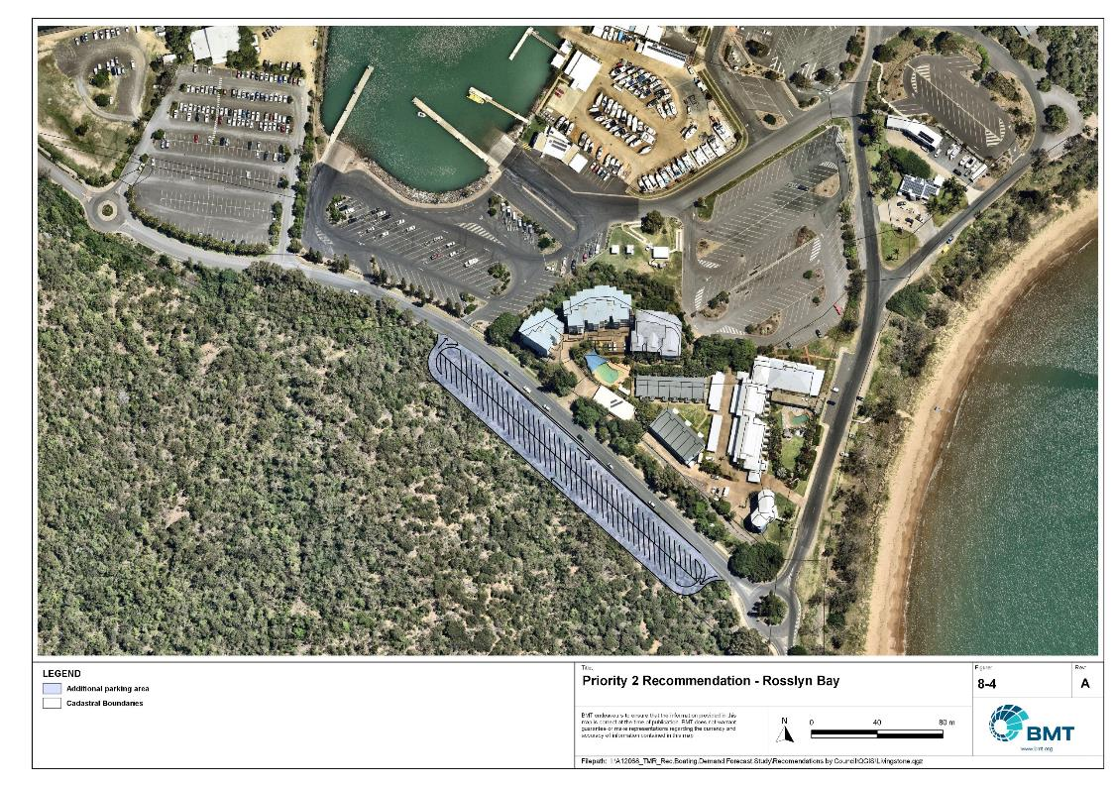

Priority 2 Recommendation – Rosslyn Bay

"I:\A12068_TMR_Rec.Boating.Demand.Forecast.Study\Recomendations by Council\JPG\Livingstone\A12068_005_LivingstoneProposedUpgrades_8-4.jpg

Stanage Bay, Banksia Road (Priority 2)

|  |  |  |  |  |
| --- | --- | --- | --- | --- |
| General description | | | | |
| Location | Stanage Bay, Thirsty Sound, at the end of Banksia Road | | | |
| Existing Facility? | Yes | | | |
| Coordinates | -22.13697292, 150.03151353 | | | |
| Existing tidal status | Part-tide | | | |
| Existing wave exposure | Exposed | | | |
| Existing current exposure | Exposed | | | |
| Proposed works | Formalise parking with concrete blocks to achieve 30 parks.  Further of expansion of the parking into the clearing to the south can be achieved in two subsequent stages if required (16 and 33 further CTUs – taking total to 79 formalised). Expansion stages will require approximately 1m of fill to raise land levels above tidal levels. | | | |
| Increased effective capacity | 0.5 effective lanes | | | |
| Capacity improvement position | Waterside | Landside | | Both |
| Rationale | Current parking is informal and not maximising the available space. Formalised parking could be achieved with concrete blocks or markers, instead of sealing the car park area, until a continuous sealed road into the facility is constructed. | | | |
| Anticipated Costs (+/- 50%) | Waterside infrastructure | | N/A | |
| Landside infrastructure | | Stage 1: $170,000  Stage 2: $1,400,000  Stage 3: $2,000,000 | |
| Planning, environmental and approvals constraints | | | | |
| Assessment | Requirement | Comments | | |
| Fish Habitat Zone | X | N/A | | |
| Native Title | X | N/A | | |
| MCU requirement | ü | Future expansions of the carpark may trigger a Development Permit for a Material Change of Use | | |
| Clearing remnant vegetation | ü | RVM category B- remnant vegetation where the new parking lot is located and would likely require a Development Permit. | | |
| GBRWHA | X | N/A | | |
| Marine Park | X | N/A | | |
| Tidal works assessment | X | N/A | | |
| Other as required | X | N/A | | |
| Sea Level Rise | ü | The proposed works are within the boundaries of the erosion prone area. | | |
| Storm Tide Hazard | ü | The proposed works are within the boundaries of a high hazard area. | | |
| Anticipated Complexity | Low | Medium | | High |

Priority 2 Recommendation – Stanage Bay

"I:\A12068_TMR_Rec.Boating.Demand.Forecast.Study\Recomendations by Council\JPG\Livingstone\A12068_005_LivingstoneProposedUpgrades_8-5.jpg"

Nerimbera, St Christophers Chapel Road - (Priority 2)

|  |  |  |  |  |
| --- | --- | --- | --- | --- |
| General description | | | | |
| Location | Northern bank of the Fitzroy River, near locality of Nerimbera, off St Christophers Chapel Road | | | |
| Existing Facility? | Yes | | | |
| Coordinates | -23.42784485, 150.59752272 | | | |
| Existing tidal status | All-tide | | | |
| Existing wave exposure | None | | | |
| Existing current exposure | None | | | |
| Proposed works | Add gangway-access pontoon to the south (downstream side) of the ramp.  Consider the impacts of submerged rocks offshore from this location (indicated by green buoy). | | | |
| Increased effective capacity | 1.0 effective lanes | | | |
| Capacity improvement position | Waterside | Landside | | Both |
| Rationale | Waterside facilities should be improved to meet the capacity of the landside facilities. | | | |
| Anticipated Costs (+/- 50%) | Waterside infrastructure | | $150,000 | |
| Landside infrastructure | | N/A | |
| Planning, environmental and approvals constraints | | | | |
| Assessment | Requirements | Comments | | |
| Fish Habitat Zone | X | FHA-072 downstream of recommendation location. | | |
| Native Title | X | N/A | | |
| MCU requirement | X | N/A | | |
| Clearing remnant vegetation | ü | RVM category R- reef- regrowth. Landholders intending to clear in a category R area must notify DoR unless no native vegetation within 50m of a regrowth watercourse and therefore will likely require a Development Permit. | | |
| GBRWHA | ü | Gangway-access pontoon works are within the GBRWHA and could require a Controlled Activity Approval | | |
| Marine Park | X | N/A | | |
| Tidal works assessment | ü | Adding a gangway-access pontoon will likely be tidal works and require a Development Permit. | | |
| Other as required | ü | Marine Plants – the pontoon works may impact marine plants and therefore may require a Development Permit for marine plant disturbance | | |
| Sea Level Rise | ü | The proposed works are within the boundaries of the erosion prone area. | | |
| Storm Tide Hazard | ü | The proposed works are within the boundaries of a high hazard area. | | |
| Anticipated Complexity | Low | Medium | | High |
| Maritime engineering review | | | | |
| Assessment | Site considerations | Comments | | |
| Engineering Matters | Current Forces | Site may be subject to moderate to high currents and further assessment of the impact on this recommendation is required. | | |
| Anticipated Complexity | Low | Medium | | High |

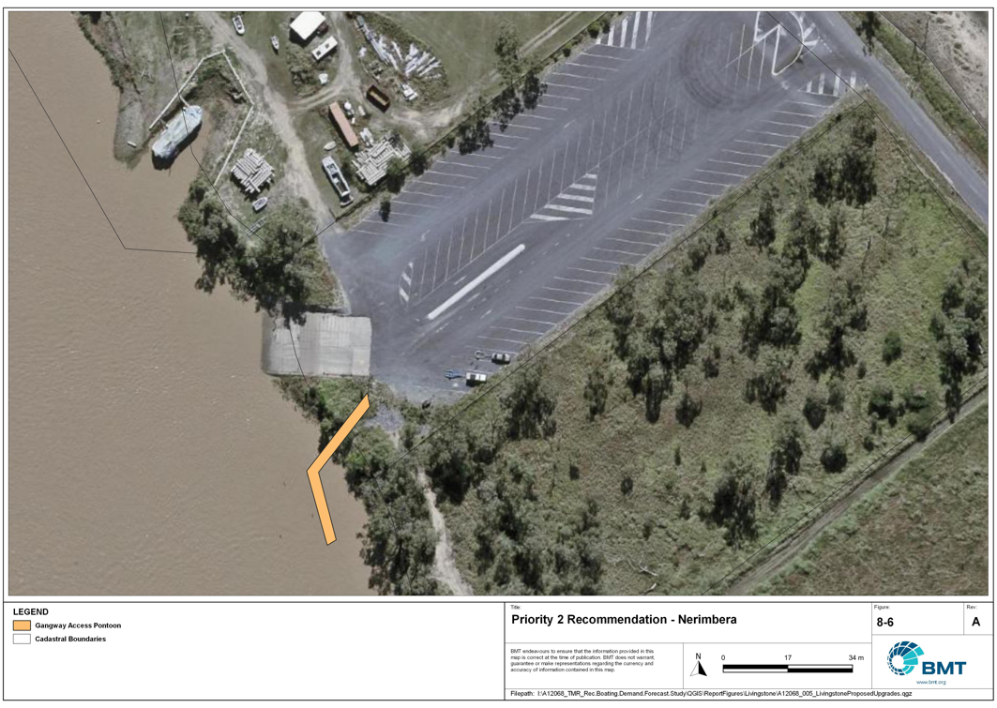

Priority 2 Recommendation – Nerimbera

"I:\A12068_TMR_Rec.Boating.Demand.Forecast.Study\Recomendations by Council\JPG\Livingstone\A12068_005_LivingstoneProposedUpgrades_8-6.jpg"

## Priority 3 recommendations

Corbetts Landing (Priority 3)

|  |  |  |  |  |
| --- | --- | --- | --- | --- |
| General description | | | | |
| Location | Water Park Creek, Corbetts Landing, Byfield | | | |
| Existing Facility? | Yes | | | |
| Coordinates | -22.88623296, 150.71951714 | | | |
| Existing tidal status | Part-tide | | | |
| Existing wave exposure | None | | | |
| Existing current exposure | Exposed | | | |
| Proposed works | Semi-formalise parking area with concrete blocks or markers to achieve 14 CTU spaces. Later stage can formalise 17 further CTU spaces if demand requires.  Construct a floating walkway on the new downstream lane, bending angled via a ‘return’ to be parallel to flood flows. | | | |
| Increased effective capacity | 0.75 effective lanes | | | |
| Capacity improvement position | Waterside | Landside | | Both |
| Rationale | Waterside capacity currently outweighs landside (2 effective lanes to 0.25), and formalised parking can increase landside capacity. Impacts of currents and flood flows should be considered. | | | |
| Anticipated Costs (+/- 50%) | Waterside infrastructure | | $350,000 | |
| Landside infrastructure | | Stage 1: $50,000  Stage 2: $40,000 | |
| Planning, environmental and approvals constraints | | | | |
| Assessment | Requirement | Comments | | |
| Fish Habitat Zone | X | Proposed floating walkway is located within the Corio Bay Fish Habitat Area (FHA-067) – Management A Area. A Development Permit and Resource Allocation Authority may be required for works within a declared FHA. Works for public boating infrastructure are permissible in FHA Management A but only where a range of policy requirements are met, including clear demand and the absence of any viable alternatives. | | |
| Native Title | X | N/A | | |
| MCU requirement | X | N/A | | |
| Clearing remnant vegetation | ü | RVM category B- remnant vegetation where the new works are located and would likely require a Development Permit. | | |
| GBRWHA | X | N/A | | |
| Marine Park | X | N/A | | |
| Tidal works assessment | ü | Floating walkway will likely be tidal works and require a Development Permit. | | |
| Other as required | ü | Marine Plants – the floating walkway works may impact marine plants and therefore may require a Development Permit for marine plant disturbance | | |
| Sea Level Rise | ü | The proposed works are within the boundaries of the erosion prone area. | | |
| Storm Tide Hazard | ü | The proposed works are within the boundaries of a high hazard area. | | |
| Anticipated Complexity | Low | Medium | | High |
| Maritime engineering review | | | | |
| Assessment | Site considerations | Comments | | |
| Engineering Matters | Current Forces | Site may be subject to moderate to high currents and further assessment of the impact on this recommendation is required. | | |
| Anticipated Complexity | Low | Medium | | High |

Priority 3 Recommendation – Corbett’s Landing

"I:\A12068_TMR_Rec.Boating.Demand.Forecast.Study\Recomendations by Council\JPG\Livingstone\A12068_005_LivingstoneProposedUpgrades_8-7.jpg"

Robert Clark Drive, Callaghan Park (Priority 3)

|  |  |  |  |  |
| --- | --- | --- | --- | --- |
| General description | | | | |
| Location | Callaghan Park, North Rockhampton, Robert Clark Drive | | | |
| Existing Facility? | Yes | | | |
| Coordinates | -23.38035800, 150.52042000 | | | |
| Existing tidal status | All-tide | | | |
| Existing wave exposure | None | | | |
| Existing current exposure | None | | | |
| Proposed works | Construct additional carpark with 54 CTU spaces. | | | |
| Increased effective capacity | 2.5 Effective Lanes | | | |
| Capacity improvement position | Waterside | Landside | | Both |
| Rationale | Doubling the landside capacity of this facility allows landside facilities to closer match the capacity of the waterside facilities. This facility is central to the main Rockhampton population area, where river fishing is popular. There are multiple conflicts with recreational boat users and other groups at present, such as markets and annual car festivals such as RockyNats. Building this carpark area across the road as a multi-purpose area would allow for the markets and RockyNats to continue without severely limiting the boat launching capacity of the facility.  This upgrade recommendation allows the Callaghan Park facility to provide a suitable amount of capacity at all times. | | | |
| Anticipated Costs (+/- 50%) | Waterside infrastructure | | N/A | |
| Landside infrastructure | | $265,000 | |
| Planning, environmental and approvals constraints | | | | |
| Assessment | Requirement | Comments | | |
| Fish Habitat Zone | X | N/A | | |
| Native Title | X | N/A | | |
| MCU requirement | ü | New carpark may trigger a Development Permit for a Material Change of Use | | |
| Clearing remnant vegetation | X | N/A | | |
| GBRWHA | X | N/A | | |
| Marine Park | X | N/A | | |
| Tidal works assessment | X | N/A | | |
| Other as required | X | N/A | | |
| Sea Level Rise | ü | The new car park is within the boundaries of the erosion prone area except for the south-eastern portion of the car park. | | |
| Storm Tide Hazard | ü | The proposed north-western portion of the car park is within the boundaries of a high hazard area compared to the south-eastern portion within the boundaries of a medium hazard area. | | |
| Anticipated Complexity | Low | Medium | | High |

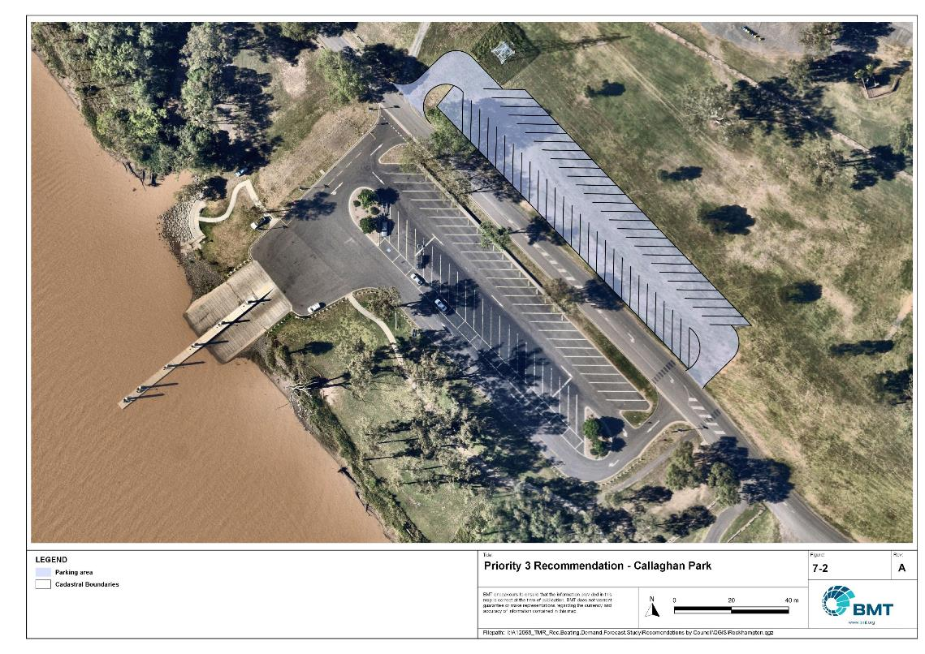

Priority 3 Recommendation – Callaghan Park

I:\A12068_TMR_Rec.Boating.Demand.Forecast.Study\Recomendations by Council\JPG\Rockhampton\A12068_005_RockhamptonProposedUpgrades_7-2.jpg

Quay Street (Priority 3)

|  |  |  |  |  |
| --- | --- | --- | --- | --- |
| General description | | | | |
| Location | Southern bank of the Fitzroy River, near Rockhampton CBD | | | |
| Existing Facility? | Yes | | | |
| Coordinates | -23.38585307, 150.52104888 | | | |
| Existing tidal status | All-tide | | | |
| Existing wave exposure | None | | | |
| Existing current exposure | Yes | | | |
| Proposed works | Reconfigure car park to maximise number of CTU spaces, without compromising the usability for launching.  Relocate the floating walkway to the upstream side of the ramp. | | | |
| Increased effective capacity | 0.25 Effective Lanes  Amenity and functionality upgrade | | | |
| Capacity improvement position | Waterside | Landside | | Both |
| Rationale | The space within the existing car park footprint could be used more efficiently to achieve more CTU spaces, without losing the number of personal vehicle spaces that exist there already.  The floating walkway presently acts as a debris trap, and recurring growth of hyacinth on the upstream side of the facility renders the downstream lane unusable until the weed is cleared. Moving the walkway to the upstream side of the ramp would allow all ramp lanes to be usable more often.  This upgrade recommendation allows the Quay Street facility to be utilised at maximum capacity at all times. | | | |
| Anticipated Costs (+/- 50%) | Waterside infrastructure | | $1,100,000 | |
| Landside infrastructure | | $110,000 | |
| Planning, environmental and approvals constraints | | | | |
| Assessment | Requirement | Comments | | |
| Fish Habitat Zone | X | N/A | | |
| Native Title | X | N/A | | |
| MCU requirement | X | N/A | | |
| Clearing remnant vegetation | ü | The proposed works are within areas of RVM category R- reef- regrowth watercourse vegetation. A permit may be required before clearing of remnant vegetation. | | |
| GBRWHA | ü | Relocation of floating walkway located within the GBRWHA may require a Controlled Activity Approval. | | |
| Marine Park | X | N/A | | |
| Tidal works assessment | ü | Relocation of the existing floating will be tidal works and likely require a Development Permit or amendment to an existing Development Permit. | | |
| Other as required | ü | Marine Plants – relocation of the floating walkway may require clearing of marine plants, and therefore will require a Development Permit for marine plant disturbance. | | |
| Sea Level Rise | ü | The proposed car park reconfiguration is not within the boundaries of the erosion prone area. However, the marine-based works (that is, relocation of the floating walkway) is within the erosion prone area. | | |
| Storm Tide Hazard | ü | The proposed car park refiguration is now within a storm tide hazard area, though the floating walking is within the boundaries of a medium/high hazard area. | | |
| Anticipated Complexity | Low | Medium | | High |

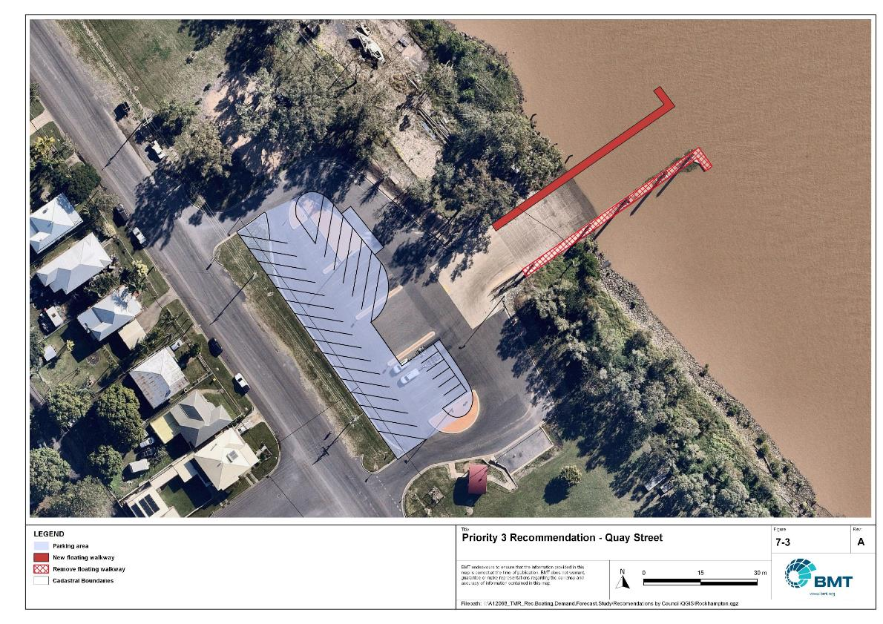

Priority 3 Recommendation – Quay Street

I:\A12068_TMR_Rec.Boating.Demand.Forecast.Study\Recomendations by Council\JPG\Rockhampton\A12068_005_RockhamptonProposedUpgrades_7-3.jpg

## Priority 4 Recommendations

Nil.

# References

Australian Bureau of Statistics (ABS), 2021, *2021 Census,* <https://www.abs.gov.au/census>

Bell, Frederick W. 2022, *Estimation of the present and projected demand and supply of boat ramps for Florida's coastal regions and counties*, Florida State University, Department of Economics.

BMT, 2015, *MPSC Managed Boating Facilities Demand and Capacity Study: Boat Ramp Modelling*

Department of Transport and Main Roads (TMR), 2020, Marine facilities and infrastructure plan.

GHD, 2011, *Recreational Boating Facilities Demand Forecasting Study*

GHD, 2017, *Queensland Recreational Boating Facilities Demand Forecasting Study 2017.*

Maritime Safety Queensland (MSQ), 2022, *Recreational Boating Facilities,* <https://www.getinvolved.qld.gov.au/gi/consultation/8850/view.html>

Queensland Government Department of Resources (DoR), 2022, *Cities and towns [OGC WMS Service]*, Accessed 5/10/2022, available online at spatial.information.qld.gov.au/arcgis/home/item.html?id=103c7c9ccca449fab79d27cde06868ab

Rose, T., R. Powell & J. Yu (2009). Identification of the Present and Future Recreational Boating Infrastructure in Redland City – A 10 Year Infrastructure Plan- Griffith University

SKM (1998) Public Boat Ramps Central Queensland Strategic Plan - Volume One - Demand Forecasting - Noosa to Yeppoon. Sinclair Knight Merz, March 1998.

Swett, R., Fik, T., Ruppert, T., Davidson, G., Guevara, C. & Betty Staugler, 2012, *Planning for the future of recreational boating access to charlotte county waterways: 2010 – 2050*, Florida Sea Grant, University of Florida.

Western Australia Department of Transport, 2019, *Perth Recreational Boating Facilities Study Review 2019*, https://www.transport.wa.gov.au/mediaFiles/marine/MAC_P_Perth_RBFS_study_review_2019.pdf

Western Australia Department of Transport, 2021, *South West Region Recreational Boating Facilities Study July 2021,* https://www.transport.wa.gov.au/mediaFiles/marine/MAC_P_SouthWest_RBFS_Study_2021.pdf

###### Demand Study

"G:\Admin\A12068.g.mpb.TMRBoatingDemand\06_Reports\09_Demand Study\2022_2119 (016) Final Demand Report (March 2023).pdf"

###### Boat launching facility capacity

Capacity of existing boat launching facilities

| Facility ID | Facility Name | LGA | No. Lanes | Tidal Access  (at ramp) | Tidal Access (to open water) | Queuing Facility | Formal CTUs | Informal CTUs | Waterside Capacity | | Landside Capacity | Effective Capacity | | Constraint |
| --- | --- | --- | --- | --- | --- | --- | --- | --- | --- | --- | --- | --- | --- | --- |
| **Open water access** | | | | | | | | | | | | | | |
| FY12 | Port Alma, Bajool-Port Alma road | Rockhampton Regional Council | 2 | All-Tide | All-Tide | None | 0 | 15 | 2 | | 1 | 1 | | Landside |
| LV71 | Rosslyn Bay, Anchor Drive (eastern) | Livingstone Shire Council | 4 | All-Tide | All-Tide | Floating Walkway | 137 |  | 5 | | 6.5 | 5 | | Waterside |
| LV73 | Rosslyn Bay, Breakwater Drive (Western) | Livingstone Shire Council | 4 | All-Tide | All-Tide | Floating Walkway | 137 |  | 5 | | 6.5 | 5 | | Waterside |
| **Subtotal** |  |  | **10** |  |  |  | **274** | **15** | **12** | | **14** | **11** | |  |
| **Distance-limited open water access** | | | | | | | | | | | | | | |
| LV12 | Nerimbera, St Christopher's Chapel Road | Livingstone Shire Council | 3 | All-Tide | Near All-Tide | None | 90 |  | 3 | | 4 | 3 | | Waterside |
| LV51 | Thompson Point | Livingstone Shire Council | 2 | All-Tide | All-Tide | Floating Walkway | 0 | 31 | 3 | | 1.75 | 1.75 | | Landside |
| RK11 | Rockhampton, Reaney Street | Rockhampton Regional Council | 1 | Part-Tide | Part-Tide | None | 15 |  | 0.5 | | 1 | 0.5 | | Waterside |
| RK15 | Robert Clark Drive, Callaghan Park | Rockhampton Regional Council | 4 | All-Tide | Near All-Tide | Floating Walkway | 52 |  | 5.4 | | 2.5 | 2.5 | | Landside |
| RK32 | Rockhampton, Quay Street | Rockhampton Regional Council | 4 | All-Tide | Near All-Tide | Floating Walkway | 9 |  | 5.4 | | 0.75 | 0.75 | | Landside |
| **Subtotal** |  |  | **14** |  |  |  | **166** | **31** | **17.3** | | **10** | **8.5** | |  |
| **Depth-limited open water access** | | | | | | | | | | | | | | |
| LV11 | Keppel Sands, Limpus Avenue | Livingstone Shire Council | 1 | Part-Tide | Part-Tide | None | 0 | 13 | 0.5 | | 1 | 0.5 | | Waterside |
| LV15 | Keppel Sands, Limpus Avenue | Livingstone Shire Council | 1 | Part-Tide | Part-Tide | None | 6 | 5 | 0.5 | | 0.75 | 0.5 | | Waterside |
| LV16 | Keppel Sands, Taylor Street, South (Musa) Head | Livingstone Shire Council | 1 | Part-Tide | Part-Tide | Beach | 0 | 5 | 0.28 | | 0.5 | 0.28 | | Waterside |
| LV21 | Coorooman Creek | Livingstone Shire Council | 4 | Near All-Tide | Near All-Tide | Floating Walkway | 89 |  | 4.32 | | 4 | 4 | | Landside |
| LV61 | Yeppoon, Scenic Hwy (Fig Tree Creek) | Livingstone Shire Council | 1 | Part-Tide | Part-Tide | None | 20 |  | 0.5 | | 1.25 | 0.5 | | Waterside |
| LV66 | Corbetts Landing northern ramp | Livingstone Shire Council | 1 | Part-Tide | Part-Tide | None | 0 | 3 | 0.5 | | 0.5 | 0.5 | | Waterside |
| LV67 | Stanage Bay, Banksia Road | Livingstone Shire Council | 2 | Part-Tide | Part-Tide | Floating Walkway | 0 | 12 | 1.5 | | 1 | 1 | | Landside |
| LV70 | Corbetts Landing southern ramp | Livingstone Shire Council | 2 | All-Tide | Near All-Tide | None | 0 | 12 | 2 | | 1 | 1 | | Landside |
| Subtotal |  |  | 13 |  |  |  | 115 | 50 | 10.1 | | 10 | 8.28 | |  |
| **Infrastructure-limited open water access** | | | | | | | | | | | | | | |
| LV41 | Mulambin, Yeppoon - Emu Park Road | Livingstone Shire Council | 1 | All-Tide | N/A - Infrastructure limited | Beach | 0 | 12 | 1.1 | | 1 | 1 | | Landside |
| Subtotal |  |  | **1** |  |  |  | **0** | **12** | **1.1** | | **1** | **1** | |  |
| **Fresh Water** | | | | | | | | | | | | | | |
| MM10 | Mount Morgan, William Street | Rockhampton Regional Council | 1 | Fresh Water | Fresh Water | None | 0 | 15 | 1 | | 1 | 1 | | Waterside |
| RK21 | Rockhampton, Larcombe Street | Rockhampton Regional Council | 2 | Fresh Water | Fresh Water | None | 0 | 35 | 2 | | 1.75 | 1.75 | | Landside |
| RK31 | Rockhampton Ski Gardens - Ramsden Street | Rockhampton Regional Council | 2 | Fresh Water | Fresh Water | None | 11 | 6 | 2 | | 1.25 | 1.25 | | Landside |
| **Subtotal** |  |  | **5** |  |  |  | **11** | **56** | **5** | | **4** | **4** | |  |
| **Beach Ramps** | | | | | | | | | | | | | | |
| LV31 | Fisherman Beach, Hill Street, Emu Park | Livingstone Shire Council | 1 | Part-Tide | Part-Tide | Beach | 16 | 5 | 0.55 | | 1.25 | 0.55 | | Waterside |
| **Subtotal** |  |  | **1** |  |  |  | **16** | **5** | **0.55** | | **1.25** | **0.55** | |  |
| **Total Effective Capacity** | | | | | | | | | |  | | | **33.3** | |

###### Travel time statistics

Travel time from population centres to nearest sheltered all-tide or near all-tide open water accessible facilities

| Population Centre | Travel time (mins) |
| --- | --- |
| Bajool | 24 |
| Bouldercombe | 47 |
| Broadmount | 37 |
| Cawarral | 21 |
| Emu Park | 10 |
| Marlborough | 89 |
| Marmor | 24 |
| Mount Chalmers | 29 |
| Mulambin | 4 |
| Port Alma | 1 |
| Rockhampton | 35 |
| Rosslyn | 3 |
| Stockyard Point | 60 |
| Taranganba | 5 |
| The Caves | 40 |
| Yeppoon | 7 |

###### Facility Use

Boat launching facility usage statistics

| Facility ID | Facility name | Total reports | Rockhampton | Livingstone | Brisbane | Central Highlands R Q | Gold Coast | Moreton Bay | Sunshine Coast | Gladstone | Mackay | Other LGAs |
| --- | --- | --- | --- | --- | --- | --- | --- | --- | --- | --- | --- | --- |
| Total |  | 30737 | 13630 | 9569 | 843 | 880 | 479 | 525 | 473 | 498 | 318 | 3695 |
| Total % |  | 100% | 44% | 31% | 3% | 3% | 2% | 2% | 2% | 2% | 1% | 12% |
| LV71 | Rosslyn Bay, Anchor Drive | 11038 | 18% | 51% | 4% | 3% | 3% | 2% | 2% | 1% | 1% | 15% |
| RK15 | Robert Clark Drive, Callaghan Park | 4117 | 65% | 11% | 2% | 3% | 1% | 2% | 2% | 3% | 2% | 11% |
| RK31 | Rockhampton Ski Gardens - Ramsden Street | 2920 | 78% | 9% | 3% | 1% | 1% | 2% | 0% | 1% | 1% | 5% |
| RK32 | Rockhampton, Quay Street | 2425 | 79% | 7% | 1% | 3% | 1% | 0% | 1% | 1% | 1% | 7% |
| LV21 | Coorooman Creek | 2253 | 23% | 53% | 1% | 6% | 1% | 1% | 2% | 1% | 1% | 12% |
| RK11 | Rockhampton, Reaney Street | 1785 | 75% | 14% | 1% | 1% | 0% | 1% | 0% | 1% | 1% | 8% |
| MM10 | Mount Morgan, William Street | 952 | 74% | 5% | 1% | 1% | 4% | 2% | 1% | 2% | 1% | 13% |
| RK21 | Rockhampton, Larcombe Street | 948 | 76% | 16% | 1% | 2% | 0% | 1% | 0% | 0% | 0% | 9% |
| LV41 | Mulambin, Yeppoon - Emu Park Road | 858 | 25% | 53% | 1% | 7% | 1% | 2% | 1% | 2% | 0% | 9% |
| LV67 | Stanage Bay, Banksia Road | 821 | 20% | 16% | 7% | 3% | 3% | 6% | 3% | 6% | 9% | 27% |
| LV12 | Nerimbera, St Christopher's Chapel Road | 495 | 70% | 16% | 1% | 2% | 0% | 1% | 0% | 1% | 0% | 9% |
| LV66 | Corbetts Landing | 416 | 23% | 52% | 2% | 2% | 2% | 2% | 1% | 1% | 1% | 14% |
| FY12 | Port Alma, Bajool-Port Alma road | 409 | 49% | 10% | 6% | 3% | 1% | 2% | 1% | 12% | 0% | 24% |
| LV51 | Thompson Point | 364 | 51% | 30% | 0% | 4% | 1% | 1% | 1% | 2% | 1% | 8% |
| LV15 | Keppel Sands, Limpus Avenue | 287 | 34% | 33% | 4% | 8% | 2% | 4% | 1% | 0% | 0% | 13% |
| LV31 | Fisherman Beach, Hill Street, Emu Park | 271 | 28% | 37% | 3% | 2% | 1% | 4% | 2% | 0% | 0% | 23% |
| LV16 | Keppel Sands, Taylor Street, South (Musa) Head | 262 | 32% | 42% | 2% | 3% | 2% | 3% | 1% | 0% | 1% | 13% |
| LV11 | Keppel Sands, Limpus Avenue | 116 | 27% | 45% | 2% | 11% | 0% | 5% | 0% | 1% | 1% | 9% |

|  |  |  |
| --- | --- | --- |
|  |  | BMT is a leading design, engineering, science and management consultancy with a reputation for engineering excellence. We are driven by a belief that things can always be better, safer, faster and more efficient. BMT is an independent organisation held in trust for its employees. |

|  |  |  |  |  |  |  |  |  |
| --- | --- | --- | --- | --- | --- | --- | --- | --- |
|  |  |  |  |  |  |  | Contact us  enquiries@bmtglobal.com  www.bmt.org  Follow us  www.bmt.org/linkedin LinkedIn logo.  www.bmt.org/youtube YouTube logo.  www.bmt.org/twitter Twitter logo.  www.bmt.org/facebook Facebook logo. |  |
|  | Level 5  348 Edward Street  Brisbane  QLD 4000  Australia  +61 7 3831 6744 |  | Registered in Australia  Registered no. 010 830 421  Registered office  Level 5, 348 Edward Street,  Brisbane QLD 4000 Australia |  |  |  |  |
|  | For your local BMT office visit www.bmt.org | | |  |  |  |  |  |