|  |
| --- |
| Queensland Recreational Boating Facilities Demand Forecasting Study 2022  Whitsunday LGA Assessment |
|  |
|  |

|  |  |  |
| --- | --- | --- |
| Customer |  | Maritime Safety Queensland |
| Project |  | A12068 |
| Deliverable |  | 014 |
| Version |  | 01 |
|  |  | 21 April 2023 |

Document Control

Document Identification

|  |  |
| --- | --- |
| Title | Queensland Recreational Boating Facilities Demand Forecasting Study 2022 |
| Project No | A12068 |
| Deliverable No | 014 |
| Version No | 01 |
| Version Date | 21 April 2023 |
| Customer | Maritime Safety Queensland, a branch of the Department of Transport and Main Roads |
| Customer Contact | boatinginfrastructure@msq.qld.gov.au |
| Classification | {None} |

|  |  |
| --- | --- |
| Author | Daniel Wishaw, Nicholas Heiner, Geoff Long, Azam Dolatshah, Sophie Barrett, Mackenzie Stacey |
| Reviewed By | Katrina O’Malley-Jones, Jeremy Visser |
| Project Manager | Daniel Wishaw |

Amendment Record

The Amendment Record below records the history and issue status of this document.

| Version | Version Date | Distribution | Record |
| --- | --- | --- | --- |
| 00 | 15 February 2023 | Maritime Safety Queensland  Whitsunday Regional Council | Draft |
| 01 | 21 April 2023 | Maritime Safety Queensland | Final |

Executive Summary

This report, part of the Queensland Recreational Boating Facilities Demand Forecasting Study 2022 (‘the Study’), provides a summary of current and forecast demand on recreational boating facilities in Whitsunday LGA and the capacity of existing facilities to meet this demand. Where capacity is insufficient to meet current or forecast demand, recommendations have been made to improve existing facilities or for the construction of new facilities. This report is intended to support facility deliverers, owners, and managers over the next 20 years in their decision-making on development priorities for recreational boating facilities within Whitsunday LGA.

Key issues and attributes of recreational boating

The key attributes of recreational boating facilities identified in this Study for Whitsunday LGA are summarised in Table 1, while consultation with stakeholders undertaken as part of the Study identified the following key issues:

* a very high proportion of visiting recreational boat users
* constraints (land availability, wave exposure) at the Shute Harbour site resulting in a facility that is insufficient to meet launching needs until the agreed-in-principle Grubby Bay boat launching facility proposal is funded
* overall lack of capacity around the Whitsunday LGA coastline owing to terrain and foreshore availability, with limited opportunities to build new facilities.

1. Key recreational boating attributes for Whitsunday LGA

| Key attribute | Value |
| --- | --- |
| Deep draught landing facilities |  |
| Existing capacity (number) | 2 |
| Existing demand (number) | 3.7 |
| Existing shortfall (number) | 1.7 |
| Boat launching facilities |  |
| Number of existing facilities | 15 |
| Current demand for boat launching lanes (effective lanes) | 32 |
| Number of existing ‘effective’ boat launching lanes | 20.7 |
| Current shortfall of ‘effective’ boat launching lanes (number) | 11.3 |
| Demand satisfaction for ‘effective’ boat launching lanes | 65% |
| State average demand satisfaction for ‘effective’ boat launching lanes | 87% |

Demand summary

The assessment of recreational boating demand is centred on a statistical demand model that considers vessel registration data, population statistics, assumptions around local usage and the movement of vessels into and out of the LGA. Key parameters from this assessment for Whitsunday LGA are:

* The population is 34,626 as at the 2021 census and is projected to be 39,483 by 2041.
* As of July 2022, there is a total of 9,670 vessels with a home registration within the LGA, with 95% being ‘trailable’ – and therefore requiring boat launching facilities – and 5% being non-trailable.
* Whitsunday LGA is deemed to be a Remote Location with an assumed vessel activation rate of 14% on a ‘good boating day’.
* Vessels are primarily used within the LGA, with some leakage to Mackay and Townsville LGAs.
* Vessels from Townsville, Mackay, Burdekin, Isaac and south-east Queensland LGAs, as well as, interstate visitors flow into the LGA and contribute to local demand.
* The existing demand for boat launching facilities is 32 ‘effective’ boat ramp lanes and projected 36.2 ‘effective’ lanes by 2041. As presented in Table 1, the current capacity is 20.7 ‘effective’ boat ramp lanes.
* The existing demand for deep-draught vessel landings is four and projected to remain four until 2041. As presented in Table 1, the current capacity is two deep-draught vessel landings.

Boat launching

Boat launching facilities comprise boat ramps, any queuing facilities (floating walkways, pontoons, beaches and fixed sloping walkways) and the provision of car-trailer unit (CTU) parking. The capacity of a boat launching facility is measured in ‘effective’ lanes for both waterside and landside facilities, with the total capacity of a facility being the minimum of the waterside or landside capacity. Waterside capacity is calculated from the number of boat ramp lanes multiplied by environmental reduction factors (for tide, current or waves) and queuing facility improvement factors to derive the number of ‘effective’ lanes. The landside capacity is calculated from the number of available CTU parking spaces.

Whitsunday LGA has 15 boat launching facilities, comprising 26 boat ramp lanes with a total effective boat launching capacity of 21 ‘effective’ lanes. Eight of these facilities are constrained by waterside capacity with the remainder constrained by landside capacity.

The capacity, forecast demand, and shortfall of boat ramp ‘effective’ lanes in Whitsunday LGA are shown in Figure 1.

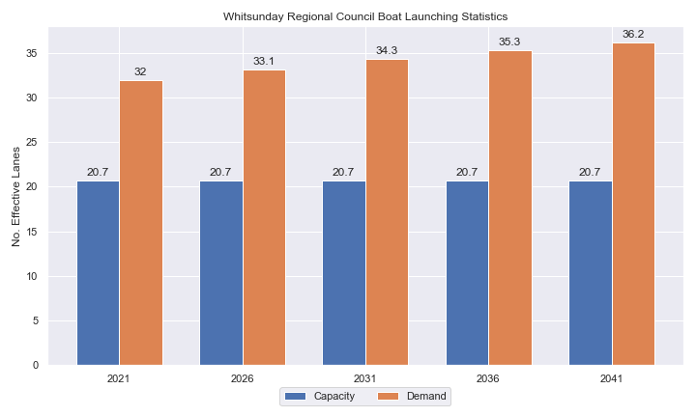

1. Existing capacity, forecast demand and shortfall of ‘effective’ boat ramp lanes for Whitsunday LGA

Deep-draught vessel landings

Vessel landing facilities are provided across the state in the form of pontoons and jetties, to provide locations for larger vessels, or their tenders, to access landside destinations or facilities. Pontoons and jetties may be provided for other purposes such as supporting boat launching or other recreation and may not be suitable for deep-draught vessels. The trend across Queensland indicates that jetties are rarely used as landings, with pontoons preferred by recreational users. As such, the Study has limited the capacity of deep-draught vessel landings to those that are accessible and commonly used by deep-draught vessels, as identified in consultation with stakeholders.

Whitsunday LGA has two public deep-draught vessel landings comprising important facilities in Airlie Beach (Abell Point Marina, 2 berths) and Bowen (Bowen boat harbour), both of which are supported by nearby significant private facilities. The shortfall assessment in Table 2 indicates that public landing capacity for deep-draught vessels is currently insufficient to support demand, and that additional public facilities are required to cater for landing requirements, particularly given the large fleet of vessels that moor outside the marina facilities.

1. Deep-draught vessel landing shortfall summary

| Criteria | 2021 | 2026 | 2031 | 2036 | 2041 |
| --- | --- | --- | --- | --- | --- |
| Deep-draught vessel demand | 3.7 | 3.8 | 4.0 | 4.1 | 4.2 |
| Deep-draught vessel capacity | 2 | 2 | 2 | 2 | 2 |
| Shortfall | 1.7 | 1.8 | 2 | 2.1 | 2.2 |

Priority recommendations

Recommendations for new facilities or upgrades to existing facilities are outlined in Table 3. The range of recommendations seeks to reduce the overall capacity shortfall within Whitsunday LGA over the 20-year planning life of this project, as well as address specific concerns, including:

* providing a solution to the general deficit in boat launching capacity issue on the Whitsunday coastline
* providing additional public deep-draught landings in Airlie Beach

Recommendations

1. Summary of recommended boating infrastructure upgrades for Whitsunday LGA

| Priority | Criteria | Recommendations |
| --- | --- | --- |
| 1 | * Required to meet existing demand. * Sites that can provide maximum benefit for existing demand pressures at an LGA scale or satisfy specific safety pressures. | * Grubby Bay: Reclaim land to provide 130 CTU spaces and a 4-lane, 2 floating walkway boat launching facility. |
| 2 | * Required to meet demand within the next five to ten years. * Sites that are likely to have low to medium approval complexity. * Sites that can provide satisfaction of specific demand or safety pressures within the LGA. | * Bowen Boat Harbour: Add an additional boat ramp and floating walkway. * Abell Point Marina: Expand existing pontoon to provide 4 public berths. |
| 3 | * Required to meet demand within the next ten to fifteen years. * Sites that service planned future growth within the LGA. | * Conway Road, Proserpine: Add an additional 2 lanes as previously committed to. |
| 4 | * Required to meet demand within the next fifteen to twenty years. * Sites that service planned future growth within the LGA. | * Molongle Creek: Expand the carpark to 85 CTU spaces. |

Contents

Definitions 11

1 Introduction 14

2 Whitsunday LGA Overview 15

2.1 Key influences on recreational boating 15

2.2 Existing recreational boating infrastructure 15

2.3 Existing usage and issues 18

3 Capacity Assessment 19

3.1 Boat ramps 19

3.2 Access to sheltered near all-tide and all-tide facilities 25

3.3 Deep-draught vessel landings 28

4 Demand Assessment 29

4.1 Activation rate 29

4.2 Digital user survey 30

4.3 Active fleet size 36

4.4 Boat ramp lane demand 36

4.5 Non-statistical demand 36

4.6 Deep-draught vessel demand 37

5 Shortfall Assessment 38

5.1 Shortfall assessment – boat ramps 38

5.2 Shortfall assessment – deep-draught landings 39

6 Stakeholder Feedback 40

6.1 Managing authority feedback 40

6.2 Stakeholder feedback 41

7 Development Recommendations 42

7.1 Previous recommendations 42

7.2 Priority recommendations 43

7.3 Priority 1 recommendations 45

7.4 Priority 2 recommendations 48

7.5 Priority 3 recommendations 53

7.6 Priority 4 recommendations 58

8 References 59

Annex A Demand Study A-1

Annex B Boat launching facility capacity B-1

Annex C Travel time statistics C-1

Annex D Facility Use D-1

Tables

Table 2.1 Recreational boating facilities by facility owner in Whitsunday LGA 15

Table 3.1 Queuing facility efficiency modifiers 22

Table 3.2 Deep-draught landing facilities within Whitsunday LGA 28

Table 4.1 LGA of origin for active fleet in Whitsunday LGA 30

Table 4.2 Popularity of boat launching facilities. 31

Table 4.3 Active fleet vessel size 36

Table 4.4 Boat ramp lane demand 36

Table 4.5 Deep-draught vessel landing demand 37

Table 5.1 Shortfall of boat launching facilities 38

Table 5.2 Shortfall assessment for open water, all-tide or near all-tide facilities for Whitsunday LGA 39

Table 5.3 Shortfall of deep-draught vessel landings 39

Table 6.1 Stakeholder identified opportunities 40

Table 7.1 Assessment of unimplemented 2017 recommendations 42

Table 7.2 Summary of recommendations for Whitsunday LGA 43

Table 7.3 Grubby Bay (Priority 1) 45

Table 7.4 Bowen Boat Harbour, Starboard Drive (Priority 2) 48

Table 7.5 Abell Point Marina pontoon (Priority 2) 50

Table 7.6 Conway Road, Proserpine (Priority 3) 53

Table 7.7 Molongle Creek - (Priority 3) 56

Table B.1. Capacity of existing boat launching facilities B-1

Table C.1. Travel time from population centres to nearest sheltered all-tide or near all-tide open water accessible facilities C-1

Table D.1. Boat launching facility usage statistics D-1

Figures

Figure 2.1 Whitsunday LGA – Boat launching facilities 16

Figure 2.2 Whitsunday LGA – Deep-draught landing facilites 17

Figure 3.1 (a) Summary of open water access from boat launching facilities (left) and (b) Summary of tidal restrictions at tidal boat launching facilities (right) 24

Figure 3.2 Summary of limiting capacity constraint 25

Figure 3.3 Distribution of travel time from Whitsunday’s eligible population centres to sheltered near all-tide facilities 26

Figure 3.4 Whitsunday LGA – Travel time to nearest all-tide or near all-tide facility 27

Figure 4.1 Whitsunday LGA – Vessel pathing 34

Figure 4.2 Whitsunday LGA – Vessel pathing 35

Figure 5.1 Shortfall assessment with recommended upgrades adopted. 38

Figure 7.1 Priority 1 Recommendation – Grubby Bay, Shute Harbour 47

Figure 7.2 Priority 2 Recommendation – Bowen Boat Harbour, Starboard Drive 49

Figure 7.3 Priority 2 Recommendation – Abell Point Marina pontoon 52

Figure 7.4 Priority 3 Recommendation – Conway Road, Proserpine 55

Figure 7.5 Priority 4 Recommendation – Molongle Creek 57

Definitions

| Term | Definition |
| --- | --- |
| All‑tide (for boat ramps) | Access from a boat ramp to the open sea with an approach depth of 0.5m below LAT or deeper and a depth at boat ramp toe of 0.5m below LAT or deeper. |
| All-tide (for landings) | Access from a gangway‑access pontoon or jetty to the open sea with an approach depth of 1.5m below LAT or deeper and a depth on at least one face of the pontoon of 1.5m below LAT or deeper. |
| BIP | Boating Infrastructure Program – a sub‑program within MSQ's Maritime Assets and Infrastructure Program |
| Boat ramp | A foreshore concrete ramp with a slope designed for vehicular launching and retrieving of recreational boats. |
| Breakwater | A structure constructed over the seabed and/or the foreshore, usually rising to a height above high tide, designed to provide protection to landward areas by limiting penetration of wave action or currents. |
| CTU | Car-trailer unit space – a parking space for a typical car with a boat trailer attached. |
| Demand | Demand is the requirement of the boat‑owning population for facilities to launch/retrieve trailer boats and/or to berth suitable boats at a given year to service their average (non‑peak period) needs. In most locations demand is based on vessel registrations and is expressed in terms of boat ramp lanes or in number of 12m berths at landings. |
| Effective capacity | For a boat ramp, effective capacity (effective lanes) means the number of boat ramp lanes after adjusting for anticipated unavailability due to unacceptable wave action (>0.2m wave height) or water depth, usage constraints such as the lack of adequate parking, and improvements to efficiency or launch/retrieval throughput such as floating walkways or pontoons. |
| FHA | Fish Habitat Area, declared under the Fisheries Act, 1994 |
| FIFO | Fly‑in fly‑out, where skilled workers travel from their city or central location home communities to a remote site to perform their duties often in blocks of time that provide regular, non-weekend, days off. |
| Fixed sloping walkway | A fixed sloping structure installed at the side of a boat ramp to assist launching/retrieval of trailer boats, and dry embarkation/disembarkation from trailer boats. It is sloped to allow use at varying tide heights – sometimes with sections of different slope. |
| Floating walkway | Multiple connected/hinged flotation modules configured to assist launching/retrieval of trailer boats, and dry embarkation/disembarkation from trailer boats at most if not all stages of the tide. Floating walkways are connected to a concrete shore abutment allowing pedestrian and assisted wheelchair access. |
| Gangway access pontoon | A platform/module that always floats, where a boat can be secured alongside on one or more faces. Pontoons are usually separated from a boat ramp and have a hinged articulated gangway for access to the shore via an abutment. |
| GBR | Great Barrier Reef |
| GCWA | Gold Coast Waterways Authority |
| Landing | A landing is a jetty or gangway‑access pontoon that facilitates berthing of vessels and transfer of passengers and stores. They are most often associated with non-trailable vessels |
| Landside | Refers to areas above high-water mark, often used to denote the location of and type of infrastructure. |
| LAT | Lowest Astronomical Tide, used as Chart Datum on navigational charts. |
| LGA | Local Government Area |
| Managing authority | Councils, port authorities, water storage managers as listed in schedule 1 of the Transport Infrastructure (Public Marine Facilities) Regulation 2011 |
| MCU | Material change of use under the planning scheme |
| MNES | Matter of national environmental significance under the Environment Protection and Biodiversity Conservation Act 1999 |
| MSQ | Maritime Safety Queensland |
| NC Act | Nature Conservation Act 1992 |
| Near all‑tide | Access from a boat ramp to the open sea with a minimum approach depth of 0.5m below LAT and minimum depth at the boat ramp of 0.5m below LAT for 80 percent or more of the tidal range (time measured over a year). |
| Parking - Formalised | A sealed, line-marked parking area for car-trailer units, providing adequately sized parking spaces, roadways and turning circles. |
| Parking – Semi-formalised | An all-weather non-sealed parking area, with markers to delineate adequately sized car-trailer unit parking bays and turning circles. Markers can be concrete blocks, pavement markers (e.g. retro-reflective raised markers) or other permanent instalment to show parking bays. |
| Parking – Informal overflow | A naturally surfaced area available for use as overflow parking on the design boating day, signed as such. To have mixed-use purpose (e.g., parkland) when not being utilised as overflow parking. |
| Part‑tide | Boat ramps that do not meet near all-tide or near all-tide requirements. |
| PV | Passenger vehicle (i.e., car – as opposed to car-trailer unit). |
| Port Authority | An organisation that is responsible for the management of one or more ports on the Queensland coast. |
| Population Centre | Official named urban settlements (populated places) that have been sourced from the Queensland Place Names Database. |
| Registration activation rate | The percentage of registered vessels liable to be in use on any given good weather weekend day |
| Shortfall | The number of effective boat ramp lanes or landings required to meet demand for a given timeframe. Negative shortfall signifies an oversupply for the time period nominated. |
| SPL | Strategic Port Land |
| Study | The Recreational Boating Facility Demand Forecasting Study 2022, including this document. |
| TMR | Department of Transport and Main Roads |
| Water Storage Authority | Includes Seqwater, Sunwater |
| Waterside | Refers to areas below high-water mark, often used to denote the location of and type of infrastructure, including dredged channels and breakwaters. |
| WHA | World Heritage Area |
| # | Number |

# Introduction

BMT has been appointed to undertake the Recreational Boating Facilities Demand Forecasting Study 2022 (‘the Study’) by Maritime Safety Queensland (MSQ), a branch of the Queensland Department of Transport and Main Roads (TMR), on behalf of all public recreational boating facility managers and owners across Queensland. The Study supersedes the 2017 study of the same name and is intended to report on recreational boating facility demand, capacity, and shortfall over a 20-year period at a Local Government Area (LGA) scale across Queensland.

The Study has been developed using information from the 2021 Australian Census (ABS, 2021), recreational boat vessel registrations, consultation with facility owners, managers, and stakeholders, the 2022 Queensland Government Get-Involved recreational boating facilities survey (MSQ, 2022), and previous versions of this Study (2011, 2017). The Study is intended for use by deliverers, owners, managers, and key stakeholders of public recreational boating facilities across Queensland, namely state government agencies including MSQ and the Gold Coast Waterways Authority (GCWA), local governments, port authorities and water authorities. The Study is non-regulatory in nature and is intended to be used as part of a broader suite of information to identify priority investment in recreational boating infrastructure at a local and state level.

The Study establishes demand primarily on statistics derived from registration and population data. Please refer to Section 4.5 for discussion of non-statistical demand. The Study evaluates existing and forecast demand over a 20-year period and makes recommendations on how this demand might be met over that period. Recommendations may include improvements to both landside and waterside capacity depending on the facility.

Recommendations are assigned a priority ranking, from 1 to 4, indicating if they are required immediately or in the next 5, 10 or 15 years respectively. To end 2022, 14% of recommendations from the 2017 study have been completed, comprising 11% of land-side recommendations and 18% of waterside recommendations and reflecting 22% of priority 1 the 2017 recommendations. A much greater percentage of the earlier 2011 study recommendations have now been implemented. Given the low uptake on existing/outstanding recommendations, this Study will review previous recommendations and carry forward, modify, or remove as appropriate. The Study has also been tasked with reviewing specific wave exposed beach launching facilities across the state to determine their contribution to meeting boating facilities demand and make recommendations about their future.

The Study is comprised of a report for every LGA in Queensland and a state-wide summary report. Each LGA report summarises demand pressures from vessel registration data, population statistics, assumptions around local usage and the movement of vessels into and out of the LGA, and existing capacity and recommends opportunities to satisfy shortfall. The state-wide report will support the LGA reports and provide context at a state level for demand pressures, current capacity, equity of access to facilities and statewide priority for major boating facilities.

The Study is intended to report on publicly accessible recreational boating facilities for registered vessels. This includes boat ramps, floating walkways, pontoons, fixed sloping walkways and supporting car-trailer unit parking at each facility. The Study does not include recommendations for facilities that are used primarily for commercial purposes, private facilities, non-motorised recreation such as launching canoes and stand-up paddle boards, and fishing platforms.

# Whitsunday LGA Overview

## Key influences on recreational boating

Within Whitsunday LGA, the principal attributes and influences that affect demand on recreational boating infrastructure include:

* its designation as a Remote region, with a large local recreational boating fleet
* moderate projected population growth
* high tourism inputs including larger vessels cruising along the Queensland coast.

## Existing recreational boating infrastructure

The recreational boating facilities within Whitsunday LGA are summarised in Table 2.1. These facilities are owned or managed by multiple organisations and include facilities that provide access to open water, estuaries, and fresh water. MSQ’s long term vision is to provide unrestricted access to open water from facilities along the Queensland coast such that all significant population centres are within one hour’s driving range where practical. For clarity, the Study has defined this vision to be the provision of sheltered all-tide, or near all-tide, boat launching facilities within one hour driving range of official population centres (DoR, 2022) lying within 30km of the coastline between the NSW border and Cooktown.

Recreational boating facilities by facility owner in Whitsunday LGA

| Owner | Open-water boat ramps | | Other boat ramps | | Landings | |
| --- | --- | --- | --- | --- | --- | --- |
| Facilities | Lanes | Facilities | Lanes | Pontoons | Jetties |
| TMR | 4 | 10 | 5 | 8 | 2 |  |
| Whitsunday Regional Council | 4 | 5 |  |  | 1 |  |
| Don River Trust |  |  | 1 | 1 |  |  |
| Sunwater |  |  | 1 | 1 |  |  |

Each of the boat launching facilities within the LGA is shown in Figure 2.1 and deep-draught vessel landings in Figure 2.2.

Access to land from deep-draught vessels is catered for by the provision of landings such as jetties and pontoons that are intended for short term usage, mainly to drop off and embark passengers and supplies. Within Whitsunday LGA these vessels are catered for at the following locations:

* Abell Point Marina, provides access to Airlie Beach.
* Bowen boat harbour provides access to Bowen.

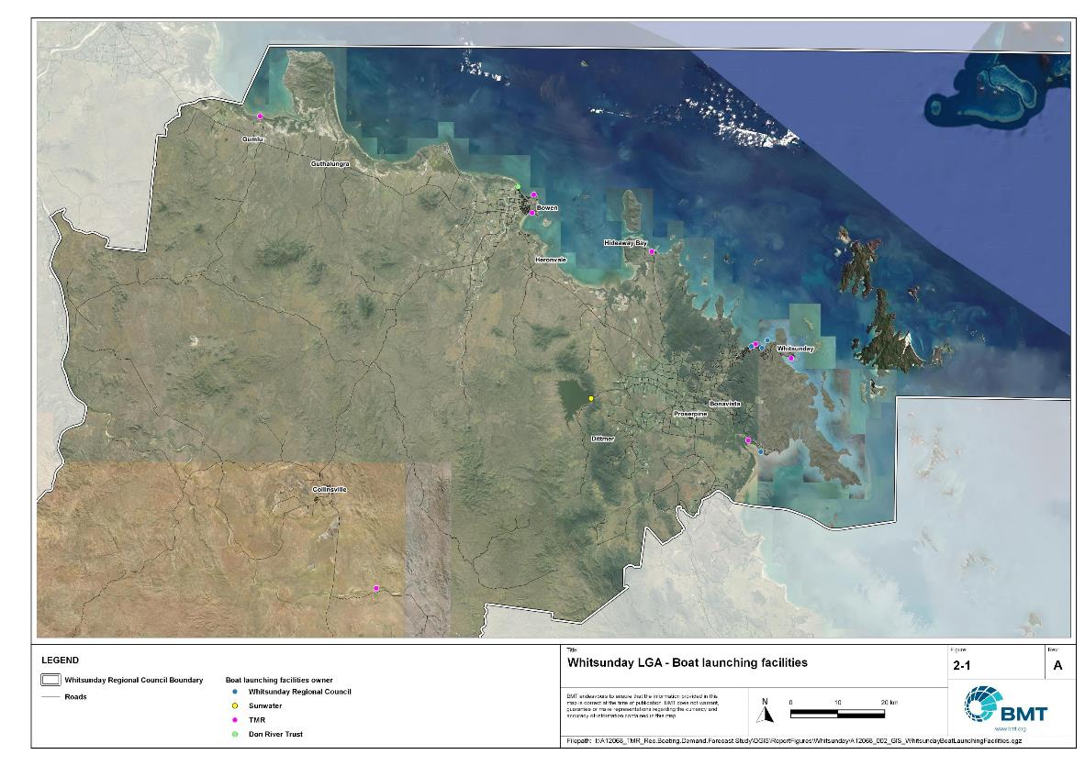

Whitsunday LGA – Boat launching facilities

"I:\A12068_TMR_Rec.Boating.Demand.Forecast.Study\QGIS\ReportFigures\Whitsunday\A12068_002_GIS_WhitsundayBoatLaunchingFacilities.jpg"

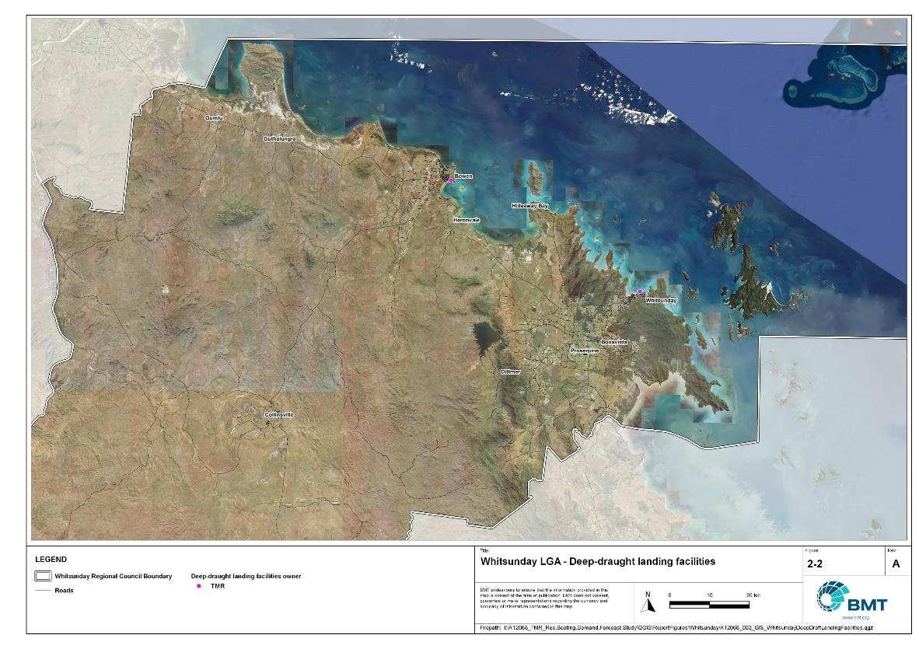

Whitsunday LGA – Deep-draught landing facilites

"I:\A12068_TMR_Rec.Boating.Demand.Forecast.Study\QGIS\ReportFigures\Whitsunday\A12068_003_GIS_WhitsundayDeepDraftLandingFacilities.jpg"

## Existing usage and issues

Consultation with Whitsunday Regional Council, Sunwater, Maritime Safety Queensland, recreational groups and feedback from the recreational boating facilities survey hosted by TMR indicate the following major themes and issues within Whitsunday LGA.

* + 1. Insufficient capacity in Airlie Beach and Bowen

Facilities that provide excellent opportunities to access open water were identified as always under pressure, both in Airlie Beach and Bowen. Stakeholders identified that there was a strong demand for these facilities, with poor redistribution to other facilities in the LGA.

* + 1. High tourism inputs

Due to the exceptional boating destinations offered around the Whitsunday island group, there is a very high contingent of visiting vessels, both from other LGAs in the region (Mackay, Townsville) and from further afield. High numbers of tourists travelling from interstate use local facilities, particularly at Airlie Beach and Shute Harbour.

* + 1. Constraints to improvement of Shute Harbour

The Shute Harbour facility is closest to the southern Whitsunday islands, making its location highly desirable for recreational boaters. However, constraints on the landside placed by commercial uses and an overall lack of parking significantly limit the capacity of this facility. The facility is also exposed to cyclonic wave conditions, making floating infrastructure such as floating walkways challenging and expensive to install and replace, and rendering the facility (which at 2022 had a fixed sloping walkway) less attractive to local boat users accustomed to using those types of queuing facilities in Airlie Beach. Consequently, despite its ideal location, this facility is not generally preferred by recreational boat users.

# Capacity Assessment

## Boat ramps

* + 1. Introduction

Boat ramps are facilities that are used for launching and retrieving trailable vessels, typically up to 8m in length (with some exceptions), to and from the water. Boat ramps consist of one or more lanes and their use is often supported by landside and waterside infrastructure to improve efficiency. In some instances, the usability of a facility can be adversely affected by environmental constraints such as low water levels, currents, or wave exposure, reducing the overall availability of the facility. Together, consideration of the number of boat ramp lanes, the supporting infrastructure, and environmental constraints results in the facility having a capacity described in terms of ‘effective lanes’ that may or may not be equal to the number of actual boat ramp lanes.

To maximise usage of each facility, the landside and waterside capacity should be balanced. Each facility will have a calculated ‘effective’ capacity for both the landside and waterside elements, with the limiting element dictating the facility's overall effective capacity. Recommendations for works or infrastructure promote balancing these two capacity elements by either improving the limiting element for increased facility effectiveness or by increasing the overall 'effective capacity' through changes to both elements.

* + 1. Boat ramp capacity

The overall capacity of each boat launching facility is limited by the effective capacity of either the waterside or landside elements. The waterside capacity is informed by the number of boat ramp lanes and the number and type of queuing facilities, such as pontoons, floating walkways, queuing beaches and fixed sloping walkways. It may also be limited by the available water depth in the adjacent waterbody and exposure to environmental or other physical factors.

Landside capacity is governed by the availability of nearby spaces for parking of car-trailer units (CTU), the provision of rigging and de-rigging facilities, and provision of single car parking spaces (single cars may otherwise be obliged to park in CTU spaces).

While it is expected that facilities will have their own characteristics influencing efficient use, this Study applies an approach that is consistent across the entire state and consistent with previous editions of the Study. Accordingly, the effective waterside capacity of a boat launching facility is determined as being:

* the ability to support 40 vessels being launched and retrieved per day per lane (see section 3.1.3)
* influenced by exposure to wave, tide, and current conditions (see section3.1.4
* supported by queuing facilities that assist in the efficient use of the boat ramp (see section 3.1.4).

Calculation of landside capacity is in line with the TMR guideline (TMR, 2020), which requires less provision of CTU parking per lane than the Australian standard (AS3962 Table 7.1), and advises:

* 10 CTUs for a single lane boat ramp accessed by an unsealed road, or 15 CTUs accessed by a sealed road
* 45 CTUs for a two-lane boat ramp
* 70 CTUs for a three-lane boat ramp
* 90 CTUs for a four-lane boat ramp.

A notable difference from the 2017 study is the recognition and inclusion of areas close to existing boating facilities that are unsealed and/or not line marked where parking of cars with trailers occurs and is not discouraged. These areas of informal parking have been identified on aerial imagery and through discussions with managing authorities. Each informal area has been assumed to be available for CTU parking only 50% of the time to account for conflicts with other uses (for example, markets), inefficient parking practices, or poor ground conditions. The rate of parking has been calculated as:

* for linear areas where nose-to-tail parking is expected – 1 CTU per 13m
* for linear areas with enough space to allow side-by-side parking – 1 CTU per 3m, provided there is a minimum distance of 15m from the road or manoeuvring area
* for large areas – 1 CTU per 100m2.
  + 1. Boat ramp capacity basis

The number of vessels per day each boat ramp lane can support is based on the Australian Standard for the Design of Marinas (AS3962-2001) and previous versions of this report (GHD, 2011 and 2017).

Research on boat ramp lane efficiency described in the previous report (GHD, 2017) identified that 40 vessels per lane per day was a reasonable compromise between 50 vessels per lane per day (representing congested conditions) and 30 vessels per lane per day (representing unhampered conditions). For context, the 40 vessels per lane per day rate represents a vessel launch or retrieval every 9 minutes per lane within an average normally used period of 12 hours per day.

During this Study, BMT has sought to validate the assumptions presented above, and those relating to capacity modification, by undertaking a literature review, conducting site visits that included observations of launching and retrieving manoeuvres, and reviewing video recordings of boats launching and retrieving at popular boating facilities. The literature review included a boat ramp efficiency investigation undertaken by BMT on the Mornington Peninsula, Victoria (BMT, 2015) and a review of standards from other Australian states and countries that undertake similar studies. The onsite and video analysis provided the opportunity to observe recreational boat operators using facilities included in the Study but did not include observation of total throughput during high demand periods. This assessment was undertaken during site visits across Queensland, and a full day of video recording at Manly Boat Harbour (north ramp) in Brisbane.

The New South Wales and Victoria governments are currently in a planning phase for boating infrastructure and there are presently no publicly accessible documents identifying how those jurisdictions calculate boat ramp lane capacity. The Western Australia government has commissioned studies of the Perth region and the southwest region (Western Australia Department of Transport, 2019 and 2021) that indicate a base rate of 50 vessels per lane per day, with no modifiers applied. Internationally, studies from Florida in the USA (Bell, 2022 and Swett et. al, 2012) assumed that total vessel launch plus retrieval time is between 20 to 40 minutes (18 to 36 vessels per day), although no evidence is provided to support this assumption.

The Mornington Peninsula report (BMT, 2015) collected boat launch and retrieval data for 6 boat ramp facilities on the Mornington Peninsula across 9 days, including the peak Australia Day holiday. Total throughput was assessed for each facility on days where there was constant pressure for launching and retrieving boats with results between 30 and 70 vessels per lane per day for the various facilities. When adjusted for queuing modifications, a baseline rate of between 20 and 50 vessels per lane per day was identified. Of the facilities, the higher rates were achieved where sufficient parking was provided and both waterside and landside queuing facilities existed.

Observations of recreational boat users launching and retrieving their vessels undertaken through the site visits and the analysis of video footage showed that:

* Most observed launches were of ‘multi-person’ boats, which made launching and retrieving boats more efficient.
* Almost all users were able to launch and/or retrieve their boat within the 9-minute target time, when adjusted for queuing facility efficiency.
* There was a preference to launch adjacent to a floating walkway, where one was available. At facilities where a queuing facility is not immediately adjacent to the lane it is expected that average launch times may slightly increase during busy periods.

While the observations that were made generally aligned with expectations, a more in-depth review of capacity assumptions was outside of the scope of the Study. For future studies there would be value in undertaking a more thorough, data-driven investigation of the assumptions about boat ramp lane capacity, both at its base level and modified by queuing facilities. Overall, the preliminary investigations undertaken as part of the Study suggest that the base rate of 40 vessels per lane per day adopted in previous studies is appropriate.

* + 1. Boat ramp efficiency modifications

The waterside capacity of boat ramp lanes can be reduced by environmental factors that include:

* Water levels: Mainly relating to tidal areas this factor considers the reduction in the amount of time the boat ramp is available to launch and retrieve vessels over the full tidal cycle, thus reducing the overall capacity of the facility. For all-tide access, the boat ramp and connecting channel to the open sea are available during all tidal conditions and therefore available 100% of the time. For near all-tide access the boat ramp and the connecting channel to the open sea are assumed to be available, on average, for 80% of the tidal cycle. For part-tide access the boat ramp and its access channel are available less than 80% of the time. A modification factor of 0.8 is applied for near all-tide facilities and 0.5 for part-tide facilities.
* Wave and current conditions: In areas where vessel launching and retrieval may be intermittently impacted by waves (most commonly on beach ramps, but not exclusively) or strong currents (such as in rivers), a modification factor of 0.5 is applied.

Conversely, effective boat ramp capacity can be improved through the use of well-designed queuing facilities. Queuing facilities aim to improve amenity and efficient use of the boat ramp by accelerating one or more of the following phases of boat launching, with the opposite steps required for retrieval:

1. manoeuvring for launching, including for CTU entering the queuing area for the boat ramp and reversing into position for launch
2. launching and securing the launched vessel
3. moving the launch vehicle from the boat ramp to the parking area
4. removing the vessel from the waterside queuing facility.

A range of waterside queuing facilities is in use in Queensland boating infrastructure, which modify different phases of the total launching process. These include:

* Floating walkways and fixed sloping walkways: Positioned to about a boat ramp lane, these structures aim to:
  + improve amenity – such as to assist embarking/disembarking passengers, provide a refuge from in-water contact with crocodiles and so on.
  + make securing the vessel and removing the vehicle from the boat ramp more rapid, while freeing the boat ramp for subsequent users.
* Pontoons: Also used by deep-draught vessels, these structures improve the ability to secure the vessel and clear the boat ramp, but there is usually some time lost returning to recover the launch vehicle compared with the above options as they are generally positioned slightly further away from the ramp.
* Queuing beaches: These also provide a place to secure the vessel close to the boat ramp, although they are generally not as fast to use as pontoons.

As observed throughout the Study site visits, each of these queuing facility types can support a limited number of boat ramp lanes depending on the available space on the queuing facility. The 2017 edition of this Study applied a blanket uplift for all boat ramp lanes where a queuing facility was provided. However, the number of lanes each type of queuing facility can realistically support varies. Accordingly, this Study has provided limitations to the number of boat ramp lanes that can benefit from each queuing facility, based on the number of “working faces” (or area for a queuing beach) provided, where the “working face” is a face that allows temporary securing of vessels during launching or retrieval. The adopted improvement factors and supported lanes are summarised in Table 3.1.

Queuing facility efficiency modifiers

| Queuing facility | Modification factor | Supported lanes |
| --- | --- | --- |
| Floating walkway (lanes adjacent to walkway) | 1.7 | 1 Lane/face |
| Floating walkway (lanes not adjacent to walkway) | 1.3 | 1 Lane/face |
| Fixed sloping walkway | 1.7 | 1 Lane/face |
| Pontoon | 1.2 | 2 Lanes/face |
| Queuing beach | 1.1 | Site-based |

In other states in Australia, reversing queuing bays are more commonly used than in Queensland. These are CTU waiting bays at the head of the boat ramp that are aligned with each boat ramp lane to allow the user to reverse directly down the boat ramp once it is clear. CTU waiting bays reduce the time of the first phase of boat launching by allowing waiting CTU’s to be ready to reverse as soon as the lane becomes clear. The BMT (2015) study on the Mornington Peninsula included facilities with and without these bays. Boat ramps that included reversing queuing bays achieved 50% greater throughput. Facilities that have implemented this approach in Queensland include North Street Southport, Urangan Boat Harbour, Townsville Recreational Boating Park, and the (under construction late 2022) boat ramp at Yorkeys Knob.

* + 1. Accessibility from boat launching facilities

Recreational boat users will typically select the boat launching facility most appropriate or convenient to the activity they are seeking to undertake, the anticipated weather/wave conditions, and their destination. Each of facility within an LGA will provide a varying degree of access to different destinations and for different activities. During the Study, consultation with stakeholders highlighted the following general types of destinations and activities:

* open water/offshore: typically accessed for visiting offshore islands or remote beaches, snorkelling or diving locations, deep sea fishing and general recreation
* creeks and estuaries: typically accessed for fishing, crabbing, wildlife observation, skiing and general recreation
* freshwater: typically accessed for skiing, fishing, wildlife observation and general recreation.

These destinations are typically serviced by different types of recreational vessels. Inshore locations including creeks, estuaries and other freshwater locations are typically patronised by vessels less than 4.5m, except for ski boats, which can be much larger than this. Offshore locations typically require larger boats for access as these vessels are more capable of managing a wide range of wave conditions and can carry sufficient fuel to access distant destinations. Smaller vessels may be able to access close destinations on good weather days, and larger vessels may choose to access inshore destinations, particularly on poor weather days.

Consequently, the following aspects are used to classify how well a facility provides open water access:

* Open-water access: There are no restrictions between the facility and open water.
* Depth-limited access: There are depth restrictions between the facility and open water that limit navigable access to part of the tidal range. This differs from tidal constraints at the actual facility, which might be usable at all tides, but offshore access is limited by a downstream bar or delta.
* Distance-limited access: The distance from the facility to the open water is unrealistic for typical boat users. This distance is assumed to be about 4.5km between the facility and open water to rate as 'distance limited', with travel times increased further where portions of the access channel are regulated by speed limits.
* Infrastructure-limited access: There are man-made obstacles between the facility and open water, such as above-ground pipeline crossings, low bridges or weirs that impede navigable access to open water.
* Beach ramps: These provide open-water access but are typically constrained by environmental conditions such as wave exposure and tide levels. The capacity of these facilities has been individually assessed based on consultation and other data sources and is described in more detail in section 4.
* Freshwater: There is no access to open water.

Certain facilities, particularly those in freshwater, may be constrained by periods of drought, or debris deposition after rainfall events that limit access to destinations, and therefore whether a facility will provide useful boat launching capacity. While it is noted that drought and rainfall may affect the overall capacity of boat launching within an LGA, and given that the timing of such events is not readily predictable, their impact on capacity has not been evaluated.

* + 1. Existing boat launching capacity

Within Whitsunday LGA there are 15 boat launching facilities with a total effective capacity of 20.7 lanes. The effective capacity of boat launching facilities within Whitsunday LGA is shown in Annex B, with a summary of the access to open water and tidal constraints shown in Figure 3.1 and the overall capacity constraint shown in Figure 3.2. Pertinent features of these facilities include:

* There are 25 total lanes, with an effective capacity of 20.7 effective lanes. This effective capacity is primarily reduced due to insufficient parking being allocated for each lane.
* Boat users in Whitsunday LGA are primarily accessing open water to travel to offshore destinations, even from beach ramps, with two facilities providing freshwater access.
* The majority of the facilities provide all-tide access.

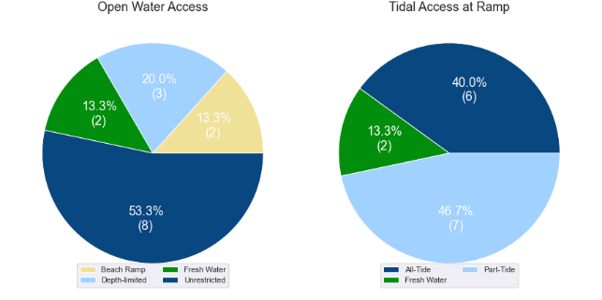

(a) Summary of open water access from boat launching facilities (left) and (b) Summary of tidal restrictions at tidal boat launching facilities (right)

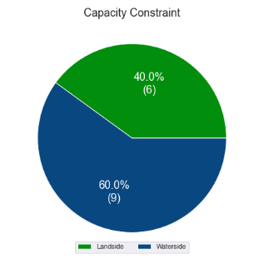

Summary of limiting capacity constraint

## Access to sheltered near all-tide and all-tide facilities

MSQ has a longer-term vision to provide access to all-tide or near all-tide open water access boat launching facilities along the Queensland coast, such that all significant population centres are within one hour’s driving range as far as practical (TMR, 2020). For this purpose, the Study has defined towns as being within the coastal strip if within 30km of the Queensland coastline. The vision (TMR,2020) is applied to the coastal strip between the NSW border and Cooktown. Consultation throughout the Study has highlighted that this vision is important with users/stakeholders and organisations that own and manage these facilities. As such, the Study has developed a statistical approach to quantify this vision to allow it to be measured and tracked over time. To do this, the Study has calculated the travel time from all Population Centres (DoR, 2022) within the coastal zone to the nearest available sheltered, all-tide or near all-tide facility, regardless of which LGA it is in. This has been accomplished using mapped road networks and assigning speed limits to each type of road, with the following speed limits applied:

* for restricted roads, 40km/hr
* for local roads, 60km/hr
* for connector roads, 70km/hr
* for distributor roads, 80km/hr
* for highways, 100km/hr.

For Whitsunday LGA the median travel time from eligible Population Centres to the nearest sheltered all-tide or near all-tide facility is 17 minutes. The distribution of travel times is shown in Figure 3.3 with detailed travel times in Annex C. Figure 3.4 provides a visual representation of the travel time from each of the sheltered near all-tide facilities that serve the LGA. Of interest for Whitsunday LGA are:

* all of the eligible population centres are within the desired 1-hour travel time
* most eligible population centres are within 40 minutes of a sheltered near all-tide or all-tide facility, except for Hideaway Bay that is 47 minutes away, having local access to a beach ramp at Dingo Beach.

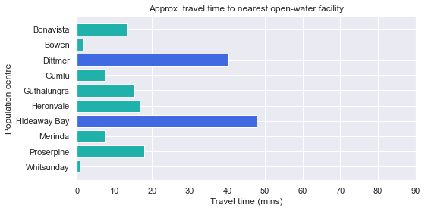

Distribution of travel time from Whitsunday’s eligible population centres to sheltered near all-tide facilities

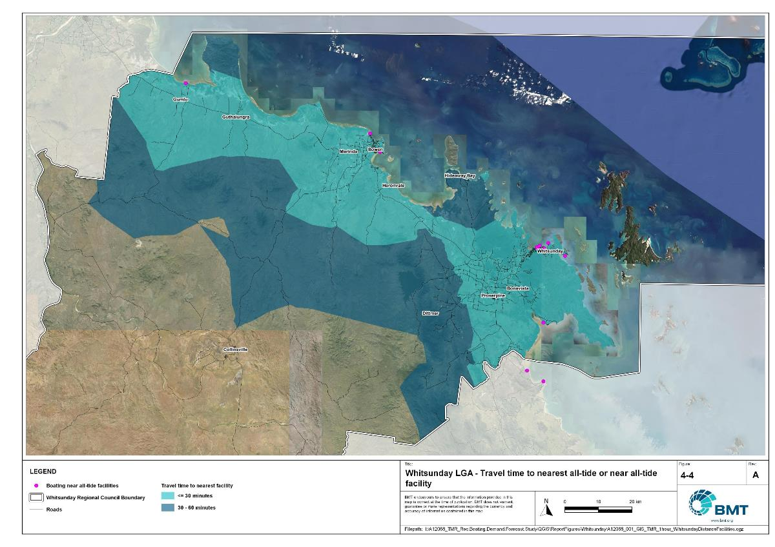

Whitsunday LGA – Travel time to nearest all-tide or near all-tide facility

"I:\A12068_TMR_Rec.Boating.Demand.Forecast.Study\QGIS\ReportFigures\Whitsunday\A12068_001_GIS_TMR_1hour_WhitsundayDistanceFacilities.jpg"

## Deep-draught vessel landings

Deep-draught vessel landings are intended to provide short-term landing capacity for vessels that are too large to use public boat launching and retrieval facilities. These facilities are provided for the benefit of both local vessels and to service the fleet of vessels that travel along the Queensland coast. Deep-draught vessel landings may be designed to accept one or more large vessels at a time and/or provide capacity for tenders from larger vessels that may be anchored or moored nearby, for the purpose of loading and offloading passengers and supplies, and making short local visits to onshore destinations.

For the Study, deep-draught vessel landings need to be primarily accessible by recreational boats for short, temporary stays. In some cases, commercial vessels may utilise these facilities subject to the relevant permissions, however, this may reduce the capacity of the facility to cater for recreational vessels. Deep-draught vessel landings should be located such that the facility provides reasonable access to landside passenger pick up and drop off, provisioning, recreational destinations, or population centres. Within Whitsunday LGA there are two deep-draught vessel landings that provide access to the following facilities or destinations:

* Abell Point Marina provides access to passenger vehicle parking, public transport and shops for provisioning in Airlie Beach.
* Bowen boat harbour provides access to passenger vehicle parking, and shops for provisioning in Bowen.

As well as the above, Whitsunday LGA has additional deep-draught vessel landings provided by private maria facilities at Port of Airlie, Hamilton Island, Abell Point Marina, and Bowen Boat Harbour.

In summary, Table 3.2 shows the total capacity of deep-draught landing facilities within Whitsunday LGA.

Deep-draught landing facilities within Whitsunday LGA

| Facility type | Total capacity |
| --- | --- |
| Public sheltered mainland landings | 2 |
| Private sheltered landings | 4 |
| **Total** | **6** |

# Demand Assessment

The Study has developed a model to calculate statistical demand for boat launching facilities and deep-draught vessel landings at an LGA scale. Vessels that are less than 8m in length are considered trailable and drive demand for boat launching facilities such as boat ramps, while those over 8m are assumed to remain on water and drive demand for deep-draught landings.

Statistical demand is recognised at three different levels for public marine facilities within the TMR guidelines (TMR, 2020), which are:

* off-peak demand – typical weekday usage
* average demand – demand on ‘good boating days’, taken to be demand for a facility on weekends (and, for certain regional locations, other busy periods)
* peak demand – demand for a facility at peak holiday periods or for special events.

The demand model created for this Study is intended to provide information on demand pressures on ‘good boating days’ for all facilities as per the intentions of the guidelines. The model achieves this through a ‘registration activation rate’ that estimates the proportion of registered vessels in an LGA that is assumed to be active on a ‘good boating day’, as well as the exchange of vessels between LGAs, and general tourism pressures.

## Activation rate

The fleet size for each LGA is determined statistically from vessel registration numbers and the application of a vessel activation rate, while for future time horizons vessel registration and population growth estimates are also utilised. The methodology for determining the registration activation rate has been adopted from the previous study (GHD, 2017), with activation rates taken to be between 8% and 14% for a typical weekend. The variability of the activation rate is intended to capture the regional differences in vessel types, and is driven by the availability of access to open water, accessibility of other recreational opportunities, and likelihood of users’ available time for recreation, considering factors including:

* remoteness classification for the LGA
* incidence of blue-collar employment
* average age of residents
* whether the LGA is coastal.

Further information about the derivation of this rate can be found in Annex A. For Whitsunday LGA the activation rate is assumed to be 14%, with the key factors influencing the rate including:

* its classification as a Remote region
* the incidence of blue-collar employment being lower than the state average
* the average age being in line with the state average
* it being located adjacent to the open coast.

## Digital user survey

To gain an understanding of usage trends at existing formal recreational boating facilities across Queensland, the Study has considered the results of a digital user survey using human movement data, sourced through a third party. The data was acquired from a location data store with more than 13 trillion mobile location observations globally from 2019 to present, which were sourced from 250,000 different mobile phone applications that users ‘opted-in’ to use the location services under the application’s terms and conditions. All data received was deidentified and compliant with relevant data privacy regulations.

The analysis uses mobile devices (such as telephones) location data as a proxy for boat user traffic, however, this relationship has several limitations including, but not limited to:

* Mobile device users detected in the area of interest may not be boat users (for example, pedestrians not using vessels may walk through the detection area).
* The relationship between mobile device users and vessels may not be 1:1 (that is, there may be multiple mobile devices providing data for each vessel).
* Users of vessels may not have a mobile device, may not be using a mobile device or may not have provided permission to use their location data.

With these, and potentially other, limitations in mind, the Study compared this data against vessel launching counts provided by various facility managers and found that approximately 15-30% of vessels are captured using this digital survey method. This percentage can change from facility to facility and from day to day. Consequently, the Study has not relied on raw counts of users from this data, but instead considered the relative trends within the data, with the assumption that no groups (for example, users from a particular LGA or using a particular facility) within the data would be more or less likely to be captured by the technique.

The Study has used this data to identify the relative volume of users, the ‘home’ local government area of users and the popularity of destinations that users travel to once vessels have been launched.

* + 1. Inter-LGA demand

The human movement data has been interrogated to determine the LGA of origin for users of Whitsunday LGA’s public boating facilities to ascertain the proportion of users from each LGA that are using specific facilities. Statistics from all public boating facilities within the LGA are then grouped together to determine the total proportion of resident or visiting users across the LGA. Table 4.1shows the active fleet proportion from the top 10 LGAs contributing to demand on facilities within Whitsunday LGA. All other sources have been grouped together.

LGA of origin for active fleet in Whitsunday LGA

| LGA of origin | Active fleet proportion |
| --- | --- |
| Whitsunday | 49.0% |
| Mackay | 6.6% |
| Brisbane | 4.6% |
| Townsville | 4.0% |
| Gold Coast | 3.4% |
| Burdekin | 3.1% |
| Sunshine Coast | 2.5% |
| Moreton Bay | 2.4% |
| Isaac | 2.3% |
| Logan | 1.5% |
| Other LGAs | 20.6% |

* + 1. Intra-LGA demand distribution

Recreational boating users will tend to use facilities that best suit their needs, the destinations they want to access, the capability of their vessel and the weather conditions. Consequently, distribution within an LGA is unlikely to be evenly spread across all facilities, with some facilities attracting users disproportionately due to amenity, access, or destinations. The attractiveness of large well-designed facilities is likely to draw visiting boat users in preference to smaller or less desirable facilities across the LGA. The human movement statistics have been assessed to qualitatively estimate the proportion of users using each facility, both in total and with respect to both resident and visiting boat users (Table 4.2).

Popularity of boat launching facilities.

| Facility | Overall fleet | Resident fleet | Visiting fleet |
| --- | --- | --- | --- |
| Airlie Beach, Abell Point Marina | 21.3% | 19.7% | 22.9% |
| Cannonvale, Whisper Bay, Altmann Avenue "VMR Ramp" | 14.3% | 14.5% | 14.2% |
| Airlie Beach, Port of Airlie | 10.8% | 9.8% | 11.7% |
| Bowen, Horseshoe Bay Road | 10.7% | 11.1% | 10.3% |
| Yasso Point, Bowen | 9.3% | 11.6% | 7.1% |
| Dingo Beach | 8.8% | 5.6% | 11.9% |
| Shute Harbour, Shute Harbour Road | 6.7% | 11.1% | 2.5% |
| Bowen, Starboard Drive | 4.8% | 6.5% | 3.1% |
| Proserpine River, Conway Road | 4.7% | 4.5% | 4.8% |
| Molongle Creek | 3.8% | 1.2% | 6.3% |
| Wilson Beach, Wilson Beach Road | 1.9% | 1.2% | 2.5% |
| Mandalay, Mandalay Road | 1.7% | 1.9% | 1.4% |
| Peter Faust Dam via Proserpine | 0.4% | 0.5% | 0.4% |
| Collinsville, Bowen River Weir | 0.0% | 0.1% | 0.0% |

The results indicate that there is a strong preference for the facilities in Airlie Beach, with Abell Point Marina the most popular facility for both resident and visiting vessels. The facility at Shute Harbour was dominated by local users, with a relatively low proportion of visitors using this facility. Results for Yasso Point and Horseshoe Bay indicates that there is likely a high level of contamination (non-boat users in the target area) as the number of users is not consistent with offshore trips shown in Figure 4.1. In addition, nearly half of all users of the Molongle Creek facility are from Burdekin Shire, with Whitsunday LGA residents accounting for less than 20% of all users at that facility.

The distribution of capacity within the LGA needs to consider these trends to avoid consistent capacity shortfalls at some facilities or indicating demand for unnecessary extra capacity at other facilities. Results from the above statistics and feedback obtained through the TMR online survey indicate that within Whitsunday LGA the following factors tend to influence the preferred facilities for recreational boat users:

* access to sheltered, all-tide launching facilities
* dry entry/exit capabilities of launching facilities provided through floating walkways, pontoons and to a lesser extent fixed sloping walkways
* ability to access offshore destinations.
  + 1. Destinations

For facilities that provide sheltered, near all-tide or all-tide open water access, additional analysis of the human movement statistics has been undertaken to identify destinations for users of these facilities. Location data from users utilising the facilities was extracted for a period of two hours after they used the facility and trimmed for water-side destinations. For Whitsunday LGA this additional analysis was applied to the following facilities, with destinations mapped in Figure 4.1:

* Airlie Beach, Abell Point Marina
* Bowen, Horseshoe Bay Road
* Bowen, Starboard Drive
* Cannonvale, Altmann Avenue “VMR Ramp”
* Dingo Beach
* Molongle Creek
* Yasso Point, Bowen.

From this additional analysis, the following notable observations were made:

* Users of Molongle Creek almost exclusively accessed the west coast of Cape Upstart (which is inaccessible by road).
* Users in Bowen preferred the Bowen Boat Harbour facility (Starboard Drive) for longer offshore trips, with Horseshoe Bay used for local excursions predominantly. People using Yasso Point rarely left the Don River. The volume of offshore reports from Starboard Drive indicate that there is significant contamination of user reports at Horseshoe Bay and Yasso Point.
* Users at Dingo Beach had a large range considering this is a beach ramp, which might be due to the limited alternatives in close proximity.
* Shute Harbour was used to access southern Whitsunday islands, as it is the closest available ramp.
* The Airlie Beach facilities was used relatively interchangeably, with users accessing the Whitsunday islands, including the areas accessed by Shute Harbour users, despite the latter facility being closer.
* There were limited offshore trips from Conway Road.

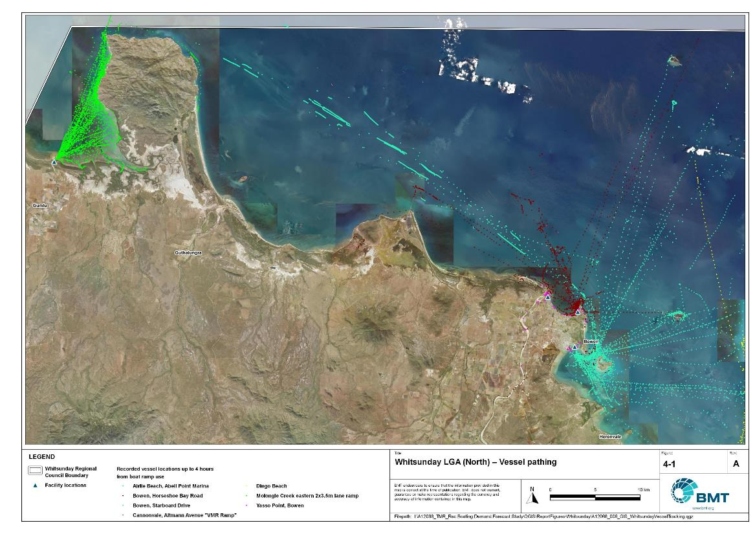

Whitsunday LGA – Vessel pathing

"I:\A12068_TMR_Rec.Boating.Demand.Forecast.Study\QGIS\ReportFigures\Whitsunday\A12068_006_GIS_NorthWhitsundayVesselTracking_4-1.jpg"

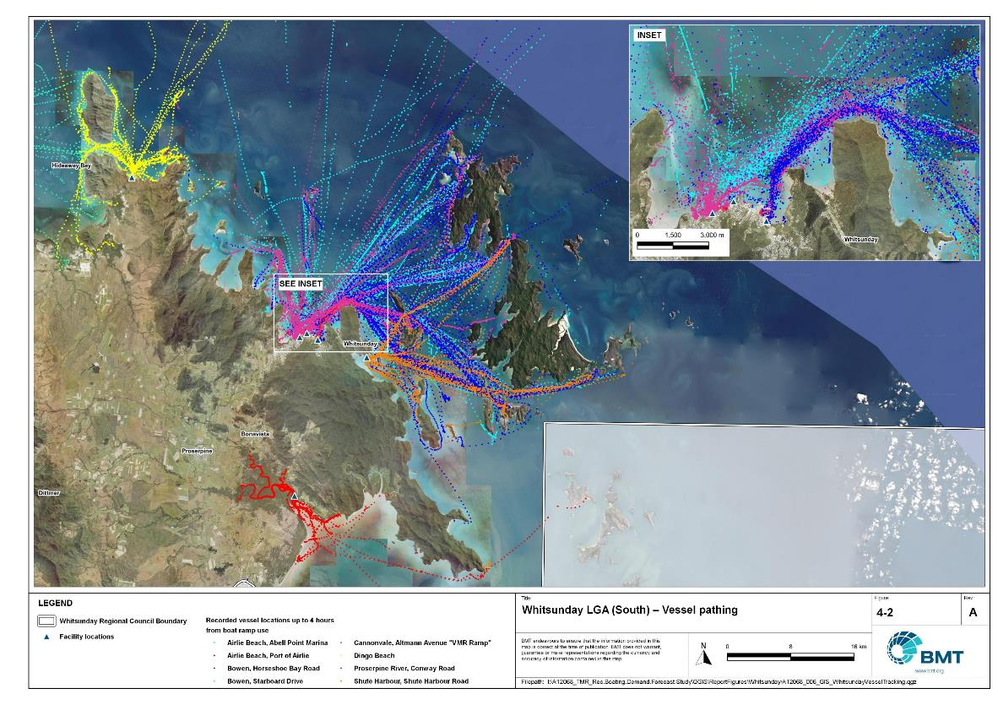

Whitsunday LGA – Vessel pathing

"I:\A12068_TMR_Rec.Boating.Demand.Forecast.Study\QGIS\ReportFigures\Whitsunday\A12068_006_GIS_NorthWhitsundayVesselTracking_4-1.jpg"

## Active fleet size

The total ‘active’ fleet on a good boating day is derived from the activation rate of the total fleet of registered vessels within the LGA and the net inflow of visiting vessels. The total number of visiting vessels from each LGA is determined from the number of vessels in the resident active fleet and the relative proportion of resident to visiting vessels outlined in Table 4.1.The fleet size is expected to change over time due to changes in population and vessel acquisition trends, with the size and proportion of the fleet across the Study period described in Table 4.3.

Active fleet vessel size

| Vessel length | 2021 | 2026 | 2031 | 2036 | 2041 |
| --- | --- | --- | --- | --- | --- |
| 0 to 4.5m | 831 | 860 | 892 | 918 | 941 |
| 4.5m to 8m | 448 | 464 | 481 | 495 | 507 |
| >8m | 74 | 77 | 79 | 82 | 83 |
| Total | 1354 | 1400 | 1452 | 1494 | 1531 |

## Boat ramp lane demand

The fleet size derived in Table 4.3 represents the statistical demand for the LGA, with vessels under 8m assumed to contribute to boat ramp demand, measured in boat ramp lanes. As outlined in section 3.1.2 the adopted capacity of each effective lane is 40 vessels per day, with each vessel assumed to both launch and retrieve, for a total of 80 vessel movements per day. The total boat ramp lane demand across the Study period is shown in Table 4.4.

Boat ramp lane demand

|  | 2021 | 2026 | 2031 | 2036 | 2041 |
| --- | --- | --- | --- | --- | --- |
| Boat ramp lane demand | 32 | 33.1 | 34.3 | 35.3 | 36.2 |

For Whitsunday LGA the important elements that contribute to the boat ramp lane demand include:

* a large sized local fleet, with a high proportion of trailable vessels
* a large fleet in the Mackay to the south, who use the local facilities
* attractive destinations for visitors, particularly from south-east Queensland.

## Non-statistical demand

As well as the statistical demand outlined in the section above, facilities may face demand pressures that are related to their functional use, which reduces the capability of the facility to service the recreational boat fleet in the desired manner. Issues with specific facilities have been identified within the consultation process of the Study with appointed managers and other stakeholders. While care has been taken to identify these non-statistical demand issues throughout the Study, it is beyond the scope of the Study to individually review the functionality, safety, and amenity of each facility across Queensland. Non-statistical demand pressures may warrant upgrades to facilities even where statistical demand is satisfied by existing capacity. These pressures have been classified into the following categories:

* Amenity: Amenity describes the functional usability of the facility including the desire to provide dry entry and exit facilities, facilities that provide easy access and/or access for persons with restricted mobility.
* Safety: Safety demand may include protection from currents and waves or contact with marine creatures such as sharks, jellyfish, and crocodiles.
* In-water congestion: Where existing queuing facilities are not able to efficiently meet the needs of the facility. Such deficiency may warrant additional queuing facility capacity to optimise boat launching and retrieval.

The Study's recommendations may alleviate these non-statistical demand pressures with consideration for capability of all facilities within the LGA. The presence of a non-statistical demand pressure at a facility may not warrant upgrades where other suitable facilities are reasonably available.

## Deep-draught vessel demand

* + 1. Cruising vessels

Vessels cruising along the east coast of Queensland have a requirement for a network of deep-draught vessel landings that are appropriately spaced to be within a day’s sailing on good weather days. These facilities are required to support the reprovisioning of vessels as they travel along the coast and provide access to desirable land-based destinations. Private marina facilities may be used by cruising vessels where there is an expectation for a prolonged stay that requires protected mooring or berthing. Within the Whitsunday LGA suitable facilities for deep-draught vessels includes the public pontoons in Airlie Beach (Abell Point Marina) and the Bowen Harbour – and the private marinas at Port of Airlie, Abell Point Marina, and Hamilton Island

Within the east coast network but outside of the LGA, the nearest public deep-draught vessel facility to the north is in Townsville, approximately 110 nautical miles north of Bowen, and to the south at Rosslyn Bay, approximately 110 nautical miles south of Airlie Beach.

* + 1. Landing demand

Statistical demand for deep-draught vessel landings has been assessed based on the size of the non-trailable fleet within the Whitsunday LGA. Landing demand is more difficult to assess than boat ramp lane demand as the requirements and duration of the landing influence the demand pressure but are highly variable between users. Nevertheless, the Study has assumed that 5% of the non-trailable fleet will be seeking a landing at any given time. The consultation undertaken during the Study indicates that this assumption may overestimate the number of landings, but that the landings are often utilised for other boating and recreation activities when not in use by deep-draught vessels. In particular, landings that are located near boat launching facilities may be used as queuing facilities and therefore support the efficient launching of smaller recreational vessels. Given this, the 5% assumption has been adopted noting that it may overestimate capacity, but not to an extent that it would be onerous to facility providers. Within Whitsunday LGA the demand for deep-draught vessel landings is outlined in Table 4.5.

Deep-draught vessel landing demand

| Requirement | 2021 | 2026 | 2031 | 2036 | 2041 |
| --- | --- | --- | --- | --- | --- |
| No. of Landings | 3.7 | 3.8 | 4 | 4.1 | 4.2 |

# Shortfall Assessment

## Shortfall assessment – boat ramps

The shortfall of boat ramp lanes within Whitsunday LGA is shown in Table 5.1 and Figure 6.1 at an LGA scale. This is presented both with and without the inclusion of additional capacity provided by the recommended upgrades.

Shortfall of boat launching facilities

| Assessment | Metric | 2021 | 2026 | 2031 | 2036 | 2041 |
| --- | --- | --- | --- | --- | --- | --- |
| Demand | Demand | 32 | 33.1 | 34.3 | 35.3 | 36.2 |
| Existing | Capacity | 20.7 | 20.7 | 20.7 | 20.7 | 20.7 |
| **Shortfall** | 11.3 | 12.4 | 13.6 | 14.6 | 15.5 |
| Improved | Capacity | 20.7 | 26.2 | 27.7 | 33.5 | 33.5 |
| **Shortfall** | 11.3 | 6.9 | 6.6 | 1.8 | 2.7 |

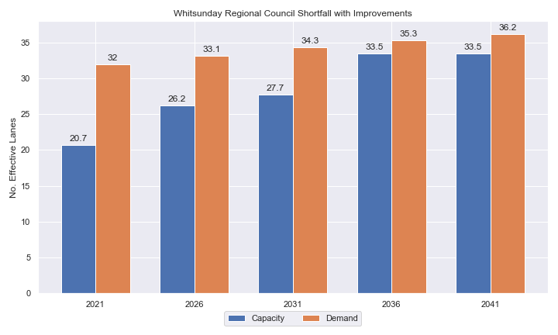

Shortfall assessment with recommended upgrades adopted.

* + 1. Open-water access shortfall in boat ramp lanes

Statistical capacity has been calculated across Whitsunday LGA in its entirety, however, some facilities are evidently more popular than others due to their ability to access open-water destinations, and/or their usability. In general, larger vessels are more suited to access open-water destinations while smaller vessels are more likely to remain in sheltered environments. This was identified in the 2017 study and confirmed during discussions with stakeholders. The human movement data indicates that visiting boats from other LGAs are drawn to facilities that provide access to open-water destinations. To ensure that the capacity of effective boat ramp lanes in the LGA is appropriately distributed to cater for these usage trends, it is worth assessing facilities providing this desirable access as a subset of the total capacity for the LGA. A ‘scenario’ approach to assessing this capacity (Table 5.2) has been developed, with Scenario 1 derived from empirical estimates of vessel distribution and Scenario 2 derived from the human movement statistics, and the result averaged between the two scenarios. This provides the opportunity to rationalise the figure that drives the demand and acknowledge when one scenario is not representative of the population or consistent with stakeholder feedback. The scenarios that were assessed are:

Scenario 1: 80% of larger vessels and 20% of smaller vessels from the local fleet and 80% of the visiting fleet are using the facilities with unrestricted open water access.

Scenario 2: Distributing the fleet between facilities as per the human movement statistics.

Shortfall assessment for open water, all-tide or near all-tide facilities for Whitsunday LGA

| Assessment | Metric | 2021 | 2026 | 2031 | 2036 | 2041 |
| --- | --- | --- | --- | --- | --- | --- |
| Overall | Capacity | 14.7 | 14.7 | 14.7 | 14.7 | 14.7 |
| Scenario 1 | Demand | 20.2 | 20.9 | 21.7 | 22.3 | 22.9 |
| Shortfall | 5.5 | 6.2 | 7.0 | 7.7 | 8.2 |
| Scenario 2 | Demand | 24.2 | 25.0 | 26.0 | 26.7 | 27.4 |
| Shortfall | 9.5 | 10.4 | 11.4 | 12.0 | 12.7 |
| **Average** | Demand | 22.2 | 23.0 | 23.9 | 24.5 | 25.2 |
| **Shortfall** | **7.5** | **8.3** | **9.2** | **9.9** | **10.5** |

Comparing the LGA-scale shortfall with the subset of facilities providing protected all-tide or near all-tide access to open water indicate that the demand is focused at this subset of facilities.

## Shortfall assessment – deep-draught landings

The shortfall of public deep-draught landings for Whitsunday LGA is provided in Table 5.3. The existing public capacity is statistically inadequate to meet demand, however, this is supplemented by significant private facilities in Airlie Beach and Bowen.

Shortfall of deep-draught vessel landings

| Assessment | Metric | 2021 | 2026 | 2031 | 2036 | 2041 |
| --- | --- | --- | --- | --- | --- | --- |
| Deep-draught vessel landings | Demand | 3.7 | 3.8 | 4 | 4.1 | 4.2 |
| Capacity | 2 | 2 | 2 | 2 | 2 |
| **Shortfall** | 1.7 | 1.8 | 2 | 2.1 | 2.2 |

# Stakeholder Feedback



The Study has undertaken extensive consultation throughout its execution to achieve a comprehensive understanding of issues relating to the use of recreational boating facilities across the state. This consultation was conducted with managing authorities that own and/or and manage recreational boating facilities, as well as with facility stakeholders including recreational groups, volunteer marine rescue and coastguard organisations, and the general public. Stakeholder engagement was supplemented with site visits to facilities where key issues had been identified.

## Managing authority feedback

For Whitsunday LGA, the Study team met with the Whitsunday Regional Council, Sunwater and Maritime Safety Queensland to discuss recreational boating facilities within the region. This consultation process identified a range of potential opportunities to alleviate demand pressures. The Study has considered the practical implementation of each of these opportunities with respect to the required infrastructure, difficulty of implementation and magnitude of benefit, as summarised in Table 6.1.

Stakeholder identified opportunities

| Location | Stakeholder opportunity | Review comments |
| --- | --- | --- |
| Molongle Creek | Expansion of parking has been requested following dredging of the channel. | Informal parking has been suitable so far. Undertake further assessment to see if expansion of channel increases demand for parking sufficient to warrant formalised car park expansion. |
| Bowen Boat Harbour | Increase throughput by adding lane and floating walkway. Plenty of informal parking. | Agreed. Human movement data suggests this is the most popular facility in Bowen. |
| Shute Harbour | Significant upgrade required, general support for a new Grubby Bay facility. | Agreed. Although difficult to achieve, the Grubby Bay facility is the most effective way to fix long-term capacity issues at Shute Harbour. |
| Shute Harbour | Upgrade existing fishing pontoon to a wave-attenuating, cyclone-resistant pontoon that can be used to support queuing. | This is an excellent way to improve the waterside usability of this facility, providing alternatives for queuing and wave attenuation for the existing ramp and fixed-sloping walkway from waves. However, given the significant landside (parking) constraint here, construction of this pontoon would not improve the overall capacity of this facility, nor provide significant improvements to amenity or safety of the recreational boating community. It is recommended that funding be prioritised to provide a new facility at Grubby Bay that solves the landside constraints and provides suitable wave protection for the floating queuing infrastructure preferred by stakeholders. |
| Conway Road, Proserpine River | Add additional boat ramp lanes on upstream side of the floating walkway. | Agreed. |
| Abell Point Marina pontoon | Expansion of this facility or additional facility in Port of Airlie. | Excellent facility, expansion at this site is possible. |

## Stakeholder feedback

Broader stakeholder feedback has been conducted within the Study by undertaking virtual or face-to-face meetings with recreational boating groups and marine rescue organisations, as well as through the Recreational Boating Facility Survey (MSQ, 2022) undertaken by Maritime Safety Queensland, which included survey responses of nearly 3,000 users and open submissions. For Whitsunday LGA a total of 127 submissions was received, with 78% of respondents using trailable power boats and 98% of respondents using recreational boating facilities at least once a month. For Whitsunday LGA the following statistics or themes were extracted from the survey and associated comments:

* 96% of respondents typically travel less than 1hr to their preferred boat ramp (which may not be their closest facility).
* 78% of respondents indicated that floating walkways are their preferred type of queuing facility.
* 83% of respondents indicated they would be unwilling to walk further than 200m from designated CTU parking to a boat ramp.
* The most common requested locations for new boat ramps were at:
  + Shute Harbour
  + Cape Gloucester (Hideaway Bay, Dingo Beach)
  + Airlie Beach (Mandalay Road)
  + Abbott Point Road, Bowen
  + Double Bay, Woodwark Bay.
* The following trends were identified with respect to existing facilities:
  + upgrade with multiple lanes, pontoons and/or floating walkways (Shute Harbour), dredging for all-tide access (Port of Airlie), and widening the ramp lanes (Abell Point Marina)
  + more parking for car trailers (Airlie Beach, Abell Point Marina, and Shute Harbour, Magee Road/Cowan Road informal ramp)
  + provision of fish filleting facilities.
* Where the closest available boat launching facility was not preferred, respondents indicated that the following key aspects influenced their choice:
  + access to better parking areas
  + access to all-tide ramps
  + access to pontoons/floating walkways.
* Respondents were provided an opportunity to provide additional feedback. In terms of inefficiency and safety matters, the Shute Harbour facility was frequently reported as to needing a redesign, fixed and/or upgrade.

# Development Recommendations

## Previous recommendations

The 2017 GHD assessment recommended opportunities for increasing capacity of recreational boating facilities across the state. However, the implementation of these recommendations has been low, with only 10% of the total state-wide recommendations delivered in part or full in the 5 years since the delivery of the report. Of the priority 1 recommendations (for immediate delivery) and priority 2 recommendations (for implementation within 5 years) only 18% and 6% respectively have been delivered. State-wide only 5% of land-side recommendations were delivered, while 16% of water-side recommendations were delivered.

Within Whitsunday LGA none of the recommendations have been implemented since the delivery of the 2017 GHD study. The low rate of implementation of these recommendations is likely the result of the devastation to the region caused by the direct impacts of Tropical Cyclone Debbie in 2017 and subsequent recovery, as well as budgetary constraints applied due to the Covid-19 pandemic. As such, many of the recommendations proposed in the 2017 GHD study remain viable. This current Study has reviewed the unimplemented 2017 recommendations (Table 7.1) for Whitsunday LGA in conjunction with stakeholders during the consultation process to identify previous recommendations that are:

* Still viable: The recommendation in its original form remains suitable for solving demand pressures.
* Still viable with modifications: The recommendation could remain viable with modifications identified throughout the consultation process.
* No longer viable: The recommendations are no longer suitable.

Recommendations from the 2017 study that are considered viable or viable with modifications are carried forward into the recommendations of this Study with a suitable update to their priority status if required.

Assessment of unimplemented 2017 recommendations

| Location | 2017 Recommendation | 2022 Review | Review comment |
| --- | --- | --- | --- |
| Priority 2 |  |  |  |
| Cape Gloucester | New 2-lane facility with formal parking. | No longer viable | Extremely challenging site to build on and very remote. Capacity is better provided elsewhere. |
| Priority 3 | | | |
| Shute Harbour | New 4-lane boat ramp and floating walkway. | No longer viable | This area has been consumed for commercial use. Alternative at Grubby Bay is more feasible. |
| Proserpine, Glen Isla Road | 2-lane boat ramp with 45 CTU space | No longer viable | Challenging site environmentally and provides limited destinations. Other sites more suitable. |

## Priority recommendations

The selection and ranking of development priorities provides for progressive implementation of solutions to meet capacity shortfalls and/or resolve existing safety and usage issues at existing facilities over time. Recommendations have been split into four categories for implementation within the 20-year planning period of this Study, with the following projected timelines:

* Priority 1: For immediate planning and design.
* Priority 2: Planning and design intended to provide capacity within 5-10 years.
* Priority 3: Planning and design intended to provide capacity within 10-15 years.
* Priority 4: Planning and design intended to provide capacity within 15-20 years.

The recommendations have been structured to include consideration of the reasonable timelines for implementation. This may include consideration for budgetary processes, planning, environmental approvals, consultation periods, and construction. The priority selection of recommendations has been conducted in accordance with TMR’s Marine Infrastructure and Facilities Plan (TMR, 2020) guidelines, namely:

1. *priority to be given to the provision of sheltered all-tide or near all-tide launching facilities giving access to the open sea on an all-tide or near all-tide basis.*
2. *part-tide facilities (for launching or access) may be provided where there is demand and dredged access is not feasible. For instance, beach access or open beach ramps may be provided where there is sufficient demand and no suitable nearby sheltered waterway*
3. *the most economically viable options will take precedence, including the expansion of existing facilities, and the changing of existing foreshore land uses. In many cases, limiting or avoiding dredging and/or breakwater costs will be a crucial factor*
4. *a goal of providing access to sheltered all-tide or near all-tide boat launching facilities within one hour’s drive for significant communities*

Consequently, higher order recommendations need to address, where possible, the provision of facilities that provide maximum benefit in the widest range of conditions and will be limited to those solutions that are already significantly advanced or ‘shovel ready’ or that require limited further design, planning and approvals. Lower order recommendations will consist of solutions where there is reduced adherence to the TMR guidelines and/or there are constraints that may result in long lead times to resolve. A summary of the recommendations are provided in Table 7.2 with full detail of each recommendation in the tables that follow.

Summary of recommendations for Whitsunday LGA

| Priority | Description | Landside or Waterside | Increased capacity  (effective lanes) |
| --- | --- | --- | --- |
| 1 | Grubby Bay: Reclaim land, construct breakwater and dredge for new facility that includes 145 CTUs and a 4-lane boat ramp with 2 floating walkways as a first stage.  Demolish existing Shute harbour facility. | Both | 5.5 lanes |
| 2 | Bowen Boat Harbour: Add an additional boat ramp and floating walkway. | Waterside | 1.5 lanes |
| 2 | Abell Point Marina: Expand existing pontoon to provide four public berths. | Waterside | 2 landings |
| 3 | Grubby Bay: Stage 2 – Install 75 CTUs and 2-lane boat ramp with 1 floating walkway. | Both | 3.5 lanes |
| 3 | Conway Road, Proserpine: Add an additional 2 lanes. | Waterside | 1.5 lanes |
| 3 | Molongle Creek: Expand the carpark to 85 CTU spaces and rebuild eastern lanes to all-tide status. | Landside | 0.75 lanes |

## Priority 1 recommendations

Grubby Bay (Priority 1)

|  |  |  |  |  |  |  |  |
| --- | --- | --- | --- | --- | --- | --- | --- |
| General description | | | | | | | |
| Location | Grubby Bay, within Shute Harbour, west of existing Shute Harbour boat ramp | | | | | | |
| Existing Facility? | No | | | | | | |
| Coordinates | -20.291277436628754, 148.78402408180187 | | | | | | |
| Existing tidal status | N/A - all-tide when constructed | | | | | | |
| Existing wave exposure | N/A - Nil to very low once constructed | | | | | | |
| Existing current exposure | N/A - Nil once constructed | | | | | | |
| Proposed works | Reclaim land, construct breakwater and dredge for new facility is constructed in two stages: Stage 1 (Priority 1): 145 CTUs and a 4-lane boat ramp with 2 floating walkways.  Stage 2 (Priority 3): 75 CTUs and 2-lane boat ramp with 1 floating walkway.  Demolish existing Shute harbour facility. | | | | | | |
| Increased effective capacity | 5.5 lanes (Stage 1)  3.5 lanes (Stage 2) | | | | | | |
| Capacity improvement position | Waterside | | Landside | | | Both | |
| Rationale | Users of the existing Shute Harbour boat launching facility have expressed concern about the usability and capacity of the facility. However, there is no available space to undertake suitable upgrades to that facility as it is heavily constrained by topography and commercial operations. The nearest facilities in Airlie Beach and Cannonvale are reported to be regularly at capacity, with no opportunities for expansion. A new facility at Grubby Bay would resolve capacity issues on the Whitsunday Coast, while providing access to the island groups that are immediately offshore. The existing facility at Shute Harbour is exposed to waves from the south and east, while a new facility in adjacent Grubby Bay would be sheltered from the east and could be designed to include wave protection from the south. | | | | | | |
| Anticipated Costs (+/- 50%) | Stage 1: Waterside infrastructure | | | | $3,500,000 | | |
| Stage 1: Landside infrastructure | | | | $8,000,000 | | |
| Stage 2: Waterside infrastructure | | | $1,200,000 | | | |
| Stage 2: Landside infrastructure | | | $3,700,000 | | | |
| Planning, environmental and approvals constraints | | | | | | | |
| Assessment | Requirement | | Comments | | |  | |
| Fish Habitat Zone | X | | N/A | | | | |
| Native Title  (Giya People) | ü | | New tenure required for works so interaction with Native Title required | | | | |
| MCU requirement | ü | | MCU required for onshore, reclamation and breakwater works may constitute a Concurrence ERA (ERA 16(1)) and will require an MCU/EA | | | | |
| Clearing remnant vegetation | X | | N/A | | | | |
| GBRWHA | ü | | Reclamation works within the GBRWHA could require a controlled activity approval | | | | |
| Marine Park | ü | | Reclamation area is located within Habitat Protection Zone of Great Barrier Reef Marine Park and will require a Marine Park Permit  Works can be undertaken within the Habitat Protection Zone to the extent they protect and manage sensitive habitats (for example, seagrass meadows, coral reef) | | | | |
| Tidal works assessment | ü | | Reclamation will likely be tidal works and require a Development Permit | | | | |
| Other as required | ü | | Marine Plants – the reclamation works may impact on marine plants and therefore may require a Development Permit for marine plant disturbance  Quarry Material Allocation – if the reclamation is undertaken using dredged material, it will require a Quarry Material Allocation  Reclamation and new facility works are adjacent to a state-controlled road and will likely require a Road Corridor Permit | | | | |
| Sea Level Rise | ü | | The proposed works are within the boundaries of the erosion prone area. | | | | |
| Storm Tide Hazard | ü | | The proposed works are within the boundaries of a high and medium hazard area. | | | | |
| Anticipated Complexity | Low | | Medium | | | | High |
| Maritime engineering review | | | | | | | |
| Assessment | Site considerations | Comments | | | | | |
| Engineering Matters | Wave Forces | Wave conditions at the site will need a detailed assessment to ensure the recommended configuration and sizing is suitable for the conditions. | | | | | |
| Deep Water | This recommendation will require construction in deep water that may impact the suitability or constructability of this recommendation. | | | | | |
| Water Levels | This site is subject to inundation from storm tides and more detailed consideration will be required to ensure the recommended option is suitable. | | | | | |
| Adjacent Structures & Constraints | Detailed consideration needs to be given to the continued use and turning areas for barges and other vessels accessing the adjacent land parcel. | | | | | |
| Anticipated Complexity | Low | Medium | | | | High | |

,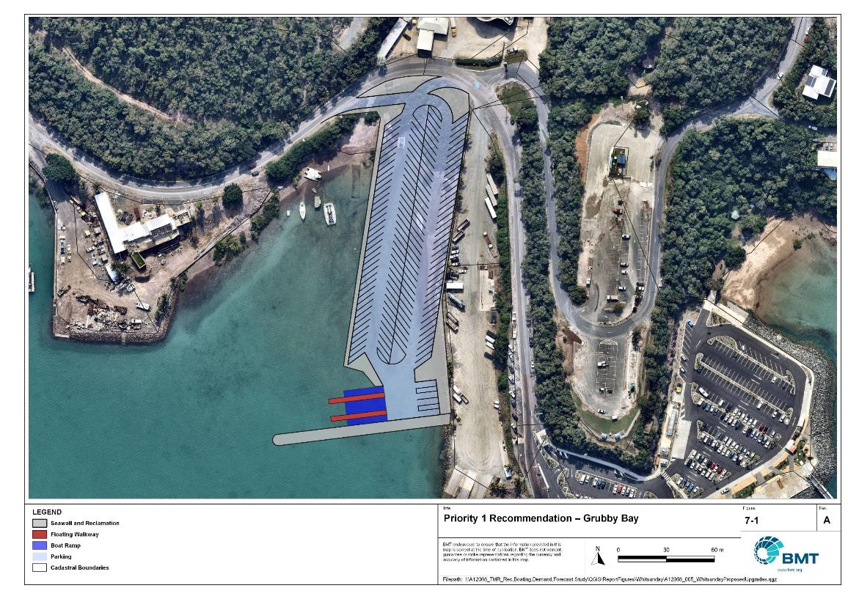

Priority 1 Recommendation – Grubby Bay, Shute Harbour

"I:\A12068_TMR_Rec.Boating.Demand.Forecast.Study\Recomendations by Council\JPG\Whitsunday\A12068_005_WhitsundayProposedUpgrades_7-1.jpg"

## Priority 2 recommendations

Bowen Boat Harbour, Starboard Drive (Priority 2)

|  |  |  |  |  |  |
| --- | --- | --- | --- | --- | --- |
| General description | | | | | |
| Location | Bowen Boat Harbour | | | | |
| Existing Facility? | Yes | | | | |
| Coordinates | -20.017210188881073, 148.254177741166 | | | | |
| Existing tidal status | All-tide | | | | |
| Existing wave exposure | None | | | | |
| Existing current exposure | None | | | | |
| Proposed works | Add an additional boat ramp lane and floating walkway | | | | |
| Increased effective capacity | 1.5 Lanes | | | | |
| Capacity improvement position | Waterside | Landside | | | Both |
| Rationale | The existing boat harbour has a large amount of overflow parking available for use but has been reported to lack sufficient throughput at the boat ramp to service the large fleet that accesses this facility. The additional boat ramp lane and floating walkway will increase the waterside capacity to alleviate these throughput concerns.  *Please note this public marine facility is located within a State Boat Harbour, any upgrades should seek to align with future planning processes for the harbour.* | | | | |
| Anticipated Costs (+/- 50%) | Waterside infrastructure | | $980,000 | | |
| Landside infrastructure | | $195,000 | | |
| Planning, environmental and approvals constraints | | | | | |
| Assessment | Requirements | Comments | | | |
| Fish Habitat Zone | X | N/A | | | |
| Native Title | X | N/A | | | |
| MCU requirement | X | N/A | | | |
| Clearing remnant vegetation | ü | RVM category R- reef- regrowth. Landholders intending to clear in a category R area must notify DoR, unless no native vegetation within 50m of a regrowth watercourse | | | |
| GBRWHA | X | N/A | | | |
| Marine Park | X | N/A | | | |
| Tidal works assessment | ü | Additional boat ramp and floating walkway will likely be tidal works and will require a Development Permit | | | |
| Other as required | ü | Marine Plants – the new boat ramp works may impact marine plants and therefore may require a Development Permit for marine plant disturbance. | | | |
| Sea Level Rise | ü | The proposed works are within the boundaries of the erosion prone area. | | | |
| Storm Tide Hazard | ü | The proposed works are within the boundaries of a high hazard area. | | | |
| Anticipated Complexity | Low | Medium | | High | |

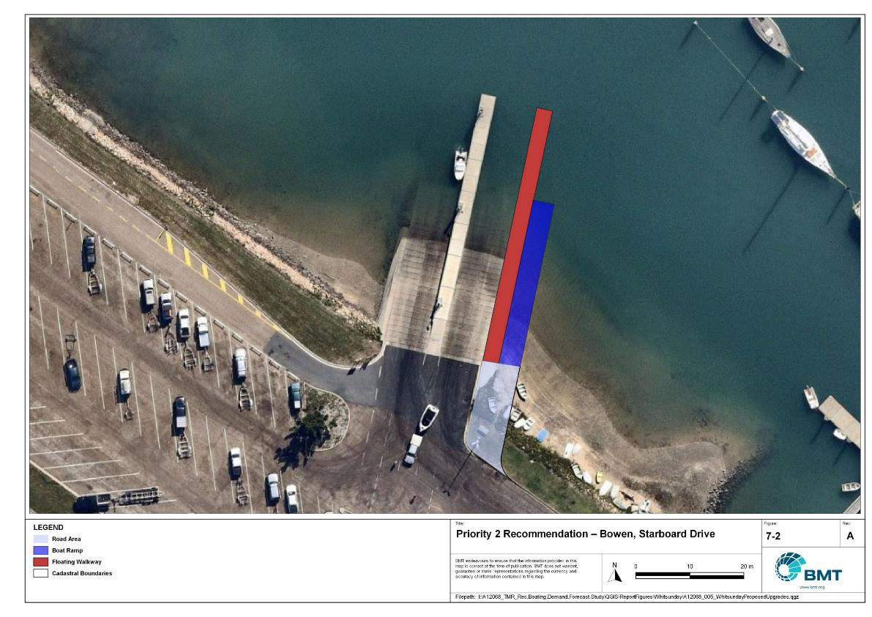

Priority 2 Recommendation – Bowen Boat Harbour, Starboard Drive

"I:\A12068_TMR_Rec.Boating.Demand.Forecast.Study\Recomendations by Council\JPG\Whitsunday\A12068_005_WhitsundayProposedUpgrades_7-2.jpg"

Abell Point Marina pontoon (Priority 2)

|  |  |  |  |  |  |  |
| --- | --- | --- | --- | --- | --- | --- |
| General Description | | | | | | |
| Location | Abell Point Marina, Airlie Beach | | | | | |
| Existing Facility? | Yes | | | | | |
| Coordinates | -20.265860269088623, 148.71188650081695 | | | | | |
| Existing tidal status | All-tide | | | | | |
| Existing wave exposure | None | | | | | |
| Existing current exposure | None | | | | | |
| Proposed works | Reconstruct pontoon to integrate with new floating walkway for the boat ramp, while providing berthing space for four deep-draught vessels as well as tenders on the northern and eastern faces of the structure. | | | | | |
| Increased effective capacity | 2 landings | | | | | |
| Capacity improvement position | Waterside | Landside | | | | Both |
| Rationale | The existing T-shaped pontoon is an excellent facility that is heavily utilised by tenders and deep-draught vessels. The pontoon is ideally located for access to Airlie Beach and Cannonvale, so expansion of this facility ensures capacity is provided where it is being used. There is good access to passenger parking and public transport at this facility, with fuel available within the marina. Alternative sites on the Whitsunday Coast (for instance at Port of Airlie) are considerably less desirable and less efficient than this recommendation. The existing pontoon module can be re-deployed to another Queensland coast location. The existing gangway can remain in use at this Abell Point Marina facility. | | | | | |
| Anticipated Costs (+/- 50%) | Waterside infrastructure | | | $1,300,000 | | |
| Landside infrastructure | | | - | | |
| Planning, environmental and approvals constraints | | | | | | |
| Assessment | Requirements | Comments | | | | |
| Fish Habitat Zone | X | N/A | | | | |
| Native Title | X | N/A | | | | |
| MCU requirement | X | N/A | | | | |
| Clearing remnant vegetation | X | N/A | | | | |
| GBRWHA | X | Pontoon works within the GBRWHA could require a controlled activity approval | | | | |
| Marine Park | X | N/A | | | | |
| Tidal works assessment | ü | Additional boat ramp lanes will likely be tidal works and will require a Development Permit | | | | |
| Other as required | X | N/A | | | | |
| Sea Level Rise | ü | The proposed works are within the boundaries of the erosion prone area. | | | | |
| Storm Tide Hazard | ü | The proposed works are within the boundaries of a high hazard area. | | | | |
| Anticipated Complexity | Low | Medium | | | Low | |
| Maritime engineering review | | | | | | |
| Assessment | Site considerations | | Comments | | | |
| Engineering Matters | Adjacent Structures & Constraints | | Ensure that sufficient manoeuvring space is provided for adjacent berthing locations. | | | |
| Anticipated Complexity | Low | | Medium | | | High |

Priority 2 Recommendation – Abell Point Marina pontoon

"I:\A12068_TMR_Rec.Boating.Demand.Forecast.Study\Recomendations by Council\JPG\Whitsunday\A12068_005_WhitsundayProposedUpgrades_7-3.jpg"

## Priority 3 recommendations

Conway Road, Proserpine (Priority 3)

|  |  |  |  |  |
| --- | --- | --- | --- | --- |
| General description | | | | |
| Location | Conway Road, Proserpine | | | |
| Existing Facility? | Yes | | | |
| Coordinates | -20.451878172374293, 148.69939223198014 | | | |
| Existing tidal status | Part-tide | | | |
| Existing wave exposure | None | | | |
| Existing current exposure | Yes | | | |
| Proposed works | Add additional 2 lanes on the upstream side of the floating walkway | | | |
| Increased effective capacity | 1.5 Lanes | | | |
| Capacity improvement position | Waterside | Landside | | Both |
| Rationale | The existing facility is heavily constrained by tidal flows and tidal levels. By adding additional lanes on the upstream side of the facility, users will be able to choose the most sheltered boat ramp lane to use to receive partial protection from the currents when launching and retrieving boats, regardless of the direction of the current flows. Noted that this is an existing MSQ commitment but was delayed due to funding availability, and that mangroves have already been trimmed to allow for the extra two lanes. | | | |
| Anticipated Costs (+/- 50%) | Waterside infrastructure | | $600,000 | |
| Landside infrastructure | | - | |
| Planning, environmental and approvals constraints | | | | |
| Assessment | Requirement | Comments | | |
| Fish Habitat Zone | X | N/A | | |
| Native Title | X | N/A | | |
| MCU requirement | X | N/A | | |
| Clearing remnant vegetation | X | N/A | | |
| GBRWHA | ü | Boat ramp works within the GBRWHA could require a controlled activity approval | | |
| Marine Park | ü | Adding an additional 2 lanes within General Use Zone of Great Barrier Reef Coast Marine Park will require a Marine Park Permit  Works can be undertaken within the General Use Zone to the extent they are reasonable | | |
| Tidal works assessment | ü | Additional boat ramp lanes will likely be tidal works and will require a Development Permit | | |
| Other as required | ü | Marine Plants – the new boat ramp works will impact marine plants. A Development Permit for marine plant disturbance is already held by MSQ. | | |
| Sea Level Rise | ü | The proposed works are within the boundaries of the erosion prone area. | | |
| Storm Tide Hazard | ü | The proposed works are within the boundaries of a high hazard area. | | |
| Anticipated Complexity | Low | Medium | | High |

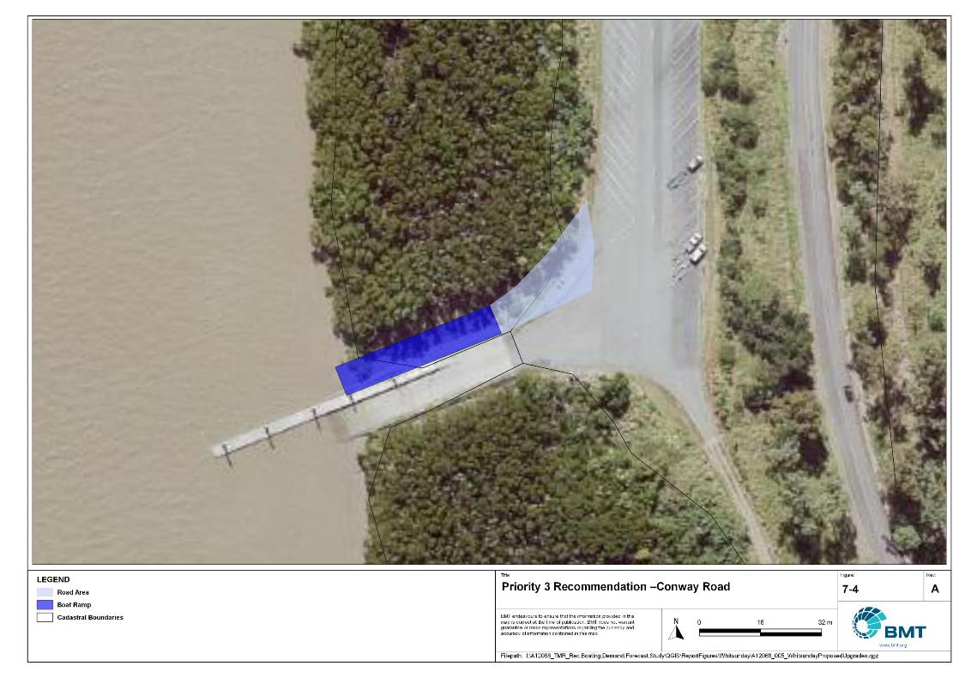

Priority 3 Recommendation – Conway Road, Proserpine

"I:\A12068_TMR_Rec.Boating.Demand.Forecast.Study\Recomendations by Council\JPG\Whitsunday\A12068_005_WhitsundayProposedUpgrades_7-4.jpg"

Molongle Creek - (Priority 3)

|  |  |  |  |  |
| --- | --- | --- | --- | --- |
| General description | | | | |
| Location | Molongle Creek, off Molongle Beach Road | | | |
| Existing Facility? | Yes | | | |
| Coordinates | -19.83438215, 147.69995515 | | | |
| Existing tidal status | All-tide | | | |
| Existing wave exposure | None | | | |
| Existing current exposure | None | | | |
| Proposed works | Expand car park to raise capacity to 85 CTU spaces.  Rebuild the eastern ramp to all-tide status. | | | |
| Increased effective capacity | 0.75 Effective lanes | | | |
| Capacity improvement position | Waterside | Landside | | Both |
| Rationale | This facility is currently landside constrained and more CTU spaces will improve efficient usage. This facility is heavily used by Burdekin Shire residents, and to a lesser extent by Whitsunday Shire and Townsville City residents. It services a wide range of boat users, with extreme peaks occurring during school holidays when it is most heavily used to access holiday homes/shacks on Cape Upstart, which has no road access. This type of usage means that CTUs are often parked at the facility for several days or more, limiting CTU availability for day-trippers. The existing eastern ramp is severely tidally constrained due to a large drop off at the bottom, so rebuilding this to all-tide status would improve its usability | | | |
| Anticipated Costs (+/- 50%) | Waterside infrastructure | | $1,100,000 | |
| Landside infrastructure | | $200,000 | |
| Planning, environmental and approvals constraints | | | | |
| Assessment | Requirement | Comments | | |
| Fish Habitat Zone | X | N/A | | |
| Native Title | X | N/A | | |
| MCU requirement | X | N/A | | |
| Clearing remnant vegetation | ü | RVM category B- remnant vegetation where the western portion of the carpark is located and would likely require a Development Permit. | | |
| GBRWHA | X | N/A | | |
| Marine Park | X | N/A | | |
| Tidal works assessment | X | N/A | | |
| Other as required | X | N/A | | |
| Sea Level Rise | ü | The proposed works are within the boundaries of the erosion prone area. | | |
| Storm Tide Hazard | ü | The proposed works are within the boundaries of a high hazard area. | | |
| Anticipated Complexity | Low | Medium | | High |

Priority 4 Recommendation – Molongle Creek

"I:\A12068_TMR_Rec.Boating.Demand.Forecast.Study\Recomendations by Council\JPG\Whitsunday\A12068_005_WhitsundayProposedUpgrades_7-5.jpg"

## Priority 4 recommendations

Nil

# References

Australian Bureau of Statistics (ABS), 2021, *2021 Census,* <https://www.abs.gov.au/census>

Bell, Frederick W. 2022, *Estimation of the present and projected demand and supply of boat ramps for Florida's coastal regions and counties*, Florida State University, Department of Economics.

BMT, 2015, *MPSC Managed Boating Facilities Demand and Capacity Study: Boat Ramp Modelling*

Department of Transport and Main Roads (TMR), 2020, Marine facilities and infrastructure plan.

GHD, 2011, *Recreational Boating Facilities Demand Forecasting Study*

GHD, 2017, *Queensland Recreational Boating Facilities Demand Forecasting Study 2017.*

Maritime Safety Queensland (MSQ), 2022, *Recreational Boating Facilities,* <https://www.getinvolved.qld.gov.au/gi/consultation/8850/view.html>

Queensland Government Department of Resources (DoR), 2022, *Cities and towns [OGC WMS Service]*, Accessed 5/10/2022, available online at spatial.information.qld.gov.au/arcgis/home/item.html?id=103c7c9ccca449fab79d27cde06868ab

Rose, T., R. Powell & J. Yu (2009). Identification of the Present and Future Recreational Boating Infrastructure in Redland City – A 10 Year Infrastructure Plan- Griffith University

SKM (1998) Public Boat Ramps Central Queensland Strategic Plan - Volume One - Demand Forecasting - Noosa to Yeppoon. Sinclair Knight Merz, March 1998.

Swett, R., Fik, T., Ruppert, T., Davidson, G., Guevara, C. & Betty Staugler, 2012, *Planning for the future of recreational boating access to charlotte county waterways: 2010 – 2050*, Florida Sea Grant, University of Florida.

Western Australia Department of Transport, 2019, *Perth Recreational Boating Facilities Study Review 2019*, https://www.transport.wa.gov.au/mediaFiles/marine/MAC_P_Perth_RBFS_study_review_2019.pdf

Western Australia Department of Transport, 2021, *South West Region Recreational Boating Facilities Study July 2021,* https://www.transport.wa.gov.au/mediaFiles/marine/MAC_P_SouthWest_RBFS_Study_2021.pdf

###### Demand Study

"G:\Admin\A12068.g.mpb.TMRBoatingDemand\06_Reports\09_Demand Study\2022_2119 (016) Final Demand Report (March 2023).pdf"

###### Boat launching facility capacity

Capacity of existing boat launching facilities

| Facility ID | Facility name | No. Lanes | Tidal Access at Ramp | Tidal Access to Open Water | Queuing facility | Formal CTUs | Informal CTUs | Waterside capacity | Landside capacity | Effective capacity | Constraint |
| --- | --- | --- | --- | --- | --- | --- | --- | --- | --- | --- | --- |
| **Open Water Access** | | | | | | | | | | | | |
| WT05 | Airlie Beach, Abell Point Marina | 2 | All-Tide | All-Tide | Floating Walkway | 18 |  | 3.00 | 1.25 | 1.25 | Landside |
| WT10 | Airlie Beach, Port of Airlie | 2 | All-Tide | All-Tide | Floating Walkway | 74 |  | 3.00 | 3.25 | 3.00 | Waterside |
| BW81 | Bowen Boat Harbour, Starboard Drive | 4 | All-Tide | All-Tide | Floating Walkway | 94 | 65 | 5.40 | 7.50 | 5.40 | Waterside |
| WT07 | Cannonvale, Altmann Avenue, Whisper Bay "VMR Ramp" | 2 | All-Tide | All-Tide | Pontoon | 46 |  | 2.40 | 2.25 | 2.25 | Landside |
| WT13 | Mandalay, Mandalay Road | 0 | Part-Tide | Part-Tide | None | 0 | 5 | 0.00 | 0.50 | 0.00 | Waterside |
| BW61 | Molongle Creek, western | 2 | All-Tide | All-Tide | Floating Walkway | 0 | 34 | 3.00 | 1.75 | 1.75 | Landside |
| PP21 | Shute Harbour, Shute Harbour Road | 2 | All-Tide | All-Tide | Pontoon | 15 |  | 2.40 | 1.00 | 1.00 | Landside |
| PP12 | Wilson Beach, Wilson Beach Road | 1 | Part-Tide | All-Tide | None | 0 | 3 | 0.50 | 0.25 | 0.25 | Landside |
| BW12 | Yasso Point, Bowen | 1 | Part-Tide | All-Tide | None | 0 | 12 | 0.50 | 1.00 | 0.50 | Waterside |
| **Subtotal** |  | **16** |  |  |  | **247** | **119** | **20.20** | **18.75** | **15.40** |  |
| **Depth-limited** | | | | | | | | | | | | |
| BW64 | Molongle Creek eastern | 2 | Part-Tide | Part-Tide | Floating Walkway | 0 | 34 | 1.50 | 1.75 | 1.50 | Waterside |
| PP15 | Proserpine River, Conway Road | 2 | Part-Tide | Part-Tide | Floating Walkway | 75 |  | 1.50 | 3.25 | 1.50 | Waterside |
| **Subtotal** |  | **4** |  |  |  | **75** | **34** | **3.00** | **5.00** | **3.00** |  |
| **Fresh Water** | | | | | | | | | | | |
| BW10 | Collinsville, Bowen River Weir | 1 | Fresh Water | Fresh Water | None | 0 | 5 | 1 | 0.5 | 0.5 | Landside |
| WT12 | Peter Faust Dam via Proserpine | 1 | Fresh Water | Fresh Water | None | 0 | 19 | 1 | 1.25 | 1 | Waterside |
| **Subtotal** |  | **2** |  |  |  | **0** | **24** | **2** | **1.75** | **1.5** |  |
| **Beach Ramps** | | | | | | | | | | | |
| BW11 | Bowen, Horseshoe Bay Road | 2 | Part-Tide | Part-Tide | Beach | 21 |  | 0.55 | 1.25 | 0.55 | Waterside |
| PP71 | Dingo Beach | 1 | Part-Tide | Part-Tide | Beach | 0 | 10 | 0.28 | 0.75 | 0.28 | Waterside |
| **Subtotal** |  | **3** |  |  |  | **21** | **10** | **0.83** | **2** | **0.83** |  |
| **Total effective capacity** | | | | | | | | | | 20.7 |  | |

###### Travel time statistics

Travel time from population centres to nearest sheltered all-tide or near all-tide open water accessible facilities

| Population centre | Travel time (mins) |
| --- | --- |
| Bonavista | 13.6 |
| Bowen | 1.9 |
| Dittmer | 40.4 |
| Gumlu | 7.4 |
| Guthalungra | 15.4 |
| Heronvale | 16.8 |
| Hideaway Bay | 47.7 |
| Merinda | 7.6 |
| Proserpine | 17.9 |
| Whitsunday | 0.8 |

###### Facility Use

Boat launching facility usage statistics

| FacilityId | Facility name | Total reports | Whitsunday | Mackay | Brisbane | Townsville | Gold Coast | Burdekin | Sunshine Coast | Moreton Bay | Isaac | Logan | Other LGAs |
| --- | --- | --- | --- | --- | --- | --- | --- | --- | --- | --- | --- | --- | --- |
| Total |  | 27268 | 13374 | 1809 | 1258 | 1092 | 922 | 838 | 669 | 646 | 624 | 418 | 5618 |
| Total % |  | 100% | 49.0% | 6.6% | 4.6% | 4.0% | 3.4% | 3.1% | 2.5% | 2.4% | 2.3% | 1.5% | 20.6% |
| WT05 | Airlie Beach, Abell Point Marina | 5820 | 45.3% | 5.9% | 6.3% | 2.3% | 5.0% | 0.3% | 3.6% | 3.0% | 1.1% | 1.7% | 25.5% |
| WT07 | Cannonvale, Altmann Avenue, Whisper Bay "VMR Ramp" | 3911 | 49.7% | 6.4% | 4.4% | 1.9% | 3.5% | 0.6% | 2.6% | 2.2% | 3.2% | 2.2% | 23.4% |
| WT10 | Airlie Beach, Port of Airlie | 2940 | 44.8% | 7.5% | 5.2% | 3.2% | 4.6% | 1.5% | 3.6% | 2.8% | 2.4% | 2.5% | 21.8% |
| BW11 | Bowen, Horseshoe Bay Road | 2925 | 50.9% | 5.6% | 4.3% | 7.5% | 2.5% | 2.1% | 1.8% | 3.2% | 2.6% | 1.2% | 18.4% |
| BW12 | Yasso Point, Bowen | 2542 | 61.3% | 4.1% | 2.6% | 4.6% | 1.3% | 4.8% | 0.6% | 1.5% | 2.1% | 0.7% | 16.4% |
| PP71 | Dingo Beach | 2393 | 31.0% | 11.1% | 6.4% | 5.0% | 4.7% | 1.0% | 3.9% | 3.0% | 2.8% | 1.6% | 29.4% |
| PP21 | Shute Harbour, Shute Harbour Road | 1819 | 81.3% | 2.6% | 3.0% | 0.9% | 0.9% | 0.2% | 1.2% | 1.3% | 0.2% | 1.4% | 7.0% |
| BW81 | Bowen, Starboard Drive | 1302 | 66.8% | 3.4% | 1.5% | 3.5% | 2.2% | 4.5% | 0.9% | 1.2% | 4.2% | 0.2% | 11.5% |
| PP15 | Proserpine River, Conway Road | 1273 | 47.7% | 14.4% | 2.7% | 2.4% | 2.9% | 1.1% | 1.5% | 2.0% | 3.5% | 0.7% | 21.1% |
| BW64 | Molongle Creek | 1032 | 15.5% | 5.2% | 5.4% | 19.5% | 0.9% | 44.8% | 0.6% | 0.8% | 1.8% | 0.1% | 5.4% |
| PP12 | Wilson Beach, Wilson Beach Road | 513 | 32.6% | 13.5% | 3.1% | 4.3% | 4.9% | 0.8% | 2.3% | 2.5% | 4.1% | 2.9% | 29.0% |
| WT13 | Mandalay, Mandalay Road | 450 | 57.8% | 8.0% | 4.0% | 1.1% | 3.1% | 0.2% | 2.0% | 1.3% | 2.2% | 2.4% | 17.8% |
| WT12 | Peter Faust Dam via Proserpine | 118 | 51.7% | 6.8% | 2.5% | 8.5% | 0.0% | 0.0% | 4.2% | 0.0% | 7.6% | 0.8% | 17.8% |
| BW10 | Collinsville, Bowen River Weir | 7 | 100.0% | 0.0% | 0.0% | 0.0% | 0.0% | 0.0% | 0.0% | 0.0% | 0.0% | 0.0% | 0.0% |

|  |  |  |
| --- | --- | --- |
|  |  | BMT is a leading design, engineering, science and management consultancy with a reputation for engineering excellence. We are driven by a belief that things can always be better, safer, faster and more efficient. BMT is an independent organisation held in trust for its employees. |

|  |  |  |  |  |  |  |  |  |
| --- | --- | --- | --- | --- | --- | --- | --- | --- |
|  |  |  |  |  |  |  | Contact us  enquiries@bmtglobal.com  www.bmt.org  Follow us  www.bmt.org/linkedin LinkedIn logo  www.bmt.org/youtube YouTube logo  www.bmt.org/twitter Twitter logo  www.bmt.org/facebook Facebook logo |  |
|  | Level 5  348 Edward Street  Brisbane  QLD 4000  Australia  +61 7 3831 6744 |  | Registered in Australia  Registered no. 010 830 421  Registered office  Level 5, 348 Edward Street,  Brisbane QLD 4000 Australia |  |  |  |  |
|  | For your local BMT office visit www.bmt.org | | |  |  |  |  |  |