|  |
| --- |
| Queensland Recreational Boating Facilities Demand Forecasting Study 2022  Cassowary Coast LGA Assessment |
|  |
|  |

|  |  |  |
| --- | --- | --- |
| Customer |  | Maritime Safety Queensland |
| Project |  | A12068 |
| Deliverable |  | 017 |
| Version |  | 01 |
|  |  | 21 April 2023 |

Document Control

Document Identification

|  |  |
| --- | --- |
| Title | Queensland Recreational Boating Facilities Demand Forecasting Study 2022 |
| Project No | A12068 |
| Deliverable No | 017 |
| Version No | 01 |
| Version Date | 21 April 2023 |
| Customer | Maritime Safety Queensland, a branch of the Department of Transport and Main Roads |
| Customer Contact | boatinginfrastructure@msq.qld.gov.au |
| Classification | {None} |

|  |  |
| --- | --- |
| Author | Daniel Wishaw, Nicholas Heiner, Geoff Long, Azam Dolatshah, Sophie Barrett, Mackenzie Stacey |
| Reviewed By | Katrina O’Malley-Jones, Jeremy Visser |
| Project Manager | Daniel Wishaw |

Amendment Record

The Amendment Record below records the history and issue status of this document.

| Version | Version Date | Distribution | Record |
| --- | --- | --- | --- |
| 00 | 31 March 2023 | Maritime Safety Queensland  Cassowary Coast Regional Council | Draft |
| 01 | 21 April 2023 | Maritime Safety Queensland | Final |

Executive Summary

This report, part of the Queensland Recreational Boating Facilities Demand Forecasting Study 2022 (‘the Study’), provides a summary of current and forecast demand on recreational boating facilities in Cassowary Coast LGA and the capacity of existing facilities to meet this demand. Where capacity is insufficient to meet current or forecast demand, recommendations have been made to improve existing facilities or for the construction of new facilities. This report is intended to support facility deliverers, owners, and managers over the next 20 years in their decision-making on development priorities for recreational boating facilities within Cassowary Coast LGA.

Key issues and attributes of recreational boating

The key attributes of recreational boating facilities identified in this Study for Cassowary Coast LGA are summarised in Table 1, while consultation with stakeholders undertaken as part of The Study identified the following key issues:

* Availability of suitable waterfront land for recreational boating facilities is limited, due to freehold land ownership, environmental constraints, and cultural heritage restrictions.
* Facilities with significant capacity, deep-water access and all-tide launching capabilities should be improved and given preference over smaller locally used facilities.
* Capacity issues are occurring at certain facilities, including on the landside of the Clump Point facility.
* The Port Hinchinbrook facility is not currently fulfilling its potential and could provide significant capacity if it was all-tide accessible.

1. Key recreational boating attributes for Cassowary Coast LGA

| Key attribute | Value |
| --- | --- |
| Deep-draught landing facilities |  |
| Existing demand (number) | 1.1 |
| Existing capacity (number) | 6 |
| Existing shortfall (number) | -4.9 |
| Boat launching facilities |  |
| Number of existing facilities | 17 |
| Current demand for boat launching lanes (effective lanes) | 23.9 |
| Number of existing ‘effective’ boat launching lanes | 17.1 |
| Current shortfall of ‘effective’ boat launching lanes (number) | 6.8 |
| Demand satisfaction for ‘effective’ boat launching lanes | 71% |
| State average demand satisfaction for ‘effective’ boat launching lanes | 82% |

Demand summary

The assessment of recreational boating demand is centred on a statistical demand model that considers vessel registration data, population statistics, assumptions around local usage, and the movement of vessels into and out of the LGA. Key parameters from this assessment for the Cassowary Coast LGA are:

* The population is 29,924 as at the 2021 census and is projected to be 31,090 by 2041.
* As of July 2022, there is a total of 4,616 vessels with a home registration within the LGA, with 98% being ‘trailable’ – and therefore requiring boat launching facilities – and 2% being non-trailable.
* Cassowary Coast LGA is deemed to be a Remote Region with an assumed vessel activation rate of 14% on a ‘good boating day’.
* Vessels are primarily used within the LGA, with some leakage to Cairns, Hinchinbrook and Townsville LGAs.
* Vessels from Cairns, Hinchinbrook, Townsville and Tablelands LGAs flow into the LGA and contribute to local demand.
* The existing demand for boat launching facilities is 23.9 ‘effective’ boat ramp lanes and projected 25.5 ‘effective’ lanes by 2041. As presented in Table 1, current capacity is 17.1 ‘effective’ boat ramp lanes.
* The existing demand for deep-draught vessel landings is two currently and projected to remain at two by the 2041 planning horizon. As presented in Table 1, current deep-draught landing capacity of 4.

Boat launching

Boat launching facilities comprise boat ramps, any queuing facilities (floating walkways, pontoons, beaches, and fixed sloping walkways) and the provision of car-trailer unit (CTU) parking. The capacity of a boat launching facility is measured in ‘effective lanes’ for both waterside and landside facilities, with the total capacity of a facility being the minimum of the waterside or landside capacity. Waterside capacity is calculated from the number of boat ramp lanes multiplied by environmental reduction factors (for tide, current or waves) and queuing facility improvement factors to derive the number of ‘effective’ lanes. The landside capacity is calculated from the number of available CTU parking spaces.

Cassowary Coast LGA has 17 boat launching facilities, comprising 26 boat ramp lanes with a total effective boat launching capacity of 17.1 ‘effective’ lanes. Six of these facilities are constrained by landside capacity with the remainder constrained by waterside capacity.

The capacity, forecast demand, and shortfall of boat ramp ‘effective’ lanes in Cassowary Coast LGA is shown in Figure 1.

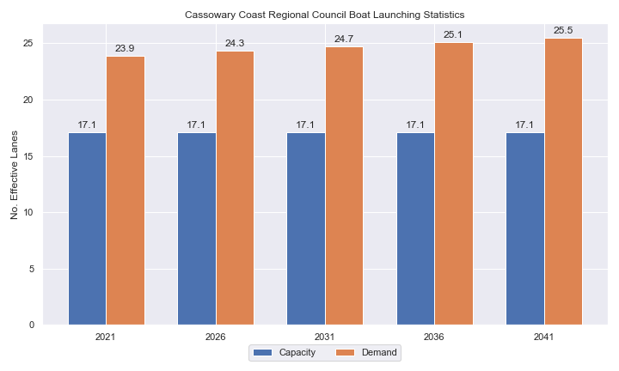

1. Existing capacity, forecast demand and shortfall of ‘effective’ boat ramp lanes for Cassowary Coast LGA

Deep-draught vessel landings

Vessel landing facilities are provided across the state in the form of pontoons and jetties, to provide locations for larger vessels, or their tenders, to access landside destinations or facilities. Pontoons and jetties may also be provided for other purposes such as supporting boat launching or other recreation and may not be suitable for deep-draught vessels. The trend across Queensland indicates that jetties are rarely used as landings, with pontoons preferred by recreational users. As such, The Study has limited the capacity of deep-draught vessel landings to those that are accessible and commonly used by deep-draught vessels, as identified in consultation with stakeholders.

Cassowary Coast LGA has six functional public deep-draught vessel landings comprising jetties at Mourilyan Harbour and Dunk Island, two jetties in Innisfail and two berths on a pontoon at the recently upgraded Clump Point facility. Wave affected jetties at Clump Point and Cardwell have not been included in this assessment as they are predominantly used nor non-boating activities. The shortfall assessment in Table 2 indicates that public landing capacity for deep-draught vessels is currently sufficient to support demand in Cassowary Coast LGA.

1. Deep-draught vessel landing shortfall summary

| Criteria | 2021 | 2026 | 2031 | 2036 | 2041 |
| --- | --- | --- | --- | --- | --- |
| Deep-draught vessel demand | 1.1 | 1.2 | 1.2 | 1.2 | 1.2 |
| Deep-draught vessel capacity | 6 | 6 | 6 | 6 | 6 |
| Shortfall | -4.9 | -4.8 | -4.8 | -4.8 | -4.8 |

Priority recommendations

Recommendations for new facilities or upgrades to existing facilities are outlined in Table 3. The range of recommendations seeks to reduce the overall capacity shortfall within Cassowary Coast LGA over the 20-year planning life of this project, as well as address specific concerns, including:

* Improving capacity of the all-weather, deep-water accessible facility at Mourilyan Harbour
* Maximising landside capacity of land parcels already in use for recreational boating facilities (for example, Coconuts)
* Acknowledge the use of accepted overflow parking on the most popular boating days.

Recommendations

1. Summary of recommended boating infrastructure upgrades for Cassowary Coast LGA

| Priority | Criteria | Recommendations |
| --- | --- | --- |
| 1 | * Required to meet existing demand. * Sites that can provide maximum benefit for existing demand pressures at an LGA scale or satisfy specific safety pressures. | * Coconuts: Install new parking area. * Mourilyan Harbour: Add 2 lanes and a centralised floating walkway. |
| 2 | * Required to meet demand within the next five to ten years. * Sites that are likely to have low to medium approval complexity. * Sites that can provide satisfaction of specific demand or safety pressures within the LGA. | * Hull River, Hull Heads: Add a boat ramp lane to the south of the existing ramp. Construct 40 CTU parks. |
| 3 | * Required to meet demand within the next ten to fifteen years. * Sites that service planned future growth within the LGA. | * Campbell Street, Innisfail: Construct a 2-lane boat ramp facility with 45 CTU parking spaces. |
| 4 | * Required to meet demand within the next fifteen to twenty years. * Sites that service planned future growth within the LGA. | * Port Hinchinbrook: Undertake dredging feasibility study to assess if all-tide access can be established and maintained in a fiscally responsible manner. If it can, formalise an increase to 90 CTUs and dredge channel to allow all-tide access. |

Contents

Definitions 10

1 Introduction 13

2 Cassowary Coast LGA Overview 14

2.1 Key influences on recreational boating 14

2.2 Existing recreational boating infrastructure 14

2.3 Existing usage and issues 17

3 Capacity Assessment 18

3.1 Boat ramps 18

3.2 Access to sheltered near all-tide and all-tide facilities 25

3.3 Deep-draught vessel landings 28

4 Beach Ramps 29

4.1 Cowley Beach 29

4.2 Flying Fish Point 30

4.3 Kurrimine Beach, Robert Johnstone Parade (near Bramble Street) 31

4.4 South Mission Beach, Kennedy Esplanade 32

4.5 Cardwell, Sheridan Street 34

5 Demand Assessment 36

5.1 Activation rate 36

5.2 Digital user survey 37

5.3 Active fleet size 42

5.4 Boat ramp lane demand 42

5.5 Non-statistical demand 42

5.6 Deep-draught vessel demand 43

6 Shortfall Assessment 45

6.1 Shortfall assessment – boat ramps 45

6.2 Shortfall assessment – deep-draught landings 46

7 Stakeholder Feedback 48

7.1 Managing authority feedback 48

7.2 Stakeholder feedback 49

8 Development Recommendations 51

8.1 Previous recommendations 51

8.2 Priority recommendations 52

8.3 Priority 1 recommendations 54

8.4 Priority 2 recommendations 60

8.5 Priority 3 recommendations 62

8.6 Priority 4 Recommendations 65

9 References 68

Annex A Demand Study A-1

Annex B Boat launching facility capacity B-1

Annex C Travel time statistics C-1

Annex D Facility Use D-1

Tables

Table 2.1 Recreational boating facilities by facility owner in Cassowary Coast LGA 14

Table 3.1 Queuing facility efficiency modifiers 21

Table 3.2 Deep-draught landing facilities within Cassowary Coast LGA 28

Table 5.1 LGA of origin for active fleet in Cassowary Coast LGA 37

Table 5.2 Popularity of boat launching facilities. 38

Table 5.3 Active fleet vessel size 42

Table 5.4 Boat ramp lane demand 42

Table 5.5 Deep-draught vessel landing demand 44

Table 6.1 Shortfall of boat launching facilities 45

Table 6.2 Shortfall assessment for open water, all-tide or near all-tide facilities for Cassowary Coast LGA 46

Table 6.3 Shortfall of deep-draught vessel landings 47

Table 7.1 Stakeholder identified opportunities 48

Table 8.1 Assessment of unimplemented 2017 recommendations 51

Table 8.2 Summary of recommendations for Cassowary Coast LGA 52

Table 8.3 Coconuts (Priority 1) 54

Table 8.4 Mourilyan Harbour (Priority 1) 57

Table 8.5 Hull River, Hull Heads (Priority 2) 60

Table 8.6 Campbell Street, Innisfail (Priority 3) 62

Table 8.7 Port Hinchinbrook (Priority 4) 65

Table B.1. Capacity of existing boat launching facilities B-1

Table C.1. Travel time from population centres to nearest sheltered all-tide or near all-tide open water accessible facilities C-1

Table D.1. Boat launching facility usage statistics D-1

Figures

Figure 2.1 Cassowary Coast LGA – Boat launching facilities 15

Figure 2.2 Cassowary Coast LGA - Deep-draught landing facilities 16

Figure 3.1 (a) Summary of open water access from boat launching facilities (left) and (b) Summary of tidal restrictions at tidal boat launching facilities (right) 23

Figure 3.2 Summary of limiting capacity constraint 24

Figure 3.3 Distribution of travel time from Cassowary Coast LGA’s eligible population centres to sheltered near all-tide facilities 26

Figure 3.4 Cassowary Coast LGA – Travel time to nearest all-tide or near all-tide facility 27

Figure 4.1 Cowley Beach boat ramp 29

Figure 4.2 Flying Fish Point boat ramp 30

Figure 4.3 Kurrimine Beach, Robert Johnstone Parade boat ramp 31

Figure 4.4 South Mission Beach, Kennedy Esplanade boat ramp 33

Figure 4.5 South Mission Beach, Kennedy Esplanade boat ramp (source: Google Maps) 33

Figure 4.6 Cardwell, Sheridan Street boat ramp 34

Figure 4.7 Cardwell, Sheridan Street boat ramp groyne effect 34

Figure 5.1 Cassowary Coast LGA – Vessel pathing 41

Figure 6.1 Shortfall assessment with recommended upgrades adopted. 45

Figure 8.1 Priority 1 Recommendation - Coconuts 56

Figure 8.2 Proposed Upgrade: Mourilyan Harbour (Priority 1) 59

Figure 8.3 Proposed Upgrade: Hull River, Hull Heads (Priority 2) 61

Figure 8.4 Proposed Upgrade: Campbell Street, Innisfail (Priority 3) 64

Figure 8.5 Proposed Upgrade: Stony Creek, Port Hinchinbrook (Priority 4) 67

Definitions

| Term | Definition |
| --- | --- |
| All‑tide (for boat ramps) | Access from a boat ramp to the open sea with an approach depth of 0.5m below LAT or deeper and a depth at boat ramp toe of 0.5m below LAT or deeper. |
| All-tide (for landings) | Access from a gangway‑access pontoon or jetty to the open sea with an approach depth of 1.5m below LAT or deeper and a depth on at least one face of the pontoon of 1.5m below LAT or deeper. |
| BIP | Boating Infrastructure Program – a sub‑program within MSQ's Maritime Assets and Infrastructure Program |
| Boat ramp | A foreshore concrete ramp with a slope designed for vehicular launching and retrieving of recreational boats. |
| Breakwater | A structure constructed over the seabed and/or the foreshore, usually rising to a height above high tide, designed to provide protection to landward areas by limiting penetration of wave action or currents. |
| CTU | Car-trailer unit space – a parking space for a typical car with a boat trailer attached. |
| Demand | Demand is the requirement of the boat‑owning population for facilities to launch/retrieve trailer boats and/or to berth suitable boats at a given year to service their average (non‑peak period) needs. In most locations demand is based on vessel registrations and is expressed in terms of boat ramp lanes or in number of 12m berths at landings. |
| Effective capacity | For a boat ramp, effective capacity (effective lanes) means the number of boat ramp lanes after adjusting for anticipated unavailability due to unacceptable wave action (>0.2m wave height) or water depth, usage constraints such as the lack of adequate parking, and improvements to efficiency or launch/retrieval throughput such as floating walkways or pontoons. |
| FHA | Fish Habitat Area, declared under the Fisheries Act, 1994 |
| FIFO | Fly‑in fly‑out, where skilled workers travel from their city or central location home communities to a remote site to perform their duties often in blocks of time that provide regular, non-weekend, days off. |
| Fixed sloping walkway | A fixed sloping structure installed at the side of a boat ramp to assist launching/retrieval of trailer boats, and dry embarkation/disembarkation from trailer boats. It is sloped to allow use at varying tide heights – sometimes with sections of different slope. |
| Floating walkway | Multiple connected/hinged flotation modules configured to assist launching/retrieval of trailer boats, and dry embarkation/disembarkation from trailer boats at most if not all stages of the tide. Floating walkways are connected to a concrete shore abutment allowing pedestrian and assisted wheelchair access. |
| Gangway access pontoon | A platform/module that always floats, where a boat can be secured alongside on one or more faces. Pontoons are usually separated from a boat ramp and have a hinged articulated gangway for access to the shore via an abutment. |
| GBR | Great Barrier Reef |
| GCWA | Gold Coast Waterways Authority |
| Landing | A landing is a jetty or gangway‑access pontoon that facilitates berthing of vessels and transfer of passengers and stores. They are most often associated with non-trailable vessels |
| Landside | Refers to areas above high-water mark, often used to denote the location of and type of infrastructure. |
| LAT | Lowest Astronomical Tide, used as Chart Datum on navigational charts. |
| LGA | Local Government Area |
| Managing authority | Councils, port authorities, water storage managers as listed in schedule 1 of the Transport Infrastructure (Public Marine Facilities) Regulation 2011 |
| MCU | Material change of use under the planning scheme |
| MNES | Matter of national environmental significance under the Environment Protection and Biodiversity Conservation Act 1999 |
| MSQ | Maritime Safety Queensland |
| NC Act | Nature Conservation Act 1992 |
| Near all‑tide | Access from a boat ramp to the open sea with a minimum approach depth of 0.5m below LAT and minimum depth at the boat ramp of 0.5m below LAT for 80 percent or more of the tidal range (time measured over a year). |
| Parking - Formalised | A sealed, line-marked parking area for car-trailer units, providing adequately sized parking spaces, roadways and turning circles. |
| Parking – Semi-formalised | An all-weather non-sealed parking area, with markers to delineate adequately sized car-trailer unit parking bays and turning circles. Markers can be concrete blocks, pavement markers (e.g. retro-reflective raised markers) or other permanent instalment to show parking bays. |
| Parking – Informal overflow | A naturally surfaced area available for use as overflow parking on the design boating day, signed as such. To have mixed-use purpose (e.g., parkland) when not being utilised as overflow parking. |
| Part‑tide | Boat ramps that do not meet near all-tide or near all-tide requirements. |
| PV | Passenger vehicle (i.e., car – as opposed to car-trailer unit). |
| Port Authority | An organisation that is responsible for the management of one or more ports on the Queensland coast. |
| Population Centre | Official named urban settlements (populated places) that have been sourced from the Queensland Place Names Database. |
| Registration activation rate | The percentage of registered vessels liable to be in use on any given good weather weekend day |
| Shortfall | The number of effective boat ramp lanes or landings required to meet demand for a given timeframe. Negative shortfall signifies an oversupply for the time period nominated. |
| SPL | Strategic Port Land |
| Study | The Recreational Boating Facility Demand Forecasting Study 2022, including this document. |
| TMR | Department of Transport and Main Roads |
| Water Storage Authority | Includes Seqwater, Sunwater |
| Waterside | Refers to areas below high-water mark, often used to denote the location of and type of infrastructure, including dredged channels and breakwaters. |
| WHA | World Heritage Area |
| # | Number |

# Introduction

BMT has been appointed to undertake the Recreational Boating Facilities Demand Forecasting Study 2022 (‘the Study’) by Maritime Safety Queensland (MSQ), a branch of the Queensland Department of Transport and Main Roads (TMR), on behalf of all public recreational boating facility managers and owners across Queensland. The Study supersedes the 2017 study of the same name and is intended to report on recreational boating facility demand, capacity, and shortfall over a 20-year period at a Local Government Area (LGA) scale across Queensland.

The Study has been developed using information from the 2021 Australian Census (ABS, 2021), recreational boat vessel registrations, consultation with facility owners, managers, and stakeholders, the 2022 Queensland Government Get-Involved recreational boating facilities survey (MSQ, 2022), and previous versions of this Study (2011, 2017). The Study is intended for use by deliverers, owners, managers, and key stakeholders of public recreational boating facilities across Queensland, namely state government agencies including MSQ and the Gold Coast Waterways Authority (GCWA), local governments, port authorities and water authorities. The Study is non-regulatory in nature and is intended to be used as part of a broader suite of information to identify priority investment in recreational boating infrastructure at a local and state level.

The Study establishes demand primarily on statistics derived from registration and population data. Please refer to Section 4.5 for discussion of non-statistical demand. The Study evaluates existing and forecast demand over a 20-year period and makes recommendations on how this demand might be met over that period. Recommendations may include improvements to both landside and waterside capacity depending on the facility.

Recommendations are assigned a priority ranking, from 1 to 4, indicating if they are required immediately or in the next 5, 10 or 15 years respectively. To end 2022, 14% of recommendations from the 2017 study have been completed, comprising 11% of land-side recommendations and 18% of waterside recommendations and reflecting 22% of priority 1 the 2017 recommendations. A much greater percentage of the earlier 2011 study recommendations have now been implemented. Given the low uptake on existing/outstanding recommendations, this Study will review previous recommendations and carry forward, modify, or remove as appropriate. The Study has also been tasked with reviewing specific wave exposed beach launching facilities across the state to determine their contribution to meeting boating facilities demand and make recommendations about their future.

The Study is comprised of a report for every LGA in Queensland and a state-wide summary report. Each LGA report summarises demand pressures from vessel registration data, population statistics, assumptions around local usage and the movement of vessels into and out of the LGA, and existing capacity and recommends opportunities to satisfy shortfall. The state-wide report will support the LGA reports and provide context at a state level for demand pressures, current capacity, equity of access to facilities and state-wide priority for major boating facilities.

The Study is intended to report on publicly accessible recreational boating facilities for registered vessels. This includes boat ramps, floating walkways, pontoons, fixed sloping walkways and supporting car-trailer unit parking at each facility. The Study does not include recommendations for facilities that are used primarily for commercial purposes, private facilities, non-motorised recreation such as launching canoes and stand-up paddle boards, and fishing platforms.

# Cassowary Coast LGA Overview

## Key influences on recreational boating

Within Cassowary Coast LGA, the principal attributes and influences that affect demand on recreational boating infrastructure include:

* its designation as a Remote Region, with a large local recreational boating fleet
* moderate projected population growth
* high tourism inputs including larger vessels cruising along the Queensland coast

## Existing recreational boating infrastructure

The recreational boating facilities within Cassowary Coast LGA are summarised in Table 2.1. These facilities are owned or managed by multiple organisations and include facilities that provide access to open water, estuaries, and fresh water. MSQ’s long term vision is to provide unrestricted access to open water from facilities along the Queensland coast such that all significant population centres are within one hour’s driving range where practical. For clarity, the Study has defined this vision to be the provision of sheltered all-tide, or near all-tide, boat launching facilities within one hour driving range of official population centres (DoR, 2022) lying within 30km of the coastline between the NSW border and Cooktown.

Recreational boating facilities by facility owner in Cassowary Coast LGA

| Owner | Open-water boat ramps | | Other boat ramps | | Landings | |
| --- | --- | --- | --- | --- | --- | --- |
| Facilities | Lanes | Facilities | Lanes | Pontoons | Jetties |
| Cassowary Coast Regional Council | 1 | 3 | 2 | 2 | 1 | 4 |
| TMR | 5 | 9 | 10 | 12 | 2 | 3 |
| Ports North |  |  |  |  |  | 1 |

Each of the boat launching facilities within the LGA are shown in Figure 2.1 and deep-draught vessel landings in Figure 2.2.

Access to land from deep-draught vessels is catered for by the provision of landings such as jetties and pontoons that are intended for short term usage, mainly to drop off and embark passengers and supplies. Within Cassowary Coast LGA these vessels are catered for at the following locations:

* Two jetties on the Johnstone River in Innisfail, one adjacent to the Edith Street (Fossey Park) boat ramp, and one to the north on Fitzgerald Esplanade near Grace Street.
* The jetty at Mourilyan Harbour, adjacent to the Ports North wharf (owned by Ports North, though short-term landing is permitted if requested).
* Two berths on the southern (public) gangway-access pontoon at Clump Point.
* The jetty on Dunk Island.

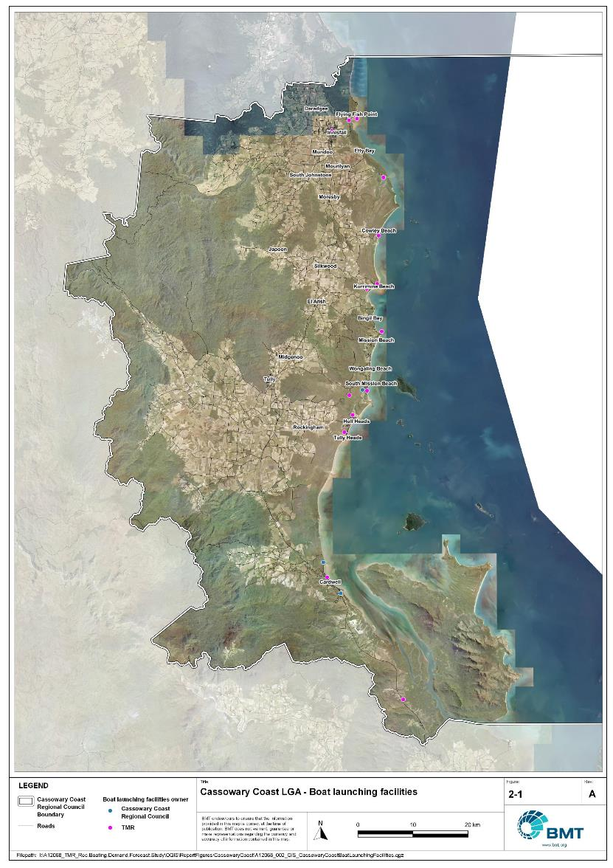

Cassowary Coast LGA – Boat launching facilities

"I:\A12068_TMR_Rec.Boating.Demand.Forecast.Study\QGIS\ReportFigures\CassowaryCoast\A12068_002_GIS_CassowaryCoastBoatLaunchingFacilities.jpg"

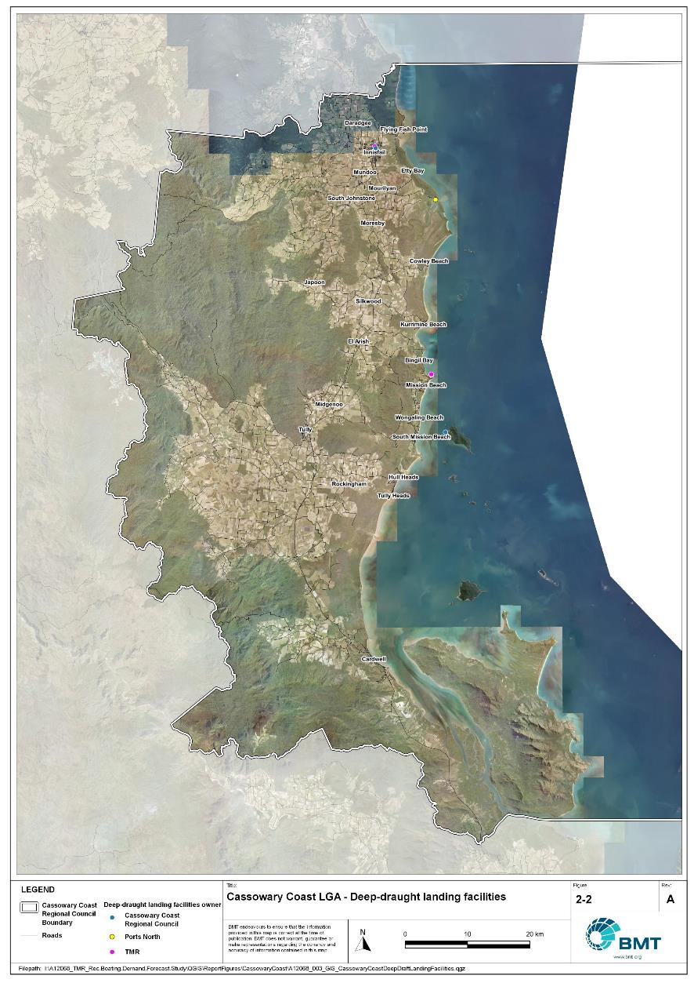

Cassowary Coast LGA - Deep-draught landing facilities

"I:\A12068_TMR_Rec.Boating.Demand.Forecast.Study\QGIS\ReportFigures\CassowaryCoast\A12068_003_GIS_CassowaryCoastDeepDraftLandingFacilities.jpg"

## Existing usage and issues

Consultation with Cassowary Coast Regional Council, Ports North, Maritime Safety Queensland, recreational groups and feedback from the recreational boating facilities survey hosted by TMR indicate the following major themes and issues within Cassowary Coast LGA.

* + 1. Functional accessibility at beach ramps

There are various beach ramps throughout Cassowary Coast LGA which provide limited capacity. These are located at coastal communities (e.g., Kurrimine, Cowley Beach, South Mission Beach) and largely service local users. Such facilities are typically exposed to environmental conditions such as wind, waves and can be fronted by wide inter-tidal flats, all of which impact the functional usage of the ramp at various times. These beach ramps are also subject to dynamic coastal processes such as sediment transport, which can be impacted by the presence of the ramp structure, resulting in local erosion issues.

* + 1. Access to offshore destinations

Offshore from the LGA, high quality reefs and islands are within each reach of the mainland. Access to these destinations is a key part of the lifestyle of the region, and sheltered, all-tide boating facilities with direct open water access are very popular. Facilities providing this functionality at various locations are desired to provide access to different reefs along this stretch of the coastline. Stakeholders desire that sheltered, all-tide facilities that can provide large increases in capacity are prioritised for upgrade.

* + 1. Landside constraints

A recurring theme throughout consultation with Cassowary Coast stakeholders (and Queensland, more broadly) is the landside constraint at boating facilities. Landside capacity (number of CTU parks) is limiting the overall capacity of facilities, and the difficulty of finding a CTU park on a good boating day a widespread challenge. Options that maximise formalised parking arrangements should be considered where possible and provide overflow parking for busier boating days where appropriate.

# Capacity Assessment

## Boat ramps

* + 1. Introduction

Boat ramps are facilities that are used for launching and retrieving trailable vessels, typically up to 8m in length (with some exceptions), to and from the water. Boat ramps consist of one or more lanes and their use is often supported by landside and waterside infrastructure to improve efficiency. In some instances, the usability of a facility can be adversely affected by environmental constraints such as low water levels, currents, or wave exposure, reducing the overall availability of the facility. Together, consideration of the number of boat ramp lanes, the supporting infrastructure, and environmental constraints results in the facility having a capacity described in terms of ‘effective lanes’ that may or may not be equal to the number of actual boat ramp lanes.

To maximise usage of each facility, the landside and waterside capacity should be balanced. Each facility will have a calculated ‘effective’ capacity for both the landside and waterside elements, with the limiting element dictating the facility's overall effective capacity. Recommendations for works or infrastructure promote balancing these two capacity elements by either improving the limiting element for increased facility effectiveness or by increasing the overall 'effective capacity' through changes to both elements.

* + 1. Boat ramp capacity

The overall capacity of each boat launching facility is limited by the effective capacity of either the waterside or landside elements. The waterside capacity is informed by the number of boat ramp lanes and the number and type of queuing facilities, such as pontoons, floating walkways, queuing beaches and fixed sloping walkways. It may also be limited by the available water depth in the adjacent waterbody and exposure to environmental or other physical factors.

Landside capacity is governed by the availability of nearby spaces for parking of car-trailer units (CTU), the provision of rigging and de-rigging facilities, and provision of single car parking spaces (single cars may otherwise be obliged to park in CTU spaces).

While it is expected that facilities will have their own characteristics influencing efficient use, this Study applies an approach that is consistent across the entire state and consistent with previous editions of the Study. Accordingly, the effective waterside capacity of a boat launching facility is determined as being:

* the ability to support 40 vessels being launched and retrieved per day per lane (see section 3.1.3)
* influenced by exposure to wave, tide, and current conditions (see section3.1.4
* supported by queuing facilities that assist in the efficient use of the boat ramp (see section 3.1.4).

Calculation of landside capacity is in line with the TMR guideline (TMR, 2020), which requires less provision of CTU parking per lane than the Australian standard (AS3962 Table 7.1), and advises:

* 10 CTUs for a single lane boat ramp accessed by an unsealed road, or 15 CTUs accessed by a sealed road
* 45 CTUs for a two-lane boat ramp
* 70 CTUs for a three-lane boat ramp
* 90 CTUs for a four-lane boat ramp.

A notable difference from the 2017 study is the recognition and inclusion of areas close to existing boating facilities that are unsealed and/or not line marked where parking of cars with trailers occurs and is not discouraged. These areas of informal parking have been identified on aerial imagery and through discussions with managing authorities. Each informal area has been assumed to be available for CTU parking only 50% of the time to account for conflicts with other uses (for example, markets), inefficient parking practices, or poor ground conditions. The rate of parking has been calculated as:

* for linear areas where nose-to-tail parking is expected – 1 CTU per 13m
* for linear areas with enough space to allow side-by-side parking – 1 CTU per 3m, provided there is a minimum distance of 15m from the road or manoeuvring area
* for large areas – 1 CTU per 100m2.
  + 1. Boat ramp capacity basis

The number of vessels per day each boat ramp lane can support is based on the Australian Standard for the Design of Marinas (AS3962-2001) and previous versions of this report (GHD, 2011 and 2017).

Research on boat ramp lane efficiency described in the previous report (GHD, 2017) identified that 40 vessels per lane per day was a reasonable compromise between 50 vessels per lane per day (representing congested conditions) and 30 vessels per lane per day (representing unhampered conditions). For context, the 40 vessels per lane per day rate represents a vessel launch or retrieval every 9 minutes per lane within an average normally used period of 12 hours per day.

During this Study, BMT has sought to validate the assumptions presented above, and those relating to capacity modification, by undertaking a literature review, conducting site visits that included observations of launching and retrieving manoeuvres, and reviewing video recordings of boats launching and retrieving at popular boating facilities. The literature review included a boat ramp efficiency investigation undertaken by BMT on the Mornington Peninsula, Victoria (BMT, 2015) and a review of standards from other Australian states and countries that undertake similar studies. The onsite and video analysis provided the opportunity to observe recreational boat operators using facilities included in the Study but did not include observation of total throughput during high demand periods. This assessment was undertaken during site visits across Queensland, and a full day of video recording at Manly Boat Harbour (north ramp) in Brisbane.

The New South Wales and Victoria governments are currently in a planning phase for boating infrastructure and there are presently no publicly accessible documents identifying how those jurisdictions calculate boat ramp lane capacity. The Western Australia government has commissioned studies of the Perth region and the southwest region (Western Australia Department of Transport, 2019 and 2021) that indicate a base rate of 50 vessels per lane per day, with no modifiers applied. Internationally, studies from Florida in the USA (Bell, 2022 and Swett et. al, 2012) assumed that total vessel launch plus retrieval time is between 20 to 40 minutes (18 to 36 vessels per day), although no evidence is provided to support this assumption.

The Mornington Peninsula report (BMT, 2015) collected boat launch and retrieval data for 6 boat ramp facilities on the Mornington Peninsula across 9 days, including the peak Australia Day holiday. Total throughput was assessed for each facility on days where there was constant pressure for launching and retrieving boats with results between 30 and 70 vessels per lane per day for the various facilities. When adjusted for queuing modifications, a baseline rate of between 20 and 50 vessels per lane per day was identified. Of the facilities, the higher rates were achieved where sufficient parking was provided and both waterside and landside queuing facilities existed.

Observations of recreational boat users launching and retrieving their vessels undertaken through the site visits and the analysis of video footage showed that:

* Most observed launches were of ‘multi-person’ boats, which made launching and retrieving boats more efficient.
* Almost all users were able to launch and/or retrieve their boat within the 9-minute target time, when adjusted for queuing facility efficiency.
* There was a preference to launch adjacent to a floating walkway, where one was available. At facilities where a queuing facility is not immediately adjacent to the lane it is expected that average launch times may slightly increase during busy periods.

While the observations that were made generally aligned with expectations, a more in-depth review of capacity assumptions was outside of the scope of the Study. For future studies there would be value in undertaking a more thorough, data-driven investigation of the assumptions about boat ramp lane capacity, both at its base level and modified by queuing facilities. Overall, the preliminary investigations undertaken as part of the Study suggest that the base rate of 40 vessels per lane per day adopted in previous studies is appropriate.

* + 1. Boat ramp efficiency modifications

The waterside capacity of boat ramp lanes can be reduced by environmental factors that include:

* Water levels: Mainly relating to tidal areas this factor considers the reduction in the amount of time the boat ramp is available to launch and retrieve vessels over the full tidal cycle, thus reducing the overall capacity of the facility. For all-tide access, the boat ramp and connecting channel to the open sea are available during all tidal conditions and therefore available 100% of the time. For near all-tide access the boat ramp and the connecting channel to the open sea are assumed to be available, on average, for 80% of the tidal cycle. For part-tide access the boat ramp and its access channel are available less than 80% of the time. A modification factor of 0.8 is applied for near all-tide facilities and 0.5 for part-tide facilities.
* Wave and current conditions: In areas where vessel launching and retrieval may be intermittently impacted by waves (most commonly on beach ramps, but not exclusively) or strong currents (such as in rivers), a modification factor of 0.5 is applied.

Conversely, effective boat ramp capacity can be improved through the use of well-designed queuing facilities. Queuing facilities aim to improve amenity and efficient use of the boat ramp by accelerating one or more of the following phases of boat launching, with the opposite steps required for retrieval:

1. manoeuvring for launching, including for CTU entering the queuing area for the boat ramp and reversing into position for launch
2. launching and securing the launched vessel
3. moving the launch vehicle from the boat ramp to the parking area
4. removing the vessel from the waterside queuing facility.

A range of waterside queuing facilities are in use in Queensland boating infrastructure, which modify different phases of the total launching process. These include:

* Floating walkways and fixed sloping walkways: Positioned to about a boat ramp lane, these structures aim to:
  + improve amenity – such as to assist embarking/disembarking passengers, provide a refuge from in-water contact with crocodiles and so on.
  + make securing the vessel and removing the vehicle from the boat ramp more rapid, while freeing the boat ramp for subsequent users.
* Pontoons: Also used by deep-draught vessels, these structures improve the ability to secure the vessel and clear the boat ramp, but there is usually some time lost returning to recover the launch vehicle compared with the above options as they are generally positioned slightly further away from the ramp.
* Queuing beaches: These also provide a place to secure the vessel close to the boat ramp, although they are generally not as fast to use as pontoons.

As observed throughout the Study site visits, each of these queuing facility types can support a limited number of boat ramp lanes depending on the available space on the queuing facility. The 2017 edition of this Study applied a blanket uplift for all boat ramp lanes where a queuing facility was provided. However, the number of lanes each type of queuing facility can realistically support varies. Accordingly, this Study has provided limitations to the number of boat ramp lanes that can benefit from each queuing facility, based on the number of “working faces” (or area for a queuing beach) provided, where the “working face” is a face that allows temporary securing of vessels during launching or retrieval. The adopted improvement factors and supported lanes are summarised in Table 3.1.

Queuing facility efficiency modifiers

| Queuing facility | Modification factor | Supported lanes |
| --- | --- | --- |
| Floating walkway (lanes adjacent to walkway) | 1.7 | 1 Lane/face |
| Floating walkway (lanes not adjacent to walkway) | 1.3 | 1 Lane/face |
| Fixed sloping walkway | 1.7 | 1 Lane/face |
| Pontoon | 1.2 | 2 Lanes/face |
| Queuing beach | 1.1 | Site-based |

In other states in Australia, reversing queuing bays are more commonly used than in Queensland. These are CTU waiting bays at the head of the boat ramp that are aligned with each boat ramp lane to allow the user to reverse directly down the boat ramp once it is clear. CTU waiting bays reduce the time of the first phase of boat launching by allowing waiting CTU’s to be ready to reverse as soon as the lane becomes clear. The BMT (2015) study on the Mornington Peninsula included facilities with and without these bays. Boat ramps that included reversing queuing bays achieved 50% greater throughput. Facilities that have implemented this approach in Queensland include North Street Southport, Urangan Boat Harbour, Townsville Recreational Boating Park, and the (under construction late 2022) boat ramp at Yorkeys Knob.

* + 1. Accessibility from boat launching facilities

Recreational boat users will typically select the boat launching facility most appropriate or convenient to the activity they are seeking to undertake, the anticipated weather/wave conditions, and their destination. Each of facility within an LGA will provide a varying degree of access to different destinations and for different activities. During the Study, consultation with stakeholders highlighted the following general types of destinations and activities:

* open water/offshore: typically accessed for visiting offshore islands or remote beaches, snorkelling or diving locations, deep sea fishing and general recreation
* creeks and estuaries: typically accessed for fishing, crabbing, wildlife observation, skiing and general recreation
* freshwater: typically accessed for skiing, fishing, wildlife observation and general recreation.

These destinations are typically serviced by different types of recreational vessels. Inshore locations including creeks, estuaries and other freshwater locations are typically patronised by vessels less than 4.5m, except for ski boats, which can be much larger than this. Offshore locations typically require larger boats for access as these vessels are more capable of managing a wide range of wave conditions and can carry sufficient fuel to access distant destinations. Smaller vessels may be able to access close destinations on good weather days, and larger vessels may choose to access inshore destinations, particularly on poor weather days.

Consequently, the following aspects are used to classify how well a facility provides open water access:

* Open-water access: There are no restrictions between the facility and open water.
* Depth-limited access: There are depth restrictions between the facility and open water that limit navigable access to part of the tidal range. This differs from tidal constraints at the actual facility, which might be usable at all tides, but offshore access is limited by a downstream bar or delta.
* Distance-limited access: The distance from the facility to the open water is unrealistic for typical boat users. This distance is assumed to be about 4.5km between the facility and open water to rate as 'distance limited', with travel times increased further where portions of the access channel are regulated by speed limits.
* Infrastructure-limited access: There are man-made obstacles between the facility and open water, such as above-ground pipeline crossings, low bridges or weirs that impede navigable access to open water.
* Beach ramps: These provide open-water access but are typically constrained by environmental conditions such as wave exposure and tide levels. The capacity of these facilities has been individually assessed based on consultation and other data sources and is described in more detail in section 4.
* Freshwater: There is no access to open water.

Certain facilities, particularly those in freshwater, may be constrained by periods of drought, or debris deposition after rainfall events that limit access to destinations, and therefore whether a facility will provide useful boat launching capacity. While it is noted that drought and rainfall may affect the overall capacity of boat launching within an LGA, and given that the timing of such events is not readily predictable, their impact on capacity has not been evaluated.

* + 1. Existing boat launching capacity

Within Cassowary Coast LGA there are 17 boat launching facilities with a total effective capacity of 17.1 lanes. The effective capacity of boat launching facilities within Cassowary Coast LGA is shown in Annex B, with a summary of the access to open water and tidal constraints shown in Figure 3.1 and the overall capacity constraint shown in Figure 3.2. Pertinent features of these facilities include:

* There are 26 total lanes, with an effective capacity of 17 effective lanes. This effective capacity is primarily reduced due to environmental conditions at the boat ramp sites, such as part-tide launching constraints, wave and current exposure (particularly applicable for beach ramps) or lack of queuing infrastructure.
* Boat users within Cassowary Coast LGA have a range of options for boating, with facilities available to access estuarine and riverine waterways, though the primary desire is for offshore access.

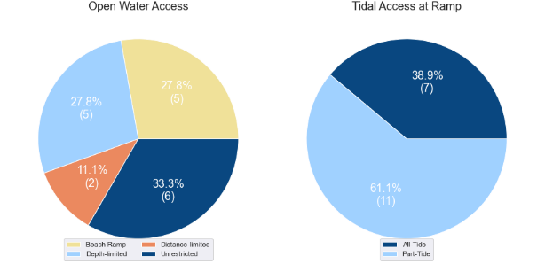

(a) Summary of open water access from boat launching facilities (left) and (b) Summary of tidal restrictions at tidal boat launching facilities (right)

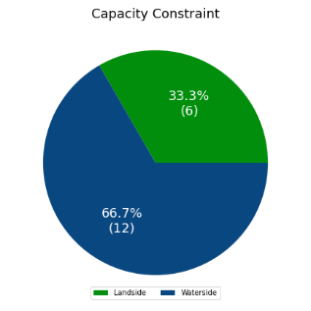

Summary of limiting capacity constraint

## Access to sheltered near all-tide and all-tide facilities

MSQ has a longer-term vision to provide access to all-tide or near all-tide open water access boat launching facilities along the Queensland coast, such that all significant population centres are within one hour’s driving range as far as practical (TMR, 2020). For this purpose, the Study has defined towns as being within the coastal strip if within 30km of the Queensland coastline. The vision (TMR,2020) is applied to the coastal strip between the NSW border and Cooktown. Consultation throughout the Study has highlighted that this vision is important with users/stakeholders and organisations that own and manage these facilities. As such, the Study has developed a statistical approach to quantify this vision to allow it to be measured and tracked over time. To do this, the Study has calculated the travel time from all Population Centres (DoR, 2022) within the coastal zone to the nearest available sheltered, all-tide or near all-tide facility, regardless of which LGA it is in. This has been accomplished using mapped road networks and assigning speed limits to each type of road, with the following speed limits applied:

* for restricted roads, 40km/hr
* for local roads, 60km/hr
* for connector roads, 70km/hr
* for distributor roads, 80km/hr
* for highways, 100km/hr.

For Cassowary Coast LGA the median travel time from eligible Population Centres to the nearest sheltered all-tide or near all-tide facility is 16 minutes. The distribution of travel times is shown in Figure 3.3 with detailed travel times in Annex C. Figure 3.4 provides a visual representation of the travel time from each of the sheltered near all-tide facilities that serve the LGA. Of interest for Cassowary Coast LGA are:

* 100% of the eligible population centres are within the desired 1-hour travel time.
* the majority of eligible population centres are within 30 minutes of a sheltered near all-tide or all-tide facility.
* The reduction in tidal status of Port Hinchinbrook increases the travel time for users in the south of the LGA.

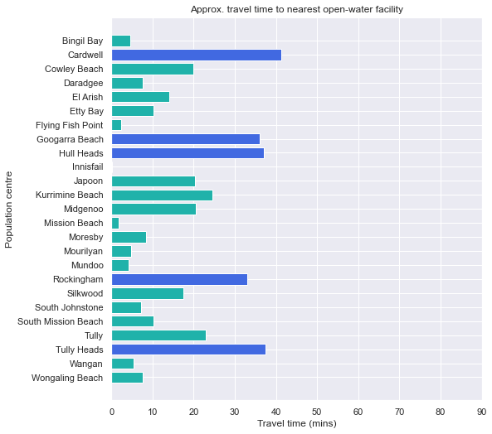

Distribution of travel time from Cassowary Coast LGA’s eligible population centres to sheltered near all-tide facilities

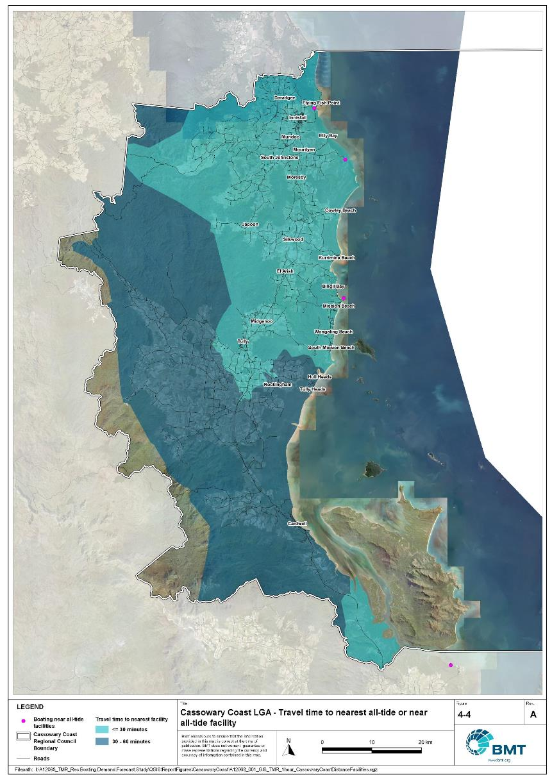

Cassowary Coast LGA – Travel time to nearest all-tide or near all-tide facility

"I:\A12068_TMR_Rec.Boating.Demand.Forecast.Study\QGIS\ReportFigures\CassowaryCoast\A12068_001_GIS_TMR_1hour_CassowaryCoastDistanceFacilities.jpg"

## Deep-draught vessel landings

Deep-draught vessel landings are intended to provide short-term landing capacity for vessels that are too large to use public boat launching and retrieval facilities. These facilities are provided for the benefit of both local vessels and to service the fleet of vessels that travel along the Queensland coast. Deep-draught vessel landings may be designed to accept one or more large vessels at a time and/or provide capacity for tenders from larger vessels that may be anchored or moored nearby, for the purpose of loading and offloading passengers and supplies, and making short local visits to onshore destinations.

For the Study, deep-draught vessel landings need to be primarily accessible by recreational boats for short, temporary stays. In some cases, commercial vessels may utilise these facilities subject to the relevant permissions, however, this may reduce the capacity of the facility to cater for recreational vessels. Deep-draught vessel landings should be located such that the facility provides reasonable access to landside passenger pick up and drop off, provisioning, recreational destinations, or population centres. Within Cassowary Coast LGA there are six public deep-draught vessel landings that provide access to the following facilities or destinations:

* Innisfail (Edith St and Grace St) has two public jetties that provide direct access to Innisfail CBD.
* Mourilyan Harbour has a jetty (owned by Ports North) which provides short-term berthing. This provides the opportunity for passenger pickup/drop-off, or travelling into mainland destinations if there was a vehicle available (noting there is no public transport connectivity here).
* There are two berths on the southern gangway-access public pontoon at Clump Point. This pontoon is also used by tenders from larger vessels, though there is ample space on both the north and south side of the pontoon.
* The Dunk Island jetty provides access to Dunk Island, but is presently only a destination for recreation, rather than reprovisioning.

Private landings are also provided within the Port Hinchinbrook development, just south of Cardwell. However, navigation within the development is currently unreliable in the absence of major maintenance dredging. Once maintained, there is potential for a public deep-draught vessel landing within Port Hinchinbrook.

In summary, Table 3.2 shows the total capacity of deep-draught landing facilities within Cassowary Coast LGA.

Deep-draught landing facilities within Cassowary Coast LGA

| Facility type | Total capacity |
| --- | --- |
| Public sheltered mainland landings | 5 |
| Public offshore landings on islands | 1 |
| **Total** | **6** |

# Beach Ramps

As part of the Study, an investigation into the suitability of wave-exposed beach launching ramps was undertaken. These facilities were visited as part of the Study and discussed with managing authorities during consultation, to assess their capability to meet existing demand and their future potential/need. In many cases, the current fleet size and intended use has outgrown the suitability of these ramps, but in some locations, they remain the only facility to service key communities along parts of the Queensland coast. These assessments seek to assist MSQ to determine its future strategy about retention, demolition, maintenance, upgrade, or potential conversion to non-registered boating use (for instance, personal watercraft, vehicular beach access) and consider where communities benefiting from these facilities have suitable alternatives.

## Cowley Beach

The Cowley Beach boat ramp provides access to the ocean from Bambarook Street, servicing the immediate community of Cowley Beach (2021 population 65) as well as tourists and visitors to the area. The facility is a timber piled beach ramp with a timber deck as shown in Figure 4.1. During inspection of the facility, it was noted that:

* The decking and substructure were in reasonable condition.
* The ramp was very exposed to wave conditions that would make launching and retrieving difficult on a high proportion of days.
* The ramp is not well supported by parking facilities and other amenities.
* The beach ramp has limited impact on coastal processes, given the elevated deck above the beach.

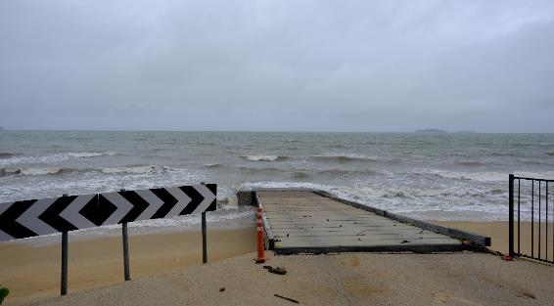

Cowley Beach boat ramp

The human movement statistics (see section 5.2) indicate that this facility is used mostly by residents of Cassowary Coast and Cairns LGAs, with very low overall use. Only 2.4% of the active fleet within Cassowary Coast LGA (local and visiting fleet combined) utilise this boat ramp.

The ramp provides good access to local fishing grounds and more direct access to the North and South Barnard Islands groups approximately 6km offshore. However, it is evident that once wind speeds increase, wave conditions at the ramp make it difficult to retrieve a vessel from the ramp, stranding users in the water, forcing them to beach, anchor and swim to shore, or seek the sheltered landing in Mourilyan Harbour, 11km to the north.

Given the level of exposure to waves, tidal constraints, and landside constraints, it is estimated that the facility is only available for approximately 30% of the time and therefore provides little in the way of satisfying statistical demand for Cassowary Coast LGA. While the ramp is currently in reasonable condition, it services a low population and there is a more reliable available facility at Mourilyan Harbour, approximately 20 minutes drive to the north. As such, it is the recommendation of the Study that the Cowley Beach facility be decommissioned when it next requires major repairs.

## Flying Fish Point

The Flying Fish Point boat ramp services the communities of Flying Fish Point (population 395) and Innisfail (population 7,173) as well as tourists and visitors to the area in conjunction with the boating facility at Coconuts. The facility is located at the mouth of the Johnstone River and consists of a concrete ramp as shown in Figure 4.2. During the inspection of the facility, it was noted that:

* The facility appears to be in excellent condition.
* The ramp is somewhat protected from the northe-ast and east by Flying Fish Point but is exposed to waves from the south-east.
* The ramp is well supported by parking facilities and other amenities.
* The ramp experiences issues with strong currents and debris.
* There is some concern for the impact of storm tides and sea-level rise into the future (beyond the planning horizons considered in this Study) at this site.

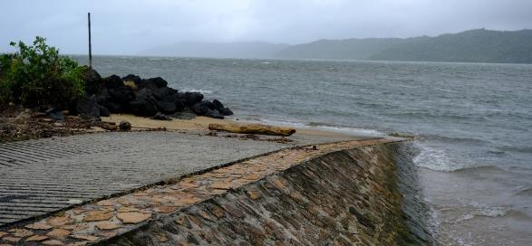

Flying Fish Point boat ramp

The human movement statistics (see section 5.2) indicate that this facility is relatively frequently used, primarily by Cassowary Coast locals, but with some use by visitors. The ramp services 5.3% of the overall fleet in the LGA, which is primarily locals. The all-tide accessible ramp provides direct offshore access to local fishing grounds and reefs. As there is no protection from dominant south-easterly winds, this ramp is frequently impacted by wind and waves and unavailable for use.

During consultation it was discussed that the facility could be improved by formalising and expanding the landside facilities. The Study is generally supportive of this recommendation and the improvement of landside capacity over the whole LGA, however at this location it is not deemed to be a priority as other facilities would provide more capacity for a similar scale upgrade on account of the reduced waterside availability of this facility.

Given the level of exposure to wind and waves, it is estimated that the facility is only available for approximately 50% of the time. While this facility contributes to meeting the statistical demand for boating facility in Cassowary Coast LGA, this Study supports the maintenance of this facility in its current capacity and condition but does not recommend any upgrades.

## Kurrimine Beach, Robert Johnstone Parade (near Bramble Street)

The Kurrimine Beach boat ramp is a 2-lane concrete beach ramp that services the Kurrimine locality (population of 742) as well as visitors from other areas relatively equally. During inspection of the facility, it was noted that:

* The ramp has behaved as a groyne, significantly interrupting the natural northward supply of sand on Kurrimine Beach. Cassowary Coast Regional Council periodically undertakes sand-shifting works by manually moving beach sand from the southern side of the ramp to the northern side.
* When beach levels on the southern side of the ramp reach that of the ramp, northward sand transport resumes, covering the ramp in a veneer of sand (refer Figure 4.3).
* The ramp surface itself is in reasonable condition, however markers along the ramp are in disrepair.
* The ramp is completely exposed to wind and waves, from the north-east to the south.

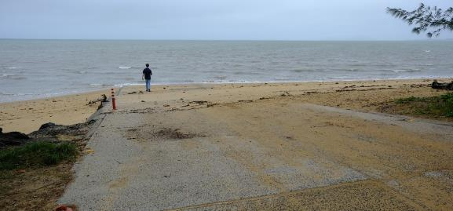

Kurrimine Beach, Robert Johnstone Parade boat ramp

There are various environmental constraints that impact the ability to launch a boat here, particularly the part-tide accessibility – requiring approximately 1.7m above lowest astronomical tide (LAT) or higher to access the ramp for launching and retrieving. This alone reduces the available launching time to slightly more than half of the tidal cycle – as mean sea level is at 1.8m above LAT. The exposure to wind and waves also reduces the time for suitable launching conditions. In addition, prop scour at the toe of the ramp presents a danger for launching at lower tides.

The human movement statistics (see section 5.2) indicate that this facility is very popular, ranking as the third most frequented facility in the LGA (behind Clump Point and Mourilyan Harbour), and servicing nearly 12% of the total fleet in Cassowary Coast LGA. It should be noted that this data collection began prior to the upgrade of the Clump Point facility, and as the ramp is adjacent to one of the caravan parks in the community, the data may be capturing other beach users.

Usage here is driven by a local community with a boating and fishing-centric lifestyle, as well as visitors staying at the three local caravan parks. There is also large demand driven by fishing competition weekends each year, as the ramp provides good access to fishing grounds, reefs and islands.

If they have the means, locals in the area are known to launch from the beach at lower tides using tractors. Since the upgrade of the Clump Point facility there has been an increase in the number of users that are now travelling there to launch, particularly those with larger boats.

Stakeholders have been vocal in their demand for improved infrastructure at this ramp. There is a desire for floating infrastructure to improve user safety from marine stingers and crocodiles, although the wave exposed nature of this site means that floating infrastructure is not viable here. The opportunity for a piled ramp extending out into deeper water would marginally improve tidal availability and allow the resumption of natural coastal processes by allowing sediment to pass under the superstructure from south to north. However, this facility would still be exposed to wind and wave action, and become constrained by the limited availability of landside CTU parking. Although this report is broadly supportive of improvements to boating facilities state-wide, the small statistical capacity increase provided by upgrades like this compared to the significant implementation costs is negligible, and therefore is not recommended as a priority upgrade.

Given the exposure to waves, tidal availability and landside constraints, it is estimated that the facility is available for approximately 40% of the time and therefore provides little satisfaction of statistical demand for Cassowary Coast LGA. While the ramp is currently in reasonable condition, it is evidently a popular facility on the days that it is usable, despite the constraints that exist. The recommendation from this Study is to retain the ramp at the current configuration and capacity for the next five years and reassess the distribution of facility use here and at nearby facilities (for example, Clump Point) during the next iteration of the Study (in five years’ time), to determine whether long-term maintenance is suitable, or upgrading to a piled ramp is required.

## South Mission Beach, Kennedy Esplanade

The South Mission Beach boat ramp on Kennedy Esplanade provides direct access into Lugger Bay, Dunk Island and beyond. A small ramp at the southern end of the broader Mission Beach embayment, it largely services the community of South Mission Beach (population 968). The exposure of this site is significant, as it is afforded no shelter from the north through to the south-east. Limited sheltering from wind and waves approaching from the south may occur.

During inspection, it was noted that there is a significant and long-term groyne effect that has contributed to erosion of the adjacent beach, as a result of the boat ramp impeding natural northward sediment transport (see Figure 4.5). This has in turn necessitated the construction of a seawall along this section of coastline to protect the coastal road.

Human movement data presented in section 5.2 indicates that this facility services only nearly 9% of the overall fleet in Cassowary Coast LGA – including nearly 10% of the visiting fleet. There is the potential for this data to be overestimated for this facility, however, as pedestrians travelling past the boat ramp to the regionally important Kennedy Walking Track to the south may have been counted. Consultation with Cassowary Coast Regional Council indicated that this facility was only typically used by those launching a vessel using a tractor as the tow vehicle. Those recreational boaters with access to a tractor were just as likely to launch directly off the beach as they were to launch from this ramp.

Due to the prevalent unfavourable environmental conditions, it is understood that suitable launching conditions at this boat ramp occur less than 50% of the time. As such the contribution of this facility to demand satisfaction at present and into the future is deemed minor, particularly since the upgrade of the Clump Point facility to a sheltered all-tide facility – which is approximately 20 minutes’ drive to the north. The recommendation of this Study is to consult the South Mission Beach community about the potential for demolition of this facility once the current useful design life is over or significant emerging maintenance appears needed.

South Mission Beach, Kennedy Esplanade boat ramp

South Mission Beach, Kennedy Esplanade boat ramp (source: Google Maps)

## Cardwell, Sheridan Street

The boat ramp near Sheridan Street, Cardwell is a single lane ramp in good condition. This facility partly services the Cardwell population of 1,320, along with facilities at Port Hinchinbrook and Meunga Creek). On inspection, it was noted that:

* The facility is very exposed to wind and waves from all onshore directions, limited mainly by the existence of Hinchinbrook and Goold Islands.
* There is a notable groyne effect occurring, where longshore sediment flow is blocked by the ramp, causing sand to build up on the southern side of the ramp resulting in moderate erosion of the beach on the northern side of the ramp.
* The facility is part-tide accessible only, with insufficient depth at the ramp to launch below mid-tide.

Cardwell, Sheridan Street boat ramp

Cardwell, Sheridan Street boat ramp groyne effect

Consultation with council officers indicated that this was an infrequently used ramp, with just a handful of users who live in Cardwell. This is supported by the human movement data presented in section 5.2, which shows that this facility is supporting just 1.1% of the overall fleet for the Cassowary Coast LGA. The Port Hinchinbrook facility is significantly more popular than this facility (and the Meunga Creek facility), despite being similarly part-tide accessible at present. As such, the current and future contribution to demand satisfaction is considered minor.

It is the recommendation of this Study that the facility be retired once its useful design life of 40 years has expired or significant shorter-term maintenance is required, and that it is not prioritised for resources to keep it in suitable condition for vessel launching/retrieval. Until then, observations of the adjacent beach should be recorded to monitor the impacts that the ramp is having on the shoreline. If the shoreline does not experience further recession as a result of the presence of this ramp, the ramp could be converted to a beach access point/canoe launching point. If shoreline recession continues, this ramp should be decommissioned, demolished, and a natural beach profile reinstated.

# Demand Assessment

The Study has developed a model to calculate statistical demand for boat launching facilities and deep-draught vessel landings at an LGA scale. Vessels that are less than 8m in length are considered trailable and drive demand for boat launching facilities such as boat ramps, while those over 8m are assumed to remain on water and drive demand for deep-draught landings.

Statistical demand is recognised at three different levels for public marine facilities within the TMR guidelines (TMR, 2020), which are:

* off-peak demand – typical weekday usage
* average demand – demand on ‘good boating days’, taken to be demand for a facility on weekends (and, for certain regional locations, other busy periods)
* peak demand – demand for a facility at peak holiday periods or for special events.

The demand model created for this Study is intended to provide information on demand pressures on ‘good boating days’ for all facilities as per the intentions of the guidelines. The model achieves this through a ‘registration activation rate’ that estimates the proportion of registered vessels in an LGA that is assumed to be active on a ‘good boating day’, as well as the exchange of vessels between LGAs, and general tourism pressures.

## Activation rate

The fleet size for each LGA is determined statistically from vessel registration numbers and the application of a vessel activation rate, while for future time horizons vessel registration and population growth estimates are also utilised. The methodology for determining the registration activation rate has been adopted from the previous study (GHD, 2017), with activation rates taken to be between 8% and 14% for a typical weekend. The variability of the activation rate is intended to capture the regional differences in vessel types, and is driven by the availability of access to open water, accessibility of other recreational opportunities, and likelihood of users’ available time for recreation, considering factors including:

* remoteness classification for the LGA
* incidence of blue-collar employment
* average age of residents
* whether the LGA is coastal.

Further information about the derivation of this rate can be found in Annex A. For Cassowary Coast LGA the activation rate is assumed to be 14%, with the key factors influencing the rate including:

* its classification as a Remote region
* the incidence of blue-collar employment being higher than the state average
* the average age being higher than the state average
* it being located adjacent to the open coast.

## Digital user survey

To gain an understanding of usage trends at existing formal recreational boating facilities across Queensland, the Study has considered the results of a digital user survey using human movement data, sourced through a third party. The data was acquired from a location data store with more than 13 trillion mobile location observations globally from 2019 to present, which were sourced from 250,000 different mobile phone applications that users ‘opted-in’ to use the location services under the application’s terms and conditions. All data received was deidentified and compliant with relevant data privacy regulations.

The analysis uses mobile devices (such as telephones) location data as a proxy for boat user traffic, however, this relationship has several limitations including, but not limited to:

* Mobile device users detected in the area of interest may not be boat users (for example, pedestrians not using vessels may walk through the detection area).
* The relationship between mobile device users and vessels may not be 1:1 (that is, there may be multiple mobile devices providing data for each vessel).
* Users of vessels may not have a mobile device, may not be using a mobile device or may not have provided permission to use their location data.

With these, and potentially other, limitations in mind, the Study compared this data against vessel launching counts provided by various facility managers and found that approximately 15-30% of vessels are captured using this digital survey method. This percentage can change from facility to facility and from day to day. Consequently, the Study has not relied on raw counts of users from this data, but instead considered the relative trends within the data, with the assumption that no groups (for example, users from a particular LGA or using a particular facility) within the data would be more or less likely to be captured by the technique.

The Study has used this data to identify the relative volume of users, the ‘home’ local government area of users and the popularity of destinations that users travel to once vessels have been launched.

* + 1. Inter-LGA demand

The human movement data has been interrogated to determine the LGA of origin for users of Cassowary Coast LGA’s public boating facilities to ascertain the proportion of users from each LGA that are using specific facilities. Statistics from all public boating facilities within the LGA are then grouped together to determine the total proportion of resident or visiting users across the LGA. Table 5.1 shows the active fleet proportion from the top 10 LGAs contributing to demand on facilities within Cassowary Coast LGA. All other sources have been grouped together.

LGA of origin for active fleet in Cassowary Coast LGA

| LGA of origin | Active fleet proportion |
| --- | --- |
| Cassowary Coast | 49.3% |
| Cairns | 11.7% |
| Townsville | 8.6% |
| Hinchinbrook | 5.4% |
| Tablelands | 3.2% |
| Brisbane | 2.0% |
| Mackay | 1.4% |
| Gold Coast | 1.3% |
| Moreton Bay | 1.1% |
| Mareeba | 1.1% |
| Other LGAs | 15.0% |

* + 1. Intra-LGA demand distribution

Recreational boating users will tend to use facilities that best suit their needs, the destinations they want to access, the capability of their vessel and the weather conditions. Consequently, distribution within an LGA is unlikely to be evenly spread across all facilities, with some facilities attracting users disproportionately due to amenity, access, or destinations. The attractiveness of large well-designed facilities is likely to draw visiting boat users in preference to smaller or less desirable facilities across the LGA. The human movement statistics have been assessed to qualitatively estimate the proportion of users using each facility, both in total and with respect to both resident and visiting boat users (Table 5.2).

Popularity of boat launching facilities.

| Facility | Overall fleet | Resident fleet | Visiting fleet |
| --- | --- | --- | --- |
| Clump Point | 18.9% | 18.8% | 18.9% |
| Mourilyan Harbour, Mourilyan Harbour Road | 13.5% | 14.4% | 12.5% |
| Kurrimine Beach, Bramble Street | 11.9% | 11.9% | 12.0% |
| South Mission Beach, Kennedy Esplanade | 8.6% | 7.6% | 9.7% |
| Cardwell, Port Hinchinbrook | 7.1% | 4.3% | 9.8% |
| Innisfail, Edith Street | 6.7% | 10.6% | 3.0% |
| Rungoo, Fishers Creek | 5.5% | 0.5% | 10.5% |
| Flying Fish Point, Flying Fish Point Road | 5.3% | 7.1% | 3.5% |
| Hull River Heads, Tully – Hull Road | 4.8% | 6.2% | 3.4% |
| Coconuts, Fern Avenue | 4.8% | 6.2% | 3.4% |
| South Mission Beach, Jackey Jackey Street | 4.2% | 4.5% | 3.9% |
| Cowley Beach, Bambarook Road | 2.4% | 2.2% | 2.6% |
| Kurrimine Beach, Maria Creek | 2.1% | 1.8% | 2.3% |
| Cardwell, Meunga Creek Boat Ramp Road | 1.5% | 0.9% | 2.1% |
| Cardwell, Sheridan Street | 1.1% | 0.9% | 1.2% |
| Tully Heads, Galmahra Street | 1.0% | 1.1% | 0.8% |
| Carmoo, Hull Drive | 0.7% | 0.9% | 0.5% |

The results indicate that the active fleet is concentrated at the sheltered all-tide facilities with deep-water access: Mourilyan Harbour and Clump Point. The resident and visiting fleet proportions at these facilities are quite equal. This shows a clear demand for this type of facility, and also that facilities with larger capacity will be used more, provided they have access to the desired destinations. The relative popularity of facilities in the Mission Beach area may differ from reported values, however, as Clump Point was not open to the recreational boating public for the whole data collection period as it underwent upgrades. As such, this will need to be reassessed during future studies.

Usage of other facilities is relatively evenly distributed, although notably data suggests that the beach ramps at Kurrimine and South Mission Beach service a significant portion of the active fleet. Although this may be accurate, there is the potential for the movements being tracked at these facilities are pedestrian, given their proximity to the caravan park and park (Kurrimine) and the walking track (South Mission) Consequently, the results for these facilities may be overestimated, and would require confirmation with real data collection (survey or tube-counters).

Another result of note is the popularity of the Port Hinchinbrook facility. Despite this facility not operating at its full intended capacity (as siltation has rendered the ramp tidally restricted), it is still a relatively popular facility. This is likely due to the sheltered conditions and the lack of other suitable facilities nearby. Furthermore, this facility services a larger portion of the visiting fleet, showing it is popular with tourists, as is the facility at Rungoo, Fishers Creek, while the facility in Innisfail (Edith St) is frequented much more by locals than visitors. Aside from the most popular facilities, which have quite even distribution between locals and visitors, the smaller facilities seem to service a greater portion of one fleet, than the other. The broad usage of smaller facilities on the open coast throughout the LGA implies that when functionally available, many of these facilities are regularly used.

The distribution of capacity within the LGA needs to consider these trends to avoid consistent capacity shortfalls at some facilities or indicating demand for unnecessary extra capacity at other facilities. Results from the above statistics and feedback obtained through the TMR online survey indicate that within Cassowary Coast LGA the following factors tend to influence the preferred facilities for recreational boat users:

* access to sheltered, all-tide launching facilities
* dry entry/exit capabilities of launching facilities provided through floating walkways and pontoons
* ability to access offshore destinations
* convenience for visitors as opposed to local ramps.
  + 1. Destinations

For facilities that provide sheltered, near all-tide or all-tide open water access, additional analysis of the human movement statistics has been undertaken to identify destinations for users of these facilities. Location data from users utilising the facilities was extracted for a period of two hours after they used the facility, and trimmed for waterside destinations. For Cassowary Coast LGA this additional analysis was applied to the following facilities, with destinations mapped in Figure 5.1:

* Cardwell, Port Hinchinbrook
* Clump Point
* Coconuts, Fern Avenue
* Cowley Beach, Bambarook Road
* Hull River Heads, Tully–Hull Road
* Kurrimine Beach, Bramble Street
* Mourilyan Harbour.

From this additional analysis, the following notable observations were made:

* Offshore venture pathing is dominated by vessels launched at either Mourilyan Harbour or Clump Point. This is a direct reflection that larger, trailable boats prefer the sheltered, all-tide characteristics of these facilities, as well as their accompanying landside and waterside infrastructure.
* Offshore destinations are quite dispersed, with various reefs and islands frequented and vessel paths relatively well spread out. The North and South Barnard Islands Groups are quite popular for vessels launching from Kurrimine Beach, Mourilyan Harbour and (to a lesser extent) Cowley Beach. Dunk Island is very popular with vessels launching from Clump Point.
* Users tend to launch at the facility closest to their intended destination, with some exceptions of vessels launching at Clump Point that travelled significant distances north (some vessels tracked north into the Cairns LGA).
* Vessels launching from Port Hinchinbrook are more likely to head south in the Hinchinbrook Channel than to travel offshore, and are even less likely to visit the waters close to the eastern coast of Hinchinbrook Island. The Study for the adjacent Hinchinbrook LGA confirms that Hinchinbrook Channel (plus its creeks/river) is a popular protected destination waterway. Hinchinbrook Channel is more regularly accessed from Dungeness (Lucinda) at its southern end.
* No popular coastal or island destinations were identified in the waters between Tully Heads and Cardwell. There is some pathing to offshore inner-barrier reefs seaward of Hinchinbrook Island.

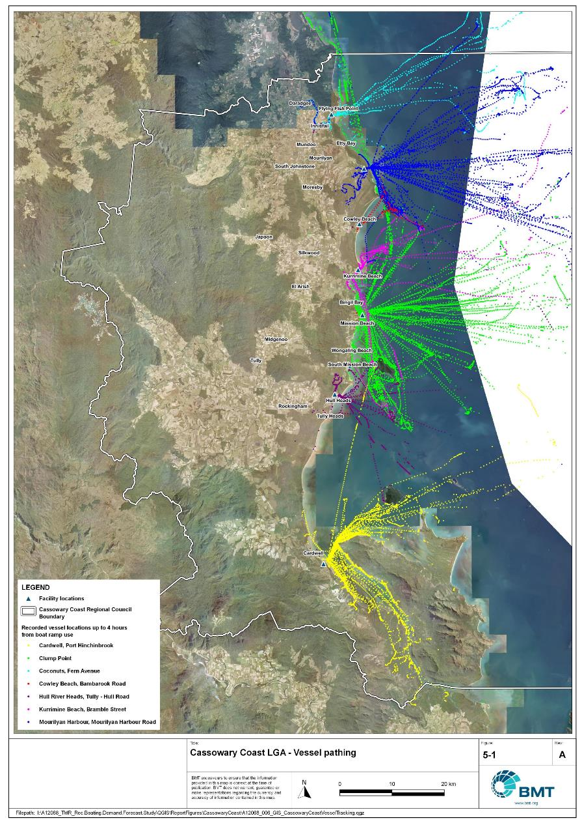

Cassowary Coast LGA – Vessel pathing

“I:\A12068_TMR_Rec.Boating.Demand.Forecast.Study\QGIS\ReportFigures\CassowaryCoast\A12068_006_GIS_CassowaryCoastVesselTracking.jpg”

## Active fleet size

The total ‘active’ fleet on a good boating day is derived from the activation rate of the total fleet of registered vessels within the LGA and the net inflow of visiting vessels. The total number of visiting vessels from each LGA is determined from the number of vessels in the resident active fleet and the relative proportion of resident to visiting vessels outlined in Table 5.1.The fleet size is expected to change over time due to changes in population and vessel acquisition trends, with the size and proportion of the fleet across the Study period described in Table 5.3.

Active fleet vessel size

| Vessel length | 2021 | 2026 | 2031 | 2036 | 2041 |
| --- | --- | --- | --- | --- | --- |
| 0 to 4.5m | 594 | 605 | 616 | 625 | 635 |
| 4.5m to 8m | 361 | 367 | 373 | 379 | 384 |
| >8m | 23 | 23 | 23 | 24 | 24 |
| Total | 978 | 995 | 1013 | 1028 | 1043 |

## Boat ramp lane demand

The fleet size derived in Table 5.3 represents the statistical demand for the LGA, with vessels under 8m assumed to contribute to boat ramp demand, measured in boat ramp lanes. As outlined in section 03.1.2 the adopted capacity of each effective lane is 40 vessels per day, with each vessel assumed to both launch and retrieve, for a total of 80 vessel movements per day. The total boat ramp lane demand across the Study period is shown in Table 5.4.

Boat ramp lane demand

|  | 2021 | 2026 | 2031 | 2036 | 2041 |
| --- | --- | --- | --- | --- | --- |
| Boat ramp lane demand | 23.9 | 24.3 | 24.7 | 25.1 | 25.5 |

For Cassowary Coast LGA the important elements that contribute to boat ramp lane demand include:

* a large sized local fleet, with a high proportion of trailable vessels
* Mmoderate to large sized fleets in the LGA to the north (Cairns), west (Tablelands) and south (Hinchinbrook, Townsville), that contribute to local demand.
* attractive destinations for visitors from south-east Queensland.

## Non-statistical demand

As well as the statistical demand outlined in the section above, facilities may face demand pressures that are related to their functional use, which reduces the capability of the facility to service the recreational boat fleet in the desired manner. Issues with specific facilities have been identified within the consultation process of the Study with appointed managers and other stakeholders. While care has been taken to identify these non-statistical demand issues throughout the Study, it is beyond the scope of the Study to individually review the functionality, safety, and amenity of each facility across Queensland. Non-statistical demand pressures may warrant upgrades to facilities even where statistical demand is satisfied by existing capacity. These pressures have been classified into the following categories:

* Amenity: Amenity describes the functional usability of the facility including the desire to provide dry entry and exit facilities, facilities that provide easy access and/or access for persons with restricted mobility.
* Safety: Safety demand may include protection from currents and waves or contact with marine creatures such as sharks, jellyfish, and crocodiles.
* In-water congestion: Where existing queuing facilities are not able to efficiently meet the needs of the facility. Such deficiency may warrant additional queuing facility capacity to optimise boat launching and retrieval.

The Study’s recommendations may alleviate these non-statistical demand pressures with consideration for capability of all facilities within the LGA. The presence of a non-statistical demand pressure at a facility may not warrant upgrades where other suitable facilities are reasonably available.

## Deep-draught vessel demand

* + 1. Cruising vessels

Vessels cruising along the east coast of Queensland have a requirement for a network of deep-draught vessel landings that are appropriately spaced to be within a day’s sailing on good weather days. These facilities are required to support the reprovisioning of vessels as they travel along the coast and provide access to desirable land-based destinations. Private marina facilities may be used by cruising vessels where there is an expectation for a prolonged stay that requires protected mooring or berthing. Within Cassowary Coast LGA suitable facilities for deep-draught vessels include the jetties in Innisfail and at Mourilyan Harbour, the pontoon berths at Clump Point, and the jetty on Dunk Island.

Within the east coast network but outside the LGA, the nearest deep-draught vessel facilities outside Cassowary Coast LGA in either direction along the coastline are 40 nautical miles to the south of Dunk Island at Dungeness, or 40 nautical miles north of Innisfail at Fitzroy Island.

The jetties in Innisfail are approximately 4 nautical miles upstream from the mouth of the Johnstone River and provide excellent access to supplies and provisions. Fuel is available at a bespoke public jetty in Innsfail by arrangement with local contractors. There are no pump-out facilities at the jetty. Throughout the LGA, jetties are mainly used as deep-draught landings, even though the general trend in Queensland is a preference for floating infrastructure (pontoons) over fixed structures (jetties). Where appropriate, consideration should be given to upgrading these facilities to floating infrastructure and including sewage pump-out facilities.

* + 1. Landing demand

Statistical demand for deep-draught vessel landings has been assessed based on the size of the non-trailable fleet within Cassowary Coast LGA. Landing demand is more difficult to assess than boat ramp lane demand as the requirements and duration of the landing influence the demand pressure but are highly variable between users. Nevertheless, the Study has assumed that 5% of the non-trailable fleet will be seeking a landing at any given time. The consultation undertaken during the Study indicates that this assumption may overestimate the number of landings, but that the landings are often utilised for other boating and recreation activities when not in use by deep-draught vessels. In particular, landings that are located near boat launching facilities may be used as queuing facilities and therefore support the efficient launching of smaller recreational vessels. Given this, the 5% assumption has been adopted noting that it may overestimate capacity, but not to an extent that it would be onerous to facility providers. Within Cassowary Coast LGA the demand for deep-draught vessel landings is outlined in Table 5.5.

Deep-draught vessel landing demand

| Requirement | 2021 | 2026 | 2031 | 2036 | 2041 |
| --- | --- | --- | --- | --- | --- |
| No. of Landings | 1.1 | 1.2 | 1.2 | 1.2 | 1.2 |

# Shortfall Assessment

## Shortfall assessment – boat ramps

The shortfall of boat ramp lanes within Cassowary Coast LGA is shown in Table 6.1 and Figure 6.1 at an LGA scale. This is presented both with and without the inclusion of additional capacity provided by the recommended upgrades.

Shortfall of boat launching facilities

| Assessment | Metric | 2021 | 2026 | 2031 | 2036 | 2041 |
| --- | --- | --- | --- | --- | --- | --- |
| Demand | Demand | 23.9 | 24.3 | 24.7 | 25.1 | 25.5 |
| Existing | Capacity | 17.1 | 17.1 | 17.1 | 17.1 | 17.1 |
| **Shortfall** | 6.8 | 7.2 | 7.6 | 8 | 8.4 |
| Improved | Capacity | 17.1 | 19.7 | 21.5 | 23.5 | 24.5 |
| **Shortfall** | 6.8 | 4.6 | 3.2 | 1.6 | 1 |

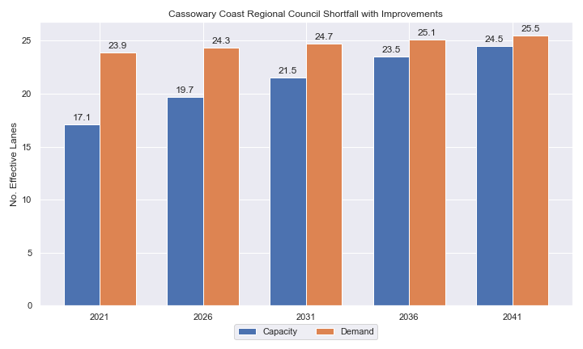

Shortfall assessment with recommended upgrades adopted.

* + 1. Open-water access shortfall in boat ramp lanes

Statistical capacity has been calculated across Cassowary Coast LGA in its entirety, however, some facilities are evidently more popular than others due to their ability to access open-water destinations, and/or their usability. In general, larger vessels are more suited to access open-water destinations while smaller vessels are more likely to remain in sheltered environments. This was identified in the 2017 study and confirmed during discussions with stakeholders. The human movement data indicates that visiting boats from other LGAs are drawn to facilities that provide access to open-water destinations. To ensure that the capacity of effective boat ramp lanes in the LGA is appropriately distributed to cater for these usage trends, it is worth assessing facilities providing this desirable access as a subset of the total capacity for the LGA. A ‘scenario’ approach to assessing this capacity (Table 6.2) has been developed, with Scenario 1 derived from empirical estimates of vessel distribution and Scenario 2 derived from the human movement statistics, and the result averaged between the two scenarios. This provides the opportunity to rationalise the figure that drives the demand and acknowledge when one scenario is not representative of the population or consistent with stakeholder feedback. The scenarios that were assessed are:

Scenario 1: 80% of larger vessels and 20% of smaller vessels from the local fleet and 80% of the visiting fleet are using the facilities with unrestricted open water access.

Scenario 2: Distributing the fleet between facilities as per the human movement statistics.

Shortfall assessment for open water, all-tide or near all-tide facilities for Cassowary Coast LGA

| Assessment | Metric | 2021 | 2026 | 2031 | 2036 | 2041 |
| --- | --- | --- | --- | --- | --- | --- |
| Overall | Capacity | 9.0 | 9.0 | 9.0 | 9.0 | 9.0 |
| Scenario 1 | Demand | 8.95 | 8.95 | 8.95 | 8.95 | 8.95 |
| Shortfall | 19.1 | 19.4 | 19.8 | 20.1 | 20.4 |
| Scenario 2 | Demand | 10.15 | 10.45 | 10.85 | 11.15 | 11.45 |
| Shortfall | 9 | 9.2 | 9.4 | 9.5 | 9.6 |
| **Average** | Demand | 0.05 | 0.25 | 0.45 | 0.55 | 0.65 |
| **Shortfall** | 14.05 | 14.3 | 14.6 | 14.8 | 15 |

Comparing the LGA-scale shortfall with the subset of facilities providing protected all-tide or near all-tide access to open water indicate that the demand is focused at this subset of facilities.

## Shortfall assessment – deep-draught landings

The shortfall of public deep-draught landings for Cassowary Coast LGA is provided in Table 6.3. The existing capacity is statistically adequate to meet demand, and the spatial distribution of landings along the coastline is satisfactory, with the jetties in Innisfail well beyond their intended design life. It is noted, however, that the majority of the landings that are accounted for in this section are jetties. Consultation with stakeholders has indicated that these specific facilities are used by deep-draught vessels, however the broader feedback from stakeholders across Queensland is that floating landing infrastructure is preferred from an amenity and safety perspective. Consideration should be given to replacing one or more of these facilities with floating infrastructure when the limit of useful design life is reached, and incorporating sewage pump out facilities as well. CCRC officers advised that master planning for the future of the Innisfail CBD waterfront area will likely call for changes to the aging public jetties.

Shortfall of deep-draught vessel landings

| Assessment | Metric | 2021 | 2026 | 2031 | 2036 | 2041 |
| --- | --- | --- | --- | --- | --- | --- |
| Deep-draught vessel landings | Demand | 1.1 | 1.2 | 1.2 | 1.2 | 1.2 |
| Capacity | 6 | 6 | 6 | 6 | 6 |
| Shortfall | -4.9 | -4.8 | -4.8 | -4.8 | -4.8 |

# Stakeholder Feedback



The Study has undertaken extensive consultation throughout its execution to achieve a comprehensive understanding of issues relating to the use of recreational boating facilities across the state. This consultation was conducted with managing authorities that own and/or and manage recreational boating facilities, as well as with facility stakeholders including recreational groups, volunteer marine rescue and coastguard organisations, and the general public. Stakeholder engagement was supplemented with site visits to facilities where key issues had been identified.

## Managing authority feedback

For Cassowary Coast LGA, the Study team met with Cassowary Coast Regional Council, Ports North (in relation to Mourilyan Harbour) and Maritime Safety Queensland to discuss recreational boating facilities within the region. This consultation process identified a range of potential opportunities to alleviate demand pressures. The Study has considered the practical implementation of each of these opportunities with respect to the required infrastructure, difficulty of implementation, and magnitude of benefit, as summarised in Table 7.1.

Stakeholder identified opportunities

| Location | Stakeholder opportunity | Review comments |
| --- | --- | --- |
| All facilities | Tend towards eventual retirement of smaller facilities and commitment to mega-facilities at deep-water locations like Clump Point, Mourilyan Harbour and Port Hinchinbrook. | While mega-facilities can provide massive amounts of capacity at popular locations, smaller, local ramps are often preferred by smaller communities due to reduced travel times and less congestion. The capacity that existing local ramps provide cannot currently be easily replaced by larger facilities. |
| Mourilyan Harbour | Provide washdown facility at Mourilyan Harbour. | Noted, but has no influence on meeting demand. |
| Mourilyan Harbour | Expand waterside facilities, acknowledging the acceptable use of overflow parking providing informal landside capacity. | Agreed. Requires Ports North to approve construction of facilities adjacent to port land, and continued permission of overflow parking. |
| Cowley Beach | Don’t replace ramp at the end of its design life, but allow site to remain as a beach access point. | Agreed. |
| Kurrimine Beach | Floating queuing infrastructure to protect from stingers when queuing at the boat ramp. | Not agreed. Floating infrastructure at this location would need to be protected from wave exposure by a breakwater, which would be both expensive and significantly detrimental to local coastal processes, for limited benefit. |
| Kurrimine Beach | 2-lane ramp with fixed sloping walkway. | Agreed for amenity and safety but not for expanded capacity. Waterside constraints (tidal range, wave action) and landside constraints (space to construct necessary CTU spaces) mean this location is not ideal for facility expansion.  A detailed usage study for recreational boating at Kurrimine Beach is recommended to understand fluctuations in ramp demand between peak and off-peak periods. This should investigate opportunities to provide temporary anchorages for those holidaying at the caravan park, such that they only require launching and retrieving once during their stay. |
| Clump Point | Provide extra parking on Porter Promenade near the existing toilet block. | This location is almost a kilometre from the boat ramp, and based on survey feedback (refer section 7.2) is considered an excessive distance for CTU parking. There would also be significant environmental, cultural heritage and geometric challenges. However, the Study understands that there are no other options for additional parking – proven by the lengthy state and federal environmental assessments and approvals associated with upgrading the Clump Point boating facility. A mini-bus link between parking and launching at busy times is a future possibility. |
| Hull River, Hull Heads | Provide a two-lane facility with a central floating walkway. | Agreed. |
| Port Hinchinbrook | Dredge the channel to provide all-tide access to open water. | Agreed that this is necessary to reinstate facility capacity, if that is supported on an ongoing basis by private and public funding entities. |
| Innisfail | Potential location for a new boat ramp on the North Johnstone River in Innisfail, near Campbell Street. | Agreed this is a good location for a boat ramp. |

## Stakeholder feedback

Broader stakeholder feedback has been conducted within The Study by undertaking virtual or face-to-face meetings with recreational boating groups and marine rescue organisations, as well as through the Recreational Boating Facility Survey (MSQ, 2022) undertaken by Maritime Safety Queensland, which included survey responses of nearly 3,000 users and open submissions. For Cassowary Coast LGA, a total of 136 submissions were received, with 85% of respondents using trailable power boats and 98% of respondents using recreational boating facilities at least once a month. For Cassowary Coast LGA, the following statistics or themes were extracted from the survey and associated comments:

* 99% of respondents typically travel less than 1hr to their preferred boat ramp (which may not be their closest facility).
* 76% of respondents indicated that floating walkways are their preferred type of queuing facility.
* 92% of respondents indicated they would be unwilling to walk further than 200m from designated CTU parking to a boat ramp.
* The most common requests for new boat ramps were at:
  + Murray River (along Bluff Road, Bilyana)
  + South Mission Beach.
* The following themes were identified with respect to existing facilities:
  + Upgrading boat ramps with pontoons (for example, Meunga Creek, Cardwell, Flying Fish Point, South Mission Beach, Carmoo), dredging and all-tide access (Port Hinchinbrook, Cardwell)
  + more parking areas for car trailers
  + provision of wash down facilities (Meunga Creek, Port Hinchinbrook)
  + fixing the existing Port Hinchinbrook facility by dredging to allow all-tide access or by providing an alternate sustainable public boat launching facility.
* Where the closest available boat launching facility was not preferred, respondents indicated that the following key aspects influenced their choice:
  + all-tide access
  + access to pontoons and floating walkways
  + more parking areas for trailers or closer parking areas to the boat ramp.
* Respondents were provided an opportunity to provide additional feedback, with the following themes identified:
  + a desire for upgrading and maintaining existing boat ramps rather than building new boat ramps
  + a high level of demand for dredging Port Hinchinbrook and Cardwell facilities
  + concerns around safety against crocodile attack, with a desire for pontoon or floating walkway installation at existing ramps.

# Development Recommendations

## Previous recommendations

The 2017 GHD assessment recommended opportunities for increasing capacity of recreational boating facilities across the state. However, the implementation of these recommendations has been low, with only 10% of the total state-wide recommendations delivered in part or full in the 5 years since the delivery of the report. Of the Priority 1 recommendations (for immediate delivery) and priority 2 recommendations (for implementation within 5 years) only 18% and 6% respectively have been delivered. State-wide only 5% of landside recommendations were delivered, while 16% of waterside recommendations were delivered.

Within Cassowary Coast LGA, one of three Priority 1 recommendations has been implemented since the delivery of the 2017 GHD study (the facility upgrade at Clump Point). The low rate of implementation of these recommendations is likely due to the area having expended considerable funds recovering from the impacts of Tropical Cyclone Yasi in 2011, along with budgetary constraints applied due to the COVID-19 pandemic. As such, the recommendations proposed in the 2017 GHD study remain generally viable. This current Study has reviewed the unimplemented 2017 recommendations (Table 8.1) for Cassowary Coast LGA in conjunction with stakeholders during the consultation process to identify previous recommendations that are:

* Still viable: The recommendation in its original form remains suitable for solving demand pressures.
* Still viable with modifications: The recommendation could remain viable with modifications identified throughout the consultation process.
* No longer viable: The recommendations are no longer suitable to be carried through as recommendations in this Study.

Recommendations from the 2017 study that are considered viable or viable with modifications may be carried forward into the recommendations of this Study with a suitable update to their priority status if required.

Assessment of unimplemented 2017 recommendations

| Location | 2017 Recommendation | 2022 Review | Review Comment |
| --- | --- | --- | --- |
| Priority 1 | | | |
| Mourilyan Harbour | Expand facility to include an additional 2 boat ramp lanes and 45 CTU spaces. | Viable with modifications. | The expansion of the waterside facilities is viable. The landside capacity provided by overflow parking (not recognised in 2017) reduces the need for the parking area to be expanded. |
| Port Hinchinbrook | Expand parking area by 25 CTU spaces. | Viable. | This is still viable, though is dependent on reinstatement of all-tide access through dredging. As there are political challenges surrounding this, timing for expansion of the parking area should align with dredging of the channel. |

## Priority recommendations

The selection and ranking of development priorities provides for progressive implementation of solutions to meet capacity shortfalls and/or resolve existing safety and usage issues at existing facilities over time. Recommendations have been split into four categories for implementation within the 20-year planning period of this Study, with the following projected timelines:

* Priority 1: For immediate planning and design.
* Priority 2: Planning and design intended to provide capacity within 5-10 years.
* Priority 3: Planning and design intended to provide capacity within 10-15 years.
* Priority 4: Planning and design intended to provide capacity within 15-20 years.

The recommendations have been structured to include consideration of the reasonable timelines for implementation. This may include consideration for budgetary processes, planning, environmental approvals, consultation periods, and construction. The priority selection of recommendations has been conducted in accordance with TMR’s Marine Infrastructure and Facilities Plan (TMR, 2020) guidelines, namely:

1. *priority to be given to the provision of sheltered all-tide or near all-tide launching facilities giving access to the open sea on an all-tide or near all-tide basis.*
2. *part-tide facilities (for launching or access) may be provided where there is demand and dredged access is not feasible. For instance, beach access or open beach ramps may be provided where there is sufficient demand and no suitable nearby sheltered waterway*
3. *the most economically viable options will take precedence, including the expansion of existing facilities, and the changing of existing foreshore land uses. In many cases, limiting or avoiding dredging and/or breakwater costs will be a crucial factor*
4. *a goal of providing access to sheltered all-tide or near all-tide boat launching facilities within one hour’s drive for significant communities*

Consequently, higher order recommendations need to address, where possible, the provision of facilities that provide maximum benefit in the widest range of conditions and will be limited to those solutions that are already significantly advanced or ‘shovel ready’ or that require limited further design, planning and approvals. Lower order recommendations will consist of solutions where there is reduced adherence to the TMR guidelines and/or there are constraints that may result in long lead times to resolve. A summary of the recommendations is provided in Table 8.2 with full detail of each recommendation in the tables that follow.

Summary of recommendations for Cassowary Coast LGA

| Priority | Description | Landside or Waterside | Increased capacity  (effective lanes) |
| --- | --- | --- | --- |
| 1 | Coconuts: Install parking area for 18 CTUs to the east. | Landside | 0.5 effective lanes |
| 1 | Mourilyan Harbour: Reclaim land to construct 2 lanes and floating walkway to the west of existing ramp. | Waterside | 2.05 effective lanes |
| 2 | Hull River Heads: Construct a new boat ramp lane and formalise 40 CTU parking spaces on the road to the south. | Both | 1.75 effective lanes |
| 3 | Campbell Street, Innisfail: Construct a 2-lane boat ramp facility with 45 CTU parking spaces. | Both | 2.0 effective lanes |
| 4 | Port Hinchinbrook: Undertake dredging feasibility study to assess if all-tide access can be established and maintained in a fiscally responsible manner. If it can, formalise an increase to 90 CTUs and dredge channel to allow all-tide access. | Both | 1.0 effective lanes |

## Priority 1 recommendations

Coconuts (Priority 1)

|  |  |  |  |  |
| --- | --- | --- | --- | --- |
| General description | | | | |
| Location | The Esplanade, Coconuts, north bank of Johnstone River | | | |
| Existing Facility? | Yes | | | |
| Coordinates | -17.50709240, 146.06254565 | | | |
| Existing tidal status | All-tide | | | |
| Existing wave exposure | None | | | |
| Existing current exposure | None | | | |
| Proposed works | Formalise grass verge to the east of the ramp to fit 18 CTUs parking spaces, trialling signage before formalisation with markers/linework. | | | |
| Increased effective capacity | 0.5 effective lanes | | | |
| Capacity improvement position | Waterside | Landside | | Both |
| Rationale | The hardstand area to the west has recently been lined-marked to provide formalised parking, although this facility still has considerably more capacity on the waterside. Expansion of parking facilities on the downstream side will improve the landside capacity in line with the waterside capacity. Informal roadside parking in the area can also be improved with signage. | | | |
| Anticipated Costs (+/- 50%) | Waterside infrastructure | | N/A | |
| Landside infrastructure | | $100,000 | |
| Planning, environmental and approvals constraints | | | | |
| Assessment | Requirements | Comments | | |
| Fish Habitat Zone | X | N/A | | |
| Native Title | X | N/A | | |
| MCU requirement | X | N/A | | |
| Clearing remnant vegetation | ü | RVM category R- reef- regrowth. Landholders intending to clear in a category R area must notify DoR, unless no native vegetation within 50m of regrowth watercourse. | | |
| GBRWHA | X | N/A | | |
| Marine Park | X | N/A | | |
| Tidal works assessment | X | N/A | | |
| Other as required | ü | Marine Plants – Carpark works may require clearing of marine plants and therefore will require a Development Permit for marine plant disturbance. | | |
| Sea Level Rise | ü | The proposed works are partially within the boundaries of the erosion-prone area (south-east car park). However, the northern portion of the proposed works is not. | | |
| Storm Tide Hazard | ü | The proposed works are partially within the boundaries of a high/medium hazard area. However, the northern portion of the proposed works is not. | | |
| Anticipated Complexity | Low | Medium | | High |

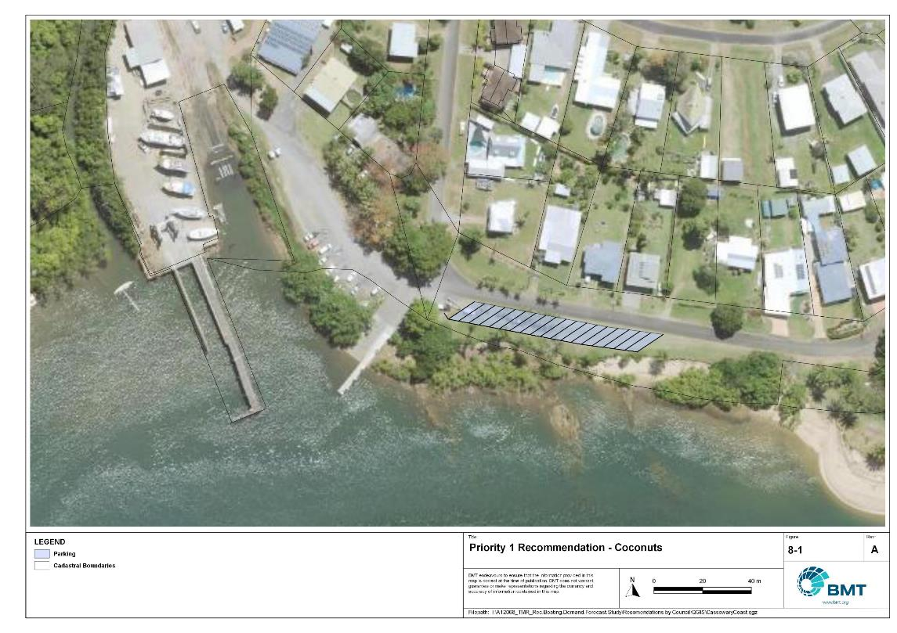

Priority 1 Recommendation - Coconuts

"I:\A12068_TMR_Rec.Boating.Demand.Forecast.Study\Recomendations by Council\JPG\CassowaryCoast\A12068_005_CassowaryCoastProposedUpgrades_8-1.jpg"

Mourilyan Harbour (Priority 1)

|  |  |  |  |  |
| --- | --- | --- | --- | --- |
| General description | | | | |
| Location | Mourilyan Harbour Road, Mourilyan | | | |
| Existing Facility? | Yes | | | |
| Coordinates | -17.60119927, 146.12102180 | | | |
| Existing tidal status | All-Tide | | | |
| Existing wave exposure | None | | | |
| Existing current exposure | None | | | |
| Proposed works | Reclaim land, construct revetment and add 2 lanes and a floating walkway to the west of the existing ramp. | | | |
| Increased effective capacity | 2.05 effective lanes | | | |
| Capacity improvement position | Waterside | Landside | | Both |
| Rationale | As an all-tide, all weather facility, this has potential to serve an even greater portion of Cassowary Coast’s population. Existing overflow parking on the vacant land parcel to the west serves as informal overflow for approximately 70 CTUs. As such raising the waterside capacity is viable and suitable, provided Ports North continues to allow that area or a similar area to be available for informal parking. | | | |
| Anticipated Costs (+/- 50%) | Waterside infrastructure | | $1,550,000 | |
| Landside infrastructure | | N/A | |
| Planning, environmental and approvals constraints | | | | |
| Assessment | Requirements | Comments | | |
| Fish Habitat Zone | X | N/A | | |
| Native Title | X | N/A | | |
| MCU requirement | X | N/A | | |
| Clearing remnant vegetation | X | N/A | | |
| GBRWHA | ü | Adding two additional lanes and a floating walkway both located within the GBRWHA could require a Controlled Activity Approval. | | |
| Marine Park | X | N/A | | |
| Tidal works assessment | ü | Adding two additional lanes and a floating walkway will likely be tidal works and require a Development Permit. | | |
| Other as required | ü | Marine Plants – Boat ramp and floating walkway works may require clearing of marine plants and therefore will require a Development Permit for marine plant disturbance.  Quarry Material Allocation – if the reclamation is undertaken using dredged material, it will require a Quarry Material Allocation. | | |
| Sea Level Rise | ü | The proposed works are partially within the boundaries of the erosion-prone area (two additional lanes, floating walkway) however, the car park is not. | | |
| Storm Tide Hazard | ü | The proposed boat ramp and floating walkway works are within the boundaries of a high hazard area and the expansion on the carpark is within the boundaries of a medium/high hazard area. | | |
| Anticipated Complexity | Low | Medium | | High |

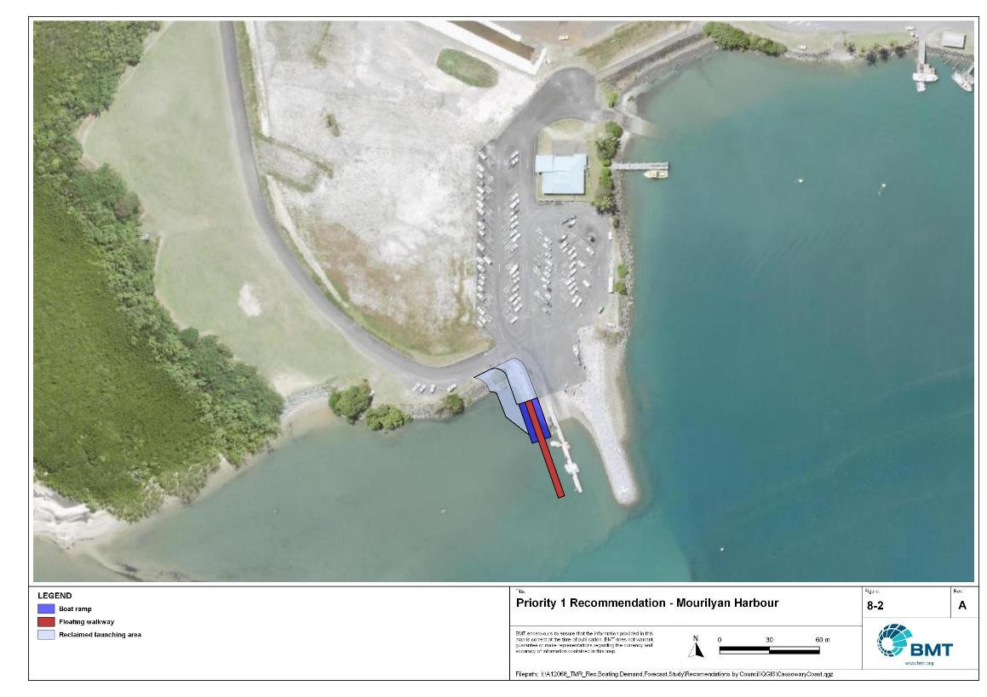

Proposed Upgrade: Mourilyan Harbour (Priority 1)

"I:\A12068_TMR_Rec.Boating.Demand.Forecast.Study\Recomendations by Council\JPG\CassowaryCoast\A12068_005_CassowaryCoastProposedUpgrades_8-2.jpg"

## Priority 2 recommendations

Hull River, Hull Heads (Priority 2)

|  |  |  |  |  |
| --- | --- | --- | --- | --- |
| General description | | | | |
| Location | South bank of Hull River, upstream of Hull Heads | | | |
| Existing Facility? | Yes | | | |
| Coordinates | -17.99052878, 146.06616900 | | | |
| Existing tidal status | Part-tide | | | |
| Existing wave exposure | None | | | |
| Existing current exposure | Exposed | | | |
| Proposed works | Construct a new boat ramp lane to the south of the existing ramp. Formalise 40 CTU parking spaces and a turnaround facility on Tully Hull Road to the south. | | | |
| Increased effective capacity | 1.75 effective lanes | | | |
| Capacity improvement position | Waterside | Landside | | Both |
| Rationale | Adds to waterside capacity with an extra working face of the existing floating walkway as well as a new lane. | | | |
| Anticipated Costs (+/- 50%) | Waterside infrastructure | | $210,000 | |
| Landside infrastructure | | $150,000 | |
| Planning, environmental and approvals constraints | | | | |
| Assessment | Requirements | Comments | | |
| Fish Habitat Zone | X | N/A | | |
| Native Title | X | N/A | | |
| MCU requirement | X | N/A | | |
| Clearing remnant vegetation | X | N/A | | |
| GBRWHA | ü | Adding a new boat lane located within the GBRWHA could require a Controlled Activity Approval. | | |
| Marine Park | X | N/A | | |
| Tidal works assessment | ü | Adding a new boat lane will likely be tidal works and require a Development Permit. | | |
| Other as required | ü | Marine Plants – Boat ramp works may require clearing of marine plants and therefore will require a Development Permit for marine plant disturbance. | | |
| Sea Level Rise | ü | The proposed works are partially within the boundaries of the erosion prone area (boat ramp), however, the car park is not. | | |
| Storm Tide Hazard | ü | The proposed boat ramp works are within the boundaries of a high hazard area however the new car park is not within the boundaries of a medium/high hazard area. | | |
| Anticipated Complexity | Low | Medium | | High |

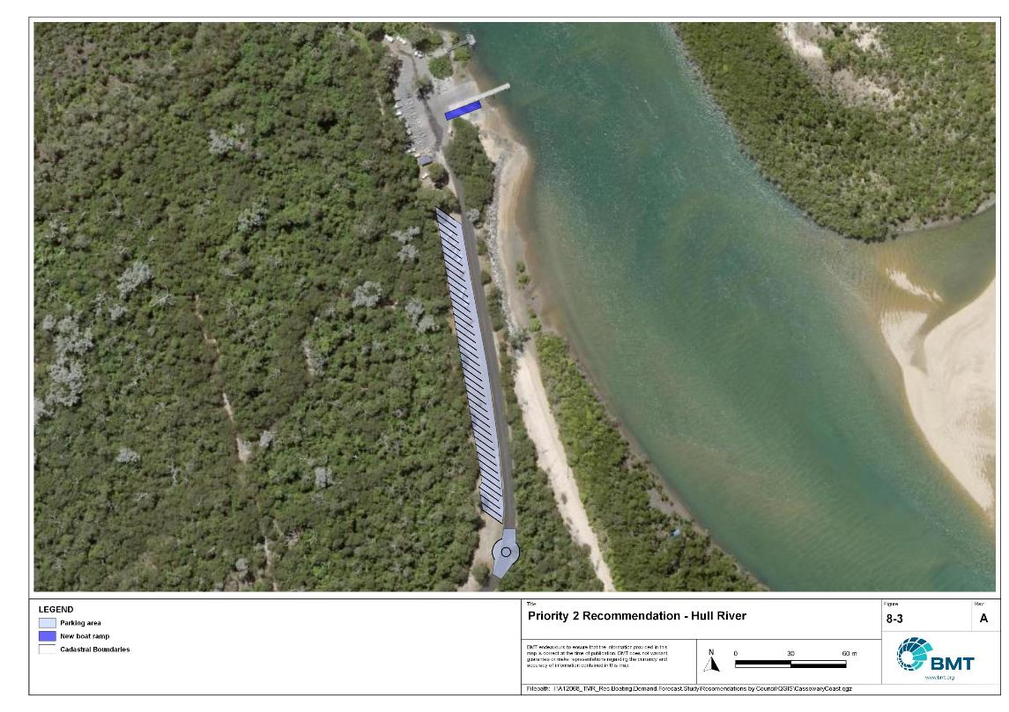

Proposed Upgrade: Hull River, Hull Heads (Priority 2)

"I:\A12068_TMR_Rec.Boating.Demand.Forecast.Study\Recomendations by Council\JPG\CassowaryCoast\A12068_005_CassowaryCoastProposedUpgrades_8-3.jpg"

## Priority 3 recommendations

Campbell Street, Innisfail (Priority 3)

|  |  |  |  |  |
| --- | --- | --- | --- | --- |
| General Description | | | | |
| Location | Corner of Campbell and Anthony Street, Innisfail, on the North Johnstone River. | | | |
| Existing Facility? | No | | | |
| Coordinates | -17.51552182, 146.03004021 | | | |
| Existing tidal status | N/A – All-tide once complete | | | |
| Existing wave exposure | N/A – None once complete | | | |
| Existing current exposure | N/A – Exposed once complete | | | |
| Proposed works | Construct a 2-lane boat ramp with a central queuing structure (fixed sloping walkway likely best option due to flood current velocities) and 45 CTU parking spaces. | | | |
| Increased effective capacity | 2.0 effective lanes | | | |
| Capacity improvement position | Waterside | Landside | | Both |
| Rationale | Improving the access to the North Johnstone River in Innisfail is a desire, as the current facility at Edith Street has limited capacity due to landside constraints. This location is close to the main population area, has access to the river and room for future expansion of the car park if necessary. | | | |
| Anticipated Costs (+/- 50%) | Waterside infrastructure | | $1,400,000 | |
| Landside infrastructure | | $750,000 | |
| Planning, environmental and approvals constraints | | | | |
| Assessment | Requirements | Comments | | |
| Fish Habitat Zone | X | N/A | | |
| Native Title  (Djirbalngan People) | ü | New tenure will be required for the proposed facility and therefore interaction with Native Title. | | |
| MCU requirement | ü | Carpark works may trigger a Development Permit for a Material Change of Use. | | |
| Clearing remnant vegetation | ü | Proposed works is within a declared RVM category R – reef-regrowth watercourse vegetation area. A Development Permit may be required for clearing of remnant vegetation. | | |
| GBRWHA | ü | Proposed marine-based works may be within the GBRWHA. This may trigger a Controlled Activity Approval if there is deemed to be a significant impact. | | |
| Marine Park | X | N/A | | |
| Tidal works assessment | ü | Works will likely be tidal works and therefore require a Development Permit. | | |
| Other as required | X | N/A | | |
| Sea Level Rise | ü | The boat ramp is within the boundaries of an erosion prone area subject to sea level rise. | | |
| Storm Tide Hazard | ü | The carpark works is within the boundaries of a medium storm tide hazard area while the boat ramp is within a high storm tide hazard area. | | |
| Anticipated Complexity | Low | Medium | | High |
| Maritime engineering review | | | | |
| Assessment | Requirements | Comments | | |
| Engineering matters | Current Forces | Site may be subject to moderate to high currents and further assessment of the impact on this recommendation is required. | | |
| Constructability | Constructability of this facility is dependent on the ground and water levels, which will determine required boat ramp length, as well as geotechnical suitability of the riverbank for construction. | | |
| Anticipated Complexity | Low | Medium | | High |

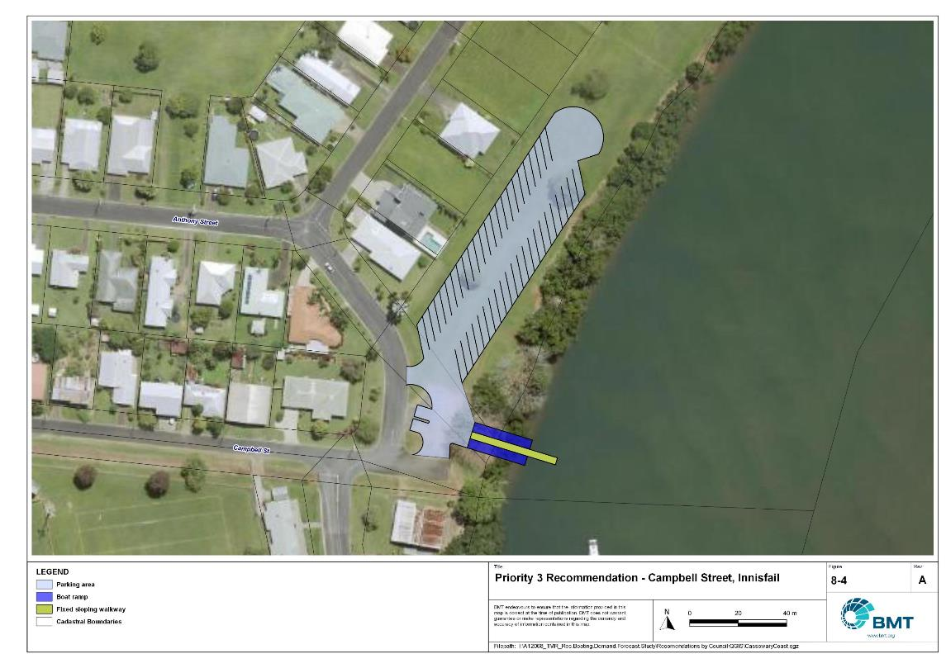

Proposed Upgrade: Campbell Street, Innisfail (Priority 3)

"I:\A12068_TMR_Rec.Boating.Demand.Forecast.Study\Recomendations by Council\JPG\CassowaryCoast\A12068_005_CassowaryCoastProposedUpgrades_8-4.jpg"

## Priority 4 Recommendations

Port Hinchinbrook (Priority 4)

|  |  |  |  |  |
| --- | --- | --- | --- | --- |
| General description | | | | |
| Location | Stony Creek, Port Hinchinbrook, south of Cardwell CBD | | | |
| Existing Facility? | Yes | | | |
| Coordinates | -18.28285630, 146.04427474 | | | |
| Existing tidal status | Part-Tide | | | |
| Existing wave exposure | None | | | |
| Existing current exposure | None | | | |
| Proposed works | Undertake dredging feasibility study to assess if all-tide access can be established and maintained in a fiscally responsible manner. If it can, formalise an increase to 90 CTUs and dredge channel to allow all-tide access. | | | |
| Increased effective capacity | +1.0 effective lanes | | | |
| Capacity improvement position | Waterside | Landside | | Both |
| Rationale | This facility requires dredging to reinstate all-tide, all-weather access for southern Cassowary Coast communities. Parking expansion to maximise capacity is only worthwhile if the dredged channel is maintained.  Once administrative issues associated with the future management of the broader development are resolved, this recommendation should be progressed to a higher priority. | | | |
| Anticipated Costs (+/- 50%) | Waterside infrastructure | | TBC | |
| Landside infrastructure | | TBC | |
| Planning, environmental and approvals constraints | | | | |
| Assessment | Requirement | Comments | | |
| Fish Habitat Zone | X | N/A | | |
| Native Title | X | N/A | | |
| MCU requirement | ü | Dredging constitutes a Concurrence ERA (ERA 16(1)) and will require a Development Permit for a Material Change of Use. | | |
| Clearing remnant vegetation | ü | RVM category R- reef- regrowth. Landholders intending to clear in a category R area must notify DoR, unless no native vegetation within 50m of regrowth watercourse. | | |
| GBRWHA | X | N/A | | |
| Marine Park | X | N/A | | |
| Tidal works assessment | ü | Dredging works may be tidal works and require a Development Permit, unless existing approvals remain. | | |
| Sea Level Rise | ü | The proposed works is not within the boundaries of the erosion prone area. However, the northern tip of the current car park is within the boundaries of the erosion prone area, meaning existing level of risk will not be increased. | | |
| Storm Tide Hazard | ü | The proposed works is not within the boundaries of a high/medium hazard area. However, the northern portion of the current carpark has a high/medium hazard area. | | |
| Anticipated Complexity | Low | Medium | | High |
| Maritime engineering review | | | | |
| Assessment | Site consideration | Comments | | |
| Engineering matters | Sediment Transport | This recommendation requires further investigation to ensure undesirable siltation or disruption to sediment transport does not occur. | | |
| Anticipated complexity | Low | Medium | | High |

Proposed Upgrade: Stony Creek, Port Hinchinbrook (Priority 4)

"I:\A12068_TMR_Rec.Boating.Demand.Forecast.Study\Recomendations by Council\JPG\CassowaryCoast\A12068_005_CassowaryCoastProposedUpgrades_8-5.jpg"

# References

Australian Bureau of Statistics (ABS), 2021, *2021 Census,* <https://www.abs.gov.au/census>

Bell, Frederick W. 2022, *Estimation of the present and projected demand and supply of boat ramps for Florida's coastal regions and counties*, Florida State University, Department of Economics.

BMT, 2015, *MPSC Managed Boating Facilities Demand and Capacity Study: Boat Ramp Modelling*

Department of Transport and Main Roads (TMR), 2020, Marine facilities and infrastructure plan.

GHD, 2011, *Recreational Boating Facilities Demand Forecasting Study*

GHD, 2017, *Queensland Recreational Boating Facilities Demand Forecasting Study 2017.*

Maritime Safety Queensland (MSQ), 2022, *Recreational Boating Facilities,* <https://www.getinvolved.qld.gov.au/gi/consultation/8850/view.html>

Queensland Government Department of Resources (DoR), 2022, *Cities and towns [OGC WMS Service]*, Accessed 5/10/2022, available online at spatial.information.qld.gov.au/arcgis/home/item.html?id=103c7c9ccca449fab79d27cde06868ab

Rose, T., R. Powell & J. Yu (2009). Identification of the Present and Future Recreational Boating Infrastructure in Redland City – A 10 Year Infrastructure Plan- Griffith University

SKM (1998) Public Boat Ramps Central Queensland Strategic Plan - Volume One - Demand Forecasting - Noosa to Yeppoon. Sinclair Knight Merz, March 1998.

Swett, R., Fik, T., Ruppert, T., Davidson, G., Guevara, C. & Betty Staugler, 2012, *Planning for the future of recreational boating access to charlotte county waterways: 2010 – 2050*, Florida Sea Grant, University of Florida.

Western Australia Department of Transport, 2019, *Perth Recreational Boating Facilities Study Review 2019*, https://www.transport.wa.gov.au/mediaFiles/marine/MAC_P_Perth_RBFS_study_review_2019.pdf

Western Australia Department of Transport, 2021, *South West Region Recreational Boating Facilities Study July 2021,* https://www.transport.wa.gov.au/mediaFiles/marine/MAC_P_SouthWest_RBFS_Study_2021.pdf

###### Demand Study

"G:\Admin\A12068.g.mpb.TMRBoatingDemand\06_Reports\09_Demand Study\2022_2119 (016) Final Demand Report (March 2023).pdf"

###### Boat launching facility capacity

Capacity of existing boat launching facilities

| Facility ID | Facility name | | No. lanes | Tidal access at boat ramp | Tidal access to open water | Queuing facility | Formal CTUs | Informal CTUs | Waterside capacity | Landside capacity | Effective capacity | Constraint |
| --- | --- | --- | --- | --- | --- | --- | --- | --- | --- | --- | --- | --- |
|  | | **Open Water Access** | | | | | | | | | | |
| CW15 | Cardwell, Port Hinchinbrook | | 3 | Part-Tide | Part-Tide | Floating Walkway | 46 |  | 2.35 | 2.25 | 2.25 | Landside |
| JS22 | Clump Point light-duty boat ramp | | 2 | All-Tide | All-Tide | Floating Walkway | 22 |  | 3.4 | 1.25 | 1.25 | Landside |
| JS30 | Clump Point heavy-duty boat ramp | | 1 | All-Tide | All-Tide | Floating Walkway | 22 |  | 1.7 | 1.25 | 1.25 | Landside |
| JS47 | Mourilyan Harbour, Mourilyan Harbour Road | | 3 | All-Tide | All-Tide | Floating Walkway | 75 | 70 | 4.7 | 6.75 | 4.7 | Waterside |
| JS56 | Coconuts, Fern Avenue | | 2 | All-Tide | All-Tide | Floating Walkway | 13 | 5 | 3 | 1.25 | 1.25 | Landside |
| JS71 | Innisfail, Edith Street | | 1 | All-Tide | All-Tide | Pontoon | 6 |  | 1.2 | 0.5 | 0.5 | Landside |
| **Subtotal** |  | | **12** |  |  |  | **184** | **75** | **16.35** | **13.25** | **11.2** |  |
|  | | **Distance-limited** | | | | | | | | | | |
| CW61 | Rungoo, Fishers Creek | | 1 | Part-Tide | Part-Tide | None | 15 |  | 0.5 | 1.5 | 0.5 | Waterside |
|  | South Mission Beach, Jackey Jackey Street | | 1 | Part-Tide | Part-Tide | Pontoon | 20 |  | 0.5 | 1.25 | 0.5 | Waterside |
| Subtotal |  | | 2 |  |  |  | 35 | 0 | 1 | 2.75 | 1 |  |
|  | | **Depth-limited** | | | | | | | | | | |
| CW16 | Cardwell, Meunga Creek Boat Ramp Road | | 1 | Part-Tide | Part-Tide | None | 0 | 8 | 0.5 | 1 | 0.5 | Waterside |
| CW22 | Tully Heads, Galmahra Street | | 1 | Part-Tide | Part-Tide | None | 15 |  | 0.5 | 1.5 | 0.5 | Waterside |
| CW25 | Carmoo, Hull Drive | | 1 | All-Tide | Part-Tide | None | 12 |  | 1 | 1 | 1 | Waterside |
| CW33 | Hull River Heads, Tully - Hull Road | | 2 | Part-Tide | Part-Tide | Pontoon | 0 | 7 | 1.45 | 0.5 | 0.5 | Landside |
| JS32 | Kurrimine Beach, Maria Creek | | 1 | Part-Tide | Part-Tide | None | 0 | 6 | 0.5 | 0.75 | 0.5 | Waterside |
| **Subtotal** |  | | **6** |  |  |  | **27** | **21** | **3.95** | **4.75** | **3** |  |
|  | | **Beach ramps** | | | | | | | | | | |
| CW17 | Cardwell, Sheridan Street | | 1 | Part-Tide | Part-Tide | Pontoon | 12 |  | 0.3 | 1 | 0.3 | Waterside |
| CW41 | South Mission Beach, Kennedy Esplanade | | 1 | Part-Tide | Part-Tide | Beach | 0 | 6 | 0.28 | 0.5 | 0.28 | Waterside |
| JS31 | Kurrimine Beach, Bramble Street | | 2 | Part-Tide | Part-Tide | Beach | 0 | 13 | 0.55 | 1 | 0.55 | Waterside |
| JS36 | Cowley Beach, Bambarook Road | | 1 | Part-Tide | Part-Tide | Beach | 0 | 6 | 0.28 | 0.5 | 0.28 | Waterside |
| JS51 | Flying Fish Point, Flying Fish Point Road | | 1 | All-Tide | Part-Tide | Beach | 5 |  | 0.55 | 0.5 | 0.5 | Landside |
| **Subtotal** |  | | **6** |  |  |  | **17** | **25** | **1.96** | **3.5** | **1.91** |  |
|  | | **Total effective capacity** | | | | | | | | | **17.11** |  |

###### Travel time statistics

Travel time from population centres to nearest sheltered all-tide or near all-tide open water accessible facilities

| Population Centre | Travel time (mins) |
| --- | --- |
| Bingil Bay | 4.7 |
| Cardwell | 41.3 |
| Cowley Beach | 20.0 |
| Daradgee | 7.7 |
| El Arish | 14.2 |
| Etty Bay | 10.2 |
| Flying Fish Point | 2.4 |
| Googarra Beach | 36.0 |
| Hull Heads | 37.1 |
| Innisfail | 0.2 |
| Japoon | 20.3 |
| Kurrimine Beach | 24.5 |
| Midgenoo | 20.6 |
| Mission Beach | 1.9 |
| Moresby | 8.4 |
| Mourilyan | 4.8 |
| Mundoo | 4.2 |
| Rockingham | 33.0 |
| Silkwood | 17.6 |
| South Johnstone | 7.2 |
| South Mission Beach | 10.2 |
| Tully | 23.0 |
| Tully Heads | 37.5 |
| Wangan | 5.3 |
| Wongaling Beach | 7.6 |

###### Facility Use

Boat launching facility usage statistics

| Facility ID | Facility name | Total reports | Cassowary Coast | Cairns | Townsville | Hinchinbrook | Tablelands | Brisbane | Mackay | Gold Coast | Moreton Bay | Mareeba | Other LGAs |
| --- | --- | --- | --- | --- | --- | --- | --- | --- | --- | --- | --- | --- | --- |
| Total |  | 13991 | 6891 | 1630 | 1208 | 751 | 454 | 286 | 189 | 176 | 157 | 155 | 2094 |
| Total % |  | 100% | 49.3% | 11.7% | 8.6% | 5.4% | 3.2% | 2.0% | 1.4% | 1.3% | 1.1% | 1.1% | 15.0% |
| JS30 | Clump Point heavy-duty boat ramp | 2639 | 49.2% | 11.4% | 9.6% | 0.9% | 1.6% | 2.3% | 1.8% | 2.0% | 1.2% | 1.2% | 18.7% |
| JS47 | Mourilyan Harbour, Mourilyan Harbour Road | 1882 | 52.7% | 15.1% | 5.3% | 0.3% | 9.4% | 1.6% | 1.1% | 1.2% | 0.6% | 1.2% | 11.6% |
| JS31 | Kurrimine Beach, Bramble Street | 1670 | 49.1% | 14.9% | 9.0% | 1.6% | 3.0% | 2.6% | 2.0% | 1.6% | 0.8% | 1.6% | 13.9% |
| CW41 | South Mission Beach, Kennedy Esplanade | 1210 | 43.3% | 12.8% | 9.0% | 1.7% | 2.5% | 2.6% | 1.0% | 2.1% | 2.3% | 0.7% | 22.1% |
| CW15 | Cardwell, Port Hinchinbrook | 992 | 29.9% | 8.6% | 24.6% | 4.2% | 2.6% | 3.0% | 2.1% | 0.3% | 1.8% | 2.0% | 20.8% |
| JS71 | Innisfail, Edith Street | 941 | 77.5% | 11.2% | 1.6% | 0.2% | 1.5% | 1.1% | 0.5% | 0.3% | 0.5% | 0.2% | 5.4% |
| CW61 | Rungoo, Fishers Creek | 776 | 4.3% | 1.4% | 10.3% | 76.9% | 0.3% | 0.1% | 0.8% | 0.0% | 1.0% | 0.3% | 4.6% |
| JS51 | Flying Fish Point, Flying Fish Point Road | 738 | 66.7% | 13.6% | 3.0% | 0.1% | 2.7% | 1.5% | 1.2% | 0.3% | 0.7% | 0.7% | 9.6% |
| CW33 | Hull River Heads, Tully - Hull Road | 672 | 63.8% | 5.2% | 7.0% | 0.7% | 2.2% | 0.6% | 1.0% | 1.0% | 1.5% | 1.3% | 15.5% |
| JS56 | Coconuts, Fern Avenue | 669 | 63.5% | 12.7% | 5.4% | 0.1% | 2.8% | 2.7% | 0.9% | 1.6% | 0.7% | 0.1% | 9.3% |
| CW51 | South Mission Beach, Jackey Jackey Street | 587 | 52.6% | 7.3% | 4.1% | 1.0% | 1.0% | 4.3% | 2.2% | 2.4% | 0.5% | 0.7% | 23.9% |
| JS36 | Cowley Beach, Bambarook Road | 337 | 45.7% | 22.0% | 6.8% | 2.1% | 3.6% | 0.6% | 0.3% | 0.6% | 1.2% | 0.9% | 16.3% |
| JS32 | Kurrimine Beach, Maria Creek | 287 | 43.9% | 19.9% | 10.5% | 0.7% | 7.0% | 0.7% | 1.0% | 0.0% | 0.3% | 4.2% | 11.8% |
| CW16 | Cardwell, Meunga Creek Boat Ramp Road | 210 | 29.5% | 9.0% | 20.0% | 2.9% | 3.3% | 1.0% | 1.9% | 0.5% | 3.8% | 3.8% | 24.3% |
| CW17 | Cardwell, Sheridan Street | 147 | 40.1% | 6.8% | 8.2% | 2.7% | 0.0% | 7.5% | 1.4% | 1.4% | 0.7% | 1.4% | 29.9% |
| CW22 | Tully Heads, Galmahra Street | 138 | 57.2% | 6.5% | 7.2% | 1.4% | 9.4% | 0.7% | 0.0% | 1.4% | 0.7% | 0.0% | 15.2% |
| CW25 | Carmoo, Hull Drive | 96 | 66.7% | 7.3% | 11.5% | 0.0% | 1.0% | 2.1% | 0.0% | 0.0% | 3.1% | 0.0% | 8.3% |

|  |  |  |
| --- | --- | --- |
|  |  | BMT is a leading design, engineering, science and management consultancy with a reputation for engineering excellence. We are driven by a belief that things can always be better, safer, faster and more efficient. BMT is an independent organisation held in trust for its employees. |

|  |  |  |  |  |  |  |  |  |
| --- | --- | --- | --- | --- | --- | --- | --- | --- |
|  |  |  |  |  |  |  | Contact us  enquiries@bmtglobal.com  www.bmt.org  Follow us  www.bmt.org/linkedin  www.bmt.org/youtube YouTube logo.  www.bmt.org/twitter Twitter logo.  www.bmt.org/facebook Facebook logo. |  |
|  | Level 5  348 Edward Street  Brisbane  QLD 4000  Australia  +61 7 3831 6744 |  | Registered in Australia  Registered no. 010 830 421  Registered office  Level 5, 348 Edward Street,  Brisbane QLD 4000 Australia |  |  |  |  |
|  | For your local BMT office visit www.bmt.org | | |  |  |  |  |  |