|  |
| --- |
| Queensland Recreational Boating Facilities Demand Forecasting Study 2022  Fraser Coast LGA Assessment |
|  |
|  |

|  |  |  |
| --- | --- | --- |
| Customer |  | Maritime Safety Queensland |
| Project |  | A12068 |
| Deliverable |  | 010 |
| Version |  | 01 |
|  |  | 21 April 2023 |

Document Control

Document Identification

|  |  |
| --- | --- |
| Title | Queensland Recreational Boating Facilities Demand Forecasting Study 2022 |
| Project No | A12068 |
| Deliverable No | 010 |
| Version No | 01 |
| Version Date | 21 April 2023 |
| Customer | Maritime Safety Queensland, a branch of the Department of Transport and Main Roads |
| Customer Contact | boatinginfrastructure@msq.qld.gov.au |
| Classification | {None} |

|  |  |
| --- | --- |
| Author | Daniel Wishaw, Nicholas Heiner, Geoff Long, Azam Dolatshah, Sophie Barrett, Mackenzie Stacey |
| Reviewed By | Katrina O’Malley-Jones, Jeremy Visser |
| Project Manager | Daniel Wishaw |

Amendment Record

The Amendment Record below records the history and issue status of this document.

| Version | Version Date | Distribution | Record |
| --- | --- | --- | --- |
| 00 | 31 March 2023 | Maritime Safety Queensland  Fraser Coast Regional Council | Draft |
| 01 | 21 April 2023 | Maritime Safety Queensland | Final |

Executive Summary

This report, part of the Queensland Recreational Boating Facilities Demand Forecasting Study 2022 (‘the Study’), provides a summary of current and forecast demand on recreational boating facilities in Fraser Coast LGA and the capacity of existing facilities to meet this demand. Where capacity is insufficient to meet current or forecast demand, recommendations have been made to improve existing facilities or for the construction of new facilities. This report is intended to support facility deliverers, owners, and managers over the next 20 years in their decision-making on development priorities for recreational boating facilities within Fraser Coast LGA.

Key issues and attributes of recreational boating

The key attributes of recreational boating facilities identified in this Study for Fraser Coast LGA are summarised in Table 1, while consultation with stakeholders undertaken as part of the Study identified the following key issues:

* strong tourism pressure, particularly from south-east Queensland, contributing to significant demand for boat launching facilities
* high demand for protected, all-tide or near all-tide facilities
* dispersed population requiring a sub-LGA scale consideration of capacity distribution.

1. Key recreational boating attributes for Fraser Coast LGA

| Key attribute | Value |
| --- | --- |
| Deep-draught landing facilities |  |
| Existing demand (number) | 3.1 |
| Existing capacity (number) | 3 |
| Existing shortfall (number) | 0.1 |
| Boat launching facilities |  |
| Number of existing facilities | 24 |
| Current demand for boat launching lanes (effective lanes) | 43.3 |
| Number of existing ‘effective’ boat launching lanes | 28.3 |
| Current shortfall of ‘effective’ boat launching lanes (number) | 15.0 |
| Demand satisfaction for ‘effective’ boat launching lanes | 65% |
| State-wide demand satisfaction for ‘effective’ boat launching lanes | 87% |

Demand summary

The assessment of recreational boating demand is centred on a statistical demand model that considers vessel registration data, population statistics, assumptions around local usage and the movement of vessels into and out of the LGA. Key parameters from this assessment for Fraser Coast LGA are:

* The population is 107,817 as at the 2021 census and is projected to be 130,631 by 2041.
* As of July 2022, there is a total of 12,615 vessels with a home registration within the LGA, with 96% being ‘trailable’ – and therefore requiring boat launching facilities – and 4% being non-trailable.
* Fraser Coast LGA is deemed to be a Regional Centre with an assumed vessel activation rate of 12% on a ‘good boating day’.
* Vessels are primarily used within the LGA, with some leakage to Gladstone and Gympie LGAs.
* Vessels from Gladstone, Gympie, Brisbane, Moreton Bay, Gold Coast and Sunshine Coast LGAs flow into the LGA and contribute to local demand.
* The existing demand for boat launching facilities is 43.3 ‘effective’ boat ramp lanes and projected 49.0 ‘effective’ lanes by 2041. As presented in Table 1, the current capacity is 28.3 ‘effective’ boat ramp lanes.
* The existing demand for deep-draught vessel landings is three currently and projected to remain stable by 2041. As presented in Table 1, the current capacity is three deep-draught vessel landings.

Boat launching

Boat launching facilities comprise boat ramps, any queuing facilities (floating walkways, pontoons, beaches, and fixed sloping walkways) and the provision of car-trailer unit (CTU) parking. The capacity of a boat launching facility is measured in ‘effective lanes’ for both waterside and landside facilities, with the total capacity of a facility being the minimum of the waterside or landside capacity. Waterside capacity is calculated from the number of boat ramp lanes multiplied by environmental reduction factors (for tide, current or waves) and queuing facility improvement factors to derive the number of ‘effective’ lanes. The landside capacity is calculated from the number of available CTU parking spaces.

Fraser Coast LGA has 24 boat launching facilities, comprising 42 boat ramp lanes with a total effective boat launching capacity of 28.3 ‘effective’ lanes. Nine of these facilities are constrained by waterside capacity with the remainder constrained by landside capacity.

The capacity, forecast demand, and shortfall of boat ramp ‘effective’ lanes in Fraser Coast LGA is shown in Figure 1.

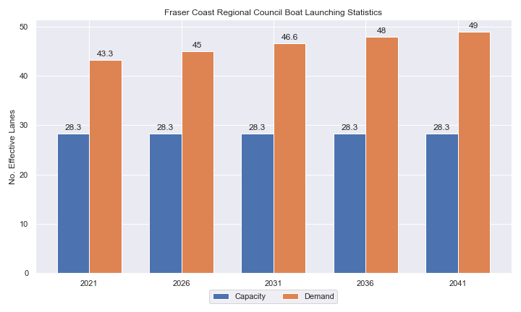

1. Existing capacity, forecast demand and shortfall of ‘effective’ boat ramp lanes for Fraser Coast LGA

Deep-draught vessel landings

Vessel landing facilities are provided across the state in the form of pontoons and jetties, to provide locations for larger vessels, or their tenders, to access landside destinations or facilities. Pontoons and jetties may also be provided for other purposes such as supporting boat launching or other recreation and may not be suitable for deep-draught vessels. The trend across Queensland indicates that jetties are rarely used as landings, with pontoons preferred by recreational users. As such, The Study has limited the capacity of deep-draught vessel landings to those that are accessible and commonly used by deep-draught vessels, as identified in consultation with stakeholders.

Fraser Coast LGA has three public deep-draught vessel landings comprising important facilities in Maryborough, Urangan and Burrum Heads, which are supported by private facilities at Urangan Boat Harbour. The shortfall assessment in Table 2 indicates that public landing capacity for deep-draught vessels is currently sufficient to support demand in the Fraser Coast LGA, although an additional public pontoon at the Urangan Boat Harbour would be desirable for coastal passaging vessels.

1. Deep-draught vessel landing shortfall summary

| Criteria | 2021 | 2026 | 2031 | 2036 | 2041 |
| --- | --- | --- | --- | --- | --- |
| Deep-draught vessel demand | 3.1 | 3.2 | 3.3 | 3.4 | 3.4 |
| Deep-draught vessel capacity | 3 | 3 | 3 | 3 | 3 |
| Shortfall | 0.1 | 0.2 | 0.3 | 0.4 | 0.4 |

Priority recommendations

Recommendations for new facilities or upgrades to existing facilities are outlined in Table 3. The range of recommendations seeks to reduce the overall capacity shortfall within Fraser Coast LGA over the 20-year planning life of this project, as well as address specific concerns, including:

* providing additional capacity for recreational vessels seeking to travel to K’gari
* ensuring suitable capacity for the southern half of the LGA
* improving the use of existing desirable facilities as a preference to new facilities.

Recommendations

1. Summary of recommended boating infrastructure upgrades for Fraser Coast LGA

| Priority | Criteria | Recommendations |
| --- | --- | --- |
| 1 | * Required to meet existing demand. * Sites that can provide maximum benefit for existing demand pressures at an LGA scale or satisfy specific safety pressures. | * Beaver Rock: Construct 2 additional boat ramp lanes and provide parking for 100 CTUs. Install pontoon. * River Heads: Reclaim land for 80 CTU spaces and install 2 new boat ramp lanes. * Urangan Boat Harbour: Provide 40 additional CTUs. |
| 2 | * Required to meet demand within the next five to ten years. * Sites that are likely to have low to medium approval complexity. * Sites that can provide satisfaction of specific demand or safety pressures within the LGA. | * Toogoom: Provide additional boat ramp lane and floating walkway. Construct CTU parking area in nearby vacant block. * Tuan: Increase CTU parking capacity by 40 CTU spaces. |
| 3 | * Required to meet demand within the next ten to fifteen years. * Sites that service planned future growth within the LGA. | * Maryborough, South Street: Expand parking for a total of 65 CTU spaces. * Gatakers Bay: Provide additional boat ramp lane and fixed sloping walkway. Add additional CTU parking. Maintain channel depth for all-tide access. * Poona: Construct a second boat ramp lane and a fixed sloping walkway. * Lenthalls Dam: Expand facility to 2-lane boat ramp with 30 CTU parking spaces |
| 4 | * Required to meet demand within the next fifteen to twenty years. * Sites that service planned future growth within the LGA. | * Nil |

Contents

Definitions 10

1 Introduction 13

2 Fraser Coast LGA Overview 14

2.1 Key influences on recreational boating 14

2.2 Existing recreational boating infrastructure 14

2.3 Existing usage and issues 17

3 Capacity Assessment 18

3.1 Boat ramps 18

3.2 Access to sheltered near all-tide and all-tide facilities 24

3.3 Deep-draught vessel landings 27

4 Demand Assessment 28

4.1 Activation rate 28

4.2 Digital user survey 29

4.3 Active fleet size 36

4.4 Boat ramp lane demand 36

4.5 Non-statistical demand 36

4.6 Deep-draught vessel demand 37

5 Shortfall Assessment 39

5.1 Shortfall assessment – boat ramps 39

5.2 Shortfall assessment – deep-draught landings 40

6 Stakeholder Feedback 42

6.1 Managing authority feedback 42

6.2 Stakeholder feedback 43

7 Development Recommendations 45

7.1 Previous recommendations 45

7.2 Priority recommendations 46

7.3 Priority 1 recommendations 48

7.4 Priority 2 Recommendations 56

7.5 Priority 3 Recommendations 62

7.6 Priority 4 Recommendations 73

8 References 74

Annex A Demand Study A-1

Annex B Boat launching facility capacity B-1

Annex C Travel time statistics C-1

Annex D Facility Use D-1

Tables

Table 2.1 Recreational boating facilities by facility owner in Fraser Coast LGA 14

Table 3.1 Queuing facility efficiency modifiers 21

Table 3.2 Deep-draught landing facilities within Fraser Coast LGA 27

Table 4.1 LGA of origin for active fleet in Fraser Coast LGA 29

Table 4.2 Popularity of boat launching facilities. 30

Table 4.3 Active fleet vessel size 36

Table 4.4 Boat ramp lane demand 36

Table 4.5 Deep-draught vessel landing demand 38

Table 5.1 Shortfall of boat launching facilities 39

Table 5.2 Shortfall assessment for open water, all-tide or near all-tide facilities for Fraser Coast LGA 40

Table 5.3 Shortfall of deep-draught vessel landings 41

Table 6.1 Stakeholder identified opportunities 42

Table 7.1 Assessment of unimplemented 2017 recommendations 45

Table 7.2 Summary of recommendations for Fraser Coast LGA 47

Table 7.3 Beaver Rock (Priority 1) 48

Table 7.4 River Heads - (Priority 1) 51

Table 7.5 Urangan Boat Harbour - (Priority 1) 54

Table 7.6 Toogoom - (Priority 2) 56

Table 7.7 Tuan, Bottlebrush Road – (Priority 2) 59

Table 7.9 Gatakers Bay, Corfield Street - (Priority 3) 64

Table 7.10 Poona, Owen Cox Street - (Priority 3) 68

Table B.1. Capacity of existing boat launching facilities B-1

Table C.1. Travel time from population centres to nearest sheltered all-tide or near all-tide open water accessible facilities C-1

Table D.1. Boat launching facility usage statistics D-1

Figures

Figure 2.1 Public boat launching facilities within Fraser Coast LGA 15

Figure 2.2 Public deep-draught vessel facilities within Fraser Coast LGA 16

Figure 3.1 (a) Summary of open water access from boat launching facilities (left) and (b) Summary of tidal restrictions at tidal boat launching facilities (right) 23

Figure 3.2 Summary of limiting capacity constraint 24

Figure 3.3 Distribution of travel time from Fraser Coast LGA’s eligible population centres to sheltered near all-tide facilities 25

Figure 3.4 Fraser Coast LGA – Travel time to nearest all-tide or near all-tide facility 26

Figure 4.1 Fraser Coast LGA (north) – Vessel pathing 34

Figure 4.2 Fraser Coast LGA (north) – Vessel pathing 35

Figure 5.1 Shortfall assessment with recommended upgrades adopted. 39

Figure 7.1 Priority 1 Recommendation – Beaver Rock 50

Figure 7.2 Priority 1 Recommendation – River Heads 53

Figure 7.3 Priority 1 Recommendation – Urangan 55

Figure 7.4 Priority 2 Recommendation - Toogoom 58

Figure 7.5 Priority 2 Recommendation - Tuan 61

Figure 7.6 Priority 3 Recommendation – Maryborough, South Street, 63

Figure 7.7 Priority 3 Recommendation – Gatakers Bay 66

Figure 7.8 Priority 3 Recommendation – Poona, Owen Cox Street 70

Figure 7.9 Priority 3 Recommendation – Lenthalls Dam 72

Definitions

| Term | Definition |
| --- | --- |
| All‑tide (for boat ramps) | Access from a boat ramp to the open sea with an approach depth of 0.5m below LAT or deeper and a depth at boat ramp toe of 0.5m below LAT or deeper. |
| All-tide (for landings) | Access from a gangway‑access pontoon or jetty to the open sea with an approach depth of 1.5m below LAT or deeper and a depth on at least one face of the pontoon of 1.5m below LAT or deeper. |
| BIP | Boating Infrastructure Program – a sub‑program within MSQ's Maritime Assets and Infrastructure Program |
| Boat ramp | A foreshore concrete ramp with a slope designed for vehicular launching and retrieving of recreational boats. |
| Breakwater | A structure constructed over the seabed and/or the foreshore, usually rising to a height above high tide, designed to provide protection to landward areas by limiting penetration of wave action or currents. |
| CTU | Car-trailer unit space – a parking space for a typical car with a boat trailer attached. |
| Demand | Demand is the requirement of the boat‑owning population for facilities to launch/retrieve trailer boats and/or to berth suitable boats at a given year to service their average (non‑peak period) needs. In most locations demand is based on vessel registrations and is expressed in terms of boat ramp lanes or in number of 12m berths at landings. |
| Effective capacity | For a boat ramp, effective capacity (effective lanes) means the number of boat ramp lanes after adjusting for anticipated unavailability due to unacceptable wave action (>0.2m wave height) or water depth, usage constraints such as the lack of adequate parking, and improvements to efficiency or launch/retrieval throughput such as floating walkways or pontoons. |
| FHA | Fish Habitat Area, declared under the Fisheries Act, 1994 |
| FIFO | Fly‑in fly‑out, where skilled workers travel from their city or central location home communities to a remote site to perform their duties often in blocks of time that provide regular, non-weekend, days off. |
| Fixed sloping walkway | A fixed sloping structure installed at the side of a boat ramp to assist launching/retrieval of trailer boats, and dry embarkation/disembarkation from trailer boats. It is sloped to allow use at varying tide heights – sometimes with sections of different slope. |
| Floating walkway | Multiple connected/hinged flotation modules configured to assist launching/retrieval of trailer boats, and dry embarkation/disembarkation from trailer boats at most if not all stages of the tide. Floating walkways are connected to a concrete shore abutment allowing pedestrian and assisted wheelchair access. |
| Gangway access pontoon | A platform/module that always floats, where a boat can be secured alongside on one or more faces. Pontoons are usually separated from a boat ramp and have a hinged articulated gangway for access to the shore via an abutment. |
| GBR | Great Barrier Reef |
| GCWA | Gold Coast Waterways Authority |
| Landing | A landing is a jetty or gangway‑access pontoon that facilitates berthing of vessels and transfer of passengers and stores. They are most often associated with non-trailable vessels |
| Landside | Refers to areas above high-water mark, often used to denote the location of and type of infrastructure. |
| LAT | Lowest Astronomical Tide, used as Chart Datum on navigational charts. |
| LGA | Local Government Area |
| Managing authority | Councils, port authorities, water storage managers as listed in schedule 1 of the Transport Infrastructure (Public Marine Facilities) Regulation 2011 |
| MCU | Material change of use under the planning scheme |
| MNES | Matter of national environmental significance under the Environment Protection and Biodiversity Conservation Act 1999 |
| MSQ | Maritime Safety Queensland |
| NC Act | Nature Conservation Act 1992 |
| Near all‑tide | Access from a boat ramp to the open sea with a minimum approach depth of 0.5m below LAT and minimum depth at the boat ramp of 0.5m below LAT for 80 percent or more of the tidal range (time measured over a year). |
| Parking - Formalised | A sealed, line-marked parking area for car-trailer units, providing adequately sized parking spaces, roadways and turning circles. |
| Parking – Semi-formalised | An all-weather non-sealed parking area, with markers to delineate adequately sized car-trailer unit parking bays and turning circles. Markers can be concrete blocks, pavement markers (e.g., retro-reflective raised markers) or other permanent instalment to show parking bays. |
| Parking – Informal overflow | A naturally surfaced area available for use as overflow parking on the design boating day, signed as such. To have mixed-use purpose (e.g., parkland) when not being utilised as overflow parking. |
| Part‑tide | Boat ramps that do not meet near all-tide or near all-tide requirements. |
| PV | Passenger vehicle (i.e., car – as opposed to car-trailer unit). |
| Port Authority | An organisation that is responsible for the management of one or more ports on the Queensland coast. |
| Population Centre | Official named urban settlements (populated places) that have been sourced from the Queensland Place Names Database. |
| Registration activation rate | The percentage of registered vessels liable to be in use on any given good weather weekend day |
| Shortfall | The number of effective boat ramp lanes or landings required to meet demand for a given timeframe. Negative shortfall signifies an oversupply for the time period nominated. |
| SPL | Strategic Port Land |
| Study | The Recreational Boating Facility Demand Forecasting Study 2022, including this document. |
| TMR | Department of Transport and Main Roads |
| Water Storage Authority | Includes Seqwater, Sunwater |
| Waterside | Refers to areas below high-water mark, often used to denote the location of and type of infrastructure, including dredged channels and breakwaters. |
| WHA | World Heritage Area |
| # | Number |

# Introduction

BMT has been appointed to undertake the Recreational Boating Facilities Demand Forecasting Study 2022 (‘the Study’) by Maritime Safety Queensland (MSQ), a branch of the Queensland Department of Transport and Main Roads (TMR), on behalf of all public recreational boating facility managers and owners across Queensland. The Study supersedes the 2017 study of the same name and is intended to report on recreational boating facility demand, capacity, and shortfall over a 20-year period at a Local Government Area (LGA) scale across Queensland.

The Study has been developed using information from the 2021 Australian Census (ABS, 2021), recreational boat vessel registrations, consultation with facility owners, managers, and stakeholders, the 2022 Queensland Government Get-Involved recreational boating facilities survey (MSQ, 2022), and previous versions of this Study (2011, 2017). The Study is intended for use by deliverers, owners, managers, and key stakeholders of public recreational boating facilities across Queensland, namely state government agencies including MSQ and the Gold Coast Waterways Authority (GCWA), local governments, port authorities and water authorities. The Study is non-regulatory in nature and is intended to be used as part of a broader suite of information to identify priority investment in recreational boating infrastructure at a local and state level.

The Study establishes demand primarily on statistics derived from registration and population data. Please refer to Section 4.5 for discussion of non-statistical demand. The Study evaluates existing and forecast demand over a 20-year period and makes recommendations on how this demand might be met over that period. Recommendations may include improvements to both landside and waterside capacity depending on the facility.

Recommendations are assigned a priority ranking, from 1 to 4, indicating if they are required immediately or in the next 5, 10 or 15 years respectively. To end 2022, 14% of recommendations from the 2017 study have been completed, comprising 11% of land-side recommendations and 18% of waterside recommendations and reflecting 22% of priority 1 the 2017 recommendations. A much greater percentage of the earlier 2011 study recommendations have now been implemented. Given the low uptake on existing/outstanding recommendations, this Study will review previous recommendations and carry forward, modify, or remove as appropriate. The Study has also been tasked with reviewing specific wave exposed beach launching facilities across the state to determine their contribution to meeting boating facilities demand and make recommendations about their future.

The Study is comprised of a report for every LGA in Queensland and a state-wide summary report. Each LGA report summarises demand pressures from vessel registration data, population statistics, assumptions around local usage and the movement of vessels into and out of the LGA, and existing capacity and recommends opportunities to satisfy shortfall. The state-wide report will support the LGA reports and provide context at a state level for demand pressures, current capacity, equity of access to facilities and state-wide priority for major boating facilities.

The Study is intended to report on publicly accessible recreational boating facilities for registered vessels. This includes boat ramps, floating walkways, pontoons, fixed sloping walkways and supporting car-trailer unit parking at each facility. The Study does not include recommendations for facilities that are used primarily for commercial purposes, private facilities, non-motorised recreation such as launching canoes and stand-up paddle boards, and fishing platforms.

# Fraser Coast LGA Overview

## Key influences on recreational boating

Within Fraser Coast LGA, the principal attributes and influences that affect demand on recreational boating infrastructure include:

* its designation as a Regional Centre, with a large local recreational boating fleet
* moderate projected population growth
* high tourism inputs including larger vessels cruising along the Queensland coast.

## Existing recreational boating infrastructure

The recreational boating facilities within Fraser Coast LGA are summarised in Table 2.1. These facilities are owned or managed by multiple organisations and include facilities that provide access to open water, estuaries, and fresh water. MSQ’s long term vision is to provide unrestricted access to open water from facilities along the Queensland coast such that all significant population centres are within one hour’s driving range where practical. For clarity, the Study has defined this vision to be the provision of sheltered all-tide, or near all-tide, boat launching facilities within one hour driving range of official population centres (DoR, 2022) lying within 30km of the coastline between the NSW border and Cooktown.

Recreational boating facilities by facility owner in Fraser Coast LGA

| Owner | Open-water boat ramps | | Other boat ramps | | Landings | |
| --- | --- | --- | --- | --- | --- | --- |
| Facilities | Lanes | Facilities | Lanes | Pontoons | Jetties |
| Fraser Coast Regional Council | 1 | 1 | 6 | 7 | 1 |  |
| TMR | 9 | 21 | 8 | 13 | 2 |  |

Each of the boat launching facilities within the LGA are shown in Figure 2.1 and deep-draught vessel landings in Figure 2.2.

Access to land from deep-draught vessels is catered for by the provision of landings such as jetties and pontoons that are intended for short term usage, mainly to drop off and embark passengers and supplies. Within Fraser Coast LGA these vessels are catered for at the following locations:

* Burrum Heads, providing an option for the northern part of the LGA, with access to shops and public transport
* Urangan Boat Harbour, with options for reprovisioning and visiting landside destinations, including access to public transport - his is also being a great berthing location for vessels visiting the western side of K’gari (Fraser Island)
* Maryborough, with direct walking access to supermarkets, ample options for reprovisioning and various landside destinations.

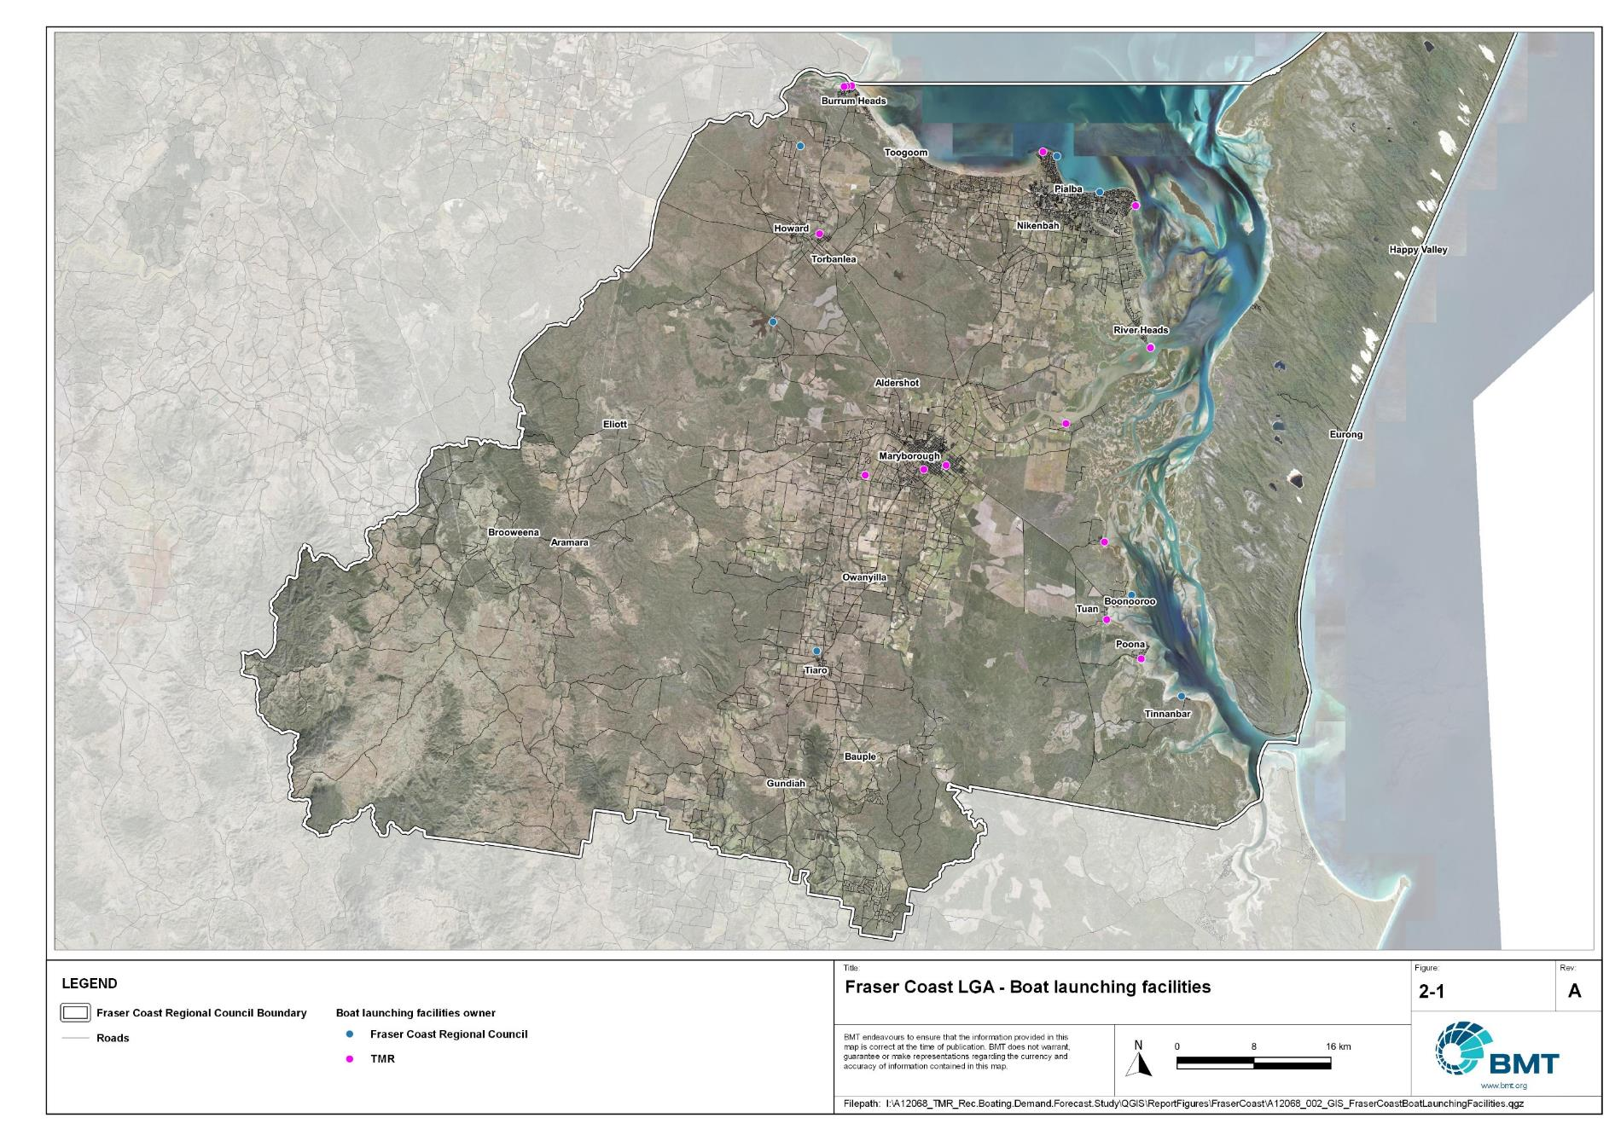

Public boat launching facilities within Fraser Coast LGA

"I:\A12068_TMR_Rec.Boating.Demand.Forecast.Study\QGIS\ReportFigures\FraserCoast\A12068_002_GIS_FraserCoastBoatLaunchingFacilities_EB.jpg"

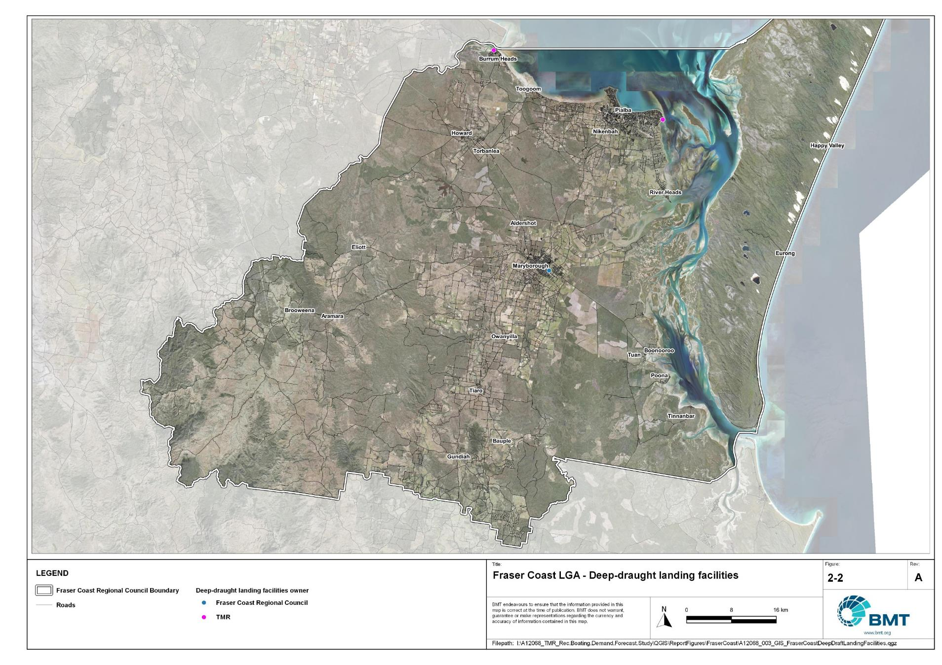

Public deep-draught vessel facilities within Fraser Coast LGA

"I:\A12068_TMR_Rec.Boating.Demand.Forecast.Study\QGIS\ReportFigures\FraserCoast\A12068_003_GIS_FraserCoastDeepDraftLandingFacilities.jpg"

## Existing usage and issues

Consultation with Fraser Coast Regional Council, Maritime Safety Queensland, recreational groups and feedback from the recreational boating facilities survey hosted by TMR indicate the following major themes and issues within Fraser Coast LGA.

* + 1. Localised demand

There are various communities within Fraser Coast LGA that have localised demand for recreational boating. These communities have been vocal in their expression of desire for improved recreational facilities. The demand statistics presented in this report, however, do not warrant the provision of an upgraded facility at each locality. An alternative strategy is to upgrade a facility which can provide the largest capacity increase at a central location, thus providing an adequate facility at an acceptable distance from each locality. This strategy caters for the regions within the LGA – the northern area (Burrum Heads/Toogoom), the Hervey Bay area and the southern area (Great Sandy Strait).

* + 1. Insufficient landside capacity

A consistent issue within Fraser Coast LGA is the constraint on the landside capacity of facilities. Many facilities have reached capacity, with further expansion of parking areas unviable. This is largely due to foreshore land being highly sought after for a range of reasons (recreational parkland, environmental conservation, commercial or residential development etc.). Furthermore, the popularity of some facilities, such as those that provide sheltered, all-tide access to open water, exacerbates this issue. This Study aims to identify opportunities to increase the capacity of facilities to take pressure off existing facilities that are at capacity in an equitable way across the whole LGA.

# Capacity Assessment

## Boat ramps

* + 1. Introduction

Boat ramps are facilities that are used for launching and retrieving trailable vessels, typically up to 8m in length (with some exceptions), to and from the water. Boat ramps consist of one or more lanes and their use is often supported by landside and waterside infrastructure to improve efficiency. In some instances, the usability of a facility can be adversely affected by environmental constraints such as low water levels, currents, or wave exposure, reducing the overall availability of the facility. Together, consideration of the number of boat ramp lanes, the supporting infrastructure, and environmental constraints results in the facility having a capacity described in terms of ‘effective lanes’ that may or may not be equal to the number of actual boat ramp lanes.

To maximise usage of each facility, the landside and waterside capacity should be balanced. Each facility will have a calculated ‘effective’ capacity for both the landside and waterside elements, with the limiting element dictating the facility's overall effective capacity. Recommendations for works or infrastructure promote balancing these two capacity elements by either improving the limiting element for increased facility effectiveness or by increasing the overall 'effective capacity' through changes to both elements.

* + 1. Boat ramp capacity

The overall capacity of each boat launching facility is limited by the effective capacity of either the waterside or landside elements. The waterside capacity is informed by the number of boat ramp lanes and the number and type of queuing facilities, such as pontoons, floating walkways, queuing beaches and fixed sloping walkways. It may also be limited by the available water depth in the adjacent waterbody and exposure to environmental or other physical factors.

Landside capacity is governed by the availability of nearby spaces for parking of car-trailer units (CTU), the provision of rigging and de-rigging facilities, and provision of single car parking spaces (single cars may otherwise be obliged to park in CTU spaces).

While it is expected that facilities will have their own characteristics influencing efficient use, this Study applies an approach that is consistent across the entire state and consistent with previous editions of the Study. Accordingly, the effective waterside capacity of a boat launching facility is determined as being:

* the ability to support 40 vessels being launched and retrieved per day per lane (see section 3.1.3)
* influenced by exposure to wave, tide, and current conditions (see section3.1.4
* supported by queuing facilities that assist in the efficient use of the boat ramp (see section 3.1.4).

Calculation of landside capacity is in line with the TMR guideline (TMR, 2020), which requires less provision of CTU parking per lane than the Australian standard (AS3962 Table 7.1), and advises:

* 10 CTUs for a single lane boat ramp accessed by an unsealed road, or 15 CTUs accessed by a sealed road
* 45 CTUs for a two-lane boat ramp
* 70 CTUs for a three-lane boat ramp
* 90 CTUs for a four-lane boat ramp.

A notable difference from the 2017 study is the recognition and inclusion of areas close to existing boating facilities that are unsealed and/or not line marked where parking of cars with trailers occurs and is not discouraged. These areas of informal parking have been identified on aerial imagery and through discussions with managing authorities. Each informal area has been assumed to be available for CTU parking only 50% of the time to account for conflicts with other uses (for example, markets), inefficient parking practices, or poor ground conditions. The rate of parking has been calculated as:

* for linear areas where nose-to-tail parking is expected – 1 CTU per 13m
* for linear areas with enough space to allow side-by-side parking – 1 CTU per 3m, provided there is a minimum distance of 15m from the road or manoeuvring area
* for large areas – 1 CTU per 100m2.
  + 1. Boat ramp capacity basis

The number of vessels per day each boat ramp lane can support is based on the Australian Standard for the Design of Marinas (AS3962-2001) and previous versions of this report (GHD, 2011 and 2017).

Research on boat ramp lane efficiency described in the previous report (GHD, 2017) identified that 40 vessels per lane per day was a reasonable compromise between 50 vessels per lane per day (representing congested conditions) and 30 vessels per lane per day (representing unhampered conditions). For context, the 40 vessels per lane per day rate represents a vessel launch or retrieval every 9 minutes per lane within an average normally used period of 12 hours per day.

During this Study, BMT has sought to validate the assumptions presented above, and those relating to capacity modification, by undertaking a literature review, conducting site visits that included observations of launching and retrieving manoeuvres, and reviewing video recordings of boats launching and retrieving at popular boating facilities. The literature review included a boat ramp efficiency investigation undertaken by BMT on the Mornington Peninsula, Victoria (BMT, 2015) and a review of standards from other Australian states and countries that undertake similar studies. The onsite and video analysis provided the opportunity to observe recreational boat operators using facilities included in the Study but did not include observation of total throughput during high demand periods. This assessment was undertaken during site visits across Queensland, and a full day of video recording at Manly Boat Harbour (north ramp) in Brisbane.

The New South Wales and Victoria governments are currently in a planning phase for boating infrastructure and there are presently no publicly accessible documents identifying how those jurisdictions calculate boat ramp lane capacity. The Western Australia government has commissioned studies of the Perth region and the southwest region (Western Australia Department of Transport, 2019 and 2021) that indicate a base rate of 50 vessels per lane per day, with no modifiers applied. Internationally, studies from Florida in the USA (Bell, 2022 and Swett et. al, 2012) assumed that total vessel launch plus retrieval time is between 20 to 40 minutes (18 to 36 vessels per day), although no evidence is provided to support this assumption.

The Mornington Peninsula report (BMT, 2015) collected boat launch and retrieval data for 6 boat ramp facilities on the Mornington Peninsula across 9 days, including the peak Australia Day holiday. Total throughput was assessed for each facility on days where there was constant pressure for launching and retrieving boats with results between 30 and 70 vessels per lane per day for the various facilities. When adjusted for queuing modifications, a baseline rate of between 20 and 50 vessels per lane per day was identified. Of the facilities, the higher rates were achieved where sufficient parking was provided and both waterside and landside queuing facilities existed.

Observations of recreational boat users launching and retrieving their vessels undertaken through the site visits and the analysis of video footage showed that:

* Most observed launches were of ‘multi-person’ boats, which made launching and retrieving boats more efficient.
* Almost all users were able to launch and/or retrieve their boat within the 9-minute target time, when adjusted for queuing facility efficiency.
* There was a preference to launch adjacent to a floating walkway, where one was available. At facilities where a queuing facility is not immediately adjacent to the lane it is expected that average launch times may slightly increase during busy periods.

While the observations that were made generally aligned with expectations, a more in-depth review of capacity assumptions was outside of the scope of the Study. For future studies there would be value in undertaking a more thorough, data-driven investigation of the assumptions about boat ramp lane capacity, both at its base level and modified by queuing facilities. Overall, the preliminary investigations undertaken as part of the Study suggest that the base rate of 40 vessels per lane per day adopted in previous studies is appropriate.

* + 1. Boat ramp efficiency modifications

The waterside capacity of boat ramp lanes can be reduced by environmental factors that include:

* Water levels: Mainly relating to tidal areas this factor considers the reduction in the amount of time the boat ramp is available to launch and retrieve vessels over the full tidal cycle, thus reducing the overall capacity of the facility. For all-tide access, the boat ramp and connecting channel to the open sea are available during all tidal conditions and therefore available 100% of the time. For near all-tide access the boat ramp and the connecting channel to the open sea are assumed to be available, on average, for 80% of the tidal cycle. For part-tide access the boat ramp and its access channel are available less than 80% of the time. A modification factor of 0.8 is applied for near all-tide facilities and 0.5 for part-tide facilities.
* Wave and current conditions: In areas where vessel launching and retrieval may be intermittently impacted by waves (most commonly on beach ramps, but not exclusively) or strong currents (such as in rivers), a modification factor of 0.5 is applied.

Conversely, effective boat ramp capacity can be improved through the use of well-designed queuing facilities. Queuing facilities aim to improve amenity and efficient use of the boat ramp by accelerating one or more of the following phases of boat launching, with the opposite steps required for retrieval:

1. manoeuvring for launching, including for CTU entering the queuing area for the boat ramp and reversing into position for launch
2. launching and securing the launched vessel
3. moving the launch vehicle from the boat ramp to the parking area
4. removing the vessel from the waterside queuing facility.

A range of waterside queuing facilities is in use in Queensland boating infrastructure, which modify different phases of the total launching process. These include:

* Floating walkways and fixed sloping walkways: Positioned to about a boat ramp lane, these structures aim to:
  + improve amenity – such as to assist embarking/disembarking passengers, provide a refuge from in-water contact with crocodiles and so on.
  + make securing the vessel and removing the vehicle from the boat ramp more rapid, while freeing the boat ramp for subsequent users.
* Pontoons: Also used by deep-draught vessels, these structures improve the ability to secure the vessel and clear the boat ramp, but there is usually some time lost returning to recover the launch vehicle compared with the above options as they are generally positioned slightly further away from the ramp.
* Queuing beaches: These also provide a place to secure the vessel close to the boat ramp, although they are generally not as fast to use as pontoons.

As observed throughout the Study site visits, each of these queuing facility types can support a limited number of boat ramp lanes depending on the available space on the queuing facility. The 2017 edition of this Study applied a blanket uplift for all boat ramp lanes where a queuing facility was provided. However, the number of lanes each type of queuing facility can realistically support varies. Accordingly, this Study has provided limitations to the number of boat ramp lanes that can benefit from each queuing facility, based on the number of “working faces” (or area for a queuing beach) provided, where the “working face” is a face that allows temporary securing of vessels during launching or retrieval. The adopted improvement factors and supported lanes are summarised in Table 3.1.

Queuing facility efficiency modifiers

| Queuing facility | Modification factor | Supported lanes |
| --- | --- | --- |
| Floating walkway (lanes adjacent to walkway) | 1.7 | 1 Lane/face |
| Floating walkway (lanes not adjacent to walkway) | 1.3 | 1 Lane/face |
| Fixed sloping walkway | 1.7 | 1 Lane/face |
| Pontoon | 1.2 | 2 Lanes/face |
| Queuing beach | 1.1 | Site-based |

In other states in Australia, reversing queuing bays are more commonly used than in Queensland. These are CTU waiting bays at the head of the boat ramp that are aligned with each boat ramp lane to allow the user to reverse directly down the boat ramp once it is clear. CTU waiting bays reduce the time of the first phase of boat launching by allowing waiting CTU’s to be ready to reverse as soon as the lane becomes clear. The BMT (2015) study on the Mornington Peninsula included facilities with and without these bays. Boat ramps that included reversing queuing bays achieved 50% greater throughput. Facilities that have implemented this approach in Queensland include North Street Southport, Urangan Boat Harbour, Townsville Recreational Boating Park, and the (under construction late 2022) boat ramp at Yorkeys Knob.

* + 1. Accessibility from boat launching facilities

Recreational boat users will typically select the boat launching facility most appropriate or convenient to the activity they are seeking to undertake, the anticipated weather/wave conditions, and their destination. Each of facility within an LGA will provide a varying degree of access to different destinations and for different activities. During the Study, consultation with stakeholders highlighted the following general types of destinations and activities:

* open water/offshore: typically accessed for visiting offshore islands or remote beaches, snorkelling or diving locations, deep sea fishing and general recreation
* creeks and estuaries: typically accessed for fishing, crabbing, wildlife observation, skiing and general recreation
* freshwater: typically accessed for skiing, fishing, wildlife observation and general recreation.

These destinations are typically serviced by different types of recreational vessels. Inshore locations including creeks, estuaries and other freshwater locations are typically patronised by vessels less than 4.5m, except for ski boats, which can be much larger than this. Offshore/open water locations typically require larger boats for access as these vessels are more capable of managing a wide range of wave conditions and can carry sufficient fuel to access distant destinations. Smaller vessels may be able to access close destinations on good weather days, and larger vessels may choose to access inshore destinations, particularly on poor weather days.

Consequently, the following aspects are used to classify how well a facility provides open water access:

* Open-water access: There are no restrictions between the facility and open water.
* Depth-limited access: There are depth restrictions between the facility and open water that limit navigable access to part of the tidal range. This differs from tidal constraints at the actual facility, which might be usable at all tides, but open water access is limited by a downstream bar or delta.
* Distance-limited access: The distance from the facility to the open water is unrealistic for typical boat users. This distance is assumed to be about 4.5km between the facility and open water to rate as 'distance limited', with travel times increased further where portions of the access channel are regulated by speed limits.
* Infrastructure-limited access: There are man-made obstacles between the facility and open water, such as above-ground pipeline crossings, low bridges or weirs that impede navigable access to open water.
* Beach ramps: These provide open-water access but are typically constrained by environmental conditions such as wave exposure and tide levels. The capacity of these facilities has been individually assessed based on consultation and other data sources and is described in more detail in section 4.
* Freshwater: There is no access to open water.

Certain facilities, particularly those in freshwater, may be constrained by periods of drought, or debris deposition after rainfall events that limit access to destinations, and therefore whether a facility will provide useful boat launching capacity. While it is noted that drought and rainfall may affect the overall capacity of boat launching within an LGA, and given that the timing of such events is not readily predictable, their impact on capacity has not been evaluated.

* + 1. Existing boat launching capacity

Within Fraser Coast LGA there are 24 boat launching facilities with a total effective capacity of 28.3 lanes. The effective capacity of boat launching facilities within Fraser Coast LGA is shown in Annex B, with a summary of the access to open water and tidal constraints shown in Figure 3.1 and the overall capacity constraint shown in Figure 3.2. Pertinent features of these facilities include:

* There are 42 total lanes, with an effective capacity of 28.3 effective lanes. This effective capacity is primarily reduced due to insufficient parking being allocated for each lane.
* Boat users in Fraser Coast LGA have a range of options for boating, with facilities available for accessing offshore and open water destinations (like dive and fishing sites), estuarine areas and freshwater rivers and dams.
* Most of the facilities provide all-tide access.

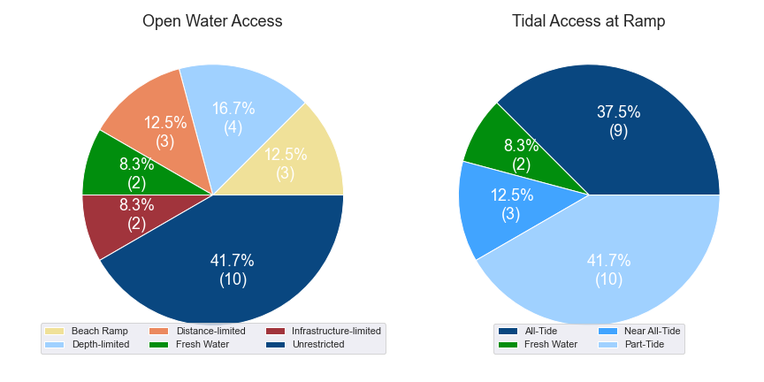

(a) Summary of open water access from boat launching facilities (left) and (b) Summary of tidal restrictions at tidal boat launching facilities (right)

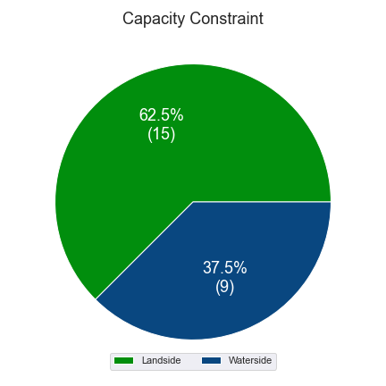

Summary of limiting capacity constraint

## Access to sheltered near all-tide and all-tide facilities

MSQ has a longer-term vision to provide access to all-tide or near all-tide open water access boat launching facilities along the Queensland coast, such that all eligible significant population centres are within one hour’s driving range as far as practical (TMR, 2020). For this purpose, the Study has defined eligible towns as being within the coastal strip if within 30km of the Queensland coastline. The vision (TMR,2020) is applied to the coastal strip between the NSW border and Cooktown. Consultation throughout the Study has highlighted that this vision is important with users/stakeholders and organisations that own and manage these facilities. As such, the Study has developed a statistical approach to quantify this vision to allow it to be measured and tracked over time. To do this, the Study has calculated the travel time from all Population Centres (DoR, 2022) within the coastal zone to the nearest available sheltered, all-tide or near all-tide facility, regardless of which LGA it is in. This has been accomplished using mapped road networks and assigning speed limits to each type of road, with the following speed limits applied:

* for restricted roads, 40km/hr
* for local roads, 60km/hr
* for connector roads, 70km/hr
* for distributor roads, 80km/hr
* for highways, 100km/hr.

For Fraser Coast LGA the median travel time from eligible Population Centres to the nearest sheltered all-tide or near all-tide facility is 16.2 minutes. The distribution of travel times is shown in Figure 3.3 with detailed travel times in Annex C. Figure 3.4 provides a visual representation of the travel time from each of the sheltered near all-tide facilities that serve the LGA. Of interest for Fraser Coast LGA are:

* 100% of the eligible population centres are within the desired 1-hour travel time.
* most eligible population centres are within 30 minutes of a sheltered near all-tide or all-tide facility.

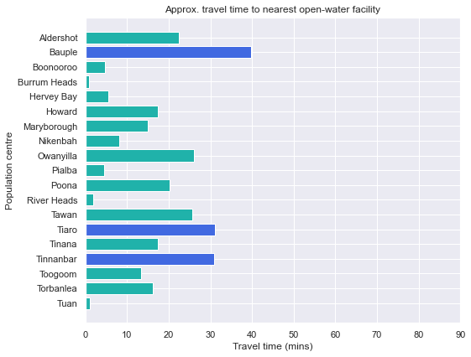

Distribution of travel time from Fraser Coast LGA’s eligible population centres to sheltered near all-tide facilities

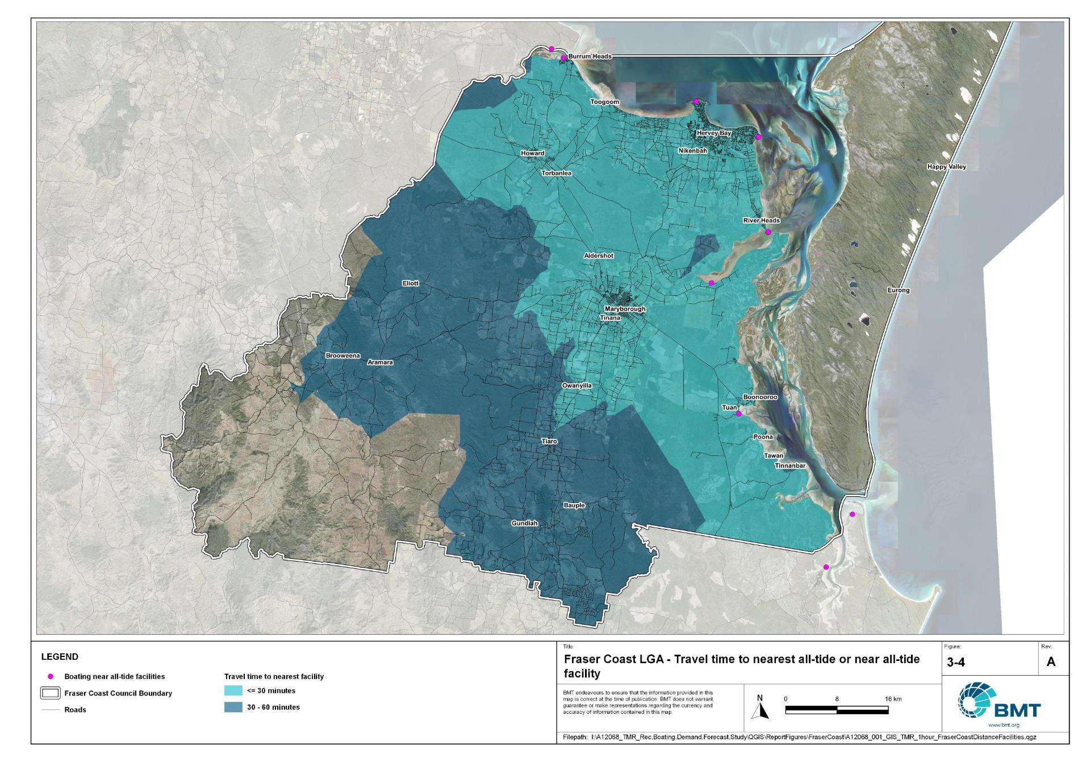

Fraser Coast LGA – Travel time to nearest all-tide or near all-tide facility

I:\A12068_TMR_Rec.Boating.Demand.Forecast.Study\QGIS\ReportFigures\FraserCoast\A12068_001_GIS_TMR_1hour_FraserCoastDistanceFacilities.jpg

## Deep-draught vessel landings

Deep-draught vessel landings are intended to provide short-term landing capacity for vessels that are too large to use public boat launching and retrieval facilities. These facilities are provided for the benefit of both local vessels and to service the fleet of vessels that travel along the Queensland coast. Deep-draught vessel landings may be designed to accept one or more large vessels at a time and/or provide capacity for tenders from larger vessels that may be anchored or moored nearby, for the purpose of loading and offloading passengers and supplies, and making short local visits to onshore destinations.

For the Study, deep-draught vessel landings need to be primarily accessible by recreational boats for short, temporary stays. In some cases, commercial vessels may utilise these facilities subject to the relevant permissions, however, this may reduce the capacity of the facility to cater for recreational vessels. Deep-draught vessel landings should be located such that the facility provides reasonable access to landside passenger pick up and drop off, provisioning, recreational destinations, or population centres. Within Fraser Coast LGA there are three deep-draught vessel landings that provide access to the following facilities or destinations:

* Burrum Heads, providing an option for the northern part of the LGA, with access to shops and public transport
* Urangan Boat Harbour, with options for reprovisioning and visiting landside destinations, including access to public transport. This is also a great berthing location for vessels visiting the western side of K’gari (Fraser Island)
* Maryborough, with direct walking access to supermarkets, ample options for reprovisioning and various landside destinations - Maryborough being also a significant population centre and suitable place for pickup or drop off of passengers.

As well as the above, there are additional deep-draught vessel landings provided by private facilities within Fraser Coast LGA. These are within the Urangan Boat Harbour, with various private entities offering berthing services (Fisherman’s Wharf Marina, Great Sandy Straits Marina, Hervey Bay Marina).

In summary, Table 3.2 shows the total capacity of deep-draught landing facilities within Fraser Coast LGA.

Deep-draught landing facilities within Fraser Coast LGA

| Facility type | Total capacity |
| --- | --- |
| Public sheltered mainland landings | 3 |
| Private sheltered landings | 3 |
| **Total** | **6** |

# Demand Assessment

The Study has developed a model to calculate statistical demand for boat launching facilities and deep-draught vessel landings at an LGA scale. Vessels that are less than 8m in length are considered trailable and drive demand for boat launching facilities such as boat ramps, while those over 8m are assumed to remain on water and drive demand for deep-draught landings.

Statistical demand is recognised at three different levels for public marine facilities within the TMR guidelines (TMR, 2020), which are:

* off-peak demand – typical weekday usage
* average demand – demand on ‘good boating days’, taken to be demand for a facility on weekends (and, for certain regional locations, other busy periods)
* peak demand – demand for a facility at peak holiday periods or for special events.

The demand model created for this Study is intended to provide information on demand pressures on ‘good boating days’ for all facilities as per the intentions of the guidelines. The model achieves this through a ‘registration activation rate’ that estimates the proportion of registered vessels in an LGA that is assumed to be active on a ‘good boating day’, as well as the exchange of vessels between LGAs, and general tourism pressures.

## Activation rate

The fleet size for each LGA is determined statistically from vessel registration numbers and the application of a vessel activation rate, while for future time horizons vessel registration and population growth estimates are also utilised. The methodology for determining the registration activation rate has been adopted from the previous study (GHD, 2017), with activation rates taken to be between 8% and 14% for a typical weekend. The variability of the activation rate is intended to capture the regional differences in vessel types, and is driven by the availability of access to open water, accessibility of other recreational opportunities, and likelihood of users’ available time for recreation, considering factors including:

* remoteness classification for the LGA
* incidence of blue-collar employment
* average age of residents
* whether the LGA is coastal.

Further information about the derivation of this rate can be found in Annex A. For Fraser Coast LGA the activation rate is assumed to be 12%, with the key factors influencing the rate including:

* its classification as a Regional Centre
* the incidence of blue-collar employment being higher than the state average
* the average age being lower than the state average
* it being located adjacent to the open coast.

## Digital user survey

To gain an understanding of usage trends at existing formal recreational boating facilities across Queensland, the Study has considered the results of a digital user survey using human movement data, sourced through a third party. The data was acquired from a location data store with more than 13 trillion mobile location observations globally from 2019 to present, which were sourced from 250,000 different mobile phone applications that users ‘opted-in’ to use the location services under the application’s terms and conditions. All data received was deidentified and compliant with relevant data privacy regulations.

The analysis uses mobile devices (such as telephones) location data as a proxy for boat user traffic, however, this relationship has several limitations including, but not limited to:

* Mobile device users detected in the area of interest may not be boat users (for example, pedestrians not using vessels may walk through the detection area).
* The relationship between mobile device users and vessels may not be 1:1 (that is, there may be multiple mobile devices providing data for each vessel).
* Users of vessels may not have a mobile device, may not be using a mobile device or may not have provided permission to use their location data.

With these, and potentially other, limitations in mind, the Study compared this data against vessel launching counts provided by various facility managers and found that approximately 15-30% of vessels are captured using this digital survey method. This percentage can change from facility to facility and from day to day. Consequently, the Study has not relied on raw counts of users from this data, but instead considered the relative trends within the data, with the assumption that no groups (for example, users from a particular LGA or using a particular facility) within the data would be more or less likely to be captured by the technique.

The Study has used this data to identify the relative volume of users, the ‘home’ local government area of users and the popularity of destinations that users travel to once vessels have been launched. Presentation of the full dataset can be found in Annex D.

* + 1. Inter-LGA demand

The human movement data has been interrogated to determine the LGA of origin for users of Fraser Coast LGA’s public boating facilities to ascertain the proportion of users from each LGA that are using specific facilities. Statistics from all public boating facilities within the LGA are then grouped together to determine the total proportion of resident or visiting users across the LGA. Table 4.1 shows the active fleet proportion from the top 10 LGAs contributing to demand on facilities within Fraser Coast LGA. All other sources have been grouped together.

LGA of origin for active fleet in Fraser Coast LGA

| LGA of origin | Active fleet proportion |
| --- | --- |
| Fraser Coast | 64.6% |
| Brisbane | 4.8% |
| Moreton Bay | 4.0% |
| Sunshine Coast | 3.8% |
| Bundaberg | 2.7% |
| Gold Coast | 2.6% |
| Gympie | 1.6% |
| Logan | 1.4% |
| Redland | 1.3% |
| Ipswich | 1.3% |
| Other LGAs | 12.0% |

* + 1. Intra-LGA demand distribution

Recreational boating users will tend to use facilities that best suit their needs, the destinations they want to access, the capability of their vessel and the weather conditions. Consequently, distribution within an LGA is unlikely to be evenly spread across all facilities, with some facilities attracting users disproportionately due to amenity, access, or destinations. The attractiveness of large well-designed facilities is likely to draw visiting boat users in preference to smaller or less desirable facilities across the LGA. The human movement statistics have been assessed to qualitatively estimate the proportion of users using each facility, both in total and with respect to both resident and visiting boat users (Table 4.2).

Popularity of boat launching facilities.

| Facility | Overall fleet | Resident fleet | Visiting fleet |
| --- | --- | --- | --- |
| Urangan Boat Harbour, Jetty Road | 27.9% | 29.7% | 24.6% |
| Burrum Heads, Lions Park | 19.6% | 17.9% | 22.9% |
| Torquay, Bideford Street | 7.6% | 8.5% | 6.1% |
| River Heads, Ariadne Street | 6.9% | 5.7% | 9.1% |
| Maryborough, South Street | 6.4% | 8.6% | 2.3% |
| Point Vernon, Aplin Street | 5.8% | 6.7% | 4.2% |
| Gatakers Bay, Corfield Street | 5.0% | 5.3% | 4.5% |
| Poona, Owen Cox Street | 3.0% | 1.3% | 6.0% |
| Maaroom, Granville Road | 2.9% | 2.8% | 2.9% |
| Tuan, Bottlebrush Drive | 2.8% | 2.8% | 2.8% |
| Toogoom, Toogoom Road | 1.9% | 1.5% | 2.5% |
| Tiaro, Petrie Park | 1.7% | 1.1% | 2.7% |
| Boonooroo, Bates Street | 1.6% | 1.7% | 1.6% |
| Beaver Rock, Beaver Rock Road | 1.4% | 1.7% | 0.8% |
| Lenthalls Dam | 1.1% | 1.0% | 1.2% |
| Burrum Heads, Burrum Heads Road | 0.9% | 0.6% | 1.5% |
| Tinnanbar, Boat Ramp Drive | 0.8% | 0.4% | 1.6% |
| Pacific Haven, Pacific Haven Crescent | 0.7% | 0.6% | 0.9% |
| Burrum Heads, Ross Street | 0.7% | 0.5% | 1.0% |
| Maryborough, Granville, Raglan Street | 0.6% | 0.7% | 0.3% |
| Howard, Powerhouse Drive | 0.5% | 0.5% | 0.5% |
| Yengarie, Pleasant View Road | 0.1% | 0.2% | 0.0% |

The results indicate that there is a distinct preference for two facilities in particular – Urangan Boat Harbour and Lions Park, Burrum Heads. These facilities both provide sheltered, all-tide launching with unrestricted access to open water. These are also the two facilities that provide the most capacity to the LGA, with excellent waterside infrastructure (including adequate queuing structures) and reasonable parking arrangements (noting that the capacity of both facilities is constrained on the landside, though have utilised all available space nearby). The largest capacity in the LGA is provided by Urangan Boat Harbour, and the data indicates that it services the most significant portion of the demand. There is a slight increase in resident vessels using the Urangan facility, and a higher proportion of visitor vessels using the Burrum Heads facility at Lions Park.

The facility at River Heads serves a notably smaller fleet, despite providing significant waterside capacity (more than that at Lions Park) at a location with direct access to the Mary River, destinations on K’gari (Fraser Island), as well as Great Sandy Strait. This is attributed to the fact that this facility is constrained on the landside and should be upgraded to provide adequate parking capacity. There is also some overestimation of the facility use reported here, as vehicles getting on the barge to K’gari have been counted after passing through the launching areas at River Heads, as discussed in section 4.2.3.

Throughout the rest of the LGA, there is a relatively equal distribution of facility use, with some facilities being preferred by locals (South Street, Maryborough) and some more frequented by visitors to the LGA (Poona).

The distribution of capacity within the LGA needs to consider these trends to avoid consistent capacity shortfalls at some facilities or indicating demand for unnecessary extra capacity at other facilities. Results from the above statistics and feedback obtained through the TMR online survey indicate that within Fraser Coast LGA the following factors tend to influence the preferred facilities for recreational boat users:

* access to sheltered, all-tide launching facilities
* dry entry/exit capabilities of launching facilities provided through floating walkways and pontoons
* ability to access offshore and open water destinations
* facilities with larger capacity.
  + 1. Destinations

For facilities that provide sheltered, near all-tide or all-tide open water access, additional analysis of the human movement statistics has been undertaken to identify destinations for users of these facilities. Location data from users utilising the facilities was extracted for a period of two hours after they used the facility and trimmed for waterside destinations. For Fraser Coast LGA this additional analysis was applied to the following facilities, with destinations mapped in Figure 4.1:

* Beaver Rock Road, Beaver Rock
* Lions Park, Burrum Heads
* Corfield Street, Gatakers Bay
* Ariadne Street, River Heads
* Toogoom Road, Toogoom
* Jetty Road, Urangan
* Bates Street, Boonooroo
* Granville Road, Maaroom
* Owen Cox Street, Poona
* Boat Ramp Drive, Tinnanbar
* Bottlebrush Drive, Tuan.

From this additional analysis, the following notable observations were made:

* The vessel tracking data shows the immense number of open water ventures from Urangan. There are various locations these vessels are going, with some heading northward, potentially on longer voyages passing through Urangan. Other vessels head south into Great Sandy Strait, some making it as far as Inskip Point and out into the open ocean from there. The majority of vessels launching from Urangan are travelling to the regularly sheltered waters on the western side of K’gari (Fraser Island). Seasonal whale watching is popular in the sheltered area west K’gari while there are also various opportunities for camping, boating and fishing in this area, in the right conditions.
* Vessels that launch at River Heads, Gatakers Bay and Burrum Heads have the potential to travel long distances to open water destinations but are more likely to stay local and visit nearby destinations (reefs/fishing grounds). There are destinations close to each of these ramps that clearly attract vessels that launch from nearby facilities.
* Vessels launching at Burrum Heads (Lions Park) are equally likely to be heading upstream into the Burrum River and its tributaries as they are to be heading to open water destinations. Similarly, vessels launching at Beaver Rock are equally likely to travel east and west.
* Gatakers Bay is used to access a few fishing spots to the north, as well as eastwards toward K’gari, however most vessels launching here stay relatively close to the shoreline near Point Vernon and to the east
* Vessels launching at River Heads are distributed throughout the estuaries of the Susan and Mary Rivers, and to the east into Great Sandy Strait. There are also common tracking paths to the western side of K’gari.
* Within the southern part of the LGA, in Great Sandy Strait, vessels tracked from the facility at Tuan are the most widely distributed, heading into the strait as well as up Big Tuan Creek, while those at Maaroom are similarly widely distributed.
* Vessels launching from Poona are more likely to stay relatively close to Poona – likely due to the tidal limitations of launching and retrieving a boat at this ramp meaning that trips tend to be aligned with suitable tides and larger boats capable of longer voyages are not well accommodated. The same pattern is observed at Tinnanbar and Boonooroo.

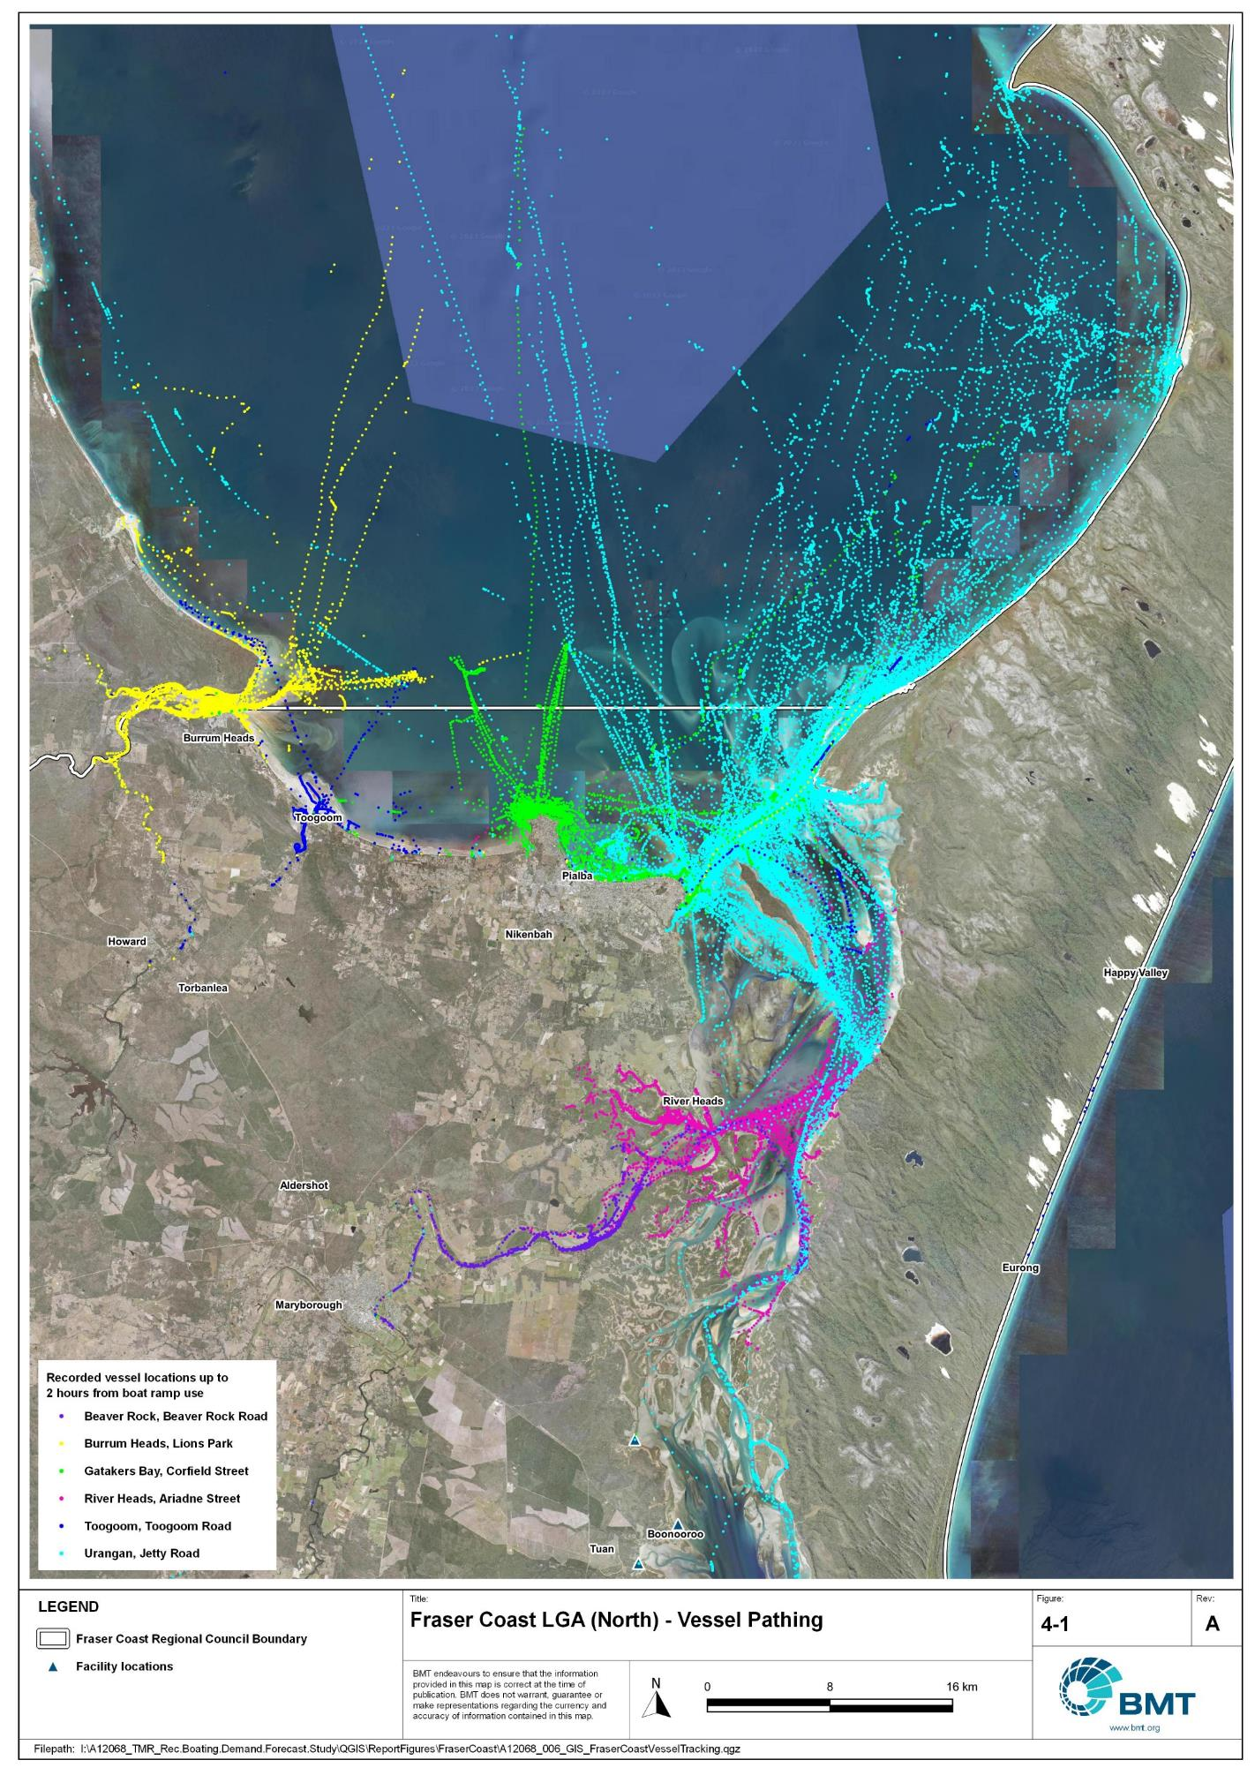

Fraser Coast LGA (north) – Vessel pathing

"I:\A12068_TMR_Rec.Boating.Demand.Forecast.Study\QGIS\ReportFigures\FraserCoast\A12068_006_GIS_FraserCoastVesselTracking_North.jpg"

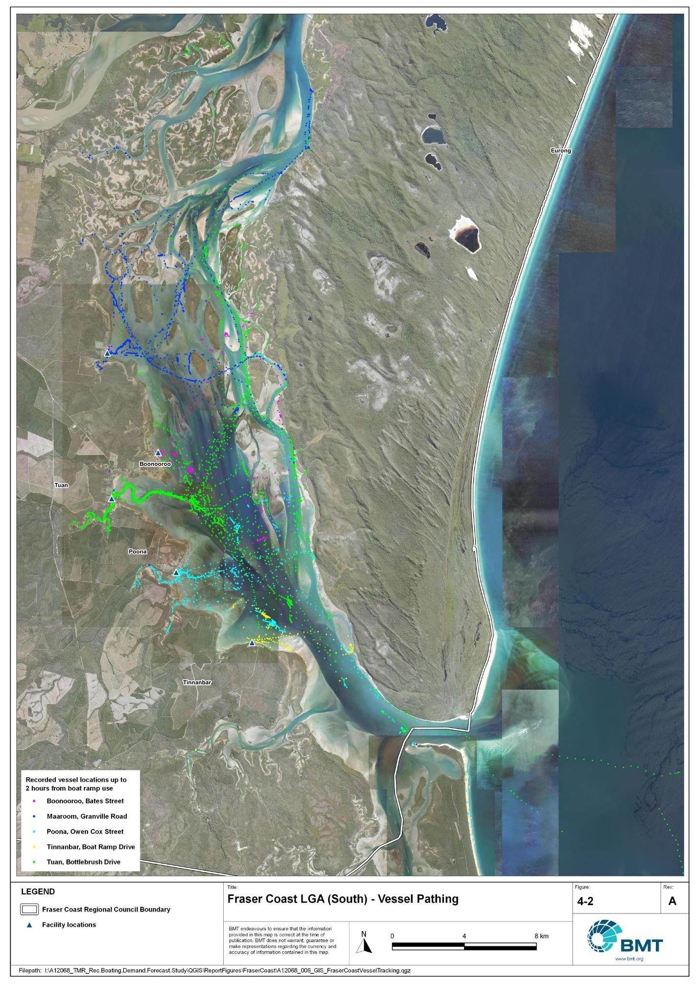

Fraser Coast LGA (north) – Vessel pathing

"I:\A12068_TMR_Rec.Boating.Demand.Forecast.Study\QGIS\ReportFigures\FraserCoast\A12068_006_GIS_FraserCoastVesselTracking_South.jpg"

## Active fleet size

The total ‘active’ fleet on a good boating day is derived from the activation rate of the total fleet of registered vessels within the LGA and the net inflow of visiting vessels. The total number of visiting vessels from each LGA is determined from the number of vessels in the resident active fleet and the relative proportion of resident to visiting vessels outlined in Table 4.1.The fleet size is expected to change over time due to changes in population and vessel acquisition trends, with the size and proportion of the fleet across the Study period described in Table 4.3.

Active fleet vessel size

| Vessel length | 2021 | 2026 | 2031 | 2036 | 2041 |
| --- | --- | --- | --- | --- | --- |
| 0 to 4.5m | 1207 | 1253 | 1300 | 1337 | 1367 |
| 4.5m to 8m | 526 | 546 | 566 | 582 | 595 |
| >8m | 62 | 64 | 66 | 68 | 69 |
| Total | 1795 | 1863 | 1932 | 1987 | 2030 |

## Boat ramp lane demand

The fleet size derived in Table 4.3 represents the statistical demand for the LGA, with vessels under 8m assumed to contribute to boat ramp demand, measured in boat ramp lanes. As outlined in section 3.1.2 the adopted capacity of each effective lane is 40 vessels per day, with each vessel assumed to both launch and retrieve, for a total of 80 vessel movements per day. The total boat ramp lane demand across the Study period is shown in Table 4.4.

Boat ramp lane demand

|  | 2021 | 2026 | 2031 | 2036 | 2041 |
| --- | --- | --- | --- | --- | --- |
| Boat ramp lane demand | 43.3 | 45 | 46.6 | 48 | 49 |

For Fraser Coast LGA the important elements that contribute to the boat ramp lane demand include:

* a large sized local fleet, with a high proportion of trailable vessels
* attractive destinations for visitors from south-east Queensland
* potential changes to commercial fishing licence framework may reduce commercial fishing, improving local fish stock, and thereby increasing popularity of fishing in the region and putting more pressure on recreational facilities.

## Non-statistical demand

As well as the statistical demand outlined in the section above, facilities may face demand pressures that are related to their functional use, which reduces the capability of the facility to service the recreational boat fleet in the desired manner. Issues with specific facilities have been identified within the consultation process of the Study with appointed managers and other stakeholders. While care has been taken to identify these non-statistical demand issues throughout the Study, it is beyond the scope of the Study to individually review the functionality, safety, and amenity of each facility across Queensland. Non-statistical demand pressures may warrant upgrades to facilities even where statistical demand is satisfied by existing capacity. These pressures have been classified into the following categories:

* Amenity: Amenity describes the functional usability of the facility including the desire to provide dry entry and exit facilities, facilities that provide easy access and/or access for persons with restricted mobility.
* Safety: Safety demand may include protection from currents and waves or contact with marine creatures such as sharks, jellyfish, and crocodiles.
* In-water congestion: Where existing queuing facilities are not able to efficiently meet the needs of the facility. Such deficiency may warrant additional queuing facility capacity to optimise boat launching and retrieval.

The Study's recommendations may alleviate these non-statistical demand pressures with consideration for capability of all facilities within the LGA. The presence of a non-statistical demand pressure at a facility may not warrant upgrades where other suitable facilities are reasonably available.

## Deep-draught vessel demand

* + 1. Cruising vessels

Vessels cruising along the east coast of Queensland have a requirement for a network of deep-draught vessel landings that are appropriately spaced to be within a day’s sailing on good weather days. These facilities are required to support the reprovisioning of vessels as they travel along the coast and provide access to desirable land-based destinations. Private marina facilities may be used by cruising vessels where there is an expectation for a prolonged stay that requires protected mooring or berthing. Within Fraser Coast LGA suitable facilities for deep-draught vessels includes the public pontoons in Burrum Heads, Urangan and Maryborough.

Within the east coast network but outside of Fraser Coast LGA, the nearest deep-draught vessel landing facility to the north is approximately 42 nautical miles from Burrum Heads at the public pontoon in Bundaberg, excluding the deep-draught landing at Buxton, on the Isis River, upstream of Burrum Heads, and the jetty at Burnett Heads, which is not considered to be fit for purpose. To the south, the closest landing is at Norman Point in Tin Can Bay, which is approximately 42 nautical miles from Urangan via Great Sandy Strait. It is noted, however, that the shoals through the strait can be very shallow and treacherous; as such experience and careful timing of the tides is necessary to make this voyage safely, particularly in a large vessel. Alternatively, it is 140 to 150 nautical miles to Norman Point whether travelling from Burrum Heads or Urangan via the eastern side of K’gari. At present there is no deep-draught vessel landing facility in the southern reaches of Great Sandy Strait, owing to the lack of locations with sufficient natural water depth.

The public pontoons at Burrum Heads, Urangan and Maryborough provide efficient access to supplies and provisions, but no fuel or sewage pump-out facilities are available for public use. It is recommended that these facilities be upgraded to provide this capability, with the priority being at Urangan. For vessels seeking to stay in the region for an extended period, protected berthing is seasonally available at private facilities within Urangan Boat Harbour.

* + 1. Landing demand

Statistical demand for deep-draught vessel landings has been assessed based on the size of the non-trailable fleet within Fraser Coast LGA. Landing demand is more difficult to assess than boat ramp lane demand as the requirements and duration of the landing influence the demand pressure but are highly variable between users. Nevertheless, the Study has assumed that 5% of the non-trailable fleet will be seeking a landing at any given time. The consultation undertaken during the Study indicates that this assumption may overestimate the number of landings, but that the landings are often utilised for other boating and recreation activities when not in use by deep-draught vessels. In particular, landings that are located near boat launching facilities may be used as queuing facilities and therefore support the efficient launching of smaller recreational vessels. Given this, the 5% assumption has been adopted noting that it may overestimate capacity, but not to an extent that it would be onerous to facility providers. Within Fraser Coast LGA the demand for deep-draught vessel landings is outlined in Table 4.5

Deep-draught vessel landing demand

| Requirement | 2021 | 2026 | 2031 | 2036 | 2041 |
| --- | --- | --- | --- | --- | --- |
| No. of Landings | 3.1 | 3.2 | 3.3 | 3.4 | 3.4 |

# Shortfall Assessment

## Shortfall assessment – boat ramps

The shortfall of boat ramp lanes within Fraser Coast LGA is shown in Table 5.1 and Figure 6.1 at an LGA scale. This is presented both with and without the inclusion of additional capacity provided by the recommended upgrades.

Shortfall of boat launching facilities

| Assessment | Metric | 2021 | 2026 | 2031 | 2036 | 2041 |
| --- | --- | --- | --- | --- | --- | --- |
| Demand | Demand | 43.3 | 45 | 46.6 | 48 | 49 |
| Existing | Capacity | 28.3 | 28.3 | 28.3 | 28.3 | 28.3 |
| **Shortfall** | 15 | 16.7 | 18.3 | 19.7 | 20.7 |
| Improved | Capacity | 28.3 | 36.9 | 40.4 | 44.7 | 44.7 |
| **Shortfall** | **15** | **8.1** | **6.2** | **3.3** | **4.3** |

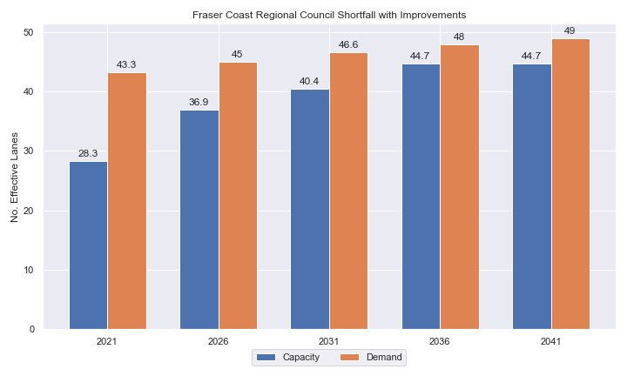

Shortfall assessment with recommended upgrades adopted.

* + 1. Open-water access shortfall in boat ramp lanes

Statistical capacity has been calculated across Fraser Coast LGA in its entirety, however, some facilities are evidently more popular than others due to their ability to access open-water destinations, and/or their usability. In general, larger vessels are more suited to access open-water destinations while smaller vessels are more likely to remain in sheltered environments. This was identified in the 2017 study and confirmed during discussions with stakeholders. The human movement data indicates that visiting boats from other LGAs are drawn to facilities that provide access to open-water destinations. To ensure that the capacity of effective boat ramp lanes in the LGA is appropriately distributed to cater for these usage trends, it is worth assessing facilities providing this desirable access as a subset of the total capacity for the LGA. A ‘scenario’ approach to assessing this capacity (Table 5.2) has been developed, with Scenario 1 derived from empirical estimates of vessel distribution and Scenario 2 derived from the human movement statistics, and the final result averaged between the two scenarios. This provides the opportunity to rationalise the figure that drives the demand and acknowledge when one scenario is not representative of the population or consistent with stakeholder feedback. The scenarios that were assessed are:

Scenario 1: 80% of larger vessels and 20% of smaller vessels from the local fleet and 80% of the visiting fleet are using the facilities with unrestricted open water access.

Scenario 2: Distributing the fleet between facilities as per the human movement statistics.

Shortfall assessment for open water, all-tide or near all-tide facilities for Fraser Coast LGA

| Assessment | Metric | 2021 | 2026 | 2031 | 2036 | 2041 |
| --- | --- | --- | --- | --- | --- | --- |
| Overall | Capacity | 17.0 | 17.0 | 17.0 | 17.0 | 17.0 |
| Scenario 1 | Demand | 24.8 | 25.9 | 26.9 | 27.7 | 28.4 |
| Shortfall | 7.8 | 8.9 | 9.9 | 10.7 | 11.4 |
| Scenario 2 | Demand | 27.1 | 28.2 | 29.2 | 30.1 | 30.8 |
| Shortfall | 10.1 | 11.2 | 12.2 | 13.1 | 13.8 |
| **Average** | Demand | 26.0 | 27.0 | 28.0 | 28.9 | 29.6 |
| **Shortfall** | **8.9** | **10.0** | **11.0** | **11.9** | **12.6** |

Comparing the LGA-scale shortfall with the subset of facilities providing protected all-tide or near all-tide access to open water indicate that the demand is somewhat well distributed within the LGA, though a preference for this type of facility is noted.

## Shortfall assessment – deep-draught landings

The shortfall of public deep-draught landings for Fraser Coast LGA is provided in Table 5.3. The existing capacity is statistically adequate to meet demand, particularly with the inclusion of facilities at the marina. However, is it noted that there is significant distance for deep-draught vessels to cover when travelling along the east coast of K’gari.

Shortfall of deep-draught vessel landings

| Assessment | Metric | 2021 | 2026 | 2031 | 2036 | 2041 |
| --- | --- | --- | --- | --- | --- | --- |
| Deep-draught vessel landings | Demand | 3.1 | 3.2 | 3.3 | 3.4 | 3.4 |
| Capacity | 3 | 3 | 3 | 3 | 3 |
| **Shortfall** | 0.1 | 0.2 | 0.3 | 0.4 | 0.4 |

# Stakeholder Feedback



The Study has undertaken extensive consultation throughout its execution to achieve a comprehensive understanding of issues relating to the use of recreational boating facilities across the state. This consultation was conducted with managing authorities that own and/or manage recreational boating facilities, as well as with facility stakeholders including recreational groups, volunteer marine rescue and coastguard organisations, and the general public. Stakeholder engagement was supplemented with site visits to facilities where key issues had been identified.

## Managing authority feedback

For Fraser Coast LGA, the Study team met with Fraser Coast Regional Council, Fraser Coast marine rescue organisations and Maritime Safety Queensland to discuss recreational boating facilities within the region. This consultation process identified a range of potential opportunities to alleviate demand pressures. The Study has considered the practical implementation of each of these opportunities with respect to the required infrastructure, difficulty of implementation, and magnitude of benefit, as summarised in Table 6.1.

Stakeholder identified opportunities

| Location | Stakeholder opportunity | Review comments |
| --- | --- | --- |
| Toogoom | Construct CTU spaces in the wetlands to the southeast of the Toogoom Road and Lorikeet Ave intersection. | While one of the few opportunities to provide CTU parking, reclamation and construction of a parking facility on this land will be complex and expensive. Results from the survey indicate it may also be at the limit of distance that people are willing to walk for parking. |
| Gatakers Bay | Dredge channel to maintain 1.5m below LAT depth. Provide floating walkway and install additional parking. | Agreed. Area for CTU parking is limited due to terrain issues. Fixed sloping walkway preferred due to exposure to wave action. |
| River Heads | Expand parking facility onto the mangroves to the east of the current facility. | Spatially, this is the only solution for this highly constrained site, however, approvals are likely to be extremely complex. |
| Great Sandy Strait townships | Need an improved facility somewhere in the southern part of the LGA | Agreed. Naturally shallow depths and highly mobile sand makes all-tide access difficult, but a larger facility in one of these townships is supported. |
| Urangan | Improve the flow of the facility by having dedicated launch or retrieve ramps depending on the time of day. | Agree that this may help, particularly with during afternoon peak retrieval times. Outside of scope for this Study to deliver as this is an operational solution. A trial period is suggested. |
| Point Vernon/  Eli Waters | New protected facility in this area of the LGA | A new all-tide protected facility in this area would cater for future population growth, although there is sufficient opportunity at existing facilities that should be maximised before a new facility here could be justified. |
| Poona | Construct new facility in Poona Creek | This recommendation from the 2017 study has been thoroughly investigated and is unviable. The existing Poona facility should be upgraded on the waterside to improve throughput at high tides. |
| Lenthalls Dam | Upgrade facilities on the dam for improved capacity. | Agreed to improve freshwater boating opportunities in the LGA. |

## Stakeholder feedback

Broader stakeholder feedback has been conducted within The Study by undertaking virtual or face-to-face meetings with recreational boating groups and marine rescue organisations, as well as through the Recreational Boating Facility Survey (MSQ, 2022) undertaken by Maritime Safety Queensland, which included survey responses of nearly 3,000 users and open submissions. For Fraser Coast LGA a total of 98 submissions was received, with 77% of respondents using trailable power boats and 99% of respondents using recreational boating facilities at least once a month. For Fraser Coast LGA the following statistics or themes were extracted from the survey and associated comments:

* 96% of respondents typically travel less than 1hr to their preferred boat ramp (which may not be their closest facility).
* 67% of respondents indicated that floating walkways are their preferred type of queuing facility.
* 92% of respondents indicated they would be unwilling to walk further than 200m from designated CTU parking to a boat ramp.
* The most common requests for new boat ramps were at:
  + Urangan (the corner of Esplanade and Moolyyir Street, Dayman Park, Charlton Esplanade, or anywhere off the Esplanade)
  + Cockatoo Crescent, Boronia Drive, Poona Creek.
* The following themes were identified with respect to existing facilities:
  + There is a need for upgrade, repair, and maintenance, ramp widening, adding pontoons and dredging at various facilities (including Gatakers Bay ramp at Point Vernon, Beaver Rock on Mary River)
  + Additional car parking is needed at formal and informal facilities (River Heads, Walls Camp on Burrum River, Boat Ramp Drive and Log Dump at Tinnanbar).
  + Stakeholders indicated a need for provision of cleaning tables for fish filleting (Urangan) and night-time lighting (Gatakers Bay).
* Where the closest available boat launching facility was not preferred, respondents indicated that the following key aspects influenced their choice:
  + access to all-tide boat ramps
  + access to pontoon-included ramps
  + preferred fishing spots
  + deep-water access.
* Respondents were given an opportunity to provide additional feedback, with the following themes identified:
  + The emergency beach access ramp located at the end of Margaret Street, Torquay, was suggested to be developed into a more accessible launching point for small craft on trolleys.
  + A high demand to upgrade and build new ramps from Urangan to Point Vernon and anywhere along the Esplanade.
  + A high demand to build more boat ramp lanes and upgrade the existing facility at Poona.
  + Current parking bays are often not long enough for bigger CTU’s.

Along with the survey conducted by TMR, it is understood that TMR has conducted extensive consultation with and received feedback from the community at Poona regarding upgrades to the existing facility and construction of a potential new facility.

# Development Recommendations

## Previous recommendations

The 2017 GHD assessment recommended opportunities for increasing capacity of recreational boating facilities across the state. However, the implementation of these recommendations has been low, with only 10% of the total state-wide recommendations delivered in part or full in the 5 years since the delivery of the report. Of the priority 1 recommendations (for immediate delivery) and priority 2 recommendations (for implementation within 5 years) only 18% and 6% respectively have been delivered. State-wide only 5% of landside recommendations were delivered, while 16% of waterside recommendations were delivered.

Within Fraser Coast LGA, some recommendations have been progressed or implemented since the delivery of the 2017 GHD study. This includes installation of pontoons at March Street, Maryborough, and Lions Park, Burrum Heads, as well as a passenger vehicle alternative parking location at River Heads. The lack of further implementation of recommendations may be the result of budgetary constraints applied due to the COVID-19 pandemic. As such, many of the recommendations proposed in the 2017 GHD study remain viable. This current Study has reviewed the unimplemented 2017 recommendations (Table 7.1) for Fraser Coast LGA in conjunction with stakeholders during the consultation process to identify previous recommendations that are:

* Still viable: The recommendation in its original form remains suitable for solving demand pressures.
* Still viable with modifications: The recommendation could remain viable with modifications identified throughout the consultation process.
* No longer viable: The recommendations are no longer suitable to be carried through as recommendations in this Study.

Recommendations from the 2017 study that are considered viable or viable with modifications may be carried forward into the recommendations of this Study with a suitable update to their priority status if required.

Assessment of unimplemented 2017 recommendations

| Location | 2017 Recommendation | 2022 Review | Review comment |
| --- | --- | --- | --- |
| Priority 1 |  |  |  |
| Beaver Creek Road | Upgrade to a 4-lane boat ramp with a supporting pontoon and CTU parking for 90 vehicles. | Still viable | This recommendation remains viable for providing capacity to Maryborough and areas south of the Mary River. |
| Poona Creek | Construct 2-lane ramp with 45 CTUs. Feasibility study to evaluate floating walkway. | No longer viable | A feasibility study for this recommendation was undertaken by MSQ and FCRC with several issues raised that make this recommendation no longer viable. Upgrading the existing facility to improve high-tide throughput is preferred, while all-tide access can be catered for at neighbouring locations. |
| Pialba-Burrum Heads Road | Construct 1-lane boat ramp with 15 CTUs. | No longer viable | Better solutions are available to solve LGA-scale demand pressures. |
| Priority 2 | | | |
| River Heads (west) | Reclaim land to the east and construct CTU parking. Install additional boat launching lanes. | Still viable | Despite significant environmental issues with this recommendation, the popularity and access from this facility make it an ideal candidate for a future upgrade. |
| South Street, Maryborough | Install additional boat ramp lane and formalise 70 CTU spaces. | Viable with modifications | Site is popular among local residents, although a reduction in priority is warranted given other opportunities. |
| Priority 3 | | | |
| Lenthalls Dam Road, Lake Lenthall | Expand to 2 lanes and formalise 45 CTUs | Viable with modifications | This remains viable for improving freshwater boating opportunities in the LGA. Some modifications to parking arrangement are recommended. |
| Priority 4 | | | |
| Powerhouse Road, Howard | Acquire land and construct 3-lane, 60 CTU facility. | No longer viable | Other opportunities are a higher priority than this site. |
| Maaroom | Formalise parking for 45 CTU spaces | No longer viable | Informal overflow parking is working well at present. |

## Priority recommendations

The selection and ranking of development priorities provides for progressive implementation of solutions to meet capacity shortfalls and/or resolve existing safety and usage issues at existing facilities over time. Recommendations have been split into four categories for implementation within the 20-year planning period of this Study, with the following projected timelines:

* Priority 1: For immediate planning and design.
* Priority 2: Planning and design intended to provide capacity within 5-10 years.
* Priority 3: Planning and design intended to provide capacity within 10-15 years.
* Priority 4: Planning and design intended to provide capacity within 15-20 years.

The recommendations have been structured to include consideration of the reasonable timelines for implementation. This may include consideration for budgetary processes, planning, environmental approvals, consultation periods, and construction. The priority selection of recommendations has been conducted in accordance with TMR’s Marine Infrastructure and Facilities Plan (TMR, 2020) guidelines, namely:

1. *priority to be given to the provision of sheltered all-tide or near all-tide launching facilities giving access to the open sea on an all-tide or near all-tide basis.*
2. *part-tide facilities (for launching or access) may be provided where there is demand and dredged access is not feasible. For instance, beach access or open beach ramps may be provided where there is sufficient demand and no suitable nearby sheltered waterway*
3. *the most economically viable options will take precedence, including the expansion of existing facilities, and the changing of existing foreshore land uses. In many cases, limiting or avoiding dredging and/or breakwater costs will be a crucial factor*
4. *a goal of providing access to sheltered all-tide or near all-tide boat launching facilities within one hour’s drive for significant communities*

Consequently, higher order recommendations need to address, where possible, the provision of facilities that provide maximum benefit in the widest range of conditions and will be limited to those solutions that are already significantly advanced or ‘shovel ready’ or that require limited further design, planning and approvals. Lower order recommendations will consist of solutions where there is reduced adherence to the TMR guidelines and/or there are constraints that may result in long lead times to resolve. A summary of the recommendations is provided in Table 7.2 with full detail of each recommendation in the tables that follow.

Summary of recommendations for Fraser Coast LGA

| Priority | Description | Landside or Waterside | Increased capacity  (effective lanes) |
| --- | --- | --- | --- |
| 1 | Beaver Rock: Construct 2 additional boat ramp lanes and provide parking for 100 CTUs. Install gangway-access pontoon to act as queuing facility if feasible. | Both | 3.15 lanes |
| 1 | River Heads: Reclaim land to the south-east of the facility for exclusive CTU parking for 80 CTU’s. Construct an additional 2 boat ramp lanes. | Both | 3.5 lanes |
| 1 | Urangan: Provide an additional 40 CTU spaces to the west of the existing facility along the Esplanade. | Landside | 2.0 lanes |
| 2 | Toogoom: Provide additional boat ramp lane and floating walkway. Construct CTU parking area in the vacant land south-east of Toogoom Rd and Lorikeet Ave intersection. | Both | 2.0 lanes |
| 2 | Tuan: Provide 40 new CTU spaces | Landside | 1.5 lanes |
| 3 | Maryborough, South Street: Expand parking for a total 65 CTU spaces | Landside | 1.5 lanes |
| 3 | Gatakers Bay: Provide additional boat ramp lane and fixed sloping walkway. Add additional CTU parking. Maintain channel depth for all-tide access. | Both | 1.65 lanes |
| 3 | Poona: Construct a second boat ramp lane and a centralised fixed sloping walkway | Waterside | 0.2 lanes |
| 3 | Lenthalls Dam: Expand facility to a 2-lane boat ramp with 30 CTU parking spaces | Both | 1.0 lane |

## Priority 1 recommendations

Beaver Rock (Priority 1)

|  |  |  |  |  |
| --- | --- | --- | --- | --- |
| General description | | | | |
| Location | Beaver Rock, off Beaver Rock Road, south bank of the Mary River | | | |
| Existing Facility? | Yes | | | |
| Coordinates | -25.50136898, 152.83572567 | | | |
| Existing tidal status | All-Tide | | | |
| Existing wave exposure | None | | | |
| Existing current exposure | Exposed | | | |
| Proposed works | Construct two new boat ramp lanes, raising facility to four lanes total. Provide 100 CTU spaces in a semi-formalised parking area. Construct gangway-access pontoon on the downstream side of the ramp. | | | |
| Increased effective capacity | 3.15 effective lanes | | | |
| Capacity improvement position | Waterside | Landside | | Both |
| Rationale | There is a need for a facility that provides all-tide access with open water access capability for the Maryborough and southern Fraser Coast area. This location is a 15 to 20 minute drive from Maryborough, provides access to river, estuary and open coast destinations and can take pressure off the existing all-tide facilities that provide access to offshore and open water destinations.  Semi-formalised parking is appropriate here due to the unsealed roadway to the facility. If, in the future, the access roads are sealed, parking area should be likewise sealed (formalised). | | | |
| Anticipated Costs (+/- 50%) | Waterside infrastructure | | $630,000 | |
| Landside infrastructure | | $430,000 | |
| Planning, environmental and approvals constraints | | | | |
| Assessment | Requirement | Comments | | |
| Fish Habitat Zone | X | N/A | | |
| Native Title | X | N/A | | |
| MCU requirement | X | N/A | | |
| Clearing remnant vegetation | ü | RVM category B- remnant vegetation where the western portion of the carpark is located. Clearing of remnant vegetation may require a Development Permit. | | |
| GBRWHA | X | N/A | | |
| Marine Park | ü | There is an existing exclusion zone that would cover most of the proposed marine-based footprint (that is, boat ramp lanes). However, part of the proposed gangway-access pontoon does extend into the current and proposed Great Sandy Strait Marine Park (Conservation Park Zone). Therefore, a Marine Park Permit may be required unless positioning of the pontoon is revised to be outside the marine park area.  Works can be undertaken within the Conservation Park Zone to the extent they have limited impact. | | |
| Tidal works assessment | ü | New boat ramp works will likely be tidal works and require a Development Permit. | | |
| Other as required | ü | Marine Plants – boat ramp works may impact on marine plants and therefore may require a Development Permit for marine plant disturbance.  New parking lot works is adjacent to a State Controlled Road and will likely require a Road Corridor Permit. | | |
| Sea Level Rise | ü | The proposed works are partially within the boundaries of the erosion prone area except for the formalised parking lot | | |
| Storm Tide Hazard | ü | The proposed works are within the boundaries of a medium and high storm tide hazard area | | |
| Anticipated Complexity | Low | Medium | | High |
| Maritime engineering review | | | | |
| Assessment | Site considerations | Comments | | |
| Engineering Matters | Current Forces | Site may be subject to moderate to high currents and further assessment of the impact on this recommendation is required. | | |
| Anticipated Complexity | Low | Medium | | High |

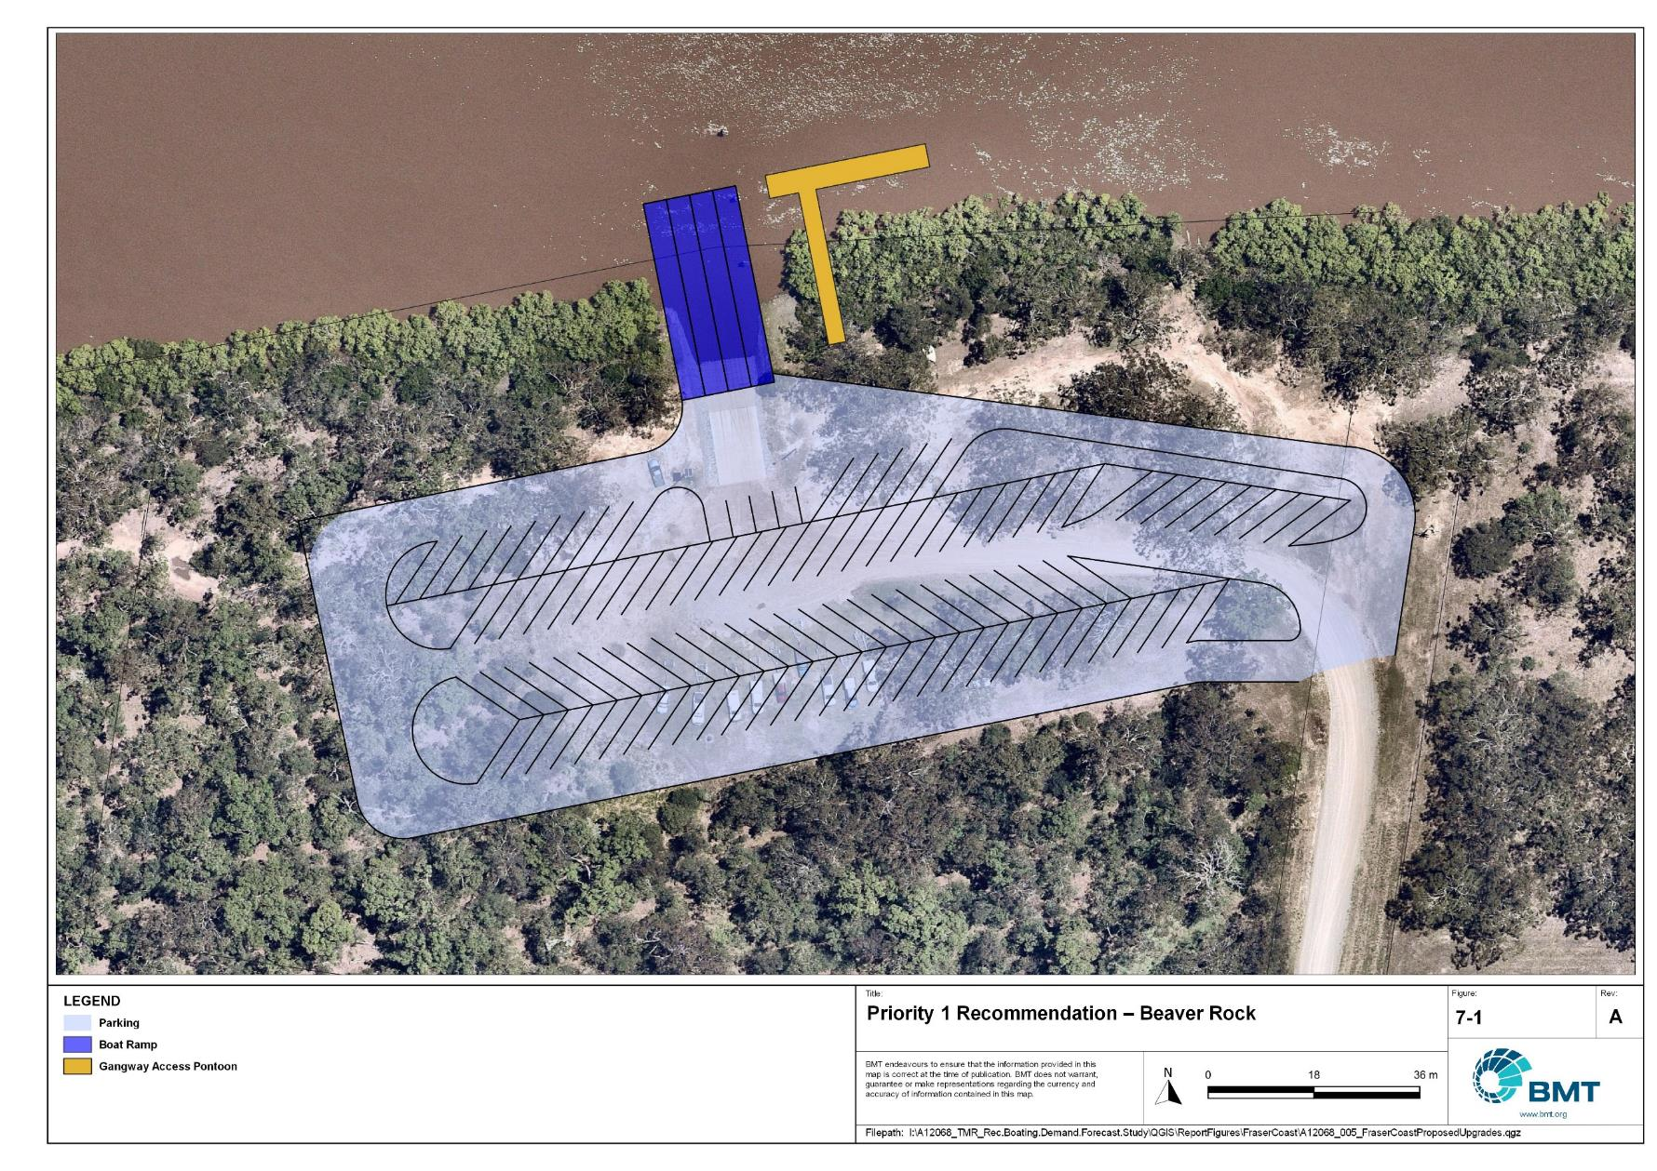

Priority 1 Recommendation – Beaver Rock

"I:\A12068_TMR_Rec.Boating.Demand.Forecast.Study\Recomendations by Council\JPG\FraserCoast\sevens\A12068_005_FraserCoastProposedUpgrades_7-1.jpg"

River Heads - (Priority 1)

|  |  |  |  |  |
| --- | --- | --- | --- | --- |
| General description | | | | |
| Location | River Heads, Ariadne Street, on the northern bank of the head of the Mary River. | | | |
| Existing Facility? | Yes | | | |
| Coordinates | -25.43011133, 152.92381632 | | | |
| Existing tidal status | All-tide | | | |
| Existing wave exposure | Exposed | | | |
| Existing current exposure | Exposed | | | |
| Proposed works | Reclaim land to construct a parking area for 80 CTUs. Construct two new boat ramp lanes to the east of the existing River Heads (west) boat ramp. | | | |
| Increased effective capacity | 3.5 effective lanes. | | | |
| Capacity improvement position | Waterside | Landside | | Both |
| Rationale | The demand Study has shown that the existing River Heads facility is severely constrained by a lack of CTU parking. River Heads is within a development corridor for the Fraser Coast LGA, and provides a deep-water, all-tide accessible recreational boating facility with excellent access to the popular destinations of K’gari and Great Sandy Strait. | | | |
| Anticipated Costs (+/- 50%) | Waterside infrastructure | | $590,000 | |
| Landside infrastructure | | $2,200,000 | |
| Planning, environmental and approvals constraints | | | | |
| Assessment | Requirement | Comments | | |
| Fish Habitat Zone | X | N/A | | |
| Native Title | X | N/A | | |
| MCU requirement | ü | Reclamation works and construction of a carpark may trigger a Development Permit for a Material Change of Use. | | |
| Clearing remnant vegetation | ü | RVM category B- remnant vegetation where the western portion of the carpark is located and would likely require a Development Permit. | | |
| GBRWHA | X | N/A | | |
| Marine Park | ü | The proposed works are located within the current and future Conservation Zone of the Great Sandy Strait Marine Park and will require a Marine Park Permit.  Works can be undertaken within the Conservation Park Zone to the extent they have limited impact. | | |
| Tidal works assessment | ü | New boat ramp and reclamation works will likely be tidal works and require a Development Permit. | | |
| Other as required | ü | Marine Plants – the boat ramp and reclamation works may impact marine plants and therefore may require a Development Permit for marine plant disturbance.  Quarry Material Allocation – if the reclamation is undertaken using dredged material, it may require a Quarry Material Allocation. | | |
| Sea Level Rise | ü | The proposed works are within the boundaries of the erosion prone area subject to sea level rise. | | |
| Storm Tide Hazard | ü | The proposed works are within the boundaries of a high storm tide hazard area | | |
| Anticipated Complexity | Low | Medium | | High |
| Maritime engineering review | | | | |
| Assessment | Site considerations | Comments | | |
| Engineering matters | Geotechnical | Low strength or unsuitable materials are likely to be found at this site and a more detailed geotechnical assessment of this recommendation is suggested. | | |
| Wave Forces | Wave conditions at the site will need a detailed assessment to ensure the recommended configuration and sizing is suitable for the conditions. | | |
| Water Levels | This site is subject to inundation from flood waters and more detailed consideration will be required to ensure the recommended option is suitable. | | |
| Anticipated complexity | Low | Medium | | High |

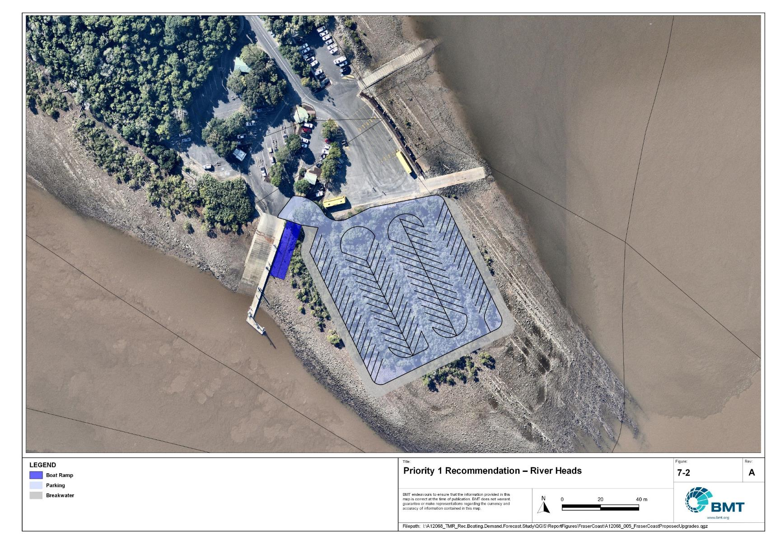

Priority 1 Recommendation – River Heads

"I:\A12068_TMR_Rec.Boating.Demand.Forecast.Study\Recomendations by Council\JPG\FraserCoast\sevens\A12068_005_FraserCoastProposedUpgrades_7-2.jpg"

Urangan Boat Harbour - (Priority 1)

|  |  |  |  |  |
| --- | --- | --- | --- | --- |
| General description | | | | |
| Location | Urangan Boat Harbour, off the Esplanade, Urangan. | | | |
| Existing Facility? | Yes | | | |
| Coordinates | -25.29644496, 152.90808965 | | | |
| Existing tidal status | All-tide | | | |
| Existing wave exposure | None | | | |
| Existing current exposure | None | | | |
| Proposed works | Expand landside facilities by providing 40 new CTU parking spaces on the verge of the Esplanade. Investigate the requirement for stormwater upgrades. | | | |
| Increased effective capacity | 2.0 Effective lanes | | | |
| Capacity improvement position | Waterside | Landside | | Both |
| Rationale | The Urangan Boat Harbour is the most popular facility in Fraser Coast LGA and is constrained by insufficient CTU parking.  *Please note the public marine facility is located within a state boat harbour, any upgrades should seek to align with future planning processes for the harbour.* | | | |
| Anticipated Costs (+/- 50%) | Waterside infrastructure | | N/A | |
| Landside infrastructure | | $250,000 | |
| Planning, environmental and approvals constraints | | | | |
| Assessment | Requirement | Comments | | |
| Fish Habitat Zone | X | N/A | | |
| Native Title  (Badtjala People) | ü | New tenure required for works so interaction with Native Title required | | |
| MCU requirement | ü | Parking lot works will likely trigger a Development Permit for a Material Change of Use | | |
| Clearing remnant vegetation | X | N/A | | |
| GBRWHA | X | N/A | | |
| Marine Park | X | N/A | | |
| Tidal works assessment | X | N/A | | |
| Other as required | ü | New parking lot works is adjacent to a State Controlled Road and will likely require a Road Corridor Permit | | |
| Sea Level Rise | ü | N/A | | |
| Storm Tide Hazard | ü | The proposed works are within the boundaries of a medium to high storm tide hazard area. | | |
| Anticipated Complexity | Low | Medium | | High |

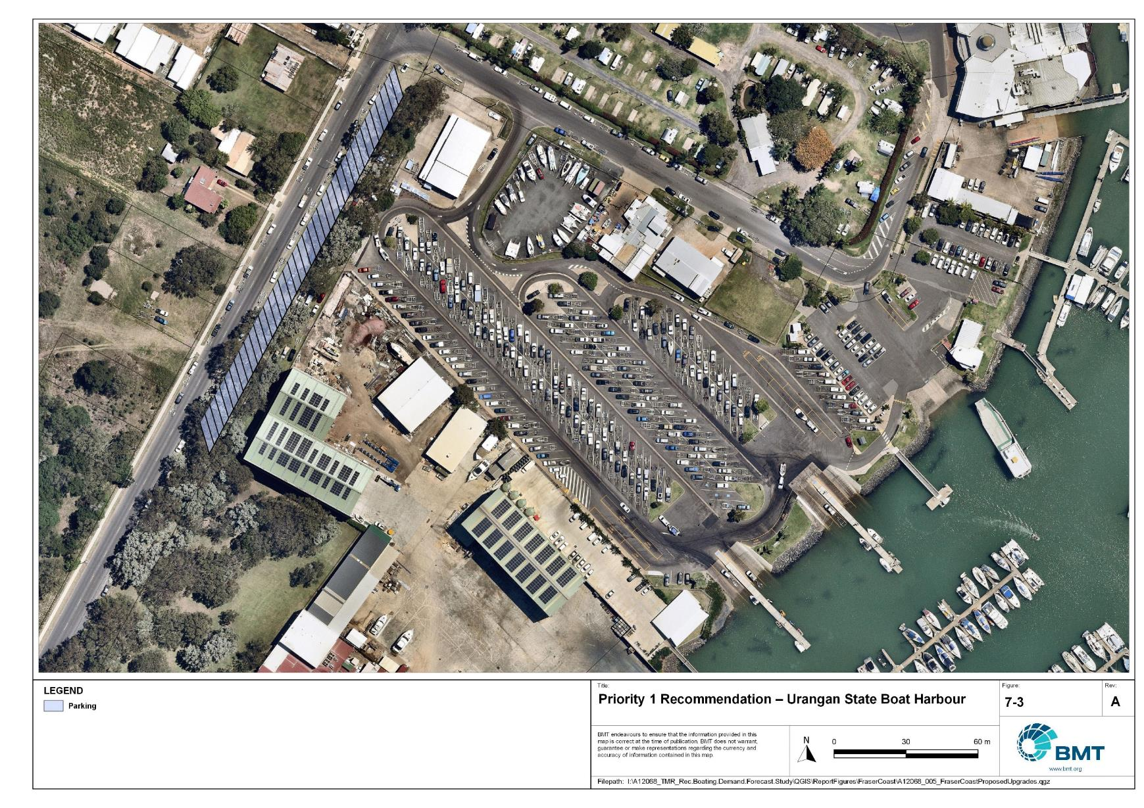

Priority 1 Recommendation – Urangan

"I:\A12068_TMR_Rec.Boating.Demand.Forecast.Study\Recomendations by Council\JPG\FraserCoast\sevens\A12068_005_FraserCoastProposedUpgrades_7-3.jpg"

## Priority 2 Recommendations

Toogoom - (Priority 2)

|  |  |  |  |  |
| --- | --- | --- | --- | --- |
| General description | | | | |
| Location | Beelbi Creek, Toogoom | | | |
| Existing Facility? | Yes | | | |
| Coordinates | -25.24745100, 152.66576100 | | | |
| Existing tidal status | Near all-tide | | | |
| Existing wave exposure | None | | | |
| Existing current exposure | None | | | |
| Proposed works | Construct an extra boat ramp lane to the west of the existing 2-lane facility and install a floating walkway on the central lane. Construct a new CTU parking area in vacant block nearby (with potential for minor raising of land levels required). Formalise a footpath from the car park to the boat ramp. | | | |
| Increased effective capacity | 2 Effective lanes | | | |
| Capacity improvement position | Waterside | Landside | | Both |
| Rationale | The Toogoom facility is the 4th most popular facility in Fraser Coast LGA (behind Urangan, River Heads and Gatakers Bay) and regularly experiences ramp congestion due to insufficient CTU parking space. This is a popular tourism township and provides access to the northern area of Fraser Coast LGA.  There are three suitable land parcels nearby that are options for CTU parking expansion, though Lot 1 RP50903 is preferred. | | | |
| Anticipated Costs (+/- 50%) | Waterside infrastructure | | $680,000 | |
| Landside infrastructure | | $880,000 | |
| Planning, environmental and approvals constraints | | | | |
| Assessment | Requirement | Comments | | |
| Fish Habitat Zone | X | Marine-based works are within the Beelbi Fish Habitat Area (FHA-030) - Management A boundary. A Development Permit and Resource Allocation Authority will be required for works within a declared FHA. Works for public boating infrastructure are permissible in FHA Management A but only where a range of policy requirements is met, including clear demand and the absence of any viable alternatives. | | |
| Native Title  (Badtjala People) | ü | New tenure required for new carpark works so interaction with Native Title required | | |
| MCU requirement | ü | Parking lot works will trigger a Development Permit for a Material Change of Use | | |
| Clearing remnant vegetation | ü | RVM category B- remnant vegetation where the proposed carpark is located. A Development Permit may be required for the clearing of remnant vegetation. | | |
| GBRWHA | X | N/A | | |
| Marine Park | X | N/A | | |
| Tidal works assessment | ü | New boat ramp works will likely be tidal works and require a Development Permit. | | |
| Other as required | ü | Marine Plants – the boat ramp works may impact marine plants and therefore may require a Development Permit for marine plant disturbance.  State Controlled Road - New parking lot works is adjacent to a State Controlled Road and will likely require a Road Corridor Permit | | |
| Sea Level Rise | ü | The proposed works are partially within the erosion prone area subject to sea level rise, except for the southern portion of the parking lot. | | |
| Storm Tide Hazard | ü | The proposed works are within the boundaries of a medium to high storm tide hazard area. | | |
| Anticipated Complexity | Low | Medium | | High |

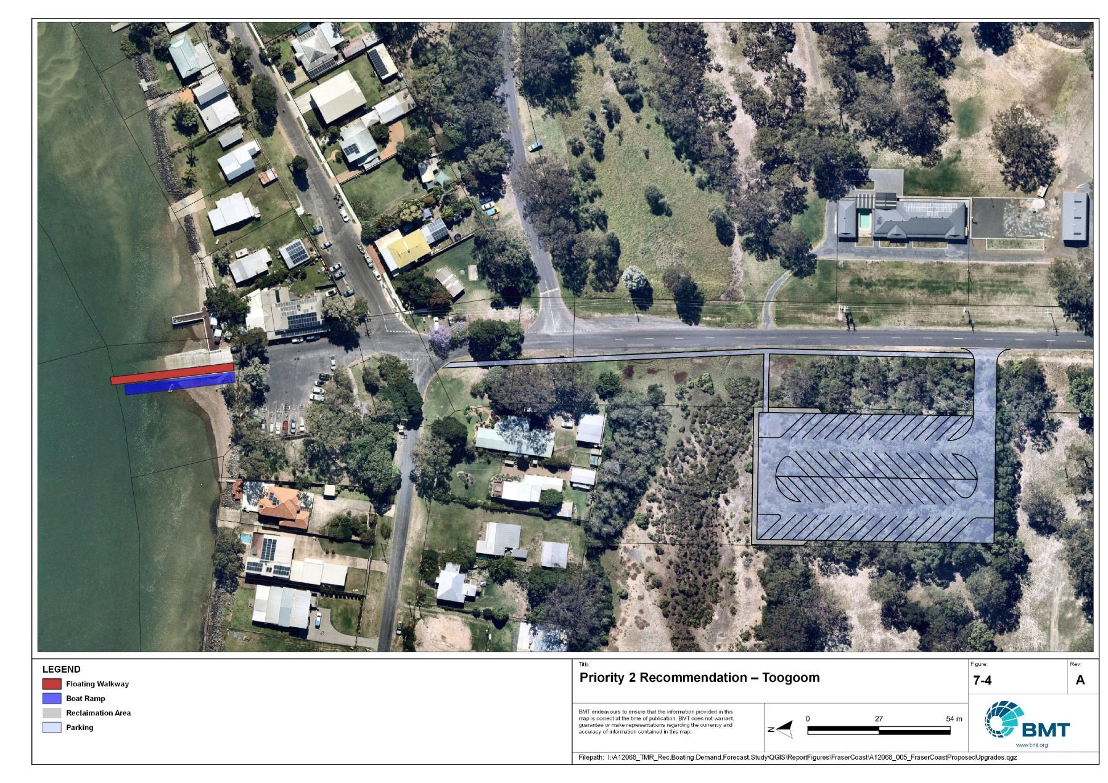

Priority 2 Recommendation - Toogoom

"I:\A12068_TMR_Rec.Boating.Demand.Forecast.Study\Recomendations by Council\JPG\FraserCoast\sevens\A12068_005_FraserCoastProposedUpgrades_7-4.jpg"

Tuan, Bottlebrush Road – (Priority 2)

|  |  |  |  |  |
| --- | --- | --- | --- | --- |
| General description | | | | |
| Location | Tuan, Bottlebrush Road, north bank of Big Tuan Creek. | | | |
| Existing Facility? | Yes | | | |
| Coordinates | -25.68566981, 152.87783255 | | | |
| Existing tidal status | Near all-tide | | | |
| Existing wave exposure | None | | | |
| Existing current exposure | None | | | |
| Proposed works | Determine feasibility of new parking area for 40 CTU parking spaces, increasing the total number of spaces to 60.  A recommended configuration is presented in Figure 7.5. If unviable, investigate options elsewhere to provide this capacity. | | | |
| Increased effective capacity | 1.5 Effective lanes | | | |
| Capacity improvement position | Waterside | Landside | | Both |
| Rationale | There are several settlements in the southern end of the LGA with direct access to Great Sandy Strait, however, there are tidal constraints on all these facilities. The Tuan facility currently has the best tidal access and waterside capacity of these facilities, with launching possible in tides above 0.4m LAT. As Tuan is centrally located between the settlements, an expansion of parking at this facility can cater to the broader area and improve capacity through a larger portion of the tidal range. | | | |
| Anticipated Costs (+/- 50%) | Waterside infrastructure | | N/A | |
| Landside infrastructure | | $190,000 infrastructure only, property acquisition excluded | |
| Planning, environmental and approvals constraints | | | | |
| Assessment | Requirement | Comments | | |
| Fish Habitat Zone | X | N/A | | |
| Native Title  (Badtjala People) | ü | New tenure required for new carpark works so interaction with Native Title required | | |
| MCU requirement | ü | Parking lot works will trigger a Development Permit for a Material Change of Use | | |
| Clearing remnant vegetation | X | N/A | | |
| GBRWHA | X | N/A | | |
| Marine Park | X | N/A | | |
| Tidal works assessment | X | N/A | | |
| Other as required | ü | Ramsar Wetlands – the eastern portion of the carpark may be within the Great Sandy Strait Ramsar wetland. This may trigger a Controlled Activity Approval if there is likely to be a significant impact or unless carpark configuration is revised to ensure it is not within the Ramsar wetland. | | |
| Sea Level Rise | X | N/A | | |
| Storm Tide Hazard | ü | The proposed works are within the boundaries of a medium storm tide hazard area. | | |
| Anticipated Complexity | Low | Medium | | High |

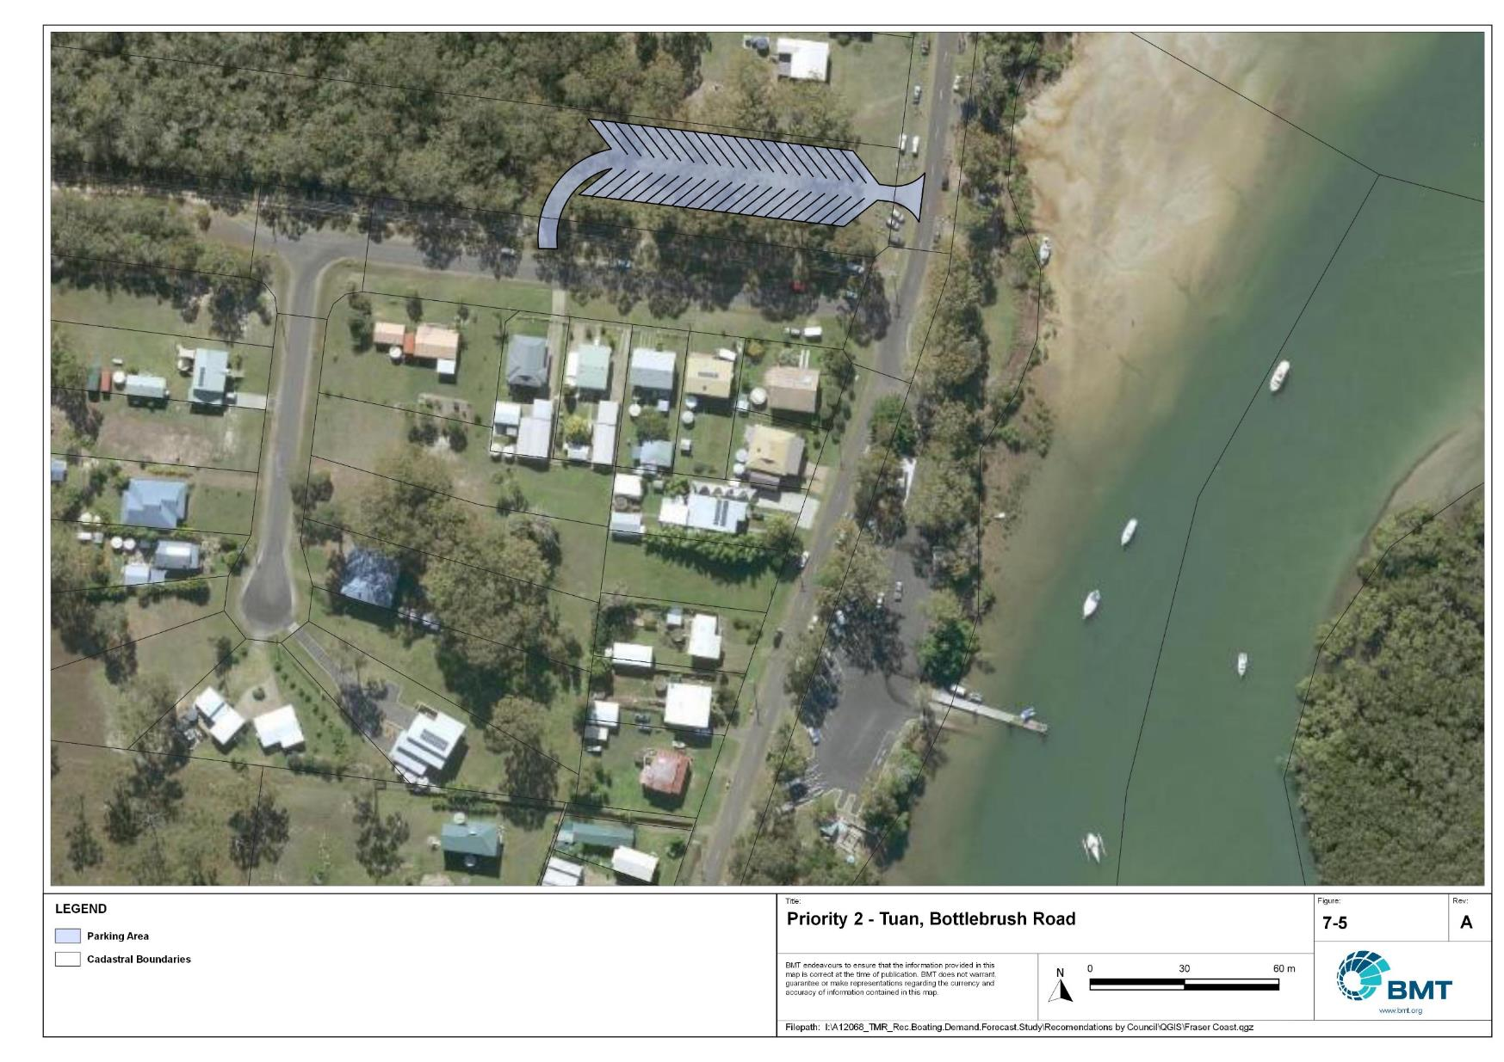

Priority 2 Recommendation - Tuan

"I:\A12068_TMR_Rec.Boating.Demand.Forecast.Study\Recomendations by Council\JPG\FraserCoast\sevens\A12068_005_FraserCoastProposedUpgrades_7-5.jpg"

## Priority 3 Recommendations

Maryborough, South Street – (Priority 3)

|  |  |  |  |  |
| --- | --- | --- | --- | --- |
| General description | | | | |
| Location | Adjacent to Lamington Bridge, on the Mary River in Maryborough | | | |
| Existing Facility? | Yes | | | |
| Coordinates | -25.54426084, 152.68848331 | | | |
| Existing tidal status | All-tide | | | |
| Existing wave exposure | None | | | |
| Existing current exposure | None | | | |
| Proposed works | Reconfigure and expand car park to allow for 65 CTU spaces.  A recommended parking layout adjacent to the ramp is presented in Figure 7.6. If unviable, investigate options elsewhere to provide this capacity. | | | |
| Increased effective capacity | 1.5 effective lanes | | | |
| Capacity improvement position | Waterside | Landside | | Both |
| Rationale | To improve access to the Mary River at a convenient location close to the main population area. | | | |
| Anticipated Costs (+/- 50%) | Waterside infrastructure | | N/A | |
| Landside infrastructure | | $300,000 | |
| Planning, environmental and approvals constraints | | | | |
| Assessment | Requirement | Comments | | |
| Fish Habitat Zone | X | N/A | | |
| Native Title | X | N/A | | |
| MCU requirement | X | N/A | | |
| Clearing remnant vegetation | ü | The southern portion of the carpark upgrade may contain areas of RVM Category R – reef-regrowth watercourse vegetation. A Development Permit may be required for clearing of remnant vegetation. | | |
| GBRWHA | X | N/A | | |
| Marine Park | X | N/A | | |
| Tidal works assessment | X | N/A | | |
| Other as required | ü | State Controlled Road - Parking lot works is adjacent to a State Controlled Road and may require a Road Corridor Permit | | |
| Sea Level Rise | ü | The southern portion of the carpark upgrade is within the boundaries of the erosion prone area subject to sea level rise. | | |
| Storm Tide Hazard | ü | The proposed works are within a medium to high storm tide hazard area. | | |
| Anticipated Complexity | Low | Medium | | High |

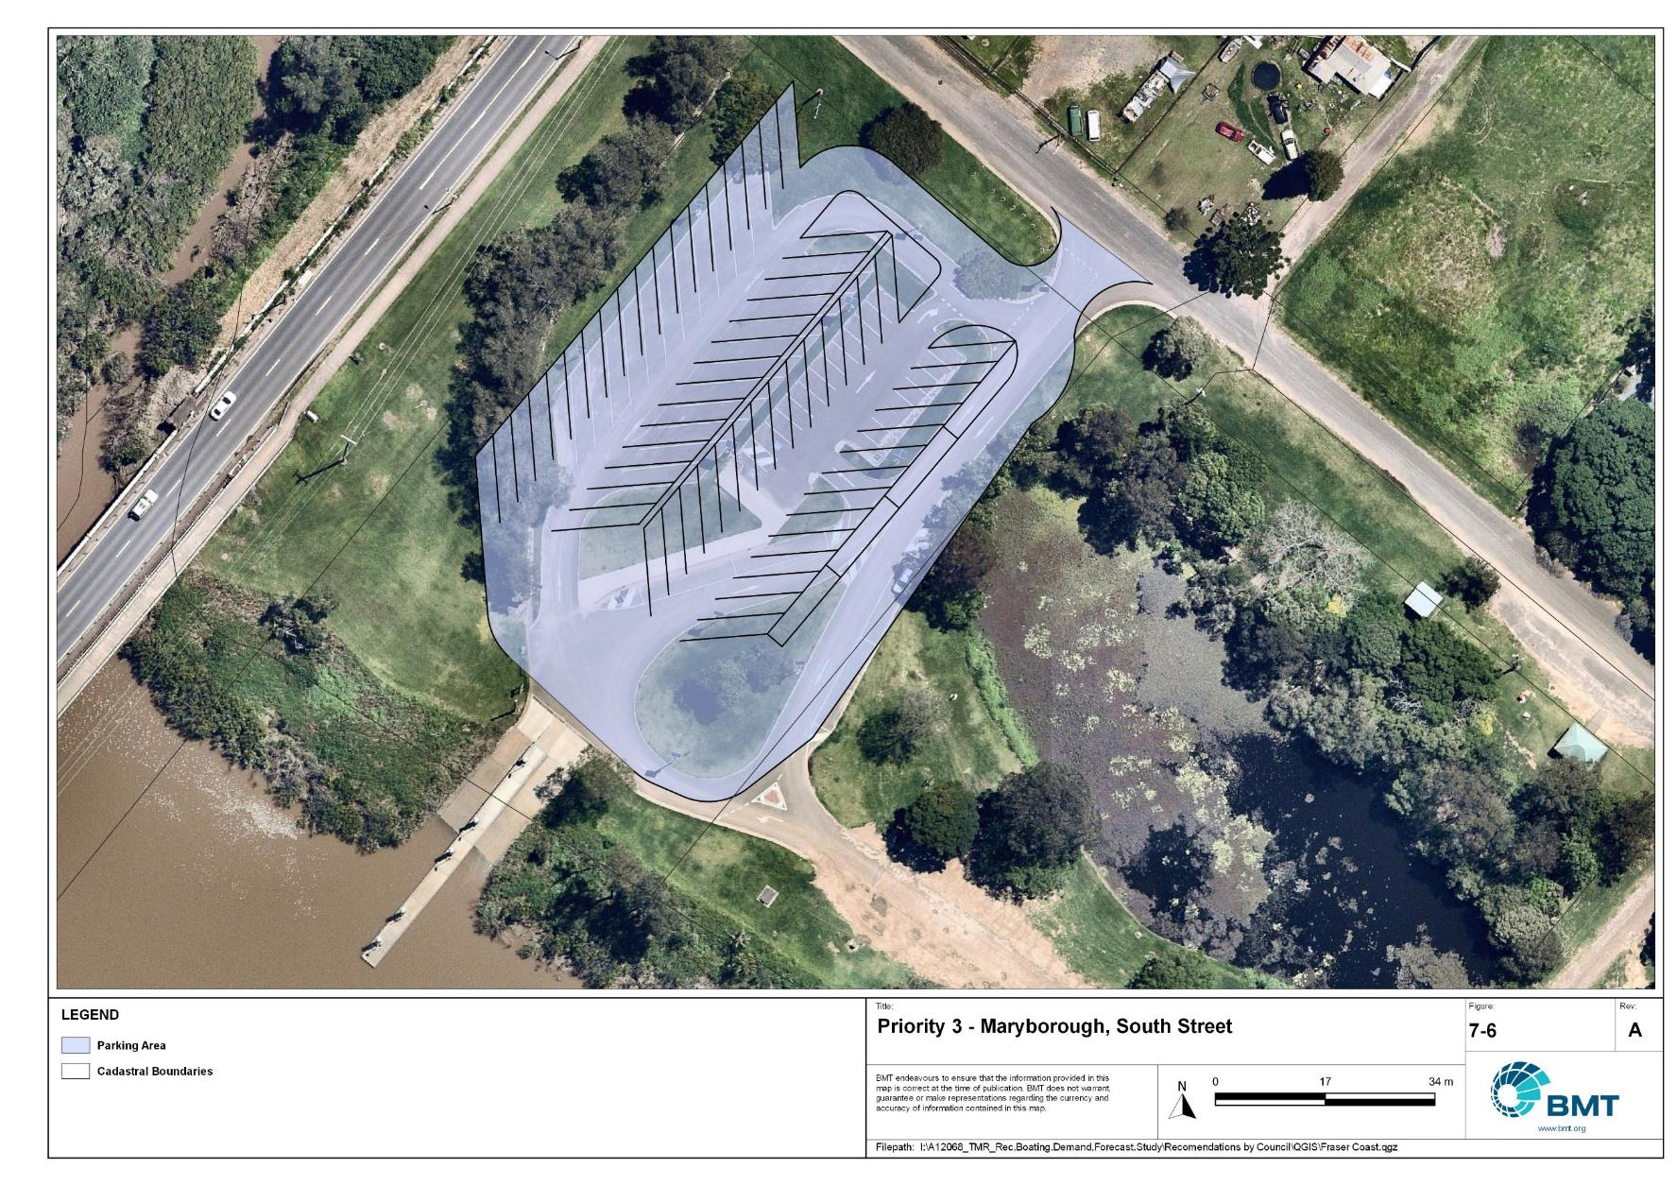

Priority 3 Recommendation – Maryborough, South Street,

I:\A12068_TMR_Rec.Boating.Demand.Forecast.Study\Recomendations by Council\JPG\FraserCoast\sevens\A12068_005_FraserCoastProposedUpgrades_7-6.jpg

Gatakers Bay, Corfield Street - (Priority 3)

|  |  |  |  |  |
| --- | --- | --- | --- | --- |
| General description | | | | |
| Location | Gatakers Bay, off the Esplanade, Point Vernon. | | | |
| Existing Facility? | Yes | | | |
| Coordinates | -25.24573300, 152.81236600 | | | |
| Existing tidal status | Near all-tide | | | |
| Existing wave exposure | None | | | |
| Existing current exposure | None | | | |
| Proposed works | Expand facility by constructing another boat ramp lane to the west of the existing ramp and installing a fixed sloping walkway (after community consultation about options) over the existing lane, making this a 2-lane facility with a centralised walkway. Expand parking area to add another 35 CTU spaces, matching the existing parking area style (semi-formalised with grass). Investigate hybrid parking arrangement for passenger vehicles and CTUs. Maintain channel depth to provide all-tide access. | | | |
| Increased effective capacity | 1.65 Effective lanes | | | |
| Capacity improvement position | Waterside | Landside | | Both |
| Rationale | An artificial channel cut through the rock shelf to the facility presently provides near all-tide, deep-water access, although the facility is unsheltered at higher tides. Maintaining this channel to ensure all-tide access would improve the capacity of the facility. This facility is very popular and has room for expansion. | | | |
| Anticipated Costs (+/- 50%) | Waterside infrastructure | | $910,000 | |
| Landside infrastructure | | $330,000 | |
| Planning, environmental and approvals constraints | | | | |
| Assessment | Requirement | Comments | | |
| Fish Habitat Zone | X | N/A | | |
| Native Title | X | N/A | | |
| MCU requirement | X | N/A | | |
| Clearing remnant vegetation | X | N/A | | |
| GBRWHA | X | N/A | | |
| Marine Park | X | N/A | | |
| Tidal works assessment | ü | New boat ramp and fixed sloping walkway as well as channel works will likely be tidal works and require a Development Permit. | | |
| Other as required | ü | Marine Plants – the channel, boat ramp and fixed sloping walkway works may impact marine plants and therefore may require a Development Permit for marine plant disturbance. | | |
| Sea Level Rise | ü | The proposed works are partially within the boundaries of the erosion prone area subject to sea level rise, except for the eastern parking lot works. | | |
| Storm Tide Hazard | ü | The proposed works are partially within the boundaries of a medium to high hazard area except for the eastern parking lot works. | | |
| Anticipated Complexity | Low | Medium | | High |
| Maritime engineering review | | | | |
| Assessment | Site considerations | Comments | | |
| Engineering Matters | Wave Forces | Wave conditions at the site will need a detailed assessment to ensure the recommended configuration and sizing is suitable for the conditions. | | |
| Anticipated Complexity | Low | Medium | | High |

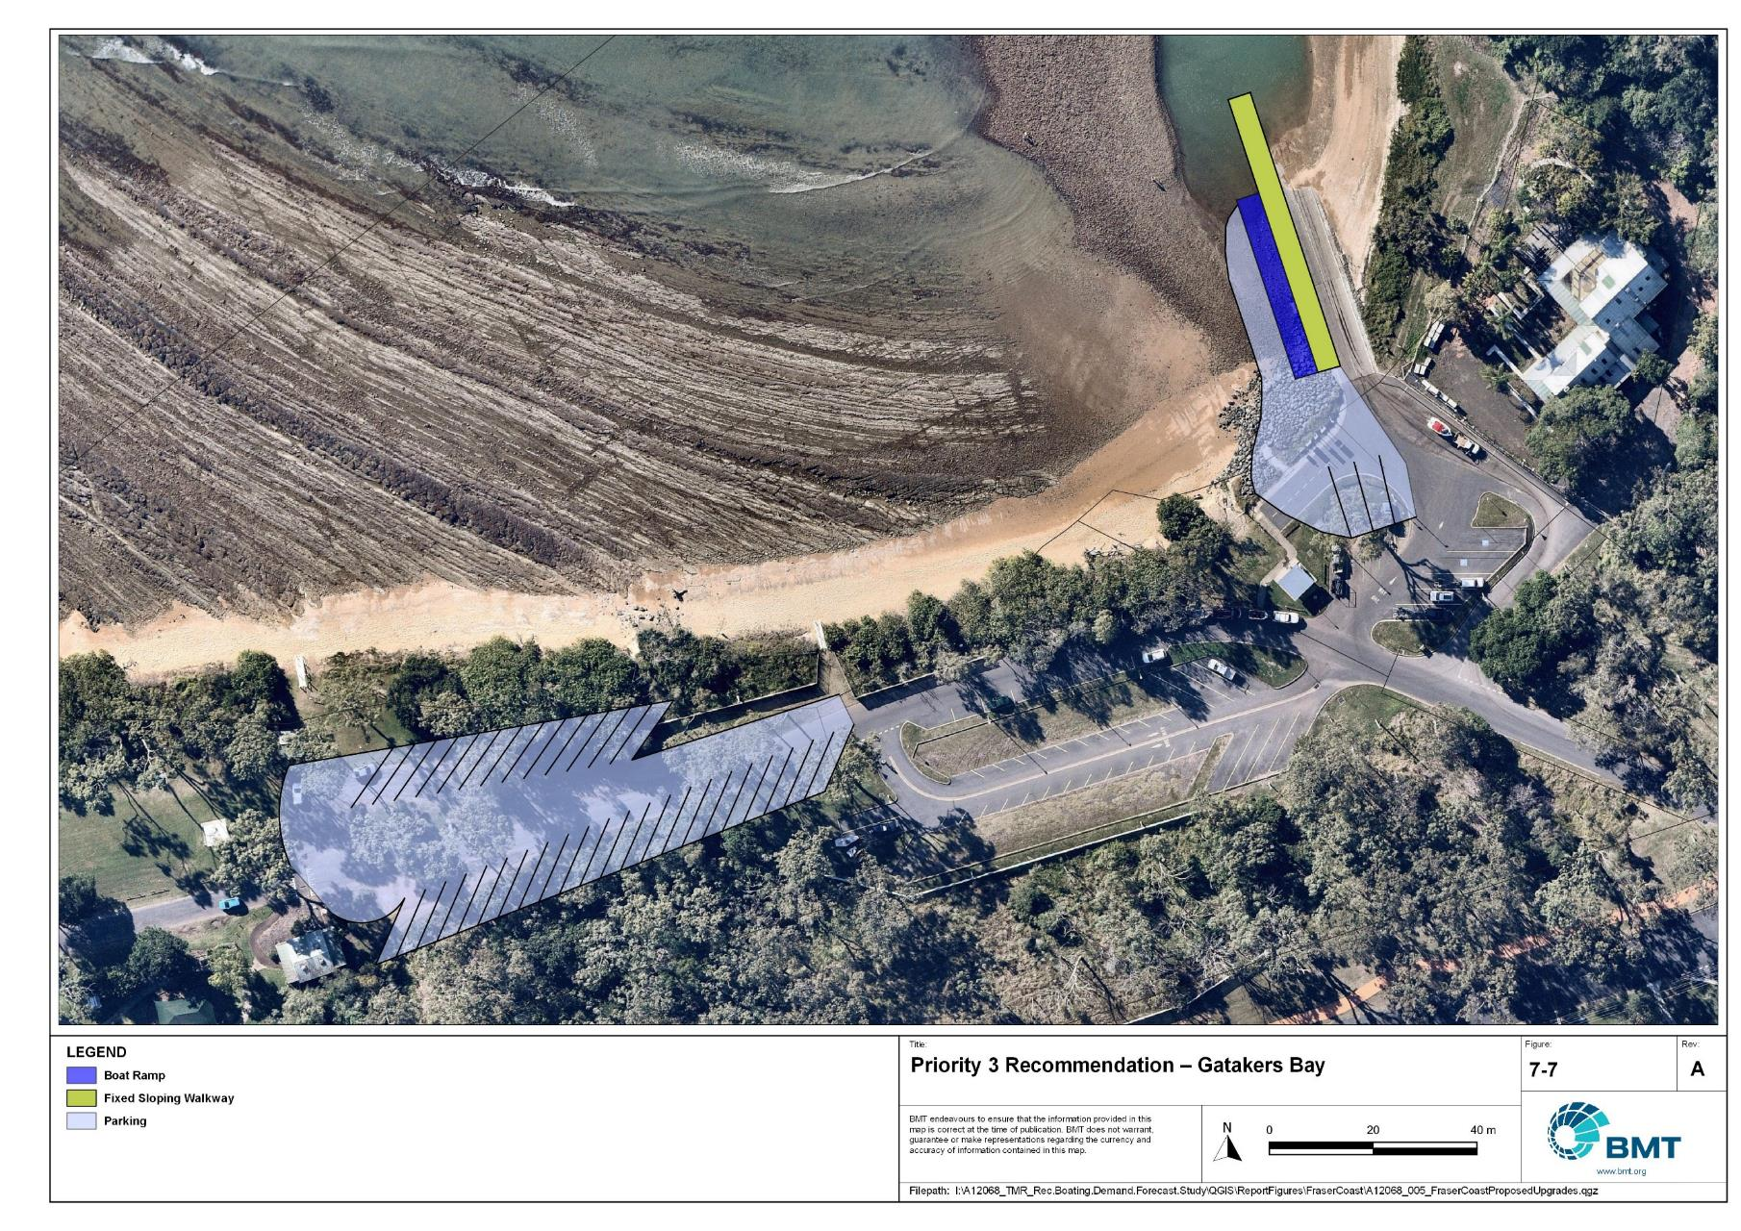

Priority 3 Recommendation – Gatakers Bay

I:\A12068_TMR_Rec.Boating.Demand.Forecast.Study\Recomendations by Council\JPG\FraserCoast\sevens\A12068_005_FraserCoastProposedUpgrades_7-7.jpg

Poona, Owen Cox Street - (Priority 3)

|  |  |  |  |  |
| --- | --- | --- | --- | --- |
| General description | | | | |
| Location | Poona Creek, Poona, Great Sandy Strait | | | |
| Existing Facility? | Yes | | | |
| Coordinates | -25.72260668, 152.91351590 | | | |
| Existing tidal status | Part-Tide | | | |
| Existing wave exposure | None | | | |
| Existing current exposure | None | | | |
| Proposed works | Expand the ramp to include a second boat ramp lane and a fixed sloping walkway. | | | |
| Increased effective capacity | 0.2 effective lanes  Safety and amenity upgrades | | | |
| Capacity improvement position | Waterside | Landside | | Both |
| Rationale | The boat ramp at Poona is currently a single lane, part-tide ramp. The finite amount of time available to launch and retrieve vessels causes congestion at the ramp and poses safety issues. Poona is an active recreational boating community, with an aging population. As such, this recommendation aims to improve amenity and useability of the facility by improving the throughput of the ramp at high tides. The small amount of wave exposure and the limited depth necessitates a fixed sloping walkway as a queueing structure, instead of a floating walkway which would be exposed to wave action and increased maintenance issues from resting on the creek bed at low tides. | | | |
| Anticipated Costs (+/- 50%) | Waterside infrastructure | | $800,000 | |
| Landside infrastructure | | N/A | |
| Planning, environmental and approvals constraints | | | | |
| Assessment | Requirement | Comments | | |
| Fish Habitat Zone | X | N/A | | |
| Native Title | X | N/A | | |
| MCU requirement | X | N/A | | |
| Clearing remnant vegetation | X | N/A | | |
| GBRWHA | X | N/A | | |
| Marine Park | X | N/A | | |
| Tidal works assessment | ü | New boat ramp expansion works will likely be tidal works and require a Development Permit. | | |
| Other as required | ü | Marine Plants – the boat ramp expansion works may impact marine plants and therefore may require a Development Permit for marine plant disturbance. | | |
| Sea Level Rise | ü | The proposed works are within the boundaries of an erosion prone area subject to sea level rise. | | |
| Storm Tide Hazard | ü | The proposed works are within the boundaries of a high hazard area. | | |
| Anticipated Complexity | Low | Medium | | High |
| Maritime engineering review | | | | |
| Assessment | Site considerations | Comments | | |
| Engineering matters | Sediment Transport | This recommendation requires further investigation to ensure undesirable siltation or disruption to sediment transport does not occur. | | |
| Anticipated Complexity | Low | Medium | | High |

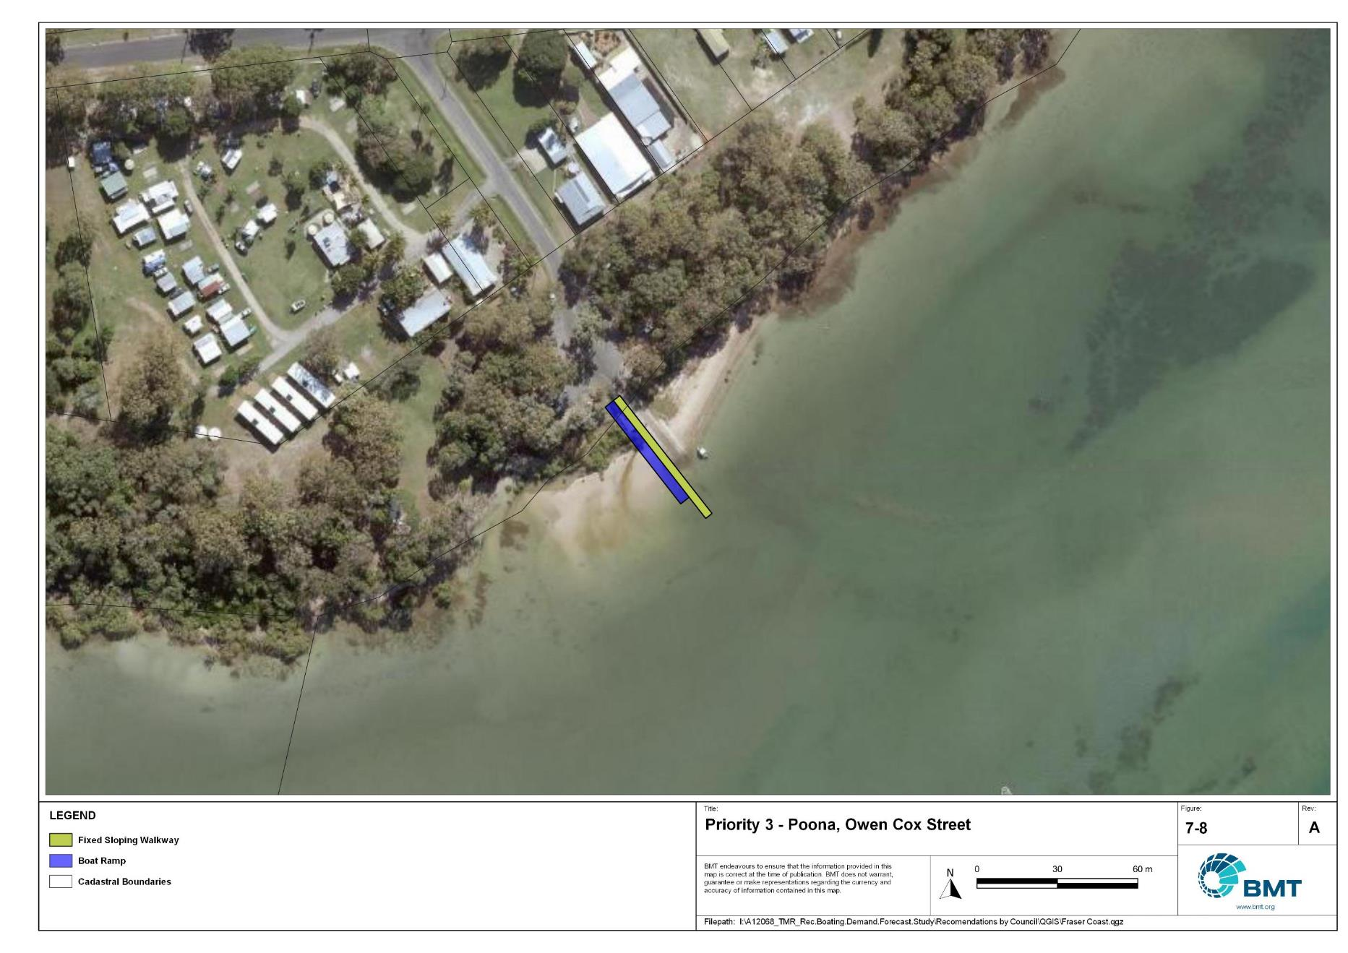

Priority 3 Recommendation – Poona, Owen Cox Street

I:\A12068_TMR_Rec.Boating.Demand.Forecast.Study\Recomendations by Council\JPG\FraserCoast\sevens\A12068_005_FraserCoastProposedUpgrades_7-8.jpg

Lenthalls Dam

|  |  |  |  |  |
| --- | --- | --- | --- | --- |
| General description | | | | |
| Location | Lake Lenthall, on the Burrum River | | | |
| Existing Facility? | Yes | | | |
| Coordinates | -25.40509800, 152.53277600 | | | |
| Existing tidal status | All-tide (dam level dependent) | | | |
| Existing wave exposure | None | | | |
| Existing current exposure | None | | | |
| Proposed works | Construct a second boat ramp lane and expand parking to 30 CTU parking spaces total. | | | |
| Increased effective capacity | 1.0 effective lane | | | |
| Capacity improvement position | Water | Landside | | Both |
| Rationale | To increase the limited opportunities for freshwater boating in Fraser Coast LGA. Expanding the boat ramp lanes and parking area will allow for better utilisation of the water storage for recreation. | | | |
| Anticipated Costs (+/- 50%) | Waterside infrastructure | | $165,000 | |
| Landside infrastructure | | $120,000 | |
| Planning, environmental and approvals constraints | | | | |
| Assessment | Requirement | Comments | | |
| Fish Habitat Zone | X | N/A | | |
| Native Title | X | N/A | | |
| MCU requirement | X | N/A | | |
| Clearing remnant vegetation | X | N/A | | |
| GBRWHA | X | N/A | | |
| Marine Park | X | N/A | | |
| Tidal works assessment | X | N/A | | |
| Other as required | ü | A Development Permit will likely be required for operational works. | | |
| Sea Level Rise | X | N/A | | |
| Storm Tide Hazard | X | N/A | | |
| Anticipated Complexity | Low | Medium | | High |

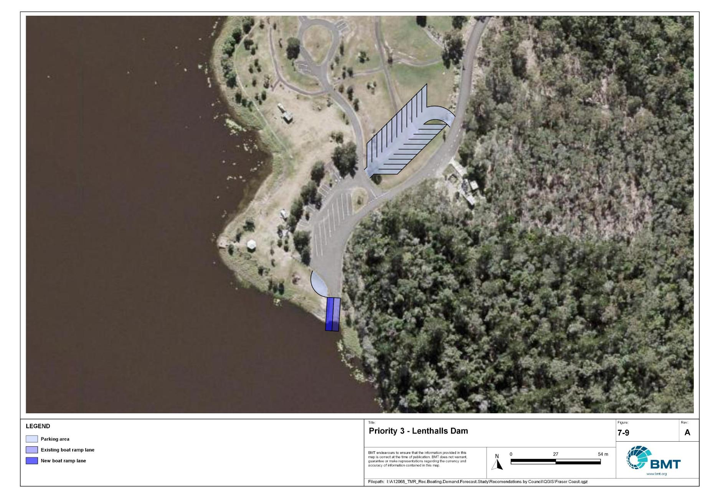

Priority 3 Recommendation – Lenthalls Dam

I:\A12068_TMR_Rec.Boating.Demand.Forecast.Study\Recomendations by Council\JPG\FraserCoast\sevens\A12068_005_FraserCoastProposedUpgrades_7-9.jpg

## Priority 4 Recommendations

Nil

# References

Australian Bureau of Statistics (ABS), 2021, *2021 Census,* <https://www.abs.gov.au/census>

Bell, Frederick W. 2022, *Estimation of the present and projected demand and supply of boat ramps for Florida's coastal regions and counties*, Florida State University, Department of Economics.

BMT, 2015, *MPSC Managed Boating Facilities Demand and Capacity Study: Boat Ramp Modelling*

Department of Transport and Main Roads (TMR), 2020, Marine facilities and infrastructure plan.

GHD, 2011, *Recreational Boating Facilities Demand Forecasting Study*

GHD, 2017, *Queensland Recreational Boating Facilities Demand Forecasting Study 2017.*

Maritime Safety Queensland (MSQ), 2022, *Recreational Boating Facilities,* <https://www.getinvolved.qld.gov.au/gi/consultation/8850/view.html>

Queensland Government Department of Resources (DoR), 2022, *Cities and towns [OGC WMS Service]*, Accessed 5/10/2022, available online at spatial.information.qld.gov.au/arcgis/home/item.html?id=103c7c9ccca449fab79d27cde06868ab

Rose, T., R. Powell & J. Yu (2009). Identification of the Present and Future Recreational Boating Infrastructure in Redland City – A 10 Year Infrastructure Plan- Griffith University

SKM (1998) Public Boat Ramps Central Queensland Strategic Plan - Volume One - Demand Forecasting - Noosa to Yeppoon. Sinclair Knight Merz, March 1998.

Swett, R., Fik, T., Ruppert, T., Davidson, G., Guevara, C. & Betty Staugler, 2012, *Planning for the future of recreational boating access to charlotte county waterways: 2010 – 2050*, Florida Sea Grant, University of Florida.

Western Australia Department of Transport, 2019, *Perth Recreational Boating Facilities Study Review 2019*, https://www.transport.wa.gov.au/mediaFiles/marine/MAC_P_Perth_RBFS_study_review_2019.pdf

Western Australia Department of Transport, 2021, *South West Region Recreational Boating Facilities Study July 2021,* https://www.transport.wa.gov.au/mediaFiles/marine/MAC_P_SouthWest_RBFS_Study_2021.pdf

###### Demand Study

"G:\Admin\A12068.g.mpb.TMRBoatingDemand\06_Reports\09_Demand Study\2022_2119 (016) Final Demand Report (March 2023).pdf"

###### Boat launching facility capacity

Capacity of existing boat launching facilities

| Facility ID | Facility name | No. lanes | Tidal access at ramp | | Tidal access to open water | Queuing facility | Formal CTUs | Informal CTUs | | Waterside capacity | Landside capacity | Effective capacity | Constraint |
| --- | --- | --- | --- | --- | --- | --- | --- | --- | --- | --- | --- | --- | --- |
| **Open water access** | | | | | | | | | | | | | | |
| HB11 | River Heads (East), Ariadne Street | 1 | All-tide | | All-tide | None | 10 |  | | 0.5 | 0.75 | 0.5 | Waterside |
| HB12 | River Heads (West), Ariadne Street | 2 | All-tide | | All-tide | Floating Walkway | 30 |  | | 3 | 1.5 | 1.5 | Landside |
| HB38 | Gatakers Bay, Corfield Street | 2 | Near all-tide | | All-tide | Beach | 45 |  | | 2.2 | 2 | 2 | Landside |
| HB41 | Toogoom, Toogoom Road | 2 | Near all-tide | | Near all-tide | Beach | 8 |  | | 1.76 | 0.75 | 0.75 | Landside |
| HB56 | Burrum Heads, Ross Street | 2 | Part-tide | | Part-tide | Pontoon | 8 |  | | 1.2 | 0.75 | 0.75 | Landside |
| HB58 | Burrum Heads, Lions Park | 2 | All-tide | | All-tide | Floating Walkway | 48 |  | | 3 | 2.25 | 2.25 | Landside |
| HB71 | Urangan, Jetty Road (north-east) | 4 | All-tide | | All-tide | Floating Walkway | 100 |  | | 6 | 4.5 | 4.5 | Landside |
| HB73 | Urangan, Jetty Road (south-west) | 4 | All-tide | | All-tide | Floating Walkway | 100 |  | | 6 | 4.5 | 4.5 | Landside |
| MB31 | Beaver Rock, Beaver Rock Road | 2 | All-tide | | All-tide | None | 0 | 20 | | 2 | 1.25 | 1.25 | Landside |
| MB43 | Boonooroo, Bates Street | 1 | Part-tide | | Part-tide | None | 0 | 5 | | 0.5 | 0.5 | 0.5 | Waterside |
| **Subtotal** |  | **22** |  | |  |  | **349** | **25** | | **26.16** | **18.75** | **18.5** |  |
| **Distance-limited open water access** | | | | | | | | | | | | | | |
| HB46 | Pacific Haven, Pacific Haven Crescent | 1 | Part-tide | | Part-tide | None | 0 | 5 | | 0.5 | 0.5 | 0.5 | Waterside |
| HB62 | Howard, Powerhouse Drive | 2 | All-tide | | Near all-tide | None | 5 |  | | 2 | 0.5 | 0.5 | Landside |
| MB11 | Maryborough, Granville, Raglan Street | 1 | All-tide | | All-tide | None | 8 |  | | 1 | 0.75 | 0.75 | Landside |
| **Subtotal** |  | **4** |  | |  |  | **13** | **5** | | **3.5** | **1.75** | **1.75** |  |
| **Depth-limited open water access** | | | | | | | | | | | | | | |
| MB41 | Tuan, Bottlebrush Drive | 2 | Near all-tide | | Near all-tide | Floating Walkway | 20 |  | | 2.72 | 1.25 | 1.25 | Landside |
| MB51 | Maaroom, Granville Road | 3 | Part-tide | | Part-tide | Floating Walkway | 11 | 15 | | 2.05 | 1.5 | 1.5 | Landside |
| MB61 | Poona, Owen Cox Street | 1 | Part-tide | | Part-tide | Beach | 10 |  | | 0.55 | 0.75 | 0.55 | Waterside |
| TI81 | Tinnanbar, Boat Ramp Drive | 2 | Part-tide | | Part-tide | Beach | 0 | 5 | | 0.55 | 0.5 | 0.5 | Landside |
| **Subtotal** |  | **8** |  | |  |  | **41** | **20** | | **5.87** | **4** | **3.8** |  |
| **Infrastructure-limited open water access** | | | | | | | | | | | | | | |
| MB21 | Maryborough, South Street | 2 | All-tide | | All-tide | Floating Walkway | 23 |  | | 3.4 | 1.5 | 1.5 | Landside |
| WC11 | Yengarie, Pleasant View Road | 1 | Part-tide | | Part-tide | None | 5 |  | | 0.5 | 0.5 | 0.5 | Waterside |
| **Subtotal** |  | **3** |  | |  |  | **28** | **0** | | **3.9** | **2** | **2** |  |
| **Fresh water** | | | | | | | | | | | | | |
| HB15 | Lenthalls Dam | 1 | Fresh water | | Fresh water | None | 8 |  | | 1 | 1 | 1 | Waterside |
| MB90 | Tiaro, Petrie Park | 1 | Fresh water | | Fresh water | Floating Walkway | 0 | 5 | | 1.7 | 0.5 | 0.5 | Landside |
| **Subtotal** |  | **2** |  | |  |  | **8** | **5** | | **2.7** | **1.5** | **1.5** |  |
| **Beach ramps** | | | | | | | | | | | | | |
| HB25 | Torquay, Bideford Street | 1 | Part-tide | | Part-tide | Beach | 7 |  | | 0.28 | 0.5 | 0.28 | Waterside |
| HB35 | Point Vernon, Aplin Street | 1 | Part-tide | | Part-tide | None | 0 | 10 | | 0.25 | 0.75 | 0.25 | Waterside |
| HB51 | Burrum Heads, Burrum Heads Road | 1 | Part-tide | | Part-tide | Beach | 7 |  | | 0.55 | 0.5 | 0.5 | Landside |
| **Subtotal** |  | **3** |  | |  |  | **14** | **10** | | **1.08** | **1.75** | **1.03** |  |
| **Total effective capacity** | | | |  | | | | |  | | | | | |

###### Travel time statistics

Travel time from population centres to nearest sheltered all-tide or near all-tide open water accessible facilities

| Population Centre | Travel time (mins) |
| --- | --- |
| Aldershot | 22.5 |
| Bauple | 39.8 |
| Boonooroo | 4.7 |
| Burrum Heads | 0.8 |
| Hervey Bay | 5.4 |
| Howard | 17.3 |
| Maryborough | 14.9 |
| Nikenbah | 8.2 |
| Owanyilla | 26 |
| Pialba | 4.4 |
| Poona | 20.3 |
| River Heads | 1.9 |
| Tawan | 25.6 |
| Tiaro | 31 |
| Tinana | 17.4 |
| Tinnanbar | 30.8 |
| Toogoom | 13.4 |
| Torbanlea | 16.2 |
| Tuan | 1 |

###### Facility Use

Boat launching facility usage statistics

| Facility ID | Facility name | Total reports | Fraser Coast | Brisbane | Moreton Bay | Sunshine Coast | Bundaberg | Gold Coast | Gympie | Logan | Redland | Ipswich | Other LGAs |
| --- | --- | --- | --- | --- | --- | --- | --- | --- | --- | --- | --- | --- | --- |
| Total |  | 46794 | 30226 | 2243 | 1851 | 1756 | 1256 | 1219 | 745 | 674 | 615 | 591 | 5618 |
| Total % |  | 100% | 64.6% | 4.8% | 4.0% | 3.8% | 2.7% | 2.6% | 1.6% | 1.4% | 1.3% | 1.3% | 12.0% |
| HB71 | Urangan Boat Harbour, Jetty Road (north-east) | 13049 | 68.8% | 4.0% | 3.5% | 3.3% | 1.8% | 2.7% | 0.9% | 1.2% | 1.1% | 1.4% | 11.3% |
| HB58 | Burrum Heads, Lions Park | 9192 | 58.7% | 6.0% | 4.7% | 4.0% | 5.1% | 2.9% | 0.7% | 1.7% | 1.9% | 1.4% | 12.7% |
| HB25 | Torquay, Bideford Street | 3566 | 71.7% | 4.9% | 3.1% | 1.5% | 2.0% | 2.2% | 0.6% | 1.6% | 1.3% | 0.8% | 10.4% |
| HB12 | River Heads (West), Ariadne Street | 3235 | 53.5% | 5.6% | 7.4% | 3.7% | 2.2% | 4.0% | 0.8% | 2.2% | 0.8% | 1.6% | 18.1% |
| MB21 | Maryborough, South Street | 2989 | 87.3% | 2.1% | 1.1% | 1.5% | 1.3% | 0.8% | 0.9% | 0.8% | 0.2% | 0.5% | 3.5% |
| HB35 | Point Vernon, Aplin Street | 2727 | 74.4% | 4.9% | 2.7% | 1.9% | 1.4% | 1.7% | 0.3% | 1.3% | 1.0% | 1.4% | 9.1% |
| HB38 | Gatakers Bay, Corfield Street | 2348 | 68.3% | 4.3% | 3.3% | 1.8% | 1.9% | 2.1% | 0.6% | 2.0% | 1.4% | 2.1% | 12.0% |
| MB61 | Poona, Owen Cox Street | 1395 | 29.0% | 8.7% | 9.5% | 8.7% | 2.9% | 3.5% | 8.4% | 3.2% | 2.2% | 1.4% | 22.7% |
| MB51 | Maaroom, Granville Road | 1337 | 64.3% | 2.8% | 2.7% | 7.9% | 2.7% | 1.9% | 6.5% | 1.3% | 0.4% | 0.4% | 9.1% |
| MB40 | Tuan, Bottlebrush Drive (Downstream) | 1321 | 64.7% | 2.9% | 2.5% | 9.0% | 1.0% | 1.4% | 5.5% | 0.5% | 0.6% | 1.3% | 10.6% |
| HB41 | Toogoom, Toogoom Road | 876 | 52.1% | 5.9% | 3.9% | 4.8% | 4.6% | 3.3% | 2.9% | 2.6% | 4.8% | 1.7% | 13.5% |
| MB90 | Tiaro, Petrie Park | 785 | 43.1% | 5.4% | 4.7% | 5.6% | 1.4% | 6.5% | 4.8% | 1.0% | 1.4% | 1.1% | 25.0% |
| MB43 | Boonooroo, Bates Street | 769 | 65.3% | 7.2% | 2.5% | 5.1% | 2.1% | 1.4% | 4.8% | 0.7% | 2.1% | 0.4% | 8.6% |
| MB31 | Beaver Rock, Beaver Rock Road | 645 | 78.4% | 0.8% | 3.1% | 0.6% | 0.9% | 1.7% | 1.4% | 0.3% | 0.8% | 0.8% | 11.2% |
| HB15 | Lenthalls Dam | 513 | 61.8% | 3.3% | 3.7% | 4.7% | 9.0% | 4.9% | 0.6% | 0.2% | 2.1% | 0.6% | 9.2% |
| HB51 | Burrum Heads, Burrum Heads Road | 440 | 43.0% | 9.1% | 5.2% | 5.5% | 5.2% | 4.5% | 1.8% | 1.6% | 3.0% | 1.6% | 19.5% |
| TI81 | Tinnanbar, Boat Ramp Drive | 392 | 32.1% | 8.2% | 7.9% | 12.0% | 1.0% | 1.5% | 15.1% | 1.0% | 0.8% | 0.5% | 19.9% |
| HB46 | Pacific Haven, Pacific Haven Crescent | 328 | 56.7% | 3.7% | 7.0% | 3.4% | 7.0% | 4.3% | 0.3% | 0.6% | 2.1% | 2.1% | 12.8% |
| HB56 | Burrum Heads, Ross Street | 307 | 46.9% | 11.4% | 3.6% | 12.4% | 3.9% | 0.0% | 1.6% | 1.3% | 1.0% | 2.0% | 16.0% |
| MB11 | Maryborough, Granville, Raglan Street | 272 | 81.2% | 1.8% | 0.4% | 4.8% | 0.7% | 0.4% | 0.4% | 0.7% | 0.4% | 0.4% | 8.8% |
| HB62 | Howard, Powerhouse Drive | 243 | 65.0% | 7.0% | 2.1% | 2.5% | 6.2% | 2.5% | 0.0% | 0.4% | 1.6% | 0.0% | 12.8% |
| WC11 | Yengarie, Pleasant View Road | 65 | 90.8% | 1.5% | 1.5% | 0.0% | 0.0% | 0.0% | 1.5% | 0.0% | 3.1% | 0.0% | 1.5% |

|  |  |  |
| --- | --- | --- |
|  |  | BMT is a leading design, engineering, science and management consultancy with a reputation for engineering excellence. We are driven by a belief that things can always be better, safer, faster and more efficient. BMT is an independent organisation held in trust for its employees. |

|  |  |  |  |  |  |  |  |  |
| --- | --- | --- | --- | --- | --- | --- | --- | --- |
|  |  |  |  |  |  |  | Contact us  enquiries@bmtglobal.com  www.bmt.org  Follow us  www.bmt.org/linkedin LinkedIn logo  www.bmt.org/youtube YouTube logo.  www.bmt.org/twitter Twitter logo.  www.bmt.org/facebook Facebook logo. |  |
|  | Level 5  348 Edward Street  Brisbane  QLD 4000  Australia  +61 7 3831 6744 |  | Registered in Australia  Registered no. 010 830 421  Registered office  Level 5, 348 Edward Street,  Brisbane QLD 4000 Australia |  |  |  |  |
|  | For your local BMT office visit www.bmt.org | | |  |  |  |  |  |