|  |
| --- |
| Queensland Recreational Boating Facilities Demand Forecasting Study 2022  Rockhampton LGA Assessment |
|  |
|  |

|  |  |  |
| --- | --- | --- |
| Customer |  | Maritime Safety Queensland |
| Project |  | A12068 |
| Deliverable |  | 008 |
| Version |  | 01 |
|  |  | 21 April 2023 |

Document Control

Document Identification

|  |  |
| --- | --- |
| Title | Queensland Recreational Boating Facilities Demand Forecasting Study 2022 |
| Project No | A12068 |
| Deliverable No | 008 |
| Version No | 01 |
| Version Date | 21 April 2023 |
| Customer | Maritime Safety Queensland, a branch of the Department of Transport and Main Roads |
| Customer Contact | boatinginfrastructure@msq.qld.gov.au |

|  |  |
| --- | --- |
| Author | Daniel Wishaw, Nicholas Heiner, Geoff Long, Azam Dolatshah, Sophie Barrett, Mackenzie Stacey |
| Reviewed By | Katrina O’Malley-Jones, Jeremy Visser |
| Project Manager | Daniel Wishaw |

Amendment Record

The Amendment Record below records the history and issue status of this document.

| Version | Version Date | Distribution | Record |
| --- | --- | --- | --- |
| 00 | 21 December 2022 | Maritime Safety Queensland  Rockhampton Regional Council | Draft |
| 01 | 21 April 2023 | Maritime Safety Queensland | Final |

Executive Summary

This report, part of the Queensland Recreational Boating Facilities Demand Forecasting Study 2022 (‘the Study’), provides a summary of current and forecast demand on recreational boating facilities in Rockhampton LGA and the capacity of existing facilities to meet this demand. Where capacity is insufficient to meet current or forecast demand, recommendations have been made to improve existing facilities or for the construction of new facilities. This report is intended to support facility deliverers, owners, and managers over the next 20 years in their decision-making on development priorities for recreational boating facilities within Rockhampton LGA.

Key issues and attributes of recreational boating

The key attributes of recreational boating facilities identified in this Study for Rockhampton LGA are summarised in Table 1, while consultation with stakeholders undertaken as part of the Study identified the following key issues:

* significant use of facilities within Livingstone LGA by Rockhampton LGA users
* the need for a public deep-draught vessel landing with pump-out facility that accesses the Rockhampton CBD
* the need to relocate the existing Port Alma facility.

1. Key recreational boating attributes for Rockhampton LGA

| Key attribute | Value |
| --- | --- |
| Deep-draught landing facilities |  |
| Existing demand (number) | 1.3 |
| Existing capacity (number) | 0 |
| Existing shortfall (number) | 1.3 |
| Boat launching facilities |  |
| Number of existing facilities | 7 |
| Current demand for boat launching lanes (effective lanes) | 11.7 |
| Number of existing ‘effective’ boat launching lanes | 8.8 |
| Current shortfall of ‘effective’ boat launching lanes (number) | 2.9 |
| Demand satisfaction for ‘effective’ boat launching lanes | 75% |
| State-wide demand satisfaction for ‘effective’ boat launching lanes | 87% |

Demand summary

The assessment of recreational boating demand is centred on a statistical demand model that considers vessel registration data, population statistics, assumptions around local usage and the movement of vessels into and out of the LGA. Key parameters from this assessment for Rockhampton LGA are:

* The population is 84,532 as at the 2021 census and is projected to be 104,153 by 2041.
* As of July 2022, there is a total of 5,568 vessels with a home registration within the LGA, with 97% being ‘trailable’ – and therefore requiring boat launching facilities – and 3% being non-trailable.
* Rockhampton LGA is deemed to be a Regional Centre with an assumed vessel activation rate of 10% on a ‘good boating day’.
* Vessels are used within the LGA, with significant (34%) leakage to Livingstone LGA and minor leakage to Gladstone and Bundaberg LGAs.
* A minor number of vessels from Livingstone, Bundaberg and Mackay LGAs flow into the LGA and contribute to local demand.
* The existing demand for boat launching facilities is 11.7 ‘effective’ boat ramp lanes and projected 12.8 ‘effective’ lanes by 2041. As presented in Table 1, the current capacity is 8.8 ‘effective’ lanes.
* The existing demand for deep-draught vessel landings is one currently and is projected to remain stable over the Study period. As presented in Table 1, there are currently no functional deep-draught vessel landings within Rockhampton LGA.

Boat launching

Boat launching facilities comprise boat ramps, any queuing facilities (floating walkways, pontoons, beaches, and fixed sloping walkways) and the provision of car-trailer unit (CTU) parking. The capacity of a boat launching facility is measured in ‘effective lanes’ for both waterside and landside facilities, with the total capacity of a facility being the minimum of the waterside or landside capacity. Waterside capacity is calculated from the number of boat ramp lanes multiplied by environmental reduction factors (for tide, current or waves) and queuing facility improvement factors to derive the number of ‘effective’ lanes. The landside capacity is calculated from the number of available CTU parking spaces.

Rockhampton LGA has seven boat launching facilities, comprising 16 boat ramp lanes with a total effective boat launching capacity of 8.8 ‘effective’ lanes. Two of these facilities are constrained by wate-side capacity with the remainder constrained by landside capacity.

The existing capacity, expected capacity from new facilities and forecast demand of boat ramp effective lanes in Rockhampton LGA is shown in Figure 1.

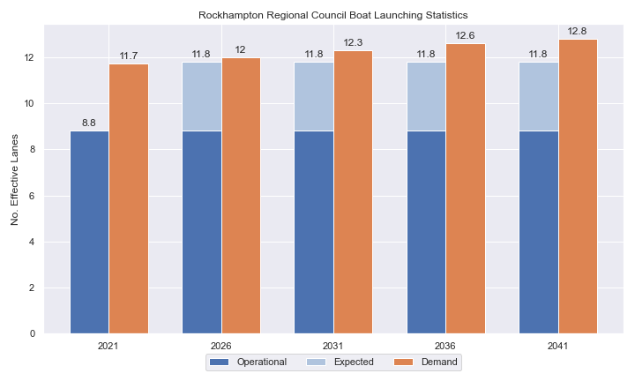

1. Existing capacity, expected capacity and forecast demand of ‘effective’ boat ramp lanes for Rockhampton LGA.

Deep-draught vessel landings

Vessel landing facilities are provided across the state in the form of pontoons and jetties, in order to provide locations for larger vessels, or their tenders, to access landside destinations or facilities. Pontoons and jetties may also be provided for other purposes such as supporting boat launching or other recreation and may not be suitable for deep-draught vessels. The trend across Queensland indicates that jetties are rarely used as landings, with pontoons preferred by recreational users. As such, the Study has limited the capacity of deep-draught vessel landings to those that are accessible and commonly used by deep-draught vessels, as identified in consultation with stakeholders.

Rockhampton LGA has no usable public deep-draught vessel landings. There is a jetty near the Rockhampton CBD, but it is not used by recreational vessels due to difficulties in access and the location of the structure. The shortfall assessment in Table 2 indicates that public landing capacity for deep-draught vessels is currently insufficient to support demand in Rockhampton LGA. An additional public landing in Rockhampton LGA is desirable to support local and coastal passaging vessels, and could also be used to support charter boat operations.

1. Deep-draught vessel landing shortfall summary

| Criteria | 2021 | 2026 | 2031 | 2036 | 2041 |
| --- | --- | --- | --- | --- | --- |
| Deep-draught vessel demand | 1.3 | 1.3 | 1.3 | 1.3 | 1.4 |
| Deep-draught vessel capacity | 0 | 0 | 0 | 0 | 0 |
| Shortfall | 1.3 | 1.3 | 1.3 | 1.4 | 1.4 |

Priority recommendations

Recommendations for new facilities or upgrades to existing facilities are outlined in Table 3. The range of recommendations seeks to reduce the overall capacity shortfall within Rockhampton LGA over the 20-year planning life of this project, as well as address specific concerns, including:

* providing a deep-draught vessel landing that can provide access to Rockhampton CBD
* maximising the capacity of and resolving conflicts at existing facilities.

Recommendations

1. Summary of recommended boating infrastructure upgrades for Rockhampton LGA

| Priority | Criteria | Recommendations |
| --- | --- | --- |
| 1 | * Required to meet existing demand. * Sites that can provide maximum benefit for existing demand pressures at an LGA scale or satisfy specific safety pressures. | * Rockhampton Boathouse, Quay Street: Construct a gangway-access pontoon as a deep-draught vessel landing. |
| 2 | * Required to meet demand within the next five to ten years. * Sites that are likely to have low to medium approval complexity. * Sites that can provide satisfaction of specific demand or safety pressures within the LGA. | * Nil. |
| 3 | * Required to meet demand within the next ten to fifteen years. * Sites that service planned future growth within the LGA. | * Callaghan Park: Construct additional carpark with 54 CTU spaces. * Quay Street: Reconfigure parking and relocate floating walkway to the northern lane. |
| 4 | * Required to meet demand within the next fifteen to twenty years. * Sites that service planned future growth within the LGA. | * Nil |

Contents

Definitions 9

1 Introduction 12

2 Rockhampton LGA Overview 13

2.1 Key influences on recreational boating 13

2.2 Existing recreational boating infrastructure 13

2.3 Existing usage and issues 15

3 Capacity Assessment 16

3.1 Boat ramps 16

3.2 Access to sheltered near all-tide and all-tide facilities 23

3.3 Deep-draught vessel landings 24

4 Demand Assessment 26

4.1 Activation rate 26

4.2 Digital user survey 27

4.3 Active fleet size 31

4.4 Boat ramp lane demand 31

4.5 Non-statistical demand 32

4.6 Deep-draught vessel demand 32

5 Shortfall Assessment 34

5.1 Shortfall assessment – boat ramps 34

5.2 Shortfall assessment – deep-draught landings 35

6 Stakeholder Feedback 37

6.1 Managing authority feedback 37

6.2 Stakeholder feedback 38

7 Development Recommendations 39

7.1 Previous recommendations 39

7.2 Priority recommendations 39

7.3 Priority 1 recommendations 41

7.4 Priority 2 recommendations 43

7.5 Priority 3 recommendations 43

7.6 Priority 4 Recommendations 49

8 References 50

Annex A Demand Study A-1

Annex B Boat launching facility capacity B-1

Annex C Travel time statistics C-1

Annex D Facility Use D-1

Tables

Table 2.1 Recreational boating facilities by facility owner in the Rockhampton LGA 13

Table 3.1 Queuing facility efficiency modifiers 19

Table 4.1 LGA of origin for active fleet in Rockhampton LGA 27

Table 4.2 Popularity of boat launching facilities. 28

Table 4.3 Active fleet vessel size 31

Table 4.4 Boat ramp lane demand 31

Table 4.5 Deep-draught vessel landing demand 33

Table 5.1 Shortfall of boat launching facilities 34

Table 5.2 Shortfall assessment for open water, all-tide or near all-tide facilities for Rockhampton LGA 35

Table 5.3 Shortfall of deep-draught vessel landings 36

Table 6.1 Stakeholder identified opportunities 37

Table 7.1 Assessment of unimplemented 2017 recommendations 39

Table 7.2 Summary of recommendations for Rockhampton LGA 40

Table 7.3 Rockhampton Boathouse, Quay Street (Priority 1) 41

Table 7.4 Robert Clark Drive, Callaghan Park (Priority 3) 43

Table 7.5 Quay Street (Priority 3) 46

Table B.1. Capacity of existing boat launching facilities B-1

Table C.1. Travel time from population centres to nearest sheltered all-tide or near all-tide open water accessible facilities C-1

Table D.1. Boat launching facility usage statistics D-1

Figures

Figure 2.1 Rockhampton LGA - Boat launching facilities 14

Figure 3.1 (a) Summary of open water access from boat launching facilities (left) and (b) Summary of tidal restrictions at tidal boat launching facilities (right) 21

Figure 3.2 Summary of limiting capacity constraint 22

Figure 3.3 Distribution of travel time from Rockhampton’s eligible population centres to sheltered near all-tide facilities 24

Figure 3.4 Rockhampton LGA – Travel time to nearest all-tide or near all-tide facility 25

Figure 4.1 Rockhampton LGA – Vessel pathing 30

Figure 5.1 Shortfall assessment with recommended upgrades adopted and expected facilities included. 34

Figure 7.1 Priority 1 Recommendation – Rockhampton Boathouse 42

Figure 7.2 Priority 2 Recommendation – Callaghan Park 45

Figure 7.3 Priority 3 Recommendation – Quay Street 48

Definitions

| Term | Definition |
| --- | --- |
| All‑tide (for boat ramps) | Access from a boat ramp to the open sea with an approach depth of 0.5m below LAT or deeper and a depth at boat ramp toe of 0.5m below LAT or deeper. |
| All-tide (for landings) | Access from a gangway‑access pontoon or jetty to the open sea with an approach depth of 1.5m below LAT or deeper and a depth on at least one face of the pontoon of 1.5m below LAT or deeper. |
| BIP | Boating Infrastructure Program – a sub‑program within MSQ's Maritime Assets and Infrastructure Program |
| Boat ramp | A foreshore concrete ramp with a slope designed for vehicular launching and retrieving of recreational boats. |
| Breakwater | A structure constructed over the seabed and/or the foreshore, usually rising to a height above high tide, designed to provide protection to landward areas by limiting penetration of wave action or currents. |
| CTU | Car-trailer unit space – a parking space for a typical car with a boat trailer attached. |
| Demand | Demand is the requirement of the boat‑owning population for facilities to launch/retrieve trailer boats and/or to berth suitable boats at a given year to service their average (non‑peak period) needs. In most locations demand is based on vessel registrations and is expressed in terms of boat ramp lanes or in number of 12m berths at landings. |
| Effective capacity | For a boat ramp, effective capacity (effective lanes) means the number of boat ramp lanes after adjusting for anticipated unavailability due to unacceptable wave action (>0.2m wave height) or water depth, usage constraints such as the lack of adequate parking, and improvements to efficiency or launch/retrieval throughput such as floating walkways or pontoons. |
| FHA | Fish Habitat Area, declared under the Fisheries Act, 1994 |
| FIFO | Fly‑in fly‑out, where skilled workers travel from their city or central location home communities to a remote site to perform their duties often in blocks of time that provide regular, non-weekend, days off. |
| Fixed sloping walkway | A fixed sloping structure installed at the side of a boat ramp to assist launching/retrieval of trailer boats, and dry embarkation/disembarkation from trailer boats. It is sloped to allow use at varying tide heights – sometimes with sections of different slope. |
| Floating walkway | Multiple connected/hinged flotation modules configured to assist launching/retrieval of trailer boats, and dry embarkation/disembarkation from trailer boats at most if not all stages of the tide. Floating walkways are connected to a concrete shore abutment allowing pedestrian and assisted wheelchair access. |
| Gangway access pontoon | A platform/module that always floats, where a boat can be secured alongside on one or more faces. Pontoons are usually separated from a boat ramp and have a hinged articulated gangway for access to the shore via an abutment. |
| GBR | Great Barrier Reef |
| GCWA | Gold Coast Waterways Authority |
| Landing | A landing is a jetty or gangway‑access pontoon that facilitates berthing of vessels and transfer of passengers and stores. They are most often associated with non-trailable vessels |
| Landside | Refers to areas above high-water mark, often used to denote the location of and type of infrastructure. |
| LAT | Lowest Astronomical Tide, used as Chart Datum on navigational charts. |
| LGA | Local Government Area |
| Managing authority | Councils, port authorities, water storage managers as listed in schedule 1 of the Transport Infrastructure (Public Marine Facilities) Regulation 2011 |
| MCU | Material change of use under the planning scheme |
| MNES | Matter of national environmental significance under the Environment Protection and Biodiversity Conservation Act 1999 |
| MSQ | Maritime Safety Queensland |
| NC Act | Nature Conservation Act 1992 |
| Near all‑tide | Access from a boat ramp to the open sea with a minimum approach depth of 0.5m below LAT and minimum depth at the boat ramp of 0.5m below LAT for 80 percent or more of the tidal range (time measured over a year). |
| Parking - Formalised | A sealed, line-marked parking area for car-trailer units, providing adequately sized parking spaces, roadways and turning circles. |
| Parking – Semi-formalised | An all-weather non-sealed parking area, with markers to delineate adequately sized car-trailer unit parking bays and turning circles. Markers can be concrete blocks, pavement markers (e.g., retro-reflective raised markers) or other permanent instalment to show parking bays. |
| Parking – Informal overflow | A naturally surfaced area available for use as overflow parking on the design boating day, signed as such. To have mixed-use purpose (e.g., parkland) when not being utilised as overflow parking. |
| Part‑tide | Boat ramps that do not meet near all-tide or near all-tide requirements. |
| PV | Passenger vehicle (i.e., car – as opposed to car-trailer unit). |
| Port Authority | An organisation that is responsible for the management of one or more ports on the Queensland coast. |
| Population Centre | Official named urban settlements (populated places) that have been sourced from the Queensland Place Names Database. |
| Registration activation rate | The percentage of registered vessels liable to be in use on any given good weather weekend day |
| Shortfall | The number of effective boat ramp lanes or landings required to meet demand for a given timeframe. Negative shortfall signifies an oversupply for the time period nominated. |
| SPL | Strategic Port Land |
| Study | The Recreational Boating Facility Demand Forecasting Study 2022, including this document. |
| TMR | Department of Transport and Main Roads |
| Water Storage Authority | Includes Seqwater, Sunwater |
| Waterside | Refers to areas below high-water mark, often used to denote the location of and type of infrastructure, including dredged channels and breakwaters. |
| WHA | World Heritage Area |
| # | Number |

# Introduction

BMT has been appointed to undertake the Recreational Boating Facilities Demand Forecasting Study 2022 (‘the Study’) by Maritime Safety Queensland (MSQ), a branch of the Queensland Department of Transport and Main Roads (TMR), on behalf of all public recreational boating facility managers and owners across Queensland. The Study supersedes the 2017 study of the same name and is intended to report on recreational boating facility demand, capacity, and shortfall over a 20-year period at a Local Government Area (LGA) scale across Queensland.

The Study has been developed using information from the 2021 Australian Census (ABS, 2021), recreational boat vessel registrations, consultation with facility owners, managers, and stakeholders, the 2022 Queensland Government Get-Involved recreational boating facilities survey (MSQ, 2022), and previous versions of this Study (2011, 2017). The Study is intended for use by deliverers, owners, managers, and key stakeholders of public recreational boating facilities across Queensland, namely state government agencies including MSQ and the Gold Coast Waterways Authority (GCWA), local governments, port authorities and water authorities. The Study is non-regulatory in nature and is intended to be used as part of a broader suite of information to identify priority investment in recreational boating infrastructure at a local and state level.

The Study establishes demand primarily on statistics derived from registration and population data. Please refer to Section 4.5 for discussion of non-statistical demand. The Study evaluates existing and forecast demand over a 20-year period and makes recommendations on how this demand might be met over that period. Recommendations may include improvements to both landside and waterside capacity depending on the facility.

Recommendations are assigned a priority ranking, from 1 to 4, indicating if they are required immediately or in the next 5, 10 or 15 years respectively. To end 2022, 14% of recommendations from the 2017 study have been completed, comprising 11% of land-side recommendations and 18% of waterside recommendations and reflecting 22% of priority 1 the 2017 recommendations. A much greater percentage of the earlier 2011 study recommendations have now been implemented. Given the low uptake on existing/outstanding recommendations, this Study will review previous recommendations and carry forward, modify, or remove as appropriate. The Study has also been tasked with reviewing specific wave exposed beach launching facilities across the state to determine their contribution to meeting boating facilities demand and make recommendations about their future.

The Study is comprised of a report for every LGA in Queensland and a state-wide summary report. Each LGA report summarises demand pressures from vessel registration data, population statistics, assumptions around local usage and the movement of vessels into and out of the LGA, and existing capacity and recommends opportunities to satisfy shortfall. The state-wide report will support the LGA reports and provide context at a state level for demand pressures, current capacity, equity of access to facilities and state-wide priority for major boating facilities.

The Study is intended to report on publicly accessible recreational boating facilities for registered vessels. This includes boat ramps, floating walkways, pontoons, fixed sloping walkways and supporting car-trailer unit parking at each facility. The Study does not include recommendations for facilities that are used primarily for commercial purposes, private facilities, non-motorised recreation such as launching canoes and stand-up paddle boards, and fishing platforms.

# Rockhampton LGA Overview

## Key influences on recreational boating

Within Rockhampton LGA, the principal attributes and influences that affect demand on recreational boating infrastructure include:

* its designation as a Regional Centre, with a large local recreational boating fleet
* the presence of the Fitzroy River – a popular boating waterway – directly through Rockhampton LGA
* Rockhampton Regional Council’s recreational fishing tourism development strategy.

## Existing recreational boating infrastructure

The recreational boating facilities within Rockhampton LGA are summarised in Table 2.1. These facilities are owned or managed by multiple organisations and include facilities that provide access to open water, estuaries, and fresh water. MSQ’s long term vision is to provide unrestricted access to open water from facilities along the Queensland coast such that all significant population centres are within one hour’s driving range where practical. For clarity, the Study has defined this vision to be the provision of sheltered all-tide, or near all-tide, boat launching facilities within one hour driving range of official population centres (DoR, 2022) lying within 30km of the coastline between the NSW border and Cooktown.

Recreational boating facilities by facility owner in the Rockhampton LGA

| Owner | Open-water boat ramps | | Other boat ramps | | Landings | |
| --- | --- | --- | --- | --- | --- | --- |
| Facilities | Lanes | Facilities | Lanes | Pontoons | Jetties |
| TMR | 1 | 2 | 4 | 12 |  | 1 |
| Rockhampton Regional Council |  |  | 2 | 2 |  |  |

Each of the boat launching facilities within the LGA are shown in Figure 2.1.

Access to land from deep-draught vessels is catered for by the provision of landings such as jetties and pontoons that are intended for short term usage, mainly to drop off and embark passengers and supplies. Within Rockhampton LGA there is no fit-for-purpose facility to service these vessels. The jetty near Derby Street in Rockhampton is occasionally used by deep-draught vessels, however feedback indicates that jetties are difficult to use and as such are not preferred, and that this particular jetty is currently in poor condition and as such is not fit-for-purpose.

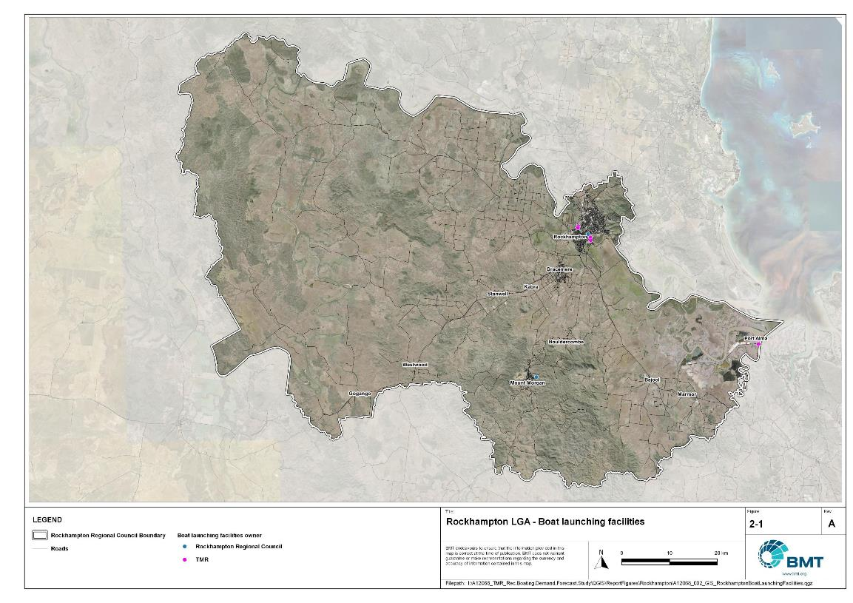

Rockhampton LGA - Boat launching facilities

I:\A12068_TMR_Rec.Boating.Demand.Forecast.Study\QGIS\ReportFigures\Rockhampton\A12068_002_GIS_RockhamptonBoatLaunchingFacilities.jpg

## Existing usage and issues

Consultation with Rockhampton Regional Council, Maritime Safety Queensland, recreational groups and feedback from the recreational boating facilities survey hosted by TMR indicate the following major themes and issues within Rockhampton LGA.

* + 1. Lack of fit-for-purpose deep-draught landing facility

There is demand within Rockhampton LGA for a deep-draught vessel landing near the city. Vessels moored or anchored in the river close to the central business district (CBD) use tenders to access the shore at various facilities with floating infrastructure. As there is no fit-for-purpose facility for these vessels, Rockhampton LGA is missing an opportunity to further attract boating/fishing tourism, which may stimulate the local economy.

* + 1. Conflicts at facilities

There are conflicting usages at some facilities – particularly during frequent markets and the annual motor festival ‘RockyNats’. These conflicts cause the capacity at facilities to be severely reduced during the period around the festival, and options to resolve these conflicts are desired.

* + 1. Major usage in Livingstone LGA

A large number of recreational boat users use facilities within Livingstone LGA, particularly to access open water. Facilities such as Nerimbera and Thompson Point, although situated within Livingstone LGA, are closer to Rockhampton population centres. As such, these facilities cater to a significant portion of the launching demand for vessels registered in Rockhampton LGA.

The facility at Rosslyn Bay Boat Harbour (Livingstone LGA) is very popular with residents of Rockhampton LGA, as it provides sheltered, all-tide and direct open water access to desirable offshore destinations, and a large amount of capacity to accommodate users.

* + 1. Recreational Fishing Strategy

The Recreational Fishing Strategy implemented by Rockhampton Regional Council seeks to improve the quality of fishing opportunities within the broader Rockhampton LGA. The strategy has included the federal declaration of a net-free fishing zone in the lower Fitzroy River and Keppel Bay and is a key approach to achieving increased tourism in the region by becoming the “Home of the Barramundi and Threadfin”. The strategy has resulted in increased demand on recreational boating facilities due to perceptions that the quality of fishing has increased.

# Capacity Assessment

## Boat ramps

* + 1. Introduction

Boat ramps are facilities that are used for launching and retrieving trailable vessels, typically up to 8m in length (with some exceptions), to and from the water. Boat ramps consist of one or more lanes and their use is often supported by landside and waterside infrastructure to improve efficiency. In some instances, the usability of a facility can be adversely affected by environmental constraints such as low water levels, currents, or wave exposure, reducing the overall availability of the facility. Together, consideration of the number of boat ramp lanes, the supporting infrastructure, and environmental constraints results in the facility having a capacity described in terms of ‘effective lanes’ that may or may not be equal to the number of actual boat ramp lanes.

To maximise usage of each facility, the landside and waterside capacity should be balanced. Each facility will have a calculated ‘effective’ capacity for both the landside and waterside elements, with the limiting element dictating the facility's overall effective capacity. Recommendations for works or infrastructure promote balancing these two capacity elements by either improving the limiting element for increased facility effectiveness or by increasing the overall 'effective capacity' through changes to both elements.

* + 1. Boat ramp capacity

The overall capacity of each boat launching facility is limited by the effective capacity of either the waterside or landside elements. The waterside capacity is informed by the number of boat ramp lanes and the number and type of queuing facilities, such as pontoons, floating walkways, queuing beaches and fixed sloping walkways. It may also be limited by the available water depth in the adjacent waterbody and exposure to environmental or other physical factors.

Landside capacity is governed by the availability of nearby spaces for parking of car-trailer units (CTU), the provision of rigging and de-rigging facilities, and provision of single car parking spaces (single cars may otherwise be obliged to park in CTU spaces).

While it is expected that facilities will have their own characteristics influencing efficient use, this Study applies an approach that is consistent across the entire state and consistent with previous editions of the Study. Accordingly, the effective waterside capacity of a boat launching facility is determined as being:

* the ability to support 40 vessels being launched and retrieved per day per lane (see section 3.1.3)
* influenced by exposure to wave, tide, and current conditions (see section3.1.4
* supported by queuing facilities that assist in the efficient use of the boat ramp (see section 3.1.4).

Calculation of landside capacity is in line with the TMR guideline (TMR, 2020), which requires less provision of CTU parking per lane than the Australian standard (AS3962 Table 7.1), and advises:

* 10 CTUs for a single lane boat ramp accessed by an unsealed road, or 15 CTUs accessed by a sealed road
* 45 CTUs for a two-lane boat ramp
* 70 CTUs for a three-lane boat ramp
* 90 CTUs for a four-lane boat ramp.

A notable difference from the 2017 study is the recognition and inclusion of areas close to existing boating facilities that are unsealed and/or not line marked where parking of cars with trailers occurs and is not discouraged. These areas of informal parking have been identified on aerial imagery and through discussions with managing authorities. Each informal area has been assumed to be available for CTU parking only 50% of the time to account for conflicts with other uses (for example, markets), inefficient parking practices, or poor ground conditions. The rate of parking has been calculated as:

* for linear areas where nose-to-tail parking is expected – 1 CTU per 13m
* for linear areas with enough space to allow side-by-side parking – 1 CTU per 3m, provided there is a minimum distance of 15m from the road or manoeuvring area
* for large areas – 1 CTU per 100m2.
  + 1. Boat ramp capacity basis

The number of vessels per day each boat ramp lane can support is based on the Australian Standard for the Design of Marinas (AS3962-2001) and previous versions of this report (GHD, 2011 and 2017).

Research on boat ramp lane efficiency described in the previous report (GHD, 2017) identified that 40 vessels per lane per day was a reasonable compromise between 50 vessels per lane per day (representing congested conditions) and 30 vessels per lane per day (representing unhampered conditions). For context, the 40 vessels per lane per day rate represents a vessel launch or retrieval every 9 minutes per lane within an average normally used period of 12 hours per day.

During this Study, BMT has sought to validate the assumptions presented above, and those relating to capacity modification, by undertaking a literature review, conducting site visits that included observations of launching and retrieving manoeuvres, and reviewing video recordings of boats launching and retrieving at popular boating facilities. The literature review included a boat ramp efficiency investigation undertaken by BMT on the Mornington Peninsula, Victoria (BMT, 2015) and a review of standards from other Australian states and countries that undertake similar studies. The onsite and video analysis provided the opportunity to observe recreational boat operators using facilities included in the Study but did not include observation of total throughput during high demand periods. This assessment was undertaken during site visits across Queensland, and a full day of video recording at Manly Boat Harbour (north ramp) in Brisbane.

The New South Wales and Victoria governments are currently in a planning phase for boating infrastructure and there are presently no publicly accessible documents identifying how those jurisdictions calculate boat ramp lane capacity. The Western Australia government has commissioned studies of the Perth region and the southwest region (Western Australia Department of Transport, 2019 and 2021) that indicate a base rate of 50 vessels per lane per day, with no modifiers applied. Internationally, studies from Florida in the USA (Bell, 2022 and Swett et. al, 2012) assumed that total vessel launch plus retrieval time is between 20 to 40 minutes (18 to 36 vessels per day), although no evidence is provided to support this assumption.

The Mornington Peninsula report (BMT, 2015) collected boat launch and retrieval data for 6 boat ramp facilities on the Mornington Peninsula across 9 days, including the peak Australia Day holiday. Total throughput was assessed for each facility on days where there was constant pressure for launching and retrieving boats with results between 30 and 70 vessels per lane per day for the various facilities. When adjusted for queuing modifications, a baseline rate of between 20 and 50 vessels per lane per day was identified. Of the facilities, the higher rates were achieved where sufficient parking was provided and both waterside and landside queuing facilities existed.

Observations of recreational boat users launching and retrieving their vessels undertaken through the site visits and the analysis of video footage showed that:

* Most observed launches were of ‘multi-person’ boats, which made launching and retrieving boats more efficient.
* Almost all users were able to launch and/or retrieve their boat within the 9-minute target time, when adjusted for queuing facility efficiency.
* There was a preference to launch adjacent to a floating walkway, where one was available. At facilities where a queuing facility is not immediately adjacent to the lane it is expected that average launch times may slightly increase during busy periods.

While the observations that were made generally aligned with expectations, a more in-depth review of capacity assumptions was outside of the scope of the Study. For future studies there would be value in undertaking a more thorough, data-driven investigation of the assumptions about boat ramp lane capacity, both at its base level and modified by queuing facilities. Overall, the preliminary investigations undertaken as part of the Study suggest that the base rate of 40 vessels per lane per day adopted in previous studies is appropriate.

* + 1. Boat ramp efficiency modifications

The waterside capacity of boat ramp lanes can be reduced by environmental factors that include:

* Water levels: Mainly relating to tidal areas this factor considers the reduction in the amount of time the boat ramp is available to launch and retrieve vessels over the full tidal cycle, thus reducing the overall capacity of the facility. For all-tide access, the boat ramp and connecting channel to the open sea are available during all tidal conditions and therefore available 100% of the time. For near all-tide access the boat ramp and the connecting channel to the open sea are assumed to be available, on average, for 80% of the tidal cycle. For part-tide access the boat ramp and its access channel are available less than 80% of the time. A modification factor of 0.8 is applied for near all-tide facilities and 0.5 for part-tide facilities.
* Wave and current conditions: In areas where vessel launching and retrieval may be intermittently impacted by waves (most commonly on beach ramps, but not exclusively) or strong currents (such as in rivers), a modification factor of 0.5 is applied.

Conversely, effective boat ramp capacity can be improved through the use of well-designed queuing facilities. Queuing facilities aim to improve amenity and efficient use of the boat ramp by accelerating one or more of the following phases of boat launching, with the opposite steps required for retrieval:

1. manoeuvring for launching, including for CTU entering the queuing area for the boat ramp and reversing into position for launch
2. launching and securing the launched vessel
3. moving the launch vehicle from the boat ramp to the parking area
4. removing the vessel from the waterside queuing facility.

A range of waterside queuing facilities is in use in Queensland boating infrastructure, which modify different phases of the total launching process. These include:

* Floating walkways and fixed sloping walkways: Positioned to about a boat ramp lane, these structures aim to:
  + improve amenity – such as to assist embarking/disembarking passengers, provide a refuge from in-water contact with crocodiles and so on
  + make securing the vessel and removing the vehicle from the boat ramp more rapid, while freeing the boat ramp for subsequent users.
* Pontoons: Also used by deep-draught vessels, these structures improve the ability to secure the vessel and clear the boat ramp, but there is usually some time lost returning to recover the launch vehicle compared with the above options as they are generally positioned slightly further away from the ramp.
* Queuing beaches: These also provide a place to secure the vessel close to the boat ramp, although they are generally not as fast to use as pontoons.

As observed throughout the Study site visits, each of these queuing facility types can support a limited number of boat ramp lanes depending on the available space on the queuing facility. The 2017 edition of this Study applied a blanket uplift for all boat ramp lanes where a queuing facility was provided. However, the number of lanes each type of queuing facility can realistically support varies. Accordingly, this Study has provided limitations to the number of boat ramp lanes that can benefit from each queuing facility, based on the number of “working faces” (or area for a queuing beach) provided, where the “working face” is a face that allows temporary securing of vessels during launching or retrieval. The adopted improvement factors and supported lanes are summarised in Table 3.1.

Queuing facility efficiency modifiers

| Queuing facility | Modification factor | Supported lanes |
| --- | --- | --- |
| Floating walkway (lanes adjacent to walkway) | 1.7 | 1 Lane/face |
| Floating walkway (lanes not adjacent to walkway) | 1.3 | 1 Lane/face |
| Fixed sloping walkway | 1.7 | 1 Lane/face |
| Pontoon | 1.2 | 2 Lanes/face |
| Queuing beach | 1.1 | Site-based |

In other states in Australia, reversing queuing bays are more commonly used than in Queensland. These are CTU waiting bays at the head of the boat ramp that are aligned with each boat ramp lane to allow the user to reverse directly down the boat ramp once it is clear. CTU waiting bays reduce the time of the first phase of boat launching by allowing waiting CTU’s to be ready to reverse as soon as the lane becomes clear. The BMT (2015) study on the Mornington Peninsula included facilities with and without these bays. Boat ramps that included reversing queuing bays achieved 50% greater throughput. Facilities that have implemented this approach in Queensland include North Street Southport, Urangan Boat Harbour, Townsville Recreational Boating Park, and the (under construction late 2022) boat ramp at Yorkeys Knob.

* + 1. Accessibility from boat launching facilities

Recreational boat users will typically select the boat launching facility most appropriate or convenient to the activity they are seeking to undertake, the anticipated weather/wave conditions, and their destination. Each of facility within an LGA will provide a varying degree of access to different destinations and for different activities. During the Study, consultation with stakeholders highlighted the following general types of destinations and activities:

* open water/offshore: typically accessed for visiting offshore islands or remote beaches, snorkelling or diving locations, deep sea fishing and general recreation
* creeks and estuaries: typically accessed for fishing, crabbing, wildlife observation, skiing and general recreation
* freshwater: typically accessed for skiing, fishing, wildlife observation and general recreation.

These destinations are typically serviced by different types of recreational vessels. Inshore locations including creeks, estuaries and other freshwater locations are typically patronised by vessels less than 4.5m, except for ski boats, which can be much larger than this. Offshore locations typically require larger boats for access as these vessels are more capable of managing a wide range of wave conditions and can carry sufficient fuel to access distant destinations. Smaller vessels may be able to access close destinations on good weather days, and larger vessels may choose to access inshore destinations, particularly on poor weather days.

Consequently, the following aspects are used to classify how well a facility provides open water access:

* Open-water access: There are no restrictions between the facility and open water.
* Depth-limited access: There are depth restrictions between the facility and open water that limit navigable access to part of the tidal range. This differs from tidal constraints at the actual facility, which might be usable at all tides, but offshore access is limited by a downstream bar or delta.
* Distance-limited access: The distance from the facility to the open water is unrealistic for typical boat users. This distance is assumed to be about 4.5km between the facility and open water to rate as 'distance limited', with travel times increased further where portions of the access channel are regulated by speed limits.
* Infrastructure-limited access: There are man-made obstacles between the facility and open water, such as above-ground pipeline crossings, low bridges or weirs that impede navigable access to open water.
* Beach ramps: These provide open-water access but are typically constrained by environmental conditions such as wave exposure and tide levels. The capacity of these facilities has been individually assessed based on consultation and other data sources and is described in more detail in section 4.
* Freshwater: There is no access to open water.

Certain facilities, particularly those in freshwater, may be constrained by periods of drought, or debris deposition after rainfall events that limit access to destinations, and therefore whether a facility will provide useful boat launching capacity. While it is noted that drought and rainfall may affect the overall capacity of boat launching within an LGA, and given that the timing of such events is not readily predictable, their impact on capacity has not been evaluated.

* + 1. Existing boat launching capacity

Within Rockhampton LGA there are seven boat launching facilities with a total effective capacity of 8.8 lanes. It should be noted that this assessment includes the facility at Mount Morgan, which at the time of writing is closed due to low dam levels. This facility is still included in the assessment as closure is seen as temporary and over the Study period the facility is expected to provide capacity.

The effective capacity of boat launching facilities within Rockhampton LGA is shown in Annex B, with a summary of the access to open water and tidal constraints shown in Figure 3.1 and the overall capacity constraint shown in Figure 3.2. Pertinent features of these facilities include:

* There are 16 total lanes, with an effective capacity of 8.8 effective lanes. This effective capacity is primarily reduced due to insufficient parking being allocated for each lane.
* Boat users in Rockhampton LGA have a range of options for boating, with facilities available for accessing freshwater destinations, water skiing areas, lower-river deltas and offshore destinations.
* All tidal facilities provide all-tide access, except for the facility at Reaney Street in North Rockhampton.

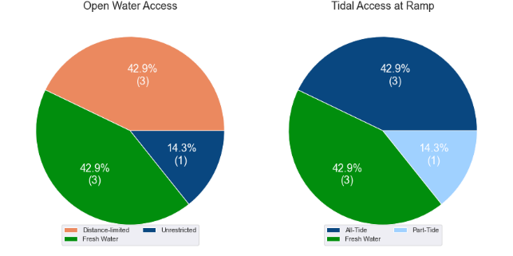

(a) Summary of open water access from boat launching facilities (left) and (b) Summary of tidal restrictions at tidal boat launching facilities (right)

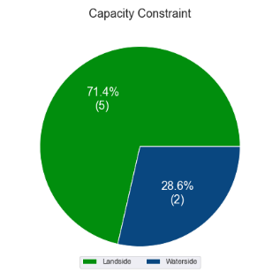

Summary of limiting capacity constraint

* + 1. Facilities expected to be completed within the Study period

Facilities that are expected to be constructed and actively providing capacity within the Study period are accounted for in this section. These are projects that have secured funding, have begun construction or have a current works contract. For all intents and purposes, these are intended to be providing capacity within the next 5 years or sooner. As such, this section acknowledges the increase in capacity that these facilities will supply.

### *Casuarina Creek, Port Alma*

This is a 2-lane facility with a central floating walkway and 53 CTU parking spaces, located off Port Alma Road. The facility will provide improved access into Casuarina Creek and the associated waterways for boating and fishing, and also provide capacity for offshore ventures. Along with Inkerman Creek, this facility is intended to replace the capacity provided by the Port Alma facility on Raglan Creek, which will soon be retired.

### *Inkerman Creek, Port Alma*

This is a 2-lane facility with a central floating walkway and 26 CTU parking spaces that is currently under construction, also off Port Alma Road. This facility will provide access into the Inkerman Creek system as well as offshore. Like the new Casuarina Creek facility, the Inkerman Creek facility will contribute towards the replacement of the capacity currently provided by the soon to be retired Port Alma facility.

Expected new facilities

| Criteria | Waterside effective lanes | Landside effective lanes | Total effective lanes |
| --- | --- | --- | --- |
| Casuarina Creek, Port Alma | 3.4 | 2.5 | 2.5 |
| Inkerman Creek, Port Alma | 3.4 | 1.5 | 1.5 |

Once these two facilities are constructed and open to use by the public, the existing Port Alma facility on Raglan Creek will be closed. This is expected to occur by 2024 and will result in the loss of 1.0 effective lane of capacity provided by that facility. Therefore, the net increase in capacity following the construction of facilities at Casuarina Creek and Inkerman Creek, to replace the Port Alma facility, will be 3.0 effective lanes.

## Access to sheltered near all-tide and all-tide facilities

MSQ has a longer-term vision to provide access to all-tide or near all-tide open water access boat launching facilities along the Queensland coast, such that all significant population centres are within one hour’s driving range as far as practical (TMR, 2020). For this purpose, the Study has defined eligible population centres as being within the coastal strip if within 30km of the Queensland coastline. The vision (TMR,2020) is applied to the coastal strip between the NSW border and Cooktown. Consultation throughout the Study has highlighted that this vision is important with users/stakeholders and organisations that own and manage these facilities. As such, the Study has developed a statistical approach to quantify this vision to allow it to be measured and tracked over time. To do this, the Study has calculated the travel time from all Population Centres (DoR, 2022) within the coastal zone to the nearest available sheltered, all-tide or near all-tide facility, regardless of which LGA it is in. This has been accomplished using mapped road networks and assigning speed limits to each type of road, with the following speed limits applied:

* for restricted roads, 40km/hr
* for local roads, 60km/hr
* for connector roads, 70km/hr
* for distributor roads, 80km/hr
* for highways, 100km/hr.

For Rockhampton LGA the median travel time from eligible Population Centres to the nearest sheltered all-tide or near all-tide facility is 24 minutes. The distribution of travel times is shown in Figure 3.3 with detailed travel times in Annex C. Figure 3.4 provides a visual representation of the travel time from each of the sheltered near all-tide facilities that serve the LGA. Of interest for Rockhampton LGA are:

* 100% of the eligible Population Centres are within the desired 1-hour travel time, 60% being within 30 minutes travel time.
* Rosslyn Bay Boat Harbour in the adjacent Livingstone LGA provides launching capacity for sheltered all-tide access for vessel owners across the whole of Rockhampton city.

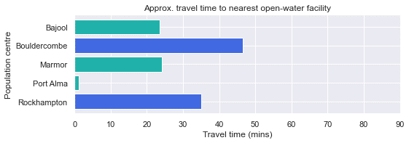

Distribution of travel time from Rockhampton’s eligible population centres to sheltered near all-tide facilities

## Deep-draught vessel landings

Deep-draught vessel landings are intended to provide short-term landing capacity for vessels that are too large to use public boat launching and retrieval facilities. These facilities are provided for the benefit of both local vessels and to service the fleet of vessels that travel along the Queensland coast. Deep-draught vessel landings may be designed to accept one or more large vessels at a time and/or provide capacity for tenders from larger vessels that may be anchored or moored nearby, for the purpose of loading and offloading passengers and supplies, and making short local visits to onshore destinations.

For the Study, deep-draught vessel landings need to be primarily accessible by recreational boats for short, temporary stays. In some cases, commercial vessels may utilise these facilities subject to the relevant permissions, however, this may reduce the capacity of the facility to cater for recreational vessels. Deep-draught vessel landings should be located such that the facility provides reasonable access to landside passenger pick up and drop off, provisioning, recreational destinations, or population centres.

Within Rockhampton LGA there are no fit-for-purpose deep-draught vessel landings that provide access to mainland destinations. The jetty near Derby Street in Rockhampton is in poor condition and is not preferred for use by deep-draught vessels, only seeing occasional use. Therefore, this jetty is not counted as a deep-draught landing as it is not fit-for-purpose at present. The capacity that was, in the past, provided by this jetty should be replaced.

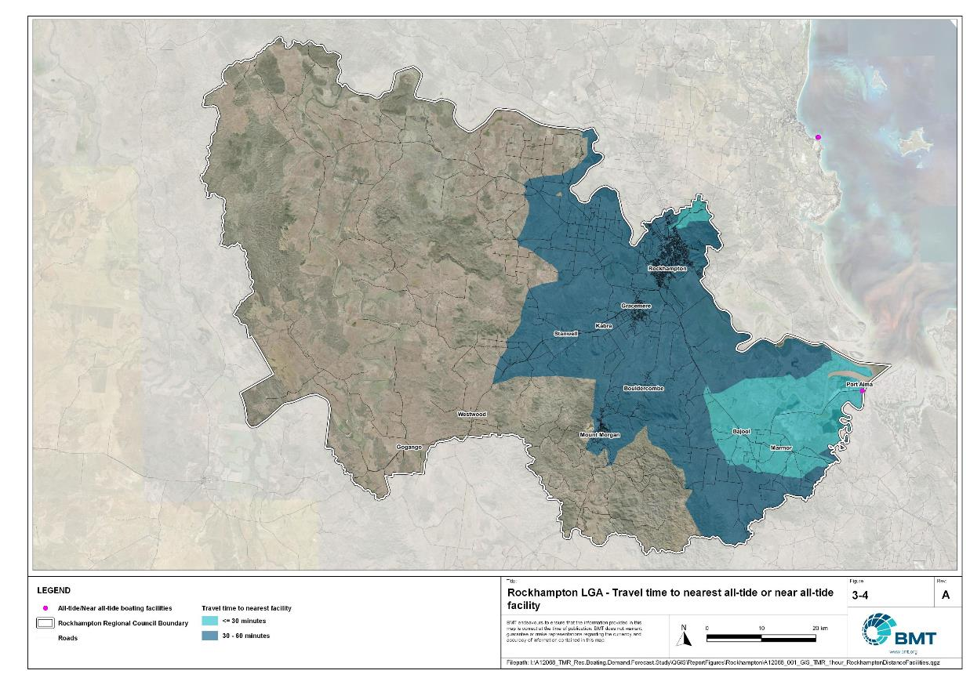

Rockhampton LGA – Travel time to nearest all-tide or near all-tide facility

"I:\A12068_TMR_Rec.Boating.Demand.Forecast.Study\QGIS\ReportFigures\Rockhampton\A12068_001_GIS_TMR_1hour_RockhamptonDistanceFacilities.jpg"

# Demand Assessment

The Study has developed a model to calculate statistical demand for boat launching facilities and deep-draught vessel landings at an LGA scale. Vessels that are less than 8m in length are considered trailable and drive demand for boat launching facilities such as boat ramps, while those over 8m are assumed to remain on water and drive demand for deep-draught landings.

Statistical demand is recognised at three different levels for public marine facilities within the TMR guidelines (TMR, 2020), which are:

* off-peak demand – typical weekday usage
* average demand – demand on ‘good boating days’, taken to be demand for a facility on weekends (and, for certain regional locations, other busy periods)
* peak demand – demand for a facility at peak holiday periods or for special events.

The demand model created for this Study is intended to provide information on demand pressures on ‘good boating days’ for all facilities as per the intentions of the guidelines. The model achieves this through a ‘registration activation rate’ that estimates the proportion of registered vessels in an LGA that is assumed to be active on a ‘good boating day’, as well as the exchange of vessels between LGAs, and general tourism pressures.

## Activation rate

The fleet size for each LGA is determined statistically from vessel registration numbers and the application of a vessel activation rate, while for future time horizons vessel registration and population growth estimates are also utilised. The methodology for determining the registration activation rate has been adopted from the previous study (GHD, 2017), with activation rates taken to be between 8% and 14% for a typical weekend. The variability of the activation rate is intended to capture the regional differences in vessel types, and is driven by the availability of access to open water, accessibility of other recreational opportunities, and likelihood of users’ available time for recreation, considering factors including:

* remoteness classification for the LGA
* incidence of blue-collar employment
* average age of residents
* whether the LGA is coastal.

Further information about the derivation of this rate can be found in Annex A. For Rockhampton LGA the activation rate is assumed to be 10%, with the key factors influencing the rate including:

* its classification as a Regional Centre
* the incidence of blue-collar employment being higher than the state average
* the average age being lower than the state average
* it being located near the open coast.

## Digital user survey

To gain an understanding of usage trends at existing formal recreational boating facilities across Queensland, the Study has considered the results of a digital user survey using human movement data, sourced through a third party. The data was acquired from a location data store with more than 13 trillion mobile location observations globally from 2019 to present, which were sourced from 250,000 different mobile phone applications that users ‘opted-in’ to use the location services under the application’s terms and conditions. All data received was deidentified and compliant with relevant data privacy regulations.

The analysis uses mobile devices (such as telephones) location data as a proxy for boat user traffic, however, this relationship has several limitations including, but not limited to:

* Mobile device users detected in the area of interest may not be boat users (for example, pedestrians not using vessels may walk through the detection area).
* The relationship between mobile device users and vessels may not be 1:1 (that is, there may be multiple mobile devices providing data for each vessel).
* Users of vessels may not have a mobile device, may not be using a mobile device or may not have provided permission to use their location data.

With these, and potentially other, limitations in mind, the Study compared this data against vessel launching counts provided by various facility managers and found that approximately 15-30% of vessels are captured using this digital survey method. This percentage can change from facility to facility and from day to day. Consequently, the Study has not relied on raw counts of users from this data, but instead considered the relative trends within the data, with the assumption that no groups (for example, users from a particular LGA or using a particular facility) within the data would be more or less likely to be captured by the technique.

The Study has used this data to identify the relative volume of users, the ‘home’ local government area of users and the popularity of destinations that users travel to once vessels have been launched. Presentation of the full dataset can be found in Annex D.

* + 1. Inter-LGA demand

The human movement data has been interrogated to determine the LGA of origin for users of Rockhampton LGA’s public boating facilities to ascertain the proportion of users from each LGA that are using specific facilities. Statistics from all public boating facilities within the LGA are then grouped together to determine the total proportion of resident or visiting users across the LGA. Table 4.1 shows the active fleet proportion from the top 10 LGAs contributing to demand on facilities within Rockhampton LGA. All other sources have been grouped together.

LGA of origin for active fleet in Rockhampton LGA

| LGA of origin | Active fleet proportion |
| --- | --- |
| Rockhampton | 72.2% |
| Livingstone | 10.2% |
| Central Highlands | 2.2% |
| Gladstone | 1.8% |
| Brisbane | 1.8% |
| Moreton Bay | 1.2% |
| Bundaberg | 1.0% |
| Mackay | 1.0% |
| Other LGAs | 8.7% |

* + 1. Intra-LGA demand distribution

Recreational boating users will tend to use facilities that best suit their needs, the destinations they want to access, the capability of their vessel and the weather conditions. Consequently, distribution within an LGA is unlikely to be evenly spread across all facilities, with some facilities attracting users disproportionately due to amenity, access, or destinations. The attractiveness of large well-designed facilities is likely to draw visiting boat users in preference to smaller or less desirable facilities across the LGA. The human movement statistics have been assessed to qualitatively estimate the proportion of users using each facility, both in total and with respect to both resident and visiting boat users (Table 4.2).

Popularity of boat launching facilities.

| Facility | Overall fleet | Resident fleet | Visiting fleet |
| --- | --- | --- | --- |
| Rockhampton, Callaghan Park, Robert Clark Drive, | 30.4% | 27.2% | 38.7% |
| Rockhampton, Ski Gardens, Ramsden Street | 21.5% | 23.1% | 17.4% |
| Rockhampton, Quay Street | 17.9% | 19.5% | 13.6% |
| Rockhampton, Reaney Street | 13.2% | 13.6% | 12.1% |
| Mount Morgan, William Street | 7.0% | 7.2% | 6.6% |
| Rockhampton, Larcombe Street | 7.0% | 7.4% | 6.0% |
| Port Alma, Port Alma Road | 3.0% | 2.0% | 5.5% |

The results indicate that the resident fleet is reasonably well distributed among the top three most popular facilities, while the visiting fleet has a strong preference for the Callaghan Park facility in North Rockhampton. this likely gives an indication of the different activities that are preferred, as Callaghan Park is used more for fishing ventures while the Ski Gardens facility is used more for water-skiing.

There is very little recorded usage of the Port Alma facility, by either residents or visitors. The facility at Quay Street is more of a local ramp, with a higher portion of the resident fleet using this facility than the visiting fleet.

The proportion of the active fleet that resides within Rockhampton LGA is the vast majority, with over 70% of facility use being by residents.

The distribution of capacity within the LGA needs to consider these trends to avoid consistent capacity shortfalls at some facilities or indicating demand for unnecessary extra capacity at other facilities. Results from the above statistics and feedback obtained through the TMR online survey indicate that within Rockhampton LGA the following factors tend to influence the preferred facilities for recreational boat users:

* Facilities are preferred that are closer to Rockhampton CBD with more capacity.
* The preferred activity while boating is important (fishing/water-skiing).
* Although the Port Alma facility is sheltered, has all-tide access and provides direct access to open-water, this facility is not popular for launching. This is likely due to its distance from population centres being similar to that of Rosslyn Bay Boat Harbour, which has significantly more capacity, provides better access and amenities, and is not as isolated.
  + 1. Destinations

For facilities that provide sheltered, near all-tide or all-tide open water access, additional analysis of the human movement statistics has been undertaken to identify destinations for users of these facilities. Location data from users utilising the facilities was extracted for a period of two hours after they used the facility, and trimmed for waterside destinations. For Rockhampton LGA this additional analysis was applied to the Port Alma facility, with destinations mapped in Figure 4.1:

From this additional analysis, the following notable observations were made:

* The proportion of users launching at Port Alma that remain within the waterways around Casuarina Creek and Inkerman Creek is higher than for venturing offshore.
* Offshore tracking shows evidence of ventures to the estuaries around Camp Island and to Hummocky Island.
* Within the mainland waterways surrounding Port Alma, vessel pathing is quite dispersed, indicating various preferences for fishing spots.

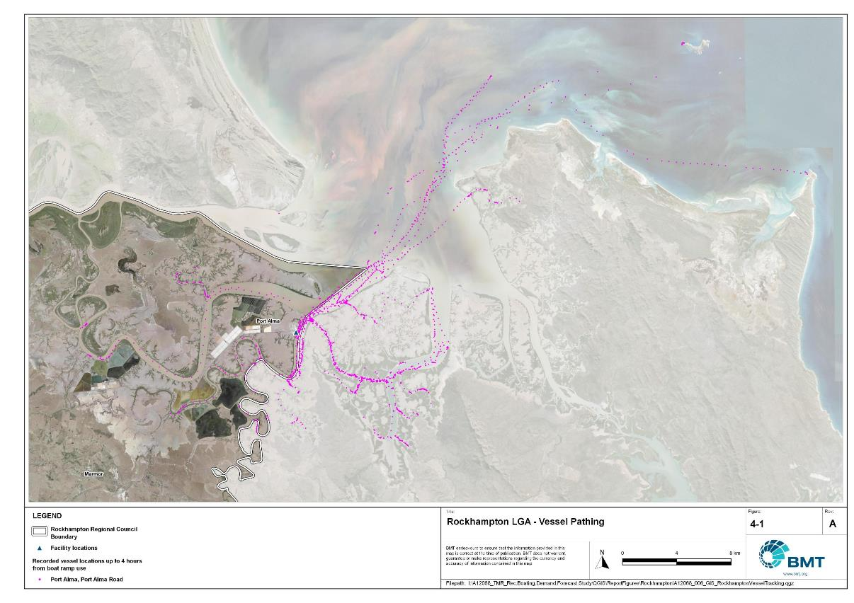

Rockhampton LGA – Vessel pathing

"I:\A12068_TMR_Rec.Boating.Demand.Forecast.Study\QGIS\ReportFigures\Rockhampton\A12068_006_GIS_RockhamptonVesselTracking.jpg"

## Active fleet size

The total ‘active’ fleet on a good boating day is derived from the activation rate of the total fleet of registered vessels within the LGA and the net inflow of visiting vessels. The total number of visiting vessels from each LGA is determined from the number of vessels in the resident active fleet and the relative proportion of resident to visiting vessels outlined in Table 4.1.The fleet size is expected to change over time due to changes in population and vessel acquisition trends, with the size and proportion of the fleet across the Study period described in Table 4.3.

Active fleet vessel size

| Vessel length | 2021 | 2026 | 2031 | 2036 | 2041 |
| --- | --- | --- | --- | --- | --- |
| 0 to 4.5m | 320 | 329 | 337 | 344 | 349 |
| 4.5m to 8m | 149 | 153 | 157 | 160 | 163 |
| >8m | 27 | 27 | 28 | 28 | 29 |
| Total | 496 | 509 | 522 | 533 | 541 |

## Boat ramp lane demand

The fleet size derived in Table 4.3 represents the statistical demand for the LGA, with vessels under 8m assumed to contribute to boat ramp demand, measured in boat ramp lanes. As outlined in section 3.1.2 the adopted capacity of each effective lane is 40 vessels per day, with each vessel assumed to both launch and retrieve, for a total of 80 vessel movements per day. The total boat ramp lane demand across the Study period is shown in Table 4.4.

Boat ramp lane demand

|  | 2021 | 2026 | 2031 | 2036 | 2041 |
| --- | --- | --- | --- | --- | --- |
| Boat ramp lane demand | 11.7 | 12 | 12.3 | 12.6 | 12.8 |

For Rockhampton LGA the important elements that contribute to boat ramp lane demand include:

* a moderate sized local fleet, with a high proportion of trailable vessels
* opportunities for fishing, supported by the Recreational Fishing Strategy, which seeks to expand recreational fishing (and fishing tourism, thereby increasing demand for boating facilities) in the broader Rockhampton LGA
* diverse facilities that cater to desired activities such as water-skiing or fishing
* the flow of demand between Rockhampton and Livingstone LGAs, with facilities such as Nerimbera and Thompson Point being close to Rockhampton population centres but within Livingstone LGA, and the current preference for open water boating to launch from Rosslyn Bay Boat Harbour rather than Port Alma - acknowledging that the preference to avoid the current Port Alma area as a take-off point may change, to an as yet unknown extent, once the facilities under construction (2022) at Casuarina Creek and Inkerman Creek are operating at full capacity.

## Non-statistical demand

As well as the statistical demand outlined in the section above, facilities may face demand pressures that are related to their functional use, which reduces the capability of the facility to service the recreational boat fleet in the desired manner. Issues with specific facilities have been identified within the consultation process of the Study with appointed managers and other stakeholders. While care has been taken to identify these non-statistical demand issues throughout the Study, it is beyond the scope of the Study to individually review the functionality, safety, and amenity of each facility across Queensland. Non-statistical demand pressures may warrant upgrades to facilities even where statistical demand is satisfied by existing capacity. These pressures have been classified into the following categories:

* Amenity: Amenity describes the functional usability of the facility including the desire to provide dry entry and exit facilities, facilities that provide easy access and/or access for persons with restricted mobility.
* Safety: Safety demand may include protection from currents and waves or contact with marine creatures such as sharks, jellyfish, and crocodiles.
* In-water congestion: Where existing queuing facilities are not able to efficiently meet the needs of the facility. Such deficiency may warrant additional queuing facility capacity to optimise boat launching and retrieval.

The Study's recommendations may alleviate these non-statistical demand pressures with consideration for capability of all facilities within the LGA. The presence of a non-statistical demand pressure at a facility may not warrant upgrades where other suitable facilities are reasonably available.

## Deep-draught vessel demand

* + 1. Cruising vessels

Vessels cruising along the east coast of Queensland have a requirement for a network of deep-draught vessel landings that are appropriately spaced to be within a day’s sailing on good weather days. These facilities are required to support the reprovisioning of vessels as they travel along the coast and provide access to desirable land-based destinations. Private marina facilities may be used by cruising vessels where there is an expectation for a prolonged stay that requires protected mooring or berthing. Within Rockhampton LGA there are no suitable facilities for landing of deep-draught vessels. The jetty at Derby Street is used occasionally for this purpose but is in poor condition and is not fit-for-purpose, and as such is not accounted for in this assessment.

Within the east coast network but outside the LGA, the nearest deep-draught vessel facility to the north is at Rosslyn Bay Boat Harbour. For a coastal passaging vessel, this is approximately 48 nautical miles distance from the Rockhampton CBD, most of which of the journey is within the Fitzroy River. To the south, the nearest landing facility along the coastal passaging route is 72 nautical miles from Rockhampton CBD in Gladstone.

At present, deep-draught vessels mooring in the Fitzroy River near the Rockhampton CBD use tenders to access the shore. The relatively large number of vessels anchored or moored should be supported by a fit-for-purpose deep-draught landing facility. Locating this near Rockhampton CBD would allow for easy access to supermarkets and shops for reprovisioning by tender, for pickup and drop-off of passengers, and for access (via tender) to public transport.

* + 1. Landing demand

Statistical demand for deep-draught vessel landings has been assessed based on the size of the non-trailable fleet within Rockhampton LGA. Landing demand is more difficult to assess than boat ramp lane demand as the requirements and duration of the landing influence the demand pressure but are highly variable between users. Nevertheless, the Study has assumed that 5% of the non-trailable fleet will be seeking a landing at any given time. The consultation undertaken during the Study indicates that this assumption may overestimate the number of landings, but that the landings are often utilised for other boating and recreation activities when not in use by deep-draught vessels. In particular, landings that are located near boat launching facilities may be used as queuing facilities and therefore support the efficient launching of smaller recreational vessels. Given this, the 5% assumption has been adopted noting that it may overestimate demand, but not to an extent that it would be onerous to facility providers. Within Rockhampton LGA the demand for deep-draught vessel landings is outlined in Table 4.5.

Deep-draught vessel landing demand

| Requirement | 2021 | 2026 | 2031 | 2036 | 2041 |
| --- | --- | --- | --- | --- | --- |
| No. of Landings | 1.3 | 1.4 | 1.4 | 1.4 | 1.4 |

# Shortfall Assessment

## Shortfall assessment – boat ramps

The shortfall of boat ramp lanes within Rockhampton LGA is shown in Table 5.1 and Figure 6.1 at an LGA scale. This is presented both with and without the inclusion of additional capacity provided by the recommended upgrades.

Shortfall of boat launching facilities

| Assessment | Metric | 2021 | 2026 | 2031 | 2036 | 2041 |
| --- | --- | --- | --- | --- | --- | --- |
| Demand | Demand | 11.7 | 12 | 12.3 | 12.6 | 12.8 |
| Existing | Capacity | 8.8 | 11.8 | 11.8 | 11.8 | 11.8 |
| **Shortfall** | 2.9 | 0.2 | 0.5 | 0.8 | 1 |
| Improved | Capacity | 8.8 | 11.8 | 11.8 | 14.3 | 14.3 |
| **Shortfall** | 2.9 | 0.2 | 0.5 | -1.7 | -1.5 |

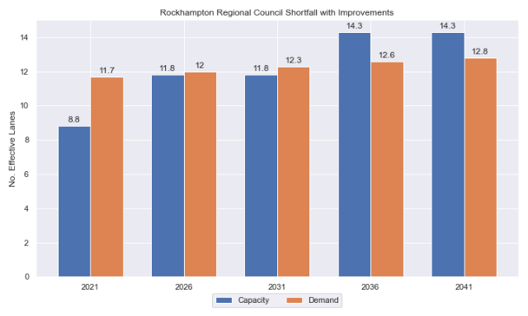

Shortfall assessment with recommended upgrades adopted and expected facilities included.

* + 1. Open-water access shortfall in boat ramp lanes

Statistical capacity has been calculated across Rockhampton LGA in its entirety, however, some facilities are evidently more popular than others due to their ability to access open-water destinations, and/or their usability. In general, larger vessels are more suited to access open-water destinations while smaller vessels are more likely to remain in sheltered environments. This was identified in the 2017 study and confirmed during discussions with stakeholders. The human movement data indicates that visiting boats from other LGAs are drawn to facilities that provide access to open-water destinations. To ensure that the capacity of effective boat ramp lanes in the LGA is appropriately distributed to cater for these usage trends, it is worth assessing facilities providing this desirable access as a subset of the total capacity for the LGA. A ‘scenario’ approach to assessing this capacity (Table 5.2) has been developed, with Scenario 1 derived from empirical estimates of vessel distribution and Scenario 2 derived from the human movement statistics, and the final result averaged between the two scenarios. This provides the opportunity to rationalise the figure that drives the demand and acknowledge when one scenario is not representative of the population or consistent with stakeholder feedback. The scenarios that were assessed are:

Scenario 1: 80% of larger vessels and 20% of smaller vessels from the local fleet and 80% of the visiting fleet are using the facilities with unrestricted open water access.

Scenario 2: Distributing the fleet between facilities as per the human movement statistics.

Shortfall assessment for open water, all-tide or near all-tide facilities for Rockhampton LGA

| Assessment | Metric | 2021 | 2026 | 2031 | 2036 | 2041 |
| --- | --- | --- | --- | --- | --- | --- |
| Overall | Capacity | 1.0 | 4.0 | 4.0 | 4.0 | 4.0 |
| Scenario 1 | Demand | 6.5 | 6.7 | 6.9 | 7.1 | 7.2 |
| Shortfall | 5.5 | 2.7 | 2.9 | 3.1 | 3.2 |
| Scenario 2 | Demand | 0.4 | 0.4 | 0.4 | 0.4 | 0.4 |
| Shortfall | -0.6 | -3.6 | -3.6 | -3.6 | -3.6 |
| **Average** | Demand | 3.5 | 3.6 | 3.7 | 3.8 | 3.8 |
| **Shortfall** | **2.5** | **-0.4** | **-0.3** | **-0.3** | **-0.2** |

Comparing the LGA-scale shortfall with the subset of facilities providing protected all-tide or near all-tide access to open water indicate that the demand is reasonably well distributed among the facilities within the LGA. Table 5.2 accounts for the expected capacity increase by 2026 detailed in section 3.1.7.

## Shortfall assessment – deep-draught landings

The shortfall of public deep-draught landings for Rockhampton LGA is provided in Table 5.3. The existing capacity is statistically inadequate to meet demand, and a new facility providing deep-draught vessel landing and access to mainland destinations such as Rockhampton CBD should be constructed to service this portion of the fleet.

Shortfall of deep-draught vessel landings

| Assessment | Metric | 2021 | 2026 | 2031 | 2036 | 2041 |
| --- | --- | --- | --- | --- | --- | --- |
| Deep-draught vessel landings | Demand | 1.3 | 1.4 | 1.4 | 1.4 | 1.4 |
| Capacity | 0 | 0 | 0 | 0 | 0 |
| **Shortfall** | 1.3 | 1.4 | 1.4 | 1.4 | 1.4 |

# Stakeholder Feedback



The Study has undertaken extensive consultation throughout its execution to achieve a comprehensive understanding of issues relating to the use of recreational boating facilities across the state. This consultation was conducted with managing authorities that own and/or and manage recreational boating facilities, as well as with facility stakeholders including recreational groups, volunteer marine rescue and coastguard organisations, and the general public. Stakeholder engagement was supplemented with site visits to facilities where key issues had been identified.

## Managing authority feedback

For Rockhampton LGA, the Study team met with Rockhampton Regional Council, Gladstone Ports Corporation (for Port Alma), and Maritime Safety Queensland to discuss recreational boating facilities within the region. This consultation process identified a range of potential opportunities to alleviate demand pressures. The Study has considered the practical implementation of each of these opportunities with respect to the required infrastructure, difficulty of implementation and magnitude of benefit, as summarised in Table 6.1.

Stakeholder identified opportunities

| Location | Stakeholder opportunity | Review comments |
| --- | --- | --- |
| Rockhampton Boathouse | Provide gangway-access pontoon with direct access to Rockhampton CBD and sewage pump-out facility. | Agreed. Excellent location for this facility. |
| Nerimbera | Provide a pontoon or floating walkway at this location | This facility is in Livingstone LGA but is heavily used by Rockhampton LGA vessels. Agreed with suggestion. |
| Parkhurst and Pink Lily | Exploration of new freshwater boating facilities. | The consideration of new freshwater facilities at these areas is viable and is not fundamentally opposed by the Study. However, current demand statistics presented in this Study indicate that demand will be satisfied by the expected facilities in the Fitzroy Delta and the two existing freshwater facilities upstream of the Fitzroy River Barrage, which are closer to major population centres. |
| Rookwood Weir (post construction) | Exploration of a new freshwater boating facility, following the construction of the Rookwood Weir. | The consideration of a facility at this site is viable and is not fundamentally opposed by the Study. The Rookwood Weir project may present opportunities for new recreational boating activities in Rockhampton LGA. However, current demand statistics presented in this Study indicate that demand will be satisfied by the expected facilities in the Fitzroy Delta and the two existing freshwater facilities upstream of the Fitzroy River Barrage, which are closer to major population centres. |

## Stakeholder feedback

Broader stakeholder feedback has been conducted within the Study by undertaking virtual or face-to-face meetings with recreational boating groups and marine rescue organisations, as well as through the Recreational Boating Facility Survey (MSQ, 2022) undertaken by Maritime Safety Queensland, which included survey responses from nearly 3,000 users and open submissions. For Rockhampton LGA, a total of 4 submissions was received, with all respondents using trailable power boats and recreational boating facilities at least once a month. It is possible that some Rockhampton LGA residents identified as being from Livingstone LGA in their survey responses as the Livingstone LGA facilities are well patronised by Rockhampton LGA residents. For Rockhampton LGA, the following statistics or themes were extracted from the survey and associated comments:

* 75% of respondents typically travel less than 1hr to their preferred boat ramp (which may not be their closest facility).
* 100% of respondents indicated that floating walkways are their preferred type of queuing facility.
* 75% of respondents indicated they would be unwilling to walk further than 200m from designated CTU parking to a boat ramp.
* The most common requests for new boat ramps were all for facilities within the adjacent Livingstone LGA, including:
  + Emu Park (Hill Street)
  + Ritamada (Ritamada Road).
* The following themes were identified with respect to existing facilities:
  + more parking for car trailers
  + boats ramps need pontoons or floating walkways, particularly Nerimbera
  + requests for regular cleaning of the ramp (that is, pressure washing)
  + pontoon facilities with power, water and sewage pump-out in Rockhampton LGA.
* Where the closest available boat launching facility was not preferred, respondents indicated that access to their desired destination influenced their choice.
* Respondents were given an opportunity to provide additional feedback, identifying a desire for policing of trailer parking areas to prevent passenger vehicles taking up trailer parking spaces during peak periods.

# Development Recommendations

## Previous recommendations

The 2017 GHD assessment recommended opportunities for increasing capacity of recreational boating facilities across the state. However, the implementation of these recommendations has been low, with only 10% of the total state-wide recommendations delivered in part or full in the 5 years since the delivery of the report. Of the priority 1 recommendations (for immediate delivery) and priority 2 recommendations (for implementation within 5 years) only 18% and 6% respectively have been delivered. State-wide only 5% of landside recommendations were delivered, while 16% of waterside recommendations were delivered.

Since the 2017 study works have commenced on the Casuarina Creek and Inkerman Creek recommendations from the 2017 GHD study. This current Study has reviewed the unimplemented 2017 recommendation (Table 7.1) for Rockhampton LGA in conjunction with stakeholders during the consultation process to identify whether previous recommendations are:

* Still viable: The recommendation in its original form remains suitable for solving demand pressures.
* Still viable with modifications: The recommendation could remain viable with modifications identified throughout the consultation process.
* No longer viable: The recommendations are no longer suitable to be carried through as recommendations in this Study.

Recommendations from the 2017 study that are considered viable or viable with modifications are carried forward into the recommendations of this Study with a suitable update to their priority status if required.

Assessment of unimplemented 2017 recommendations

| Location | 2017 Recommendation | 2022 Review | Review comment |
| --- | --- | --- | --- |
| Priority 4 | | | |
| Quay St, Rockhampton | Pontoon for access by deep-draught vessels. | Still viable | Agreed, upgraded priority. |

## Priority recommendations

The selection and ranking of development priorities provides for progressive implementation of solutions to meet capacity shortfalls and/or resolve existing safety and usage issues at existing facilities over time. Recommendations have been split into four categories for implementation within the 20-year planning period of this Study, with the following projected timelines:

* Priority 1: For immediate planning and design.
* Priority 2: Planning and design intended to provide capacity within 5-10 years.
* Priority 3: Planning and design intended to provide capacity within 10-15 years.
* Priority 4: Planning and design intended to provide capacity within 15-20 years.

The recommendations have been structured to include consideration of the reasonable timelines for implementation. This may include consideration for budgetary processes, planning, environmental approvals, consultation periods, and construction. The priority selection of recommendations has been conducted in accordance with TMR’s Marine Infrastructure and Facilities Plan (TMR, 2020) guidelines, namely:

1. *priority to be given to the provision of sheltered all-tide or near all-tide launching facilities giving access to the open sea on an all-tide or near all-tide basis.*
2. *part-tide facilities (for launching or access) may be provided where there is demand and dredged access is not feasible. For instance, beach access or open beach ramps may be provided where there is sufficient demand and no suitable nearby sheltered waterway*
3. *the most economically viable options will take precedence, including the expansion of existing facilities, and the changing of existing foreshore land uses. In many cases, limiting or avoiding dredging and/or breakwater costs will be a crucial factor*
4. *a goal of providing access to sheltered all-tide or near all-tide boat launching facilities within one hour’s drive for significant communities*

Consequently, higher order recommendations need to address, where possible, the provision of facilities that provide maximum benefit in the widest range of conditions and will be limited to those solutions that are already significantly advanced or ‘shovel ready’ or that require limited further design, planning, and approvals. Lower order recommendations will consist of solutions where there is reduced adherence to the TMR guidelines and/or there are constraints that may result in long lead times to resolve. A summary of the recommendations is provided in Table 7.2 with full detail of each recommendation in the tables that follow.

Summary of recommendations for Rockhampton LGA

| Priority | Description | Landside or Waterside | Increased capacity  (effective lanes) |
| --- | --- | --- | --- |
| 1 | Rockhampton Boathouse, Quay Street: Construct a gangway-access pontoon for a deep-draught vessel landing. Pontoon should have sewage pump-out facilities and be DDA compliant. | Waterside | 1 landing |
| 3 | Callaghan Park: Construct additional carpark with 54 CTU spaces. | Landside | 2.5 lanes |
| 3 | Quay Street: Reconfigure parking and move floating walkway to the northern lane | Both | 0.25 lanes  Amenity Improvement |

## Priority 1 recommendations

Rockhampton Boathouse, Quay Street (Priority 1)

|  |  |  |  |  |
| --- | --- | --- | --- | --- |
| General description | | | | |
| Location | On Quay Street, Rockhampton, beneath the existing Boathouse on the Fitzroy River. | | | |
| Existing Facility? | No | | | |
| Coordinates | -23.37728141, 150.51476877 | | | |
| Existing tidal status | N/A | | | |
| Existing wave exposure | N/A | | | |
| Existing current exposure | N/A | | | |
| Proposed works | Construct a gangway-access pontoon for a deep-draught vessel landing. | | | |
| Increased effective capacity | N/A | | | |
| Capacity improvement position | Waterside | Landside | | Both |
| Rationale | An all-tide accessible landing for deep-draught vessels is needed in Rockhampton LGA to reinstate capacity historically provided by the Derby Street Jetty. This location is suitable due to its proximity to Rockhampton CBD, and the existing structure and amenities there, which also can support a sewage pump-out facility. This facility will improve access, particularly for visiting vessels. | | | |
| Anticipated Costs (+/- 50%) | Waterside infrastructure | | $110,000 | |
| Landside infrastructure | | N/A | |
| Planning, environmental and approvals constraints | | | | |
| Assessment | Requirement | Comment | | |
| Fish Habitat Zone | X | N/A | | |
| Native Title | X | N/A | | |
| MCU requirement | X | N/A | | |
| Clearing remnant vegetation | X | N/A | | |
| GBRWHA | ü | Construction of a pontoon within the GBRWHA may require a Controlled Activity Approval. | | |
| Marine Park | X | N/A | | |
| Tidal works assessment | ü | Construction of a new pontoon will likely be tidal works and require a Development Permit | | |
| Other as required | X | N/A | | |
| Sea Level Rise | ü | The marine-based works are within the boundaries of the erosion prone area. | | |
| Storm Time Hazard | ü | The works are within the boundaries of a high hazard area. | | |
| Anticipated Complexity | Low | Medium | | High |

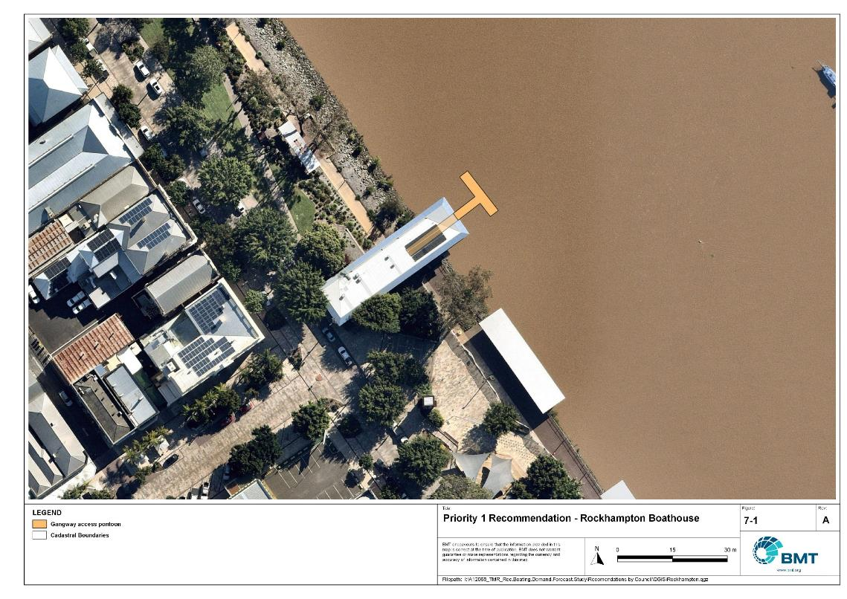

Priority 1 Recommendation – Rockhampton Boathouse

I:\A12068_TMR_Rec.Boating.Demand.Forecast.Study\Recomendations by Council\JPG\Rockhampton\A12068_005_RockhamptonProposedUpgrades_7-1.jpg

## Priority 2 recommendations

Nil.

## Priority 3 recommendations

Robert Clark Drive, Callaghan Park (Priority 3)

|  |  |  |  |  |
| --- | --- | --- | --- | --- |
| General description | | | | |
| Location | Callaghan Park, North Rockhampton, Robert Clark Drive | | | |
| Existing Facility? | Yes | | | |
| Coordinates | -23.38035800, 150.52042000 | | | |
| Existing tidal status | All-tide | | | |
| Existing wave exposure | None | | | |
| Existing current exposure | None | | | |
| Proposed works | Construct additional carpark with 54 CTU spaces. | | | |
| Increased effective capacity | 2.5 Effective Lanes | | | |
| Capacity improvement position | Waterside | Landside | | Both |
| Rationale | Doubling the landside capacity of this facility allows landside facilities to closer match the capacity of the waterside facilities. This facility is central to Rockhampton LGA, where river fishing is popular. There are multiple conflicts with recreational boat users and other groups at present, such as markets and annual car festivals such as RockyNats. Building this carpark area across the road as a multi-purpose area would allow for the markets and RockyNats to continue without severely limiting the boat launching capacity of the facility.  This upgrade recommendation allows the Callaghan Park facility to provide a suitable amount of capacity at all times. | | | |
| Anticipated Costs (+/- 50%) | Waterside infrastructure | | N/A | |
| Landside infrastructure | | $265,000 | |
| Planning, environmental and approvals constraints | | | | |
| Assessment | Requirement | Comments | | |
| Fish Habitat Zone | X | N/A | | |
| Native Title | X | N/A | | |
| MCU requirement | ü | New carpark may trigger a Development Permit for a Material Change of Use | | |
| Clearing remnant vegetation | X | N/A | | |
| GBRWHA | X | N/A | | |
| Marine Park | X | N/A | | |
| Tidal works assessment | X | N/A | | |
| Other as required | X | N/A | | |
| Sea Level Rise | ü | The new car park is within the boundaries of the erosion prone area except for the south-eastern portion of the car park. | | |
| Storm Tide Hazard | ü | The proposed north-western portion of the car park is within the boundaries of a high hazard area compared to the south-eastern portion within the boundaries of a medium hazard area. | | |
| Anticipated Complexity | Low | Medium | | High |

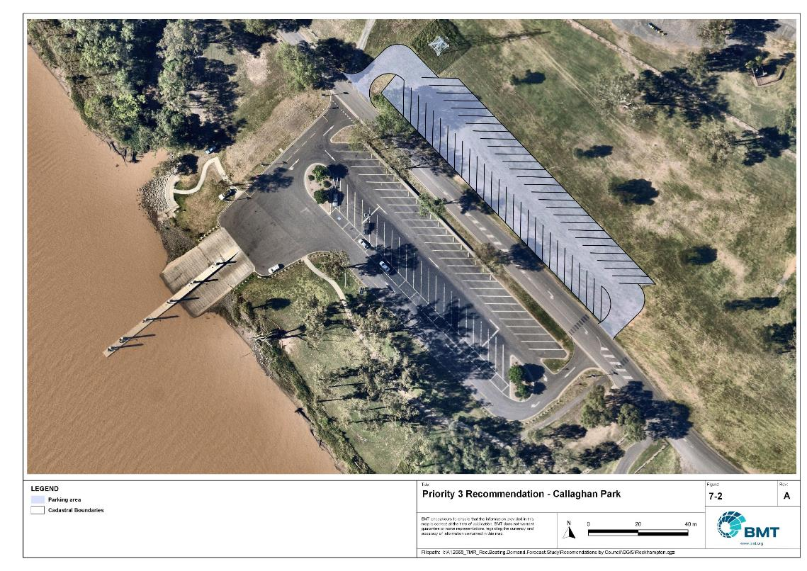

Priority 2 Recommendation – Callaghan Park

I:\A12068_TMR_Rec.Boating.Demand.Forecast.Study\Recomendations by Council\JPG\Rockhampton\A12068_005_RockhamptonProposedUpgrades_7-2.jpg

Quay Street (Priority 3)

|  |  |  |  |  |
| --- | --- | --- | --- | --- |
| General description | | | | |
| Location | Southern bank of the Fitzroy River, near Rockhampton CBD | | | |
| Existing Facility? | Yes | | | |
| Coordinates | -23.38585307, 150.52104888 | | | |
| Existing tidal status | All-tide | | | |
| Existing wave exposure | None | | | |
| Existing current exposure | Yes | | | |
| Proposed works | Reconfigure car park to maximise number of CTU spaces, without compromising the usability for launching.  Relocate the floating walkway to the upstream side of the ramp. | | | |
| Increased effective capacity | 0.25 Effective Lanes  Amenity and functionality upgrade | | | |
| Capacity improvement position | Waterside | Landside | | Both |
| Rationale | The space within the existing car park footprint could be used more efficiently to achieve more CTU spaces, without losing the number of personal vehicle spaces that exist there already.  The floating walkway presently acts as a debris trap, and recurring growth of hyacinth on the upstream side of the facility renders the downstream lane unusable until the weed is cleared. Moving the walkway to the upstream side of the ramp would allow all ramp lanes to be usable more often.  This upgrade recommendation allows the Quay Street facility to be utilised at maximum capacity at all times. | | | |
| Anticipated Costs (+/- 50%) | Waterside infrastructure | | $1,100,000 | |
| Landside infrastructure | | $110,000 | |
| Planning, environmental and approvals constraints | | | | |
| Assessment | Requirement | Comments | | |
| Fish Habitat Zone | X | N/A | | |
| Native Title | X | N/A | | |
| MCU requirement | X | N/A | | |
| Clearing remnant vegetation | ü | The proposed works are within areas of RVM category R- reef- regrowth watercourse vegetation. A permit may be required before clearing of remnant vegetation. | | |
| GBRWHA | ü | Relocation of floating walkway located within the GBRWHA may require a Controlled Activity Approval. | | |
| Marine Park | X | N/A | | |
| Tidal works assessment | ü | Relocation of the existing floating will be tidal works and likely require a Development Permit or amendment to an existing Development Permit. | | |
| Other as required | ü | Marine Plants – relocation of the floating walkway may require clearing of marine plants, and therefore will require a Development Permit for marine plant disturbance. | | |
| Sea Level Rise | ü | The proposed car park reconfiguration is not within the boundaries of the erosion prone area. However, the marine-based works (that is, relocation of the floating walkway) is within the erosion prone area. | | |
| Storm Tide Hazard | ü | The proposed car park refiguration is now within a storm tide hazard area, though the floating walking is within the boundaries of a medium/high hazard area. | | |
| Anticipated Complexity | Low | Medium | | High |

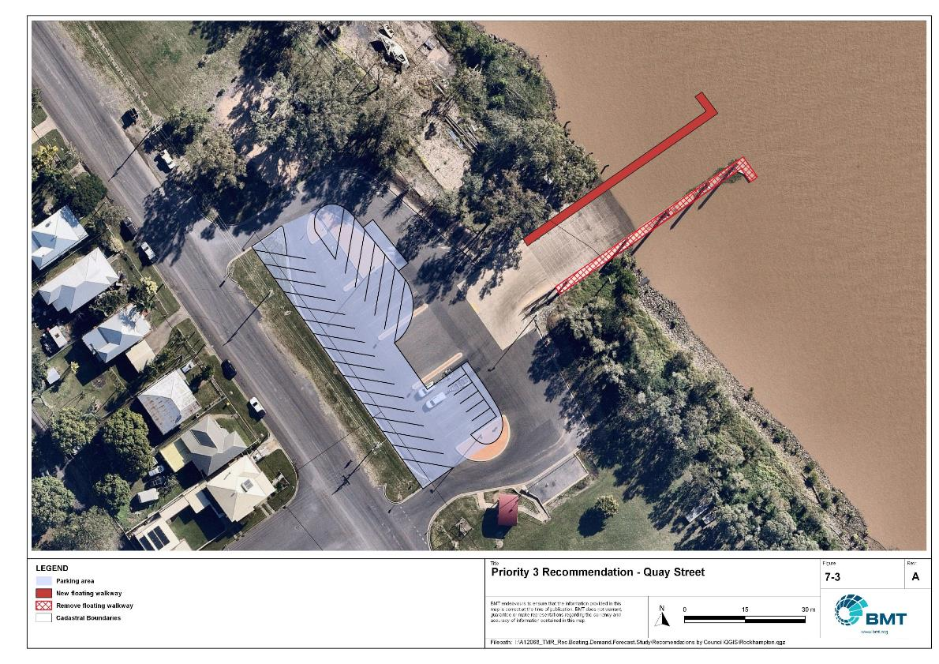

Priority 3 Recommendation – Quay Street

I:\A12068_TMR_Rec.Boating.Demand.Forecast.Study\Recomendations by Council\JPG\Rockhampton\A12068_005_RockhamptonProposedUpgrades_7-3.jpg

## Priority 4 Recommendations

Nil.

# References

Australian Bureau of Statistics (ABS), 2021, *2021 Census,* <https://www.abs.gov.au/census>

Bell, Frederick W. 2022, *Estimation of the present and projected demand and supply of boat ramps for Florida's coastal regions and counties*, Florida State University, Department of Economics.

BMT, 2015, *MPSC Managed Boating Facilities Demand and Capacity Study: Boat Ramp Modelling*

Department of Transport and Main Roads (TMR), 2020, Marine facilities and infrastructure plan.

GHD, 2011, *Recreational Boating Facilities Demand Forecasting Study*

GHD, 2017, *Queensland Recreational Boating Facilities Demand Forecasting Study 2017.*

Maritime Safety Queensland (MSQ), 2022, *Recreational Boating Facilities,* <https://www.getinvolved.qld.gov.au/gi/consultation/8850/view.html>

Queensland Government Department of Resources (DoR), 2022, *Cities and towns [OGC WMS Service]*, Accessed 5/10/2022, available online at spatial.information.qld.gov.au/arcgis/home/item.html?id=103c7c9ccca449fab79d27cde06868ab

Rose, T., R. Powell & J. Yu (2009). Identification of the Present and Future Recreational Boating Infrastructure in Redland City – A 10 Year Infrastructure Plan- Griffith University

SKM (1998) Public Boat Ramps Central Queensland Strategic Plan - Volume One - Demand Forecasting - Noosa to Yeppoon. Sinclair Knight Merz, March 1998.

Swett, R., Fik, T., Ruppert, T., Davidson, G., Guevara, C. & Betty Staugler, 2012, *Planning for the future of recreational boating access to charlotte county waterways: 2010 – 2050*, Florida Sea Grant, University of Florida.

Western Australia Department of Transport, 2019, *Perth Recreational Boating Facilities Study Review 2019*, https://www.transport.wa.gov.au/mediaFiles/marine/MAC_P_Perth_RBFS_study_review_2019.pdf

Western Australia Department of Transport, 2021, *South West Region Recreational Boating Facilities Study July 2021,* https://www.transport.wa.gov.au/mediaFiles/marine/MAC_P_SouthWest_RBFS_Study_2021.pdf

###### Demand Study

"G:\Admin\A12068.g.mpb.TMRBoatingDemand\06_Reports\09_Demand Study\2022_2119 (016) Final Demand Report (March 2023).pdf"

###### Boat launching facility capacity

Capacity of existing boat launching facilities

| Facility ID | Facility name | No. lanes | Tidal access at the ramp | Tidal access to open water | Queuing facility | Formal CTUs | Informal CTUs | Waterside capacity | Landside capacity | Effective capacity | Constraint |
| --- | --- | --- | --- | --- | --- | --- | --- | --- | --- | --- | --- |
| **Open water access** | | | | | | | | | | | | |
| FY12 | Port Alma, Port Alma Road | 2 | All-Tide | All-Tide | None | 0 | 15 | 2 | 1 | 1 | Landside |
| **Subtotal** |  | **2** |  |  |  | **0** | **15** | **2** | **1** | **1** |  |
| **Distance-limited open water access** | | | | | | | | | | | | |
| RK11 | Rockhampton, Reaney Street | 1 | Part-Tide | Part-Tide | None | 15 |  | 0.5 | 1 | 0.5 | Waterside |
| RK15 | Robert Clark Drive, Callaghan Park | 4 | All-Tide | Near All-Tide | Floating Walkway | 52 |  | 5.4 | 2.5 | 2.5 | Landside |
| RK32 | Rockhampton, Quay Street | 4 | All-Tide | Near All-Tide | Floating Walkway | 9 |  | 5.4 | 0.75 | 0.75 | Landside |
| **Subtotal** |  | **9** |  |  |  | **76** | **0** | **11.3** | **4.25** | **3.75** |  |
| **Fresh water** | | | | | | | | | | | | |
| MM10 | Mount Morgan, William Street | 1 | Fresh Water | Fresh Water | None | 0 | 15 | 1 | 1 | 1 | Waterside |
| RK21 | Rockhampton, Larcombe Street | 2 | Fresh Water | Fresh Water | None | 0 | 35 | 2 | 1.75 | 1.75 | Landside |
| RK31 | Rockhampton Ski Gardens - Ramsden Street | 2 | Fresh Water | Fresh Water | None | 11 | 6 | 2 | 1.25 | 1.25 | Landside |
| **Subtotal** |  | **5** |  |  |  | **11** | **56** | **5** | **4** | **4** |  |
| **Total effective capacity** | | | | | | | | | | **8.75** | |

###### Travel time statistics

Travel time from population centres to nearest sheltered all-tide or near all-tide open water accessible facilities

| Population Centre | Travel time (mins) |
| --- | --- |
| Bajool | 23.5 |
| Bouldercombe | 46.5 |
| Marmor | 24.2 |
| Port Alma | 1.2 |
| Rockhampton | 35.1 |

###### Facility Use

Boat launching facility usage statistics

| Facility ID | Facility name | Total reports | Rockhampton | Livingstone | Central Highlands | Gladstone | Brisbane | Moreton Bay | Bundaberg | Mackay | Sunshine Coast | Gold Coast | Other LGAs |
| --- | --- | --- | --- | --- | --- | --- | --- | --- | --- | --- | --- | --- | --- |
| Total |  | 13556 | 9789 | 1376 | 302 | 241 | 239 | 169 | 136 | 135 | 122 | 104 | 943 |
| Total % |  | 100% | 72.2% | 10.2% | 2.2% | 1.8% | 1.8% | 1.2% | 1.0% | 1.0% | 0.9% | 0.8% | 7.0% |
| RK15 | Rockhampton, Callaghan Park, Robert Clark Drive | 4117 | 64.6% | 11.4% | 3.3% | 2.6% | 1.5% | 1.7% | 1.0% | 1.9% | 1.7% | 0.6% | 9.9% |
| RK31 | Rockhampton, Ski Gardens, Ramsden Street | 2920 | 77.5% | 8.7% | 1.4% | 0.8% | 2.6% | 1.5% | 1.6% | 0.5% | 0.4% | 0.8% | 4.0% |
| RK32 | Rockhampton, Quay Street | 2425 | 78.8% | 7.0% | 2.6% | 1.2% | 1.3% | 0.4% | 1.0% | 0.7% | 0.9% | 0.5% | 5.5% |
| RK11 | Rockhampton, Reaney Street | 1785 | 74.5% | 13.6% | 1.4% | 0.8% | 1.4% | 0.9% | 0.4% | 0.5% | 0.4% | 0.2% | 5.8% |
| MM10 | Mount Morgan, William Street | 952 | 74.1% | 5.1% | 0.8% | 1.7% | 1.4% | 1.8% | 0.7% | 1.2% | 0.7% | 3.8% | 8.7% |
| RK21 | Rockhampton, Larcombe Street | 948 | 76.1% | 15.6% | 1.9% | 0.1% | 0.8% | 0.5% | 0.0% | 0.3% | 0.2% | 0.2% | 4.2% |
| FY12 | Port Alma, Port Alma Road | 409 | 48.9% | 10.3% | 2.9% | 11.5% | 6.4% | 2.0% | 2.0% | 0.2% | 0.7% | 1.0% | 14.2% |

|  |  |  |
| --- | --- | --- |
|  |  | BMT is a leading design, engineering, science and management consultancy with a reputation for engineering excellence. We are driven by a belief that things can always be better, safer, faster and more efficient. BMT is an independent organisation held in trust for its employees. |

|  |  |  |  |  |  |  |  |  |
| --- | --- | --- | --- | --- | --- | --- | --- | --- |
|  |  |  |  |  |  |  | Contact us  enquiries@bmtglobal.com  www.bmt.org  Follow us  www.bmt.org/linkedin LinkedIn logo.  www.bmt.org/youtube YouTube logo.  www.bmt.org/twitter Twitter logo.  www.bmt.org/facebook Facebook logo. |  |
|  | Level 5  348 Edward Street  Brisbane  QLD 4000  Australia  +61 7 3831 6744 |  | Registered in Australia  Registered no. 010 830 421  Registered office  Level 5, 348 Edward Street,  Brisbane QLD 4000 Australia |  |  |  |  |
|  | For your local BMT office visit www.bmt.org | | |  |  |  |  |  |