|  |
| --- |
| Queensland Recreational Boating Facilities Demand Forecasting Study 2022  Redland LGA Assessment |
|  |
|  |

|  |  |  |
| --- | --- | --- |
| Customer |  | Maritime Safety Queensland |
| Project |  | A12068 |
| Deliverable |  | 063 |
| Version |  | 01 |
|  |  | 21 April 2023 |

Document Control

Document Identification

|  |  |
| --- | --- |
| Title | Queensland Recreational Boating Facilities Demand Forecasting Study 2022 |
| Project No | A12068 |
| Deliverable No | 063 |
| Version No | 01 |
| Version Date | 21 April 2023 |
| Customer | Maritime Safety Queensland, a branch of the Department of Transport and Main Roads |
| Customer Contact | boatinginfrastructure@msq.qld.gov.au |
| Classification | {None} |

|  |  |
| --- | --- |
| Author | Daniel Wishaw, Nicholas Heiner, Geoff Long, Azam Dolatshah, Sophie Barrett, Mackenzie Stacey |
| Reviewed By | Katrina O’Malley-Jones, Jeremy Visser |
| Project Manager | Daniel Wishaw |

Amendment Record

The Amendment Record below records the history and issue status of this document.

| Version | Version Date | Distribution | Record |
| --- | --- | --- | --- |
| 00 | 15 February 2023 | Maritime Safety Queensland  Redland City Council | Draft |
| 01 | 21 April 2023 | Maritime Safety Queensland | Final |

Executive Summary

This report, part of the Queensland Recreational Boating Facilities Demand Forecasting Study 2022 (‘the Study’), provides a summary of current and forecast demand on recreational boating facilities in Redland LGA and the capacity of existing facilities to meet this demand. Where capacity is insufficient to meet current or forecast demand, recommendations have been made to improve existing facilities or for the construction of new facilities. This report is intended to support facility deliverers, owners, and managers over the next 20 years in their decision-making on development priorities for recreational boating facilities within Redland LGA.

Key issues and attributes of recreational boating

The key attributes of recreational boating facilities identified in this Study for Redland LGA are summarised in Table 1, while consultation with stakeholders undertaken as part of the Study identified the following key issues:

* Across the LGA there is good demand satisfaction, but demand is concentrated on facilities with easy access to open water and Moreton Bay, leading to localised congestion.
* There are permanent settlements on some of the islands within the LGA that require boating facilities for access, regardless of statistical demand for recreational boating.
* There is a perceived lack of queuing infrastructure (floating walkways, pontoons, beaches and fixed sloping walkways) at boat launching facilities.
* There is a need for more public pontoons for deep-draught vessels.

1. Key recreational boating attributes for Redland LGA

| Key attribute | Value |
| --- | --- |
| Deep-draught landing facilities |  |
| Existing demand (number) | 6.7 |
| Existing capacity (number) | 2.0 |
| Existing shortfall (number) | 4.7 |
| Boat launching facilities |  |
| Number of existing facilities | 24 |
| Current demand for boat launching lanes (effective lanes) | 36.6 |
| Number of existing ‘effective’ boat launching lanes | 26.3 |
| Current shortfall of ‘effective’ boat launching lanes (number) | 10.3 |
| Demand satisfaction for ‘effective’ boat launching lanes | 72% |
| State average demand satisfaction for ‘effective’ boat launching lanes | 87% |

Demand summary

The assessment of recreational boating demand is centred on a statistical demand model that considers vessel registration data, population statistics, assumptions around local usage and the movement of vessels into and out of the LGA. Key parameters from this assessment for Redland LGA are:

* The population is 161,027 as at the 2021 census and is projected to be 192,431 by 2041.
* As of July 2022, there is a total of 14,117 vessels with a home registration within the LGA, with 13,093 being ‘trailable’ – and therefore requiring boat launching facilities – and 1,024 being non-trailable.
* Redland LGA is deemed to be a Metropolitan Area with an assumed vessel activation rate of 10% on a ‘good boating day’.
* Vessels are primarily used within the LGA, with some leakage to Brisbane, Gold Coast, Moreton Bay and Logan LGAs.
* Vessels from Brisbane (18%) and Logan (8%), as well as lesser numbers from Gold Coast and Ipswich, contribute to local demand.
* The existing demand for boat launching facilities is 36.6 ‘effective’ boat ramp lanes and is projected to be 45 ‘effective’ lanes by 2041. As presented in Table 1, the current capacity is 26.3 ‘effective’ lanes.
* The existing demand for deep-draught vessel landings is seven currently (2022) and is projected to be eight by 2041. As presented in Table 1, there are currently (2022) only two deep-draught vessel landings in the LGA. However, an additional four will be delivered during 2023 on several of the southern Moreton Bay islands in association with new ferry terminals.

Boat launching

Boat launching facilities comprise boat ramps, any queuing facilities (floating walkways, pontoons, beaches and fixed sloping walkways) and the provision of car and trailer unit (CTU) parking. The capacity of a boat launching facility is measured in ‘effective lanes’ for both waterside and landside facilities, with the total capacity of a facility being the minimum of the waterside or landside capacity. Waterside capacity is calculated from the number of boat ramp lanes multiplied by environmental reduction factors (for tide, current or waves) and queuing facility improvement factors to derive the number of ‘effective’ lanes. The landside capacity is calculated from the number of available CTU parking spaces.

Redland LGA has 24 boat launching facilities, comprising 45 boat ramp lanes with a total effective boat launching capacity of 26.3 ‘effective’ lanes. Nine of these facilities are constrained by waterside capacity with the remainder constrained by landside capacity.

The capacity including expected facilities, forecast demand, and shortfall of boat ramp effective lanes in Redland LGA are shown in Figure 1.

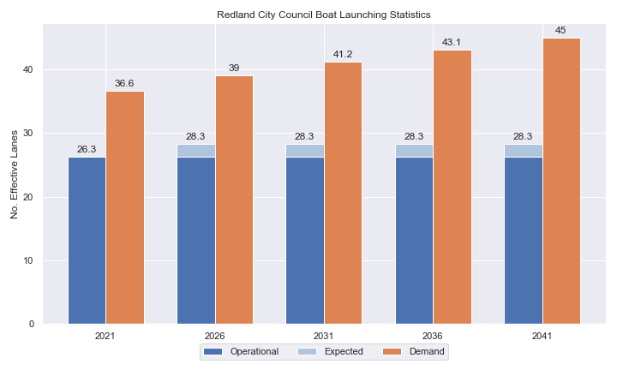

1. Existing capacity, expected capacity and forecast demand of ‘effective’ boat ramp lanes for Redland LGA

Deep-draught vessel landings

Vessel landing facilities are provided across the state in the form of pontoons and jetties, to provide locations for larger vessels, or their tenders, to access landside destinations or facilities. Pontoons and jetties may also be provided for other purposes such as supporting boat launching or other recreation and may not be suitable for deep-draught vessels. The trend across Queensland indicates that jetties are rarely used as landings, with pontoons preferred by recreational users. As such, the Study has limited the capacity of deep-draught vessel landings to those that are accessible and commonly used by deep-draught vessels, as identified in consultation with stakeholders.

Redland LGA has two public deep-draught vessel landings, one at Raby Bay Harbour Park, Cleveland, and one being the northern face of the common-user pontoon at One Mile, Dunwich. These are intended to be supplemented with a public facility in the Toondah Harbour development, although the timing for this is not confirmed.

Four repurposed recreational deep-draught pontoons are to be installed on residential islands in southern Moreton Bay, and are being delivered as part of a ferry terminal upgrade project. These are expected to be installed in 2023 and will be providing capacity at the first future planning horizon (that is. before 2026). These pontoons will be located at Lamb, Karragarra, Macleay and Russell Islands and bring the LGA capacity to six as shown in Table 2.

1. Deep-draught vessel landing shortfall summary

| Criteria | 2021 | 2026 | 2031 | 2036 | 2041 |
| --- | --- | --- | --- | --- | --- |
| Deep-draught vessel demand | 5.4 | 5.7 | 6.0 | 6.3 | 6.5 |
| Deep-draught vessel capacity | 2 | 6 | 6 | 6 | 6 |
| Shortfall | 3.4 | -0.3 | 0 | 0.3 | 0.5 |

Priority recommendations

Recommendations for new facilities or upgrades to existing facilities are outlined in Table 3. The range of recommendations seeks to reduce the overall capacity shortfall within Redland LGA over the 20-year planning life of this project, as well as address specific concerns, including:

* increasing capacity overall for facilities with access to Moreton Bay, particularly in provision of parking
* improving boating facilities on the southern Moreton Bay Islands, including separating barge ramps from boat ramps
* providing new floating infrastructure for queuing and deep-draught landing.

Recommendations

1. Summary of recommended boating infrastructure upgrades for Redland LGA

| Priority | Criteria | Recommendations |
| --- | --- | --- |
| 1 | * Required to meet existing demand. * Sites that can provide maximum benefit for existing demand pressures at an LGA scale or satisfy specific safety pressures. | * William Street, Cleveland: Construct 3 additional boat ramp lanes and 2 additional floating walkways. Upgrade parking area to maximise capacity. Construct a breakwater, new deep-draught landing facility and install a queuing beach on the southern shoreline. * Weinam Creek: Construct a new 3-lane ramp with two floating walkways and parking for 130 CTUs (in 2 stages). |
| 2 | * Required to meet demand within the next five to ten years. * Sites that are likely to have low to medium approval complexity. * Sites that can provide satisfaction of specific demand or safety pressures within the LGA. | * Wellington Point: Install 2 floating walkways, an extra boat ramp lane, rebuild the existing breakwater, as well as reclaiming land to provide improved CTU parking capacity and a queuing beach. * Thorneside: Construct a second boat ramp lane and floating walkway, and upgrade parking to provide 60 CTU spaces. * Lamb Island: Construct a new single lane facility with floating walkway and 15 CTU parking spaces. * Russell Island, Jock Kennedy Park: Formalise 20 new CTU parks, extend causeway and rebuild boat ramp. |
| 3 | * Required to meet demand within the next ten to fifteen years. * Sites that service planned future growth within the LGA. | * Victoria Point: Install a gangway-access pontoon for deep-draught vessel landing. |
| 4 | * Required to meet demand within the next fifteen to twenty years. * Sites that service planned future growth within the LGA. | * Dunwich: Construct a new 2-lane ramp and CTU parking area. * Karragarra Island: Construct new single lane boat ramp with 15 CTU parking spaces. |

Contents

Definitions 11

1 Introduction 14

2 Redland LGA Overview 15

2.1 Key influences on recreational boating 15

2.2 Existing recreational boating infrastructure 15

2.3 Existing usage and issues 18

3 Capacity Assessment 19

3.1 Boat ramps 19

3.2 Access to sheltered near all-tide and all-tide facilities 26

3.3 Deep-draught vessel landings 28

4 Demand Assessment 29

4.1 Activation rate 29

4.2 Digital user survey 30

4.3 Active fleet size 34

4.4 Boat ramp lane demand 34

4.5 Non-statistical demand 34

4.6 Deep-draught vessel demand 35

5 Shortfall Assessment 37

5.1 Shortfall assessment – boat ramps 37

5.2 Shortfall assessment – deep-draught landings 38

6 Stakeholder Feedback 39

6.1 Managing authority feedback 39

6.2 Stakeholder feedback 40

7 Development Recommendations 41

7.1 Previous recommendations 41

7.2 Priority recommendations 42

7.3 Priority 1 recommendations 45

7.4 Priority 2 recommendations 51

7.5 Priority 3 recommendations 63

7.6 Priority 4 recommendations 66

8 References 72

Annex A Demand Study A-1

Annex B Boat launching facility capacity B-1

Annex C Facility Use C-1

Tables

Table 2.1 Recreational boating facilities by facility owner in Redland LGA 15

Table 3.1 Queuing facility efficiency modifiers 22

Table 3.3 Deep-draught landing facilities within Redland LGA 28

Table 4.1 LGA of origin for active fleet in Redland LGA 30

Table 4.2 Popularity of boat launching facilities. 31

Table 4.3 Active fleet vessel size 34

Table 4.4 Boat ramp lane demand 34

Table 4.5 Deep-draught vessel landing demand 36

Table 5.1 Shortfall of boat launching facilities 37

Table 5.2 Shortfall assessment for open water, all-tide or near all-tide facilities for Redland LGA 38

Table 5.3 Shortfall of deep-draught vessel landings 38

Table 6.1 Stakeholder identified opportunities 39

Table 7.1 Assessment of unimplemented 2017 recommendations 41

Table 7.2 Summary of recommendations for Redland LGA 43

Table 7.3 William Street, Cleveland – Priority 1 45

Table 7.4 Weinam Creek – Priority 1 48

Table 7.5 Wellington Point – Priority 2 51

Table 7.7 Tina Avenue, Lamb Island – Priority 2 57

Table 7.8 Russell Island, Jock Kennedy Park – Priority 2 60

Table 7.9 Victoria Point – new gangway-access pontoon – Priority 3 63

Table 7.10 Dunwich – New boat launching facility - Priority 4 66

Table 7.11 The Esplanade, Karragarra Island – Priority 4 69

Table B.1. Capacity of existing boat launching facilities B-1

Table C.1. Boat launching facility usage statistics C-1

Figures

Figure 2.1 Public boat launching facilities within Redland LGA 16

Figure 2.2 Public deep-draught vessel facilities within Redland LGA 17

Figure 3.1 (a) Summary of open water access from boat launching facilities (left) and (b) Summary of tidal restrictions at tidal boat launching facilities (right) 24

Figure 3.2 Summary of limiting capacity constraint 25

Figure 3.3 Redland LGA – Travel time to nearest all-tide or near all-tide facility 27

Figure 4.1 Redland LGA – Vessel pathing 33

Figure 5.1 Shortfall assessment with recommended upgrades adopted. 37

Figure 7.1 Priority 1 Recommendation: William Street, Cleveland (Option 1) 47

Figure 7.2 Priority 1 Recommendation: Weinam Creek 50

Figure 7.3 Priority 2 Recommendation: Wellington Point 53

Figure 7.4 Priority 2 Recommendation: Thorneside, Helen Street 56

Figure 7.5 Priority 2 Recommendation: Tina Avenue, Lamb Island 59

Figure 7.6 Priority 2 Recommendation: Russell Island, Jock Kennedy Park 62

Figure 7.7 Priority 3 Recommendation: Victoria Point 65

Figure 7.8 Priority 4 Recommendation: Dunwich 68

Figure 7.9 Priority 2 Recommendation: Karragarra Island 71

Definitions

| Term | Definition |
| --- | --- |
| All‑tide (for boat ramps) | Access from a boat ramp to the open sea with an approach depth of 0.5m below LAT or deeper and a depth at boat ramp toe of 0.5m below LAT or deeper. |
| All-tide (for landings) | Access from a gangway‑access pontoon or jetty to the open sea with an approach depth of 1.5m below LAT or deeper and a depth on at least one face of the pontoon of 1.5m below LAT or deeper. |
| BIP | Boating Infrastructure Program – a sub‑program within MSQ's Maritime Assets and Infrastructure Program |
| Boat ramp | A foreshore concrete ramp with a slope designed for vehicular launching and retrieving of recreational boats. |
| Breakwater | A structure constructed over the seabed and/or the foreshore, usually rising to a height above high tide, designed to provide protection to landward areas by limiting penetration of wave action or currents. |
| CTU | Car-trailer unit space – a parking space for a typical car with a boat trailer attached. |
| Demand | Demand is the requirement of the boat‑owning population for facilities to launch/retrieve trailer boats and/or to berth suitable boats at a given year to service their average (non‑peak period) needs. In most locations demand is based on vessel registrations and is expressed in terms of boat ramp lanes or in number of 12m berths at landings. |
| Effective capacity | For a boat ramp, effective capacity (effective lanes) means the number of boat ramp lanes after adjusting for anticipated unavailability due to unacceptable wave action (>0.2m wave height) or water depth, usage constraints such as the lack of adequate parking, and improvements to efficiency or launch/retrieval throughput such as floating walkways or pontoons. |
| FHA | Fish Habitat Area, declared under the Fisheries Act, 1994 |
| FIFO | Fly‑in fly‑out, where skilled workers travel from their city or central location home communities to a remote site to perform their duties often in blocks of time that provide regular, non-weekend, days off. |
| Fixed sloping walkway | A fixed sloping structure installed at the side of a boat ramp to assist launching/retrieval of trailer boats, and dry embarkation/disembarkation from trailer boats. It is sloped to allow use at varying tide heights – sometimes with sections of different slope. |
| Floating walkway | Multiple connected/hinged flotation modules configured to assist launching/retrieval of trailer boats, and dry embarkation/disembarkation from trailer boats at most if not all stages of the tide. Floating walkways are connected to a concrete shore abutment allowing pedestrian and assisted wheelchair access. |
| Gangway access pontoon | A platform/module that always floats, where a boat can be secured alongside on one or more faces. Pontoons are usually separated from a boat ramp and have a hinged articulated gangway for access to the shore via an abutment. |
| GBR | Great Barrier Reef |
| GCWA | Gold Coast Waterways Authority |
| Landing | A landing is a jetty or gangway‑access pontoon that facilitates berthing of vessels and transfer of passengers and stores. They are most often associated with non-trailable vessels |
| Landside | Refers to areas above high-water mark, often used to denote the location of and type of infrastructure. |
| LAT | Lowest Astronomical Tide, used as Chart Datum on navigational charts. |
| LGA | Local Government Area |
| Managing authority | Councils, port authorities, water storage managers as listed in schedule 1 of the Transport Infrastructure (Public Marine Facilities) Regulation 2011 |
| MCU | Material change of use under the planning scheme |
| MNES | Matter of national environmental significance under the Environment Protection and Biodiversity Conservation Act 1999 |
| MSQ | Maritime Safety Queensland |
| NC Act | Nature Conservation Act 1992 |
| Near all‑tide | Access from a boat ramp to the open sea with a minimum approach depth of 0.5m below LAT and minimum depth at the boat ramp of 0.5m below LAT for 80 percent or more of the tidal range (time measured over a year). |
| Parking - Formalised | A sealed, line-marked parking area for car-trailer units, providing adequately sized parking spaces, roadways and turning circles. |
| Parking – Semi-formalised | An all-weather non-sealed parking area, with markers to delineate adequately sized car-trailer unit parking bays and turning circles. Markers can be concrete blocks, pavement markers (e.g. retro-reflective raised markers) or other permanent instalment to show parking bays. |
| Parking – Informal overflow | A naturally surfaced area available for use as overflow parking on the design boating day, signed as such. To have mixed-use purpose (e.g., parkland) when not being utilised as overflow parking. |
| Part‑tide | Boat ramps that do not meet near all-tide or near all-tide requirements. |
| PV | Passenger vehicle (i.e., car – as opposed to car-trailer unit). |
| Port Authority | An organisation that is responsible for the management of one or more ports on the Queensland coast. |
| Population Centre | Official named urban settlements (populated places) that have been sourced from the Queensland Place Names Database. |
| Registration activation rate | The percentage of registered vessels liable to be in use on any given good weather weekend day |
| Shortfall | The number of effective boat ramp lanes or landings required to meet demand for a given timeframe. Negative shortfall signifies an oversupply for the time period nominated. |
| SPL | Strategic Port Land |
| Study | The Recreational Boating Facility Demand Forecasting Study 2022, including this document. |
| TMR | Department of Transport and Main Roads |
| Water Storage Authority | Includes Seqwater, Sunwater |
| Waterside | Refers to areas below high-water mark, often used to denote the location of and type of infrastructure, including dredged channels and breakwaters. |
| WHA | World Heritage Area |
| # | Number |

# Introduction

BMT has been appointed to undertake the Recreational Boating Facilities Demand Forecasting Study 2022 (‘the Study’) by Maritime Safety Queensland (MSQ), a branch of the Queensland Department of Transport and Main Roads (TMR), on behalf of all public recreational boating facility managers and owners across Queensland. The Study supersedes the 2017 study of the same name and is intended to report on recreational boating facility demand, capacity, and shortfall over a 20-year period at a Local Government Area (LGA) scale across Queensland.

The Study has been developed using information from the 2021 Australian Census (ABS, 2021), recreational boat vessel registrations, consultation with facility owners, managers, and stakeholders, the 2022 Queensland Government Get-Involved recreational boating facilities survey (MSQ, 2022), and previous versions of this Study (2011, 2017). The Study is intended for use by deliverers, owners, managers, and key stakeholders of public recreational boating facilities across Queensland, namely state government agencies including MSQ and the Gold Coast Waterways Authority (GCWA), local governments, port authorities and water authorities. The Study is non-regulatory in nature and is intended to be used as part of a broader suite of information to identify priority investment in recreational boating infrastructure at a local and state level.

The Study establishes demand primarily on statistics derived from registration and population data. Please refer to Section 4.5 for discussion of non-statistical demand. The Study evaluates existing and forecast demand over a 20-year period and makes recommendations on how this demand might be met over that period. Recommendations may include improvements to both landside and waterside capacity depending on the facility.

Recommendations are assigned a priority ranking, from 1 to 4, indicating if they are required immediately or in the next 5, 10 or 15 years respectively. To end 2022, 14% of recommendations from the 2017 study have been completed, comprising 11% of land-side recommendations and 18% of waterside recommendations and reflecting 22% of priority 1 the 2017 recommendations. A much greater percentage of the earlier 2011 study recommendations have now been implemented. Given the low uptake on existing/outstanding recommendations, this Study will review previous recommendations and carry forward, modify, or remove as appropriate. The Study has also been tasked with reviewing specific wave exposed beach launching facilities across the state to determine their contribution to meeting boating facilities demand and make recommendations about their future.

The Study is comprised of a report for every LGA in Queensland and a state-wide summary report. Each LGA report summarises demand pressures from vessel registration data, population statistics, assumptions around local usage and the movement of vessels into and out of the LGA, and existing capacity and recommends opportunities to satisfy shortfall. The state-wide report will support the LGA reports and provide context at a state level for demand pressures, current capacity, equity of access to facilities and statewide priority for major boating facilities.

The Study is intended to report on publicly accessible recreational boating facilities for registered vessels. This includes boat ramps, floating walkways, pontoons, fixed sloping walkways and supporting car-trailer unit parking at each facility. The Study does not include recommendations for facilities that are used primarily for commercial purposes, private facilities, non-motorised recreation such as launching canoes and stand-up paddle boards, and fishing platforms.

# Redland LGA Overview

## Key influences on recreational boating

Within Redland LGA, the principal attributes and influences that affect demand on recreational boating infrastructure include:

* its designation as a Metropolitan Area, with a large local recreational boating fleet
* strong projected population growth
* high tourism vessel in-flows from Brisbane LGA
* island communities that require boat launching facilities for general accessibility.

## Existing recreational boating infrastructure

The recreational boating facilities within Redland LGA are summarised in Table 2.1. These facilities are owned or managed by multiple organisations and include facilities that provide access to open water and estuaries. MSQ’s long term vision is to provide unrestricted access to open water from facilities along the Queensland coast such that all significant population centres are within one hour’s driving range where practical. For clarity, the Study has defined this vision to be the provision of sheltered all-tide, or near all-tide, boat launching facilities within one hour driving range of official population centres (DoR, 2022) lying within 30km of the coastline between the NSW border and Cooktown.

Recreational boating facilities by facility owner in Redland LGA

| Owner | Open-water boat ramps | | Other boat ramps | | Landings | |
| --- | --- | --- | --- | --- | --- | --- |
| Facilities | Lanes | Facilities | Lanes | Pontoons | Jetties |
| Redland City Council | 8 | 11 |  |  | 14 | 2 |
| TMR | 15 | 31 | 1 | 1 | 1 | 6 |

Each of the boat launching facilities within the LGA is shown in Figure 2.1 and deep-draught vessel landings in Figure 2.2.

Access to land from deep-draught vessels is catered for by the provision of landings such as jetties and pontoons that are intended for short term usage, mainly to drop off and embark passengers and supplies. Within Redland LGA these vessels are catered for at the following locations:

* Raby Bay Harbour, which provides opportunities for access to landside transport and shops
* One Mile, Dunwich which provides access to North Stradbroke Island (Minjerribah) and its amenities.

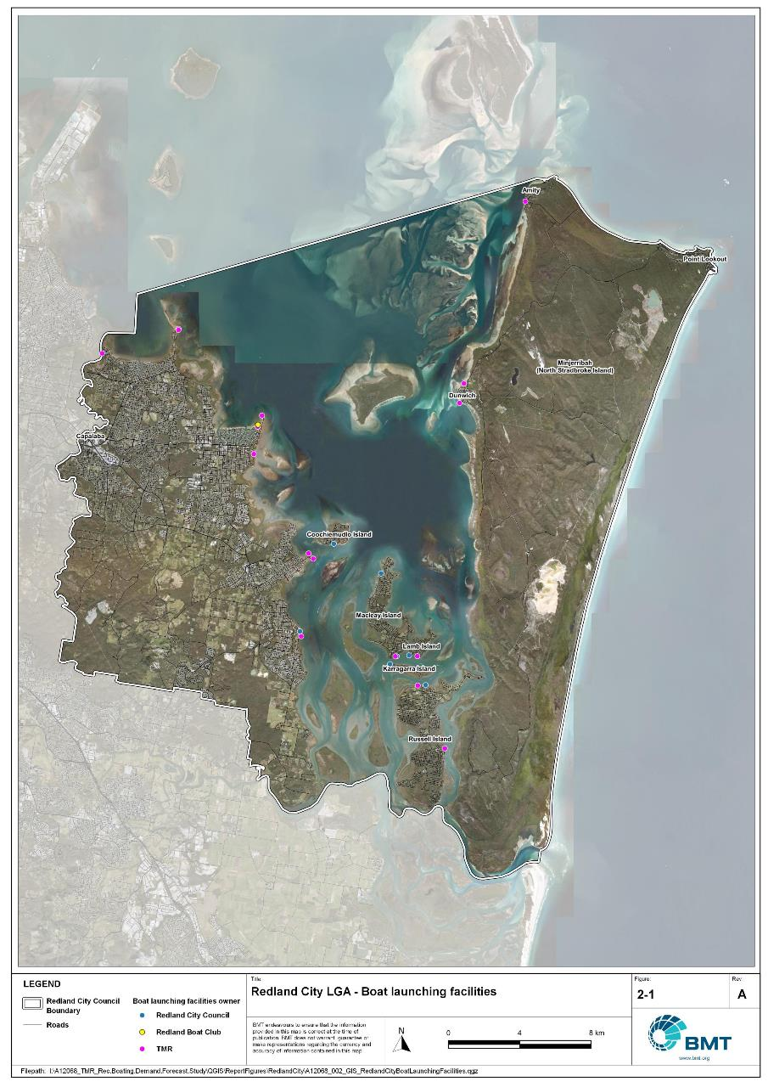

Public boat launching facilities within Redland LGA

"I:\A12068_TMR_Rec.Boating.Demand.Forecast.Study\QGIS\ReportFigures\RedlandCity\A12068_002_GIS_RedlandCityBoatLaunchingFacilities.jpg"

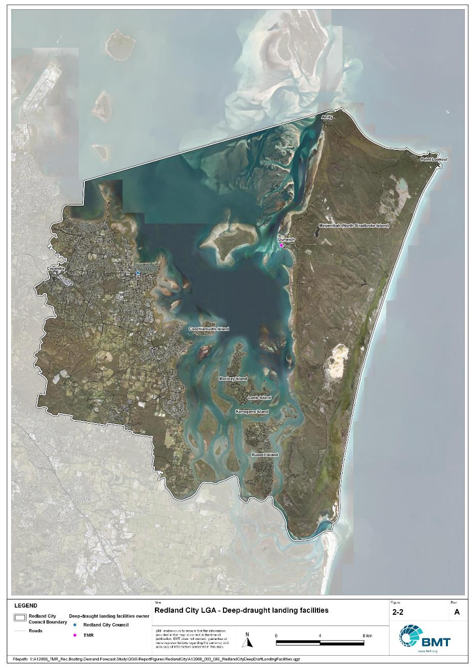

Public deep-draught vessel facilities within Redland LGA

"I:\A12068_TMR_Rec.Boating.Demand.Forecast.Study\QGIS\ReportFigures\RedlandCity\A12068_003_GIS_RedlandCityDeepDraftLandingFacilities.jpg"

## Existing usage and issues

Consultation with Redland City Council, Maritime Safety Queensland, recreational groups and feedback from the recreational boating facilities survey hosted by TMR indicate the following major issues within Redland LGA.

* + 1. Strong preference for particular facilities

Facilities that have excellent access directly into Moreton Bay are strongly preferred by both the local and visiting fleets, with facilities like William Street, Victoria Point and Wellington Point catering for a high proportion of the overall demand within the LGA.

* + 1. Need to service island communities

Redland LGA contains a number of populated islands that are only accessible by water or air. Each of these islands therefore requires at least one boating facility, catering for barge access as well as by smaller vessels for recreation or commuting. As demand for these facilities is on an island-by-island basis it doesn’t fit well within the statistical framework of the Study.

2.3.3 Redland LGA destinations visited from other LGA departure points

Many of the island, fishing, and cruising destinations within Redland LGA are accessed by boats (both trailer and deep-draught) departing from other LGAs – mainly Brisbane and Logan. The statistics for vessels from other LGAs to use Redland LGA facilities are presented in section 4.2 below. Infrastructure improvements recommended in this Study for Redland LGA interact significantly on a supply-and-demand basis with other LGAs.

# Capacity Assessment

## Boat ramps

* + 1. Introduction

Boat ramps are facilities that are used for launching and retrieving trailable vessels, typically up to 8m in length (with some exceptions), to and from the water. Boat ramps consist of one or more lanes and their use is often supported by landside and waterside infrastructure to improve efficiency. In some instances, the usability of a facility can be adversely affected by environmental constraints such as low water levels, currents, or wave exposure, reducing the overall availability of the facility. Together, consideration of the number of boat ramp lanes, the supporting infrastructure, and environmental constraints results in the facility having a capacity described in terms of ‘effective lanes’ that may or may not be equal to the number of actual boat ramp lanes.

To maximise usage of each facility, the landside and waterside capacity should be balanced. Each facility will have a calculated ‘effective’ capacity for both the landside and waterside elements, with the limiting element dictating the facility's overall effective capacity. Recommendations for works or infrastructure promote balancing these two capacity elements by either improving the limiting element for increased facility effectiveness or by increasing the overall 'effective capacity' through changes to both elements.

* + 1. Boat ramp capacity

The overall capacity of each boat launching facility is limited by the effective capacity of either the waterside or landside elements. The waterside capacity is informed by the number of boat ramp lanes and the number and type of queuing facilities, such as pontoons, floating walkways, queuing beaches and fixed sloping walkways. It may also be limited by the available water depth in the adjacent waterbody and exposure to environmental or other physical factors.

Landside capacity is governed by the availability of nearby spaces for parking of car-trailer units (CTU), the provision of rigging and de-rigging facilities, and provision of single car parking spaces (single cars may otherwise be obliged to park in CTU spaces).

While it is expected that facilities will have their own characteristics influencing efficient use, this Study applies an approach that is consistent across the entire state and consistent with previous editions of the Study. Accordingly, the effective waterside capacity of a boat launching facility is determined as being:

* the ability to support 40 vessels being launched and retrieved per day per lane (see section 3.1.3)
* influenced by exposure to wave, tide, and current conditions (see section3.1.4
* supported by queuing facilities that assist in the efficient use of the boat ramp (see section 3.1.4).

Calculation of landside capacity is in line with the TMR guideline (TMR, 2020), which requires less provision of CTU parking per lane than the Australian standard (AS3962 Table 7.1), and advises:

* 10 CTUs for a single lane boat ramp accessed by an unsealed road, or 15 CTUs accessed by a sealed road
* 45 CTUs for a two-lane boat ramp
* 70 CTUs for a three-lane boat ramp
* 90 CTUs for a four-lane boat ramp.

A notable difference from the 2017 study is the recognition and inclusion of areas close to existing boating facilities that are unsealed and/or not line marked where parking of cars with trailers occurs and is not discouraged. These areas of informal parking have been identified on aerial imagery and through discussions with managing authorities. Each informal area has been assumed to be available for CTU parking only 50% of the time to account for conflicts with other uses (for example, markets), inefficient parking practices, or poor ground conditions. The rate of parking has been calculated as:

* for linear areas where nose-to-tail parking is expected – 1 CTU per 13m
* for linear areas with enough space to allow side-by-side parking – 1 CTU per 3m, provided there is a minimum distance of 15m from the road or manoeuvring area
* for large areas – 1 CTU per 100m2.
  + 1. Boat ramp capacity basis

The number of vessels per day each boat ramp lane can support is based on the Australian Standard for the Design of Marinas (AS3962-2001) and previous versions of this report (GHD, 2011 and 2017).

Research on boat ramp lane efficiency described in the previous report (GHD, 2017) identified that 40 vessels per lane per day was a reasonable compromise between 50 vessels per lane per day (representing congested conditions) and 30 vessels per lane per day (representing unhampered conditions). For context, the 40 vessels per lane per day rate represents a vessel launch or retrieval every 9 minutes per lane within an average normally used period of 12 hours per day.

During this Study, BMT has sought to validate the assumptions presented above, and those relating to capacity modification, by undertaking a literature review, conducting site visits that included observations of launching and retrieving manoeuvres, and reviewing video recordings of boats launching and retrieving at popular boating facilities. The literature review included a boat ramp efficiency investigation undertaken by BMT on the Mornington Peninsula, Victoria (BMT, 2015) and a review of standards from other Australian states and countries that undertake similar studies. The onsite and video analysis provided the opportunity to observe recreational boat operators using facilities included in the Study but did not include observation of total throughput during high demand periods. This assessment was undertaken during site visits across Queensland, and a full day of video recording at Manly Boat Harbour (north ramp) in Brisbane.

The New South Wales and Victoria governments are currently in a planning phase for boating infrastructure and there are presently no publicly accessible documents identifying how those jurisdictions calculate boat ramp lane capacity. The Western Australia government has commissioned studies of the Perth region and the southwest region (Western Australia Department of Transport, 2019 and 2021) that indicate a base rate of 50 vessels per lane per day, with no modifiers applied. Internationally, studies from Florida in the USA (Bell, 2022 and Swett et. al, 2012) assumed that total vessel launch plus retrieval time is between 20 to 40 minutes (18 to 36 vessels per day), although no evidence is provided to support this assumption.

The Mornington Peninsula report (BMT, 2015) collected boat launch and retrieval data for 6 boat ramp facilities on the Mornington Peninsula across 9 days, including the peak Australia Day holiday. Total throughput was assessed for each facility on days where there was constant pressure for launching and retrieving boats with results between 30 and 70 vessels per lane per day for the various facilities. When adjusted for queuing modifications, a baseline rate of between 20 and 50 vessels per lane per day was identified. Of the facilities, the higher rates were achieved where sufficient parking was provided and both waterside and landside queuing facilities existed.

Observations of recreational boat users launching and retrieving their vessels undertaken through the site visits and the analysis of video footage showed that:

* Most observed launches were of ‘multi-person’ boats, which made launching and retrieving boats more efficient.
* Almost all users were able to launch and/or retrieve their boat within the 9-minute target time, when adjusted for queuing facility efficiency.
* There was a preference to launch adjacent to a floating walkway, where one was available. At facilities where a queuing facility is not immediately adjacent to the lane it is expected that average launch times may slightly increase during busy periods.

While the observations that were made generally aligned with expectations, a more in-depth review of capacity assumptions was outside of the scope of the Study. For future studies there would be value in undertaking a more thorough, data-driven investigation of the assumptions about boat ramp lane capacity, both at its base level and modified by queuing facilities. Overall, the preliminary investigations undertaken as part of the Study suggest that the base rate of 40 vessels per lane per day adopted in previous studies is appropriate.

* + 1. Boat ramp efficiency modifications

The waterside capacity of boat ramp lanes can be reduced by environmental factors that include:

* Water levels: Mainly relating to tidal areas this factor considers the reduction in the amount of time the boat ramp is available to launch and retrieve vessels over the full tidal cycle, thus reducing the overall capacity of the facility. For all-tide access, the boat ramp and connecting channel to the open sea are available during all tidal conditions and therefore available 100% of the time. For near all-tide access the boat ramp and the connecting channel to the open sea are assumed to be available, on average, for 80% of the tidal cycle. For part-tide access the boat ramp and its access channel are available less than 80% of the time. A modification factor of 0.8 is applied for near all-tide facilities and 0.5 for part-tide facilities.
* Wave and current conditions: In areas where vessel launching and retrieval may be intermittently impacted by waves (most commonly on beach ramps, but not exclusively) or strong currents (such as in rivers), a modification factor of 0.5 is applied.

Conversely, effective boat ramp capacity can be improved through the use of well-designed queuing facilities. Queuing facilities aim to improve amenity and efficient use of the boat ramp by accelerating one or more of the following phases of boat launching, with the opposite steps required for retrieval:

1. manoeuvring for launching, including for CTU entering the queuing area for the boat ramp and reversing into position for launch
2. launching and securing the launched vessel
3. moving the launch vehicle from the boat ramp to the parking area
4. removing the vessel from the waterside queuing facility.

A range of waterside queuing facilities is in use in Queensland boating infrastructure, which modify different phases of the total launching process. These include:

* Floating walkways and fixed sloping walkways: Positioned to about a boat ramp lane, these structures aim to:
  + improve amenity – such as to assist embarking/disembarking passengers, provide a refuge from in-water contact with crocodiles and so on
  + make securing the vessel and removing the vehicle from the boat ramp more rapid, while freeing the boat ramp for subsequent users.
* Pontoons: Also used by deep-draught vessels, these structures improve the ability to secure the vessel and clear the boat ramp, but there is usually some time lost returning to recover the launch vehicle compared with the above options as they are generally positioned slightly further away from the ramp.
* Queuing beaches: These also provide a place to secure the vessel close to the boat ramp, although they are generally not as fast to use as pontoons.

As observed throughout the Study site visits, each of these queuing facility types can support a limited number of boat ramp lanes depending on the available space on the queuing facility. The 2017 edition of this Study applied a blanket uplift for all boat ramp lanes where a queuing facility was provided. However, the number of lanes each type of queuing facility can realistically support varies. Accordingly, this Study has provided limitations to the number of boat ramp lanes that can benefit from each queuing facility, based on the number of “working faces” (or area for a queuing beach) provided, where the “working face” is a face that allows temporary securing of vessels during launching or retrieval. The adopted improvement factors and supported lanes are summarised in Table 3.1.

Queuing facility efficiency modifiers

| Queuing facility | Modification factor | Supported lanes |
| --- | --- | --- |
| Floating walkway (lanes adjacent to walkway) | 1.7 | 1 Lane/face |
| Floating walkway (lanes not adjacent to walkway) | 1.3 | 1 Lane/face |
| Fixed sloping walkway | 1.7 | 1 Lane/face |
| Pontoon | 1.2 | 2 Lanes/face |
| Queuing beach | 1.1 | Site-based |

In other states in Australia, reversing queuing bays are more commonly used than in Queensland. These are CTU waiting bays at the head of the boat ramp that are aligned with each boat ramp lane to allow the user to reverse directly down the boat ramp once it is clear. CTU waiting bays reduce the time of the first phase of boat launching by allowing waiting CTU’s to be ready to reverse as soon as the lane becomes clear. The BMT (2015) study on the Mornington Peninsula included facilities with and without these bays. Boat ramps that included reversing queuing bays achieved 50% greater throughput. Facilities that have implemented this approach in Queensland include North Street Southport, Urangan Boat Harbour, Townsville Recreational Boating Park, and the (under construction late 2022) boat ramp at Yorkeys Knob.

* + 1. Accessibility from boat launching facilities

Recreational boat users will typically select the boat launching facility most appropriate or convenient to the activity they are seeking to undertake, the anticipated weather/wave conditions, and their destination. Each of facility within an LGA will provide a varying degree of access to different destinations and for different activities. During the Study, consultation with stakeholders highlighted the following general types of destinations and activities:

* open water/offshore: typically accessed for visiting offshore islands or remote beaches, snorkelling or diving locations, deep sea fishing and general recreation
* creeks and estuaries: typically accessed for fishing, crabbing, wildlife observation, skiing and general recreation
* freshwater: typically accessed for skiing, fishing, wildlife observation and general recreation.

These destinations are typically serviced by different types of recreational vessels. Inshore locations including creeks, estuaries and other freshwater locations are typically patronised by vessels less than 4.5m, except for ski boats, which can be much larger than this. Offshore locations typically require larger boats for access as these vessels are more capable of managing a wide range of wave conditions and can carry sufficient fuel to access distant destinations. Smaller vessels may be able to access close destinations on good weather days, and larger vessels may choose to access inshore destinations, particularly on poor weather days.

Consequently, the following aspects are used to classify how well a facility provides open water access:

* Open-water access: There are no restrictions between the facility and open water.
* Depth-limited access: There are depth restrictions between the facility and open water that limit navigable access to part of the tidal range. This differs from tidal constraints at the actual facility, which might be usable at all tides, but offshore access is limited by a downstream bar or delta.
* Distance-limited access: The distance from the facility to the open water is unrealistic for typical boat users. This distance is assumed to be about 4.5km between the facility and open water to rate as 'distance limited', with travel times increased further where portions of the access channel are regulated by speed limits.
* Infrastructure-limited access: There are man-made obstacles between the facility and open water, such as above-ground pipeline crossings, low bridges or weirs that impede navigable access to open water.
* Beach ramps: These provide open-water access but are typically constrained by environmental conditions such as wave exposure and tide levels. The capacity of these facilities has been individually assessed based on consultation and other data sources and is described in more detail in section 4.
* Freshwater: There is no access to open water.

Certain facilities, particularly those in freshwater, may be constrained by periods of drought, or debris deposition after rainfall events that limit access to destinations, and therefore whether a facility will provide useful boat launching capacity. While it is noted that drought and rainfall may affect the overall capacity of boat launching within an LGA, and given that the timing of such events is not readily predictable, their impact on capacity has not been evaluated.

* + 1. Existing boat launching capacity

Within Redland LGA there are 25 boat launching facilities with a total effective capacity of 26.3 lanes. The effective capacity of boat launching facilities within Redland LGA is shown in Annex B, with a summary of the access to open water and tidal constraints shown in Figure 3.1 and the overall capacity constraint shown in Figure 3.2. Pertinent features of these facilities include:

* There are 45 total lanes, with an effective capacity of 26.3 effective lanes. This effective capacity is primarily reduced due to insufficient parking being allocated for each lane.
* Boat users in Redland LGA primarily seek access to Moreton Bay, with all facilities except Thorneside providing unrestricted access to the open water. Thorneside is somewhat constrained due to depth limitations at the mouth of Tingalpa Creek.
* Most of the facilities provide all-tide access.
* There are no freshwater facilities in the LGA.

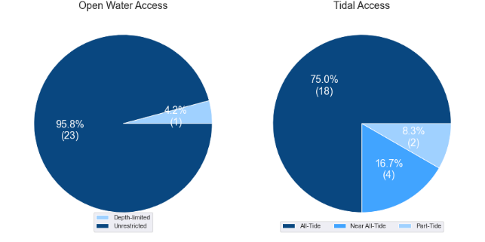

(a) Summary of open water access from boat launching facilities (left) and (b) Summary of tidal restrictions at tidal boat launching facilities (right)

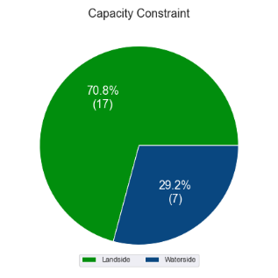

Summary of limiting capacity constraint

* + 1. Facilities expected to be completed within the Study period

Facilities that are expected to be constructed and providing capacity within the Study period are accounted for in this section. These are projects that have secured funding, have begun construction or have a current works contract. For all intents and purposes, these are intended to be providing capacity within the next 5 years or sooner. As such, this section acknowledges the increase in capacity that these facilities will supply.

### Wallaby Road, southern Redland Bay

This site is located in southern Redland Bay, with direct access into Moreton Bay from the facility. It is expected to be constructed over the first planning horizon of the Study period, as a two-lane boat ramp with a single floating walkway on the upstream side of the ramp, and 45 CTU parking spaces. The capacity expected to be provided by this facility is presented in Table 3.2

Expected facility – Wallaby Road, southern Redland Bay

| Site | Waterside effective lanes | Landside effective lanes | Total effective lanes |
| --- | --- | --- | --- |
| Wallaby Road | 3.0 | 2.0 | **2.0** |

## Access to sheltered near all-tide and all-tide facilities

MSQ has a longer-term vision to provide access to all-tide or near all-tide open water access boat launching facilities along the Queensland coast, such that all significant population centres are within one hour’s driving range as far as practical (TMR, 2020). For this purpose, the Study has defined towns as being within the coastal strip if within 30km of the Queensland coastline. The vision (TMR,2020) is applied to the coastal strip between the NSW border and Cooktown. Consultation throughout the Study has highlighted that this vision is important with users/stakeholders and organisations that own and manage these facilities. As such, the Study has developed a statistical approach to quantify this vision to allow it to be measured and tracked over time. To do this, the Study has calculated the travel time from all Population Centres (DoR, 2022) within the coastal zone to the nearest available sheltered, all-tide or near all-tide facility, regardless of which LGA it is in. This has been accomplished using mapped road networks and assigning speed limits to each type of road, with the following speed limits applied:

* for restricted roads, 40km/hr
* for local roads, 60km/hr
* for connector roads, 70km/hr
* for distributor roads, 80km/hr
* for highways, 100km/hr.

For Redland LGA the central business district is in Capalaba. The travel time from Capalaba to the nearest sheltered all-tide or near all-tide facility is 8 minutes. Figure 3.3 provides a visual representation of the travel time from each of the mainland sheltered near all-tide facilities that serve the LGA, with the entire mainland portion of the LGA within 30 minutes of one of these facilities.

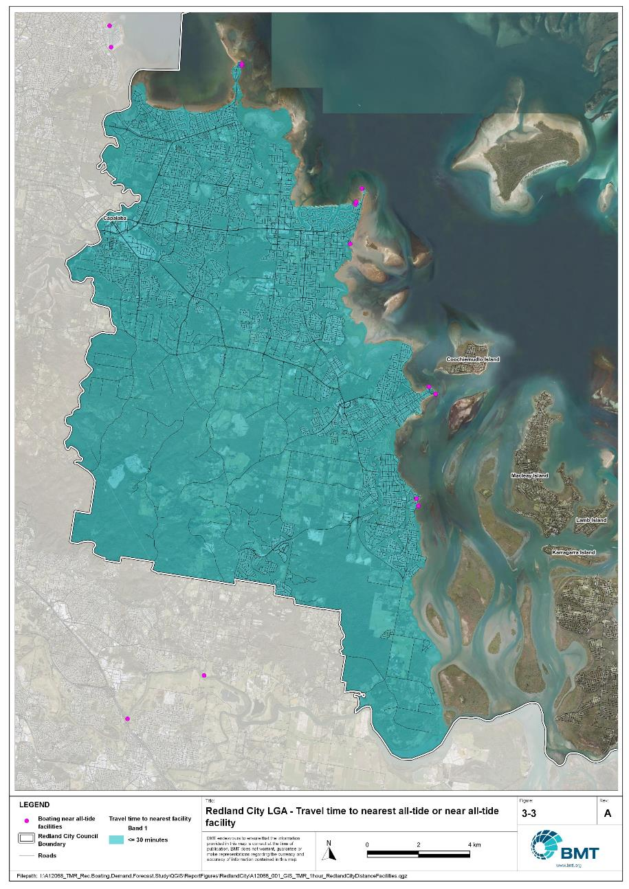

Redland LGA – Travel time to nearest all-tide or near all-tide facility

"I:\A12068_TMR_Rec.Boating.Demand.Forecast.Study\QGIS\ReportFigures\RedlandCity\A12068_001_GIS_TMR_1hour_RedlandCityDistanceFacilities.jpg"

## Deep-draught vessel landings

Deep-draught vessel landings are intended to provide short-term landing capacity for vessels that are too large to use public boat launching and retrieval facilities. These facilities are provided for the benefit of both local vessels and to service the fleet of vessels that travel along the Queensland coast. Deep-draught vessel landings may be designed to accept one or more large vessels at a time and/or provide capacity for tenders from larger vessels that may be anchored or moored nearby, for the purpose of loading and offloading passengers and supplies, and making short local visits to onshore destinations.

For the Study, deep-draught vessel landings need to be primarily accessible by recreational boats for short, temporary stays. In some cases, commercial vessels may utilise these facilities subject to the relevant permissions, however, this may reduce the capacity of the facility to cater for recreational vessels. Deep-draught vessel landings should be located such that the facility provides reasonable access to landside passenger pick up and drop off, provisioning, recreational destinations, or population centres. Within Redland LGA there are two deep-draught vessel landings that provide access to the following facilities or destinations:

* Raby Bay Harbour provides access to passenger vehicle parking, public transport including Cleveland train station, shops for provisioning, restaurants and other amenities.
* One Mile, Dunwich provides access to North Stradbroke Island (Minjerribah) and associated amenities but with limited passenger vehicle and CTU parking available.

As well as the above, private deep-draught vessel landings are available for lease or ownership at Raby Bay Marina. This facility has refuelling facilities.

In summary, Table 3.3 shows the total capacity of deep-draught landing facilities within Redland LGA.

Deep-draught landing facilities within Redland LGA

| Facility type | Total capacity |
| --- | --- |
| Public sheltered mainland landings | 2 |
| Private sheltered landings | 1 |
| **Total** | **3** |

Deep-draught landing facilities expected to be completed within the Study period

Four repurposed recreational deep-draught pontoons are to be installed on residential islands in southern Moreton Bay, and are being delivered as part of a ferry terminal upgrade project. These are expected to be installed in 2023 and will be providing capacity at the first Study planning horizon (that is, before 2026). These pontoons will be located at Lamb, Karragarra, Macleay and Russell Islands and bring the LGA capacity to six.

# Demand Assessment

The Study has developed a model to calculate statistical demand for boat launching facilities and deep-draught vessel landings at an LGA scale. Vessels that are less than 8m in length are considered trailable and drive demand for boat launching facilities such as boat ramps, while those over 8m are assumed to remain on water and drive demand for deep-draught landings.

Statistical demand is recognised at three different levels for public marine facilities within the TMR guidelines (TMR, 2020), which are:

* off-peak demand – typical weekday usage
* average demand – demand on ‘good boating days’, taken to be demand for a facility on weekends (and, for certain regional locations, other busy periods)
* peak demand – demand for a facility at peak holiday periods or for special events.

The demand model created for this Study is intended to provide information on demand pressures on ‘good boating days’ for all facilities as per the intentions of the guidelines. The model achieves this through a ‘registration activation rate’ that estimates the proportion of registered vessels in an LGA that is assumed to be active on a ‘good boating day’, as well as the exchange of vessels between LGAs, and general tourism pressures.

## Activation rate

The fleet size for each LGA is determined statistically from vessel registration numbers and the application of a vessel activation rate, while for future time horizons vessel registration and population growth estimates are also utilised. The methodology for determining the registration activation rate has been adopted from the previous study (GHD, 2017), with activation rates taken to be between 8% and 14% for a typical weekend. The variability of the activation rate is intended to capture the regional differences in vessel types, and is driven by the availability of access to open water, accessibility of other recreational opportunities, and likelihood of users’ available time for recreation, considering factors including:

* remoteness classification for the LGA
* incidence of blue-collar employment
* average age of residents
* whether the LGA is coastal.

Further information about the derivation of this rate can be found in Annex A. For Redland LGA the activation rate is assumed to be 10%, with the key factors influencing the rate including:

* its classification as a Metropolitan Area
* number of populated islands within the LGA
* it being located adjacent to the open coast.

## Digital user survey

To gain an understanding of usage trends at existing formal recreational boating facilities across Queensland, the Study has considered the results of a digital user survey using human movement data, sourced through a third party. The data was acquired from a location data store with more than 13 trillion mobile location observations globally from 2019 to present, which were sourced from 250,000 different mobile phone applications that users ‘opted-in’ to use the location services under the application’s terms and conditions. All data received was deidentified and compliant with relevant data privacy regulations.

The analysis uses mobile devices (such as telephones) location data as a proxy for boat user traffic, however, this relationship has several limitations including, but not limited to:

* Mobile device users detected in the area of interest may not be boat users (for example, pedestrians not using vessels may walk through the detection area).
* The relationship between mobile device users and vessels may not be 1:1 (that is, there may be multiple mobile devices providing data for each vessel).
* Users of vessels may not have a mobile device, may not be using a mobile device or may not have provided permission to use their location data.

With these, and potentially other, limitations in mind, the Study compared this data against vessel launching counts provided by various facility managers and found that approximately 15-30% of vessels are captured using this digital survey method. This percentage can change from facility to facility and from day to day. Consequently, the Study has not relied on raw counts of users from this data, but instead considered the relative trends within the data, with the assumption that no groups (for example, users from a particular LGA or using a particular facility) within the data would be more or less likely to be captured by the technique.

The Study has used this data to identify the relative volume of users, the ‘home’ local government area of users and the popularity of destinations that users travel to once vessels have been launched.

* + 1. Inter-LGA demand

The human movement data has been interrogated to determine the LGA of origin for users of Redland LGA’s public boating facilities to ascertain the proportion of users from each LGA that are using specific facilities. Statistics from all public boating facilities within the LGA are then grouped together to determine the total proportion of resident or visiting users across the LGA. Table 4.1 shows the active fleet proportion from the top 10 LGAs contributing to demand on facilities within Redland LGA. All other sources have been grouped together.

LGA of origin for active fleet in Redland LGA

| LGA of origin | Active fleet proportion |
| --- | --- |
| Redland | 62.0% |
| Brisbane | 17.7% |
| Logan | 8.2% |
| Gold Coast | 2.8% |
| Ipswich | 2.6% |
| Moreton Bay | 1.9% |
| Sunshine Coast | 0.7% |
| Toowoomba | 0.4% |
| Lockyer Valley | 0.2% |
| Scenic Rim | 0.2% |
| Other LGAs | 3.2% |

* + 1. Intra-LGA demand distribution

Recreational boating users will tend to use facilities that best suit their needs, the destinations they want to access, the capability of their vessel and the weather conditions. Consequently, distribution within an LGA is unlikely to be evenly spread across all facilities, with some facilities attracting users disproportionately due to amenity, access, or destinations. The attractiveness of large well-designed facilities is likely to draw visiting boat users in preference to smaller or less desirable facilities across the LGA. The human movement statistics have been assessed to qualitatively estimate the proportion of users using each facility, both in total and with respect to both resident and visiting boat users (Table 4.2).

Popularity of boat launching facilities.

| Facility | Overall fleet | Resident fleet | Visiting fleet |
| --- | --- | --- | --- |
| Cleveland, William Street | 24.0% | 25.3% | 21.7% |
| Victoria Point, Colburn Avenue | 22.0% | 23.5% | 19.4% |
| Wellington Point, Main Road | 15.1% | 14.0% | 16.8% |
| Weinam Creek boat ramp | 12.1% | 14.1% | 8.9% |
| Victoria Point, Masters Avenue | 7.7% | 6.7% | 9.4% |
| Cleveland, Emmet Street (Toondah Harbour) | 3.9% | 2.8% | 5.8% |
| Thorneside, Helen Street | 3.3% | 3.6% | 2.6% |
| Coochiemudlo Island, Tageruba Street | 2.9% | 2.2% | 4.2% |
| Cleveland, Shore Street | 2.3% | 2.3% | 2.2% |
| Macleay Island, Dalpura Street | 1.8% | 1.6% | 2.1% |
| Dunwich, Yabby Street (One Mile) | 1.6% | 1.1% | 2.4% |
| Amity Point, Claytons Road | 1.3% | 0.6% | 2.6% |
| Redland Bay, Moores Road | 0.9% | 1.1% | 0.7% |
| Russell Island, Alice Street (Jock Kennedy Park) | 0.6% | 0.6% | 0.6% |
| Russell Island, Wahine Drive | 0.5% | 0.4% | 0.7% |

The results indicate that the William Street, Victoria Point and Wellington Point facilities cater for more than 50% of the overall LGA fleet. Boat launching facilities on the smaller islands are only providing for local communities and the statistical capacity that they provide is not usable for the LGA due to the lack of road access for redistribution of vessels.

The distribution of capacity within the LGA needs to consider these trends to avoid consistent capacity shortfalls at some facilities or indicating demand for unnecessary extra capacity at other facilities. Results from the above statistics and feedback obtained through the TMR online survey indicate that within Redland LGA the following factors tend to influence the preferred facilities for recreational boat users:

* easily accessible from the mainland by vehicle
* opportunity for unrestricted access to Moreton Bay
* dry entry/exit capabilities of launching facilities provided through floating walkways and pontoons.
  + 1. Destinations

For facilities that provide sheltered, near all-tide or all-tide open water access, additional analysis of the human movement statistics has been undertaken to identify destinations for users of these facilities. Location data from users utilising the facilities was extracted for a period of two hours after they used the facility and trimmed for waterside destinations. For Redland LGA this additional analysis was applied to the following facilities, with destinations mapped in Figure 4.1:

* Cleveland, Emmet Street (Toondah Harbour)
* Cleveland, William Street
* Dunwich, Yabby Street
* Russell Island, Alice Street
* Victoria Point, Colburn Avenue
* Weinam Creek
* Wellington Point

From this additional analysis, the following notable observations were made:

* Users wanting to access northern Moreton Bay or destinations beyond Moreton Island (Moorgumpin) and North Stradbroke Island (Minjerribah) had a strong preference for the William Street facility.
* Users wanting to access the islands in southern Moreton Bay and out to Jumpinpin had a strong preference for the two Victoria Point facilities.
* Horseshoe Bay on the southern side of Peel Island was an attractive destination from all facilities.

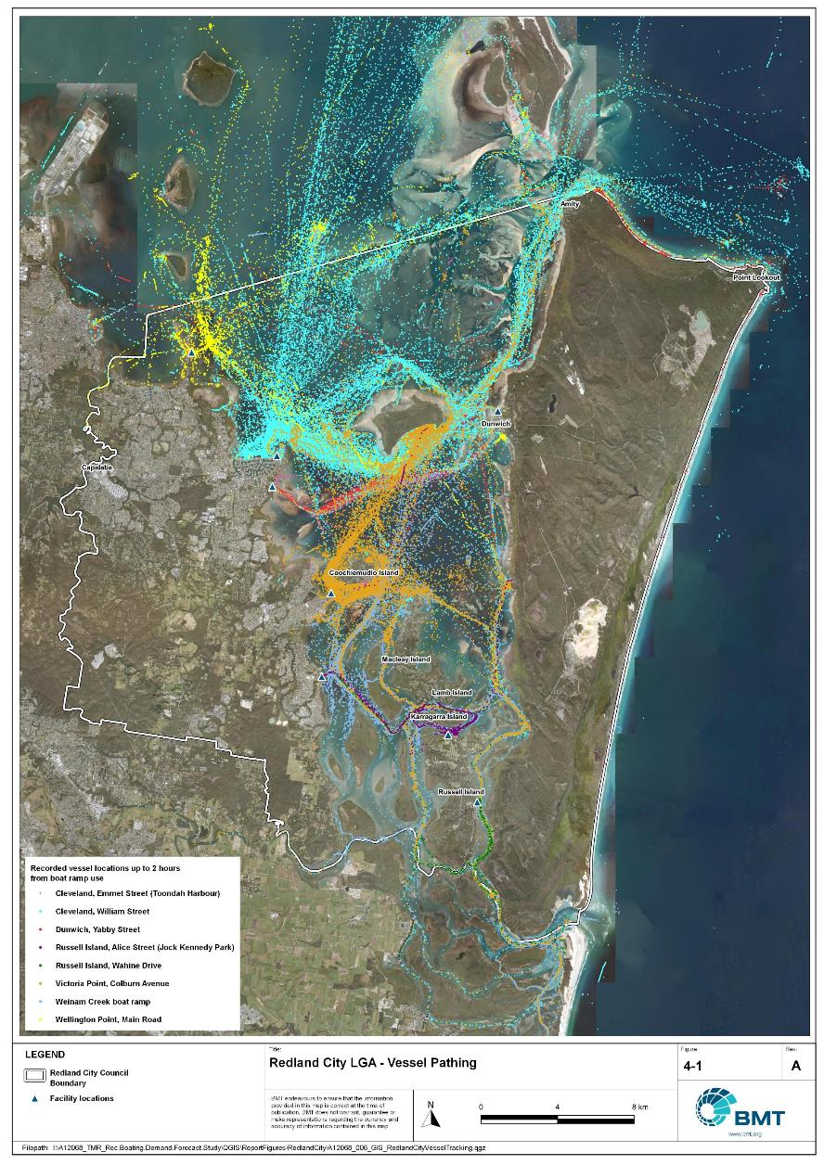

Redland LGA – Vessel pathing

"I:\A12068_TMR_Rec.Boating.Demand.Forecast.Study\QGIS\ReportFigures\RedlandCity\A12068_006_GIS_RedlandCityVesselTracking.jpg"

## Active fleet size

The total ‘active’ fleet on a good boating day is derived from the activation rate of the total fleet of registered vessels within the LGA and the net inflow of visiting vessels. The total number of visiting vessels from each LGA is determined from the number of vessels in the resident active fleet and the relative proportion of resident to visiting vessels outlined in Table 4.1.The fleet size is expected to change over time due to changes in population and vessel acquisition trends, with the size and proportion of the fleet across the Study period described in Table 4.3.

Active fleet vessel size

| Vessel length | 2021 | 2026 | 2031 | 2036 | 2041 |
| --- | --- | --- | --- | --- | --- |
| 0 to 4.5m | 964 | 1029 | 1086 | 1138 | 1188 |
| 4.5m to 8m | 501 | 533 | 561 | 586 | 610 |
| >8m | 134 | 143 | 150 | 157 | 163 |
| Total | 1599 | 1704 | 1798 | 1880 | 1961 |

## Boat ramp lane demand

The fleet size derived in Table 4.3 represents the statistical demand for the LGA, with vessels under 8m assumed to contribute to boat ramp demand, measured in boat ramp lanes. As outlined in section 3.1.2 the adopted capacity of each effective lane is 40 vessels per day, with each vessel assumed to both launch and retrieve, for a total of 80 vessel movements per day. The total boat ramp lane demand across the Study period is shown in Table 4.4.

Boat ramp lane demand

|  | 2021 | 2026 | 2031 | 2036 | 2041 |
| --- | --- | --- | --- | --- | --- |
| Boat ramp lane demand | 36.6 | 39 | 41.2 | 43.1 | 45 |

For Redland LGA the important elements that contribute to the boat ramp lane demand include:

* A large sized local fleet, with a high proportion of trailable vessels.
* A large size fleet in Brisbane that contributes to the local fleet
* Attractive destinations for visitors from other south-east Queensland LGAs.

## Non-statistical demand

As well as the statistical demand outlined in the section above, facilities may face demand pressures that are related to their functional use, which reduces the capability of the facility to service the recreational boat fleet in the desired manner. Issues with specific facilities have been identified within the consultation process of the Study with appointed managers and other stakeholders. While care has been taken to identify these non-statistical demand issues throughout the Study, it is beyond the scope of the Study to individually review the functionality, safety, and amenity of each facility across Queensland. Non-statistical demand pressures may warrant upgrades to facilities even where statistical demand is satisfied by existing capacity. These pressures have been classified into the following categories:

* Amenity: Amenity describes the functional usability of the facility including the desire to provide dry entry and exit facilities, facilities that provide easy access and/or access for persons with restricted mobility.
* Safety: Safety demand may include protection from currents and waves or contact with marine creatures such as sharks, jellyfish, and crocodiles.
* In-water congestion: Where existing queuing facilities are not able to efficiently meet the needs of the facility. Such deficiency may warrant additional queuing facility capacity to optimise boat launching and retrieval.

The Study's recommendations may alleviate these non-statistical demand pressures with consideration for capability of all facilities within the LGA. The presence of a non-statistical demand pressure at a facility may not warrant upgrades where other suitable facilities are reasonably available.

## Deep-draught vessel demand

* + 1. Cruising vessels

Vessels cruising along the east coast of Queensland have a requirement for a network of deep-draught vessel landings that are appropriately spaced to be within a day’s sailing on good weather days. These facilities are required to support the reprovisioning of vessels as they travel along the coast and provide access to desirable land-based destinations. Private marina facilities may be used by cruising vessels where there is an expectation for a prolonged stay that requires protected mooring or berthing. Within Redland LGA suitable facilities for deep-draught vessels includes the public pontoons at Raby Bay and One Mile, Dunwich.

The Moreton Bay frontage councils (Moreton Bay, Brisbane, Redland) along with the Gold Coast are home to approximately half of all deep-draught vessel registrations in Queensland, with this area typically used as an origin for Queensland coastal cruising. Within the east coast network but outside Moreton Bay, the nearest deep-draught vessel facility to the north is at Mooloolaba, approximately 35 nautical miles north of Scarborough Boat Harbour. Vessels travelling to Mooloolaba have access to public and private facilities for landing or mooring.

* + 1. Landing demand

Statistical demand for deep-draught vessel landings has been assessed based on the size of the non-trailable fleet within Redland LGA. Landing demand is more difficult to assess than boat ramp lane demand as the requirements and duration of the landing influence the demand pressure but are highly variable between users. Nevertheless, the Study has assumed that 5% of the non-trailable fleet will be seeking a landing at any given time. The consultation undertaken during the Study indicates that this assumption may overestimate the number of landings, but that the landings are often utilised for other boating and recreation activities when not in use by deep-draught vessels. In particular, landings that are located near boat launching facilities may be used as queuing facilities and therefore support the efficient launching of smaller recreational vessels. Given this, the 5% assumption has been adopted noting that it may overestimate capacity, but not to an extent that it would be onerous to facility providers. Within Redland LGA the demand for deep-draught vessel landings is outlined in Table 4.5.

The Study notes that the three LGAs that access Moreton Bay (Brisbane, Redlands, Moreton) exchange deep-draught vessels freely between them, with the assumed demand distribution (see Annex A) regularly changing depending on desirable destinations and needs. As such the demand pressure for public deep-draught landings may change frequently and fluidly and may periodically overwhelm the LGA’s capacity of deep-draught landings. While this demand pressure is difficult to capture statistically, it is justifiable that each of these LGAs have public deep-draught landing capacity in excess of the requirements for their LGA in isolation.

Deep-draught vessel landing demand

| Requirement | 2021 | 2026 | 2031 | 2036 | 2041 |
| --- | --- | --- | --- | --- | --- |
| No. of Landings | 6.7 | 7.2 | 7.5 | 7.8 | 8.2 |

# Shortfall Assessment

## Shortfall assessment – boat ramps

The shortfall of boat ramp lanes within Redland LGA is shown in Table 5.1 and Figure 6.1 at an LGA scale. This is presented both with and without the inclusion of additional capacity provided by the recommended upgrades.

Shortfall of boat launching facilities

| Assessment | Metric | 2021 | 2026 | 2031 | 2036 | 2041 |
| --- | --- | --- | --- | --- | --- | --- |
| Demand | Demand | 36.6 | 39 | 41.2 | 43.1 | 45 |
| Existing | Capacity | 26.3 | 28.3 | 28.3 | 28.3 | 28.3 |
| **Shortfall** | 10.3 | 10.7 | 12.9 | 14.8 | 16.7 |
| Improved  (Minimum upgrades) | Capacity | 26.3 | 37.1 | 40.8 | 40.8 | 43.8 |
| **Shortfall** | 10.3 | 1.9 | 0.4 | 2.3 | 1.2 |
| Improved  (Maximum upgrades) | Capacity | 26.3 | 38.3 | 42 | 42 | 45 |
| **Shortfall** | 10.3 | 0.7 | -0.8 | 1.1 | 0.0 |

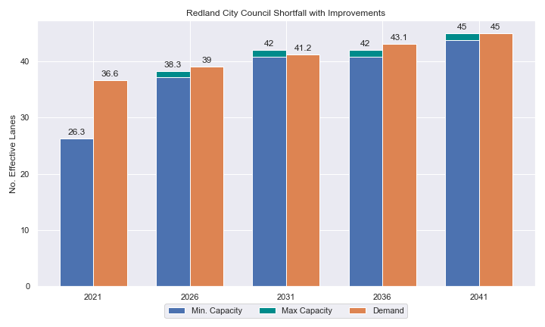

Shortfall assessment with recommended upgrades adopted.

* + 1. Open-water access shortfall in boat ramp lanes

Statistical capacity has been calculated across Redland LGA in its entirety, however, some facilities are evidently more popular than others due to their ability to access open-water destinations, and/or their usability. In general, larger vessels are more suited to access open-water destinations while smaller vessels are more likely to remain in sheltered environments. This was identified in the 2017 study and confirmed during discussions with stakeholders. The human movement data indicates that visiting boats from other LGAs are drawn to facilities that provide access to open-water destinations. To ensure that the capacity of effective boat ramp lanes in the LGA is appropriately distributed to cater for these usage trends, it is worth assessing facilities providing this desirable access as a subset of the total capacity for the LGA. A ‘scenario’ approach to assessing this capacity (Table 5.2) has been developed, with Scenario 1 derived from empirical estimates of vessel distribution and Scenario 2 derived from the human movement statistics, and the final result averaged between the two scenarios. This provides the opportunity to rationalise the figure that drives the demand and acknowledge when one scenario is not representative of the population or consistent with stakeholder feedback. The scenarios that were assessed are:

Scenario 1: 80% of larger vessels and 20% of smaller vessels from the local fleet and 80% of the visiting fleet are using the facilities with unrestricted open water access.

Scenario 2: Distributing the fleet between facilities as per the human movement statistics.

Shortfall assessment for open water, all-tide or near all-tide facilities for Redland LGA

| Assessment | Metric | 2021 | 2026 | 2031 | 2036 | 2041 |
| --- | --- | --- | --- | --- | --- | --- |
| Overall | Capacity | 25.6 | 27.6 | 27.6 | 27.6 | 27.6 |
| Scenario 1 | Demand | 22.0 | 23.6 | 25.0 | 26.3 | 27.6 |
| Shortfall | -3.6 | -3.9 | -2.6 | -1.3 | 0.1 |
| Scenario 2 | Demand | 34.8 | 37.1 | 39.1 | 40.9 | 42.7 |
| Shortfall | 9.2 | 9.6 | 11.6 | 13.3 | 15.2 |
| **Average** | Demand | 28.4 | 30.4 | 32.1 | 33.6 | 35.2 |
| **Shortfall** | **2.9** | **2.8** | **4.5** | **6.1** | **7.6** |

Comparing the LGA-scale shortfall with the subset of facilities providing protected all-tide or near all-tide access to open water indicate that the demand is strongly focused on this subset of facilities.

## Shortfall assessment – deep-draught landings

The shortfall of public deep-draught landings for Redland LGA is provided in Table 5.3. The existing capacity (including the soon to be delivered landings on the islands) is statistically adequate to meet existing demand, however, further capacity will be required soon to meet projected demand.

Shortfall of deep-draught vessel landings

| Assessment | Metric | 2021 | 2026 | 2031 | 2036 | 2041 |
| --- | --- | --- | --- | --- | --- | --- |
| Deep-draught vessel landings | Demand | 6.7 | 7.2 | 7.5 | 7.8 | 8.2 |
| Capacity | 6 | 6 | 6 | 6 | 6 |
| **Shortfall** | 0.7 | 1.2 | 1.5 | 1.8 | 2.2 |

# Stakeholder Feedback



The Study has undertaken extensive consultation throughout its execution to achieve a comprehensive understanding of issues relating to the use of recreational boating facilities across the state. This consultation was conducted with managing authorities that own and/or and manage recreational boating facilities, as well as with facility stakeholders including recreational groups, volunteer marine rescue and coastguard organisations, and the general public. Stakeholder engagement was supplemented with site visits to facilities where key issues had been identified.

## Managing authority feedback

For Redland LGA, the Study team met with Redland City Council and Maritime Safety Queensland to discuss recreational boating facilities within the region. This consultation process identified a range of potential opportunities to alleviate demand pressures. The Study has considered the practical implementation of each of these opportunities with respect to the required infrastructure, difficulty of implementation and magnitude of benefit, as summarised in Table 6.1.

Stakeholder identified opportunities

| Location | Stakeholder opportunity | Review comments |
| --- | --- | --- |
| Wellington Point | Reclaim land to the south of the ramps for CTU parking. | Agreed. |
| Wellington Point | Reinstate breakwater between the ramps for wave protection. | Agreed. |
| Thorneside | Formalise the area on Railway Pde (to the south of the existing Helen Street facility) as a boating facility. | Upgrade of the Helen Street boat launching facility is preferable. Bathymetry at opportunity site may be unfavourable. |
| William Street, Cleveland | Expand parking area. | Agreed. |
| William Street, Cleveland | Construct breakwater on the southern side of the entrance channel to make facility usable in all weather conditions. | Agreed. |
| Colburn Avenue, Victoria Point | Construct pontoon and breakwater to provide all-weather launching. | The facility already has a floating walkway for queuing. Proximity to Masters Avenue facility (which is oppositely orientated) provides option for launching if there is wave action from the north. |
| Lamb Island and Karragarra Island. | Provide a new facility for launching of recreational vessels, separate from the barge ramp. | Agreed. |
| Russell Island | Expand parking. | Agreed. |
| Russell Island | Install floating walkways at the two boat ramps | This would be desirable on amenity grounds, although at present demand does not call for it. |

## Stakeholder feedback

Broader stakeholder feedback has been conducted within the Study by undertaking virtual or face-to-face meetings with recreational boating groups and marine rescue organisations, as well as through the Recreational Boating Facility Survey (MSQ, 2022) undertaken by Maritime Safety Queensland, which included survey responses of nearly 3,000 users and open submissions. For Redland LGA a total of 136 submissions was received, with 77% of respondents using trailable power boats and 95% of respondents using recreational boating facilities at least once a month. For Redland LGA the following statistics or themes were extracted from the survey and associated comments:

* 95% of respondents typically travel less than 1hr to their preferred boat ramp (which may not be their closest facility).
* 70% of respondents indicated that floating walkways are their preferred type of queuing facility.
* 95% of respondents indicated that they would be unwilling to walk further than 200m from designated CTU parking to a boat ramp.
* The most common requests for new or upgraded boat ramps were at:
  + Weinam Creek, Redland Bay
  + Aquatic Paradise, Birkdale
  + Railway Pde, Thorneside
  + Toondah Harbour (once developed), Cleveland.
* The following themes were identified with respect to existing facilities:
  + Additional parking is required at most facilities (Cleveland and Victoria Points in particular)
  + More queuing infrastructure is needed at most facilities.
  + Facilities on Russell Island need improvement to assist with launching when strong currents exist, as well the ramp angle (Wahine Drive) and length (Jock Kennedy Park) can make the facilities difficult to use and sometimes unsafe.
* Where the closest available boat launching facility was not preferred, respondents indicated that the following key aspects influenced their choice:
  + proximity to preferred fishing areas
  + availability of better queuing infrastructure
  + access to deeper water
  + protection from wind.
* Respondents were given an opportunity to provide additional feedback, with the following themes identified:
  + There is demand for more deep-draught landing facilities.
  + Protection from wind and currents is desired.
  + Safety within parking areas is a problem, with various respondents concerned about theft and vandalism.

# Development Recommendations

## Previous recommendations

The 2017 GHD assessment recommended opportunities for increasing capacity of recreational boating facilities across the state. However, the implementation of these recommendations has been low, with only 10% of the total state-wide recommendations delivered in part or full in the 5 years since the delivery of the report. Of the priority 1 recommendations (for immediate delivery) and priority 2 recommendations (for implementation within 5 years) only 18% and 6% respectively have been delivered. State-wide only 5% of landside recommendations were delivered, while 16% of waterside recommendations were delivered.

Within Redland LGA none of the recommendations have been implemented since the delivery of the 2017 GHD study, although planning for implementation has occurred. The low rate of implementation of these recommendations is likely the result of budgetary constraints applied due to the COVID-19 pandemic. As such, many of the recommendations proposed in the 2017 GHD study remain viable. This current Study has reviewed the unimplemented 2017 recommendations (Table 7.1) for Redland LGA in conjunction with stakeholders during the consultation process to identify previous recommendations that are:

* Still viable: The recommendation in its original form remains suitable for solving demand pressures.
* Still viable with modifications: The recommendation could remain viable with modifications identified throughout the consultation process.
* No longer viable: The recommendations are no longer suitable to be carried through as recommendations in this Study.

Recommendations from the 2017 study that are considered viable or viable with modifications are carried forward into the recommendations of this Study with a suitable update to their priority status if required.

Assessment of unimplemented 2017 recommendations

| Location | 2017 Recommendation | 2022 Review | Review comment |
| --- | --- | --- | --- |
| Priority 1 | | | |
| William Street, Cleveland | Expand both ramps to 4-lanes, each with two floating walkways. Increase parking to achieve maximum practicable number of CTU spaces. | Still viable. | Agreed. To remain high priority. |
| Priority 2 | | | |
| Wellington Point | Increase parking to the south of the existing area, converting car only spaces to 6 CTU spaces. | Viable with modifications. | Increase to parking is necessary, though recommendation for significantly more CTU spaces is preferred. Priority to increase. |
| Thorneside, Helen Street | Expand the facility to 2-lanes and increase parking area to achieve highest practicable number of parks. | Still viable. | Agreed, though expand parking further. |
| Priority 3 | | | |
| Wallaby Road, Redland Bay | Reclaim land to construct new 2-lane ramp with floating walkway and 45 CTU parking spaces. | Still viable. | Facility planning has progressed. Recommended facility is expected to be operational over Study period first five year horizon. |
| Priority 4 | | | |
| Victoria Point, Masters Avenue | Expand ramp by 2 lanes and reclaim land to the west of the existing southern ramp for 70 CTU spaces. | No longer viable | Demand shortfall can be met more efficiently elsewhere, environmental and cost constraints significant. |
| Lamb Island | Construct a 1 lane ramp with 15 CTU spaces. | Still viable. | Agreed, priority increased. |
| Dunwich Sand Mine Wharf | Replace infrastructure with a 2-lane ramp and floating walkway, with 45 CTU spaces. | Viable with modifications. | A new facility at Dunwich is recommended, with investigation into most suitable location. Master planning for the now decommissioned wharf area is being undertaken as part of a whole of Dunwich (Goompi) master plan. |

## Priority recommendations

The selection and ranking of development priorities provides for progressive implementation of solutions to meet capacity shortfalls and/or resolve existing safety and usage issues at existing facilities over time. Recommendations have been split into four categories for implementation within the 20-year planning period of this Study, with the following projected timelines:

* Priority 1: For immediate planning and design.
* Priority 2: Planning and design intended to provide capacity within 5-10 years.
* Priority 3: Planning and design intended to provide capacity within 10-15 years.
* Priority 4: Planning and design intended to provide capacity within 15-20 years.

The recommendations have been structured to include consideration of the reasonable timelines for implementation. This may include consideration for budgetary processes, planning, environmental approvals, consultation periods and construction. The priority selection of recommendations has been conducted in accordance with TMR’s Marine Infrastructure and Facilities Plan (TMR, 2020) guidelines, namely:

1. *priority to be given to the provision of sheltered all-tide or near all-tide launching facilities giving access to the open sea on an all-tide or near all-tide basis.*
2. *part-tide facilities (for launching or access) may be provided where there is demand and dredged access is not feasible. For instance, beach access or open beach ramps may be provided where there is sufficient demand and no suitable nearby sheltered waterway*
3. *the most economically viable options will take precedence, including the expansion of existing facilities, and the changing of existing foreshore land uses. In many cases, limiting or avoiding dredging and/or breakwater costs will be a crucial factor*
4. *a goal of providing access to sheltered all-tide or near all-tide boat launching facilities within one hour’s drive for significant communities*

Consequently, higher order recommendations need to address, where possible, the provision of facilities that provide maximum benefit in the widest range of conditions. Lower order recommendations will consist of solutions where there is reduced adherence to the TMR guidelines and/or there are constraints that may result in long lead times to resolve. A summary of the recommendations is provided in Table 7.2 with full detail of each recommendation in the tables that follow.

Summary of recommendations for Redland LGA

| Priority | Description | Landside or Waterside | Increased capacity  (Effective lanes) |
| --- | --- | --- | --- |
| 1 | William Street, Cleveland: Construct 3 boat ramp lanes and 2 floating walkways, construct a breakwater to the south of the entrance channel, install a T-shaped gangway-access pontoon and maximise parking area. | Both | 6.55 lanes  2 deep-draught vessel landings. |
| 1 | Weinam Creek: Construct a new 3-lane ramp with two floating walkways and parking for 130 CTUs (in 2 stages). To replace retiring facility on north side of Weinam Creek. | Both | 2.35 lanes (5.1 lanes offset by 2.75 loss of existing facility |
| 2 | Wellington Point: On the southern ramp, construct two floating walkways and a new boat ramp lane. Reconstruct the existing breakwater (between the two ramps) and reclaim land to expand CTU parking capacity. Construct a new breakwater and queuing beach. | Both | 3.5 lanes |
| 2 | Helen Street, Thorneside: Add a second boat ramp lane and floating walkway and increase CTU parking spaces to 60 total. | Both | 1.2 lanes |
| 2 | Tina Avenue, Lamb Island: Construct a new facility with one boat ramp lane, a floating walkway and 15 CTU parking spaces. | Both | 0.8 lanes |
| 2 | Jock Kennedy Park, Russell Island: Formalise 20 new CTU spaces and extend ramp. | Both | 0.5 lanes |
| 3 | Victoria Point jetty: Install gangway-access pontoon. | Waterside | 1 deep-draught vessel landing |
| 4 | Dunwich, North Stradbroke Island (Minjerribah): Construct new 2-lane facility with floating walkway and adequate CTU parking area. | Both | 2 lanes |
| 4 | The Esplanade, Karragarra Island: Construct single lane ramp with 15 CTU parking spaces. | Both | 1 lane |

## Priority 1 recommendations

William Street, Cleveland – Priority 1

|  |  |  |  |  |
| --- | --- | --- | --- | --- |
| General description | | | | |
| Location | William Street, Cleveland, eastern side of Raby Bay | | | |
| Existing Facility? | Yes | | | |
| Coordinates | -27.51534006, 153.28733063 | | | |
| Existing tidal status | All-tide | | | |
| Existing wave exposure | None | | | |
| Existing current exposure | None | | | |
| Proposed works | Construct 3 boat ramp lanes and 2 floating walkways to upgrade each ramp to 4 lanes with 2 central floating walkways. Maximise formal parking in the park adjacent (330+ CTU spaces can be achieved). Provide sufficient room for rigging and de-rigging without causing traffic congestion.  Create a queuing beach on the southern shoreline of the harbour.  Construct a new breakwater to protect the facility from westerly winds/waves.  Construct a T-shaped gangway-access pontoon on the new breakwater for 2 deep-draught vessel berths. | | | |
| Increased effective capacity | 6.55 Effective lanes  2 deep-draught vessel landings | | | |
| Capacity improvement position | Waterside | Landside | | Both |
| Rationale | This facility (north and south ramps combined) provides excellent deep-water access to Moreton Bay and is very popular. The facility is regularly over capacity and overflow parking on the park adjacent is allowed by Redland City Council. The efficient use of space over the site footprint can be improved to significantly increase capacity. | | | |
| Anticipated costs (+/- 50%) | Waterside infrastructure | | $3,500,000 | |
| Landside infrastructure | | $1,400,000 | |
| Planning, environmental and approvals constraints | | | | |
| Assessment | Requirement | Comments | |  |
| Fish Habitat Zone | X | N/A | | |
| Native Title | X | N/A | | |
| MCU requirement | X | N/A | | |
| Clearing remnant vegetation | X | N/A | | |
| GBRWHA | X | N/A | | |
| Marine Park | ü | The breakwater and pontoon works are within the Habitat Protection Zone within Moreton Bay Marine Park and will likely require a Marine Park Permit.  Works can be undertaken within the Habitat Protection Zone to the extent they protect and manage sensitive habitats (for example. seagrass meadows, coral reef) | | |
| Tidal works assessment | ü | The addition of queuing structures, extra boat ramp lanes, breakwater and queuing beach works will likely be tidal works and require a Development Permit. | | |
| Other as required | ü | Marine Plants – the addition of floating walkways, extra boat ramp lanes and breakwater works may impact marine plants and therefore may require a Development Permit.  Quarry Material Allocation – if the removal of material from dredging occurs, it will require a Quarry Material Allocation. | | |
| Sea Level Rise | ü | The proposed works are partially within the boundaries of the erosion prone area (floating walkways, boat lanes, breakwater and eastern boundary of parking lot) with the exception of the majority of the parking lot. | | |
| Storm Tide Hazard | ü | The proposed works are within the boundaries of a medium to high storm tide hazard area. | | |
| Anticipated Complexity | Low | Medium | | High |
| Maritime engineering review | | | | |
| Assessment | Site considerations | Comments | | |
| Engineering Matters | Geotechnical | Low strength or unsuitable materials are likely to be found at this site (at the location of the breakwater) and a more detailed geotechnical assessment of this recommendation is suggested. | | |
| Adjacent Structures & Constraints | Construction of the breakwater will likely require disruption to the adjacent parkland. | | |
| Anticipated Complexity | Low | Medium | | High |

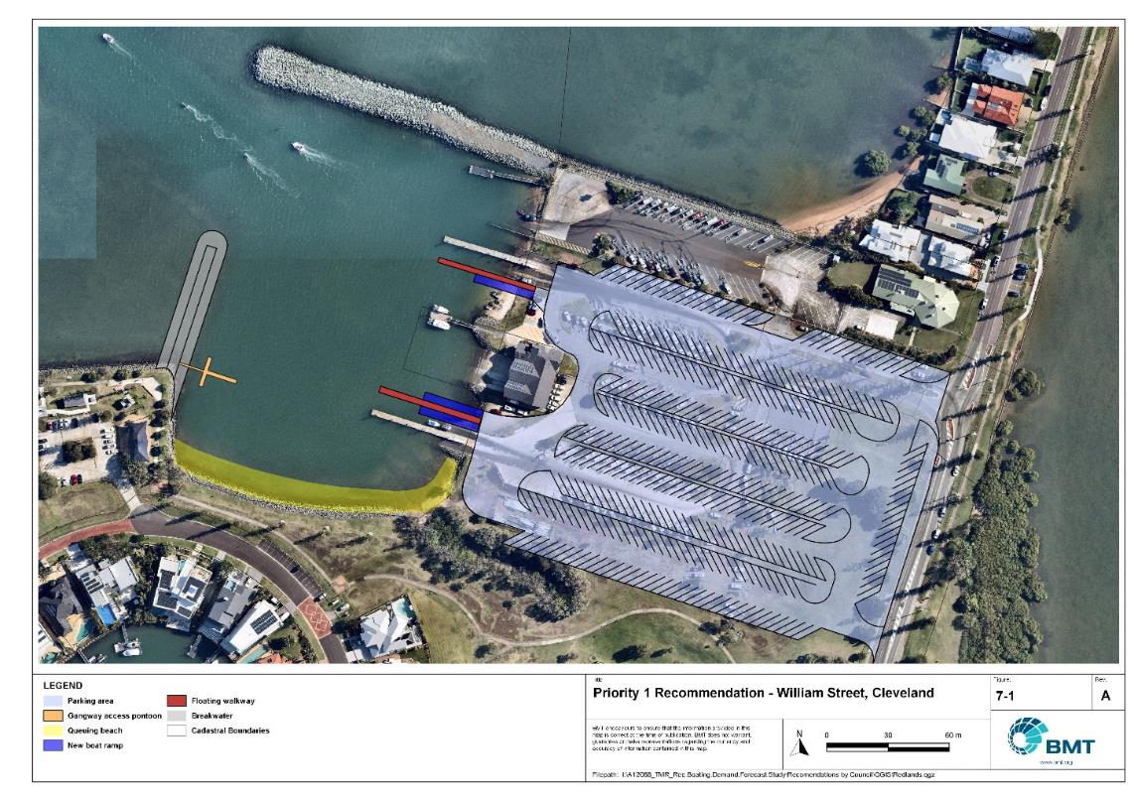

Priority 1 Recommendation: William Street, Cleveland (Option 1)

I:\A12068_TMR_Rec.Boating.Demand.Forecast.Study\Recomendations by Council\JPG\RedlandCity\A12068_005_RedlandCityProposedUpgrades_7-1.jpg

Weinam Creek – Priority 1

|  |  |  |  |  |
| --- | --- | --- | --- | --- |
| General description | | | | |
| Location | Weinam Creek, Redland Bay | | | |
| Existing Facility? | Yes | | | |
| Coordinates | -27.62016168, 153.30924248 | | | |
| Existing tidal status | All-tide | | | |
| Existing wave exposure | None | | | |
| Existing current exposure | None | | | |
| Proposed works | Construct new 3-lane ramp with two floating walkways on the southern bank of Weinam Creek.  Construct parking for 130 CTUs in 2 stages (first 85 CTUs, then a further 45).  Decommission the existing Weinam Creek boat ramp as a public marine facility, reserving its operation for agency use.  Redirection of the boardwalk may be required to allow for suitable turnaround space entering the boat launching/rigging area, but will need consideration during detailed design (to be completed first, as to not disrupt commuter thoroughfare).  Convert existing CTU spaces (adjacent existing ramp) to other uses. | | | |
| Increased effective capacity | Stage 1 – 1 effective lane  Stage 2 – 1.35 effective lanes  2.35 total increase, accounting for retirement of existing facility. | | | |
| Capacity improvement position | Waterside | Landside | | Both |
| Rationale | The planned (at 2022) retirement of the existing facility on the northern side of Weinam Creek is planned to better cater for island commuters using the adjacent ferry terminal. The existing facility is significantly constrained on the landside, so relocating the facility to the southern bank of the creek, providing 3 lanes with a floating walkway and ample CTU parking raises the effective lane capacity of this facility to 4.9. | | | |
| Anticipated costs (+/- 50%) | Waterside infrastructure | | $1,500,000 | |
| Landside infrastructure | | Stage 1: $590,000  Stage 2: $320,000 | |
| Planning, environmental and approvals constraints | | | | |
| Assessment | Requirement | Comments | |  |
| Fish Habitat Zone | X | N/A | | |
| Native Title | X | N/A | | |
| MCU requirement | ü | New carpark may trigger a Development Permit for a Material Change of Use. | | |
| Clearing remnant vegetation | ü | RVM category B- remnant vegetation where the redirection of the boardwalk and part of the new boat ramp is located. A Development Permit may be required for the clearing of remnant vegetation. | | |
| GBRWHA | X | N/A | | |
| Marine Park | ü | The marine-based works are within the General Use Zone of Moreton Bay Marine Park and will likely require a Marine Park Permit. | | |
| Tidal works assessment | ü | Adding a new boat ramp and floating walkway will likely be tidal works and require a Development Permit. | | |
| Other as required | ü | Marine Plants – Boat ramp and floating walkway works may require clearing of marine plants such as mangroves and therefore will require a Development Permit for marine plant disturbance. | | |
| Sea Level Rise | ü | The proposed works are within the boundaries of the erosion prone area. | | |
| Storm Tide Hazard | ü | The proposed works are within the boundaries of high and medium hazard area. | | |
| Anticipated Complexity | Low | Medium | | High |

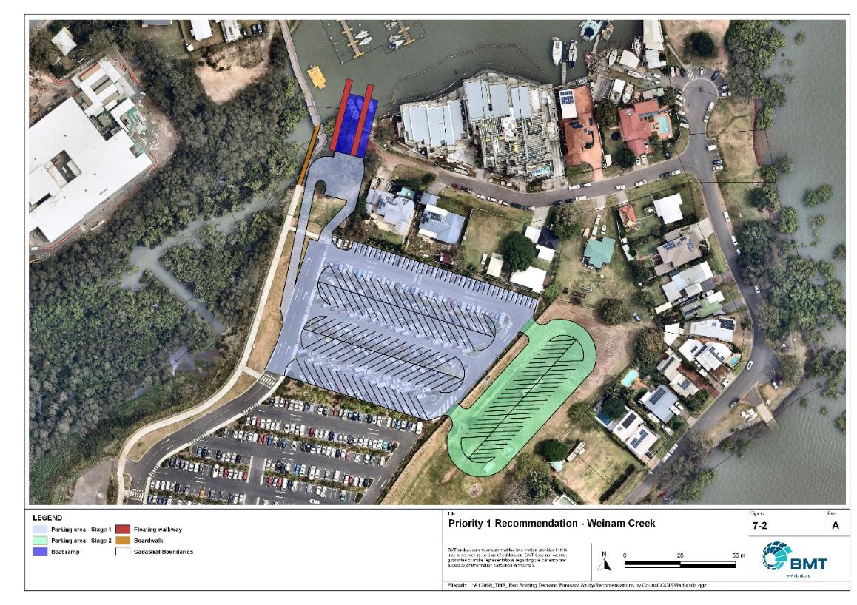

Priority 1 Recommendation: Weinam Creek

I:\A12068_TMR_Rec.Boating.Demand.Forecast.Study\Recomendations by Council\JPG\RedlandCity\A12068_005_RedlandCityProposedUpgrades_7-2.jpg

## Priority 2 recommendations

Wellington Point – Priority 2

|  |  |  |  |  |
| --- | --- | --- | --- | --- |
| General description | | | | |
| Location | Eastern side of Wellington Point | | | |
| Existing Facility? | Yes | | | |
| Coordinates | -27.46646842, 153.24123866 | | | |
| Existing tidal status | All-tide | | | |
| Existing wave exposure | Moderate | | | |
| Existing current exposure | None | | | |
| Proposed works | Reclaim land to the south of the existing southern boat ramp to expand CTU parking capacity, relocating fifteen passenger vehicle parks for a net gain of 75 CTU parking spaces. Provide wave sheltering by reconstructing the existing breakwater between the north and south ramp and constructing a new breakwater arm from the reclaimed area to form a mini-harbour around the existing southern dredge area. Construct two new floating walkways (one on an existing central boat ramp lane, one to the south of the ramp) and a new boat ramp lane, expanding the facility to 4-lanes with 2 floating walkways. Create a sandy queuing beach to the north of the ramp. | | | |
| Increased effective capacity | 3.5 Effective lanes | | | |
| Capacity improvement position | Waterside | Landside | | Both |
| Rationale | Wellington Point is a popular location for accessing central Moreton Bay. There are existing constraints on this facility (north and south ramps combined) due to a lack of available land for CTU parking, as the adjacent parkland is very popular. To maximise the capacity here, reclamation of land is recommended for the construction of a new parking area. The reclamation would allow for a new breakwater arm to be constructed, sheltering the southern ramp from waves and allowing for the installation of floating walkways to increase the throughput efficiency. Stakeholder feedback indicates that these ramps are frequented by significant numbers of larger trailable vessels as well as jet-skis. As such, the northern two lanes have been left un-enclosed by queuing infrastructure, but supported by a queuing beach adjacent, to best support both user groups.  The layout shown in Figure 7.3 allows for the maximum capacity to be achieved between the existing dredge channel area and the boundary of the Moreton Bay Ramsar site.  This facility provides much needed additional capacity for protected all-tide or near all-tide open water access for the region and it is recommended that planning and design work commence as soon as practicable, given the expected complexity of implementation. | | | |
| Anticipated costs (+/- 50%) | Waterside infrastructure | | $3,200,000 | |
| Landside infrastructure | | $3,000,000 | |
| Planning, environmental and approvals Constraints | | | | |
| Assessment | Requirement | Comments | |  |
| Fish Habitat Zone | X | N/A | | |
| Native Title | X | N/A | | |
| MCU requirement | ü | Reclamation works may trigger a Development Permit for a Material Change of Use. | | |
| Clearing remnant vegetation | X | N/A | | |
| GBRWHA | X | N/A | | |
| Marine Park | ü | Reclamation works are within the Habitat Protection Zone within Moreton Bay Marine Park and will likely require a Marine Park Permit.  Works can be undertaken within the Habitat Protection Zone to the extent they protect and manage sensitive habitats (for example, seagrass meadows, coral reef). | | |
| Tidal works assessment | ü | Reclamation and addition of floating walkways and the extra boat ramp lane will likely be tidal works and require a Development Permit. | | |
| Other as required | ü | Marine Plants – the reclamation works impact marine plants and therefore may require a Development Permit.  Quarry Material Allocation – if the reclamation is undertaken using dredged material, it will require a Quarry Material Allocation. | | |
| Sea Level Rise | ü | The proposed works are within the boundaries of the erosion prone area. | | |
| Storm Tide Hazard | ü | The proposed works are within the boundaries of a high and medium storm tide hazard area. | | |
| Anticipated Complexity | Low | Medium | | High |
| Maritime engineering review | | | | |
| Assessment | Site considerations | Comments | | |
| Engineering Matters | Wave Forces | Wave conditions at the site will need a detailed assessment to ensure the recommended configuration and sizing is suitable for the conditions. | | |
| Deep Water | This recommendation will require partial construction in deep water that may impact the suitability or constructability of this recommendation. | | |
| Adjacent Structures & Constraints | Construction of this recommendation will need to be undertaken with the spatial constraints of the existing dredge channel, Ramsar declared area and the existing jetty. This will need careful consideration during construction planning. | | |
| Anticipated Complexity | Low | Medium | | High |

Priority 2 Recommendation: Wellington Point

I:\A12068_TMR_Rec.Boating.Demand.Forecast.Study\Recomendations by Council\JPG\RedlandCity\A12068_005_RedlandCityProposedUpgrades_7-3.jpg

Thorneside, Helen Street – Priority 2

|  |  |  |  |  |
| --- | --- | --- | --- | --- |
| General description | | | | |
| Location | Thorneside, Queens Esplanade (near Helen Street), eastern bank of Tingalpa Creek | | | |
| Existing Facility? | Yes | | | |
| Coordinates | -27.47828962, 153.19817553 | | | |
| Existing tidal status | Part-tide | | | |
| Existing wave exposure | None | | | |
| Existing current exposure | Exposed | | | |
| Proposed works | Add a second boat ramp lane and floating walkway. Increase CTU parking spaces to 60+ total, expanding into the verge on the adjacent street, accommodating existing trees and potentially using a geo-grid surface or delineated with concrete blocks.  Separate the CTU parking area from the roadway through a concrete median, similar to the southern car parks. Construct a roundabout as a turnaround facility. | | | |
| Increased effective capacity | 1.2 effective lanes | | | |
| Capacity improvement position | Waterside | Landside | | Both |
| Rationale | This popular local ramp services the northern part of the LGA, providing access to the creek system and into Moreton Bay for a variety of recreational activities. There is ample space at the ramp for another lane and along the surrounding street verge for more CTU parking spaces. | | | |
| Anticipated costs (+/- 50%) | Waterside infrastructure | | $590,000 | |
| Landside infrastructure | | $240,000 | |
| Planning, environmental and approvals Constraints | | | | |
| Assessment | Requirement | Comments | |  |
| Fish Habitat Zone | X | N/A | | |
| Native Title | X | N/A | | |
| MCU requirement | X | N/A | | |
| Clearing remnant vegetation | X | N/A | | |
| GBRWHA | X | N/A | | |
| Marine Park | ü | Works are within a Habitat Protection Zone of the Moreton Bay Marine Park and may require a Marine Park Permit.  Works can be undertaken within the Habitat Protection Zone to the extent they protect and manage sensitive habitats (for example. seagrass meadows, coral reef). | | |
| Tidal works assessment | ü | Adding a second boat ramp lane and a floating walkway will be tidal works and require a Development Permit. | | |
| Other as required | ü | Marine Plants – Boat ramp and floating walkway works may require clearing of marine plants and therefore will require a Development Permit for marine plant disturbance. | | |
| Sea Level Rise | ü | The proposed works are partially within the boundaries of the erosion prone area (two additional lanes, floating walkway) however part of the car park is not. | | |
| Storm Tide Hazard | ü | The proposed works are within the boundaries of high and medium hazard area. | | |
| Anticipated Complexity | Low | Medium | | High |
| Maritime engineering review | | | | |
| Assessment | Site considerations | Comments | | |
| Engineering Matters | Current Forces | Site may be subject to moderate to high currents and further assessment of the impact on this recommendation is required. | | |
| Anticipated Complexity | Low | Medium | | High |

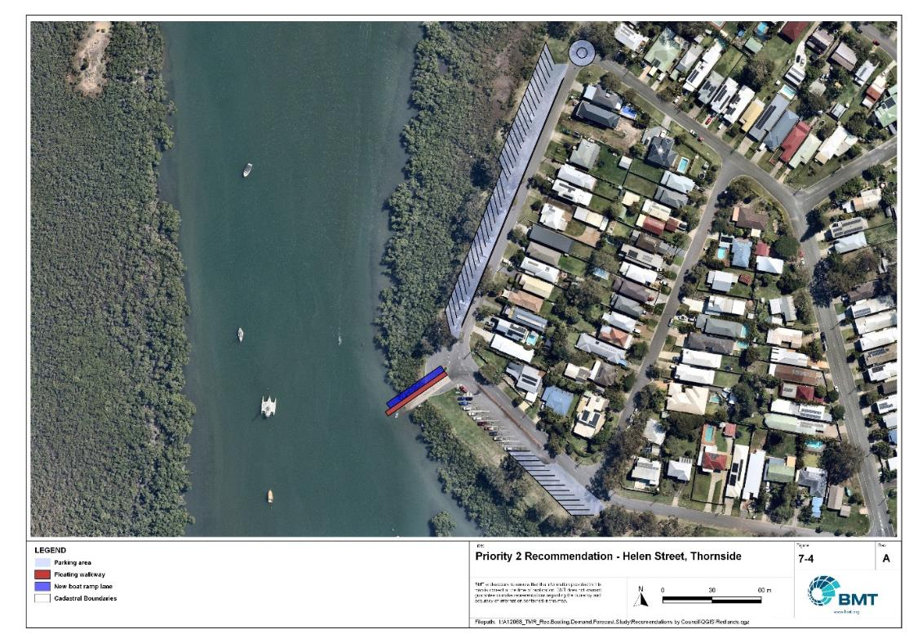

Priority 2 Recommendation: Thorneside, Helen Street

I:\A12068_TMR_Rec.Boating.Demand.Forecast.Study\Recomendations by Council\JPG\RedlandCity\A12068_005_RedlandCityProposedUpgrades_7-4.jpg

Tina Avenue, Lamb Island – Priority 2

|  |  |  |  |  |
| --- | --- | --- | --- | --- |
| General description | | | | |
| Location | Tina Avenue, southern shore of Lamb Island, Moreton Bay | | | |
| Existing Facility? | No | | | |
| Coordinates | -27.63113078, 153.37750977 | | | |
| Existing tidal status | N/A - near all-tide once constructed | | | |
| Existing wave exposure | N/A | | | |
| Existing current exposure | N/A | | | |
| Proposed works | Construct a single lane ramp with a floating walkway and 15 CTUs. In accordance with the bathymetric study, a causeway will be needed to provide near all-tide access to the proposed ramp. | | | |
| Increased effective capacity | 0.8 effective lane | | | |
| Capacity improvement position | Waterside | Landside | | Both |
| Rationale | Currently recreational boat users on Lamb Island launch from the barge ramp, presenting safety conflicts on land and water. There is also no CTU parking spaces. Tina Avenue is one of the only locations on the island where the public can directly access a reasonably deep foreshore and there is space for CTU parking. The Study notes that the landside facilities are on reclaimed land, for which the tenure is held by Redland City Council. The Study was advised that other locations on Lamb Island were investigated jointly by MSQ and RCC and found to be not feasible. | | | |
| Anticipated costs (+/- 50%) | Waterside infrastructure | | $725,000 | |
| Landside infrastructure | | $120,000 | |
| Planning, environmental and approvals Constraints | | | | |
| Assessment | Requirement | Comments | |  |
| Fish Habitat Zone | X | N/A | | |
| Native Title  (Yuggera People) | ü | New tenure required for works so interaction with Native Title may be required. | | |
| MCU requirement | ü | A new boat ramp and floating walkway works will likely trigger a Development Permit for a Material Change of Use. | | |
| Clearing remnant vegetation | X | N/A | | |
| GBRWHA | X | N/A | | |
| Marine Park | ü | The marine-based works are within a Habitat Protection Zone within Moreton Bay Marine Park and will likely require a Marine Park Permit.  Works can be undertaken within a Habitat Protection Zone Works to the extent they protect and manage sensitive habitats (for example. seagrass meadows, coral reef). | | |
| Tidal works assessment | ü | Adding a new boat ramp and floating walkway will be tidal works and require a Development Permit. | | |
| Other as required | ü | N/A | | |
| Sea Level Rise | ü | The proposed works are within the boundaries of the erosion prone area. | | |
| Storm Tide Hazard | ü | The proposed works are within the boundaries of high and medium storm tide hazard areas. | | |
| Anticipated Complexity | Low | Medium | | High |
| Maritime engineering review | | | | |
| Assessment | Site considerations | Comments | | |
| Engineering Matters | Wave Forces | Wave conditions at the site will need a detailed assessment to ensure the recommended configuration and sizing is suitable for the conditions. | | |
| Geotechnical | Low strength or unsuitable materials are likely to be found at this site and a more detailed geotechnical assessment of this recommendation is suggested. | | |
| Anticipated Complexity | Low | Medium | | High |

Priority 2 Recommendation: Tina Avenue, Lamb Island

I:\A12068_TMR_Rec.Boating.Demand.Forecast.Study\Recomendations by Council\JPG\RedlandCity\A12068_005_RedlandCityProposedUpgrades_7-5.jpg

Russell Island, Jock Kennedy Park – Priority 2

|  |  |  |  |  |
| --- | --- | --- | --- | --- |
| General description | | | | |
| Location | Jock Kennedy Park, north-west Russell Island | | | |
| Existing Facility? | Yes | | | |
| Coordinates | -27.64660012, 153.37769018 | | | |
| Existing tidal status | Near all-tide | | | |
| Existing wave exposure | None | | | |
| Existing current exposure | None | | | |
| Proposed works | Formalise 20 new CTU spaces and build retaining wall if required. Extend the causeway by 10-15m (approx.) and rebuild the boat ramp to access 0.5m below LAT. | | | |
| Increased effective capacity | 0.5 effective lanes | | | |
| Capacity improvement position | Waterside | Landside | | Both |
| Rationale | Parking availability at this facility is very limited and formalising the parking would help regulate use and limit environmental damage. Formalising more parks on this block is possible and worthwhile but would require geotechnical investigation and works to avoid impacts on adjacent properties.  At present, there is an abrupt drop-off at the ramp toe, and the ramp does not extend into sufficiently into deep water at low tide, necessitating users to launch from beyond the toe of the ramp. Ramp extension should be undertaken for safety and amenity reasons.  A floating walkway adjacent to the boat ramp may be desirable on amenity grounds. | | | |
| Anticipated costs (+/- 50%) | Waterside infrastructure | | $85,000 | |
| Landside infrastructure | | $125,000 | |
| Planning, environmental and approvals constraints | | | | |
| Assessment | Requirement | Comments | |  |
| Fish Habitat Zone | X | N/A | | |
| Native Title | X | N/A | | |
| MCU requirement | X | N/A | | |
| Clearing remnant vegetation | X | N/A | | |
| GBRWHA | X | N/A | | |
| Marine Park | ü | Proposed boat ramp extension is within the Moreton Bay Marine Park (Habitat Protection Zone) and therefore may require a Marine Park Permit. Works can be undertaken within a Habitat Protection Zone to the extent they protect and manage sensitive habitat (for example seagrass meadows, coral reef). | | |
| Tidal works assessment | ü | Extension of the existing boat ramp will likely be tidal works and therefore require a Development Permit. | | |
| Other as required | ü | Ramsar Wetlands – Proposed boat ramp extension is within the Moreton Bay Ramsar Wetland which may trigger a Controlled Activity Approval if there is likely to be significant impact. | | |
| Sea Level Rise | ü | The proposed landside works are not within the boundaries of the erosion prone area. | | |
| Storm Tide Hazard | ü | The proposed works are within the boundaries of the medium hazard area. | | |
| Anticipated Complexity | Low | Medium | | High |
| Maritime engineering review | | | | |
| Assessment | Site considerations | Comments | | |
| Engineering Matters | Wave Forces | Wave conditions at the site will need a detailed assessment to ensure the recommended configuration and sizing is suitable for the conditions. | | |
| Geotechnical | Low strength or unsuitable materials are likely to be found at this site and a more detailed geotechnical assessment of this recommendation is suggested. | | |
| Anticipated Complexity | Low | Medium | | High |

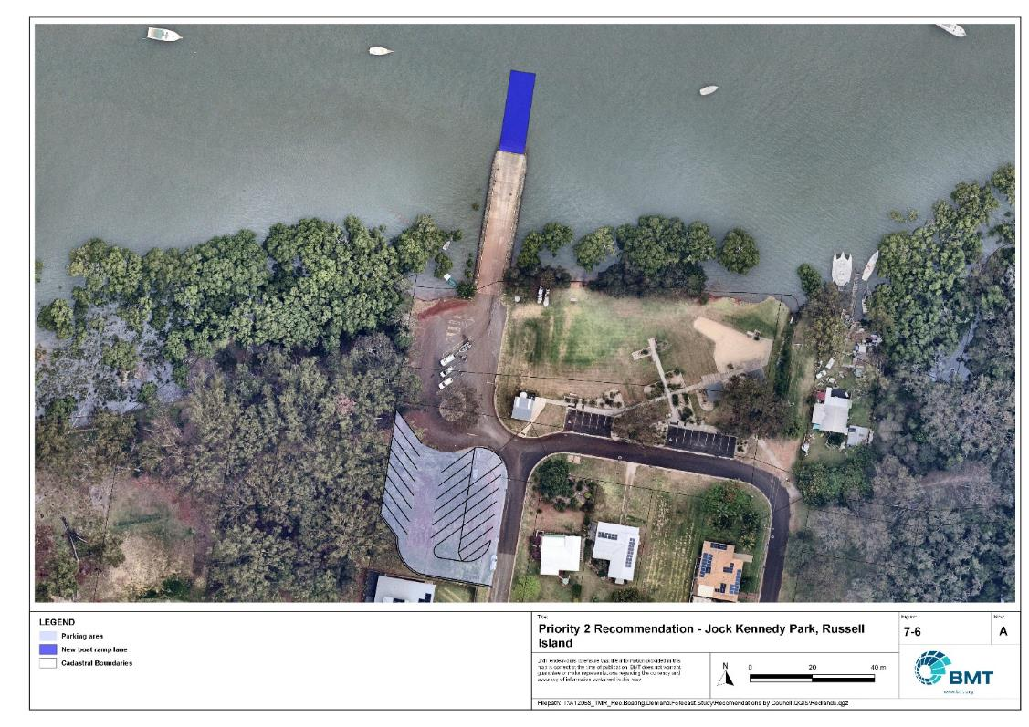

Priority 2 Recommendation: Russell Island, Jock Kennedy Park

I:\A12068_TMR_Rec.Boating.Demand.Forecast.Study\Recomendations by Council\JPG\RedlandCity\A12068_005_RedlandCityProposedUpgrades_7-6.jpg

## Priority 3 recommendations

Victoria Point – new gangway-access pontoon – Priority 3

|  |  |  |  |  |
| --- | --- | --- | --- | --- |
| General description | | | | |
| Location | Victoria Point jetty, near Masters Avenue, adjacent to the existing boat ramp. | | | |
| Existing Facility? | No | | | |
| Coordinates | -27.58166491, 153.31874277 | | | |
| Existing tidal status | N/A | | | |
| Existing wave exposure | N/A | | | |
| Existing current exposure | N/A | | | |
| Proposed works | Construct a new gangway-access pontoon for deep-draught vessel access. An amendment to the existing approved dredge footprint will be required. | | | |
| Increased effective capacity | 1 deep-draught landing facility | | | |
| Capacity improvement position | Waterside | Landside | | Both |
| Rationale | More deep-draught landings are required on the mainland and this location on an existing jetty provides deep water access in a maintained channel close to shops and public transport. | | | |
| Anticipated costs (+/- 50%) | Waterside infrastructure | | $130,000 | |
| Landside infrastructure | | N/A | |
| Planning, environmental and approvals constraints | | | | |
| Assessment | Requirement | Comments | |  |
| Fish Habitat Zone | X | N/A | | |
| Native Title | X | N/A | | |
| MCU requirement | X | N/A | | |
| Clearing remnant vegetation | X | N/A | | |
| GBRWHA | X | N/A | | |
| Marine Park | ü | The marine-based works are within the Habitat Protection Zone within Moreton Bay Marine Park and will likely require a Marine Park Permit.  Works can be undertaken within the Habitat Protection Zone to the extent they protect and manage sensitive habitats (for example. seagrass meadows, coral reef). | | |
| Tidal works assessment | ü | Adding a new gangway-access pontoon will likely be tidal works and require a Development Permit. | | |
| Other as required | ü | Marine Plants – Gangway-access pontoon works may require clearing of marine plants and therefore will require a Development Permit for marine plant disturbance.  Amendments will be required to existing approvals for dredging works | | |
| Sea Level Rise | ü | The proposed works are within the boundaries of the erosion prone area. | | |
| Storm Tide Hazard | ü | The proposed works are within the boundaries of high or medium hazard areas. | | |
| Anticipated Complexity | Low | Medium | | High |
| Maritime engineering review | | | | |
| Assessment | Site considerations | Comments | | |
| Engineering Matters | Wave Forces | Wave conditions at the site will need a detailed assessment to ensure the recommended configuration and sizing is suitable for the conditions. | | |
| Anticipated Complexity | Low | Medium | | High |

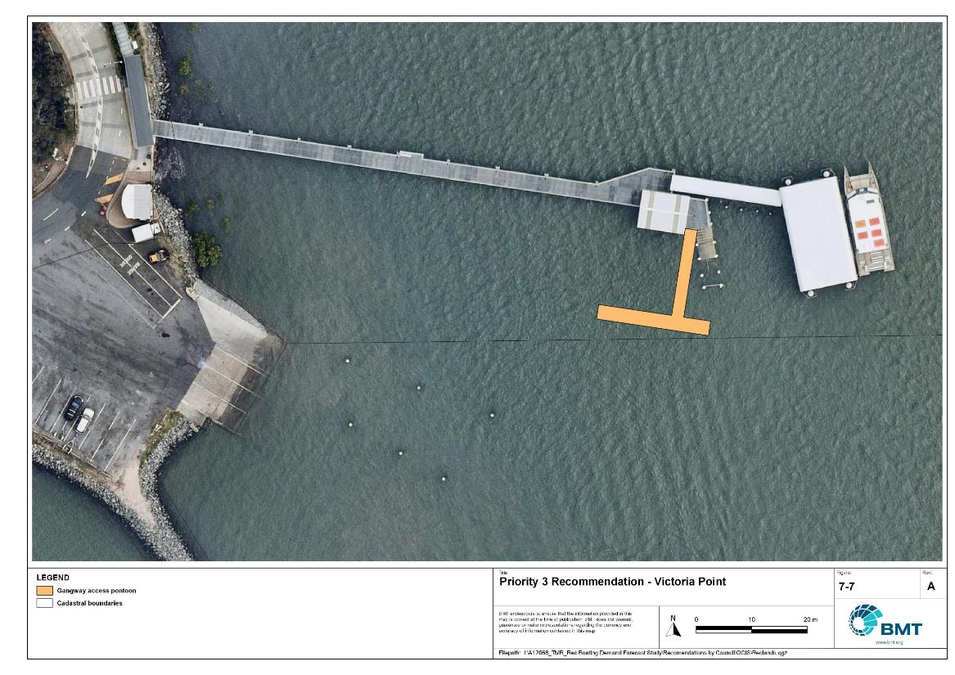

Priority 3 Recommendation: Victoria Point

I:\A12068_TMR_Rec.Boating.Demand.Forecast.Study\Recomendations by Council\JPG\RedlandCity\A12068_005_RedlandCityProposedUpgrades_7-7.jpg

## Priority 4 recommendations

Dunwich – New boat launching facility - Priority 4

|  |  |  |  |  |
| --- | --- | --- | --- | --- |
| General description | | | | |
| Location | Dunwich, North Stradbroke Island (Minjerribah) | | | |
| Existing Facility? | Yes | | | |
| Coordinates | -27.49804377, 153.40368726 | | | |
| Existing tidal status | All-tide | | | |
| Existing wave exposure | N/A | | | |
| Existing current exposure | N/A | | | |
| Proposed works | Conduct investigation and community consultation into best location for construction of a new 2-lane ramp with 45 CTU parking spaces to service the Dunwich community. | | | |
| Increased effective capacity | 2.0 effective lanes | | | |
| Capacity improvement position | Waterside | Landside | | Both |
| Rationale | There are limited recreational boating facilities at Dunwich and across the populated areas of North Stradbroke Island (Minjerribah). The various communities have indicated a desire for a new facility to service their needs. Parking at the existing One Mile boat ramp is extremely limited. | | | |
| Anticipated costs (+/- 50%) | Waterside infrastructure | | TBD | |
| Landside infrastructure | | TBD | |
| Planning, environmental and approvals constraints | | | | |
| Assessment | Requirement | Comments | |  |
| Fish Habitat Zone | X | N/A | | |
| Native Title | X | N/A | | |
| MCU requirement | ü | A new boat ramp and floating walkway works will likely trigger a Development Permit for a Material Change of Use | | |
| Clearing remnant vegetation | X | N/A | | |
| GBRWHA | X | N/A | | |
| Marine Park | ü | The marine-based works are within the Habitat Protection Zone and General Use Zone within Moreton Bay Marine Park and will likely require a Marine Park Permit. | | |
| Tidal works assessment | ü | Adding a new boat ramp will be tidal works and require a Development Permit. | | |
| Other as required | ü | Marine Plants – Boat ramp and walkway may require clearing of marine plants and therefore will require a Development Permit for marine plant disturbance. | | |
| Sea Level Rise | ü | The proposed works are within the boundaries of the erosion prone area. | | |
| Storm Tide Hazard | ü | The proposed works are within the boundaries of high or medium hazard areas. | | |
| Anticipated Complexity | Low | Medium | | High |

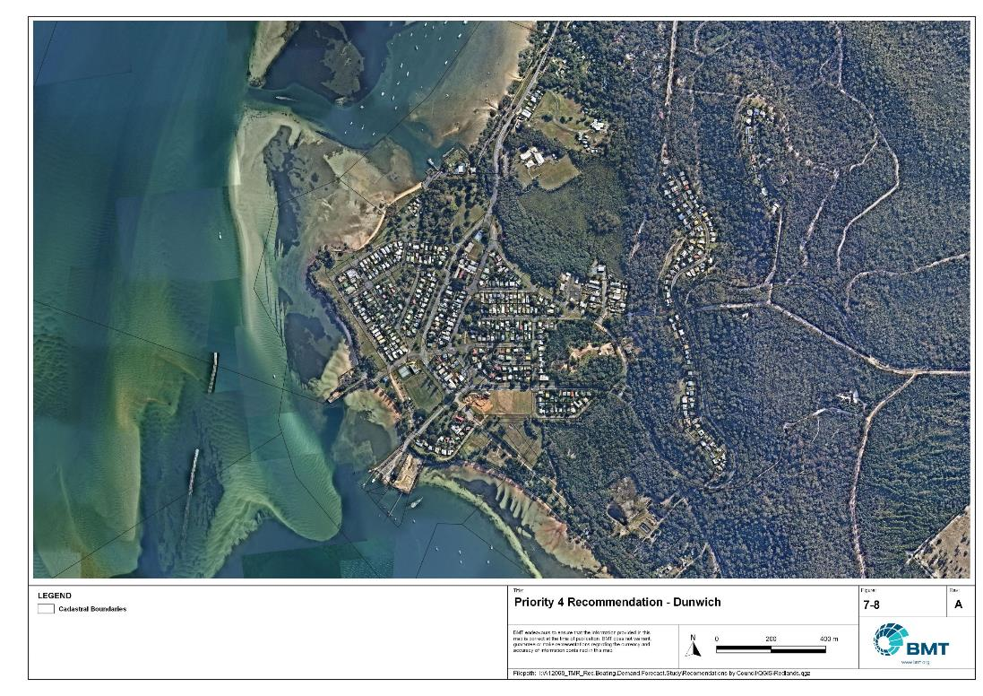

Priority 4 Recommendation: Dunwich

"I:\A12068_TMR_Rec.Boating.Demand.Forecast.Study\Recomendations by Council\JPG\RedlandCity\A12068_005_RedlandCityProposedUpgrades_7-8.jpg"

The Esplanade, Karragarra Island – Priority 4

|  |  |  |  |  |
| --- | --- | --- | --- | --- |
| General description | | | | |
| Location | The Esplanade, northern Karragarra Island, Moreton Bay | | | |
| Existing Facility? | No | | | |
| Coordinates | -27.63542873, 153.36479337 | | | |
| Existing tidal status | N/A - all-tide once constructed | | | |
| Existing wave exposure | N/A | | | |
| Existing current exposure | N/A | | | |
| Proposed works | Conduct investigation and community consultation into best location for construction of a new 1-lane ramp with 15 CTU parking spaces to service the Karragarra recreational boating community. Consider sediment transport and a piled and elevated ramp structure to avoid impacts on natural sediment transport processes. | | | |
| Increased effective capacity | 1.0 effective lane | | | |
| Capacity improvement position | Waterside | Landside | | Both |
| Rationale | Karragarra Island has a single ramp that caters to both recreational users and the vehicular barge. This facility does not meet the recreational demand and ramp usage conflicts pose a safety risk.  Note that there is a long-term potential for the barge ramp to be relocated to another location on the island. In the case of this, this recommendation would be unnecessary as the existing ramp would become exclusively recreational. | | | |
| Anticipated costs (+/- 50%) | Waterside infrastructure | | TBD | |
| Landside infrastructure | | TBD | |
| Planning, environmental and approvals constraints | | | | |
| Assessment | Requirement | Comments | |  |
| Fish Habitat Zone | X | N/A | | |
| Native Title | ü | New tenure required for works so interaction with Native Title required | | |
| MCU requirement | ü | A new boat ramp and floating walkway works will likely trigger a Development Permit for a Material Change of Use. | | |
| Clearing remnant vegetation | X | N/A | | |
| GBRWHA | X | N/A | | |
| Marine Park | ü | The marine-based works are within the Habitat Protection Zone within Moreton Bay Marine Park and will likely require a Marine Park Permit.  Works can be undertaken within the Habitat Protection Zone to the extent they protect and manage sensitive habitats (for example. seagrass meadows, coral reef). | | |
| Tidal works assessment | ü | Adding a new boat ramp will likely be tidal works and require a Development Permit. | | |
| Other as required | ü | Marine Plants – Boat ramp may require clearing of marine plants and therefore will require a Development Permit for marine plant disturbance. | | |
| Sea Level Rise | ü | The proposed works are within the boundaries of the erosion prone area. | | |
| Storm Tide Hazard | ü | The proposed works are within the boundaries of high or medium hazard areas. | | |
| Anticipated Complexity | Low | Medium | | High |

Priority 2 Recommendation: Karragarra Island

"I:\A12068_TMR_Rec.Boating.Demand.Forecast.Study\Recomendations by Council\JPG\RedlandCity\A12068_005_RedlandCityProposedUpgrades_7-9.jpg"

# References

Australian Bureau of Statistics (ABS), 2021, *2021 Census,* <https://www.abs.gov.au/census>

Bell, Frederick W. 2022, *Estimation of the present and projected demand and supply of boat ramps for Florida's coastal regions and counties*, Florida State University, Department of Economics.

BMT, 2015, *MPSC Managed Boating Facilities Demand and Capacity Study: Boat Ramp Modelling*

Department of Transport and Main Roads (TMR), 2020, Marine facilities and infrastructure plan.

GHD, 2011, *Recreational Boating Facilities Demand Forecasting Study*

GHD, 2017, *Queensland Recreational Boating Facilities Demand Forecasting Study 2017.*

Maritime Safety Queensland (MSQ), 2022, *Recreational Boating Facilities,* <https://www.getinvolved.qld.gov.au/gi/consultation/8850/view.html>

Queensland Government Department of Resources (DoR), 2022, *Cities and towns [OGC WMS Service]*, Accessed 5/10/2022, available online at spatial.information.qld.gov.au/arcgis/home/item.html?id=103c7c9ccca449fab79d27cde06868ab

Rose, T., R. Powell & J. Yu (2009). Identification of the Present and Future Recreational Boating Infrastructure in Redland City – A 10 Year Infrastructure Plan- Griffith University

SKM (1998) Public Boat Ramps Central Queensland Strategic Plan - Volume One - Demand Forecasting - Noosa to Yeppoon. Sinclair Knight Merz, March 1998.

Swett, R., Fik, T., Ruppert, T., Davidson, G., Guevara, C. & Betty Staugler, 2012, *Planning for the future of recreational boating access to charlotte county waterways: 2010 – 2050*, Florida Sea Grant, University of Florida.

Western Australia Department of Transport, 2019, *Perth Recreational Boating Facilities Study Review 2019*, https://www.transport.wa.gov.au/mediaFiles/marine/MAC_P_Perth_RBFS_study_review_2019.pdf

Western Australia Department of Transport, 2021, *South West Region Recreational Boating Facilities Study July 2021,* https://www.transport.wa.gov.au/mediaFiles/marine/MAC_P_SouthWest_RBFS_Study_2021.pdf

###### Demand Study

"G:\Admin\A12068.g.mpb.TMRBoatingDemand\06_Reports\09_Demand Study\2022_2119 (016) Final Demand Report (March 2023).pdf"

###### Boat launching facility capacity

Capacity of existing boat launching facilities

| Facility ID | Facility name | | No. Lanes | Tidal Access at Ramp | Tidal Access to Open Water | Queuing facility | Formal CTUs | Informal CTUs | Waterside capacity | Landside capacity | Effective capacity | Constraint |
| --- | --- | --- | --- | --- | --- | --- | --- | --- | --- | --- | --- | --- |
| **Open Water Access** | | | | | | | | | | | | | |
| RB12 | Russell Island, High Street | | 1 | Near All-Tide | Near All-Tide | Pontoon | 0 |  | 0.96 | 0 | 0 | Landside |
| RB13 | Russell Island, Wahine Drive | | 2 | All-Tide | All-Tide | None | 0 | 12 | 2 | 1 | 1 | Landside |
| RB15 | Russell Island, Alice Street (Jock Kennedy Park) | | 2 | Near All-Tide | Near All-Tide | None | 12 |  | 1.6 | 1 | 1 | Landside |
| RB22 | Karragarra Island, The Esplanade | | 1 | Near All-Tide | Near All-Tide | Pontoon | 0 | 2 | 0.96 | 0.25 | 0.25 | Landside |
| RB32 | Lamb Island, Lucas Drive | | 1 | All-Tide | All-Tide | Pontoon | 0 | 0 | 1.2 | 0 | 0 | Landside |
| RB42 | Macleay Island, Brighton Road | | 2 | All-Tide | All-Tide | Pontoon | 3 | 0 | 2.4 | 0.25 | 0 | Landside |
| RB45 | Macleay Island, Russell Terrace | | 2 | All-Tide | All-Tide | Floating Walkway | 26 | 0 | 3 | 1.5 | 1.5 | Landside |
| RB47 | Macleay Island, Dalpura Street | | 1 | Part-Tide | Part-Tide | Beach | 10 | 0 | 0.28 | 0.75 | 0.28 | Waterside |
| RB52 | Coochiemudlo, Tageruba Street | | 1 | All-Tide | All-Tide | Pontoon | 0 | 6 | 1.2 | 0.5 | 0.5 | Landside |
| RB73 | Dunwich, Junner Street | | 1 | All-Tide | All-Tide | Beach | 0 | 0 | 1.1 | 0 | 0 | Landside |
| RB82 | Dunwich, Yabby Street | | 2 | All-Tide | All-Tide | Pontoon | 7 | 0 | 2.4 | 0.5 | 0.5 | Landside |
| RB92 | Amity Point, Claytons Road | | 2 | All-Tide | All-Tide | Pontoon | 0 | 9 | 1.2 | 0.75 | 0.75 | Landside |
| RD11 | Redland Bay, Moores Road | | 1 | Near All-Tide | Near All-Tide | None | 5 | 0 | 0.4 | 0.5 | 0.4 | Waterside |
| RD16 | Weinam Creek boat ramp | | 4 | All-Tide | All-Tide | Pontoon | 63 | 0 | 4.4 | 2.75 | 2.75 | Landside |
| RD30 | Victoria Point, Masters Avenue | | 0 | All-Tide | All-Tide | None | 15 | 0 | 0 | 1 | 0 | Waterside |
| RD35 | Victoria Point, Masters Avenue | | 3 | All-Tide | All-Tide | None | 15 | 0 | 1.5 | 1 | 1 | Landside |
| RD36 | Victoria Point, Colburn Avenue (north) | | 2 | All-Tide | All-Tide | Floating Walkway | 56 | 0 | 3.4 | 2.5 | 2.5 | Landside |
| RD45 | Cleveland, Emmet Street (Toondah Harbour) | | 2 | All-Tide | All-Tide | None | 49 | 0 | 2 | 2.25 | 2 | Waterside |
| RD52 | Cleveland, William Street | | 3 | All-Tide | All-Tide | Floating Walkway | 64 | 30 | 4.7 | 4.25 | 4.25 | Landside |
| RD53 | Cleveland, William Street | | 2 | All-Tide | All-Tide | Pontoon | 64 | 30 | 3.4 | 4.25 | 3.4 | Waterside |
| RD56 | Cleveland, Shore Street | | 1 | All-Tide | All-Tide | None | 0 | 3 | 0.5 | 0.25 | 0.25 | Landside |
| RD61 | Wellington Point, Main Road | | 2 | All-Tide | All-Tide | None | 19 | 0 | 1 | 1.25 | 1 | Waterside |
| RD62 | Wellington Point, Main Road | | 4 | All-Tide | All-Tide | None | 56 | 0 | 4 | 2.5 | 2.5 | Landside |
| **Subtotal** |  | | **43** |  |  |  | **507** | **92** | **43.6** | **31.0** | **25.8** |  |
| **Depth-limited** | | | | | | | | | | | | | |
| RD71 | Thorneside, Helen Street | | 1 | Part-Tide | Part-Tide | None | 12 | 0 | 0.5 | 1 | 0.5 | Waterside |
| **Subtotal** |  | | **1** |  |  |  | **12** | **0** | **0.5** | **1** | **0.5** |  |
|  | | **Total effective capacity** | | | | | | | | | **26.3** |  | |

###### Facility Use

Boat launching facility usage statistics

| FacilityId | Facility Name | Total reports | Redland | Brisbane | Logan | Gold Coast | Ipswich | Moreton Bay | Sunshine Coast | Toowoomba | Lockyer Valley | Scenic Rim | Other LGAs |
| --- | --- | --- | --- | --- | --- | --- | --- | --- | --- | --- | --- | --- | --- |
| Total |  | 72192 | 44745 | 12775 | 5955 | 2052 | 1887 | 1342 | 529 | 266 | 176 | 158 | 2307 |
| Total % |  | 100% | 62.0% | 17.7% | 8.2% | 2.8% | 2.6% | 1.9% | 0.7% | 0.4% | 0.2% | 0.2% | 3.2% |
| RD52 | Cleveland, William Street | 17299 | 65.6% | 17.7% | 6.7% | 2.6% | 2.3% | 2.0% | 0.5% | 0.3% | 0.1% | 0.1% | 2.3% |
| RD36 | Victoria Point, Colburn Avenue | 15848 | 66.4% | 12.8% | 9.5% | 2.6% | 2.6% | 1.4% | 0.7% | 0.4% | 0.5% | 0.3% | 3.1% |
| RD61 | Wellington Point, Main Road | 10895 | 57.7% | 25.5% | 8.1% | 1.5% | 2.2% | 1.2% | 0.5% | 0.4% | 0.3% | 0.2% | 2.2% |
| RD16 | Weinam Creek boat ramp | 8756 | 72.2% | 8.8% | 8.0% | 3.1% | 2.4% | 1.4% | 0.5% | 0.2% | 0.1% | 0.3% | 3.2% |
| RD30 | Victoria Point, Masters Avenue | 5583 | 53.8% | 17.4% | 11.8% | 3.5% | 4.6% | 2.1% | 0.8% | 0.4% | 0.2% | 0.2% | 5.1% |
| RD45 | Cleveland, Emmet Street (Toondah Harbour) | 2828 | 43.8% | 26.6% | 6.2% | 4.1% | 3.3% | 5.1% | 2.7% | 1.0% | 0.4% | 0.5% | 6.3% |
| RD71 | Thorneside, Helen Street | 2350 | 69.4% | 23.5% | 2.1% | 0.8% | 1.4% | 1.1% | 0.6% | 0.3% | 0.1% | 0.0% | 0.7% |
| RB52 | Coochiemudlo Island, Tageruba Street | 2113 | 45.6% | 20.4% | 13.8% | 3.8% | 6.0% | 2.4% | 0.9% | 0.7% | 0.1% | 0.4% | 6.0% |
| RD56 | Cleveland, Shore Street | 1634 | 62.4% | 20.0% | 8.7% | 2.3% | 1.3% | 1.6% | 0.6% | 0.2% | 0.2% | 0.2% | 2.4% |
| RB47 | Macleay Island, Dalpura Street | 1266 | 55.1% | 16.4% | 13.4% | 3.2% | 2.4% | 2.5% | 0.6% | 0.2% | 0.2% | 0.5% | 5.6% |
| RB82 | Dunwich, Yabby Street | 1153 | 43.5% | 36.3% | 2.9% | 6.9% | 1.9% | 2.0% | 1.9% | 0.1% | 0.3% | 0.0% | 4.2% |
| RB92 | Amity Point, Claytons Road | 967 | 25.5% | 38.1% | 6.3% | 8.6% | 2.1% | 5.6% | 4.2% | 1.1% | 0.3% | 0.5% | 7.7% |
| RD11 | Redland Bay, Moores Road | 673 | 73.0% | 9.2% | 9.2% | 2.8% | 1.8% | 1.0% | 0.1% | 0.1% | 0.3% | 0.4% | 1.9% |
| RB15 | Russell Island, Alice Street (Jock Kennedy Park) | 446 | 64.1% | 8.5% | 8.5% | 5.6% | 2.2% | 2.9% | 0.7% | 1.8% | 0.4% | 0.7% | 4.5% |
| RB13 | Russell Island, Wahine Drive | 381 | 52.0% | 5.0% | 8.4% | 15.2% | 3.1% | 8.7% | 0.5% | 0.8% | 0.0% | 0.0% | 6.3% |

|  |  |  |
| --- | --- | --- |
|  |  | BMT is a leading design, engineering, science and management consultancy with a reputation for engineering excellence. We are driven by a belief that things can always be better, safer, faster and more efficient. BMT is an independent organisation held in trust for its employees. |

|  |  |  |  |  |  |  |  |  |
| --- | --- | --- | --- | --- | --- | --- | --- | --- |
|  |  |  |  |  |  |  | Contact us  enquiries@bmtglobal.com  www.bmt.org  Follow us  www.bmt.org/linkedin LinkedIn logo.  www.bmt.org/youtube YouTube logo.  www.bmt.org/twitter Twitter logo.  www.bmt.org/facebook Facebook logo. |  |
|  | Level 5  348 Edward Street  Brisbane  QLD 4000  Australia  +61 7 3831 6744 |  | Registered in Australia  Registered no. 010 830 421  Registered office  Level 5, 348 Edward Street,  Brisbane QLD 4000 Australia |  |  |  |  |
|  | For your local BMT office visit www.bmt.org | | |  |  |  |  |  |