|  |
| --- |
| Queensland Recreational Boating Facilities Demand Forecasting Study 2022  Townsville LGA Assessment |
|  |
|  |

|  |  |  |
| --- | --- | --- |
| Customer |  | Maritime Safety Queensland |
| Project |  | A12068 |
| Deliverable |  | 004 |
| Version |  | 01 |
|  |  | 21 April 2023 |

Document Control

Document Identification

|  |  |
| --- | --- |
| Title | Queensland Recreational Boating Facilities Demand Forecasting Study 2022 |
| Project No | A12068 |
| Deliverable No | 004 |
| Version No | 01 |
| Version Date | 21 April 2023 |
| Customer | Maritime Safety Queensland, a branch of the Department of Transport and Main Roads |
| Customer Contact | boatinginfrastructure@msq.qld.gov.au |
| Classification | {None} |

|  |  |
| --- | --- |
| Author | Daniel Wishaw, Nicholas Heiner, Geoff Long, Azam Dolatshah, Sophie Barrett, Mackenzie Stacey |
| Reviewed By | Katrina O’Malley-Jones, Jeremy Visser |
| Project Manager | Daniel Wishaw |

Amendment Record

The Amendment Record below records the history and issue status of this document.

| Version | Version Date | Distribution | Record |
| --- | --- | --- | --- |
| 00 | 31 January 2023 | Maritime Safety Queensland  Townsville City Council | Draft |
| 01 | 21 April 2023 | Maritime Safety Queensland | Final |

Executive Summary

This report, part of the Queensland Recreational Boating Facilities Demand Forecasting Study 2022 (‘the Study’), provides a summary of current and forecast demand on recreational boating facilities in Townsville LGA and the capacity of existing facilities to meet this demand. Where capacity is insufficient to meet current or forecast demand, recommendations have been made to improve existing facilities or for the construction of new facilities. This report is intended to support facility deliverers, owners, and managers over the next 20 years in their decision-making on development priorities for recreational boating facilities within Townsville LGA.

Key issues and attributes of recreational boating

The key attributes of recreational boating facilities identified in this Study for Townsville LGA are summarised in Table 1. While the capacity provided by existing recreational boating facilities is servicing the region well, consultation with stakeholders undertaken as part of The Study identified the following issues:

* The Townsville Recreational Boating Park has greatly improved the capacity of the region.
* There is some conflict between on-water port traffic and recreational boats launching at the Ross Creek facilities.
* Parking of car-trailer units is sometimes under pressure and can clash with parking of passenger vehicles at some facilities.
* Access to more coastal creeks for fishing is desired.

1. Key recreational boating attributes for Townsville LGA

| Key attribute | Value |
| --- | --- |
| Deep-draught landing facilities |  |
| Existing demand (number) | 2.2 |
| Existing capacity (number) | 3 |
| Existing shortfall (number) | -0.8 |
| Boat launching facilities |  |
| Number of existing facilities | 20 |
| Current demand for boat launching lanes (effective lanes) | 34.1 |
| Number of existing ‘effective’ boat launching lanes | 36.7 |
| Current shortfall of ‘effective’ boat launching lanes (number) | -2.6 |
| Current demand satisfaction for ‘effective’ boat launching lanes | 108% |
| State-wide demand satisfaction for ‘effective’ boat launching lanes | 87% |

Demand summary

The assessment of recreational boating demand is centred on a statistical demand model that considers vessel registration data, population statistics, assumptions around local usage and the movement of vessels into and out of the LGA. Key parameters from this assessment for Townsville LGA are:

* The population is 204,262 as at the 2021 census and is projected to be 282,281 by 2041.
* As of July 2022, there is a total of 13,704 vessels with a home registration within the LGA, with 94% being ‘trailable’ – and therefore requiring boat launching facilities – and 6% being non-trailable.
* Townsville LGA is deemed to be a Regional Centre with an assumed vessel activation rate of 10% on a ‘good boating day’.
* Vessels are primarily used within the LGA, with some leakage to Whitsunday, Burdekin, Cassowary Coast and Hinchinbrook LGAs.
* Vessels from Cairns, Burdekin, Charters Towers and south-east Queensland LGAs flow into the LGA and contribute to local demand.
* The existing demand for boat launching facilities is 34.1 ‘effective’ boat ramp lanes and projected 41.8 ‘effective’ lanes by 2041. As presented in Table 1, the current capacity is 36.7 ‘effective’ lanes.
* The existing demand for deep-draught vessel landings is two currently and three by 2041. As presented in Table 1, the current capacity is 3 deep-draught vessel landings.

Boat launching

Boat launching facilities comprise boat ramps, any queuing facilities (floating walkways, pontoons, beaches, and fixed sloping walkways) and the provision of car-trailer unit (CTU) parking. The capacity of a boat launching facility is measured in ‘effective lanes’ for both waterside and landside facilities, with the total capacity of a facility being the minimum of the waterside or landside capacity. Waterside capacity is calculated from the number of boat ramp lanes multiplied by environmental reduction factors (for tide, current or waves) and queuing facility improvement factors to derive the number of ‘effective’ lanes. The landside capacity is calculated from the number of available CTU parking spaces.

Townsville LGA has 20 boat launching facilities (including 4 facilities within the Townsville Recreational Boating Park (TRBP)), comprising 44 boat ramp lanes with a total effective boat launching capacity of 36.7 ‘effective’ lanes. Five of these facilities are constrained by waterside capacity with the remainder constrained by landside capacity.

The capacity, forecast demand and shortfall of boat ramp effective lanes in Townsville LGA is shown in Figure 1.

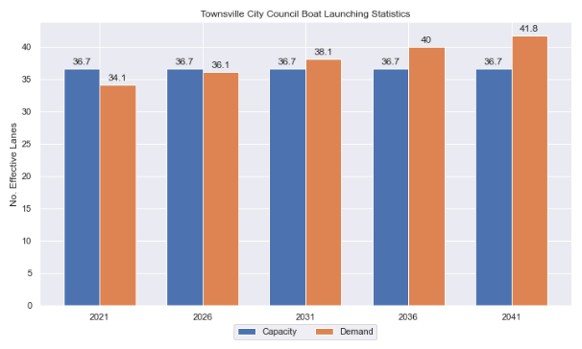

1. Existing capacity, forecast demand and shortfall of ‘effective’ boat ramp lanes for Townsville LGA

Deep-draught vessel landings

Vessel landing facilities are provided across the state in the form of pontoons and jetties, to provide locations for larger vessels, or their tenders, to access landside destinations or facilities. Pontoons and jetties may also be provided for other purposes such as supporting boat launching or other recreation and may not be suitable for deep-draught vessels. The trend across Queensland indicates that jetties are rarely used as landings, with pontoons preferred by recreational users. As such, The Study has limited the capacity of deep-draught vessel landings to those that are accessible and commonly used by deep-draught vessels, as identified in consultation with stakeholders.

Townsville LGA has three public deep-draught vessel landings comprising important facilities, two of which are within the TRBP and one on Magnetic Island at Nelly Bay. These are supported by private facilities at Breakwater Marina in Townsville’s city centre, the Townsville Yacht Club and Marina, and at the Magnetic Island Marina. There are also three jetties in the LGA that are not counted as deep-draught landings – on Ross Creek at Plume Street and Dibbs Street, South Townsville, and at Picnic Bay, Magnetic Island. These structures are in varying deteriorated condition, and at fixed heights provide an undesirable landing spot for deep-draught vessels.

The shortfall assessment in Table 2 indicates that public landing capacity for deep-draught vessels is currently sufficient to support demand in Townsville LGA, although an additional public landing in Nelly Bay Harbour on Magnetic Island would be desirable for coastal passaging vessels. The two existing South Townville jetties in Ross Creek should be upgraded to gangway-access pontoons.

1. Deep-draught vessel landing shortfall summary

| Criteria | 2021 | 2026 | 2031 | 2036 | 2041 |
| --- | --- | --- | --- | --- | --- |
| Deep-draught vessel demand | 2.2 | 2.3 | 2.4 | 2.6 | 2.7 |
| Deep-draught vessel capacity | 3 | 3 | 3 | 3 | 3 |
| Shortfall | -0.8 | -0.7 | -0.6 | -0.4 | -0.3 |

Priority recommendations

Recommendations for new facilities or upgrades to existing facilities are outlined in Table 3. The range of recommendations seeks to reduce the overall capacity shortfall that is forecast to occur in the Townsville LGA over the 20-year planning life of this project, as well as address specific concerns, including improving the capacity of facilities for coastal creek fishing.

Recommendations

1. Summary of recommended boating infrastructure upgrades for Townsville LGA

| Priority | Criteria | Recommendations |
| --- | --- | --- |
| 1 | * Required to meet existing demand. * Sites that can provide maximum benefit for existing demand pressures at an LGA scale or satisfy specific safety pressures. | * Nil |
| 2 | * Required to meet demand within the next five to ten years. * Sites that are likely to have low to medium approval complexity. * Sites that can provide satisfaction of specific demand or safety pressures within the LGA. | * Bushland Beach (Stony Creek): Improve parking capacity by semi-formalising the open areas around the facility. * Ross Creek: Demolish existing jetty and construct new gangway-access pontoon |
| 3 | * Required to meet demand within the next ten to fifteen years. * Sites that service planned future growth within the LGA. | * Nil |
| 4 | * Required to meet demand within the next fifteen to twenty years. * Sites that service planned future growth within the LGA. | * Nathan Street, Cranbrook: Construct 2-lane ramp and CTU parking area. |

Contents

Definitions 10

1 Introduction 13

2 Townsville LGA Overview 14

2.1 Key influences on recreational boating 14

2.2 Existing recreational boating infrastructure 14

2.3 Existing usage and issues 17

3 Capacity Assessment 18

3.1 Boat ramps 18

3.2 Access to sheltered near all-tide and all-tide facilities 25

3.3 Deep-draught vessel landings 28

4 Beach Ramps 29

4.1 Pallarenda, Marlow Street 29

5 Demand Assessment 31

5.1 Activation rate 31

5.2 Digital user survey 32

5.3 Active fleet size 36

5.4 Boat ramp lane demand 36

5.5 Non-statistical demand 36

5.6 Deep-draught vessel demand 37

6 Shortfall Assessment 39

6.1 Shortfall assessment – boat ramps 39

6.2 Shortfall assessment – deep-draught landings 40

7 Stakeholder Feedback 42

7.1 Managing authority feedback 42

7.2 Stakeholder feedback 43

8 Development Recommendations 45

8.1 Previous recommendations 45

8.2 Priority recommendations 46

8.3 Priority 1 recommendations 48

8.4 Priority 2 recommendations 48

8.5 Priority 3 Recommendations 53

8.6 Priority 4 Recommendations 53

9 References 56

Annex A Demand Study A-1

Annex B Boat launching facility capacity B-1

Annex C Travel time statistics C-1

Annex D Facility Use D-1

Tables

Table 2.1 Recreational boating facilities by facility owner in the Townsville LGA 14

Table 3.1 Queuing facility efficiency modifiers 21

Table 3.2 Deep-draught landing facilities within Townsville LGA 28

Table 5.1 LGA of origin for active fleet in Townsville LGA 32

Table 5.2 Popularity of boat launching facilities. 33

Table 5.3 Active fleet vessel size 36

Table 5.4 Boat ramp lane demand 36

Table 5.5 Deep-draught vessel landing demand 38

Table 6.1 Shortfall of boat launching facilities 39

Table 6.2 Shortfall assessment for open water, all-tide or near all-tide facilities for Townsville LGA 40

Table 6.3 Shortfall of deep-draught vessel landings 41

Table 7.1 Stakeholder identified opportunities 42

Table 8.1 Assessment of unimplemented 2017 recommendations 45

Table 8.2 Summary of recommendations for Townsville LGA 47

Table 8.3 Bushland Beach, Marina Drive (Stony Creek) 48

Table 8.4 Ross Creek deep-draught landing 50

Table 8.5 Nathan Street, Cranbrook 53

Table B.1. Capacity of existing boat launching facilities B-1

Table C.1. Travel time from population centres to nearest sheltered all-tide or near all-tide open water accessible facilities C-1

Table D.1. Boat launching facility usage statistics D-1

Figures

Figure 2.1 Townsville LGA - boat launching facilities 15

Figure 2.2 Townsville LGA - deep-draught landing facilities 16

Figure 3.1 (a) Summary of open water access from boat launching facilities (left) and (b) Summary of tidal restrictions at tidal boat launching facilities (right) 23

Figure 3.2 Summary of limiting capacity constraint 24

Figure 3.3 Distribution of travel time from Townsville LGA’s eligible population centres to sheltered near all-tide facilities 26

Figure 3.4 Townsville LGA – Travel time to nearest all-tide or near all-tide facility 27

Figure 4.1 Pallarenda boat ramp 29

Figure 5.1 Townsville LGA – Vessel pathing 35

Figure 6.1 Shortfall assessment with recommended upgrades adopted. 39

Figure 8.1 Priority 2 Recommendation – Bushland Beach 49

Figure 8.2 Priority 2 Recommendation – Ross Creek deep-draught landing 52

Figure 8.3 Priority 4 Recommendation – Nathan Street, Cranbrook 55

Definitions

| Term | Definition |
| --- | --- |
| All‑tide (for boat ramps) | Access from a boat ramp to the open sea with an approach depth of 0.5m below LAT or deeper and a depth at boat ramp toe of 0.5m below LAT or deeper. |
| All-tide (for landings) | Access from a gangway‑access pontoon or jetty to the open sea with an approach depth of 1.5m below LAT or deeper and a depth on at least one face of the pontoon of 1.5m below LAT or deeper. |
| BIP | Boating Infrastructure Program – a sub‑program within MSQ's Maritime Assets and Infrastructure Program |
| Boat ramp | A foreshore concrete ramp with a slope designed for vehicular launching and retrieving of recreational boats. |
| Breakwater | A structure constructed over the seabed and/or the foreshore, usually rising to a height above high tide, designed to provide protection to landward areas by limiting penetration of wave action or currents. |
| CTU | Car-trailer unit space – a parking space for a typical car with a boat trailer attached. |
| Demand | Demand is the requirement of the boat‑owning population for facilities to launch/retrieve trailer boats and/or to berth suitable boats at a given year to service their average (non‑peak period) needs. In most locations demand is based on vessel registrations and is expressed in terms of boat ramp lanes or in number of 12m berths at landings. |
| Effective capacity | For a boat ramp, effective capacity (effective lanes) means the number of boat ramp lanes after adjusting for anticipated unavailability due to unacceptable wave action (>0.2m wave height) or water depth, usage constraints such as the lack of adequate parking, and improvements to efficiency or launch/retrieval throughput such as floating walkways or pontoons. |
| FHA | Fish Habitat Area, declared under the Fisheries Act, 1994 |
| FIFO | Fly‑in fly‑out, where skilled workers travel from their city or central location home communities to a remote site to perform their duties often in blocks of time that provide regular, non-weekend, days off. |
| Fixed sloping walkway | A fixed sloping structure installed at the side of a boat ramp to assist launching/retrieval of trailer boats, and dry embarkation/disembarkation from trailer boats. It is sloped to allow use at varying tide heights – sometimes with sections of different slope. |
| Floating walkway | Multiple connected/hinged flotation modules configured to assist launching/retrieval of trailer boats, and dry embarkation/disembarkation from trailer boats at most if not all stages of the tide. Floating walkways are connected to a concrete shore abutment allowing pedestrian and assisted wheelchair access. |
| Gangway access pontoon | A platform/module that always floats, where a boat can be secured alongside on one or more faces. Pontoons are usually separated from a boat ramp and have a hinged articulated gangway for access to the shore via an abutment. |
| GBR | Great Barrier Reef |
| GCWA | Gold Coast Waterways Authority |
| Landing | A landing is a jetty or gangway‑access pontoon that facilitates berthing of vessels and transfer of passengers and stores. They are most often associated with non-trailable vessels |
| Landside | Refers to areas above high-water mark, often used to denote the location of and type of infrastructure. |
| LAT | Lowest Astronomical Tide, used as Chart Datum on navigational charts. |
| LGA | Local Government Area |
| Managing authority | Councils, port authorities, water storage managers as listed in schedule 1 of the Transport Infrastructure (Public Marine Facilities) Regulation 2011 |
| MCU | Material change of use under the planning scheme |
| MNES | Matter of national environmental significance under the Environment Protection and Biodiversity Conservation Act 1999 |
| MSQ | Maritime Safety Queensland |
| NC Act | Nature Conservation Act 1992 |
| Near all‑tide | Access from a boat ramp to the open sea with a minimum approach depth of 0.5m below LAT and minimum depth at the boat ramp of 0.5m below LAT for 80 percent or more of the tidal range (time measured over a year). |
| Parking - Formalised | A sealed, line-marked parking area for car-trailer units, providing adequately sized parking spaces, roadways and turning circles. |
| Parking – Semi-formalised | An all-weather non-sealed parking area, with markers to delineate adequately sized car-trailer unit parking bays and turning circles. Markers can be concrete blocks, pavement markers (e.g., retro-reflective raised markers) or other permanent instalment to show parking bays. |
| Parking – Informal overflow | A naturally surfaced area available for use as overflow parking on the design boating day, signed as such. To have mixed-use purpose (e.g., parkland) when not being utilised as overflow parking. |
| Part‑tide | Boat ramps that do not meet near all-tide or near all-tide requirements. |
| PV | Passenger vehicle (i.e., car – as opposed to car-trailer unit). |
| Port Authority | An organisation that is responsible for the management of one or more ports on the Queensland coast. |
| Population Centre | Official named urban settlements (populated places) that have been sourced from the Queensland Place Names Database. |
| Registration activation rate | The percentage of registered vessels liable to be in use on any given good weather weekend day |
| Shortfall | The number of effective boat ramp lanes or landings required to meet demand for a given timeframe. Negative shortfall signifies an oversupply for the time period nominated. |
| SPL | Strategic Port Land |
| Study | The Recreational Boating Facility Demand Forecasting Study 2022, including this document. |
| TMR | Department of Transport and Main Roads |
| Water Storage Authority | Includes Seqwater, Sunwater |
| Waterside | Refers to areas below high-water mark, often used to denote the location of and type of infrastructure, including dredged channels and breakwaters. |
| WHA | World Heritage Area |
| # | Number |

# Introduction

BMT has been appointed to undertake the Recreational Boating Facilities Demand Forecasting Study 2022 (‘the Study’) by Maritime Safety Queensland (MSQ), a branch of the Queensland Department of Transport and Main Roads (TMR), on behalf of all public recreational boating facility managers and owners across Queensland. The Study supersedes the 2017 study of the same name and is intended to report on recreational boating facility demand, capacity, and shortfall over a 20-year period at a Local Government Area (LGA) scale across Queensland.

The Study has been developed using information from the 2021 Australian Census (ABS, 2021), recreational boat vessel registrations, consultation with facility owners, managers, and stakeholders, the 2022 Queensland Government Get-Involved recreational boating facilities survey (MSQ, 2022), and previous versions of this Study (2011, 2017). The Study is intended for use by deliverers, owners, managers, and key stakeholders of public recreational boating facilities across Queensland, namely state government agencies including MSQ and the Gold Coast Waterways Authority (GCWA), local governments, port authorities and water authorities. The Study is non-regulatory in nature and is intended to be used as part of a broader suite of information to identify priority investment in recreational boating infrastructure at a local and state level.

The Study establishes demand primarily on statistics derived from registration and population data. Please refer to Section 4.5 for discussion of non-statistical demand. The Study evaluates existing and forecast demand over a 20-year period and makes recommendations on how this demand might be met over that period. Recommendations may include improvements to both landside and waterside capacity depending on the facility.

Recommendations are assigned a priority ranking, from 1 to 4, indicating if they are required immediately or in the next 5, 10 or 15 years respectively. To end 2022, 14% of recommendations from the 2017 study have been completed, comprising 11% of land-side recommendations and 18% of waterside recommendations and reflecting 22% of priority 1 the 2017 recommendations. A much greater percentage of the earlier 2011 study recommendations have now been implemented. Given the low uptake on existing/outstanding recommendations, this Study will review previous recommendations and carry forward, modify, or remove as appropriate. The Study has also been tasked with reviewing specific wave exposed beach launching facilities across the state to determine their contribution to meeting boating facilities demand and make recommendations about their future.

The Study is comprised of a report for every LGA in Queensland and a state-wide summary report. Each LGA report summarises demand pressures from vessel registration data, population statistics, assumptions around local usage and the movement of vessels into and out of the LGA, and existing capacity and recommends opportunities to satisfy shortfall. The state-wide report will support the LGA reports and provide context at a state level for demand pressures, current capacity, equity of access to facilities and state-wide priority for major boating facilities.

The Study is intended to report on publicly accessible recreational boating facilities for registered vessels. This includes boat ramps, floating walkways, pontoons, fixed sloping walkways and supporting car-trailer unit parking at each facility. The Study does not include recommendations for facilities that are used primarily for commercial purposes, private facilities, non-motorised recreation such as launching canoes and stand-up paddle boards, and fishing platforms.

# Townsville LGA Overview

## Key influences on recreational boating

Within Townsville LGA, the principal attributes and influences that affect demand on recreational boating infrastructure include:

* its designation as a Regional Centre, with a large local recreational boating fleet
* strong projected population growth
* smaller LGAs to the north and south with launching locations in closer proximity to attractive destinations for the Townsville LGA fleet
* complicated relationship between recreational vessels and Port of Townsville operations.

## Existing recreational boating infrastructure

The recreational boating facilities within Townsville LGA are summarised in Table 2.1. These facilities are owned or managed by multiple organisations and include facilities that provide access to open water, estuaries, and fresh water. MSQ’s long term vision is to provide unrestricted access to open water from facilities along the Queensland coast such that all significant population centres are within one hour’s driving range where practical. For clarity, the Study has defined this vision to be the provision of sheltered all-tide, or near all-tide, boat launching facilities within one hour driving range of official population centres (DoR, 2022) lying within 30km of the coastline between the NSW border and Cooktown.

Recreational boating facilities by facility owner in the Townsville LGA

| Owner | Open-water boat ramps | | Other boat ramps | | Landings | |
| --- | --- | --- | --- | --- | --- | --- |
| Facilities | Lanes | Facilities | Lanes | Pontoons | Jetties |
| TMR | 9 | 30 | 7 | 9 | 4 | 3 |
| Townsville City Council |  |  | 4 | 4 | 1 |  |

Each of the boat launching facilities within the LGA are shown in Figure 2.1 and deep-draught vessel landings in Figure 2.2.

Access to land from deep-draught vessels is catered for by the provision of landings that are intended for short term usage, mainly to drop off and embark passengers and supplies. Within Townsville LGA these vessels are catered for at the following locations:

* two public pontoons at the Townsville Recreational Boating Park
* a gangway-access pontoon at Nelly Bay, Magnetic Island.

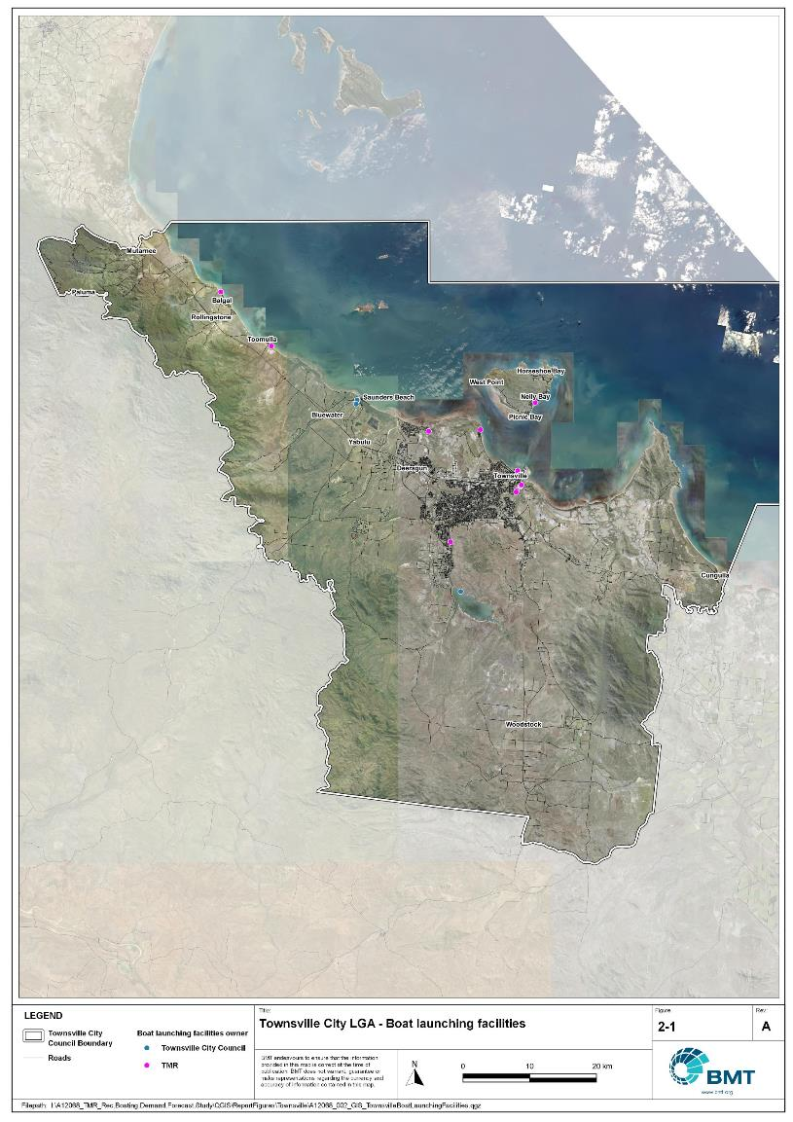

Townsville LGA - boat launching facilities

"I:\A12068_TMR_Rec.Boating.Demand.Forecast.Study\QGIS\ReportFigures\Townsville\A12068_002_GIS_TownsvilleBoatLaunchingFacilities.jpg"

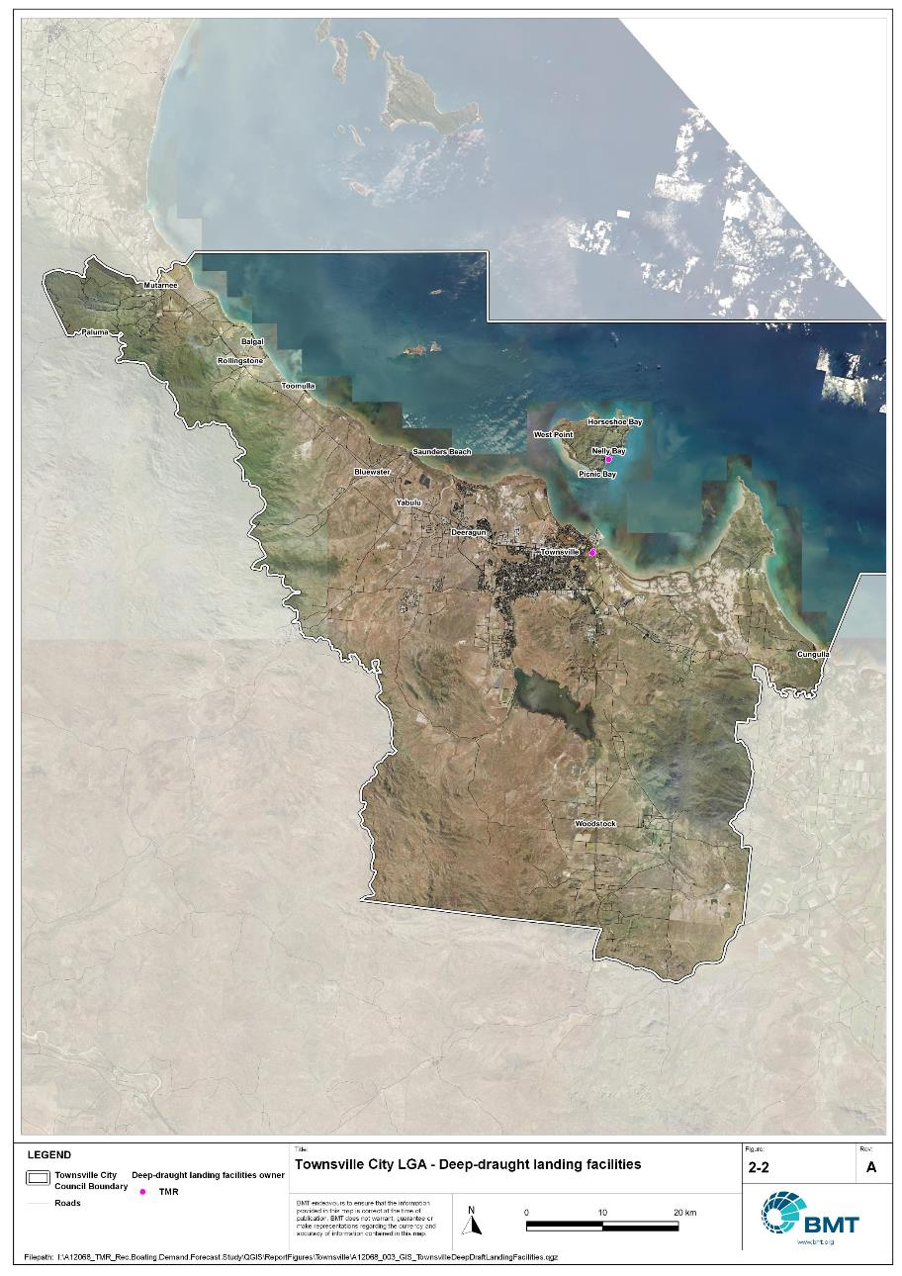

Townsville LGA - deep-draught landing facilities

"I:\A12068_TMR_Rec.Boating.Demand.Forecast.Study\QGIS\ReportFigures\Townsville\A12068_003_GIS_TownsvilleDeepDraftLandingFacilities.jpg"

## Existing usage and issues

Consultation with Townsville City Council, Sunwater, Port of Townsville, Maritime Safety Queensland, recreational groups and feedback from the recreational boating facilities survey hosted by TMR indicate the following major themes and issues within Townsville LGA.

* + 1. Conflicts in Ross River between recreational boats and Port of Townsville operations

The existing recreational facilities in Ross Creek are very popular due to their close access to open water destinations. However, this is also a prime area for future port expansion. Even if the existing recreational facilities are retained, the planned increase in number and size of vessels entering the Port of Townsville will increase conflicts between recreational vessels and port operations. Discussions between all parties indicated a desire to separate recreational and port marine traffic.

* + 1. Air-draught limit at the Townsville Recreational Boating Park

The southern port-access road bridge that crosses Ross River limits the height of vessels that can access the Townsville Recreational Boating Park to 6m. While this is reasonable for most trailable vessels, masted yachts and larger non-trailable vessels seeking to use the pontoons at the boating park are unable to access the facilities. As such, unrestricted air-draught facilities are required to be retained in future for both launching ‘trailer-sailers’ and as landing facilities for deep-draught vessels. This is particularly important given the desire (above) to separate recreational facilities from Port of Townsville activities.

# Capacity Assessment

## Boat ramps

* + 1. Introduction

Boat ramps are facilities that are used for launching and retrieving trailable vessels, typically up to 8m in length (with some exceptions), to and from the water. Boat ramps consist of one or more lanes and their use is often supported by landside and waterside infrastructure to improve efficiency. In some instances, the usability of a facility can be adversely affected by environmental constraints such as low water levels, currents, or wave exposure, reducing the overall availability of the facility. Together, consideration of the number of boat ramp lanes, the supporting infrastructure, and environmental constraints results in the facility having a capacity described in terms of ‘effective lanes’ that may or may not be equal to the number of actual boat ramp lanes.

To maximise usage of each facility, the landside and waterside capacity should be balanced. Each facility will have a calculated ‘effective’ capacity for both the landside and waterside elements, with the limiting element dictating the facility's overall effective capacity. Recommendations for works or infrastructure promote balancing these two capacity elements by either improving the limiting element for increased facility effectiveness or by increasing the overall 'effective capacity' through changes to both elements.

* + 1. Boat ramp capacity

The overall capacity of each boat launching facility is limited by the effective capacity of either the waterside or landside elements. The waterside capacity is informed by the number of boat ramp lanes and the number and type of queuing facilities, such as pontoons, floating walkways, queuing beaches and fixed sloping walkways. It may also be limited by the available water depth in the adjacent waterbody and exposure to environmental or other physical factors.

Landside capacity is governed by the availability of nearby spaces for parking of car-trailer units (CTU), the provision of rigging and de-rigging facilities, and provision of single car parking spaces (single cars may otherwise be obliged to park in CTU spaces).

While it is expected that facilities will have their own characteristics influencing efficient use, this Study applies an approach that is consistent across the entire state and consistent with previous editions of the Study. Accordingly, the effective waterside capacity of a boat launching facility is determined as being:

* the ability to support 40 vessels being launched and retrieved per day per lane (see section 3.1.3)
* influenced by exposure to wave, tide, and current conditions (see section3.1.4
* supported by queuing facilities that assist in the efficient use of the boat ramp (see section 3.1.4).

Calculation of landside capacity is in line with the TMR guideline (TMR, 2020), which requires less provision of CTU parking per lane than the Australian standard (AS3962 Table 7.1), and advises:

* 10 CTUs for a single lane boat ramp accessed by an unsealed road, or 15 CTUs accessed by a sealed road
* 45 CTUs for a two-lane boat ramp
* 70 CTUs for a three-lane boat ramp
* 90 CTUs for a four-lane boat ramp.

A notable difference from the 2017 study is the recognition and inclusion of areas close to existing boating facilities that are unsealed and/or not line marked where parking of cars with trailers occurs and is not discouraged. These areas of informal parking have been identified on aerial imagery and through discussions with managing authorities. Each informal area has been assumed to be available for CTU parking only 50% of the time to account for conflicts with other uses (for example, markets), inefficient parking practices, or poor ground conditions. The rate of parking has been calculated as:

* for linear areas where nose-to-tail parking is expected – 1 CTU per 13m
* for linear areas with enough space to allow side-by-side parking – 1 CTU per 3m, provided there is a minimum distance of 15m from the road or manoeuvring area
* for large areas – 1 CTU per 100m2.
  + 1. Boat ramp capacity basis

The number of vessels per day each boat ramp lane can support is based on the Australian Standard for the Design of Marinas (AS3962-2001) and previous versions of this report (GHD, 2011 and 2017).

Research on boat ramp lane efficiency described in the previous report (GHD, 2017) identified that 40 vessels per lane per day was a reasonable compromise between 50 vessels per lane per day (representing congested conditions) and 30 vessels per lane per day (representing unhampered conditions). For context, the 40 vessels per lane per day rate represents a vessel launch or retrieval every 9 minutes per lane within an average normally used period of 12 hours per day.

During this Study, BMT has sought to validate the assumptions presented above, and those relating to capacity modification, by undertaking a literature review, conducting site visits that included observations of launching and retrieving manoeuvres, and reviewing video recordings of boats launching and retrieving at popular boating facilities. The literature review included a boat ramp efficiency investigation undertaken by BMT on the Mornington Peninsula, Victoria (BMT, 2015) and a review of standards from other Australian states and countries that undertake similar studies. The onsite and video analysis provided the opportunity to observe recreational boat operators using facilities included in the Study but did not include observation of total throughput during high demand periods. This assessment was undertaken during site visits across Queensland, and a full day of video recording at Manly Boat Harbour (north ramp) in Brisbane.

The New South Wales and Victoria governments are currently in a planning phase for boating infrastructure and there are presently no publicly accessible documents identifying how those jurisdictions calculate boat ramp lane capacity. The Western Australia government has commissioned studies of the Perth region and the southwest region (Western Australia Department of Transport, 2019 and 2021) that indicate a base rate of 50 vessels per lane per day, with no modifiers applied. Internationally, studies from Florida in the USA (Bell, 2022 and Swett et. al, 2012) assumed that total vessel launch plus retrieval time is between 20 to 40 minutes (18 to 36 vessels per day), although no evidence is provided to support this assumption.

The Mornington Peninsula report (BMT, 2015) collected boat launch and retrieval data for 6 boat ramp facilities on the Mornington Peninsula across 9 days, including the peak Australia Day holiday. Total throughput was assessed for each facility on days where there was constant pressure for launching and retrieving boats with results between 30 and 70 vessels per lane per day for the various facilities. When adjusted for queuing modifications, a baseline rate of between 20 and 50 vessels per lane per day was identified. Of the facilities, the higher rates were achieved where sufficient parking was provided and both waterside and landside queuing facilities existed.

Observations of recreational boat users launching and retrieving their vessels undertaken through the site visits and the analysis of video footage showed that:

* Most observed launches were of ‘multi-person’ boats, which made launching and retrieving boats more efficient.
* Almost all users were able to launch and/or retrieve their boat within the 9-minute target time, when adjusted for queuing facility efficiency.
* There was a preference to launch adjacent to a floating walkway, where one was available. At facilities where a queuing facility is not immediately adjacent to the lane it is expected that average launch times may slightly increase during busy periods.

While the observations that were made generally aligned with expectations, a more in-depth review of capacity assumptions was outside of the scope of the Study. For future studies there would be value in undertaking a more thorough, data-driven investigation of the assumptions about boat ramp lane capacity, both at its base level and modified by queuing facilities. Overall, the preliminary investigations undertaken as part of the Study suggest that the base rate of 40 vessels per lane per day adopted in previous studies is appropriate.

* + 1. Boat ramp efficiency modifications

The waterside capacity of boat ramp lanes can be reduced by environmental factors that include:

* Water levels: Mainly relating to tidal areas this factor considers the reduction in the amount of time the boat ramp is available to launch and retrieve vessels over the full tidal cycle, thus reducing the overall capacity of the facility. For all-tide access, the boat ramp and connecting channel to the open sea are available during all tidal conditions and therefore available 100% of the time. For near all-tide access the boat ramp and the connecting channel to the open sea are assumed to be available, on average, for 80% of the tidal cycle. For part-tide access the boat ramp and its access channel are available less than 80% of the time. A modification factor of 0.8 is applied for near all-tide facilities and 0.5 for part-tide facilities.
* Wave and current conditions: In areas where vessel launching and retrieval may be intermittently impacted by waves (most commonly on beach ramps, but not exclusively) or strong currents (such as in rivers), a modification factor of 0.5 is applied.

Conversely, effective boat ramp capacity can be improved through the use of well-designed queuing facilities. Queuing facilities aim to improve amenity and efficient use of the boat ramp by accelerating one or more of the following phases of boat launching, with the opposite steps required for retrieval:

1. manoeuvring for launching, including for CTU entering the queuing area for the boat ramp and reversing into position for launch
2. launching and securing the launched vessel
3. moving the launch vehicle from the boat ramp to the parking area
4. removing the vessel from the waterside queuing facility.

A range of waterside queuing facilities is in use in Queensland boating infrastructure, which modify different phases of the total launching process. These include:

* Floating walkways and fixed sloping walkways: Positioned to about a boat ramp lane, these structures aim to:
  + improve amenity – such as to assist embarking/disembarking passengers, provide a refuge from in-water contact with crocodiles and so on
  + make securing the vessel and removing the vehicle from the boat ramp more rapid, while freeing the boat ramp for subsequent users.
* Pontoons: Also used by deep-draught vessels, these structures improve the ability to secure the vessel and clear the boat ramp, but there is usually some time lost returning to recover the launch vehicle compared with the above options as they are generally positioned slightly further away from the ramp.
* Queuing beaches: These also provide a place to secure the vessel close to the boat ramp, although they are generally not as fast to use as pontoons.

As observed throughout the Study site visits, each of these queuing facility types can support a limited number of boat ramp lanes depending on the available space on the queuing facility. The 2017 edition of this Study applied a blanket uplift for all boat ramp lanes where a queuing facility was provided. However, the number of lanes each type of queuing facility can realistically support varies. Accordingly, this Study has provided limitations to the number of boat ramp lanes that can benefit from each queuing facility, based on the number of “working faces” (or area for a queuing beach) provided, where the “working face” is a face that allows temporary securing of vessels during launching or retrieval. The adopted improvement factors and supported lanes are summarised in Table 3.1.

Queuing facility efficiency modifiers

| Queuing facility | Modification factor | Supported lanes |
| --- | --- | --- |
| Floating walkway (lanes adjacent to walkway) | 1.7 | 1 Lane/face |
| Floating walkway (lanes not adjacent to walkway) | 1.3 | 1 Lane/face |
| Fixed sloping walkway | 1.7 | 1 Lane/face |
| Pontoon | 1.2 | 2 Lanes/face |
| Queuing beach | 1.1 | Site-based |

In other states in Australia, reversing queuing bays are more commonly used than in Queensland. These are CTU waiting bays at the head of the boat ramp that are aligned with each boat ramp lane to allow the user to reverse directly down the boat ramp once it is clear. CTU waiting bays reduce the time of the first phase of boat launching by allowing waiting CTU’s to be ready to reverse as soon as the lane becomes clear. The BMT (2015) study on the Mornington Peninsula included facilities with and without these bays. Boat ramps that included reversing queuing bays achieved 50% greater throughput. Facilities that have implemented this approach in Queensland include North Street Southport, Urangan Boat Harbour, Townsville Recreational Boating Park, and the (under construction late 2022) boat ramp at Yorkeys Knob.

* + 1. Accessibility from boat launching facilities

Recreational boat users will typically select the boat launching facility most appropriate or convenient to the activity they are seeking to undertake, the anticipated weather/wave conditions, and their destination. Each of facility within an LGA will provide a varying degree of access to different destinations and for different activities. During the Study, consultation with stakeholders highlighted the following general types of destinations and activities:

* open water/offshore: typically accessed for visiting offshore islands or remote beaches, snorkelling or diving locations, deep sea fishing and general recreation
* creeks and estuaries: typically accessed for fishing, crabbing, wildlife observation, skiing and general recreation
* freshwater: typically accessed for skiing, fishing, wildlife observation and general recreation.

These destinations are typically serviced by different types of recreational vessels. Inshore locations including creeks, estuaries and other freshwater locations are typically patronised by vessels less than 4.5m, except for ski boats, which can be much larger than this. Offshore locations typically require larger boats for access as these vessels are more capable of managing a wide range of wave conditions and can carry sufficient fuel to access distant destinations. Smaller vessels may be able to access close destinations on good weather days, and larger vessels may choose to access inshore destinations, particularly on poor weather days.

Consequently, the following aspects are used to classify how well a facility provides open water access:

* Open-water access: There are no restrictions between the facility and open water.
* Depth-limited access: There are depth restrictions between the facility and open water that limit navigable access to part of the tidal range. This differs from tidal constraints at the actual facility, which might be usable at all tides, but offshore access is limited by a downstream bar or delta.
* Distance-limited access: The distance from the facility to the open water is unrealistic for typical boat users. This distance is assumed to be about 4.5km between the facility and open water to rate as 'distance limited', with travel times increased further where portions of the access channel are regulated by speed limits.
* Infrastructure-limited access: There are man-made obstacles between the facility and open water, such as above-ground pipeline crossings, low bridges or weirs that impede navigable access to open water.
* Beach ramps: These provide open-water access but are typically constrained by environmental conditions such as wave exposure and tide levels. The capacity of these facilities has been individually assessed based on consultation and other data sources and is described in more detail in section 4.
* Freshwater: There is no access to open water.

Certain facilities, particularly those in freshwater, may be constrained by periods of drought, or debris deposition after rainfall events that limit access to destinations, and therefore whether a facility will provide useful boat launching capacity. While it is noted that drought and rainfall may affect the overall capacity of boat launching within an LGA, and given that the timing of such events is not readily predictable, their impact on capacity has not been evaluated.

* + 1. Existing boat launching capacity

Within Townsville LGA there are 20 boat launching facilities with a total effective capacity of 36.7 lanes. The effective capacity of boat launching facilities within Townsville LGA is shown in Annex B, with a summary of the access to open water and tidal constraints shown in Figure 3.1 and the overall capacity constraint shown in Figure 3.2. Pertinent features of these facilities include:

* There are 44 total lanes, with an effective capacity of 36.7 effective lanes. This effective capacity is primarily reduced due to insufficient parking being allocated for each lane.
* Boat users in Townsville LGA have a range of options for boating, with facilities available for accessing freshwater destinations, estuaries and offshore destinations.
* Most of the facilities provide all-tide access.

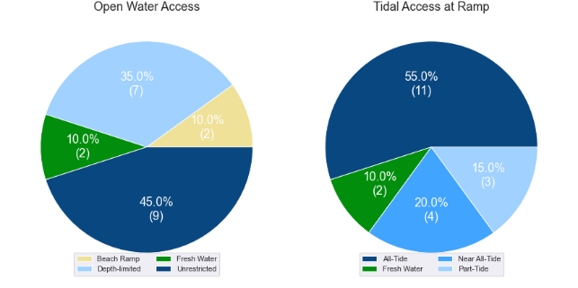

(a) Summary of open water access from boat launching facilities (left) and (b) Summary of tidal restrictions at tidal boat launching facilities (right)

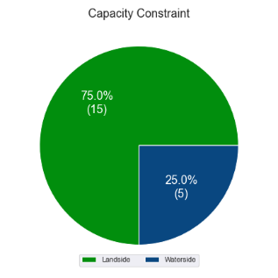

Summary of limiting capacity constraint

## Access to sheltered near all-tide and all-tide facilities

MSQ has a longer-term vision to provide access to all-tide or near all-tide open water access boat launching facilities along the Queensland coast, such that all significant population centres are within one hour’s driving range as far as practical (TMR, 2020). For this purpose, the Study has defined towns as being within the coastal strip if within 30km of the Queensland coastline. The vision (TMR,2020) is applied to the coastal strip between the NSW border and Cooktown. Consultation throughout the Study has highlighted that this vision is important with users/stakeholders and organisations that own and manage these facilities. As such, the Study has developed a statistical approach to quantify this vision to allow it to be measured and tracked over time. To do this, the Study has calculated the travel time from all Population Centres (DoR, 2022) within the coastal zone to the nearest available sheltered, all-tide or near all-tide facility, regardless of which LGA it is in. This has been accomplished using mapped road networks and assigning speed limits to each type of road, with the following speed limits applied:

* for restricted roads, 40km/hr
* for local roads, 60km/hr
* for connector roads, 70km/hr
* for distributor roads, 80km/hr
* for highways, 100km/hr.

For Townsville LGA the median travel time from eligible Population Centres to the nearest sheltered all-tide or near all-tide facility is 26 minutes. The distribution of travel times is shown in Figure 3.3 with detailed travel times in Annex C. Figure 3.4 provides a visual representation of the travel time from each of the sheltered near all-tide facilities that serve the LGA. Of interest for Townsville LGA are:

* 100% of the eligible population centres are within the desired 1-hour travel time.
* Most eligible population centres are within 30 minutes of a sheltered near all-tide or all-tide facility.
* Various facilities in central Townsville are the only mainland facilities providing this capacity, so travel time increases from the Townsville CBD.

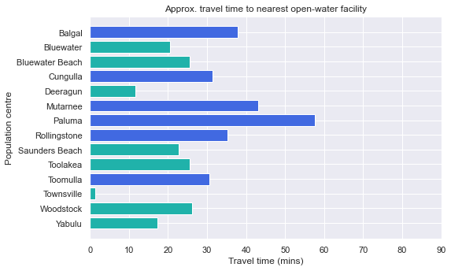

Distribution of travel time from Townsville LGA’s eligible population centres to sheltered near all-tide facilities

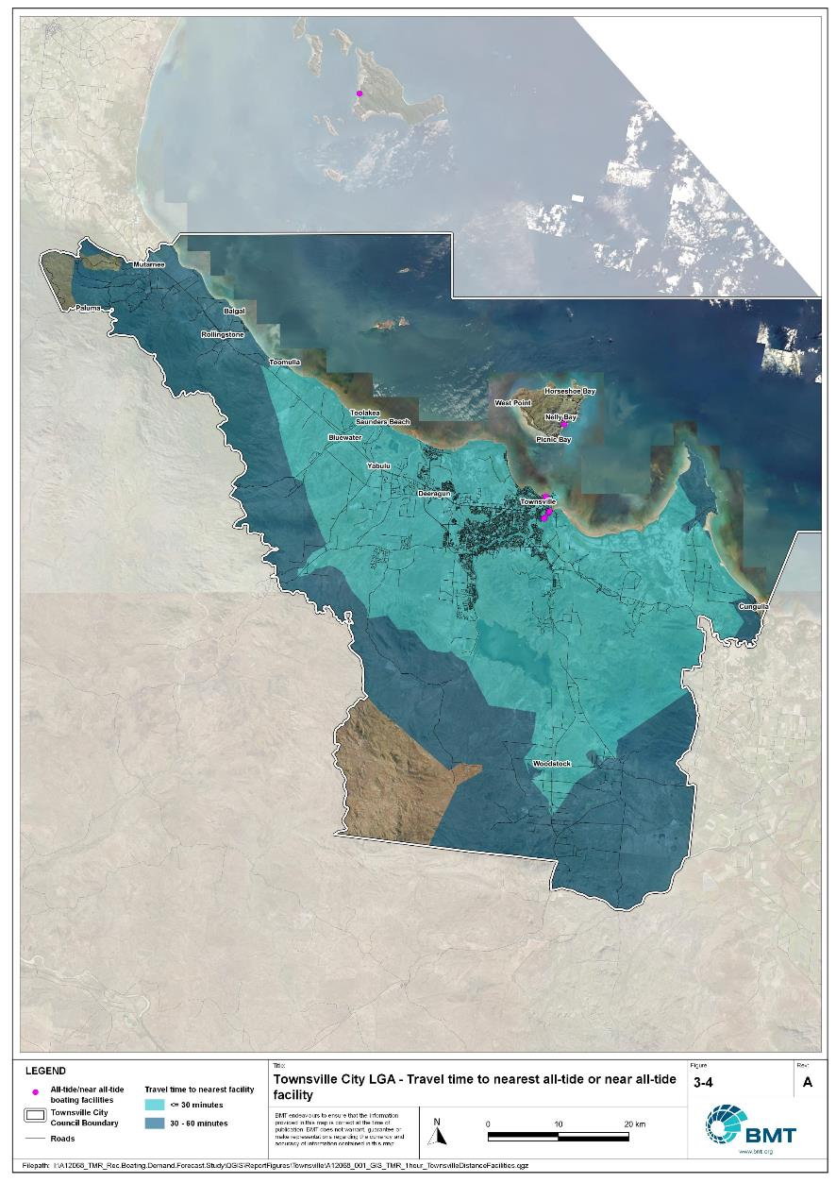

Townsville LGA – Travel time to nearest all-tide or near all-tide facility

"I:\A12068_TMR_Rec.Boating.Demand.Forecast.Study\QGIS\ReportFigures\Townsville\A12068_001_GIS_TMR_1hour_TownsvilleDistanceFacilities.jpg"

## Deep-draught vessel landings

Deep-draught vessel landings are intended to provide short-term landing capacity for vessels that are too large to use public boat launching and retrieval facilities. These facilities are provided for the benefit of both local vessels and to service the fleet of vessels that travel along the Queensland coast. Deep-draught vessel landings may be designed to accept one or more large vessels at a time and/or provide capacity for tenders from larger vessels that may be anchored or moored nearby, for the purpose of loading and offloading passengers and supplies, and making short local visits to onshore destinations.

For the Study, deep-draught vessel landings need to be primarily accessible by recreational boats for short, temporary stays. In some cases, commercial vessels may utilise these facilities subject to the relevant permissions, however, this may reduce the capacity of the facility to cater for recreational vessels. Deep-draught vessel landings should be located such that the facility provides reasonable access to landside passenger pick up and drop off, provisioning, recreational destinations, or population centres. Within Townsville LGA there are three fit for purpose landings that provide access to the following facilities or destinations:

* Two public pontoons in the Townsville Recreational Boating Park, that are restricted to boats with an air draught of less than 6m due to the downstream bridge. These landings are of 30m and 50m lengths, the latter of which may be able to accommodate two deep-draught vessels. These facilities provide access to a car park for pickup/drop-off of passengers, as well as a walk and/or public transport options to reach landside destinations such as supermarkets for reprovisioning.
* A gangway-access pontoon on Magnetic Island at Nelly Bay allows for reprovisioning at the supermarket (approximately 1.2km distance), as well as various recreational activities and destinations on Magnetic Island as a holiday destination.

As well as the above, Townsville LGA has additional deep-draught vessel landings provided by private facilities at Breakwater Marina and the Townsville Yacht Club which have publicly available refuelling facilities.

There are also two jetties located within Ross Creek in South Townsville, at Dibbs Street and Plume Street. These are not counted in this assessment as fit for purpose deep-draught landing facilities as they are in deteriorated condition and are undesirable for use. Similarly, there is a jetty at Picnic Bay, Magnetic Island, which is of fixed height and is unsheltered from wind and waves, and is consequently undesirable for use and not included in the deep-draught landing statistics.

In summary, Table 3.2 shows the total capacity of deep-draught landing facilities within Townsville LGA.

Deep-draught landing facilities within Townsville LGA

| Facility type | Total capacity |
| --- | --- |
| Public sheltered mainland landings | 3 |
| Private sheltered landings | 3 |
| **Total** | **5** |

# Beach Ramps

As part of the Study, an investigation into the suitability of wave-exposed beach launching ramps was undertaken. These facilities were visited as part of the Study and discussed with managing authorities during consultation, to assess their capability to meet existing demand and their future potential/need. In many cases, the current fleet size and intended use has outgrown the suitability of these ramps, but in some locations, they remain the only facility to service key communities along parts of the Queensland coast. These assessments seek to assist MSQ to determine its future strategy about retention, demolition, maintenance, upgrade, or potential conversion to non-registered boating use (for instance, personal watercraft, vehicular beach access), while also considering where communities benefiting from these facilities can access suitable alternatives.

## Pallarenda, Marlow Street

The Pallarenda boat ramp is accessed from Marlow Street, servicing the immediate suburb of Pallarenda (2021 population 778) as well as nearby Townsville suburbs. The ramp consists of a concrete flexmat beach ramp as shown in Figure 4.1. During inspection of the facility, it was noted that:

* The flexmat was in good condition.
* There was considerable sand covering the flexmat at the base of the ramp.
* The ramp was exposed to occasional direct local wave action, with protection offered by Magnetic Island from waves to the northeast, and a relatively short (20-25km) fetch for easterly and south-easterly waves, although this is enough fetch for wind waves to affect the ramp and make launching difficult.
* The ramp is well supported by parking facilities and other amenities.
* The ramp has a low profile across the beach with resultant limited impact on coastal processes.

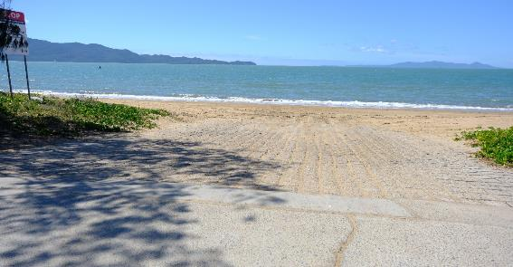

Pallarenda boat ramp

The human movement statistics (see section 5.2) indicate that this facility is used mostly by residents of Townsville City, with a very low proportion of visitors using this ramp. The ramp does provide direct access to local fishing grounds and convenient access to Magnetic Island for residents of Pallarenda. However, it is evident that once wind speeds increase, wave conditions at the ramp would make it difficult to retrieve a vessel from the ramp or force users to divert to the sheltered facility in Ross Creek, approximately 8.5km to the southeast.

Given the level of exposure to waves, tidal constraints, and landside constraints, it is likely that the facility is only available for approximately 25% to 30% of the time and therefore provides little in the way of satisfying statistical demand for Townsville LGA. Despite this, during good conditions, the ramp remains popular. It is the recommendation of the Study that the Pallarenda facility be retained in its current form as a flexmat beach access ramp.

# Demand Assessment

The Study has developed a model to calculate statistical demand for boat launching facilities and deep-draught vessel landings at an LGA scale. Vessels that are less than 8m in length are considered trailable and drive demand for boat launching facilities such as boat ramps, while those over 8m are assumed to remain on water and drive demand for deep-draught landings.

Statistical demand is recognised at three different levels for public marine facilities within the TMR guidelines (TMR, 2020), which are:

* off-peak demand – typical weekday usage
* average demand – demand on ‘good boating days’, taken to be demand for a facility on weekends (and, for certain regional locations, other busy periods)
* peak demand – demand for a facility at peak holiday periods or for special events.

The demand model created for this Study is intended to provide information on demand pressures on ‘good boating days’ for all facilities as per the intentions of the guidelines. The model achieves this through a ‘registration activation rate’ that estimates the proportion of registered vessels in an LGA that is assumed to be active on a ‘good boating day’, as well as the exchange of vessels between LGAs, and general tourism pressures.

## Activation rate

The fleet size for each LGA is determined statistically from vessel registration numbers and the application of a vessel activation rate, while for future time horizons vessel registration and population growth estimates are also utilised. The methodology for determining the registration activation rate has been adopted from the previous study (GHD, 2017), with activation rates taken to be between 8% and 14% for a typical weekend. The variability of the activation rate is intended to capture the regional differences in vessel types, and is driven by the availability of access to open water, accessibility of other recreational opportunities, and likelihood of users’ available time for recreation, considering factors including:

* remoteness classification for the LGA
* incidence of blue-collar employment
* average age of residents
* whether the LGA is coastal.

Further information about the derivation of this rate can be found in Annex A. For Townsville LGA the activation rate is assumed to be 10%, with the key factors influencing the rate including:

* its classification as a Regional Centre
* the incidence of blue-collar employment being higher than the state average
* the average age being lower than the state average
* it being located adjacent to the open coast.

## Digital user survey

To gain an understanding of usage trends at existing formal recreational boating facilities across Queensland, the Study has considered the results of a digital user survey using human movement data, sourced through a third party. The data was acquired from a location data store with more than 13 trillion mobile location observations globally from 2019 to present, which were sourced from 250,000 different mobile phone applications that users ‘opted-in’ to use the location services under the application’s terms and conditions. All data received was deidentified and compliant with relevant data privacy regulations.

The analysis uses mobile devices (such as telephones) location data as a proxy for boat user traffic, however, this relationship has several limitations including, but not limited to:

* Mobile device users detected in the area of interest may not be boat users (for example, pedestrians not using vessels may walk through the detection area).
* The relationship between mobile device users and vessels may not be 1:1 (that is, there may be multiple mobile devices providing data for each vessel).
* Users of vessels may not have a mobile device, may not be using a mobile device or may not have provided permission to use their location data.

With these, and potentially other, limitations in mind, the Study compared this data against vessel launching counts provided by various facility managers and found that 15-30% of vessels are captured using this digital survey method. This percentage can change from facility to facility and from day to day. Consequently, the Study has not relied on raw counts of users from this data, but instead considered the relative trends within the data, with the assumption that no groups (for example, users from a particular LGA or using a particular facility) within the data would be more or less likely to be captured by the technique.

The Study has used this data to identify the relative volume of users, the ‘home’ local government area of users and the popularity of destinations that users travel to once vessels have been launched. Presentation of the full dataset can be found in Annex D.

* + 1. Inter-LGA demand

The human movement data has been interrogated to determine the LGA of origin for users of Townsville LGA’s public boating facilities to ascertain the proportion of users from each LGA that are using specific facilities. Statistics from all public boating facilities within the LGA are then grouped together to determine the total proportion of resident or visiting users across the LGA. Table 5.1 shows the active fleet proportion from the top 10 LGAs contributing to demand on facilities within Townsville LGA. All other sources have been grouped together.

LGA of origin for active fleet in Townsville LGA

| LGA of origin | Active fleet proportion |
| --- | --- |
| Townsville | 74.7% |
| Brisbane | 2.7% |
| Cairns | 2.2% |
| Gold Coast | 1.5% |
| Mackay | 1.5% |
| Moreton Bay | 1.1% |
| Burdekin | 1.1% |
| Whitsunday | 1.1% |
| Sunshine Coast | 0.9% |
| Charters Towers | 0.6% |
| Other LGAs | 12.6% |

* + 1. Intra-LGA demand distribution

Recreational boating users will tend to use facilities that best suit their needs, the destinations they want to access, the capability of their vessel and the weather conditions. Consequently, distribution within an LGA is unlikely to be evenly spread across all facilities, with some facilities attracting users disproportionately due to amenity, access, or destinations. The attractiveness of large well-designed facilities is likely to draw visiting boat users in preference to smaller or less desirable facilities across the LGA. The human movement statistics have been assessed to qualitatively estimate the proportion of users using each facility, both in total and with respect to both resident and visiting boat users (Table 5.2).

Popularity of boat launching facilities.

| Facility | Overall fleet | Resident fleet | Visiting fleet |
| --- | --- | --- | --- |
| Townsville, Ross Creek | 29.9% | 32.6% | 22.1% |
| Magnetic Island, Horseshoe Bay | 19.4% | 12.7% | 39.3% |
| Townsville Recreational Boating Park | 13.3% | 15.3% | 7.2% |
| Pallarenda, Marlow Street | 6.9% | 8.0% | 3.6% |
| Bushland Beach, Marina Drive | 6.1% | 7.4% | 2.4% |
| Magnetic Island, Picnic Bay | 5.7% | 4.2% | 10.2% |
| Rasmussen, Loam Island, Illuta Street | 5.4% | 6.6% | 1.8% |
| Railway Estate, Barnicle Street | 3.6% | 4.2% | 1.9% |
| Magnetic Island, Nelly Bay Harbour | 3.1% | 2.4% | 5.2% |
| Balgal Beach, Marlin Street | 2.9% | 2.4% | 4.6% |
| Saunders Beach, Boat Ramp Road | 1.6% | 2.0% | 0.5% |
| Saunders Beach, Purono Parkway | 0.8% | 1.0% | 0.3% |
| Bluewater Beach, Bluewater Road | 0.7% | 0.9% | 0.4% |
| Toomulla, Herald Street | 0.4% | 0.3% | 0.6% |
| Townsville, Ross River Dam | 0.0% | 0.0% | 0.1% |

The results indicate that active fleet is overwhelmingly from Townsville LGA, with only minor contributions from other LGAs. The Ross Creek facilities are the preferred location to launch, with the Townsville Recreational Boating Park secondary to the Ross Creek facilities. A review of vessel paths indicates that there is likely significant pedestrian contamination in the data for Pallarenda (see Figure 5.1) and Horseshoe Bay. Bushland Beach is a popular alternative to the facilities in Townsville City with a strong presence amongst local users, while the facilities at Railway Estate are the least preferred amongst the major facilities. Both of these latter facilities are popular for estuarine boating.

The distribution of capacity within the LGA needs to consider these trends to avoid consistent capacity shortfalls at some facilities or indicating demand for unnecessary extra capacity at other facilities. Results from the above statistics and feedback obtained through the TMR online survey indicate that within Townsville LGA the following factors tend to influence the preferred facilities for recreational boat users:

* access to sheltered, all-tide launching facilities
* dry entry/exit capabilities of launching facilities provided through floating walkways and pontoons
* ability to access open water destinations.
  + 1. Destinations

For facilities that provide sheltered, near all-tide or all-tide open water access, additional analysis of the human movement statistics has been undertaken to identify destinations for users of these facilities. Location data from users utilising the facilities was extracted for a period of two hours after they used the facility and trimmed for waterside destinations. For Townsville LGA, this additional analysis was applied to the following facilities, with destinations mapped in Figure 5.1:

* Bushland Beach, Marina Drive
* Pallarenda, Marlow Street
* Railway Estate, Barnicle Street
* Townsville Recreational Boating Park
* Townsville, Ross Creek.

From this additional analysis, the following notable observations were made:

* Magnetic Island is the most desirable offshore destination for boat users, with users preferring to use the Townsville Recreational Boating Park or the Ross Creek facilities to access Magnetic Island.
* Users from the Ross Creek facilities accessed the Palm Island group, while users of the Townsville Recreational Boating Park accessed Magnetic Island, Cape Cleveland and the estuaries between Townsville and Cape Cleveland (Alligator Creek, Crocodile Creek).
* Users from Bushland Beach preferred to access local fishing grounds and offshore destinations such as Bay Rock and Rattlesnake Island.

There were very few offshore trips from Pallarenda or Railway Estate.

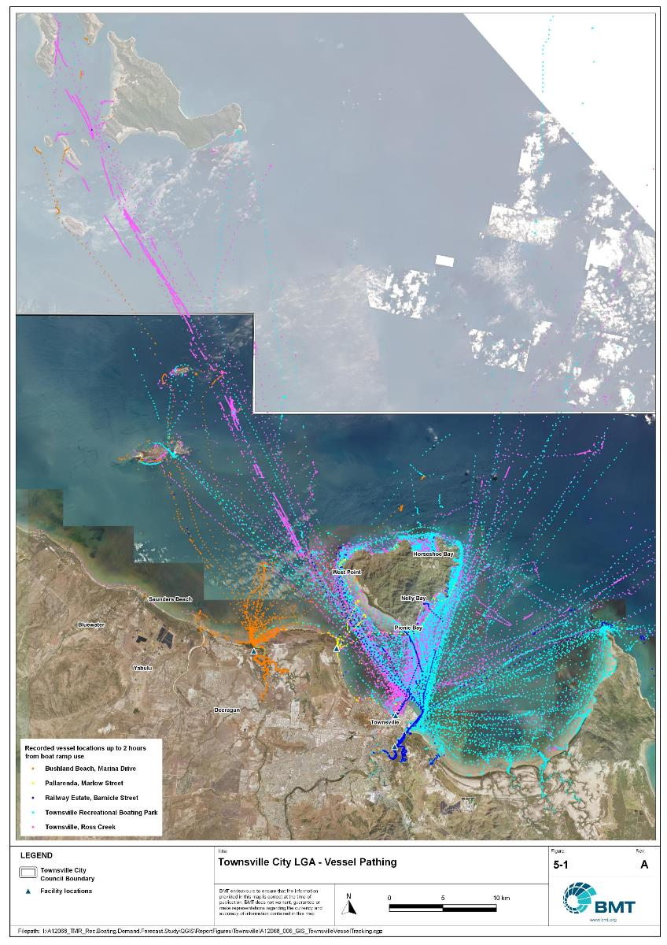

Townsville LGA – Vessel pathing

"I:\A12068_TMR_Rec.Boating.Demand.Forecast.Study\QGIS\ReportFigures\Townsville\A12068_006_GIS_TownsvilleVesselTracking_01.jpg"

## Active fleet size

The total ‘active’ fleet on a good boating day is derived from the activation rate of the total fleet of registered vessels within the LGA and the net inflow of visiting vessels. The total number of visiting vessels from each LGA is determined from the number of vessels in the resident active fleet and the relative proportion of resident to visiting vessels outlined in Table 5.1. The fleet size is expected to change over time due to changes in population and vessel acquisition trends, with the size and proportion of the fleet across the Study period described in Table 5.3.

Active fleet vessel size

| Vessel length | 2021 | 2026 | 2031 | 2036 | 2041 |
| --- | --- | --- | --- | --- | --- |
| 0 to 4.5m | 894 | 944 | 996 | 1046 | 1093 |
| 4.5m to 8m | 472 | 499 | 527 | 554 | 579 |
| >8m | 44 | 46 | 49 | 51 | 54 |
| Total | 1410 | 1489 | 1571 | 1651 | 1727 |

## Boat ramp lane demand

The fleet size derived in Table 5.3 represents the statistical demand for the LGA, with vessels under 8m assumed to contribute to boat ramp demand, measured in boat ramp lanes. As outlined in section 3.1.2 the adopted capacity of each effective lane is 40 vessels per day, with each vessel assumed to both launch and retrieve, for a total of 80 vessel movements per day. The total boat ramp lane demand across the Study period is shown in Table 5.4.

Boat ramp lane demand

|  | 2021 | 2026 | 2031 | 2036 | 2041 |
| --- | --- | --- | --- | --- | --- |
| Boat ramp lane demand | 34.1 | 36.1 | 38.1 | 40 | 41.8 |

For Townsville LGA, the important elements that contribute to the boat ramp lane demand include:

* a large sized local fleet, with a high proportion of trailable vessels
* nearby attractive destinations most easily accessed from neighbouring LGAs, which draw Townsville-based users away from Townsville LGA facilities
* a strong desire to access open water destinations.

## Non-statistical demand

As well as the statistical demand outlined in the section above, facilities may face demand pressures that are related to their functional use, which reduces the capability of the facility to service the recreational boat fleet in the desired manner. Issues with specific facilities have been identified within the consultation process of the Study with appointed managers and other stakeholders. While care has been taken to identify these non-statistical demand issues throughout the Study, it is beyond the scope of the Study to individually review the functionality, safety, and amenity of each facility across Queensland. Non-statistical demand pressures may warrant upgrades to facilities even where statistical demand is satisfied by existing capacity. These pressures have been classified into the following categories:

* Amenity: Amenity describes the functional usability of the facility including the desire to provide dry entry and exit facilities, facilities that provide easy access and/or access for persons with restricted mobility.
* Safety: Safety demand may include protection from currents and waves or contact with marine creatures such as sharks, jellyfish, and crocodiles.
* In-water congestion: Where existing queuing facilities are not able to efficiently meet the needs of the facility. Such deficiency may warrant additional queuing facility capacity to optimise boat launching and retrieval.

The Study's recommendations may alleviate these non-statistical demand pressures with consideration for capability of all facilities within the LGA. The presence of a non-statistical demand pressure at a facility may not warrant upgrades where other suitable facilities are reasonably available.

## Deep-draught vessel demand

* + 1. Cruising vessels

Vessels cruising along the east coast of Queensland have a requirement for a network of deep-draught vessel landings that are appropriately spaced to be within a day’s sailing on good weather days. These facilities are required to support the reprovisioning of vessels as they travel along the coast and provide access to desirable land-based destinations. Private marina facilities may be used by cruising vessels where there is an expectation for a prolonged stay that requires protected mooring or berthing. Within Townsville LGA suitable facilities for deep-draught vessels include the public pontoons at the Townsville Recreational Boating Park and the pontoon within Nelly Harbour on Magnetic Island.

Within the east coast network but outside of the LGA, the nearest deep-draught vessel facility to the north is at Dungeness, approximately 55 nautical miles from Townsville, and to the south at Bowen, a distance of approximately 100 nautical miles. There are no usable deep-draught vessel landings in Burdekin Shire between Bowen and Townsville and no opportunities for any new deep-draught facilities along this stretch of coastline.

The two pontoons at the Townsville Recreational Boating Park are excellent, although they are limited to vessels with an air-draught under 6m, which presents access difficulties for taller vessels. There is a public landing in Ross Creek that is an old jetty structure, which is not preferred by boat users, but is ideally located to access the Townsville CBD. Access to public transport requires a short walk from the Townsville Recreational Boating Park, while shops are in close proximity to the Ross Creek facility. The facility on Magnetic Island at Nelly Bay provides access to a supermarket within walking distance, as well as various landside destinations for recreation, as Magnetic Island is an attractive travel destination. Refuelling is available at the private marinas.

* + 1. Landing demand

Statistical demand for deep-draught vessel landings has been assessed based on the size of the non-trailable fleet within Townsville LGA. Landing demand is more difficult to assess than boat ramp lane demand as the requirements and duration of the landing influence the demand pressure but are highly variable between users. Nevertheless, the Study has assumed that 5% of the non-trailable fleet will be seeking a landing at any given time. The consultation undertaken during the Study indicates that this assumption may overestimate the number of landings, but that the landings are often utilised for other boating and recreation activities when not in use by deep-draught vessels. In particular, landings that are located near boat launching facilities may be used as queuing facilities and therefore support the efficient launching of smaller recreational vessels. Given this, the 5% assumption has been adopted noting that it may overestimate capacity, but not to an extent that it would be onerous to facility providers. Within Townsville LGA the demand for deep-draught vessel landings is outlined in Table 5.5:

Deep-draught vessel landing demand

| Requirement | 2021 | 2026 | 2031 | 2036 | 2041 |
| --- | --- | --- | --- | --- | --- |
| No. of Landings | 2.2 | 2.3 | 2.4 | 2.6 | 2.7 |

# Shortfall Assessment

## Shortfall assessment – boat ramps

The shortfall of boat ramp lanes within Townsville LGA is shown in Table 6.1 and Figure 6.1 at an LGA scale. This is presented both with and without the inclusion of additional capacity provided by the recommended upgrades.

Shortfall of boat launching facilities

| Assessment | Metric | 2021 | 2026 | 2031 | 2036 | 2041 |
| --- | --- | --- | --- | --- | --- | --- |
| Demand | Demand | 34.1 | 36.1 | 38.1 | 40 | 41.8 |
| Existing | Capacity | 36.7 | 36.7 | 36.7 | 36.7 | 36.7 |
| **Shortfall** | -2.6 | -0.6 | 1.4 | 3.3 | 5.1 |
| Improved | Capacity | 36.7 | 36.7 | 38.2 | 38.2 | 40.2 |
| **Shortfall** | -2.6 | -0.6 | -0.1 | 1.8 | 1.6 |

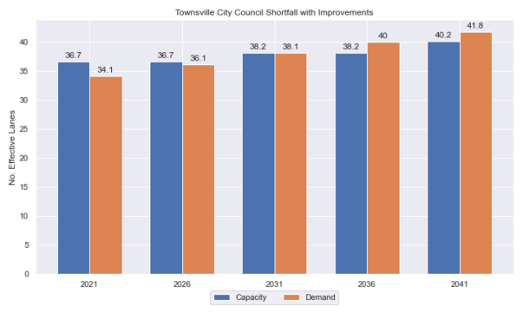

Shortfall assessment with recommended upgrades adopted.

* + 1. Open-water access shortfall in boat ramp lanes

Statistical capacity has been calculated across Townsville LGA in its entirety, however, some facilities are evidently more popular than others due to their ability to access open-water destinations, and/or their usability. In general, larger vessels are more suited to access open-water destinations while smaller vessels are more likely to remain in sheltered environments. This was identified in the 2017 study and confirmed during discussions with stakeholders. The human movement data indicates that visiting boats from other LGAs are drawn to facilities that provide access to open-water destinations. To ensure that the capacity of effective boat ramp lanes in the LGA is appropriately distributed to cater for these usage trends, it is worth assessing facilities providing this desirable access as a subset of the total capacity for the LGA. A ‘scenario’ approach to assessing this capacity (Table 6.2) has been developed, with Scenario 1 derived from empirical estimates of vessel distribution and Scenario 2 derived from the human movement statistics, and the final result averaged between the two scenarios. This provides the opportunity to rationalise the figure that drives the demand and acknowledge when one scenario is not representative of the population or consistent with stakeholder feedback. The scenarios that were assessed are:

Scenario 1: 80% of larger vessels and 20% of smaller vessels from the local fleet and 80% of the visiting fleet are using the facilities with unrestricted open water access.

Scenario 2: Distributing the fleet between facilities as per the human movement statistics.

Shortfall assessment for open water, all-tide or near all-tide facilities for Townsville LGA

| Assessment | Metric | 2021 | 2026 | 2031 | 2036 | 2041 |
| --- | --- | --- | --- | --- | --- | --- |
| Overall | Capacity | 28.8 | 28.8 | 28.8 | 28.8 | 28.8 |
| Scenario 1 | Demand | 18.6 | 19.5 | 20.6 | 21.5 | 22.4 |
| Shortfall | -10.1 | -9.3 | -8.1 | -7.3 | -6.4 |
| Scenario 2 | Demand | 17.3 | 18.3 | 19.4 | 20.4 | 21.4 |
| Shortfall | -11.5 | -10.5 | -9.4 | -8.4 | -7.4 |
| **Average** | Demand | 18.0 | 18.9 | 20.0 | 21.0 | 21.9 |
| **Shortfall** | **-10.8** | **-9.9** | **-8.8** | **-7.8** | **-6.9** |

Comparing the LGA-scale shortfall with the subset of facilities providing protected all-tide or near all-tide access to open water indicate that the demand is well catered for within Townsville LGA.

## Shortfall assessment – deep-draught landings

The shortfall of public deep-draught landings for Townsville LGA is provided in Table 6.3. The existing capacity is statistically adequate to meet demand, particularly with the inclusion of private facilities at the three marinas both on the mainland and on Magnetic Island. The facilities in Ross Creek are not providing capacity to the Townsville LGA fleet or to cruising vessels given their poor condition and the undesirable configuration of a fixed deck height. Future use is limited due to this and the likely future demolition of one or both of these facilities to make way for a new cross-river pedestrian bridge. This would result in limited direct public access to Townsville CBD (including landside destinations such as The Strand and The Ville Resort Casino) from deep-draught vessel landings, indicating there is a demand for an additional fit for purpose deep-draught landing that could provide this capacity should either/both of the Ross Creek facilities be demolished.

Shortfall of deep-draught vessel landings

| Assessment | Metric | 2021 | 2026 | 2031 | 2036 | 2041 |
| --- | --- | --- | --- | --- | --- | --- |
| Deep-draught vessel landings | Demand | 2.2 | 2.3 | 2.4 | 2.6 | 2.7 |
| Capacity | 3 | 3 | 3 | 3 | 3 |
| **Shortfall** | -0.8 | -0.7 | -0.6 | -0.4 | -0.3 |

# Stakeholder Feedback



The Study has undertaken extensive consultation throughout its execution to achieve a comprehensive understanding of issues relating to the use of recreational boating facilities across the state. This consultation was conducted with managing authorities that own and/or and manage recreational boating facilities, as well as with facility stakeholders including recreational groups, volunteer marine rescue and coastguard organisations, and the general public. Stakeholder engagement was supplemented with site visits to facilities where key issues had been identified.

## Managing authority feedback

For Townsville LGA, the Study team and Maritime Safety Queensland met with representatives of Townsville City Council, the Port of Townsville, and the Townsville Coast Guard (QF8) to discuss recreational boating facilities in the region. This consultation process identified a range of potential opportunities to alleviate demand pressures. The Study has considered the practical implementation of each of these opportunities with respect to the required infrastructure, difficulty of implementation and magnitude of benefit, as summarised in Table 7.1.

Stakeholder identified opportunities

| Location | Stakeholder opportunity | Review comments |
| --- | --- | --- |
| Loam Island, Rasmussen, | A pontoon or floating walkway would be beneficial here. | This would improve the facility, although there may not be demonstrated demand. |
| Townsville Ross Creek boat launching facilities | To reduce conflict with port traffic, there a long-term desire to relocate these facilities. Options for replacement locations on port land are being investigated, considering Ross River South Townsville or the Duck Pond breakwater. | Any retirement of the facilities on Ross Creek should be replaced by a facility with equal or improved capacity and open water access. |
| Bohle River | A new boating facility on the Bohle River, requiring a causeway (approx. 1m high and 1km in length) to be built from North Shore Blvd. | This would require significant approvals and would be difficult and expensive to construct. At present there is insufficient demand to warrant recommendation of this facility. |
| Cranbrook | Potential for recreational boating facility on the northern bank, west of Nathan Street Bridge, room for expansion if the existing infrastructure is relocated. | Agreed, this is a good location for a new facility. |
| Dibbs St and Plume St landings | Gangway-access pontoon upgrade would be desirable | Agreed. |
| Balgal Beach | Upgrade/seal/formalise parking. | This would improve the facility, although there may not be demonstrated demand. |
| Balgal Beach | Create “mega-facility” here (multi-lane, wave and current protected, 100+ CTUs, similar to Dungeness) to provide deep-water access for people between Lucinda and Townsville. | This would require significant approvals and would be difficult and expensive to construct, and State policy precludes dredging the entrance to Balgal Creek (both capital and maintenance). At present there is insufficient demand within Townsville LGA to warrant recommendation of this facility. |

## Stakeholder feedback

Broader stakeholder feedback has been conducted within The Study by undertaking virtual or face-to-face meetings with recreational boating groups and marine rescue organisations, as well as through the Recreational Boating Facility Survey (MSQ, 2022) undertaken by Maritime Safety Queensland, which included survey responses of nearly 3,000 users and open submissions. For Townsville LGA a total of 106 submissions was received, with 74% of respondents using trailable power boats and 95% of respondents using recreational boating facilities at least once a month. For Townsville LGA, the following statistics or themes were extracted from the survey and associated comments:

* 82% of respondents typically travel less than 1hr to their preferred boat ramp (which may not be their closest facility).
* 71% of respondents indicated that floating walkways are their preferred type of queuing facility.
* 93% of respondents indicated they would be unwilling to walk further than 200m from designated CTU parking to a boat ramp.
* The most common requests for new boat ramps were at:
  + Alligator and Crocodile Creeks (to open up the Cape Cleveland area waterway)
  + Crystal Creek
  + Cardwell (in Cassowary Coast LGA).
* The following themes were identified with respect to existing facilities:
  + All-tide and larger boat ramps with pontoons or floating walkways are preferred.
  + Dredging is needed to improve access (for example, at Cardwell (Cassowary Coast LGA) and Lucinda (Hinchinbrook LGA).
  + Larger parking areas and more secure parking are needed.
  + More supplementary facilities (for example, public toilet, wash-down tap) are needed.
* Where the closest available boat launching facility was not preferred, respondents indicated that the following key aspects influenced their choice:
  + all-tide access restrictions
  + lack of adequate and secure parking
  + looking for better fishing area.
* Respondents were provided an opportunity to provide additional feedback, with the following themes identified:
  + Upgrade existing ramps and add a few more facilities.
  + Dual-ramps, pontoons, walkways, parking, toilets, wash-down taps, drinking water, etc. would improve the facilities.
  + Regular cleaning of boat ramps, including slippery ramps and debris accumulation is required.
  + There are lots of parking issues and congestion, especially on weekends.
  + Assigning trailer vehicle-specified parking areas is needed where there is mixed-use.
  + Provide night-time security with lighting and CCTV (for both parking areas and ramps).
  + Fish filleting stations are needed with information about fish species including highlighting the QLD fishing app, fishery monitoring activities, and so on.
  + Restrict fishing on queuing facilities.

# Development Recommendations

## Previous recommendations

The 2017 GHD assessment recommended opportunities for increasing capacity of recreational boating facilities across the state. However, the implementation of these recommendations has been low, with only 10% of the total state-wide recommendations delivered in part or full in the 5 years since the delivery of the report. Of the Priority 1 recommendations (for immediate delivery) and priority 2 recommendations (for implementation within 5 years) only 18% and 6% respectively have been delivered. State-wide only 5% of landside recommendations were delivered, while 16% of waterside recommendations were delivered.

Within Townsville LGA none of the recommendations have been implemented since the delivery of the 2017 GHD study. The low rate of implementation of these recommendations is likely the result of damage to the region incurred during the 2019 floods and budgetary constraints applied due to the COVID-19 pandemic by both state and local governments. This current Study has reviewed the unimplemented 2017 recommendations (Table 8.1) for Townsville LGA in conjunction with stakeholders during the consultation process to identify previous recommendations that are:

* Still viable: The recommendation in its original form remains suitable for solving demand pressures.
* Still viable with modifications: The recommendation could remain viable with modifications identified through the consultation process.
* No longer viable: The recommendations are no longer suitable to be carried through as recommendations in this Study.

Recommendations from the 2017 study that are considered viable or viable with modifications are carried forward into the recommendations of this Study with a suitable update to their priority status if required.

Assessment of unimplemented 2017 recommendations

| Location | 2017 Recommendation | 2022 Review | Review comment |
| --- | --- | --- | --- |
| Priority 2 |  |  |  |
| Bohle River, Burdell | Construct a new 2-lane ramp with a floating walkway and 45 CTU spaces. | No longer viable | The existing and projected demand does not warrant construction of this facility in the 20-year outlook, given the upgrades to other facilities that would better provide capacity. |
| Priority 4 |  |  |  |
| Alligator Creek, Nome | Construct a new 4-lane ramp with a floating walkway and 90 CTU spaces. | No longer viable. | Although feedback from the community indicates that a facility on Alligator Creek is desirable, this area is within Fish Habitat Area A, and approvals may be difficult to gain. This option may become viable (with modifications) in the future but is not recommended at present. |

## Priority recommendations

The selection and ranking of development priorities provides for progressive implementation of solutions to meet capacity shortfalls and/or resolve existing safety and usage issues at existing facilities over time. Recommendations have been split into four categories for implementation within the 20-year planning period of this Study, with the following projected timelines:

* Priority 1: For immediate planning and design.
* Priority 2: Planning and design intended to provide capacity within 5-10 years.
* Priority 3: Planning and design intended to provide capacity within 10-15 years.
* Priority 4: Planning and design intended to provide capacity within 15-20 years.

The recommendations have been structured to include consideration of reasonable timelines for implementation. This may include consideration for budgetary processes, planning, environmental approvals, consultation periods, and construction. The priority selection of recommendations has been conducted in accordance with TMR’s Marine Infrastructure and Facilities Plan (TMR, 2020) guidelines, namely:

1. *priority to be given to the provision of sheltered all-tide or near all-tide launching facilities giving access to the open sea on an all-tide or near all-tide basis.*
2. *part-tide facilities (for launching or access) may be provided where there is demand and dredged access is not feasible. For instance, beach access or open beach ramps may be provided where there is sufficient demand and no suitable nearby sheltered waterway*
3. *the most economically viable options will take precedence, including the expansion of existing facilities, and the changing of existing foreshore land uses. In many cases, limiting or avoiding dredging and/or breakwater costs will be a crucial factor*
4. *a goal of providing access to sheltered all-tide or near all-tide boat launching facilities within one hour’s drive for significant communities*

Consequently, higher order recommendations need to address, where possible, the provision of facilities that provide maximum benefit in the widest range of conditions and will be limited to those solutions that are already significantly advanced or ‘shovel ready’ or that require very limited further design, planning and approvals. Lower order recommendations will consist of solutions where there is reduced adherence to the TMR guidelines and/or there are constraints that may result in long lead times to resolve. A summary of the recommendations is provided in Table 8.2 with full detail of each recommendation in the tables that follow.

Summary of recommendations for Townsville LGA

| Priority | Description | Landside or Waterside | Increased capacity  (effective lanes) |
| --- | --- | --- | --- |
| 2 | Bushland Beach, Marina Drive (Stony Creek): Expand parking area to provide 75 CTU spaces. | Landside | 1.5 lanes |
| 2 | Ross Creek deep-draught landing: Demolish existing jetty on Ross Creek and install new gangway-access pontoon further downstream on the northern bank of the creek | Waterside | 1 landing |
| 4 | Nathan Street, Cranbrook: Construct a 2-lane boat ramp CTU parking area. | Both | 2 lanes |

## Priority 1 recommendations

Nil

## Priority 2 recommendations

Bushland Beach, Marina Drive (Stony Creek)

|  |  |  |  |  |
| --- | --- | --- | --- | --- |
| General description | | | | |
| Location | End of Marina Drive, Bushland Beach (Bohle River) | | | |
| Existing Facility? | Yes | | | |
| Coordinates | -19.19952766, 146.70059020 | | | |
| Existing tidal status | All-tide | | | |
| Existing wave exposure | None | | | |
| Existing current exposure | None | | | |
| Proposed works | Expand parking area to provide 75 CTU spaces, semi-formalised with markers/concrete blocks. | | | |
| Increased effective capacity | 1.5 Effective Lanes | | | |
| Capacity improvement position | Waterside | Landside | | Both |
| Rationale | To upgrade the landside capacity of the facility to maximise efficiency of the existing waterside facilities. Improves access for the northern Townsville area. | | | |
| Anticipated Costs (+/- 50%) | Waterside infrastructure | | N/A | |
| Landside infrastructure | | $350,000 | |
| Planning, environmental and approvals constraints | | | | |
| Assessment | Requirement | Comments | | |
| Fish Habitat Zone | X | N/A | | |
| Native Title | X | N/A | | |
| MCU requirement | X | N/A | | |
| Clearing remnant vegetation | ü | RVM category B- remnant vegetation where the proposed carpark upgrade is located and would likely require a Development Permit. | | |
| GBRWHA | X | N/A | | |
| Marine Park | X | N/A | | |
| Tidal works assessment | X | N/A | | |
| Other as required | X | N/A | | |
| Sea Level Rise | ü | The proposed works are within the boundaries of the erosion prone area subject to sea level rise. | | |
| Storm Tide Hazard | ü | The proposed works are within the boundaries of a high hazard area. | | |
| Anticipated Complexity | Low | Medium | | High |

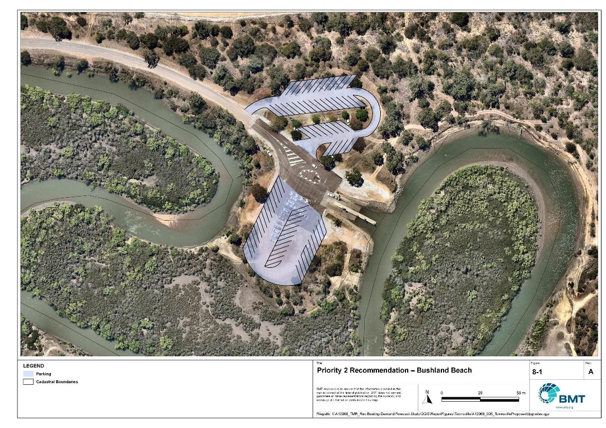

Priority 2 Recommendation – Bushland Beach

"I:\A12068_TMR_Rec.Boating.Demand.Forecast.Study\Recomendations by Council\JPG\Townsville\A12068_005_TownsvilleProposedUpgrades_8-1.jpg"

Ross Creek deep-draught landing

|  |  |  |  |  |
| --- | --- | --- | --- | --- |
| General description | | | | |
| Location | End of The Strand on the north side of Ross Creek | | | |
| Existing Facility? | No | | | |
| Coordinates | -19.257209726216626, 146.82500636949075 | | | |
| Existing tidal status | All-tide | | | |
| Existing wave exposure | None | | | |
| Existing current exposure | None | | | |
| Proposed works | Demolish existing jetties in Ross Creek and install new gangway-access pontoon further downstream on the north bank of the creek. | | | |
| Increased effective capacity | 1 Landing | | | |
| Capacity improvement position | Waterside | Landside | | Both |
| Rationale | The existing jetties in Ross Creek at Plume and Dibbs Streets, South Townsville, are in poor condition and not desirable or fit for purpose as a deep-draught landing facility. Mainland access to the CBD is recommended and these dated facilities are no longer providing this capacity. Consultation with Townsville City indicates that the existing Plume Street jetty is in a desirable location for a future pedestrian bridge, and so replacing the jetty with a pontoon in the same location is not advisable.  A review of historical aerial images shows that pontoons were historically located near the downstream boat ramp, and at the end of the Strand, on the north bank of Ross Creek, which is ideally located for access to Townsville CBD and landside destinations such as the recreation areas and retailers on the Strand, and The Ville Resort Casino. Any new pontoon should also be DDA-compliant (Disability Discrimination Act compliant). | | | |
| Anticipated Costs (+/- 50%) | Waterside infrastructure | | N/A | |
| Landside infrastructure | | $180,000 | |
| Planning, environmental and approvals constraints | | | | |
| Assessment | Requirement | Comments | | |
| Fish Habitat Zone | X | N/A | | |
| Native Title | X | N/A | | |
| MCU requirement | X | N/A | | |
| Clearing remnant vegetation | ü | RVM category R- reef-regrowth watercourse vegetation where the proposed pontoon is located. Removal of regulated vegetation will likely require a Development Permit. | | |
| GBRWHA | X | The proposed works is within the boundaries of the GBRWHA which may trigger a Controlled Activity Approval if there is likely to be a significant impact. | | |
| Marine Park | X | N/A | | |
| Tidal works assessment | ü | The proposed works is likely tidal works and therefore will require a Development Permit. | | |
| Other as required | X | N/A | | |
| Sea Level Rise | ü | The proposed works are within the boundaries of the erosion prone area subject to sea level rise. | | |
| Storm Tide Hazard | ü | The proposed works are within the boundaries of a high hazard area. | | |
| Anticipated Complexity | Low | Medium | | High |

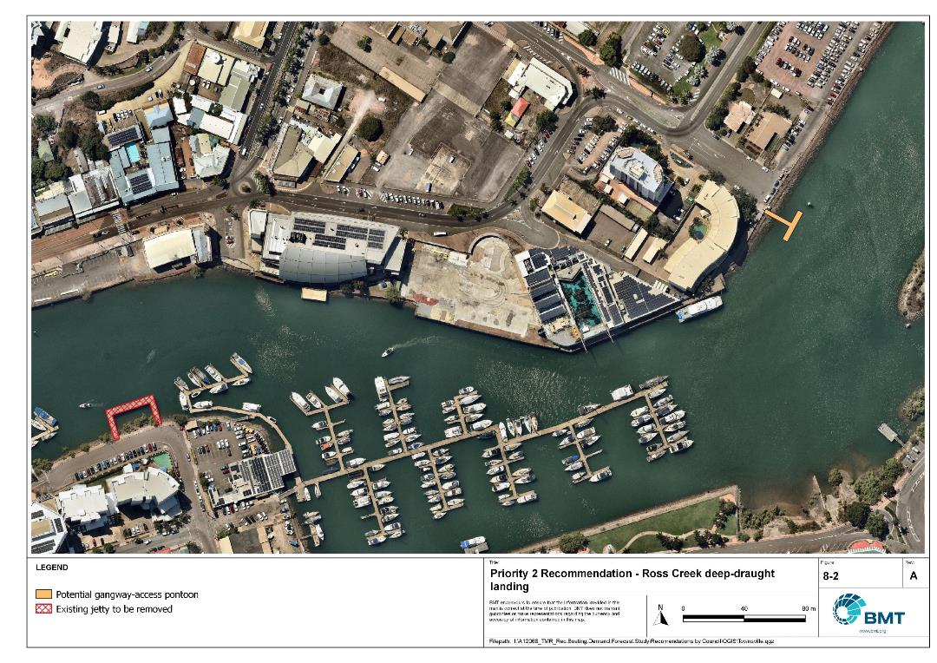

Priority 2 Recommendation – Ross Creek deep-draught landing

"I:\A12068_TMR_Rec.Boating.Demand.Forecast.Study\Recomendations by Council\JPG\Townsville\A12068_005_TownsvilleProposedUpgrades_8-2_DDL.jpg"

## Priority 3 Recommendations

Nil.

## Priority 4 Recommendations

Nathan Street, Cranbrook

|  |  |  |  |  |
| --- | --- | --- | --- | --- |
| General description | | | | |
| Location | On the north bank of the Ross River, west of the Nathan Street Bridge in Cranbrook | | | |
| Existing Facility? | No | | | |
| Coordinates | -19.30712859, 146.76053207 | | | |
| Existing tidal status | N/A – Fresh water | | | |
| Existing wave exposure | N/A – None once complete | | | |
| Existing current exposure | N/A – Flood current exposed once complete | | | |
| Proposed works | Construct a 2 lane ramp and a suitable CTU parking area. | | | |
| Increased effective capacity | 2.0 effective lanes | | | |
| Capacity improvement position | Waterside | Landside | | Both |
| Rationale | At present, there are no boating facilities between Loam Island, Rasmussen and Railway Estate downstream. There is demand for another facility in this section of Ross River, which is upstream of Aplins Weir, and would provide opportunities for recreational boating and activities such as water-skiing for the large population of western Townsville. The area to the north could be used for hybrid CTU and passenger vehicle parks, to accommodate the adjacent sports field. If a land parcel nearby becomes available for purchase, separation of parking areas could be achieved. | | | |
| Anticipated Costs (+/- 50%) | Waterside infrastructure | | TBC | |
| Landside infrastructure | | TBC | |
| Planning, environmental and approvals constraints | | | | |
| Assessment | Requirement | Comments | | |
| Fish Habitat Zone | X | N/A | | |
| Native Title | X | N/A | | |
| MCU requirement | X | N/A | | |
| Clearing remnant vegetation | ✓ | Works are within area containing RVM category B – remnant vegetation. A Development Permit will likely be required for clearing of remnant vegetation. | | |
| GBRWHA | X | N/A | | |
| Marine Park | X | N/A | | |
| Tidal works assessment | X | N/A | | |
| Other as required | ✓ | Formalisation of parking lot works is within and adjacent to a state controlled road and will likely require a Road Corridor Permit and referral | | |
| Sea Level Rise | X | N/A—due to the weir present downstream, the proposed works are not within an area of sea level rise | | |
| Storm Tide Hazard | X | N/A—due to the weir present downstream, the proposed works are not within an area of a storm tide hazard. | | |
| Anticipated Complexity | Low | Medium | | High |
| Maritime engineering review | | | | |
| Assessment | Site considerations | Comments | | |
| Engineering Matters | Current Forces | Site may be subject to moderate to high currents and further assessment of the impact on this recommendation is required. | | |
| Water Levels | This site is subject to inundation from flood waters and more detailed consideration will be required to ensure the recommended option is suitable. | | |
| Adjacent Structures & Constraints | Consideration of impact on adjacent bridge during construction or operation is required, particularly concerning the bridge and traffic flow adjacent. | | |
| Anticipated Complexity | Low | Medium | | High |

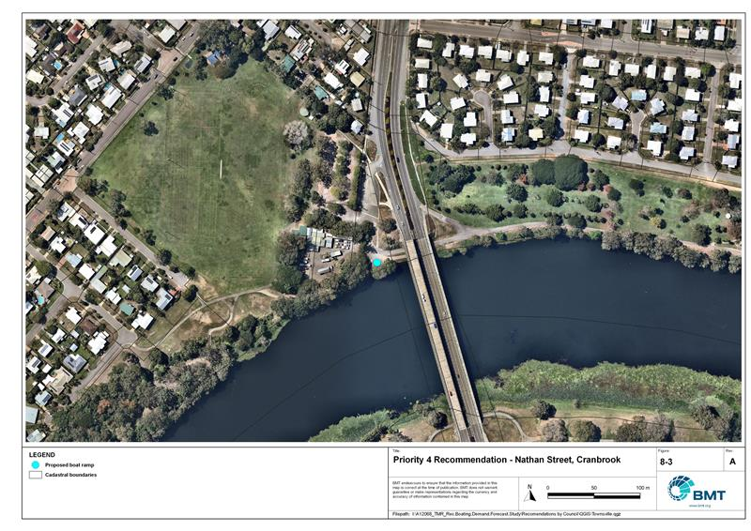

Priority 4 Recommendation – Nathan Street, Cranbrook

"I:\A12068_TMR_Rec.Boating.Demand.Forecast.Study\Recomendations by Council\JPG\Townsville\A12068_005_TownsvilleProposedUpgrades_8-3.jpg"

# References

Australian Bureau of Statistics (ABS), 2021, *2021 Census,* <https://www.abs.gov.au/census>

Bell, Frederick W. 2022, *Estimation of the present and projected demand and supply of boat ramps for Florida's coastal regions and counties*, Florida State University, Department of Economics.

BMT, 2015, *MPSC Managed Boating Facilities Demand and Capacity Study: Boat Ramp Modelling*

Department of Transport and Main Roads (TMR), 2020, Marine facilities and infrastructure plan.

GHD, 2011, *Recreational Boating Facilities Demand Forecasting Study*

GHD, 2017, *Queensland Recreational Boating Facilities Demand Forecasting Study 2017.*

Maritime Safety Queensland (MSQ), 2022, *Recreational Boating Facilities,* <https://www.getinvolved.qld.gov.au/gi/consultation/8850/view.html>

Queensland Government Department of Resources (DoR), 2022, *Cities and towns [OGC WMS Service]*, Accessed 5/10/2022, available online at spatial.information.qld.gov.au/arcgis/home/item.html?id=103c7c9ccca449fab79d27cde06868ab

Rose, T., R. Powell & J. Yu (2009). Identification of the Present and Future Recreational Boating Infrastructure in Redland City – A 10 Year Infrastructure Plan- Griffith University

SKM (1998) Public Boat Ramps Central Queensland Strategic Plan - Volume One - Demand Forecasting - Noosa to Yeppoon. Sinclair Knight Merz, March 1998.

Swett, R., Fik, T., Ruppert, T., Davidson, G., Guevara, C. & Betty Staugler, 2012, *Planning for the future of recreational boating access to charlotte county waterways: 2010 – 2050*, Florida Sea Grant, University of Florida.

Western Australia Department of Transport, 2019, *Perth Recreational Boating Facilities Study Review 2019*, https://www.transport.wa.gov.au/mediaFiles/marine/MAC_P_Perth_RBFS_study_review_2019.pdf

Western Australia Department of Transport, 2021, *South West Region Recreational Boating Facilities Study July 2021,* https://www.transport.wa.gov.au/mediaFiles/marine/MAC_P_SouthWest_RBFS_Study_2021.pdf

###### Demand Study

"G:\Admin\A12068.g.mpb.TMRBoatingDemand\06_Reports\09_Demand Study\2022_2119 (016) Final Demand Report (March 2023).pdf"

###### Boat launching facility capacity

Capacity of existing boat launching facilities

| Facility ID | Facility name | No. Lanes | Tidal access  (at ramp) | | Tidal access (to open water) | Queuing facility | Formal CTUs | Informal CTUs | | Waterside capacity | Landside capacity | Effective capacity | Constraint |
| --- | --- | --- | --- | --- | --- | --- | --- | --- | --- | --- | --- | --- | --- |
| Open water access | | | | | | | | | | | | | | |
| TV11 | Railway Estate, Barnicle Street (Downstream) | 4 | All-tide | | All-tide | Pontoon | 73 | 0 | | 4.4 | 3.25 | 3.25 | Landside |
| TV14 | Railway Estate, Barnicle Street (upstream) | 2 | All-tide | | All-tide | Floating Walkway | 73 | 0 | | 3.4 | 3.25 | 3.25 | Landside |
| TV30 | Townsville Recreational Boating Park | 4 | All-tide | | All-tide | Floating Walkway | 86 | 0 | | 6 | 4 | 4 | Landside |
| TV32 | Townsville Recreational Boating Park | 4 | All-tide | | All-tide | Pontoon | 86 | 0 | | 5.8 | 4 | 4 | Landside |
| TV34 | Townsville Recreational Boating Park | 4 | All-tide | | All-tide | Pontoon | 86 | 0 | | 5.8 | 4 | 4 | Landside |
| TV36 | Townsville Recreational Boating Park | 4 | All-tide | | All-tide | Pontoon | 86 | 0 | | 5.8 | 4 | 4 | Landside |
| TV53 | Magnetic Island, Nelly Bay Harbour | 2 | All-tide | | All-tide | Pontoon | 47 | 0 | | 2.4 | 2.25 | 2.25 | Landside |
| TV71 | Townsville, Ross Creek (upstream) | 3 | All-tide | | All-tide | Floating Walkway | 47 | 0 | | 5 | 2.25 | 2.25 | Landside |
| TV72 | Townsville, Ross Creek (downstream) | 3 | All-tide | | All-tide | Floating Walkway | 34 | 0 | | 5 | 1.75 | 1.75 | Landside |
| **Subtotal** |  | **30** |  | |  |  | **618** | **0** | | **43.6** | **28.75** | **28.75** |  |
| **Depth-limited open water access** | | | | | | | | | | | | | | |
| TH11 | Balgal Beach, Marlin Street | 1 | All-tide | | Part-Tide | Pontoon | 0 | 15 | | 1.2 | 1 | 1 | Landside |
| TH21 | Saunders Beach, Boat Ramp Road | 1 | Near all-Tide | | Part-tide | Floating Walkway | 0 | 6 | | 1.36 | 0.5 | 0.5 | Landside |
| TH35 | Toomulla, Herald Street | 1 | Near all-tide | | Part-tide | None | 0 | 6 | | 0.8 | 0.5 | 0.5 | Landside |
| TH41 | Bluewater Beach, Bluewater Road | 1 | All-tide | | Part-tide | None | 0 | 6 | | 1 | 0.75 | 0.75 | Landside |
| TH45 | Townsville, Bluewater, Purono Parkway | 1 | Near all-tide | | Part-tide | None | 0 | 10 | | 0.8 | 1 | 0.8 | Waterside |
| TH51 | Bushland Beach, Marina Drive | 2 | Near all-tide | | Near all-tide | Floating Walkway | 5 | 15 | | 2.72 | 1.25 | 1.25 | Landside |
| TV51 | Magnetic Island, Picnic Bay | 1 | Part-tide | | Part-tide | Beach | 6 | 0 | | 0.28 | 0.5 | 0.28 | Waterside |
| **Subtotal** |  | **8** |  | |  |  | **11** | **58** | | **8.16** | **5.5** | **5.08** |  |
| **Fresh water facilities** | | | | | | | | | | | | | |
| TH61 | Rassmussen, Loam Island, Illuta Street | 1 | Fresh water | | Fresh water | None | 10 | 0 | | 1 | 0.75 | 0.75 | Landside |
| TV18 | Townsville, Ross River Dam | 1 | Fresh water | | Fresh water | None | 0 | 8 | | 1 | 1 | 1 | Waterside |
| **Subtotal** |  | **2** |  | |  |  | **10** | **8** | | **2** | **1.75** | **1.75** |  |
| **Beach ramps** | | | | | | | | | | | | | |
| TV61 | Magnetic Island, Horseshoe Bay | 1 | Part-tide | | Part-tide | Beach | 0 | 5 | | 0.28 | 0.5 | 0.28 | Waterside |
| TV91 | Pallarenda, Marlow Street | 3 | Part-tide | | Part-tide | Beach | 30 | 0 | | 0.82 | 1.5 | 0.82 | Waterside |
| **Subtotal** |  | **4** |  | |  |  | **30** | **5** | | **1.1** | **2** | **1.1** |  |
| **Total effective capacity** | | | |  | | | | | **36.68** | | | | | |

###### Travel time statistics

Travel time from population centres to nearest sheltered all-tide or near all-tide open water accessible facilities

| Population Centre | Travel time (mins) |
| --- | --- |
| Balgal | 37.8 |
| Bluewater | 20.5 |
| Bluewater Beach | 25.5 |
| Cungulla | 31.5 |
| Deeragun | 11.6 |
| Mutarnee | 43.0 |
| Paluma | 57.7 |
| Rollingstone | 35.2 |
| Saunders Beach | 22.7 |
| Toolakea | 25.5 |
| Toomulla | 30.5 |
| Townsville | 1.3 |
| Woodstock | 26.1 |
| Yabulu | 17.2 |

###### Facility Use

Boat launching facility usage statistics

| Facility ID | Facility name | Total reports | Townsville | Brisbane | Cairns | Gold Coast | Mackay | Moreton Bay | Burdekin | Whitsunday | Sunshine Coast | Charters Towers | Other LGAs |
| --- | --- | --- | --- | --- | --- | --- | --- | --- | --- | --- | --- | --- | --- |
| Total |  | 35995 | 26874 | 976 | 802 | 542 | 532 | 410 | 410 | 392 | 314 | 214 | 4529 |
| Total % |  | 100% | 74.7% | 2.7% | 2.2% | 1.5% | 1.5% | 1.1% | 1.1% | 1.1% | 0.9% | 0.6% | 12.6% |
| TV71 | Townsville, Ross Creek | 10771 | 81.3% | 2.4% | 1.4% | 1.1% | 1.0% | 0.7% | 1.4% | 1.0% | 0.5% | 0.4% | 8.9% |
| TV61 | Magnetic Island, Horseshoe Bay | 6986 | 48.7% | 5.8% | 5.0% | 3.7% | 3.3% | 2.3% | 1.1% | 2.1% | 1.9% | 0.4% | 25.7% |
| TV30 | Townsville Recreational Boating Park | 4772 | 86.3% | 1.0% | 0.9% | 0.5% | 0.5% | 0.6% | 1.2% | 0.7% | 0.3% | 1.6% | 6.3% |
| TV91 | Pallarenda, Marlow Street | 2481 | 86.9% | 1.6% | 0.8% | 0.8% | 1.0% | 0.7% | 0.6% | 0.3% | 0.8% | 0.5% | 6.0% |
| TH51 | Bushland Beach, Marina Drive | 2195 | 90.1% | 0.5% | 1.0% | 0.5% | 0.2% | 0.6% | 0.4% | 0.3% | 0.2% | 0.4% | 5.7% |
| TV51 | Magnetic Island, Picnic Bay | 2052 | 54.6% | 5.0% | 4.3% | 2.8% | 3.0% | 1.9% | 1.7% | 1.8% | 2.1% | 0.6% | 22.3% |
| TH61 | Rasmussen, Loam Island, Illuta Street | 1950 | 91.6% | 0.4% | 0.4% | 0.2% | 0.9% | 0.5% | 0.3% | 0.4% | 0.2% | 0.2% | 4.9% |
| TV11 | Railway Estate, Barnicle Street | 1312 | 87.0% | 1.7% | 0.6% | 0.2% | 0.2% | 0.8% | 0.8% | 0.5% | 0.5% | 0.8% | 6.9% |
| TV53 | Magnetic Island, Nelly Bay Harbour | 1121 | 57.5% | 4.6% | 5.5% | 2.6% | 2.3% | 2.5% | 2.1% | 0.7% | 1.3% | 0.4% | 20.2% |
| TH11 | Balgal Beach, Marlin Street | 1061 | 60.8% | 1.8% | 4.6% | 0.9% | 3.0% | 1.4% | 1.6% | 2.3% | 1.6% | 0.8% | 21.1% |
| TH21 | Saunders Beach, Boat Ramp Road | 581 | 91.6% | 0.2% | 0.2% | 0.3% | 0.0% | 0.9% | 0.2% | 0.5% | 0.9% | 0.5% | 4.8% |
| TH45 | Saunders Beach, Purono Parkway | 293 | 92.2% | 0.7% | 0.3% | 0.3% | 0.0% | 0.7% | 0.0% | 0.0% | 0.0% | 0.3% | 5.5% |
| TH41 | Bluewater Beach, Bluewater Road | 269 | 85.5% | 0.0% | 0.7% | 0.0% | 0.4% | 1.9% | 1.1% | 0.7% | 0.4% | 0.0% | 9.3% |
| TH35 | Toomulla, Herald Street | 135 | 61.5% | 1.5% | 3.7% | 2.2% | 2.2% | 1.5% | 0.7% | 1.5% | 0.0% | 1.5% | 23.7% |
| TV18 | Townsville, Ross River Dam | 16 | 68.8% | 0.0% | 0.0% | 0.0% | 0.0% | 0.0% | 0.0% | 6.2% | 0.0% | 0.0% | 25.0% |

|  |  |  |
| --- | --- | --- |
|  |  | BMT is a leading design, engineering, science and management consultancy with a reputation for engineering excellence. We are driven by a belief that things can always be better, safer, faster and more efficient. BMT is an independent organisation held in trust for its employees. |

|  |  |  |  |  |  |  |  |  |
| --- | --- | --- | --- | --- | --- | --- | --- | --- |
|  |  |  |  |  |  |  | Contact us  enquiries@bmtglobal.com  www.bmt.org  Follow us  www.bmt.org/linkedin LinkedIn logo  www.bmt.org/youtube YouTube logo  www.bmt.org/twitter Twitter logo  www.bmt.org/facebook Facebook logo |  |
|  | Level 5  348 Edward Street  Brisbane  QLD 4000  Australia  +61 7 3831 6744 |  | Registered in Australia  Registered no. 010 830 421  Registered office  Level 5, 348 Edward Street,  Brisbane QLD 4000 Australia |  |  |  |  |
|  | For your local BMT office visit www.bmt.org | | |  |  |  |  |  |