- Appendices
16.1 Port of Mourilyan 54
16.2 Mourilyan harbour 55
16.3 Pilot Boarding Ground and Anchorage 56
16.4 Pilotage plans 57
16.5 Gas-free status declaration 59
16.6 Permission to Immobilise Main Engines 60
16.7 Application for Reduction in Tugs 61

  - Port of Mourilyan
  - For a high resolution map please visit 16.1 Port of Mourilyan - Mourilyan: Port Procedures and Information for Shipping - Publications | Queensland Government

  - Mourilyan harbour
  - For a high resolution map please visit 16.2 Mourilyan Harbour - Mourilyan: Port Procedures and Information for Shipping - Publications | Queensland Government
  - Pilot Boarding Ground and Anchorage
  - For a high resolution map please visit 16.3 Pilot Boarding Ground and Anchorage - Mourilyan: Port Procedures and Information for Shipping - Publications | Queensland Government
  - Pilotage plans
  - For a high resolution map please visit 16.4 Pilotage plans - Mourilyan: Port Procedures and Information for Shipping - Publications | Queensland Government

  - Gas-free status declaration
  - Please follow this link to access the official fillable PDF form: F5202 - Gas Free Status Declaration
  - This is a replica of the form and is not intended to be used.
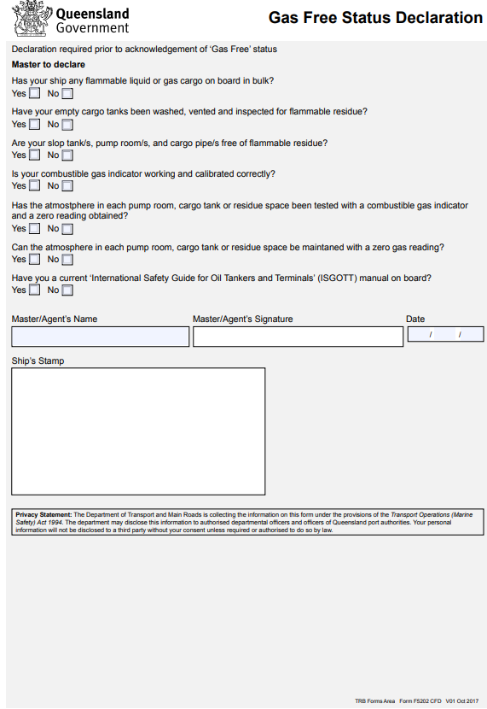
SAMPLE
  - Permission to Immobilise Main Engines
Please follow this link to access the official fillable PDF form: F5199 - Permission to Immobilise Main Engines - Cairns Region
This is a replica of the form and is not intended to be used.
(THIS FORM IS ONLY TO BE USED IF THE REQUEST CANNOT BE SUBMITTED BY THE AGENT WITHIN QSHIPS)
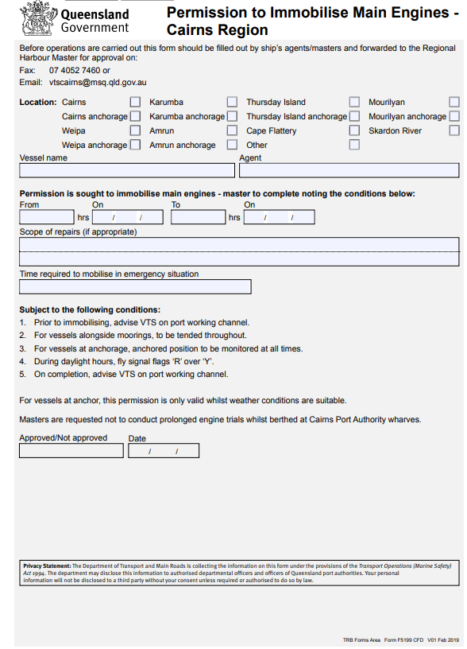
SAMPLE

  - Application for Reduction in Tugs
Please follow this link to access the official fillable PDF form: F5365 - Reduction in Tugs Application - Cairns
This is a replica of the form and is not intended to be used.
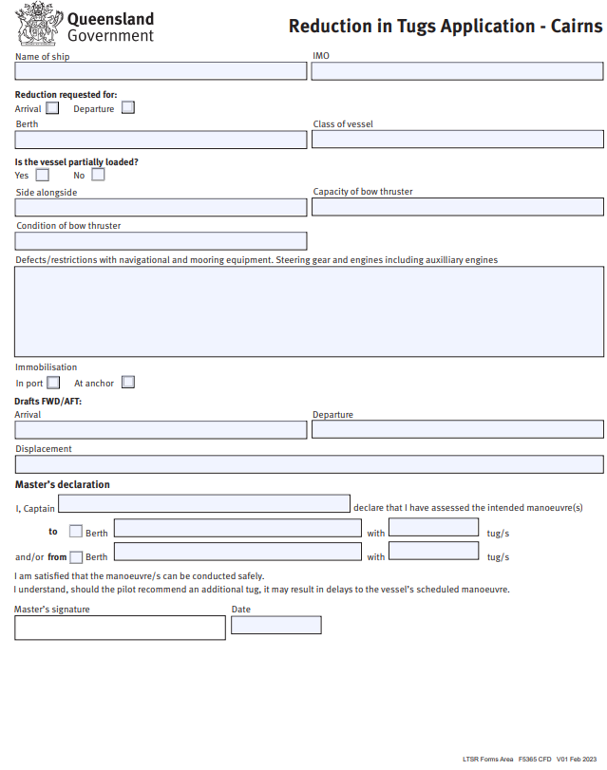
SAMPLE

