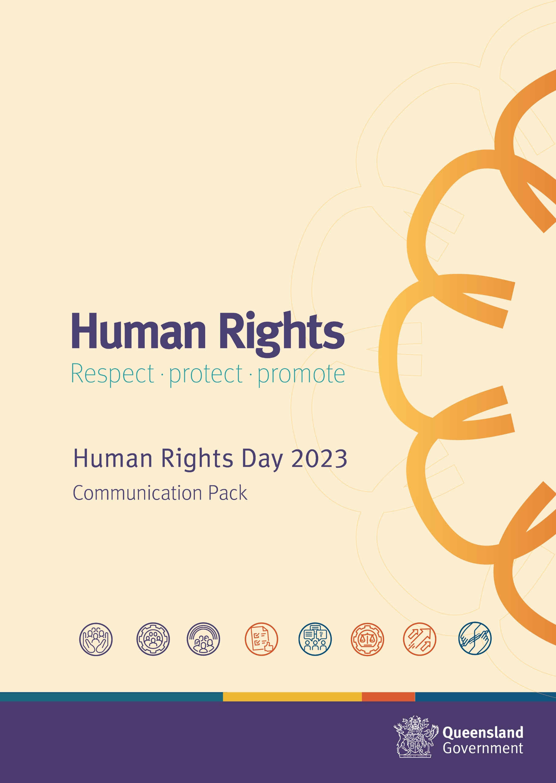

Communication Pack

Human Rights Day
Human Rights Day is on 10 December 2023 and this year the world celebrates the 75th anniversary of the Universal Declaration of Human Rights!

To raise awareness of Human Rights Day in the Queensland public sector, the Human Rights Unit in the Department of Justice and Attorney-General (DJAG) has developed promotional content that can be posted on social media and distributed via your internal communication channels.

In this Communication Pack, you will find information to share with your public-facing audiences, internal networks, and links to human rights resources to help public sector employees meet their obligations under the Queensland Human Rights Act 2019.

Imagery
You can access graphics for use on social media or in your internal communication channels on the Human Rights Day resources publications page. In it you will also find four A3 posters to help you start a conversation about human rights in your workplace.

If using images, we recommend including image descriptions or alt text to ensure they are accessible.

Social media (including Yammer)
Suggested post 1 — lead up to Human Rights Day
Human Rights Day (10 December) is an opportunity for the world to come together to raise awareness of the universality and indivisibility of human rights.

This year we celebrate 75 years since the adoption of the Universal Declaration of Human Rights. To commemorate this moment in history, the United Nations has been running Human Rights 75 — a year-long awareness campaign that will culminate on 10 December 2023 with worldwide pledges and a vision for the future of human rights.

Learn more at www.ohchr.org/en/get-involved/campaign/udhr-75

Suggested post 2 — to be posted on 10 December 2023
Happy Human Rights Day! Today the world celebrates 75 years since the adoption of the Universal Declaration of Human Rights by the United Nations (UN) General Assembly.

To celebrate, the UN will be hosting events worldwide including a free concert covering a range of genres and human rights themes. Find out more at www.ohchr.org/en/get-involved/campaign/udhr-75

Newsletter content (internal/staff newsletters)
Celebrate Human Rights Day

Human Rights Day will be celebrated worldwide on 10 December 2023 and this year marks 75 years since the adoption of the Universal Declaration of Human Rights. To commemorate this remarkable moment in history, the United Nations has been running Human Rights 75 — a year-long awareness campaign that seeks to increase worldwide knowledge and understanding of the universality and indivisibility of human rights.

The Human Rights Unit in the Department of Justice and Attorney-General has developed resources to raise awareness of Human Rights Day 2023 in the public sector. We encourage you to join the celebrations by:

- attending a free one-hour 101 webinar on human rights for public sector employees
- sharing human rights posters and other creative assets
- starting a conversation in your workplace about the importance of protecting and promoting human rights in Queensland.

As Queensland public sector employees, we have an obligation to consider human rights in our decision making. To find out more about human rights in the public sector, please visit the Queensland Government Human Rights Portal.

Intranet content

Suggested news post
Want to learn more about human rights and your obligations under the Human Rights Act as a public sector employee?

In the lead up to Human Rights Day 2023, the Department of Justice and Attorney-General's Human Rights Unit is delivering a 101 introduction to the Human Rights Act. This one-hour webinar is designed for public sector employees who are new to working with the Act or need a refresher on the basics.

Suggested news post 2
Human Rights Day (10 December) is an opportunity for the world to come together to raise awareness of the universality and indivisibility of human rights. In 2023 we celebrate 75 years since the adoption of the landmark Universal Declaration of Human Rights.

Find out more about how to raise awareness of this important moment in history on the United Nations website or join public sector colleagues for a one-hour webinar on the basics of Queensland’s Human Rights Act.

Human rights resources and training
DJAG’s Human Rights Unit develops education resources designed for government employees to raise awareness of human rights in the public sector. They include:

- guides
- factsheets
- posters
- bespoke training sessions for policy teams.

