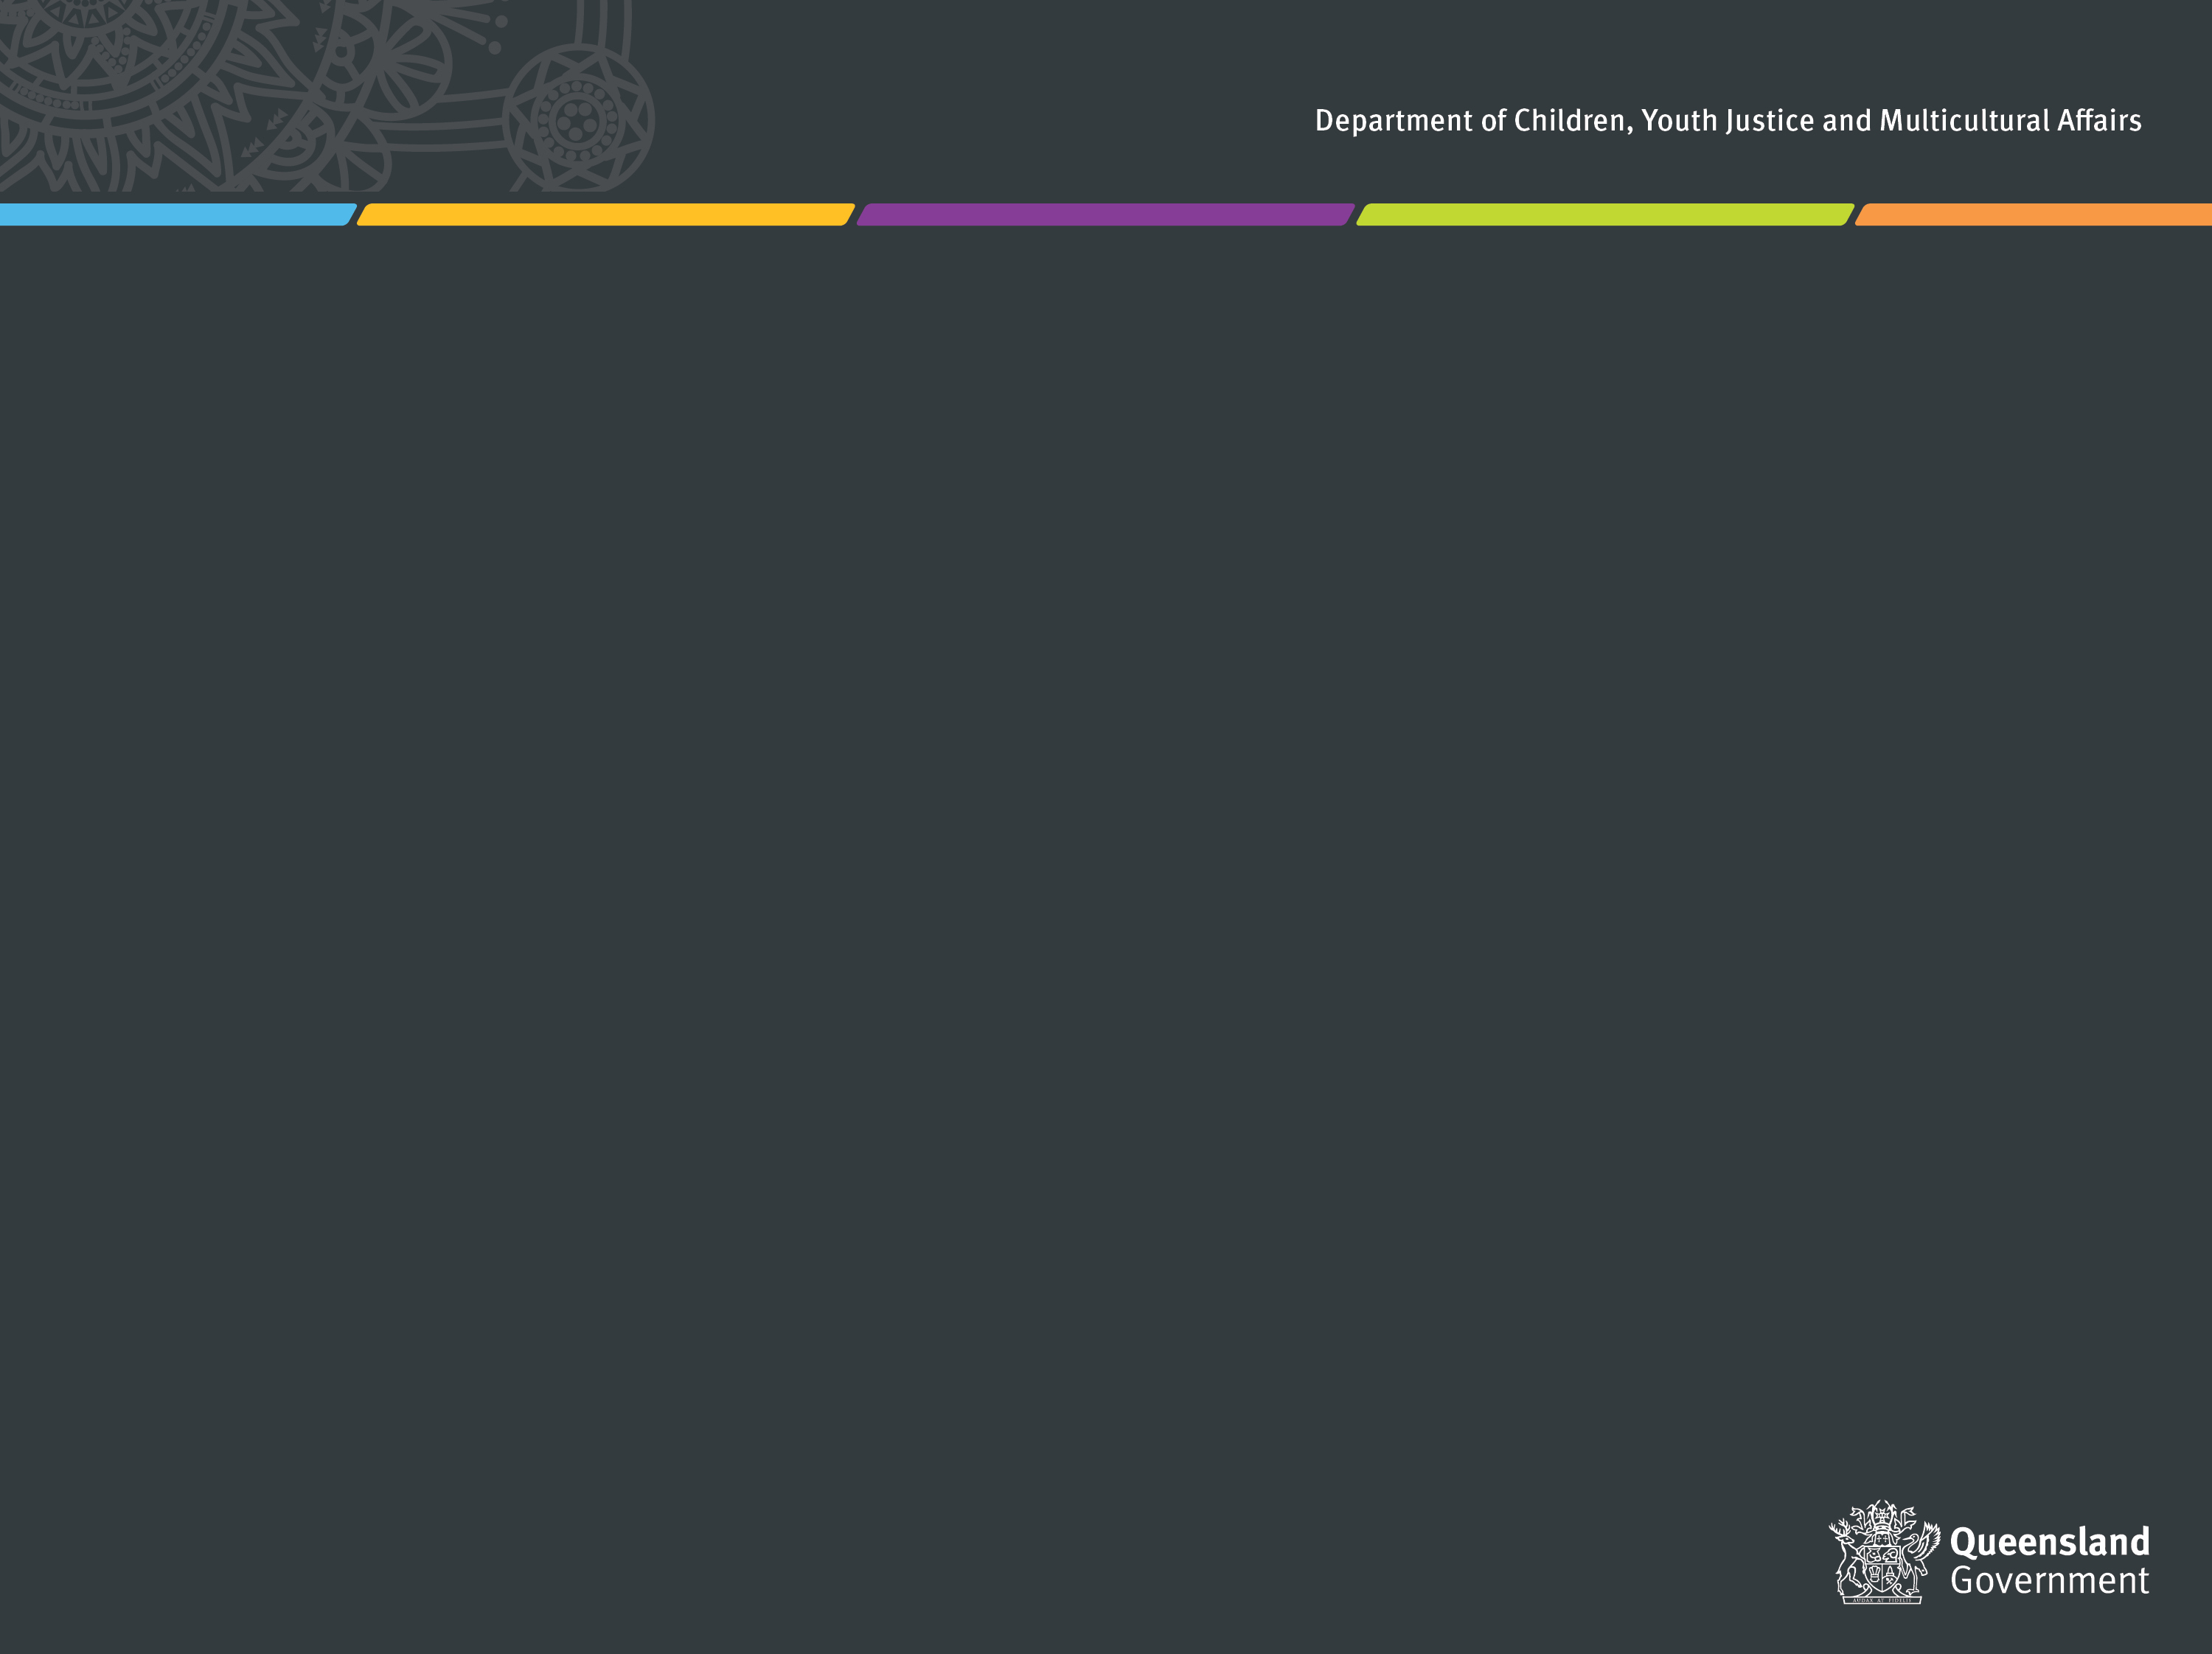

# **Key information**

This reporting template is provided to agencies with actions in the [*Queensland Multicultural Action Plan 2022-2024*](https://www.dcssds.qld.gov.au/__data/assets/pdf_file/0026/5579/multicultural-action-plan-2022-2024.pdf) (*Action Plan*).

Under Section 24 of the [*Multicultural Recognition Act 2016*](https://www.legislation.qld.gov.au/view/pdf/asmade/act-2016-001)(*the Act*), agencies with actions in the Action Plan are required to publicly report on their progress on an annual basis. To meet this requirement, we request that your agency:

* Please carefully review the scope of reporting, agency commitments, and instructions below to assist you in completing this report in line with the requirements under the Act. *Please note that this reporting template is the same as in the previous year, as 2023-24 is the second year of reporting under the Action Plan for 2022-24.*
* **Publish** the report on your agency’s website by no later than **30 September 2024** and email a hyperlink and copy of final report to [MAQ.Secretariat@maq.qld.gov.au](mailto:MAQ.Secretariat@maq.qld.gov.au).

If you have any questions or would like any assistance, please contact Angela Payam, Policy Officer, Multicultural Affairs Queensland on 3097 7708 or at [Angela.Payam@maq.qld.gov.au](mailto:Angela.Payam@maq.qld.gov.au).

|  |
| --- |
| **Scope of reporting** The [*Queensland Multicultural Policy*](https://www.dcssds.qld.gov.au/__data/assets/pdf_file/0021/4638/multicultural-policy.pdf) and *Action Plan* aim to achieve positive outcomes for Queenslanders from **culturally and linguistically diverse backgrounds**.  We acknowledge agencies may be implementing measures to support diversity and inclusion for various cohorts, including Aboriginal and Torres Strait Islander peoples, women, youth, seniors, LGBTIQ+ communities and people with disability. While we welcome reporting on activities that recognise and respond to intersectionality across groups, the purpose of this report is to collect information about activities that specifically focus on achieving outcomes for:   * ***People from ‘culturally and linguistically diverse’ backgrounds. While there is no formal agreed definition of this term, in this context it is used to refer to people from a migrant or refugee background (which can include second or third generation migrants), people seeking asylum, and Australian South Sea Islander peoples.[1]***   We therefore request that activities only be included in this reporting if they specifically focus on delivering positive outcomes for this population.    If you have any questions about the relevance of any agency activities in line with this scope, please contact the Multicultural Affairs Queensland contact listed above. |

# **Agency commitments for 2022-24**

Each agency has committed to undertaking activities in one or more of the Action Plan’s six Key Action Areas. The table below indicates which of the Key Action Areas your agency has committed to and will therefore be required to report on in this template.

*Note this table has been updated from the version on page 14 of the Action Plan to reflect the recent machinery of government (MOG) changes.[2]*

|  |  |  |  |  |  |  |
| --- | --- | --- | --- | --- | --- | --- |
| **Agency** | **Key action 1** | **Key action 2** | **Key action 3** | **Key action 4** | **Key action 5** | **Key action 6** |
| **DEC** | **⚫** | **⚫** |  |  | **⚫** | **⚫** |
| **DoR** | **⚫** | **⚫** |  |  | **⚫** | **⚫** |
| **DSDI** | **⚫** | **⚫** |  |  | **⚫** | **⚫** |
| **DRDMW** |  | **⚫** | **⚫** |  | **⚫** | **⚫** |
| **DTS** |  | **⚫** |  | **⚫** | **⚫** | **⚫** |
| **DoE** |  | **⚫** | **⚫** | **⚫** | **⚫** | **⚫** |
| **DESI** | **⚫** | **⚫** |  |  |  | **⚫** |
| **DJAG** | **⚫** | **⚫** | **⚫** | **⚫** | **⚫** | **⚫** |
| **DPC** | **⚫** | **⚫** |  |  | **⚫** | **⚫** |
| **QPS** |  | **⚫** | **⚫** | **⚫** | **⚫** | **⚫** |
| **QT** | **⚫** | **⚫** |  | **⚫** | **⚫** | **⚫** |
| **DAF** | **⚫** | **⚫** | **⚫** |  | **⚫** | **⚫** |
| **DESBT** | **⚫** | **⚫** | **⚫** | **⚫** | **⚫** | **⚫** |
| **DTMR** |  | **⚫** | **⚫** | **⚫** | **⚫** | **⚫** |
| **PSC** |  | **⚫** |  | **⚫** |  |  |
| **QCS** |  | **⚫** | **⚫** | **⚫** | **⚫** | **⚫** |
| **QFD** |  | **⚫** |  | **⚫** | **⚫** | **⚫** |
| **QH** |  | **⚫** | **⚫** | **⚫** | **⚫** | **⚫** |
| **ECQ** |  | **⚫** |  |  | **⚫** | **⚫** |
| **LAQ** |  | **⚫** | **⚫** | **⚫** | **⚫** | **⚫** |
| **QHRC** |  | **⚫** |  | **⚫** | **⚫** |  |
| **QMHC** | **⚫** | **⚫** | **⚫** | **⚫** | **⚫** | **⚫** |
| **RTA** |  | **⚫** | **⚫** | **⚫** |  | **⚫** |
| **TIQ** | **⚫** | **⚫** |  | **⚫** | **⚫** | **⚫** |
| **TAFE QLD** |  | **⚫** | **⚫** |  | **⚫** | **⚫** |
| **DCSSDS** | **⚫** | **⚫** | **⚫** | **⚫** | **⚫** | **⚫** |
| **DTATSIPCA** | **⚫** | **⚫** |  | **⚫** | **⚫** | **⚫** |
| **DHLGPPW** |  | **⚫** | **⚫** | **⚫** | **⚫** |  |
| **DYJ** | **⚫** | **⚫** |  |  | **⚫** |  |

# **Instructions**

**This template has been pre-populated with your agency’s commitments under the** [***Queensland Multicultural Action Plan 2022-24***](https://www.dcssds.qld.gov.au/__data/assets/pdf_file/0026/5579/multicultural-action-plan-2022-2024.pdf)**. Please update each table to report your agency’s progress, as follows:**

1. Review the **agency commitments table** on page 2 (above) to confirm which of the Key Actions your agency is required to report against.

1. Review the **activities** that have been pre-populated in the table under each Key Action Area. These are the activities your agency indicated in the 2022-23 Action Plan report.
2. Use the drop-down box to select the **Final status** for each activity and provide comments to support your selection. The options are defined as:

* ***Delivered*** *–* *This includes activities which are completed or ongoing.*

* ***Not delivered*** *– This includes activities which were unable to be completed or were superseded. Please provide a brief description of why the activity was not delivered under the ‘Outcomes’ column.*

1. Enter the **Outcomes achieved** for people from culturally and linguistically diverse communities. This can be provided as commentary or dot points, and should include:

* Details of any **outputs** produced (events, resources, or other actions).
* Any **budget** expenditure specifically allocated to the activity or program.
* The **target audience** and **reach** of any activities (number of individuals, clients, staff members or organisations engaged or supported by the activity; any specific communities, regions or migration pathways being targeted)
* Any **qualitative or quantitative** **evidence** demonstrating the outcomes of your activities, particularly in terms of the benefits obtained for culturally and linguistically diverse people.

1. In the final section for each Key Action Area, add any **case studies, images or highlights** that may be helpful to promote your agency’s work or highlight lessons learnt. These may be used in the *Third Progress Report on the Queensland Multicultural Policy* which will be tabled in Parliament.
2. Once completed, please finalise your report by:

* Ensuring all headers in this document reflect your agency’s name.
* Deleting the introduction, scope, and instructions sections of this template.
* Checking that all actions have a final status, in line with guidance provided above.
* Checking the Outcomes Achieved section is completed, in line with the guidance provided.
* Completing (or deleting) the box for case studies or lessons learnt at the end of each section.
* Ensuring all activities being reported on relate to outcomes for people from culturally and linguistically diverse backgrounds*, specifically people from a migrant or refugee background, people seeking asylum or Australian South Sea Islander peoples.*

1. **Publish** the final report on your agency’s website by **30 September 2024.** Please also provide a final copy and a link to your published report to [MAQ.Secretariat@maq.qld.gov.au](mailto:MAQ.Secretariat@maq.qld.gov.au).



**⚫ KEY ACTION 1: Economic participation**

The Queensland Government will facilitate **economic participation** opportunities for people from culturally diverse backgrounds. As per the Queensland Multicultural Policy, activities in this section should link to one or more of the following outcomes:

* *Queensland gets the most benefit from our diversity and global connections.*
* *Individuals are supported to participate in the economy.*

| **Agency activities supporting Key Action 1** | **Progress status for 2023-24** | **Outcomes achieved for people from culturally and linguistically diverse backgrounds.** |
| --- | --- | --- |
| Youth Justice will seek to progress enhanced life outcomes and training/employment pathways for marginalised African youth. Please note: this is ongoing work, however ‘delivered’ has been selected as there is no option for ‘ongoing’. | **Delivered** | Enhanced and ongoing partnership with stakeholders, including the Queensland African Communities Council (QACC), in the delivery of case management services for young people and families of African cultural backgrounds. Recruitment of staff from African cultural backgrounds to Department of Youth Justice (DYJ) roles to enable more culturally responsive service delivery.  Continued focus on providing culturally appropriate supports and services to assist the delivery of core DYJ statutory functions for young people from culturally and linguistically diverse backgrounds and their families. Specifically, young people in youth detention are supported including their transition from custody into the community, as well as ongoing partnerships with vocational education and employment agencies to encourage at risk African youths into training and employment pathways. |

**⚫ KEY ACTION 2: Recruitment and workplace culture**

Barriers to participation facing culturally and linguistically diverse communities will be removed so they can join the Public Sector and Queensland Government boards, through **culturally inclusive recruitment practices and workplace cultures**. As per the Queensland Multicultural Policy, activities in this section should link to one or more of the following high-level outcomes:

* *Queensland gets the most benefit from our diversity and global connections.*
* *Individuals are supported to participate in the economy.*
* *Recognition and respect for Aboriginal and Torres Strait Islander heritage and culture.*
* *Queenslanders celebrate our multicultural identity.*
* *Connected and resilient communities.*
* *A respectful and inclusive narrative about diversity.*

| **Agency activities supporting Key Action 2** | **Progress status for 2023-24** | **Outcomes achieved for people from culturally and linguistically diverse backgrounds.** |
| --- | --- | --- |
| Implement initiatives to raise awareness about and address unconscious bias in recruitment. | **Delivered** | Since becoming a standalone agency in December 2023, DYJ has established its own processes and systems. The DYJ hascreated its own Equity and Diversity Plan which includes key priorities related to improving end to end recruitment and selection processes, workplace culture, building on cultural safety and improving diversity targets and reporting. The DYJ’s People and Culture unit drafted a recruitment and selection policy (currently in consultation) aligned to the new *Public Sector Act 2022* and the Recruitment and Selection Directive 07/23. The DYJ engaged a consultant to review and set up its end-to-end recruitment processes to align to its commitments under the Act and Directive. |

# **⚫ KEY ACTION 5: Interpreters and communication strategies**

Queensland Government agencies will ensure people who have difficulty communicating in English can access information and services at the right time and in the right manner, through **improved access to interpreters and implementing multilingual and multi-modal communication strategies**. As per the Queensland Multicultural Policy, activities in this section should link to one or more of the following high-level outcomes:

* *Improved knowledge about customers’ diversity.*
* *Culturally capable services and programs.*
* *A productive, culturally capable, and diverse workforce.*
* *Queensland gets the most benefit from our diversity and global connections.*
* *Individuals are supported to participate in the economy.*

| **Agency activities supporting Key Action 5** | **Progress status for 2023-24** | **Outcomes achieved for people from culturally and linguistically diverse backgrounds.** |
| --- | --- | --- |
| Progress a more culturally responsive case management approach to African young people in the Youth Justice System and enable enhanced integration with African families and community organisations. | **Delivered** | Effective engagement with cultural stakeholders continues, including the QACC. Continued focus on providing culturally appropriate supports and services to assist the delivery of core DYJ statutory functions for young people from culturally and linguistically diverse backgrounds and their families. Specifically, young people in youth detention are supported including their transition from custody into the community, as well as ongoing partnerships with vocational education and employment agencies to encourage at risk African youths into training and employment pathways. |
| For agencies involved in front line service delivery, support the whole-of government Standing Offer Arrangement for the provision of interpreting and translation services. | **Delivered** | Where required, DYJ staff generally purchase interpreting services through the Translating Interpreting Service (TIS). |

1. Australian South Sea Islanders are the Australian-born direct descendants of people who were brought to Australia between 1863 and 1904 to work as indentured labourers in the primary industries. More than 50,000 people came from some 80 Pacific Islands, primarily Vanuatu and the Solomon Islands, and the majority were kidnapped, ‘blackbirded’ or deceived into coming.
2. Following MOG changes in December 2023, Action Plan commitments have been reviewed and allocated across departments accordingly.