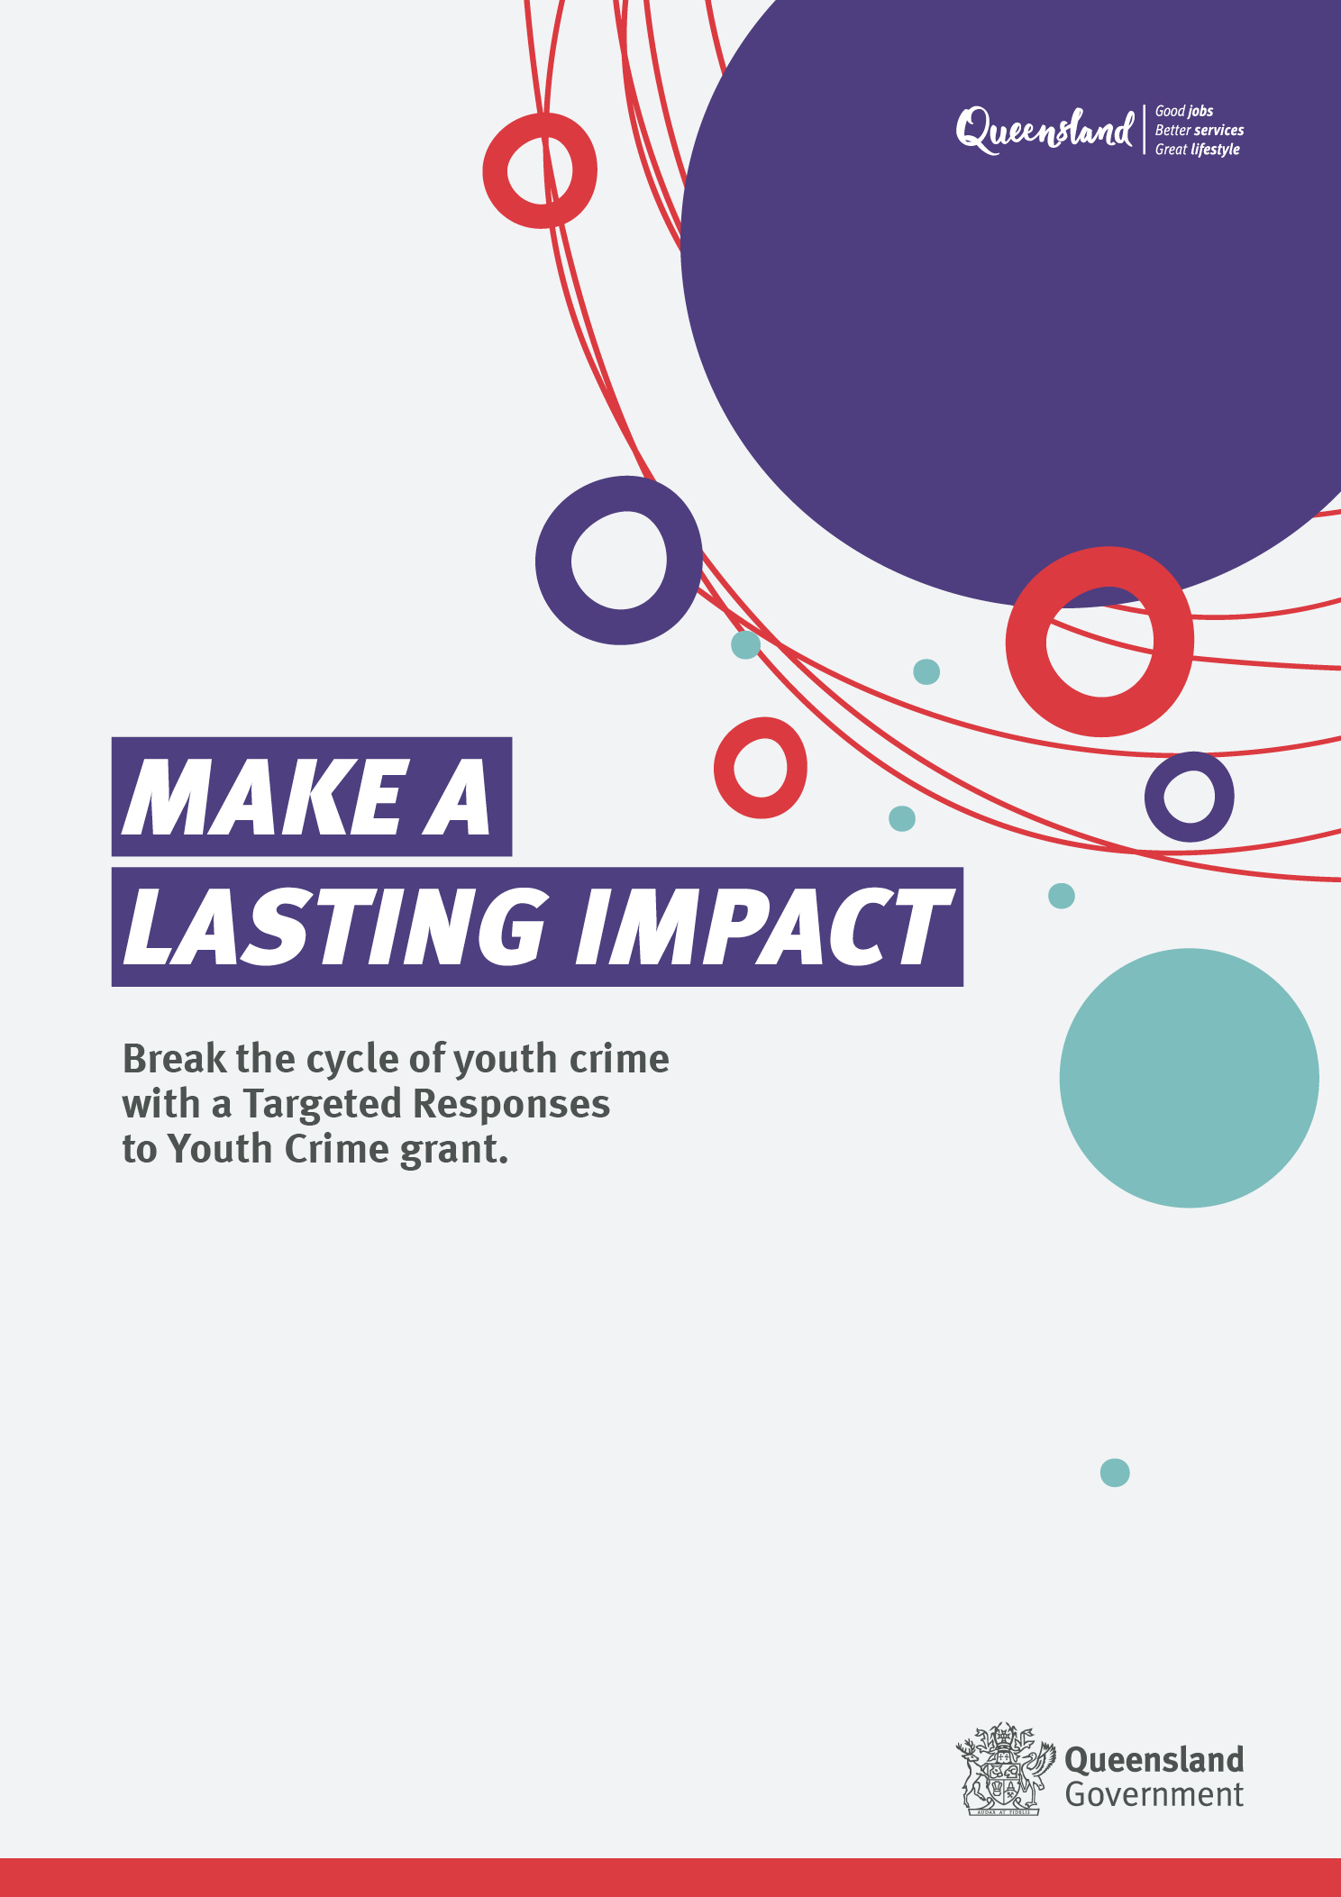

# Program information and Grant Guidelines

* **Applications open – 21 November 2023**
* **Applications close – 14 February 2024.**

## Background – Working Together Changing the Story

The Queensland Government is committed to reducing youth offending and improving community safety across Queensland. The [*Youth Justice Strategy 2019–2023: Working Together Changing the Story*](https://desbt.qld.gov.au/__data/assets/pdf_file/0022/17149/strategy.pdf), guides the government’s approach to the Youth Justice Crime Prevention Grants (CPG). These grants support short-term or one-time projects that address specific local youth crime issues, allowing communities to implement their own solutions.

## What are Youth Justice Crime Prevention Grants

Our Crime Prevention Grants (CPG) aim to empower local communities to respond to youth offending while fostering stakeholder collaboration and community engagement to address local youth crime priorities.

CPG emphasise investing in First Nations organisations to develop community-led initiatives addressing the over-representation of Aboriginal and Torres Strait Islander youth in the Youth Justice system.

CPG has two streams:

1. Community-based Crime Action (CBCA) grants
2. Targeted Responses to Youth Crime (TRYC) grants.

## What are Targeted Responses to Youth Crime grants?

The Queensland Government is seeking to engage local communities, businesses, and organisations to address complex causes of crime and offending behaviour at an individual and family level. We are looking for innovative ideas and targeted projects to identify, design and deliver intensive change-oriented responses to young people at high and very high risk of re-offending and serious repeat offenders.

Building on or complementing existing local responses and knowledge, TRYC grants will support innovative solutions to reduce youth crime and re-offending, that build community confidence and form lasting, meaningful changes and connections for young people involved in the youth justice system.

Solutions will be designed using evidence and community knowledge and delivered to meet the needs of young people, their families, and the broader community.

Projects proposed through TRYC should:

* be available to young people in the youth justice system (interacting with police, courts, Youth Justice department)
* build skills within the community or people working with young people who commit offences to upskill in specific areas of need related to the complex causes of youth crime
* promote sustainable and positive relationships through consultation with relevant stakeholders including First Nations peoples
* address over representation of First Nations young people in the youth justice system.

## What funds are available?

The 2023-24 Targeted Responses to Youth Crime grants will provide up to a total of $2.5 million in funds for short term or one-off local projects in communities across Queensland, with funding of up to $300,000 per project available.

The project establishment must commence from 31 March 2024 (you must include the date you expect the project to finish in your submission).

There is no guarantee or commitment of additional funding beyond the one-off grant in 2023–24.

## Is the Targeted Responses to Youth Crime grant right for you?

* Is your response focused on community safety, addressing the root causes of youth crime, and targeting young people who are serious repeat offenders?
* Does it have clear goals that address one of the identified areas of emerging need in response to youth crime and local community concerns?
* Is it culturally appropriate and include evidence of community support and partnerships with Aboriginal and Torres Strait Islander and/or culturally and linguistically diverse peoples and communities?
* Is it targeted – with a risk/needs assessment to determine the type of program that is effective for young people with the highest risk of future offending?
* Does the response provide sufficient duration and intensity to positively impact offending behaviour?
* Have you determined how you will collect data and monitor and evaluate your response to assess its effectiveness and learnings that could be improved or replicated?
* Have you considered how to appropriately transition young people to other supports and programs once funding for your project ends?

## Is there another grant program that better matches your proposed project?

Information about other potential funding and grants is available online. [Find a grant or assistance in Queensland (services.qld.gov.au)](https://www.grants.services.qld.gov.au/).

## Identified areas of emerging need in response to youth crime

We are interested in responses that target or support areas of emerging need in your location.

Statewide areas of need:

* responses that are available after business hours (i.e., after 5pm and into the night), on weekends or public holidays
* culturally safe responses for First Nations young people
* responses that upskill and build capacity for the workforce that support young people in the youth justice system (i.e., developing resources, programs, responses, and/or training to people who work with repeat offenders to address criminogenic behaviour)
* 10 to 13-year-olds involved in youth crime
* young people transitioning from detention
* responses tailored to the specific need of young women at risk/who have offended
* responses to address use of violence and use of weapons
* responses that connect up, leverage and strengthen existing services, programs and networks

[Locational areas of need](https://desbt.qld.gov.au/__data/assets/pdf_file/0011/18002/tryc-emerging-needs.pdf).

## Age range of participants

The funding prioritises individuals and groups generally aged 10 to 17, recognising them as our primary support focus. This aligns with our commitment to tailored responses for the needs of communities and young people who engage with Youth Justice.

## What you need to include in your application

Your application should include the following:

* Describe what your idea/concept is about, including clear goals and desired outcomes that respond to an identified area of emerging need. Include details in your response that have not been tried or previously available in your community.
* Detail how it will have a measurable impact, and how your model/program/project will respond to local issues to prevent youth crime matters in your community:
  1. Describe the methods used to constructively engage with your community to understand what the community feels needs to happen to respond to youth crime issues (who did you meet with?)
  2. Illustrate the localised concerns based on your community engagement (what did the community agree on to be a great way forward?)
  3. Describe your approach on how your proposal will address these concerns identified by the community
* Provide details on how your idea/concept is culturally safe and includes evidence of localised support and partnerships with Aboriginal and Torres Strait Islander peoples and communities.
* Describe who will be involved in the delivery of your response and evidence of their commitment (including local partners, organisations and community members if any)

**Please note:** Youth Justice staff will not be available to provide service delivery support or supervision to young people on grant funded programs. Applicants must ensure their application covers full-service delivery costs.

**Your response to each of the above should be no more than 500 words.**

|  |
| --- |
| **Mandatory Requirements**  You **must** demonstrate understanding of your requirements under [Working for Children legislation](https://www.qld.gov.au/law/laws-regulated-industries-and-accountability/queensland-laws-and-regulations/regulated-industries-and-licensing/blue-card). For more information visit: [Blue cards for working with children](https://www.qld.gov.au/law/laws-regulated-industries-and-accountability/queensland-laws-and-regulations/regulated-industries-and-licensing/blue-card).  If your project is to be delivered to an Aboriginal and/or Torres Strait Islander community, you **must** include a letter of support for the project from the community (i.e., Aboriginal and/or Torres Strait Islander Regional Council).  If your application includes other partners, you **must** provide a letter of support from the other organisations involved in the delivery of your proposed project or program for which the grant is sought. |

## Geographic catchment areas

Each application must be for one region only.

One application cannot go across multiple regions.

If you have a proposal that goes over regional boundaries, separate applications must be submitted – one for each region. Applicants can submit more than one application per round.

## How will your application be assessed?

An initial check will be conducted by the Department of Youth Justice, Employment, Small Business and Training to ensure it meets the eligibility (see below) and funding requirements.

Eligible applications will be progressed to an Assessment Panel who will undertake a merit-based assessment process, reviewing each application against the below criteria:

* **Addressing the identified areas of emerging need in response to youth crime**
* How strongly the proposed project meets an identified area of need, demonstrates local partnerships and evidences consultation with relevant stakeholders including First Nations stakeholders.
* **Benefits and delivery of the project**
* The application is inclusive, based on sound evidence, clearly outlines how the project is to be delivered and has tangible link to outcomes intended to be achieved.
* **Value for money/cost effectiveness**
* The extent to which the project has been costed realistically (including justification of budget items), provides value for money (as demonstrated in the project budget) and any in-kind contributions of project partners.

Successful applicants will be notified from March 2024.

Please note that **funding decisions are final** and unsuccessful applications are not able to be reconsidered for TRYC grant funding in 2023–24.

|  |
| --- |
| **PLEASE NOTE:**  If currently funded Youth Justice organisations have any overdue progress or acquittal reports or have not contacted the department to discuss alternate arrangements for the submission of an overdue report, they may not be considered for 2023-24 funding. |

## What funding cannot be used for

Funding provided through the grants can only be used for the purpose of delivering the TRYC project. The following costs or use of funds will not be allowed:

* salaries and organisational running costs for existing staff performing usual business operations
* acquittal, auditing or reporting costs
* auspicing fees (for anything other than this specific project)
* existing debt or loan repayments
* gifts of any sort (e.g., gift bags, door prizes, raffle prizes, giveaways, tickets to events)
* purchase of assets (assets include capital items in excess of $5,000 with a useful life of more than 12 months).

## Who is eligible to apply?

Applicants can be a single organisation or individual, joint partners, or combined organisations.

Aboriginal and/or Torres Strait Islander Community Controlled Organisations and Indigenous businesses are encouraged to apply.

State and Federal Government agencies are not eligible to apply.

## Joint applications

Applications relating to more than one organisation must be made jointly.

For joint applications between more than one organization, a lead must be identified. As the lead agency will be legally accountable for the activity and grant expenditure they must:

* be an incorporated not-for-profit, registered business or legal entity
* have an auspice agreement with any of the above entities (which is to be detailed in your application).

Lead agencies must also:

* have a registered and current Australian Business Number (ABN) or Australian Company Number (ACN) and be registered for GST
* have experience delivering services in Queensland
* provide a letter of support from the other organisations involved in the application for the service or program for which the grant is sought
* hold public liability insurance to the value of not less than $10 million, or provide evidence of plans to obtain insurance to the value of not less than $10 million to cover the proposed project
* have no overdue reports, or service delivery or performance issues for funding previously or currently provided by the Department of Children, Youth Justice, and Multicultural Affairs, or the Department of Youth Justice, Employment, Small Business and Training.

**If your organisation is not incorporated or you do not have an active ABN, you can ask an eligible incorporated not-for-profit organisation, which has operations or already delivers services in Queensland, to auspice your project.**

If successful in receiving funding, the auspicing organisation will be required to enter into a service agreement, receive the funding and disburse this to the applicant organisation at the start of the project, and submit report/s. The auspicing organisation must have no overdue reports or performance issues related to funding previously or currently provided by the department.

## How to apply

Read these guidelines carefully to determine the eligibility of your organisation and whether your application meets the relevant program/funding requirements for project funding.

* **Complete and submit your application online by 11.59pm Wednesday 14 February 2024** through SmartyGrants. Visit [https://yj.smartygrants.com.au/yjtrycgrant3](https://aus01.safelinks.protection.outlook.com/?url=https%3A%2F%2Fyj.smartygrants.com.au%2Fyjtrycgrant3&data=05%7C01%7CSuzanne.Butler%40cyjma.qld.gov.au%7Cb17d7a5a7c0e47abdb4808dbe71317ba%7C95b907c2752b485088ad86939ce522f0%7C0%7C0%7C638357841422612372%7CUnknown%7CTWFpbGZsb3d8eyJWIjoiMC4wLjAwMDAiLCJQIjoiV2luMzIiLCJBTiI6Ik1haWwiLCJXVCI6Mn0%3D%7C3000%7C%7C%7C&sdata=SCpa0oj9zBME7%2B2aYmXz35IQhkhm8eSpHU%2FEdEDkYzs%3D&reserved=0)
* In exceptional circumstances, the department may consider an alternative method of submitting an application. Please email the department no **later than 5pm Monday 8 January 2024** at [YJ_Grants@cyjma.qld.gov.au](mailto:YJCommissioning@youthjustice.qld.gov.au) to enquire.
* **You will receive an acknowledgement email** from SmartyGrants once you submit your application.
* If you do not receive an acknowledgement email, your application has not been submitted. Check your application for errors and resubmit. If your application does not submit, contact SmartyGrants Technical Support (refer to end of this document for contact information).
* The SmartyGrants system will automatically shut off at midnight on Wednesday 14 February 2024 and will not allow applications to be submitted.
* To ensure fairness to all applicants, applications and supporting documentation **will not be accepted** after the closing date.

## Contractual requirements of successful applications

All successful applicants will be required to:

* **Enter into a contract** with the Department of Youth Justice, Employment, Small Business and Training and comply with the requirements and conditions of the agreement including:
* relevant laws and regulations (such as the *Working with Children (Risk Management and Screening) Act 2000* and the *Youth Justice Act 1992 including privacy provisions*)
* performance and financial reporting requirements and periods, including financial acquittals
* the principles of the *Human Rights Act 2019* to respect, protect and promote the human rights of participants. Visit [[QHRC: Human rights](https://www.qhrc.qld.gov.au/your-rights/human-rights-law) for](https://www.qld.gov.au/law/your-rights/human-rights) more information.

Before accepting funds, it is recommended you carefully read the agreement, including project deliverables, to ensure all information is correct. For examples of possible agreement templates, please visit [Streamlined agreements](https://www.dcssds.qld.gov.au/about-us/our-department/funding-grants-investment/streamlined-agreements).

* **Acknowledge the Queensland Government funding** with the use of the Queensland Government crest (logo) on all promotional material associated with your funded project. Versions of the logo will be provided to you by the department.
* **Request approval from the department for any proposed change to the funded project**, including any changes to the project activities. The organisation must receive approval from the department **BEFORE** any changes can be implemented. Not receiving approval or notifying the department is in breach of the service agreement and may require the applicant to return some or all funding.

Please ensure when delivering project activities, that funded organisations stay updated with COVID Safe requirements. For further information, please visit Queensland Health’s website at <https://www.health.qld.gov.au/>

Successful applications may be advertised in Queensland Government publications and websites. An applicant must inform the department if the organisation does not want their contact information made public.

## Further information and assistance

Ensure that you check for updates and information about the2023–24 Targeted Responses to Youth Crime grants on <https://desbt.qld.gov.au/youth-justice/partnerships/grants/targeted-responses>.

Answersto **any frequently asked questions** will be regularly posted on the site.

Questions about the grants must be submitted to the department by **5pm AEST on Monday 22 January 2024.**

Should you require further assistance, please email [YJ_Grants@cyjma.qld.gov.au](mailto:YJCommissioning@youthjustice.qld.gov.au).

If you need assistance with your SmartyGrants account, or for any technical issues, please contact SmartyGrants Technical Support on (03) 9320 6888 or [service@smartygrants.com.au](mailto:service@smartygrants.com.au). Support Desk Hours are from 9am–5pm AEST, Monday to Friday.

If you have difficulty understanding this publication or other funding documents and need language assistance, please call the Translating and Interpreting Service (TIS National) on 13 14 50 and ask them to telephone the Queensland Department of Youth Justice, Employment Small Business and Training on 13 QGOV (13 74 68).