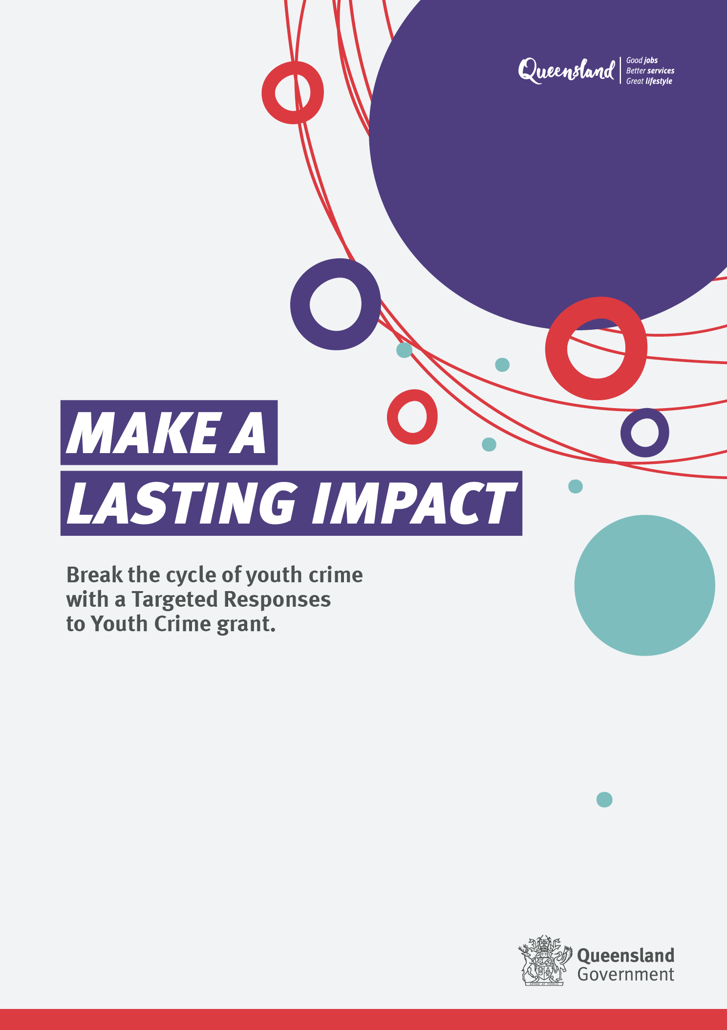

# Targeted Responses to Youth Crime

## Digital Factsheet

Updated 28 November 2023

**Background**

The Queensland Government is committed to reducing youth offending and improving community safety across Queensland. The [*Youth Justice Strategy 2019–2023: Working Together Changing the Story*](https://desbt.qld.gov.au/__data/assets/pdf_file/0022/17149/strategy.pdf), guides the government’s approach to the Youth Justice Crime Prevention Grants (CPG). These grants support short-term or one-time projects that address specific local youth crime issues, allowing communities to implement their own solutions.

**What are Targeted Responses to Youth Crime grants?**

Building on or complementing existing local responses and knowledge, the Targeted Responses to Youth Crime (TRYC) grants will support innovative solutions to reduce youth crime and re-offending, that build community confidence and form lasting, meaningful changes and connections for young people involved in the youth justice system.

Solutions will be designed using evidence and community knowledge and delivered to meet the needs of young people, their families, and the broader community.

The grants are about building community confidence and safety by:

* building on strengths within a community
* creating community networks and connections
* delivering locally driven responses to support young people to realise goals
* investing in things that will make communities safe now and in the future.

For young people, it is about making a difference to their lives by:

* healing their connections
* reconnecting them
* strengthening their connections
* keeping them connected.

All community members – family and kin, Elders, mentors, local businesses, not-for-profit organisations and social enterprises – can be involved in supporting young people and influencing positive and long-lasting change to reduce offending behaviour.

**What funds are available?**

The 2023–24 Targeted Responses to Youth Crime grants program will provide up to $2.5 million in total funds for short-term or one-off local projects in communities across Queensland. Grants of up to $300,000 are available per project.

**What projects will be considered?**

A project will be considered if it:

* focuses on community safety, addressing the root causes of youth crime, and targeting young people who are serious repeat offenders
* has clear goals that address one of the identified areas of emerging need in response to youth crime and local community concerns
* is culturally appropriate and include evidence of community support and partnerships with Aboriginal and Torres Strait Islander and/or culturally and linguistically diverse peoples and communities
* is targeted toward young people with the highest risk of future offending
* provides sufficient duration and intensity to positively impact offending behaviour.

**Engaging with your community**

Applicants are encouraged to consult with their community and engage local stakeholders to develop proposals. As part of your application, you will need to:

* explain who you met with and how you engaged with your community to understand what they feel needs to happen to respond to youth crime issues
* tell us what the localised concerns are as a result of your community engagement
* tell us how your proposal will address the concerns identified by the community
* outline who will be involved in the delivery of your response and provide evidence of their commitment
* demonstrate culturally safe and localised partnerships with Aboriginal and Torres Strait Islander peoples and communities.

**More information**

<https://desbt.qld.gov.au/yjgrantstargeted>

**Enquiries**

[YJ_Grants@cyjma.qld.gov.au](mailto:YJ_Grants@cyjma.qld.gov.au)