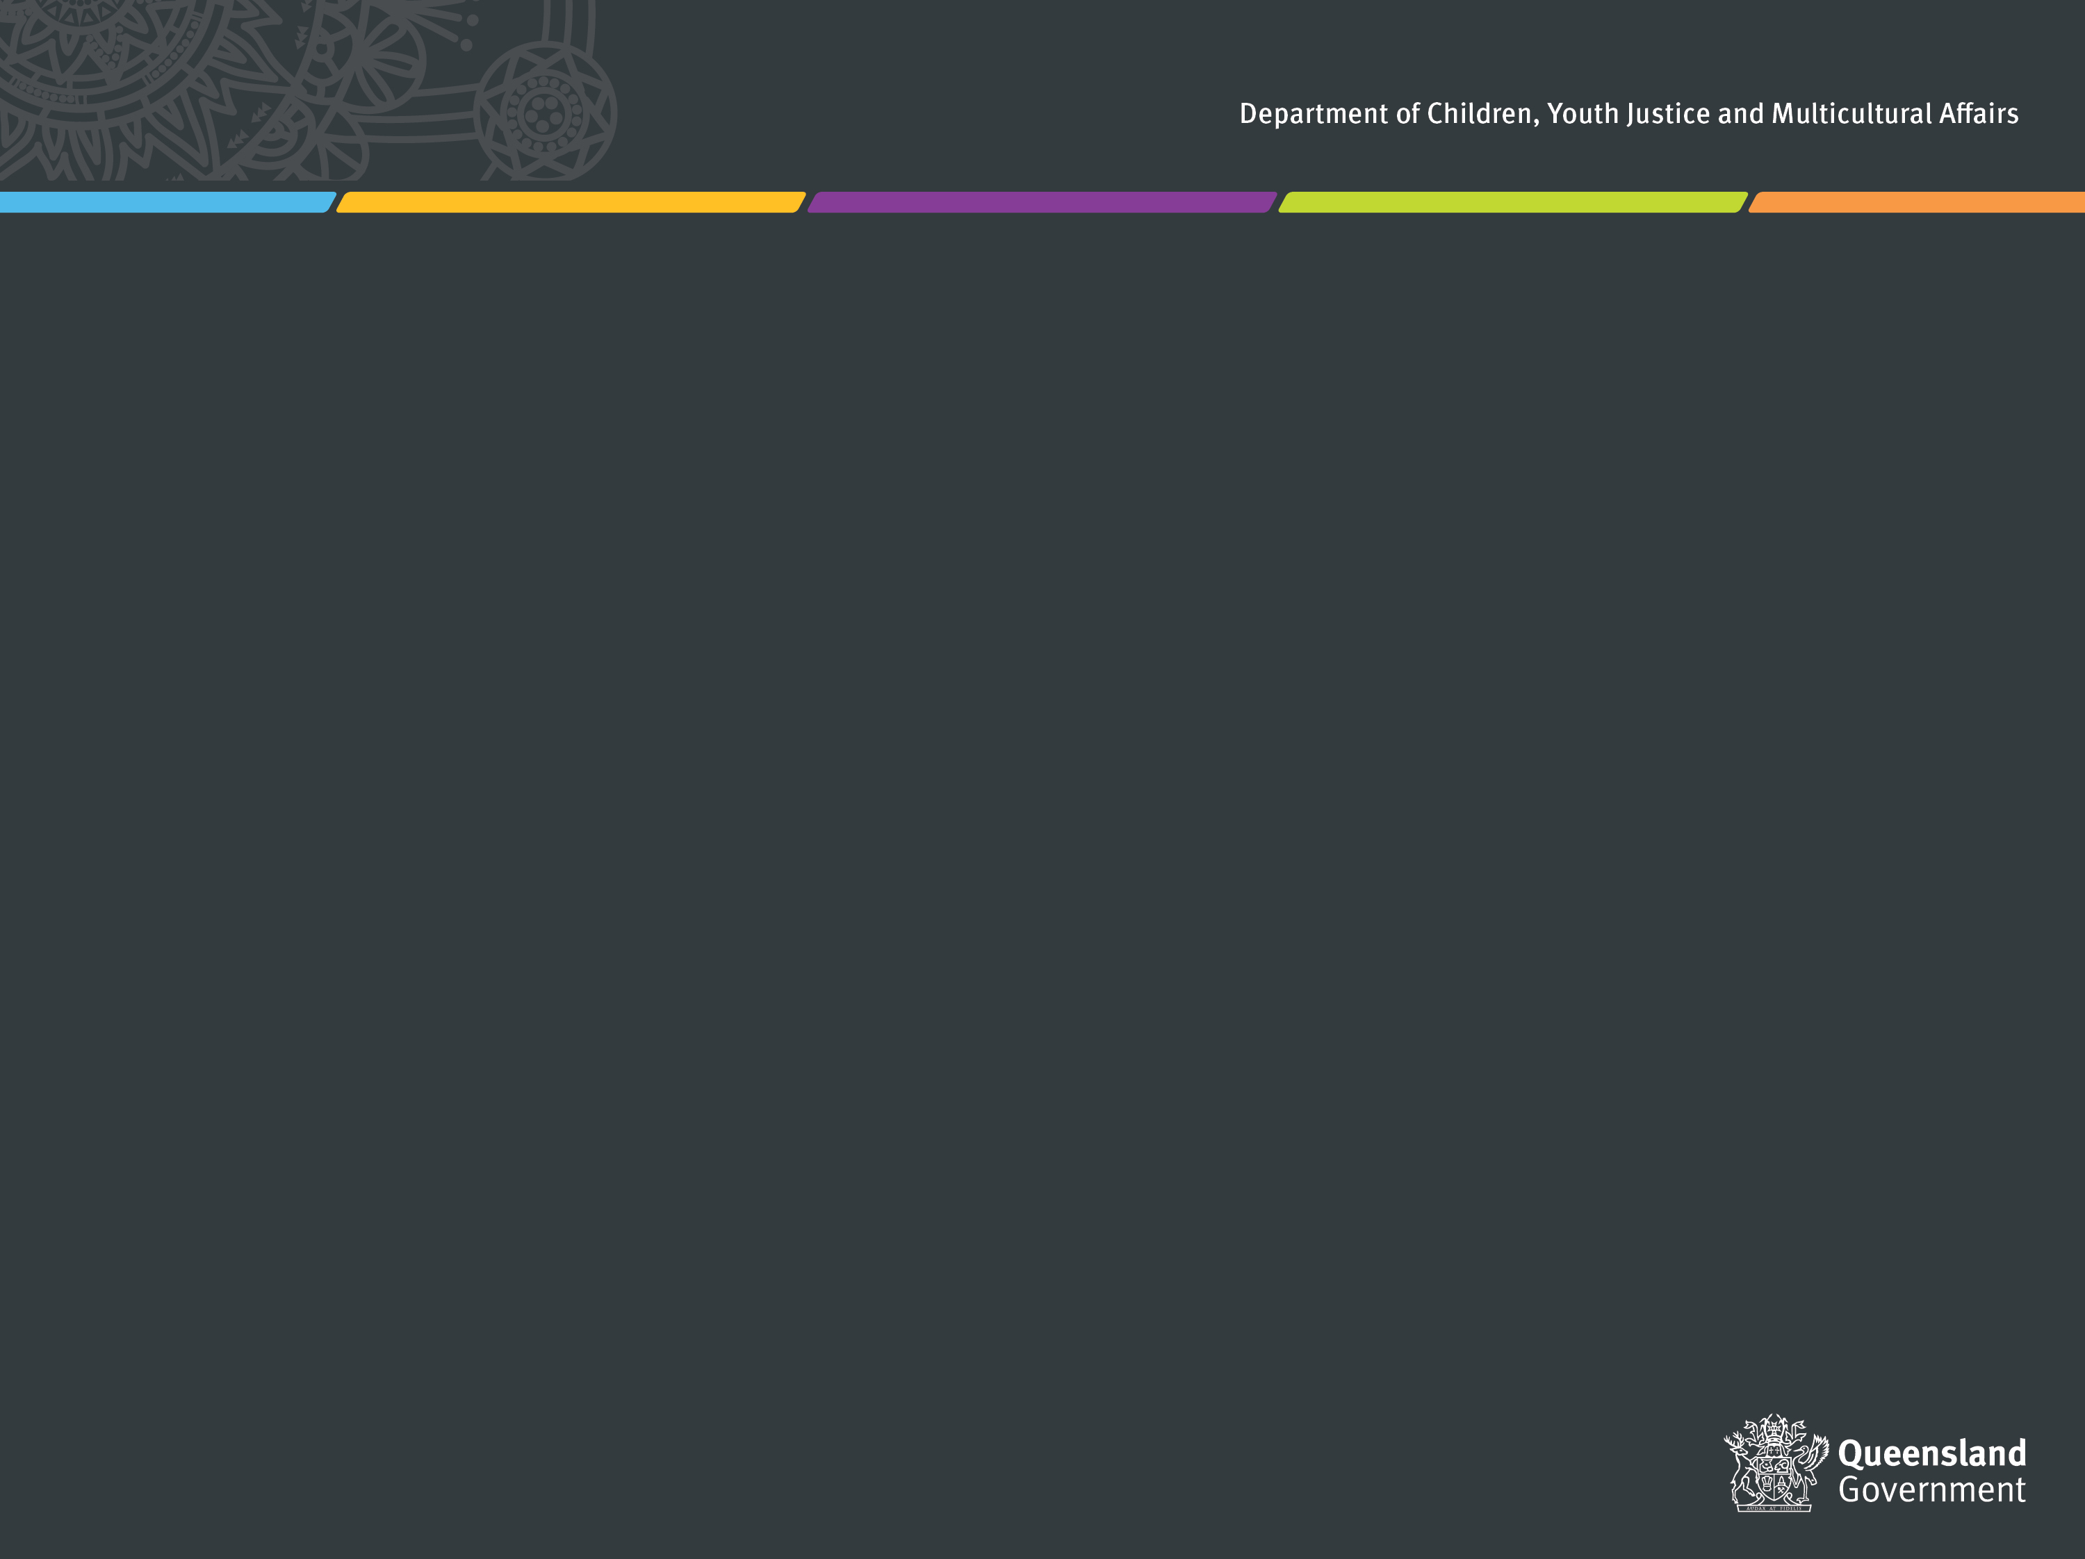

# **Agency commitments for 2022-24**

Each agency has committed to undertaking activities in one or more of the Action Plan’s six Key Action Areas. The table below indicates which of the Key Action Areas your agency has committed to and will therefore be required to report on in this template.

*Note this table has been updated from the version on page 14 of the Action Plan to reflect the recent machinery of government (MOG) changes.[1]*

|  |  |  |  |  |  |  |
| --- | --- | --- | --- | --- | --- | --- |
| **Agency** | **Key action 1** | **Key action 2** | **Key action 3** | **Key action 4** | **Key action 5** | **Key action 6** |
| **DEC** | **⚫** | **⚫** |  |  | **⚫** | **⚫** |
| **DoR** | **⚫** | **⚫** |  |  | **⚫** | **⚫** |
| **DSDI** | **⚫** | **⚫** |  |  | **⚫** | **⚫** |
| **DRDMW** |  | **⚫** | **⚫** |  | **⚫** | **⚫** |
| **DTS** |  | **⚫** |  | **⚫** | **⚫** | **⚫** |
| **DoE** |  | **⚫** | **⚫** | **⚫** | **⚫** | **⚫** |
| **DESI** | **⚫** | **⚫** |  |  |  | **⚫** |
| **DJAG** | **⚫** | **⚫** | **⚫** | **⚫** | **⚫** | **⚫** |
| **DPC** | **⚫** | **⚫** |  |  | **⚫** | **⚫** |
| **QPS** |  | **⚫** | **⚫** | **⚫** | **⚫** | **⚫** |
| **QT** | **⚫** | **⚫** |  | **⚫** | **⚫** | **⚫** |
| **DAF** | **⚫** | **⚫** | **⚫** |  | **⚫** | **⚫** |
| **DESBT** | **⚫** | **⚫** | **⚫** | **⚫** | **⚫** | **⚫** |
| **DTMR** |  | **⚫** | **⚫** | **⚫** | **⚫** | **⚫** |
| **PSC** |  | **⚫** |  | **⚫** |  |  |
| **QCS** |  | **⚫** | **⚫** | **⚫** | **⚫** | **⚫** |
| **QFD** |  | **⚫** |  | **⚫** | **⚫** | **⚫** |
| **QH** |  | **⚫** | **⚫** | **⚫** | **⚫** | **⚫** |
| **ECQ** |  | **⚫** |  |  | **⚫** | **⚫** |
| **LAQ** |  | **⚫** | **⚫** | **⚫** | **⚫** | **⚫** |
| **QHRC** |  | **⚫** |  | **⚫** | **⚫** |  |
| **QMHC** | **⚫** | **⚫** | **⚫** | **⚫** | **⚫** | **⚫** |
| **RTA** |  | **⚫** | **⚫** | **⚫** |  | **⚫** |
| **TIQ** | **⚫** | **⚫** |  | **⚫** | **⚫** | **⚫** |
| **TAFE QLD** |  | **⚫** | **⚫** |  | **⚫** | **⚫** |
| **DCSSDS** | **⚫** | **⚫** | **⚫** | **⚫** | **⚫** | **⚫** |
| **DTATSIPCA** | **⚫** | **⚫** |  | **⚫** | **⚫** | **⚫** |
| **DHLGPPW** |  | **⚫** | **⚫** | **⚫** | **⚫** |  |
| **DYJ** | **⚫** | **⚫** |  |  | **⚫** |  |

**⚫ KEY ACTION 2: Recruitment and workplace culture**

Barriers to participation facing culturally and linguistically diverse communities will be removed so they can join the Public Sector and Queensland Government boards, through **culturally inclusive recruitment practices and workplace cultures**. As per the Queensland Multicultural Policy, activities in this section should link to one or more of the following high-level outcomes:

* *Queensland gets the most benefit from our diversity and global connections.*
* *Individuals are supported to participate in the economy.*
* *Recognition and respect for Aboriginal and Torres Strait Islander heritage and culture.*
* *Queenslanders celebrate our multicultural identity.*
* *Connected and resilient communities.*
* *A respectful and inclusive narrative about diversity.*

| **Agency activities supporting**  **Key Action 2** | **Progress status for 2023-24** | **Outcomes achieved for people from culturally and linguistically diverse backgrounds.** |
| --- | --- | --- |
| Ensure targeted recruitment or career development initiatives are undertaken in partnership with community including, for example, where agencies are focusing on attracting applicants from specific cultural groups for positions. | **Delivered** | As of 30 June 2024, 3.6% of Queensland Corrective Services (QCS) employees were born overseas, and 2.6% of employees speak a language other than English at home.  QCS has developed the QCS Workforce Strategy 2022-2027, which maps the overarching priorities and strategies for developing the systems necessary to support, strengthen and enable its workforce to deliver professional, ethical, and sustainable corrective services now and into the future. The QCS Workforce Strategy will be reviewed in 2024-25 to ensure it reflects the *Public Sector Act 2022.* QCS is committed to fulfilling the purpose of Chapter 2 of the Act in developing an inclusive, respectful, and diverse workforce.  In 2023-24, QCS continued to work in partnership with Multicultural Australia, which facilitates pathways to employment for migrants, refugees, and asylum seekers in both custodial and non-custodial workplaces.  QCS is also proud to featured on the Queensland Government #BeHere4Queensland website to champion both Custodial Correctional Officers and the Community Corrections workforce to further enhance attraction and recruitment processes.  QCS will continue to encourage individuals from culturally and linguistically diverse backgrounds to apply through recruitment processes. |

# **⚫ KEY ACTION 3: Culturally responsive services**

Over the next two years, Queensland Government agencies will improve their cultural responsiveness by undertaking an **audit of critical areas of service delivery** (funded or directly delivered). As per the Queensland Multicultural Policy, activities in this section should link to one or more of the following high-level outcomes:

* *Improved knowledge about customers’ diversity.*
* *Culturally capable services and programs.*
* *A productive, culturally capable, and diverse workforce.*

| **Agency activities supporting**  **Key Action 3** | **Progress status for 2023-24** | **Outcomes achieved for people from culturally and linguistically diverse backgrounds.** |
| --- | --- | --- |
| Queensland Corrective Services will review the information and mechanisms of providing information to eligible persons and stakeholders from the QCS Victims Register. | **Delivered** | In June 2024, the *Corrective Services Act 2006* was amended to ensure the Victims Register (VR) can be accessed by those who need it most to support their safety and wellbeing by:   * expanding the grounds to support eligible persons for homicide offences * recognising First Nations family and kinship as immediate family members * increasing flexibility and more discretion for the chief executive to register an eligible person.   The VR continues to be adaptable to the communication needs of eligible persons. For eligible persons requiring interpreter services, the VR utilises approved translating and interpreting services available to Queensland Corrective Services as required, as well as support persons and support agencies nominated by eligible persons. |

**⚫** **KEY ACTION 4: Cultural diversity data**

The Queensland Government will collect, analyse, and use **cultural diversity data** to improve service delivery and better meet customer needs. As per the Queensland Multicultural Policy, activities in this section should link to one or more of the following high-level outcomes:

* *Improved knowledge about customers’ diversity.*
* *Culturally capable services and programs.*
* *A productive, culturally capable, and diverse workforce.*

| **Agency activities supporting**  **Key Action 4** | **Progress status for 2023-24** | **Outcomes achieved for people from culturally and linguistically diverse backgrounds.** |
| --- | --- | --- |
| Queensland Corrective Services will identify opportunities to enhance collection of diversity data to better inform service delivery and workforce practices and processes. | **Delivered** | Queensland Corrective Services (QCS) completed an Equity and Diversity Audit in April 2024 and submitted this to the Office of the Special Commissioner, Equity and Diversity.  The QCS Equity and Diversity Action Plan 2023-2026 reinforces inclusive attitudes and behaviours consistent with QCS’ values and addresses the workforce diversity gaps to meet QCS’ Workforce Strategy objectives and *Corrections 2030* vision. The focus areas of the Equity and Diversity Plan are revised each year in accordance with the audit findings. The 2026 workforce diversity targets for QCS are:   * 4% First Nations officers * 12% Officers with diversity * 12% Culturally and linguistically diverse officers * 50% Women in leadership. |

# **⚫ KEY ACTION 5: Interpreters and communication strategies**

Queensland Government agencies will ensure people who have difficulty communicating in English can access information and services at the right time and in the right manner, through **improved access to interpreters and implementing multilingual and multi-modal communication strategies**. As per the Queensland Multicultural Policy, activities in this section should link to one or more of the following high-level outcomes:

* *Improved knowledge about customers’ diversity.*
* *Culturally capable services and programs.*
* *A productive, culturally capable, and diverse workforce.*
* *Queensland gets the most benefit from our diversity and global connections.*
* *Individuals are supported to participate in the economy.*

| **Agency activities supporting**  **Key Action 5** | **Progress status for 2023-24** | **Outcomes achieved for people from culturally and linguistically diverse backgrounds.** |
| --- | --- | --- |
| Queensland Corrective Services will increase the use of translation services for CALD people engaged with Community Corrections. | **Delivered** | Guidelines were published on the Queensland Corrective Services (QCS) intranet in 2022-23 regarding the whole-of-government Standing Offer Arrangement for the provision of translator and interpreter services, including a list of services officers may access.  In 2023-24, Community Corrections’ expenditure across the state on translation and interpreter services increased slightly from the 2022-23 expenditure. In 2023-24, Community Corrections spent approximately $8,900 on translation an interpreter services.  Community Corrections staff are aware they should use translation services where required and appropriate, noting the Operational Practice Guidelines directs staff to do so when a supervised individual has difficulties in understanding or communicating in English.  Further, in 2024, if they felt comfortable to do so staff members from across the state who speak a language other than English nominated the alternative language/s they spoke and were agreeable to supporting staff from other office locations with translation services, where of benefit and appropriate. |
| Queensland Corrective Services will assess the viability of providing copies of key information documents, such as the Prisoner Induction Handbook, in the most common non-English languages. | **Delivered** | Queensland Corrective Services (QCS) has assessed the viability of providing copies of key information documents in the most common non-English languages. To allow QCS to understand what the common non-English languages are at any given time, enhancements are required to the Integrated Offender Management System (IOMS) to collect this diversity data (Key Action 4). Due to other critical updates to IOMS, this work does not have an expected end date.  Updates have been progressed to enhance Custodial Operations Practice Directives (COPD’s) to better utilise the whole-of-government Standing Offer Arrangement (SOA) for the provision of translator and interpreter services when making these key information documents available. When finalised, centres will be reminded how to access the SOA to ensure documents such as the Prisoner Induction Handbook can be made available.  QCS is also investigating whether translation pens could be utilised to translate documents.  Community Corrections are currently reviewing trend data to determine which languages, other than English, are most common across the supervised individual cohort.  Once determined, the SOA will be utilised to engage the appropriate service to translate frequently used documents, such as induction packs, into those languages. |
| For agencies involved in front line service delivery, support the whole-of-government Standing Offer Arrangement for the provision of interpreting and translation services. | **Delivered** | Guidelines have been published on the Queensland Corrective Services (QCS) intranet regarding the common-use supply arrangement for the provision of translator and interpreter services, including a list of services officers may access.  In 2023-24, QCS spent approximately $31,600 on translation and interpreter services. |

|  |
| --- |
| **Case studies or good news stories to highlight achievements relevant to Key Action 5 (Interpreters and communication strategies):** |
| Use of interpretation and translation services across Community Corrections has increased staff ability to engage with supervised individuals with limited English. Noting the importance of supervised individuals having a strong understanding of their Order conditions and requirements, ensuring this is communicated to individuals in their preferred language increases their capacity to comply. Supervised individuals have provided positive feedback about the use of translation services, advising they feel better supported. It has also increased communication with support persons, with translation services having been used on occasion to engage with the families of supervised individuals. |

**⚫ KEY ACTION 6: Address racism, discrimination, and promote inclusion.**

Queensland Government agencies will ensure equitable and respectful opportunities and experiences for staff and customers from culturally and linguistically diverse backgrounds, through targeted initiatives to **address unconscious bias and racism and promote inclusion**. As per the Queensland Multicultural Policy, activities in this section should link to one or more of the following high-level outcomes:

* *Improved knowledge about customers’ diversity.*
* *Culturally capable services and programs.*
* *A productive, culturally capable, and diverse workforce.*
* *Recognition and respect for Aboriginal and Torres Strait Islander heritage and culture.*
* *Queenslanders celebrate our multicultural identity.*
* *Connected and resilient communities.*
* *A respectful and inclusive narrative about diversity.*

| **Agency activities supporting**  **Key Action 6** | **Progress status for 2023-24** | **Outcomes achieved for people from culturally and linguistically diverse backgrounds.** |
| --- | --- | --- |
| Queensland Corrective Services will commence an organisational culture change program including initiatives and programs aimed at raising awareness and improving outcomes around inclusion and diversity. | **Delivered** | Queensland Corrective Services (QCS) recently co-designed and launched the *QCS Culture Framework 2024-2028* (the Framework), a five-year plan which articulates the desired culture for QCS. The Framework consists of five key focus areas:   * Safe and Respectful Workplaces * People-Centred Leadership * Diverse and Inclusive Workplaces * One QCS untied by our People and Purpose * Governing with Ethics and Integrity.   The tool which will drive delivery implementation of this framework is the initial two-year *QCS Culture Action Plan 2024-2026* (Horizon 1 of 2). |

1. Following MOG changes in December 2023, Action Plan commitments have been reviewed and allocated across departments accordingly.